Associations of Early Life Per- and Polyfluoroalkyl Substances (PFAS) Exposure with Body Mass Index and Risk of Overweight or Obesity at Age 2-18 Years: Mixture Analysis in the Prospective Boston Birth Cohort
Supplemental Materials

Li, Zeyu¹; Wang, Guoying¹; Braun, Joseph M.²; Hong, Xiumei¹; Choi, Giehae³; O'Leary, Shawn P.⁴; Yu, Chang Ho⁴; Pearson, Colleen⁵; Adams, William G.⁵; Fan, Zhihua (Tina)⁴; Buckley, Jessie P.^{3,6 #}; Wang, Xiaobin^{1,7 #}.
¹Center on the Early Life Origins of Disease, Department of Population, Family and Reproductive Health, Johns Hopkins Bloomberg School of Public Health, Baltimore, MD, USA
²Department of Epidemiology, Brown University, Providence, RI, USA
³Department of Environmental Health and Engineering, Johns Hopkins Bloomberg School of Public Health, Baltimore, MD, USA
⁴Environmental and Chemical Laboratory Services, Public Health and Environmental Laboratories, New Jersey Department of Health, Trenton, NJ, USA
⁵Department of Pediatrics, Boston University Chobanian and Avedisian School of Medicine and Boston Medical Center, Boston, MA, USA
⁶Department of Epidemiology, University of North Carolina at Chapel Hill, Chapel Hill, NC, USA
⁷Department of Pediatrics, Johns Hopkins School of Medicine, Baltimore, MD, USA.
#Corresponding authors. Address:
Jessie Buckley, Department of Epidemiology, University of North Carolina at Chapel Hill, McGavran-Greenberg Hall CB#7435, 2106-B, Chapel Hill, NC 27599, USA. E-mail address: jessie.buckley@unc.edu (J. Buckley).
Xiaobin Wang, Center on the Early Life Origins of Disease, Johns Hopkins Bloomberg School of Public Health, 615 N. Wolfe Street, E4132, Baltimore, MD 21205, USA. E-mail address: xwang82@jhu.edu (X. Wang).
Table of Contents
Table S1. Comparison of general characteristics between included and all mother-child dyads in the Boston Birth Cohort. ª 4
Table S2. Association of maternal plasma PFAS with repeated child BMI Z-score and child OWO measures at the age of 2-18 years examined by linear and modified Poisson mixed-effects models among 1189 mother-child dyads in the Boston Birth Cohort. ª 6
Table S3. Interaction terms between log2-transformed maternal plasma PFAS concentrations and child age group among 1189 mother-child dyads in the Boston Birth Cohort. 9
Table S4. Quantile-based g-computation models of the maternal plasma PFAS mixture with the last measure of child BMI Z-score and child OWO status at the age of 2-18 years among 1189 mother-child dyads in the Boston Birth Cohort. ª 10
Table S5. Quantile-based g-computation models stratified by child age group of maternal plasma PFAS mixture with the last measure of child BMI Z-score and child OWO status among 1189 mother-child dyads in the Boston Birth Cohort. ª 12
Table S6. Individual association of maternal plasma PFAS with the last measure child BMI Z-score and child OWO status at the age of 2-18 years among 1189 mother-child dyads in the Boston Birth Cohort. ª 13
Table S7. Joint association of maternal plasma PFAS and maternal OWO status with child BMI Z-score and child OWO status at the age of 2-18 years among 1189 mother-child dyads in the Boston Birth Cohort. ª 15
Table S8. Joint association stratified by child age group of maternal plasma PFAS and maternal OWO status with child BMI Z-score and child OWO status among 1189 mother-child dyads in the Boston Birth Cohort. ª 17
Table S9. Joint association stratified by child sex of maternal plasma PFAS and maternal OWO status with child BMI Z-score and child OWO status at the age of 2-18 years among 1189 mother-child dyads in the Boston Birth Cohort. ª 19
Table S10. Joint association stratified by race groups of maternal plasma PFAS and maternal OWO status with child BMI Z-score and child OWO status at the age of 2-18 years among 1189 mother-child dyads in the Boston Birth Cohort. ª 21
Table S11. Sensitivity analysis additionally adjusting for fish intake and Mediterranean diet score in individual association of maternal plasma PFAS with child BMI Z-score and child OWO status at the age of 2-18 years among 1189 mother-child dyads in the Boston Birth Cohort. ª 23
Table S12. Sensitivity analysis without adjusting for maternal diabetes and birthweight-for-gestational age in individual association of maternal plasma PFAS with child BMI Z-score and child OWO status at the age of 2-18 years among 1189 mother-child dyads in the Boston Birth Cohort. ª 24
Table S13. Sensitivity analysis additionally adjusting for maternal smoking in individual association of maternal plasma PFAS with child BMI Z-score and child OWO status at the age of 2-18 years among 1189 mother-child dyads in the Boston Birth Cohort. ª 25
Table S14. Sensitivity analysis additionally adjusting for breastfeeding in individual association of maternal plasma PFAS with child BMI Z-score and child OWO status at the age of 2-18 years among 1189 mother-child dyads in the Boston Birth Cohort. ª 26
Fig. S1. Flowchart of inclusion of 1189 mother-child dyads in the Boston Birth Cohort. 27
Fig. S2. Directed Acyclic Graph (DAG) showing the covariates included in the models of this study between maternal post-partum plasma PFAS and child’s BMI or OWO. 28
Fig. S3. Spearman’s rank order correlation coefficients of maternal plasma PFAS concentrations among 1189 mother-child dyads in the Boston Birth Cohort. 29
Fig. S4. Predicted trajectories of child BMI from 2 to 18 years by quartiles of maternal plasma PFAS concentrations at delivery among 1,094 mother-child dyads in the Boston Birth Cohort. 30
Fig. S5. Effect modification of maternal pre-pregnancy BMI on the relationship of maternal plasma PFAS with child BMI Z-score and child OWO status estimated by Bayesian kernel machine regression among 1189 mother-child dyads in the Boston Birth Cohort. 31
Fig. S6. Smooth plots of relationship between log2-transformed maternal plasma PFAS and child BMI Z-score and box plots of relationship between log2-transformed maternal plasma PFAS and child OWO status at the age of 2-18 years among 1189 mother-child dyads in the Boston Birth Cohort. 32
Fig. S7. Density plots of log2-transformed PFAS concentrations in maternal plasma stratified by maternal pre-pregnancy OWO. 35

Table S1. Comparison of general characteristics between included and all mother-child dyads in the Boston Birth Cohort. ª
Characteristics | Mean ± SD / No. (%)
Characteristics | Included ^{b} (n = 1189) | All ^{b} (n = 3414)
Maternal age at delivery (years) | 28.8 ± 6.5 | 28.5 ± 6.5
Maternal race
Black | 705 (59) | 2008 (59)
Non-Black | 484 (41) | 1406 (41)
Maternal education
High school or below | 764 (65) | 2156 (64)
College or above | 419 (35) | 1222 (36)
Maternal pre-pregnancy BMI (kg/m²) | 27.0 ± 6.6 | 26.6 ± 6.6
Maternal pre-pregnancy OWO ^{c} | 616 (52) | 1658 (52)
Maternal pregestational or gestational diabetes | 202 (17) | 549 (16)
Maternal smoking history during pregnancy | 195 (16) | 622 (18)
Parity
Nulliparous | 505 (42) | 1466 (43)
Multiparous | 684 (58) | 1946 (57)
Delivery mode
Vaginal delivery | 741 (62) | 2188 (64)
Cesarean section | 448 (38) | 1209 (36)
Child’s sex
Male | 585 (49) | 1717 (50)
Female | 604 (51) | 1697 (50)
Gestational age (weeks) | 38.0 ± 3.1 | 37.7 ± 3.5
Preterm
< 37 weeks | 277 (23) | 978 (29)
≥ 37 weeks | 912 (77) | 2436 (71)
Birthweight (g) | 2983.8 ± 781.2 | 2903.7 ± 817.5
Birthweight-for-gestational age
AGA | 937 (79) | 2635 (78)
SGA | 128 (11) | 428 (13)
LGA | 123 (10) | 309 (9)

Note:
- Abbreviations: No. – frequency; % – percentage; SD – standard deviation; OWO – overweight or obesity; BMI – body mass index; AGA – appropriate for gestational age; SGA – small for gestational age; LGA – large for gestational age. The number of missing values among excluded participants: maternal education: 29; maternal pre-pregnancy BMI: 125; maternal smoking history during pregnancy: 23; parity: 1; delivery mode: 15; birthweight: 5; birthweight-for-gestational age: 35.
- “All” means the mother-child dyads that were longitudinally followed in the Boston Birth Cohort and had a completed maternal postpartum questionnaire; “Included” means the mother-child dyads that had both PFAS and at least one child BMI data who were included in the study; the information reported here for “Included” is the same as Table 1.
- Maternal pre-pregnancy OWO is defined as a maternal pre-pregnancy BMI ≥ 25 kg/m².

Table S2. Association of maternal plasma PFAS with repeated child BMI Z-score and child OWO measures at the age of 2-18 years examined by linear and modified Poisson mixed-effects models among 1189 mother-child dyads in the Boston Birth Cohort. ª
PFAS | Model | Group | Child BMI Z-score | Child OWO ^{b}
PFAS | Model | Group | β (95% CI) | RR (95% CI)
Me-PFOSA-AcOH | Crude |  | -0.02 (-0.07, 0.03) | 0.99 (0.92, 1.05)
Me-PFOSA-AcOH | Adjusted |  | 0.03 (-0.02, 0.08) | 1.05 (0.98, 1.13)
Me-PFOSA-AcOH | Age | 2-5 years | 0.02 (-0.03, 0.07) | 1.05 (0.97, 1.13)
Me-PFOSA-AcOH |  | 6-12 years | 0.01 (-0.04, 0.06) | 1.04 (0.97, 1.11)
Me-PFOSA-AcOH |  | 13-18 years | 0.08 (0.02, 0.13) | 1.09 (1.00, 1.19)
Me-PFOSA-AcOH | Sex | Female | 0.06 (-0.01, 0.12) | 1.09 (1.00, 1.19)
Me-PFOSA-AcOH |  | Male | 0.00 (-0.08, 0.07) | 1.01 (0.92, 1.11)
Me-PFOSA-AcOH | Race | Non-Black | 0.07 (-0.01, 0.14) | 1.07 (0.97, 1.19)
Me-PFOSA-AcOH |  | Black | 0.00 (-0.06, 0.07) | 1.04 (0.96, 1.13)
Me-PFOSA-AcOH | Maternal OWO ^{c} | No | 0.09 (0.01, 0.16) | 1.13 (1.01, 1.27)
Me-PFOSA-AcOH |  | Yes | -0.01 (-0.08, 0.05) | 1.02 (0.94, 1.10)
PFDeA | Crude |  | 0.04 (-0.03, 0.11) | 1.09 (1.00, 1.19)
PFDeA | Adjusted |  | 0.05 (-0.01, 0.12) | 1.10 (1.00, 1.20)
PFDeA | Age | 2-5 years | 0.07 (0.01, 0.13) | 1.12 (1.01, 1.23)
PFDeA |  | 6-12 years | 0.03 (-0.03, 0.09) | 1.08 (0.98, 1.18)
PFDeA |  | 13-18 years | -0.02 (-0.09, 0.05) | 1.07 (0.96, 1.20)
PFDeA | Sex | Female | 0.04 (-0.04, 0.13) | 1.12 (1.00, 1.27)
PFDeA |  | Male | 0.07 (-0.03, 0.16) | 1.07 (0.94, 1.21)
PFDeA | Race | Non-Black | 0.09 (-0.01, 0.19) | 1.14 (1.00, 1.30)
PFDeA |  | Black | 0.03 (-0.06, 0.11) | 1.06 (0.95, 1.20)
PFDeA | Maternal OWO | No | 0.05 (-0.04, 0.15) | 1.18 (1.01, 1.38)
PFDeA |  | Yes | 0.05 (-0.04, 0.13) | 1.04 (0.94, 1.15)
PFHpS | Crude |  | 0.05 (-0.01, 0.11) | 1.05 (0.97, 1.14)
PFHpS | Adjusted |  | 0.07 (0.01, 0.13) | 1.07 (0.98, 1.16)
PFHpS | Age | 2-5 years | 0.04 (-0.02, 0.10) | 1.06 (0.97, 1.17)
PFHpS |  | 6-12 years | 0.07 (0.01, 0.13) | 1.05 (0.97, 1.14)
PFHpS |  | 13-18 years | 0.12 (0.05, 0.18) | 1.08 (0.98, 1.18)
PFHpS | Sex | Female | 0.07 (-0.02, 0.15) | 1.07 (0.96, 1.20)
PFHpS |  | Male | 0.08 (-0.01, 0.16) | 1.06 (0.95, 1.19)
PFHpS | Race | Non-Black | 0.14 (0.05, 0.23) | 1.10 (0.98, 1.24)
PFHpS |  | Black | 0.02 (-0.05, 0.10) | 1.04 (0.94, 1.16)
PFHpS | Maternal OWO | No | 0.07 (-0.02, 0.16) | 1.08 (0.94, 1.25)
PFHpS |  | Yes | 0.05 (-0.03, 0.13) | 1.04 (0.95, 1.15)
PFHxS | Crude |  | 0.05 (0.00, 0.10) | 1.04 (0.97, 1.11)
PFHxS | Adjusted |  | 0.07 (0.02, 0.12) | 1.06 (0.99, 1.14)
PFHxS | Age | 2-5 years | 0.04 (-0.01, 0.09) | 1.04 (0.97, 1.12)
PFHxS |  | 6-12 years | 0.08 (0.03, 0.13) | 1.07 (1.00, 1.14)
PFHxS |  | 13-18 years | 0.09 (0.04, 0.15) | 1.06 (0.98, 1.15)
PFHxS | Sex | Female | 0.09 (0.02, 0.15) | 1.09 (1.00, 1.19)
PFHxS |  | Male | 0.05 (-0.02, 0.12) | 1.03 (0.93, 1.13)
PFHxS | Race | Non-Black | 0.12 (0.04, 0.20) | 1.10 (0.98, 1.24)
PFHxS |  | Black | 0.04 (-0.03, 0.10) | 1.04 (0.96, 1.13)
PFHxS | Maternal OWO | No | 0.10 (0.03, 0.18) | 1.10 (0.98, 1.23)
PFHxS |  | Yes | 0.02 (-0.05, 0.08) | 1.02 (0.94, 1.10)
PFNA | Crude |  | 0.03 (-0.05, 0.12) | 1.09 (0.98, 1.21)
PFNA | Adjusted |  | 0.04 (-0.03, 0.12) | 1.09 (0.98, 1.21)
PFNA | Age | 2-5 years | 0.05 (-0.03, 0.13) | 1.09 (0.97, 1.23)
PFNA |  | 6-12 years | 0.03 (-0.05, 0.11) | 1.07 (0.96, 1.20)
PFNA |  | 13-18 years | -0.04 (-0.12, 0.04) | 1.07 (0.94, 1.22)
PFNA | Sex | Female | 0.02 (-0.09, 0.13) | 1.10 (0.95, 1.27)
PFNA |  | Male | 0.07 (-0.04, 0.18) | 1.08 (0.93, 1.25)
PFNA | Race | Non-Black | 0.07 (-0.05, 0.19) | 1.12 (0.94, 1.32)
PFNA |  | Black | 0.02 (-0.08, 0.13) | 1.07 (0.93, 1.23)
PFNA | Maternal OWO | No | 0.01 (-0.10, 0.13) | 1.12 (0.92, 1.35)
PFNA |  | Yes | 0.06 (-0.05, 0.16) | 1.07 (0.95, 1.21)
PFOA | Crude |  | -0.03 (-0.11, 0.04) | 0.97 (0.88, 1.07)
PFOA | Adjusted |  | 0.02 (-0.06, 0.09) | 1.04 (0.94, 1.15)
PFOA | Age | 2-5 years | 0.02 (-0.06, 0.09) | 1.04 (0.93, 1.16)
PFOA |  | 6-12 years | -0.02 (-0.10, 0.05) | 1.02 (0.92, 1.12)
PFOA |  | 13-18 years | 0.06 (-0.02, 0.14) | 1.04 (0.94, 1.15)
PFOA | Sex | Female | -0.02 (-0.12, 0.08) | 1.02 (0.89, 1.16)
PFOA |  | Male | 0.06 (-0.05, 0.16) | 1.06 (0.92, 1.23)
PFOA | Race | Non-Black | 0.12 (0.00, 0.24) | 1.13 (0.95, 1.33)
PFOA |  | Black | -0.04 (-0.13, 0.05) | 0.99 (0.88, 1.12)
PFOA | Maternal OWO | No | 0.06 (-0.05, 0.17) | 1.09 (0.92, 1.30)
PFOA |  | Yes | -0.01 (-0.10, 0.08) | 1.02 (0.91, 1.15)
PFOS | Crude |  | 0.01 (-0.06, 0.07) | 1.01 (0.93, 1.11)
PFOS | Adjusted |  | 0.05 (-0.02, 0.12) | 1.08 (0.98, 1.19)
PFOS | Age | 2-5 years | 0.03 (-0.04, 0.10) | 1.06 (0.96, 1.18)
PFOS |  | 6-12 years | 0.05 (-0.02, 0.12) | 1.08 (0.98, 1.19)
PFOS |  | 13-18 years | 0.07 (0.00, 0.15) | 1.08 (0.97, 1.21)
PFOS | Sex | Female | 0.05 (-0.05, 0.14) | 1.12 (0.99, 1.27)
PFOS |  | Male | 0.06 (-0.04, 0.16) | 1.04 (0.91, 1.19)
PFOS | Race | Non-Black | 0.11 (0.01, 0.22) | 1.15 (1.00, 1.33)
PFOS |  | Black | 0.01 (-0.08, 0.10) | 1.04 (0.92, 1.17)
PFOS | Maternal OWO | No | 0.08 (-0.02, 0.18) | 1.12 (0.95, 1.33)
PFOS |  | Yes | 0.02 (-0.06, 0.11) | 1.05 (0.94, 1.17)
PFUnA | Crude |  | 0.01 (-0.03, 0.06) | 1.04 (0.97, 1.10)
PFUnA | Adjusted |  | 0.02 (-0.02, 0.07) | 1.04 (0.98, 1.11)
PFUnA | Age | 2-5 years | 0.03 (-0.02, 0.07) | 1.05 (0.98, 1.13)
PFUnA |  | 6-12 years | 0.01 (-0.03, 0.06) | 1.03 (0.97, 1.10)
PFUnA |  | 13-18 years | -0.03 (-0.08, 0.02) | 1.03 (0.95, 1.11)
PFUnA | Sex | Female | -0.01 (-0.07, 0.06) | 1.02 (0.94, 1.10)
PFUnA |  | Male | 0.06 (-0.01, 0.12) | 1.07 (0.98, 1.18)
PFUnA | Race | Non-Black | 0.01 (-0.05, 0.07) | 1.04 (0.95, 1.13)
PFUnA |  | Black | 0.03 (-0.03, 0.10) | 1.05 (0.96, 1.14)
PFUnA | Maternal OWO | No | 0.01 (-0.05, 0.08) | 1.08 (0.97, 1.21)
PFUnA |  | Yes | 0.04 (-0.02, 0.10) | 1.03 (0.96, 1.10)

Note:
- Abbreviations: PFAS – per- and polyfluoroalkyl substances; BMI – body mass index; OWO – overweight or obesity; β – coefficient; CI – confidence interval; RR – risk ratio; Me-PFOSA-AcOH – 2-(N-Methyl-perfluorooctane sulfonamido) acetic acid; PFDeA – perfluorodecanoic acid; PFHpS – perfluoroheptanesulfonic acid; PFHxS – perfluorohexanesulfonic acid; PFNA – perfluorononanoic acid; PFOA – perfluorooctanoic acid; PFOS – perfluorooctanesulfonic acid; PFUnA – perfluoroundecanoic acid. Models were adjusted for maternal age, education, race (if models were not stratified by race), maternal pre-pregnancy BMI (if models were not stratified by maternal OWO), diabetes, child’s sex (if models were not stratified by sex), birthweight-for-gestational age (ie. AGA, SGA, LGA), year of birth, delivery mode, and parity.
- Child OWO status is defined as the percentile of the BMI measure at the corresponding age period ≥ 85%.
- Maternal OWO is defined as a maternal pre-pregnancy BMI ≥ 25 kg/m².

Table S3. Interaction terms between log2-transformed maternal plasma PFAS concentrations and child age group among 1189 mother-child dyads in the Boston Birth Cohort.
PFAS | Child BMI Z-score | Child OWO
Me-PFOSA-AcOH | 0.19 | 0.90
PFDeA | < 0.01 | 0.35
PFHpS | < 0.01 | 0.68
PFHxS | < 0.01 | 0.40
PFNA | < 0.01 | 0.62
PFOA | 0.48 | 0.64
PFOS | 0.33 | 0.79
PFUnA | < 0.01 | 0.60

Note: The table presents the P value of log2(PFAS) (continuous)*child age group (3-level) in a fully adjusted linear or modified Poisson mixed-effects model. Models were adjusted for maternal age, education, race, maternal pre-pregnancy BMI, diabetes, child’s sex, birthweight-for-gestational age (ie. AGA, SGA, LGA), year of birth, delivery mode, and parity. Abbreviations: PFAS – per- and polyfluoroalkyl substances; BMI – body mass index; OWO – overweight or obesity; β – coefficient; CI – confidence interval; RR – risk ratio; Me-PFOSA-AcOH – 2-(N-Methyl-perfluorooctane sulfonamido) acetic acid; PFDeA – perfluorodecanoic acid; PFHpS – perfluoroheptanesulfonic acid; PFHxS – perfluorohexanesulfonic acid; PFNA – perfluorononanoic acid; PFOA – perfluorooctanoic acid; PFOS – perfluorooctanesulfonic acid; PFUnA – perfluoroundecanoic acid.

Table S4. Quantile-based g-computation models of the maternal plasma PFAS mixture with the last measure of child BMI Z-score and child OWO status at the age of 2-18 years among 1189 mother-child dyads in the Boston Birth Cohort. ª
Outcome | Child BMI Z-score |  | Child OWO ^{b}
All (n = 1189)
Overall effect | 0.09 (-0.02, 0.20) |  | 1.11 (0.91, 1.34)
Direction | Positive | Negative | Positive | Negative
Scaled effect | 0.20 | -0.11 | 1.22 | 0.90
Weight
Me-PFOSA-AcOH | 0.11 |  | 0.31
PFDeA | 0.45 |  |  | 0.18
PFHpS | 0.10 |  | 0.04
PFHxS | 0.34 |  |  | 0.01
PFNA |  | 0.45 | 0.49
PFOA |  | 0.15 |  | 0.60
PFOS |  | 0.29 |  | 0.21
PFUnA |  | 0.12 | 0.16
Maternal OWO ^{c} (n = 616)
Overall effect | 0.01 (-0.14, 0.17) |  | 1.01 (0.78, 1.31)
Direction | Positive | Negative | Positive | Negative
Scaled effect | 0.24 | -0.23 | 1.20 | 0.84
Weight
Me-PFOSA-AcOH |  | 0.14 |  | 0.06
PFDeA | 0.37 |  |  | 0.12
PFHpS | 0.20 |  |  | 0.13
PFHxS |  | 0.20 |  | 0.68
PFNA |  | 0.50 |  | < 0.01
PFOA | 0.30 |  | 0.49
PFOS |  | 0.17 | 0.26
PFUnA | 0.13 |  | 0.25
Maternal non-OWO (n = 516)
Overall effect | 0.21 (0.05, 0.36) |  | 1.26 (0.94, 1.70)
Direction | Positive | Negative | Positive | Negative
Scaled effect | 0.33 | -0.12 | 1.58 | 0.80
Weight
Me-PFOSA-AcOH | 0.17 |  | 0.25
PFDeA | 0.24 |  |  | 0.04
PFHpS | 0.03 |  | 0.13
PFHxS | 0.55 |  | 0.22
PFNA | < 0.01 |  | 0.40
PFOA |  | 0.26 |  | 0.42
PFOS |  | 0.20 |  | 0.54
PFUnA |  | 0.55 | < 0.01
P_{inter} ^{d} | 0.03 |  | 0.13

Note:
- Abbreviation: PFAS – per- and polyfluoroalkyl substances; BMI – body mass index; OWO – overweight or obesity; Me-PFOSA-AcOH – 2-(N-Methyl-perfluorooctane sulfonamido) acetic acid; PFDeA – perfluorodecanoic acid; PFHpS – perfluoroheptanesulfonic acid; PFHxS – perfluorohexanesulfonic acid; PFNA – perfluorononanoic acid; PFOA – perfluorooctanoic acid; PFOS – perfluorooctanesulfonic acid; PFUnA – perfluoroundecanoic acid. Models were adjusted for maternal age, education, race, maternal pre-pregnancy BMI (if models were not stratified by maternal OWO), diabetes, child’s sex, birthweight-for-gestational age (ie. AGA, SGA, LGA), year of birth, delivery mode, and parity.
- Child OWO status is defined as the BMI percentile at the age of 2-18 years was ≥ 85 percentile.
- Maternal pre-pregnancy OWO is defined as a maternal pre-pregnancy BMI ≥ 25 kg/m².
- P_{inter} means P value for the overall effect (psi) *maternal OWO interaction term using qgcompint package for R.

Table S5. Quantile-based g-computation models stratified by child age group of maternal plasma PFAS mixture with the last measure of child BMI Z-score and child OWO status among 1189 mother-child dyads in the Boston Birth Cohort. ª
Child age group | Child BMI Z-score | Child OWO ^{b}
Child age group | β (95% CI) | RR (95% CI)
2-5 years (n = 1136) | 0.06 (-0.06, 0.17) | 1.02 (0.83, 1.26)
6-12 years (n = 964) | 0.05 (-0.07, 0.17) | 1.02 (0.83, 1.26)
13-18 years (n = 472) | 0.05 (-0.13, 0.24) | 1.07 (0.76, 1.50)

Note:
- Abbreviation: PFAS – per- and polyfluoroalkyl substances; BMI – body mass index; OWO – overweight or obesity; Me-PFOSA-AcOH – 2-(N-Methyl-perfluorooctane sulfonamido) acetic acid; PFDeA – perfluorodecanoic acid; PFHpS – perfluoroheptanesulfonic acid; PFHxS – perfluorohexanesulfonic acid; PFNA – perfluorononanoic acid; PFOA – perfluorooctanoic acid; PFOS – perfluorooctanesulfonic acid; PFUnA – perfluoroundecanoic acid. Models were adjusted for maternal age, education, race, maternal pre-pregnancy BMI, diabetes, child’s sex, birthweight-for-gestational age (ie. AGA, SGA, LGA), year of birth, delivery mode, and parity.
- Child OWO status is defined as the BMI percentile at the age of 2-18 years was ≥ 85 percentile.

Table S6. Individual association of maternal plasma PFAS with the last measure child BMI Z-score and child OWO status at the age of 2-18 years among 1189 mother-child dyads in the Boston Birth Cohort. ª
PFAS | Child BMI Z-score |  |  | Child OWO ^{b}
PFAS | β (95% CI) | P |  | RR (95% CI) | P
Me-PFOSA-AcOH
Q1 | Ref. |  |  | Ref.
Q2 | 0.17 (-0.03, 0.36) | 0.09 |  | 0.98 (0.84, 1.15) | 0.83
Q3 | 0.14 (-0.06, 0.34) | 0.16 |  | 0.98 (0.86, 1.13) | 0.83
Q4 | 0.12 (-0.09, 0.34) | 0.26 |  | 1.07 (0.90, 1.27) | 0.46
Log2 | 0.03 (-0.03, 0.08) | 0.29 |  | 1.02 (0.97, 1.06) | 0.47
PFDeA
Q1 | Ref. |  |  | Ref.
Q2 | 0.00 (-0.19, 0.20) | 0.97 |  | 1.04 (0.89, 1.21) | 0.66
Q3 | 0.02 (-0.17, 0.22) | 0.82 |  | 1.04 (0.90, 1.21) | 0.58
Q4 | 0.09 (-0.11, 0.29) | 0.36 |  | 1.06 (0.92, 1.23) | 0.42
Log2 | 0.05 (-0.01, 0.12) | 0.11 |  | 1.05 (0.99, 1.11) | 0.10
PFHpS
Q1 | Ref. |  |  | Ref.
Q2 | 0.02 (-0.17, 0.21) | 0.84 |  | 0.90 (0.76, 1.06) | 0.20
Q3 | 0.13 (-0.07, 0.33) | 0.20 |  | 0.98 (0.85, 1.12) | 0.74
Q4 | 0.07 (-0.14, 0.27) | 0.51 |  | 1.02 (0.87, 1.19) | 0.84
Log2 | 0.03 (-0.03, 0.10) | 0.29 |  | 1.01 (0.96, 1.06) | 0.79
PFHxS
Q1 | Ref. |  |  | Ref.
Q2 | 0.08 (-0.11, 0.28) | 0.41 |  | 0.98 (0.85, 1.13) | 0.77
Q3 | 0.05 (-0.15, 0.25) | 0.61 |  | 1.03 (0.88, 1.20) | 0.72
Q4 | 0.21 (0.01, 0.41) | 0.04 |  | 1.04 (0.88, 1.22) | 0.68
Log2 | 0.04 (-0.01, 0.10) | 0.10 |  | 1.00 (0.96, 1.05) | 0.85
PFNA
Q1 | Ref. |  |  | Ref.
Q2 | -0.11 (-0.30, 0.08) | 0.26 |  | 0.95 (0.82, 1.11) | 0.53
Q3 | -0.17 (-0.36, 0.02) | 0.09 |  | 0.94 (0.81, 1.09) | 0.41
Q4 | 0.02 (-0.18, 0.21) | 0.85 |  | 1.16 (1.00, 1.33) | 0.05
Log2 | 0.02 (-0.06, 0.11) | 0.58 |  | 1.06 (0.99, 1.14) | 0.09
PFOA
Q1 | Ref. |  |  | Ref.
Q2 | -0.06 (-0.26, 0.13) | 0.52 |  | 0.98 (0.85, 1.14) | 0.83
Q3 | -0.13 (-0.32, 0.07) | 0.20 |  | 0.96 (0.83, 1.11) | 0.55
Q4 | 0.05 (-0.15, 0.26) | 0.60 |  | 1.07 (0.91, 1.25) | 0.42
Log2 | -0.01 (-0.08, 0.07) | 0.86 |  | 1.00 (0.94, 1.07) | 0.94
PFOS
Q1 | Ref. |  |  | Ref.
Q2 | 0.05 (-0.14, 0.25) | 0.60 |  | 1.05 (0.91, 1.23) | 0.49
Q3 | -0.02 (-0.22, 0.18) | 0.83 |  | 1.01 (0.87, 1.17) | 0.94
Q4 | 0.06 (-0.15, 0.27) | 0.57 |  | 1.13 (0.96, 1.34) | 0.13
Log2 | 0.04 (-0.03, 0.12) | 0.27 |  | 1.03 (0.97, 1.09) | 0.31
PFUnA
Q1 | Ref. |  |  | Ref.
Q2 | 0.08 (-0.11, 0.28) | 0.41 |  | 1.08 (0.93, 1.26) | 0.30
Q3 | 0.03 (-0.16, 0.23) | 0.74 |  | 1.08 (0.93, 1.25) | 0.34
Q4 | 0.06 (-0.13, 0.26) | 0.53 |  | 1.10 (0.94, 1.29) | 0.23
Log2 | 0.04 (-0.01, 0.09) | 0.13 |  | 1.03 (0.99, 1.07) | 0.15

Note:
- Abbreviations: PFAS – per- and polyfluoroalkyl substances; BMI – body mass index; OWO – overweight or obesity; β – coefficient; CI – confidence interval; RR – risk ratio; Q – quartile; Ref. – reference group; Me-PFOSA-AcOH – 2-(N-Methyl-perfluorooctane sulfonamido) acetic acid; PFDeA – perfluorodecanoic acid; PFHpS – perfluoroheptanesulfonic acid; PFHxS – perfluorohexanesulfonic acid; PFNA – perfluorononanoic acid; PFOA – perfluorooctanoic acid; PFOS – perfluorooctanesulfonic acid; PFUnA – perfluoroundecanoic acid. Models were adjusted for maternal age, education, race, pre-pregnancy BMI, diabetes, child’s sex, birthweight-for-gestational age (ie. AGA, SGA, LGA), year of birth, delivery mode, and parity.
- Child OWO status is defined as the BMI percentile at the age of 2-18 years was ≥ 85 percentile.

Table S7. Joint association of maternal plasma PFAS and maternal OWO status with child BMI Z-score and child OWO status at the age of 2-18 years among 1189 mother-child dyads in the Boston Birth Cohort. ª
Maternal OWO ^{c} | PFAS | Child BMI Z-score | Child OWO ^{b}
Maternal OWO ^{c} | PFAS | β (95% CI) | RR (95% CI)
No (n = 516) |  | Ref. | Ref.
Yes (n = 616) |  | 0.73 (0.59, 0.87) | 1.65 (1.44, 1.89)
Me-PFOSA-AcOH
No | Q1-Q3 | Ref. | Ref.
No | Q4 | -0.02 (-0.21, 0.17) | 1.14 (0.84, 1.54)
Yes | Q1-Q3 | 0.30 (0.21, 0.39) | 1.67 (1.41, 1.98)
Yes | Q4 | 0.22 (0.03, 0.41) | 1.63 (1.23, 2.15)
 | PFDeA
No | Q1-Q3 | Ref. | Ref.
No | Q4 | 0.05 (-0.12, 0.23) | 1.15 (0.87, 1.53)
Yes | Q1-Q3 | 0.27 (0.18, 0.37) | 1.62 (1.36, 1.93)
Yes | Q4 | 0.37 (0.20, 0.54) | 1.82 (1.40, 2.36)
 | PFHpS
No | Q1-Q3 | Ref. | Ref.
No | Q4 | 0.10 (-0.11, 0.30) | 1.20 (0.88, 1.65)
Yes | Q1-Q3 | 0.29 (0.20, 0.37) | 1.63 (1.38, 1.94)
Yes | Q4 | 0.36 (0.18, 0.54) | 1.75 (1.35, 2.27)
 | PFHxS
No | Q1-Q3 | Ref. | Ref.
No | Q4 | 0.17 (-0.01, 0.35) | 1.27 (0.95, 1.69)
Yes | Q1-Q3 | 0.30 (0.20, 0.39) | 1.69 (1.42, 2.02)
Yes | Q4 | 0.43 (0.26, 0.60) | 1.75 (1.35, 2.27)
 | PFNA
No | Q1-Q3 | Ref. | Ref.
No | Q4 | 0.14 (-0.04, 0.31) | 1.41 (1.06, 1.87)
Yes | Q1-Q3 | 0.29 (0.20, 0.39) | 1.67 (1.40, 1.99)
Yes | Q4 | 0.41 (0.24, 0.58) | 1.99 (1.54, 2.56)
 | PFOA
No | Q1-Q3 | Ref. | Ref.
No | Q4 | 0.08 (-0.10, 0.27) | 1.17 (0.87, 1.57)
Yes | Q1-Q3 | 0.29 (0.20, 0.38) | 1.64 (1.38, 1.94)
Yes | Q4 | 0.34 (0.17, 0.52) | 1.74 (1.33, 2.27)
 | PFOS
No | Q1-Q3 | Ref. | Ref.
No | Q4 | 0.17 (-0.03, 0.37) | 1.39 (1.02, 1.89)
Yes | Q1-Q3 | 0.31 (0.23, 0.40) | 1.71 (1.44, 2.02)
Yes | Q4 | 0.33 (0.15, 0.52) | 1.80 (1.38, 2.36)
 | PFUnA
No | Q1-Q3 | Ref. | Ref.
No | Q4 | -0.05 (-0.23, 0.14) | 0.94 (0.70, 1.26)
Yes | Q1-Q3 | 0.27 (0.18, 0.35) | 1.52 (1.29, 1.81)
Yes | Q4 | 0.31 (0.13, 0.49) | 1.83 (1.40, 2.40)

Note:
- Abbreviations: PFAS – per- and polyfluoroalkyl substances; BMI – body mass index; OWO – overweight or obesity; β – coefficient; CI – confidence interval; RR – risk ratio; Q – quartile; Ref. – reference group; Me-PFOSA-AcOH – 2-(N-Methyl-perfluorooctane sulfonamido) acetic acid; PFDeA – perfluorodecanoic acid; PFHpS – perfluoroheptanesulfonic acid; PFHxS – perfluorohexanesulfonic acid; PFNA – perfluorononanoic acid; PFOA – perfluorooctanoic acid; PFOS – perfluorooctanesulfonic acid; PFUnA – perfluoroundecanoic acid. Models were adjusted for maternal age, education, race, diabetes, child’s sex, birthweight-for-gestational age (ie. AGA, SGA, LGA), year of birth, delivery mode, and parity.
- Child OWO status is defined as the BMI percentile at the age of 2-18 years was ≥ 85 percentile.
- Maternal pre-pregnancy OWO is defined as a maternal pre-pregnancy BMI ≥ 25 kg/m².
- P_{inter} means the P value of the interaction term between PFAS exposure (Q1-Q3 versus Q4) and maternal pre-pregnancy OWO status (no versus yes).

Table S8. Joint association stratified by child age group of maternal plasma PFAS and maternal OWO status with child BMI Z-score and child OWO status among 1189 mother-child dyads in the Boston Birth Cohort. ª
Maternal OWO ^{c} | PFAS | Child BMI Z-score [β (95% CI)] |  |  |  | Child OWO ^{b} [RR (95% CI)]
Maternal OWO ^{c} | PFAS | 2-5 years ^{d}  (n = 1136) | 6-12 years ^{d}  (n = 964) | 13-18 years ^{d}  (n = 472) |  | 2-5 years ^{d}  (n = 1136) | 6-12 years ^{d}  (n = 964) | 13-18 years ^{d}  (n = 472)
Me-PFOSA-AcOH
No | Q1-Q3 | Ref. | Ref. | Ref. |  | Ref. | Ref. | Ref.
No | Q4 | 0.03 (-0.18, 0.24) | -0.12 (-0.34, 0.10) | 0.16 (-0.18, 0.50) |  | 1.29 (0.91, 1.83) | 0.93 (0.67, 1.31) | 1.10 (0.73, 1.66)
Yes | Q1-Q3 | 0.33 (0.22, 0.44) | 0.24 (0.15, 0.32) | 0.42 (0.25, 0.60) |  | 1.86 (1.49, 2.32) | 1.70 (1.40, 2.05) | 1.97 (1.52, 2.54)
Yes | Q4 | 0.24 (0.04, 0.45) | 0.12 (-0.09, 0.33) | 0.28 (-0.04, 0.61) |  | 1.56 (1.13, 2.16) | 1.61 (1.20, 2.15) | 2.19 (1.57, 3.06)
 | PFDeA
No | Q1-Q3 | Ref. | Ref. | Ref. |  | Ref. | Ref. | Ref.
No | Q4 | 0.09 (-0.10, 0.29) | -0.04 (-0.24, 0.16) | -0.03 (-0.34, 0.28) |  | 1.33 (0.96, 1.85) | 1.11 (0.81, 1.51) | 0.67 (0.45, 1.01)
Yes | Q1-Q3 | 0.32 (0.20, 0.44) | 0.19 (0.10, 0.29) | 0.30 (0.13, 0.46) |  | 1.85 (1.48, 2.30) | 1.71 (1.40, 2.07) | 1.68 (1.31, 2.17)
Yes | Q4 | 0.35 (0.16, 0.54) | 0.29 (0.10, 0.48) | 0.40 (0.11, 0.70) |  | 1.68 (1.23, 2.30) | 1.85 (1.42, 2.42) | 1.99 (1.47, 2.71)
 | PFHpS
No | Q1-Q3 | Ref. | Ref. | Ref. |  | Ref. | Ref. | Ref.
No | Q4 | 0.01 (-0.22, 0.24) | 0.12 (-0.11, 0.35) | 0.23 (-0.10, 0.57) |  | 1.30 (0.90, 1.88) | 1.08 (0.76, 1.53) | 1.11 (0.73, 1.67)
Yes | Q1-Q3 | 0.29 (0.18, 0.39) | 0.25 (0.17, 0.33) | 0.38 (0.21, 0.55) |  | 1.78 (1.44, 2.21) | 1.76 (1.46, 2.12) | 1.99 (1.54, 2.58)
Yes | Q4 | 0.37 (0.17, 0.56) | 0.26 (0.06, 0.46) | 0.42 (0.12, 0.71) |  | 1.75 (1.30, 2.36) | 1.62 (1.24, 2.12) | 2.10 (1.55, 2.84)
 | PFHxS
No | Q1-Q3 | Ref. | Ref. | Ref. |  | Ref. | Ref. | Ref.
No | Q4 | 0.19 (0.00, 0.39) | 0.11 (-0.10, 0.31) | 0.22 (-0.10, 0.53) |  | 1.26 (0.89, 1.77) | 1.17 (0.85, 1.61) | 1.22 (0.82, 1.82)
Yes | Q1-Q3 | 0.33 (0.21, 0.45) | 0.23 (0.14, 0.32) | 0.46 (0.27, 0.64) |  | 1.72 (1.38, 2.14) | 1.76 (1.44, 2.13) | 2.19 (1.70, 2.83)
Yes | Q4 | 0.43 (0.24, 0.62) | 0.37 (0.18, 0.56) | 0.36 (0.06, 0.65) |  | 1.89 (1.40, 2.56) | 1.81 (1.39, 2.36) | 1.78 (1.28, 2.48)
 | PFNA
No | Q1-Q3 | Ref. | Ref. | Ref. |  | Ref. | Ref. | Ref.
No | Q4 | 0.14 (-0.05, 0.33) | 0.11 (-0.08, 0.31) | 0.02 (-0.31, 0.35) |  | 1.57 (1.13, 2.19) | 1.40 (1.03, 1.91) | 0.99 (0.65, 1.49)
Yes | Q1-Q3 | 0.32 (0.20, 0.43) | 0.24 (0.15, 0.34) | 0.32 (0.15, 0.48) |  | 1.89 (1.52, 2.36) | 1.78 (1.46, 2.17) | 1.89 (1.46, 2.44)
Yes | Q4 | 0.41 (0.22, 0.59) | 0.34 (0.15, 0.53) | 0.40 (0.11, 0.70) |  | 1.93 (1.43, 2.62) | 2.04 (1.57, 2.64) | 2.16 (1.59, 2.94)
 | PFOA
No | Q1-Q3 | Ref. | Ref. | Ref. |  | Ref. | Ref. | Ref.
No | Q4 | 0.03 (-0.17, 0.24) | 0.03 (-0.18, 0.24) | 0.18 (-0.14, 0.50) |  | 1.17 (0.83, 1.65) | 1.14 (0.83, 1.57) | 0.63 (0.42, 0.96)
Yes | Q1-Q3 | 0.30 (0.18, 0.41) | 0.26 (0.17, 0.35) | 0.37 (0.20, 0.54) |  | 1.74 (1.40, 2.17) | 1.80 (1.48, 2.18) | 1.66 (1.29, 2.14)
Yes | Q4 | 0.35 (0.15, 0.54) | 0.21 (0.01, 0.40) | 0.42 (0.13, 0.71) |  | 1.71 (1.25, 2.34) | 1.65 (1.25, 2.18) | 1.98 (1.47, 2.66)
 | PFOS
No | Q1-Q3 | Ref. | Ref. | Ref. |  | Ref. | Ref. | Ref.
No | Q4 | 0.10 (-0.12, 0.32) | 0.23 (0.00, 0.45) | 0.25 (-0.08, 0.59) |  | 1.55 (1.09, 2.20) | 1.38 (0.99, 1.94) | 0.94 (0.61, 1.45)
Yes | Q1-Q3 | 0.32 (0.21, 0.42) | 0.29 (0.20, 0.38) | 0.41 (0.24, 0.58) |  | 1.91 (1.54, 2.38) | 1.86 (1.54, 2.25) | 1.91 (1.48, 2.47)
Yes | Q4 | 0.33 (0.13, 0.53) | 0.24 (0.04, 0.45) | 0.37 (0.08, 0.66) |  | 1.68 (1.22, 2.30) | 1.68 (1.28, 2.22) | 2.02 (1.50, 2.72)
 | PFUnA
No | Q1-Q3 | Ref. | Ref. | Ref. |  | Ref. | Ref. | Ref.
No | Q4 | -0.02 (-0.22, 0.18) | -0.09 (-0.29, 0.11) | -0.18 (-0.50, 0.13) |  | 1.22 (0.87, 1.70) | 0.94 (0.68, 1.28) | 0.66 (0.43, 1.01)
Yes | Q1-Q3 | 0.28 (0.17, 0.39) | 0.20 (0.11, 0.29) | 0.33 (0.16, 0.51) |  | 1.71 (1.37, 2.12) | 1.64 (1.35, 1.99) | 1.79 (1.39, 2.30)
Yes | Q4 | 0.36 (0.16, 0.56) | 0.27 (0.07, 0.46) | 0.14 (-0.16, 0.45) |  | 1.94 (1.42, 2.66) | 1.80 (1.37, 2.36) | 1.73 (1.24, 2.40)

Note:
- Abbreviations: PFAS – per- and polyfluoroalkyl substances; BMI – body mass index; OWO – overweight or obesity; β – coefficient; CI – confidence interval; RR – risk ratio; Q – quartile; Ref. – reference group; Me-PFOSA-AcOH – 2-(N-Methyl-perfluorooctane sulfonamido) acetic acid; PFDeA – perfluorodecanoic acid; PFHpS – perfluoroheptanesulfonic acid; PFHxS – perfluorohexanesulfonic acid; PFNA – perfluorononanoic acid; PFOA – perfluorooctanoic acid; PFOS – perfluorooctanesulfonic acid; PFUnA – perfluoroundecanoic acid. Models were adjusted for maternal age, education, race, diabetes, child’s sex, birthweight-for-gestational age (ie. AGA, SGA, LGA), year of birth, delivery mode, and parity.
- Child OWO status is defined as the percentile at the last BMI measure of the child at the corresponding age period ≥ 85 percentile.
- Maternal pre-pregnancy OWO is defined as a maternal pre-pregnancy BMI ≥ 25 kg/m².
- In each age group, we included children with at least one BMI measure within the corresponding age period. We kept the last BMI measure within the corresponding age period as the outcomes.

Table S9. Joint association stratified by child sex of maternal plasma PFAS and maternal OWO status with child BMI Z-score and child OWO status at the age of 2-18 years among 1189 mother-child dyads in the Boston Birth Cohort. ª
Maternal OWO ^{c} | PFAS | Child BMI Z-score [β (95% CI)] |  |  | Child OWO ^{b} [RR (95% CI)]
Maternal OWO ^{c} | PFAS | Male (n = 585) | Female (n = 604) |  | Male (n = 585) | Female (n = 604)
Me-PFOSA-AcOH
No | Q1-Q3 | Ref. | Ref. |  | Ref. | Ref.
No | Q4 | 0.07 (-0.20, 0.34) | -0.07 (-0.35, 0.21) |  | 1.51 (0.97, 2.33) | 0.88 (0.58, 1.34)
Yes | Q1-Q3 | 0.28 (0.16, 0.40) | 0.32 (0.19, 0.46) |  | 1.82 (1.41, 2.35) | 1.56 (1.24, 1.96)
Yes | Q4 | 0.24 (-0.02, 0.49) | 0.25 (-0.03, 0.52) |  | 1.68 (1.12, 2.51) | 1.75 (1.19, 2.57)
 | PFDeA
No | Q1-Q3 | Ref. | Ref. |  | Ref. | Ref.
No | Q4 | 0.05 (-0.20, 0.29) | 0.07 (-0.19, 0.33) |  | 0.89 (0.57, 1.39) | 1.39 (0.96, 2.01)
Yes | Q1-Q3 | 0.21 (0.08, 0.33) | 0.33 (0.19, 0.47) |  | 1.48 (1.15, 1.89) | 1.78 (1.39, 2.28)
Yes | Q4 | 0.37 (0.14, 0.60) | 0.36 (0.10, 0.63) |  | 1.75 (1.21, 2.53) | 1.91 (1.33, 2.75)
 | PFHpS
No | Q1-Q3 | Ref. | Ref. |  | Ref. | Ref.
No | Q4 | 0.13 (-0.16, 0.42) | 0.09 (-0.20, 0.37) |  | 1.43 (0.91, 2.27) | 1.03 (0.67, 1.59)
Yes | Q1-Q3 | 0.28 (0.17, 0.39) | 0.29 (0.16, 0.43) |  | 1.78 (1.39, 2.27) | 1.52 (1.21, 1.92)
Yes | Q4 | 0.20 (-0.05, 0.45) | 0.49 (0.24, 0.75) |  | 1.46 (1.01, 2.13) | 2.08 (1.47, 2.96)
 | PFHxS
No | Q1-Q3 | Ref. | Ref. |  | Ref. | Ref.
No | Q4 | 0.05 (-0.20, 0.30) | 0.29 (0.03, 0.56) |  | 1.25 (0.82, 1.90) | 1.30 (0.88, 1.92)
Yes | Q1-Q3 | 0.24 (0.12, 0.36) | 0.36 (0.21, 0.50) |  | 1.70 (1.31, 2.19) | 1.70 (1.33, 2.17)
Yes | Q4 | 0.32 (0.08, 0.56) | 0.53 (0.28, 0.79) |  | 1.63 (1.12, 2.37) | 1.90 (1.33, 2.70)
 | PFNA
No | Q1-Q3 | Ref. | Ref. |  | Ref. | Ref.
No | Q4 | 0.11 (-0.12, 0.35) | 0.11 (-0.16, 0.38) |  | 1.29 (0.84, 1.97) | 1.50 (1.03, 2.20)
Yes | Q1-Q3 | 0.26 (0.13, 0.40) | 0.31 (0.17, 0.44) |  | 1.60 (1.24, 2.06) | 1.74 (1.37, 2.21)
Yes | Q4 | 0.34 (0.12, 0.56) | 0.50 (0.23, 0.78) |  | 1.87 (1.32, 2.65) | 2.16 (1.48, 3.13)
 | PFOA
No | Q1-Q3 | Ref. | Ref. |  | Ref. | Ref.
No | Q4 | 0.15 (-0.10, 0.40) | 0.01 (-0.27, 0.28) |  | 1.26 (0.82, 1.94) | 1.03 (0.69, 1.55)
Yes | Q1-Q3 | 0.29 (0.17, 0.40) | 0.29 (0.15, 0.43) |  | 1.68 (1.32, 2.15) | 1.58 (1.24, 2.01)
Yes | Q4 | 0.27 (0.02, 0.51) | 0.40 (0.14, 0.67) |  | 1.54 (1.04, 2.27) | 1.85 (1.28, 2.67)
 | PFOS
No | Q1-Q3 | Ref. | Ref. |  | Ref. | Ref.
No | Q4 | 0.25 (-0.04, 0.53) | 0.09 (-0.19, 0.37) |  | 1.45 (0.90, 2.33) | 1.35 (0.90, 2.01)
Yes | Q1-Q3 | 0.30 (0.19, 0.41) | 0.33 (0.19, 0.46) |  | 1.75 (1.37, 2.23) | 1.67 (1.32, 2.12)
Yes | Q4 | 0.26 (0.01, 0.52) | 0.39 (0.12, 0.66) |  | 1.58 (1.07, 2.32) | 2.05 (1.41, 2.99)
 | PFUnA
No | Q1-Q3 | Ref. | Ref. |  | Ref. | Ref.
No | Q4 | -0.10 (-0.35, 0.16) | 0.04 (-0.22, 0.30) |  | 0.77 (0.49, 1.20) | 1.10 (0.75, 1.62)
Yes | Q1-Q3 | 0.19 (0.08, 0.31) | 0.35 (0.21, 0.49) |  | 1.43 (1.12, 1.81) | 1.63 (1.28, 2.07)
Yes | Q4 | 0.36 (0.12, 0.61) | 0.26 (0.01, 0.52) |  | 1.86 (1.26, 2.75) | 1.86 (1.29, 2.67)
Note:
- Abbreviations: PFAS – per- and polyfluoroalkyl substances; BMI – body mass index; OWO – overweight or obesity; β – coefficient; CI – confidence interval; RR – risk ratio; Q – quartile; Ref. – reference group; Me-PFOSA-AcOH – 2-(N-Methyl-perfluorooctane sulfonamido) acetic acid; PFDeA – perfluorodecanoic acid; PFHpS – perfluoroheptanesulfonic acid; PFHxS – perfluorohexanesulfonic acid; PFNA – perfluorononanoic acid; PFOA – perfluorooctanoic acid; PFOS – perfluorooctanesulfonic acid; PFUnA – perfluoroundecanoic acid. Models were adjusted for maternal age, education, race, diabetes, birthweight-for-gestational age (ie. AGA, SGA, LGA), year of birth, delivery mode, and parity.
- Child OWO status is defined as the BMI percentile at the age of 2-18 years was ≥ 85 percentile.
- Maternal pre-pregnancy OWO is defined as a maternal pre-pregnancy BMI ≥ 25 kg/m².

Table S10. Joint association stratified by race groups of maternal plasma PFAS and maternal OWO status with child BMI Z-score and child OWO status at the age of 2-18 years among 1189 mother-child dyads in the Boston Birth Cohort. ª
Maternal OWO ^{d} | PFAS | Child BMI Z-score [β (95% CI)] |  |  | Child OWO ^{c} [RR (95% CI)]
Maternal OWO ^{d} | PFAS | Black  (n = 705) | Non-Black  (n = 484) |  | Black  (n = 705) | Non-Black  (n = 484)
Me-PFOSA-AcOH
No | Q1-Q3 | Ref. | Ref. |  | Ref. | Ref.
No | Q4 | -0.04 (-0.28, 0.20) | 0.07 (-0.27, 0.41) |  | 1.21 (0.84, 1.75) | 0.97 (0.56, 1.67)
Yes | Q1-Q3 | 0.31 (0.19, 0.43) | 0.29 (0.15, 0.42) |  | 1.68 (1.34, 2.10) | 1.67 (1.28, 2.19)
Yes | Q4 | 0.21 (-0.02, 0.45) | 0.19 (-0.13, 0.52) |  | 1.63 (1.16, 2.30) | 1.64 (1.00, 2.69)
 | PFDeA
No | Q1-Q3 | Ref. | Ref. |  | Ref. | Ref.
No | Q4 | 0.04 (-0.21, 0.29) | 0.05 (-0.22, 0.31) |  | 1.20 (0.80, 1.82) | 1.10 (0.72, 1.69)
Yes | Q1-Q3 | 0.29 (0.17, 0.40) | 0.24 (0.06, 0.41) |  | 1.60 (1.30, 1.97) | 1.64 (1.19, 2.28)
Yes | Q4 | 0.37 (0.14, 0.60) | 0.35 (0.08, 0.61) |  | 1.72 (1.23, 2.41) | 1.88 (1.24, 2.87)
 | PFHpS
No | Q1-Q3 | Ref. | Ref. |  | Ref. | Ref.
No | Q4 | -0.04 (-0.30, 0.23) | 0.32 (-0.01, 0.64) |  | 1.10 (0.74, 1.64) | 1.39 (0.82, 2.34)
Yes | Q1-Q3 | 0.27 (0.16, 0.38) | 0.32 (0.18, 0.45) |  | 1.56 (1.26, 1.94) | 1.76 (1.35, 2.31)
Yes | Q4 | 0.39 (0.17, 0.62) | 0.25 (-0.05, 0.55) |  | 1.74 (1.27, 2.38) | 1.68 (1.06, 2.66)
 | PFHxS
No | Q1-Q3 | Ref. | Ref. |  | Ref. | Ref.
No | Q4 | 0.15 (-0.07, 0.37) | 0.21 (-0.13, 0.55) |  | 1.27 (0.90, 1.79) | 1.27 (0.72, 2.23)
Yes | Q1-Q3 | 0.31 (0.18, 0.44) | 0.27 (0.14, 0.40) |  | 1.68 (1.33, 2.13) | 1.72 (1.32, 2.25)
Yes | Q4 | 0.43 (0.22, 0.64) | 0.43 (0.09, 0.76) |  | 1.79 (1.32, 2.43) | 1.74 (1.04, 2.94)
 | PFNA
No | Q1-Q3 | Ref. | Ref. |  | Ref. | Ref.
No | Q4 | 0.13 (-0.11, 0.37) | 0.13 (-0.13, 0.40) |  | 1.47 (1.00, 2.17) | 1.38 (0.90, 2.13)
Yes | Q1-Q3 | 0.32 (0.20, 0.43) | 0.23 (0.07, 0.39) |  | 1.65 (1.33, 2.04) | 1.74 (1.27, 2.37)
Yes | Q4 | 0.37 (0.15, 0.60) | 0.44 (0.18, 0.70) |  | 1.92 (1.38, 2.67) | 2.15 (1.43, 3.22)
 | PFOA
No | Q1-Q3 | Ref. | Ref. |  | Ref. | Ref.
No | Q4 | -0.12 (-0.39, 0.14) | 0.32 (0.05, 0.59) |  | 1.00 (0.66, 1.50) | 1.46 (0.94, 2.27)
Yes | Q1-Q3 | 0.27 (0.16, 0.38) | 0.34 (0.18, 0.49) |  | 1.56 (1.27, 1.93) | 1.81 (1.34, 2.45)
Yes | Q4 | 0.28 (0.03, 0.53) | 0.45 (0.19, 0.71) |  | 1.58 (1.10, 2.27) | 2.07 (1.38, 3.12)
 | PFOS
No | Q1-Q3 | Ref. | Ref. |  | Ref. | Ref.
No | Q4 | 0.09 (-0.17, 0.36) | 0.29 (-0.01, 0.59) |  | 1.36 (0.91, 2.04) | 1.48 (0.92, 2.38)
Yes | Q1-Q3 | 0.32 (0.21, 0.43) | 0.30 (0.16, 0.43) |  | 1.67 (1.35, 2.06) | 1.78 (1.34, 2.36)
Yes | Q4 | 0.28 (0.04, 0.52) | 0.43 (0.14, 0.73) |  | 1.70 (1.21, 2.37) | 2.06 (1.32, 3.23)
 | PFUnA
No | Q1-Q3 | Ref. | Ref. |  | Ref. | Ref.
No | Q4 | -0.05 (-0.31, 0.21) | -0.03 (-0.29, 0.24) |  | 0.93 (0.62, 1.40) | 1.00 (0.64, 1.54)
Yes | Q1-Q3 | 0.29 (0.18, 0.40) | 0.21 (0.05, 0.36) |  | 1.54 (1.25, 1.89) | 1.50 (1.12, 2.00)
Yes | Q4 | 0.28 (0.05, 0.51) | 0.35 (0.07, 0.63) |  | 1.65 (1.19, 2.30) | 2.31 (1.47, 3.65)

Note:
- Abbreviations: PFAS – per- and polyfluoroalkyl substances; BMI – body mass index; OWO – overweight or obesity; β – coefficient; CI – confidence interval; RR – risk ratio; Q – quartile; Ref. – reference group; Me-PFOSA-AcOH – 2-(N-Methyl-perfluorooctane sulfonamido) acetic acid; PFDeA – perfluorodecanoic acid; PFHpS – perfluoroheptanesulfonic acid; PFHxS – perfluorohexanesulfonic acid; PFNA – perfluorononanoic acid; PFOA – perfluorooctanoic acid; PFOS – perfluorooctanesulfonic acid; PFUnA – perfluoroundecanoic acid.
- Models were adjusted for maternal age, education, diabetes, child’s sex, birthweight-for-gestational age (ie. AGA, SGA, LGA), year of birth, delivery mode, and parity.
- Child OWO status is defined as the percentile of the last BMI measure of the child at the corresponding age period ≥ 85%.
- Maternal pre-pregnancy OWO is defined as a maternal pre-pregnancy BMI ≥ 25 kg/m².

Table S11. Sensitivity analysis additionally adjusting for fish intake and Mediterranean diet score in individual association of maternal plasma PFAS with child BMI Z-score and child OWO status at the age of 2-18 years among 1189 mother-child dyads in the Boston Birth Cohort. ª
PFAS | Child BMI Z-score | Child OWO
PFAS | β (95% CI) | RR (95% CI)
Me-PFOSA-AcOH | 0.03 (-0.02, 0.08) | 1.05 (0.98, 1.13)
PFDeA | 0.05 (-0.02, 0.11) | 1.09 (1.00, 1.19)
PFHpS | 0.07 (0.01, 0.13) | 1.06 (0.98, 1.16)
PFHxS | 0.07 (0.02, 0.12) | 1.06 (0.99, 1.13)
PFNA | 0.04 (-0.04, 0.12) | 1.08 (0.97, 1.21)
PFOA | 0.01 (-0.06, 0.09) | 1.04 (0.94, 1.15)
PFOS | 0.05 (-0.02, 0.12) | 1.08 (0.98, 1.19)
PFUnA | 0.02 (-0.02, 0.07) | 1.03 (0.97, 1.11)

Note:
- Abbreviations: PFAS – per- and polyfluoroalkyl substances; BMI – body mass index; OWO – overweight or obesity; β – coefficient; CI – confidence interval; RR – risk ratio; Q – quartile; Ref. – reference group; Me-PFOSA-AcOH – 2-(N-Methyl-perfluorooctane sulfonamido) acetic acid; PFDeA – perfluorodecanoic acid; PFHpS – perfluoroheptanesulfonic acid; PFHxS – perfluorohexanesulfonic acid; PFNA – perfluorononanoic acid; PFOA – perfluorooctanoic acid; PFOS – perfluorooctanesulfonic acid; PFUnA – perfluoroundecanoic acid. Models were adjusted for maternal age, education, race, pre-pregnancy BMI, diabetes, child’s sex, birthweight-for-gestational age (ie. AGA, SGA, LGA), year of birth, delivery mode, parity, fish intake, and Mediterranean diet score.
- Child OWO status is defined as the BMI percentile at the age of 2-18 years was ≥ 85 percentile.

Table S12. Sensitivity analysis without adjusting for maternal diabetes and birthweight-for-gestational age in individual association of maternal plasma PFAS with child BMI Z-score and child OWO status at the age of 2-18 years among 1189 mother-child dyads in the Boston Birth Cohort. ª
PFAS | Child BMI Z-score | Child OWO
PFAS | β (95% CI) | RR (95% CI)
Me-PFOSA-AcOH | 0.01 (-0.04, 0.06) | 1.03 (0.96, 1.11)
PFDeA | 0.04 (-0.02, 0.11) | 1.08 (0.99, 1.18)
PFHpS | 0.06 (0.00, 0.12) | 1.06 (0.98, 1.15)
PFHxS | 0.06 (0.01, 0.11) | 1.05 (0.98, 1.13)
PFNA | 0.03 (-0.05, 0.11) | 1.08 (0.97, 1.2)
PFOA | 0.00 (-0.08, 0.07) | 1.02 (0.92, 1.12)
PFOS | 0.04 (-0.03, 0.12) | 1.08 (0.98, 1.19)
PFUnA | 0.02 (-0.03, 0.06) | 1.04 (0.97, 1.11)

Note:
- Abbreviations: PFAS – per- and polyfluoroalkyl substances; BMI – body mass index; OWO – overweight or obesity; β – coefficient; CI – confidence interval; RR – risk ratio; Q – quartile; Ref. – reference group; Me-PFOSA-AcOH – 2-(N-Methyl-perfluorooctane sulfonamido) acetic acid; PFDeA – perfluorodecanoic acid; PFHpS – perfluoroheptanesulfonic acid; PFHxS – perfluorohexanesulfonic acid; PFNA – perfluorononanoic acid; PFOA – perfluorooctanoic acid; PFOS – perfluorooctanesulfonic acid; PFUnA – perfluoroundecanoic acid. Models were adjusted for maternal age, education, race, maternal pre-pregnancy BMI, child’s sex, year of birth, delivery mode, and parity.
- Child OWO status is defined as the BMI percentile at the age of 2-18 years was ≥ 85 percentile.

Table S13. Sensitivity analysis additionally adjusting for maternal smoking in individual association of maternal plasma PFAS with child BMI Z-score and child OWO status at the age of 2-18 years among 1189 mother-child dyads in the Boston Birth Cohort. ª
PFAS | Child BMI Z-score | Child OWO
PFAS | β (95% CI) | RR (95% CI)
Me-PFOSA-AcOH | 0.02 (-0.03, 0.08) | 1.04 (0.97, 1.12)
PFDeA | 0.06 (0.00, 0.12) | 1.11 (1.01, 1.21)
PFHpS | 0.06 (0.00, 0.12) | 1.06 (0.97, 1.15)
PFHxS | 0.07 (0.02, 0.12) | 1.06 (0.99, 1.14)
PFNA | 0.04 (-0.04, 0.12) | 1.09 (0.98, 1.21)
PFOA | 0.01 (-0.06, 0.08) | 1.03 (0.93, 1.14)
PFOS | 0.05 (-0.02, 0.12) | 1.08 (0.98, 1.19)
PFUnA | 0.03 (-0.01, 0.08) | 1.05 (0.99, 1.12)

Note:
- Abbreviations: PFAS – per- and polyfluoroalkyl substances; BMI – body mass index; OWO – overweight or obesity; β – coefficient; CI – confidence interval; RR – risk ratio; Q – quartile; Ref. – reference group; Me-PFOSA-AcOH – 2-(N-Methyl-perfluorooctane sulfonamido) acetic acid; PFDeA – perfluorodecanoic acid; PFHpS – perfluoroheptanesulfonic acid; PFHxS – perfluorohexanesulfonic acid; PFNA – perfluorononanoic acid; PFOA – perfluorooctanoic acid; PFOS – perfluorooctanesulfonic acid; PFUnA – perfluoroundecanoic acid. Models were adjusted for maternal age, education, race, maternal pre-pregnancy BMI, diabetes, child’s sex, birthweight-for-gestational age (ie. AGA, SGA, LGA), year of birth, delivery mode, parity, and maternal smoking.
- Child OWO status is defined as the BMI percentile at the age of 2-18 years was ≥ 85 percentile.

Table S14. Sensitivity analysis additionally adjusting for breastfeeding in individual association of maternal plasma PFAS with child BMI Z-score and child OWO status at the age of 2-18 years among 1189 mother-child dyads in the Boston Birth Cohort. ª
PFAS | Child BMI Z-score | Child OWO
PFAS | β (95% CI) | RR (95% CI)
Me-PFOSA-AcOH | 0.03 (-0.03, 0.08) | 1.04 (0.97, 1.13)
PFDeA | 0.06 (0.00, 0.13) | 1.10 (1.00, 1.21)
PFHpS | 0.06 (0.00, 0.12) | 1.05 (0.96, 1.15)
PFHxS | 0.06 (0.01, 0.11) | 1.05 (0.97, 1.13)
PFNA | 0.03 (-0.05, 0.12) | 1.07 (0.95, 1.20)
PFOA | 0.00 (-0.07, 0.08) | 1.01 (0.91, 1.13)
PFOS | 0.05 (-0.02, 0.12) | 1.07 (0.97, 1.19)
PFUnA | 0.03 (-0.01, 0.08) | 1.05 (0.98, 1.12)

Note:
- Abbreviations: PFAS – per- and polyfluoroalkyl substances; BMI – body mass index; OWO – overweight or obesity; β – coefficient; CI – confidence interval; RR – risk ratio; Q – quartile; Ref. – reference group; Me-PFOSA-AcOH – 2-(N-Methyl-perfluorooctane sulfonamido) acetic acid; PFDeA – perfluorodecanoic acid; PFHpS – perfluoroheptanesulfonic acid; PFHxS – perfluorohexanesulfonic acid; PFNA – perfluorononanoic acid; PFOA – perfluorooctanoic acid; PFOS – perfluorooctanesulfonic acid; PFUnA – perfluoroundecanoic acid. Models were adjusted for maternal age, education, race, maternal pre-pregnancy BMI, diabetes, child’s sex, birthweight-for-gestational age (ie. AGA, SGA, LGA), year of birth, delivery mode, parity, and breastfeeding.
- Child OWO status is defined as the BMI percentile at the age of 2-18 years was ≥ 85 percentile.

Fig. S1. Flowchart of inclusion of 1189 mother-child dyads in the Boston Birth Cohort.
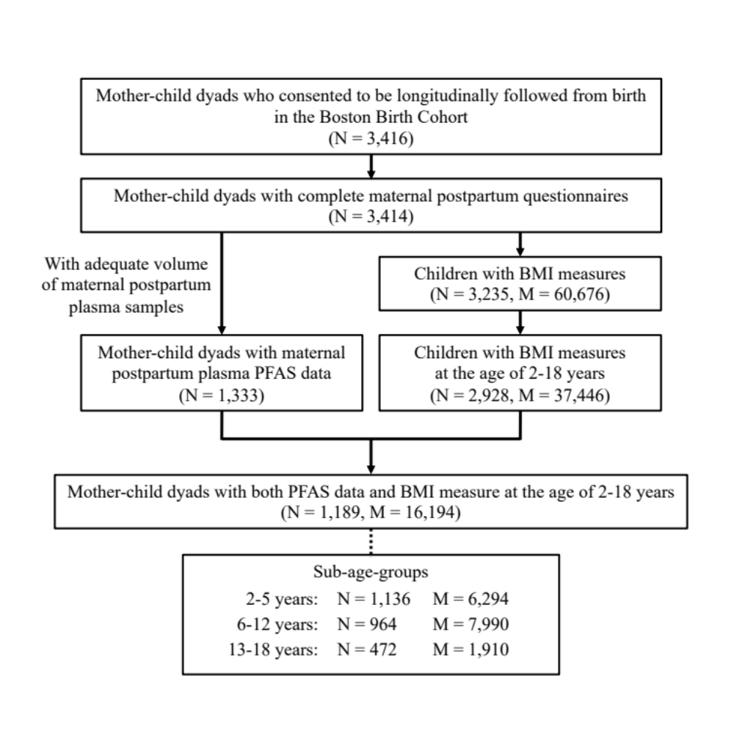

Note: Abbreviations: BMI – body mass index; PFAS – per- and polyfluoroalkyl substances; N – number of individuals/mother-child dyads; M = number of BMI measures. The number of individuals represents the number of children with at least one BMI measure within the corresponding age period; therefore, the same child may exist in multiple age groups.

Fig. S2. Directed Acyclic Graph (DAG) showing the covariates included in the models of this study between maternal post-partum plasma PFAS and child’s BMI or OWO.
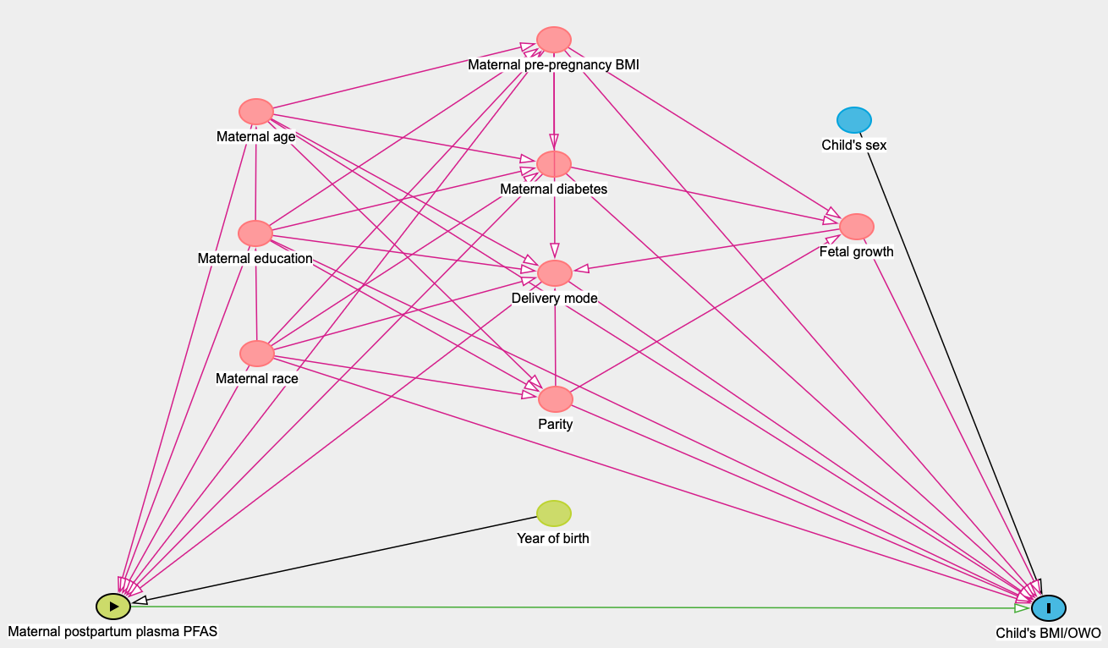

Abbreviations: PFAS – per- and polyfluoroalkyl substances; BMI – body mass index; OWO – overweight or obesity.

Fig. S3. Spearman’s rank order correlation coefficients of maternal plasma PFAS concentrations among 1189 mother-child dyads in the Boston Birth Cohort.

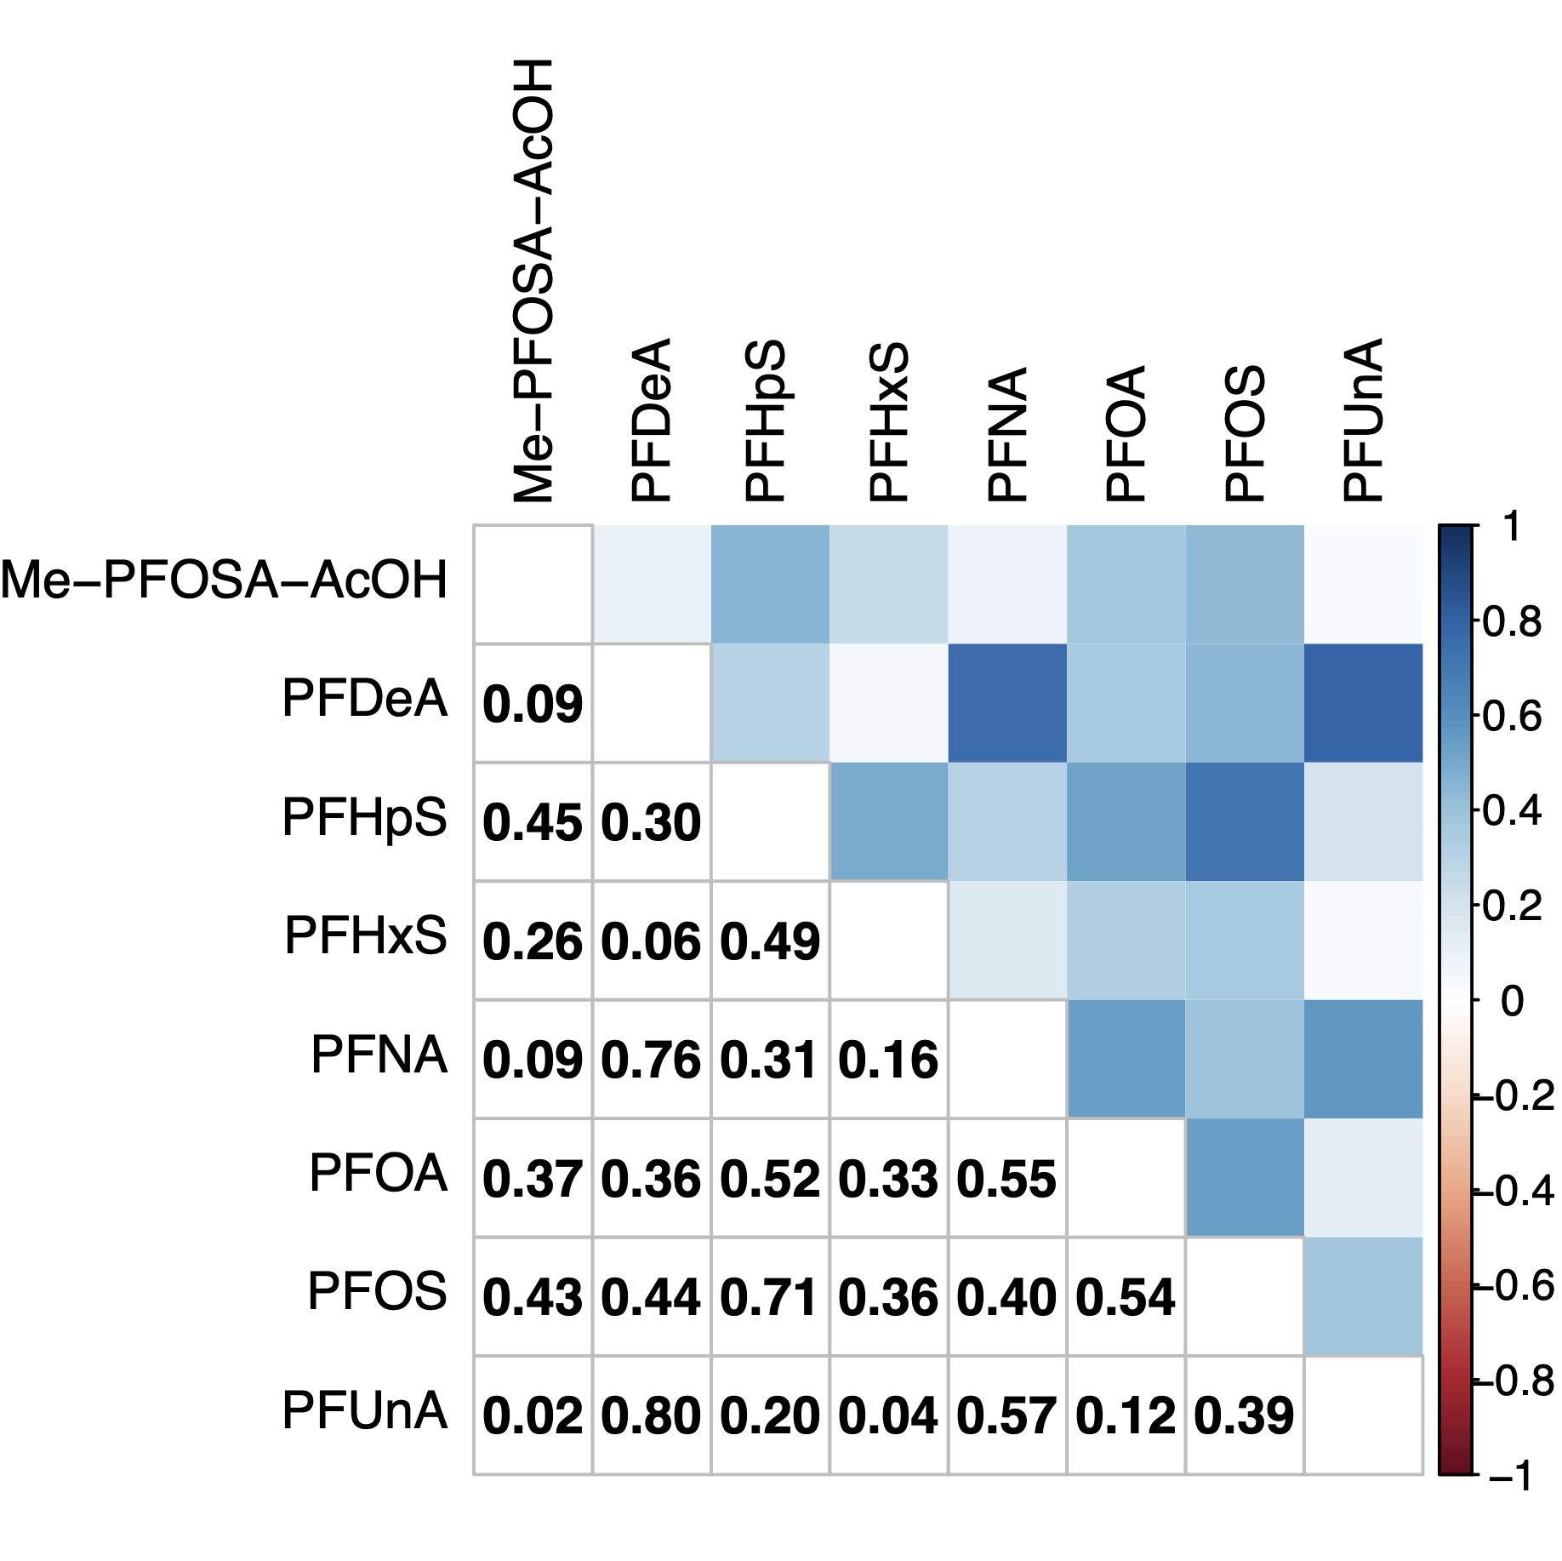

Abbreviations: PFAS – per- and polyfluoroalkyl substances; Me-PFOSA-AcOH – 2-(N-Methyl-perfluorooctane sulfonamido) acetic acid; PFDeA – perfluorodecanoic acid; PFHpS – perfluoroheptanesulfonic acid; PFHxS – perfluorohexanesulfonic acid; PFNA – perfluorononanoic acid; PFOA – perfluorooctanoic acid; PFOS – perfluorooctanesulfonic acid; PFUnA – perfluoroundecanoic acid.

Fig. S4. Predicted trajectories of child BMI from 2 to 18 years by quartiles of maternal plasma PFAS concentrations at delivery among 1,094 mother-child dyads in the Boston Birth Cohort.
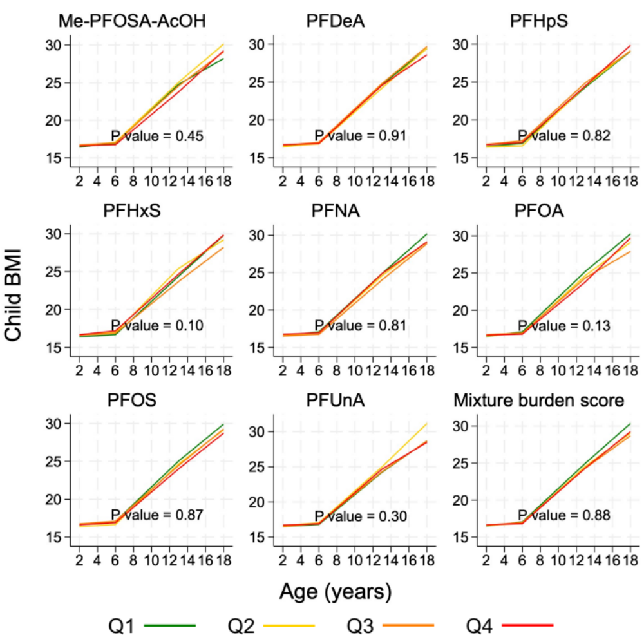

Note: The P value was from Wald tests examining the differences in BP trajectories by prenatal PFAS exposure quartiles by testing the null hypothesis that all interaction terms of PFAS tertiles with child age splines are equal to 0. Abbreviations: PFAS – per- and polyfluoroalkyl substances; BMI – body mass index; Q – quartile; Me-PFOSA-AcOH – 2-(N-Methyl-perfluorooctane sulfonamido) acetic acid; PFDeA – perfluorodecanoic acid; PFHpS – perfluoroheptanesulfonic acid; PFHxS – perfluorohexanesulfonic acid; PFNA – perfluorononanoic acid; PFOA – perfluorooctanoic acid; PFOS – perfluorooctanesulfonic acid; PFUnA – perfluoroundecanoic acid.

Fig. S5. Effect modification of maternal pre-pregnancy BMI on the relationship of maternal plasma PFAS with child BMI Z-score and child OWO status estimated by Bayesian kernel machine regression among 1189 mother-child dyads in the Boston Birth Cohort.

Child BMI  Z-score | 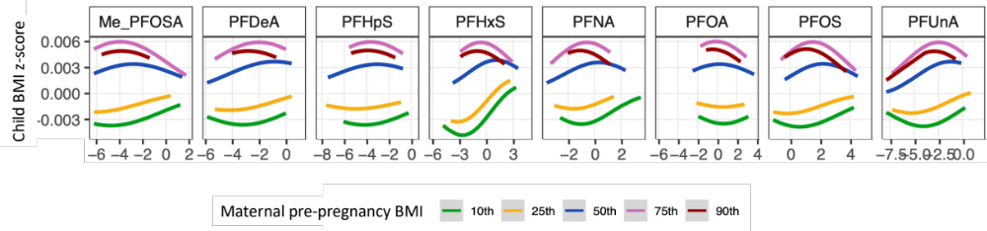
Child  OWO ^{d} | 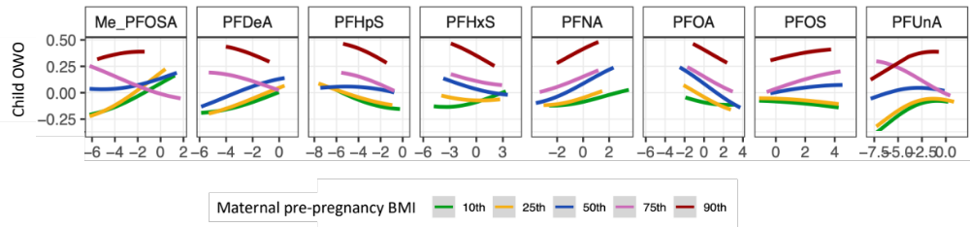

Note: The plots show the exposure-response relationship of a single exposure to PFAS with the outcome where the maternal pre-pregnancy BMI is fixed at various quantiles (from 10th to 90th). Models were adjusted for maternal age, education, race, diabetes, child’s sex, birthweight-for-gestational age (ie. AGA, SGA, LGA), year of birth, delivery mode, and parity. Abbreviations: PFAS – per- and polyfluoroalkyl substances; BMI – body mass index; OWO – overweight or obesity; Me-PFOSA-AcOH – 2-(N-Methyl-perfluorooctane sulfonamido) acetic acid; PFDeA – perfluorodecanoic acid; PFHpS – perfluoroheptanesulfonic acid; PFHxS – perfluorohexanesulfonic acid; PFNA – perfluorononanoic acid; PFOA – perfluorooctanoic acid; PFOS – perfluorooctanesulfonic acid; PFUnA – perfluoroundecanoic acid.

Fig. S6. Smooth plots of relationship between log2-transformed maternal plasma PFAS and child BMI Z-score and box plots of relationship between log2-transformed maternal plasma PFAS and child OWO status at the age of 2-18 years among 1189 mother-child dyads in the Boston Birth Cohort.
PFAS | Child BMI Z-score | Child OWO status
Me-PFOSA-AcOH | 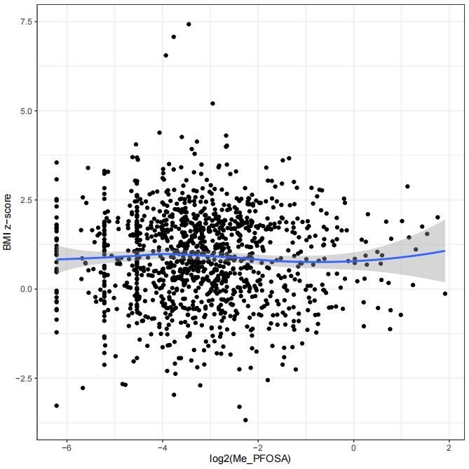 | 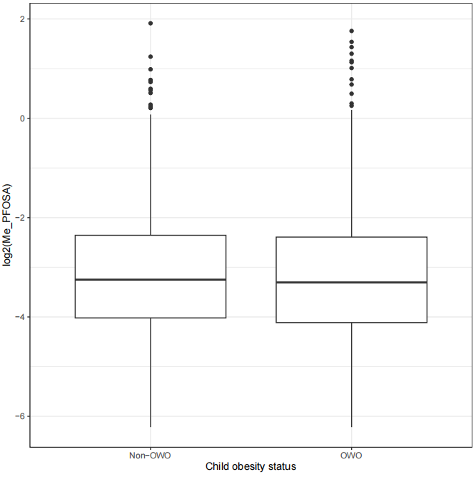
PFDeA | 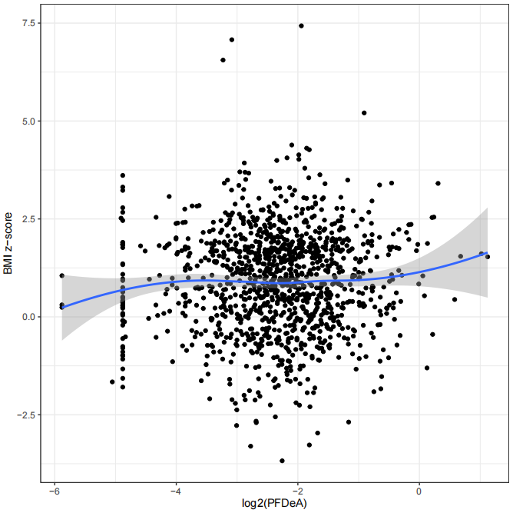 | 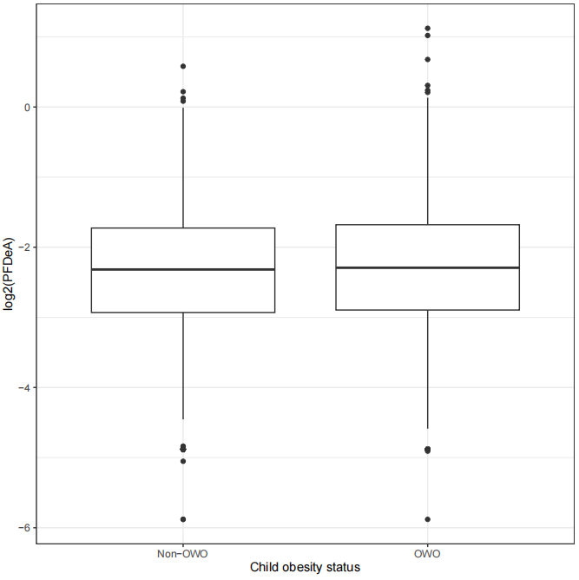
PFHpS | 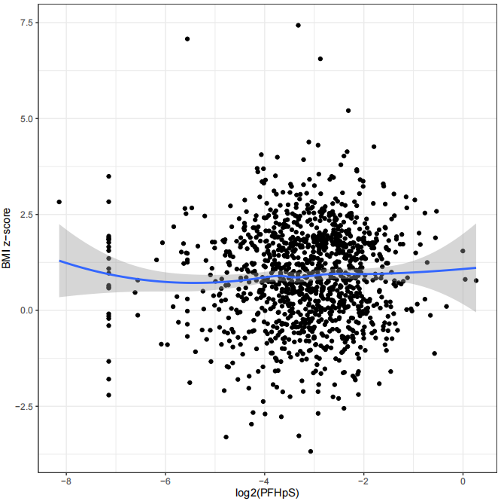 | 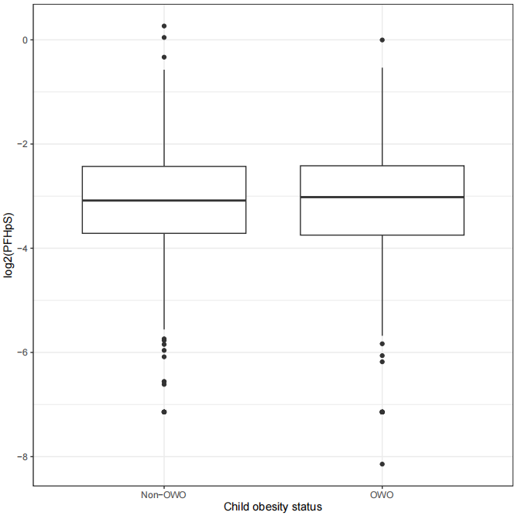
PFHxS | 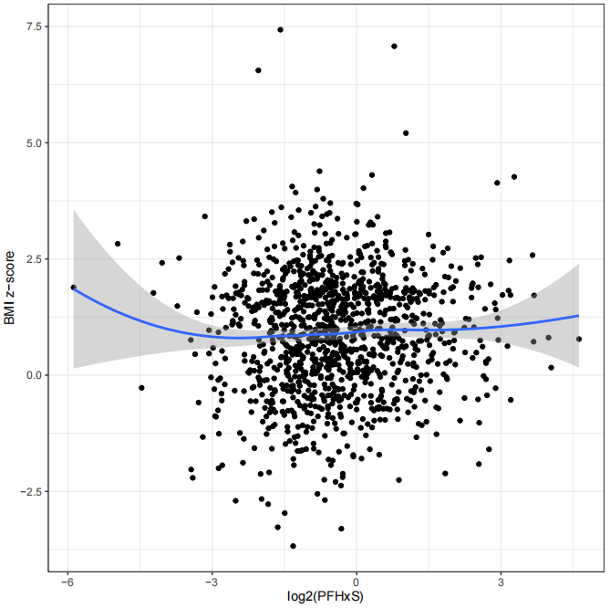 | 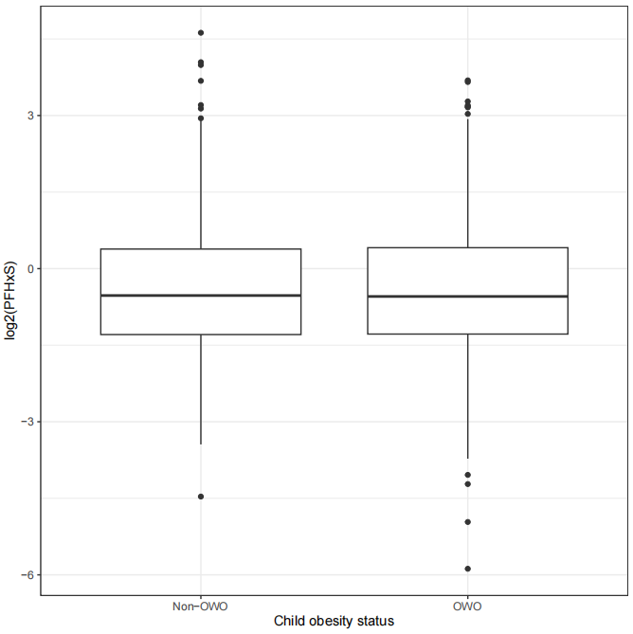
PFNA | 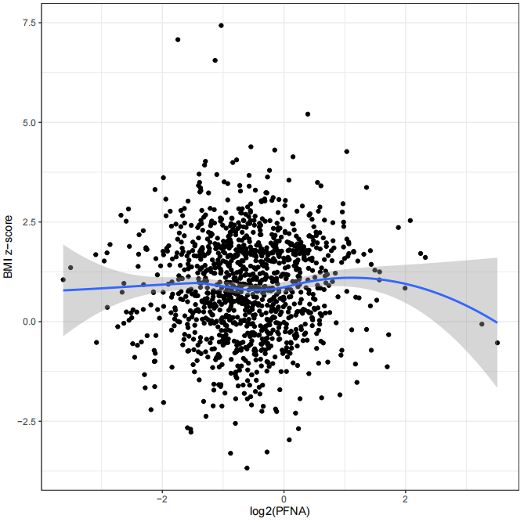 | 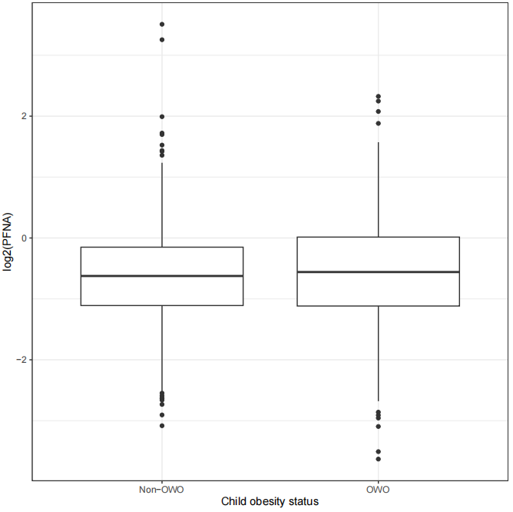
PFOA | 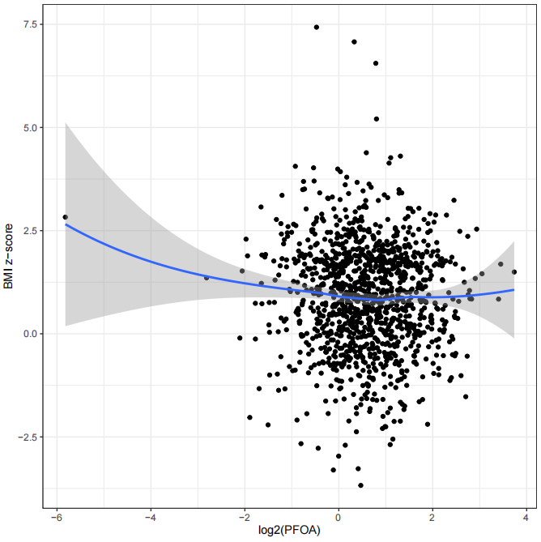 | 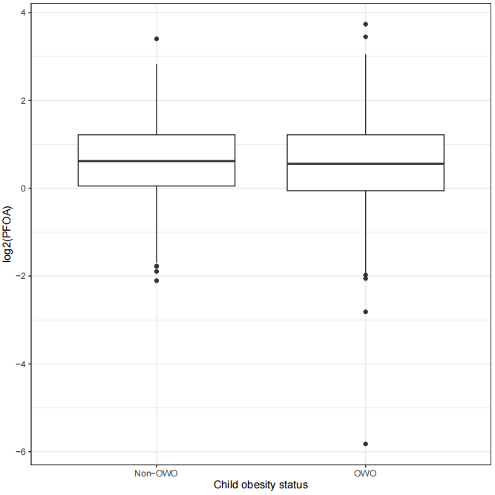
PFOS | 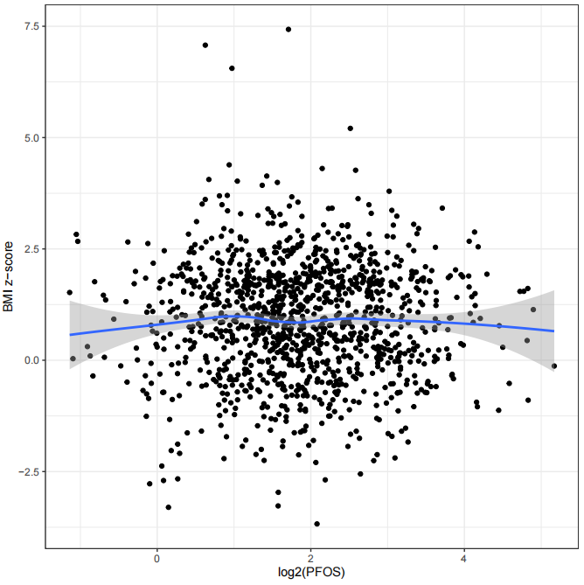 | 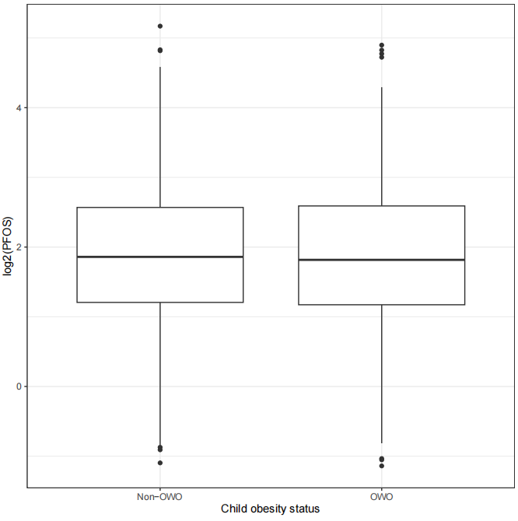
PFUnA | 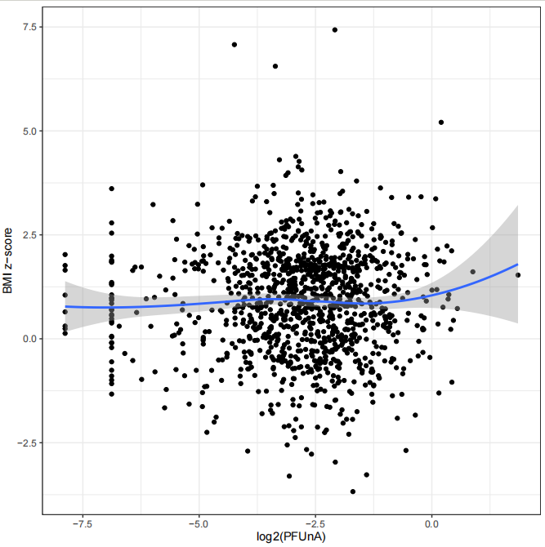 | 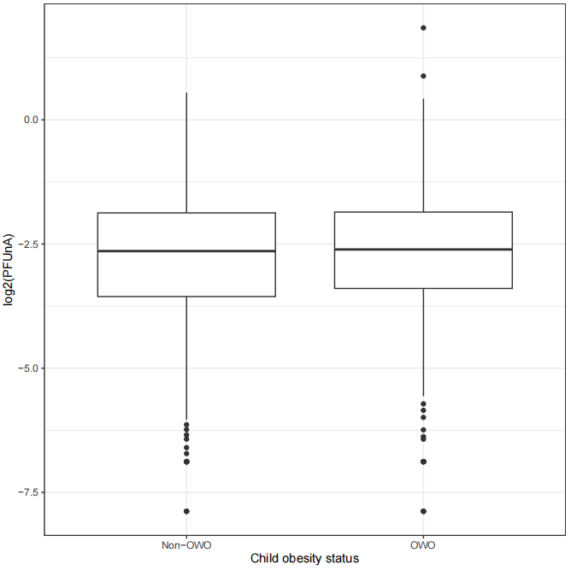

Abbreviations: PFAS – per- and polyfluoroalkyl substances; BMI – body mass index; OWO – overweight or obesity; Me-PFOSA-AcOH – 2-(N-Methyl-perfluorooctane sulfonamido) acetic acid; PFDeA – perfluorodecanoic acid; PFHpS – perfluoroheptanesulfonic acid; PFHxS – perfluorohexanesulfonic acid; PFNA – perfluorononanoic acid; PFOA – perfluorooctanoic acid; PFOS – perfluorooctanesulfonic acid; PFUnA – perfluoroundecanoic acid.

Fig. S7. Density plots of log2-transformed PFAS concentrations in maternal plasma stratified by maternal pre-pregnancy OWO.
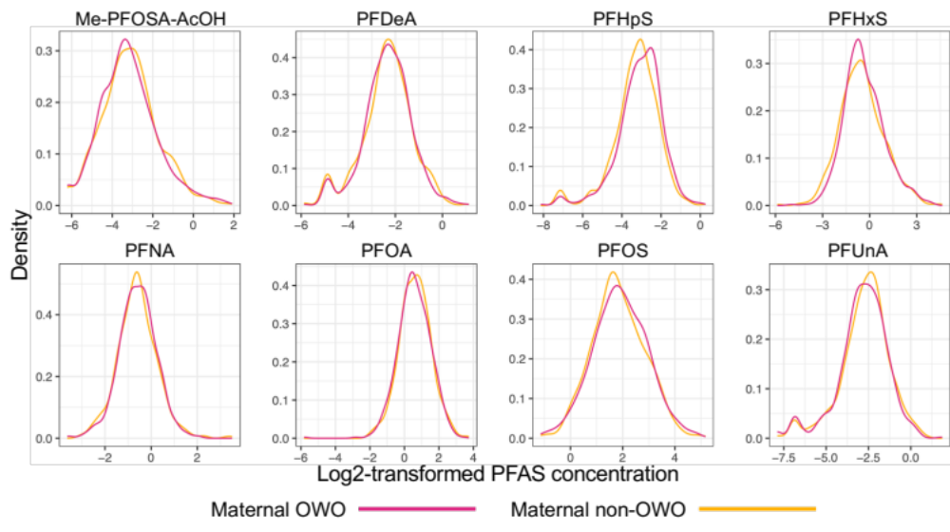
Abbreviations: PFAS – per- and polyfluoroalkyl substances; OWO – overweight or obesity; Me-PFOSA-AcOH – 2-(N-Methyl-perfluorooctane sulfonamido) acetic acid; PFDeA – perfluorodecanoic acid; PFHpS – perfluoroheptanesulfonic acid; PFHxS – perfluorohexanesulfonic acid; PFNA – perfluorononanoic acid; PFOA – perfluorooctanoic acid; PFOS – perfluorooctanesulfonic acid; PFUnA – perfluoroundecanoic acid.

