APPENDIX

Supplementary figures
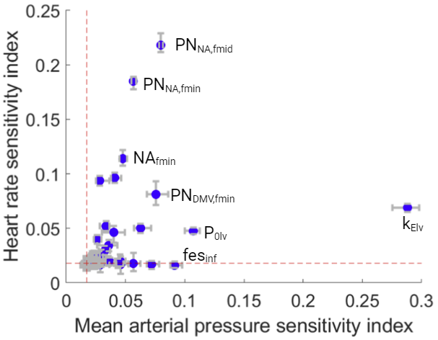
Fig. S1. Twenty eight of 51 parameters representing baroreflex and left ventricular function had significant effects on heart rate and/or MAP. A PAWN global sensitivity analysis was used to quantify which parameters have a significant effect on hemodynamics. Heart rate was measured as the average over a 15 s period and MAP was measured as the average of a 30 s period. Sensitivity indices range between 0 and 1, with 0 indicating that the model parameter has no impact on the output, and 1 indicating that the parameter of interest has a major influence on the output. Parameters with a sensitivity index greater than the red line are significant based on the use of a dummy parameter known to have no influence on the output. Parameters were varied over a ±2 fold range from the nominal value and six conditioning intervals were used. Each error bar represents the 95% confidence interval of the sensitivity index based on bootstrapping tests that involved 40,000 iterations of a random sampling of the simulated output. PN_{NA,fmid}, midpoint firing rate for principal neurons that receive inputs from the nucleus ambiguus (PN_{NA}); PN_{NA,fmin}, minimum firing rate of PNNA; NA_{fmin}, minimum firing rate of nucleus ambiguus neurons; PN_{DMV,fmin}, minimum firing rate of principal neurons that receive inputs from the dorsal motor nucleus of the vagus; P_{0lv}, left ventricular pressure at diastole; k_{Elv}, gain for volume effects on pressure changes in left ventricle; fes_{inf}, constant describing sympathetic efferent tone.

