Exploratory analysis of gait mechanics in farmers

Mariana V. Jacobsª, Kate N. Jochimsen^{b,c}, Jody L. Claseyª, and Michael A. Samaanª

Affiliations:
ªDepartment of Kinesiology & Health Promotion, University of Kentucky, Lexington, KY, USA] ^{b}Center for Health Outcomes and Interdisciplinary Research (CHOIR), Massachusetts General Hospital, Boston, MA, USA
^{c}Department of Psychiatry, Harvard Medical School, Boston, MA, USA

Correspondence should be addressed to:
Michael A. Samaan
michael.samaan@uky.edu
Phone: 859-257-2706
Fax: 859-232-1090

Keywords: Agricultural; Ergonomics; Kinematics, Osteoarthritis; Walking, Vertical ground reaction force
Word Count: 2,560

ABSTRACT
Farmers may be at a higher risk of developing hip osteoarthritis (OA) due to the high demands of their occupation. To the authors’ knowledge, the gait patterns of farmers that may be associated with hip joint degeneration have yet to be analyzed. Therefore, the purpose of this study was to compare gait mechanics between farmers and non-farmers (controls). It is hypothesized that farmers would exhibit altered lower extremity joint mechanics during walking when compared to matched controls. This exploratory study included 5 farmers and 5 sex-, age- and body mass index (BMI)-matched controls. A 3D gait analysis was performed while study participants walked at a self-selected speed on an instrumented treadmill. Sagittal plane hip, knee, and ankle kinetics and kinematics were assessed. Effect sizes and between-group differences in demographics and gait mechanics were assessed. There were no group differences in walking speed, total stance time as well as hip and knee joint kinematics (p>0.05). Farmers exhibited statistical trends (p = 0.07 – 0.08) of lower peak ankle plantarflexion angles, higher plantarflexor moments, higher knee flexion moment impulse, and higher peak vertical ground reaction force during the first and second halves of stance. Additionally, farmers ambulated with a significantly higher knee extensor moment (p=0.04) and moment impulse (p=0.05) during the first half of stance and a higher ankle plantarflexion moment impulse (p=0.04). The results demonstrate a multi-joint gait alteration in farmers compared to non-farmers and may suggest a compensatory gait pattern to optimize hip joint mechanics and mitigate hip joint degeneration. These results provide a preliminary understanding of the impact that agricultural occupations have on joint mechanics that may be associated with the increased prevalence of hip OA in the farming population.

INTRODUCTION
Farmers have a high risk of developing hip osteoarthritis (OA) due to the physical demands of their occupation. Nearly all farmers (87%) report joint pain while 22% have a prior diagnosis of OA (Webber et al. 2021). Farmers are at an approximately 9 times higher risk to develop hip OA compared to the general population (Croft et al. 1992). Farmers are at a 60% higher risk of developing severe hip OA within the first five years of their agricultural career (Croft et al. 1992; Andersen et al. 2012), which may be associated with the harsh terrains that farmers ambulate through on a daily basis (Services 2001). This increased risk is associated with a diminished work capacity (Webber et al. 2021) leading to a financial burden of approximately $167 million in lost productivity (Davis and Kotowski 2007). Although occupational tasks such as excessive standing and lifting heavy loads are associated with increased odds of developing symptomatic hip OA (Allen et al. 2010), there is little known about the potential biomechanical factors associated with hip joint degeneration in the farming population. This lack of information has led to ineffective non-operative treatments for both the clinical- (pain and dysfunction) and structural- (cartilage degeneration) symptoms associated with hip OA in the farming community.
Optimal joint loading during activity is essential in maintaining adequate articular cartilage health (Griffin and Guilak 2005) yet people with hip OA exhibit altered hip joint loading patterns during walking. More specifically, when compared to people without hip OA, people with hip OA exhibit lower peak hip extension angles as well as a higher peak hip extensor moments during walking and these altered sagittal plane hip joint mechanics are associated with hip joint cartilage degeneration and poor hip-related outcomes.(Kumar et al. 2015; Liao et al. 2019) These altered hip joint loading patterns may also be associated with the higher bone mineral density (BMD) within the femoral neck, which leads to a 57% higher risk of developing hip OA (Bergink et al. 2019). This multi-factorial pathomechanism of altered hip joint mechanics and impaired bone health observed in the non-agricultural population, may be similar to the pathomechanism of hip OA in the agricultural population, who’s job demands increase the exposure to this abnormal joint loading. However, the gait mechanics in farmers with hip OA has yet to be investigated.
Current non-operative treatments for hip OA used in the non-agricultural population include exercise (Zhang et al. 2008; Bannuru et al. 2019; Kolasinski et al. 2020) yet these exercise-based guidelines are based on clinical opinion (Kolasinski et al. 2020) and may not be generalizable to the farming population. Understanding the biomechanical etiology of hip OA in farmers will lead to the development of effective treatment programs for hip OA in the farming population. More specifically, an assessment of the gait-related deficits that may lead to hip OA in farmers is warranted and will provide the biomechanical targets needed to develop effective multi-disciplinary, exercise and movement re-training programs for treatment of hip-related clinical- and structural-disease within the farming community. Therefore, the purpose of this exploratory study was to assess gait mechanics in farmers compared to matched asymptomatic, non-farming individuals. It was hypothesized that farmers would exhibit altered lower extremity joint mechanics during walking when compared to the control group.

METHODS
Participants
This exploratory study included 5 farmers (4 crop farmers, 1 cattle farmer) recruited from the local community and 5 sex-, age- and body mass index (BMI)-matched asymptomatic controls (non-farmers) from an ongoing study in the authors’ laboratory. Control data were obtained from a previously established database. The inclusionary criteria for this study were: 1) no prior lower extremity surgery, 2) no lower extremity injury in the past 6 weeks, 3) no neurological conditions that may affect gait patterns, 4) BMI < 35 kg·m⁻² for data validity and 5) able to ambulate without an assistive device. It should be noted that prior history of lower extremity pain in the farmer group was not considered an exclusionary criterion for this study. All healthy controls self-reported no lower extremity pain. The test limb was defined as the most painful limb during self-reported pain questionnaires for the farmers and the dominant limb for the healthy controls. This study was approved by the University’s Institutional Review Board and written informed consent was obtained from each participant prior to testing.
Gait Analysis
Gait analysis was performed utilizing a previously established methodology (Ball et al. 2024). Three-dimensional marker position and ground reaction force (GRF) data were collected using a 13-camera motion capture system (Motion Analysis Corp., Santa Rosa, CA) and an instrumented treadmill (Bertec, Columbus, OH) at 200Hz and 2000Hz, respectively. Standardized footwear (New Balance; MZANTPC4) were worn by all participants to limit footwear effects on gait mechanics. A modified Cleveland Clinic marker set consisting of 46 retroreflective markers was used to record 3D segment positions. Markers placed on the sternal notch, C7 vertebrae, and the acromion processes were used to track the torso. Markers placed bilaterally on the iliac crests as well as the anterior and posterior superior iliac spines were used to track the pelvis. Calibration markers were placed bilaterally on the medial and lateral femoral epicondyles, malleoli, and the first metatarsal heads. Rigid body clusters, consisting of 4 markers each, were placed bilaterally on the lateral thighs and shanks to track position of these segments. The feet were tracked using markers placed on the superior and inferior heel shoe counter, lateral heel, second and fifth metatarsal heads. After a one-second static calibration trial was obtained, the calibration markers were removed. Participants were instructed to look straight ahead and walk at a self-selected, comfortable speed while maintaining one foot on each of the treadmill belts. In order to ensure comfort with walking on the treadmill at the chosen speed, a 2-minute acclimation period was provided for each participant. After the acclimation period, a 20-second capture of the walking task was collected.
Data Analysis
All raw marker position and GRF data were filtered using a fourth order, Butterworth filter with cut-off frequencies of 8Hz and 35Hz, respectively. Visual3D software (v2023.01.2, C-Motion, Germantown, MD) was used to build an 8-segment musculoskeletal model, consisting of a torso, pelvis and bilateral thighs, shanks, and feet, using each participant’s static calibration trial. Joint coordinates and segment positions were defined using a local coordinate system (Spoor and Veldpaus 1980). Medial-lateral, anterior-posterior, and superior-inferior directions were defined by using the Cardan sequence of X-Y’-Z”, respectively.
All parameters were assessed during the stance phase of gait, which was defined as initial contact to toe-off and was time normalized to 101 points (100% stance). Initial contact was defined as the time-point at which the vGRF exceeded 20 Newtons. A custom MATLAB (The MathWorks, Natick, MA) algorithm was created to extract peak hip, knee, and ankle joint sagittal plane kinematics and internal joint moments (Nm·kg⁻¹) as well as to calculate joint moment impulses (Nm·ms·kg⁻¹). These biomechanical characteristics were calculated across 5 successful trials for each participant and the corresponding subject averages for the biomechanical parameters were used for statistical analysis. A successful trial was defined as a clean foot strike on the appropriate force belt of the treadmill. The range of motion (ROM) for the hip and ankle joints as well as the knee joint excursion, defined as the knee joint displacement from initial contact to peak knee flexion during loading response, were calculated. Hip ROM was defined as the difference between peak hip flexion and extension while the ankle ROM was defined as the difference between peak ankle dorsiflexion and plantarflexion. The peak vertical ground reaction forces (vGRF); during the first and second half of stance were extracted and normalized to bodyweight (BW). In addition, the vGRF loading rate was calculated and was defined as the change in vGRF from 20 – 80% of the first peak vGRF (BW·ms⁻¹). For this study, hip flexion, knee extension, and ankle dorsiflexion angles and moments were defined as positive.
Statistical Analysis
Between-group differences in demographics were compared using an independent t-test or chi-square test. A Shapiro Wilk test was used to determine if gait-related data were normally distributed within each group and distribution of the data was also verified by visual inspection of the histograms. An independent t-test or Mann-Whitney U-test was used to determine between-group differences in gait mechanics as needed (SPSS v28.0, IBM Corp, Armonk, NY). The Levene’s test for equality of variances was also performed prior to independent t-tests in order to determine variance between the 2 groups. The corresponding equal variance or unequal variance-based output from the independent t-test was used for statistical analysis. Effect size was calculated for each dependent variable using Cohen’s d values (Cohen 1988) whereby a value of 0 – 0.2, 0.21 – 0.5 and > 0.5 were classified as small, medium, and large effect sizes, respectively. Calculation of effect sizes was included in this exploratory study to provide an understanding of the impact of farming on lower extremity gait mechanics. A p-value ≤ 0.05 was considered statistically significant.
RESULTS
There were no between group differences in demographics, walking speed or total stance time (p>0.05; Table 1). Hip and knee joint kinematics were similar between the farmers and the controls (p>0.05; Figure 1) yet farmers exhibited statistical trends of lower peak ankle plantarflexion angles (p=0.08, d=1.28). Despite similar hip joint moments, the farmers ambulated with a significantly higher knee extensor moment (p=0.04, d=1.52) and moment impulse (p=0.05, d=1.66) during the first half of stance as well as statistical trends (p=0.08, d=1.46) of higher knee flexion moment impulse during the second half of stance (Figure 2). Farmers also walked with statistical trends of a higher ankle plantarflexor moment (p=0.08, d=1.48) and a significantly higher ankle plantarflexion moment impulse (p=0.04, d=1.56) when compared to the control group (Table 2). Farmers exhibited statistical trends of higher peak vGRF during the first (p=0.07, d=1.56) and second (p=0.07, d=1.53) halves of stance yet similar vGRF loading rates (p=0.15) as the control group (Figure 3).
DISCUSSION
This exploratory study assessed lower extremity gait mechanics in farmers to develop a preliminary understanding of the potential biomechanical factors related to hip joint OA in the agricultural community. The results of this study demonstrate a multi-joint gait alteration in farmers compared to non-farmers and may suggest a compensatory gait pattern to optimize hip joint mechanics in these farmers. More specifically, these results may suggest that farmers ambulate with altered knee and ankle joint mechanics in order to potentially absorb the large vGRF that are transferred through the lower extremity in a more optimal manner.
The farmers ambulated with higher peak vGRF during the first and second half of stance, suggesting that the farmers tended to apply a larger amount of force to the ground while walking. Although there were no differences in hip or knee kinematics, these higher vGRF may require a larger amount of absorption by the foot/ankle complex and may lead to the more dorsiflexed (i.e. less plantarflexed) ankle joint exhibited by the farmers during loading response. The more dorsiflexed ankle joint may require a proximal joint compensation to help support the lower extremity during the early stance phase. This study results indicate that the farmers ambulate with a higher knee extensor moment and moment impulse. This suggests farmers require a larger demand on the quadriceps to support the lower extremity.
Similar to the first half of stance, the farmers ambulated with a higher peak vGRF compared to the control group. In order to potentially provide for a more optimal strategy to absorb the higher vGRF through the lower extremity, the farmers ambulated with a higher knee flexor moment impulse compared to the control group in order to utilize the knee flexor musculature to help absorb the larger vGRF. These altered knee joint mechanics may have placed a larger demand on the ankle plantarflexors during terminal stance. More specifically, the farmers ambulated with a higher ankle plantarflexion moment and moment impulse during the second half of the stance phase, which may have potentially assisted farmers with push off of the lower extremity during terminal stance. In addition, prior work in the femoroacetabular impingement syndrome (FAIS) population, a pre-arthritic hip disease, demonstrated that individuals with FAIS ambulate with higher ankle plantarflexion moments and moment impulses compared to healthy individuals (Samaan et al. 2017). The farmers in this study demonstrated similar ankle joint mechanics during terminal stance as individuals with FAIS and may suggest that altered ankle joint mechanics in farmers may be a biomechanical marker associated with pre-arthritic hip joint disease.
LIMITATIONS
This study is not without limitations and therefore, the results should be interpreted with caution. The main limitation of this study is the small sample size, yet the intention in this exploratory study was to provide an assessment of gait mechanics in farmers compared to a non-farming population. Although the small sample size is a limitation, the effect sizes of these results were large and suggests practical significance of the findings. The cross-sectional design of this study does not allow the determinization of whether or not these altered gait mechanics in farmers are a causative or compensatory mechanism of hip joint degeneration or hip pain in the farming population. Additionally, the design of this study has farmers walking on a flat treadmill despite previous work showing that there are other occupational specific tasks such as excessive standing and lifting heavy loads (Allen et al. 2010) that may be associated with development of lower extremity joint pain. Farmers also tend to wear work boots while performing their daily agricultural tasks, which may help to explain the large vGRF observed in this farmer cohort. This study’s experimental protocol required these farmers to ambulate with standardized athletic shoes, which may be considered a limitation of this study. It is also important to mention that despite the relatively large effect sizes for the statistically significant results, this study may be underpowered and therefore, future studies should include a larger cohort of farmers. The study results should be interpreted with caution as four crop farmers and one cattle farmer were included, and due to the small sample size, the authors are unable to directly understand occupation specific factors related to altered gait patterns. Although the overall intent of this paper was to assess gait mechanics in farmers, the cohort of farmers all self-reported lower extremity pain prior to the study, yet it should be noted that pain was not an inclusionary criterion for this study. Despite these limitations, the study provides a preliminary understanding of the impact that agricultural occupations have on joint mechanics that may be associated with the increased prevalence of hip OA in the agricultural population.
CONCLUSION
This study provides an initial assessment of lower extremity joint mechanics during walking in farmers. The farmer cohort in this study ambulated with altered lower extremity joint mechanics compared to an asymptomatic, non-farming population. As farmers are at an elevated risk of developing hip osteoarthritis, larger scale studies should be conducted to obtain a more conclusive understanding of the potential impact of altered gait mechanics on hip joint health in agricultural populations. In addition, future work should utilize a larger and more diverse sample of farmers in order to perform sub-group analyses to quantify gait patterns between different farming occupational groups. Further biomechanics-related research in farmers can provide the data needed to develop a multidisciplinary-based exercise program for conservative treatment of hip OA in the farming community.

ACKNOWLEDGEMENTS
This study was supported by the University of Kentucky Pediatric Exercise Physiology Lab, NIH K01-AG073698, NIH K23-AT011922, and NIOSH U54-OH007547. The results of this study do not reflect the opinions of the NIH or NIOSH.

REFERENCES
Allen KD, Chen J-C, Callahan LF, Golightly YM, Helmick CG, Renner JB, Jordan JM. 2010. Associations of Occupational Tasks with Knee and Hip Osteoarthritis: The Johnston County Osteoarthritis Project. The Journal of Rheumatology. 37(4):842-850.
Andersen S, Thygesen LC, Davidsen M, Helweg-Larsen K. 2012. Cumulative years in occupation and the risk of hip or knee osteoarthritis in men and women: a register-based follow-up study. Occup Environ Med. 69(5):325-330.
Ball LN, Jacobs MV, McLouth CJ, Clasey J, Francomano C, Sheppard MB, Samaan MA. 2024. Assessment of gait mechanics and muscle strength in hypermobile Ehlers Danlos Syndrome. Clin Biomech (Bristol, Avon). 113:106210. eng.
Bannuru RR, Osani MC, Vaysbrot EE, Arden NK, Bennell K, Bierma-Zeinstra SMA, Kraus VB, Lohmander LS, Abbott JH, Bhandari M et al. 2019. OARSI guidelines for the non-surgical management of knee, hip, and polyarticular osteoarthritis. Osteoarthritis Cartilage. 27(11):1578-1589.
Bergink AP, Rivadeneira F, Bierma-Zeinstra SM, Zillikens MC, Ikram MA, Uitterlinden AG, van Meurs JBJ. 2019. Are Bone Mineral Density and Fractures Related to the Incidence and Progression of Radiographic Osteoarthritis of the Knee, Hip, and Hand in Elderly Men and Women? The Rotterdam Study. Arthritis Rheumatol. 71(3):361-369.
Cohen J. 1988. Statistical Power Analysis for the Behavioral Sciences. Second ed. Hillsdale, NJ: Lawrence Erlbaum Associates, Publishers.
Croft P, Coggon D, Cruddas M, Cooper C. 1992. Osteoarthritis of the hip: an occupational disease in farmers. BMJ. 304(6837):1269-1272.
Croft P, Cooper C, Wickham C, Coggon D. 1992. Osteoarthritis of the hip and occupational activity. Scand J Work Environ Health. 18(1):59-63.
Davis KG, Kotowski SE. 2007. Understanding the ergonomic risk for musculoskeletal disorders in the United States agricultural sector. Am J Ind Med. 50(7):501-511.
Griffin TM, Guilak F. 2005. The role of mechanical loading in the onset and progression of osteoarthritis. Exerc Sport Sci Rev. 33(4):195-200.
Kolasinski SL, Neogi T, Hochberg MC, Oatis C, Guyatt G, Block J, Callahan L, Copenhaver C, Dodge C, Felson D et al. 2020. 2019 American College of Rheumatology/Arthritis Foundation Guideline for the Management of Osteoarthritis of the Hand, Hip, and Knee. Arthritis Rheumatol. 72(2):220-233.
Kumar D, Wyatt C, Chiba K, Lee S, Nardo L, Link TM, Majumdar S, Souza RB. 2015. Anatomic correlates of reduced hip extension during walking in individuals with mild-moderate radiographic hip osteoarthritis. J Orthop Res. 33(4):527-534.
Liao TC, Samaan MA, Popovic T, Neumann J, Zhang AL, Link TM, Majumdar S, Souza RB. 2019. Abnormal Joint Loading During Gait in Persons With Hip Osteoarthritis Is Associated With Symptoms and Cartilage Lesions. J Orthop Sports Phys Ther. 49(12):917-924.

Samaan MA, Schwaiger BJ, Gallo MC, Sada K, Link TM, Zhang AL, Majumdar S, Souza RB. 2017. Joint Loading in the Sagittal Plane During Gait Is Associated With Hip Joint Abnormalities in Patients With Femoroacetabular Impingement. Am J Sports Med. 45(4):810-818.
Services USDoHaH. 2001. Baron SE, C; Steege, A; and Lalich, N., editor. Simple Solutions: Ergonomics for Farm Workers. National Institute for Occupational Safety and Health.
Spoor CW, Veldpaus FE. 1980. Rigid body motion calculated from spatial co-ordinates of markers. J Biomech. 13(4):391-393.
Webber EJ, Tran T, June R, Healy E, Andrews TM, Younkin R, MacDonald J, Adams ES. 2021. WOMAC score and arthritis diagnosis predict decreased agricultural productivity. BMC Musculoskelet Disord. 22(1):181. eng.
Zhang W, Moskowitz RW, Nuki G, Abramson S, Altman RD, Arden N, Bierma-Zeinstra S, Brandt KD, Croft P, Doherty M et al. 2008. OARSI recommendations for the management of hip and knee osteoarthritis, Part II: OARSI evidence-based, expert consensus guidelines. Osteoarthritis Cartilage. 16(2):137-162.

TABLES

Table 1. Group demographics and spatiotemporal parameters (mean ± standard deviations) for the farmer and healthy control groups.

Parameter | Farmer | Control | p-value
Age (yrs) | 53.4 ± 17.3 | 52.8 ± 12.7 | 0.95
Sex (males:females) | 3:2 | 3:2 | 1.00
BMI (kg·m⁻²) | 25.6 ± 3.46 | 27.6 ± 3.0 | 0.36
Walking Speed (m·s⁻¹) | 1.04 ± 0.29 | 0.82 ± 0.13 | 0.17
Total Stance Time (ms) | 798.60 ± 159.5 | 745.40 ± 54.5 | 0.51

Table 2. Lower extremity joint kinematics, internal moments and vertical ground reaction forces (vGRF), presented as mean ± standard deviation, for the farmer and healthy control groups.

Parameter |  | Farmer |  |  |  |  | Control |  | p-value |  |  |  |  | Cohen’s d
Kinematics (Degrees)
Peak Hip Flexion |  |  | 24.18 ± 6.96 |  |  | 19.94 ± 2.68 |  |  |  | 0.26 |  |  | -0.80
Peak Hip Extension |  |  | -8.06 ± 4.47 |  |  | -6.49 ± 1.38 |  |  |  | 0.49 |  |  | 0.47
Knee Flexion at Initial Contact |  |  | -1.45 ± 5.88 |  |  | -0.01 ± 5.34 |  |  |  | 0.70 |  |  | 0.26
Knee Flexion during Loading Response |  |  | -11.50 ± 5.15 |  |  | -8.36 ± 3.15 |  |  |  | 0.42 |  |  | 0.74
Peak Ankle Plantarflexion |  |  | -6.29 ± 2.44 |  |  | -9.40 ± 2.44 |  |  |  | 0.08 |  |  | -1.28
Peak Ankle Dorsiflexion |  |  | 9.39 ± 3.35 |  |  | 8.61 ± 4.62 |  |  |  | 0.77 |  |  | -0.19
Hip Range of Motion |  |  | 32.24 ± 8.04 |  |  | 26.43 ± 3.45 |  |  |  | 0.19 |  |  | -0.94
Knee Excursion |  |  | 42.02 ± 3.54 |  |  | 42.03 ± 5.07 |  |  |  | 0.99 |  |  | 0.00
Ankle Range of Motion |  |  | 20.55 ± 2.86 |  |  | 18.10 ± 3.27 |  |  |  | 0.25 |  |  | -0.80
Moments (Nm·kg⁻¹)
Peak Hip Extensor |  |  | -1.47 ± 0.98 |  |  | -0.71 ± 0.19 |  |  |  | 0.16 |  |  | 1.08
Peak Hip Flexor |  |  | 0.52 ± 0.18 |  |  | 0.32 ± 0.24 |  |  |  | 0.10 |  |  | -0.91
Knee Extensor (First Half of Stance) |  |  | 0.32 ± 0.14* |  |  | 0.09 ± 0.16 |  |  |  | 0.04 |  |  | -1.52
Knee Flexor (First Half of Stance) |  |  | -0.80 ± 0.52 |  |  | -0.37 ± 0.13 |  |  |  | 0.14 |  |  | 1.13
Knee Extensor (Second Half of Stance) |  |  | 0.14 ± 0.08 |  |  | 0.08 ± 0.04 |  |  |  | 0.18 |  |  | -0.93
Knee Flexor (Second Half of Stance) |  |  | -0.97 ± 0.60 |  |  | -0.47 ± 0.15 |  |  |  | 0.14 |  |  | 1.14
Peak Plantarflexor |  |  | -2.52 ± 1.10 |  |  | -1.36 ± 0.13 |  |  |  | 0.08 |  |  | 1.48
Peak Dorsiflexor |  |  | 0.19 ± 0.15 |  |  | 0.06 ± 0.04 |  |  |  | 0.12 |  |  | -1.20
Joint Moment Impulses (Nm·ms·kg⁻¹)
Hip Extensor |  |  | 181.20 ± 140.73 |  |  | 104.89 ± 39.88 |  |  |  | 0.28 |  |  | -0.74
Hip Flexor |  |  | 80.33 ± 41.81 |  |  | 55.06 ± 66.27 |  |  |  | 0.31 |  |  | -0.46
Knee Extensor (First Half of Stance) |  |  | 35.45 ± 22.98* |  |  | 6.50 ± 9.17 |  |  |  | 0.05 |  |  | -1.66
Knee Flexor (First Half of Stance) |  |  | 30.83 ± 24.08 |  |  | 8.93 ± 5.48 |  |  |  | 0.11 |  |  | -1.25
Knee Extensor (Second Half of Stance) |  |  | 6.10 ± 2.70 |  |  | 9.57 ± 14.84 |  |  |  | 0.55 |  |  | 0.33
Knee Flexor (Second Half of Stance) |  |  | 266.69 ± 165.69 |  |  | 91.02 ± 41.28 |  |  |  | 0.08 |  |  | -1.46
Plantarflexor |  |  | 884.59 ± 358.13* |  |  | 484.06 ± 65.11 |  |  |  | 0.04 |  |  | -1.56
Dorsiflexor |  |  | 11.97 ± 11.29 |  |  | 2.38 ± 2.62 |  |  |  | 0.13 |  |  | -1.17
vGRF
Peak vGRF during first half of stance (BW) |  |  | 1.65 ± 0.58 |  | 1.01 ± 0.01 |  |  |  |  |  | 0.07 | -1.56
Peak vGRF during second half of stance (BW) |  |  | 1.65 ± 0.60 |  | 1.00 ± 0.03 |  |  |  |  |  | 0.07 | -1.53
vGRF loading rate (BW·ms⁻¹) |  |  | 11.85 ± 6.40 |  | 6.73 ± 1.40 |  |  |  |  |  | 0.15 | -1.11
*Represents statistically significant differences between groups (p<0.05).
BW: bodyweight
vGRF: vertical ground reaction force

FIGURES

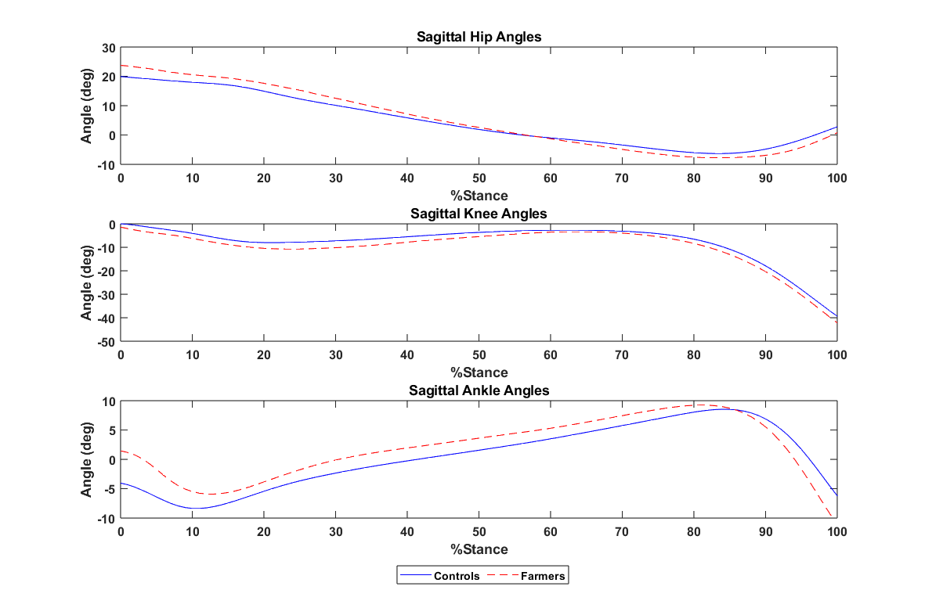

Figure 1. Hip, Knee, and Ankle Joint Kinematic Profiles for the Controls and Farmers during the stance phase (initial contact to toe-off). Positive values indicate hip flexion, knee extension and ankle dorsiflexion.

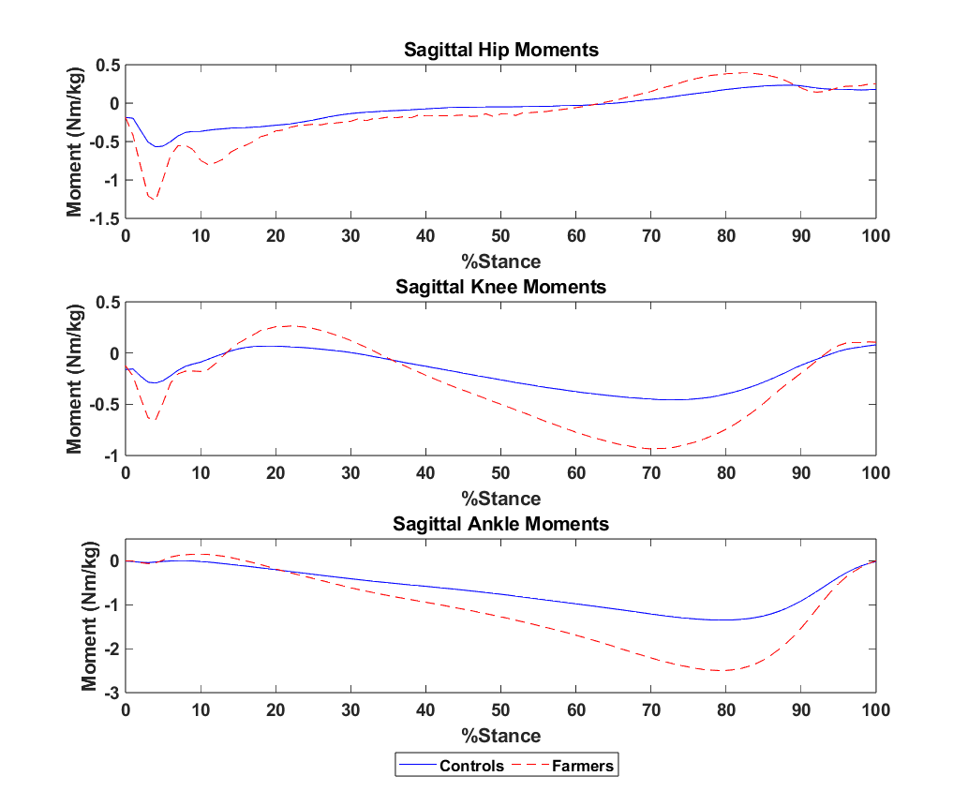

Figure 2. Hip, knee, and ankle joint moment profiles for the non-farmers (controls) and farmers during the stance phase (initial contact to toe-off). Positive values indicate hip flexion, knee extension and ankle dorsiflexion moments.

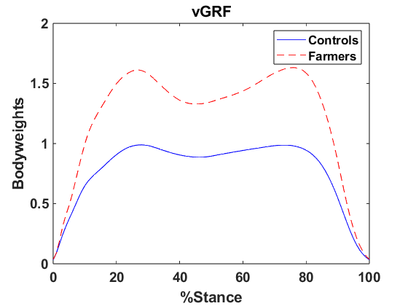

Figure 3. Vertical ground reaction force profiles for the non-farmers (controls) and farmers during the stance phase (foot strike to toe-off).

