Evaluation of Bayesian Maximum Entropy data fusion approaches to estimate styrene, benzene, toluene, ethylbenzene, and xylenes and to inform epidemiological analyses in the US Gulf States
(Supporting Information)
Nora A. Abbott†, Lucie Semone†, Richard Strott†, Praful Dodda†, Chi-Tsan Wang‡, Jaime Green†, Bok Haeng Baek‡, Lawrence S. Engel§, William Vizuete†, Marc L. Serre†*

†Department of Environmental Sciences & Engineering, University of North Carolina, Chapel Hill, NC, United States
‡Center for Spatial Information Science and Systems (CSISS), George Mason University, Fairfax, VA, United States
§Department of Epidemiology, University of North Carolina, Chapel Hill, NC, United States
* Corresponding Author

This supporting information contains 89 pages, 46 figures, and 16 tables.

S1. Observational Data Processing
Observational data had a recorded station identification (ID) code and was converted to units of parts per billion (ppb). Daily sample means were calculated as the arithmetic average of observations recorded at the same station ID with the same sample duration.
For each daily value calculated as the arithmetic average of sub-daily values, an incompleteness standard deviation σ_{i,t} (equation S1) was calculated to account for the uncertainty associated with missing sub-daily values.¹ In equation S1, n_{i,t} is the sample size (i.e., the number of sub-daily measurements recorded) at sampling location i and time t, z_{i,j} are the corresponding sub-daily measurement values, µ_{i,j} is their sample mean, and n_{i}* is the maximum possible number of sub-daily measurements in a day for a given sampling frequency (e.g. n_{i}*=24 for an hourly monitor since the maximum possible number of hourly values in a day is 24). The term under the left radical represents the sample mean variance of a sample of size n_{i,t}, while the term under the right radical is the incompleteness factor.
$σ_{i,t}=\sqrt{\frac{\frac{\sum_{j=1}^{n_{i,t}}{{\left(z_{i,j}-μ_{i,t}\right)}^{2}}}{n_{i,t}-1}}{n_{i,t}}}⋅\sqrt{\frac{n_{i}^{*}-n_{i,t}}{n_{i}^{*}}}$ (Equation (Eqn.) S1)
Daily values were assigned a federal method detection limit (MDL) based on the Air Quality System (AQS) method, and a corresponding measurement error variance equal to the squared measurement error standard deviation, SE², where SE=Federal MDL/3, hence the measurement error variance is set to (Federal MDL)²/9. The overall uncertainty associated with each measured value was then taken as the maximum variance between the incompleteness variance (the square of equation S1) and measurement error variance.
Some daily values were recorded by different instruments at the same monitoring station locations. For duplicate measurements, the sample means and variances were averaged using an inverse-(maximum) variance weighted average of the duplicate sample means and maximum variances. The de-duplicated sample mean and variance and the number of duplicate measurements processed were assigned the measurement characteristics (incompleteness variance, AQS method, and Program ID) of that with the lowest maximum variance.
To account for the ubiquitous nature of VOCs in the environment and the unlikelihood of true zero daily values,² measured-zero daily values were assigned mean and variance equal to the mean and variance of a Log Normal distribution, ~LN(µ, σ²), truncated above the federal log-MDL, where µ and σ² are estimates of the mean and variance of log concentrations. The reassignment of zero daily values reflects the knowledge that SBTEX observations are lognormally distributed, and the true value of measured-zero daily values are below the respective log-MDL. A natural logarithm transformation was then applied to the styrene, benzene, toluene, ethylbenzene, and xylenes (SBTEX) processed measurements to yield a more normal distribution, as shown in Figure S1.
To perform xylenes BME estimation, m/p- and o-xylene measurements were combined. Daily xylenes were only calculated for monitoring stations that recorded m/p- and o-xylene measurements on the same day. Observed value, maximum variance, number of duplicates, and Federal MDL were combined using the additive property, while incompleteness variance, AQS method, and Program ID were selected as the value from m/p- or o-xylenes with the higher maximum variance. After observational data pre-processing was complete, styrene, toluene, benzene, ethylbenzene, and xylenes were measured at 163, 182, 163, 163, and 151 monitoring stations, respectively, and 183 monitoring stations total.
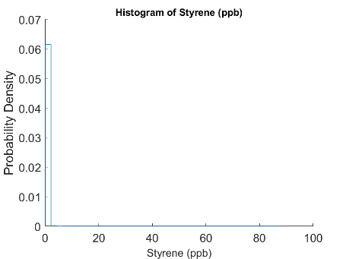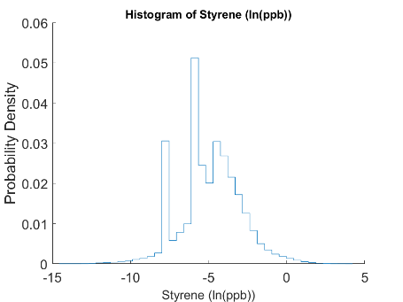
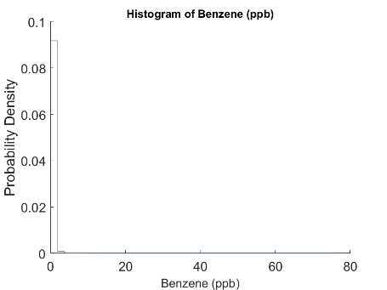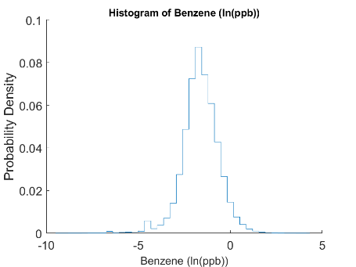
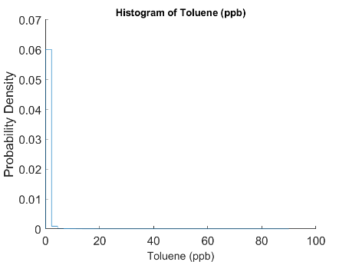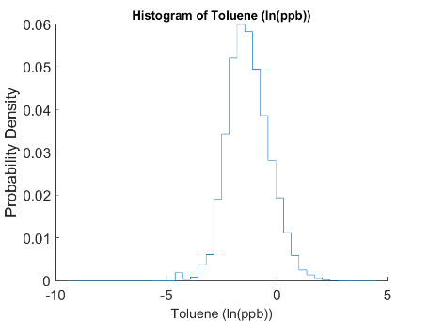
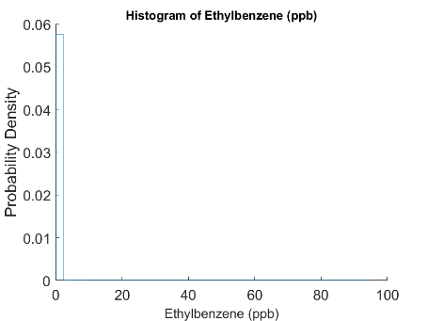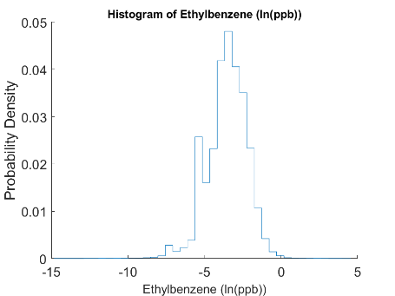
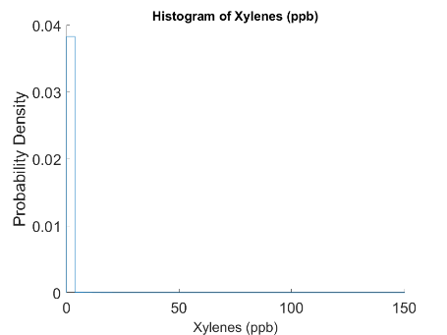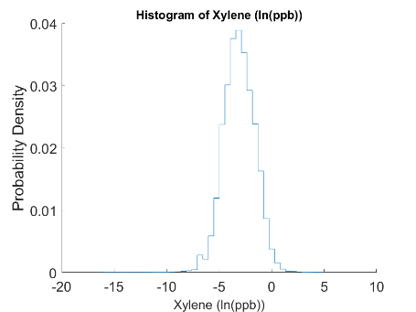
Figure S1. Density-scaled histograms of SBTEX measurements from 2006 to 2017. From top to bottom, row 1: styrene; row 2: benzene; row 3: toluene, row 4: ethylbenzene; row 5: xylenes. Left column: Concentrations; right column: log-concentrations.
S2. Observational Data Exploratory Analysis
Exploratory analyses demonstrated that, as expected, SBTEX monitoring stations were clustered across the Gulf States, with regulatory goals in mind,³ with most measurements occurring in TX (Figure S2). The highest SBTEX measurements, on average, were recorded in Western TX; FL; Birmingham, AL; and in major urban hubs along the Gulf Coast, like Houston, TX, and New Orleans, LA (Figure S2). Percentile and aerial mean time trends of SBTEX monitoring demonstrated decreasing concentrations between 2006 and 2017 (Figure S2).

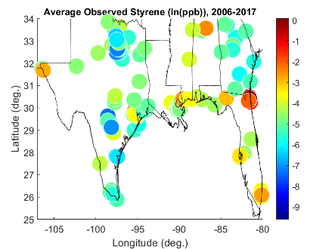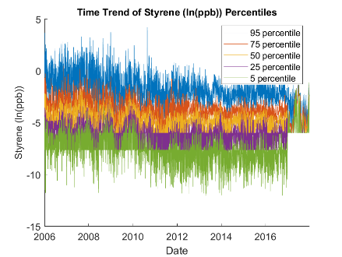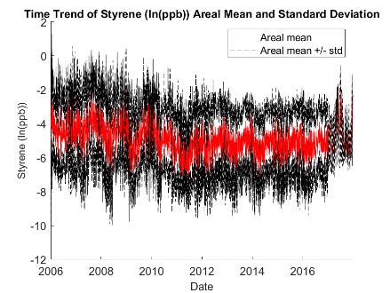
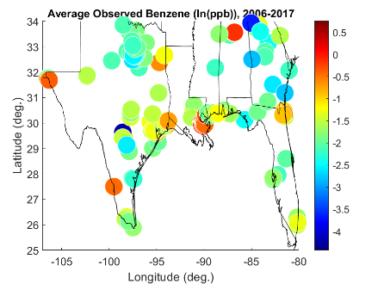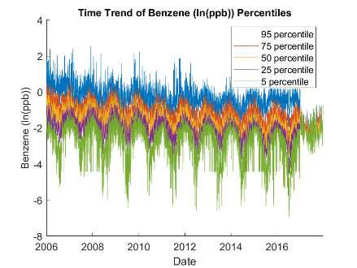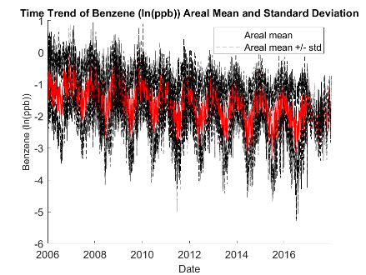
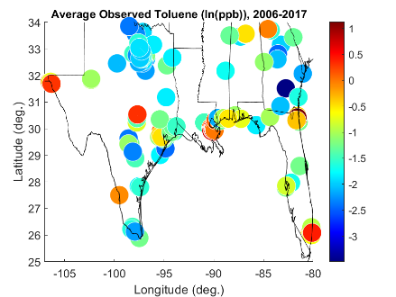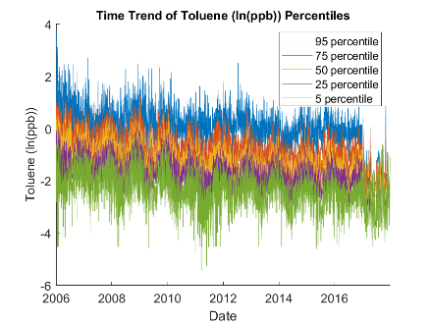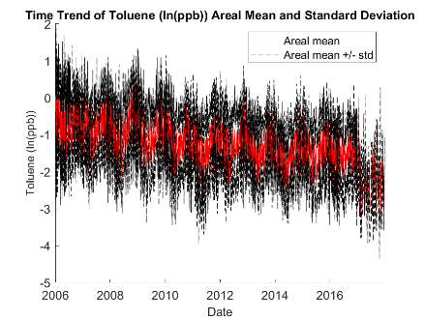
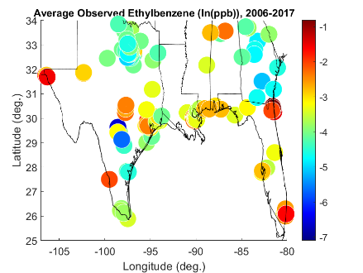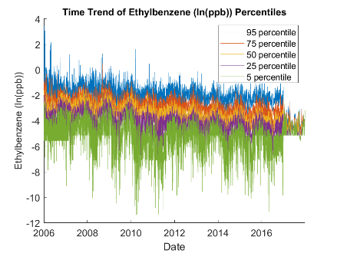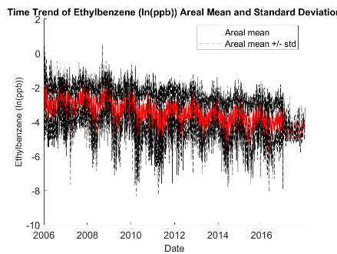
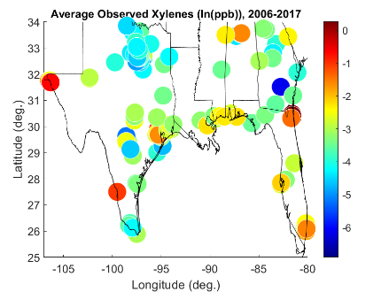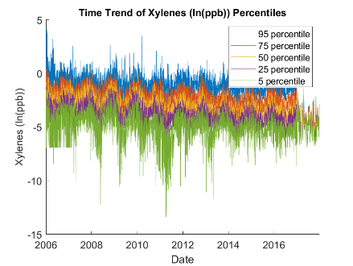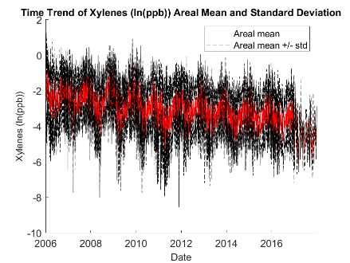
Figure S2. Exploratory analysis plots of SBTEX measurements from 2006 to 2017. From top to bottom, row 1: log-styrene; row 2: log-benzene; row 3: log-toluene, row 4: log-ethylbenzene; row 5: log-xylenes. Right column: average log-SBTEX concentrations at monitoring stations in the Gulf States, from 2006 to 2017. Center column: select percentile time trends of SBTEX from 2006 to 2017; Left column: areal mean and standard deviation time trends of SBTEX from 2006 to 2017.
S3. Land Use Regression Model (LUR) Development
In this work, we created a LUR model for each SBTEX component that predicted annual average concentrations from 2008 to 2017. Annual average concentrations were derived from averaging daily observed SBTEX and used as the dependent variables in the LUR. Previous research to create BTEX LURs has identified point sources, industrial areas, traffic predictors, and medical, religious, and educational facilities as significant pollution predictors.^{4–11} Annual point source emissions, annual nonpoint source emissions, and average annual daily traffic (AADT) were selected as potential predictors based on data availability and previous publications. Units of point and nonpoint emissions were pounds (pounds (lbs)) and AADT was vehicles per day (vehicles per day (vpd))
SBTEX point source, nonpoint source, and on-road emissions data (in units of pounds) for 2008, 2011, 2014, and 2017 were downloaded from the EPA’s National Emissions Inventory (NEI). Polyline highway files were downloaded from the Federal Highway Administration (FHWA) Highway Performance Monitoring System for 2011, 2014, and 2017, and were processed to yield create 0.1km by 0.1km grid cells across the Gulf States containing the sum of AADT values from polylines passing through each grid cell. 2008 AADT grid data was calculated by multiplying the ratio of 2008:2011 SBTEX NEI on-road emissions by 2011 AADT grid data, following Reyes & Serre (2014) methodology. Point source, nonpoint source, and AADT data were interpolated between years to yield annual predictor estimates for 2008 to 2017. In the Gulf States from 2008 to 2017, there were a small number of point source emitters (<5) that reported disproportionately high SBTEX emissions. As a result, the point source predictor term was originally driven by these extreme sources and did not account for the localized effects of most point sources in the Gulf States. A scaling factor of ½ was applied to point source emissions (e.g., [point-source emission (pounds)]^{½}) because the highly skewed distribution of un-scaled emissions obscured the relationship with SBTEX concentration. The application of the ½ scaling factor allowed for the concentration effects of all point sources on ambient concentrations to be captured, rather than just the effects of a small number.
Styrene was predicted by point source (δ=2.2km), AADT (δ=33.3km), and nonpoint source (δ=111.1km) Sum of Exponentially Decaying Contributions (SEDC) terms, where δ is the decay range of the SEDC term;¹ benzene was predicted only by point source (δ=4.4km) SEDC terms; toluene was predicted by AADT (δ=11.1km) and nonpoint source (δ=83.3km) SEDC terms; and ethylbenzene and xylenes were predicted only by AADT (δ=27.8km) SEDC terms. Final LUR equations and performance are shown in Table S1.
The LURs developed in this work have several limitations. The LURs developed in this work did not account for seasonal variation in SBTEX because it predicted SBTEX at an annual resolution, rather than a higher resolution like seasonal or daily. Previous works have cautioned against developing annual or multi-year LURs, especially for SBTEX which shows seasonal variation.¹² For the present study, we elected to model annual SBTEX concentrations to reflect the frequent exclusion of seasonality in LUR studies.¹² The LURs developed in this study also exclude meteorological predictors, such as wind direction. While wind direction can be beneficial to LURs,¹³ we excluded wind direction variables from this work previous work to estimate 48-hour VOC concentrations cautioned wind direction use¹⁴ and weekly VOC and NO₂ concentrations excluded wind direction¹² because the averaging of pollutant data limits the benefits of meteorological data that can quickly change. The present study does not account for the time correlation between observed values because it was built to predict annual concentrations. While this is a limitation of the work, we believe that the reactive nature of VOCs would cause low time correlation between SBTEX observations, and the use of annual concentrations allowed us to use predictors with annual data available, such as the NEI and FHWA Highway Performance Monitoring System. Furthermore, while some studies have cautioned against applying a single LUR to multiple cities, other studies have found LUR transferability to similar geographic factors and regional background concentrations, like the Gulf Region.^{6,8,9,15}

Table S1. SBTEX LUR equations for annual average concentrations in the Gulf States from 2008 to 2017 and 2011-2012 performance statistics. Variable naming is as follows: pSEDC_{X} for point source SEDC terms with δ=X degrees, npSEDC_{Y} for nonpoint source SEDC terms with δ=Y degrees, oSEDC_{Z} for (on-road) average annual daily traffic (AADT) SEDC terms with δ=Z degrees.
Species Name | LUR Equation | 2011-2012 Performance
Species Name | LUR Equation | Pearson R | Spearman R
Styrene | y (ppb) = 0.0117 (95% CI [-1.1e-2, 3.5e-2], SE= 1.2e-2) ppb  + 0.0096 (95% CI [7.0e-3, 1.2e-2], SE= 1.3e-3) ppb/lbs^{1/2}*[pSEDC_{0.02} (lbs^{1/2})]  + 3.2505e-10 (95% CI [4.1e-11, 6.1e-10], SE= 1.4e-10) ppb/(vpd)*[oSEDC_{0.3} (vpd)]  + 8.9647e-7 (95% CI [-2.2e-7, 2e-6], SE= 5.7e-7) ppb/lbs*[nSEDC₁ (lbs)] | 0.670 | 0.564
Benzene | y (ppb) = 0.2513 (95% CI [2.3e-1, 2.7e-1], SE= 1.1e-2) ppb  + 0.0149 (95% CI [1.3e-2, 1.6e-2], SE= 7.7e-4) ppb/lbs^{1/2}*[pSEDC_{0.04} (lbs^{1/2})] | 0.781 | 0.666
Toluene | y (ppb) = 0.3302 (95% CI [2.3e-1, 4.3e-1], SE= 4.9e-2) ppb  + 0.0017 (95% CI [7.2e-4, 2.7e-3], SE= 5.1e-4) ppb/lbs^{1/2}*[pSEDC_{0.1} (lbs^{1/2})]  + 8.9654e-8 (95% CI [3.6e-8, 1.4e-7], SE= 2.7e-8) ppb/(vpd)*[oSEDC_{0.75} (vpd)] | 0.399 | 0.507
Ethylbenzene | y (ppb) = 0.0125 (95% CI [-9.4e-2, 1.2e-1], SE= 5.4e-2) ppb  + 5.6141e-8 (95% CI [2.4e-9, 1.1e-7, SE= 2.7e-8) ppb/(vpd)*[oSEDC_{0.25} (vpd)] | 0.087 | 0.042
Xylenes | y (ppb) = 0.1274 (95% CI [-1.1e-1, 3.7e-1], SE= 1.2e-1) ppb  + 3.7118e-8 (95% CI [9.5e-10, 7.3e-8], SE= 1.8e-8) ppb/(vpd)*[oSEDC_{0.25} (vpd)] | 0.087 | 0.031

S4. Data from the Air Quality Model
This study builds on previous research that developed an air quality modeling system using CAMx7.0, which accounts for atmospheric physical and chemical processes to predict spatially and temporally enhanced SBTEX concentrations in the Gulf States. Hazardous air pollutant (HAP) reporting (except benzene) to the NEI is voluntary, resulting in incomplete emission inputs. Missing HAP emissions were identified and imputed and used as CAMx inputs with meteorological data from the Weather Research and Forecasting Model (WRF), via the HAPs Imputation (HAPI) tool.¹⁶
CAMx (+HAPI) benzene estimates used in the present study were leveraged from the core chemical transport model (i.e., model species ‘BENZ’), while styrene, toluene, ethylbenzene, and xylenes (STEX) estimates were estimated using an explicit reactive tracer approach.¹⁶ Explicit HAP species cannot be directly obtained from CAMx because their chemical mechanisms are not developed in the current version of CAMx. To model species-specific STEX concentrations, the Reactive Tracer feature of CAMx was used, which, like the CAMx core model, accounts for physical transport, chemical deposition, and chemical decay, however, it also accounts for second-order chemical decay rates.¹⁶
Compared to the LUR model developed in this study, CAMx estimates account for seasonality of SBTEX because they are developed with consideration for hourly gridded meteorological data from the state of science WRF meteorology model, physical deposition and chemical reaction rates, and hourly-gridded emissions inventory.¹⁶
A natural logarithm transformation was applied to CAMx estimates to yield more normally distributed estimates as shown in Figure S3.

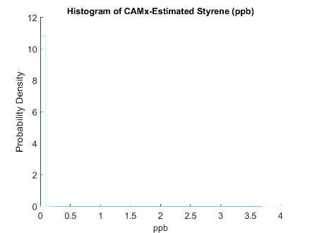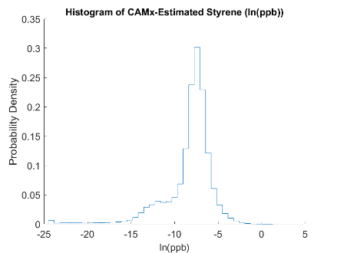
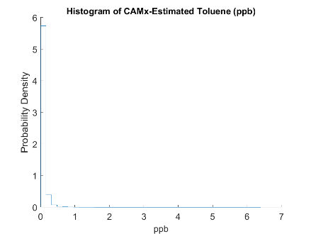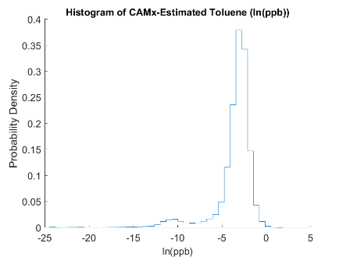
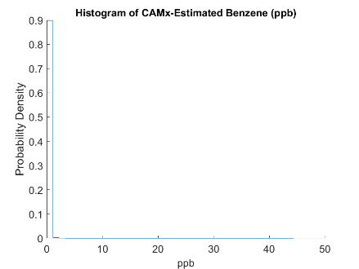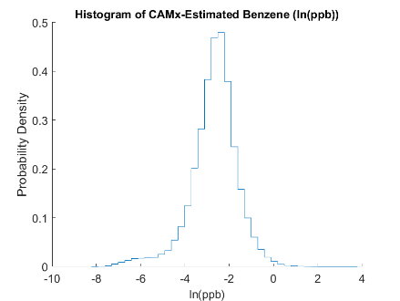
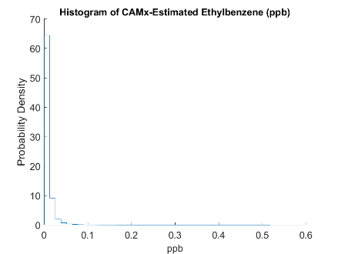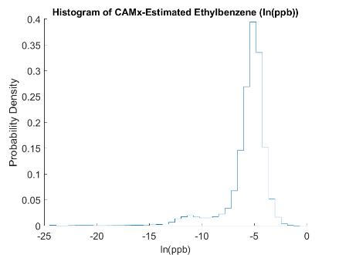
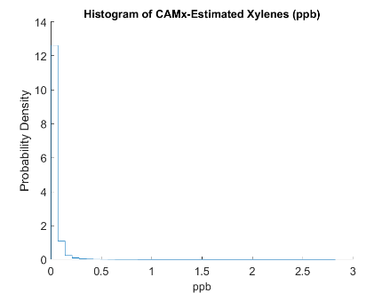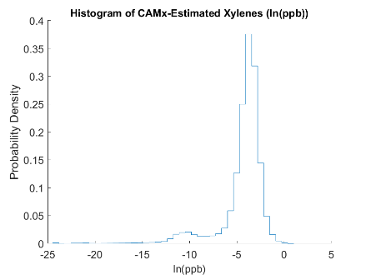
Figure S3. Density-scaled histograms of SBTEX CAMx estimates from 2011 to 2012. From top to bottom, row 1: styrene; row 2: benzene; row 3: toluene, row 4: ethylbenzene; row 5: xylenes. Left column: concentrations; right column: log-concentrations.

S5. Constant Air Model Performance Correction of Model Data
Constant Air Model Performance (CAMP) correction of CAMx data was performed for 2011 and 2012 separately. Figures S4-S8 demonstrate that CAMx tended to underpredict observed values when CAMx predicted low (1:1 line was below the λ₁) and overpredict observed values when CAMx predicted high (1:1 line was above the λ₁).

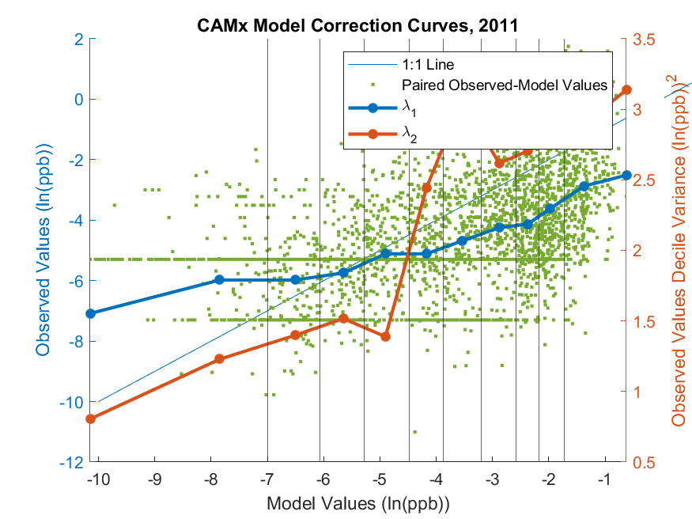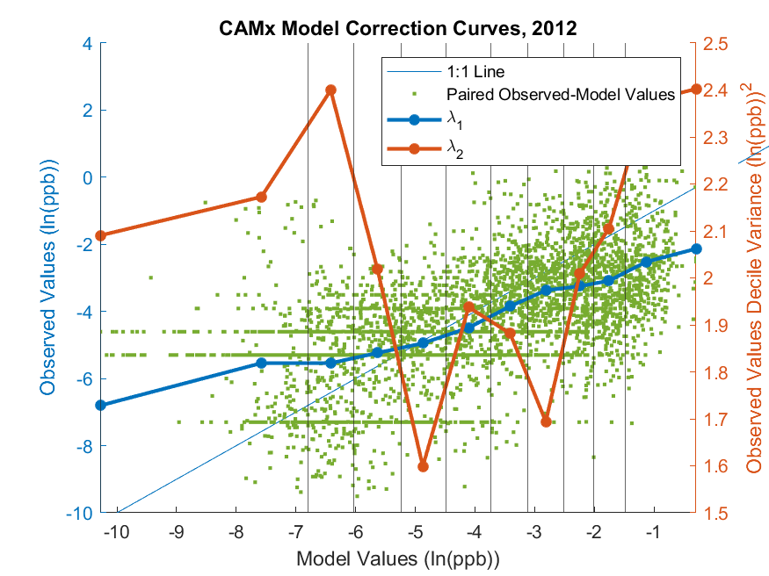
Figure S4. CAMP correction for CAMx-modeled log-styrene in 2011 (left panel) and 2012 (right panel). Green dots represent log-CAMx and log-observed concentrations. Black vertical lines represent CAMx model decile bounds. λ₁ (dark blue line) is the (monotonically increasing) mean observed value within each decile bin (left axis). λ₂ (orange line) is the CAMx variance within each decile bin (right axis). CAMx-observed value one-to-one line represented by the thin blue line.
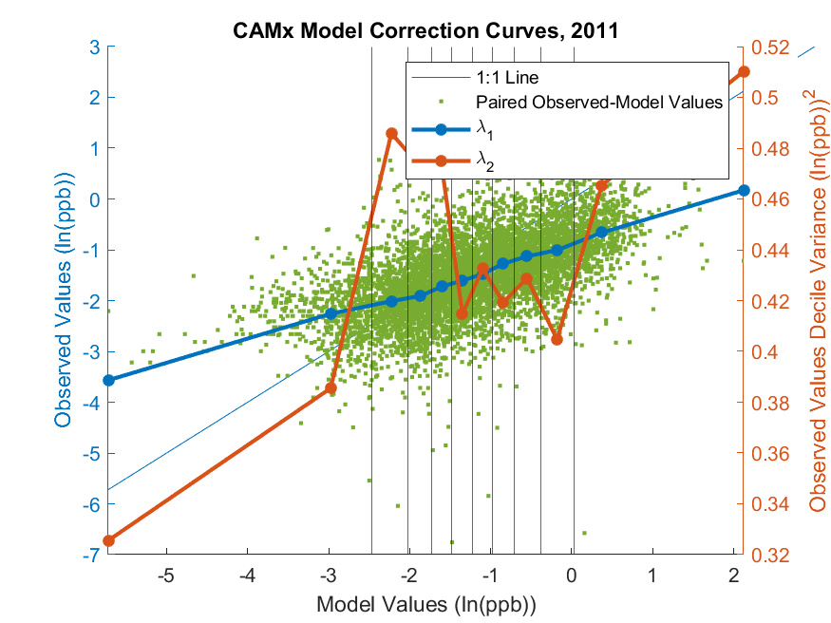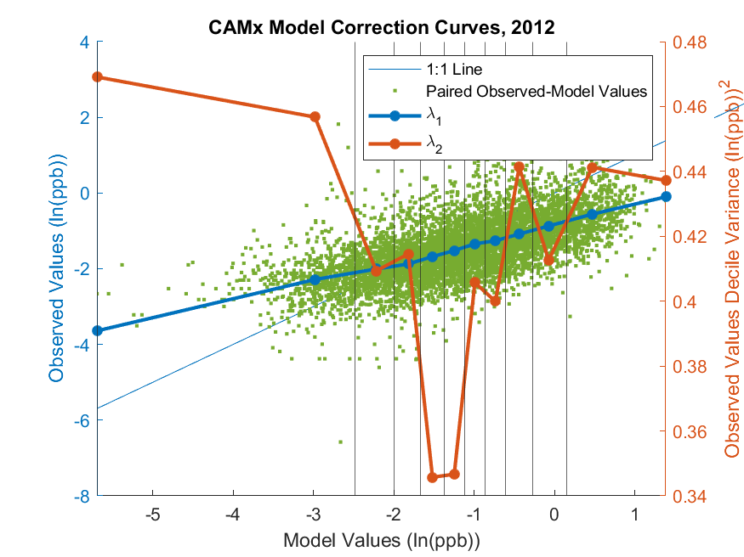
Figure S5. CAMP correction for CAMx-modeled log-benzene in 2011 (left panel) and 2012 (right panel). Green dots represent log-CAMx and log-observed concentrations. Black vertical lines represent CAMx model decile bounds. λ₁ (dark blue line) is the (monotonically increasing) mean observed value within each decile bin (left axis). λ₂ (orange line) is the CAMx variance within each decile bin (right axis). CAMx-observed value one-to-one line represented by the thin blue line.

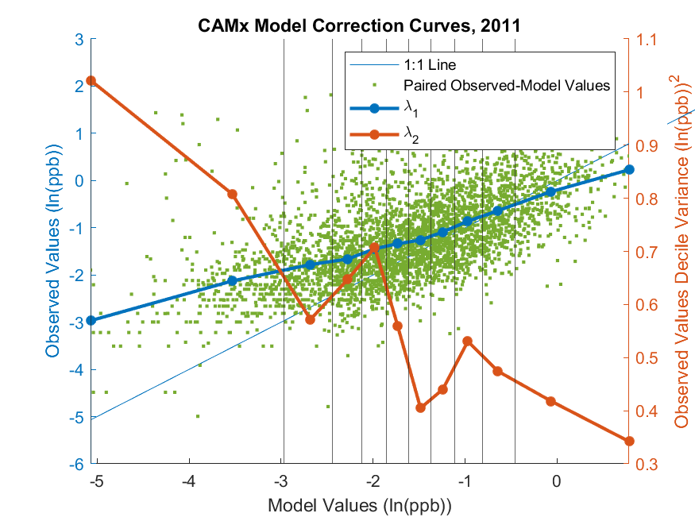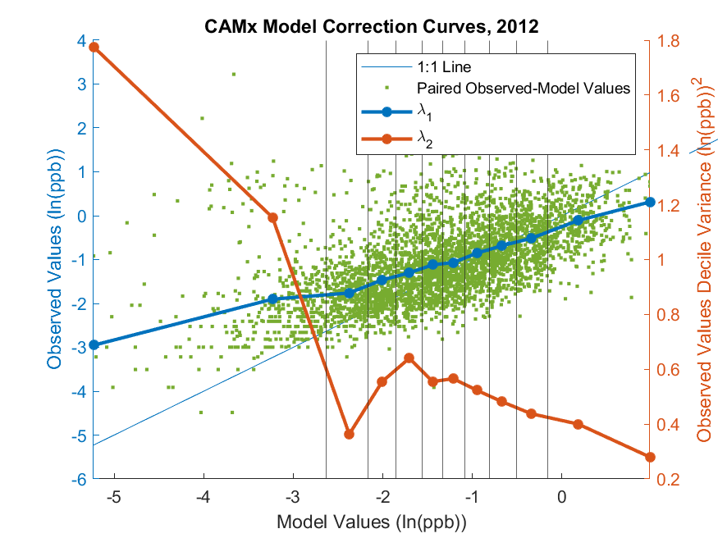
Figure S6. CAMP correction for CAMx-modeled log-toluene in 2011 (left panel) and 2012 (right panel). Green dots represent log-CAMx and log-observed concentrations. Black vertical lines represent CAMx model decile bounds. λ₁ (dark blue line) is the (monotonically increasing) mean observed value within each decile bin (left axis). λ₂ (orange line) is the CAMx variance within each decile bin (right axis). CAMx-observed value one-to-one line represented by the thin blue line.

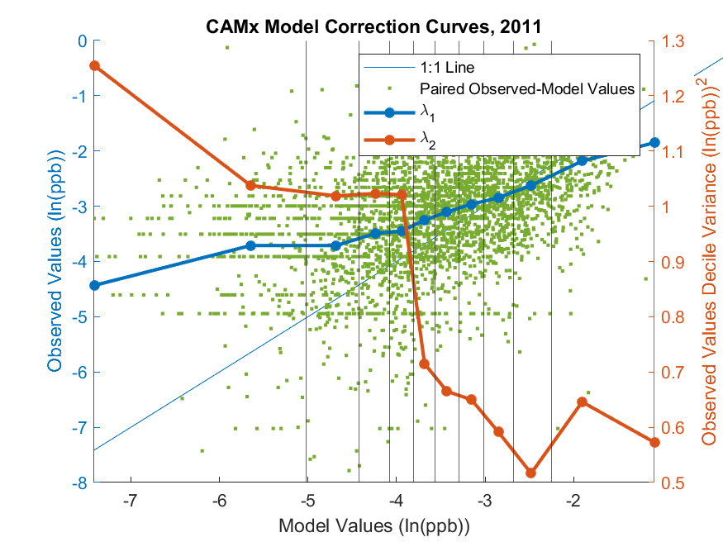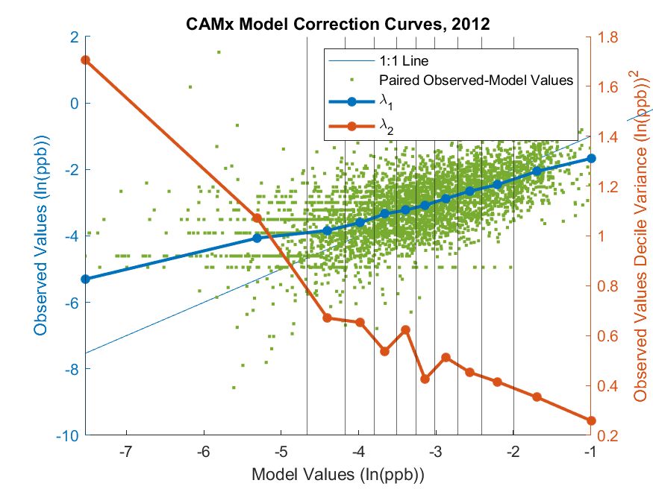Figure S7. CAMP correction for CAMx-modeled log-ethylbenzene in 2011 (left panel) and 2012 (right panel). Green dots represent log-CAMx and log-observed concentrations. Black vertical lines represent CAMx model decile bounds. λ₁ (dark blue line) is the (monotonically increasing) mean observed value within each decile bin (left axis). λ₂ (orange line) is the CAMx variance within each decile bin (right axis). CAMx-observed value one-to-one line represented by the thin blue line.

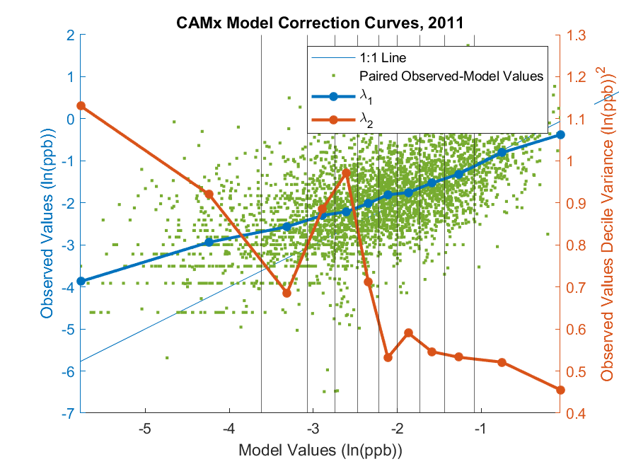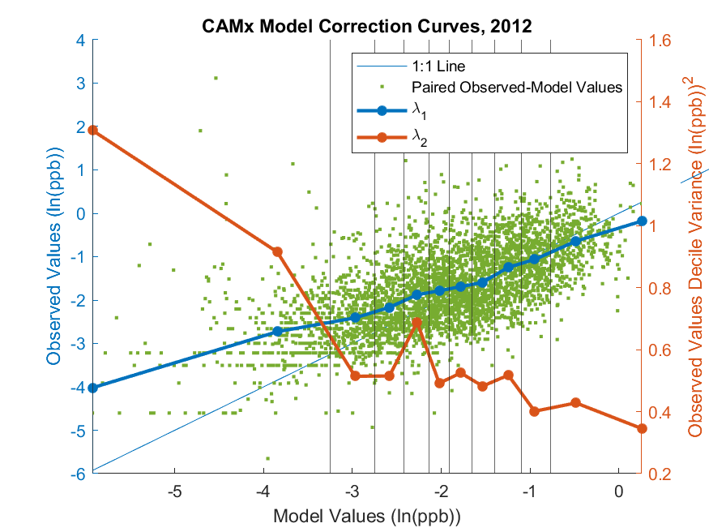Figure S8. CAMP correction for CAMx-modeled log-xylenes in 2011 (left panel) and 2012 (right panel). Green dots represent log-CAMx and log-observed concentrations. Black vertical lines represent CAMx model decile bounds. λ₁ (dark blue line) is the (monotonically increasing) mean observed value within each decile bin (left axis). λ₂ (orange line) is the CAMx variance within each decile bin (right axis). CAMx-observed value one-to-one line represented by the thin blue line.
S6. BME Framework Description
The first step of the BME analysis consists of developing, for each SBTEX compound, global offsets at three resolutions: flat, medium, and fine. This was done by developing 10 global offsets, labeled go0, go1, …, and go9, and assigning them to the three desired resolutions. These global offsets are described in Tables S2-S6 for styrene, benzene, toluene, ethylbenzene, and xylenes, respectively. Taking styrene (Table S2) as an example, the 10 global offsets are as follows:
- Global offsets go0 and go1 had values set to 0 and to a constant (the average of all log concentrations for each SBTEX compound), respectively, which corresponded to the flat resolution.
- Global offsets go2 to go5 were created with a spatial component, $o_{α,s}\left(s\right)$, and temporal component, $o_{α,t}\left(t\right)$, obtained from exponential Kernel Smoothing (KS) of spatially- and time-averaged observational log concentrations, respectively, as described in Akita et al. (2007), and henceforward referred to as global offsets of type Spatial & Temporal Kernel Smoothing, or, in short, S/T-KS type. The resolution of go2 to go5 were set by their kernel smoothing range parameters, with spatial and temporal ranges varying from large (i.e., 7.5 degree and 730 days) values for go2 and progressively becoming finer from go2 to go4 till they reach small (i.e., 0.2 degree and 90 days) values for go4. Global offsets go2 and g3 were classified as medium resolution and global offsets go4 and go5 are classified as fine resolution.
- Global offsets go6 to go9 had the same temporal component, $o_{α,t}\left(t\right)$, as go2 to go5, respectively, but their spatial components, $o_{α,s}\left(s\right)$, were replaced with the LUR model (such that go6 to go9 share the same spatial component). Since their spatial component was obtained from LUR, and their temporal component was obtained from KS, they are referred to as being of type Spatial LUR & Temporal Kernel Smoothing, or, in short, S-LUR+T-KS type. Global offsets go6 and g7 were classified as medium resolution and go8 and go9 are classified as fine resolution.
As can be seen from the description above, there were several global offsets corresponding to each of the resolutions; global offsets go0 and go1 had a flat resolution, global offsets go2, go3, go6, and go7 had a medium resolution, and global offsets go3, go4, go8, and go9 had a fine resolution. Evaluating each of these global offsets would be too computationally expensive. Therefore, only one global offset per resolution was fully evaluated. They are the global offset shown in boldface in Tables S2-S6. For example, in the case of styrene (Table S2), the selected global offsets were go1 (flat), go2 (medium resolution of type S/T-KS), and go5 (fine resolution of type S/T-KS), while for benzene (Table S3), the selected global offsets were go1 (flat), go6 (medium resolution of type S-LUR+T-KS), and go8 (fine resolution of type S-LUR+T-KS). The selected global offsets were obtained by choosing those with the best performance at a cross-validation radius of 3 degrees.
Table S2. Log-styrene global offset parameters. Bolded global offset scenarios were used during method evaluation and determined using 3-degree RCV sensitivity analyses.
Global Offset Name | Global Offset Type | Global Offset Resolution | Global Offset Subtype | Kernel Smoothing Parameters |  | SEDC LUR Parameters (δ)
 |  |  |  | Spatial Range (deg.) | Temporal Range (day) | Point (deg.) | Nonpoint (deg.) | On road (deg.)
GO=0 | Zero
GO=1 | Constant | Flat |  | 10000 | 10000
GO=2 | Spatial & Temporal Kernel Smoothing | Medium | Domain-wide | 7.5 | 730
GO=3 | Spatial & Temporal Kernel Smoothing | Medium | Regional | 2.5 | 365
GO=4 | Spatial & Temporal Kernel Smoothing | Fine | Semi-local | 0.6 | 180
GO=5 | Spatial & Temporal Kernel Smoothing | Fine | Local | 0.2 | 90
GO=6 | Spatial LUR & Temporal Kernel Smoothing | Medium | Domain-wide |  | 730 | 0.02 | 0.3 | 1
GO=7 | Spatial LUR & Temporal Kernel Smoothing | Medium | Regional |  | 365 | 0.02 | 0.3 | 1
GO=8 | Spatial LUR & Temporal Kernel Smoothing | Fine | Semi-local |  | 180 | 0.02 | 0.3 | 1
GO=9 | Spatial LUR & Temporal Kernel Smoothing | Fine | Local |  | 90 | 0.02 | 0.3 | 1

Table S3. Log-benzene global offset parameters. Bolded global offset scenarios were used during method evaluation and determined using 3-degree RCV sensitivity analyses.
Global Offset Name | Global Offset Type | Global Offset Resolution | Global Offset Subtype | Kernel Smoothing Parameters |  | SEDC LUR Parameters (δ)
 |  |  |  | Spatial Range (deg.) | Temporal Range (day) | Point (deg.) | Nonpoint (deg.) | On road (deg.)
GO=0 | Zero
GO=1 | Constant | Flat |  | 10000 | 10000
GO=2 | Spatial & Temporal Kernel Smoothing | Medium | Domain-wide | 7.5 | 730
GO=3 | Spatial & Temporal Kernel Smoothing | Medium | Regional | 2.5 | 365
GO=4 | Spatial & Temporal Kernel Smoothing | Fine | Semi-local | 0.6 | 180
GO=5 | Spatial & Temporal Kernel Smoothing | Fine | Local | 0.2 | 90
GO=6 | Spatial LUR & Temporal Kernel Smoothing | Medium | Domain-wide |  | 730 | 0.04 | N/A | N/A
GO=7 | Spatial LUR & Temporal Kernel Smoothing | Medium | Regional |  | 365 | 0.04 | N/A | N/A
GO=8 | Spatial LUR & Temporal Kernel Smoothing | Fine | Semi-local |  | 180 | 0.04 | N/A | N/A
GO=9 | Spatial LUR & Temporal Kernel Smoothing | Fine | Local |  | 90 | 0.04 | N/A | N/A

Table S4. Log-toluene global offset parameters. Bolded global offset scenarios were used during method evaluation and determined using 3-degree RCV sensitivity analyses.
Global Offset Name | Global Offset Type | Global Offset Resolution | Global Offset Subtype | Kernel Smoothing Parameters |  | SEDC LUR Parameters (δ)
 |  |  |  | Spatial Range (deg.) | Temporal Range (day) | Point (deg.) | Nonpoint (deg.) | On road (deg.)
GO=0 | Zero
GO=1 | Constant | Flat |  | 10000 | 10000
GO=2 | Spatial & Temporal Kernel Smoothing | Medium | Domain-wide | 7.5 | 730
GO=3 | Spatial & Temporal Kernel Smoothing | Medium | Regional | 2.5 | 365
GO=4 | Spatial & Temporal Kernel Smoothing | Fine | Semi-local | 0.6 | 180
GO=5 | Spatial & Temporal Kernel Smoothing | Fine | Local | 0.2 | 90
GO=6 | Spatial LUR & Temporal Kernel Smoothing | Medium | Domain-wide |  | 730 | 0.1 | N/A | 0.75
GO=7 | Spatial LUR & Temporal Kernel Smoothing | Medium | Regional |  | 365 | 0.1 | N/A | 0.75
GO=8 | Spatial LUR & Temporal Kernel Smoothing | Fine | Semi-local |  | 180 | 0.1 | N/A | 0.75
GO=9 | Spatial LUR & Temporal Kernel Smoothing | Fine | Local |  | 90 | 0.1 | N/A | 0.75

Table S5. Log-ethylbenzene global offset parameters. Bolded global offset scenarios were used during method evaluation and determined using 3-degree RCV sensitivity analyses.
Global Offset Name | Global Offset Type | Global Offset Resolution | Global Offset Subtype | Kernel Smoothing Parameters |  | SEDC LUR Parameters (δ)
 |  |  |  | Spatial Range (deg.) | Temporal Range (day) | Point (deg.) | Nonpoint (deg.) | On road (deg.)
GO=0 | Zero
GO=1 | Constant | Flat |  | 10000 | 10000
GO=2 | Spatial & Temporal Kernel Smoothing | Medium | Domain-wide | 7.5 | 730
GO=3 | Spatial & Temporal Kernel Smoothing | Medium | Regional | 2.5 | 365
GO=4 | Spatial & Temporal Kernel Smoothing | Fine | Semi-local | 0.6 | 180
GO=5 | Spatial & Temporal Kernel Smoothing | Fine | Local | 0.2 | 90
GO=6 | Spatial LUR & Temporal Kernel Smoothing | Medium | Domain-wide |  | 730 | N/A | N/A | 0.25
GO=7 | Spatial LUR & Temporal Kernel Smoothing | Medium | Regional |  | 365 | N/A | N/A | 0.25
GO=8 | Spatial LUR & Temporal Kernel Smoothing | Fine | Semi-local |  | 180 | N/A | N/A | 0.25
GO=9 | Spatial LUR & Temporal Kernel Smoothing | Fine | Local |  | 90 | N/A | N/A | 0.25

Table S6. Log-xylenes global offset parameters. Bolded global offset scenarios were used during method evaluation and determined using 3-degree RCV sensitivity analyses.
Global Offset Name | Global Offset Type | Global Offset Resolution | Global Offset Subtype | Kernel Smoothing Parameters |  | SEDC LUR Parameters (δ)
 |  |  |  | Spatial Range (deg.) | Temporal Range (day) | Point (deg.) | Nonpoint (deg.) | On road (deg.)
GO=0 | Zero
GO=1 | Constant | Flat |  | 10000 | 10000
GO=2 | Spatial & Temporal Kernel Smoothing | Medium | Domain-wide | 7.5 | 730
GO=3 | Spatial & Temporal Kernel Smoothing | Medium | Regional | 2.5 | 365
GO=4 | Spatial & Temporal Kernel Smoothing | Fine | Semi-local | 0.6 | 180
GO=5 | Spatial & Temporal Kernel Smoothing | Fine | Local | 0.2 | 90
GO=6 | Spatial LUR & Temporal Kernel Smoothing | Medium | Domain-wide |  | 730 | N/A | N/A | 0.25
GO=7 | Spatial LUR & Temporal Kernel Smoothing | Medium | Regional |  | 365 | N/A | N/A | 1.25
GO=8 | Spatial LUR & Temporal Kernel Smoothing | Fine | Semi-local |  | 180 | N/A | N/A | 2.25
GO=9 | Spatial LUR & Temporal Kernel Smoothing | Fine | Local |  | 90 | N/A | N/A | 3.25

The raw spatial and raw/smoothed temporal features of the three global offsets selected using three-degree radius cross-validation are shown for SBTEX in Figures S9-S13.

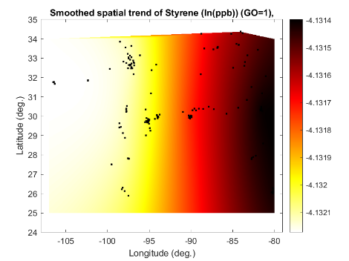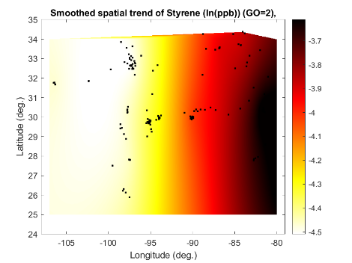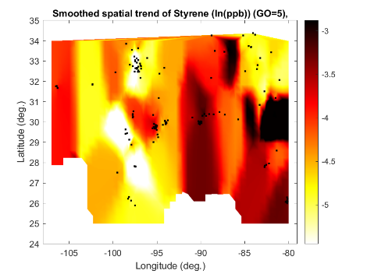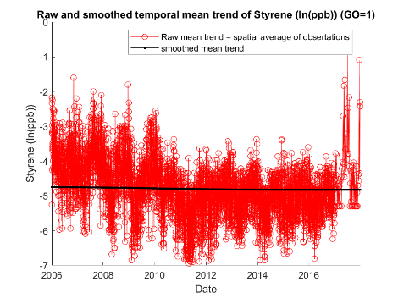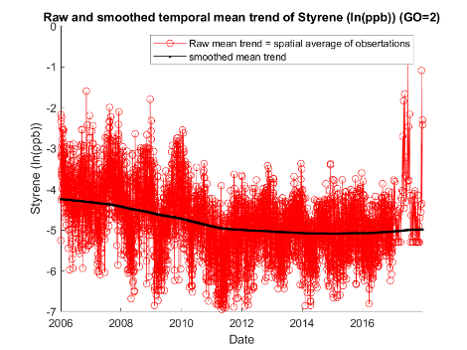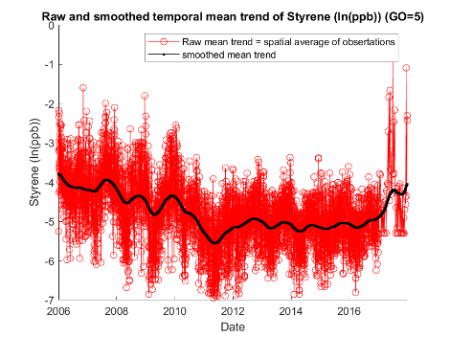
Figure S9. Raw spatial (top row) and raw/smoothed temporal (bottom row) styrene global offsets calculated using log-styrene concentrations in the Gulf States from 2006 to 2017. Left column: flat global offset (i.e., Global Offset [GO]=1); center column: domain-wide spatial (S)/temporal (T) - kernel-smoothing (KS) (i.e., GO=2); right column: local S/T-KS (i.e., GO=5).

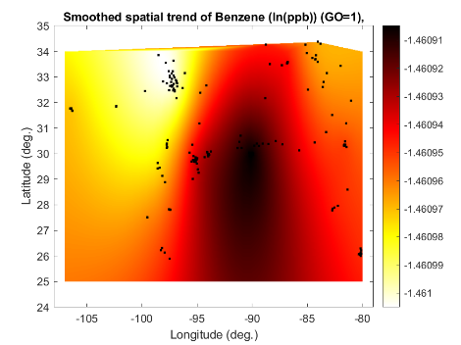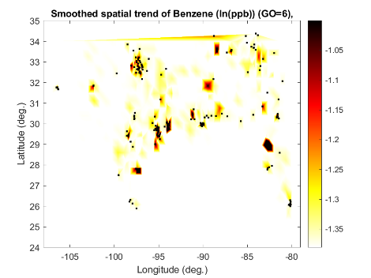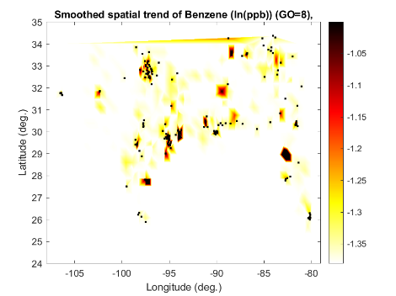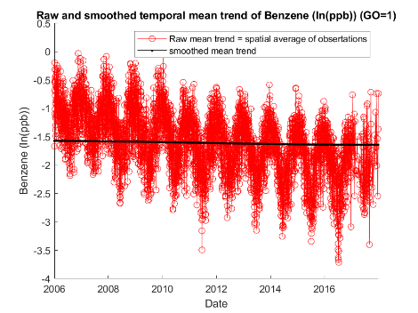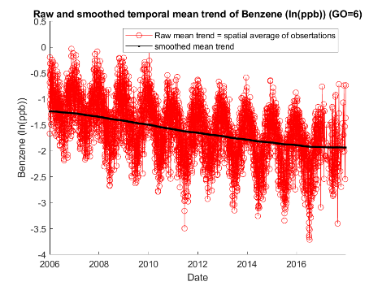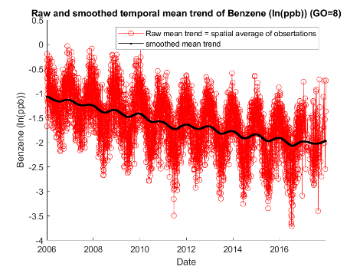
Figure S10. Raw spatial (top row) and raw/smoothed temporal (bottom row) benzene global offsets calculated using log-benzene concentrations in the Gulf States from 2006 to 2017. Left column: flat global offset (i.e., GO=1); center column: S-land use regression (LUR) and domain-wide T-KS (i.e., GO=6); right column: S-land use regression (LUR) and semi-local T-KS (i.e., GO=5).

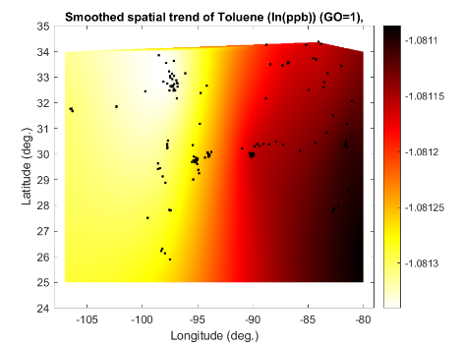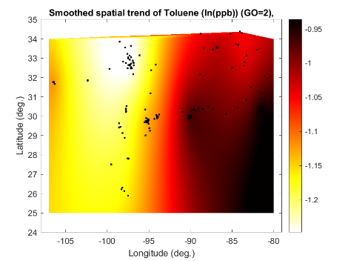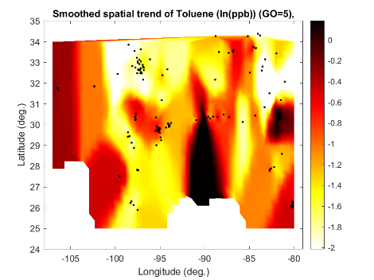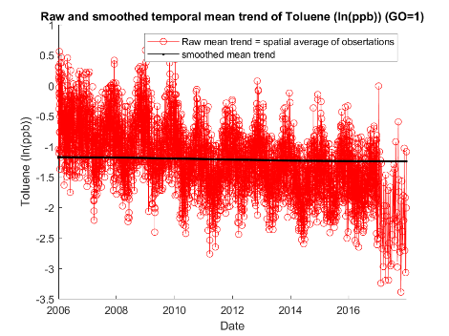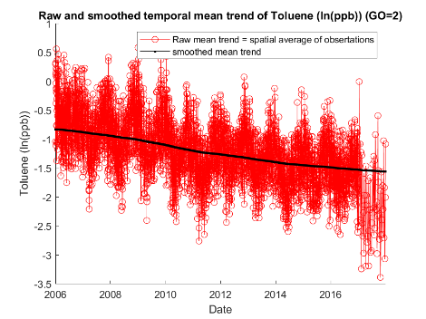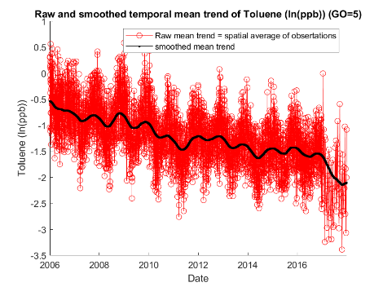
Figure S11. Raw spatial (top row) and raw/smoothed temporal (bottom row) toluene global offsets calculated using log-toluene concentrations in the Gulf States from 2006 to 2017. Left column: flat global offset (i.e., GO=1); center column: domain-wide S/T-KS (i.e., GO=2); right column: local S/T-KS (i.e., GO=5).

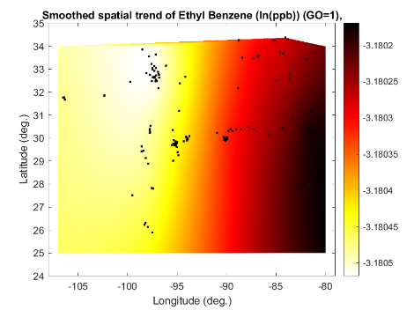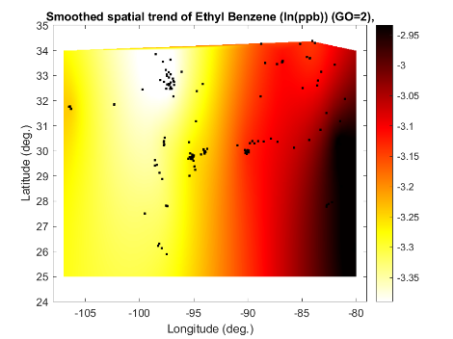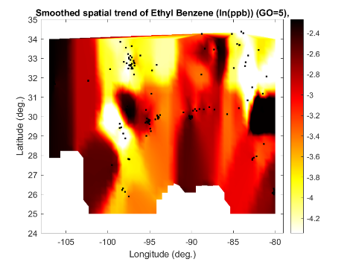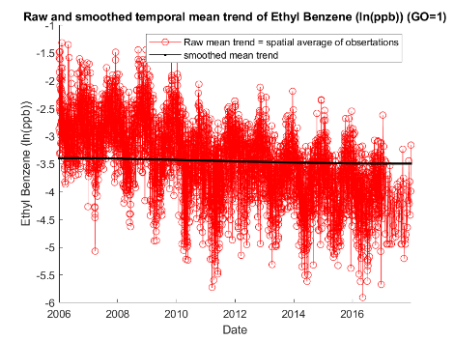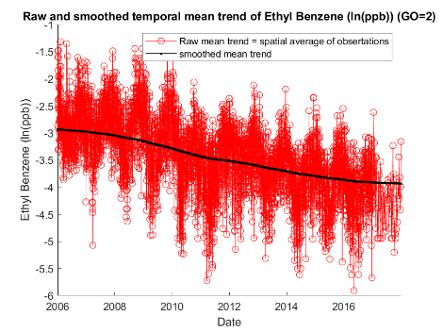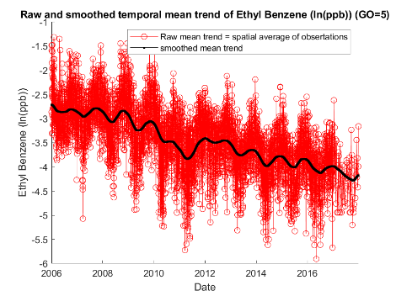
Figure S12. Raw spatial (top row) and raw/smoothed temporal (bottom row) ethylbenzene global offsets calculated using log-ethylbenzene concentrations in the Gulf States from 2006 to 2017. Left column: flat global offset (i.e., GO=1); center column: domain-wide S/T-KS (i.e., GO=2); right column: local S/T-KS (i.e., GO=5).

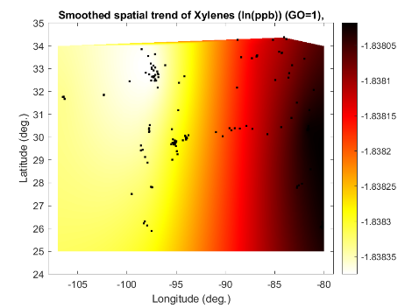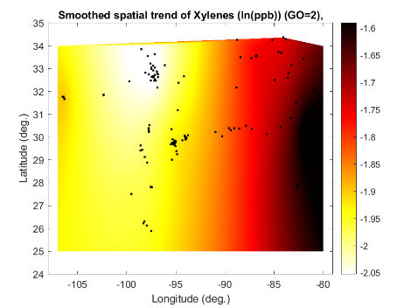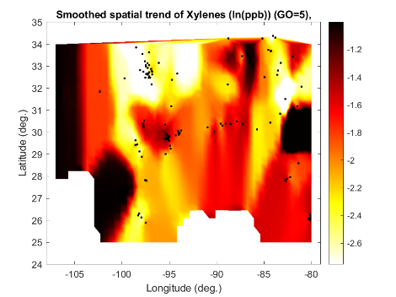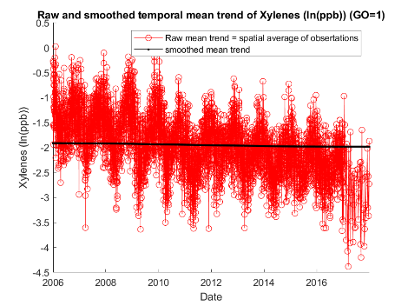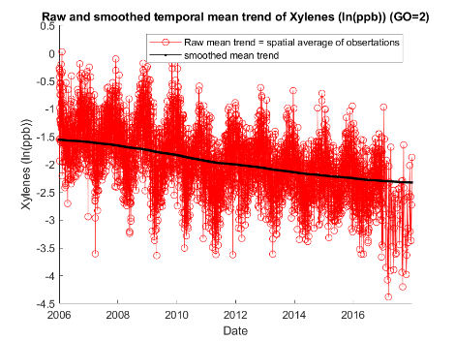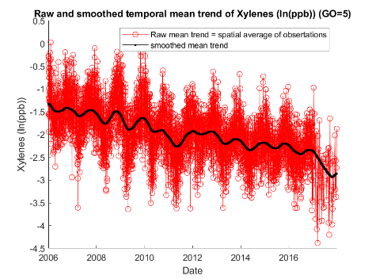
Figure S13. Raw spatial (top row) and raw/smoothed temporal (bottom row) xylenes global offsets calculated using log-xylenes concentrations in the Gulf States from 2006 to 2017. Left column: flat global offset (i.e., GO=1); center column: domain-wide S/T-KS (i.e., GO=2); right column: local S/T-KS (i.e., GO=5).

In step 2 of the BME analysis, we manually modeled the covariance of the log-transformed, offset-removed residual data $x_{h}=ln(z_{h})-o_{α}(p_{h})$, where $z_{h}$ are the concentrations observed at points, and $o_{α}(p_{h})$ is the global offset at resolution, $α$, set to either flat, medium, or fine, as shown in boldface in Tables S2-S6. For each global offset resolution, we modeled the variability of the corresponding residual data, $x_{h}$, using a homogenous/stationary Space/Time Random Field (S/TRF), $X(p)$, with a three-structure exponential model as shown in equation S2,
$c_{X}\left(r,τ\right)=c_{1}{σ_{X}}^{2}\exp\left(\frac{-3r}{a_{r1}}\right)\exp\left(\frac{-3τ}{a_{τ1}}\right)+c_{2}{σ_{X}}^{2}\exp\left(\frac{-3r}{a_{r1}}\right)\exp\left(\frac{-3τ}{aτ_{2}}\right)+c_{3}{σ_{X}}^{2}\exp\left(\frac{-3r}{a_{r2}}\right)\exp\left(\frac{-3τ}{aτ_{2}}\right)$
(Eqn. S2)
where $c_{X}\left(r,τ\right)$ is the modeled covariance; c₁, c₂, and c₃ are the sill fractions; ${σ_{X}}^{2}$ is the sill ((log(ppb)²); $a_{r1}$ is the short spatial range (degrees); $a_{r2}$ is the long spatial range (degrees); $a_{τ1}$ is the short temporal range (days); $a_{τ2}$ is the long temporal range (days); and r and 𝜏 are the spatial lag (degrees) and temporal lag (days), respectively, separating any two space/time points of interest. Manual covariance fitting was performed such that the change in covariance parameters was progressive, monotonic, and gradual between global offsets to avoid large changes in parameter values. The covariance model parameters used for each of the 10 global offsets of styrene are shown in Table S7, and those for benzene, toluene, ethylbenzene, and xylenes are shown in S8-S11. As can be seen from these tables, the variance ${σ_{X}}^{2}$ generally decreases from go0 to go5, indicating that finer resolution global offsets produce residual data with smaller variability.

Table S7. Log-styrene covariance models inputs based on selected global offset. Bolded covariance models were used during method evaluation and determined using 3-degree RCV sensitivity analyses.
Global Offset Type | Global Offset Subtype | ${σ_{X}}^{2}$ (log(ppb)²) | Structure 1 (exp.) |  |  | Structure 2 (exp.) |  |  | Structure 3 (exp.)
Global Offset Type | Global Offset Subtype | ${σ_{X}}^{2}$ (log(ppb)²) | c₁ | a_{r1} (deg.) | a_{t1} (day) | c₂ | a_{r1} (deg.) | a_{t2} (day) | c₃ | a_{r2} (deg.) | a_{t2} (day)
Zero |  | 3.2270 | 0.25 | 0.45 | 4.0 | 0.65 | 0.45 | 700 | 0.10 | 6 | 700
Flat |  | 3.2113 | 0.25 | 0.45 | 4.0 | 0.65 | 0.45 | 700 | 0.10 | 6 | 700
Spatial & Temporal Kernel Smoothing | Domain-wide | 2.9665 | 0.30 | 0.45 | 3.5 | 0.60 | 0.45 | 700 | 0.10 | 6 | 700
Spatial & Temporal Kernel Smoothing | Regional | 2.7880 | 0.35 | 0.40 | 3.2 | 0.55 | 0.40 | 600 | 0.10 | 6 | 600
Spatial & Temporal Kernel Smoothing | Semi-local | 2.4023 | 0.43 | 0.15 | 3.2 | 0.40 | 0.15 | 600 | 0.17 | 6 | 600
Spatial & Temporal Kernel Smoothing | Local | 2.1938 | 0.50 | 0.15 | 3.2 | 0.30 | 0.15 | 500 | 0.20 | 6 | 500
Spatial LUR & Temporal Kernel Smoothing | Domain-wide | 2.5390 | 0.52 | 0.30 | 3.5 | 0.30 | 0.30 | 700 | 0.18 | 2 | 700
Spatial LUR & Temporal Kernel Smoothing | Regional | 2.5329 | 0.52 | 0.30 | 3.5 | 0.30 | 0.30 | 600 | 0.18 | 2 | 600
Spatial LUR & Temporal Kernel Smoothing | Semi-local | 2.5215 | 0.52 | 0.30 | 3.2 | 0.30 | 0.30 | 600 | 0.18 | 2 | 600
Spatial LUR & Temporal Kernel Smoothing | Local | 2.5037 | 0.52 | 0.30 | 3.2 | 0.30 | 0.30 | 500 | 0.18 | 2 | 500

Table S8. Log-benzene covariance models inputs based on selected global offset. Bolded covariance models were used during method evaluation and determined using 3-degree RCV sensitivity analyses.
Global Offset Type | Global Offset Subtype | ${σ_{X}}^{2}$ (log(ppb)²) | Structure 1 (exp.) |  |  | Structure 2 (exp.) |  |  | Structure 3 (exp.)
Global Offset Type | Global Offset Subtype | ${σ_{X}}^{2}$ (log(ppb)²) | c₁ | a_{r1} (deg.) | a_{t1} (day) | c₂ | a_{r1} (deg.) | a_{t2} (day) | c₃ | a_{r2} (deg.) | a_{t2} (day)
Zero |  | 0.9899 | 0.45 | 0.15 | 4 | 0.05 | 0.15 | 600 | 0.50 | 15 | 600
Flat |  | 0.9780 | 0.45 | 0.15 | 4 | 0.05 | 0.15 | 600 | 0.50 | 15 | 600
Spatial & Temporal Kernel Smoothing | Domain-wide | 0.8844 | 0.53 | 0.15 | 4 | 0.05 | 0.15 | 600 | 0.42 | 15 | 600
Spatial & Temporal Kernel Smoothing | Regional | 0.8130 | 0.55 | 0.14 | 4 | 0.05 | 0.14 | 550 | 0.40 | 15 | 550
Spatial & Temporal Kernel Smoothing | Semi-local | 0.7386 | 0.60 | 0.13 | 4 | 0.05 | 0.13 | 500 | 0.35 | 15 | 500
Spatial & Temporal Kernel Smoothing | Local | 0.6812 | 0.62 | 0.12 | 4 | 0.05 | 0.12 | 450 | 0.33 | 15 | 450
Spatial LUR & Temporal Kernel Smoothing | Domain-wide | 0.8502 | 0.55 | 0.13 | 4 | 0.05 | 0.13 | 600 | 0.40 | 8 | 600
Spatial LUR & Temporal Kernel Smoothing | Regional | 0.8446 | 0.55 | 0.13 | 4 | 0.05 | 0.13 | 550 | 0.40 | 8 | 550
Spatial LUR & Temporal Kernel Smoothing | Semi-local | 0.8299 | 0.55 | 0.13 | 4 | 0.05 | 0.13 | 500 | 0.40 | 8 | 500
Spatial LUR & Temporal Kernel Smoothing | Local | 0.8027 | 0.55 | 0.13 | 4 | 0.05 | 0.13 | 450 | 0.40 | 8 | 450

Table S9. Log-toluene covariance models inputs based on selected global offset. Bolded covariance models were used during method evaluation and determined using 3-degree RCV sensitivity analyses.
Global Offset Type | Global Offset Subtype | ${σ_{X}}^{2}$ (log(ppb)²) | Structure 1 (exp.) |  |  | Structure 2 (exp.) |  |  | Structure 3 (exp.)
Global Offset Type | Global Offset Subtype | ${σ_{X}}^{2}$ (log(ppb)²) | c₁ | a_{r1} (deg.) | a_{t1} (day) | c₂ | a_{r1} (deg.) | a_{t2} (day) | c₃ | a_{r2} (deg.) | a_{t2} (day)
Zero |  | 0.9158 | 0.55 | 0.45 | 2 | 0.20 | 0.45 | 800 | 0.25 | 15 | 800
Flat |  | 0.9044 | 0.55 | 0.45 | 2 | 0.20 | 0.45 | 800 | 0.25 | 15 | 800
Spatial & Temporal Kernel Smoothing | Domain-wide | 0.8289 | 0.60 | 0.25 | 2 | 0.10 | 0.25 | 600 | 0.30 | 15 | 600
Spatial & Temporal Kernel Smoothing | Regional | 0.7841 | 0.60 | 0.22 | 2 | 0.10 | 0.22 | 500 | 0.30 | 15 | 500
Spatial & Temporal Kernel Smoothing | Semi-local | 0.7152 | 0.60 | 0.2 | 2 | 0.05 | 0.20 | 400 | 0.35 | 15 | 400
Spatial & Temporal Kernel Smoothing | Local | 0.6464 | 0.63 | 0.15 | 2 | 0.02 | 0.15 | 300 | 0.35 | 15 | 300
Spatial LUR & Temporal Kernel Smoothing | Domain-wide | 0.7542 | 0.70 | 0.30 | 2 | 0.05 | 0.35 | 600 | 0.25 | 15 | 600
Spatial LUR & Temporal Kernel Smoothing | Regional | 0.7507 | 0.70 | 0.30 | 2 | 0.04 | 0.35 | 500 | 0.26 | 15 | 500
Spatial LUR & Temporal Kernel Smoothing | Semi-local | 0.7437 | 0.70 | 0.30 | 2 | 0.03 | 0.35 | 400 | 0.27 | 15 | 400
Spatial LUR & Temporal Kernel Smoothing | Local | 0.7329 | 0.70 | 0.30 | 2 | 0.02 | 0.35 | 300 | 0.28 | 15 | 300

Table S10. Log-ethylbenzene covariance models inputs based on selected global offset. Bolded covariance models were used during method evaluation and determined using 3-degree RCV sensitivity analyses.
Global Offset Type | Global Offset Subtype | ${σ_{X}}^{2}$ (log(ppb)²) | Structure 1 (exp.) |  |  | Structure 2 (exp.) |  |  | Structure 3 (exp.)
Global Offset Type | Global Offset Subtype | ${σ_{X}}^{2}$ (log(ppb)²) | c₁ | a_{r1} (deg.) | a_{t1} (day) | c₂ | a_{r1} (deg.) | a_{t2} (day) | c₃ | a_{r2} (deg.) | a_{t2} (day)
Zero |  | 1.5784 | 0.40 | 0.50 | 3.50 | 0.35 | 0.50 | 700 | 0.25 | 15 | 700
Flat |  | 1.5545 | 0.40 | 0.50 | 3.50 | 0.35 | 0.50 | 700 | 0.25 | 15 | 700
Spatial & Temporal Kernel Smoothing | Domain-wide | 1.3923 | 0.50 | 0.35 | 3.00 | 0.30 | 0.35 | 650 | 0.25 | 15 | 650
Spatial & Temporal Kernel Smoothing | Regional | 1.2917 | 0.55 | 0.30 | 2.75 | 0.25 | 0.30 | 600 | 0.25 | 15 | 600
Spatial & Temporal Kernel Smoothing | Semi-local | 1.1272 | 0.57 | 0.25 | 2.50 | 0.16 | 0.25 | 550 | 0.27 | 15 | 550
Spatial & Temporal Kernel Smoothing | Local | 1.0494 | 0.58 | 0.20 | 2.25 | 0.12 | 0.20 | 500 | 0.30 | 15 | 500
Spatial LUR & Temporal Kernel Smoothing | Domain-wide | 1.6469 | 0.40 | 0.25 | 3.00 | 0.35 | 0.25 | 650 | 0.30 | 4 | 650
Spatial LUR & Temporal Kernel Smoothing | Regional | 1.6300 | 0.40 | 0.25 | 2.75 | 0.35 | 0.25 | 600 | 0.30 | 4 | 600
Spatial LUR & Temporal Kernel Smoothing | Semi-local | 1.6153 | 0.40 | 0.25 | 2.50 | 0.35 | 0.25 | 550 | 0.30 | 4 | 550
Spatial LUR & Temporal Kernel Smoothing | Local | 1.5964 | 0.40 | 0.25 | 2.25 | 0.35 | 0.25 | 500 | 0.30 | 4 | 500

Table S11. Log-xylenes covariance models inputs based on selected global offset. Bolded covariance models were used during method evaluation and determined using 3-degree RCV sensitivity analyses.
Global Offset Type | Global Offset Subtype | ${σ_{X}}^{2}$ (log(ppb)²) | Structure 1 (exp.) |  |  | Structure 2 (exp.) |  |  | Structure 3 (exp.)
Global Offset Type | Global Offset Subtype | ${σ_{X}}^{2}$ (log(ppb)²) | c₁ | a_{r1} (deg.) | a_{t1} (day) | c₂ | a_{r1} (deg.) | a_{t2} (day) | c₃ | a_{r2} (deg.) | a_{t2} (day)
Zero |  | 1.1047 | 0.43 | 0.25 | 2.00 | 0.17 | 0.25 | 600 | 0.40 | 3.5 | 600
Flat |  | 1.0918 | 0.43 | 0.25 | 2.00 | 0.17 | 0.25 | 600 | 0.40 | 3.5 | 600
Spatial & Temporal Kernel Smoothing | Domain-wide | 0.9889 | 0.58 | 0.30 | 2.25 | 0.17 | 0.30 | 900 | 0.25 | 6.0 | 900
Spatial & Temporal Kernel Smoothing | Regional | 0.9889 | 0.65 | 0.32 | 2.50 | 0.10 | 0.32 | 900 | 0.25 | 20.0 | 900
Spatial & Temporal Kernel Smoothing | Semi-local | 0.8337 | 0.65 | 0.35 | 2.75 | 0.10 | 0.35 | 900 | 0.25 | 22.0 | 900
Spatial & Temporal Kernel Smoothing | Local | 0.7729 | 0.65 | 0.40 | 3.00 | 0.10 | 0.40 | 900 | 0.25 | 25.0 | 900
Spatial LUR & Temporal Kernel Smoothing | Domain-wide | 1.1000 | 0.50 | 0.40 | 2.25 | 0.20 | 0.40 | 900 | 0.30 | 3.8 | 900
Spatial LUR & Temporal Kernel Smoothing | Regional | 1.0907 | 0.51 | 0.40 | 2.50 | 0.20 | 0.40 | 900 | 0.29 | 3.8 | 900
Spatial LUR & Temporal Kernel Smoothing | Semi-local | 1.0803 | 0.53 | 0.40 | 2.75 | 0.20 | 0.40 | 900 | 0.27 | 3.8 | 900
Spatial LUR & Temporal Kernel Smoothing | Local | 1.0649 | 0.55 | 0.40 | 3.00 | 0.20 | 0.40 | 900 | 0.25 | 3.8 | 900

SBTEX experimental covariance values and corresponding covariance models are shown for the three global offsets selected using three-degree radius cross-validation in Figure S15.

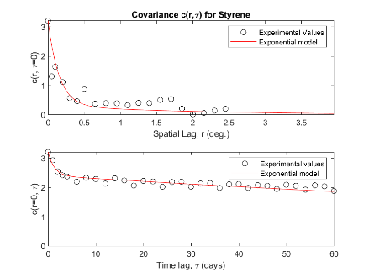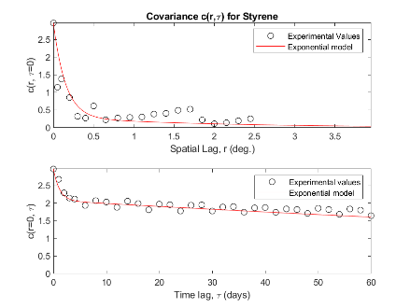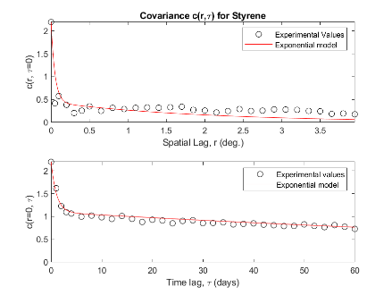
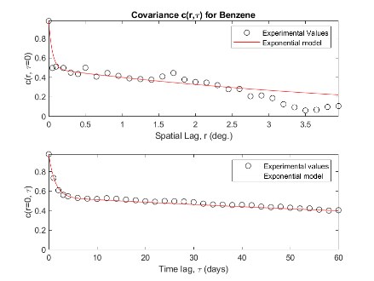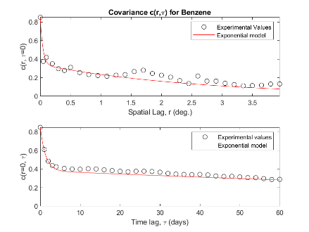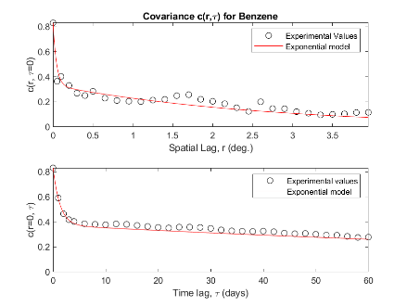
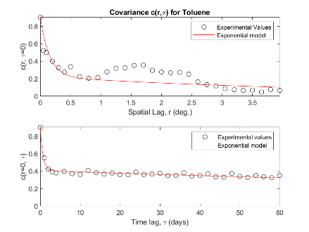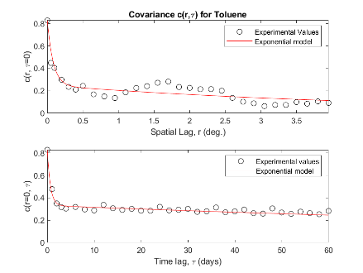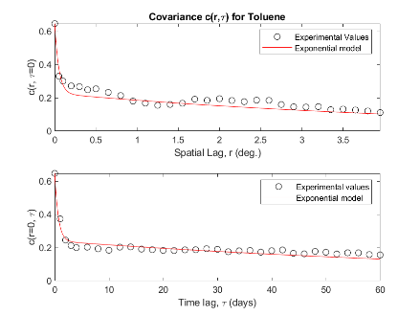
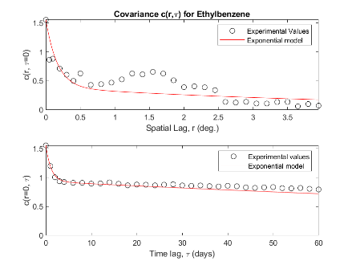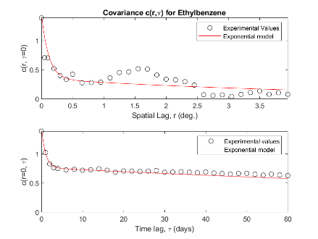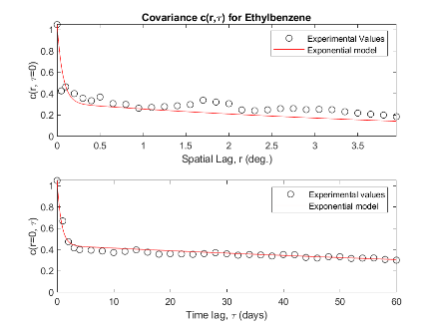
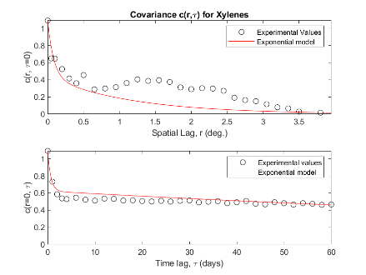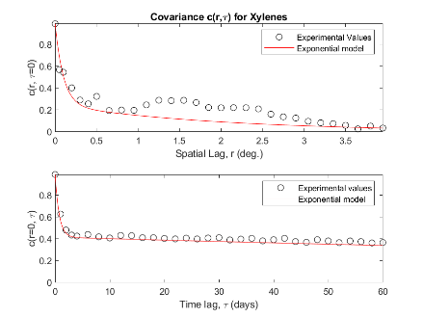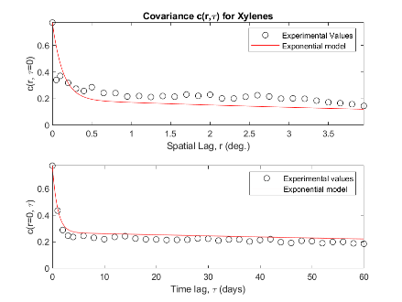
Figure S14. Spatial and temporal structures of log-SBTEX covariance models. From top to bottom, row 1: styrene; row 2: benzene; row 3: toluene, row 4: ethylbenzene; row 5: xylenes. Left column: covariance model using a flat global offset (i.e., GO=1); center column: covariance models using a domain-wide S/T-KS global offset for styrene, toluene, ethylbenzene, and xylenes (STEX) (i.e., GO=2) and a S-LUR+ domain-wide T-KS global offset for benzene (i.e., GO=6); right column: covariance models using a local S/T-KS global offset for STEX (i.e., GO=5) and a S-LUR+ semi-local T-KS global offset for benzene (i.e., GO=8).
For ease of comprehension, Figure 15 shows a flow diagram depicting the steps of the BME data fusion with global offset methodology. The BME processes (shown in each rectangle) are color-coded in grey, pink, green, and blue corresponding to data, BME step 1, BME step 2, and BME step 3, respectively.
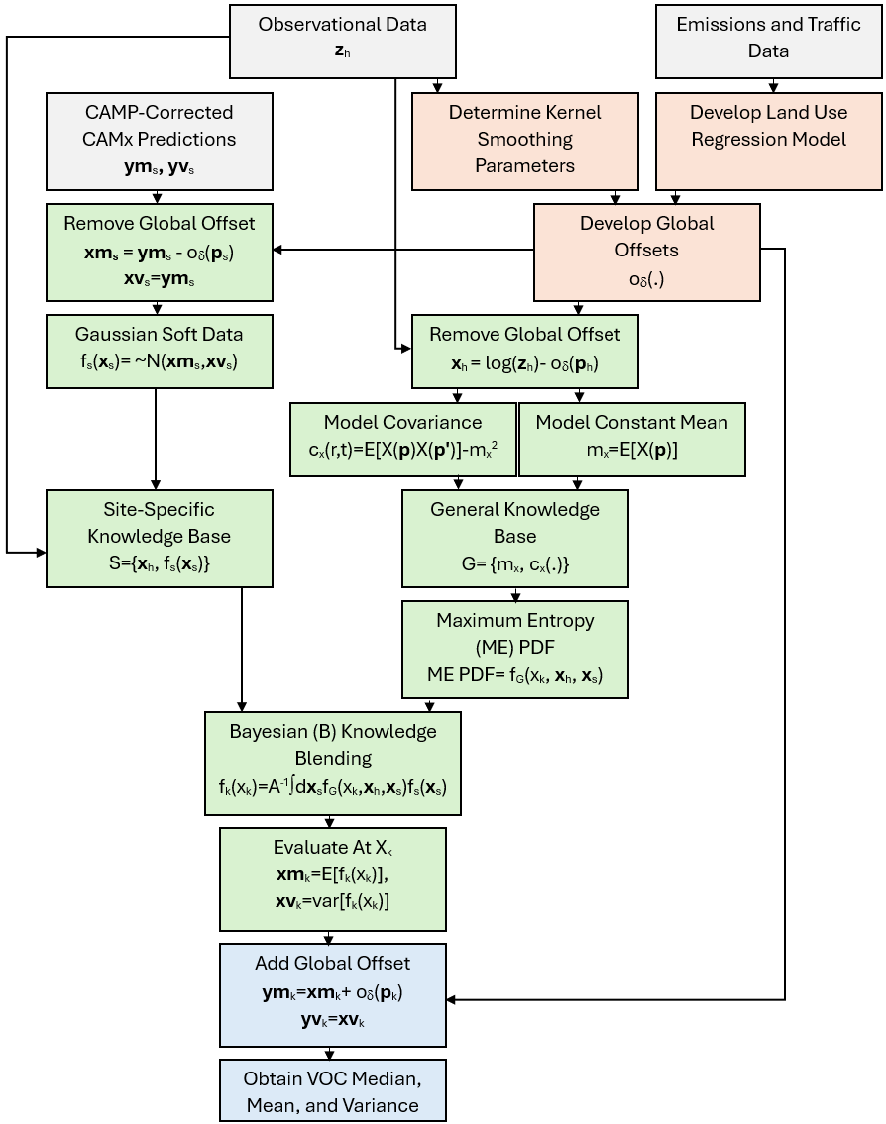
Figure S15. Flow chart demonstrating the BME data fusion with global offsets methodology to estimate SBTEX at a location p_{k}, where p_{k}=[s, t] and s=(s₁, s₂) is a 2D spatial location and t is time. Boxes filled with grey represent the data, boxes filled with pink represent BME step 1 processes, boxes filled with green represent BME step 2 processes, and boxes filled with blue represent BME step 3 processes. Relevant formulas and variables are included below the process description in each box.
S7. BME Spatial Estimate Development
A step-by-step analysis of creating BME data fusion estimates is documented below, using log-styrene on August 4th, 2012, as an example. First, observational data is gathered and aggregated (Figure S16).
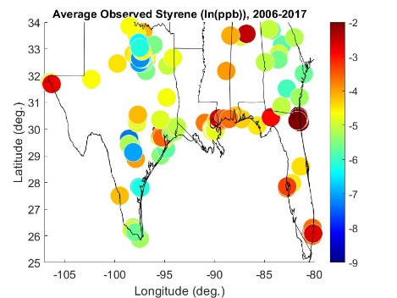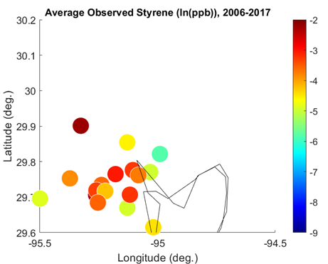
Figure S16. Average observed concentrations of log-styrene from 2006 to 2017. Left panel: average concentrations in the Gulf States; right panel: average concentrations in Houston, Texas.
Next, global offsets are created based on observational data. A spatial component of a flat global offset was a single mean value across the region, which is not highly informed by observational data (Figure S17). Conversely, space/time kernel smoothing (KS), pulled more information from observational data, and could reveal regional trends of styrene concentrations from 2006 to 2017 (Figure S17). For example, S/T-KS revealed higher average styrene values from 2006-2017 near the western and eastern borders of the Gulf States (Figure S17).
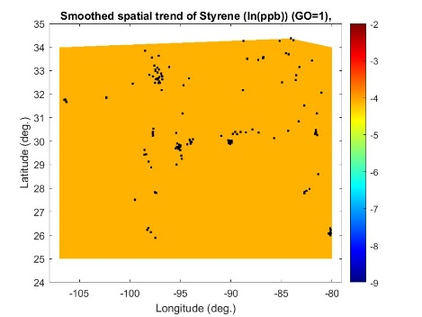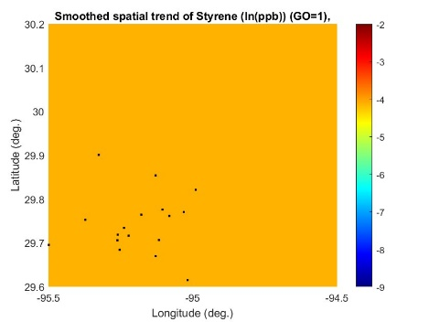
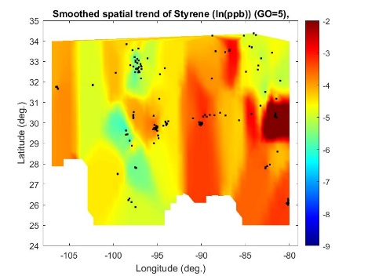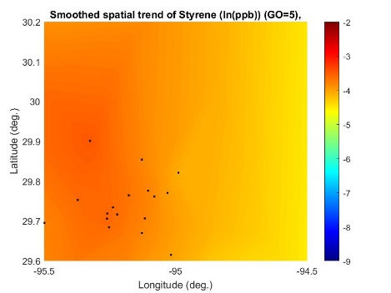
Figure S17. Smoothed spatial global offsets for log-styrene. Black dots denote monitoring station locations from 2006 to 2017. Left column: global offsets across the Gulf States; right column: global offsets in Houston, Texas. Top row: flat global offsets; bottom row: local S/T-KS global offsets.
Using global offsets, observational interpolation of log-styrene values could be performed. When log-styrene observational interpolation was performed using a flat global offset, estimates reflected measured values on the estimated day when close to monitoring locations or were informed by historic monitoring data in the region when close to historic monitoring data locations (Figure S18). However, when far from monitoring station information, log-styrene estimates returned to the estimate provided by the flat global offset (Figure S18). Conversely, when S/T-KS was implemented for observational interpolation, log-styrene estimates were informed by present and historical observational data when close to monitoring station locations, however, estimates far from monitoring stations reflected regional trends identified using S/T-KS (Figure S18).
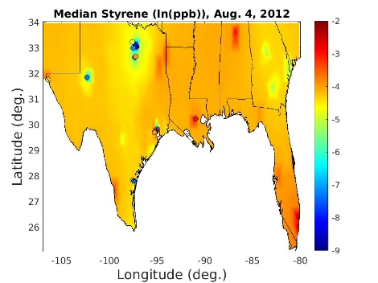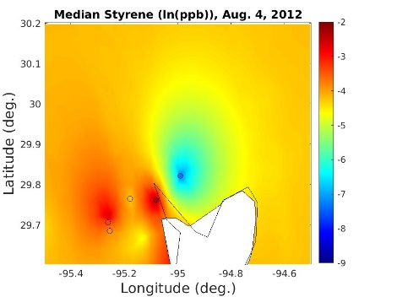
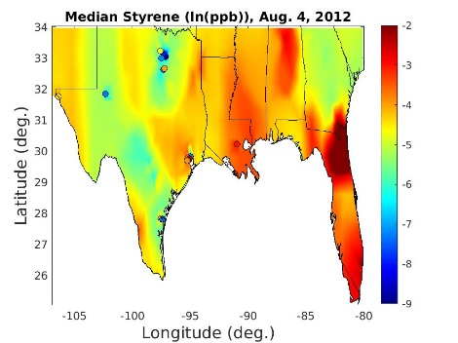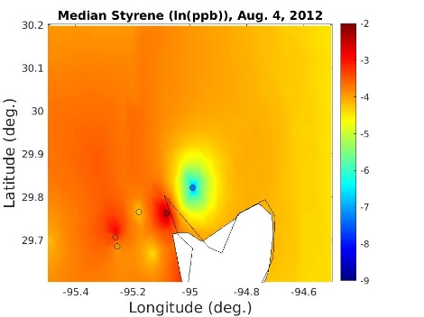
Figure S18. Observational interpolation of log-styrene using global offsets on August 4th, 2012. Color-filled circles represent log-styrene measurements on August 4th, 2012. Left column: global offsets across the Gulf States; right column: global offsets in Houston, Texas. Top row: flat global offsets; bottom row: local S/T-KS global offsets.
Uncorrected CAMx log-styrene estimates were very high in centralized locations reflecting plume estimation but quickly dropped to low values (i.e., -9 log(ppb) or less) within short distances of plumes (Figure S19). These graphical results agree with CAMP curve findings that CAMx underpredicted log-styrene when CAMx predicted low and CAMx overpredicted log-styrene when CAMx predicted high (Figure S4). After applying the CAMP correction of estimated values using the λ₁ curve, high CAMx values were attenuated lower, and low CAMx values were attenuated higher (Figure S19).

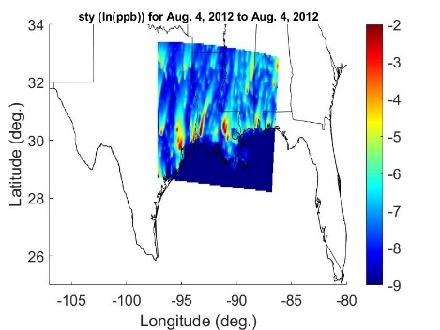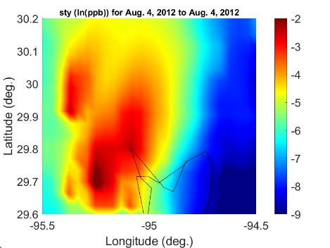
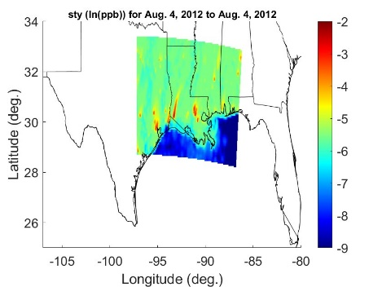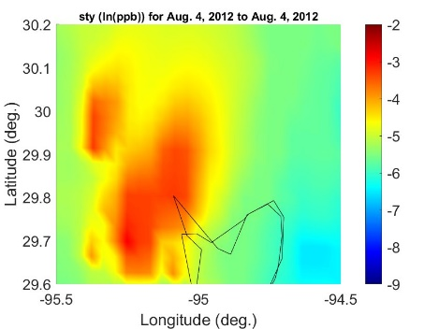
Figure S19. Application of CAMP correction to CAMx log-styrene data on August 4th, 2012. Left column: global offsets across the Gulf States; right column: global offsets in Houston, Texas. Top row: uncorrected CAMx; bottom row: CAMP-corrected CAMx.
Figure S20 shows BME estimates obtained using global offsets and CAMP-corrected CAMx. When using a flat global offset, BME estimates reflected CAMP-corrected CAMx values when close to the CAMx-modeled domain but returned to the mean value away from CAMx (Figure S19). Conversely, BME estimates created using a S/T-KS global offset reflected CAMP-corrected CAMx when close to the CAMx-modeled domain but were also informed by the regional observational trends identified using S/T-KS across the Gulf States (Figure S20).

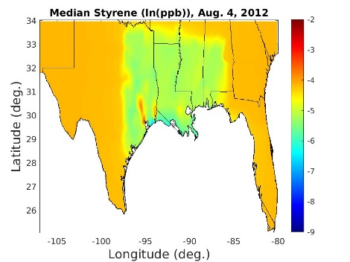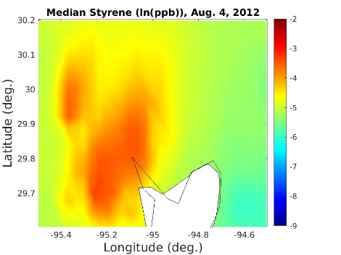
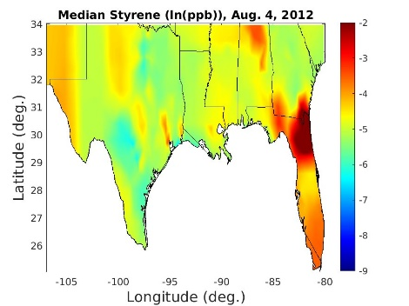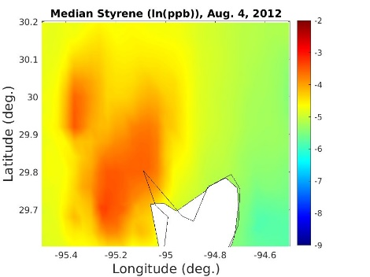
Figure S20. BME log-styrene estimates using global offsets and CAMP-corrected CAMx on August 4th, 2012. Left column: global offsets across the Gulf States; right column: global offsets in Houston, Texas. Top row: flat global offsets; bottom row: local S/T-KS global offsets.
Finally, BME estimates of log-styrene were created using observational data, global offsets, and CAMP-corrected CAMx. When a flat global offset was used, log-styrene estimates reflected observational data when close to a monitoring station, CAMP-corrected CAMx when near the CAMx-modeled domain and away from a monitoring station, and the flat, mean trend value when far from CAMx and monitoring stations (Figure S21). Using the S/T-KS global offset, log-styrene estimates reflected observational data when close to a monitoring station, CAMP-corrected CAMx when near the CAMx-modeled domain and away from a monitoring station, and regional trends in observational data across the domain from the global offset (Figure S21).

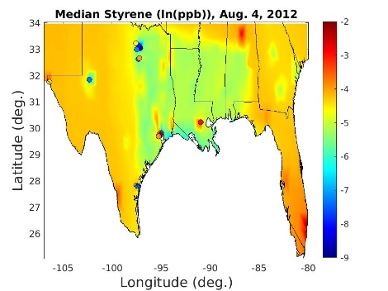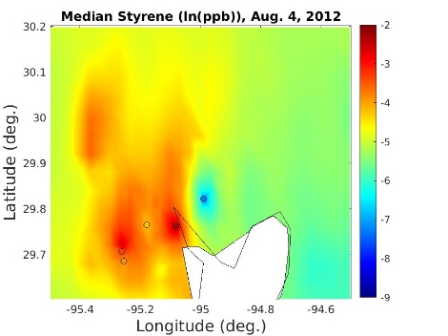
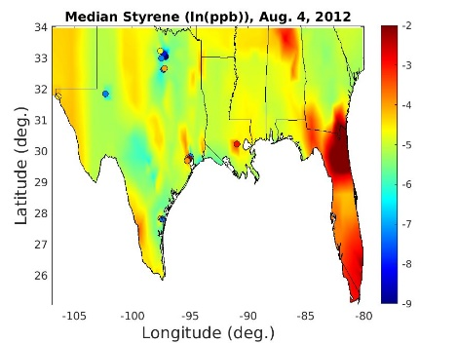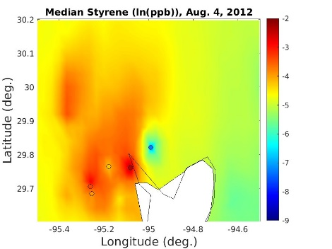
Figure S21. BME log-styrene estimates using global offsets, CAMP-corrected CAMx, and observational data on August 4th, 2012. Color-filled circles represent log-styrene measurements on August 4th, 2012. Left column: global offsets across the Gulf States; right column: global offsets in Houston, Texas. Top row: flat global offsets; bottom row: local S/T-KS global offsets.
Comparing BME estimates using S/T-KS and either CAMP-corrected CAMx or observational data revealed how different information sources were blended in Houston, Texas. Figure S22 shows that the CAMP-corrected CAMx predicted a plume of high log-styrene concentrations in Western Houston on August 4th, 2012. Observational measurements of log-styrene concentrations revealed generally higher styrene values in Western Houston, lower measured values about 0.2 degrees longitude west of the Houston Ship Channel, and very low measured values east of the Houston Ship Channel (Figure S22). BME data fusion of CAMP-corrected CAMx and observation data using a S/T-KS global offset, allowed for knowledge blending and log-styrene estimates that revealed the CAMP-corrected CAMx-estimated plume in Western Houston, while simultaneously incorporating local observational data (Figure S22).
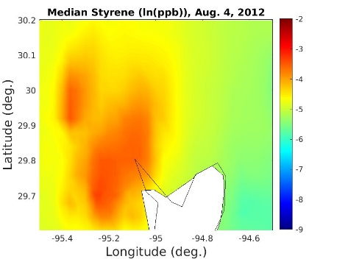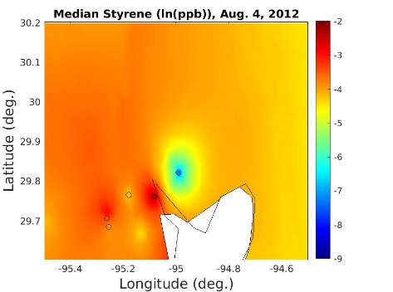
Figure S22. BME log-styrene estimates using a S/T-KS global offset on August 4th, 2012. Color-filled circles represent log-styrene measurements on August 4th, 2012. Left panel: BME data fusion estimates using CAMP-corrected CAMx only; center panel: BME data fusion estimates using observational data only; right panel: BME data fusion estimates using CAMP-corrected CAMx and observational data.
Finally, a comparison of uncorrected CAMx and BME data fusion estimates created using a S/T-KS global offset, observational data, and CAMP-corrected CAMx (BME) allowed for the identification of BME contributions to log-styrene estimation. For example, the negative difference between uncorrected CAMx and BME estimates in Eastern Houston is reflective of the CAMP-correction of CAMx that attenuated the underestimation on log-styrene when CAMx predicted low (Figure S23). When close to monitoring stations, positive or negative, localized differences were the result of the inclusion of observational data (Figure S23). Finally, slight positive differences between CAMx and BME estimates were revealed north of the Houston coastline, which may be the result of regional CAMx attenuation from the CAMP correction and/or domain-wide information provided by S/T-KS (Figure S23).
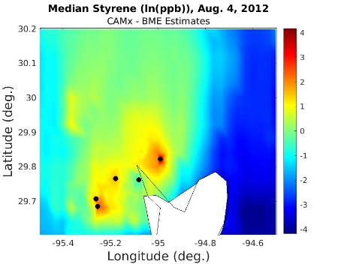
Figure S23. BME log-styrene estimates and method differences on August 4th, 2012. Color-filled circles represent log-styrene measurements on August 4th, 2012. Black dots represent log-styrene monitoring locations with measurements on August 4th, 2012. Left panel: uncorrected CAMx log-styrene estimates; center panel: BME data fusion estimates using CAMP-corrected CAMx and observational data; right panel: differences between uncorrected CAMx and BME data fusion log-styrene estimates.
S8. BME Model Validation
Three scenarios are shown in Figure S24. In each scenario, the CAMx R-value is constant, but depicts a different situation, with low, intermediate, and high CAMx performance shown on the left, center, and right panels, respectively, of Figure S24, as indicated by the red dashed lines. Finally, the BME data fusion method is depicted, via the solid yellow lines, as having, for each radius, the highest performance between observation-only and CAMx-only predictions, with implications for methodology selection described in Figure S24.
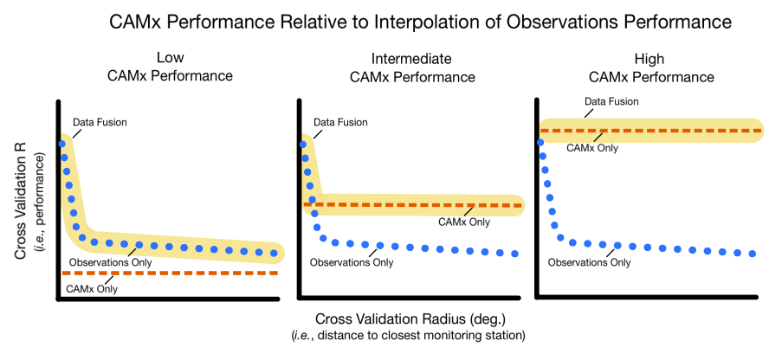Figure S24. Example Radius Cross Validation (RCV) plots for low, intermediate, and high CAMx performance, where data fusion aligns closely with the highest performing method at a given cross-validation radius (X-axis). Left panel: CAMx performance is poor (i.e., never better than observation interpolation), and observation interpolation is selected to estimate SBTEX. Center panel: CAMx performance is intermediate (i.e., sometimes better than observation interpolation), so data fusion is selected to estimate SBTEX. Right panel: CAMx performance is good (i.e., always better than observation interpolation), so CAMx is only selected to estimate SBTEX.
We evaluated SBTEX estimation methods using Pearson and Spearman R values as a cross-validation metric. The root mean square error or mean absolute percentage error would be useful metrics to measure model error, but they were not used in this work. The decision to use R-values rather than error-based metrics was based on the goal of making this work interpretable to broad audiences, especially those in epidemiology, which are not typically well-versed in air quality model error or significance.
RCV was used to compare the performance of observational data interpolation using a 1) flat (least computationally intense), 2) medium-resolution (moderately intense), and 3) fine-resolution (moderately intense) global offset. Method intensity was based on whether observational data pre-processing, global offset processing, and CAMx modeling were required for the method, the amount of time required to create a spatial estimate on a single day, and the amount of time required to complete an RCV curve. Table S12 summarizes the characteristics of each method intensity level. These method characteristics are crucially important to consider because others looking to implement this methodology may not have the time or resources to apply these methods.
Table S12. Comparison of method intensity levels evaluated for SBTEX estimation using BME data fusion with global offsets.
Method Intensity | Observational Data Pre-processing | Global Offset Processing (KS parameters and LUR development) | CAMx Modeling | Daily Estimate Mapping |  | One RCV Curve Time Requirement^{1,2}
 |  |  |  | Total Hard/Soft Data Points Available for Estimation | Time Requirement of Computation¹ | One RCV Curve Time Requirement^{1,2}
Least | Yes | No | No | 88,000-132,000 | <10 seconds | <20 minutes
Moderate | Yes | Yes | No | 88,000-132,000 | <10 seconds | <20 minutes
Most | Yes | Maybe³ | Yes | 1,480,000-1,520,000 | <5 minutes | <6 hours
¹Performed using the University of North Carolina’s Longleaf MATLAB GPU (CPU=2; memory=16g)
²Estimated as the time required to calculate RCV radius for 2011-2012 and multiplying by 7 (e.g., number of radii tested in RCV curve)
³Global offset processing will occur unless a flat global offset (go=1) is selected

For each global offset resolution, the global offset is either LUR or kernel smoothing, and if it is kernel smoothing, it can be of subtypes ‘domain-wide’ or ‘regional’ for the medium resolution, and of subtypes ‘semi-local’ or ‘local’ for the fine resolution. For styrene, toluene, ethylbenzene, and xylenes, the medium-resolution global offset was ‘Spatial KS Domain-wide & Temporal KS domain-wide and the fine-resolution global offset was ‘Spatial KS Local & Temporal KS Local. For benzene, the medium-resolution global offset was ‘Spatial LUR & Temporal KS Domain-wide and the fine-resolution global offset was ‘Spatial LUR & Temporal KS Semi-local.’ They were obtained by choosing the one with the best Pearson and Spearman R-values at a radius of 3 degrees. This was done because the computational cost associated with this work was very high and evaluating the full RCV curve for each subtype was too costly. Similarly, the ‘best’ global offset resolution for the data fusion method was selected by choosing the one with the highest R-value at a radius of 3 degrees. Table S13 shows a summary of the flat, medium-resolution, and fine-resolution spatial and temporal components selected and evaluated as SBTEX global offsets.

Table S13. Subtypes of the spatial and temporal components of the global offsets that were selected for each VOC and each global offset resolution. The subtypes were selected based on having the highest R-value at a cross-validation radius of three degrees. Details about the selected subtypes are shown in boldface in Tables S2-S6.
Species Name | Global Offset Resolution
Species Name | Flat | Medium | Fine
Styrene | Constant | Spatial KS Domain-wide &  Temporal KS Domain-wide | Spatial KS Local &  Temporal KS Local
Benzene | Constant | Spatial LUR &  Temporal KS Domain-wide | Spatial LUR &  Temporal KS Semi-local
Toluene | Constant | Spatial KS Domain-wide &  Temporal KS Domain-wide | Spatial KS Local &  Temporal KS Local
Ethylbenzene | Constant | Spatial KS Domain-wide &  Temporal KS Domain-wide | Spatial KS Local &  Temporal KS Local
Xylenes | Constant | Spatial KS Domain-wide &  Temporal KS Domain-wide | Spatial KS Local &  Temporal KS Local

S9. Complete Validation Results Within the CAMx-modeled Domain
For ease of interpretation, we henceforward refer to ${ym}_{k}$ as ${logVOC}_{mean}$ and to ${yv}_{k}$ as ${logVOC}_{variance}$. Then, it follows that the BME PDF (equation 4) could similarly be defined as $Y_{k}\sim Gaussian({logVOC}_{mean},{logVOC}_{variance})$ and $Z_{k}=exp⁡(Y_{k})$ correspondingly has a median, mean, and variance given by
${VOC}_{median}={exp⁡(logVOC}_{mean})$ (Eqn. S3)
${VOC}_{mean}=exp⁡({logVOC}_{mean}+\frac{{logVOC}_{variance}}{2})$ (Eqn. S4)
${VOC}_{variance}=\left[\exp\left({logVOC}_{variance}\right)-1\right][{exp⁡(2logVOC}_{mean}+{logVOC}_{variance})]$
(Eqn. S5)
RCV curves for logVOC_{mean}, VOC_{median}, and VOC_{mean} estimates inside of CAMx for each SBTEX pollutant are in the following figures: Figure S25 (styrene), Figure S26 (benzene), Figure S27 (toluene), Figure S28 (ethylbenzene), and Figure S29 (xylenes).
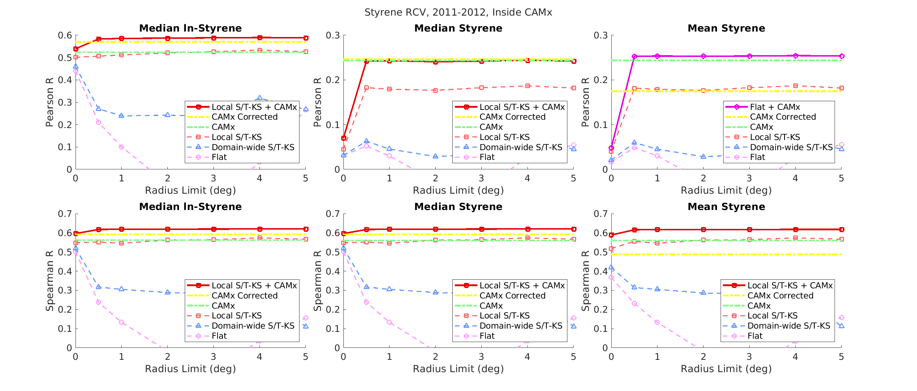Figure S25. RCV plots for styrene estimation on the inside of CAMx region. Top row: RCV plots using the Pearson R as the Cross Validation R; bottom row: RCV plots using the Spearman R as the Cross Validation R. Left column: logVOC_{mean} RCV plots; center column: VOC_{median} RCV plots; right column: VOC_{mean} RCV plots.

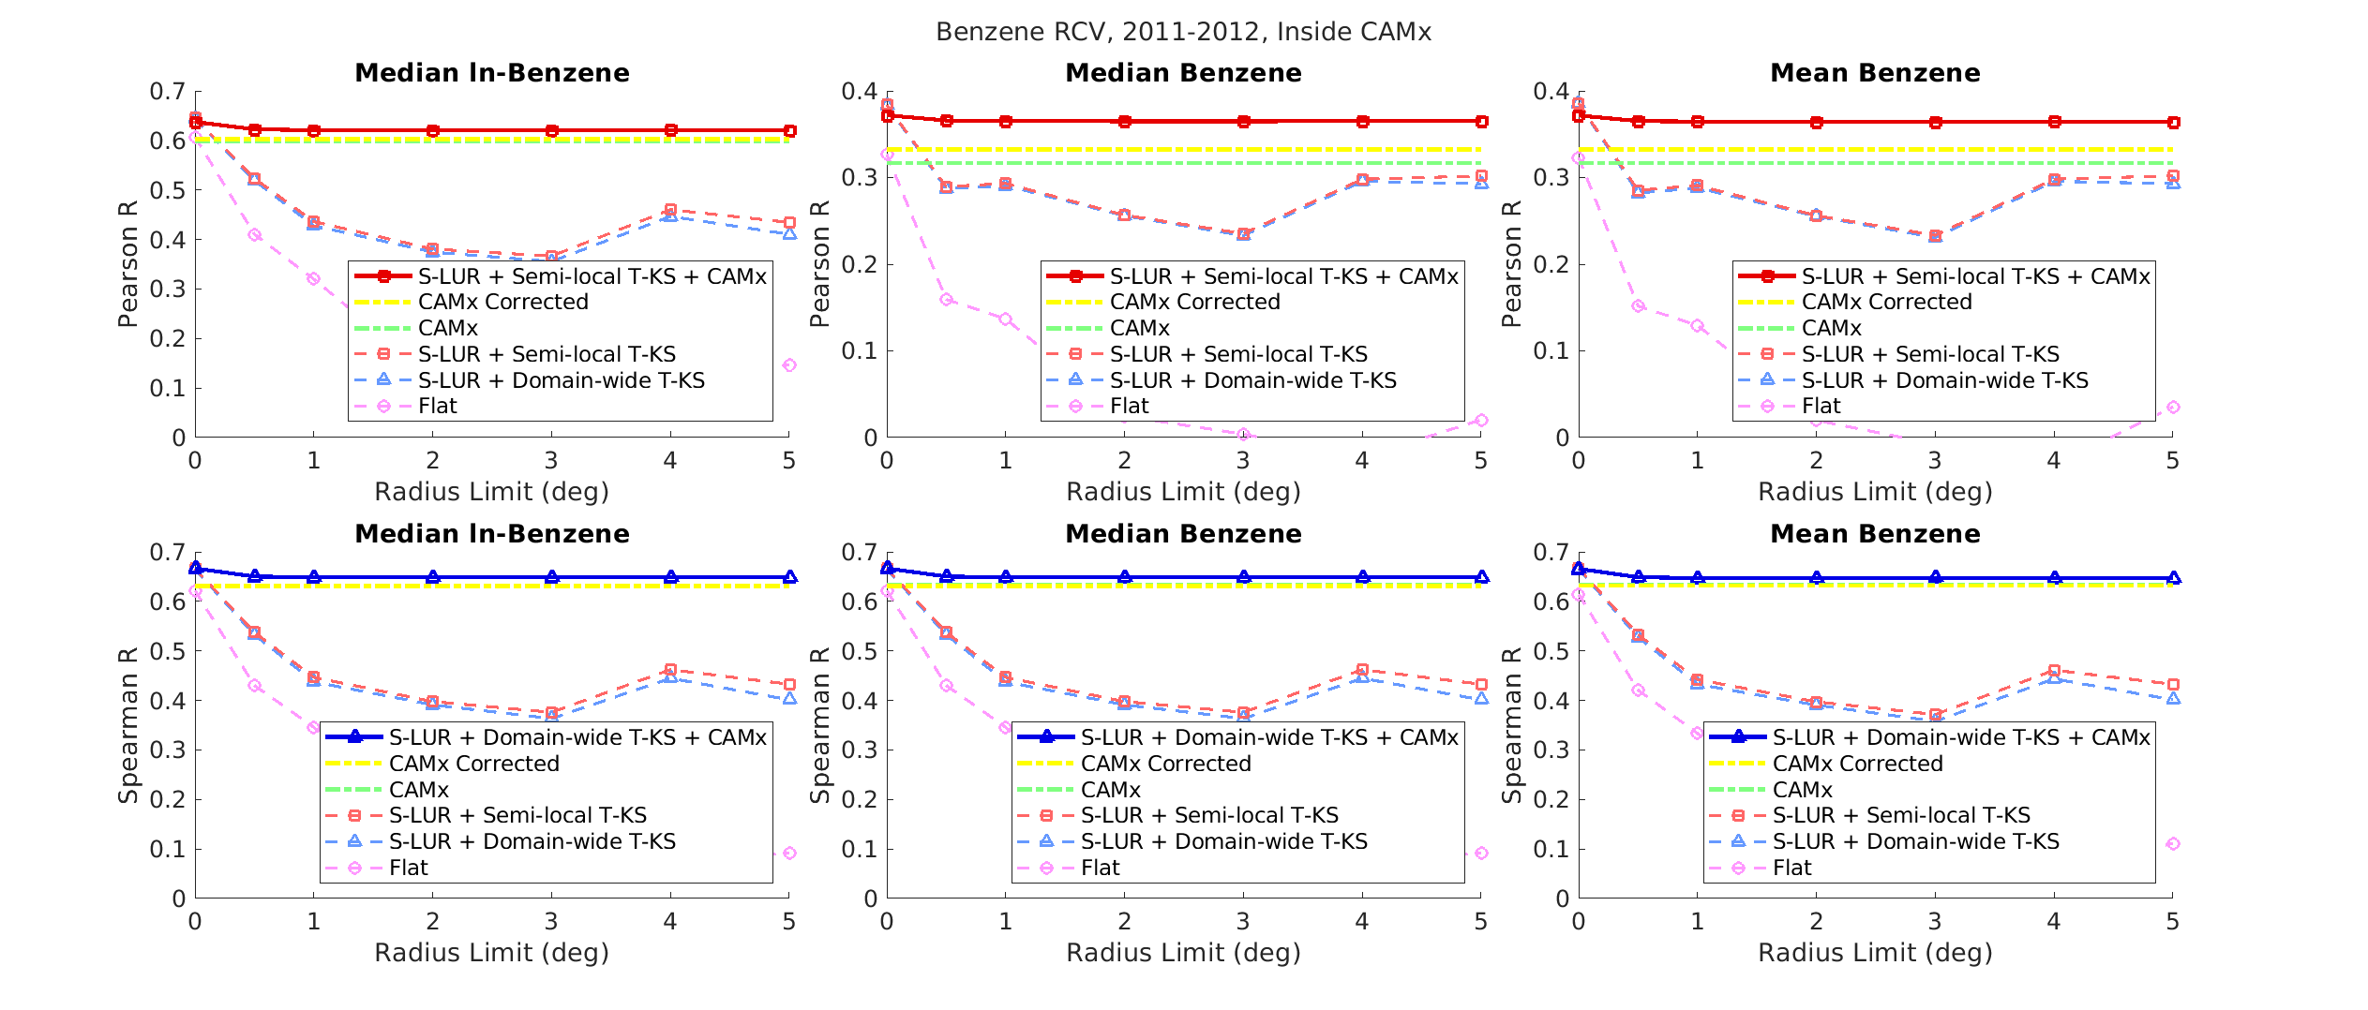Figure S26. RCV plots for benzene estimation on the inside of CAMx region. Top row: RCV plots using the Pearson R as the Cross Validation R; bottom row: RCV plots using the Spearman R as the Cross Validation R. Left column: logVOC_{mean} RCV plots; center column: VOC_{median} RCV plots; right column: VOC_{mean} RCV plots.

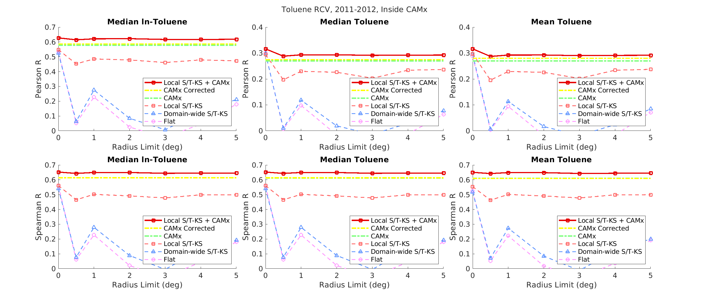Figure S27. RCV plots for benzene estimation on the toluene of CAMx region. Top row: RCV plots using the Pearson R as the Cross Validation R; bottom row: RCV plots using the Spearman R as the Cross Validation R. Left column: logVOC_{mean} RCV plots; center column: VOC_{median} RCV plots; right column: VOC_{mean} RCV plots.

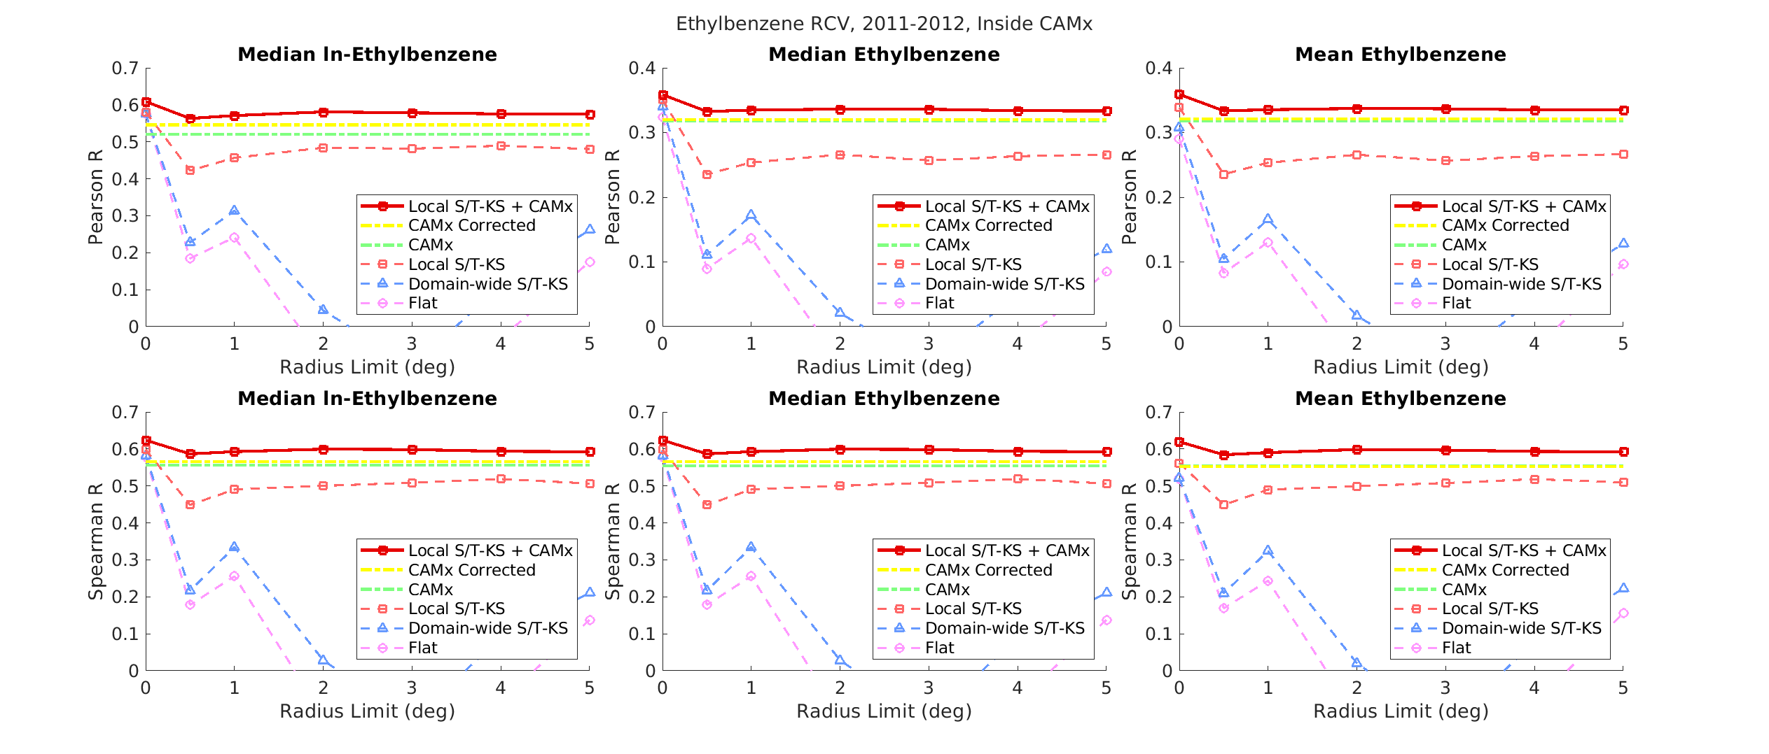Figure S28. RCV plots for ethylbenzene estimation on the inside of CAMx region. Top row: RCV plots using the Pearson R as the Cross Validation R; bottom row: RCV plots using the Spearman R as the Cross Validation R. Left column: logVOC_{mean} RCV plots; center column: VOC_{median} RCV plots; right column: VOC_{mean} RCV plots.

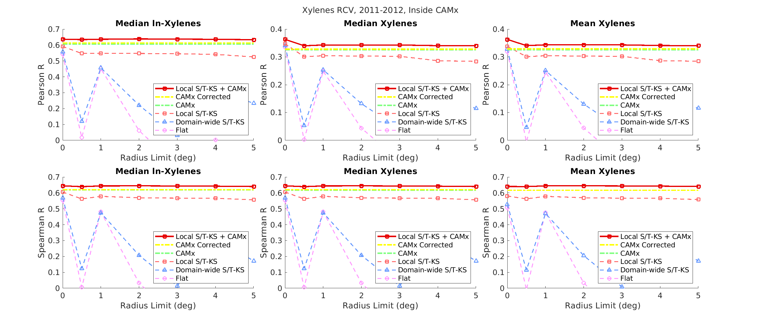Figure S29. RCV plots for xylenes estimation on the inside of CAMx region. Top row: RCV plots using the Pearson R as the Cross Validation R; bottom row: RCV plots using the Spearman R as the Cross Validation R. Left column: logVOC_{mean} RCV plots; center column: VOC_{median} RCV plots; right column: VOC_{mean} RCV plots.
Interpolation of SBTEX observation performance for VOC_{mean} RCV curves was like VOC_{median} RCV curves for order, shape, and value (Figures S25-S29). CAMP correction of CAMx unexpectedly caused a decrease in VOC_{mean} estimation performance from unaltered CAMx performance for styrene Pearson R and Spearman R, ethylbenzene Spearman R RCV curves (Figure S25, Figures S28). This behavior may result from the CAMP correction being performed using observational and CAMx values without variance but considering CAMP-corrected CAMx variance for mean performance. If one had used VOC_{mean} RCV curves to select SBTEX estimation methods rather than VOC_{median} RCV curves, the same estimation methods would have been selected for SBTEX estimation inside of CAMx (Figures S25-S29). This finding extends to mean styrene concentrations because the Spearman R recommendation would be selected over the Pearson R, which on average was less than 50% of the average Spearman R value (Figure S25).
Interpolation of logVOC_{mean} observations performed in the same fashion as VOC_{median} observation interpolation for SBTEX, where a flat global offset performed the worst, a medium-resolution global offset performed better, and finally a fine-resolution global offset performed the best (Figures S25-S29). CAMx performance was intermediate for logVOC_{mean}, so fine-resolution global offset+CAMx data fusion methods were selected for each SBTEX component. Again, method selection for mean log-benzene deferred to the Pearson R RCV curves because they monotonically decreased over radius limits and were on average greater than 50% of average Spearman R values (Figure S26). Interpolation of mean log-styrene concentrations for Pearson and Spearman R performed like median styrene Spearman R RCV curves, which suggested that the Pearson R for styrene concentrations was susceptible to extreme value effects (Figure S25). Like median styrene RCV data fusion, mean log-styrene data fusion revealed a performance increase from a radius limit of 0 degrees to a radius limit of 0.5 degrees (Figure S25).
Interestingly, observational interpolation of logVOC_{mean} concentrations with a flat global offset yielded higher Pearson R and Spearman R values (approximately 0.5 to 0.6) than VOC_{median} or VOC_{mean} interpolation (Figures S25-S29), suggesting that SBTEX observation interpolation performed better for estimating logVOC_{mean} concentrations than VOC concentrations. This behavior is attributed to the higher autocorrelation of SBTEX concentrations after natural logarithm transformation.
Table S14 shows the CAMx, average RCV, and leave-one-out cross-validation (LOOCV) Pearson R performance of SBTEX estimation methods and VOC_{median} estimates. As global offset resolution increased, observational interpolation average RCV performance increased for all SBTEX (Table S14). Selected data fusion methods for SBTEX always outperformed observational interpolation (Table S14). Selected data fusion methods for BTEX outperformed CAMx Pearson R values, but not for styrene (Table S14).
Table S14. CAMx, observational interpolation using global offsets, and selected data fusion method Pearson R performance to estimate observed SBTEX inside of the CAMx-modeled domain. Observational interpolation and selected data fusion methods were evaluated using the average radius cross-validation (RCV). Selected data fusion methods were further evaluated using leave-one-out cross-validation (LOOCV). Performance was measured using VOC_{median} estimates.
VOC | CAMx Pearson R | Average RCV Pearson R |  |  |  | LOOCV Pearson R
VOC | CAMx Pearson R | Observational Interpolation |  |  | Selected Data Fusion Method | Selected Data Fusion Method
VOC | CAMx Pearson R | Flat Global Offset | Medium- Resolution Global Offset | Fine- Resolution Global Offset | Selected Data Fusion Method | Selected Data Fusion Method
Styrene | 0.244 | 0.018 | 0.045 | 0.162 | 0.218 | 0.370
Benzene | 0.317 | 0.093 | 0.291 | 0.294 | 0.366 | 0.449
Toluene | 0.270 | 0.056 | 0.077 | 0.231 | 0.295 | 0.407
Ethylbenzene | 0.318 | 0.062 | 0.108 | 0.270 | 0.338 | 0.421
Xylenes | 0.325 | 0.069 | 0.156 | 0.304 | 0.345 | 0.446

S10. Complete Validation Results Outside the CAMx-modeled Domain
RCV curves for logVOC_{mean}, VOC_{median}, and VOC_{mean} estimates outside of CAMx for each SBTEX pollutant are in the following figures: Figure S30 (styrene), Figure S31 (benzene), Figure S32 (toluene), Figure S33 (ethylbenzene), and Figure S34 (xylenes).
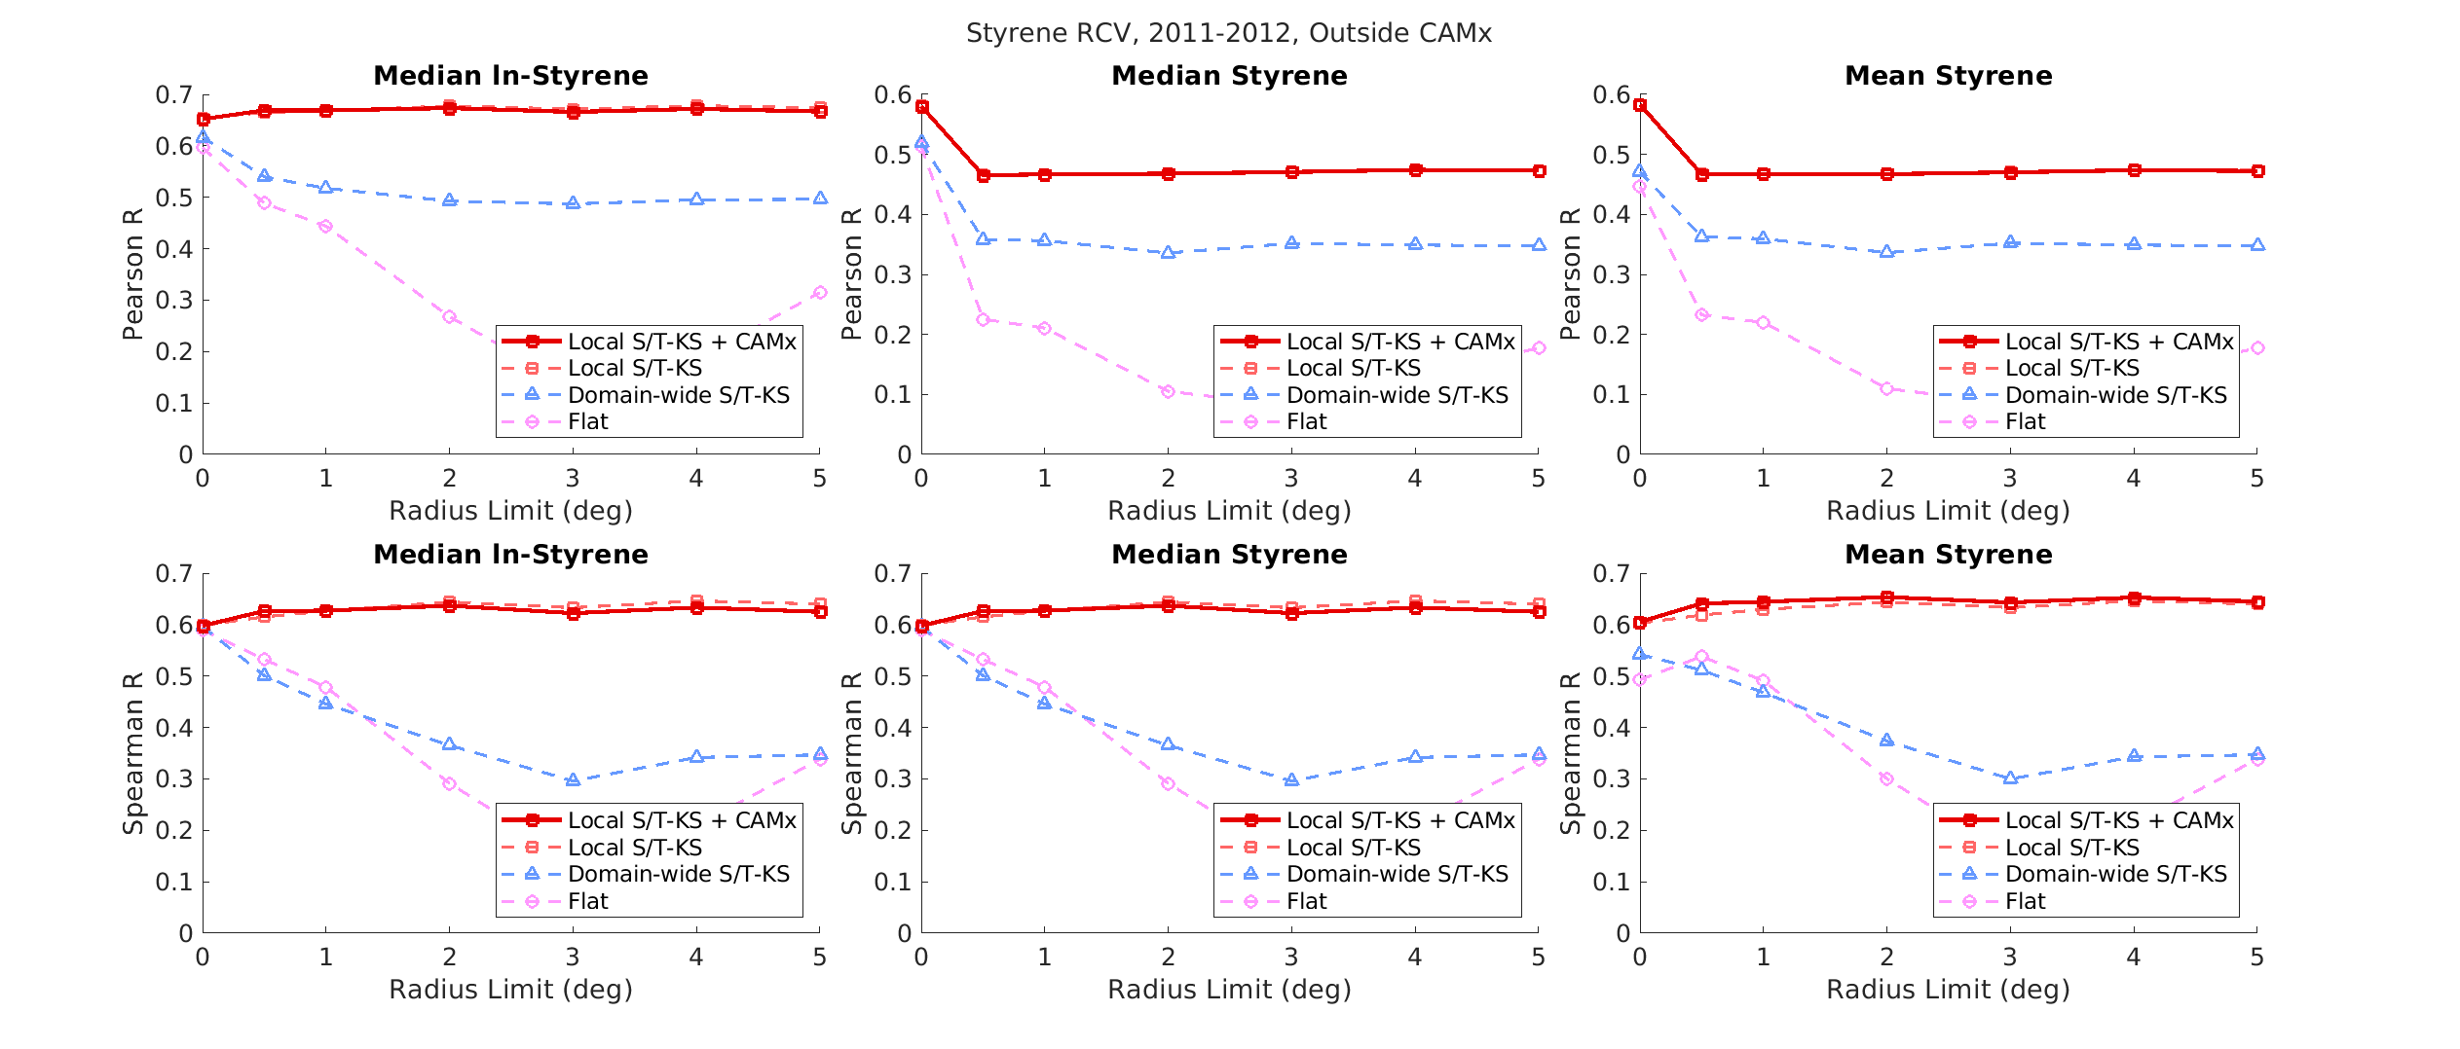Figure S30. RCV plots for styrene estimation on the outside of CAMx region. Top row: RCV plots using the Pearson R as the Cross Validation R; bottom row: RCV plots using the Spearman R as the Cross Validation R. Left column: logVOC_{mean} RCV plots; center column: VOC_{median} RCV plots; right column: VOC_{mean} RCV plots.

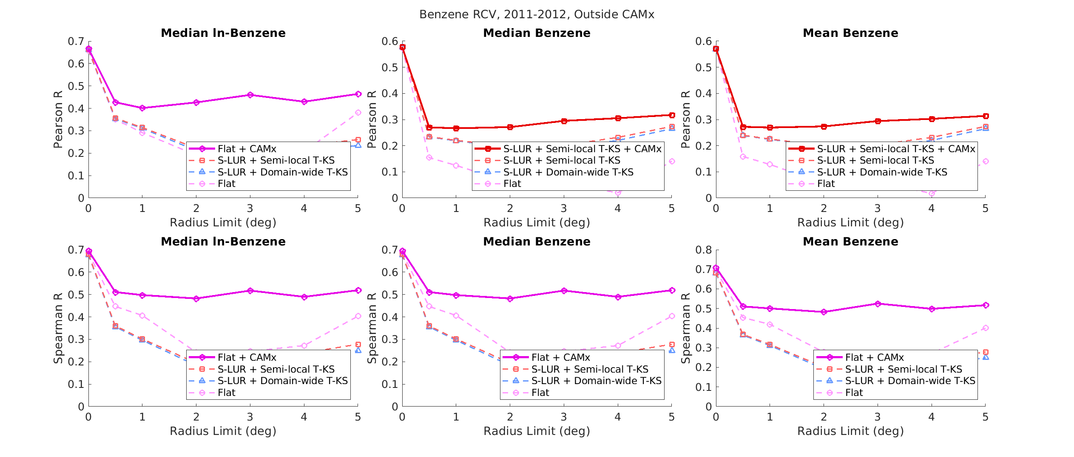Figure S31. RCV plots for benzene estimation on the outside of CAMx region. Top row: RCV plots using the Pearson R as the Cross Validation R; bottom row: RCV plots using the Spearman R as the Cross Validation R. Left column: logVOC_{mean} RCV plots; center column: VOC_{median} RCV plots; right column: VOC_{mean} RCV plots.

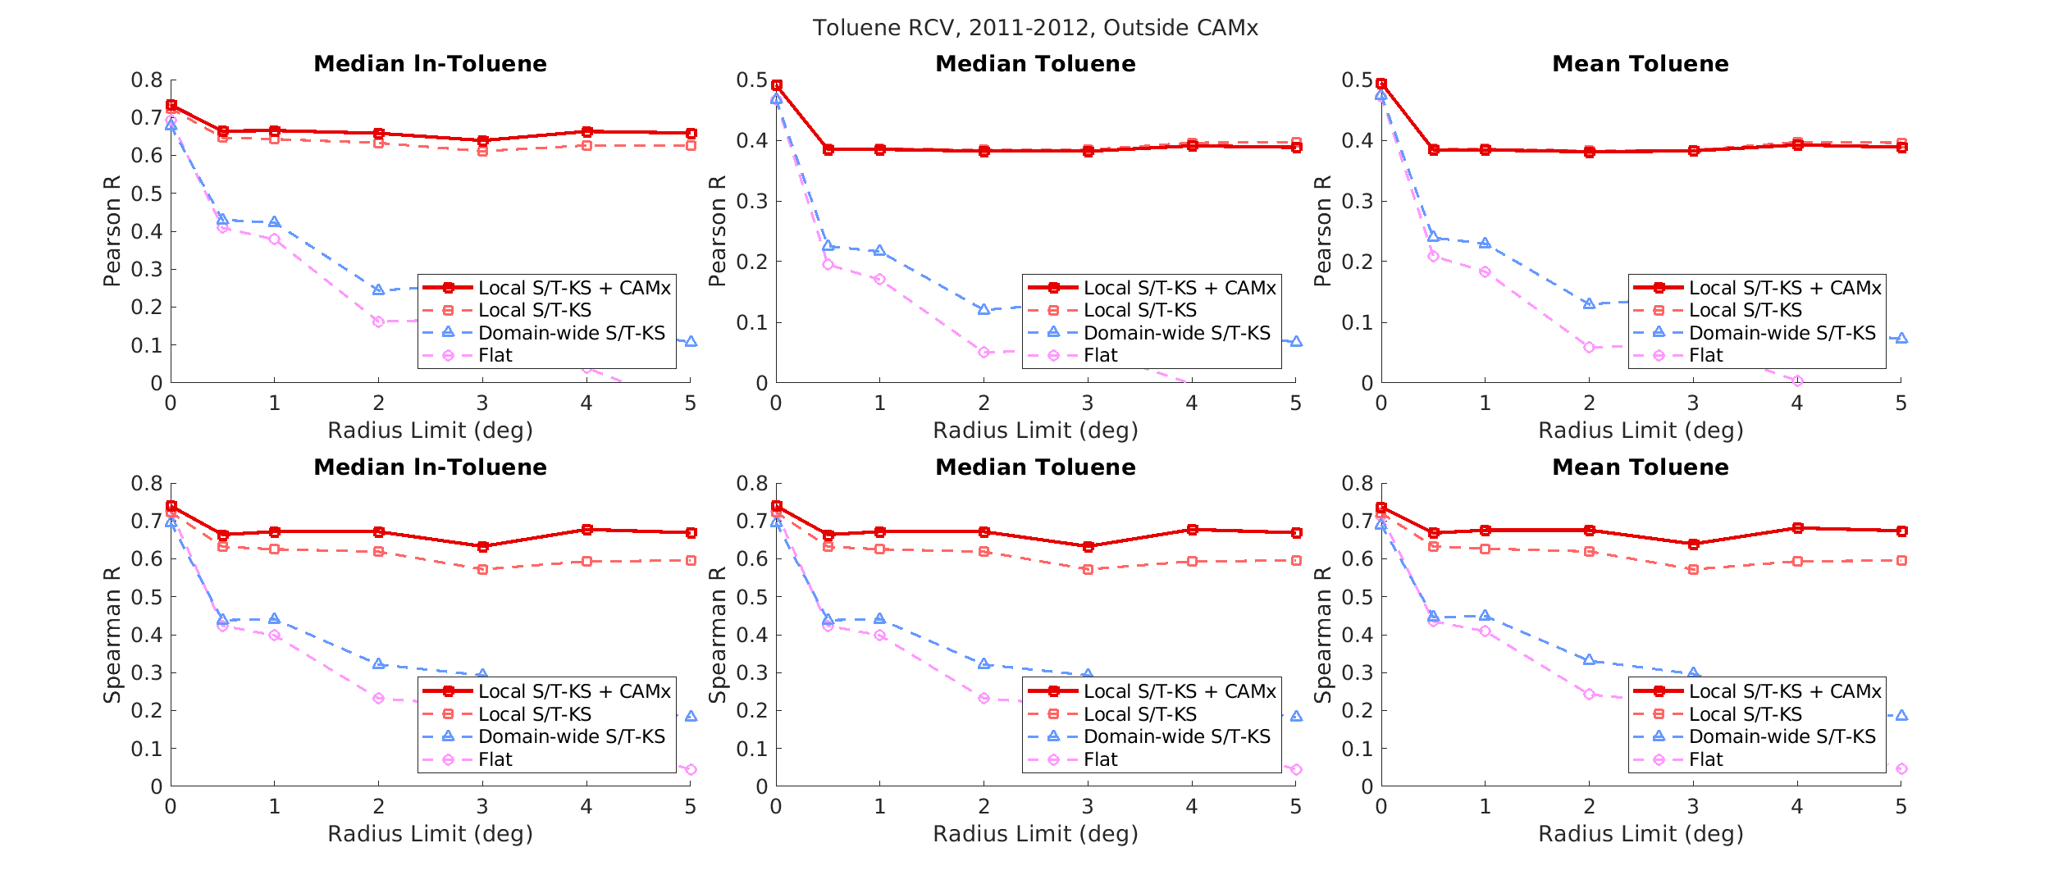Figure S32. RCV plots for benzene estimation on the outside of CAMx region. Top row: RCV plots using the Pearson R as the Cross Validation R; bottom row: RCV plots using the Spearman R as the Cross Validation R. Left column: logVOC_{mean} RCV plots; center column: VOC_{median} RCV plots; right column: VOC_{mean} RCV plots.

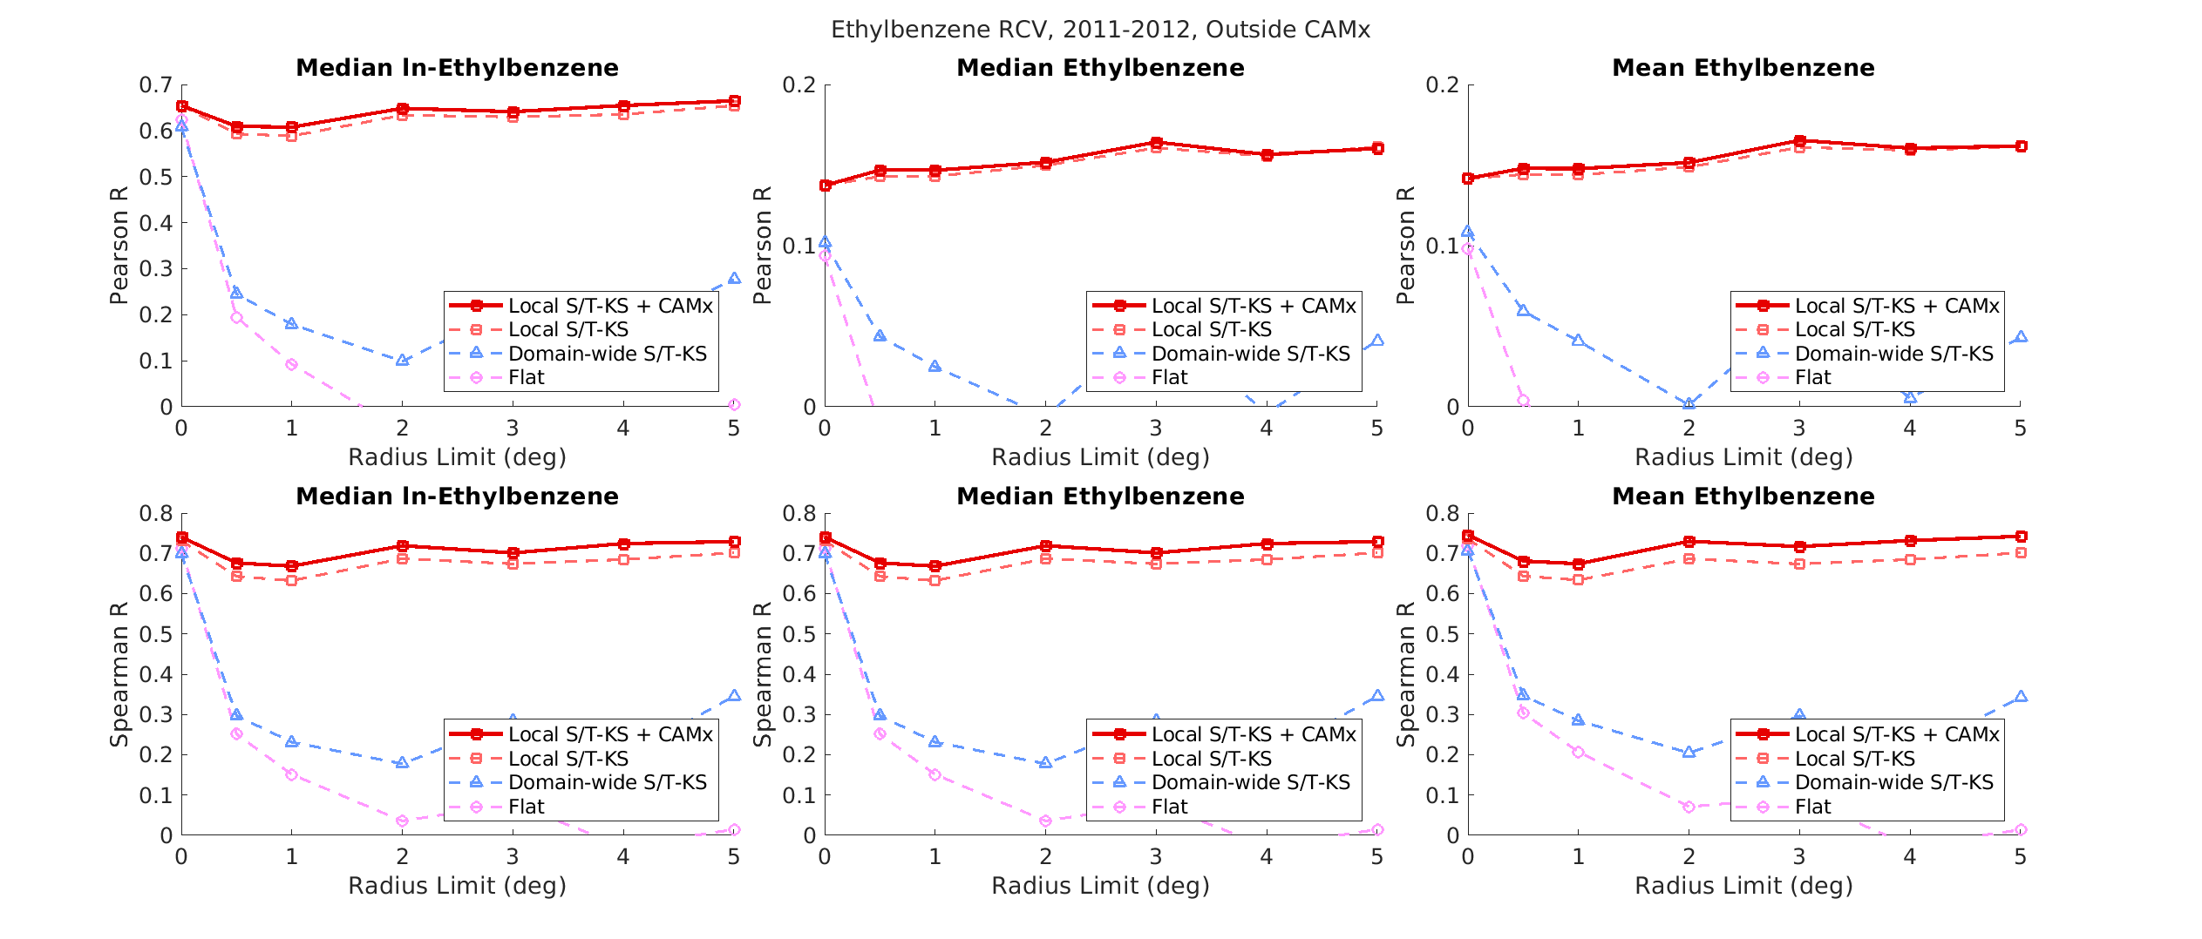Figure S33. RCV plots for ethylbenzene estimation on the outside of CAMx region. Top row: RCV plots using the Pearson R as the Cross Validation R; bottom row: RCV plots using the Spearman R as the Cross Validation R. Left column: logVOC_{mean} RCV plots; center column: VOC_{median} RCV plots; right column: VOC_{mean} RCV plots.

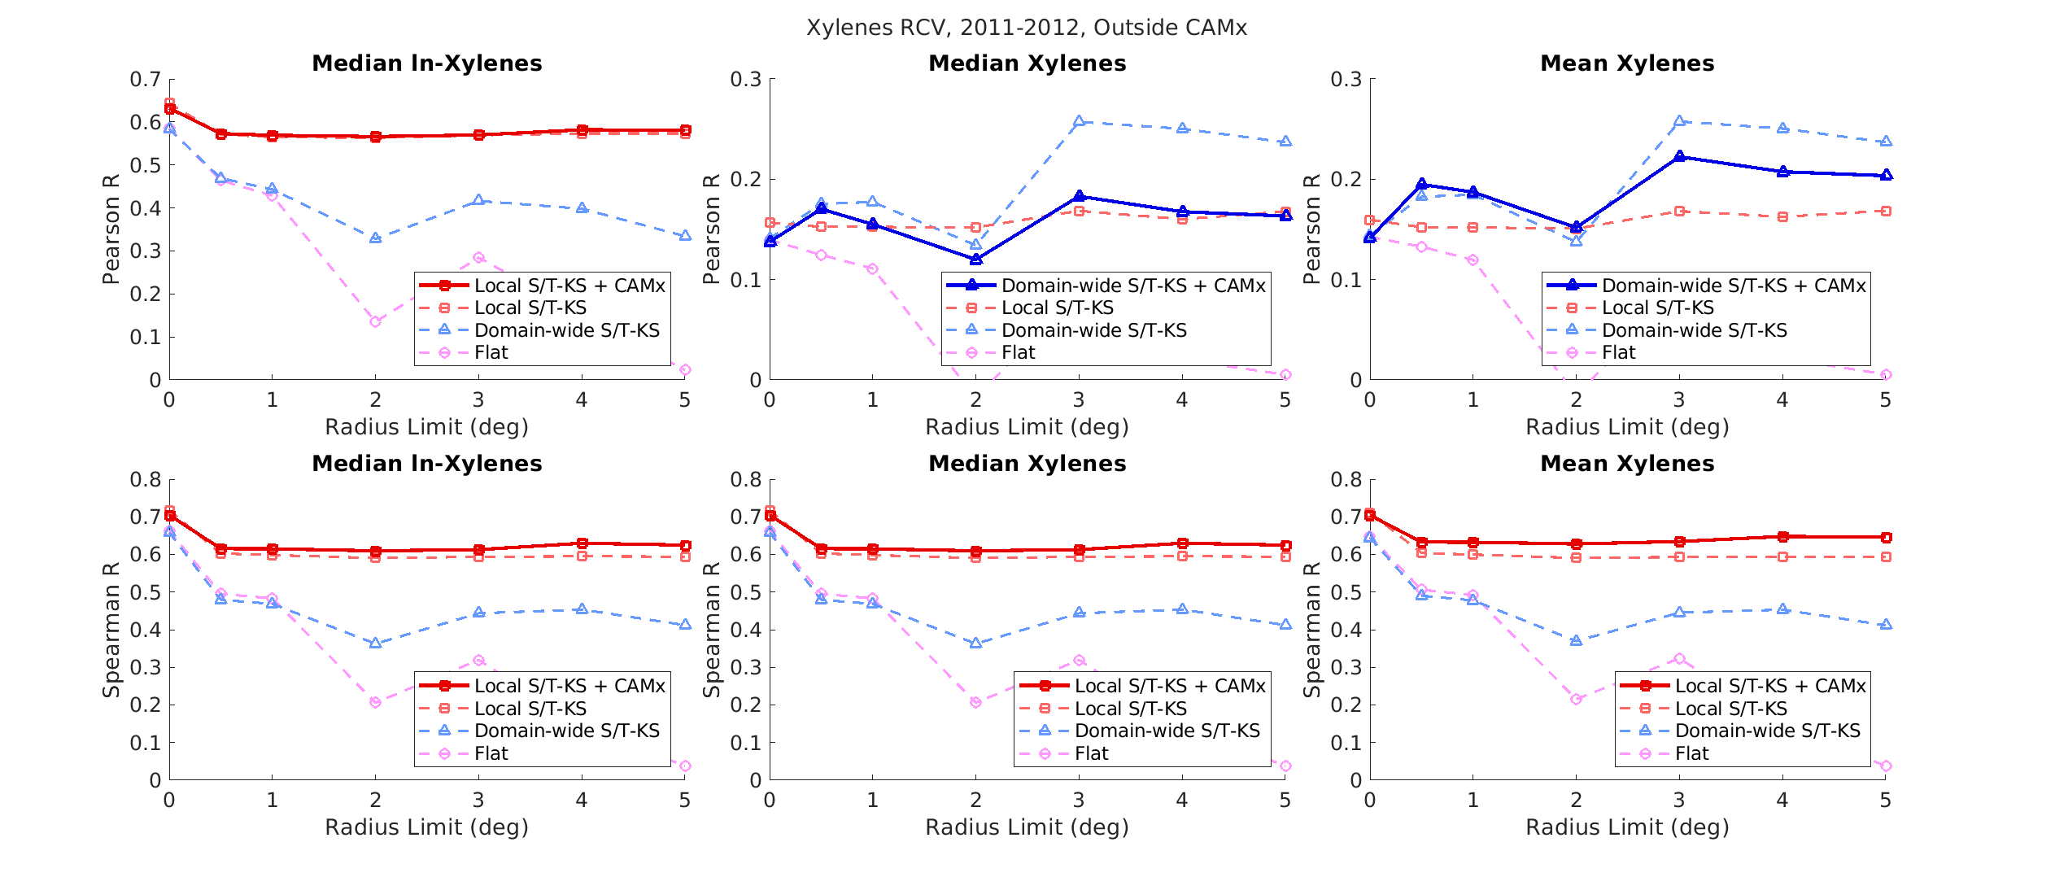Figure S34. RCV plots for xylenes estimation on the outside of CAMx region. Top row: RCV plots using the Pearson R as the Cross Validation R; bottom row: RCV plots using the Spearman R as the Cross Validation R. Left column: logVOC_{mean} RCV plots; center column: VOC_{median} RCV plots; right column: VOC_{mean} RCV plots.
VOC_{mean} RCV curves behaved very similar to VOC_{median} curves outside of CAMx, with respect to observational interpolation performance and best estimation method selection (Figures S30-S34). Additionally, the same estimation methods would have been selected for SBTEX estimation outside of CAMx if one had used VOC_{mean} RCV rather than VOC_{median} RCV curves (Figures S30-S34). One should note that method selection for mean benzene and ethylbenzene deferred to the Spearman R recommendation because Pearson R RCV curves did not monotonically decrease over radius limits (Figure S31, Figure S33). Xylene’s method selection also deferred to the Spearman R because the average Pearson R values were less than 50% of the average Spearman R values (Figure S34).
Observational interpolation for logVOC_{mean} using global offsets performed in the expected order for STEX, where the flat global offset performed the worst, the medium-resolution global offset performed better, and the fine-resolution offset performed best (Figure S30, Figures S32-S34).
STEX observational interpolation of logVOC_{mean} estimates decreased, as expected, over increasing radius limits when using a flat or medium-resolution global offset but appeared to plateau using a fine-resolution global offset (Figure S30, Figures S32-S34). The observed plateau behavior of observational interpolation using fine-resolution global offsets could not be confirmed due to the limited size of the Gulf states and may have been a slow decrease in performance attributed to the long spatial covariance structure for SBTEX.
Observational interpolation of mean log-benzene using global offsets all decreased over increasing radius limits but did not perform in the expected order for Spearman R RCV curves (Figure S31). Mean log-benzene Pearson R RCV curves showed observational interpolation performance from low to high as a flat global offset, medium-resolution global offset, and fine-resolution global offset (Figure S31). Conversely, the flat global offset outperformed medium- and fine-resolution global offsets for Spearman R, which may be attributed to the longer covariance range of the flat global offset retrieving more information to preserve the rank order of estimates (Figure S31).
S11. Composite Method Performance in the Gulf States
Complete RCV curves for logVOC_{mean}, VOC_{median}, and VOC_{mean} estimates in the Gulf States for each SBTEX pollutant are in the following figures: Figure S35 (styrene), Figure S36 (benzene), Figure S37 (toluene), Figure S38 (ethylbenzene), and Figure S39 (xylenes). The composite methods, composed of the selected methods inside and outside of CAMx, were also evaluated across the Gulf States.
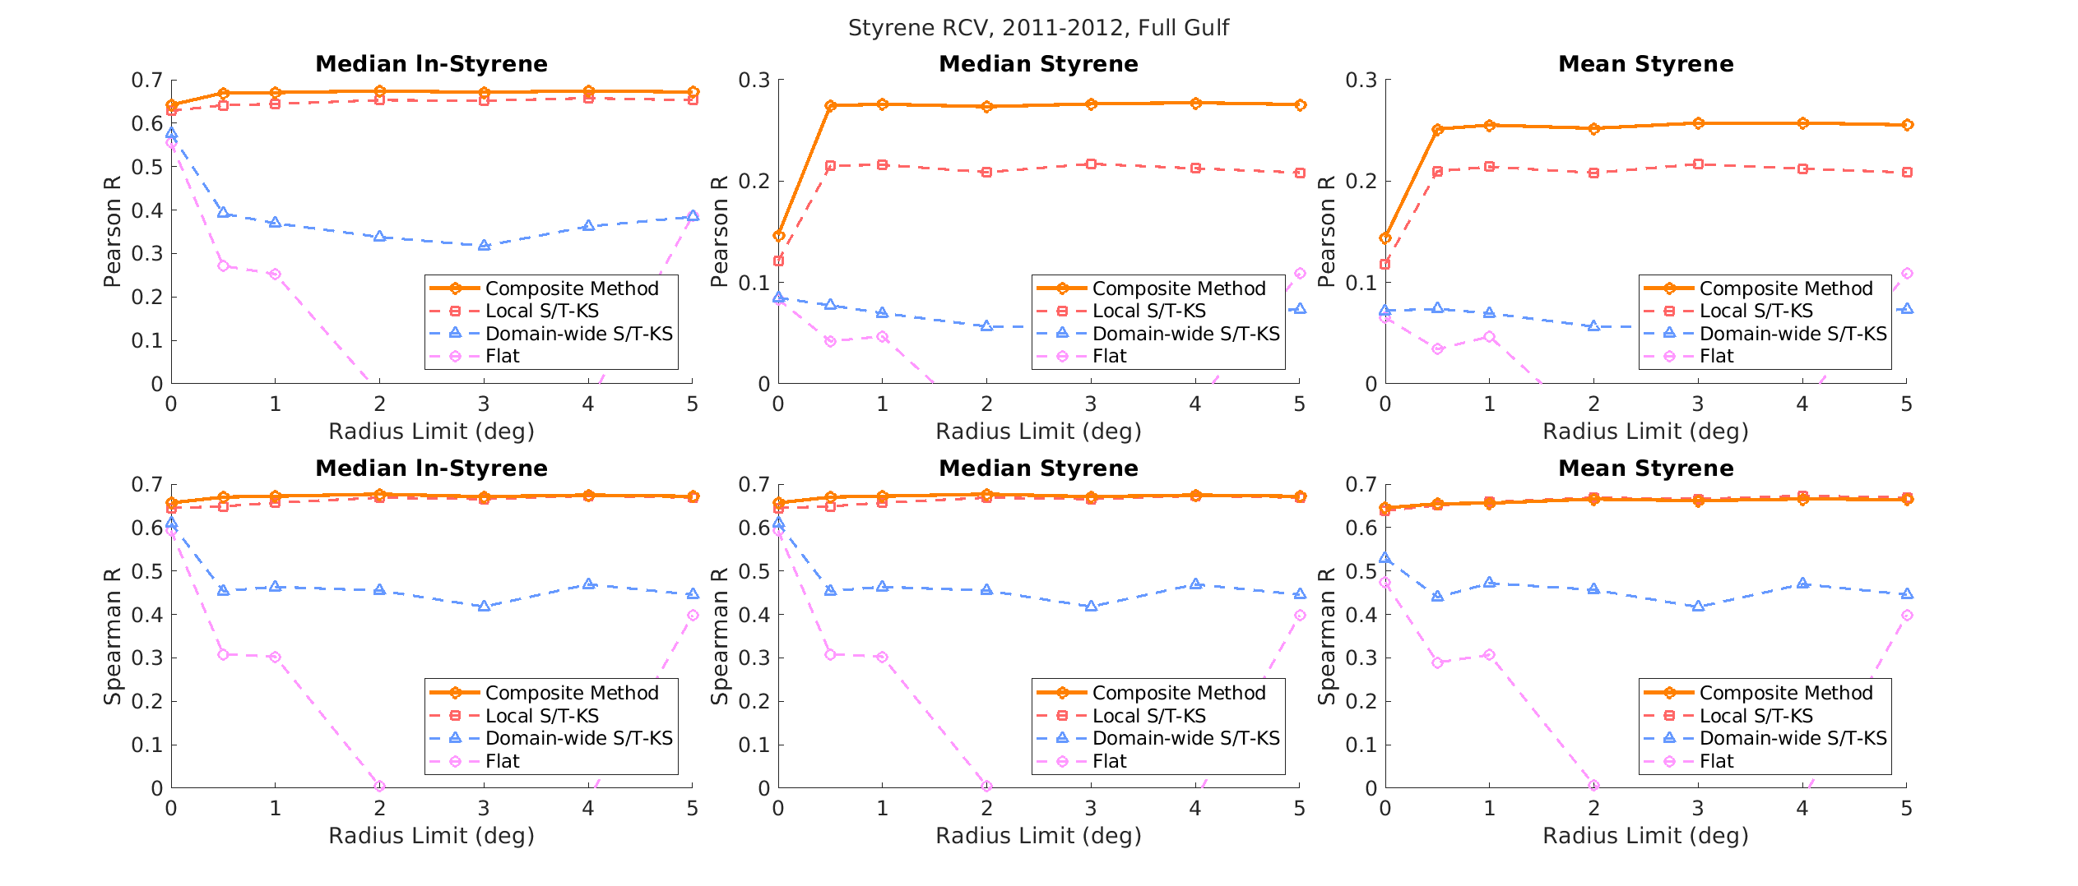Figure S35. RCV plots for styrene estimation for the full Gulf using the composite method. Top row: RCV plots using the Pearson R as the Cross Validation R; bottom row: RCV plots using the Spearman R as the Cross Validation R. Left column: logVOC_{mean} RCV plots; center column: VOC_{median} RCV plots; right column: VOC_{mean} RCV plots.

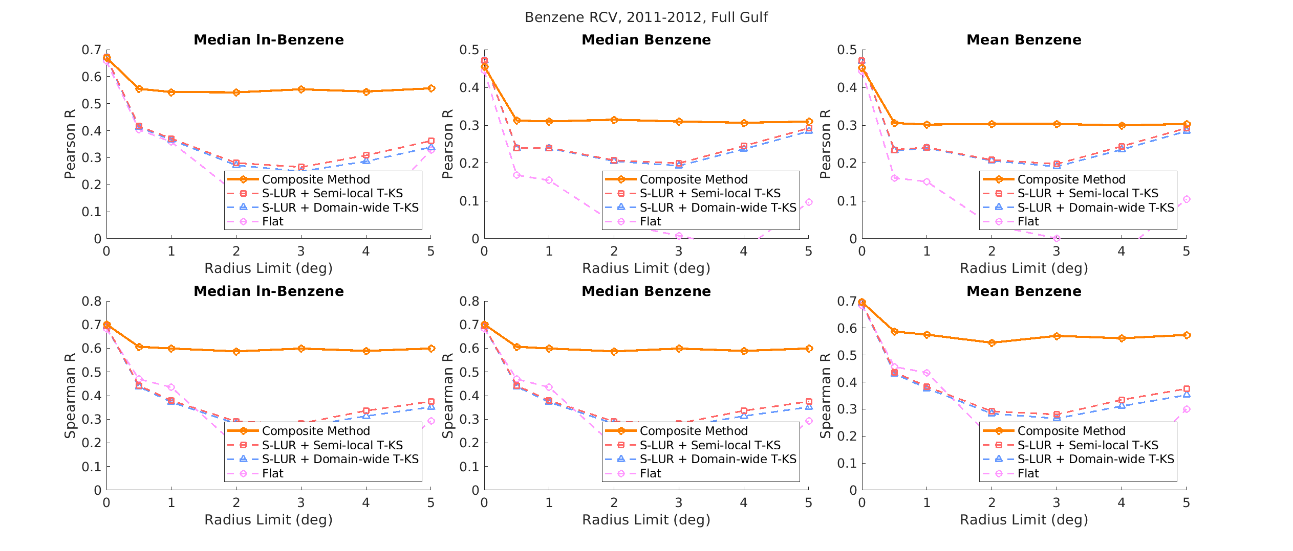Figure S36. RCV plots for benzene estimation on the full Gulf using the composite method. Top row: RCV plots using the Pearson R as the Cross Validation R; bottom row: RCV plots using the Spearman R as the Cross Validation R. Left column: logVOC_{mean} RCV plots; center column: VOC_{median} RCV plots; right column: VOC_{mean} RCV plots.

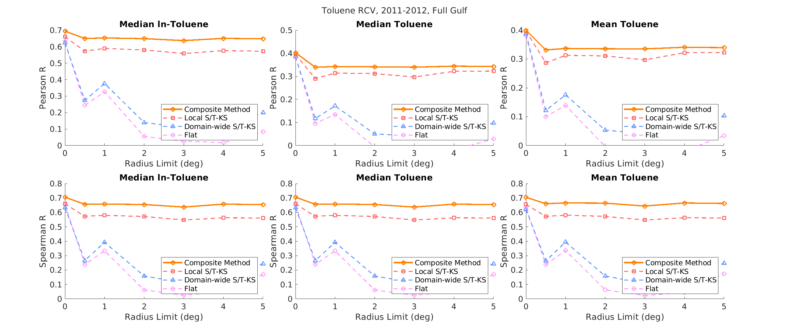
Figure S37. RCV plots for toluene estimation on the inside of CAMx region using the composite method. Top row: RCV plots using the Pearson R as the Cross Validation R; bottom row: RCV plots using the Spearman R as the Cross Validation R. Left column: logVOC_{mean} RCV plots; center column: VOC_{median} RCV plots; right column: VOC_{mean} RCV plots.

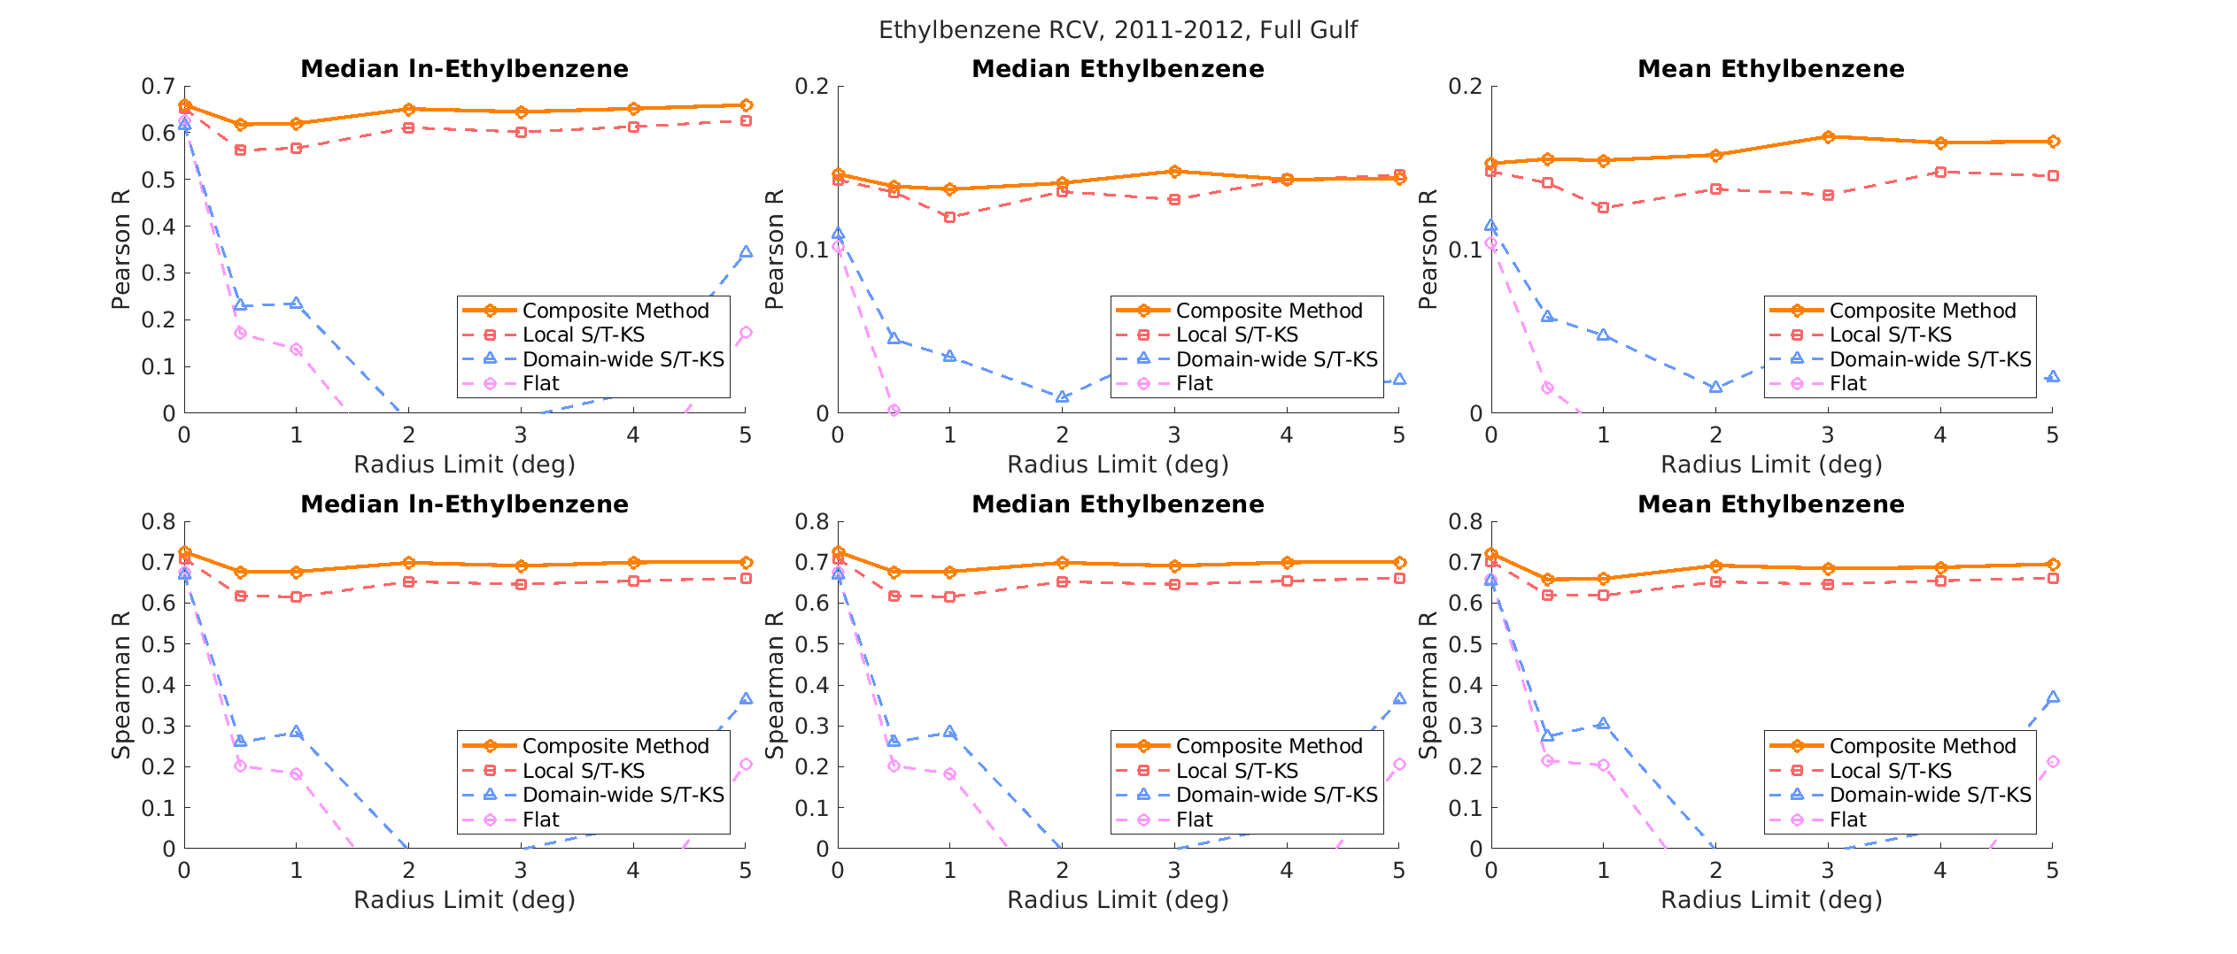Figure S38. RCV plots for ethylbenzene estimation in the full Gulf using the composite method. Top row: RCV plots using the Pearson R as the Cross Validation R; bottom row: RCV plots using the Spearman R as the Cross Validation R. Left column: logVOC_{mean} RCV plots; center column: VOC_{median} RCV plots; right column: VOC_{mean} RCV plots.

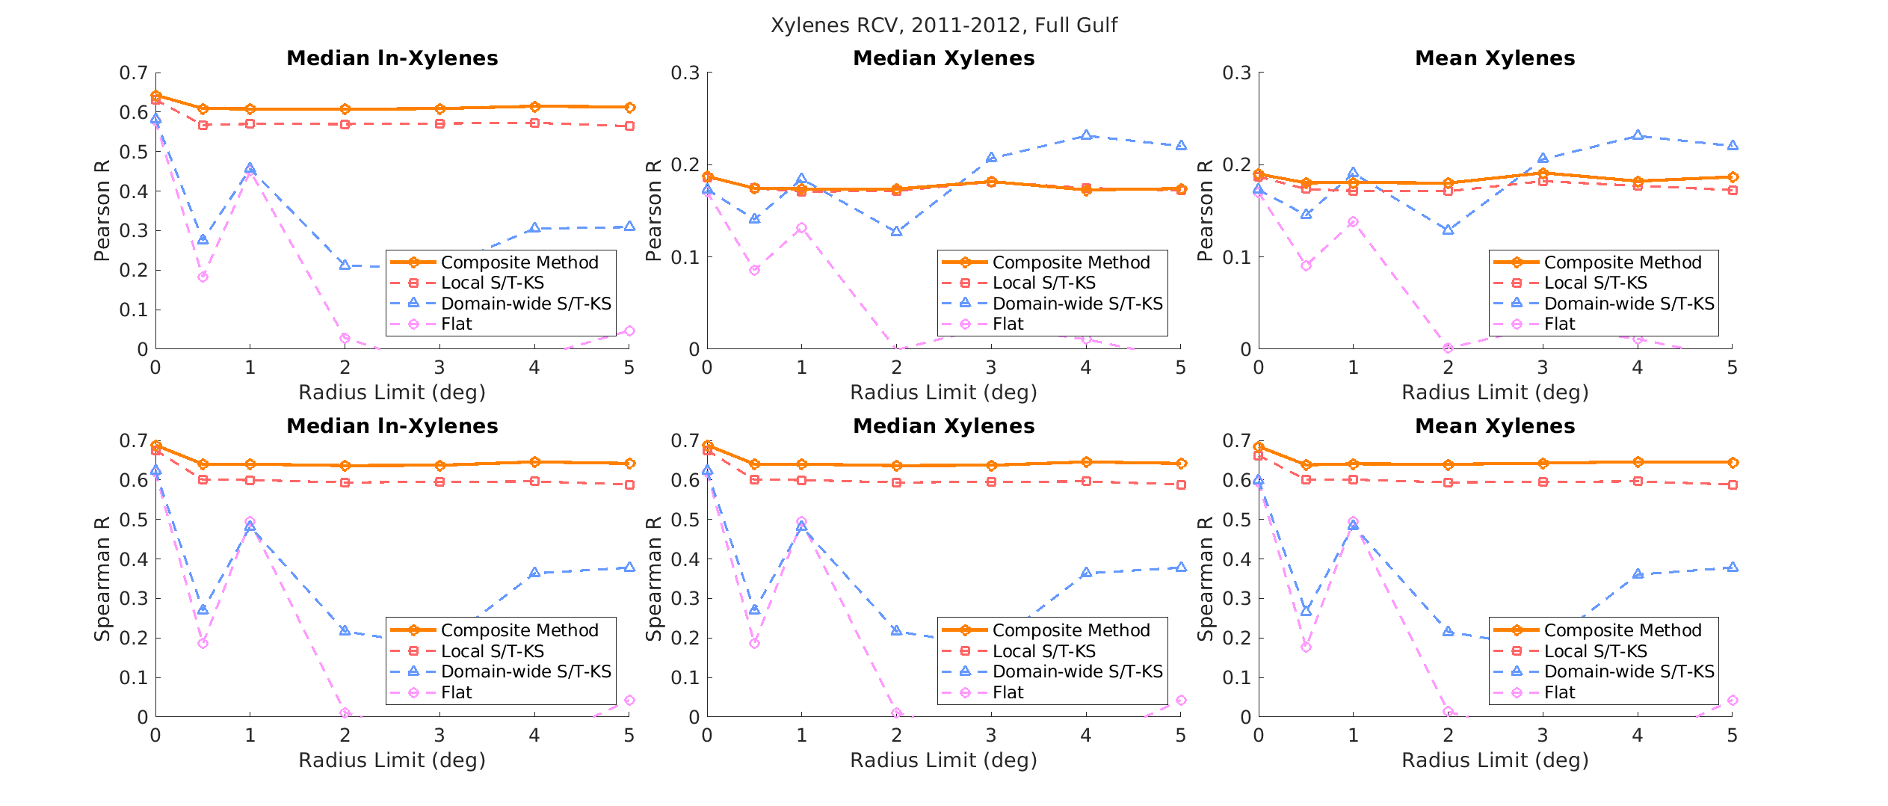
Figure S39. RCV plots for xylenes estimation in the Gulf using the composite method. Top row: RCV plots using the Pearson R as the Cross Validation R; bottom row: RCV plots using the Spearman R as the Cross Validation R. Left column: logVOC_{mean} RCV plots; center column: VOC_{median} RCV plots; right column: VOC_{mean} RCV plots.
Interpolation of VOC_{median} STEX observations using global offsets performed as expected across the Gulf States. Observation interpolation methods from worst to best were a flat global offset, a medium-resolution global offset, and a fine-resolution global offset (Figure S35, S37-S39). Across the Gulf States, styrene observation interpolation using a fine-resolution global offset improved as the radius limit increased, which, again, may be related to the high variability in styrene measurements. It should be noted that the xylenes medium-resolution global offset performed unexpectedly high for Pearson R at some cross-validation limits, but the performance was very variable and could not be assumed to be better than the fine-resolution global offset overall (Figure S39). For benzene, interpolation of global offsets from worst to best was a flat global offset, medium-resolution global offset, and fine-resolution global offset (Figure S36). Observational interpolation of SBTEX results demonstrated that estimation methods with moderate resource intensity improved STEX estimation performance over least intensive methods but did not yield those same benefits for benzene estimation. Observational interpolation and composite methods to estimate VOC_{mean} concentrations across the Gulf States performed very similarly to VOC_{median} methods (Figure S35-S39).
Observational interpolation of logVOC_{mean} concentrations performed as expected, where the flat global offset performed the worst, the medium-resolution global offset performed slightly better, and a fine-resolution global offset performed the best for Pearson and Spearman R (Figure S35-S39). The Pearson R xylenes observational interpolation using a medium-resolution global offset appeared to be higher than the data fusion Pearson R at some cross-validation radii (Figure S39). Due to the noise in the medium-resolution global offset Pearson R curves, however, the performance of the composite method was considered more reliable and thus better (Figure S39). Like VOC_{median} RCV curves, the performance of local S/T-KS curves appeared to plateau as the radius limit increased, but this behavior could not be confirmed due to the limited size of the Gulf States (Figures S35, S37-S39).
Composite methods for logVOC_{mean} performed better than all observational interpolation methods for Pearson R and Spearman R (Figures S35-S39). These results suggest that CAMP-correction in data fusion improved performance in the Gulf States. Furthermore, the composite method fine-resolution global offset inside of CAMx and a flat global offset+CAMx outside of CAMx interact beneficially to improve log-benzene estimation (Figure S36). Overall, the most resource-intensive, composite methods improved logVOC_{mean}, VOC_{median}, and VOC_{mean} estimation performance in terms of the linear (Pearson R) and rank (Spearman R) at every radius limit, compared to methods with the least- and moderate-resource intensity (Figure S35-S39).
For VOC_{median} estimates. average SBTEX RCV values ranged from –0.03 to 0.13 for Pearson R and 0.11 to 0.325 for Spearman R observational interpolation with a flat global offset, indicating that the least resource-intensive methods are poor for SBTEX exposure estimation in the Gulf States (Tables S15-S16). As SBTEX estimation methods moved toward moderate resource intensity, average RCV observation interpolation increased (Tables S15-S16). Composite methods with the most resource intensity improved average RCV Pearson R performance by 0.5% to 28.6% and average Spearman R performance by 1.4 to 52.9% when compared to observational interpolation with a flat global offset (Tables S15-S16). The composite method performance further improved using LOOCV, demonstrating 44.3% to 408% increases in average RCV Pearson R and 18.7 to 35% increases in average RCV Spearman R between the composite method LOOCV and observation interpolation using a flat global offset performance (Tables S15-S16). Overall, increases in estimation method resource intensity generally resulted in improved exposure estimates at and away from SBTEX monitoring stations.

Table S15. SBTEX composite method selections, observational interpolation using global offsets, and selected data fusion method Pearson R performance to estimate observed SBTEX inside of the CAMx-modeled domain. Observational interpolation and selected data fusion methods were evaluated using the average radius cross-validation (RCV). Selected data fusion methods were further evaluated using leave-one-out cross-validation (LOOCV). Performance was measured using VOC_{median} estimates.
VOC | Composite Method Selection |  | Average RCV Pearson R |  |  |  | LOOCV Pearson R
VOC |  |  | Observational Interpolation |  |  | Composite Method | Composite Method
VOC | Selected Data Fusion Method Inside CAMx | Selected Data Fusion Method Outside CAMx | Flat  Global Offset | Medium- Resolution Global Offset | Fine- Resolution Global Offset | Composite Method | Composite Method
Styrene | Local S/T-KS  +CAMx | Local S/T-KS  +CAMx | 0.018 | 0.070 | 0.200 | 0.257 | 0.405
Benzene | S-LUR  +semi-local T-KS  +CAMx | Flat  +CAMx | 0.126 | 0.267 | 0.271 | 0.331 | 0.525
Toluene | Local S/T-KS  +CAMx | Local S/T-KS  +CAMx | 0.086 | 0.130 | 0.322 | 0.350 | 0.506
Ethylbenzene | Local S/T-KS  +CAMx | Local S/T-KS  +CAMx | -0.028 | 0.039 | 0.136 | 0.142 | 0.724
Xylenes | Local S/T-KS  +CAMx | Local S/T-KS  +CAMx | 0.059 | 0.183 | 0.176 | 0.177 | 0.667

Table S16. SBTEX composite method selections, observational interpolation using global offsets, and selected data fusion method Spearman R performance to estimate observed SBTEX inside of the CAMx-modeled domain. Observational interpolation and selected data fusion methods were evaluated using the average radius cross-validation (RCV). Selected data fusion methods were further evaluated using leave-one-out cross-validation (LOOCV). Performance was measured using VOC_{median} estimates.
VOC | Composite Method Selection |  | Average RCV Spearman R |  |  |  | LOOCV Spearman R
VOC |  |  | Observational Interpolation |  |  | Composite Method | Composite Method
VOC | Selected Data Fusion Method Inside CAMx | Selected Data Fusion Method Outside CAMx | Flat  Global Offset | Medium- Resolution Global Offset | Fine- Resolution Global Offset | Composite Method | Composite Method
Styrene | Local S/T-KS  +CAMx | Local S/T-KS  +CAMx | 0.200 | 0.473 | 0.661 | 0.670 | 0.819
Benzene | S-LUR  +semi-local T-KS  +CAMx | Flat  +CAMx | 0.325 | 0.388 | 0.400 | 0.612 | 0.826
Toluene | Local S/T-KS  +CAMx | Local S/T-KS  +CAMx | 0.219 | 0.278 | 0.579 | 0.661 | 0.793
Ethylbenzene | Local S/T-KS  +CAMx | Local S/T-KS  +CAMx | 0.107 | 0.233 | 0.651 | 0.695 | 0.825
Xylenes | Local S/T-KS  +CAMx | Local S/T-KS  +CAMx | 0.177 | 0.359 | 0.607 | 0.647 | 0.793

S12. Composite Method logVOC_{mean} Estimates near the CAMx-modeled Domain
Figure S40 shows logVOC_{mean} (where logVOC_{mean} = logVOC_{median}) estimates and estimation variance near the CAMx-modeled region on August 4th, 2012. The logVOC_{mean} estimates showed the same spatial distribution of high and low estimates as the VOC_{median} plots (because a monotonic natural logarithm was used between them) but demonstrated more variability between estimated values (Figure S40). Figure S40 demonstrates that, when close to a monitored location, observed measurements drove logVOC_{mean} estimates, but CAMP-corrected CAMx drove logVOC_{mean} estimates far from monitoring stations. Monitoring station measurements improved estimates in highly polluted and populated urban centers, like Houston and Beaumont, Texas, and Baton Rouge, Louisiana (Figure S40). Figure S40 also demonstrates that observational data was useful in improving differences between low-measured values, like in Dallas, Texas.
The estimated plumes outside the CAMx-modeled domain were driven by temporal information, from historic monitoring data, within the BME framework (Figure S40). However, the exact value of this estimated plume is uncertain because the corresponding estimation SD was also higher in the same areas, therefore, the plumes outside the CAMx-modeled domain could be considered artifacts (Figure S40).
Generally, the inclusion of CAMx lowered logVOC_{mean} estimation variance 2- to 4-fold moving inside the CAMx-modeled region and compared to the transition between where CAMx was or was not directly modeled (Figure S40). This is because, when data fusion was used, estimates could draw information from exact measurements from observational data; LUR and/or KS; NEI-reported emissions, missing NEI emissions through HAPI, chemical reactions, transport through meteorology from CAMx; and adjustment for the CAMx underestimation of low values and overestimation of high values through CAMP corrections. Interestingly, estimation variance inside of the CAMx domain varied, due to proximity to observational data and CAMP-corrected CAMx estimation variance calculated from the λ₂ curve CAMP correction curve (Figure S40).
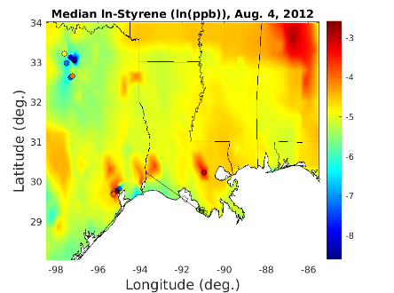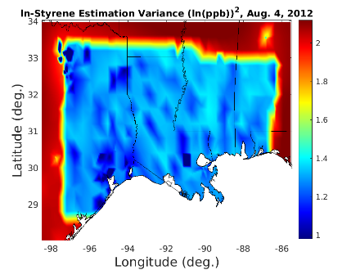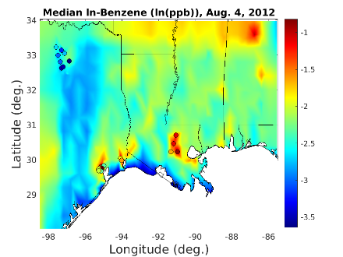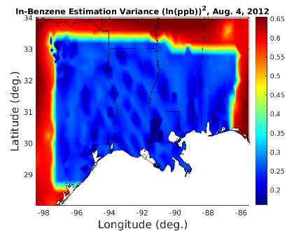
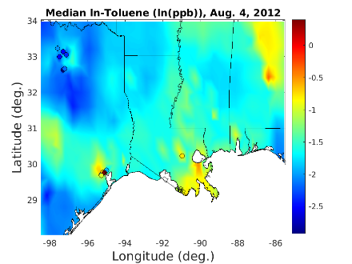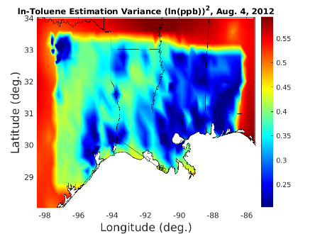
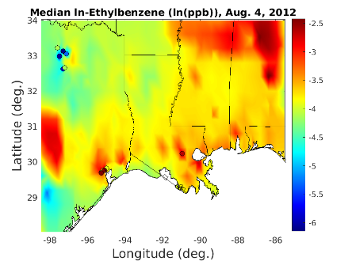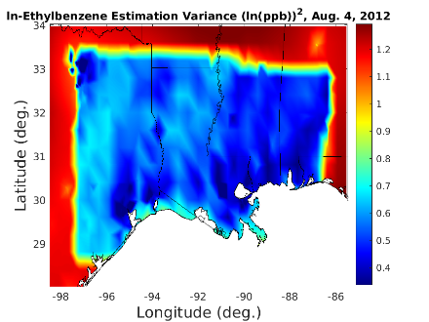
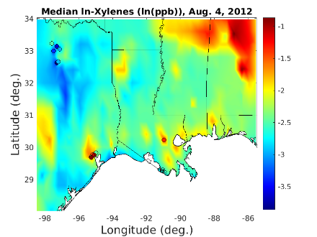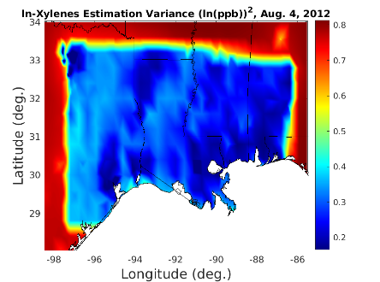
Figure S40. SBTEX estimates and estimation variance near the modeled CAMx region on August 4th, 2012. From top to bottom, row 1: styrene; row 2: benzene; row 3: toluene, row 4: ethylbenzene; row 5: xylenes. Left column: logVOC_{mean} estimates; right column: logVOC_{variance}.
S13. Composite Method Estimates in the Gulf States
Full Gulf logVOC_{mean}, VOC_{median}, and VOC_{mean} estimates and estimation variance were mapped using composite methods on August 4th, 2012. Figure S41 (styrene), Figure S42 (benzene), Figure S43 (toluene), Figure S44 (ethylbenzene), and Figure S45 (xylenes) demonstrated the resulting estimates using composite methods.
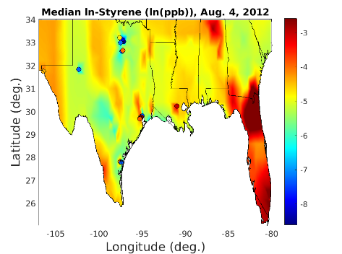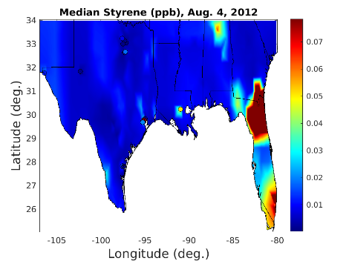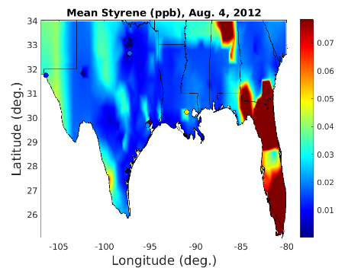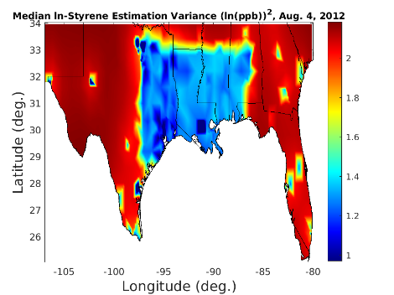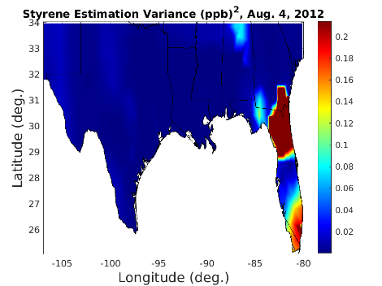
Figure S41. Styrene and log-styrene estimates and estimation variance across Gulf States on August 4th, 2012. Top row: estimated styrene; bottom row: styrene estimation variance. Left column: logVOC_{mean}; center column: VOC_{median}; center column: VOC_{mean}.

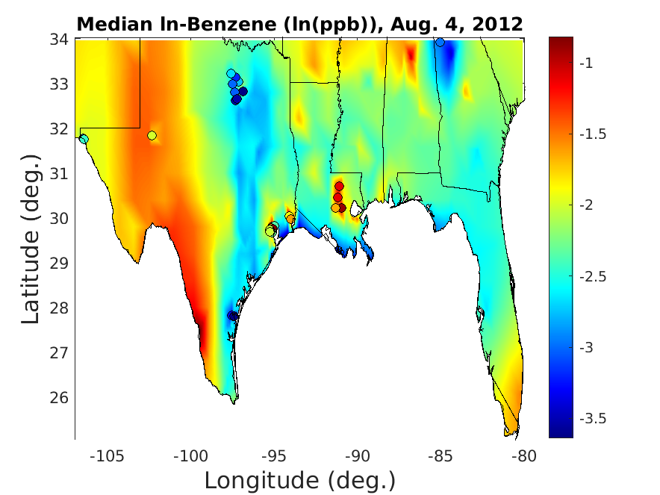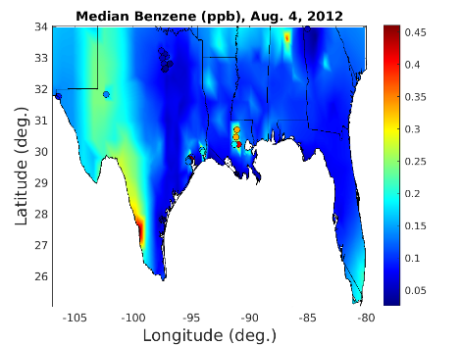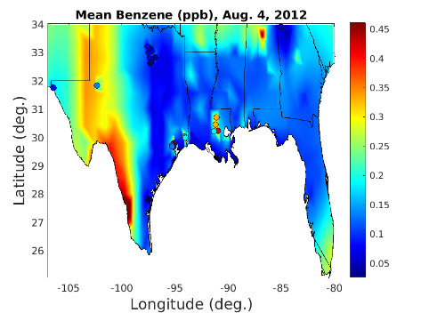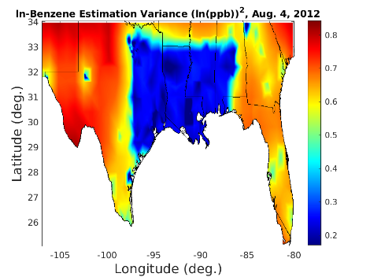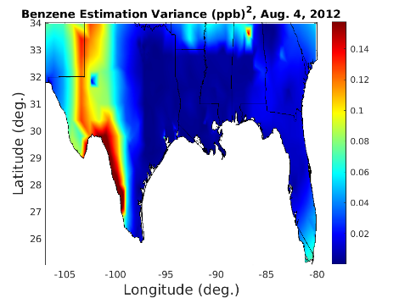
Figure S42. Benzene and log-benzene estimates and estimation variance across Gulf States on August 4th, 2012. Top row: estimated benzene; bottom row: benzene estimation variance. Left column: logVOC_{mean}; center column: VOC_{median}; center column: VOC_{mean}.

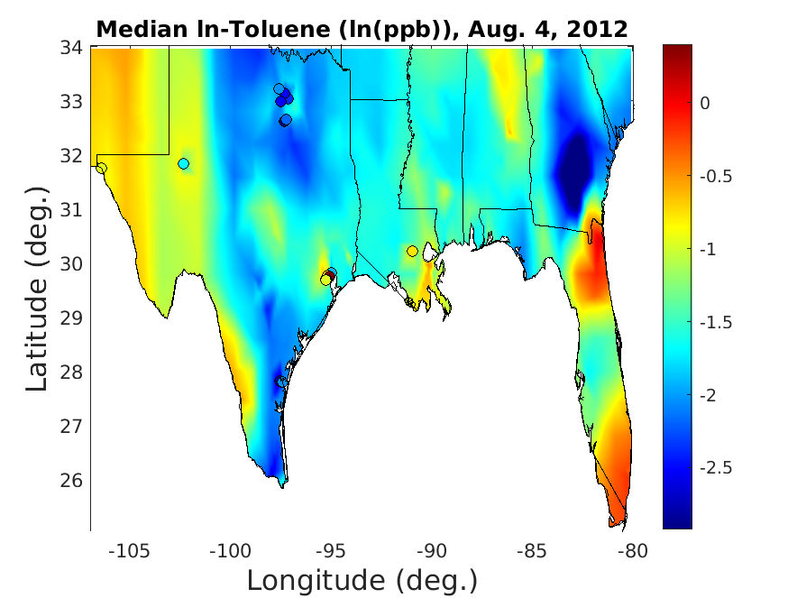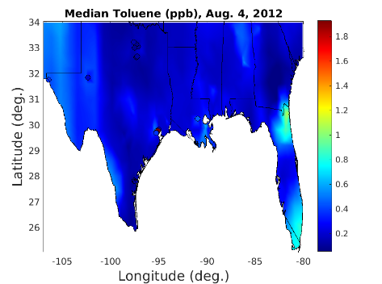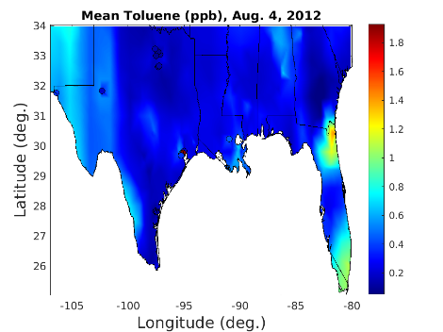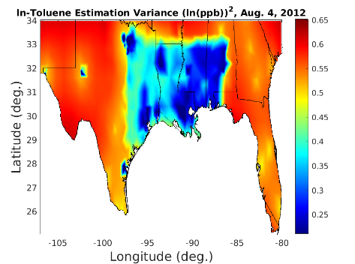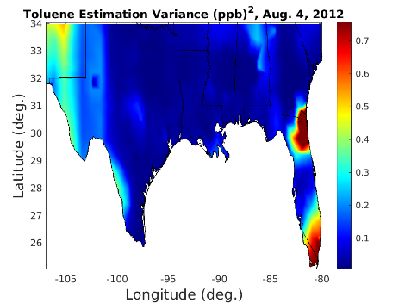
Figure S43. Toluene and log-toluene estimates and estimation variance across Gulf States on August 4th, 2012. Top row: estimated toluene; bottom row: toluene estimation variance. Left column: logVOC_{mean}; center column: VOC_{median}; center column: VOC_{mean}.

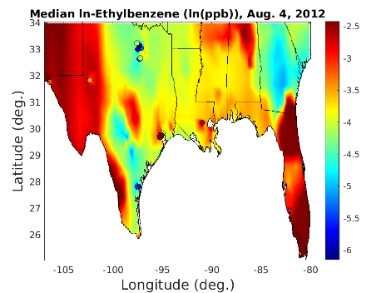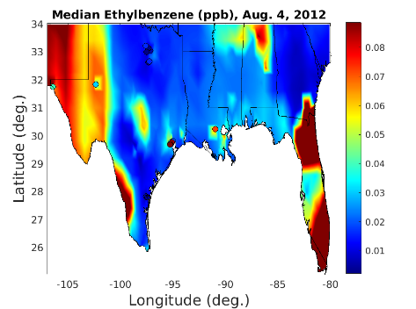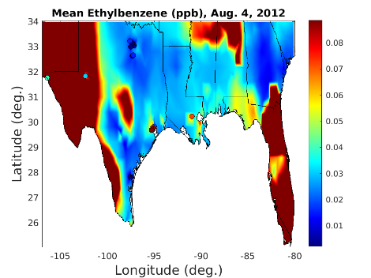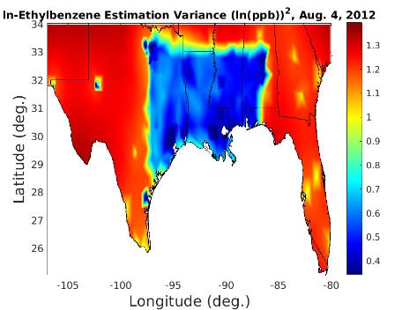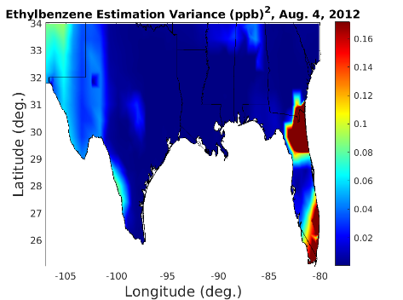Figure S44. Ethylbenzene and log-ethylbenzene estimates and estimation variance across Gulf States on August 4th, 2012. Top row: estimated ethylbenzene; bottom row: ethylbenzene estimation variance. Left column: logVOC_{mean}; center column: VOC_{median}; center column: VOC_{mean}.

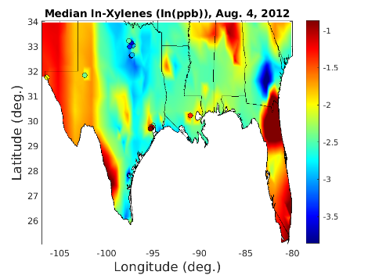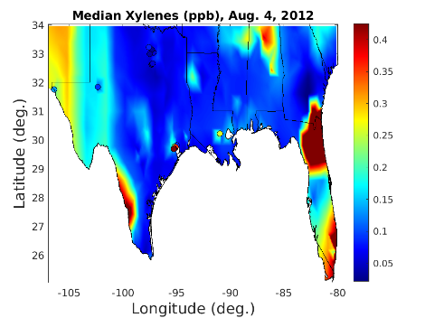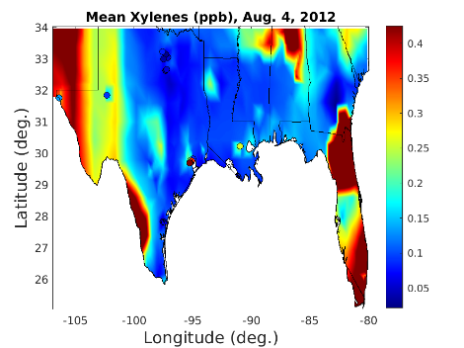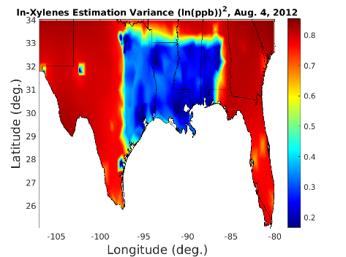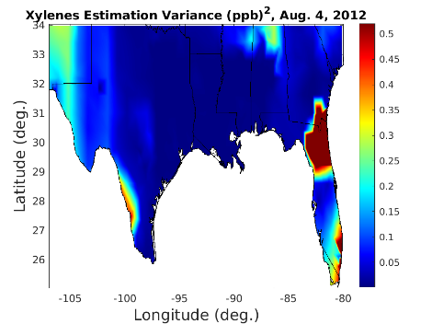
Figure S45. Xylenes and log-xylenes estimates and estimation variance across Gulf States on August 4th, 2012. Top row: estimated xylenes; bottom row: xylenes estimation variance. Left column: logVOC_{mean}; center column: VOC_{median}; center column: VOC_{mean}.
Figures S41-S45 demonstrate that logVOC_{mean} and VOC_{median} estimates blended well inside and outside the CAMx region, with little CAMx transition visible. The transition area distinguishing the inside and outside of CAMx region because more visible when estimation variance was considered for VOC_{mean} estimates. Large areas of high estimated concentrations appeared in Western Texas and Florida, where there is little monitoring data (Figures S41-S45). These areas of high estimated SBTEX are likely attributed to high historic observational data and global offsets. Importantly, estimates immediately outside of the CAMx-modeled region, unless very close to a monitoring station, have very high estimation variance, or uncertainty relative to inside CAMx (Figures S41-S45). Therefore, the estimated plumes in Western Texas and Florida should not be assumed accurate for exposure analyses.
S14. Comparison of Composite Method and CAMx Model Estimates
Differences between SBTEX estimates calculated using CAMx alone and BME data fusion were calculated for Houston, TX. Houston was selected for this assessment because it was an urban area located within the geographic region of the CAMx model, and it had complicated SBTEX emissions, a dense monitoring network, and the highest population among CAMx-modeled cities from 2011-2012.^{3,16–18} Figure S46 shows estimation differences in Houston on three representative days from 2011 to 2012.

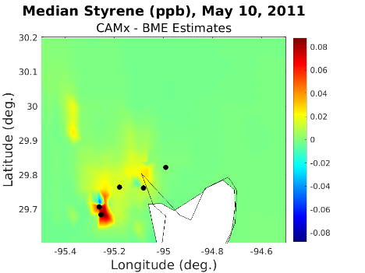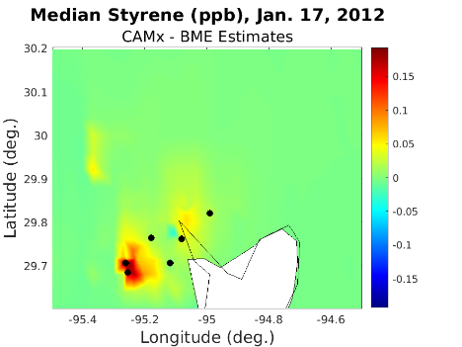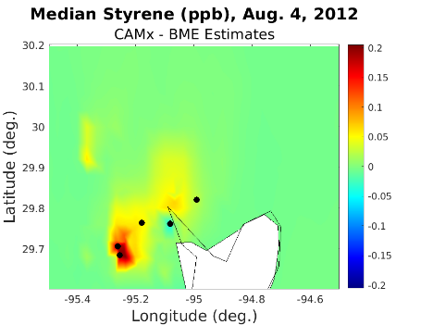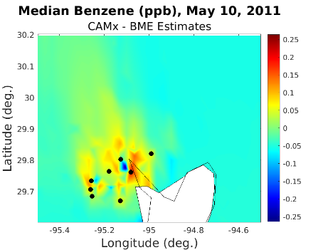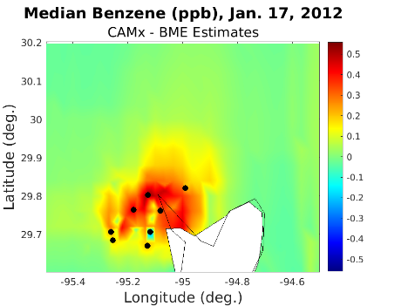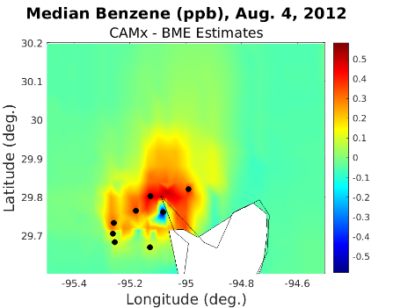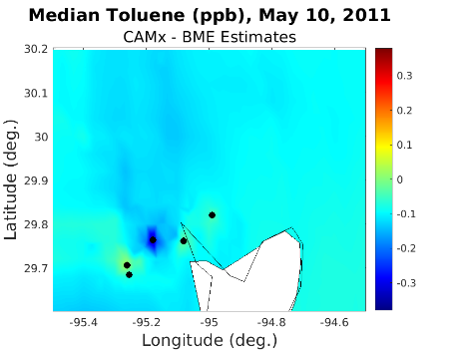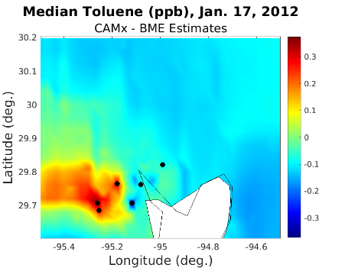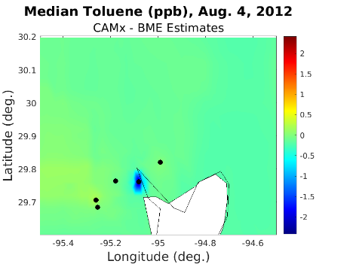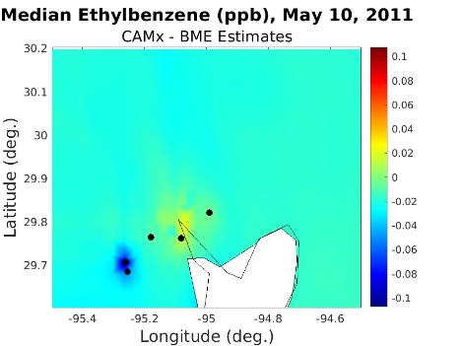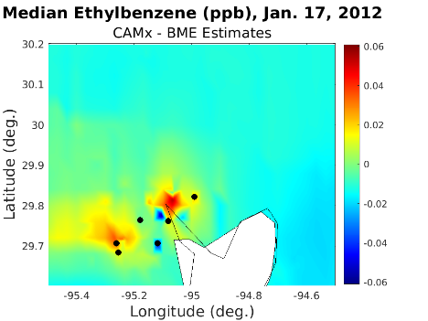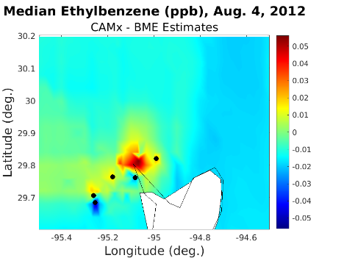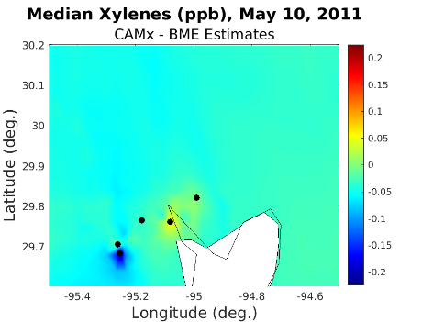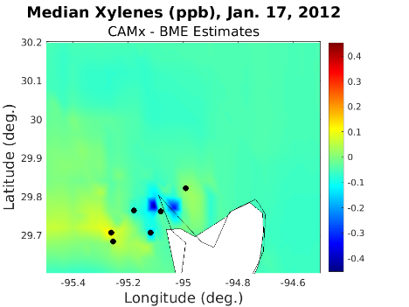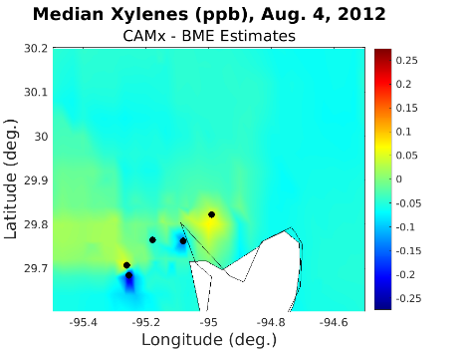
Figure S46. Differences between CAMx and median BME data fusion estimates in Houston, TX, on three dates between 2011 and 2012. Green coloring represents very little difference, cooler colors represent higher estimates using BME data fusion, and warmer colors represent higher estimates using CAMx alone. From top to bottom, row 1: styrene; row 2: benzene; row 3: toluene, row 4: ethylbenzene; row 5: xylenes. Left column: differences (ppb) on May 10th, 2011; Center column: differences on January 17th, 2012; Right column: differences on August 4th, 2012.
Figure S46 demonstrates that BME data fusion methods augment CAMx per pollutant and day. Interestingly, styrene difference plots demonstrated the most consistent pattern over the three days, which may result from most styrene emissions deriving from stationary, and consistent, point sources.¹⁶ In some cases, BME estimates were like CAMx estimates, with only slight changes occurring in the proximity of monitoring stations, such as xylenes on May 10th, 2011, or toluene on August 4th, 2012 (Figure S46). In other cases, BME raised and lowered estimates near and far away from monitoring stations, such as toluene on January 17th, 2012, or benzene on May 10th, 2012 (Figure S46).
When far from monitoring stations, data fusion-derived estimates were driven by CAMP-corrected CAMx, which was previously limited by unreported emissions data and difficulty distinguishing exposure classification (or always predicting low concentrations) away from SBTEX sources.¹⁶ SBTEX CAMP curves showed CAMx underestimated low values where CAMx predicted low (i.e., λ₁ curve above the one-to-one line) and overestimated high values where CAMx predicted high (i.e., λ₁ curve below the one-to-one line), which was addressed using the CAMP correction framework. The CAMP-correction of CAMx, especially correction for underestimated low values when CAMx predicted low, covered a much larger geographic region than high-concentration-predicted areas, impacting exposure estimates for many participants (Figure S46).
Finally, within the CAMx-modeled domain, there were areas where the global offset (whether KS or LUR) raised SBTEX estimates, suggesting that trends in observational data were higher than CAMx predictions and played a role in spatial estimation (Figure S46).
Wang et al. (2023) noted that two industrial sites near Houston still largely underestimated toluene after integrating HAPI in CAMx, including site ID 482011015, located at approximately 29.76 degrees latitude and –95.08 degrees longitude. Using monitoring data, BME informed estimated concentrations near site ID 482011015, which was useful for addressing incomplete NEI emissions. BME difference plots suggested that the incorporation of measured SBTEX observations when using BME data fusion alters estimate granularity near monitoring stations, but also regional estimates from CAMP correction of the CAMx (Figure S46).
S15. GuLF Study Cancer and Noncancer Risk and Exposure Estimates Discussion
Assuming a residence occupancy period (ROP) of 33 years, hazard quotients for toxic risks of SBTEX were calculated using Iris minimal risk level (MRL) and reference concentration (RfC) values.^{19–23} Hazard quotients for daily SBTEX exposures at all percentiles were less than one, suggesting the potential noncancer (MRL or RfC) health guidelines for SBTEX were not exceeded.
Excess cancer risk for benzene (an EPA-known human carcinogen) and for ethylbenzene (a California-known human carcinogen) was estimated for each daily percentile exposure estimate made in this study using the upper benzene inhalation unit risk (IUR) from Iris and ethylbenzene IUR from the California Office of Environmental Health Hazard Assessment^{20,24}. Assuming a residence occupancy period of 33 years and averaging time of 78 years, the corresponding daily concentration to exceed a one-in-a-million risk of cancer, an EPA-established public health-protective level²⁵, was 0.10 ppb and 0.22 ppb for benzene and ethylbenzene, respectively. Considering all residence locations among our study population, the 25th percentile daily exposures to benzene exceeded 0.10 ppb (Table 2). In other words, we found 75% of residence locations exceed daily ambient benzene levels corresponding to a 1-in-a-million excess lifetime cancer risk. No percentile daily exposure to ethylbenzene exceeded the estimated one-in-a-million excess risk of cancer (Table ).
Previous studies have also investigated associations between ambient styrene exposure, estimated using county-level, modeled annual average concentrations from the 2011 National Air Toxics Assessment (NATA), and adverse sensory, motor, and neurological symptoms within the GuLF Study cohort.^{26,27} These works were limited by the coarse spatial (estimated accuracy within 30km of census tract) and temporal (yearly) scales of NATA when estimating associations.^{26–28} This work provides estimates at an unprecedented fine scale (sub-4km by 4km and daily), allowing the identification at improved spatial resolution of adversely impacted residence locations.
To the author’s knowledge, the evaluation of SBTEX estimation methods using KS, LUR, and data fusion techniques has not been performed previously. Lessons learned from RCV and LOOCV are significant for epidemiologists, who need to know how SBTEX estimation performance changes as a function of computational resource intensity. Furthermore, validation results may assist in epidemiological study design, such as identifying appropriate geographic areas for the inclusion of study participants with ambient SBTEX exposure estimates of sufficient confidence or otherwise accounting for differences in this confidence.

S16. References
(1) Reyes, J. M.; Serre, M. L. An LUR/BME Framework to Estimate PM _{2.5} Explained by on Road Mobile and Stationary Sources. Environ. Sci. Technol. 2014, 48 (3), 1736–1744. DOI: 10.1021/es4040528.
(2) Li, A. J.; Pal, V. K.; Kannan, Kurunthachalam. A Review of Environmental Occurrence, Toxicity, Biotransformation and Biomonitoring of Volatile Organic Compounds. Environmental Chemistry and Ecotoxicology 2021, 3, 91–116. DOI: 10.1016/j.enceco.2021.01.001.
(3) Whitworth, K. W.; Symanski, E.; Lai, D.; Coker, A. L. Kriged and Modeled Ambient Air Levels of Benzene in an Urban Environment: An Exposure Assessment Study. Environ Health 2011, 10 (1), 21. DOI: 10.1186/1476-069X-10-21.
(4) Mukerjee, S.; Smith, L. A.; Thoma, E. D.; Whitaker, D. A.; Oliver, K. D.; Duvall, R.; Cousett, T. A. Spatial Analysis of Volatile Organic Compounds Using Passive Samplers in the Rubbertown Industrial Area of Louisville, Kentucky, USA. Atmospheric Pollution Research 2020, 11 (6), 81–86. DOI: 10.1016/j.apr.2020.02.021.
(5) Tecer, L. H.; Tagil, S.; Ulukaya, O.; Ficici, M. Spatial Distribution of BTEX and Inorganic Pollutants During Summer Season in Yalova, Turkey. Ecological Chemistry and Engineering S 2017, 24 (4), 565–581. DOI: 10.1515/eces-2017-0037.
(6) Miller, L.; Lemke, L. D.; Xu, X.; Molaroni, S. M.; You, H.; Wheeler, A. J.; Booza, J.; Grgicak-Mannion, A.; Krajenta, R.; Graniero, P. Intra-Urban Correlation and Spatial Variability of Air Toxics across an International Airshed in Detroit, Michigan (USA) and Windsor, Ontario (Canada). Atmospheric Environment 2010, 44 (9), 1162–1174. DOI: 10.1016/j.atmosenv.2009.12.030.
(7) Hsu, C.-Y.; Zeng, Y.-T.; Chen, Y.-C.; Chen, M.-J.; Lung, S.-C. C.; Wu, C.-D. Kriging-Based Land-Use Regression Models That Use Machine Learning Algorithms to Estimate the Monthly BTEX Concentration. International Journal of Environmental Research and Public Health 2020, 17 (19), 6956. DOI: 10.3390/ijerph17196956.
(8) Wheeler, A. J.; Smith-Doiron, M.; Xu, X.; Gilbert, N. L.; Brook, J. R. Intra-Urban Variability of Air Pollution in Windsor, Ontario—Measurement and Modeling for Human Exposure Assessment. Environmental Research 2008, 106 (1), 7–16. DOI: 10.1016/j.envres.2007.09.004.
(9) Mukerjee, S.; Smith, L.; Neas, L.; Norris, G. Evaluation of Land Use Regression Models for Nitrogen Dioxide and Benzene in Four US Cities. The Scientific World Journal 2012, 2012, 1–8. DOI: 10.1100/2012/865150.
(10) Mohammadi, A.; Ghassoun, Y.; Löwner, M.-O.; Behmanesh, M.; Faraji, M.; Nemati, S.; Toolabi, A.; Abdolahnejad, A.; Panahi, H.; Heydari, H.; Miri, M. Spatial Analysis and Risk Assessment of Urban BTEX Compounds in Urmia, Iran. Chemosphere 2020, 246, 125769. DOI: 10.1016/j.chemosphere.2019.125769.
(11) Su, J. G.; Jerrett, M.; Beckerman, B.; Verma, D.; Arain, M. A.; Kanaroglou, P.; Stieb, D.; Finkelstein, M.; Brook, J. A Land Use Regression Model for Predicting Ambient Volatile Organic Compound Concentrations in Toronto, Canada. Atmospheric Environment 2010, 44 (29), 3529–3537. DOI: 10.1016/j.atmosenv.2010.06.015.
(12) Smith, L. A.; Mukerjee, S.; Chung, K. C.; Afghani, J. Spatial Analysis and Land Use Regression of VOCs and NO2 in Dallas, Texas during Two Seasons. J. Environ. Monit. 2011, 13 (4), 999. DOI: 10.1039/c0em00724b.
(13) Arain, M. A.; Blair, R.; Finkelstein, N.; Brook, J. R.; Sahsuvaroglu, T.; Beckerman, B.; Zhang, L.; Jerrett, M. The Use of Wind Fields in a Land Use Regression Model to Predict Air Pollution Concentrations for Health Exposure Studies. Atmospheric Environment 2007, 41 (16), 3453–3464. DOI: 10.1016/j.atmosenv.2006.11.063.
(14) Kwon, J.; Weisel, C. P.; Morandi, M. T.; Stock, T. H. Source Proximity and Meteorological Effects on Residential Outdoor VOCs in Urban Areas: Results from the Houston and Los Angeles RIOPA Studies. Science of The Total Environment 2016, 573, 954–964. DOI: 10.1016/j.scitotenv.2016.08.186.
(15) Azmi, W. N. F. W.; Pillai, T. R.; Latif, M. T.; Koshy, S.; Shaharudin, R. Application of Land Use Regression Model to Assess Outdoor Air Pollution Exposure: A Review. Environmental Advances 2023, 11, 100353. DOI: 10.1016/j.envadv.2023.100353.
(16) Wang, C.-T.; Baek, B. H.; Vizuete, W.; Engel, L. S.; Xing, J.; Green, J.; Serre, M.; Strott, R.; Bowden, J.; Woo, J.-H. Spatiotemporally Resolved Emissions and Concentrations of Styrene, Benzene, Toluene, Ethylbenzene, and Xylenes (SBTEX) in the US Gulf Region. Earth System Science Data 2023, 15 (11), 5261–5279. DOI: 10.5194/essd-15-5261-2023.
(17) Smith, L. A.; Stock, T. H.; Chung, K. C.; Mukerjee, S.; Liao, X. L.; Stallings, C.; Afshar, M. Spatial Analysis of Volatile Organic Compounds from a Community-Based Air Toxics Monitoring Network in Deer Park, Texas, USA. Environ Monit Assess 2007, 128 (1–3), 369–379. DOI: 10.1007/s10661-006-9320-8.
(18) City and Town Population Totals: 2010-2019. https://www.census.gov/data/tables/time-series/demo/popest/2010s-total-cities-and-towns.html (accessed 2024-01-26).
(19) Agency for Toxic Substances and Disease Registry. TOXICOLOGICAL PROFILE FOR STYRENE, 2010. https://www.atsdr.cdc.gov/toxprofiles/tp53.pdf (accessed 2024-01-17).
(20) Agency for Toxic Substances and Disease Registry. TOXICOLOGICAL PROFILE FOR BENZENE, 2007. https://www.atsdr.cdc.gov/toxprofiles/tp3.pdf (accessed 2024-01-17).
(21) Agency for Toxic Substances and Disease Registry. TOXICOLOGICAL PROFILE FOR TOLUENE, 2017. https://www.atsdr.cdc.gov/toxprofiles/tp56.pdf (accessed 2024-01-17).
(22) Agency for Toxic Substances and Disease Registry. TOXICOLOGICAL PROFILE FOR ETHYLBENZENE, 2010. https://www.atsdr.cdc.gov/toxprofiles/tp110.pdf (accessed 2024-01-17).
(23) Agency for Toxic Substances and Disease Registry. TOXICOLOGICAL PROFILE FOR XYLENE, 2007. https://www.atsdr.cdc.gov/toxprofiles/tp71.pdf (accessed 2024-01-17).
(24) Ethylbenzene. https://oehha.ca.gov/chemicals/ethylbenzene (accessed 2024-04-25).
(25) United States Environmental Protection Agency. Guidelines for Carcinogen Risk Assessment; EPA/630/P-03/001F; United States Environmental Protection Agency: Washington, DC, 2005. https://www.epa.gov/sites/default/files/2013-09/documents/cancer_guidelines_final_3-25-05.pdf (accessed 2024-04-25).
(26) Werder, E. J.; Engel, L. S.; Richardson, D. B.; Emch, M. E.; Gerr, F. E.; Kwok, R. K.; Sandler, D. P. Environmental Styrene Exposure and Neurologic Symptoms in U.S. Gulf Coast Residents. Environment International 2018, 121, 480–490. DOI: 10.1016/j.envint.2018.09.025.
(27) Werder, E. J.; Sandler, D. P.; Richardson, D. B.; Emch, M. E.; Kwok, R. K.; Gerr, F. E.; Engel, L. S. Environmental Styrene Exposure and Sensory and Motor Function in Gulf Coast Residents. Environ Health Perspect 2019, 127 (4), 047006. DOI: 10.1289/EHP3954.
(28) United States Environmental Protection Agency. Technical Support Document EPA’s 2011 National-Scale Air Toxics Assessment, 2015. https://www.epa.gov/sites/default/files/2015-12/documents/2011-nata-tsd.pdf (accessed 2024-04-25).

