Supplementary Materials
Table S1 Evaluation metrics of MC methods and machine learning models with non-suppressed values
Metrics | MC | ML with Population |  |  |  |  | ML with population  and ancillary data
Metrics | MC | GLM | GBM | RF | XGB | OLS | GLM | GBM | RF | XGB | OLS
MAE | 3.41 | 124.16 | 12.28 | 12.36 | 10.08 | 27.98 | 132.97 | 14.76 | 178.62 | 23.83 | 83.52
MSE | 27.61 | 25770 | 3825 | 7996 | 328 | 1382 | 31676 | 559 | 45733 | 1572 | 10050
RMSE | 5.25 | 160.5 | 61.9 | 89.4 | 18.1 | 37.2 | 178.0 | 23.7 | 213.9 | 39.6 | 100.3
MAPE | 0.17 | 8.44 | 0.34 | 0.30 | 0.40 | 2.26 | 8.53 | 0.93 | 13.89 | 1.24 | 6.66
R | 0.991 | 0.60 | 0.61 | 0.48 | 0.91 | 0.83 | 0.59 | 0.84 | 0.43 | 0.63 | 0.43
R2 | 0.98 | 0.36 | 0.37 | 0.23 | 0.83 | 0.69 | 0.35 | 0.71 | 0.18 | 0.40 | 0.18
Note: MAE: mean absolute error, MSE: mean squared error, RMSE: root mean squared error, MAPE：mean absolute percentage error, R: Correlation, R²: Squared R. Values in bold font indicate the best-performing ML models.

Table S2 Evaluation metrics of MC methods and machine learning models using binary values
Model |  | TP | FP | TN | FN | Rec | Pr | Sn | Sp | F1 | Acc | κ
MC | 1 | 2110 | 202 | 1108 | 48 | 0.98 | 0.91 | 0.98 | 0.85 | 0.94 | 0.93 | 0.84
MC | 0 | 1108 | 48 | 2110 | 202 | 0.85 | 0.96 | 0.85 | 0.98 | 0.90 | 0.93 | 0.84
GLM | 1 | 524 | 52 | 1104 | 1788 | 0.23 | 0.91 | 0.23 | 0.96 | 0.36 | 0.47 | 0.13
GLM | 0 | 1104 | 1788 | 524 | 52 | 0.96 | 0.38 | 0.96 | 0.23 | 0.55 | 0.47 | 0.13
GBM | 1 | 0 | 0 | 1156 | 2312 | 0.00 |  | 0.00 | 1.00 |  | 0.33 | 0.00
GBM | 0 | 1156 | 2312 | 0 | 0 | 1.00 | 0.33 | 1.00 | 0.00 | 0.50 | 0.33 | 0.00
RF | 1 | 273 | 7 | 1149 | 2039 | 0.12 | 0.98 | 0.12 | 0.99 | 0.21 | 0.41 | 0.08
RF | 0 | 1149 | 2039 | 273 | 7 | 0.99 | 0.36 | 0.99 | 0.12 | 0.53 | 0.41 | 0.08
OLS | 1 | 1890 | 521 | 635 | 422 | 0.82 | 0.78 | 0.82 | 0.55 | 0.80 | 0.73 | 0.37
OLS | 0 | 635 | 422 | 1890 | 521 | 0.55 | 0.60 | 0.55 | 0.82 | 0.57 | 0.73 | 0.37
XGB | 1 | 0 | 0 | 1156 | 2312 | 0.00 |  | 0.00 | 1.00 |  | 0.33 | 0.00
XGB | 0 | 1156 | 2312 | 0 | 0 | 1.00 | 0.33 | 1.00 | 0.00 | 0.50 | 0.33 | 0.00
GLM* | 1 | 737 | 78 | 1054 | 1515 | 0.33 | 0.90 | 0.33 | 0.93 | 0.48 | 0.53 | 0.20
GLM* | 0 | 1054 | 1515 | 737 | 78 | 0.93 | 0.41 | 0.93 | 0.33 | 0.57 | 0.53 | 0.20
GBM* | 1 | 522 | 81 | 1051 | 1730 | 0.23 | 0.87 | 0.23 | 0.93 | 0.37 | 0.46 | 0.12
GBM* | 0 | 1051 | 1730 | 522 | 81 | 0.93 | 0.38 | 0.93 | 0.23 | 0.54 | 0.46 | 0.12
RF* | 1 | 0 | 0 | 1132 | 2252 | 0.00 |  | 0.00 | 1.00 | 0.50 | 0.33 | 0.00
RF* | 0 | 1132 | 2252 | 0 | 0 | 1.00 | 0.33 | 1.00 | 0.00 | 0.50 | 0.33 | 0.00
OLS* | 1 | 1627 | 916 | 216 | 625 | 0.72 | 0.64 | 0.72 | 0.19 | 0.68 | 0.54 | -0.09
OLS* | 0 | 216 | 625 | 1627 | 916 | 0.19 | 0.26 | 0.19 | 0.72 | 0.22 | 0.54 | -0.09
XGB* | 1 | 591 | 160 | 972 | 1661 | 0.26 | 0.79 | 0.26 | 0.86 | 0.39 | 0.46 | 0.09
XGB* | 0 | 972 | 1661 | 591 | 160 | 0.86 | 0.37 | 0.86 | 0.26 | 0.52 | 0.46 | 0.09
Note: * for machine learning (ML) models using ancillary data, compared to those models using only population data. Metrics are defined as follows: TP (True Positives), FP (False Positives), TN (True Negatives), FN (False Negatives), R (Recall), Pr (Precision), Sn (Sensitivity), Sp (Specificity), F1 (F-measure), Acc (Accuracy), and κ (Cohen's kappa).

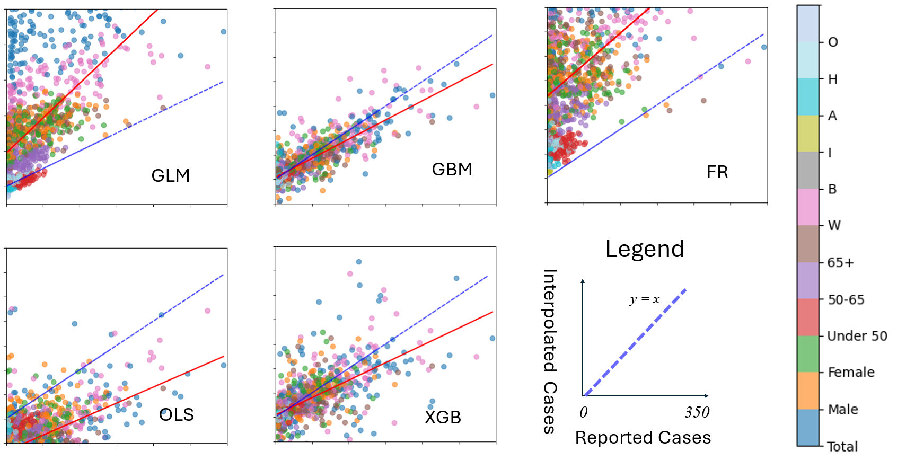
Figure S1 Scatter plots for machine learning models using population and ancillary data

