Long-term opioid therapy and risk of opioid overdose by derived clinical indication in North Carolina, 2006-2018

Bethany L. DiPrete, Shabbar I. Ranapurwala, Audrey E. Pettifor, Kimberly A. Powers, Paul L. Delamater, Naoko Fulcher, Brian W. Pence

SUPPLEMENTARY ONLINE CONTENT

eMethods

eTable 1. Active ingredient of prescription opioids considered

eTable 2. ICD-9-CM and ICD-10-CM diagnostic codes used to identify acute and chronic pain in claims data

eTable 3. ICD-9-CM and ICD-10-CM diagnostic codes used to identify opioid overdose in claims data

eTable 4. ICD-10 codes used to identify fatal opioid overdose in linked death records

eTable 5. R packages used in analyses

eTable 6. Distribution of patient outcomes, comparing patients exposed to LTOT to those with SMTOT - North Carolina, 2006-2018

eTable 7. IPTCW risk differences (95% CI) for the relationship between LTOT and incident opioid overdose among patients with a pain diagnosis or surgery in North Carolina, 2006-2018 at multiple points of follow-up, examining varying exposure definitions

eTable 8. Unweighted and IPTC-weighted hazard ratios (HR) for opioid overdose among patients with a pain diagnosis or surgery comparing patients exposed to LTOT to those with shorter duration of therapy, using varying exposure definitions - North Carolina, 2006-2018

eFigure 1. Hierarchical matching algorithm used to match insurance claims to death records

eFigure 2. Study timeline

eFigure 3. Defining long-term opioid therapy (LTOT) compared to short- to medium- term opioid therapy (SMTOT) during the 90-day exposure classification period.

eFigure 4. Directed acyclic graph (DAG) of hypothesized relationships of key variables in the association between LTOT and opioid overdose.

eFigure 5. Study flowchart

eFigure 6. Covariate balance before and after inverse probability weighting

eFigure 7. Crude cumulative incidence of opioid overdose among patients initiating opioid analgesics following a pain diagnosis or surgery by primary exposure status - North Carolina, 2006-2018

eFigure 8. Weighted cumulative incidence of opioid overdose among patients initiating opioid analgesics following a pain diagnosis or surgery by primary exposure status, stratified by derived clinical indication - North Carolina, 2006-2018

eReferences
eMethods

Determining Dates of Prescription Fills

We defined long-term opioid therapy (LTOT) using date of fill and days’ supply to calculate total days’ supply of outpatient prescription opioids and timing of receipt. When overlapping prescriptions of the same ingredient occurred, we used a seven-day rule such that if the start date was ≤7 days before the end date of the previous prescription, this was assumed to reflect an early refill and the start date of that prescription was pushed forward to the end date of the previous prescription ¹. Otherwise, prescriptions were assumed to truly overlap.

Calculating Daily MME

Dose per unit, determined using dose and quantity identified from the prescription’s National Drug Code, was multiplied by number of units dispensed and then divided by prescription days’ supply from the outpatient pharmaceutical claim record to obtain milligrams of medication/day. This was then multiplied by an MME conversion factor from CDC conversion tables ². Finally, daily MME was calculated as the sum of MMEs for all prescriptions per calendar day.

Inverse probability weighting

Our primary aim was to examine the association between LTOT and risk of clinically recognized nonfatal or fatal opioid overdose. The causal diagram in eFigure 3 outlines the hypothesized associations between the exposure, outcome, and potential confounders of our association of interest.

We used stabilized inverse probability of treatment weights (IPTW) to account for measured confounding. To create IPTW, propensity scores were derived from a multivariate logistic regression model estimating the probability of LTOT as a function of measured covariates described in the main text (Patient Characteristics in the Methods section) and shown in eFigure 3. We stabilized the IPTW by dividing the probability of treatment by the propensity score (Formula 1). To improve confounding control, we used restricted cubic spline terms for continuous covariates where appropriate, determined using the Akaike information criterion (AIC).
(1)
$${IPTW}_{i}= \frac{\hat{P} \left(A_{i}=a\right)}{\hat{P} \left(A_{i}=a|L_{i}\right)}$$
To account for informative censoring, we estimated time-varying stabilized inverse probability of censoring weights (IPCW) using pooled logistic regression at 6-month intervals over the duration of follow-up, multiplying weights over time as shown in Formula 2, where D_{i} is an indicator of whether the patient did not drop out prior to time q and L_{i} is a vector of baseline covariates as defined in Patient Characteristics in the Methods section of the manuscript and exposure status. Total inverse probability weights (IPW) were calculated by multiplying IPTW by IPCW. To minimize the impact of extreme weights, we truncated IPW at the upper and lower 0.02%.
(2)
$${IPCW}_{i}=\prod_{q≤t}{\frac{\hat{P}\left\{D_{i}\left(q\right)=0\right\}}{\hat{P}\left\{D_{i}\left(q\right)=0 | L_{i}\right\}}}$$
Our secondary aim was to examine modification of the association between LTOT and risk of opioid overdose, stratifying by chronic pain versus acute pain or surgery. We re-estimated IPTW and IPCW, including derived indication in the numerator of the stabilized weights and stratifying the cumulative incidence function by derived indication.

Assessment of opioid overdose outcome in claims data

In inpatient, outpatient, and ED claims, clinically recognized opioid overdose was defined using ICD-9-CM and ICD-10-CM diagnosis codes (eTable 3).^{3,4} For ICD-10-CM codes, we included codes for any type of opioid-related poisoning, limited to initial encounters in order to ensure that we were capturing incident events. The ICD-9-CM codes we used have been validated in the ED setting by Rowe et al,³ showing low sensitivity (25%), but high specificity (99.9%) and negative predictive value (99.0%) and acceptable positive predictive value (84.6%). Similarly, the ICD-10-CM codes we used to identify opioid overdoses in claims data were validated in the ED setting by Chhabra et al,⁴ with moderate sensitivity (56%), but high specificity (99%) and unadjusted positive predictive value (97.0%), with an acceptable adjusted positive predictive value (78%).

Competing Events

Competing events after the anchoring date were treated as competing risks rather than censoring events.^{5,6} These competing events included death not due to opioid overdose, identified in death records, or a new cancer diagnosis, identified in insurance claims. Censoring competing events infers the assumption that a patient can still experience the outcome of interest following the competing event, which can introduce bias into our effect estimates. By treating death not due to opioid overdose as a competing event, we recognize that a patient who dies due to other causes cannot go on to experience an opioid overdose event. Similarly, once a patient is diagnosed with cancer, they are then no longer part of a population of patients without a history of cancer. In this analysis that uses an all-available lookback to define cancer history, a patient diagnosed with cancer cannot then transition back to a non-cancer state and cannot experience an opioid overdose as a patient without a history of cancer.

Assessment of excluded overdoses in during exposure classification period

We investigated the threat of survivor bias due to our 90-day exposure classification window and the resulting exclusion4 of overdoses experienced in those 90 days. To do so, we included patients with a fatal or nonfatal opioid overdose during the 90-day exposure classification window who met all other inclusion and exclusion criteria. We first characterized the time distribution of opioid overdose events within 90 days of the index date. Next, among patients experiencing an opioid overdose at any point, we examined predictors of experiencing a fatal or nonfatal opioid overdose within those first 90 days of the index date compared to ≥90 days after the index date. For each covariate outlined in “Patient Characteristic”, we examined the distribution of each characteristic, using Fisher’s exact test to test for differences in categorical variables, and the Mann-Whitney U test in the case of continuous variables. Variables with a p-value of <0.05 were considered strongly predictive of opioid overdose within the first 90 days following the index date.

There were 74 opioid overdose events <90 days following the index date, nine (12%) of which were fatal, and the median time to overdose was 34 days (IQR: 8-53 days). Among patients experiencing an opioid overdose at any time after the index date (n=421), the distribution of patient factors was similar between patients overdosing within 90 days and patients overdosing ≥90 days after the index date. Among those with an overdose, only a history of ED visit within 30 days before the index date (p=0.034) was associated with a higher likelihood of that overdose occurring within the first 90 days rather than >90 days after the index date.

eTables

eTable 1. Active ingredient of prescription opioids considered

Opioid Ingredient
Codeine
Dihydrocodeine
Fentanyl
Hydrocodone
Hydromorphone
Morphine
Oxycodone
Oxymorphone
Pentazocine
Propoxyphene
Tapentadol
Tramadol
- Excluding formulations used to treat cough, cold, and allergies. This include opioids in combination with: chlorpheniramine, gauifenesin, bromodiphenhydramine, pseudoephedrine, brompheniramine, calcium, pryilamine, phenylpropanolamine, phenylephrine, promethazine, dexbrompheniramine, diphenhydramine, chlorcyclizine, terpin, phos/gg, triprolidine, homatropine, carbinoxamine.

eTable 2. ICD-9-CM and ICD-10-CM diagnostic codes used to identify acute and chronic pain in claims data

Acute Pain
ICD-9-CM | Description |  | ICD-10-CM | Description
282.62 | Sickle cell anemia |  | D57 | Sickle cell anemia
338.11, 338.12, 338.18, 338.19 | Other nervous system disorders |  | G89.11, G89.12, G89.18 | Other nervous system disorders
522.5, 522.7 | Disorders of teeth and jaw |  | K04.6, K04.7 | Disorders of teeth and jaw
574 | Biliary tract disease |  | K80, K87 | Biliary tract disease
577 | Pancreatic disorders (not diabetes) |  | K85-K86 | Pancreatic disorders (not diabetes)
592 | Genitourinary |  | L08.89 | Skin and subcutaneous tissue infections
733 | Pathological fracture |  | M48.5 | Other spondylopathies
800-804, 850-854 | Intracranial injury; skull and face fractures |  | M80, M84.4 | Pathological fracture
805, 807-829 | Fractures |  | M84.75, M99.1, S00-S99, T08, T14-T19, T71, T73, T74.01-T74.02, T75.4, T79 | Injury
830-839 | Joint disorders and dislocations; trauma-related |  | T20-T28, T30-T32 | Burns**
840-848 | Sprains and strains |  | N13.9, N13.2, N20, N22 | Genitourinary**
860-869, 900-904, 925-929 | Crushing injury or internal injury |  | R52 | Pain, not elsewhere classified
870-897 | Open wounds |  | V00-V99, W00-W99, X00-X99, Y00-Y38 | E codes
910-924 | Superficial injury; contusion
930-939, 951-951, 953-959 | Other injuries and conditions due to external causes
940-949 | Burns
806, 952 | Spinal cord injury
E800-E999 | E codes
Chronic Pain
ICD-9-CM | Description |  | ICD-10-CM | Description
307.81 | Miscellaneous mental health disorders |  | A18.01, A18.02 | Tuberculosis of other organs
338.21, 338.22, 338.28, 338.29, 338.4 | Other nervous system disorders |  | A52.16 | Late syphilis
346.0-346.5, 346.7-346.9 | Headache, migraine |  | E08.610, E08.618, E09.610, E09.618, E10.610, E10.618, E11.610, E11.618 | Diabetes mellitus with complications
346.6 | Acute cerebrovascular disease |  | G43, G44.209 | Headache, including migraine
710, 725-726, 727-729 | Other connective tissue disease |  | G89.21, G89.22, G89.28, G89.29, R26.2 | Other nervous system disorders
711 | Infective arthritis and osteomyelitis |  | M00.00, M01, M02.1, M02.3-M02.9 | Infective arthritis and osteomyelitis
712 | Gout |  | M02.0, M02.2, M12.1, M13, M14.6, M14.8, M36.1-M36.4, R29.4 | Other non-traumatic joint disorders
713, 716, 718.1-718.9, 719 | Other non-traumatic joint disorders |  | M04.2, M04.8, M04.9 | Immunity disorders
714-715, 720.0 | Rheumatoid arthritis and osteoarthritis |  | M05-M08, M12, M14.6, M14.8, M15-M19, M45, M48.8 | Rheumatoid arthritis and osteomyelitis
716.1, 717-718 | Joint disorders and dislocations, trauma-related |  | M11 | Gout
718.4 | Other acquired deformities |  | M12.5, M22, M23, M24.0-M24.3, M24.6-M24.9, M43.3-M43.5 | Joint disorders and dislocations; trauma-related
720.1, 721-724 | Spondylosis; intervertebral disc disorders; other back problems |  | M20.1, M20.6 | Acquired foot deformities
727.1 | Acquired foot deformities |  | M24.5, M43.8X9 | Other acquired deformities
 |  |  | M32-M34, M35, M36.0, M36.8, M60-M62, M63.8, M65-M67, M75-M79, R25.2, R29.898 | Systemic lupus and connective tissue disorders
 |  |  | M43.2, M48.0-M48, M49.8, M50, M51, M53, M54, M62.830, M96, M99.2 | Spondylosis; intervertebral disc disorders, other back problems
 |  |  | Q68.6 | Other congenital anomalies

eTable 3. ICD-9-CM and ICD-10-CM diagnostic codes used to identify opioid overdose in claims data

ICD-9-CM | ICD-10-CM
965.00 | T40.0X1A, T40.0X4A
965.01 | T40.1X1A, T40.1X4A
965.02 | T40.2X1A, T40.2X4A
965.09 | T40.3X1A, T40.3X4A
E850.0 | T40.4X1A, T40.4X4A
E850.1 | T40.601A, T40.604A
E850.2 | T40.691A, T40.694A

eTable 4. ICD-10 codes used to identify fatal opioid overdose in linked death records

Underlying Cause* |  | Contributing Cause
X40 |  | T40.0
X41 |  | T40.1
X42 |  | T40.2
X43 |  | T40.3
X44 |  | T40.4
X60 |  | T40.6
X61
X62
X63
X64
X85
Y10
Y11
Y12
Y13
Y14
*The death must have a both an underlying cause code and contributing cause code.

eTable 5. R packages used in analyses

Package | Version
broom | 0.5.5
cobalt | 4.1.0
cowplot | 1.0.0
dplyr | 0.8.5
forcats | 0.5.1
ggplot2 | 3.3.0
ggpubr | 0.2.5
ggsci | 2.9
ggstance | 0.3.5
glue | 1.4.1
haven | 2.2.0
here | 0.1
Hmisc | 4.4-0
knitr | 1.29
labelled | 2.2.2
lattice | 0.20-38
latticeExtra | 0.6-29
lubridate | 1.7.10
magrittr | 1.5
MASS | 7.3-54
nnet | 7.3-12
purrr | 0.3.4
rlang | 0.4.11
rms | 5.1-4
scales | 1.1.0
stringr | 1.4.0
survey | 4.0
survival | 3.2-13
survminer | 0.4.6
tableone | 0.11.1
tibble | 2.1.3
tidyselect | 1.1.1
tidyr | 1.0.2
zoo | 1.8-7

eTable 6. Distribution of patient outcomes, comparing patients exposed to LTOT to those with SMTOT - North Carolina, 2006-2018

Outcome | LTOT |  |  |  | SMTOT
 | N | % |  | N |  | %
Opioid overdose | 33 | 0.4 |  | 314 |  | 0.1
Competing risk: death not due to opioid overdose | 52 | 0.6 |  | 971 |  | 0.2
Competing risk: cancer diagnosis | 352 | 4.3 |  | 19,500 |  | 4.0
Censoring: disenrollment | 4,391 | 56 |  | 217,321 |  | 47

eTable 7. IPTCW risk differences (95% CI) for the relationship between LTOT and incident opioid overdose among patients with a pain diagnosis or surgery in North Carolina, 2006-2018 at multiple points of follow-up, examining varying exposure definitions

 | Primary Analysis |  |  | Sensitivity Analysis 1 |  |  | Sensitivity Analysis 2
 | 60+ vs. <60 days |  |  | Monthly vs. short-term |  |  | 30-59 vs. <30 days |  |  | 60+ vs. <30 days
 | RD | 95% CI |  | RD | 95% CI |  | RD | 95% CI |  | RD | 95% CI
6 months | 0.001 | 0.000-0.002 |  | 0.001 | 0.000-0.001 |  | 0.000 | 0.000-0.001 |  | 0.001 | 0.000-0.002
1 year | 0.002 | 0.000-0.004 |  | 0.001 | 0.000-0.001 |  | 0.001 | 0.000-0.002 |  | 0.002 | 0.000-0.004
2 years | 0.004 | 0.001-0.007 |  | 0.002 | 0.001-0.003 |  | 0.001 | 0.000-0.002 |  | 0.004 | 0.001-0.007
3 years | 0.007 | 0.001-0.013 |  | 0.002 | 0.001-0.004 |  | 0.002 | 0.000-0.003 |  | 0.007 | 0.013-0.001

eTable 8. Unweighted and IPTC-weighted hazard ratios (HR) for opioid overdose among patients with a pain diagnosis or surgery comparing patients exposed to LTOT to those with shorter duration of therapy, using varying exposure definitions - North Carolina, 2006-2018

Analysis | Exposure Definition | Crude |  |  |  | IP-weighted
 | Exposure Definition | HR | 95% CI |  |  | HR | 95% CI
Primary Analysis | LTOT: 60+ vs. <60 days | 6.60 | 4.61-9.44 |  |  | 4.42 | 2.41-8.11
Sensitivity Analysis 1 | LTOT: Monthly vs. short-term | 4.71 | 3.61-6.14 |  |  | 3.12 | 2.10-4.66
Sensitivity Analysis 2 | Categorical: 30-59 vs. <30 days | 4.66 | 3.14-6.91 |  |  | 2.79 | 1.66-4.68
 | Categorical: 60+ vs. <30 days | 7.07 | 4.93-10.14 |  |  | 4.54 | 2.50-8.24

eFigures

eFigure 1. Algorithm for matching claims data with NC DHHS death records

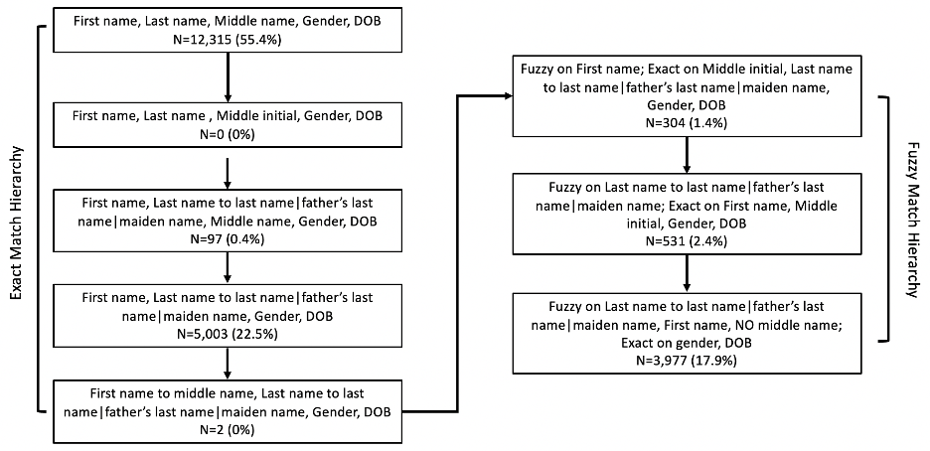

eFigure 2. Study timeline. (A) Index date definition for preoperative prescriptions, (B) Index date definition for postsurgical or nonsurgical prescriptions, and (C) Overall study timeline

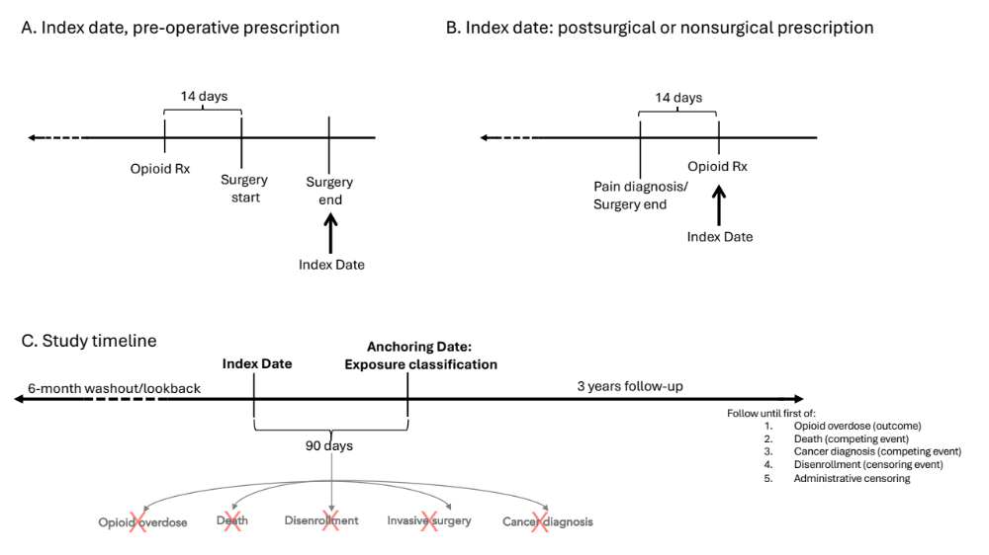
eFigure 3. Defining long-term opioid therapy (LTOT) compared to short- to medium- term opioid therapy (SMTOT) during the 90-day exposure classification period.

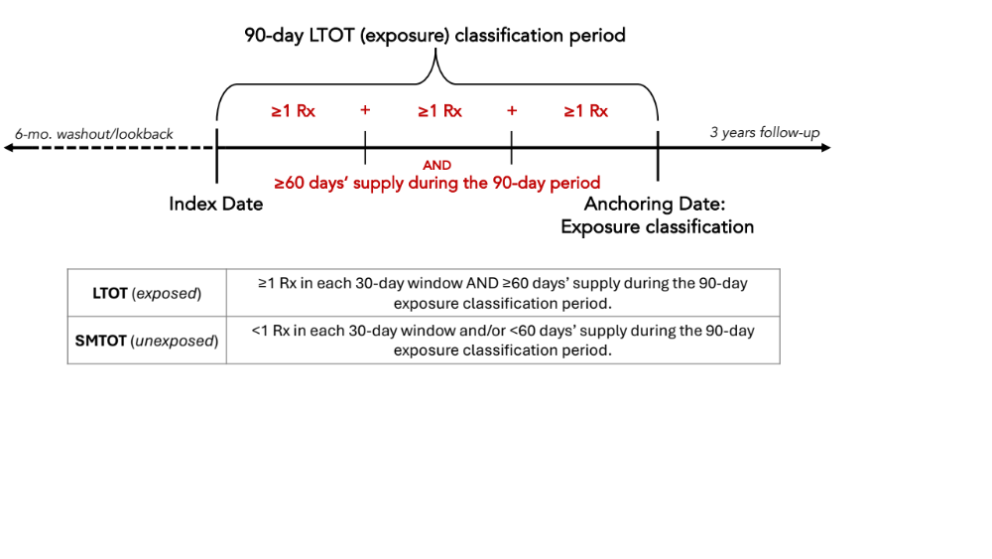
eFigure 4. Directed acyclic graph (DAG) of hypothesized relationships of key variables in the association between LTOT and opioid overdose.
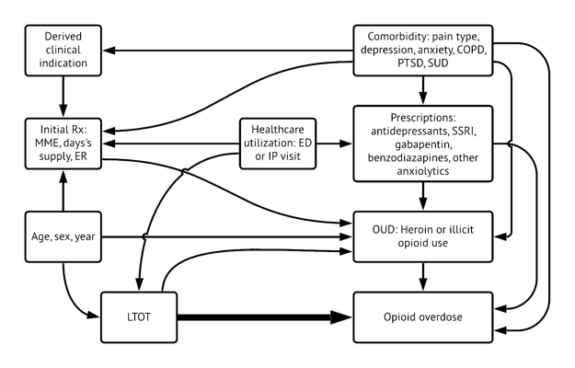
eFigure 5. Covariate balance before and after IPTW

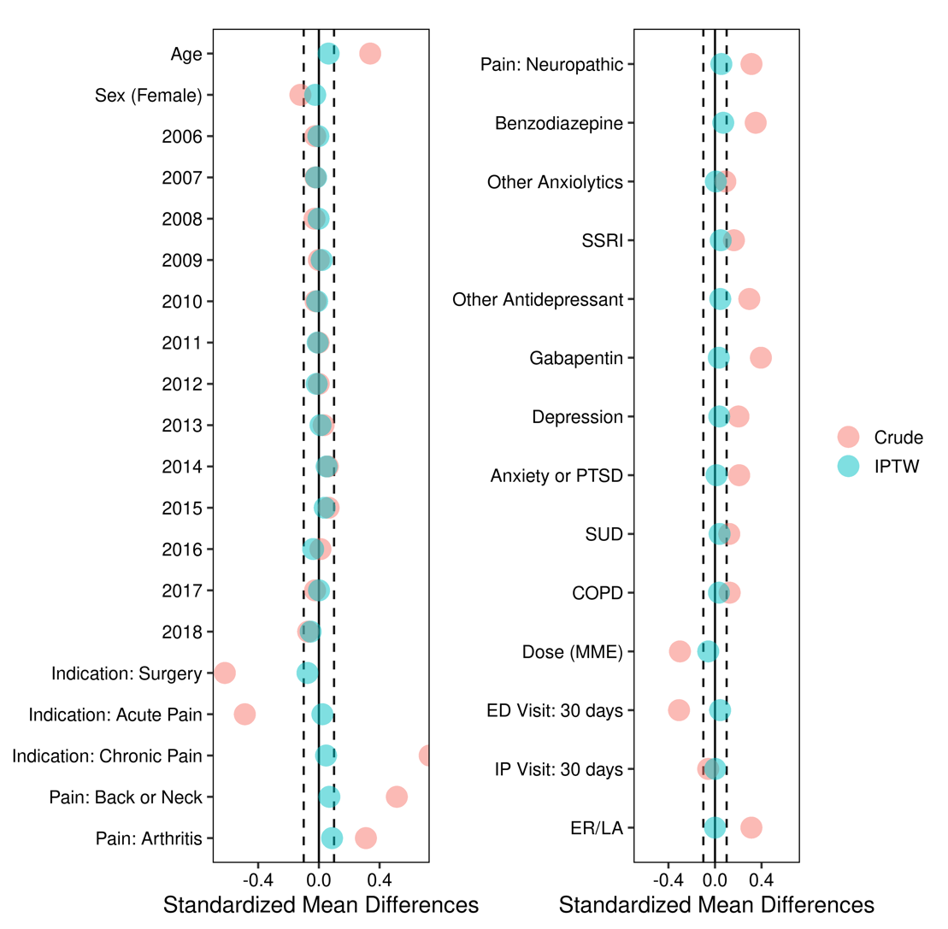

eFigure 6. Study flowchart of selection of patients prescribed opioid analgesics for a derived indication of pain or surgery in North Carolina 2006-2018 into the analytic cohort

eFigure 7. Crude cumulative incidence of opioid overdose among patients initiating opioid analgesics following a pain diagnosis or surgery by primary exposure status - North Carolina, 2006-2018

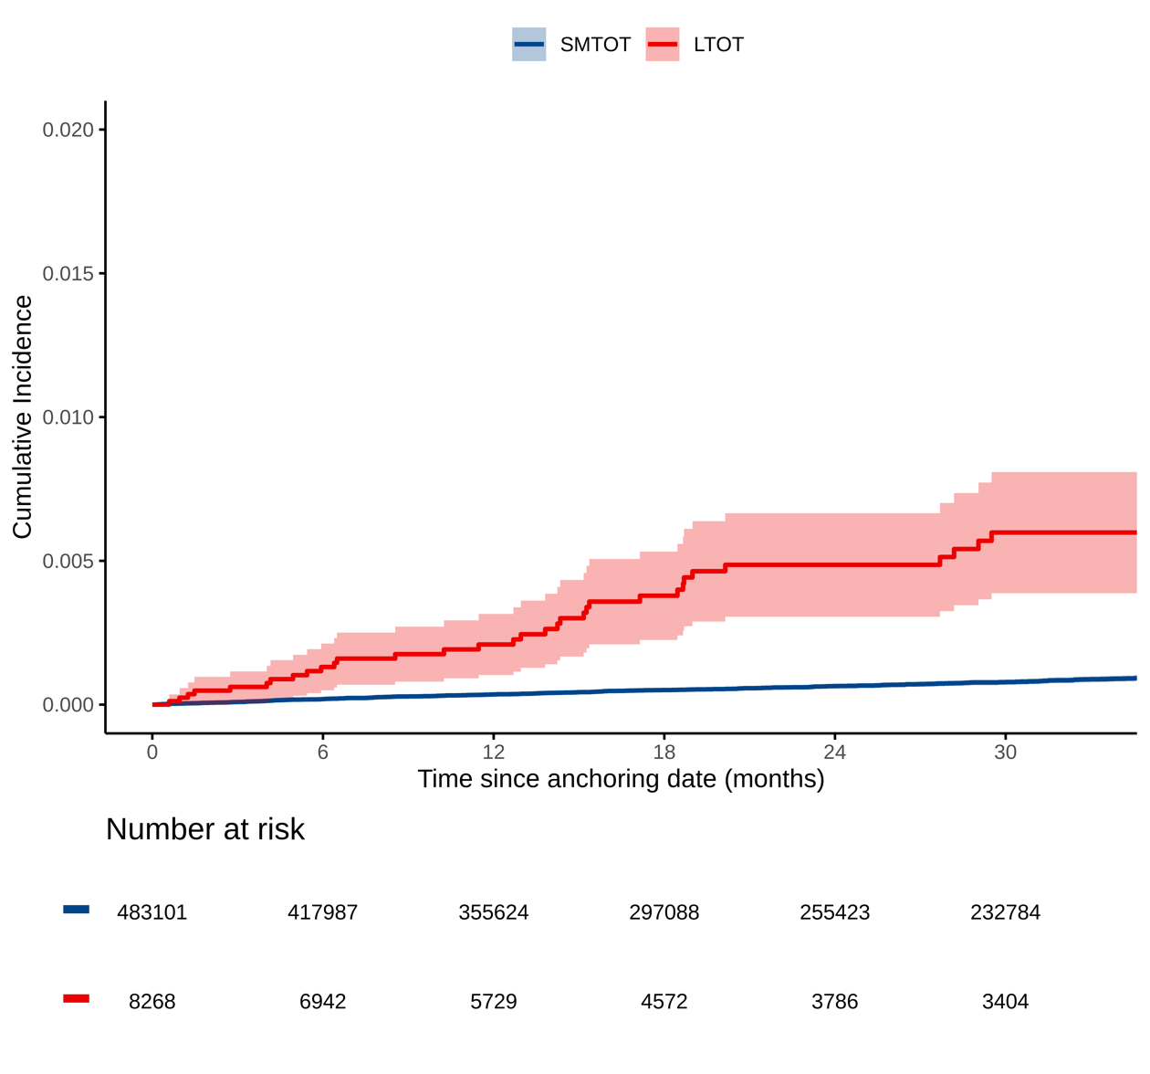

eFigure 8. Weighted cumulative incidence of opioid overdose among patients initiating opioid analgesics following a pain diagnosis or surgery by primary exposure status, stratified by derived clinical indication - North Carolina, 2006-2018

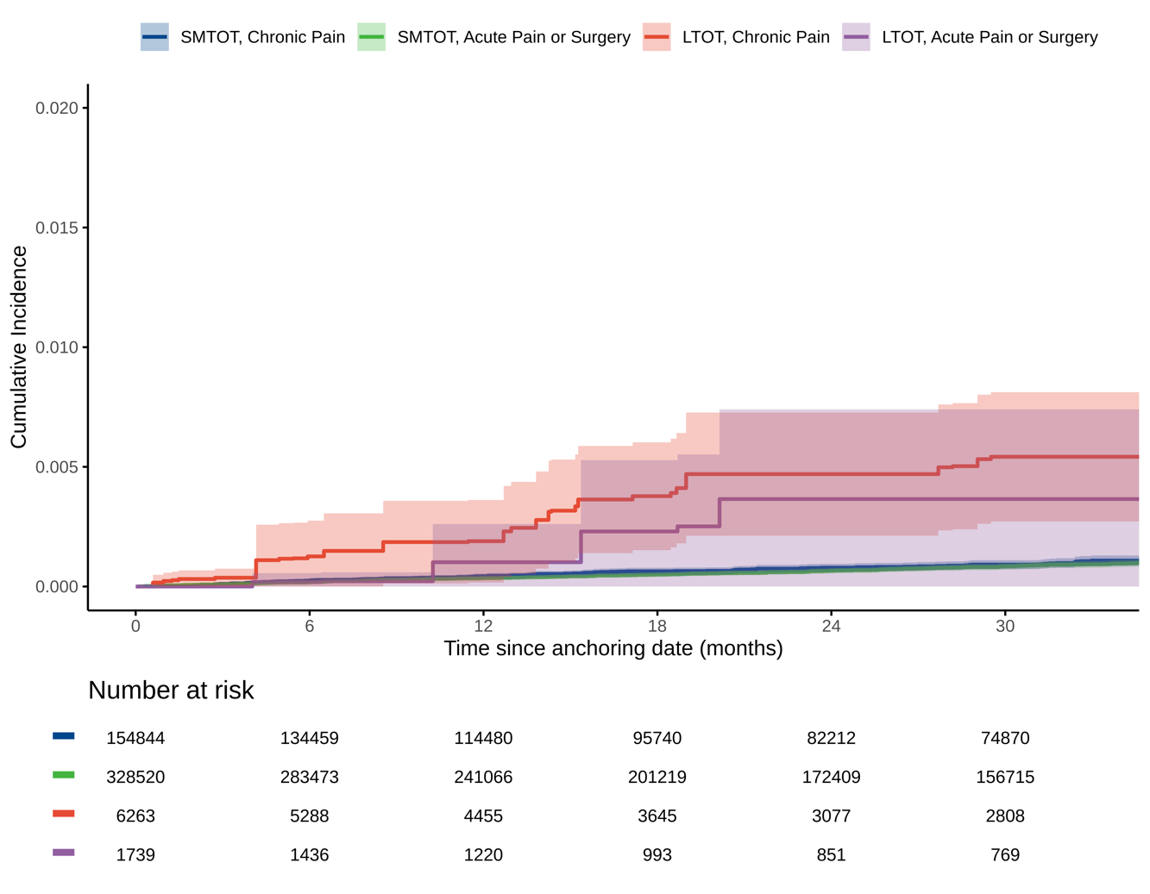

eReferences

1. Ray GT, Bahorik AL, VanVeldhuisen PC, Weisner CM, Rubinstein AL, Campbell CI. Prescription Opioid Registry Protocol in an Integrated Health System. Am J Manag Care. May 01 2017;23(5):e146-55.
2. Centers for Disease Control and Prevention (CDC). National Center for Injury Prevention and Control. Opioid Overdose: Data Resources. Analyzing prescription data and morphine milligram equivalents (MME). 2021. Accessed July 16, 2021. https://www.cdc.gov/opioids/data-resources/index.html
3. Rowe C, Vittinghoff E, Santos GM, Behar E, Turner C, Coffin PO. Performance Measures of Diagnostic Codes for Detecting Opioid Overdose in the Emergency Department. Academic emergency medicine : official journal of the Society for Academic Emergency Medicine. Apr 2017;24(4):475-483. doi:10.1111/acem.13121
4. Chhabra N, Smith D, Pachwicewicz P, et al. Performance of International Classification of Disease-10 codes in detecting emergency department patients with opioid misuse. Addiction. Apr 2024;119(4):766-771. doi:10.1111/add.16394
5. Cole SR, Lau B, Eron JJ, et al. Estimation of the standardized risk difference and ratio in a competing risks framework: application to injection drug use and progression to AIDS after initiation of antiretroviral therapy. Am J Epidemiol. Feb 15 2015;181(4):238-45. doi:10.1093/aje/kwu122
6. Cole SR, Hudgens MG, Brookhart MA, Westreich D. Risk. Am J Epidemiol. Feb 15 2015;181(4):246-50. doi:10.1093/aje/kwv001

