Supplemental Figures
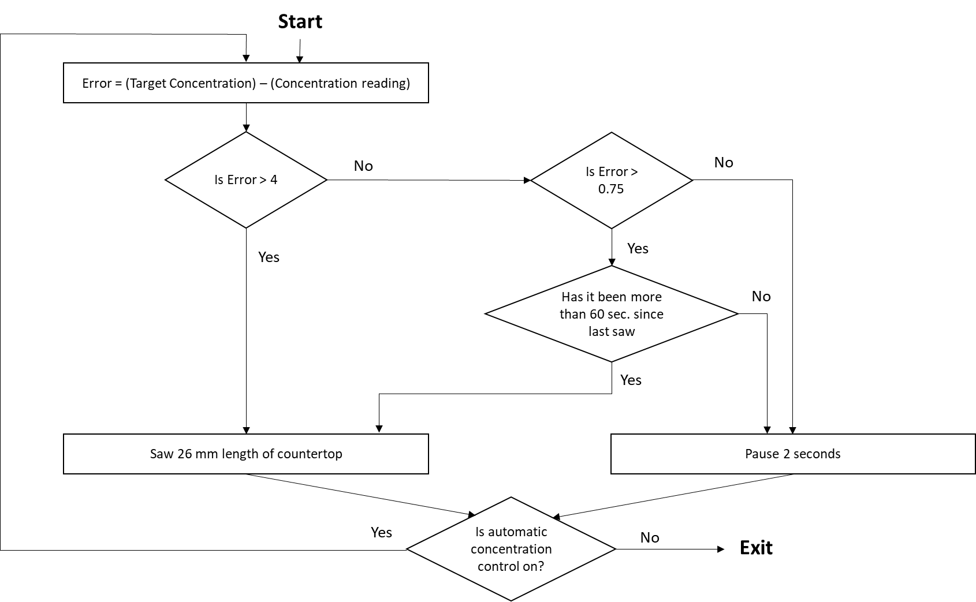
S1. Concentration control algorithm flow chart. Graphical representation of the algorithm used by the particle generation apparatus to maintain chamber particle concentration via activation of saw and step motor.
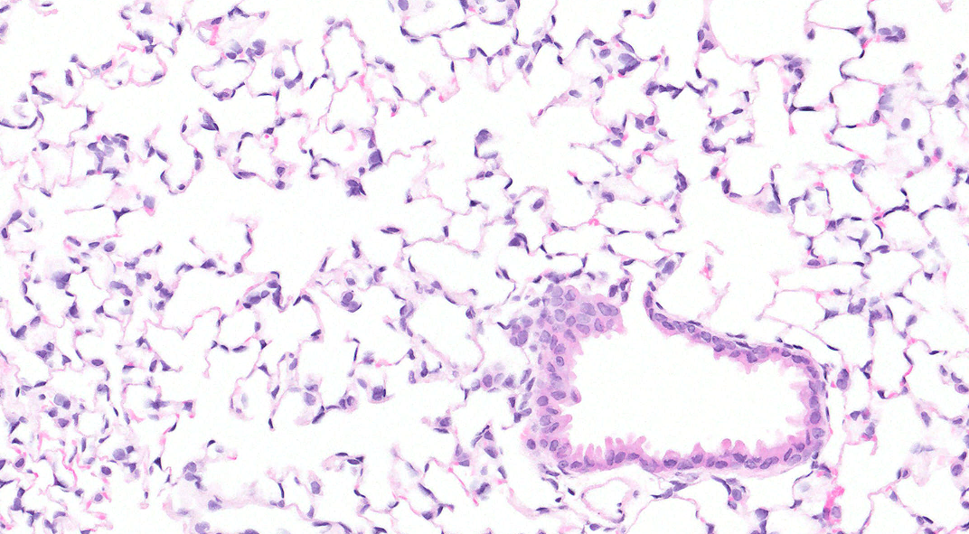
S2. Representative micrograph of mouse lung exposed to filtered air control at 1-day post-exposure, stained in H&E. 20X magnification.
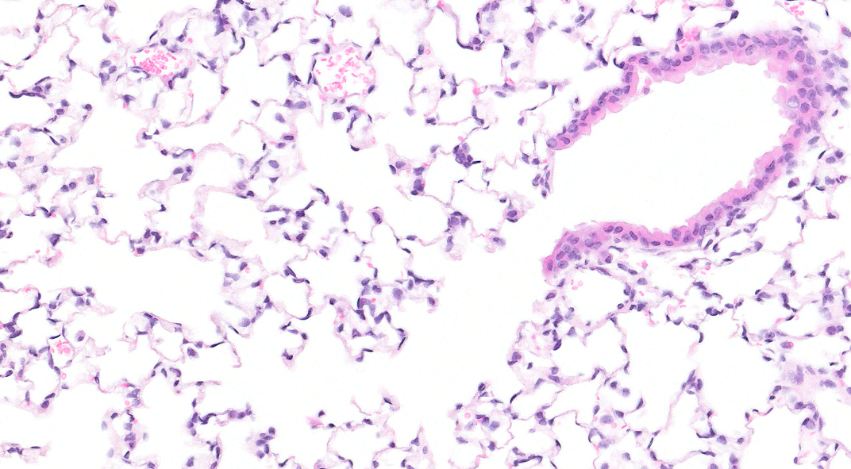
S3. Representative micrograph of mouse lung exposed to filtered air control at 56 days post-exposure, stained in H&E. 20X magnification.

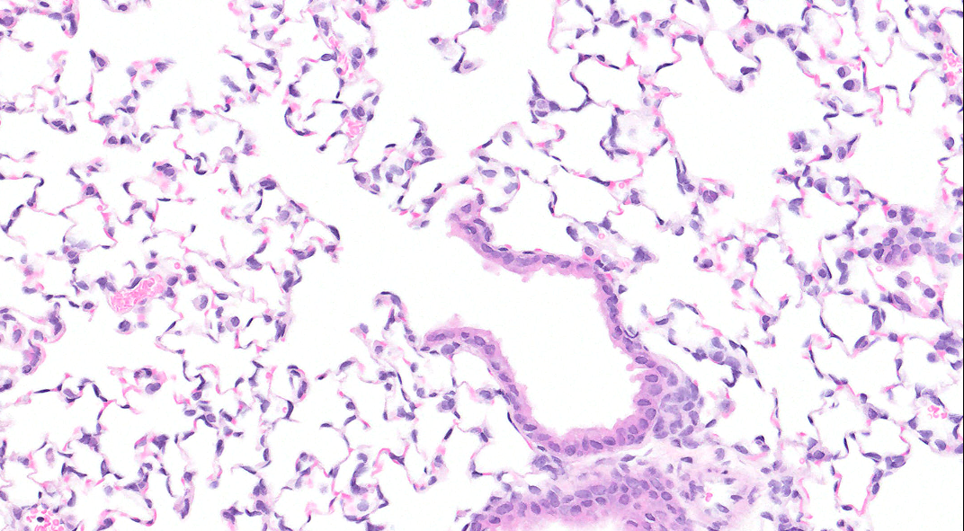
S4. Representative micrograph of mouse lung exposed to emissions from cutting SSC for 4 days, 4 hours / day, at 1-day post-exposure, stained in H&E. 20X magnification.

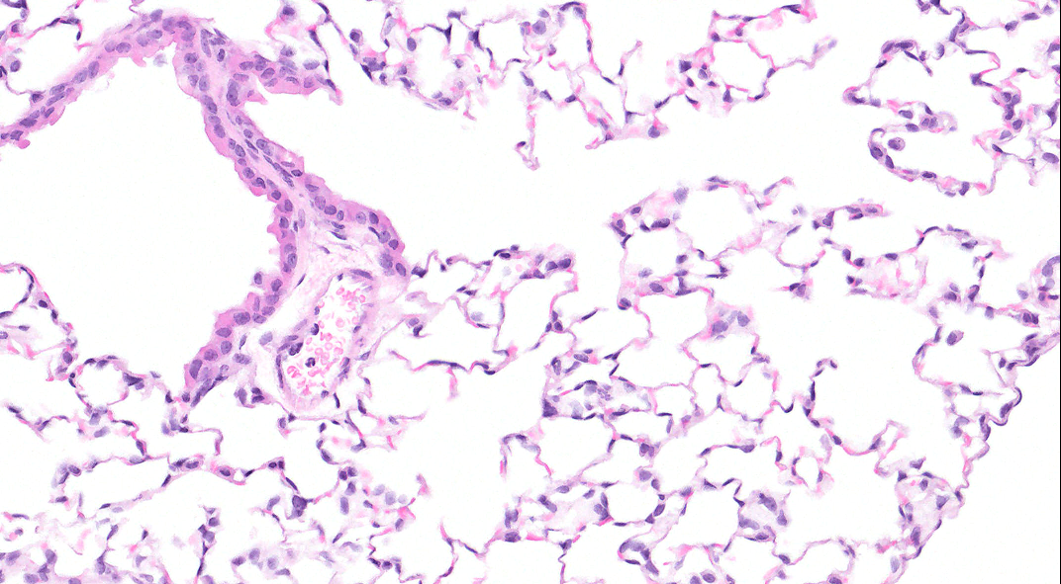
S5. Representative micrograph of mouse lung exposed to emissions from cutting SSC for 4 days, 4 hours / day, at 56 days post-exposure, stained in H&E. 20X magnification.

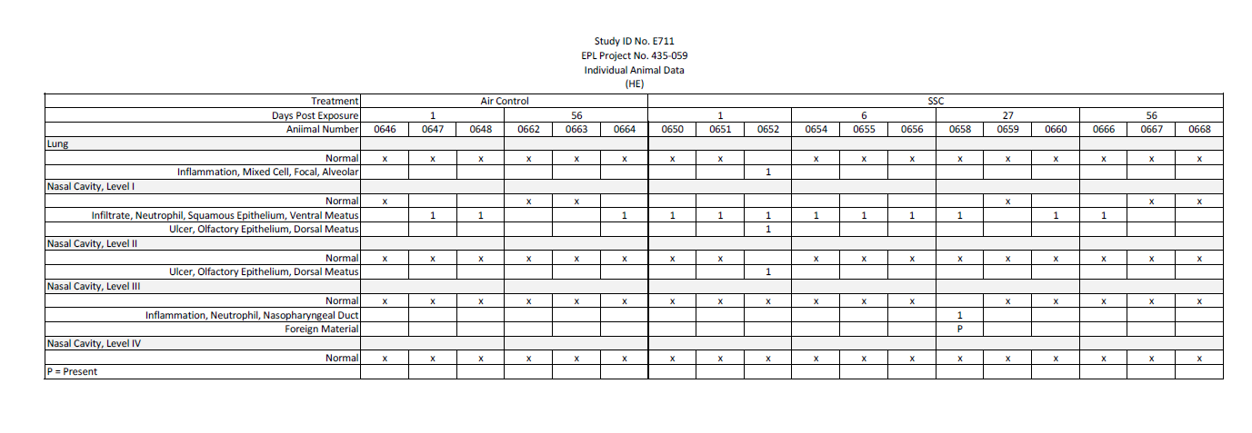
S6. Histology scores for mouse lungs and nasal sections I-IV exposed to exposed to emissions from cutting SSC or filtered air for 4 days, 4 hours / day.

S7. Data Dictionary
Field Term | Definition
RBC(M/µL) | Erythrocytes - functional component of blood responsible for the transportation of gases
HGB(g/dL) | Hemoglobin - protein in red blood cells that carries oxygen.
HCT(%) | Hematocrit - the percentage by volume of red cells
MCV(fL) | Mean corpuscular volume - measurement of the average size of red blood cells
MCH(pg) | Mean corpuscular hemoglobin -average amount of hemoglobin found in the red blood cells
MCHC(g/dL) | Mean Corpuscular Hemoglobin Concentration - measurement of the amount of hemoglobin a red blood cell has relative to the cell's volume
RDW-SD(fL) | Red Cell Distribution Width - heterogeneity of cell size in the peripheral blood
RDW-CV(%) | Red Cell Distribution Width deviation
RET# (K/µL) | Reticulocytes - immature red blood cells (RBCs) produced in the bone marrow and released into the peripheral blood
RET (%) | % Reticulocytes
PLT (K/µL) | Platelets - cell fragments that form clots and stop or prevent bleeding
PDW (fL) | Platelet Distribution Width - measurement of platelet anisocytosis calculated from the distribution of individual platelet volumes
MPV (fL) | Mean Platelet Volume
P-LCR (%) | Platelet-large cell ratio - percentage of all platelets with a volume measuring over 12 fL circulating in the bloodstream
PCT (%) | Plateletcrit - volume occupied by platelets in the blood
WBC (K/µL) | White Blood Cells - granulocytes (neutrophils, eosinophils, and basophils) and non-granulocytes (lymphocytes and monocytes)
NEUT #(K/µL) | Neutrophils - most abundant type of granulocytes
LYMPH #(K/µL) | Lymphocytes - type of white blood cell that is part of the immune system
MONO #(K/µL) | Monocytes - white blood cells that derive from the bone marrow
EO# (K/µL) | Eosinophils - granulocytes that express cytoplasmic granules that contain basic proteins and bind with acidic dyes
BAS# (K/µL) | Basophils - least common type of granulocyte
NEUT (%) | Neutrophils percent
LYMPH (%) | Lymphocytes percent
MONO (%) | Monocytes percent
EO (%) | Eosinophils percent
BASO (%) | Basophils percent
LDH (U/L) | Lactate dehydrogenase - LDH is an enzyme that is found in all cells, but it is released into the bloodstream when cells are damaged. A high LDH level in BALF can indicate that there is damage to the lung tissue
IFN-y (pg/mL) | Interferon gamma - cytokine involved in innate and adaptive immunity
IL-10 (pg/mL) | Interleukin-10 - cytokine with effects in immunoregulation and inflammation
IL-13 (pg/mL) | Interleukin-13 - cytokine that promotes the differentiation of Th2 cells and the production of IgE antibodies
IL1-β (pg/mL) | Interleukin 1 beta - proinflammatory cytokine that promotes inflammation, fever, cytokine production, T cell activation, and bone resorption
IL-4 (pg/mL) | Interleukin-4 - cytokine that promotes Th2 cell differentiation and is involved in allergic inflammation.
IL-5 (pg/mL) | Interleukin -5 - cytokine that promotes the differentiation and activation of eosinophils
IL-6 (pg/mL) | Interleukin-6 - pleiotropic cytokine that regulates inflammation, immunity, and metabolism
KC/GRO (pg/mL) | Keratinocyte chemoattractant /human growth-regulated oncogene - measures the levels of two proteins, keratinocyte chemoattractant and human growth-regulated oncogene, which are associated with the development of cancer
TNF-α (pg/mL) | Tumor necrosis factor - alpha - proinflammatory cytokine that plays a role in a variety of cellular processes, including cell proliferation, differentiation, and apoptosis
TP (mg/mL) | Total protein - amount of protein in lung fluid. High levels can indicate conditions like pulmonary edema, pneumonia, fibrosis, sarcoidosis, or lung cancer.
TAC - Total Antioxidant Capacity (% inhibition)- | Biomarker in quantifying the inherent antioxidant defense system within cells.
SOD - superoxide dismutase (U / mg protein) | Quantifies the enzymatic activity of SODs, a family of antioxidant enzymes constituting the first line of defense against oxidative stress.

S8. Limits of detection and quantification for the V-PLEX Proinflammatory Panel.
Analyte | LLOD | LLOQ | ULOQ | Dynamic Range | Unit
IFN-γ | 0.04 | 0.39 | 570 | 0.04 - 570 | pg/mL
IL-1β | 0.11 | 0.72 | 1,030 | 0.11 - 1,030 | pg/mL
IL-2 | 0.22 | 1.03 | 1,570 | 0.22 - 1,570 | pg/mL
IL-4 | 0.11 | 0.818 | 1,060 | 0.11 - 1,060 | pg/mL
IL-5 | 0.06 | 0.302 | 590 | 0.06 - 590 | pg/mL
IL-6 | 0.61 | 7.61 | 3,140 | 0.61 - 3,140 | pg/mL
IL-10 | 0.94 | 7.26 | 2,030 | 0.94 - 2,030 | pg/mL
IL-12p70 | 9.95 | 179 | 20,600 | 9.95 - 20,600 | pg/mL
KC/GRO | 0.24 | 3.29 | 1,230 | 0.24 - 1,230 | pg/mL
TNF-α | 0.13 | 0.98 | 403 | 0.13 - 403 | pg/mL

S9. MPPD model parameters used to estimate mouse lung burden.
MPPD v3.04 © 2016 by Applied Research Associates, Inc.
--> Lung morphometry <--
Lung Geometry: mouse
Number of segments: 22
Scaling tree by (TLC ---> FRC): 0.597
TLC = 1.03 ml
FRC = 0.22 ml
Scaling tree by ((1+TV/2FRC) ^1/3): 1.779
Calculated FRC = 0.22 ml
Lung (distal) volume = 1.23 ml
Volume of conducting airways: 0.09 ml

-----> Breathing Parameters and Times <-------
Breathing Frequency: 250.0 #/min Tidal volume: 2.0268848624439206 ml
Nasopharyngeal dead space: 0.0322 ml
--> Regional Deposition <--

Inhalation time: 0.12 sec Exhalation time: 0.12 sec
Volumetric inhalation flow rate at trachea: 16.89070718703267 ml/sec
Volumetric exhalation flow rate at trachea: 16.89070718703267 ml/sec
Time spent in the head during inhalation: 0.002 sec
Time spent in the head during exhalation: 0.002 sec

--> Particle properties <--
Diameter: 1.790E+0 µm
Sigma_g (GSD): 2.750E+0
Mass density: 1.0 g/cm^3

Aerosol concentration: 20.0 mg/m^3

Inhalable fraction: 1.0000
Breathing route: nasal

--> Inhalation <--
Inspiratory Fraction: 0.5

--> Pause <--
Pause Fraction: 0.0

Total head deposition fraction: 0.9252
Total TB deposition fraction: 0.0145
Total pulmonary deposition fraction: 0.0122
Total deposition fraction: 0.9519

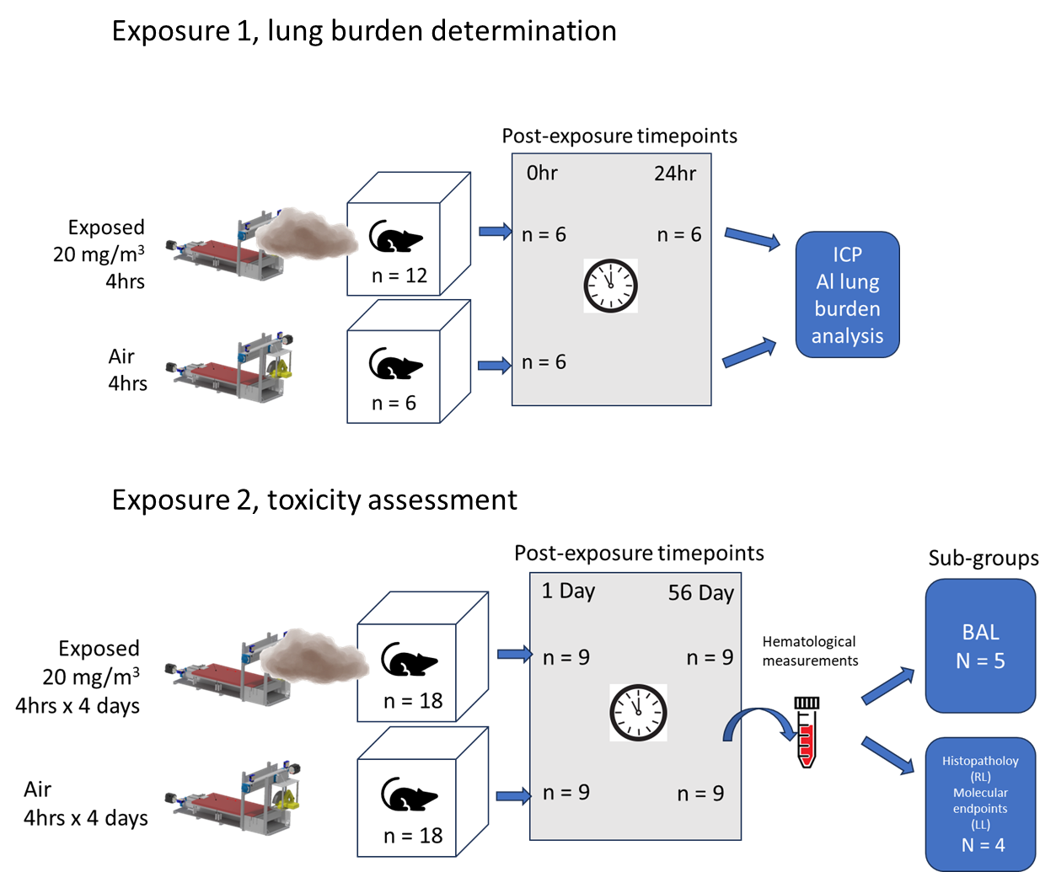
S10. Experimental design diagram.
S11. Histopathology scoring system
Grade 1 (1+): Minimal. This corresponds to a histopathologic change ranging from
inconspicuous to barely noticeable but so minor, small, or infrequent as to warrant no more than
the least assignable grade. For multifocal or diffusely-distributed lesions, this grade was used
for processes where less than approximately 10% of the tissue in an average high-power field
was involved. For focal or diffuse hyperplastic/hypoplastic/ atrophic lesions, this grade was
used when the affected structure or tissue had undergone a less than approximately 10%
increase or decrease in volume.
Grade 2 (2+): Mild. This corresponds to a histopathologic change that is a noticeable but not a
prominent feature of the tissue. For multifocal or diffusely-distributed lesions, this grade was
used for processes where between approximately 10% and 25% of the tissue in an average
high-power field was involved. For focal or diffuse hyperplastic/hypoplastic/atrophic lesions, this
grade was used when the affected structure or tissue had undergone between an approximately
10% to 25% increase or decrease in volume.
Grade 3 (3+): Moderate. This corresponds to a histopathologic change that is a prominent but
not a dominant feature of the tissue. For multifocal or diffusely-distributed lesions, this grade
was used for processes where between approximately 25% and 50% of the tissue in an
average high-power field was involved. For focal or diffuse hyperplastic/hypoplastic/atrophic
lesions, this grade was used when the affected structure or tissue had undergone between an
approximately 25% to 50% increase or decrease in volume.
Grade 4 (4+): Marked. This corresponds to a histopathologic change that is a dominant but not
an overwhelming feature of the tissue. For multifocal or diffusely-distributed lesions, this grade
was used for processes where between approximately 50% and 95% of the tissue in an
average high-power field was involved. For focal or diffuse hyperplastic/hypoplastic/atrophic
lesions, this grade was used when the affected structure or tissue had undergone between an
approximately 50% to 95% increase or decrease in volume.
Grade 5 (5+): Severe. This corresponds to a histopathologic change that is an overwhelming
feature of the tissue. For multifocal or diffusely-distributed lesions, this grade was used for
processes where greater than approximately 95% of the tissue in an average high-power field
was involved. For focal or diffuse hyperplastic/hypoplastic/atrophic lesions, this grade was used
when the affected structure or tissue had undergone a greater than approximately 95% increase
of decrease in volume.

Supplemental Equations
Eq. 1. Exposure rate = Minute ventilation * Permissible Exposure Limit * Deposition fraction
$$\frac{0.005 mg}{min}= \frac{0.02{ m}^{3}}{\text{min }}* \frac{2.5 mg}{m^{3}}* 10\%$$
Eq. 2. Yearly deposition = Exposure rate * Exposure duration
$\frac{300 mg}{year }$ = $\frac{0.005 mg}{min} *\frac{60 min}{hour}*\frac{4 hrs}{day}*\frac{5 days}{week}*\frac{50 weeks}{year}$
Eq. 3. Exposure relative to alveolar surface area = Yearly deposition / human alveolar surface area
$$\frac{2.94 mg/m^{2}}{year}= \frac{300 mg}{102{ m}^{2}}$$

Eq. 4. Mouse alveolar surface area / exposure relative to alveolar surface area = Human equivalent exposure years
$\frac{Experimental Deposition (mg)}{0.05{ m}^{2}}$ / $\frac{2.94 mg/m^{2}}{year}$ = Human equivalent exposure years

First, the equivalent volume diameter (d_{e}) must be calculated using Eq .5 using the measured geometric diameter (d_{PA}) with a volume shape factor (α) of .21 (Hinds 1999).
Eq. 5. Particle equivalent volume diameter
$$de=d_{PA}{\left(\frac{6α_{v}}{π}\right)}^{\frac{1}{3}}$$
$$de=1.16µm{\left(\frac{6*0.21}{π}\right)}^{1/3}=0.85µm$$

Eq. 6. Particle aerodynamic diameter
$$d_{a}=d_{e}{\left(\frac{ρ_{p}}{ρ_{0 }x}\right)}^{1/2}$$
$$d_{a}=1.16µm{\left(\frac{1800\frac{kg}{m^{3}}}{1000\frac{kg}{m^{3}}*0.839}\right)}^{1/2}=1.56 µm$$

With d_{e} determined, the aerodynamic diameter may be calculated (d_{a}) using Eq. 6, where Ρρ is the particle density (1800 kg/m³) (DuPont 2015, 2016), Ρ₀ is the standard particle density of 1000 kg/m³, and X is the dynamic shape factor of 0.839 (Hsieh 1985).

