Supporting Information
Figure S1: Geometric mean concentrations (µg/L) and 95% confidence intervals (CI) among the general U.S. population from the period between 1999–2000 and 2017–March 2020 for PFOS (A), PFOA (B), PFHxS (C), and PFNA (D).
Figure S2: PFAS concentration profiles of geometric means and 95th percentiles in NHANES by survey cycle.
Figure S3: PFAS profiles in communities affected by AFFF contamination and NHANES at similar time points.
Table S1: PFAS biomarkers, including their abbreviations and CAS numbers, measured in the serum of NHANES participants from 1999–2000 through 2017–March 2020.
Table S2: Detection Rate of 9CLPF by race/ethnicity from the National Health and Nutrition Examination Survey 2017–2018.
TABLE S3. Geometric mean and select percentiles of serum n-PFOA concentrations (in µg/L) for the U.S. population from the National Health and Nutrition Examination Survey (2017–March 2020).
TABLE S4. Geometric mean and select percentiles of serum Sb-PFOA concentrations (in µg/L) for the U.S. population from the National Health and Nutrition Examination Survey (2017–March 2020).
TABLE S5. Geometric mean and select percentiles of serum PFOA concentrations (in µg/L) for the U.S. population from the National Health and Nutrition Examination Survey (2017–March 2020).
TABLE S6. Geometric mean and select percentiles of serum n-PFOS concentrations (in µg/L) for the U.S. population from the National Health and Nutrition Examination Survey (2017–March 2020).
TABLE S7. Geometric mean and select percentiles of serum Sm-PFOS concentrations (in µg/L) for the U.S. population from the National Health and Nutrition Examination Survey (2017–March 2020).
TABLE S8. Geometric mean and select percentiles of serum PF0S concentrations (in µg/L) for the U.S. population from the National Health and Nutrition Examination Survey (2017–March 2020).
TABLE S9. Geometric mean and select percentiles of serum PFHxS concentrations (in µg/L) for the U.S. population from the National Health and Nutrition Examination Survey (2017–March 2020).
TABLE S10. Geometric mean and select percentiles of serum PFNA concentrations (in µg/L) for the U.S. population from the National Health and Nutrition Examination Survey (2017–March 2020).
TABLE S11. Geometric mean and select percentiles of serum PFDA concentrations (in µg/L) for the U.S. population from the National Health and Nutrition Examination Survey (2017–March 2020).
TABLE S12. Geometric mean and select percentiles of serum PFUnDA concentrations (in µg/L) for the U.S. population from the National Health and Nutrition Examination Survey (2017–March 2020).
TABLE S13. Geometric mean and select percentiles of serum MeFOSAA concentrations (in µg/L) for the U.S. population from the National Health and Nutrition Examination Survey (2017–March 2020).
Table S14. Estimated weighted detection frequency (and upper and lower 95% confidence limits) of PFHxS, PFOS, PFOA and PFNA by NHANES cycle.
Table S15. Estimated weighted detection frequency (and upper and lower 95% confidence limits) of having detectable concentrations of four or more PFAS by NHANES cycle.

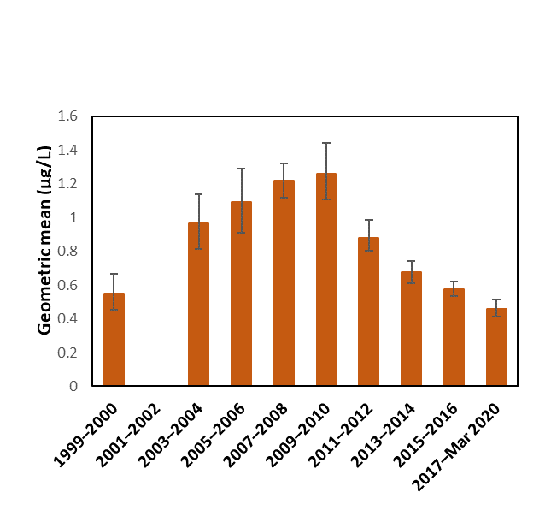
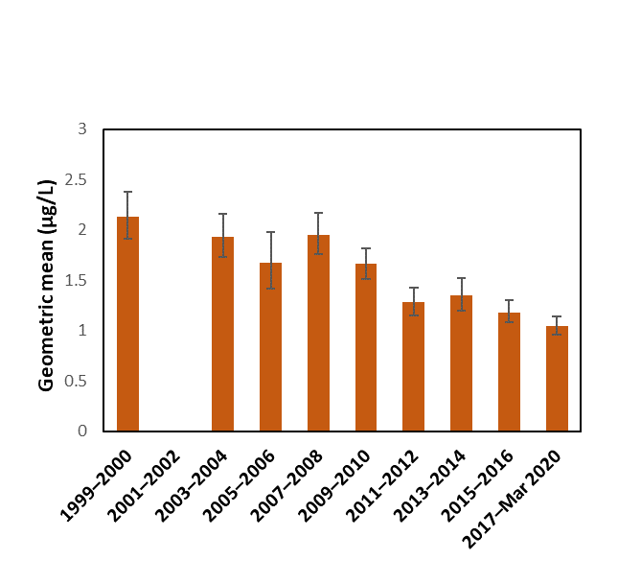
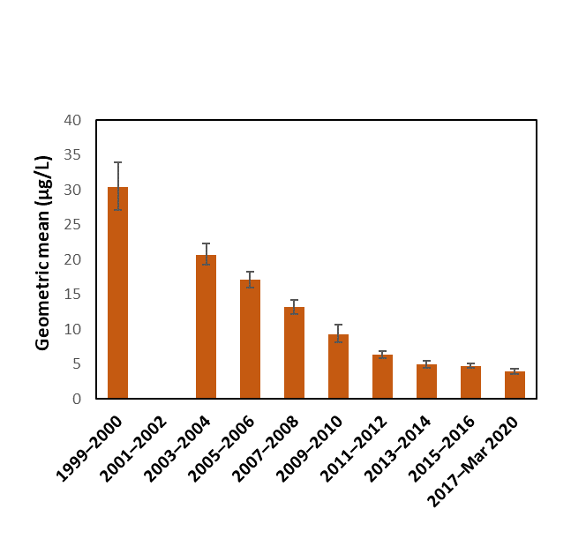
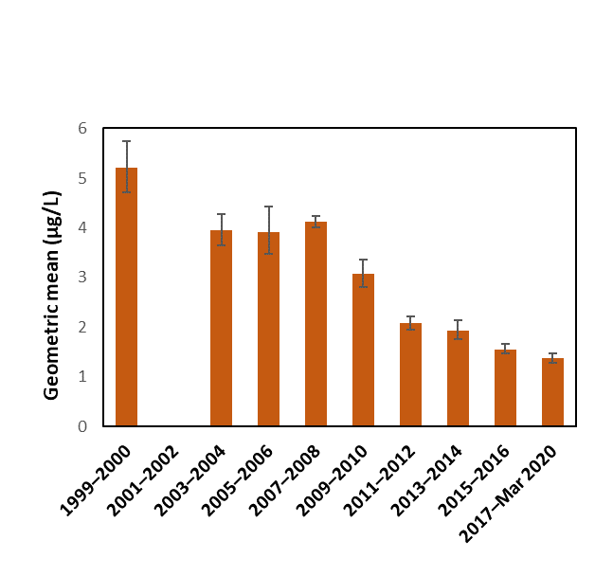
Figure S1. Geometric mean concentrations (µg/L) and 95% confidence intervals (CI) among the general U.S. population from the period between 1999–2000 and 2017–March 2020 for PFOS (A), PFOA (B), PFHxS (C), and PFNA (D). No data available for NHANES 2001–2002 because the volume of individual sera was insufficient for analysis.
B
A

PFOA
PFOS

PFNA
D
C
PFHxS
Figure S2. Profiles of PFHxS, PFOS, PFOA, and PFNA based on (A) their serum geometric mean concentrations (μg/L) and (B) 95th percentiles of PFHxS, in NHANES by cycle. NHANES geometric mean (GM) or 95th percentile (95th %ile) serum concentrations shown (μg/L) were calculated from data available on NHANES website.

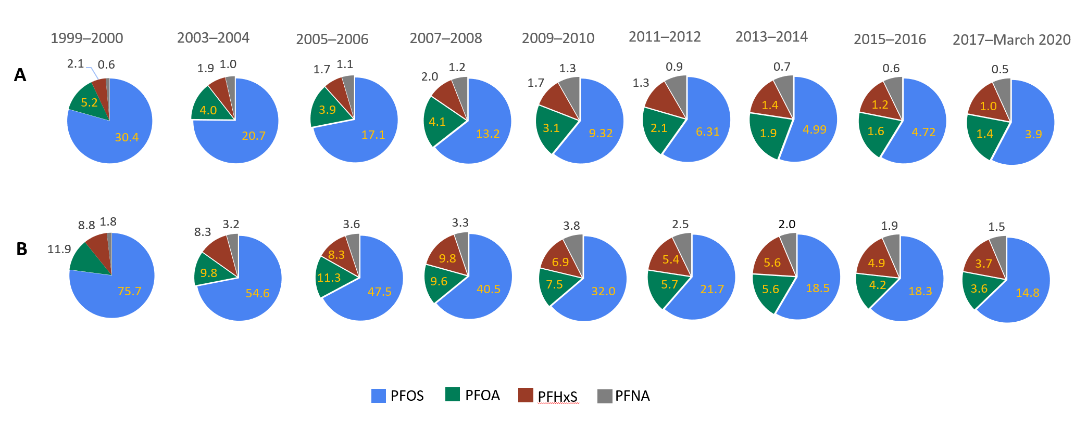

Figure S3. Profiles of PFHxS, PFOS, PFOA, and PFNA based on their serum geometric mean concentrations (μg/L) in communities affected by AFFF contamination and in NHANES (based on both geometric mean and 95th percentile concentrations) at similar time points. NHANES geometric mean (GM) or 95th percentile (95th %ile) serum concentrations shown (μg/L) were calculated from data available on NHANES website. AFFF contaminated communities geometric mean (in μg/L) were obtained from https://www.atsdr.cdc.gov/pfas/activities/assessments/sites.html

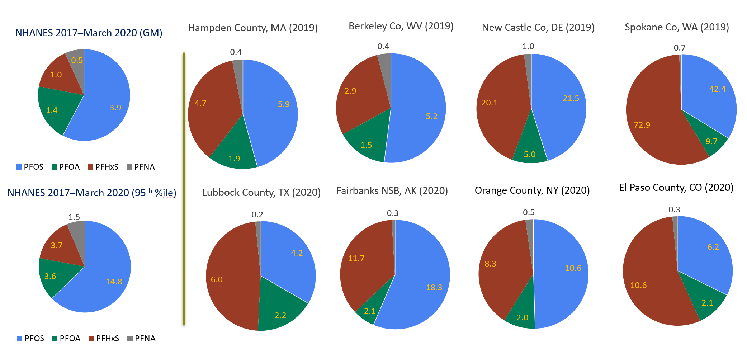

Table S1: PFAS biomarkers, including their abbreviations and CAS numbers, measured in the serum of NHANES participants from 1999–2000 through 2017–March 2020 (X indicates the cycle the PFAS measurements were made).

PFAS biomarkersª | Abbreviation | CAS Number | NHANES cycle ^{b}
PFAS biomarkersª | Abbreviation | CAS Number | 99–00 | 03−04  thru  11−12 | 13−14 | 15−16 | 17−March 20
Perfluorohexanoic acid | PFHxA | 307-24-4 |  |  |  |  | X ^{c}
Perfluoroheptanoic acid | PFHpA | 375-85-9 | X | X | X
Perfluorooctanoic acid | PFOA | 335-67-1 | X | X | X | X | X
Perfluorononanoic acid | PFNA | 375-95-1 | X | X | X | X | X
Perfluorodecanoic acid | PFDA | 335-76-2 | X | X | X | X | X
Perfluoroundecanoic acid | PFUnDA | 2058-94-8 | X | X | X | X | X
Perfluorododecanoic acid | PFDoDA | 307-55-1 | X | X | X | X
Perfluorobutane sulfonic acid | PFBS | 375-73-5 |  | X | X
Perfluorohexane sulfonic acid | PFHxS | 355-46-4 | X | X | X | X | X
Perfluoroheptane sulfonic acid | PFHpS | 375-92-8 |  |  |  |  | X^{c}
Perfluorooctane sulfonic acid | PFOS | 1763-23-1 | X | X | X | X | X
Perfluorooctane sulfonamide | FOSA | 754-91-6 | X | X
2-(N-Methyl-perfluorooctane sulfonamido) acetic acid | MeFOSAA | 2355-31-9 | X | X | X | X | X
2-(N-Ethyl-perfluorooctane sulfonamido) acetic acid | EtFOSAA | 2991-50-6 | X | X
2,3,3,3-tetrafluoro-2-(1,1,2,2,3,3,3-heptafluoropropoxy)-propanoic acid | GenX | 13252-13-6 |  |  |  |  | X ^{c}
4,8-dioxa-3H-perfluorononanoic acid | ADONA | 958445-44-8 |  |  |  |  | X ^{c}
9-chlorohexadecafluoro-3-oxanonane-1-sulfonic acid | 9CLPF | 73606-19-6 |  |  |  |  | X ^{c}
ªStarting with 2013–2014 NHANES, PFOS and PFOA branched and linear isomers were measured separately [57].
^{b}For 2001–2002 no data exist because the volume of individual sera was insufficient for analysis.
^{c}Only measured in 2017–2018 NHANES.

Table S2: Detection frequency of 9CLPF by race/ethnicity from the National Health and Nutrition Examination Survey 2017–2018.
Categories | Detection frequency (%)
ALL | 7.98
Mexican American | 5.34
non-Hispanic White | 3.72
non-Hispanic Black | 12.80
Asian | 44.72
All Hispanic^{b} | 9.10
Other Raceª/Not Reported | 24.32
ªThe Other Race category includes people who self-identified as being multiracial.
^{b}The All Hispanic category includes people who self-identified as Mexican American.

TABLE S3. Geometric mean and select percentiles of serum n-PFOA concentrations (in µg/L) for the U.S. population from the National Health and Nutrition Examination Survey (2017–March 2020).
Demographic Categories | Survey (years) | Geometric mean (95% Conf. Interval) | 50th Percentile (95% Conf. Interval) | 75th Percentile (95% Conf. Interval) | 90th Percentile (95% Conf. Interval) | 95th Percentile (95% Conf. Interval) | Sample size
Total population | 17-20 | 1.28 (1.22-1.35) | 1.30 (1.20-1.40) | 2.00 (1.90-2.10) | 2.90 (2.70-3.10) | 3.50 (3.20-3.80) | 3072
Age 12-19 years | 17-20 | 1.03 (.942-1.13) | 1.00 (.900-1.10) | 1.40 (1.20-1.70) | 2.00 (1.70-2.30) | 2.30 (1.90-2.90) | 521
Age 20+ years | 17-20 | 1.32 (1.25-1.40) | 1.40 (1.30-1.50) | 2.00 (1.90-2.20) | 3.00 (2.70-3.20) | 3.60 (3.30-4.10) | 2551
Males | 17-20 | 1.43 (1.36-1.51) | 1.50 (1.40-1.60) | 2.00 (1.90-2.20) | 2.80 (2.70-3.20) | 3.50 (3.30-3.80) | 1506
Females | 17-20 | 1.16 (1.09-1.23) | 1.20 (1.00-1.20) | 1.90 (1.70-2.10) | 2.90 (2.60-3.10) | 3.50 (3.10-4.30) | 1566
Mexican American | 17-20 | .960 (.861-1.07) | 1.00 (.800-1.10) | 1.40 (1.30-1.60) | 2.00 (1.80-2.20) | 2.50 (2.10-2.80) | 409
Non-Hispanic Black | 17-20 | 1.01 (.927-1.11) | 1.10 (1.00-1.20) | 1.60 (1.50-1.80) | 2.40 (2.20-2.60) | 3.10 (2.70-3.40) | 787
Non-Hispanic White | 17-20 | 1.42 (1.33-1.51) | 1.50 (1.30-1.60) | 2.10 (2.00-2.30) | 3.00 (2.70-3.30) | 3.60 (3.30-4.10) | 1048
All Hispanic | 17-20 | 1.05 (.956-1.15) | 1.10 (1.00-1.20) | 1.60 (1.40-1.70) | 2.20 (1.90-2.40) | 2.60 (2.40-2.90) | 715
Asian | 17-20 | 1.53 (1.38-1.68) | 1.50 (1.30-1.60) | 2.50 (2.20-2.70) | 4.20 (3.00-5.90) | 5.90 (3.30-14.8) | 362
The limit of detection (LOD) is 0.1 µg/L.

TABLE S4. Geometric mean and select percentiles of serum Sb-PFOA concentrations (in µg/L) for the U.S. population from the National Health and Nutrition Examination Survey (2017–March 2020).
Demographic Categories | Survey (years) | Geometric mean (95% Conf. Interval) | 50th Percentile (95% Conf. Interval) | 75th Percentile (95% Conf. Interval) | 90th Percentile (95% Conf. Interval) | 95th Percentile (95% Conf. Interval) | Sample size
Total population | 17-20 | * | < LOD | < LOD | < LOD | .100 (<LOD-.200) | 3072
Age 12-19 years | 17-20 | * | < LOD | < LOD | < LOD | .100 (<LOD-.200) | 521
Age 20+ years | 17-20 | * | < LOD | < LOD | < LOD | .100 (<LOD-.200) | 2551
Males | 17-20 | * | < LOD | < LOD | < LOD | .100 (<LOD-.200) | 1506
Females | 17-20 | * | < LOD | < LOD | < LOD | < LOD | 1566
Mexican American | 17-20 | * | < LOD | < LOD | < LOD | .100 (<LOD-.200) | 409
Non-Hispanic Black | 17-20 | * | < LOD | < LOD | < LOD | < LOD | 787
Non-Hispanic White | 17-20 | * | < LOD | < LOD | < LOD | .100 (<LOD-.200) | 1048
All Hispanic | 17-20 | * | < LOD | < LOD | < LOD | .100 (<LOD-.200) | 715
Asian | 17-20 | * | < LOD | < LOD | < LOD | .200 (<LOD-.400) | 362
The limit of detection (LOD) is 0.1 µg/L.
* denotes that the geometric mean was not calculated because the proportion of results <LOD was too high to provide a valid result.

TABLE S5. Geometric mean and select percentiles of serum PFOAª concentrations (in µg/L) for the U.S. population from the National Health and Nutrition Examination Survey (2017–March 2020).
Demographic Categories | Survey (years) | Geometric mean (95% Conf. Interval) | 50th Percentile (95% Conf. Interval) | 75th Percentile (95% Conf. Interval) | 90th Percentile (95% Conf. Interval) | 95th Percentile (95% Conf. Interval) | Sample size
Total population | 17-20 | 1.38 (1.31-1.45) | 1.37 (1.27-1.47) | 2.07 (1.97-2.17) | 2.97 (2.77-3.17) | 3.57 (3.27-3.90) | 3072
Age 12-19 years | 17-20 | 1.12 (1.03-1.22) | 1.07 (.970-1.17) | 1.50 (1.37-1.77) | 2.07 (1.77-2.37) | 2.37 (2.07-2.97) | 521
Age 20+ years | 17-20 | 1.42 (1.35-1.49) | 1.47 (1.37-1.57) | 2.17 (1.97-2.27) | 3.07 (2.77-3.27) | 3.67 (3.47-4.17) | 2551
Males | 17-20 | 1.52 (1.45-1.60) | 1.57 (1.47-1.67) | 2.07 (1.97-2.27) | 2.87 (2.77-3.27) | 3.57 (3.37-3.87) | 1506
Females | 17-20 | 1.25 (1.18-1.33) | 1.27 (1.07-1.27) | 1.97 (1.77-2.17) | 2.97 (2.67-3.17) | 3.57 (3.17-4.27) | 1566
Mexican American | 17-20 | 1.05 (.954-1.16) | 1.07 (.900-1.17) | 1.47 (1.37-1.70) | 2.07 (1.87-2.27) | 2.57 (2.17-2.87) | 409
Non-Hispanic Black | 17-20 | 1.11 (1.03-1.20) | 1.17 (1.07-1.27) | 1.67 (1.57-1.87) | 2.50 (2.27-2.77) | 3.17 (2.77-3.47) | 787
Non-Hispanic White | 17-20 | 1.51 (1.42-1.61) | 1.57 (1.37-1.70) | 2.27 (2.07-2.37) | 3.07 (2.77-3.37) | 3.67 (3.37-4.17) | 1048
All Hispanic | 17-20 | 1.14 (1.05-1.24) | 1.17 (1.07-1.27) | 1.67 (1.50-1.77) | 2.27 (1.97-2.50) | 2.67 (2.47-2.97) | 715
Asian | 17-20 | 1.63 (1.48-1.79) | 1.57 (1.47-1.67) | 2.57 (2.27-2.77) | 4.27 (3.07-5.97) | 6.00 (3.80-9.87) | 362
ªSum of linear and branched PFOA isomers. The limit of detection (LOD) is 0.1 µg/L.

TABLE S6. Geometric mean and select percentiles of serum n-PFOS concentrations (in µg/L) for the U.S. population from the National Health and Nutrition Examination Survey (2017–March 2020).
Demographic Categories | Survey (years) | Geometric mean (95% Conf. Interval) | 50th Percentile (95% Conf. Interval) | 75th Percentile (95% Conf. Interval) | 90th Percentile (95% Conf. Interval) | 95th Percentile (95% Conf. Interval) | Sample size
Total population | 17-20 | 2.72 (2.53-2.93) | 2.70 (2.50-3.00) | 4.80 (4.40-5.30) | 7.70 (6.80-9.00) | 10.4 (9.40-11.8) | 3072
Age 12-19 years | 17-20 | 1.73 (1.50-1.98) | 1.70 (1.40-1.90) | 2.60 (2.20-2.90) | 3.90 (3.20-6.00) | 6.10 (3.90-7.70) | 521
Age 20+ years | 17-20 | 2.90 (2.70-3.12) | 3.00 (2.70-3.20) | 5.10 (4.80-5.60) | 8.30 (7.20-9.30) | 11.0 (9.60-12.4) | 2551
Males | 17-20 | 3.37 (3.11-3.66) | 3.40 (3.10-3.70) | 5.60 (5.00-6.10) | 9.20 (7.90-9.80) | 11.6 (10.0-13.5) | 1506
Females | 17-20 | 2.23 (2.02-2.45) | 2.10 (1.90-2.40) | 3.80 (3.40-4.50) | 6.50 (5.90-7.40) | 9.30 (7.20-11.8) | 1566
Mexican American | 17-20 | 1.94 (1.71-2.21) | 1.80 (1.60-2.10) | 3.20 (2.70-3.90) | 5.30 (4.30-6.20) | 6.90 (5.80-9.70) | 409
Non-Hispanic Black | 17-20 | 2.85 (2.41-3.37) | 2.70 (2.30-3.20) | 5.40 (4.50-6.70) | 11.6 (8.70-13.7) | 16.6 (13.2-20.8) | 787
Non-Hispanic White | 17-20 | 2.91 (2.65-3.20) | 3.00 (2.60-3.30) | 5.00 (4.50-5.70) | 7.70 (6.80-8.80) | 9.60 (9.30-10.3) | 1048
All Hispanic | 17-20 | 2.08 (1.88-2.31) | 2.00 (1.80-2.20) | 3.30 (2.90-4.00) | 5.60 (5.10-6.00) | 7.50 (5.90-9.80) | 715
Asian | 17-20 | 3.02 (2.44-3.74) | 3.10 (2.30-4.00) | 6.00 (5.20-8.00) | 13.0 (8.10-19.9) | 19.9 (14.5-27.0) | 362
The limit of detection (LOD) is 0.1 µg/L.

TABLE S7. Geometric mean and select percentiles of serum Sm-PFOS concentrations (in µg/L) for the U.S. population from the National Health and Nutrition Examination Survey (2017–March 2020).
Demographic Categories | Survey (years) | Geometric mean (95% Conf. Interval) | 50th Percentile (95% Conf. Interval) | 75th Percentile (95% Conf. Interval) | 90th Percentile (95% Conf. Interval) | 95th Percentile (95% Conf. Interval) | Sample size
Total population | 17-20 | 1.13 (1.06-1.21) | 1.20 (1.10-1.30) | 2.10 (1.90-2.30) | 3.40 (3.20-3.60) | 4.50 (4.00-5.10) | 3072
Age 12-19 years | 17-20 | .647 (.563-.742) | .600 (.500-.700) | .900 (.800-1.10) | 1.50 (1.10-2.00) | 2.00 (1.30-4.50) | 521
Age 20+ years | 17-20 | 1.23 (1.15-1.31) | 1.30 (1.20-1.40) | 2.30 (2.10-2.40) | 3.60 (3.30-3.80) | 4.70 (4.20-5.20) | 2551
Males | 17-20 | 1.48 (1.36-1.62) | 1.50 (1.40-1.70) | 2.60 (2.20-2.90) | 3.70 (3.50-4.40) | 5.10 (4.40-5.80) | 1506
Females | 17-20 | .878 (.812-.949) | .800 (.800-.900) | 1.60 (1.40-1.90) | 2.80 (2.40-3.20) | 3.80 (3.40-4.40) | 1566
Mexican American | 17-20 | .766 (.672-.873) | .700 (.600-.800) | 1.30 (1.10-1.60) | 2.20 (1.80-2.80) | 3.20 (2.40-3.70) | 409
Non-Hispanic Black | 17-20 | .936 (.831-1.05) | .900 (.800-1.10) | 2.00 (1.70-2.20) | 3.60 (3.00-4.20) | 5.20 (4.20-5.70) | 787
Non-Hispanic White | 17-20 | 1.32 (1.21-1.42) | 1.30 (1.20-1.50) | 2.30 (2.10-2.70) | 3.60 (3.30-4.10) | 4.70 (4.40-5.40) | 1048
All Hispanic | 17-20 | .824 (.752-.903) | .800 (.700-.900) | 1.40 (1.30-1.60) | 2.30 (2.00-2.70) | 3.10 (2.70-3.30) | 715
Asian | 17-20 | .996 (.876-1.13) | 1.00 (.800-1.20) | 1.70 (1.40-2.30) | 3.40 (2.70-4.00) | 4.70 (3.30-5.90) | 362
The limit of detection (LOD) is 0.1 µg/L.

TABLE S8. Geometric mean and select percentiles of serum PFOSª concentrations (in µg/L) for the U.S. population from the National Health and Nutrition Examination Survey (2017–March 2020).
Demographic Categories | Survey (years) | Geometric mean (95% Conf. Interval) | 50th Percentile (95% Conf. Interval) | 75th Percentile (95% Conf. Interval) | 90th Percentile (95% Conf. Interval) | 95th Percentile (95% Conf. Interval) | Sample size
Total population | 17-20 | 3.93 (3.68-4.21) | 3.90 (3.60-4.20) | 7.10 (6.50-7.70) | 11.4 (10.1-12.5) | 14.8 (13.4-16.3) | 3072
Age 12-19 years | 17-20 | 2.41 (2.11-2.76) | 2.30 (2.00-2.70) | 3.50 (3.10-3.90) | 5.60 (4.10-7.30) | 7.50 (5.50-10.6) | 521
Age 20+ years | 17-20 | 4.21 (3.95-4.49) | 4.30 (3.90-4.70) | 7.50 (7.00-8.00) | 12.0 (10.4-13.1) | 15.5 (13.8-17.0) | 2551
Males | 17-20 | 4.94 (4.56-5.36) | 5.10 (4.50-5.60) | 8.10 (7.40-9.20) | 12.8 (11.5-13.9) | 16.1 (13.9-18.4) | 1506
Females | 17-20 | 3.18 (2.91-3.46) | 3.00 (2.70-3.30) | 5.60 (5.00-6.10) | 9.40 (8.30-10.6) | 13.1 (10.6-15.3) | 1566
Mexican American | 17-20 | 2.75 (2.43-3.12) | 2.60 (2.30-2.90) | 4.50 (3.80-5.30) | 7.50 (6.00-9.30) | 9.50 (7.80-12.8) | 409
Non-Hispanic Black | 17-20 | 3.88 (3.34-4.50) | 3.80 (3.20-4.20) | 7.70 (6.10-9.60) | 14.5 (11.5-17.8) | 21.5 (17.5-24.2) | 787
Non-Hispanic White | 17-20 | 4.30 (3.95-4.68) | 4.40 (3.90-4.90) | 7.60 (6.80-8.10) | 11.5 (10.2-12.7) | 14.2 (13.1-15.7) | 1048
All Hispanic | 17-20 | 2.96 (2.69-3.26) | 2.80 (2.60-3.20) | 4.80 (4.20-5.70) | 7.80 (7.20-8.60) | 10.4 (8.40-12.7) | 715
Asian | 17-20 | 4.15 (3.46-4.97) | 4.20 (3.30-5.50) | 8.00 (6.80-10.3) | 16.6 (12.0-21.3) | 23.1 (17.0-31.0) | 362
ªSum of linear and branched PFOS isomers. The limit of detection (LOD) is 0.1 µg/L.

TABLE S9. Geometric mean and select percentiles of serum PFHxS concentrations (in µg/L) for the U.S. population from the National Health and Nutrition Examination Survey (2017–March 2020).
Demographic Categories | Survey (years) | Geometric mean (95% Conf. Interval) | 50th Percentile (95% Conf. Interval) | 75th Percentile (95% Conf. Interval) | 90th Percentile (95% Conf. Interval) | 95th Percentile (95% Conf. Interval) | Sample size
Total population | 17-20 | 1.04 (.971-1.12) | 1.10 (1.00-1.20) | 1.90 (1.70-2.00) | 2.90 (2.60-3.30) | 3.70 (3.40-4.80) | 3072
Age 12-19 years | 17-20 | .759 (.668-.863) | .700 (.600-.800) | 1.10 (1.00-1.40) | 2.10 (1.50-2.90) | 2.90 (2.20-3.70) | 521
Age 20+ years | 17-20 | 1.09 (1.02-1.17) | 1.20 (1.10-1.20) | 1.90 (1.80-2.10) | 3.00 (2.70-3.30) | 3.90 (3.50-5.00) | 2551
Males | 17-20 | 1.41 (1.30-1.54) | 1.40 (1.30-1.60) | 2.20 (2.00-2.50) | 3.40 (3.00-3.70) | 4.90 (3.70-6.70) | 1506
Females | 17-20 | .783 (.725-.845) | .800 (.700-.800) | 1.40 (1.20-1.50) | 2.30 (2.10-2.70) | 3.30 (2.70-3.50) | 1566
Mexican American | 17-20 | .791 (.689-.909) | .800 (.600-1.00) | 1.40 (1.20-1.60) | 2.20 (1.90-2.40) | 2.90 (2.30-3.50) | 409
Non-Hispanic Black | 17-20 | .904 (.797-1.03) | .900 (.800-1.10) | 1.80 (1.60-2.00) | 2.90 (2.60-3.10) | 3.90 (3.20-5.50) | 787
Non-Hispanic White | 17-20 | 1.17 (1.07-1.28) | 1.20 (1.10-1.30) | 2.00 (1.80-2.20) | 3.10 (2.70-3.50) | 4.00 (3.50-5.20) | 1048
All Hispanic | 17-20 | .821 (.745-.904) | .800 (.700-.900) | 1.40 (1.20-1.60) | 2.30 (2.00-2.70) | 3.20 (2.60-3.40) | 715
Asian | 17-20 | .984 (.783-1.24) | .900 (.700-1.10) | 1.70 (1.30-2.20) | 3.00 (2.20-4.10) | 4.10 (2.10-21.8) | 362
The limit of detection (LOD) is 0.1 µg/L.

TABLE S10. Geometric mean and select percentiles of serum PFNA concentrations (in µg/L) for the U.S. population from the National Health and Nutrition Examination Survey (2017–March 2020).
Demographic Categories | Survey (years) | Geometric mean (95% Conf. Interval) | 50th Percentile (95% Conf. Interval) | 75th Percentile (95% Conf. Interval) | 90th Percentile (95% Conf. Interval) | 95th Percentile (95% Conf. Interval) | Sample size
Total population | 17-20 | .460 (.412-.514) | .500 (.400-.500) | .800 (.700-.900) | 1.20 (1.10-1.30) | 1.50 (1.30-1.90) | 3072
Age 12-19 years | 17-20 | .403 (.331-.492) | .400 (.300-.500) | .700 (.500-.900) | 1.10 (.900-1.30) | 1.40 (1.10-1.50) | 521
Age 20+ years | 17-20 | .468 (.421-.522) | .500 (.400-.500) | .800 (.700-.900) | 1.20 (1.10-1.30) | 1.50 (1.30-2.00) | 2551
Males | 17-20 | .497 (.448-.550) | .500 (.500-.600) | .800 (.700-.900) | 1.10 (1.00-1.30) | 1.40 (1.20-1.70) | 1506
Females | 17-20 | .428 (.378-.483) | .400 (.400-.500) | .800 (.700-.900) | 1.20 (1.00-1.40) | 1.60 (1.30-2.30) | 1566
Mexican American | 17-20 | .346 (.273-.438) | .400 (.300-.500) | .600 (.500-.800) | 1.00 (.800-1.20) | 1.20 (1.10-1.50) | 409
Non-Hispanic Black | 17-20 | .436 (.364-.522) | .500 (.400-.500) | .800 (.700-.900) | 1.30 (1.10-1.50) | 1.60 (1.40-2.00) | 787
Non-Hispanic White | 17-20 | .480 (.430-.536) | .500 (.400-.500) | .800 (.700-.900) | 1.20 (1.00-1.30) | 1.50 (1.30-2.30) | 1048
All Hispanic | 17-20 | .385 (.322-.460) | .400 (.300-.500) | .700 (.600-.800) | 1.00 (.900-1.10) | 1.20 (1.10-1.40) | 715
Asian | 17-20 | .594 (.512-.688) | .600 (.500-.800) | 1.20 (1.00-1.30) | 1.70 (1.40-2.10) | 2.20 (1.80-2.60) | 362
The limit of detection (LOD) is 0.1 µg/L.

TABLE S11. Geometric mean and select percentiles of serum PFDA concentrations (in µg/L) for the U.S. population from the National Health and Nutrition Examination Survey (2017–March 2020).
Demographic Categories | Survey (years) | Geometric mean (95% Conf. Interval) | 50th Percentile (95% Conf. Interval) | 75th Percentile (95% Conf. Interval) | 90th Percentile (95% Conf. Interval) | 95th Percentile (95% Conf. Interval) | Sample size
Total population | 17-20 | .176 (.164-.188) | .200 (.200-.200) | .300 (.200-.300) | .400 (.400-.500) | .600 (.500-.700) | 3072
Age 12-19 years | 17-20 | .137 (.121-.155) | .100 (.100-.200) | .200 (.200-.300) | .300 (.200-.400) | .400 (.300-.600) | 521
Age 20+ years | 17-20 | .182 (.170-.195) | .200 (.200-.200) | .300 (.300-.300) | .400 (.400-.500) | .600 (.500-.800) | 2551
Males | 17-20 | .175 (.162-.188) | .200 (.200-.200) | .300 (.200-.300) | .400 (.300-.400) | .500 (.500-.700) | 1506
Females | 17-20 | .177 (.163-.191) | .200 (.200-.200) | .300 (.200-.300) | .500 (.400-.500) | .600 (.500-.900) | 1566
Mexican American | 17-20 | .152 (.135-.171) | .200 (.100-.200) | .200 (.200-.300) | .300 (.300-.500) | .500 (.300-.600) | 409
Non-Hispanic Black | 17-20 | .180 (.158-.204) | .200 (.100-.200) | .300 (.200-.300) | .500 (.400-.700) | .800 (.700-1.00) | 787
Non-Hispanic White | 17-20 | .175 (.160-.191) | .200 (.200-.200) | .300 (.200-.300) | .400 (.300-.500) | .600 (.400-.600) | 1048
All Hispanic | 17-20 | .159 (.144-.175) | .200 (.100-.200) | .200 (.200-.300) | .300 (.300-.400) | .500 (.300-.600) | 715
Asian | 17-20 | .265 (.220-.320) | .200 (.200-.300) | .500 (.400-.600) | 1.00 (.700-1.20) | 1.20 (1.00-2.20) | 362
The limit of detection (LOD) is 0.1 µg/L.

TABLE S12. Geometric mean and select percentiles of serum PFUnDA concentrations (in µg/L) for the U.S. population from the National Health and Nutrition Examination Survey (2017–March 2020).
Demographic Categories | Survey (years) | Geometric mean (95% Conf. Interval) | 50th Percentile (95% Conf. Interval) | 75th Percentile (95% Conf. Interval) | 90th Percentile (95% Conf. Interval) | 95th Percentile (95% Conf. Interval) | Sample size
Total population | 17-20 | * | .100 (.100-.100) | .200 (.200-.200) | .300 (.300-.300) | .400 (.300-.500) | 3072
Age 12-19 years | 17-20 | * | < LOD | .100 (.100-.100) | .200 (.100-.200) | .200 (.200-.400) | 521
Age 20+ years | 17-20 | .125 (.118-.133) | .100 (.100-.100) | .200 (.200-.200) | .300 (.300-.400) | .400 (.300-.600) | 2551
Males | 17-20 | * | .100 (.100-.100) | .200 (.200-.200) | .300 (.200-.300) | .300 (.300-.500) | 1506
Females | 17-20 | * | .100 (.100-.100) | .200 (.200-.200) | .300 (.200-.400) | .500 (.400-.500) | 1566
Mexican American | 17-20 | * | < LOD | .100 (.100-.200) | .200 (.200-.300) | .300 (.200-.300) | 409
Non-Hispanic Black | 17-20 | .139 (.125-.155) | .100 (.100-.200) | .200 (.200-.300) | .400 (.300-.400) | .600 (.500-.700) | 787
Non-Hispanic White | 17-20 | * | .100 (.100-.100) | .200 (.200-.200) | .300 (.200-.300) | .400 (.300-.500) | 1048
All Hispanic | 17-20 | * | .100 (<LOD-.100) | .200 (.100-.200) | .200 (.200-.300) | .300 (.300-.300) | 715
Asian | 17-20 | .203 (.164-.252) | .200 (.100-.300) | .400 (.300-.600) | .800 (.600-1.20) | 1.10 (.700-1.80) | 362
The limit of detection (LOD) is 0.1 µg/L.
* denotes that the geometric mean was not calculated because the proportion of results <LOD was too high to provide a valid result.

TABLE S13. Geometric mean and select percentiles of serum MeFOSAA concentrations (in µg/L) for the U.S. population from the National Health and Nutrition Examination Survey (2017–March 2020).
Demographic Categories | Survey (years) | Geometric mean (95% Conf. Interval) | 50th Percentile (95% Conf. Interval) | 75th Percentile (95% Conf. Interval) | 90th Percentile (95% Conf. Interval) | 95th Percentile (95% Conf. Interval) | Sample size
Total population | 17-20 | * | .100 (<LOD-.100) | .200 (.200-.200) | .400 (.300-.400) | .600 (.500-.700) | 3072
Age 12-19 years | 17-20 | * | .100 (<LOD-.100) | .200 (.100-.200) | .300 (.200-.600) | .600 (.400-1.20) | 521
Age 20+ years | 17-20 | * | .100 (<LOD-.100) | .200 (.200-.200) | .400 (.400-.400) | .600 (.500-.700) | 2551
Males | 17-20 | * | .100 (<LOD-.100) | .200 (.200-.200) | .400 (.300-.500) | .600 (.500-.800) | 1506
Females | 17-20 | * | .100 (<LOD-.100) | .200 (.100-.200) | .400 (.300-.400) | .600 (.500-.700) | 1566
Mexican American | 17-20 | * | < LOD | .100 (<LOD-.100) | .200 (.100-.300) | .400 (.200-.400) | 409
Non-Hispanic Black | 17-20 | * | < LOD | .200 (.100-.200) | .400 (.300-.400) | .500 (.400-.700) | 787
Non-Hispanic White | 17-20 | * | .100 (.100-.100) | .200 (.200-.200) | .500 (.400-.500) | .700 (.500-.800) | 1048
All Hispanic | 17-20 | * | < LOD | .100 (.100-.100) | .200 (.100-.300) | .300 (.200-.400) | 715
Asian | 17-20 | * | < LOD | .100 (.100-.300) | .300 (.200-.400) | .500 (.400-1.30) | 362
The limit of detection (LOD) is 0.1 µg/L.
* denotes that the geometric mean was not calculated because the proportion of results <LOD was too high to provide a valid result.

Table S14. Estimated weighted detection frequency and upper and lower 95% confidence limits (CL) of PFHxS, PFOS, PFOA and PFNA by NHANES cycle.^{a,b}
 |  | PFHxS |  |  | PFOS |  |  | PFOA |  |  | PFNA
NHANES | Total N | Frequency  (%) | Lower  CL (%) | Upper  CL (%) | Frequency  (%) | Lower  CL (%) | Upper  CL (%) | Frequency  (%) | Lower  CL (%) | Upper  CL (%) | Frequency  (%) | Lower  CL (%) | Upper  CL (%)
1999–2000 | 1432 | 99.77 | 99.40 | 100.00 | 100.00 | 100.00 | 100.00 | 99.99 | 99.96 | 100.00 | 96.79 | 95.10 | 98.49
2003–2004 | 2094 | 98.33 | 97.75 | 98.91 | 99.91 | 99.78 | 100.00 | 99.67 | 99.35 | 99.99 | 98.82 | 98.06 | 99.58
2005–2006 | 2120 | 96.86 | 95.13 | 98.59 | 99.93 | 99.81 | 100.00 | 99.76 | 99.43 | 100.00 | 99.29 | 98.30 | 100.00
2007–2008 | 2100 | 99.17 | 98.55 | 99.79 | 99.82 | 99.54 | 100.00 | 99.86 | 99.60 | 100.00 | 99.49 | 98.90 | 100.00
2009–2010 | 2233 | 99.68 | 99.38 | 99.98 | 99.91 | 99.79 | 100.00 | 99.88 | 99.71 | 100.00 | 99.81 | 99.60 | 100.00
2011–2012 | 1904 | 98.87 | 98.31 | 99.43 | 99.75 | 99.52 | 99.98 | 99.73 | 99.47 | 99.99 | 99.28 | 98.71 | 99.86
2013–2014 | 1954 | 98.83 | 98.24 | 99.43 | 98.87 | 98.02 | 99.73 | 99.25 | 98.81 | 99.70 | 98.71 | 97.91 | 99.51
2015–2016 | 1993 | 98.87 | 98.32 | 99.41 | 99.45 | 98.89 | 100.00 | 98.94 | 98.23 | 99.66 | 98.37 | 97.42 | 99.32
2017–Mar 2020 | 3072 | 99.15 | 98.61 | 99.69 | 99.83 | 99.73 | 99.93 | 99.79 | 99.65 | 99.94 | 95.00 | 92.09 | 97.91

ªThe limit of detection (LOD) for PFHxS was 0.1 μg/L for all cycles except 2003–2004 (0.3 μg/L). LOD for PFOS (1999–2000, 2005–2006 to 2011–2012) and both PFOS linear and branched isomers (2013–2014 to 2017–Mar 2020) was 0.1 μg/L; for PFOS in 2003–2004, LOD was 0.4 μg/L. LOD for PFOA (1999–2000 to 2011–2012) and both PFOA linear and branched isomers (2013–2014 to 2017–Mar 2020) was 0.1 μg/L. LOD for PFNA was 0.1 μg/L for all cycles except for 2007–2008 and 2009–2010 that was 0.082 μg/L. We used the specific LOD for each PFAS and survey cycle.
^{b}Beginning with 2013–2014 NHANES, we quantified separately linear and branched isomers of both PFOS and PFOA. We summed the concentrations of the respective linear and branched isomers to calculate the total concentrations of these two PFAS [57] shown above. When the concentration of any of the isomers was below the LOD, we used the imputed value of LOD/SQR2 before summing the concentrations of the respective isomers. The sum of isomers is comparable to the concentrations of these two PFAS reported from 1999–2000 NHANES up to 2011–2012 NHANES [34].
Table S15. Estimated weighted detection frequency (and upper and lower 95% confidence limits) of having detectable concentrations of four or more PFAS by NHANES cycle.
 | Detectable concentrations of four or more PFAS
 | All population (12 years and above) |  |  |  | 12–19 years population
NHANES  Cycle | N | Percent | 95% Confidence Limits |  | N | Percent | 95% Confidence Limits
1999–2000 | 1432 | 99.95 | 99.87 | 100.00 | 497 | 99.92 | 99.73 | 100.00
2003–2004* | 2094 | 97.83 | 96.80 | 98.88 | 640 | 97.91 | 96.19 | 99.63
2005–2006 | 2120 | 99.19 | 98.78 | 99.60 | 640 | 99.2 | 98.2 | 100.00
2007–2008 | 2100 | 99.33 | 98.61 | 100.00 | 357 | 100.00 | 100.00 | 100.00
2009–2010 | 2233 | 99.68 | 99.37 | 99.99 | 364 | 100.00 | 100.00 | 100.00
2011–2012 | 1904 | 99.50 | 99.09 | 99.91 | 344 | 100.00 | 100.00 | 100.00
2013–2014 | 1954 | 98.43 | 97.41 | 99.45 | 348 | 100.00 | 100.00 | 100.00
2015–2016 | 1993 | 98.31 | 97.81 | 98.82 | 353 | 99.91 | 99.72 | 100.00
2017–Mar 2020 | 3072 | 97.11 | 94.98 | 99.25 | 521 | 96.49 | 92.27 | 100.00
*LOD for this cycle was slightly higher for PFOS and PFHxS (0.4 and 0.3 μg/L) vs other cycles (0.2 and 0.1 μg/L)

