Supplemental Table A: Variables considered to be covariates in our Bayesian model to extrapolate influenza hospitalizations for all 50 U.S. states with stratification and source.
VARIABLES | STRATIFIED BY | SOURCE
Vital records death:  Percent of all-cause deaths that were coded as influenza deaths | Month, State, Age | National Vital Surveillance System¹⁴
Vaccination:  Percent of population vaccinated with influenza vaccine | Month, State, Age | CDC/FluVaxView¹⁵
Laboratory surveillance:  Influenza percent positive | Month, State | The National Respiratory and Enteric Virus Surveillance System: Commercial lab and public health lab data¹³
Influenza outpatient:  Percent of patient visits to healthcare providers for ILI | Month, State | U.S. Outpatient Influenza-like Illness Surveillance Network (ILINet)¹⁶
Hospital capacity:  % influenza patients out of all inpatients, % ICU occupied out of all ICU beds | Month, State | National Healthcare Safety Network (NHSN)⁶
Race/Ethnicity:  % Non-White, % Hispanic | State, Age | CDC Wonder¹⁷
Rural/Urban:  % population in urban area, % urban area | State | Census Bureau¹⁸
Social Vulnerability Index:  % poverty, % unemployed, % families with no vehicle | State | CDC/ATSDR¹⁹
Chronic conditions/diseases:  % any chronic, % obesity, % heart disease, % COPD, % Diabetes, % CKD, % asthma | State | CDC MMWR Stacks / The Behavioral Risk Factor Surveillance System²⁰

Supplemental Table B: List of each state’s public health department website where reported influenza-related hospitalizations public data were posted and exact words related to the reported influenza hospitalization number from their site.
State | Exact words around reported number: additional details | Website
California | Influenza-related admissions: Reports to FluSurv-NET | https://www.cdph.ca.gov/Programs/CID/DCDC/Pages/Immunization/Influenza.aspx
Colorado | Flu hospital admission: Defined a hospitalized patient as one who tested positive for influenza through a rapid antigen, polymerase chain reaction (PCR),  direct fluorescent antibody (DFA), or viral culture test was considered an influenza-associated hospitalization. | https://cdphe.colorado.gov/viral-respiratory-diseases-report
Connecticut | Influenza-associated hospitalizations: Providers are required to report influenza-associated hospitalizations and influenza-associated deaths. | https://app.powerbigov.us/view?r=eyJrIjoiYjFkNjc1NjItOTFjNi00ZjI5LWE3ODUtYWQ4MjZkZjllZDY1IiwidCI6IjExOGI3Y2ZhLWEzZGQtNDhiOS1iMDI2LTMxZmY2OWJiNzM4YiJ9
Delaware | Flu Hospitalizations: Delaware syndromic surveillance data from emergency department and freestanding emergency centers. | https://myhealthycommunity.dhss.delaware.gov/portals/flu/locations/state/seasons/2022-2023/overview
Florida | Hospital admissions with flu diagnosis: people who were hospitalized with a discharge diagnosis of influenza (with  exclusions for vaccination, parainfluenza, and Haemophilus influenzae). Florida developed the query. Only data from  EDs are included | https://www.floridahealth.gov/diseases-and-conditions/respiratory-illness/influenza/florida-influenza-surveillance-report-archive/index.html
Georgia | Influenza-Associated Hospitalizations: The Influenza Hospitalization Surveillance Network (FluSurv-Net) reports laboratory confirmed influenza hospitalizations in the eight-county metro Atlanta area (Fulton, DeKalb, Clayton, Cobb, Douglas, Gwinnett, Rockdale, and Newton). | https://dph.georgia.gov/flu-activity-georgia
Iowa | Influenza Hospitalizations: All Iowa Hospitals reporting from HealthData.gov (NHSN) | https://hhs.iowa.gov/center-acute-disease-epidemiology/iowa-influenza-surveillance
Maine | Influenza-Associated Hospitalizations | https://www.maine.gov/dhhs/mecdc/infectious-disease/epi/influenza/influenza-surveillance-weekly-updates.shtml
Maryland | Influenza-Associated Hopsitalizations: Reports to FluSurv-NET through The Emerging Infections Program (EIP) at MDH and conducts active surveillance for lab confirmed, influenza-associated hospitalizations. A person with an overnight hospital stay along with a positive influenza test of any kind (e.g., RIDT or PCR) is considered an “influenza-associated hospitalization”. | https://health.maryland.gov/phpa/influenza/Pages/flu-dashboard.aspx
Massachusetts | Hospitalization (Flu): For influenza surveillance, the number of hospitalization associated with influenza is tracked. | https://www.mass.gov/info-details/weekly-flu-report
Minnesota | Influenza Hospitalizations: Hospitalized influenza cases are based on disease reports of laboratory-positive influenza (via DFA, IFA, viral culture, EIA, rapid test, paired serological tests or RT-PCR) and specimens from hospitalized patients with acute respiratory illness submitted to MDH-PHL by hospitals and laboratories. | https://www.health.state.mn.us/diseases/flu/stats/index.html
Missouri | New Influenza Hospital Admissions: Reported to HHS Protect, Missouri Hospitals, Data Source: https://healthdata.gov/Hospital/COVID-19 Reported Patient Impact and Hospital Capacity by State Timeseries | HealthData.gov. | https://health.mo.gov/living/healthcondiseases/communicable/influenza/pdf/week132223.pdf
Montana | Influenza-associated hospitalizations: Influenza hospitalizations and deaths are reportable to local public health. Flu hospitalizations are reported following laboratory confirmation of infection and when the case  is hospitalized for complications related to their influenza illness. | https://dphhs.mt.gov/assets/publichealth/CDEpi/DiseasesAtoZ/influenza/2022-2023MontanaInfluenzaSummary-Week14.pdf
Nebraska | ILI Hospitalizations: Total ILI Hospital Admissions. Voluntary reporting by hospital infection preventionists of the number of hospitalizations with a diagnosis of ILI and the total number of admissions by age group each surveillance week. | https://dhhs.ne.gov/Flu%20Documents/Report.pdf
Nevada | Influenza-related Hospitalizations: Local authorities investigate and report influenza-associated hospitalization to DPBH. An influenza-associated hospitalization is defined as a hospital admission date 14 days or less after a positive influenza test or a hospital admission date three days or less before a positive influenza test. LHAs include the Southern Nevada Health District, the Washoe County Health District, Carson City Health and Human Services, and Rural Health Services. | https://dpbh.nv.gov/Programs/Flu/Influenza/
New Mexico | Weekly Influenza Hospitalization Rate | https://www.nmhealth.org/data/view/infectious/2773/
New York | Patients Hospitalized with Laboratory-Confirmed Influenza: Hospitals in NYS and NYC report the number of hospitalized patients with laboratory-confirmed influenza to NYSDOH. | https://www.health.ny.gov/diseases/communicable/influenza/surveillance/2022-2023/archive/
North Carolina | Influenza-like Hospital Admissions: This metric shows the number of hospital admissions from emergency departments for a diagnosis of Influenza (ICD-9/ICD-10 codes). | https://covid19.ncdhhs.gov/dashboard
North Dakota | New Influenza Hospitalization: Influenza hospitalization information is collected via daily aggregated reports to NDHHS. | https://www.hhs.nd.gov/health/influenza
Ohio | Influenza-associated Hospitalizations: Influenza-associated hospitalizations are reported to  ODH from local health departments and hospitals by direct entry into the Ohio Disease Reporting  System (ODRS). | https://odh.ohio.gov/know-our-programs/seasonal-influenza/ohio-flu-activity
Oregon | Portland tri-county influenza-associated hospitalizations: Based on hospitalization surveillance in Clackamas, Multnomah, and Washington counties. | https://www.oregon.gov/oha/ph/diseasesconditions/communicabledisease/diseasesurveillancedata/influenza/pages/surveil.aspx
Rhode Island | Influenza-associated Hospitalizations: All positive influenza tests at Rhode Island’s 10 acute care hospitals are reported to RIDOH weekly. The data reported to RIDOH includes inpatient hospitalizations and  emergency department visits. Influenza-positive hospitalizations are presented as a subset of all hospital data. Data include both molecular and rapid antigen testing methods. | https://drive.google.com/file/d/1e6MhXwcRnUqgTGZS-MzR-IyHQFGJGqo4/view
South Carolina | Reported Influenza-associated Hospitalizations | https://scdhec.gov/health/flu/flu-watch-data-reports-maps/2022-2023-weekly-surveillance-reports
Utah | Influenza-associated hospitalizations: Influenza-associated hospitalization (IAH) is a reportable condition in Utah. People meet the case definition for flu hospitalization if they are hospitalized for any length of time and have a positive influenza laboratory test within a specific time frame. | https://coronavirus.utah.gov/case-counts/

Supplemental Figure A: Median cumulative influenza-related hospitalization rate per 100,000 population from October 2022 through April 2023 for 50 U.S. states from our Bayesian model output as a heatmap.
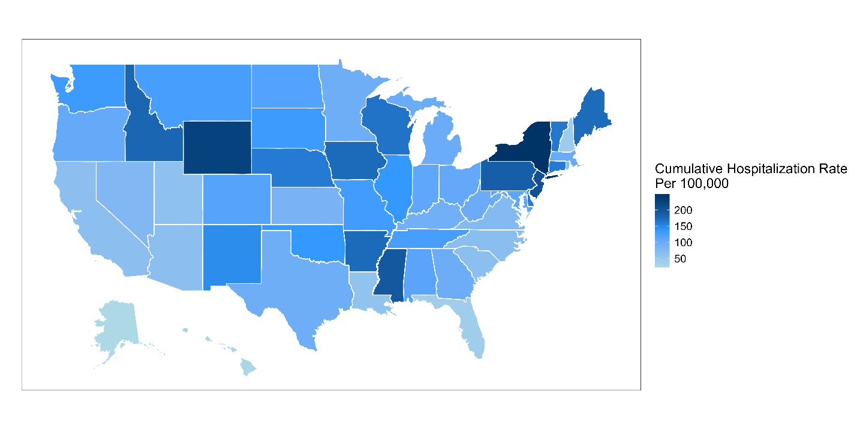

Supplemental Figure B: Influenza-related hospitalization rates per 100,000 population and 90% credible intervals over time from October 2022 through April 2024 by age group.
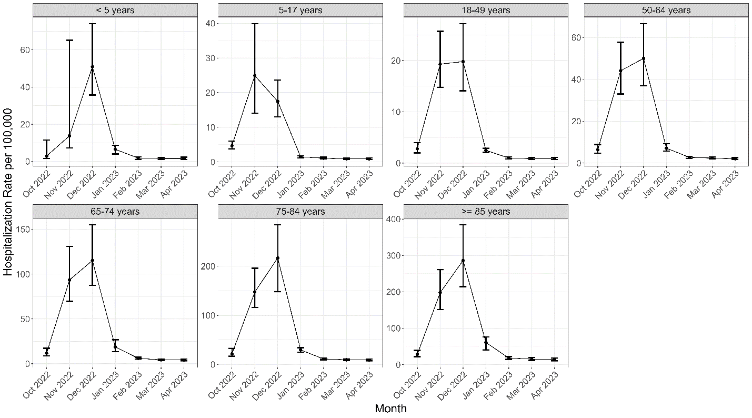

Supplemental Figure C: Influenza-related hospitalization rates per 100,000 population over time from October 2022 through April 2023 for each state showing output from our Bayesian model with 90% credible intervals, unadjusted FluSurv-NET data, National Healthcare Safety Network’s (NHSN) data, and state reported publicly available influenza hospitalization data when available (Supplemental Table B).
