Maternal Macronutrient Intake at Pregnancy and Offspring Growth Trajectory through Childhood: A Prospective Analysis in the Growing Up Today Study 2 Cohort
Sheng et al
SUPPLEMENTAL MATERIAL

Supplementary Figure 1 Flowchart of exclusion and inclusion criteria for participants having macronutrients intake information during pregnancy¹.
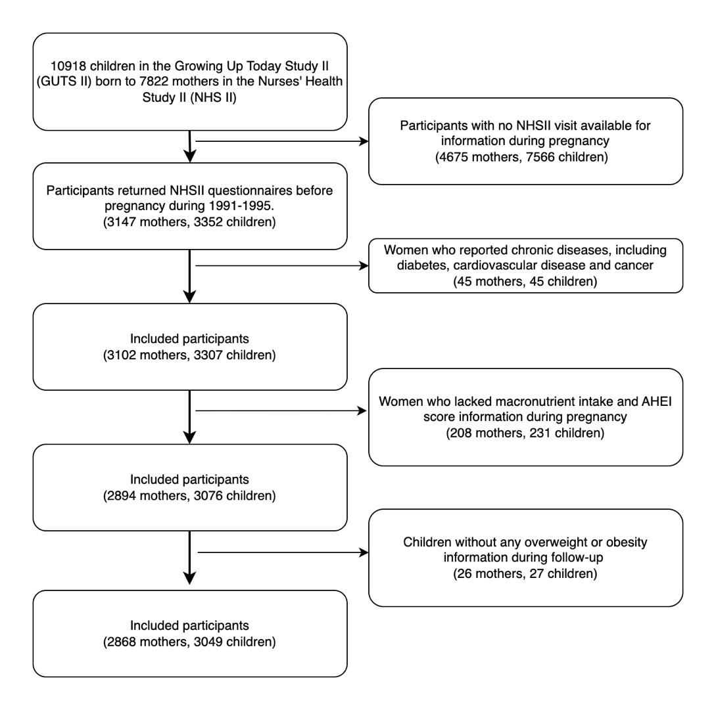
¹ Cardiovascular diseases included stroke, coronary artery surgery/angioplasty status and myocardial infarction. Cancer included melanoma, breast cancer and other cancers.
Supplementary Figure 2 Flowchart of exclusion and inclusion criteria for participants having macronutrients intake information before pregnancy².
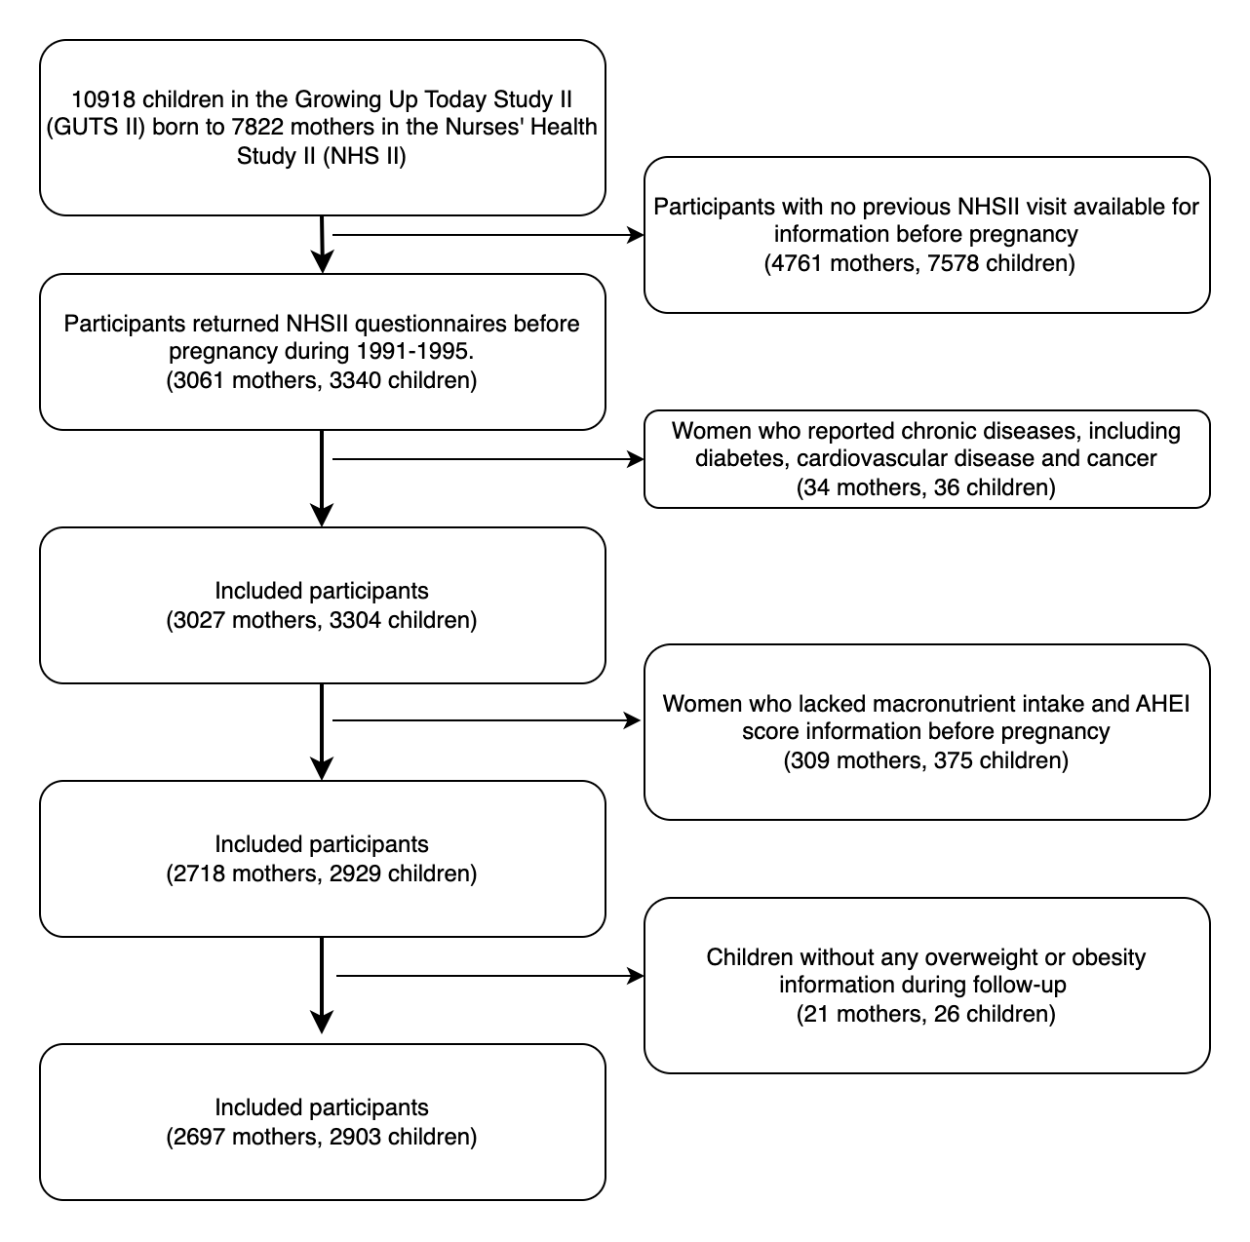
² Cardiovascular diseases included stroke, coronary artery surgery/angioplasty status and myocardial infarction. Cancer included melanoma, breast cancer and other cancers.
Supplementary Figure 3 Definition of diet during pregnancy

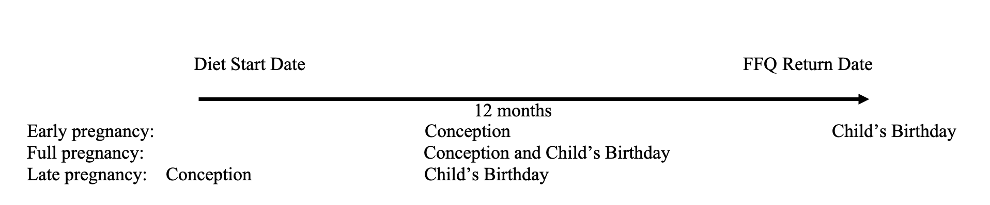

Supplementary Figure 4 Offspring overweight trajectory and 95% confidence intervals (95% CI) during follow-up across quartiles of maternal macronutrients intake during peri-pregnancy period
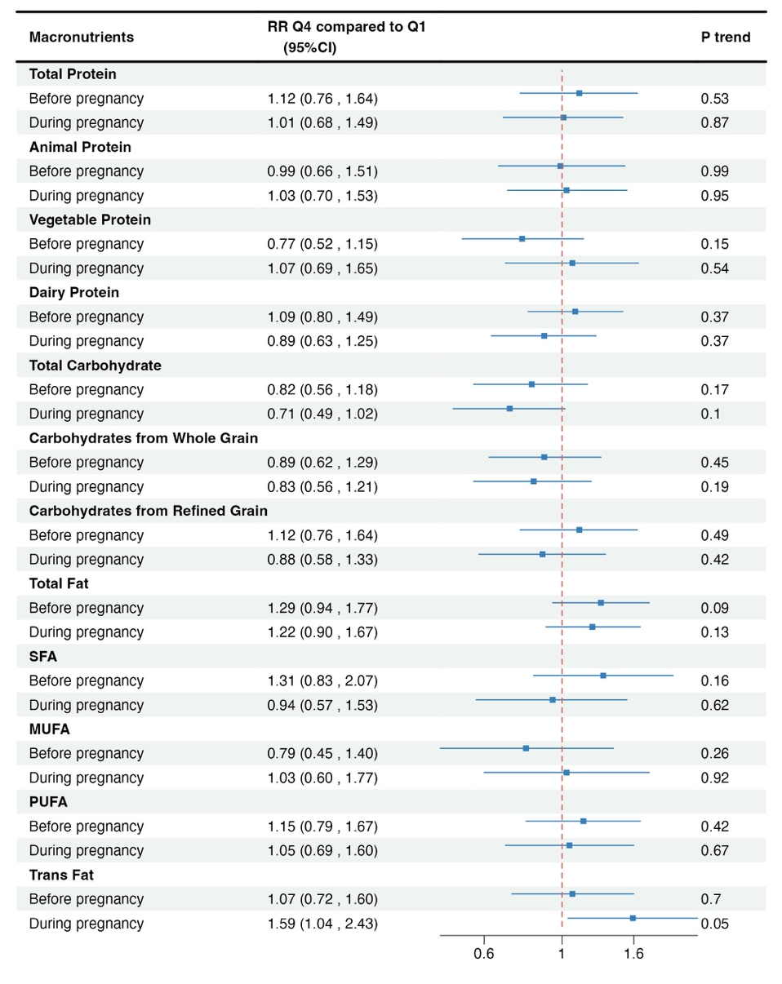
BMI z-score, body mass index z-score; RR, relative risk; 95%CI, 95% confidence interval; SFA, saturated fatty acid; MUFA, monounsaturated fatty acid; PUFA, polyunsaturated fatty acid, AHEI, alternative healthy eating index.
All models adjusted for maternal age at pregnancy (continuous), race (Caucasian, not Caucasian), smoking status at pregnancy (never, current, past), alcohol intake at pregnancy (0, 0-5, 5-15, 15+, missing), AHEI (continuous), physical activity (continuous), gestational complications (yes, no), parity (nulliparous, 1, 2, 3, 4 + previous pregnancies, missing), gestational age (37, 37–39, 40-42, ≥ 43 wks), husband’s education (high school, college, graduate school, missing), offspring sex (boy/girl), offspring age (continuous).
For each macronutrient model, maternal total energy intake (continuous) was further adjusted. Protein models further adjusted for percentage of energy from total carbohydrate intake. Animal protein models were further adjusted for vegetable protein energy, and vice versa. Carbohydrate models further adjusted for percentage of energy from total protein intake. Carbohydrates from Whole Grain models were further adjusted for Carbohydrates from Refined Grain energy, and vice versa. Fat models further adjusted for percentage of energy from total protein intake. Each of the SFA, MUFA, and PUFA models were further adjusted for trans-fatty acid, with the SFA model also accounting for PUFA and MUFA, the MUFA model for SFA and PUFA, and the PUFA model for SFA and MUFA. The Trans Fat model further adjusted for total energy intake, total protein energy intake, SFA, PUFA, MUFA.

Supplementary Figure 5 Mean offspring BMI z score trajectory and 95% confidence intervals (95% CI) during follow-up across quartiles of maternal macronutrients intake during pregnancy, stratified by maternal overweight status before pregnancy.
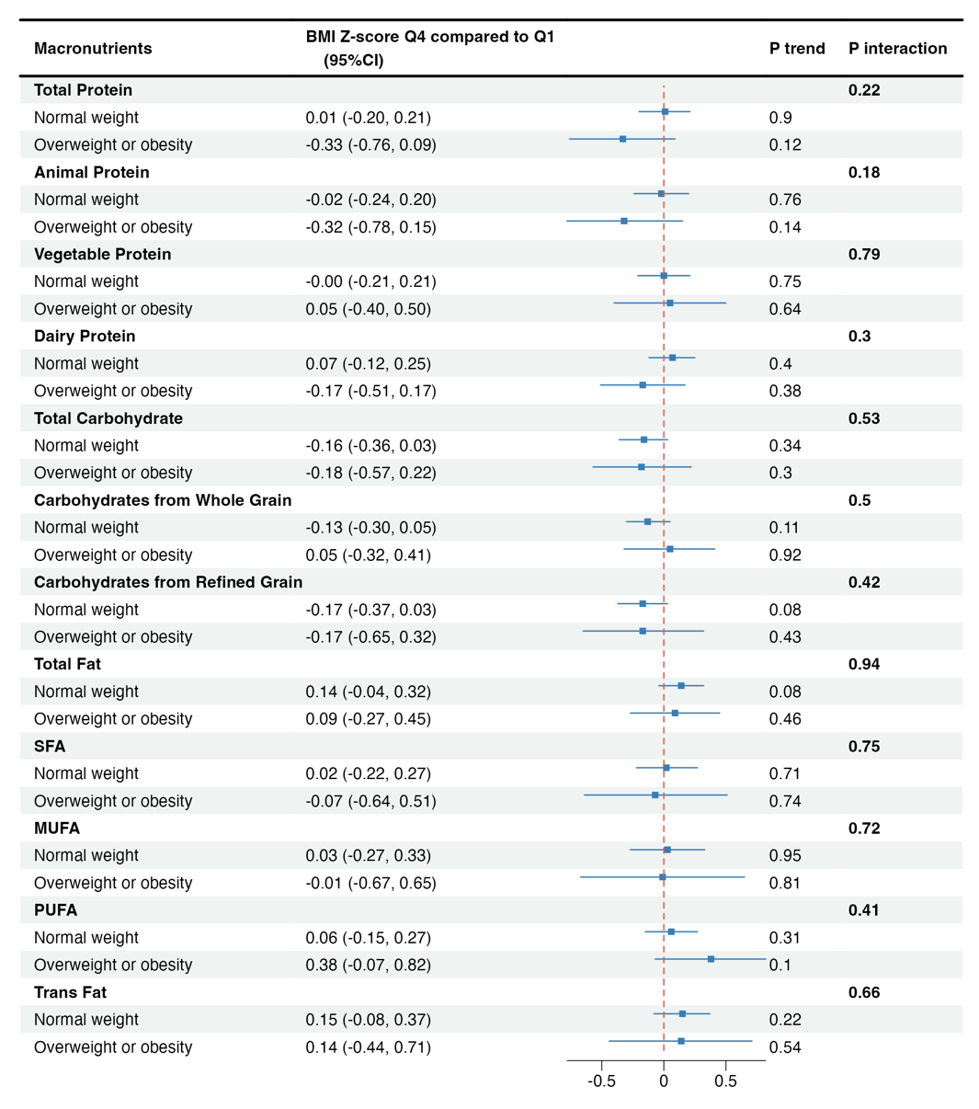
BMI z-score, body mass index z-score; SFA, saturated fatty acid; MUFA, monounsaturated fatty acid; PUFA, polyunsaturated fatty acid, AHEI, alternative healthy eating index. Normal weight is defined as BMI < 25kg/m² before pregnancy. Overweight or obesity is defined as pre-conceptional BMI $≥$25 kg/m².
All models adjusted for maternal age at pregnancy (continuous), race (Caucasian, not Caucasian), smoking status at pregnancy (never, current, past), alcohol intake at pregnancy (0, 0-5, 5-15, 15+, missing), AHEI (continuous), physical activity (continuous), gestational complications (yes, no), parity (nulliparous, 1, 2, 3, 4 + previous pregnancies, missing), gestational age (37, 37–39, 40-42, ≥ 43 wks), husband’s education (high school, college, graduate school, missing), offspring sex (boy/girl), offspring age (continuous).
For each macronutrient model, maternal total energy intake (continuous) was further adjusted. Protein models further adjusted for percentage of energy from total carbohydrate intake. Animal protein models were further adjusted for vegetable protein energy, and vice versa. Carbohydrate models further adjusted for percentage of energy from total protein intake. Carbohydrates from Whole Grain models were further adjusted for Carbohydrates from Refined Grain energy, and vice versa. Fat models further adjusted for percentage of energy from total protein intake. Each of the SFA, MUFA, and PUFA models were further adjusted for trans-fatty acid, with the SFA model also accounting for PUFA and MUFA, the MUFA model for SFA and PUFA, and the PUFA model for SFA and MUFA. The Trans Fat model further adjusted for total energy intake, total protein energy intake, SFA, PUFA, MUFA.

Supplementary Figure 6 Mean offspring BMI z score trajectory and 95% confidence intervals (95% CI) during follow-up across quartiles of maternal macronutrients intake during pregnancy, stratified by offspring sex.

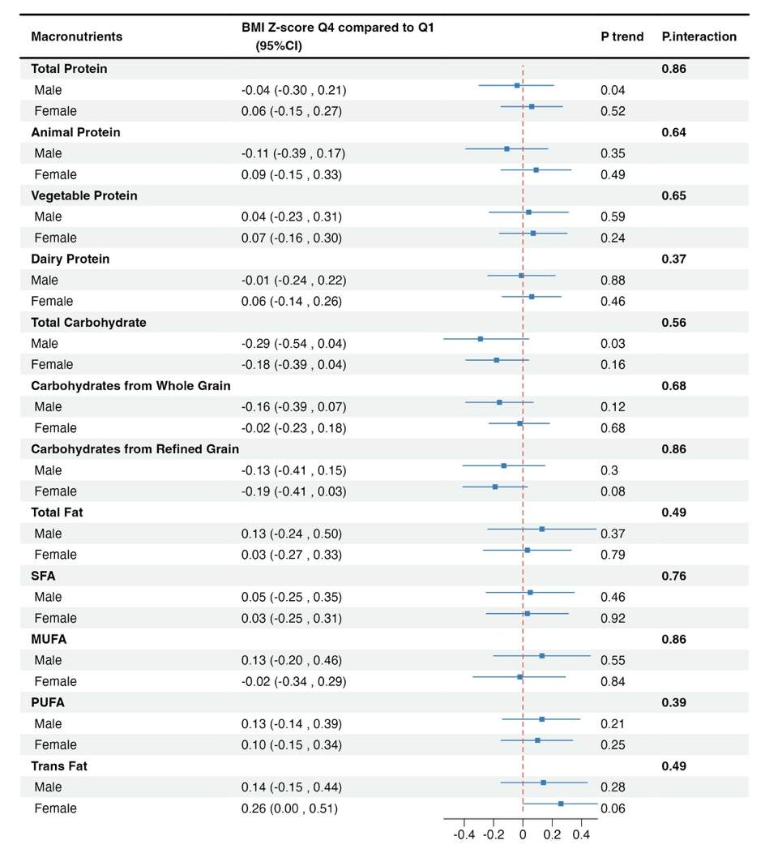

BMI z-score, body mass index z-score; SFA, saturated fatty acid; MUFA, monounsaturated fatty acid; PUFA, polyunsaturated fatty acid, AHEI, alternative healthy eating index.
All models adjusted for maternal age at pregnancy (continuous), race (Caucasian, not Caucasian), smoking status at pregnancy (never, current, past), alcohol intake at pregnancy (0, 0-5, 5-15, 15+, missing), AHEI (continuous), physical activity (continuous), gestational complications (yes, no), parity (nulliparous, 1, 2, 3, 4 + previous pregnancies, missing), gestational age (37, 37–39, 40-42, ≥ 43 wks), husband’s education (high school, college, graduate school, missing), offspring sex (boy/girl), offspring age (continuous).
For each macronutrient model, maternal total energy intake (continuous) was further adjusted. Protein models further adjusted for percentage of energy from total carbohydrate intake. Animal protein models were further adjusted for vegetable protein energy, and vice versa. Carbohydrate models further adjusted for percentage of energy from total protein intake. Carbohydrates from Whole Grain models were further adjusted for Carbohydrates from Refined Grain energy, and vice versa. Fat models further adjusted for percentage of energy from total protein intake. Each of the SFA, MUFA, and PUFA models were further adjusted for trans-fatty acid, with the SFA model also accounting for PUFA and MUFA, the MUFA model for SFA and PUFA, and the PUFA model for SFA and MUFA. The Trans Fat model further adjusted for total energy intake, total protein energy intake, SFA, PUFA, MUFA.

Supplementary Table 1 Baseline characteristics of participants before pregnancy
 |  | Total Protein Energy |  |  |  |  | Total Carbohydrate |  |  |  | Total Fat |  | Total
Maternal Characteristics |  | Quartile 1 (n=677) |  | Quartile 4 (n=660) |  |  | Quartile 1 (n=676) |  | Quartile 4 (n=668) |  | Quartile 1 (n=672) | Quartile 4 (n=678) | (n=2697)
Age, mean (SD) |  | 33.4 (3.5) |  | 33.7 (3.4) |  |  | 33.4 (3.2) |  | 33.5 (3.4) |  | 33.8 (3.5) | 33.3 (3.2) | 33.5 (3.4)
Smoking status, %
Never |  | 70.9 |  | 72.1 |  |  | 66.6 |  | 77.2 |  | 75.3 | 71.2 | 73.2
Past smoker |  | 21.0 |  | 21.5 |  |  | 22.6 |  | 18.9 |  | 19.3 | 18.1 | 19.7
Current smoker |  | 8.1 |  | 6.2 |  |  | 10.7 |  | 3.9 |  | 5.4 | 10.3 | 6.9
Missing |  | 0.0 |  | 0.2 |  |  | 0.1 |  | 0.0 |  | 0.0 | 0.3 | 0.2
Alcohol intake (g/d), %
0 |  | 35.9 |  | 43.0 |  |  | 35.1 |  | 46.7 |  | 40.6 | 42.6 | 40.0
0-5 |  | 40.9 |  | 42.6 |  |  | 40.4 |  | 42.2 |  | 41.2 | 43.4 | 42.3
5-15 |  | 19.1 |  | 12.7 |  |  | 18.6 |  | 10.3 |  | 14.9 | 12.5 | 15.3
>15 |  | 4.1 |  | 1.7 |  |  | 5.9 |  | 0.7 |  | 3.3 | 1.5 | 2.4
AHEI, mean (SD) |  | 41.1 (11.5) |  | 46.2 (9.1) |  |  | 41.5 (9.4) |  | 45.4 (11.2) |  | 47.1 (10.4) | 39.5 (9.4) | 42.8 (10.1)
Physical activity (MET-hours/week), %
0-9 |  | 35.5 |  | 28.0 |  |  | 38.8 |  | 28.7 |  | 27.4 | 43.7 | 34.3
9-27 |  | 32.6 |  | 41.2 |  |  | 37.1 |  | 33.5 |  | 33.6 | 34.7 | 36.6
27 |  | 31.5 |  | 30.5 |  |  | 24.0 |  | 37.6 |  | 39.0 | 21.2 | 28.9
Missing |  | 0.4 |  | 0.3 |  |  | 0.1 |  | 0.1 |  | 0.0 | 0.4 | 0.3
BMI (kg/m²), %
< 18.5 |  | 4.7 |  | 2.0 |  |  | 2.7 |  | 6.1 |  | 5.4 | 3.1 | 3.8
18.5 - 25 |  | 71.6 |  | 62.0 |  |  | 62.4 |  | 73.2 |  | 72.5 | 64.6 | 66.4
25 - 30 |  | 10.8 |  | 18.2 |  |  | 16.0 |  | 8.2 |  | 9.8 | 14.7 | 13.1
30 |  | 4.4 |  | 7.3 |  |  | 9.8 |  | 2.8 |  | 3.3 | 9.4 | 6.2
Missing |  | 8.4 |  | 10.6 |  |  | 9.2 |  | 9.6 |  | 9.1 | 8.1 | 10.5
Pregnancy complications, % |  | 25.0 |  | 28.2 |  |  | 27.8 |  | 25.6 |  | 27.8 | 28.6 | 25.9
GDM |  | 4.7 |  | 6.7 |  |  | 6.8 |  | 4.8 |  | 4.3 | 5.8 | 5.0
Preeclampsia |  | 2.4 |  | 2.3 |  |  | 2.7 |  | 2.5 |  | 3.1 | 3.1 | 2.6
Gestational hypertension |  | 3.7 |  | 3.9 |  |  | 3.4 |  | 3.9 |  | 4.6 | 3.2 | 3.7
Caesarean delivery |  | 25.0 |  | 28.2 |  |  | 20.1 |  | 19.9 |  | 20.7 | 22.1 | 19.6
Caucasian, % | 96.2 |  |  | 95.9 |  |  | 97.5 |  | 95.2 |  | 95.8 | 97.6 | 97.0
Parity, %
Nulliparous |  | 32.1 |  | 25.8 |  |  | 29.0 |  | 29.3 |  | 30.5 | 26.4 | 26.6
1 |  | 32.8 |  | 38.2 |  |  | 34.5 |  | 35.8 |  | 35.9 | 34.5 | 35.4
2 |  | 19.2 |  | 19.2 |  |  | 20.9 |  | 17.1 |  | 17.9 | 23.6 | 20.0
3 |  | 5.5 |  | 4.5 |  |  | 5.2 |  | 5.2 |  | 3.9 | 5.3 | 5.3
4+ |  | 2.4 |  | 2.0 |  |  | 1.6 |  | 2.1 |  | 1.8 | 2.1 | 1.9
Missing |  | 8.1 |  | 10.3 |  |  | 8.9 |  | 10.5 |  | 10.1 | 8.1 | 10.8
Husband education, %
Highschool |  | 15.7 |  | 12.7 |  |  | 15.4 |  | 10.8 |  | 10.7 | 16.4 | 14.1
College |  | 47.0 |  | 48.0 |  |  | 48.8 |  | 49.9 |  | 47.3 | 49.0 | 48.9
Graduate school, |  | 32.9 |  | 34.2 |  |  | 31.2 |  | 36.1 |  | 38.2 | 29.4 | 32.8
Missing |  | 4.4 |  | 5.0 |  |  | 4.6 |  | 3.3 |  | 3.7 | 5.3 | 4.3
Macronutrients % energy, mean (SD)
Total protein |  | 15.3 (1.5) |  | 23.4 (1.9) |  |  | 21.3 (3.1) |  | 16.9 (2.8) |  | 18.8 (3.7) | 19.4 (3) | 19.3 (3.2)
Animal protein |  | 10.1 (2.2) |  | 18.6 (2.2) |  |  | 16.9 (3.2) |  | 11.5 (3.2) |  | 13.3 (4) | 14.9 (3.4) | 14.3 (3.5)
Vegetable protein |  | 5.2 (1.5) |  | 4.8 (0.9) |  |  | 4.4 (0.8) |  | 5.5 (1.5) |  | 5.4 (1.5) | 4.6 (0.9) | 5.0 (1.1)
Dairy protein |  | 3.7 (1.6) |  | 5.4 (2.4) |  |  | 4.6 (2.1) |  | 4.4 (2.1) |  | 4.7 (2.3) | 4.4 (2) | 4.7 (2.1)
Total carbohydrate |  | 55.8 (6.8) |  | 46.3 (6) |  |  | 42.1 (3.6) |  | 59.8 (4) |  | 58.2 (5.7) | 43.8 (4.8) | 50.8 (7.0)
Carbohydrates from Whole Grain |  | 3.2 (2.8) |  | 3.3 (2.4) |  |  | 2.4 (1.6) |  | 4.2 (3.8) |  | 4.3 (3.7) | 2.4 (1.7) | 3.2 (2.6)
Carbohydrates from Refined Grain |  | 31.9 (7.4) |  | 21.9 (4.8) |  |  | 22.8 (4.9) |  | 31 (8.1) |  | 28.9 (8.3) | 24.9 (5.7) | 26.7 (6.8)
Total fat |  | 29.9 (5.7) |  | 30.8 (5) |  |  | 36.2 (4.3) |  | 25.3 (3.4) |  | 24.2 (2.5) | 37.6 (2.8) | 30.8 (5.3)
SFA |  | 10.6 (2.6) |  | 11.2 (2.2) |  |  | 13.2 (2.2) |  | 8.9 (1.7) |  | 8.6 (1.4) | 13.7 (1.9) | 11.2 (2.4)
MUFA |  | 11.4 (2.4) |  | 11.4 (2.2) |  |  | 13.7 (1.9) |  | 9.4 (1.6) |  | 8.9 (1.2) | 14.4 (1.4) | 11.6 (2.2)
MUFA from plants |  | 6.4 (2.1) |  | 4.7 (1.4) |  |  | 6.1 (2.0) |  | 5.1 (1.6) |  | 4.5 (1.4) | 6.9 (2.0) | 5.7 (1.8)
MUFA from animals |  | 4.8 (1.6) |  | 6.3 (1.6) |  |  | 7.2 (1.5) |  | 4.1 (1.2) |  | 4.2 (1.1) | 7.1 (1.6) | 5.7 (1.7)
PUFA |  | 5.4 (1.5) |  | 5.4 (1.2) |  |  | 6.1 (1.4) |  | 4.7 (1.1) |  | 4.5 (0.9) | 6.3 (1.4) | 5.4 (1.3)
Trans fat |  | 1.6 (0.7) |  | 1.4 (0.5) |  |  | 1.8 (0.6) |  | 1.2 (0.5) |  | 1.1 (0.3) | 2 (0.6) | 1.5 (0.6)
Offspring Characteristics |  | Quartile 1 (n=725) |  |  | Quartile 4 (n=726) |  | Quartile 1 (n=725) |  | Quartile 4 (n=726) |  | Quartile 1 (n=725) | Quartile 4 (n=726) | (n=2903)
Age at baseline, year, mean (SD) |  | 10.8 (0.8) |  |  | 10.7 (0.8) |  | 10.7 (0.8) |  |  | 10.7 (0.9) | 10.7 (0.9) | 10.8 (0.8) | 10.8 (0.8)
Birthweight, kg, mean (SD) |  | 3.5 (0.5) |  |  | 3.5 (0.6) |  | 3.5 (0.6) |  |  | 3.5 (0.5) | 3.5 (0.5) | 3.6 (0.5) | 3.5 (0.6)
Gestational age, week, %
Missing |  | 11.6 |  |  | 12.8 |  | 12.8 |  |  | 12.8 | 12.1 | 10.9 | 12.3
<37 |  | 6.1 |  |  | 8.3 |  | 7.0 |  |  | 6.2 | 6.5 | 6.7 | 7.2
37-39 |  | 26.3 |  |  | 27.5 |  | 28.3 |  |  | 26.6 | 26.6 | 29.5 | 27.0
39-42 |  | 52.4 |  |  | 47.7 |  | 48.8 |  |  | 50.7 | 51.0 | 49.7 | 50.0
 |  | 3.6 |  |  | 3.7 |  | 3.0 |  |  | 3.7 | 3.7 | 3.2 | 3.4
Female, % |  | 52.8 |  |  | 53.9 |  | 51.6 |  |  | 54.4 | 53.1 | 53.0 | 53.0
BMI, body mass index; SFA, saturated fatty acid; MUFA, monounsaturated fatty acid; PUFA, polyunsaturated fatty acid; AHEI, alternative healthy eating index; GDM, gestational diabetes mellitus.

Supplementary Table 2 Offspring birthweight (kg) and 95% confidence intervals (95% CI) during follow-up across quartiles of maternal macronutrients intake before pregnancy.
Macronutrients, Quartile Energy %
 |  | Q1 |  | Q2 |  |  |  | Q3 | Q4 | P- Trend
Total Protein
Median (IQR) |  | 15.7 (14.5, 16.5) |  |  |  | 18.2 (17.7, 18.8) |  | 20.2 (19.7, 20.7) | 22.9 (22.0, 24.1)
Model 1¹ |  | 0 (reference) |  |  |  | 0.04 (0.01, 0.10) |  | 0.04 (-0.01, 0.10) | 0.03 (-0.03, 0.08) | 0.31
Model 2² |  | 0 (reference) |  |  |  | 0.03 (-0.02, 0.09) |  | 0.03 (-0.03, 0.09) | 0.01 (-0.05, 0.08) | 0.75
Animal Protein
Median (IQR) |  | 10.6 (9.1, 11.3) |  |  |  | 13.2 (12.6, 13.8) |  | 15.4 (14.8, 16.0) | 18.2 (17.3, 19.5)
Model 1 |  | 0 (reference) |  |  |  | 0.04 (-0.02, 0.09) |  | 0.03 (-0.02, 0.09) | 0.04 (-0.01, 0.10) | 0.15
Model 2 |  | 0 (reference) |  |  |  | 0.03 (-0.03, 0.08) |  | 0.02 (-0.04, 0.09) | 0.03 (-0.04, 0.10) | 0.42
Vegetable Protein
Median (IQR) | 3.8 (3.5, 4.1) |  |  |  |  |  | 4.6 (4.4, 4.7) | 5.1 (5.0, 5.3) | 6.1 (5.8, 6.6)
Model 1 | 0 (reference) |  |  |  |  |  | -0.02 (-0.08, 0.03) | -0.03 (-0.09, 0.03) | -0.01 (-0.07, 0.05) | 0.74
Model 2 | 0 (reference) |  |  |  |  |  | -0.02 (-0.07, 0.04) | -0.02 (-0.08, 0.04) | 0.01 (-0.06, 0.08) | 0.79
Dairy Protein
Median (IQR) | 2.4 (1.9, 2.7) |  |  |  |  |  | 3.8 (3.5, 4.1) | 5.2 (4.8, 5.5) | 7.2 (6.6, 8.1)
Model 1 | 0 (reference) |  |  |  |  |  | 0.00 (-0.05, 0.05) | 0.04 (-0.02, 0.09) | 0.07 (0.02, 0.13) | <0.01
Model 2 | 0 (reference) |  |  |  |  |  | 0.00 (-0.06, 0.05) | 0.03 (-0.02, 0.09) | 0.07 (0.01, 0.12) | 0.01
Total Carbohydrate
Median (IQR) | 43.1 (40.5, 44.9) |  |  |  |  |  | 48.6 (47.6, 49.5) | 52.7 (51.6, 53.8) | 58.6 (56.9, 61.8)
Model 1 | 0 (reference) |  |  |  |  |  | 0.01 (-0.05, 0.06) | 0.01 (-0.04, 0.06) | -0.04 (-0.10, 0.01) | 0.13
Model 2 | 0 (reference) |  |  |  |  |  | 0.00 (-0.05, 0.06) | 0.00 (-0.06, 0.06) | -0.05 (-0.12, 0.01) | 0.14
Carbohydrates from Whole Grain
Median (IQR) |  | 0.9 (0.6, 1.2) |  |  |  |  | 2.0 (1.7, 2.3) | 3.4 (3.0, 3.8) | 5.8 (4.9, 7.3)
Model 1 |  | 0 (reference) |  |  |  |  | 0.04 (-0.01, 0.10) | 0.06 (0.01, 0.12) | 0.04 (-0.01, 0.10) | 0.20
Model 2 |  | 0 (reference) |  |  |  |  | 0.04 (-0.02, 0.09) | 0.05 (0.00, 0.11) | 0.03 (-0.03, 0.09) | 0.40
Carbohydrates from Refined Grain
Median (IQR) |  | 19.3 (17.4, 20.6) |  |  |  |  | 24.0 (23.0, 25.0) | 28.2 (27.2, 29.4) | 34.0 (32.0, 37.5)
Model 1 |  | 0 (reference) |  |  |  |  | 0.00 (-0.06, 0.05) | -0.04 (-0.09, 0.02) | -0.07 (-0.13, -0.02) | <0.01
Model 2 |  | 0 (reference) |  |  |  |  | -0.01 (-0.07, 0.04) | -0.05 (-0.11, 0.01) | -0.09 (-0.16, -0.02) | <0.01
Total Fat
Median (IQR) |  | 24.7 (22.8, 26.0) |  |  | 28.8 (28.1, 29.6) |  |  | 32.0 (31.2, 32.9) | 36.2 (34.9, 38.2)
Model 1 |  | 0 (reference) |  |  | 0.05 (0.00, 0.11) |  |  | 0.03 (-0.03, 0.08) | 0.05 (0.00, 0.11) | 0.13
Model 2 |  | 0 (reference) |  |  | 0.05 (0.00, 0.11) |  |  | 0.03 (-0.03, 0.08) | 0.05 (0.00, 0.11) | 0.13
SFA
Median (IQR) |  | 8.6 (7.7, 9.1) |  |  | 10.4 (10.1, 10.7) |  |  | 11.7 (11.4, 12.2) | 13.7 (13.1, 14.8)
Model 1 |  | 0 (reference) |  |  | 0.10 (0.05, 0.16) |  |  | 0.07 (0.02, 0.13) | 0.08 (0.02, 0.13) | 0.03
Model 2 |  | 0 (reference) |  |  | 0.11 (0.05, 0.17) |  |  | 0.08 (0.02, 0.15) | 0.10 (0.01, 0.18) | 0.06
MUFA
Median (IQR) |  | 9.1 (8.3, 9.6) |  |  | 10.8 (10.5, 11.2) |  |  | 12.2 (11.9, 12.6) | 14.2 (13.6, 15.2)
Model 1 |  | 0 (reference) |  |  | 0.04 (-0.02, 0.09) |  |  | 0.03 (-0.03, 0.08) | 0.04 (-0.02, 0.10) | 0.21
Model 2 |  | 0 (reference) |  |  | 0.01 (-0.05, 0.07) |  |  | -0.02 (-0.09, 0.05) | -0.03 (-0.12, 0.06) | 0.42
PUFA
Median (IQR) |  | 4.1 (3.7, 4.3) |  |  | 4.9 (4.7, 5.1) |  |  | 5.7 (5.5, 5.9) | 6.8 (6.4, 7.5)
Model 1 |  | 0 (reference) |  |  | 0.00 (-0.06, 0.05) |  |  | 0.00 (-0.05, 0.06) | -0.01 (-0.06, 0.05) | 0.84
Model 2 |  | 0 (reference) |  |  | -0.02 (-0.07, 0.04) |  |  | -0.02 (-0.08, 0.04) | -0.03 (-0.10, 0.04) | 0.38
Trans Fat
Median (IQR) |  |  | 0.9 (0.8, 1.0) |  | 1.3 (1.2, 1.4) |  |  | 1.6 (1.5, 1.8) | 2.2 (2.0, 2.5)
Model 1 |  |  | 0 (reference) |  | 0.04 (-0.02, 0.09) |  |  | 0.03 (-0.03, 0.09) | 0.05 (-0.01, 0.11) | 0.17
Model 2 |  |  | 0 (reference) |  | 0.04 (-0.02, 0.09) |  |  | 0.03 (-0.04, 0.09) | 0.06 (-0.01, 0.14) | 0.16
95%CI, 95% confidence interval; SFA, saturated fatty acid; MUFA, monounsaturated fatty acid; PUFA, polyunsaturated fatty acid, AHEI, alternative healthy eating index.
¹ Adjusted for maternal age at pregnancy (continuous), race (Caucasian, not Caucasian), smoking status at pregnancy (never, current, past), alcohol intake at pregnancy (0, 0-5, 5-15, 15+, missing), AHEI (continuous), physical activity (0-9 MET-hours/week, 9-27 MET-hours/week, 27+ MET-hour/week), gestational complications (yes, no), parity (nulliparous, 1, 2, 3, 4 + previous pregnancies, missing), gestational age (37, 37–39, 40-42, ≥ 43 weeks), husband’s education (high school, college, graduate school, missing), offspring sex (boy/girl), offspring age (continuous).
² Further adjusted for maternal total energy intake (continuous). Protein models further adjusted for percentage of energy from total carbohydrate intake. Animal protein models were further adjusted for vegetable protein energy, and vice versa. Carbohydrate models further adjusted for percentage of energy from total protein intake. Carbohydrates from Whole Grain models were further adjusted for Carbohydrates from Refined Grain energy, and vice versa. Fat models further adjusted for percentage of energy from total protein intake. Each of the SFA, MUFA, and PUFA models were further adjusted for trans-fatty acid, with the SFA model also accounting for PUFA and MUFA, the MUFA model for SFA and PUFA, and the PUFA model for SFA and MUFA. The Trans Fat model further adjusted for total energy intake, total protein energy intake, SFA, PUFA, MUFA.

Supplementary Table 3 Offspring birthweight (kg) and 95% confidence intervals (95% CI) during follow-up across quartiles of maternal macronutrients intake during pregnancy.
Macronutrients, Quartile Energy %
 | Q1 |  |  | Q2 | Q3 | Q4 | P- Trend
Total Protein
Median (IQR) |  | 15.9 (14.8, 16.7) |  | 18.4 (17.8, 18.8) | 20.1 (19.7, 20.7) | 22.9 (21.9, 24.1)
Model 1¹ |  | 0 (reference) |  | 0.04 (-0.01, 0.10) | 0.01 (-0.04, 0.06) | 0.05 (0.00, 0.11) | 0.12
Model 2² |  | 0 (reference) |  | 0.03 (-0.02, 0.09) | -0.01 (-0.06, 0.05) | 0.03 (-0.04, 0.10) | 0.60
Animal Protein
Median (IQR) |  | 10.7 (9.5, 11.6) |  | 13.4 (12.9, 13.8) | 15.4 (14.8, 16.0) | 18.2 (17.2, 19.6)
Model 1 |  | 0 (reference) |  | 0.02 (-0.03, 0.07) | 0.00 (-0.05, 0.06) | 0.04 (-0.01, 0.10) | 0.16
Model 2 |  | 0 (reference) |  | 0.01 (-0.05, 0.07) | -0.01 (-0.07, 0.05) | 0.02 (-0.05, 0.09) | 0.70
Dairy Protein
Median (IQR) |  | 2.6 (2.0, 3.0) |  | 4.1 (3.7, 4.4) | 5.6 (5.2, 6.0) | 7.6 (6.9, 8.6)
Model 1 |  | 0 (reference) |  | 0.02 (-0.03, 0.08) | 0.02 (-0.03, 0.07) | 0.04 (-0.01, 0.09) | 0.17
Model 2 |  | 0 (reference) |  | 0.02 (-0.03, 0.08) | 0.02 (-0.03, 0.08) | 0.04 (-0.02, 0.10) | 0.18
Vegetable Protein
Median (IQR) |  |  | 3.8 (3.5, 4.0) | 4.5 (4.4, 4.6) | 5.1 (4.9, 5.3) | 6.0 (5.7, 6.4)
Model 1 |  |  | 0 (reference) | 0.00 (-0.05, 0.06) | 0.00 (-0.06, 0.05) | -0.01 (-0.08, 0.05) | 0.62
Model 2 |  |  | 0 (reference) | 0.01 (-0.05, 0.06) | 0.01 (-0.05, 0.06) | 0.01 (-0.06, 0.08) | 0.86
Total Carbohydrate
Median (IQR) |  |  | 43.7 (41.1, 45.4) | 49.1 (48.1 50.1) | 53.2 (52.2, 54.3) | 58.5 (56.9, 61.2)
Model 1 |  |  | 0 (reference) | -0.05 (-0.10, 0.00) | -0.03 (-0.09, 0.02) | -0.04 (-0.10, 0.01) | 0.17
Model 2 |  |  | 0 (reference) | -0.04 (-0.10, 0.01) | -0.02 (-0.08, 0.04) | -0.03 (-0.09, 0.04) | 0.54
Carbohydrates from Whole Grain
Median (IQR) |  | 1.0 (0.6, 1.2) |  | 2.0 (1.8, 2.3) | 3.4 (3.0, 3.8) | 5.7 (4.8, 7.0)
Model 1 |  | 0 (reference) |  | 0.00 (-0.05, 0.06) | 0.03 (-0.02, 0.09) | 0.01 (-0.04, 0.07) | 0.54
Model 2 |  | 0 (reference) |  | 0.00 (-0.05, 0.06) | 0.03 (-0.02, 0.08) | 0.01 (-0.05, 0.07) | 0.70
Carbohydrates from Refined Grain
Median (IQR) |  | 19.5 (17.4, 20.9) |  | 24.0 (23.0, 25.0) | 27.8 (26.9, 29.0) | 33.8 (31.8, 37.0)
Model 1 |  | 0 (reference) |  | -0.02 (-0.07, 0.03) | -0.05 (-0.11, 0.00) | -0.06 (-0.11, -0.00) | 0.03
Model 2 |  | 0 (reference) |  | -0.01 (-0.07, 0.04) | -0.05 (-0.11, 0.01) | -0.04 (-0.11, 0.02) | 0.14
Total Fat
Median (IQR) |  | 25.1 (23.2, 26.4) |  | 29.0 (28.3, 29.9) | 32.3 (31.4, 33.0) | 36.4 (35.0, 38.5)
Model 1 |  | 0 (reference) |  | 0.01 (-0.04, 0.07) | 0.03 (-0.03, 0.08) | 0.03 (-0.03, 0.08) | 0.28
Model 2 |  | 0 (reference) |  | 0.01 (-0.04, 0.07) | 0.02 (-0.03, 0.08) | 0.02 (-0.03, 0.08) | 0.37
SFA
Median (IQR) |  | 8.7 (8.0, 9.3) |  | 10.5 (10.1, 10.8) | 11.8 (11.4, 12.1) | 13.7 (13.1, 14.7)
Model 1 |  | 0 (reference) |  | 0.01 (-0.05,0.06) | 0.03 (-0.02, 0.09) | 0.03 (-0.02, 0.09) | 0.19
Model 2 |  | 0 (reference) |  | -0.01 (-0.07,0.04) | -0.00 (-0.07, 0.06) | -0.02 (-0.10, 0.06) | 0.71
MUFA
Median (IQR) |  | 9.1 (8.3, 9.7) |  | 10.8 (10.4, 11.2) | 12.2 (11.9, 12.5) | 14.0 (13.4, 15.0)
Model 1 |  | 0 (reference) |  | 0.02 (-0.03,0.08) | 0.04 (-0.02, 0.09) | 0.04 (-0.02, 0.10) | 0.16
Model 2 |  | 0 (reference) |  | 0.01 (-0.05,0.07) | 0.02 (-0.05, 0.09) | 0.01 (-0.08, 0.10) | 0.76
PUFA
Median (IQR) |  | 4.0 (3.6, 4.2) |  | 4.8 (4.6, 5.0) | 5.5 (5.3, 5.7) | 6.6 (6.3, 7.2)
Model 1 |  | 0 (reference) |  | 0.00 (-0.05,0.06) | 0.01 (-0.04, 0.07) | 0.01 (-0.04, 0.07) | 0.61
Model 2 |  | 0 (reference) |  | -0.01 (-0.07,0.04) | -0.01 (-0.07, 0.05) | -0.02 (-0.09, 0.04) | 0.52
Trans Fat
Median (IQR) |  | 1.0 (0.8, 1.1) |  | 1.3 (1.2, 1.4) | 1.6 (1.5, 1.7) | 2.2 (2.0, 2.4)
Model 1 |  | 0 (reference) |  | 0.04 (-0.02, 0.09) | 0.01 (-0.04, 0.07) | 0.05 (-0.01, 0.11) | 0.23
Model 2 |  | 0 (reference) |  | 0.03 (-0.03, 0.09) | 0.00 (-0.06, 0.07) | 0.03 (-0.04, 0.11) | 0.56
95%CI, 95% confidence interval; SFA, saturated fatty acid; MUFA, monounsaturated fatty acid; PUFA, polyunsaturated fatty acid, AHEI, alternative healthy eating index.
¹ Adjusted for maternal age at pregnancy (continuous), race (Caucasian, not Caucasian), smoking status at pregnancy (never, current, past), alcohol intake at pregnancy (0, 0-5, 5-15, 15+, missing), AHEI (continuous), physical activity (0-9 MET-hours/week, 9-27 MET-hours/week, 27+ MET-hour/week), gestational complications (yes, no), parity (nulliparous, 1, 2, 3, 4 + previous pregnancies, missing), gestational age (37, 37–39, 40-42, ≥ 43 weeks), husband’s education (high school, college, graduate school, missing), offspring sex (boy/girl), offspring age (continuous).
² Further adjusted for maternal total energy intake (continuous). Protein models further adjusted for percentage of energy from total carbohydrate intake. Animal protein models were further adjusted for vegetable protein energy, and vice versa. Carbohydrate models further adjusted for percentage of energy from total protein intake. Carbohydrates from Whole Grain models were further adjusted for Carbohydrates from Refined Grain energy, and vice versa. Fat models further adjusted for percentage of energy from total protein intake. Each of the SFA, MUFA, and PUFA models were further adjusted for trans-fatty acid, with the SFA model also accounting for PUFA and MUFA, the MUFA model for SFA and PUFA, and the PUFA model for SFA and MUFA. The Trans Fat model further adjusted for total energy intake, total protein energy intake, SFA, PUFA, MUFA.

Supplementary Table 4 Substitution model for the association between macronutrients intake before/during pregnancy and offspring BMI z-score trajectory during follow-up
Macronutrients¹ | Q1 | Q2 | Q3 | Q4 | p-trend
Before Pregnancy
MUFA-P for MUFA-A² | 0 (reference) | -0.03 (-0.20, 0.14) | -0.02 (-0.22, 0.18) | -0.03 (-0.28, 0.21) | 0.76
Protein-V for Protein-A³ | 0 (reference) | -0.03 (-0.18, 0.11) | -0.01 (-0.16, 0.14) | -0.10 (-0.28, 0.08) | 0.22
PUFA for SFA⁴ | 0 (reference) | 0.04 (-0.11, 0.19) | 0.01 (-0.15, 0.17) | 0.08 (-0.10, 0.25) | 0.37
Carbohydrates from Whole Grain for Carbohydrates from Refined Grain⁵ | 0 (reference) | 0.03 (-0.12, 0.18) | 0.03 (-0.13, 0.19) | -0.04 (-0.21, 0.13) | 0.39
During Pregnancy
MUFA-P for MUFA-A² | 0 (reference) | -0.05 (-0.20, 0.10) | 0.04 (-0.13, 0.21) | -0.04 (-0.26, 0.18) | 0.87
Protein-V for Protein-A³ | 0 (reference) | -0.04 (-0.19, 0.10) | 0.07 (-0.08, 0.21) | 0.03 (-0.13, 0.20) | 0.34
PUFA for SFA⁴ | 0 (reference) | -0.00 (-0.15, 0.14) | 0.03 (-0.13, 0.19) | 0.08 (-0.09, 0.24) | 0.21
Carbohydrates from Whole Grain for Carbohydrates from Refined Grain⁵ | 0 (reference) | -0.01 (-0.15, 0.14) | -0.01 (-0.17, 0.16) | -0.04 (-0.20, 0.11) | 0.46
95%CI, 95% confidence interval; MUFA-P, monounsaturated fatty acid from plants; MUFA-A, monounsaturated fatty acid from animals; Protein-V, protein from vegetable sources; Protein-A, protein from animal sources; PUFA, polyunsaturated fatty acid, SFA, saturated fatty acid; AHEI, alternative healthy eating index.
¹ All models adjusted for maternal age at pregnancy (continuous), race (Caucasian, not Caucasian), smoking status at pregnancy (never, current, past), alcohol intake at pregnancy (0, 0-5, 5-15, 15+, missing), AHEI (continuous), physical activity (0-9 MET-hours/week, 9-27 MET-hours/week, 27+ MET-hour/week), gestational complications (yes, no), parity (nulliparous, 1, 2, 3, 4 + previous pregnancies, missing), gestational age (37, 37–39, 40-42, ≥ 43 weeks), husband’s education (high school, college, graduate school, missing), offspring sex (boy/girl), offspring age (continuous).
² The MUFA model further adjusted for maternal total energy intake, total carbohydrate energy, total protein energy, PUFA, saturated fatty acids, and trans fatty acids percent energy.
³ The Protein model further adjusted for maternal total energy intake, total carbohydrate energy, and total fat energy.
⁴ The PUFA for SFA model further adjusted for maternal total energy intake, total carbohydrate energy, total protein energy, MUFA and trans fatty acids energy.
⁵ The carbohydrate model further adjusted for maternal total energy intake, total protein energy and total fat energy.

Supplementary Table 5 Offspring BMI z-score trajectory and 95% confidence intervals (95% CI) during follow-up across quartiles of maternal macronutrients intake during pregnancy after adjusted for offspring diet during follow-up.

Macronutrients, Quartile Energy %
 | Q1 |  |  | Q2 |  | Q3 | Q4 |  | P- Trend
Total Protein
Median (IQR) |  | 15.9 (14.8, 16.7) |  | 18.4 (17.8, 18.8) |  | 20.1 (19.7, 20.7) | 22.9 (21.9, 24.1)
Model 1¹ |  | 0 (reference) |  | 0.10 (-0.03, 0.23) |  | 0.12 (-0.03, 0.27) | 0.15 (0.01, 0.29) |  | 0.04
Model 2² |  | 0 (reference) |  | 0.05 (-0.09, 0.18) |  | 0.03 (-0.13, 0.18) | -0.00 (-0.17, 0.16) |  | 0.90
Animal Protein
Median (IQR) |  | 10.7 (9.5, 11.6) |  | 13.4 (12.9, 13.8) |  | 15.4 (14.8, 16.0) | 18.2 (17.2, 19.6)
Model 1 |  | 0 (reference) |  | 0.09 (-0.05, 0.22) |  | 0.09 (-0.05, 0.23) | 0.14 (-0.00, 0.29) |  | 0.06
Model 2 |  | 0 (reference) |  | 0.03 (-0.11, 0.17) |  | -0.00 (-0.16, 0.15) | -0.02 (-0.20, 0.16) |  | 0.67
Vegetable Protein
Median (IQR) |  |  | 3.8 (3.5, 4.0) | 4.5 (4.4, 4.6) |  | 5.1 (4.9, 5.3) | 6.0 (5.7, 6.4)
Model 1 |  |  | 0 (reference) | -0.05 (-0.20, 0.09) |  | 0.03 (-0.11, 0.18) | -0.04 (-0.20, 0.11) |  | 0.75
Model 2 |  |  | 0 (reference) | -0.04 (-0.19, 0.10) |  | 0.07 (-0.09, 0.22) | 0.03 (-0.16, 0.21) |  | 0.42
Dairy Protein
Median (IQR) |  |  | 2.6 (2.0, 3.0) | 4.1 (3.7, 4.4) | 5.6 (5.2, 6.0) |  | 7.6 (6.9, 8.6)
Model 1 |  |  | 0 (reference) | 0.01 (-0.14, 0.16) |  | 0.02 (-0.12, 0.17) | 0.02 (-0.13, 0.17) |  | 0.65
Model 2 |  |  | 0 (reference) | 0.02 (-0.13, 0.17) |  | 0.03 (-0.12, 0.18) | 0.01 (-0.14, 0.16) |  | 0.85
Total Carbohydrate
Median (IQR) |  |  | 43.7 (41.1, 45.4) | 49.1 (48.1 50.1) |  | 53.2 (52.2, 54.3) | 58.5 (56.9, 61.2)
Model 1 |  |  | 0 (reference) | -0.12 (-0.27, 0.02) |  | -0.09 (-0.25, 0.07) | -0.26 (-0.41, -0.11) |  | 0.01
Model 2 |  |  | 0 (reference) | -0.12 (-0.26, 0.03) |  | -0.08 (-0.25, 0.08) | -0.25 (-0.42, -0.09) |  | 0.02
Carbohydrates from Whole Grain
Median (IQR) |  | 1.0 (0.6, 1.2) |  | 2.0 (1.8, 2.3) |  | 3.4 (3.0, 3.8) | 5.7 (4.8, 7.0)
Model 1 |  | 0 (reference) |  | -0.02 (-0.17, 0.12) |  | -0.04 (-0.20, 0.12) | -0.10 (-0.25, 0.05) |  | 0.12
Model 2 |  | 0 (reference) |  | -0.02 (-0.17, 0.13) |  | -0.04 (-0.20, 0.13) | -0.11 (-0.26, 0.05) |  | 0.11
Carbohydrates from Refined Grain
Median (IQR) |  | 19.5 (17.4, 20.9) |  | 24.0 (23.0, 25.0) |  | 27.8 (26.9, 29.0) | 33.8 (31.8, 37.0)
Model 1 |  | 0 (reference) |  | -0.05 (-0.20, 0.09) |  | -0.07 (-0.21, 0.06) | -0.19 (-0.34, -0.05) |  | 0.02
Model 2 |  | 0 (reference) |  | -0.05 (-0.20, 0.10) |  | -0.06 (-0.21, 0.08) | -0.17 (-0.34, 0.00) |  | 0.05
Total Fat
Median (IQR) |  | 25.1 (23.2, 26.4) |  | 29.0 (28.3, 29.9) |  | 32.3 (31.4, 33.0) | 36.4 (35.0, 38.5)
Model 1 |  | 0 (reference) |  | 0.12 (-0.01, 0.26) |  | 0.19 (0.04, 0.33) | 0.24 (0.08, 0.39) |  | 0.01
Model 2 |  | 0 (reference) |  | 0.11 (-0.02, 0.25) |  | 0.18 (0.03, 0.32) | 0.22 (0.07, 0.37) |  | 0.02
SFA
Median (IQR) |  | 8.7 (8.0, 9.3) |  | 10.5 (10.1, 10.8) |  | 11.8 (11.4, 12.1) | 13.7 (13.1, 14.7)
Model 1 |  | 0 (reference) |  | 0.07 (-0.07, 0.21) |  | 0.17 (0.03, 0.31) | 0.16 (0.02, 0.31) |  | 0.03
Model 2 |  | 0 (reference) |  | 0.01 (-0.13, 0.16) |  | 0.07 (-0.09, 0.23) | 0.03 (-0.18, 0.23) |  | 0.65
MUFA
Median (IQR) |  | 9.1 (8.3, 9.7) |  | 10.8 (10.4, 11.2) |  | 12.2 (11.9, 12.5) | 14.0 (13.4, 15.0)
Model 1 |  | 0 (reference) |  | 0.14 (-0.01, 0.30) |  | 0.13 (-0.02, 0.28) | 0.25 (0.10, 0.39) |  | 0.01
Model 2 |  | 0 (reference) |  | 0.07 (-0.10, 0.24) |  | 0.02 (-0.16, 0.20) | 0.06 (-0.17, 0.28) |  | 0.68
PUFA
Median (IQR) |  | 4.0 (3.6, 4.2) |  | 4.8 (4.6, 5.0) |  | 5.5 (5.3, 5.7) | 6.6 (6.3, 7.2)
Model 1 |  | 0 (reference) |  | 0.04 (-0.10, 0.18) |  | 0.10 (-0.04, 0.25) | 0.18 (0.04, 0.31) |  | 0.02
Model 2 |  | 0 (reference) |  | 0.00 (-0.15, 0.15) |  | 0.05 (-0.12, 0.21) | 0.10 (-0.07, 0.27) |  | 0.13
Trans Fat
Median (IQR) |  | 1.0 (0.8, 1.1) |  | 1.3 (1.2, 1.4) |  | 1.6 (1.5, 1.7) | 2.2 (2.0, 2.4)
Model 1 |  | 0 (reference) |  | 0.16 (0.02, 0.30) |  | 0.19 (0.05, 0.34) | 0.27 (0.12, 0.43) |  | 0.01
Model 2 |  | 0 (reference) |  | 0.12 (-0.02, 0.27) |  | 0.14 (-0.02, 0.31) | 0.20 (0.00, 0.40) |  | 0.06
95%CI, 95% confidence interval; SFA, saturated fatty acid; MUFA, monounsaturated fatty acid; PUFA, polyunsaturated fatty acid, AHEI, alternative healthy eating index.
¹ Adjusted for maternal age at pregnancy (continuous), race (Caucasian, not Caucasian), smoking status at pregnancy (never, current, past), alcohol intake at pregnancy (0, 0-5, 5-15, 15+, missing), AHEI (continuous), physical activity (0-9 MET-hours/week, 9-27 MET-hours/week, 27+ MET-hour/week), gestational complications (yes, no), parity (nulliparous, 1, 2, 3, 4 + previous pregnancies, missing), gestational age (37, 37–39, 40-42, ≥ 43 weeks), husband’s education (high school, college, graduate school, missing), offspring sex (boy/girl), offspring age (continuous).
² Further adjusted for maternal total energy intake (continuous). Protein models further adjusted for percentage of energy from total carbohydrate intake. Animal protein models were further adjusted for vegetable protein energy, and vice versa. Carbohydrate models further adjusted for percentage of energy from total protein intake. Carbohydrates from Whole Grain models were further adjusted for Carbohydrates from Refined Grain energy, and vice versa. Fat models further adjusted for percentage of energy from total protein intake. Each of the SFA, MUFA, and PUFA models were further adjusted for trans-fatty acid, with the SFA model also accounting for PUFA and MUFA, the MUFA model for SFA and PUFA, and the PUFA model for SFA and MUFA. The Trans Fat model further adjusted for total energy intake, total protein energy intake, SFA, PUFA, MUFA.

