Supplemental Table 1. State prenatal substance use policy categories, 2018-2022 (unless otherwise specified)
Child abuse policy only | Alabama, Colorado, Florida, Idaho, Indiana, Missouri, New Mexico, Ohio, Rhode Island (2018-2020), South Dakota (2018), Texas, Virginia
Mandated reporting policy only | Alaska, California, Connecticut, Iowa, Kentucky (2018), Massachusetts, Maine, Michigan, Montana
Both policies | Arkansas, Arizona, District of Columbia, Georgia, Illinois, Kentucky (2019-2022), Louisiana, Maryland, Minnesota, North Dakota, Nevada, Oklahoma, Rhode Island (2021-2022), South Carolina, South Dakota (2019-2022), Utah, Wisconsin
Neither policy | Delaware, Hawaii, Kansas, Mississippi, North Carolina, Nebraska, New Hampshire, New Jersey, New York, Oregon, Pennsylvania, Tennessee, Vermont, Washington, West Virginia, Wyoming
Note: Three states (Rhode Island, Kentucky, South Dakota) newly implemented a child abuse policy or a mandated reporting policy during the 2018-2022 study period. All other states and D.C. first implemented child abuse or mandated reporting policies prior to 2018. In sensitivity analyses, Idaho, New Mexico, Ohio, and Rhode Island were categorized as not having a child abuse policy given that these state policies did not criminalize prenatal substance use, defined prenatal substance use as child abuse or neglect, or considered prenatal substance use as grounds for termination of parental rights. In additional sensitivity analyses, California, Connecticut, Kentucky, Massachusetts, and Minnesota were categorized as not having a mandated reporting policy as these state policies required reporting of prenatal substance use to child protective services agencies only if there is also a suspicion of child abuse or neglect.

Supplemental Figure 1. Conceptual diagram

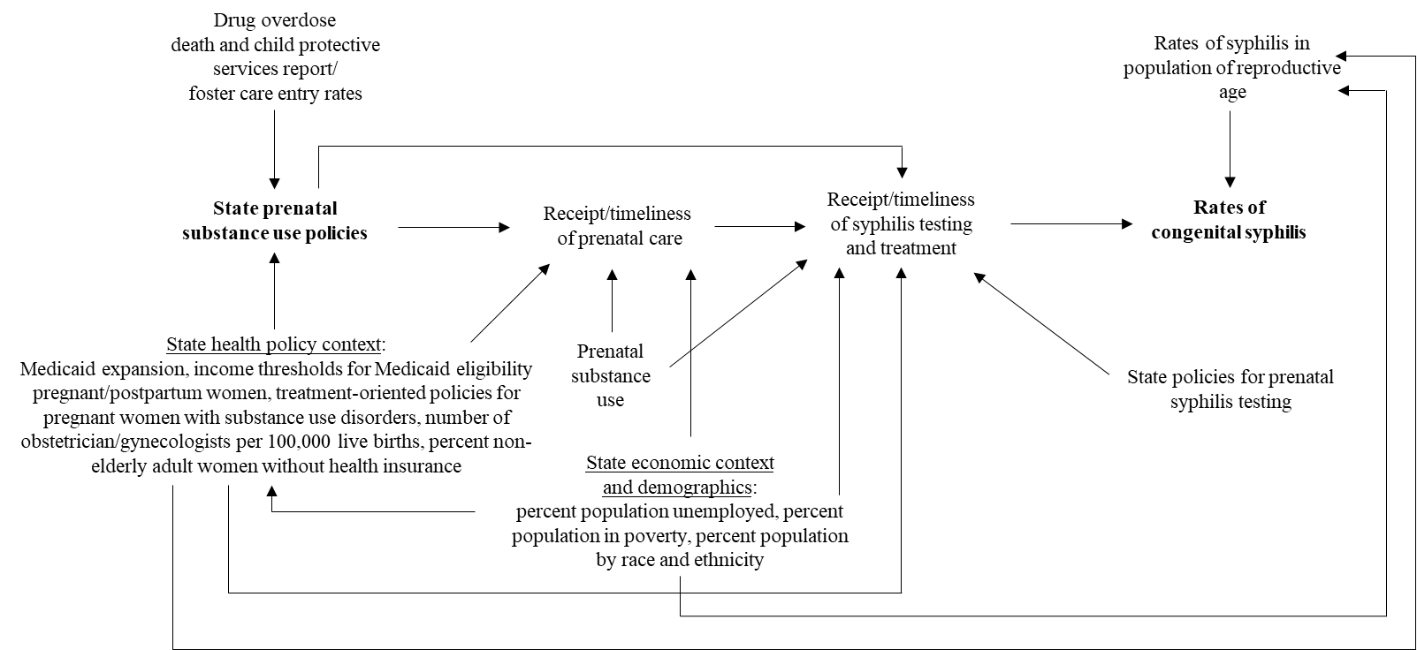

Supplemental Table 2. Rates of congenital syphilis cases per 100,000 live births by year and state prenatal substance use policy category, 2018-2022
State policy category | Year | Number of congenital syphilis cases | Number of live births | Rate of congenital syphilis cases per 100,000 live births
Child abuse policy only | 2018 | 558 | 1,177,545 | 47.4
Child abuse policy only | 2019 | 790 | 1,159,159 | 68.2
Child abuse policy only | 2020 | 894 | 1,122,380 | 79.7
Child abuse policy only | 2021 | 1136 | 1,129,690 | 100.6
Child abuse policy only | 2022 | 1580 | 1,151,206 | 137.2
Mandated reporting policy only | 2018 | 358 | 794,403 | 45.1
Mandated reporting policy only | 2019 | 475 | 728,069 | 65.2
Mandated reporting policy only | 2020 | 533 | 692,134 | 77.0
Mandated reporting policy only | 2021 | 605 | 699,834 | 86.4
Mandated reporting policy only | 2022 | 709 | 694,474 | 102.1
Both policies | 2018 | 294 | 860,073 | 34.1
Both policies | 2019 | 462 | 912,984 | 50.6
Both policies | 2020 | 504 | 882,131 | 57.1
Both policies | 2021 | 754 | 900,883 | 83.7
Both policies | 2022 | 982 | 894,363 | 109.8
Neither policy | 2018 | 115 | 959,691 | 12.0
Neither policy | 2019 | 155 | 947,328 | 16.4
Neither policy | 2020 | 232 | 917,002 | 25.3
Neither policy | 2021 | 383 | 933,885 | 41.0
Neither policy | 2022 | 490 | 927,715 | 52.8

Supplemental Table 3. Distribution of covariates by state prenatal substance use policy category, 2018-2022
 |  |  | Child abuse policy only  (N=41  state-years) | Mandated reporting policy only  (N=42  state-years) |  | Both child abuse and mandated reporting policies  (N=93  state-years) | Neither policy  (N=79  state-years)
 |  |  | Mean  (25th, 50th, 75th percentile) | Mean  (25th, 50th, 75th percentile) |  | Mean  (25th, 50th, 75th percentile) | Mean  (25th, 50th, 75th percentile)
Percent non-elderly adult women uninsured |  |  | 11.9  (8.7, 11, 13.6) | 7.5  (5.8, 6.7, 9.8) |  | 9.9  (6.9, 9.3, 13.2) | 9.0  (6.3, 8, 12.1)
Number of OB/GYNs per 100,000 live births |  |  | 10.4  (9.0, 10.3, 11.6) | 12.6  (9.2, 12.1, 14.8) |  | 11.0  (7.8, 10.1, 12.2) | 12.3  (10.0, 11, 14.2)
Percent population unemployed |  |  | 4.4  (3.1, 3.9, 5.4) | 4.9  (3.5, 4.2, 5.8) |  | 4.5  (3.2, 3.9, 5.5) | 4.7  (3.5, 4.2, 5.5)
Percent population in poverty |  |  | 11.7  (9.3, 11.5, 13.5) | 10.3  (9.4, 10.2, 11.2) |  | 11.6  (8.5, 11.7, 14.0) | 10.4  (8.3, 9.5, 11.9)
Percent population American Indian/Alaska Native |  |  | 2.0  (0.5, 0.7, 1.6) | 3.3  (0.6, 0.7, 1.7) |  | 2.4  (0.6, 1.2, 1.7) | 1.0  (0.4, 0.7, 1.6)
Percent population Asian |  |  | 3.2  (1.9, 2.7, 3.7) | 5.3  (1.6, 3.5, 6.7) |  | 3.7  (1.8, 3.1, 5.0) | 6.2  (2.0, 3.2, 7.1)
Percent population Black |  |  | 11.6  (4.6, 11.8, 17.0) | 6.6  (3.7, 6.5, 9.5) |  | 15.8  (6.6, 9.1, 31.0) | 10.9  (2.2, 5.8, 17.3)
Percent population Native Hawaiian or other Pacific Islander |  |  | 0.1  (0.1, 0.1, 0.2) | 0.3  (0.1, 0.1, 0.2) |  | 0.3  (0.1, 0.1, 0.3) | 0.8  (0.1, 0.1, 0.1)
Percent population White |  |  | 80.5  (77.2, 81.6, 84.5) | 81.1  (78.4, 79.8, 89) |  | 74.9  (62.8, 78.5, 84.6) | 77.1  (69.8, 79.8, 90.2)
Percent population multiple races |  |  | 2.6  (2.3, 2.5, 2.8) | 3.3  (2.2, 2.7, 3.0) |  | 2.9  (2.2, 2.6, 3.0) | 4.0  (2.1, 2.4, 3.0)
Percent population Hispanic |  |  | 17.8  (4.8, 12.8, 26.2) | 11.7  (4.5, 6.9, 13.1) |  | 11.9  (5.7, 10.1, 14.6) | 9.9  (5.1, 10.3, 13.0)
 |  |  | N (%) | N (%) |  | N (%) | N (%)
Medicaid expansion |  |  | 32 (59.3) | 40 (97.6) |  | 56 (70.0) | 52 (66.4)
Medicaid threshold for pregnancy and postpartum women above the U.S. median |  |  | 28 (51.9) | 20 (48.8) |  | 47 (58.8) | 28 (35.0)
Priority access to substance use disorder treatment for pregnant women |  |  | 20 (37.0) | 11 (26.8) |  | 34 (42.5) | 20 (25.0)
 | Supplemental Table 4. Sensitivity analyses for average difference in rates of congenital syphilis cases per 100,000 live births for states by state prenatal substance use policies, 2018-2022: Recategorizing states with less expansive child abuse policiesª
 |  | Unadjusted β  (95% CI) |  |  | Adjusted β^{b}  (95% CI)
 | State policy category
 | Neither policy | 0.0 |  |  | 0.0
 | Child abuse policy only | 10.4 (-30.9, 51.8) |  |  | -0.7 (-16.2, 14.9)
 | Mandated reporting policy only | 2.6 (-22.6, 27.8) |  |  | 0.2 (-11.5, 12.0)
 | Both policies | 38.3 (5.6, 71.1) |  |  | 26.0 (4.6, 47.5)
ªIdaho, New Mexico, Ohio, and Rhode Island were categorized as not having a child abuse policy given that these state policies do not criminalize prenatal substance use, defined prenatal substance use as child abuse or neglect, or considered prenatal substance use as grounds for termination of parental rights.
^{b}Adjusted for a linear time trend and state Medicaid expansion, threshold for Medicaid eligibility for pregnant and postpartum women, percent women 19 to 64 years uninsured, number of OB/GYNs per 100,000 live births, policies specifying priority access to substance use disorder treatment for pregnant women, percent population unemployed, percent population in poverty, and percent population by race and ethnicity

Supplemental Table 5. Sensitivity analyses for average difference in rates of congenital syphilis cases per 100,000 live births for states by state prenatal substance use policies, 2018-2022: Recategorizing states with less expansive mandated reporting policiesª
 | Unadjusted β  (95% CI) | Adjusted β^{b}  (95% CI)
State policy category
Neither policy | 0.0 | 0.0
Child abuse policy only | 15.5 (-13.7, 44.7) | 1.6 (-11.1, 14.3)
Mandated reporting policy only | -4.8 (-26.6, 16.9) | 3.0 (-10.0, 16.0)
Both policies | 45.7 (14.6, 76.9) | 26.8 (4.1, 49.6)
ªCalifornia, Connecticut, Kentucky, Massachusetts, and Minnesota were categorized as not having a mandated reporting policy as these state policies require reporting of prenatal substance use to child protective services agencies only if there is also a suspicion of child abuse or neglect
^{b}Adjusted for a linear time trend and state Medicaid expansion, threshold for Medicaid eligibility for pregnant and postpartum women, percent women 19 to 64 years uninsured, number of OB/GYNs per 100,000 live births, policies specifying priority access to substance use disorder treatment for pregnant women, percent population unemployed, percent population in poverty, and percent population by race and ethnicity

Supplemental Table 6. Sensitivity analyses for average difference in rates of congenital syphilis cases per 100,000 live births for states by state prenatal substance use policies, 2018-2019 and 2021-2022
 | Unadjusted β  (95% CI) | Adjusted βª  (95% CI)
State policy category
Neither policy | 0.0 | 0.0
Child abuse policy only | 19.7 (-16.5, 55.9) | -3.0 (-18.8, 12.7)
Mandated reporting policy only | 2.2 (-22.7, 27.1) | 2.2 (-11.1, 15.6)
Both policies | 44.1 (13, 75.1) | 25.3 (0.5, 50.2)
ªAdjusted for a linear time trend and state Medicaid expansion, threshold for Medicaid eligibility for pregnant and postpartum women, percent women 19 to 64 years uninsured, number of OB/GYNs per 100,000 live births, policies specifying priority access to substance use disorder treatment for pregnant women, percent population unemployed, percent population in poverty, and percent population by race and ethnicity

Supplemental Table 7. Sensitivity analyses for average difference in rates of congenital syphilis cases per 100,000 live births for states by state prenatal substance use policies, 2018-2022: Additional adjustment for the rate of syphilis infections among women ages 15-44 years
 | Unadjusted β  (95% CI) | Adjusted βª  (95% CI)
State policy category
Neither policy | 0.0 | 0.0
Child abuse policy only | 3.2 (-21.6, 28.1) | 3.6 (-8.9, 16.1)
Mandated reporting policy only | 18.6 (-16.6, 53.7) | 0.8 (-11.8, 13.5)
Both policies | 41.7 (12.9, 70.5) | 22.5 (4.3, 40.7)
ªAdjusted for a linear time trend and state Medicaid expansion, threshold for Medicaid eligibility for pregnant and postpartum women, percent women 19 to 64 years uninsured, number of OB/GYNs per 100,000 live births, policies specifying priority access to substance use disorder treatment for pregnant women, percent population unemployed, percent population in poverty, percent population by race and ethnicity, and rate of syphilis infections among women ages 15-44 years

Supplemental Table 8. Sensitivity analyses for average difference in rates of congenital syphilis cases per 100,000 live births for states by state prenatal substance use policies, 2018-2022: Additional adjustment for whether state required syphilis third trimester syphilis testing
 | Unadjusted β  (95% CI) | Adjusted βª  (95% CI)
State policy category
Neither policy | 0.0 | 0.0
Mandated reporting policy only | 3.2 (-21.6, 28.1) | 2.0 (-11.0, 15.0)
Child abuse policy only | 18.6 (-16.6, 53.7) | -1.4 (-16.4, 13.6)
Both policies | 41.7 (12.9, 70.5) | 22.7 (1.9, 43.9)
ªAdjusted for a linear time trend and state Medicaid expansion, threshold for Medicaid eligibility for pregnant and postpartum women, percent women 19 to 64 years uninsured, number of OB/GYNs per 100,000 live births, policies specifying priority access to substance use disorder treatment for pregnant women, percent population unemployed, percent population in poverty, percent population by race and ethnicity, and requirement for third trimester syphilis testing among pregnant women

Supplemental Table 9. Sensitivity analyses for average difference in rates of congenital syphilis cases per 100,000 live births for states by state prenatal substance use policies, 2018-2022: Excluding California
 | Unadjusted β  (95% CI) | Adjusted βª  (95% CI)
State policy category
Neither policy | 0.0 | 0.0
Child abuse policy only | 19.0 (-16.2, 54.2) | -0.3 (-15.6, 15.1)
Mandated reporting policy only | -6.4 (-24.9, 12.0) | 1.6 (-12.2., 15.3)
Both policies | 41.1 (12.2, 70.0) | 23.6 (2.2, 45.0)
ªAdjusted for a linear time trend and state Medicaid expansion, threshold for Medicaid eligibility for pregnant and postpartum women, percent women 19 to 64 years uninsured, number of OB/GYNs per 100,000 live births, policies specifying priority access to substance use disorder treatment for pregnant women, percent population unemployed, percent population in poverty, and percent population by race and ethnicity

Supplemental Table 10. Sensitivity analyses for average difference in rates of congenital syphilis cases per 100,000 live births for states by state prenatal substance use policies, 2018-2022: Excluding Florida and Texas
 | Unadjusted β  (95% CI) | Adjusted βª  (95% CI)
State policy category
Neither policy | 0.0 | 0.0
Child abuse policy only | 5.9 (-28.3, 40.1) | -0.7 (-15.6, 14.2)
Mandated reporting policy only | 3.0 (-22.0, 28.0) | 1.7 (-10.9., 14.4)
Both policies | 40.1 (11.6, 68.7) | 24.2 (2.7, 45.7)
ªAdjusted for a linear time trend and state Medicaid expansion, threshold for Medicaid eligibility for pregnant and postpartum women, percent women 19 to 64 years uninsured, number of OB/GYNs per 100,000 live births, policies specifying priority access to substance use disorder treatment for pregnant women, percent population unemployed, percent population in poverty, and percent population by race and ethnicity

Supplemental Figure 2. Missed prevention opportunities for congenital syphilis cases in states with a child abuse policy only for prenatal substance use, 2018-2022

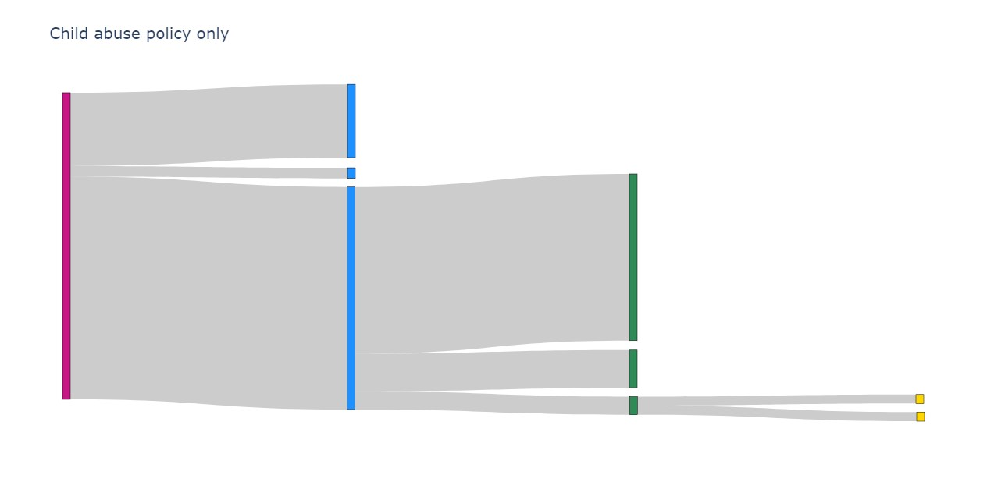
Congenital syphilis cases
Non-documented or non-timely test
Late identification of seroconversion
Timely testing
Inadequate treatment
No or non-documented treatment
Adequate treatment
Clinical evidence despite
adequate treatment
Unclear indication

Note: The CDC used a stepwise analytic framework¹ to classify congenital syphilis cases by type of missed prevention opportunity: (1) among all congenital syphilis cases, the number that had a non-documented or non-timely test or late identification of seroconversion in pregnancy; (2) among cases with a timely test, the number that received inadequate treatment or no or non-documented treatment; and (3) among cases with adequate treatment, the number that had clinical evidence of congenital syphilis despite adequate treatment or an unclear indication. In the above Sankey diagram, a larger bar indicates a greater number of cases in the missed prevention opportunity category. See Supplemental Table 8 for numbers and percents for each missed prevention opportunity category.

Supplemental Figure 3. Missed prevention opportunities for congenital syphilis cases in states with a mandated reporting policy only for prenatal substance use, 2018-2022
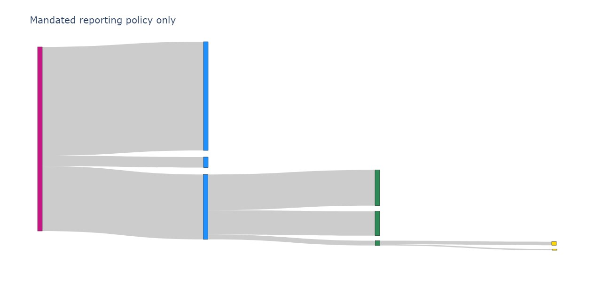
Congenital syphilis cases
Non-documented or non-timely test
Late identification of seroconversion
Timely testing
Inadequate treatment
No or non-documented treatment
Adequate treatment
Clinical evidence despite
adequate treatment
Unclear indication

Note: The CDC used a stepwise analytic framework¹ to classify congenital syphilis cases by type of missed prevention opportunity: (1) among all congenital syphilis cases, the number that had a non-documented or non-timely test or late identification of seroconversion in pregnancy; (2) among cases with a timely test, the number that received inadequate treatment or no or non-documented treatment; and (3) among cases with adequate treatment, the number that had clinical evidence of congenital syphilis despite adequate treatment or an unclear indication. In the above Sankey diagram, a larger bar indicates a greater number of cases in the missed prevention opportunity category. See Supplemental Table 8 for numbers and percents for each missed prevention opportunity category.

Supplemental Figure 4. Missed prevention opportunities for congenital syphilis cases in states with both a child abuse policy and a mandated reporting policy for prenatal substance use, 2018-2022

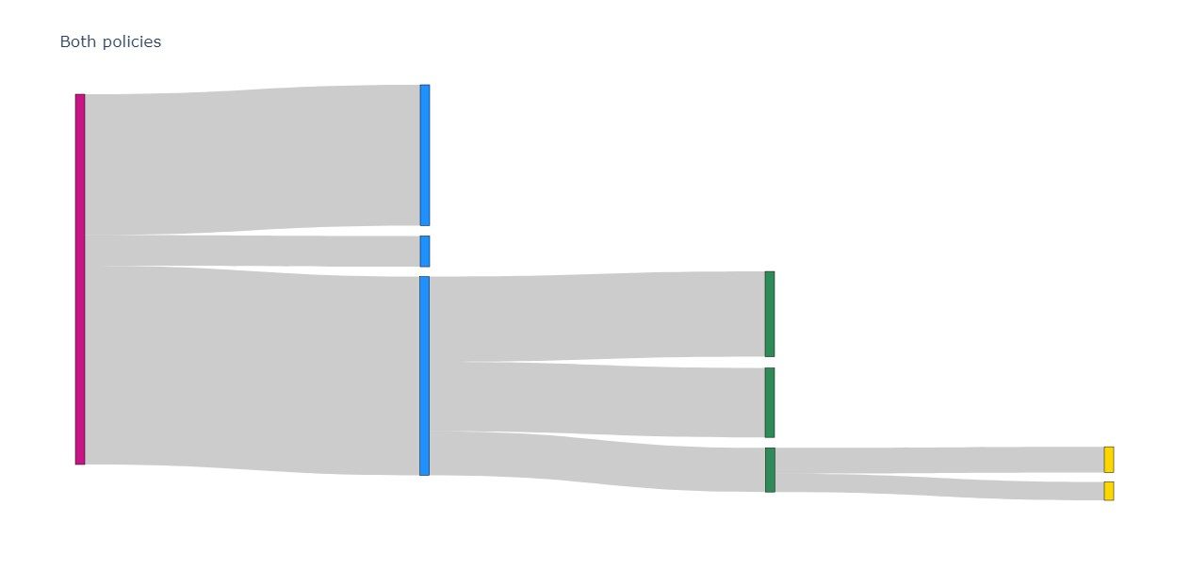
Congenital syphilis cases
Non-documented or non-timely test
Late identification of seroconversion
Timely testing
Inadequate treatment
No or non-documented treatment
Adequate treatment
Clinical evidence despite
adequate treatment
Unclear indication

Note: The CDC used a stepwise analytic framework¹ to classify congenital syphilis cases by type of missed prevention opportunity: (1) among all congenital syphilis cases, the number that had a non-documented or non-timely test or late identification of seroconversion in pregnancy; (2) among cases with a timely test, the number that received inadequate treatment or no or non-documented treatment; and (3) among cases with adequate treatment, the number that had clinical evidence of congenital syphilis despite adequate treatment or an unclear indication. In the above Sankey diagram, a larger bar indicates a greater number of cases in the missed prevention opportunity category. See Supplemental Table 8 for numbers and percents for each missed prevention opportunity category.

Supplemental Figure 5. Missed prevention opportunities for congenital syphilis cases in states with neither a child abuse policy nor a mandated reporting policy for prenatal substance use, 2018-2022
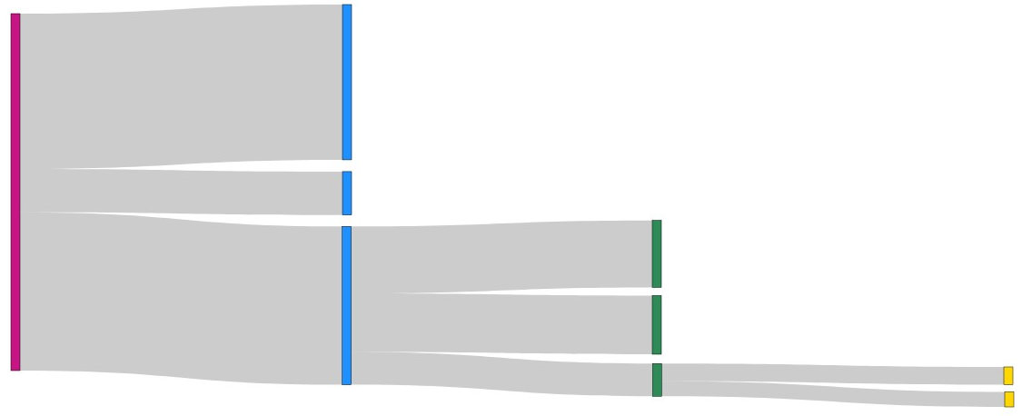
Congenital syphilis cases
Non-documented or non-timely test
Late identification of seroconversion
Timely testing
Inadequate treatment
No or non-documented treatment
Adequate treatment
Clinical evidence despite
adequate treatment
Unclear indication

Note: The CDC used a stepwise analytic framework¹ to classify congenital syphilis cases by type of missed prevention opportunity: (1) among all congenital syphilis cases, the number that had a non-documented or non-timely test or late identification of seroconversion in pregnancy; (2) among cases with a timely test, the number that received inadequate treatment or no or non-documented treatment; and (3) among cases with adequate treatment, the number that had clinical evidence of congenital syphilis despite adequate treatment or an unclear indication. In the above Sankey diagram, a larger bar indicates a greater number of cases in the missed prevention opportunity category. See Supplemental Table 8 for numbers and percents for each missed prevention opportunity category.

Supplemental Table 11. Missed prevention opportunities for congenital syphilis cases by state prenatal substance use policies, 2018-2022

 | Both policies |  | Child abuse policy only |  | Mandated reporting policy only |  | Neither policy
 | N | % | N | % | N | % | N | %
Congenital syphilis cases | 2,996 |  | 4,958 |  | 2,680 |  | 1,375
Among all cases of congenital syphilis
Cases with a non-documented or  non-timely syphilis test during pregnancy | 1,139 | 38.0 | 1185 | 23.9 | 1,582 | 59.0 | 598 | 43.5
Cases with late identification of  seroconversion in pregnancy | 249 | 8.3 | 173 | 3.5 | 154 | 5.7 | 167 | 12.1
Cases with timely syphilis testing during  pregnancy | 1,608 | 53.7 | 3,600 | 72.6 | 944 | 35.2 | 610 | 44.4
Among congenital syphilis cases with timely syphilis testing during pregnancy
Cases with inadequate syphilis treatment  during pregnancy | 690 | 42.9 | 2697 | 74.9 | 519 | 55 | 258 | 42.3
Cases with no or non-documented  syphilis treatment during pregnancy | 561 | 34.9 | 610 | 16.9 | 355 | 37.6 | 226 | 37.0
Cases with adequate syphilis treatment  during pregnancy | 357 | 22.2 | 293 | 8.1 | 70 | 7.4 | 126 | 20.7
Among congenital syphilis cases with adequate syphilis treatment during pregnancy
Cases with clinical evidence of congenital syphilis  despite adequate treatment | 208 | 58.3 | 146 | 49.8 | 19 | 27.1 | 68 | 54.0
Cases with an unclear indication | 149 | 41.7 | 147 | 50.2 | 51 | 72.9 | 58 | 46.0
Note: The CDC used a stepwise analytic framework¹ to classify congenital syphilis cases by type of missed prevention opportunity: (1) among all congenital syphilis cases, the number that had a non-documented or non-timely test or late identification of seroconversion in pregnancy; (2) among cases with a timely test, the number that received inadequate treatment or no or non-documented treatment; and (3) among cases with adequate treatment, the number that had clinical evidence of congenital syphilis despite adequate treatment or an unclear indication. Numbers and percentages are unadjusted.

References
- O’Callaghan KP, Jones MLJ, McDonald R, et al. The congenital syphilis prevention cascade: Reimagining a missed prevention opportunities framework for effective intervention. Sexually Transmitted Diseases. 2023:10-1097.

