Supplemental materials

eTable 1. List of Dx and Rx names used for case definitions
Algorithm criteria | Source PMAP table [field name] | Codes
Dx codes* | HSP_ADMIT_DX, HSP_BILLING_DX, MEDICAL_HX, PAT_ENC_DX, PROBLEM_LIST  [icd10_code] | "I49.8", "I49", "I49.9", "I50.1", "I30", "I30.9", "I30.0", "I30.8", "I31.9", "I51.4", "I40", "I40.9", "I40.1", "I40.8", "E11", "E03.9", "E03.8", "E03", "E05.9", "E05", "E27.49", "E27.8", "E27", "J18.9", "J84.89", "J84.114", "J84.113", "G04.9", "G04", "G92.8", "G04.8", "G04.90", "G04.81", "G04.00", "G05.3", "G05", "K52.9", "K50", "K51", "K52", "K52.3", "K52.89", "K52.8", "K51.513", "K51.5", "K51.514", "K51.51", "K51.50", "K51.512", "K51.519", "K75.9", "K75.4", "K75.2", "L30.9", "L20", "L20.9", "L27.9", "L27", "L30.8", "L27.8", "L20.89", "L20.8", "L30", "R21", "D72.12", "D72.810", "D61.9", "D61.3", "D61.1", "D61.2", "D61", "M60", "M60.9", "M60.1", "M60.8", "M60.10", "M60.18", "H57.1", "H57.10", "H35.38", "H35.383", "H35.389", "N28.9", "N08", "N14.19", "N14.2", "N14.1", "N14.4", "L13.0"
Rx codes | DERIVED_MED_ADMIN  [medication_name] | All irAE types:  "PREDNISONE", "METHYLPREDNISOLONE", "INFLIXIMAB", “DUPILUMAB”, “AZATHIOPRINE”, “METHOTREXATE”, “MYCOPHENOLATE MOFETIL”, “IVIG”, “RITUXIMAB”  Additional medications by organ system:  Dermatologic: "TRIAMCINOLONE", "BETAMETHASONE", "CLOBETASOL", "FLUOCINONIDE", "HALOBETASOL", "DESONIDE", “OMALIZUMAB”, “DUPILUMAB”  Endocrine**: "LEVOTHYROXINE"  Kidney: “AZATHIOPRINE”  Colitis: “EDOLIZUMAB”, “TOFACITINIB”, “USTEKINUMAB”  Hepatic: (NOT “INFLIXIMAB”), “AZATHIOPRINE”, “MYCOPHENOLATE MOFETIL”, “TACROLIMUS”, “ANTITHYMOCYTE GLOBULIN”, “TOCILIZUMAB”  Myocarditis/myositis: “ABATACEPT”, “ALEMTUZUMAB”, “ANTITHYMOCYTE GLOBULIN”, “METHOTREXED”, “MYCOPHENOLATE”
Rx dosages | DERIVED_MED_ADMIN  [sig_num]  [dose_unit] | Prednisone: 50mg***  Methylprednisolone: 50mg***  Infliximab: 250mg***  Levothyroxine, triamcinolone/other topical agents, & other biologic therapies: no threshold
* Corresponding to cardiovascular, endocrine, pulmonary, nervous system, gastrointestinal, skin, hematologic, musculoskeletal, ocular, and renal anatomic domains
** Although irAE thyroiditis includes both symptomatic hyperthyroidism (treatable with beta blockers) and hypothyroidism (treatable with levothyroxine), in most cases patients experience a short, undetected period of hyperthyroidism followed by a longer period of hypothyroidism; with the latter, more stable clinical scenario more likely to be detected and treated. For this reason we did not include beta blockers for hyperthyroidism in the algorithm.
*** Given that guidance recommends 1mg/kg/day prednisone or methylprednisolone for most commonly occurring irAEs (depending on the diagnosis and the guideline used), and 5mg/kg/day infliximab for certain steroid-refractory irAE, the chosen thresholds were based the assumption that 50mg/day would correspond to 1 mg/kg (and 250 mg/day = 5 mg/kg infliximab) for a patient of 50kg (110 lbs).
Topical agents for treatment of skin-related irAE
eFigure 1. CONSORT Flow Diagram- irAE Validation Cohort
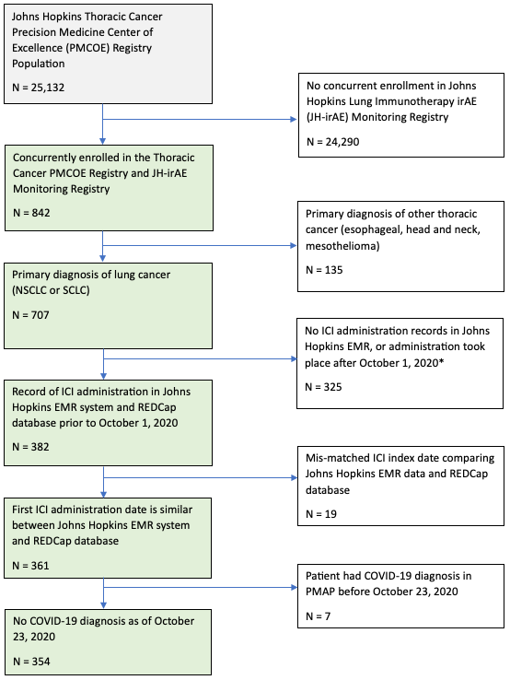

* The irAE monitoring registry included patients that were consented on clinical trials or clinical protocols (e.g., biospecimen collection protocol) if they were eligible to receive immunotherapy. Some of these patients were eligible, but they may have not received immunotherapy. This explains why there may be data prior to FDA approval of commonly used immunotherapy agents and why some patients did not receive immunotherapy.

eTable 2. IrAE Case Definition Algorithm Criteria
Criteriaª | Dx / Rx^{b} | Dx/Rx (relaxed) | Discontinue | Rx only | Dx only
ICI exposure  (NDC codes) | Any ICI medication | Any ICI medication | Any ICI medication | Any ICI medication | Any ICI medication
irAE toxicity dx  (ICD-10 codes)^{c} | Based on toxicities as listed in the NCCN/ASCO guidelines^{d} | Based on toxicities as listed in the NCCN/ASCO guidelines | Based on toxicities as listed in the NCCN/ASCO guidelines | N/A | Based on toxicities as listed in the NCCN/ASCO guidelines
Corticosteroid/  DMARD use (Medication codes) | Based on treatments in NCCN/ASCO guidelines^{e} | Based on treatments in NCCN/ASCO guidelines | Based on treatments in NCCN/ASCO guidelines | Based on treatments in NCCN/ASCO guidelines | N/A
Corticosteroid timing | Within +/- 40 days of “irAE” dx^{f} | Any time prior to “irAE” dx to +40 days | Within +/- 40 days of “irAE” dx | N/A | N/A
ICI treatment discontinuation | N/A | N/A | >60 days with no ICI administration^{g} | N/A | N/A
ª All criteria were required to be present for a particular algorithm to classify a patient as having an irAE
^{b} Brown V et al. Cancer Investigation, 2021. doi: 10.1080/07357907.2021.1913502.
^{c} Algorithm toxicity definitions adapted from published examples that used Medicare claims. We could not emulate the requirement that ICD-10 codes appear in the first 4 claims positions because those fields do not exist in EHR.
^{d} Toxicities are cardiovascular, endocrine, pulmonary, nervous system, gastrointestinal, skin, hematologic, musculoskeletal, ocular, or renal.
^{e} See eTable 1.
^{f} This criteria may differ slightly from the published algorithm, as details were not available at the time of analysis.
^{g} The choice of >60 days of no ICI administration generally aligns with missing at least two cycles of treatment. This is a reasonable surrogate of treatment discontinuation, although it may not capture all patients for which other treatment delays (personal, financial, or otherwise) occurred. The authors of the published case definition also used >60 days of no ICI administration to define treatment discontinuation in their analysis of irAE-related outcomes.

eFigure 2. Graphical Depiction of irAE Case Definition Algorithm(s)
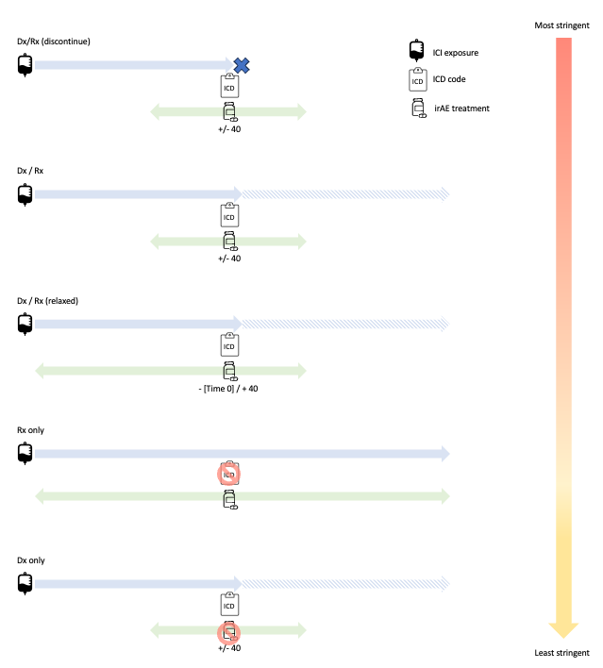
Algorithm Dx/Rx was adapted directly from a publication, as previously described. For algorithm Dx/Rx relaxed, we expanded the date buffer for irAE treatment to include any date prior to the ICD-10 code, up to 40 days following. For algorithm Dx/Rx (discontinue), we added a requirement that ICI treatment be discontinued subsequent to the ICD-10 code, in concordance with guidelines for management of moderate-severe irAE. For algorithms Rx only and Dx only) we relaxed the requirement for the presence of both diagnosis and pharmacy data to define an irAE episode.

eTable 3. ICI initiation and incident irAE/severity by year

Year | New ICI patients, N | Incident irAE, N | Severe(+) irAE, N (%)
2015 | 5 | 1 | 0 (0)
2016 | 48 | 20 | 6 (30)
2017 | 93 | 47 | 19 (40)
2018 | 85 | 22 | 12 (55)
2019 | 93 | 26 | 11 (42)
2020 | 30 | 8 | 1 (13)
TOTAL | 354 | 126* | 49 (39)
* Total = 126, not 89, as individual patients may have experienced >1 irAE

