eFigure 1. Monthly Rate of Individuals per 100,000 Dispensed Buprenorphine from U.S. Retail Pharmacies; by Sex, January 2018 to December 2023

A. Male B. Female
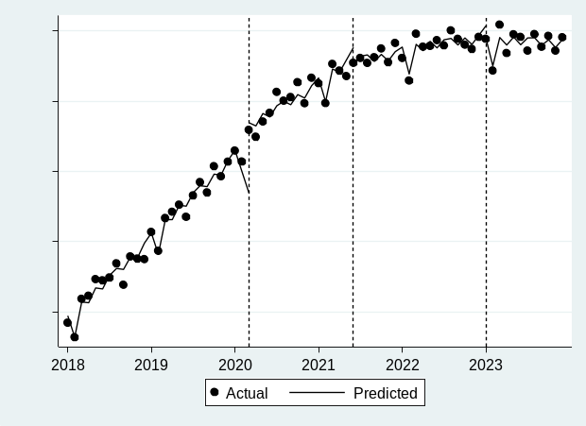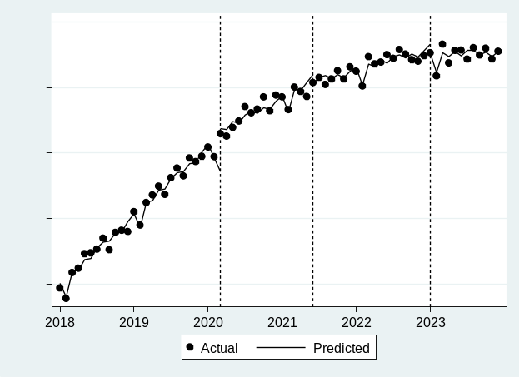

Source: IQVIA Total Patient Tracker (TPT) 2018-2023

eFigure 2. Monthly Rate of Individuals per 100,000 Dispensed Buprenorphine from U.S. Retail Pharmacies by Age, January 2018 to December 2023

A. Ages 0-19 years B. Age 20-39 years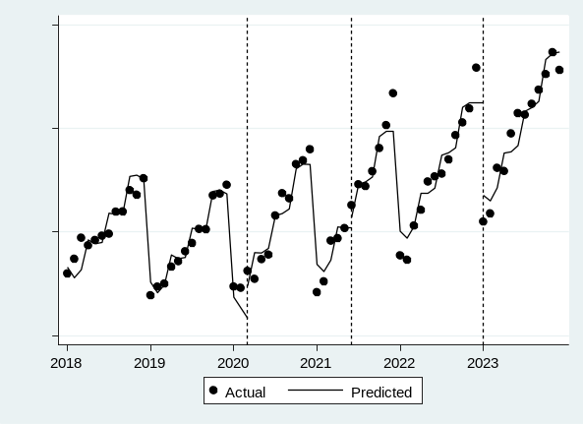 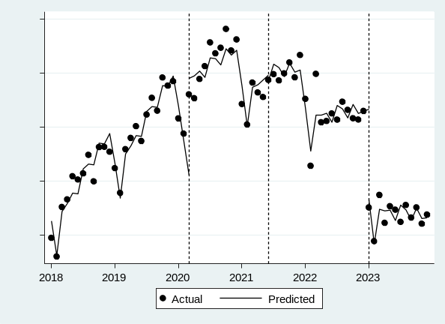

C. Age 40-64 years D. Age ≥65 years
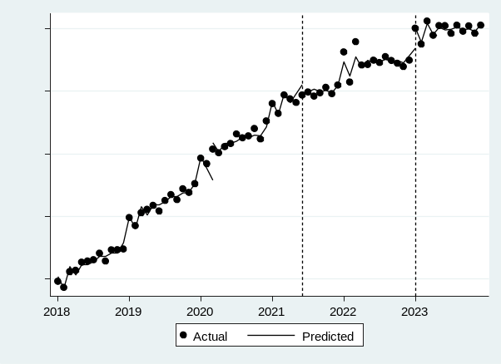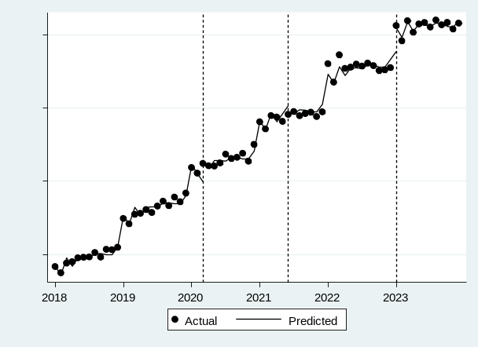

Source: IQVIA Total Patient Tracker (TPT) 2018-2023

eFigure 3. Monthly Rate of Individuals per 100,000 Dispensed Buprenorphine from U.S. Retail Pharmacies by Prescriber Specialty, January 2018 to December 2023

A. Overall B. Advanced Practitioner 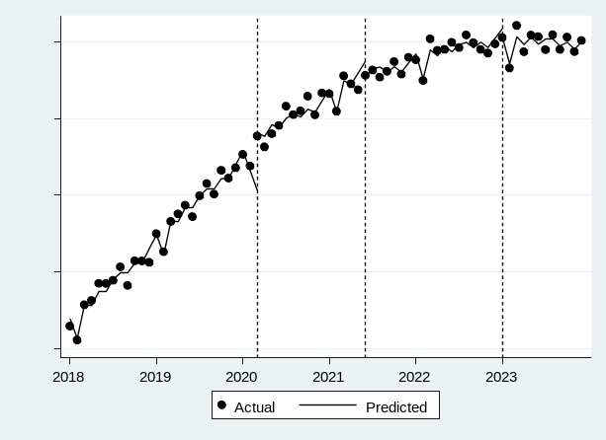 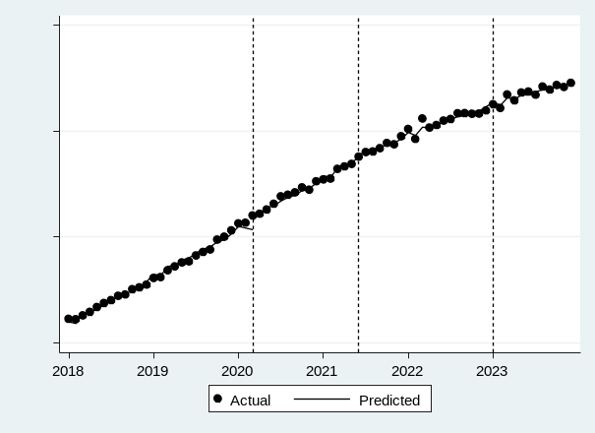

C. Primary Care D. Addiction Medicine
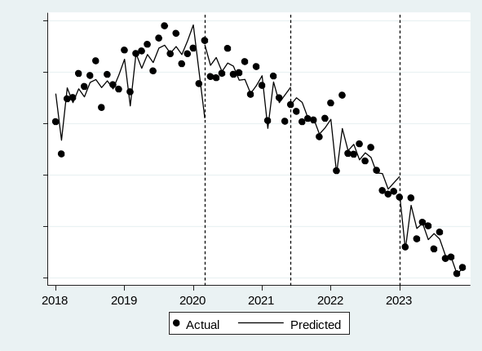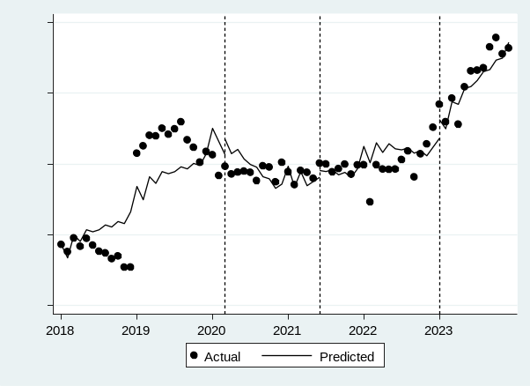

E. Emergency Medicine F. Hospitalist and Palliative Care
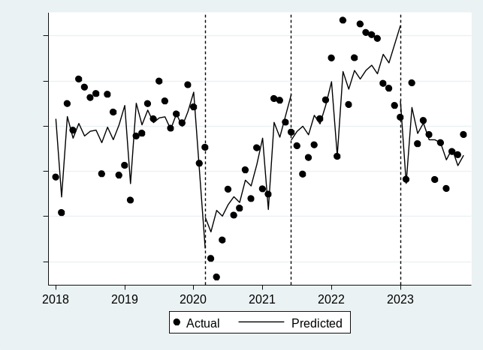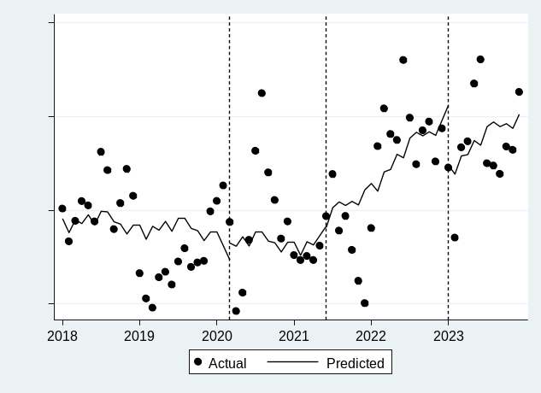

G. Musculoskeletal H. Obstetrics/Gynecology
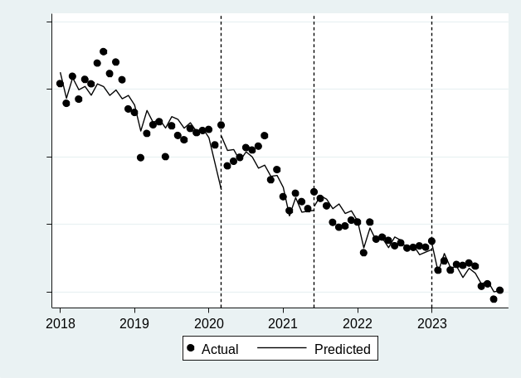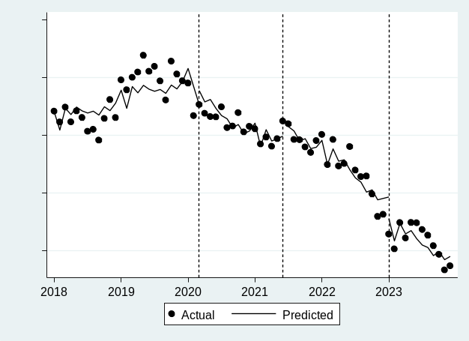

I. Other/Unknown J. Pain Medicine
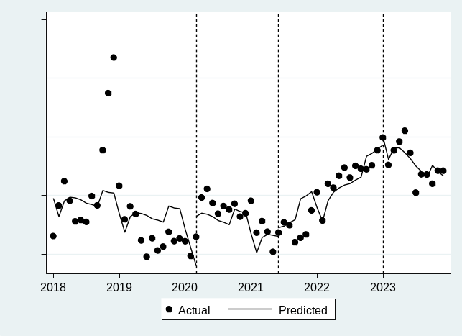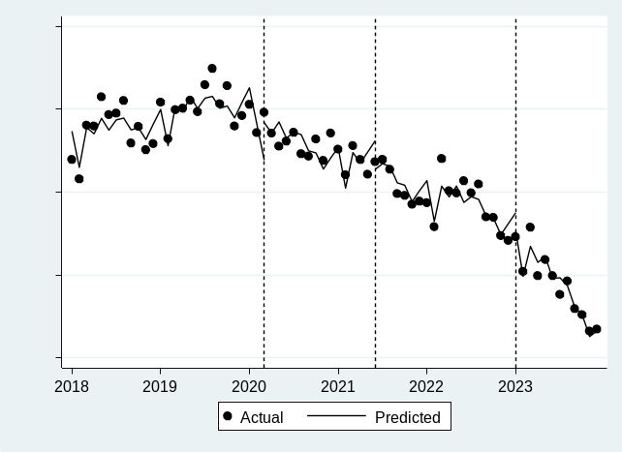

K. Psychiatrist L. Medical Subspeciality
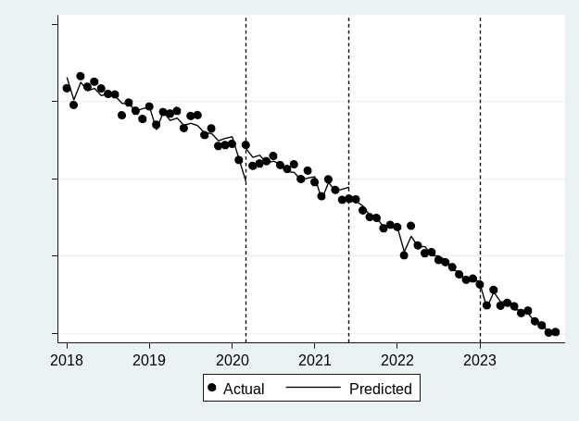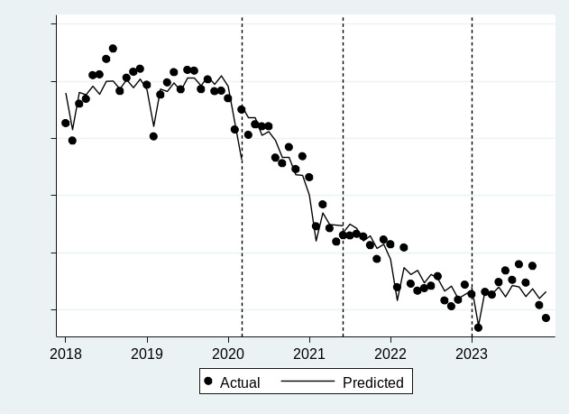

M. Surgery
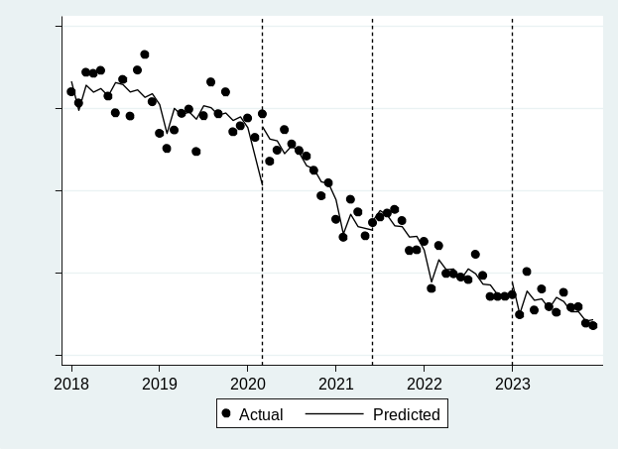
Source: IQVIA Total Patient Tracker (TPT) 2018-2023

