Supplement to “Effects of the COVID-19 pandemic on TB outcomes in the United States: a Bayesian analysis”
Contents
- MITUS model description
  - Model structure
    - Figure S1: Structural schematic of the MITUS model, showing model compartments and transitions.
  - Key model assumptions
  - Initial model calibration
  - Secondary model calibration to include COVID-19 changes
    - Table S1: Calibrated baseline and COVID-19 mechanism adjustment parameters used in the MITUS transmission model.
    - Figure S2: Schematic describing the incorporation of the COVID-19 adjustment parameters for the time trend in immigration.

- Additional results
  - Figure S3: Comparison of calibration targets and model estimates for the fitted pandemic scenario and no-pandemic counterfactual during 2019–2023. Shaded areas represent 95% uncertainty intervals.
  - Figure S4: Estimated impact of each examined COVID-19 related mechanism on incident TB infections during 2020–2035.
  - Figure S5: Model estimated annual difference in TB outcomes under the fitted pandemic scenario compared with each counterfactual immigration scenario during 2015–2035.
- MITUS model description
Model structure
The Modeling Interventions for Tuberculosis in the United States (MITUS) model is a deterministic compartmental model of TB. Figure 1 presents the schematic of the MITUS model structure. The model subdivides the US population into discrete strata describing important mechanisms of TB transmission, natural history, and treatment. The model is further stratified into additional dimensions describing (i) prior TB disease and mycobacterium tuberculosis (Mtb) infection treatment, (ii) heterogeneity in TB risks between US-born and non-US-born populations, (iii) age-based differences in disease mechanisms and risk factor prevalence, and (iv) disparity in TB risks among marginalized populations. This model was based on an earlier TB simulation models [1], with the addition of two generic risk dimensions to allow flexibility in simulating the impact of preventive treatment in different populations. The first of these dimensions represents variation in the risk of developing TB disease after Mtb infection. The second of these dimensions represents variation in all-cause mortality risks not captured in other dimensions. Together, these dimensions are used to represent the additional risks of TB progression and mortality associated with a given risk factor. Additional details of the MITUS model are described in [2]. A summary of key modelling assumptions is provided below.

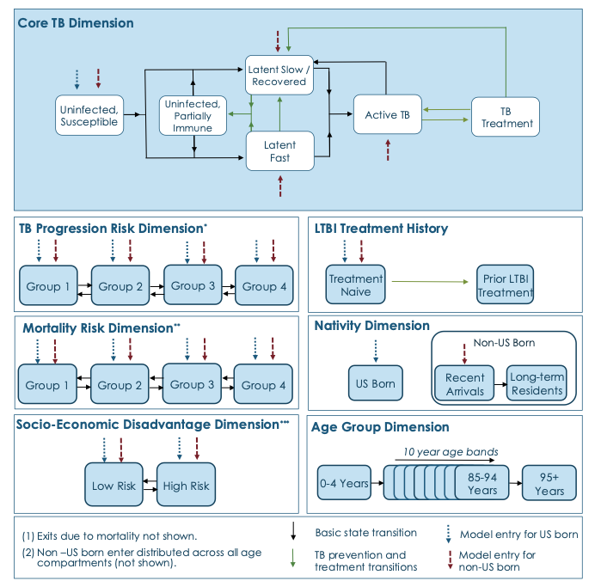
Figure S1: Structural schematic of the MITUS model, showing model compartments and transitions.
i) The TB progression risk dimension represents the differential risk of latent tuberculosis infection progressing to TB disease associated with differential immune activity. ii) The mortality risk dimension represents the differential all-cause mortality risk associated with an individual’s immune activity. iii) Socio-economic disadvantage dimension includes assortative mixing within the population, higher TB contact rates, an elevated mortality rate, higher LTBI screening rates, and higher active TB treatment default. iv) Assortative mixing was included in both nativity and socioeconomic disadvantage dimensions. A fraction of contacts is withheld for “with-like” interactions; this value is calibrated and applied to future model runs. Each nativity and socio-economic disadvantage stratum has a unique contact rate and probability of transmission per effective contact.

Key model assumptions
Upon Mtb infection, a small fraction of individuals are assumed to progress directly to TB disease. All remaining infected individuals enter a set of latent tuberculosis infection (LTBI) states and experience a declining reactivation risk over time [3, 4]. Individuals with distant infection are also assumed to have reduced LTBI test positivity. Mtb infection treatment is assumed to reduce but not eliminate TB progression risk [5, 6], and treated individuals could experience a future Mtb reinfection.
The model includes international immigration, emigration of non-US-born residents, and interstate net migration of both US-born and non-US-born residents. International migrants are assumed to have higher rates of Mtb infection than current US residents. Future international immigration volume is assumed to increase at an annual rate of 0.4% from 2019 levels, based on net immigration projections from the US Census Bureau [7]. TB burden among persons entering the United States is assumed to decline at 1.5% per year. Future rates of interstate migration and international emigration are fixed at 2019 levels. TB transmission risks are calculated dynamically based on TB disease prevalence and population mixing patterns.
Initial model calibration
The MITUS model was originally developed to project future TB trends and outcomes in the United States [2]. A Bayesian calibration approach [8, 9] was used to combine data sources and calibrate the model to data on US demography, reported TB epidemiological data, natural history evidence, and health services data spanning 1950–2019. Log-likelihood functions were used to compare model estimates to reported data for each of the calibration data targets. We used incremental mixture importance sampling to sample the posterior distribution each of calibrated parameters. This procedure yielded 1,000 parameter sets consistent with the reported TB data while representing the joint uncertainty in the calibrated parameters. The result of this calibration is referred to as the “pre-COVID-19” calibration.
Secondary model calibration to include COVID-19 changes
To estimate the potential impact of COVID-19 on tuberculosis in the United States we performed a secondary calibration of the model to data collected during the pandemic period. We mapped each of the four explored mechanisms (changes in immigration, accurate diagnosis and treatment initiation rates, interpersonal contact rates, and mortality among persons with TB disease) to their corresponding model inputs. Table S1 presents these parameters, their pre-COVID-19 levels, their prior distributions, the fitted parameter means and uncertainty intervals. We held all the other parameters fixed to the calibrated mean pre-COVID-19 values and allowed only the parameters representing the four mechanisms to vary during the COVID-19 calibration. The COVID-19 calibration period was March 2020–March 2023. Figure S2 presents an example schematic of how the secondary calibration parameters were incorporated into the model fits. The calibration algorithm was identical to the initial calibration, but exclusive to the mechanism parameters.

Parameter name | Fitted parameter mean and 95% interval | Prior distribution informed by reported data | Sources
Accurate diagnosis and treatment initiation rates
Baseline value | 0.30 |  | Calibrated
Time varying ratio of change  March – August 2020 | 0.67 (0.38, 1.04) | Gamma(15.19, 22.76) | [10]
September 2020 – February 2021 | 0.80 (0.45, 1.25) | Gamma(15.19, 18.91) | [10]
March – August 2021 | 0.92 (0.52, 1.45) | Gamma(15.19, 16.37) | [10]
September 2021 – February 2022 | 1.00 (0.56, 1.56) | Gamma(15.19, 15.19) | [10]
March – August 2022 | 1.00 (0.56, 1.56) | Gamma(15.19, 15.19) | [10]
September 2022 – February 2023 | 1.00 (0.56, 1.56) | Gamma(15.19, 15.19) | [10]
Respiratory contact rates
Baseline value | Varies by nativity and risk;  ranges from 0.00043 (low risk, US-born)  to 0.036 (high risk non-US–born) |  | Calibrated
Time varying ratio of change  March – August 2020 | 0.42 (0.24, 0.67) | Gamma(15.19, 35.43) | [11, 12]
September 2020 – February 2021 | 0.55 (0.31, 0.87) | Gamma(15.19, 27.42) | [11, 12]
March – August 2021 | 0.68 (0.38, 1.06) | Gamma(15.19, 22.37) | [11, 12]
September 2021 – February 2022 | 0.80 (0.45, 1.25) | Gamma(15.19, 18.89) | [11, 12]
March – August 2022 | 0.93 (0.52, 1.45) | Gamma(15.19, 16.34) | [11, 12]
September 2022 – February 2023 | 1.05 (0.59, 1.64) | Gamma(15.19, 14.40) | [11, 12]
TB mortality rate
Baseline value | Varies with age; ranges from  0.0013 (0-4 years) to 0.17 (95+ years) |  | Calibrated
Time varying ratio of change  March – August 2020 | 1.26 (0.71, 2.00) | Gamma(15.19, 12.00) | [13, 14]
September 2020 – February 2021 | 1.21 (0.68, 1.88) | Gamma(15.19, 12.61) | [13, 14]
March – August 2021 | 1.14 (0.64, 1.79) | Gamma(15.19, 13.28) | [13, 14]
September 2021 – February 2022 | 1.08 (0.61, 1.69) | Gamma(15.19, 14.03) | [13, 14]
March – August 2022 | 1.02 (0.57, 1.59) | Gamma(15.19, 18.86) | [13, 14]
September 2022 – February 2023 | 0.96 (0.54, 1.50) | Gamma(15.19, 15.81) | [13, 14]
Immigration volume
Baseline value | 132,705 |  | Calibrated
Time varying ratio of change  March – August 2020 | 0.33 (0.19, 0.52) | Gamma(15.19, 45.57) | [15]
September 2020 – February 2021 | 0.60 (0.33, 0.93) | Gamma(15.19, 25.51) | [15]
March – August 2021 | 0.85 (0.28, 1.34) | Gamma(15.19, 17.72) | [15]
September 2021 – February 2022 | 1.12 (0.63, 1.75) | Gamma(15.19, 13.57) | [15]
March – August 2022 | 1.38 (0.78, 2.15) | Gamma(15.19, 11.00) | [15]
September 2022 – February 2023 | 1.64 (0.92, 2.57) | Gamma(15.19, 9.24) | [15]

Table S1: Calibrated baseline and COVID-19 mechanism adjustment parameters and prior distributions used in the MITUS transmission model.

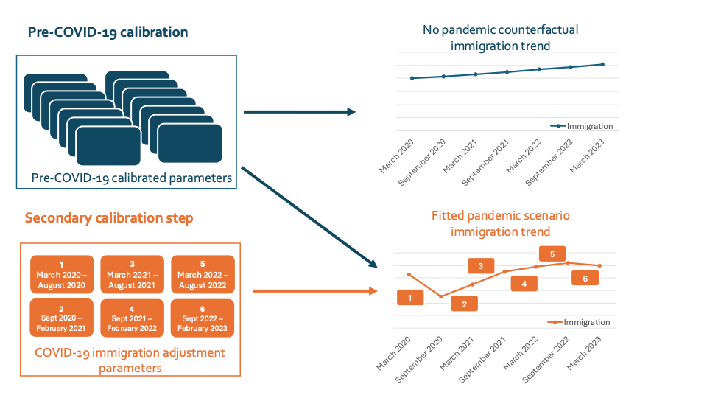
Figure S2: Schematic describing the incorporation of the COVID-19 adjustment parameters for the time trend in immigration.

- Additional Results

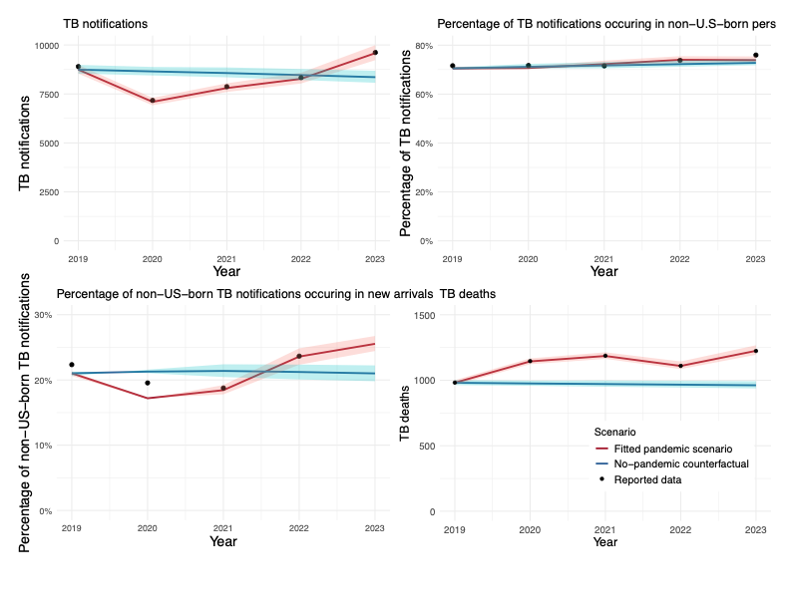
Figure S3: Comparison of calibration targets and model estimates for the fitted pandemic scenario and no-pandemic counterfactual during 2019–2023. Shaded areas represent 95% uncertainty intervals.
Note: New arrivals defined as non-U.S.–born persons in the United States less than or equal to 2 years.

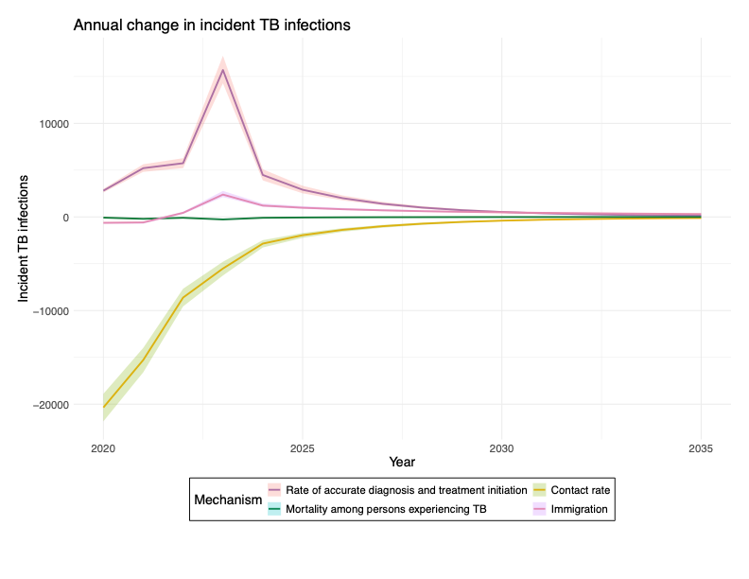
Figure S4: Estimated impact of each examined COVID-19 related mechanism on incident TB infections during 2020–2035.
Note: Error bars and shaded area represent 95% uncertainty intervals.

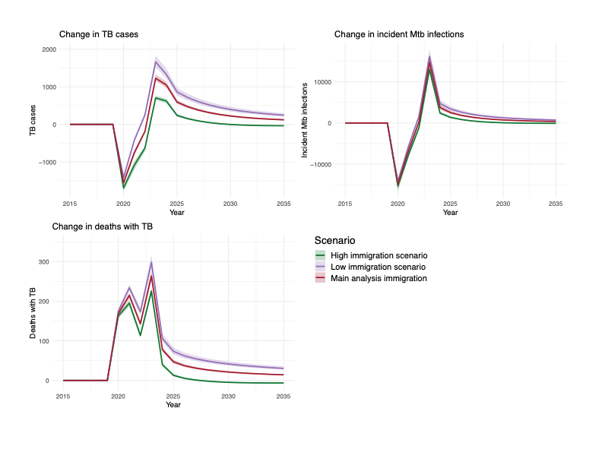
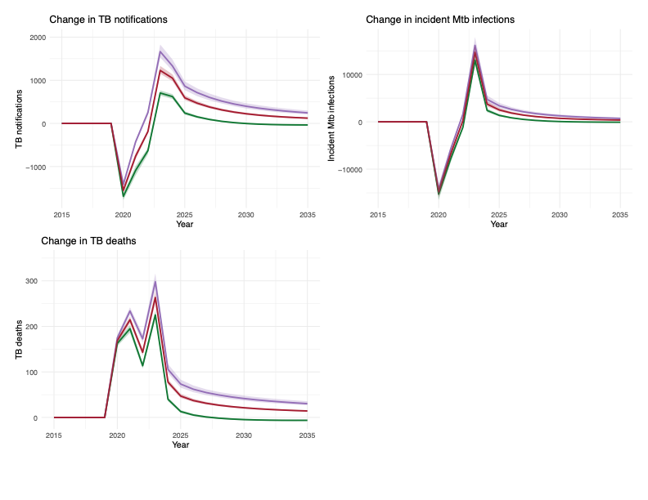
Figure S5: Model estimated annual difference in TB outcomes under the fitted pandemic scenario compared with each counterfactual immigration scenario during 2015–2035.
References

1. Menzies NA, Cohen T, Hill AN, et al. Prospects for tuberculosis elimination in the United States: results of a transmission dynamic model. American journal of epidemiology 2018; 187(9): 2011-20.
2. Swartwood NA, Testa C, Cohen T, et al. Tabby2: a user-friendly web tool for forecasting state-level TB outcomes in the United States. BMC medicine 2023; 21(1): 331.
3. Ferebee SH, Mount FW. Tuberculosis morbidity in a controlled trial of the prophylactic use of isoniazid among household contacts. American Review of Respiratory Disease 1962; 85(4): 490-510.
4. Sutherland I. The ten-year incidence of clinical tuberculosis following “conversion” in 2550 individuals aged 14 to 19 years. TSRU Progress Report 1968; 13: 1781-3.
5. Prophylaxis IUATCo. Efficacy of various durations of isoniazid preventive therapy for tuberculosis: five years of follow-up in the IUAT trial. Bulletin of the World Health Organization 1982; 60(4): 555.
6. Comstock G. How much isoniazid is needed for prevention of tuberculosis among immunocompetent adults?[Counterpoint]. The International Journal of Tuberculosis and Lung Disease 1999; 3(10): 847-50.
7. U.S. Census Bureau. 2023 National Population Projections Tables: Main Series (NP2023-T13). In: U.S. Census Bureau. Washington D.C. : U.S. Census Bureau, Population Division, 2023. https://www.census.gov/data/tables/2023/demo/popproj/2023-summary-tables.html.
8. Menzies NA, Soeteman DI, Pandya A, Kim JJ. Bayesian methods for calibrating health policy models: a tutorial. Pharmacoeconomics 2017; 35(6): 613-24. https://www.ncbi.nlm.nih.gov/pmc/articles/PMC5448142/pdf/nihms856339.pdf.
9. Jackson CH, Jit M, Sharples LD, De Angelis D. Calibration of complex models through Bayesian evidence synthesis: a demonstration and tutorial. Medical decision making 2015; 35(2): 148-61.
10. Centers for Disease Control and Prevention (CDC) National Center for Health Statistics (NCHS). Reduced Access to Care Available at: https://www.cdc.gov/nchs/covid19/rands/reduced-access-to-care.htm. Accessed 21 July.
11. Mathieu E, Ritchie H, Rodés-Guirao L, et al. Coronavirus pandemic (COVID-19). Our world in data 2020.
12. Feehan DM, Mahmud AS. Quantifying population contact patterns in the United States during the COVID-19 pandemic. Nature Communications 2021; 12(1): 893. https://doi.org/10.1038/s41467-021-20990-2.
13. Centers for Disease Control and Prevention. Available at: http://wonder.cdc.gov/mcd-icd10.html.
14. United States Centers for Disease Control and Prevention. Online Tuberculosis Information System (OTIS). Available at: https://wonder.cdc.gov/TB-v2022.html. Accessed 23 Apr 2024.
15. Baugh R. Annual Flow Report U.S. Lawful Permanent Residents: 2022. Department of Homeland Security 2023.

