Supplementary material

Title: Recognition and Spread of Clostridioides difficile Isolates with Reduced Fidaxomicin Susceptibility in an Acute Care Hospital

Epidemiology of C. difficile in the study hospital
During the study period, the incidence of healthcare-associated CDI [1] in the facility ranged from 6 to 8.2 cases per 10,000 bed days of care. There were no recognized clusters or outbreaks of CDI during the study period. Fluorescent PCR ribotyping was performed for 309 CDI isolates during the study period. As shown in Figure 1, multiple ribotypes of C. difficile were recovered, with F014-020 and F106 being most common.

Figure 1. PCR ribotypes of 309 Clostridioides difficile isolates recovered from CDI patients during the 3-year study period.
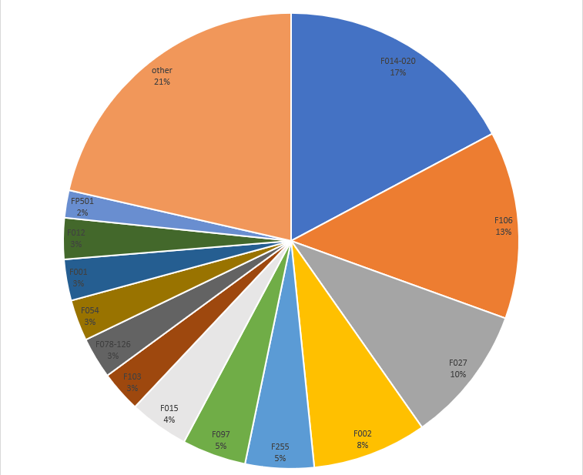
Reference
1). Kociolek LK, Gerding DN, Carrico R, et al. Strategies to prevent Clostridioides difficile infections in acute-care hospitals: 2022 Update. Infect Control Hosp Epidemiol 2023;44:527-549.

CDI diagnostic testing, treatment, and infection control measures in the study hospital.
A 2-step CDI test algorithm is used with an initial NAAT followed by an enzyme immunoassay (EIA) for toxin in NAAT-positive samples. Testing is performed at the request of providers. An electronic clinical decision support tool is used when orders are placed to discourage inappropriate testing of patients not meeting criteria for diarrhea (3 or more unformed stools per day) or with alternative explanations for diarrhea (e.g., laxatives). The laboratory rejects stool specimens that are formed. Another electronic clinical decision support tool is provided when positive results are reported to alert clinicians that NAAT-positive, but toxin EIA-negative results may represent either colonization or infection, and that treatment is not indicated for colonization.
Beginning in February 2022, fidaxomicin was recommended for initial CDI cases in patients age >65 years, immunocompromised, or LTCF residents, and for first recurrences. This recommendation was based on the 2021 focused update guidelines for management of CDI [1]. During the study period, 108/296 (36%) patients and 122/328 (37%) CDI episodes were treated with fidaxomicin with the remaining patients receiving oral vancomycin. As shown in Figure 2, fidaxomicin use increased substantially during the study period, with more than half of all cases receiving fidaxomicin starting in the 3rd quarter of 2022.

Figure 2. Percentage of all CDI cases treated with fidaxomicin

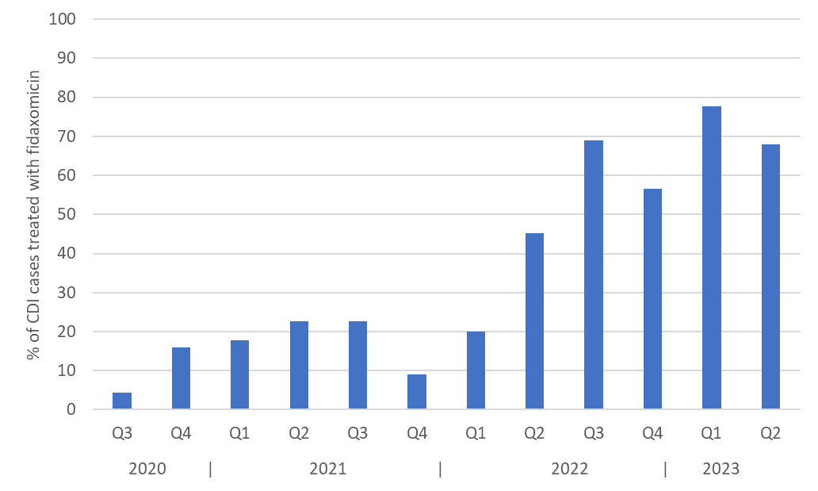

Infection control measures for CDI were consistent with current SHEA guidelines [2]. All essential practices were implemented. Additional approaches used in the facility included use of soap and water for hand hygiene after contact with CDI patients or their environment, preemptive isolation for patients with suspected CDI while awaiting test results, extension of contact precautions for 30 days after the diagnosis of CDI, and use of sporicidal disinfectants for daily and post-discharge disinfection of CDI rooms [2]. In addition, ultraviolet-C room decontamination devices are used as an adjunct after completion of manual post-discharge cleaning and disinfection.

References
1). Johnson S, Lavergne V, Skinner AM, et al. Clinical Practice Guideline by the Infectious Diseases Society of America (IDSA) and Society for Healthcare Epidemiology of America (SHEA): 2021 Focused Update Guidelines on Management of Clostridioides difficile Infection in Adults. Clin Infect Dis 2021;73:e1029-e1044.
2). Kociolek LK, Gerding DN, Carrico R, et al. Strategies to prevent Clostridioides difficile infections in acute-care hospitals: 2022 Update. Infect Control Hosp Epidemiol 2023;44:527-549.

Susceptibility testing methods
MICs for fidaxomicin were determined using the reference agar dilution method in accordance with CLSI recommendations [1] and as described by Thorpe et al. [2]. The test medium was brucella agar (Becton Dickinson, Sparksville, MD) supplemented with 5 mg/L hemin and 1 mg/L vitamin K1. Fidaxomicin (Tokyo Chemicals International, Tokyo, Japan) was dissolved in dimethyl sulfoxide (DMSO). Serial 2-fold dilutions of fidaxomicin were added to liquid agar in petri dishes and allowed to solidify. The test isolates were diluted to a 0.5 McFarland standard and inocula were deposited on the agar in a final concentration of 104 CFU per spot. The plates were incubated anaerobically at 37°C with MICs read after 48 hours. The quality control strain was C. difficile American Type Culture Collection (ATCC) 700057. Reduced susceptibility (RS) was defined as MIC >2 µg/mL and resistance (R) was defined as MIC >16 µg/mL [3]. Isolates with fidaxomicin reduced susceptibility and resistance were sent to 2 laboratories with expertise in C. difficile reference susceptibility testing for confirmatory testing. Fidaxomicin MIC results for all 3 laboratories are shown in Table 1.
At the Cleveland VA, all C. difficile isolates recovered from the 6 patients with 1 or more isolates with reduced fidaxomicin susceptibility were subjected to susceptibility testing for erythromycin, rifampin, vancomycin, and moxifloxacin using the reference agar dilution method in accordance with CLSI recommendations [1]. MICs are shown in Table 2.

References
1). CLSI. Methods for Antimicrobial Susceptibility Testing of Anaerobic Bacteria. 9th ed. CLSI standard M11. Wayne, PA: Clinical and Laboratory Standards Institute; 2018.
2). Thorpe CM, McDermott LA, Tran MK, et al. U.S.-based national surveillance for fidaxomicin susceptibility of Clostridioides difficile-associated diarrheal isolates from 2013 to 2016. Antimicrob Agents Chemother 2019; 63:e00391-19.
3). Baines SD, Wilcox MH. Antimicrobial resistance and reduced susceptibility in Clostridium difficile: Potential consequences for induction, treatment, and recurrence of C. difficile infection. Antibiotics (Basel) 2015; 4:267-98.

Susceptibility results

Table 1. Comparison of fidaxomicin minimum inhibitory concentration (MIC) results obtained from 3 laboratories using the reference agar dilution method in accordance with CLSI recommendations.

Pt. Number | Lab 1 | Lab 2 | Lab 3
1A | < 0.25 (S) | ND | 0.25 (S)
1B | < 0.25 (S) | ND | 1 (S)
1C | < 0.25 (S) | 0.12 (S) | ND
1D | 16 (R) | 16 (R) | 16 (R)
1E | 16 (R) | 16 (R) | 16 (R)
1F | 8 (RS) | 16 (R) | 16 (R)
2A | < 0.25 (S) | 0.25 (S) | 0.5 (S)
2B | < 0.25 (S) | 0.25 (S) | 0.5 (S)
2C | 32 (R) | >32 (R) | 32 (R)
3A | 8 (RS) | 16 (R) | 16 (R)
3B | 8 (RS) | 16 (R) | 8 (RS)
4A | < 0.25 (S) | 0.25 (S) | 0.5 (S)
4B | 8 (RS) | 16 (R) | 4 (RS)
5A | 32 (R) | ND | >32 (R)
6A | < 0.25 (S) | ND | 0.25
6B | 16 (R) | ND | 32 (R)
Quality Control Strain | <0.25 (S) | 0.03 (S) | 0.12 (S)

Abbreviations: ND, not determined; CLSI, Clinical and Laboratory Standards Institute
Footnotes
Lab 1: Cleveland VA Medical Center (PI: Curtis Donskey, MD)
Fidaxomicin purchased from Tokyo Chemicals International, Tokyo, Japan. Quality Control strain: C. difficile ATCC 700057.
Lab 2: Centers for Disease Control and Prevention, Division of Healthcare Quality Promotion (PI: Amy Gargis, PhD)
Fidaxomicin purchased from TOKU-E. Quality Control strain: C. difficile ATCC 700057.
Lab 3: VA Salt Lake City Healthcare System (PI: Andrew Skinner, MD)
Fidaxomicin purchased from Selleck Chemical. Reference strains: Staphylococcus aureus (ATCC 29213) and C. difficile ATCC 700057.

Pt., patient
RS, reduced susceptibility defined as MIC >2 µg/mL
R, resistant defined as MIC >16 µg/mL
CLSI, Clinical Laboratory Standards Institute

Table 2. Minimum inhibitory concentration (MIC) results and associated resistance genes/mutations.

 | MIC µg/mL (associated resistance genes/mutations)
Isolate | Erythromycin | Rifampin | Vancomycin | Moxifloxacin
1A | <4 (none) | <0.002 (none) | < 1 (none) | <2 (none)
1B | <4 (none) | <0.002 (none) | < 1 (none) | <2 (none)
1C | <4 (ermB) | <0.002 (none) | 0.002 (none) | <2 (none)
1D | <4 (none) | <0.002 (none) | < 1 (none) | <2 (none)
1F | ND (none) | ND (none) | ND (none) | ND (none)
2A | <4 (none) | <0.002 (none) | < 1 (none) | <2 (gyrB I139R)
2B | <4 (none) | <0.002 (none) | < 1 (none) | <2 (gyrB I139R))
2C | <4 (none) | <0.002 (none) | < 1 (none) | <2 (gyrB I139R)
3A | <4 (none) | <0.002 (none) | < 1 (none) | <2 (none)
3B | <4 (none) | <0.002 (none) | < 1 (none) | <2 (none)
4A | >16 (ermB) | 64 (R505K; E1037Q) | < 1 (vanRCd T115A) | 16 (gyrA T82I)
4B | <4 (none) | <0.002 (none) | < 1 (none) | <2 (none)
5A | <4 (none) | <0.002 (none) | < 1 (none) | <2 (gyrA L406I, D468N)
6A | <4 (none) | <0.002 (none) | < 1 (none) | <2 (gyrB V130I)
6B | <4 (none) | <0.002 (none) | < 1 (none) | <2 (gyrB V130I)

Abbreviations: ND, not determined. Quality Control strain: C. difficile ATCC 700057; a clinical ribotype 027 isolate with moxifloxacin MIC 32 µg/mL was used as a positive control for reduced moxifloxacin susceptibility.

Methods for whole genome sequencing and bioinformatic analysis
Whole genome sequencing was performed as previously described [1]. After extracting genomic DNA using genomic DNA purification kit (NEB, Ipswich, MA), libraries were prepared using Nextera DNA prep Kit (Illumina, San Diego, CA). Sequencing was performed on the NextSeq 550 sequencing system (Illumina, San Diego, CA). De novo assembly of reads was done using St. Petersburg genome assembler (SPAdes genome assembler (v.3.9)) on the Bionumerics calculation engine [2] and a multilocus sequence type (MLST) was assigned based on the PubMLST database [3]. The rpoB and rpoC genes were detected using BLAST v2.11.0 utilizing reference genes against the assembled sequences.

Trimmed reads were aligned to a C. difficile reference genome using Burrows-Wheeler Aligner-MEM v0.7.17 and variances were filtered using stringent filtering criteria. Positions with at least one unreliable (N) base, ambiguous (non-ACGT) base, or gap were removed. Non-informative SNP positions (i.e, positions that contain SNPs in comparison with the reference sequence, but all sample sequences have the same base) were also removed. Each retained SNP had a minimum 5x coverage and was covered at least once in the forward and reverse direction. If an entry did not have sufficient coverage at a specific SNP position, the SNP was removed for that entry, resulting in an empty cell in the SNP matrix. The SNP position was removed from the SNP matrix if none of the entries had sufficient coverage for a given SNP. The minimum distance between SNPs was 12 bp.
The reference sequence was strain S-0253 (Genbank GCA_018885085.1) for clade 1 isolates and strain R20291 (Genbank NC_013316.1) for clade 2 isolates. A dendrogram of the entire genome was created using Unweighted Pair-Group Method with Arithmetic averages (UPGMA) cluster analysis on Bionumerics software (v.8.1, Applied Maths). Isolates were considered genomically related if they differed by <2 single nucleotide polymorphisms (SNPs). All isolates will be deposited in NCBI.

References
1). Gonzalez-Orta M, Saldana C, Ng-Wong Y, Cadnum J, Jencson A, Jinadatha C, Donskey C. Are many patients diagnosed with healthcare-associated Clostridioides difficile infection colonized with the infecting strain on admission? Clin Infect Dis 2019;30;69:1801-1804.
2). Bankevich A, Nurk S, Antipov D, et al. SPAdes: A new genome assembly algorithm and its applications to single-cell sequencing. J Comput Biol 2012;19(5):455–77.
3). Jolley KA, Bray JE, Maiden MCJ. Open-access bacterial population genomics: BIGSdb software, the PubMLST.org website and their applications. Wellcome Open Res. 2018 Sep 24;3:124. doi: 10.12688/wellcomeopenres.14826.1.

Figure 3. Pairwise SNP comparison for isolates recovered from patients with 1 or more isolates with reduced fidaxomicin susceptibility.

4B ST21 0.00
1D ST21 0.00 0.00
1E ST21 0.00 0.00 0.00
3A ST21 0.00 0.00 0.00 0.00
3B ST21 0.00 0.00 0.00 0.00 0.00
1B ST21 1.00 1.00 1.00 1.00 1.00 0.00
1A ST21 3.00 3.00 3.00 3.00 3.00 2.00 0.00
1F ST21 7.00 7.00 7.00 7.00 7.00 8.00 10.00 0.00
6A N/A 200.00 200.00 200.00 200.00 200.00 200.00 200.00 200.00 0.00
6B N/A 200.00 200.00 200.00 200.00 200.00 200.00 200.00 200.00 1.00 0.00
2A ST2 200.00 200.00 200.00 200.00 200.00 200.00 200.00 200.00 200.00 200.00 0.00
2B ST2 200.00 200.00 200.00 200.00 200.00 200.00 200.00 200.00 200.00 200.00 0.00 0.00
2C ST2 200.00 200.00 200.00 200.00 200.00 200.00 200.00 200.00 200.00 200.00 1.00 1.00 0.00
4A ST1 200.00 200.00 200.00 200.00 200.00 200.00 200.00 200.00 200.00 200.00 200.00 200.00 200.00 0.00
1C ST58 200.00 200.00 200.00 200.00 200.00 200.00 200.00 200.00 200.00 200.00 200.00 200.00 200.00 200.00 0.00
5A ST224 200.00 200.00 200.00 200.00 200.00 200.00 200.00 200.00 200.00 200.00 200.00 200.00 200.00 200.00 200.00 0.00

Table 3. Gene names and amino acid changes in isolate 1.F in comparison to 1.D and 1.E isolates. Isolate 1.F was recovered from patient 1 more than 1 year after the previous infection.
Gene name | Amino acid changes
Cell wall metabolism sensor histidine kinase WalK | A172S
DNA polymerase III PolC | E983D
flagella motor switch protein FIiM | Synonymous, V220V
nicotinate-nucleotide-dimethylbenzimidazole phosphoribosyltransferase (cobT) | A255T
translation elongation factor Tu | Synonymous, S290S
RNA polymerase beta subunit (rpoB) | D814Y
M15 family metallopeptidase | T160A

