Supplemental Figure 1. Conceptual diagram

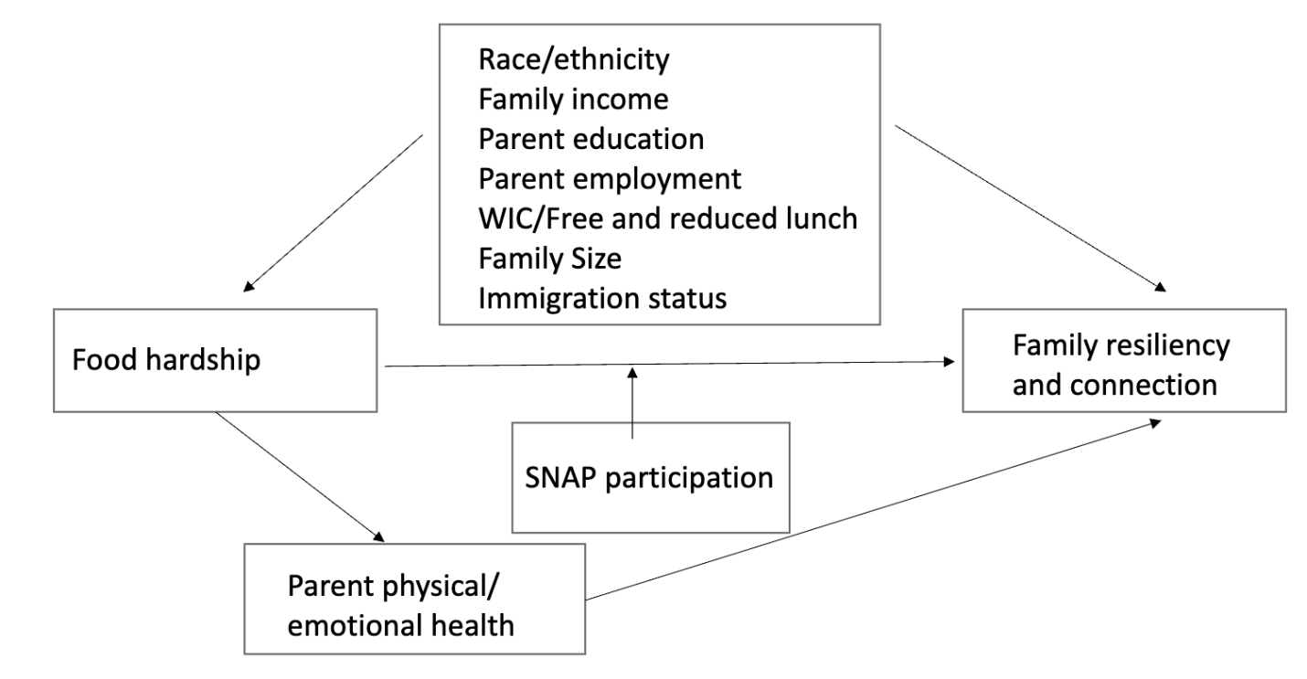
Supplemental Table 1. Description of confounders

Variable | How variable was operationalized
Household income | 0-99% of the Federal Poverty Line  100-299% of the Federal Poverty Line  200-399% of the Federal Poverty Line  ≥400% of the Federal Poverty Line
Highest education level achieved by caregiver(s) | High school or less  Some College  College or Higher
Child race and ethnicity | Hispanic  White Non Hispanic  Black Non Hispanic  Multiracial/ Non Hispanic/ Other
Women Infant and Children (WIC) Program receipt | In the last 12 months, even for one month, someone in the family received benefits from the WIC Program
Supplemental Nutrition Assistance Program (SNAP) participation | In the last 12 months, even for one month, someone in the family received benefits from the SNAP Program
Free or Reduced Lunch participation | In the last 12 months, even for one month, someone in the family received free or reduced-cost breakfasts or lunches at school
Caregiver employment | The household was considered to have an employed caregiver if one of the following answers was selected:  1. The child lives in a home where one of the adult primary caregivers is employed at least 50 out of the last 52 weeks  2. At least one caregiver is employed full time  3. At least one caregiver is employed part time  The household was considered to have a caregiver who was unemployed if one of the following answers was selected:  1. The child does not live in a home where one of the adult primary caregivers is employed at least 50 out of the last 52 weeks  2. Caregiver(s) unemployed or working without pay  Note: Between 2019 and 2020, the NSCH survey changed the question around caregiver employment from "Does the child live in a home where one of the adult primary caregivers is employed at least 50 out of the last 52 weeks?” with the answer choices of “yes” or no” to "What is the employment status of caregiver(s) in this child’s household?" With answer choices of “At least one caregiver is employed full time,” “At least one caregiver is employed part time,” “caregiver(s) unemployed or working without pay.” In order to combine the data from 2019-2021, we made the employment variable dichotomous. If a family answered “yes,” “at least one caregiver is employed full time” or “at least one caregiver is employed part time,” the family was considered “employed.” If an answer of “no” or “caregiver(s) unemployed or working without pay,” the family was considered unemployed.
Family Size | How many of these people in your household are family members?  Small family: 4 or fewer  Large family: 5 or more
Immigration history | Child of immigrant parents: child is born outside the U.S. and all reported parents born outside the U.S., OR child is born in the US and at least one parent is born outside the US OR child is born outside the U.S, one parent is born in the U.S., and one parent is born outside the U.S.  Child of U.S. born parents: All parents in the household are born in the U.S., OR child is born in the U.S. and parents are not listed  Note: This method of categorization was chosen consistent with prior studies ^{1, 2}
¹ Vaughn JM, Rojas-Flores L, Wang KT. Preschoolers’ Psychosocial Development, Parents, and Neighborhoods: Towards an Integrative Approach for Immigrant Families. Journal of child and family studies. 2023;32:3635-3651.

² Slopen, N., Shonkoff, J. P., Albert, M. A., Yoshikawa, H., Jacobs, A., Stoltz, R., & Williams, D. R. (2016). Racial disparities in child adversity in the U.S. interactions with family immigration history and income. American Journal of Preventive Medicine, 50(1), 47-56. https://doi.org/10.1016/j.amepre.2015.06.013

Supplemental Table 2. Characteristics of households with children ages 6-17 years and incomes <200% of the Federal Poverty Level (FPL), 2019-2021 National Survey of Children’s Health
 | Household did not receive SNAP benefits in the past 12 months (N=14,602) |  | Household received SNAP benefits in the past 12 months  (N=8,274)
 | Unweighted N | Weighted % (95% CI) | Unweighted N | Weighted % (95% CI)
Food Hardship
Yes | 5,849 | 41.6 (39.7, 43.4) | 4,861 | 55.2 (53.0, 57.4)
No | 8,701 | 58.4 (56.6, 60.3) | 3,375 | 44.8 (42.6, 47.1)
Family Resiliency and Connection Index (FRCI)
Low or moderate | 6,922 | 45.0 (43.1, 46.9) | 3,986 | 47.3 (44.9, 49.4)
High | 7,139 | 55.0 (53.1, 56.9) | 3,968 | 52.9 (50.6, 55.1)
Participation in Free and Reduced Lunch in past 12 months
No | 7,984 | 45.4 (43.5, 47.2) | 1,042 | 12.5 (11.1, 14.1)
Yes | 6,576 | 55.0 (52.8, 56.5) | 7,138 | 87.5 (85.9, 88.9)
Participation in WIC in past 12 months
No | 13,882 | 92.4 (91.2, 93.5) | 6,751 | 80.0 (78.0, 81.8)
Yes | 682 | 7.6 (6.5, 8.8) | 1,305 | 20.0 (18.2, 22.0)
Caregiver employment
Unemployed | 1,474 | 11.5 (88.5, 87.2) | 2,421 | 29.4 (27.4, 31.5)
Employed | 12,830 | 89.6 (87.5, 91.3) | 5,627 | 70.6 (68.5, 72.7)
Caregiver education
High school or less | 4,386 | 48.4 (46.5, 50.3) | 3,767 | 61.2 (59.1, 63.2)
Some college | 4,686 | 24.3 (22.9, 25.6) | 3,044 | 27.4 (25.6, 29.2)
College or higher | 5,530 | 27.3 (25.9, 28.8) | 1,463 | 11.5 (10.4, 12.6)
Household income as % of FPL
0-99% | 4,872 | 34.1 (32.4, 35.9) | 4,843 | 62.0 (59.9, 64.1)
100-199% | 9,730 | 65.9 (64.1, 67.7) | 3,431 | 38.0 (35.9, 40.1)
Child age (years)
6-11 years | 6,340 | 47.7 (45.8, 49.6) | 4,094 | 51.7 (49.5, 53.9)
12-17 years | 8,262 | 52.3 (50.4, 54.2) | 4,180 | 48.3 (46.1, 50.5)
Child race and ethnicity
Hispanic | 2,992 | 38.8 (36.9, 40.8) | 1,820 | 34.0 (31.8, 36.2
White, Non Hispanic | 8,331 | 37.7 (36.2, 39.2) | 3,635 | 27.9 (26.3, 31.1)
Black, Non Hispanic | 1,317 | 13.9 (12.7, 15.1) | 1,651 | 29.2 (27.3, 31.3)
Multiracial/Non Hispanic/Other races | 1,962 | 9.7 (8.9, 10.6) | 1,168 | 8.9 (7.9, 10.1)
Immigration history
Child of immigrant parents | 3,528 | 39.1 (37.1, 41.0) | 1,503 | 27.2 (25.0, 29.4)
Child of U.S. born parents | 10,862 | 60.9 (59.0, 62.9) | 6,652 | 72.9 (70.6, 75.0)
Family size
Small family (4 or less family members in the home) | 9,512 | 53.6 (51.7, 55.6) | 5,448 | 56.6 (54.3, 58.9)
Large family (5 or more family members in the home) | 4,696 | 46.4 (44.4, 48.3) | 2,559 | 43.4 (41.1, 45.7)
FPL= Federal Poverty Level; SNAP= Supplemental Nutrition Assistance Program; WIC= Special Supplemental Nutrition Program for Women, Infants, and Children

