Supplemental Table 1: Factors included in the World Trade Center Clinical Frailty Index (based on Bello et al, J Aging Health, 2021).
Item
General Health and Medical and Medication History
1) Ever had pneumonia
2) Ever had diabetes
3) Persistent fatigue
4) Unexplained weight loss
5) Difficulty urinating
6) Inability to taste
7) Difficulty swallowing
8) Change in bowel habits
9) Coughing after lying down or eating
10) Difficulty hearing
11) Self-rated health (positive: Fair or poor)
12) Polypharmacy (positive: 6+)
Mental Health
13) In past month, did you accomplished less than you would like?
14) In past month, were you limited in the kind of work or other activities you could perform?
15) In past month, did you accomplished less due to emotional problems?
16) In past month, did you work less carefully than usual due to emotional problems?
17) In past month, how often have you felt calm/peaceful? (positive: Some or little of the time or none of the time)
18) In past month, how often have you had felt lots of energy? (positive: Some or little of the time or none of the time)
19) In past month, how often have you felt downhearted? (positive: All or most of the time)
20) In the past month, how often has your physical health/emotional problems interfered with social activities? (positive: All or most of the time)
Physical Exam
21) Abnormal eye exam
22) Abnormal ear exam
23) Abnormal extremities exam
24) Abnormal heart exam
25) Abnormal physician-assessed general appearance
Functional Assessment
26) Difficulty performing moderate activities (positive: yes, a lot)
27) Difficulty climbing several flights of stairs (positive: yes, a lot)
28) Frequency of short-term memory problems (positive: Quite a bit or extremely)
29) In past month, frequency of difficulty concentrating (positive: Quite a bit or extremely)
30) How much does pain interfere with normal work (positive: Quite a bit or extremely)

Supplemental Table 2: Akaike (AIC) and Bayesian (BIC) Information Criteria for the linear class mixed model considering linear and non-linear time trend of the classes, after selecting 3 as the number of classes.
Model with 3 classes | AIC | BIC
Linear | -112975 | -112867
Non-linear | -153040 | -152832

Supplemental Table 3: Comparison between WTC CFI trajectory class for general responders with a single visit vs multiple visits
SINGLE VISIT |  |  |  |  | MULTIPLE VISITS
Variable | Low WTC CFI Trajectory (1,284) | High WTC CFI Trajectory (689) | Progressively Increasing WTC CFI Trajectory (353) | p-value¹ | Low WTC CFI Trajectory (6,079) | High WTC CFI Trajectory (4,824) | Progressively Increasing WTC CFI Trajectory (3,342) | p-value¹
Age (years) at 9/11, mean (SD) | 36 (8) | 38 (9) | 39 (9) | <0.001 | 37 (8) | 40 (8) | 40 (9) | <0.001
Sex, % |  |  |  | 0.01 |  |  |  | <0.001
Female | 10 | 15 | 13 |  | 13 | 19 | 16
Male | 90 | 85 | 87 |  | 87 | 81 | 84
Education, % |  |  |  | <0.001 |  |  |  | <0.001
High School or Less | 19 | 39 | 32 |  | 21 | 41 | 29
More than High School | 81 | 61 | 68 |  | 79 | 59 | 71
Income category, % |  |  |  | <0.001 |  |  |  | <0.001
Less than $30,000 | 4 | 20 | 10 |  | 5 | 22 | 10
$30,000-60,000 | 28 | 30 | 25 |  | 28 | 32 | 31
$60,000-80,000 | 28 | 23 | 29 |  | 30 | 23 | 28
More than $80,000 | 40 | 27 | 35 |  | 38 | 23 | 31
Frailty Index, median (Q1, Q3) | 0.03 (0.00, 0.07) | 0.37 (0.30, 0.47) | 0.17 (0.17, 0.20) | <0.001 | 0.03 (0.00, 0.07) | 0.34 (0.23, 0.47) | 0.14 (0.07, 0.21) | <0.001
Race/Ethnicity, % |  |  |  | <0.001 |  |  |  | <0.001
Non-Hispanic Black | 11 | 11 | 7 |  | 13 | 13 | 13
Hispanic | 15 | 29 | 19 |  | 21 | 31 | 25
Non-Hispanic Other | 5 | 4 | 5 |  | 3 | 3 | 3
Non-Hispanic White | 70 | 56 | 69 |  | 63 | 54 | 59
Occupation on 9/11, % |  |  |  | <0.001 |  |  |  | <0.001
Construction | 9 | 31 | 22 |  | 14 | 35 | 22
Protective Services | 70 | 36 | 49 |  | 64 | 31 | 47
Other | 13 | 23 | 20 |  | 15 | 23 | 20
Maintenance and Repair | 7 | 11 | 9 |  | 7 | 12 | 11
Severity of WTC exposure, % |  |  |  | 0.01 |  |  |  | <0.001
High/Very High | 20% | 19 | 26 |  | 23 | 21 | 21
Intermediate | 62 | 67 | 60 |  | 62 | 67 | 64
Low | 19 | 15 | 15 |  | 15 | 12 | 15
Time since 9/11, mean (SD) | 15.0 (4.1) | 13.5 (4.3) | 15.1 (3.8) | <0.001 | 9.8 (4.1) | 9.3 (3.7) | 9.4 (3.9) | <0.001
¹ Pearson’s Chi-squared test, Kruskal-Wallis rank sum test
WTC: World Trade Center, CFI: Clinical Frailty Index, Q: quartile, SD: standard deviation

Supplemental Table 4: Relative Risk Ratios Comparing the High WTC CFI Trajectory and Progressively Increasing WTC CFI Trajectory Classes with the Low WTC CFI Trajectory Class, adjusting for covariates including age
 | High WTC CFI Trajectory |  |  | Progressively Increasing WTC CFI Trajectory
 | Relative Risk Ratio | 95% Confidence Interval |  | Relative Risk Ratio | 95% Confidence Interval
Age | 1.02 | 1.02 | 1.03 | 1.03 | 1.03 | 1.04
Sex
Female Sex | 1.65 | 1.45 | 1.88 | 1.31 | 1.14 | 1.51
Male Sex | Ref | - | - | Ref | - | -
Education
More than High School | 0.68 | 0.61 | 0.75 | 0.84 | 0.75 | 0.94
High School or Less | Ref | - | - | Ref | - | -
Income Category
$30,000-60,000 | 0.43 | 0.36 | 0.51 | 0.69 | 0.57 | 0.85
$60,000-80,000 | 0.35 | 0.29 | 0.42 | 0.65 | 0.53 | 0.81
More than $80,000 | 0.28 | 0.24 | 0.34 | 0.54 | 0.44 | 0.66
Less than $30,000 | Ref | - | - | Ref | - | -
Race/Ethnicity
Non-Hispanic Black | 0.98 | 0.85 | 1.13 | 0.92 | 0.79 | 1.07
Hispanic | 1.21 | 1.08 | 1.35 | 1.16 | 1.03 | 1.32
Non-Hispanic Other | 0.92 | 0.69 | 1.22 | 1.00 | 0.75 | 1.34
Non-Hispanic White | Ref | - | - | Ref | - | -
Pre-9/11 Occupation on 9/11
Construction | 3.71 | 3.26 | 4.23 | 1.80 | 1.56 | 2.08
Other | 2.13 | 1.87 | 2.42 | 1.51 | 1.31 | 1.73
Maintenance and Repair | 2.39 | 2.03 | 2.82 | 1.61 | 1.35 | 1.92
Protective Services | Ref | - | - | Ref | - | -
Severity of WTC Exposure
High/Very High | 1.81 | 1.54 | 2.12 | 1.20 | 1.02 | 1.41
Intermediate | 1.43 | 1.25 | 1.65 | 1.07 | 0.93 | 1.23
Low | Ref | - | - | Ref | - | -
WTC: World Trade Center, CFI: Clinical Frailty Index

Supplemental Figure 1: Akaike (AIC) and Bayesian (BIC) Information Criteria for the linear class mixed model considering different classes (from 1 to 7) and linear time trend of the classes. The model with 3 classes showed parsimony and small information criteria.
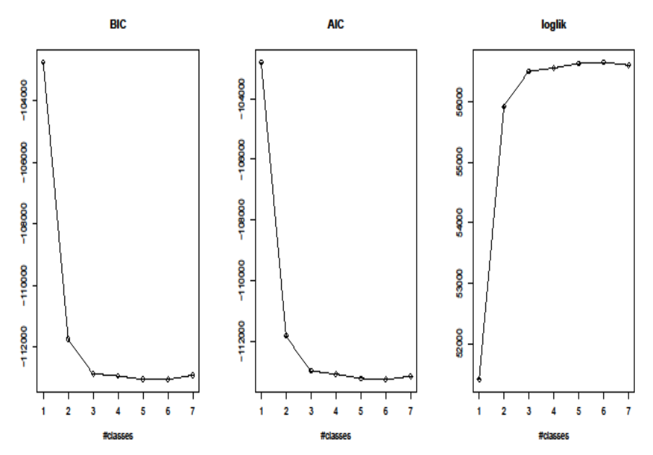
Supplemental Figure 2: Linear class mixed model considering non-linear time trend of the selected three classes.
