Supplementary Table 1: Baseline characteristics of kidney transplant recipients exposed to belatacept and tacrolimus before and after propensity-score matching
Variables | TCM |  |  | SRTR
Variables | Belatacept | Tacrolimus | Tacrolimus | Belatacept | Tacrolimus | Tacrolimus
Variables |  | Unmatched | Matched |  | Unmatched | Matched
Total participants, n | 815 | 64465 | 4057 | 1514 | 125164 | 7570
Age at transplantation in years, median (IQR) | 57 (45-64) | 52 (40-62) | 56 (44-64) | 57 (46-65) | 53 (41-63) | 57 (45-65)
Age category, n (%)
<30 Years | 53 (6.5) | 8035 (12.5) | 281 (6.9) | 88 (5.8) | 14162 (11.3) | 426 (5.6)
30-39 Years | 90 (11.0) | 7736 (12.0) | 497 (12.3) | 142 (9.4) | 14351 (11.5) | 734 (9.7)
40-49 Years | 122 (15.0) | 12337 (19.1) | 616 (15.2) | 244 (16.1) | 22929 (18.3) | 1293 (17.1)
50-59 Years | 220 (27.0) | 16346 (25.4) | 1069 (26.4) | 390 (25.8) | 31398 (25.1) | 1905 (25.2)
60-69 Years | 243 (29.8) | 15566 (24.2) | 1220 (30.1) | 464 (30.7) | 32023 (25.6) | 2275 (30.1)
≥70 Years | 87 (10.7) | 4445 (6.9) | 374 (9.2) | 186 (12.3) | 10301 (8.2) | 937 (12.4)
Sex, n (%)
Female | 276 (33.9) | 25453 (39.5) | 1354 (33.4) | 508 (33.6) | 49051 (39.2) | 2504 (33.1)
Male | 539 (66.1) | 39012 (60.5) | 2703 (66.6) | 1006 (66.4) | 76113 (60.8) | 5066 (66.9)
Race/ethnicity, n (%)
White, Non-Hispanic | 411 (50.4) | 27864 (43.2) | 2299 (56.7) | 814 (53.8) | 57100 (45.6) | 4252 (56.2)
Black/Hispanic/Other | 404 (49.6) | 36601 (56.8) | 1758 (43.3) | 700 (46.2) | 68064 (54.4) | 3318 (43.8)
Educational status, n (%)
≤High School/None/unknown | 370 (45.4) | 32244 (50.0) | 1700 (41.9) | 654 (43.2) | 61207 (48.9) | 3073 (40.6)
College or above | 445 (54.6) | 32221 (50.0) | 2357 (58.1) | 860 (56.8) | 63957 (51.1) | 4497 (59.4)
Calendar year of transplantation category, n (%)
2011-2013 | 230 (28.2) | 24331 (37.7) | 1223 (30.2) | 311 (20.5) | 32555 (26.0) | 1626 (21.5)
2014-2016 | 424 (52.0) | 29546 (45.8) | 2246 (55.4) | 621 (41.0) | 40895 (32.7) | 3337 (44.1)
2017-2019 | 161 (19.8) | 10588 (16.4) | 588 (14.5) | 582 (38.4) | 51714 (41.3) | 2607 (34.4)
Living donor, n (%) | 261 (32.0) | 21653 (33.6) | 1237 (30.5) | 469 (31.0) | 41426 (33.1) | 2283 (30.2)
Expanded donor, n (%) | 157 (19.3) | 6184 (9.6) | 793 (19.6) | 296 (19.6) | 12160 (9.7) | 1407 (18.6)
First transplant, n (%) | 807 (99.0) | 64018 (99.3) | 4025 (99.2) | 1502 (99.2) | 123877 (99.0) | 7487 (98.9)
Total years on dialysis, median (IQR) | 2.6 (0.8-4.9) | 2.6 (0.7-5.2) | 2.8 (0.8-5.3) | 2.5 (0.7-4.6) | 2.6 (0.7-5.2) | 2.9 (0.8-5.3)
Cytomegalovirus serology status, n(%)
Positive/missing/unknown | 533 (65.4) | 41808 (64.9) | 2522 (62.2) | 949 (62.7) | 79364 (63.4) | 4609 (60.9)
Negative | 282 (34.6) | 22657 (35.2) | 1535 (37.8) | 565 (37.3) | 45800 (36.6) | 2961 (39.1)
EBV serology status, n (%)
Positive/missing/unknown | 746 (91.5) | 57673 (89.5) | 3634 (89.6) | 1423 (94.0) | 112348 (89.8) | 6829 (90.2)
Negative | 69 (8.5) | 6792 (10.5) | 423 (10.4) | 91 (6.0) | 12816 (10.2) | 741 (9.8)
Hepatitis B virus infection, n (%)
Uninfected/unknown | 735 (90.2) | 58768 (91.2) | 3680 (90.7) | 1379 (91.1) | 114964 (91.8) | 6949 (91.8)
Active/Resolved | 80 (9.8) | 5697 (8.8) | 377 (9.3) | 135 (8.9) | 10200 (8.2) | 621 (8.2)
Hepatitis C virus infection, n (%)
Negative/unknown | 801 (98.3) | 61993 (96.2) | 3914 (96.5) | 1476 (97.5) | 120470 (96.2) | 7311 (96.6)
Positive | 14 (1.7) | 2472 (3.8) | 143 (3.5) | 38 (2.5) | 4694 (3.8) | 259 (3.4)
Diabetes mellitus, n (%) | 326 (40.0) | 21409 (33.2) | 1628 (40.1) | 585 (38.6) | 42234 (33.7) | 2858 (37.8)
BMI, median (IQR) | 28.3 (24.9-32.6) | 27.8 (24.2-31.9) | 28.6 (25.2-32.4) | 28.6 (24.8-32.7) | 28.0 (24.4-32.1) | 28.3 (24.9-32.3)
BMI category, n (%)
Underweight/Normal | 216 (26.5) | 22287 (34.6) | 976 (24.1) | 410 (27.1) | 41701 (33.3) | 2066 (27.3)
Overweight/Obese | 599 (73.5) | 42178 (65.4) | 3081 (75.9) | 1104 (72.9) | 83463 (66.7) | 5504 (72.7)
Induction therapy, n (%)
Polyclonal antibodies | 442 (54.2) | 34739 (53.9) | 2024 (49.9) | 820 (54.2) | 69193 (55.3) | 4031 (53.3)
IL2 antagonists | 377 (46.3) | 15865 (24.6) | 1827 (45.0) | 549 (36.3) | 27531 (22.0) | 2642 (34.9)
Alemtuzumab | 99 (12.2) | 10239 (15.9) | 435 (10.7) | 243 (16.1) | 21106 (16.9) | 1091 (14.4)
Rituximab | 5 (0.6) | 685 (1.1) | 92 (2.3) | 6 (0.4) | 1155 (0.9) | 126 (1.7)
Corticosteroids | 705 (86.5) | 44641 (69.3) | 3513 (86.6) | 1271 (84.0) | 86996 (69.5) | 6339 (83.7)
Other maintenance therapy, n (%)
Mycophenolate mofetil | 799 (98.0) | 63547 (98.6) | 4010 (98.8) | 1475 (97.4) | 123010 (98.3) | 7458 (98.5)
Azathioprine | 1 (0.1) | 198 (0.3) | 11 (0.3) | 4 (0.3) | 515 (0.4) | 25 (0.3)
Corticosteroids | 614 (75.3) | 43707 (67.8) | 2972 (73.3) | 1109 (73.3) | 86996 (69.5) | 5527 (73.0)
Number of HLA mismatches, n (%)
0-3 | 241 (29.6) | 20725 (32.1) | 1225 (30.2) | 416 (27.5) | 39797 (31.8) | 2249 (29.7)
4-6 | 574 (70.4) | 43740 (67.9) | 2832 (69.8) | 1098 (72.5) | 85367 (68.2) | 5321 (70.3)
Abbreviations: BMI body mass index, HLA human leucocyte antigen, IQR interquartile range, PS propensity score, SRTR Scientific Registry of Transplant Recipients; TCM Transplant Cancer Match.

Supplementary Table 2: Standardized difference in the propensity scores (PS) overall and for selected dichotomous variables include in the PS models.

Propensity Score | Observations | TCM Cohort |  | SRTR Cohort
Propensity Score | Observations | Standardized  Difference | Percent  Reduction | Standardized  Difference | Percent  Reduction
Overall Propensity Score | All | 0.6989 |  | 0.5911
Overall Propensity Score | Region | 0.6948 | 0.59 | 0.5860 | 0.86
Overall Propensity Score | Matched | 0.0189 | 97.29 | 0.0001 | 99.98
Logit of the Prop Score | All | 0.7793 |  | 0.6573
Logit of the Prop Score | Region | 0.7632 | 2.06 | 0.6418 | 2.36
Logit of the Prop Score | Matched | 0.0095 | 98.78 | 0.0000 | 100.00
Sex | All | -0.1168 |  | -0.1174
Sex | Region | -0.1153 | 1.32 | -0.1146 | 2.33
Sex | Matched | 0.0102 | 91.27 | 0.0099 | 91.56
Race | All | -0.1448 |  | -0.1634
Race | Region | -0.1417 | 2.12 | -0.1604 | 1.85
Race | Matched | 0.1253 | 13.43 | 0.0483 | 70.48
Education | All | -0.0926 |  | -0.1146
Education | Region | -0.0883 | 4.61 | -0.1106 | 3.49
Education | Matched | 0.0701 | 24.32 | 0.0523 | 54.38
Expanded donor criteria | All | -0.2779 |  | -0.2810
Expanded donor criteria | Region | -0.2763 | 0.59 | -0.2795 | 0.55
Expanded donor criteria | Matched | 0.0081 | 97.08 | -0.0276 | 90.20
Diabetes | All | -0.1413 |  | -0.1020
Diabetes | Region | -0.1378 | 2.46 | -0.0986 | 3.33
Diabetes | Matched | 0.0027 | 98.11 | -0.0184 | 81.92
BMI category | All | 0.1759 |  | 0.1362
BMI category | Region | 0.1687 | 4.06 | 0.1298 | 4.66
BMI category | Matched | -0.0533 | 69.69 | 0.0046 | 96.61
Induction with polyclonal antibody | All | -0.0069 |  | 0.0225
Induction with polyclonal antibody | Region | -0.0015 | 77.91 | 0.0264 | 0.00
Induction with polyclonal antibody | Matched | -0.0872 | 0.00 | -0.0183 | 18.67
Induction with IL2 antagonists | All | -0.4646 |  | -0.3179
Induction with IL2 antagonists | Region | -0.4615 | 0.67 | -0.3152 | 0.86
Induction with IL2 antagonists | Matched | -0.0263 | 94.34 | -0.0303 | 90.46
Induction with corticosteroids | All | -0.4250 |  | -0.3469
Induction with corticosteroids | Region | -0.4149 | 2.37 | -0.3376 | 2.69
Induction with corticosteroids | Matched | 0.0022 | 99.49 | -0.0051 | 98.54
Maintenance corticosteroids | All | -0.1677 |  | -0.1250
Maintenance corticosteroids | Region | -0.1628 | 2.94 | -0.1211 | 3.07
Maintenance corticosteroids | Matched | -0.0463 | 72.39 | -0.0052 | 95.82

Supplementary Table 3: Kaplan‐Meier survival estimates for the proportion of kidney recipients with cancer, death, GF/RT, cSCC and PTLD
 | Belatacept |  |  | Tacrolimus (PS-matched cohort)
Years since transplant | No at risk | Cumulative no. of events | Survival rate (%) | No at risk | Cumulative no. of events | Survival rate (%)
Cancer
0 | 815 | 0 | 100 | 4057 | 0 | 100
1 | 639 | 5 | 99.3 | 3209 | 41 | 98.9
2 | 462 | 11 | 98.1 | 2412 | 76 | 97.7
3 | 336 | 18 | 96.4 | 1665 | 103 | 96.4
4 | 229 | 20 | 95.7 | 992 | 124 | 94.8
5 | 117 | 21 | 95.3 | 570 | 133 | 93.6
6 | 29 | 22 | 94.4 | 207 | 135 | 93.2
7 | 1 | 22 | 94.4 | 54 | 138 | 90.9
8 | 0 | 22 | 94.4 | 14 | 139 | 88.6
9 | - | - | - | 0 | 139 | 88.6
10
Death
0 | 1514 | 0 | 100 | 7570 | 0 | 100
1 | 1402 | 46 | 96.9 | 7119 | 175 | 97.6
2 | 1111 | 77 | 94.5 | 6194 | 309 | 95.7
3 | 909 | 106 | 91.7 | 5010 | 419 | 93.8
4 | 778 | 129 | 89.2 | 3892 | 538 | 91.3
5 | 571 | 153 | 86.1 | 2861 | 634 | 88.7
6 | 386 | 169 | 83.1 | 1873 | 718 | 85.5
7 | 245 | 177 | 80.9 | 1045 | 774 | 82.1
8 | 117 | 189 | 75.2 | 525 | 812 | 77.9
9 | 35 | 191 | 73.3 | 209 | 828 | 74.4
10 | 0 | 191 | 73.3 | 19 | 833 | 68.0
Death among EBV seropositive KTRs
0 | 1407 | 0 | 0 | 6398 | 0 | 100
1 | 1300 | 43 | 96.9 | 6017 | 148 | 97.6
2 | 1020 | 71 | 94.6 | 5201 | 257 | 95.8
3 | 832 | 95 | 92.0 | 4155 | 355 | 93.7
4 | 713 | 117 | 89.4 | 3221 | 457 | 91.1
5 | 529 | 138 | 86.4 | 2324 | 541 | 88.4
6 | 369 | 153 | 83.4 | 1519 | 611 | 85.1
7 | 242 | 160 | 81.4 | 840 | 651 | 82.1
8 | 116 | 172 | 75.6 | 404 | 684 | 77.5
9 | 35 | 174 | 73.7 | 158 | 698 | 73.4
10 | 0 | 174 | 73.7 | 16 | 702 | 67.2
Death among EBV seronegative KTRs
0 | 91 | 0 | 0 | 741 | 0 | 100
1 | 87 | 3 | 96.7 | 698 | 16 | 97.8
2 | 77 | 5 | 94.4 | 628 | 30 | 95.8
3 | 66 | 10 | 87.9 | 532 | 36 | 94.8
4 | 54 | 11 | 86.4 | 401 | 48 | 92.3
5 | 32 | 14 | 80.5 | 317 | 54 | 90.7
6 | 11 | 15 | 76.7 | 193 | 61 | 88.3
7 | 2 | 16 | 67.1 | 98 | 71 | 82.1
8 | 1 | 16 | 67.1 | 58 | 72 | 81.0
9 | - | - | - | 25 | 72 | 81.0
10 | - | - | - | 2 | 72 | 81.0
GF/RT
0 | 1514 | 0 | 100 | 7570 | 0 | 100
1 | 1402 | 46 | 96.9 | 7119 | 156 | 97.9
2 | 1111 | 69 | 95.2 | 6194 | 260 | 96.4
3 | 909 | 82 | 93.9 | 5010 | 369 | 94.5
4 | 778 | 98 | 92.1 | 3892 | 451 | 92.7
5 | 571 | 110 | 90.4 | 2861 | 522 | 90.8
6 | 386 | 117 | 89.1 | 1873 | 581 | 88.5
7 | 245 | 121 | 87.9 | 1045 | 625 | 85.8
8 | 117 | 121 | 87.9 | 525 | 646 | 83.3
9 | 35 | 121 | 87.9 | 209 | 659 | 80.2
10 | 0 | 121 | 87.9 | 19 | 661 | 77.8
cSCC
0 | 1514 | 0 | 100 | 7570 | 0 | 100
1 | 1393 | 9 | 99.4 | 7090 | 29 | 99.6
2 | 1095 | 17 | 98.7 | 6115 | 90 | 98.7
3 | 891 | 21 | 98.3 | 4892 | 144 | 97.7
4 | 761 | 24 | 97.9 | 3772 | 178 | 96.9
5 | 551 | 29 | 97.2 | 2752 | 199 | 96.3
6 | 371 | 33 | 96.3 | 1791 | 218 | 95.5
7 | 237 | 35 | 95.7 | 984 | 228 | 94.8
8 | 110 | 40 | 92.6 | 488 | 233 | 94.1
9 | 31 | 40 | 92.6 | 192 | 235 | 93.5
10 | 0 | 40 | 92.6 | 15 | 235 | 93.5
PTLD
0 | 1514 | 0 | 100 | 7570 | 0 | 100
1 | 1400 | 4 | 99.7 | 7106 | 15 | 99.8
2 | 1106 | 10 | 99.2 | 6176 | 23 | 99.7
3 | 905 | 11 | 99.1 | 4991 | 31 | 99.5
4 | 775 | 12 | 99.0 | 3872 | 38 | 99.4
5 | 567 | 14 | 98.7 | 2846 | 40 | 99.3
6 | 384 | 14 | 98.7 | 1859 | 43 | 99.2
7 | 244 | 14 | 98.7 | 1034 | 45 | 99.0
8 | 117 | 14 | 98.7 | 518 | 47 | 98.8
9 | 35 | 14 | 98.7 | 207 | 47 | 98.8
10 | 0 | 14 | 98.7 | 19 | 47 | 98.8
Abbreviations: cSCC cutaneous squamous cell carcinoma, EBV Epstein-Barr virus, GF/RT graft failure/retransplantation, KTR kidney transplant recipients, PTLD posttransplant lymphoproliferative disorders.

Supplementary Table 4: Associations of outcomes with belatacept use in comparison to unmatched tacrolimus users
Outcomes and stratification by baseline EBV serostatus | Tacrolimus | Belatacept vs. Tacrolimus
Outcomes and stratification by baseline EBV serostatus | Incidence per 1,000 py (N) | Unadjusted HR (95%CI) | p | Adjusted* HR (95%CI) | p
Overall invasive cancer | 10.5 (1862) | 0.96 (0.63-1.47) | 0.864 | 0.88 (0.58-1.34) | 0.539
Specific invasive cancer sites
Oral cavity/oropharynx | 0.3 (51)
Stomach | 0.2 (31) | 7.78 (2.38-25.43) | 0.001 | 8.55 (2.49-29.40) | 0.001
Colorectum | 0.4 (62) | 5.23 (1.90-14.37) | 0.001 | 3.92 (1.40-10.97) | 0.009
Pancreas | 0.3 (48) | 1.69 (0.23-12.24) | 0.604 | 1.53 (0.21-11.23) | 0.677
Lung | 0.9 (161) | 1.04 (0.26-4.19) | 0.956 | 0.89 (0.22-3.61) | 0.869
Melanoma | 0.5 (83) | 1.00 (0.14-7.18) | 1.000 | 0.86 (0.12-6.20) | 0.878
Breast (female only) | 1.3 (94)
Prostate (male only) | 1.6 (168)
Bladder | 0.3 (54) | 1.48 (0.21-10.69) | 0.699 | 1.14 (0.16-8.32) | 0.900
Kidney | 1.6 (285) | 0.29 (0.04-2.04) | 0.211 | 0.28 (0.04-2.01) | 0.207
Thyroid | 0.4 (77) | 1.05 (0.15-7.53) | 0.963 | 1.04 (0.14-7.53) | 0.970
Non-Hodgkin lymphoma | 1.2 (209) | 1.17 (0.38-3.67) | 0.784 | 1.11 (0.35-3.49) | 0.859
Myeloma | 0.2 (39)
Miscellaneous | 2.8 (500) | 0.82 (0.34-1.97) | 0.649 | 0.84 (0.35-2.03) | 0.694
Death | 22.2 (11443) | 1.40 (1.21-1.61) | <0.001 | 1.16 (1.00-1.33) | 0.048
EBV-seropositive at baseline | 22.5 (9439) | 1.33 (1.14-1.54) | <0.001 | 1.14 (0.98-1.33) | 0.089
EBV-seronegative at baseline | 18.3 (1031) | 2.54 (1.55-4.16) | <0.001 | 1.50 (0.91-2.47) | 0.112
GF/RT | 20.1 (10402) | 0.97 (0.81-1.16) | 0.744 | 0.99 (0.83-1.18) | 0.900
EBV- seropositive at baseline | 19.8 (8307) | 0.97 (0.80-1.17) | 0.740 | 0.98 (0.81-1.19) | 0.850
EBV-seronegative at baseline | 20.2 (1136) | 1.23 (0.64-2.36) | 0.542 | 1.11 (0.57-2.14) | 0.768
PTLD | 1.6 (817) | 1.44 (0.85-2.45) | 0.174 | 1.63 (0.96-2.77) | 0.071
EBV-seropositive at baseline | 1.1 (460) | 2.07 (1.19-3.60) | 0.010 | 1.98 (1.14-3.45) | 0.016
EBV-seronegative at baseline | 5.3 (295) | --
cSCC | 5.4 (2761) | 1.21 (0.89-1.66) | 0.227 | 0.92 (0.67-1.26) | 0.595
Bolded results indicate statistical significance (p<0.004 for invasive cancers; p<0.05 for other outcomes).
Abbreviations: CI confidence interval, cSCC cutaneous squamous cell carcinoma, EBV Epstein-Barr virus, GF/RT graft failure/retransplantation, HR hazard ratio, PTLD posttransplant lymphoproliferative disorders, py person-years.
* Adjusted for age (3 categories: <40, 40-59, and 60+ years), sex (male, female), race (4 categories: non-Hispanic White, Black/Hispanic/other), education(≤high school, college or above), transplant year (3 categories: 2011-2013, 2014-2016, 2017-2019), donor type (3 categories: living, expanded, non-expanded), diabetes (yes, no), Epstein-Barr virus serostatus (negative, positive/missing/unknown), donor type (3 categories: living, expanded, non-expanded), hepatitis C virus status (negative, positive or unknown), induction therapy with IL2 antagonist, induction therapy with corticosteroids, and maintenance therapy with corticosteroids [+number of HLA mismatch in SRTR cohort].

Supplementary Table 5: Associations of belatacept use with cause-specific mortality in comparison to unmatched tacrolimus users
Cause of Death* | Belatacept | Tacrolimus | Belatacept vs. Tacrolimus
Cause of Death* | Mortality per 1000 py (N) | Mortality per 1000 py (N) | Unadjusted  HR (95%CI) | p | Adjusted**  HR (95%CI) | p
Heart diseases | 5.1 (25) | 3.8 (1580) | 1.35 (0.91-2.01) | 0.134 | 1.07 (0.72-1.59) | 0.752
Neoplasms | 3.3 (16) | 3.2 (1361) | 1.00 (0.61-1.63) | 0.987 | 0.87 (0.53-1.43) | 0.586
Cerebrovascular diseases | -- | 0.7 (298) | 2.00 (0.95-4.23) | 0.070 | 1.73 (0.82-3.69) | 0.152
Diabetes mellitus | 3.0 (15) | 2.2 (944) | 1.36 (0.82-2.26) | 0.237 | 1.05 (0.63-1.75) | 0.857
Kidney diseases | 3.9 (19) | 2.3 (970) | 1.68 (1.07-2.64) | 0.025 | 1.40 (0.89-2.21) | 0.155
Influenza and pneumonia | -- | 0.5 (228) | 2.64 (1.24-5.60) | 0.012 | 2.17 (1.01-4.62) | 0.046
Other infections | -- | 1.4 (587) | 0.73 (0.30-1.77) | 0.488 | 0.61 (0.25-1.48) | 0.274
All other cause | 5.9 (29) | 4.5 (1889) | 1.31 (0.91-1.89) | 0.147 | 1.12 (0.77-1.62) | 0.555
Bolded results indicate statistical significance (p<0.05).
Abbreviations: HR hazard ratio, py person-years.
* Data on cause of death were obtained from a linkage to the National Death Index. Analyses were censored after December 31, 2019. Some cells based on small numbers of deaths are suppressed according to the data use agreement.
** Adjusted for age (3 categories: <40, 40-59, and 60+ years), sex (male, female), race (non-Hispanic White, Black/Hispanic/Other), transplant year (3 categories: 2011-2013, 2014-2016, 2017-2019), EBV serostatus (negative, positive/missing/unknown), donor type (3 categories: living, expanded, non-expanded), diabetes mellitus (yes, no), induction therapy with polyclonal antibodies, number of HLA mismatch (0-3, 4 and above).

Supplementary Table 6: Additional Cox models accounting for transplant center effects and matched observations
 | Main analysis | Frailty model with random effect for transplant center | Analysis with matched ID as stratum variable
 | Adjusted HR (95%CI)* | Adjusted HR (95%CI)* | Adjusted OR (95%CI)*
Overall invasive cancer | 0.83 (0.53-1.30) | 0.85 (0.50-1.43) | 1.01 (0.60-1.68)
Death | 1.22 (1.04-1.43) | 1.19 (1.00-1.42) | 1.23 (1.03-1.46)
GF/RT | 0.95 (0.79-1.16) | 0.94 (0.76-1.16) | 0.98 (0.80-1.21)
PTLD | 1.62 (0.89-2.95) | 1.79 (0.95-3.39) | 1.64 (0.87-3.09)
cSCC | 0.92 (0.65-1.28) | 1.06 (0.72-1.57) | 0.99 (0.70-1.42)
EBV-seropositive
Death | 1.20 (1.01-1.41) | 1.17 (0.97-1.41) | 1.24 (1.02-1.49)
GF/RT | 0.98 (0.80-1.20) | 0.97 (0.77-1.21) | 1.03 (0.82-1.28)
PTLD | 1.96 (1.03-3.73) | 2.10 (1.07-4.10) | 1.82 (0.90-3.69)
cSCC | 0.84 (0.59-1.19) | 1.00 (0.66-1.50) | 0.90 (0.62-1.32)
EBV-seronegative
Death | 1.98 (1.12-3.50) | 2.08 (1.13-3.82) | 1.94 (0.54-7.06)
GF/RT | 1.06 (0.52-2.17) | 0.98 (0.47-2.06) | --
PTLD | -- | -- | --
cSCC | 0.65 (0.09-4.96) | 0.62 (0.08-4.96) | --

* Adjusted for age (3 categories: <40, 40-59, and 60+ years), sex (male, female), race (non-Hispanic White, Black/Hispanic/Other), transplant year (3 categories: 2011-2013, 2014-2016, 2017-2019), Epstein-Barr virus serostatus (negative, positive/missing/unknown), donor type (3 categories: living, expanded, non-expanded), diabetes status (yes, no), induction therapy with polyclonal antibodies [and number of HLA mismatch for SRTR Cohort (0-3, 4-6)].

-- Model did not converge due to small sample size.
Supplementary Figure 1: Distribution of propensity Score
- TCM Cohort
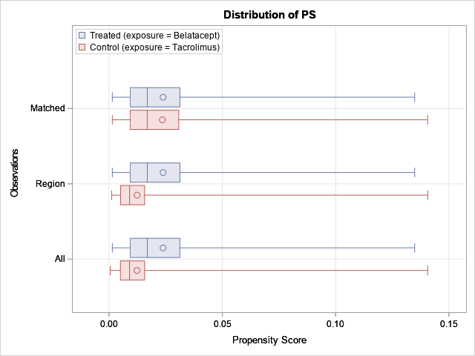
- SRTR Cohort

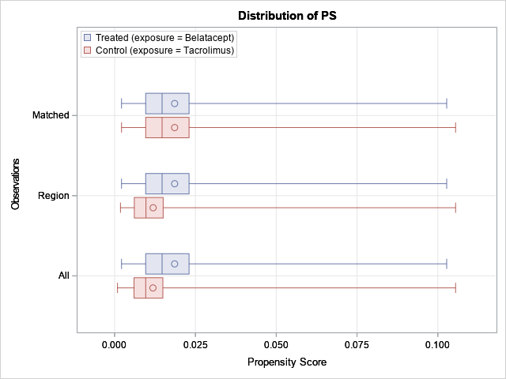

Supplementary Figure 2: Kaplan-Meier curves for death, graft failure/retransplantation and PTLD by EBV serostatus
A. Death in EBV-seropositive KTRs
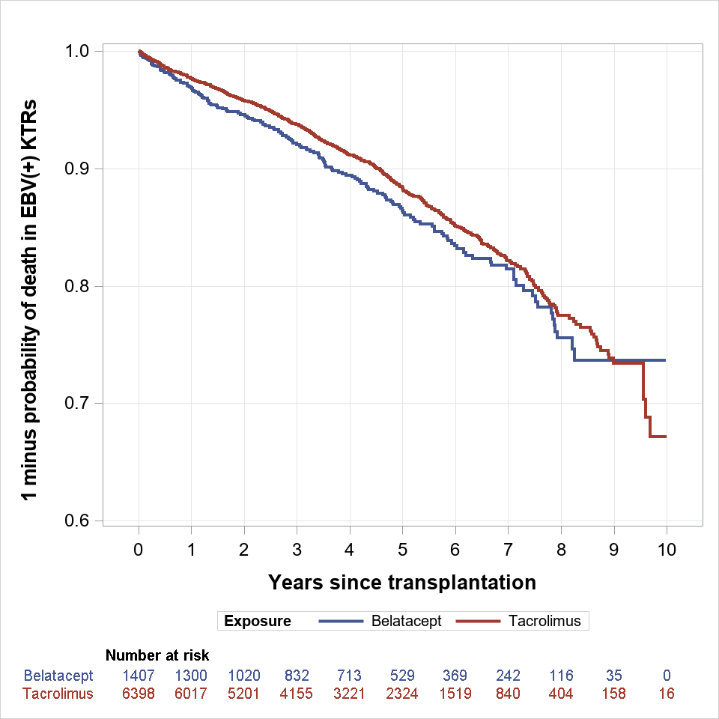
B. Death in EBV-seronegative KTRs
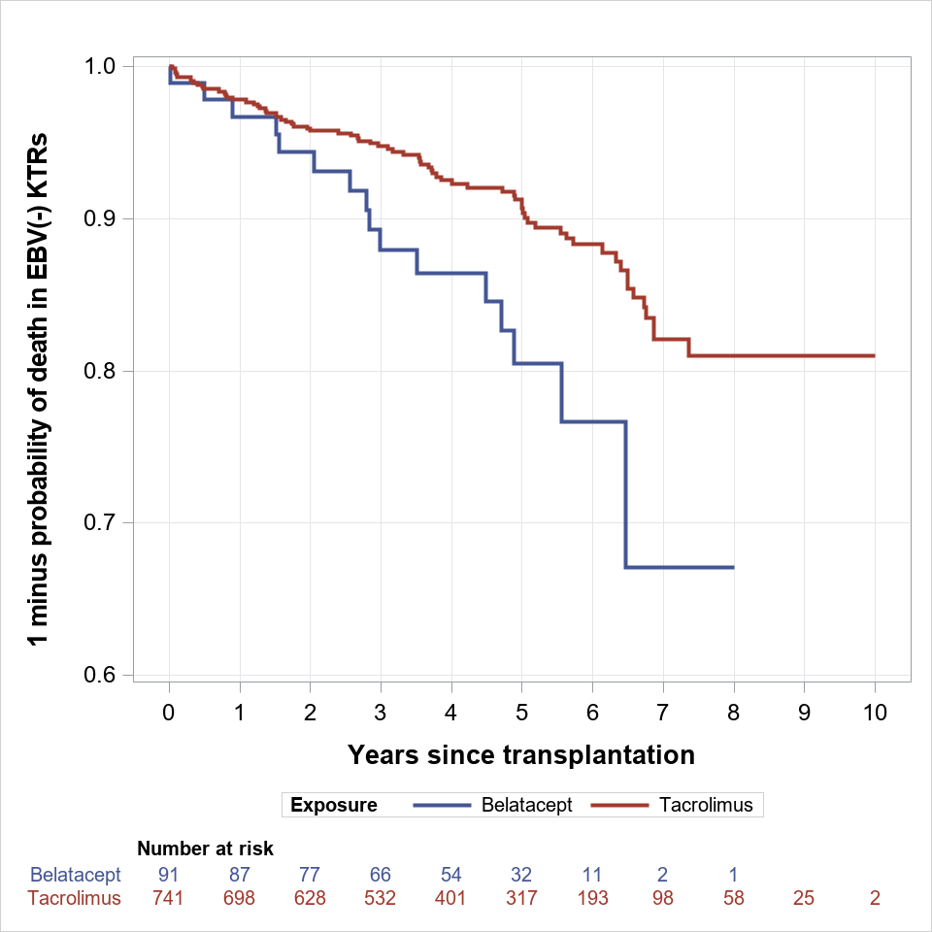
C. Graft failure/retransplantation in EBV-seropositive KTRs
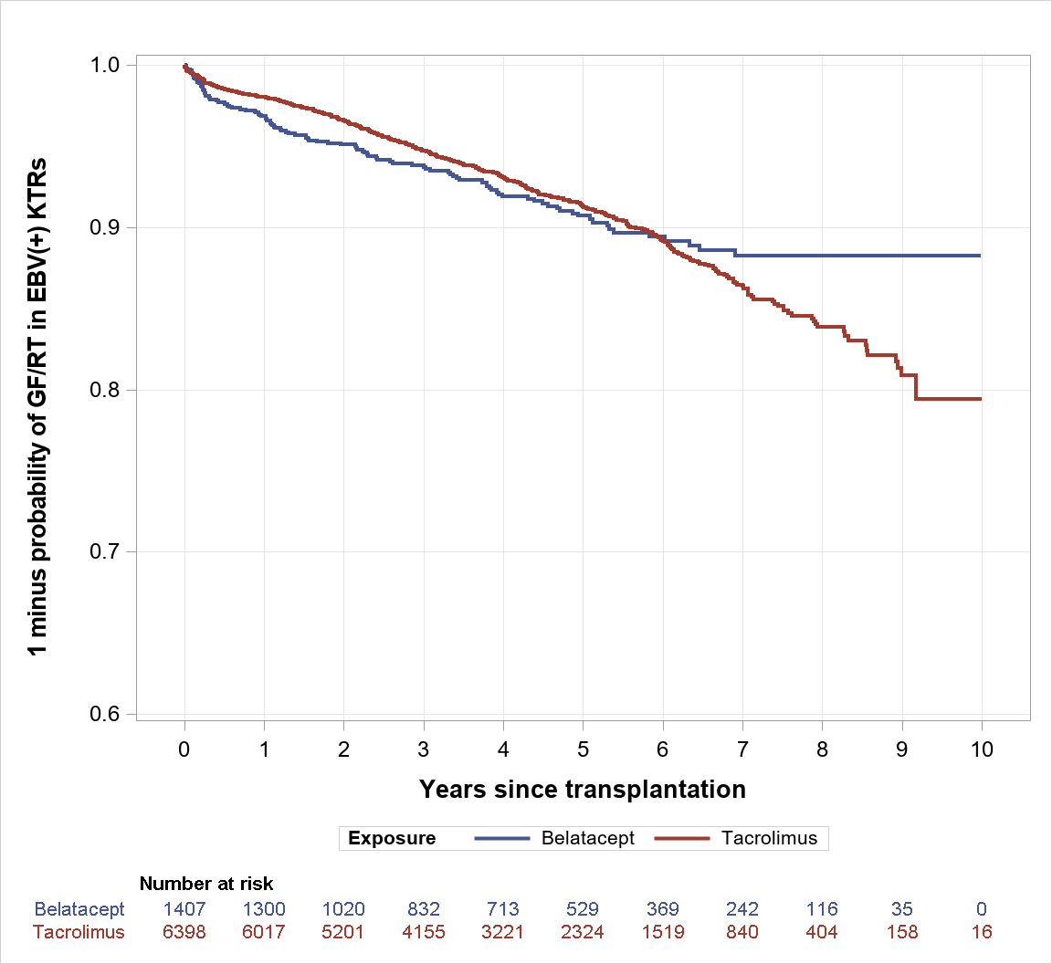
D. Graft failure/retransplantation in EBV-seronegative KTRs
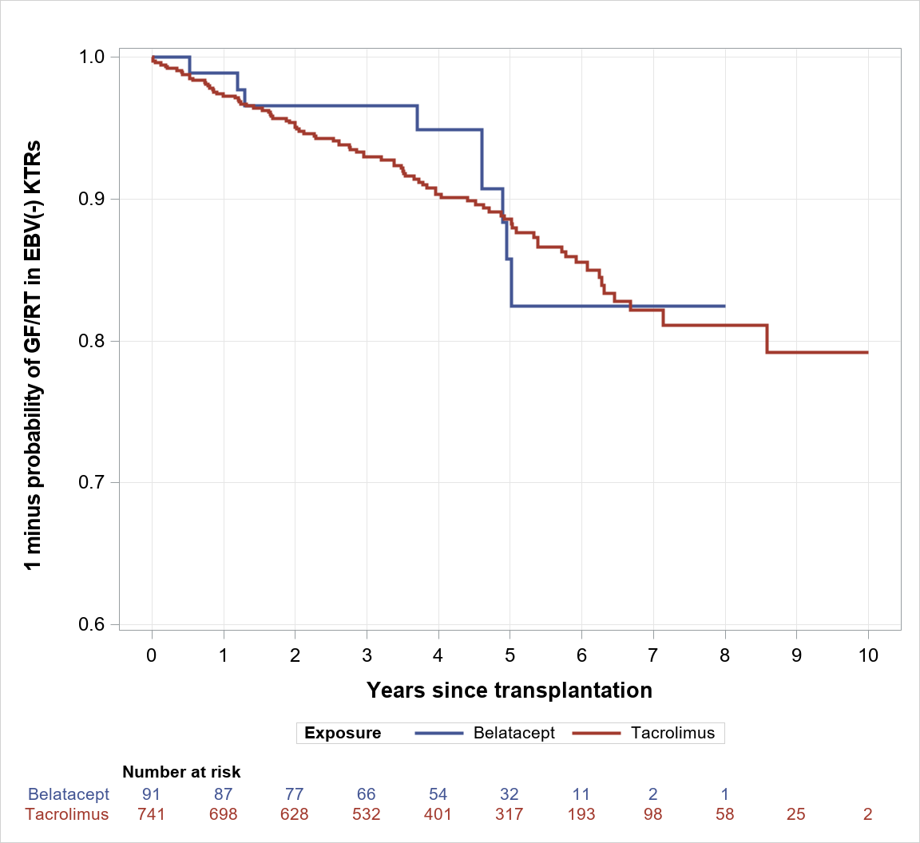

E. PTLD in EBV-seropositive KTRs
