Supplementary Data
Title: Modeling the Impact of Vaccine Dose Prioritization Strategies During the 2022 Mpox Outbreak
Authors: Patrick A. Clay*, Emily D. Pollock, Enrique M. Saldarriaga, Preeti Pathela, Michelle Macaraig, Jane R. Zucker, Bindy Crouch, Ian Kracalik, Ian H. Spicknall

Table of Contents
Appendix S1: Network parameters | p. 2
Table S1: Network parameters. | p. 2
Appendix S2: Calculating time between first and second dose administration when doses are pre-allocated | p. 4
Figure S1: Visualization of method for estimating average time between first and second dose recipients. | p. 5
Appendix S3: Posterior distributions of fit model parameters | p. 6
Figure S2: Posterior distributions of the parameters in our model that were fit to incident case data, and correlations between those parameters. | p. 7
Appendix S4: Sensitivity analysis of higher or lower incremental vaccine efficacy | p. 8
Figure S3: Repeat of Figure 3 with varying incremental vaccine efficacy. | p. 9
Appendix S5: Sensitivity analysis of higher transmission probability | p. 9
Figure S4: Repeat of Figure 3 with increased per contact transmission probability, to mimic a potential clade I mpxv scenario. | p. 10

S.1: Network parameters
Parameters for the dynamic network were taken from a nationally distributed survey of sexual behaviors among gay, bisexual, and other men who have sex with men (GBMSM) from 2017-2019 (as described in [1]). We recognize that sexual networks among GBMSM may have been impacted by COVID-19, but extensive egocentric surveys of sexual behavior among GBMSM taken after COVID-19 restrictions were implemented and relaxed have not been published. Thus, the ARTnet survey represents the most up to date and thorough source of sexual behavior data among GBMSM. For data on sexual position behavior, ARTnet data was supplemented by prior surveys of sexual behavior among GBMSM in Atlanta [3] (Table S1).
ARTnet reports the proportion of GBMSM who have between 0 and 2 ‘Main’ partners and between 0 and 3 ‘Casual’ partners. Individuals with 2 ‘Main’ partners represent a only 2%of the population. Modeling the behavior of small fractions of the population can lead to instability when fitting dynamic network models, so we removed individuals with 2 main partners from the model for this analysis (Table S1). This should have negligible impacts on our results, given the small percent of the population that has multiple ‘main’ partnerships, and given that mpox transmission primarily occurred though through one-time partnerships [3] (Table S1).
Table S1: Network parameters.
Parameter | Value
Proportion individuals with 0 main and 0 casual partners | 0.30
Proportion individuals with 0 main and 1 casual partners | 0.15
Proportion individuals with 0 main and 2 casual partners | 0.132
Proportion individuals with 1 main and 0 casual partners | 0.307
Proportion individuals with 1 main and 1 casual partners | 0.059
Proportion individuals with 1 main and 2 casual partners | 0.055
Mean duration of Main partnerships | 407 days
Mean duration of Casual partnerships | 166 days
Probability per day of individual in activity group 1 having a one-time sexual contact | 0.000755
Probability per day of individual in activity group 2 having a one-time sexual contact | 0.00832
Probability per day of individual in activity group 3 having a one-time sexual contact | 0.0271
Probability per day of individual in activity group 4 having a one-time sexual contact | 0.0637
Probability per day of individual in activity group 5 having a one-time sexual contact | 0.158
Probability per day of individual in activity group 6 having a one-time sexual contact | 0.371
Proportion of the population in activity group 1 | 0.40
Proportion of the population in activity group 2 | 0.30
Proportion of the population in activity group 3 | 0.15
Proportion of the population in activity group 4 | 0.10
Proportion of the population in activity group 5 | 0.04
Proportion of the population in activity group 6 | 0.01
Mean difference between square roots of ages of Main partners | 0.519
Mean difference between square roots of ages of Casual partners | 0.875
Mean difference between square roots of ages of one-time partners | 0.801
Proportion of population who are exclusively insertive | 0.242
Proportion of population who are exclusively receptive | 0.321
Proportion of population who are versatile | 0.437
Probability of having sexual contact per timestep with Main partner | 0.22
Probability of having sexual contact per timestep with Casual partner | 0.14
Probability of having sexual contact per timestep with one-time partner | 1

S.2: Calculating time between first and second dose administration when doses are pre-allocated
Individuals receiving a full course of the JYNNEOS® vaccine are currently recommended to wait 4 weeks between doses. However, logistical issues often prevent patients from completing the two doses exactly 4 weeks apart, even when doses are available. Thus, for our ‘second-dose priority’ scenario, where doses were pre-allocated for individuals, we estimated the mean time that would pass between first and second doses in a pre-allocation scenario.
While NYC employed a ‘first-dose priority’ strategy, CDC guidance at the beginning of the mpox outbreak recommended that all individuals complete a full course of JYNNEOS at the recommended schedule. Thus, it is reasonable to assume that many jurisdictions prioritized 2-dose vaccination in a limited portion of the population. To parameterize time between doses in our ‘second-dose priority’, we measured the average time between doses in California, Washington D.C., and Illinois: three jurisdictions with large early mpox outbreaks.
We measured time between doses by fitting the transformed number of cumulative first doses administered over time to the number of cumulative second doses over time in each of these jurisdictions. We first multiplied the cumulative number of first doses administered over time by the percent of individuals receiving a first dose who eventually received a second dose in each jurisdiction. We treat the resulting data as the cumulative number of first doses administered to individuals who would eventually receive their second dose. We then shifted the cumulative number of first doses administered forward in time x = [1, 2… 10] weeks. We calculate the sum of square differences between the first and second dose curves after shifting the first dose forward by x = [1, 2… 10]. We treat the value of x that results in the smallest sum of square differences as a proxy for mean time between first and second vaccine doses (Figure S1).
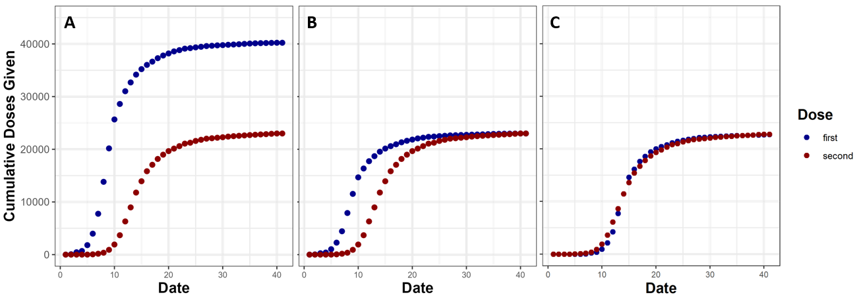
Figure S1: Visualization of method for estimating average time between first and second dose recipients. In panel A, we show simulated cumulative first and second dose administration. In panel B, we multiply cumulative first doses by the proportion of individuals who go on to get second doses. In panel C, we shift the cumulative first dose curve forward by 5 weeks, minimizing sum of squared differences between the curves.
We estimate that on average 5 weeks passed between first and second vaccine dose administration for California, Illinois, and Washington D.C. We thus delay second dose vaccination by 5 weeks in our ‘second-dose priority’ scenario.
We note that our ‘second-dose priority’ scenario will overestimate the potential benefit of pre-allocating doses, because we do not account for individuals being pre-allocated doses and then being unable or unwilling to show up for their second dose.
S.3: Posterior distributions of fit model parameters
Our fitting procedure drew 100 posterior parameter sets from our 1000 prior parameter sets, with the likelihood of a set being drawn being based on the negative binomial likelihood of the corresponding model output generating observed daily incident cases, with replacement.
In our prior parameter sets, all parameters were drawn from a uniform distribution, and parameters were not correlated with one another across sets. In our posterior distribution, we find that many parameters are significantly correlated with one another (Figure S2). In particular, the transmission rate during extra-network GBMSM gatherings during the surge period was negatively correlated with the in-network per-contact transmission rate, and also negatively correlated with the importation rate during the surge period. This indicates that parameter sets with disparate parameter combinations can generate similar epidemic curves. For example, a parameter set with low importation rate and a high extra-network transmission rate could generate a similar epidemic curve as a parameter set with a high importation rate and a low extra-network transmission rate. This means that this analysis should not be used to infer the value of any one of these parameters individually.
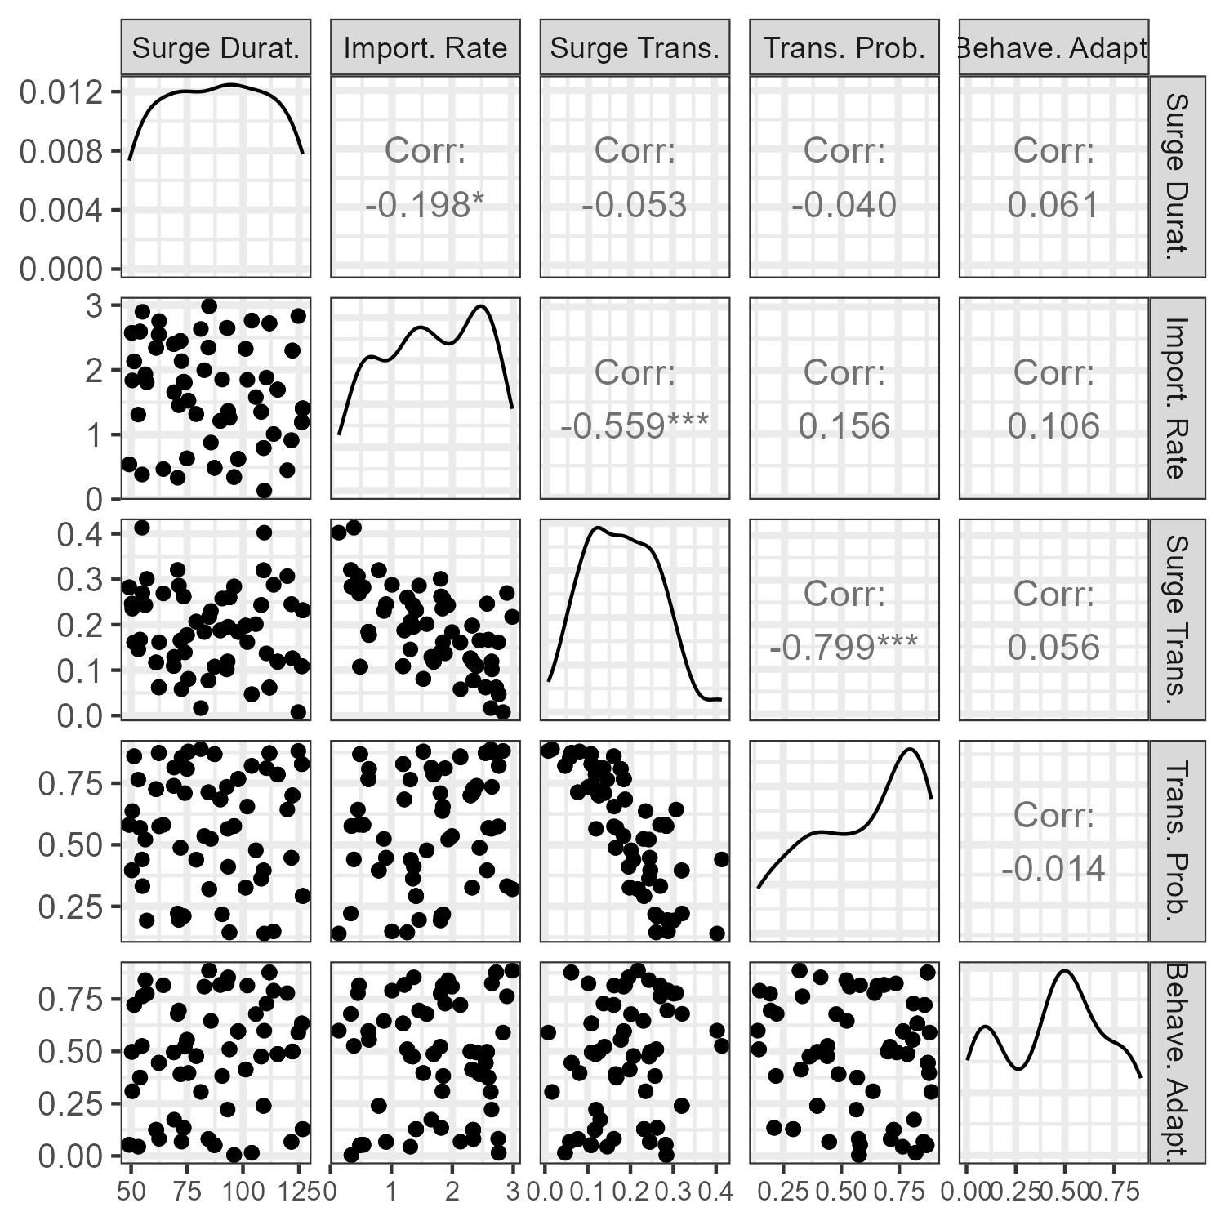
Figure S2: Posterior distributions of the parameters in our model that were fit to incident case data, and correlations between those parameters. ‘Surge Durat.’ indicates the length in days of the surge period. ‘Import Rate.’ Indicates the importation rate of infections during the surge period. ‘Surge Trans.’ indicates the transmission parameter for extra-network GBMSM gatherings during the surge period. ‘Trans. Prob.’ indicates the probability of mokeypox virus transmission per contact between a susceptible and an infectious individual. ‘Behave. Adapt.’ indicates behavioral adaptation, or the maximum percent reduction in one-time and casual sexual contacts due to the perceived risk of mpox. Panels show scatterplots of parameters across posterior parameter sets (bottom left panels), the posterior distribution of fit parameters (top-left to bottom-right), and correlations between parameters across posterior parameter sets (top-right panels).

S.4: Sensitivity analysis of higher or lower incremental vaccine efficacy
Here, we rerun our vaccine strategy simulations with lower incremental VE (incremental VE = 9%, 1 dose VE = 72%, 2 dose VE = 81%) and higher incremental VE (incremental VE = 21%, 1 dose VE = 64%, 2 dose VE = 85%), varying VE values within the 95% confidence intervals estimated by Saldarriaga et al [3]. Note that for the higher incremental VE scenario we use the upper bound estimate for the 1-dose VE and the lower bound estimate for the 2-dose VE, while for the lower incremental VE scenario we use the lower bound estimate for the 1-dose VE and the upper bound estimate for the 2-dose VE. We find that varying incremental VE from 9 to 21% does not change our qualitative results (Figure S3).
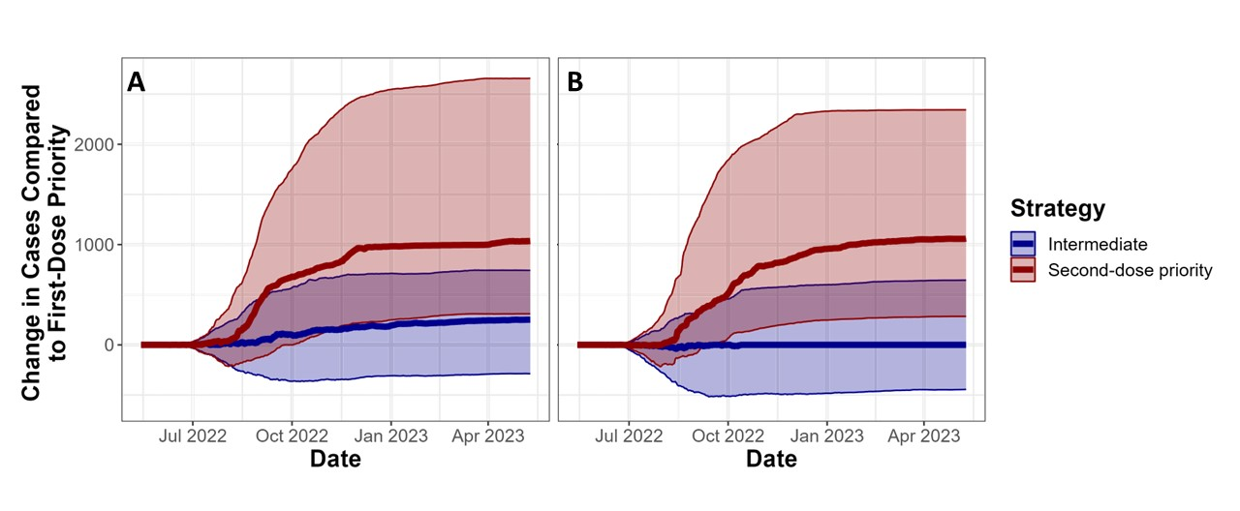
Figure S3: Repeat of Figure 3 with varying incremental vaccine efficacy. Here we compare different vaccine administration strategies*. We show the difference in cases under the ‘intermediate’ or ‘second-dose priority’ strategy compared to the ‘first-dose priority’ strategy on the Y-axis, over time on the X-axis. Solid lines indicate median values across fit parameter sets, and transparent bands indicate interquartile ranges across parameter sets. Panel A uses a higher incremental vaccine efficacy (21%), while panel B uses a lower incremental vaccine efficacy (9%).
*First-dose priority: first and second doses in model are based on first and second doses administered by NYC. Intermediate: Individuals who are eligible for a second dose receive priority for available doses, but there is no preallocation. Second-dose priority: doses are preallocated to ensure that all individuals receive full course of thes vaccine.
S.5. Sensitivity analysis of higher transmission probability
Here, we rerun our vaccine strategy simulations with 20% higher transmission probabilities, testing whether our results qualitatively change for mpox scenarios with a higher transmission rate. This may be applicable under outbreaks of clade I mpxv, which is more transmissible than clade II mpxv [5]. We find that increasing the transmission probability does not change our qualitative results (Figure S4).
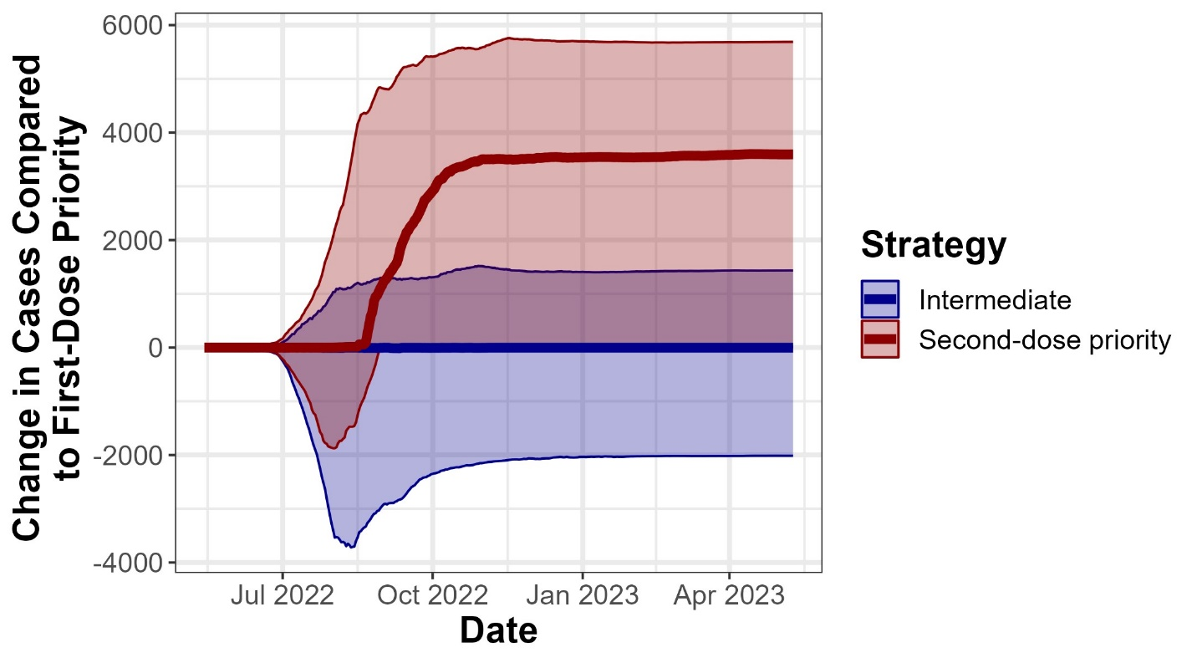
Figure S4: Repeat of Figure 3 with increased per contact transmission probability, to mimic a potential clade I mpxv scenario. Here we compare different vaccine administration strategies*. We show the difference in cases under the ‘intermediate’ or ‘second-dose priority’ strategy compared to the ‘first-dose priority’ strategy on the Y-axis, over time on the X-axis. Solid lines indicate median values across fit parameter sets, and transparent bands indicate interquartile ranges across parameter sets.
*First-dose priority: first and second doses in model are based on first and second doses administered by NYC. Intermediate: Individuals who are eligible for a second dose receive priority for available doses, but there is no preallocation. Second-dose priority: doses are preallocated to ensure that all individuals receive full course of thes vaccine.

Bibliography
1. Weiss KM, Goodreau SM, Morris M, et al. Egocentric sexual networks of men who have sex with men in the United States: Results from the ARTnet study. Epidemics. 2020; 30:100386.
2. Jenness SM, Weiss KM, Goodreau SM, et al. Incidence of Gonorrhea and Chlamydia Following Human Immunodeficiency Virus Preexposure Prophylaxis Among Men Who Have Sex With Men: A Modeling Study. Clin Infect Dis. 2017; 65(5):712–718.
2. Spicknall IH, Pollock ED, Clay PA, et al. Modeling the impact of sexual networks in the transmission of monkeypox virus among gay, bisexual, and other men who have sex with men—United States. MMWR. Morbidity and Mortality Weekly Report. 2022; 71.
3. Saldarriaga EM, Spicknall IH, Clay PA, Romero-Severson E. Model-based Estimates of Vaccine Efficacy Against Mpox Acquisition: Implications for Preparedness and Control. Presented at: 2024 STI Prevention Conference; September 18, 2024; Atlanta.
4. Likos, Anna M., Scott A. Sammons, Victoria A. Olson, A. Michael Frace, Yu Li, Melissa Olsen-Rasmussen, Whitni Davidson et al. "A tale of two clades: monkeypox viruses." Journal of General Virology 86, no. 10 (2005): 2661-2672.

