SUPPLEMENT
Table S1. The International Classification of Diseases, (ICD) codes used to define study cases. ª
Cause of Death |  | ICD Revision
 |  | Seventh | Eighth | Ninth | Tenth
Suicide |  | 963, 970-979 | 950-959 | 950-959 | X60-X84, Y870
Overdose | Accidental poisoning | 870-878 | 850-859 | 850-858 | X40-X44, Y10-14, Y87.2
Overdose | Accidental poisoning, late effects | 878-888, 890-895, 961 | 860-877, 942 | 861-869, 981-989, 929.2 | X46-X49, Y16-Y19
Overdose | Alcohol poisoning | 880 | 860 | 860, 980 | X45, Y15
ª Case A, Deaton A. Rising morbidity and mortality in midlife among white non-Hispanic Americans in the 21st century. Proc Natl Acad Sci U S A. Dec 8 2015;112(49):15078-83. doi:10.1073/pnas.1518393112

Table S2. Age-adjusted rate estimates per 100,000 person-years for suicide among DEMS II male mine workers by mine site and calendar period.
Calendar period | New Mexico: Potash (n=3,850) |  |  | Wyoming: Trona (n=5,102)
Calendar period | Cases, N | Age-adjusted IR | 95% CI | Cases, N | Age-adjusted IR | 95% CI
1947-2015 | 67 | 47.9 | 36.0-62.5 | 91 | 54.9 | 43.0-68.9
1940-1979 | 12 | 49.3 | 12.9- 150.8 | 11 | 35.0 | 17.3-345.9
1980-1989 | 23 | 81.8 | 46.5-133.8 | 33 | 83.2 | 52.3-146.0
1990-1999 | 14 | 45.9 | 23.4-94.1 | 20 | 43.6 | 25.1-97.6
2000-2015 ª | 18 | 77.3 | 34.9-141.9 | 27 | 35.2 | 22.6-59.4
Abbreviations: Incidence Rate = IR.
ª Restricted the age groups to those over 35 years of age.

Table S3. Adjusted hazard ratio estimated for the relationship between suicide and overdose and time inactive.
Time Inactive | Cases (N=241) | HR | (95% CI)
No Time Off | 164 | 1.00 | -
<1 year | 42 | 1.12 | 0.79, 1.59
1-2 years | 15 | 1.45 | 0.85, 2.48
$≥$3 years | 20 | 0.92 | 0.58, 1.48
Cox models used age as the scale, stratified the baseline hazard by mine state of employment (Missouri, New Mexico, Ohio, or Wyoming) and adjusted for year of hire, work location (surface, underground)

Table S4. Adjusted hazard ratio (HR) estimates for suicide or overdose after worker exit by age at worker exit (N=7,731).
Age at worker exit | Entire Cohort ª |  |  | Worker Exit before 1980 |  |  | Worker Exit After 1980 |  |  | Ratio of HRs ^{b} | Test of Inter-action ^{c}
Age at worker exit | N Cases=187 |  |  | N cases=97 |  |  | N Cases=90
Age at worker exit | N cases | HR | (95% CI) | N cases | HR | (95% CI) | N cases | HR | (95% CI)
55 years or older | 35 | 1.00 | - | 18 | 1.00 | - | 17 | 1.00 | -
40-54 years | 32 | 0.90 | 0.55, 1.49 | 17 | 0.58 | 0.29, 1.17 | 15 | 1.24 | 0.61, 2.51 | 2.14  [0.79, 5.76] | 0.13
30-39 years | 52 | 1.01 | 0.64, 1.59 | 26 | 0.57 | 0.30, 1.10 | 26 | 1.48 | 0.78, 2.80 | 2.60  [1.04, 6.46] | 0.04
<30 years | 68 | 0.99 | 0.63, 1.54 | 36 | 0.48 | 0.26, 0.89 | 32 | 1.81 | 0.96, 3.43 | 3.77  [1.61, 8.82] | 0.00
Cox models used time since worker exit as the scale, stratified the baseline hazard by mine state of employment (Missouri, New Mexico, Ohio, or Wyoming), and adjusted for 5-year calendar interval, work location (surface, underground), and race/ethnicity (White, Unknown).
ª Population is restricted to persons who exited work. Excludes person whose employment follow-up is censored and persons who died at work and those who died within one day of exiting work.
^{b} The Ratio of the hazard ratio can be used to understand if the hazard ratio for suicide or overdose for a given age at worker exit category (e.g. 40-54 vs the reference of 55 years or older) is different based on if the worker exited before or after 1980 (the two stratified estimates). A RHR >1 means the HR among workers exiting after 1980 is larger than the HR for workers exiting before 1980, for a given age at worker exit category.
^{c} Two-sided p-value to compare estimates on a log scale and the reported p-value from these stratified hazard ratio estimates is equivalent to the p-value obtained from one model with an interaction for socioeconomic period. The p-values are evaluated at the 5% level of significance.

Table S5. Adjusted hazard ratio estimates for suicide or overdose and suicide only after work exit, by decade of worker exit (N=7,731) ª
Decade worker exit | Suicides or Overdose  N Cases=187 |  |  | Suicides  N Cases=126
Decade worker exit | N | HR | (95% CI) | N | HR | (95% CI)
1947-1969 | 22 | 1.00 | - | 17 | 1.00 | -
1970-1979 | 75 | 2.11 | 1.21, 3.68 | 48 | 1.93 | 1.01, 3.70
1980-1989 | 66 | 2.38 | 1.28, 4.43 | 40 | 2.05 | 0.98, 4.26
1990-1999 | 24 | 1.98 | 0.90, 4.38 | 21 | 2.43 | 0.99, 5.97
Cox models used time since worker exit as the scale, stratified the baseline hazard by mine state of employment (Missouri, New Mexico, Ohio, or Wyoming) and adjusted for year of hire, 10-year age categories, work location (surface, underground)
ª Excludes persons whose employment follow-up is censored, persons who died at work, and those who died within one day of exiting work.

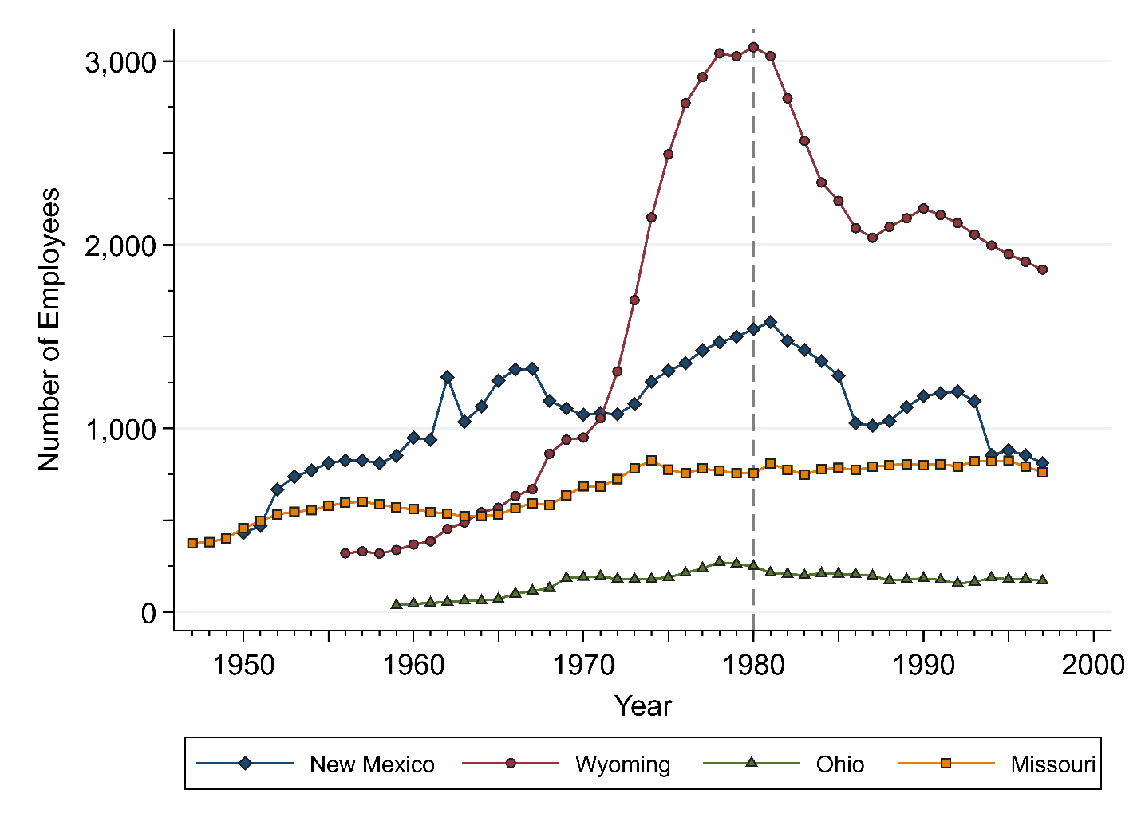

Figure S1. Number of employees in full DEMS II cohort (N=12,315) over calendar time by mine type (1947-1997).

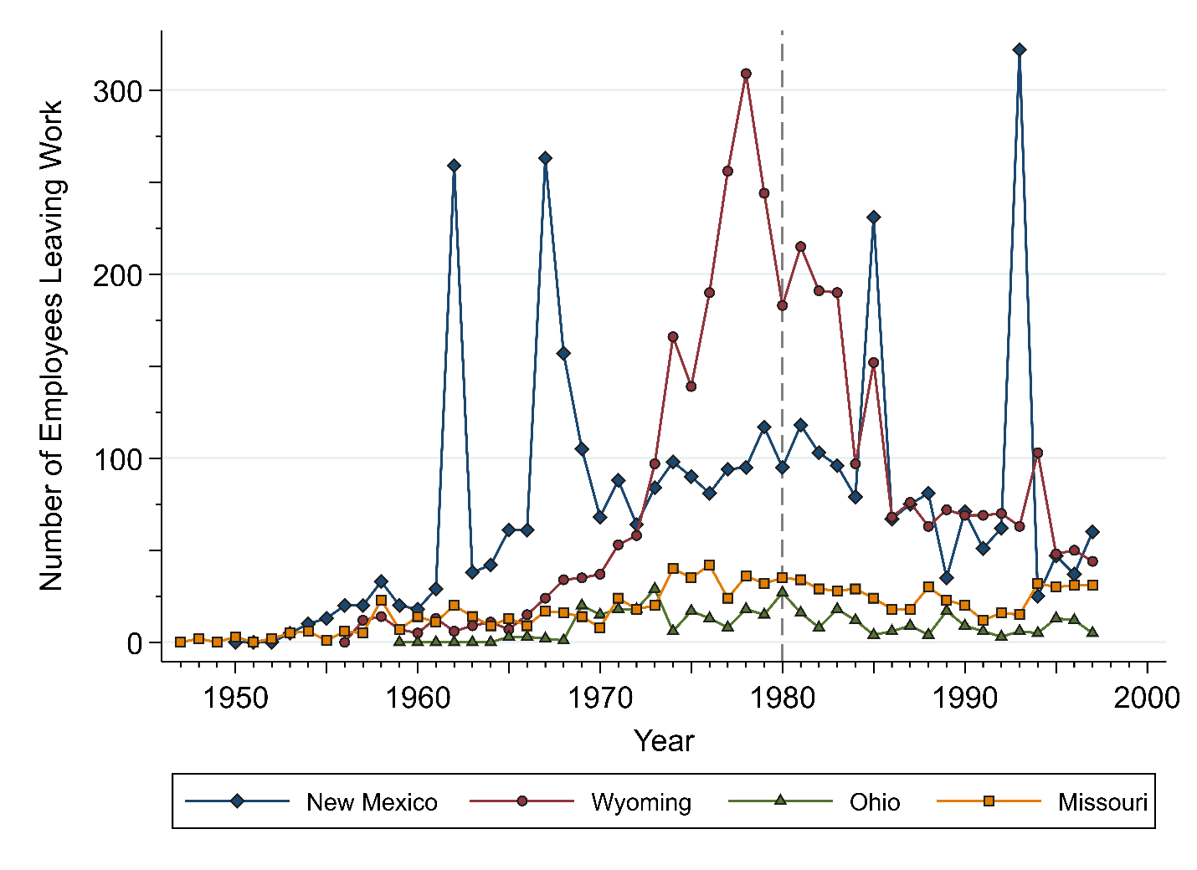
Figure S2. Number of employees in full DEMS II cohort (N=12,315) exiting work by mine state (1947-1997).

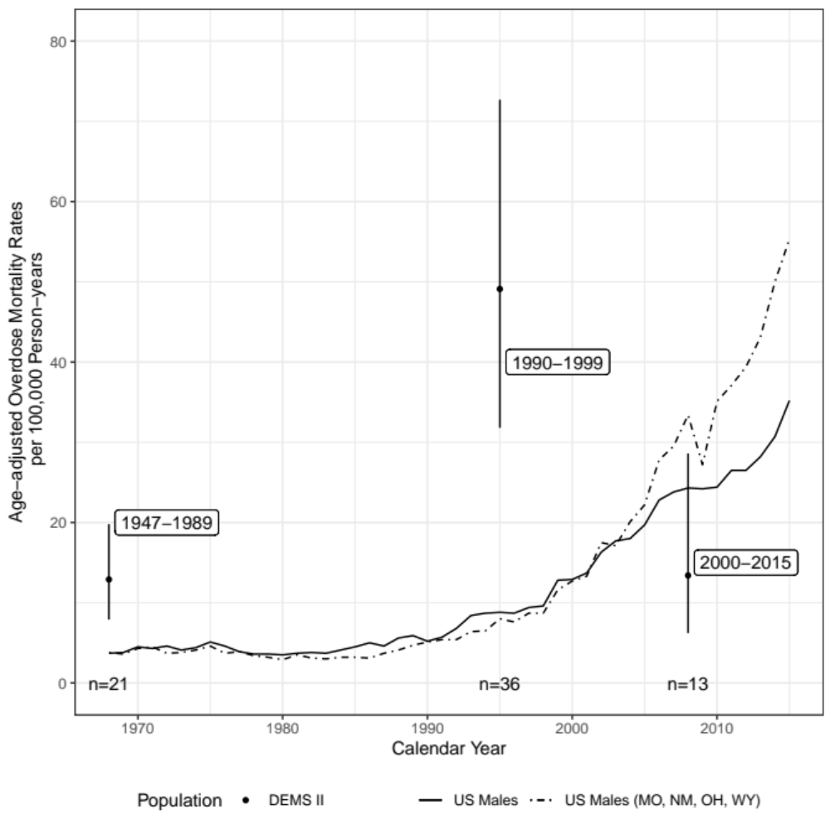
Figure S3. Age-adjusted overdose mortality rates among men in the DEMS II cohort (1947-2015), the United States (US) overall, and the US states Missouri, New Mexico, Ohio, and Wyoming (1968-2015). Age-adjusted DEMS II cohort overdose mortality rate point estimates are represented by the solid dot with 95% confidence intervals being the surrounding vertical lines. Age-adjusted overdose mortality rates for the US are represented by the solid line and for the select US states by the dashed line.

