Online Supplement

Interlaboratory Comparison of Serum Lipoprotein(a) Analytical Results Across Clinical Assays – Steps Towards Standardization

Alicia N. Lyle, PhD¹, Elias N. Flores, MS¹, Clark C. Coffman, BS^{1,2}, Alex H. Doty, BS^{1,2}, Otoe Sugahara, BS¹, Florian Kronenberg, MD³, L. Renee Ruhaak, PhD⁴, Christa M. Cobbaert, PhD⁴, Hubert W. Vesper, PhD¹

¹ Division of Laboratory Sciences, Centers for Disease Control and Prevention (CDC), Atlanta, GA, USA; ² Battelle, Columbus, OH, United States; ³ Institute of Genetic Epidemiology, Department of Genetics, Medical University of Innsbruck, Innsbruck, Austria; ⁴ Department of Clinical Chemistry and Laboratory Medicine, Leiden University Medical Center, Leiden, The Netherlands

Online Supplement Contents:

Supplemental Table 1. Median coefficients of variation and CV ranges for each measurement procedure for clinical samples and QC serum pools.
Supplemental Table 2. Lp(a) mean concentration measurements and mean coefficients of variation for clinical samples and QC serum pools.
Supplemental Table 3. Mean difference in bias for clinical samples for each measurement procedure exhibit changes relative to the Lp(a) clinical decision limit concentration of 50 mg/dL.
Supplemental Table 4. Mean coefficients of variation by dominant Lp(a) isoform size for each clinical sample and QC serum pool.
Supplemental Figure 1. Pairwise comparisons for serum samples and QC serum pool Lp(a) measurements between all measurement procedures.
Supplemental Figure 2. Clinical sample and QC serum pool standard deviations increase with increasing Lp(a) concentration.
Supplemental Figure 3. Across assay coefficients of variability for each clinical sample do not increase with increasing Lp(a) concentration.

Assay | Lab ID | Median CV (range) [%]
Roche, Tina-quant Lipoprotein(a) Gen.2 on Cobas® c501 | Lp1 | 1.2 (0.0* – 17.1)
Roche, Tina-quant Lipoprotein(a) Gen.2 on Cobas® c502 | Lp2 | 1.3 (0.0* – 12.2)
Randox, Lipoprotein(a)  on Beckman®AU5800 | Lp3 | 12.1 (2.3 – 26.5)
Randox, Lipoprotein(a)  on Cobas® c501 | Lp4 | 4.8 (0.0* – 22.3)
MedTest DX, Lipoprotein(a)  on Alfa Wassermann ACE Axcel® | Lp5 | 1.4 (0.4 – 8.0)
Roche, Tina-quant Lipoprotein(a) Gen.2 on Cobas® c501 | Lp6 | 2.6 (0.0* – 15.0)
Sentinel, Lipoprotein(a) Ultra  on Beckman® AU5800 | Lp8 | 3.6 (0.4 – 12.0)
Sentinel, Lipoprotein(a) Ultra  on Beckman® AU5800 | Lp9 | 7.6 (0.0* – 51.6)
* Due to assay/instrument rounding of numerical concentration data

Supplemental Table 1. Median coefficients of variation and CV ranges for each measurement procedure for clinical samples and QC serum pools.

Supplemental Table 2. Lp(a) all lab mean concentration and the coefficients of variation for the all lab means are shown for all clinical samples and QC serum pools.

Sample ID | Mean Conc. (mg/dL) | Mean CV  (%)
CS02 | 6.00 | 16.2
CS01 | 6.06 | 8.8
CS03 | 6.77 | 10.7
CS04 | 6.80 | 10.7
CS07 | 7.70 | 14.0
CS06 | 8.07 | 16.8
CS05 | 8.84 | 7.3
CS08 | 9.08 | 11.3
CS10 | 9.27 | 15.9
CS09 | 10.69 | 69.1
CS11 | 11.08 | 16.4
CS12 | 11.93 | 20.0
CS13 | 13.07 | 11.7
CS15 | 14.73 | 11.9
CS14 | 16.63 | 6.2
CS16 | 18.71 | 15.1
CS20 | 21.17 | 16.8
CS17 | 21.43 | 17.2
CS19 | 23.15 | 10.4
CS18 | 23.62 | 31.9
CS21 | 33.97 | 7.6
CS22 | 34.26 | 7.4
CS30 | 37.26 | 18.9
CS24 | 41.01 | 10.0
CS23 | 41.05 | 8.3
CS29 | 44.22 | 23.7
CS25 | 44.58 | 8.1
CS26 | 44.88 | 20.8
CS34 | 49.46 | 14.3
CS37 | 53.53 | 14.8
CS27 | 54.17 | 3.2
CS33 | 54.24 | 19.5
CS28 | 55.04 | 15.4
CS32 | 62.51 | 13.0
CS35 | 72.67 | 16.3
CS40 | 74.26 | 28.2
CS31 | 74.42 | 7.4
CS36 | 80.25 | 25.7
CS38 | 89.00 | 14.8
CS39 | 96.53 | 11.1
CDC1 | 19.14 | 7.1
CDC2 | 37.16 | 9.1
CDC3 | 58.24 | 9.2

Supplemental Table 3. Mean difference in bias for clinical samples for each measurement procedure exhibit changes relative to the Lp(a) clinical decision limit concentration of 50 mg/dL.

Assay | Lab ID | Mean Bias,  0 – 120 mg/dL | Mean Bias,  0 – 50 mg/dL | Mean Bias,  51 – 120 mg/dL
Roche, Tina-quant Lipoprotein(a) Gen.2 on Cobas® c501 | Lp1 | 6.2% | 4.3% | 11.2%
Roche, Tina-quant Lipoprotein(a) Gen.2 on Cobas® c502 | Lp2 | 1.2% | -2.4% | 10.6%
Randox, Lipoprotein(a)  on Cobas® c501 | Lp4 | 11.0% | 12.3% | 6.7%
MedTest DX, Lipoprotein(a)  on Alfa Wassermann ACE Axcel® | Lp5 | 8.4% | 9.6% | 5.2%
Roche, Tina-quant Lipoprotein(a) Gen.2 on Cobas® c501 | Lp6 | -10.2% | -7.7% | -17.9%
Sentinel, Lipoprotein(a) Ultra  on Beckman® AU5800 | Lp8 | -15.8% | -16.1% | -14.9%
Sentinel, Lipoprotein(a) Ultra  on Beckman® AU5800 | Lp9 | -0.5% | 0.0% | -1.9%

Sample ID | Isoform Size (KIV#) | Mean CV  (%)
CS31 | 14 | 7.4
CS25 | 16 | 8.1
CS38 | 17 | 14.8
CS27 | 18 | 3.2
CS05 | 20 | 7.3
CS22 | 20 | 7.4
CS32 | 20 | 13.0
CS35 | 20 | 16.3
CS36 | 20 | 25.7
CS23 | 21 | 8.3
CS04 | 22 | 10.7
CS07 | 22 | 14.0
CS13 | 22 | 11.7
CS24 | 22 | 10.0
CS29 | 22 | 23.7
CS40 | 22 | 28.2
CS39 | 22 | 11.1
CS01 | 23 | 8.8
CS34 | 23 | 14.3
CS33 | 23 | 19.5
CS21 | 24 | 7.6
CS28 | 24 | 15.4
CS14 | 25 | 6.2
CS19 | 25 | 10.4
CS37 | 25 | 14.8
CS16 | 26 | 15.1
CS30 | 27 | 18.9
CS12 | 28 | 20.0
CS15 | 28 | 11.9
CS20 | 28 | 16.8
CS18 | 29 | 31.9
CS26 | 29 | 20.8
CS08 | 30 | 11.3
CS10 | 30 | 15.9
CS11 | 30 | 16.4
CS17 | 30 | 17.2
CS09 | 35 | 69.1
CS02 | 36 | 16.2
CS06 | 36 | 16.8
CS03 | 38 | 10.7
CDC1 | N/A | 7.1
CDC2 | N/A | 9.1
CDC3 | N/A | 9.2
Supplemental Table 4. Mean coefficients of variation by dominant Lp(a) isoform size for each clinical sample and QC serum pool.

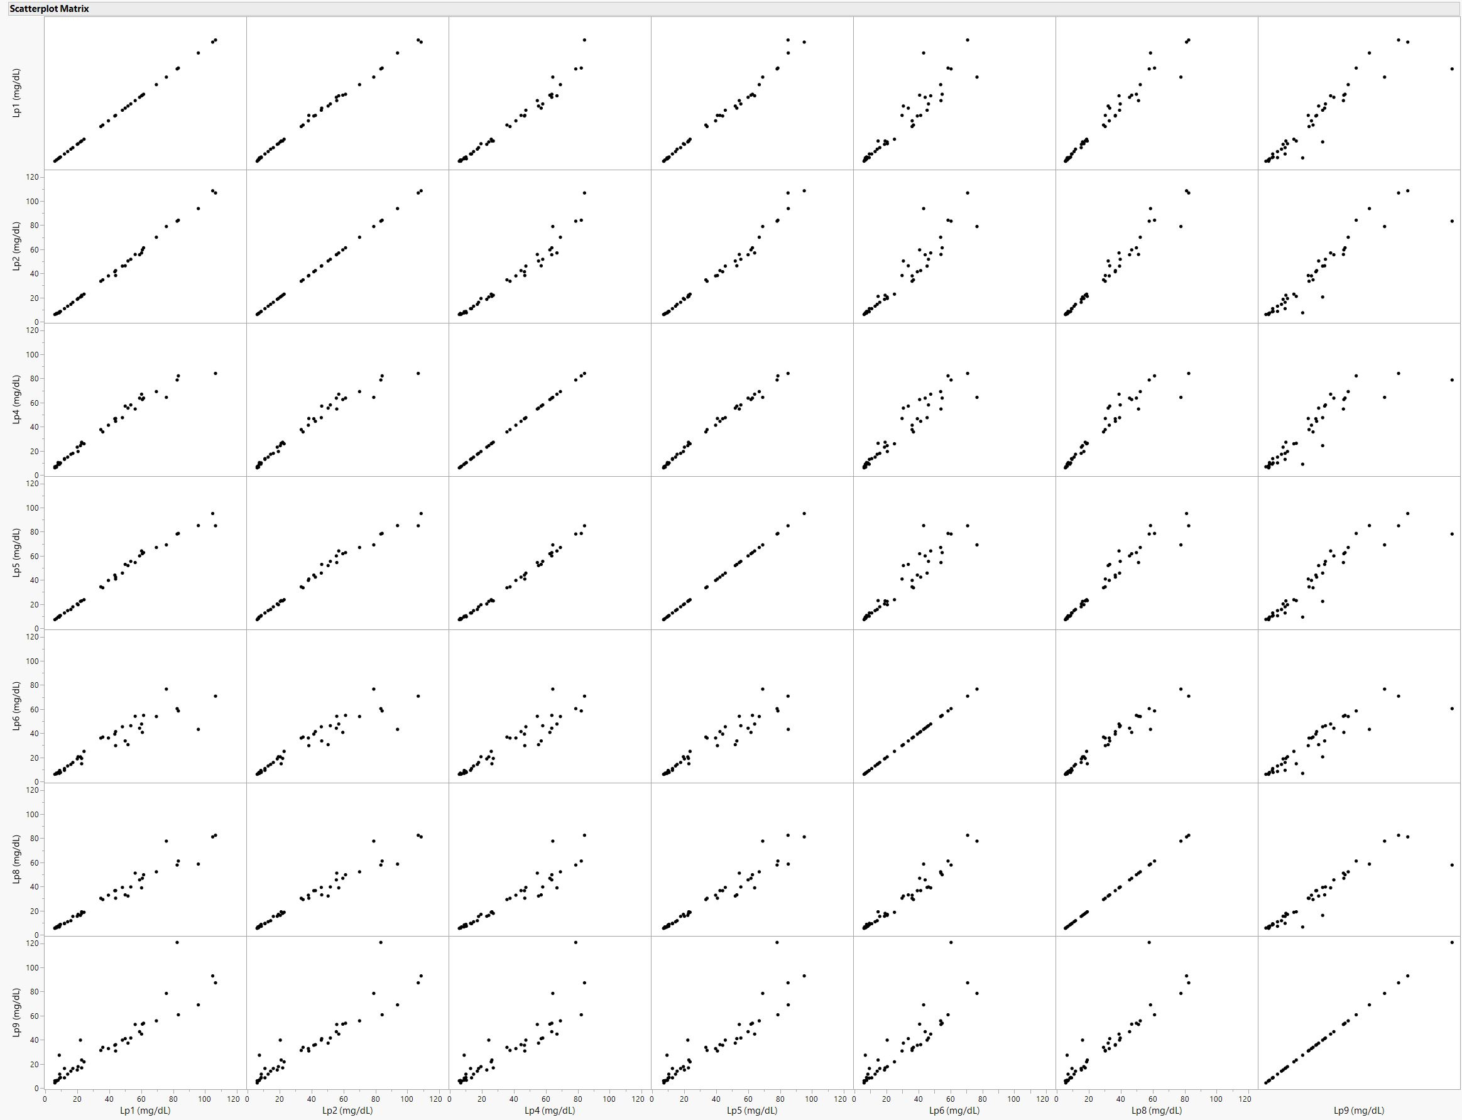
Lp2 (mg/dL)
Lp4 (mg/dL)
Lp1 (mg/dL)
Lp5 (mg/dL)
Lp6 (mg/dL)
Lp8 (mg/dL)
Lp4 (mg/dL)
Lp5 (mg/dL)
Lp6 (mg/dL)
Lp2 (mg/dL)
Lp9 (mg/dL)
Lp8 (mg/dL)
Supplemental Figure 1. Pairwise comparisons for serum samples and QC serum pool Lp(a) measurements between all measurement procedures.

Supplemental Figure 2. Clinical sample and QC serum pool measurement standard deviations increase with increasing Lp(a) concentration.
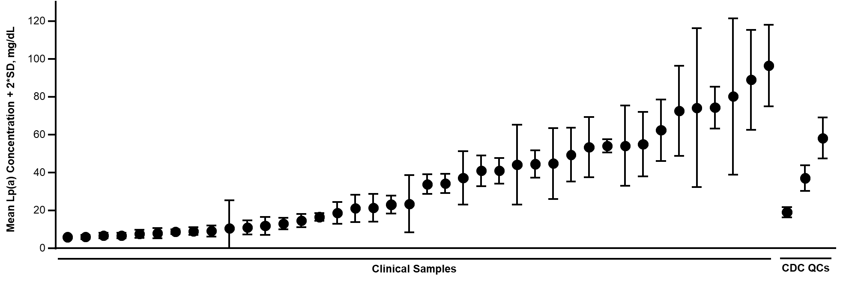
Clinical decision limit

Supplemental Figure 3. Across assay coefficients of variability for each clinical sample do not increase with increasing Lp(a) concentration.
0
20
40
60
80
100
0
20
40
60
80
Lp(a) (mg/dL)
Mean CV%

