Supplementary Information for
Direct Transfer of Multicellular Tumor Spheroids Grown in Agarose Microarrays for High-Throughput Mass Spectrometry Imaging Analysis
Yuan Liu¹, Jillian Johnson¹, Hua Zhang¹, Penghsuan Huang², Lingjun Li^{1,2,3,*}
¹School of Pharmacy, University of Wisconsin-Madison, Madison, WI
²Department of Chemistry, University of Wisconsin-Madison, Madison, WI
³Lachman Institute for Pharmaceutical Development, School of Pharmacy, University of Wisconsin-Madison, Madison, WI

* Corresponding author: Lingjun Li, lingjun.li@wisc.edu

Corresponding author: | Lingjun Li
Post address: | 777 Highland Ave, Madison, Wisconsin, United States
ZIP Code: | 53705
Email:  Tel:  Fax: | lingjun.li@wisc.edu  +1 608-265-8491  +1 608-262-5345

Supplementary Figure S1. Evaluate the sample preparation sequence for sectioning. All samples were embedded in 5% gelatin.

(a)
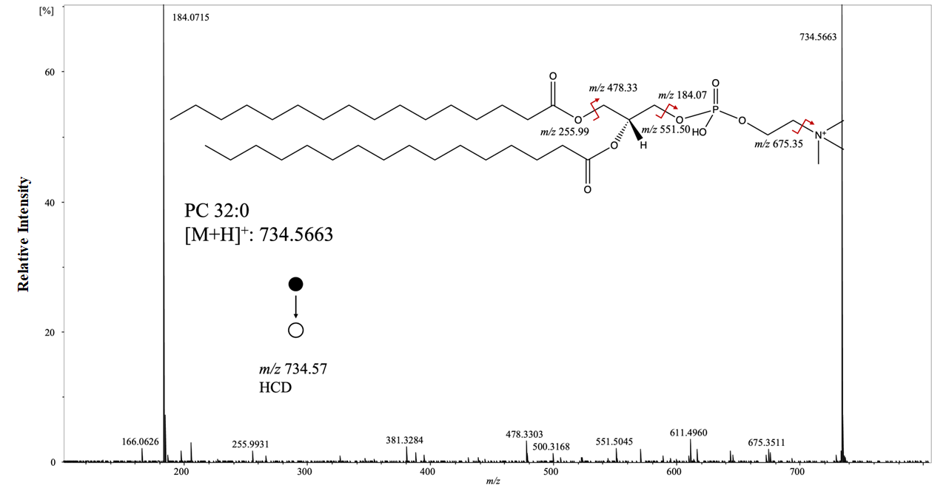
(b)
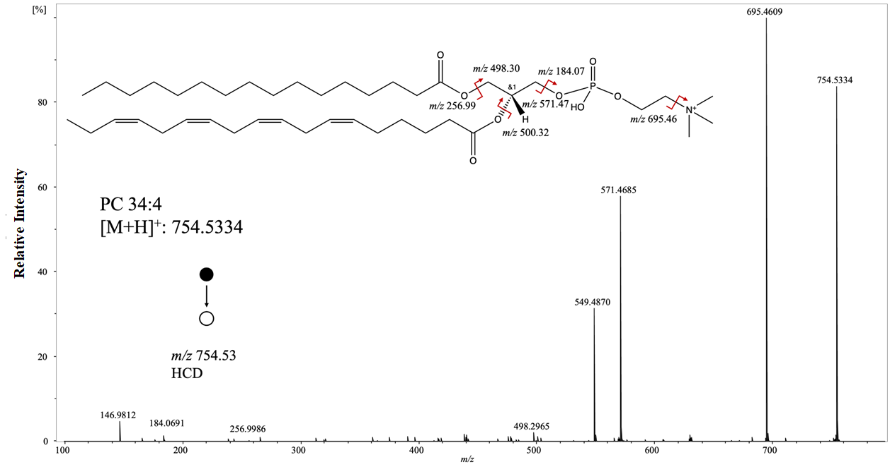

(c)
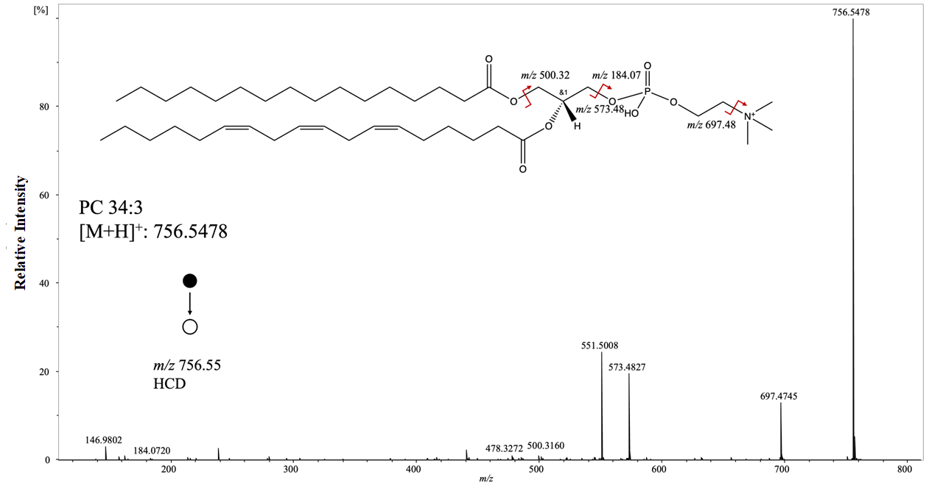
(d)
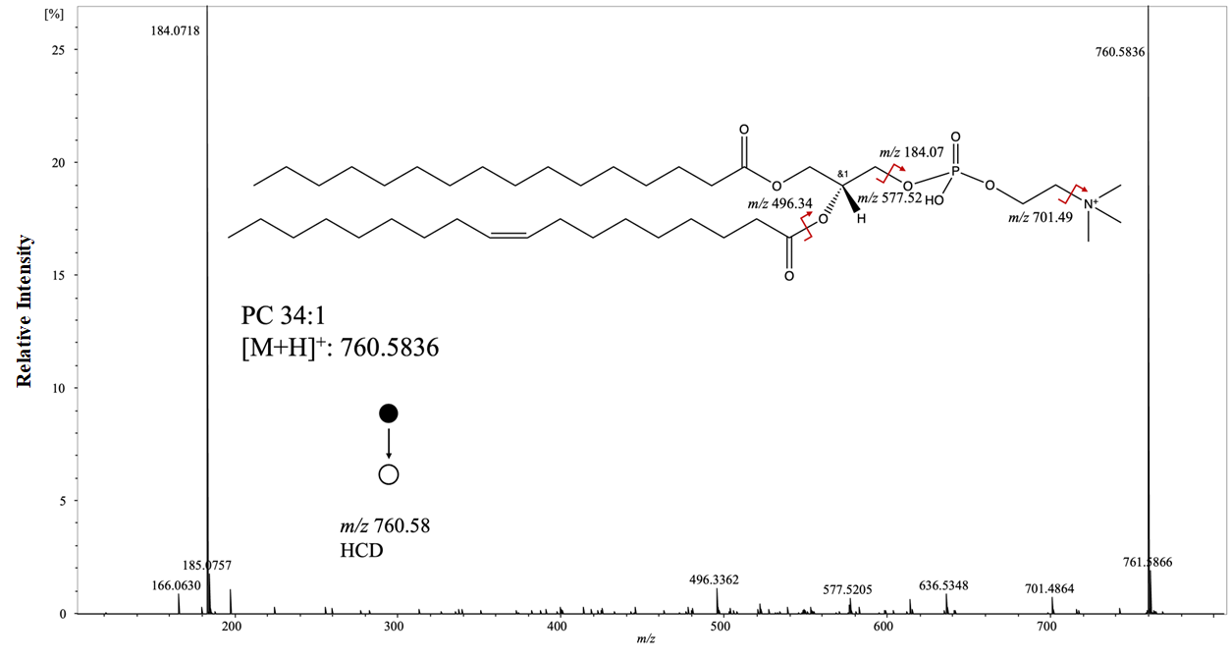

(e)
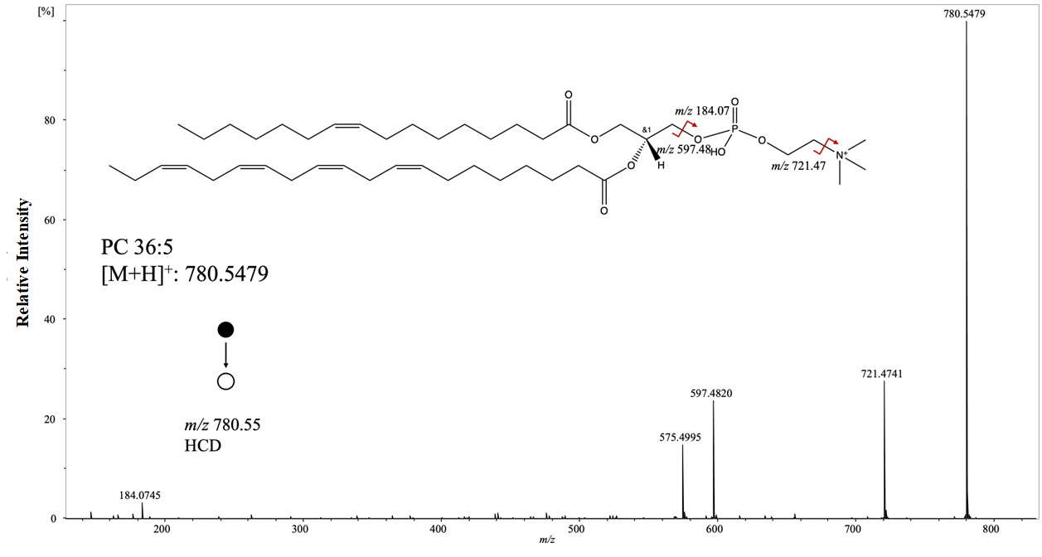
(f)
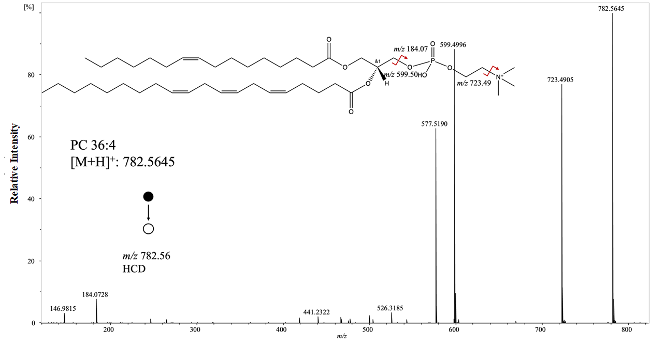

(g)

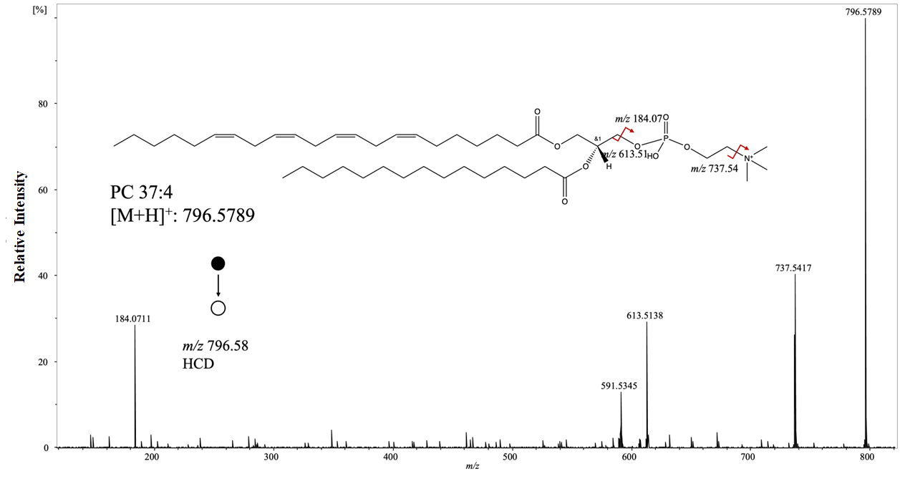
(h)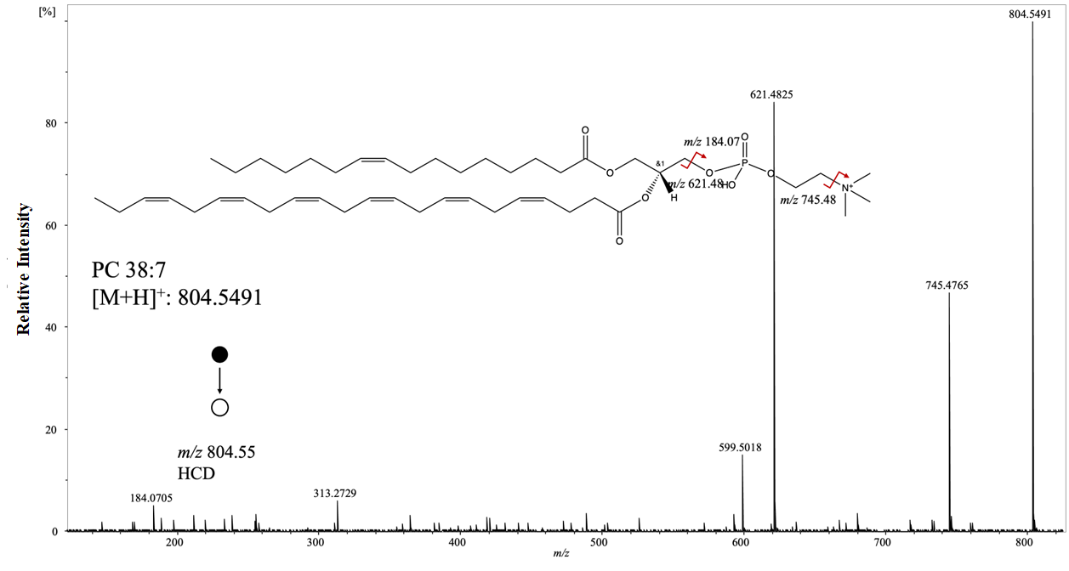

(i)
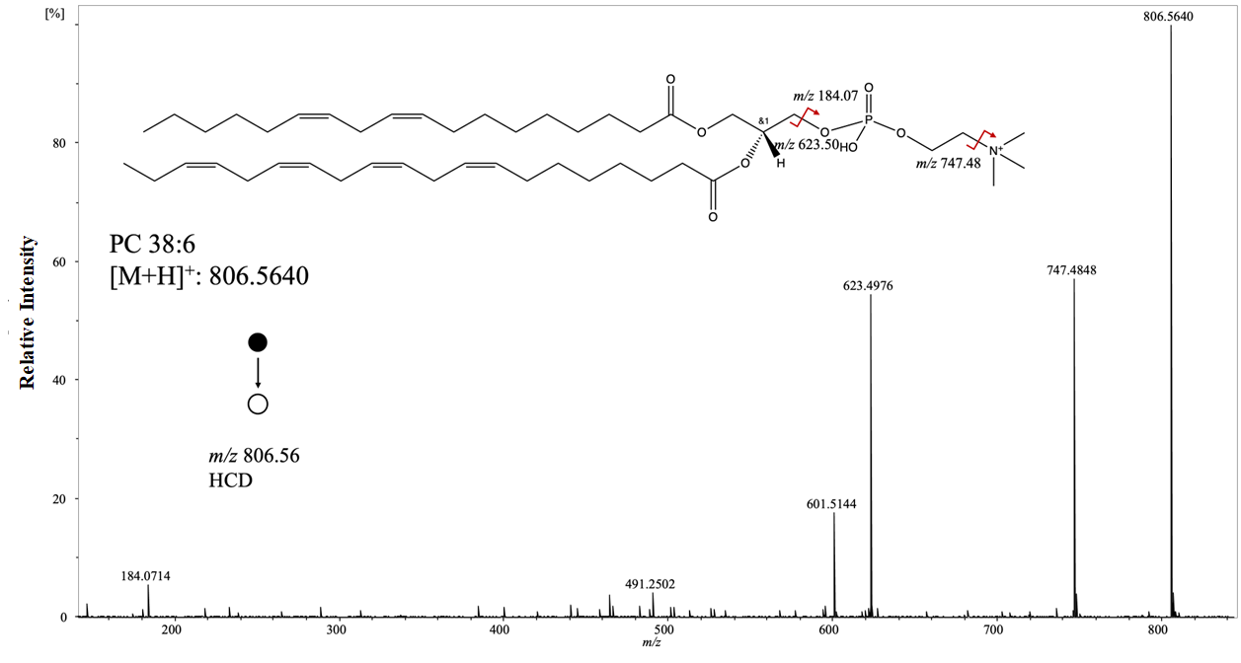
(j)
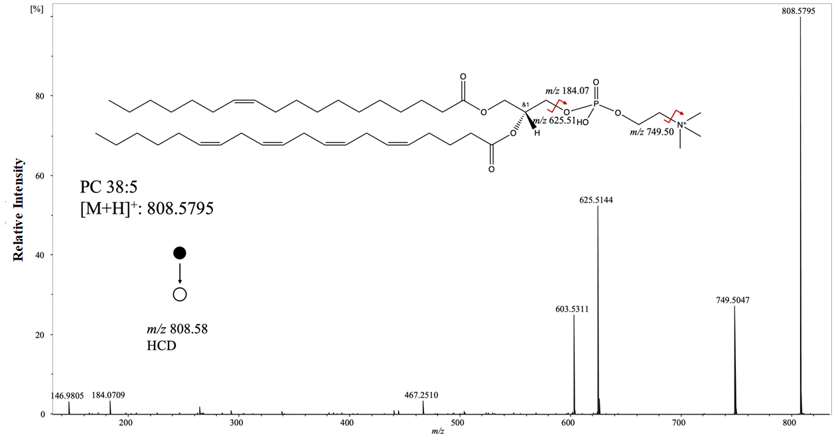

(k)
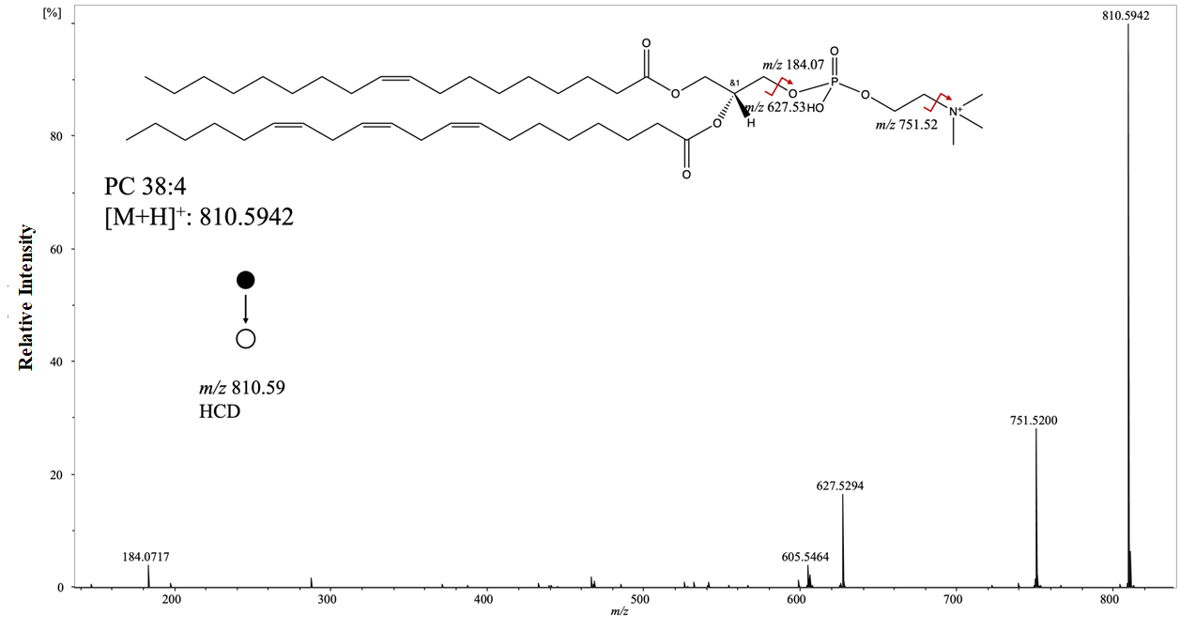
(l)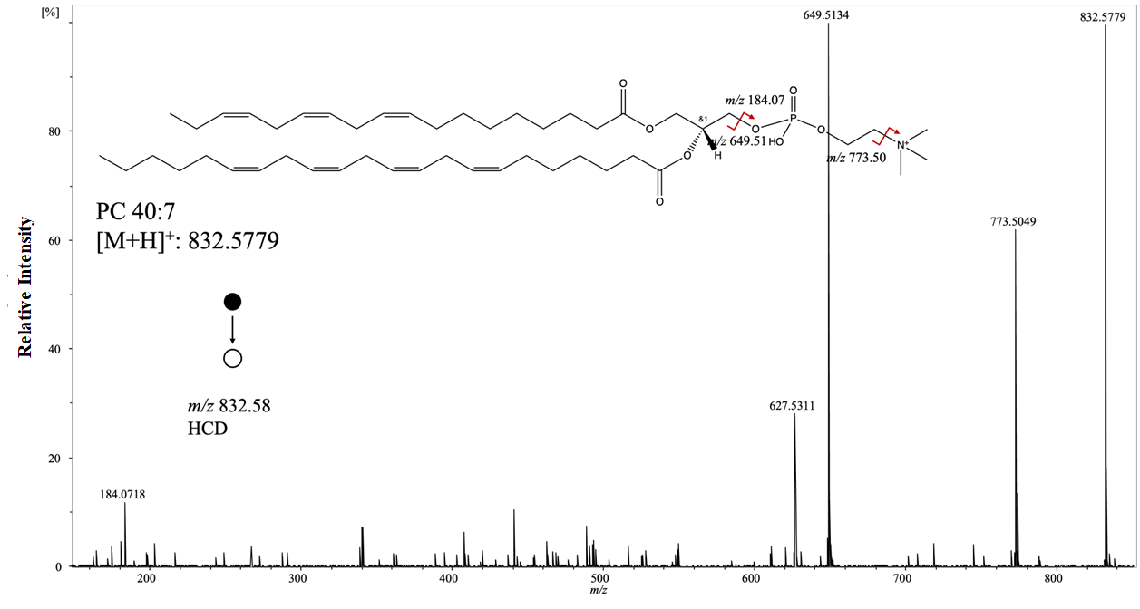

(m)
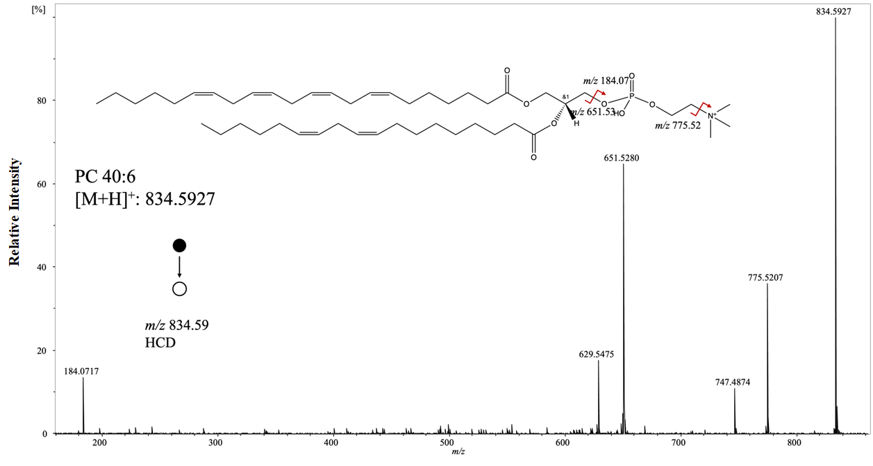
Supplementary Figure 2. (a-m) MALDI MS/MS spectra of features observed from MS images of MCTS sections and their putative identities. All spheroid MSI images were obtained with mass error tolerance of 10 ppm.

Supplementary Table S1. List of the putative lipid species from MTCS samples using MALDI MS.
Name | Ions | Molecular Formula | m/z meas. | Theoretical m/z | ppm
LPC 16:0-SN2 | [M+H]⁺ | C24H50NO7P | 496.3401 | 496.3398 | 0.7
PC 30:4 | [M+H]⁺ | C38H69NO8P | 698.4768 | 698.4755 | 1.9
PC 12:0_18:0 | [M+H]⁺ | C38H76NO8P | 706.5390 | 706.5381 | 1.2
PC O-32:1 | [M+H]⁺ | C40H80NO7P | 718.5758 | 718.5745 | 1.8
PC O-32:0 | [M+H]⁺ | C40H82NO7P | 720.5905 | 720.5902 | 0.5
PC 14:1_18:2 | [M+H]⁺ | C40H74NO8P | 728.5208 | 728.5225 | -2.3
PC 16:0_16:1 | [M+H]⁺ | C40H78NO8P | 732.5552 | 732.5538 | 1.9
PC 32:0 | [M+H]⁺ | C40H80NO8P | 734.5663 | 734.5694 | -4.2
PC 16:0_16:0 | [M+H]⁺ | C40H80NO8P | 734.5700 | 734.5694 | 0.8
PC 16:0_17:1 | [M+H]⁺ | C41H80NO8P | 746.5707 | 746.5694 | 1.7
PE 34:4 | [M+H]⁺ | C42H76NO8P | 754.5334 | 754.5381 | -6.2
PC 34:3 | [M+H]⁺ | C42H78NO8P | 756.5478 | 756.5538 | -7.9
PC 17:1_17:1 | [M+H]⁺ | C42H80NO8P | 758.5647 | 758.5694 | -6.2
PC 34:1 | [M+H]⁺ | C42H82NO8P | 760.5836 | 760.5851 | -2.0
PC 34:0 | [M+H]⁺ | C42H84NO8P | 762.5979 | 762.6007 | -3.7
PC 18:0_17:1 | [M+H]⁺ | C43H84NO8P | 774.6008 | 774.6007 | 0.1
PC 36:5 | [M+H]⁺ | C44H78NO8P | 780.5476 | 780.5538 | -7.9
PC 18:1_18:4 | [M+H]⁺ | C44H78NO8P | 780.5523 | 780.5538 | -1.9
PC 36:4 | [M+H]⁺ | C44H80NO8P | 782.5645 | 782.5694 | -6.3
PC 16:1_20:3 | [M+H]⁺ | C44H80NO8P | 782.5683 | 782.5694 | -1.4
PC 18:1_18:2 | [M+H]⁺ | C44H82NO8P | 784.5808 | 784.5851 | -5.5
PC 36:2 | [M+H]⁺ | C44H84NO8P | 786.6015 | 786.6007 | 1.0
PC 37:4 | [M+H]⁺ | C45H82NO8P | 796.5789 | 796.5851 | -7.8
PC 16:2_21:2 | [M+H]⁺ | C45H82NO8P | 796.5843 | 796.5851 | -1.0
PC O-38:4 | [M+H]⁺ | C46H86NO7P | 796.6210 | 796.6215 | -0.6
PC 38:7 | [M+H]⁺ | C46H78NO8P | 804.5491 | 804.5538 | -5.8
PC 38:6 | [M+H]⁺ | C46H80NO8P | 806.5640 | 806.5694 | -6.7
PC 18:2_20:4 | [M+H]⁺ | C46H80NO8P | 806.5672 | 806.5694 | -2.8
PC 38:5 | [M+H]⁺ | C46H82NO8P | 808.5795 | 808.5851 | -6.9
PC 18:1_20:4 | [M+H]⁺ | C46H82NO8P | 808.5830 | 808.5851 | -2.6
PC 38:4 | [M+H]⁺ | C46H84NO8P | 810.5942 | 810.6007 | -8.0
PC 18:0_20:4 | [M+H]⁺ | C46H84NO8P | 810.5999 | 810.6007 | -1.0
PC 40:7 | [M+H]⁺ | C48H82NO8P | 832.5779 | 832.5851 | -8.6
PC 18:3_22:4 | [M+H]⁺ | C48H82NO8P | 832.5844 | 832.5851 | -0.8
PC 40:6 | [M+H]⁺ | C48H84NO8P | 834.5927 | 834.6007 | -9.6
PC 18:0_22:6 | [M+H]⁺ | C48H84NO8P | 834.5963 | 834.6007 | -5.3
Supplementary Figure 3. MSI of MCTS microarrays with diameter of 300 - 400 µm. MS images of representative putative lipid species detected from PANC-1 MCTSs(a) PC (34:4) ([M + H]⁺, m/z 754.5372), (b) PC (34:1) ([M + H]⁺, m/z 760.5863), (c) PC (36:4) ( [M + H]⁺, m/z 782.567), (d) PC (36:3) ([M + H]⁺, m/z 784.5808), (e) PC (37:4) ([M + H]⁺, m/z 796.58258), (f) PC (38:5) ( [M + H]⁺, m/z 808.5799). Scale bar, 2 mm.

Supplementary Figure 4. Unsupervised statistical analysis of the heterogeneity of large MCTS (600-800µm) microarray using k-means analysis. (a) k-means segmentation analysis for the whole array. (b) k-means segmentation analysis of spheroids in the first row. (c) k-means segmentation analysis of spheroid in the first row and first column only. In Supplementary Figure 4a shows the variability of MCTSs, with the lime green largely distinguishing MCTS from background tissue and panel 4c shows the breakdown of a single MCTS into possible biological regions including an outer proliferating zone (dark blue), quiescent zone (orange), and necrotic core (lime green). k-means clustering the number of partitions, n, in to k-number of pre-chosen clustering, where each observation will then belong to the cluster with the nearest mean. A k-value of 5 was used for analysis of individual spectrum that are TIC normalized.

Supplementary Figure 5. Unsupervised statistical analysis of the heterogeneity of large MCTS(600-800µm) microarray using a bisecting k-means analysis. Bisecting k-means incorporates hierarchical clustering method that partitions the images based on the similarity of the data points, but not their spatial distribution, but then uses a k-means algorithm repeatedly on the parent cluster to determine the next best possible split to obtain the daughter clusters. This bisecting k-means algorithm was performed to split into 4 times for Figure 5a and Figure 5b, but only 3 times for Figure 5c, as the splitting into daughters regions was done with an emphasis on splitting the MCTSs to capture biological variation in the tissues. (a) Bisecting k-Means segmentation analysis for the whole array. (b) Bisecting k-Means segmentation analysis for spheroids in the first row. (c) Bisecting k-Means segmentation analysis for MCTSs in the first row and first column only. In Supplementary Figure 5a shows the variability of MCTSs in the outer edges with showing the lime green spectral splitting, and Figure 5c shows the breakdown of a single MCTS into possible biological regions including an outer proliferating zone (orange), quiescent zone (green), and necrotic core (blue).

Supplementary Figure 6. Unsupervised statistical analysis of the heterogeneity of large MCTS(600-800µm) microarray using principal component analysis (PCA). PCA is used to reduce the dimensionality of a dataset by converting possibly correlated variables into a set of linearly uncorrelated values (known as principal components, PCs). These principal components are then used as distinct vectors to cause the greatest amount of variability in the dataset, where PC1 is responsible for the largest variation in the dataset, followed subsequently by PC2, which is responsible for the second largest variation in the dataset, and so on with each ascending PC number. Shown above in the figure, PC1 distinguishes MCTS vs background matrix and gelatin, and PC5 shows the variation in the data that shows that outer MCTS rows (the edges of the array) being more similarly clustered together, confirming the spectral variation noticed in the bisecting k-means in Supplementary Figure 5.

