Supplemental Information

Dust Resuspension from the Splash of a Falling Powder:
A Numerical Aerodynamic Simulation of a Pellet
Falling onto a Powder Monolayer

Leonid A. Turkevich^{1 *} Hongyu Chen² Milind A. Jog²

¹Division of Field Studies & Engineering (DFSE)
National Institute for Occupational Safety & Health (NIOSH)
The Centers for Disease Control & Prevention (CDC)
Alice Hamilton Laboratory
1090 Tusculum Avenue
Cincinnati, OH 45226 USA

²Thermal Fluids & Thermal Processing Lab
Mechanical & Materials Engineering
University of Cincinnati
Cincinnati, OH 45221-0072 USA

Submitted: Aerosol Science & Technology
14 March 2024
Revised per Editor’s instructions: 27 March 2024

*Corresponding author
E-mail address: LLT0@cdc.gov (L.A. Turkevich)

- Simplifications used to Model the Splash from the Falling Powder
Our simulations study the aerodynamic dust generation resulting from the impact of the falling powder with the bottom surface. Falling agglomerates, or the collective motion of the falling powder, are modeled as a falling pellet disk:

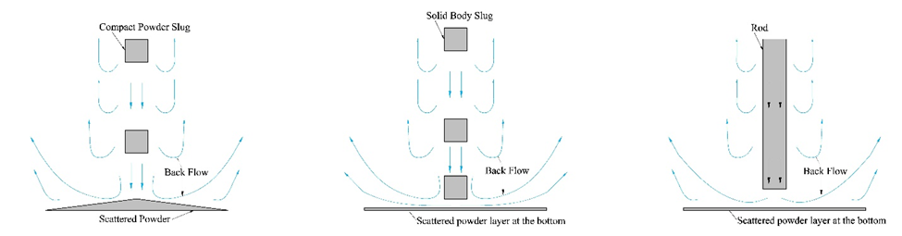

Figure S-1. Simplification of the dust generation splash process: a) pellet falling onto a hill of primary particles; b) approximating the hill of primary particles by a monolayer; c) (incorrect) approximation of falling pellet, and its wake, by a falling cylinder (plunger).

The pellet remains intact in this simulation. The powder hill (Figure S-1a) at the base of the powder stream is modeled as a layer of particles (Figure S-1b). In our simulations, this layer of particles is released slightly above the bottom surface within 0.1 sec after the powder pellet impact. A result of our simulations is that the backflow generated by the falling disk (vortex shedding) is much more efficient than that from an impinging piston (Figure S-1c) whose backflow at the surface merely derives from the displaced air ahead of the piston.
- Geometry of the grid
The domain is the Heitbrink chamber (75 cm x 12 cm x 12 cm). Unstructured grids [Ferziger et al., 2019] were generated within STAR-CCM+; the basic cell is a 3 mm cube (‘trimmed cell’) in the bulk of the domain and flattened rectangular prisms at the disk boundary surface. Near the bottom surface (5 cm x 12 cm x 12 cm), the grid is 50% refined (refined cell is a 1.5 cm cube). The central column (75 cm x 5 cm x 5 cm) is also 50% refined. The total cell count is 1,131,386. The falling disk is treated as a moving part. The refined grid in the central cylinder rigidly moves with the falling disk (Figure S-2).
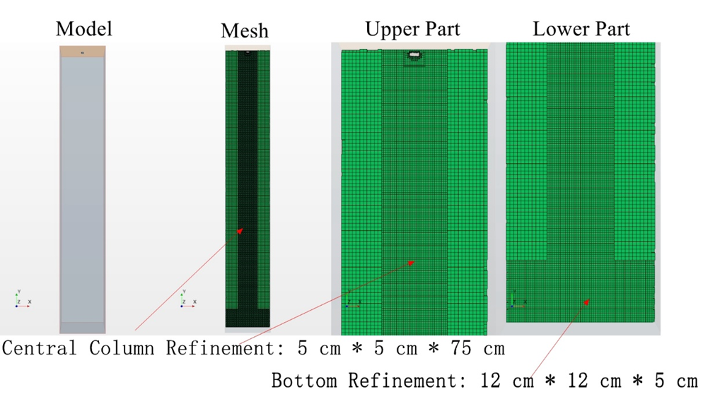

Figure S-2. Mesh for falling disk simulation (the right two pictures show a magnified view of the upper and lower parts of the domain).

- Grid independence verification
The magnitude of the air mass flow, |Q(t=0.6 s)|, integrated over a horizontal plane located 1 cm above the bottom, is used to check grid-independence. Five sets of meshes with cell base sizes ranging from 4.8 mm to 3 mm were generated. The parameters of each mesh are listed below:
Table S-1 Parameters of meshes for grid independence check
Base Size [mm] | 3 | 3.2 | 3.4 | 3.6 | 4.8
Refined Size [mm] | 1.5 | 1.5 | 1.7 | 1.8 | 2.4
Number of Cells | 1131386 | 901825 | 798434 | 635401 | 304626
Time Step [sec] | 0.0025 | 0.0025 | 0.0025 | 0.003 | 0.004
Pellet Release Time [sec] | 0.025 | 0.025 | 0.025 | 0.03 | 0.04
Ramp Time [sec] | 0.25 | 0.25 | 0.25 | 0.3 | 0.4
Pellet Impact Time [sec] | 0.54 | 0.54 | 0.54 | 0.567 | 0.624
Pellet Final Velocity [m/s] | 3.6379 | 3.6409 | 3.6336 | 3.6253 | 3.5908
Mass Flow [g/s] at h = 1 cm | 0.20657 | 0.1976 | 0.17681 | 0.1427 | 0.14

The coarsest mesh (base cell size = 4.8 mm) cannot be used, as both the pellet release time and the ramping up of the gravitational acceleration differ significantly from the parameters of the other four simulations.

The integrated absolute value of the mass flow rate, |Q|, increases quadratically as the base cell size is reduced (Figure S-3). Assuming continued monotonic behavior, it is reasonable to extrapolate to infinitesimal grid size.

Figure S-3. Surface integral of absolute value of mass flow rate |Q| at y = 1 cm as a function of base gris cell size h.

The derivative, with respect to base grid cell size, of this surface integral, ^{d}/_{dh} ∫|Q| dA, is linear (Figure S-4) and extrapolates to 0 at h = 2.96 mm; at this base cell size, we extrapolate ∫|Q| dA → 2.0657 * 10⁻⁴ kg/mm-sec; the relative error in using the finest grid (of base cell size h = 3 mm) is 0.43%. Note that this extrapolation occurs outside the asymptotic region (h → 0), where we would expect Richardson finite grid scaling behavior to obtain (leading to smaller errors) [Celik et al., 2008].

Figure S-4. The variation -d|Q|/dh with grid base cell size h

Celik, I.B., Ghia, U., Roache, P.J., Freitas, C.J., Coleman, H. & Raad, P.E. (2008). Procedure for estimation and reporting of uncertainty due to discretization in CFD applications. J. Fluids Eng. 130: 078001.

- Results: air flow of the standard falling pellet
In this section, we discuss the air flow generated by the falling pellet disk (R = 4 mm, t = 3 mm). As the disk falls, it induces air motion within the chamber. After Δt ~ 0.3 sec, Re > 100, and vortices are shed behind the disk; the flow behind the disk is asymmetric and unstable. Figure S-5 shows a time sequence of the air velocity vectors in the central midplane.

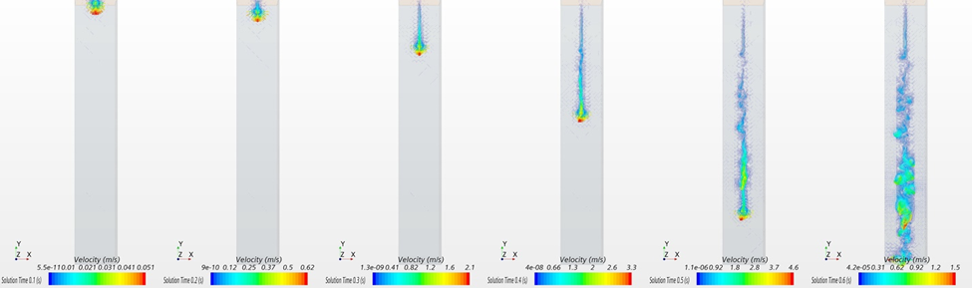

Figure S-5. Airflow velocity vectors for falling disk (from left to right, 0.1 sec, 0.2 sec, 0.3 sec, 0.4 sec, and 0.5 sec).

Air ahead of the disk is quiescent. The disk ‘impacts’ the bottom of the chamber at t = 0.54 sec. Particles will be released at 0.6 sec.

Figure S-6 shows the flow near the bottom of the chamber (left panel--central midplane; right panel—diagonal) as the pellet impacts.
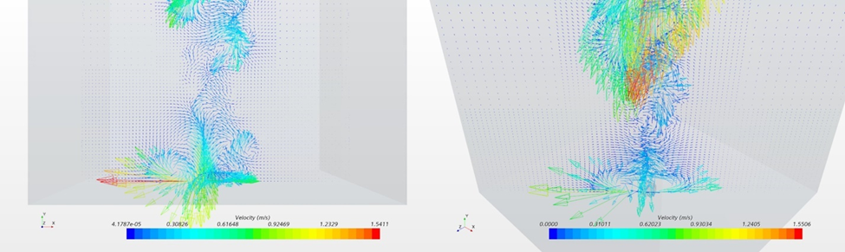
Figure S-6. Airflow velocity vector surrounding falling disk (left: airflow on the central plane; right: airflow on the diagonal plane).

The edges of the disk are regions of high vorticity. Radial and upward air flow has the potential to loft particles up from the surface and aerosolize a dust cloud.

Figure S-7 shows a time sequence (t = 0.2, 0.3, 0.4, 0.5, 0.6, 0.7, 0.8, 0.9, 1.0 sec) of the vertical velocity, v_{y}, on the central midplane (z = 0); the top of the chamber is at left; the base of the chamber is at right. We are particularly interested in the air flow induced at the base of the chamber, which will be instrumental in lofting dust from the monolayer. Prior to impact, the downward vertical velocity is confined to the wake immediately behind the disk (there is negligible flow ahead of the disk, arguing against the importance of piston-like flow driving dust dispersion) ; a small region of upward velocity exists just outside the disk, presumably from the attached vortex ring around the disk. Upon impact, the region of upward velocity extends from the disk radius outwards all the way towards the chamber walls.
Figure S-7. Vertical velocity, v_{y}, on the central midplane (z = 0): a) t = 0.2, b) 0.3, c) 0.4, d) 0.5, e) 0.6, f) 0.7, g) 0.8, h) 0.9, i) 1.0 sec (panels read from left to right within each row).

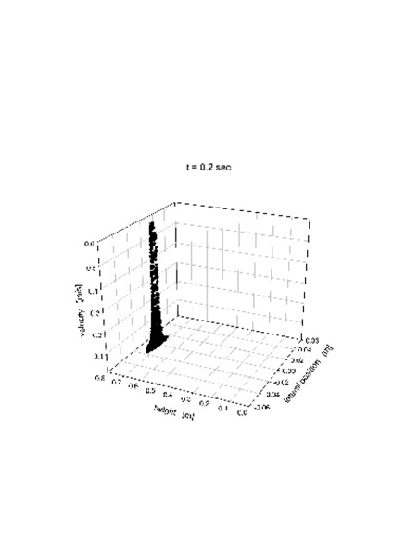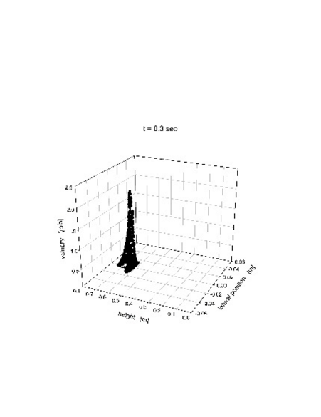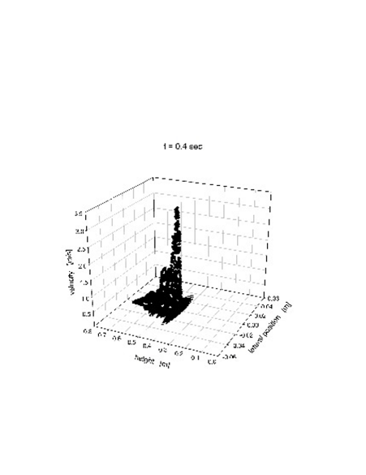
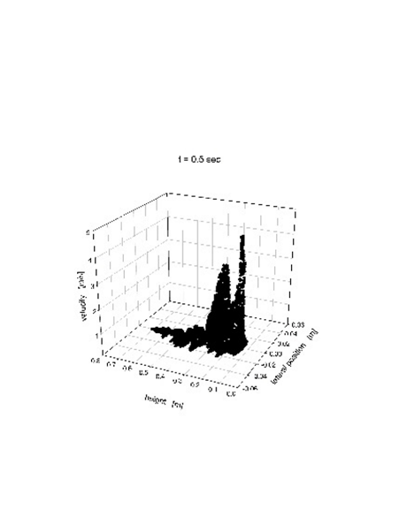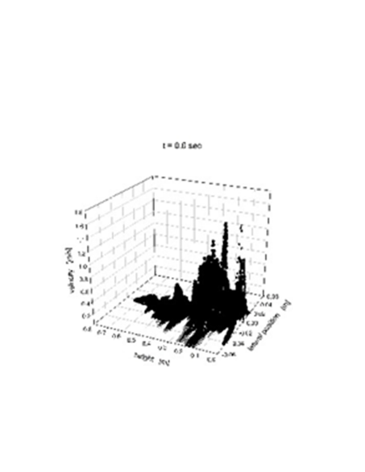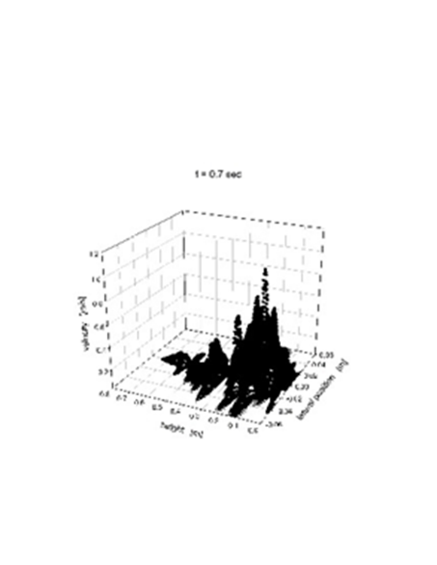
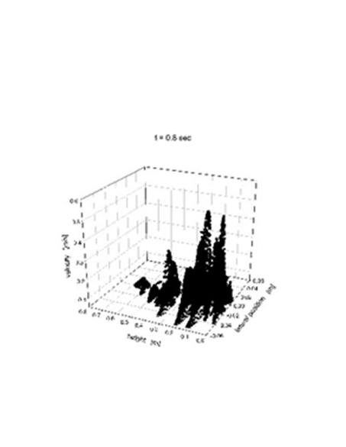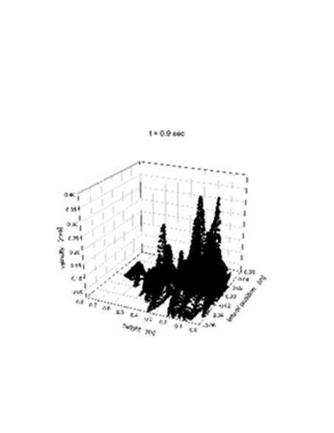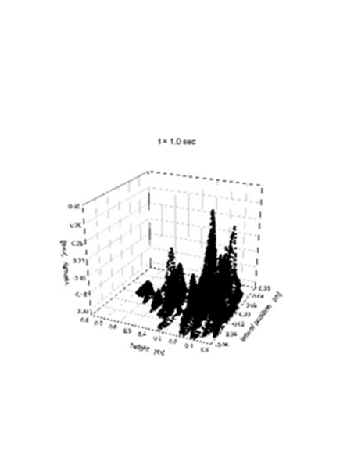

Figure S-8 shows the same time sequence (t = 0.2, 0.3, 0.4, 0.5, 0.6, 0.7, 0.8, 0.9, 1.0 sec) of the out-of-plane vorticity magnitude, |ω_{z}|, on the central midplane (z = 0); the top of the chamber is at left; the base of the chamber is at right. We are particularly interested in the air flow induced at the base of the chamber, which will be instrumental in lofting dust from the monolayer. Prior to impact, there is large positive/negative vorticity on the right/left of the disk, indicative of the vortex ring attached to the disk; again, vorticity is confined to the wake behind the pellet. Upon impact, the vorticity dissipates radially (note the decrease in vorticity scale for t > 0.6 sec).

Figure S-8. Out-of-plane vorticity magnitude, |ω_{z}|, on the central midplane (z = 0): a) t = 0.2, b) 0.3, c) 0.4, d) 0.5, e) 0.6, f) 0.7, g) 0.8, h) 0.9, i) 1.0 sec.

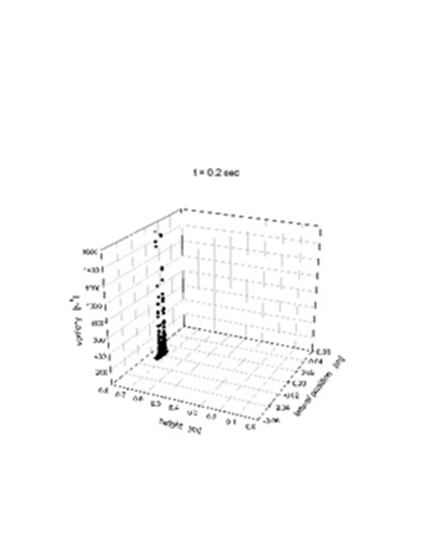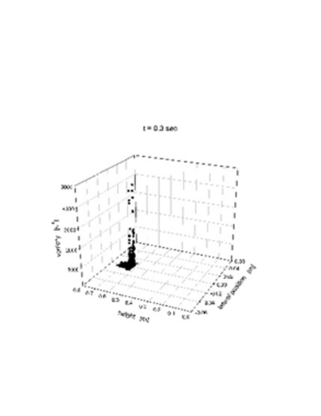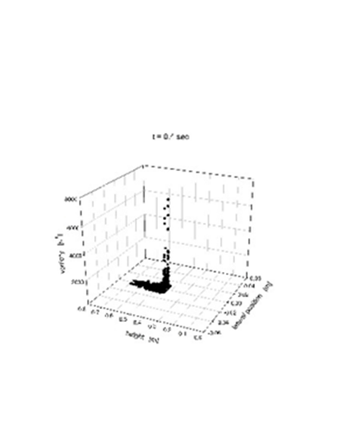
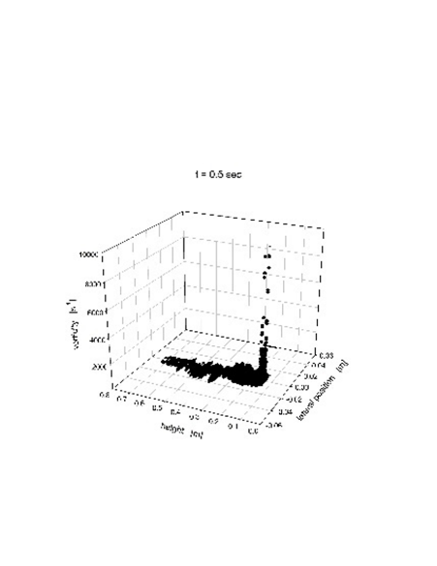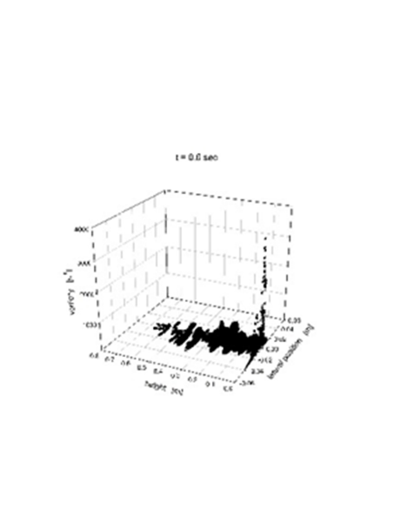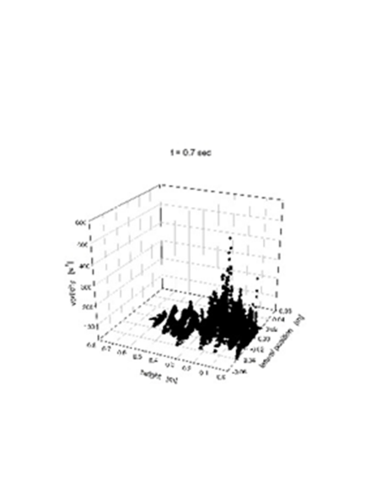
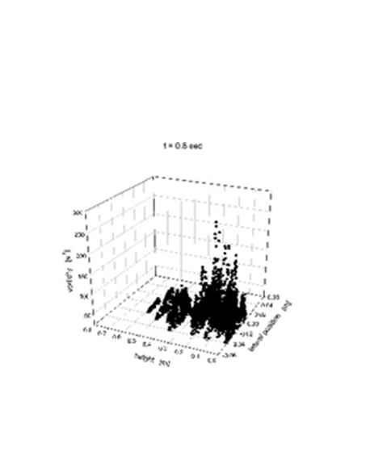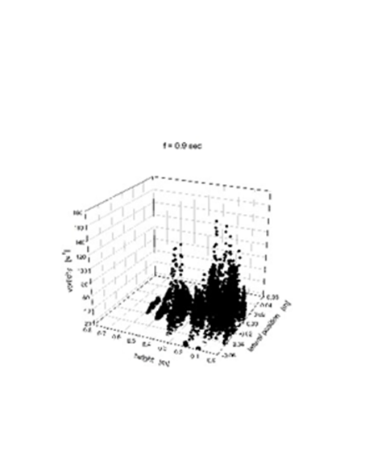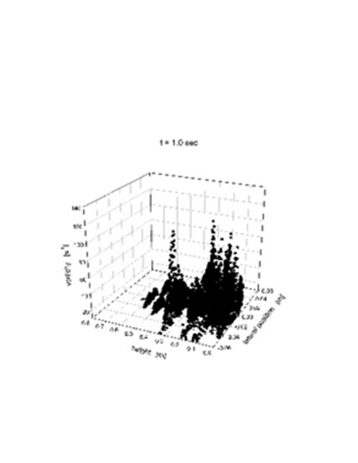
- Results: dust cloud from the standard pellet falling on monolayer of 1μm silica particles
In this section, we discuss the evolution of the dust cloud generated by the impact of the standard pellet disk (R = 4 mm, t = 3 mm) on a monolayer of 1 μm silica particles. The dust cloud develops with time, as shown in Figure 5. For the purposes of the simulation, dustiness is operationally defined as the fraction of particles that are lofted above y = 5 mm. Figure S-9 displays the dustiness as a function of time.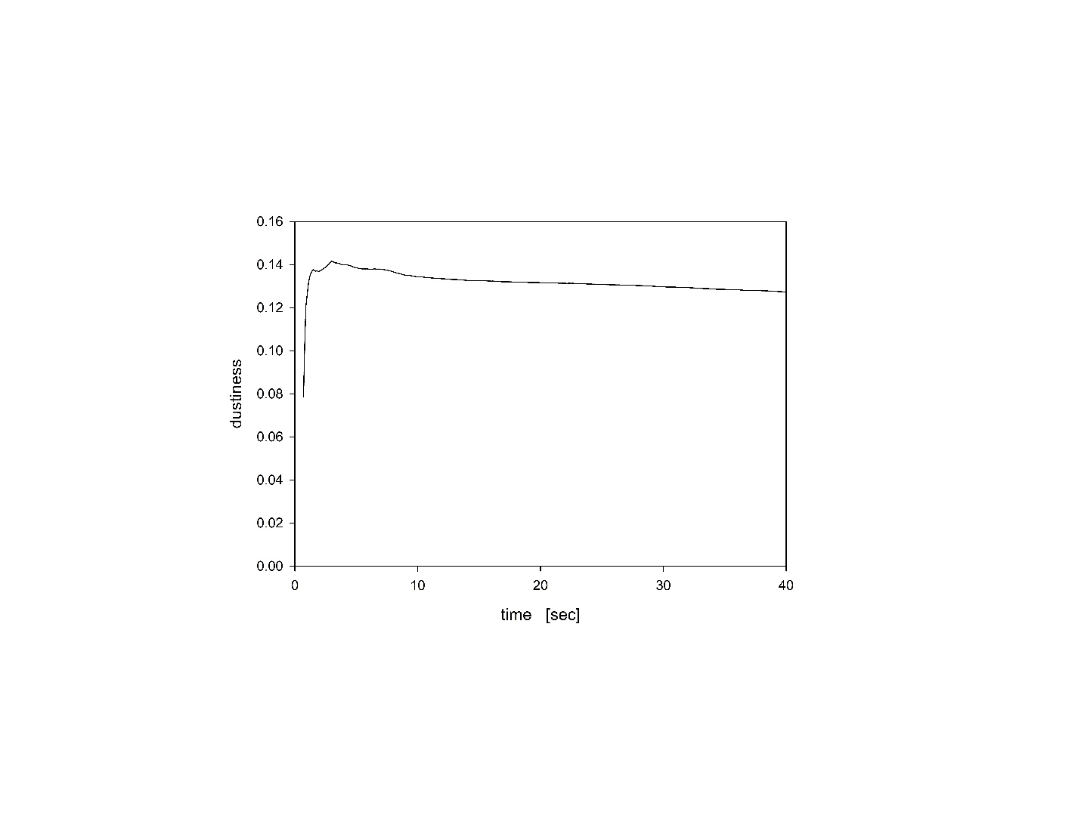
Figure S-9. Dustiness as a function of time for a monolayer of 1 μm particles lofted by the impact of the standard pellet disk.

Within 0.5 sec of impact, 14% of the monolayer has been aerosolized (note that the magnitude of this fraction is somewhat arbitrary, as it would be reduced for a chamber of larger base size). Due to their small size, the particles remain suspended for the duration of the simulation (40 sec).

Figure S-10 displays the height of the dust cloud.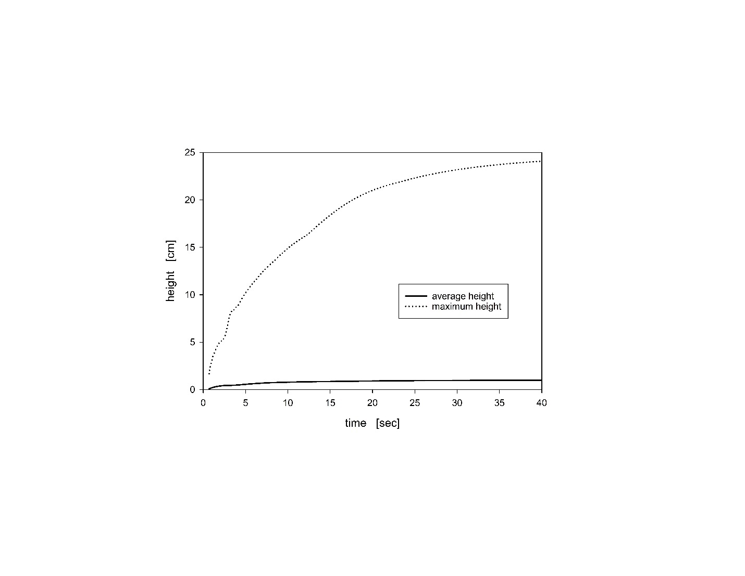Figure S-10. Average and maximum heights of the dust cloud, as a function of time, for a monolayer of 1 μm particles lofted by the impact of the standard pellet disk.

The maximum height (height of the highest particle) is approximately twenty times the average height (averaging the height over all particles). This indicates that the dust cloud density decreases with height, as expected. It also indicates that the dust cloud is not vertically well-mixed over its entire height. The constancy of that ratio suggests that the structure of the dust cloud does not change with time.

Figure S-11 displays the average radius of the dust cloud (averaging the radial location over all particles).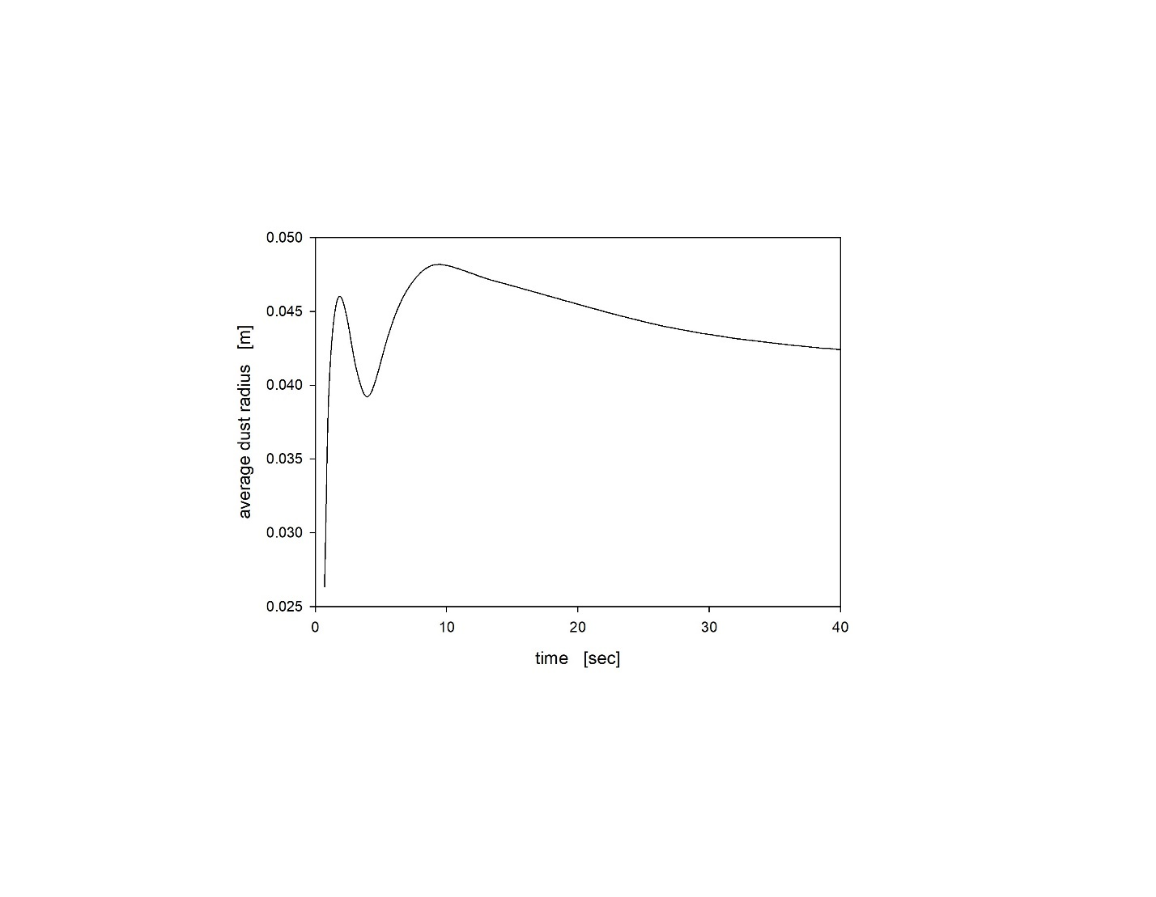
Figure S-11. Average radius of the dust cloud, as a function of time, for a monolayer of 1 μm particles lofted by the impact of the standard pellet disk.

Within 0.5 sec, the extent of the dust cloud quickly expands to 4.5 cm, which is an order of magnitude larger than the disk radius, and seems to be limited by the confining walls of the chamber; we cannot measure the intrinsic radius (with no confining chamber walls) of the dust cloud in these simulations. The small undulation for 2 sec < t < 6 sec suggests that while the cloud is initially propelled outward, it undergoes a minor retraction during this time interval (possibly driven by the motion of the vortex ring detaching from the fallen disk).

We have also tracked (Figure S-12) the centroid trajectory of the cloud resuspended from each of the annular monolayers described in Section 3.2.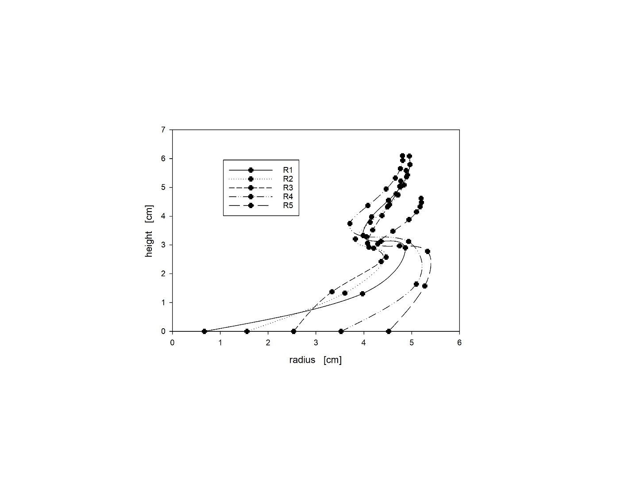
Figure S-12. Trajectories of sector dust cloud centroids—the lowest values are the sector centroid prior to lofting (t = 0).

Each annulus, once resuspended, is propelled radially outward as lofting progresses. Each annulus experiences a retraction (2 sec < t < 4 sec) before it resumes expansion and lofting. For t > 4 sec, the trajectories of all but the outermost annulus coincide, suggesting radial mixing of the particles originating from these different annuli.

- Variation in pellet size
We have conducted simulations for different size pellets to determine variation in the dust cloud due to variations in pellet geometry. 1 μm particles are uniformly distributed at the bottom of the chamber at an equal distance of 0.5 mm in both directions. The particle count is 57,121 which is the same as for the particle size study. Simulations are conducted with changes in radius and thickness. Dustiness and average characteristics of dust clouds are evaluated and compared globally as well as for different sections.

We first investigate variations in disk radius (R = 4, 6, 8 mm) with a constant disk thickness (t = 3 mm). Dustiness (Figure S-13) increases monotonically with disk radius. This is consistent with Heitbrink’s observation that dustiness increases with pellet size. Since dustiness is bounded both from below (dustiness must vanish for zero disk radius) and from above (dustiness cannot exceed unity for large disk radius), dustiness cannot scale algebraically with disk radius.
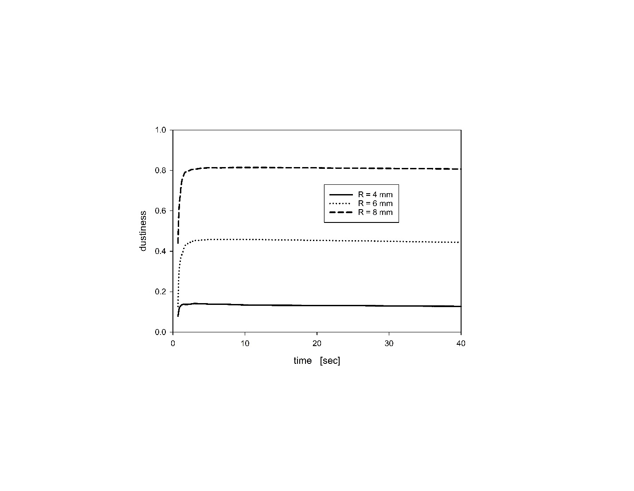
Figure S-13. Dustiness for 1 μm particles lofted by falling pellet disk of different radii (R = 4, 6, 8 mm), all with t = 3 mm.

The disk radius affects the average radius of the dust cloud during the early stage of the simulation. The larger the disk radius, the sooner the dust cloud reaches its largest average radius. Yet, after 10 sec, the dust clouds lofted by all three disks stabilize to a similar dust cloud average radius. This supports the speculation that the radial extent of the dust cloud is limited in our simulations by the confining walls of the chamber. The disk radius also influences the average height of the dust cloud, again with the larger pellet more quickly lofting the dust cloud. Both effects contribute to very similar dust cloud centroid trajectories (Figure S-14), but with the larger pellet inducing a quicker dust cloud elevation.
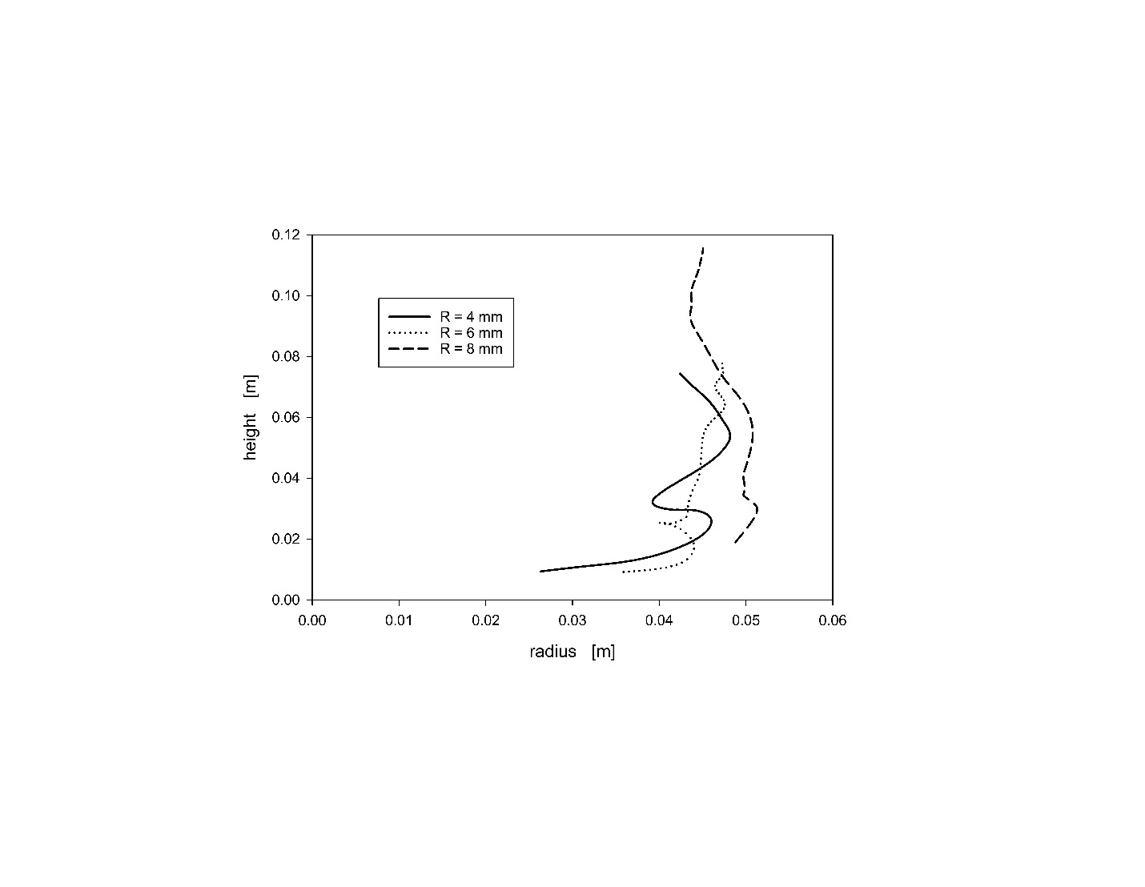
Figure S-14. Dust cloud centroid trajectory for 1 μm particles lofted by falling pellet disk of different radii (R = 4, 6, 8 mm), all with t = 3 mm.

Figures S-15 show the difference in airflow generated by the impact of disks of different radii. As expected, when the disk radius is increased, the secondary flow gets stronger, with an increase in both maximum air velocity and area covered by the secondary flow. The increase in both strength and coverage of the secondary flow enhances dust generation.

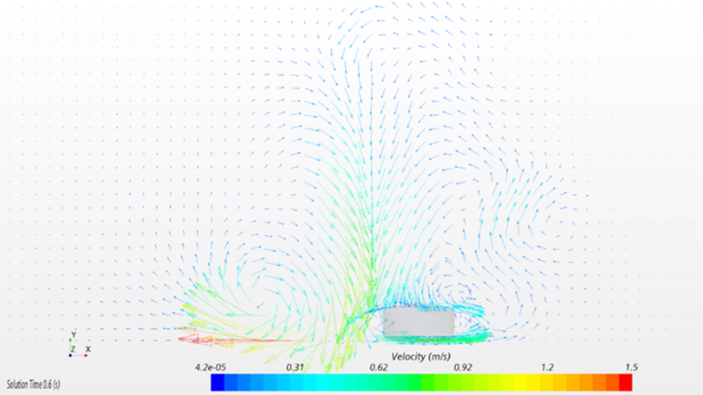
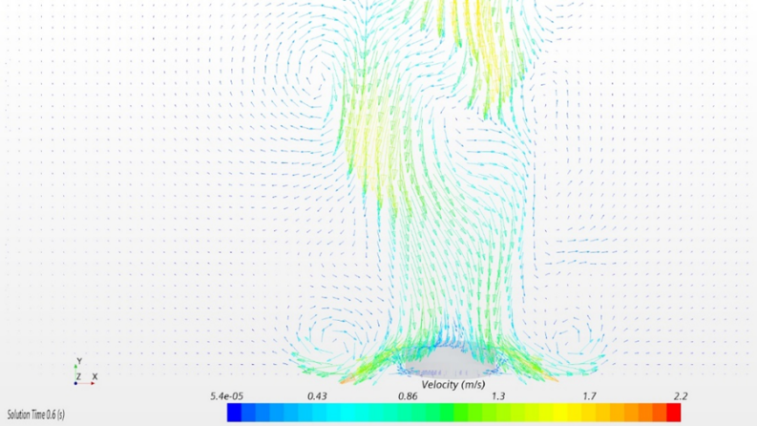
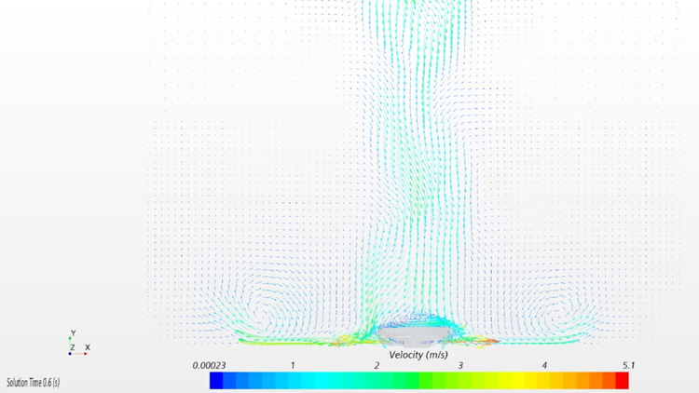

Figure S-15. Air flow generated by falling pellet at t = 0.6 sec for disks of different radii all with thickness t = 3 mm: a) R = 4 mm; b) R = 6 mm; c) R = 8 mm.

We next investigate variations in disk thickness (t = 1, 2, 3, 4, 5 mm) with a constant disk radius (R = 4 mm). Dustiness does not increase monotonically with disk thickness (Figure S-16). While the dustiness must still be bounded between 0 and 1, an infinitely thin disk of this radius might still generate a finite dustiness, and similarly a very long cylinder might not achieve unit dustiness. The reduced dustiness at intermediate thickness (t = 3 mm R = 4 mm) probably reflects a special backflow profile which arises from ‘matching’ radius and thickness.
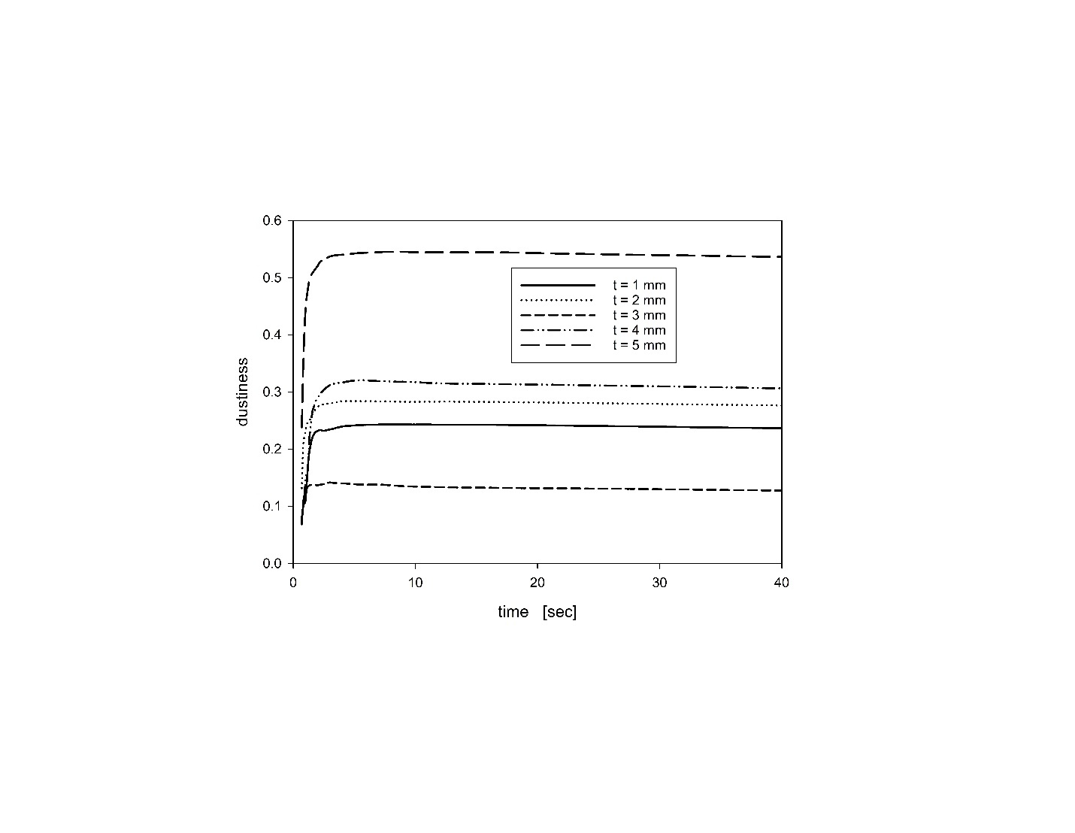
Figure S-16. Dustiness for 1 μm particles lofted by falling pellet disk of different thicknesses (t = 1, 2, 3, 4, 5 mm), all with disk radius R = 4 mm.

The long time height of the dust clouds varies with disk thickness, with the thickest disk (t = 5 mm) generating the highest average height and the thinnest disk (t = 1 mm) thickness cases show the lowest height. At short time (t < 5 sec), the thickest disk (t = 5 mm) generates the quickest lofting, and the thinnest disk generates the slowest lofting. Both long and short time differences in vertical motion duration contribute to differences in dustiness cloud average height. Disk thickness has a limited effect on the dust cloud radius. As a result, all disks generate qualitatively similar dust cloud centroid trajectories (Figure S-17), but with the thicker disks inducing higher dust clouds.
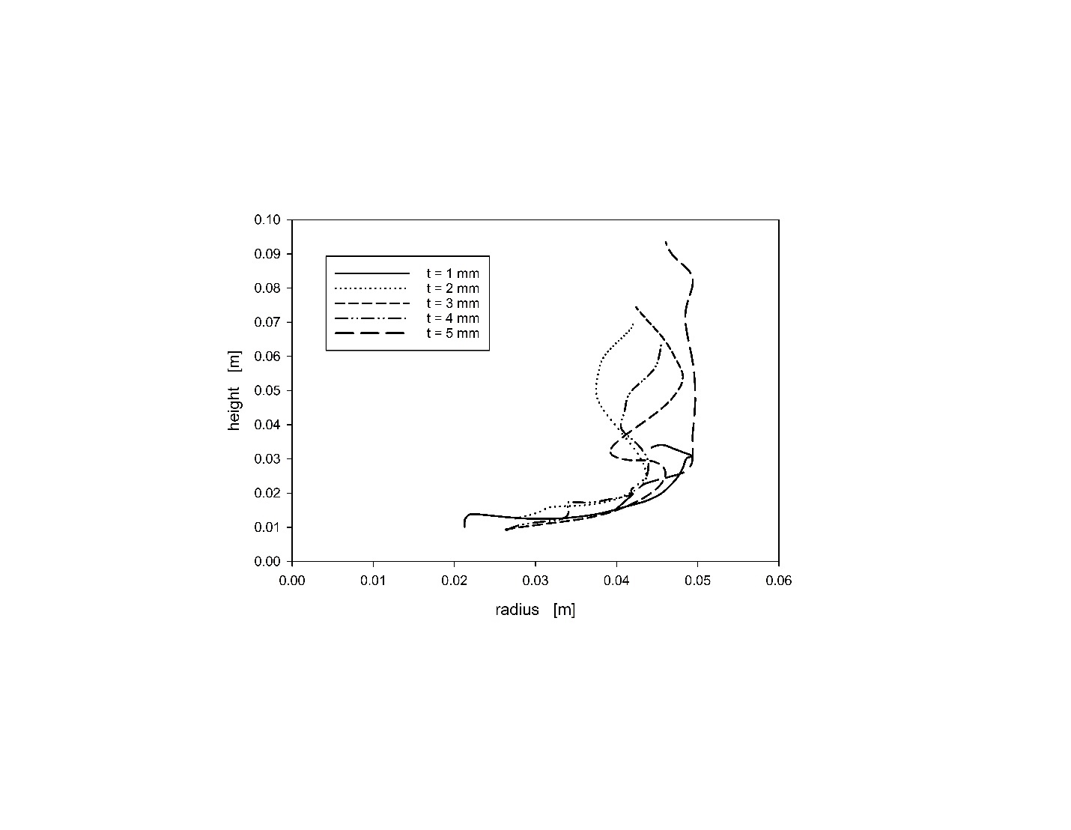
Figure S-17. Dust cloud centroid trajectory for 1 μm particles lofted by falling pellet disk of different thicknesses (t = 1, 2, 3, 4, 5 mm), all with R = 4 mm.

Figures S-18 display the air flow motion around the pellet disk immediately after impact (t = 0.6 sec). The vortex ring can be seen emanating out from the disk along the bottom surface. The strength of the flow (maximum velocity) and the area covered by the secondary flow are hardly affected by the increase in disk thickness. The symmetry of the vortex shedding behind the disk may depend on the disk thickness, but this is not anticipated to affect the dust lofting from the surface.
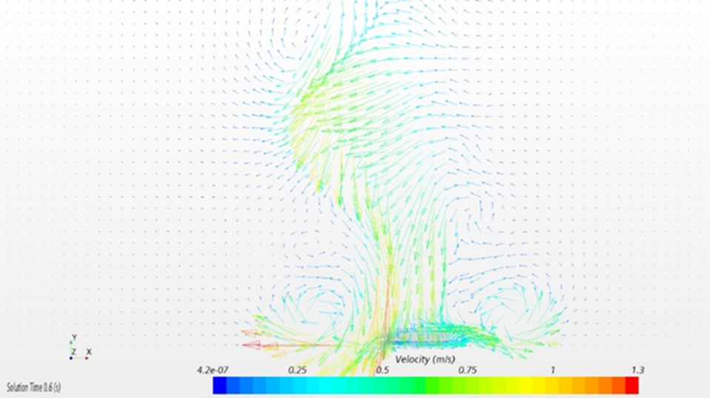
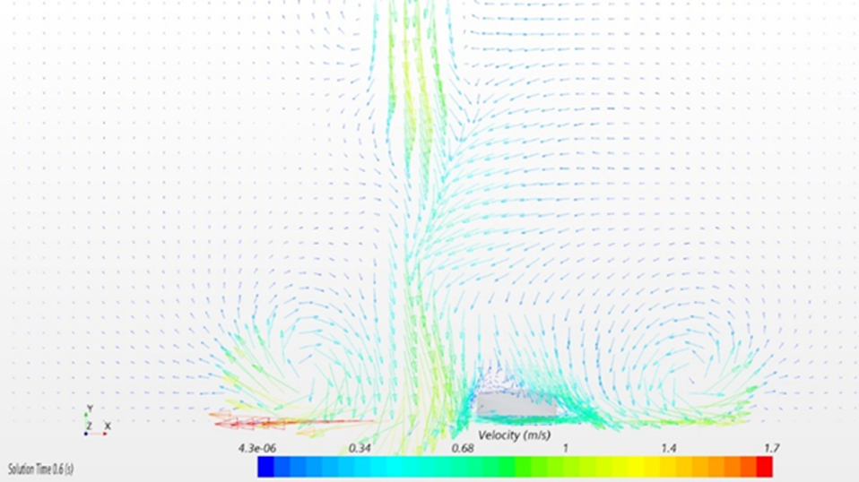
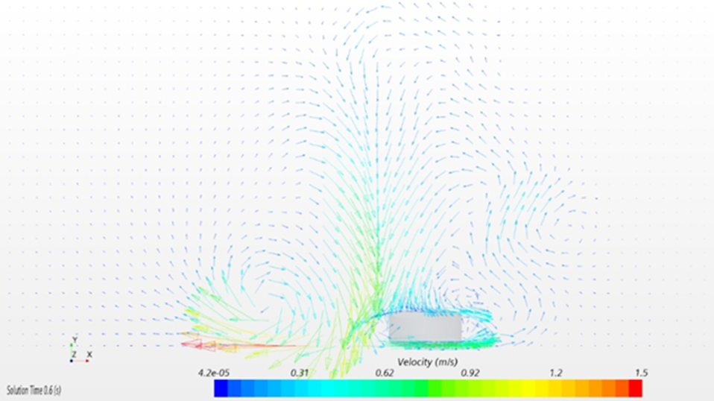
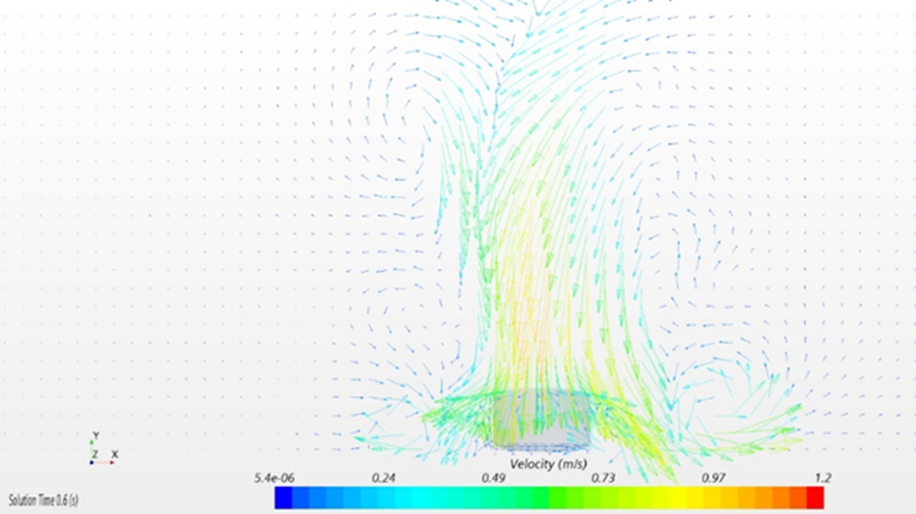
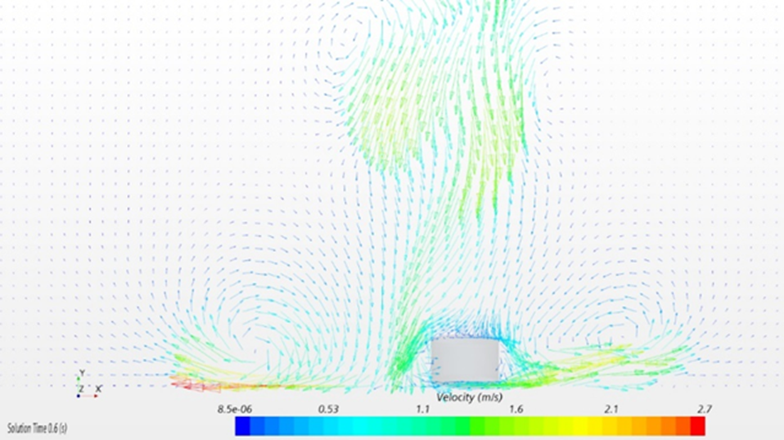
Figure S-18. Air flow generated by falling pellet disk at t = 0.6 sec for disks of different thicknesses all with radius R = 4 mm: a) t = 1 mm; b) t = 2 mm; c) t = 3 mm; d) t = 4 mm; e) t = 5 mm.

