Supplement

Supplemental Methods

Imputation of WIC eligibility
To impute WIC eligibility, we used the US Census Bureau’s Current Population Survey (CPS) Annual Social and Economic Supplement data from 2003 to 2019, for states in our final sample. Within each survey year, we selected a sample of women having infants (i.e., children under age 1). Note that the CPS is collected in the spring but asks about income during the previous calendar year; it also does not ask about pregnancy, so this was a proxy for having given birth in the previous calendar year as those who have a 0-year-old in March likely had an infant in the previous calendar year. Based on USDA criteria for WIC eligibility, a woman with an infant was considered WIC-eligible if her household income for the previous calendar year (when she was likely pregnant) was below 185% of the Federal Poverty Guideline based on private and public income for that year for her family,(United States Department of Agriculture) or if she reported using Medicaid, the Supplemental Nutrition Assistance Program (SNAP), or Temporary Assistance to Needy Families (TANF), which provide adjunctive eligibility for WIC (i.e., one is WIC-eligible if one participates in these programs).(Bitler & Seifoddini, 2019) We then employed a logistic regression model to create estimates to predict WIC eligibility in these CPS data, based on individual characteristics also available in the birth certificate data: age, race/ethnicity, education, marital status, nativity, and the number of coresident children (as a proxy for birth parity), interactions among these characteristics, as well as fixed effects (i.e., indicator variables) for state and year. Finally, these parameters obtained from the CPS were employed to predict WIC eligibility for women in the birth certificate data. A woman was categorized as WIC-eligible if her predicted probability of being WIC-eligible was greater than 0.5; otherwise, she was classified as WIC-ineligible. To gauge the accuracy of this predicted WIC eligibility, we compared it with the data from years when WIC participation during pregnancy was reported in the birth certificate data. About 70% of predicted WIC-eligible women self-reported using WIC, compared with 16% of predicted WIC-ineligible mothers.

DID assumptions
DID analysis relies on several assumptions. One is that trends in outcomes would be the same for treatment and control groups in the absence of the intervention, known as the “parallel trends assumption”. Although this counterfactual scenario cannot be directly tested, assessing whether trends are parallel in treatment and control groups during the pre-intervention period provides an indication of the validity of the assumption (i.e., a necessary but insufficient condition).
To do so, we first graphically compared the trends of each outcome for WIC-eligible and WIC-ineligible mothers over time. Figure 2 suggested parallel trends among WIC-eligible and WIC-ineligible mothers before the 2009 revision for each of the outcomes.
We also tested the assumption quantitatively, by conducting event-study analyses; these involved regressing outcomes on the interaction of WIC eligibility with a set of leads and lags relative to the event time (e.g., -2, -1, 0, 1, 2 months from the end of 2009).(Clarke & Tapia-Schythe, 2021; Miller, 2023) By comparing outcomes in different periods with the baseline reference period, the coefficients on the leads and lags allow for estimation and visual presentation of the differential policy effect between WIC-eligible and WIC-ineligible mothers over time. Statistically insignificant coefficients of interaction terms with leads (i.e., the pre-treatment period) would suggest that the parallel trends assumption was satisfied. As shown in Figure S2, the estimated effects for some but not all pre-treatment periods were significantly different from zero for several outcomes, primarily birthweight and GWG, indicating a potential violation of parallel trend assumption, although no consistent deviations were observed. The results should therefore be interpreted cautiously. We do note however, the magnitude of these coefficients is small. For example, the largest estimated effect for birth weight in pre-treatment periods is 20 grams, equivalents to 0.6% of the baseline mean. Additionally, the estimated confidence intervals may be understated due to the fact that we are treating the observations as independent rather than clustering them by geographic locations. Individuals within geographic locations are likely to be more similar than individuals drawn at random. We tested the sensitivity of our results by clustering standard errors by state, even though this is not standard practice as standard errors are typically clustered at the level of the treatment. The results with clustering are reported in Figure S3 and Table S3. Clustering by state reduced the parallel trends violation, as more estimated coefficients for pre-treatment periods were insignificant for birthweight and GWG (Figure S3). However, the assumption is still violated to some extent. Table S3 shows that our main result for birthweight remained robust to clustering, while the results for SGA and GWG were no longer significant. We additionally applied a recently developed method to test the sensitivity of our results to possible violations of the parallel trends assumption (i.e., the “HonestDiD” method described in the sensitivity test section below).A second assumption is no differential compositional changes among the treatment and control group over time that might contribute to observed differences. We examined this assumption by running regressions with individual characteristics as the dependent variables in the models. All estimated coefficients are statistically significant, again likely due to the large sample size. This concern has been addressed by adjusting for those characteristics in our regression models to minimize the potential for confounding. In addition, DID analysis also relies on the assumption that no other policies changed at the same time as our policy of interest and there were no anticipation effects. To our knowledge, no other relevant WIC policies changing at the same time, and any policy changes about the Great Recession including changes in the maximum food stamp allotment were national and accounted for in our models using time fixed effects. We also note that in the main design, we are estimating the effects of the WIC revision, with treatment turning on at a single point in time. Thus, concerns raised about contamination of the estimate pre-trends or bias caused if there is heterogeneity in the effects of treatment by timing and cross-sectional unit of adoption are not relevant for the main analysis.(Callaway & Sant’Anna, 2021; De Chaisemartin & D’Haultfoeuille, 2020; Sun & Abraham, 2021)

Sensitivity tests
First, we considered a higher threshold for the imputed cutoff of WIC eligibility, classifying women as WIC-eligible if the predicted probability of being eligible was greater than 0.8, and then running the same DID analysis. Second, we recoded the post-period to April 2009, using the cutoff date of the earliest adopting states to define exposure (New York and Delaware adopted the new package in January 2009, therefore second trimester started in April 2009). Third, we included different lengths of pre-treatment periods in the main model. Specifically, we ran the analogous analyses on two additional samples: (1) including mothers who lived in states that implemented the new birth certificate in or before 2007, which allowed us to include one more year of pre-revision periods but reduced the number of states in the analysis to 24; and (2) including mothers who lived in states that implemented the new birth certificate in or before 2006, which allowed us to include two more year of pre-revision periods but reduced the number of states in the analysis to 18. Finally, we conducted HonestDiD analysis,(Rambachan & Roth, 2023) a recently developed method for assessing the sensitivity of treatment effects to potential violations of the parallel trends assumption. The method imposes restrictions that bound the magnitude of post-treatment violations of parallel trends to be $\overline{M}$ times the maximum violation observed in the pre-treatment period. Sensitivity tests are then performed to assess the robustness of the treatment effect across a range of values of $\overline{M}$. Conclusions can be drawn about the robustness of the result, allowing for violations of parallel trends up to $\overline{M}$ times the maximum violation in the pre-treatment period (known as the “breakdown value”).

We additionally examined of an additional generalized DID analysis to leverage the staggered timing of adoption of the WIC food package across states. The additional generalized DID model (or “Two-way fixed effects” model) was implemented by running the following regression among the predicted WIC-eligible women:

$$Y_{ist}= {\text{β}}_{0}+{\text{β}}_{1}{\text{T}}_{ijt}+{\text{β}}_{2}{\text{X}}_{ist}+{\text{β}}_{3}{\text{Z}}_{st}+{\text{β}}_{4}{State}_{s}+{{\text{β}}_{5}{\text{Time}}_{t}+ε}_{ist}$$

$Y_{ist}$ represents an outcome of interest, and ${\text{T}}_{ijt}$ is a dummy variable, which indicates whether the woman’s second trimester occurred after the month when her state implemented the new food package. ${\text{X}}_{ist}$ represents individual-level covariates. ${\text{Z}}_{st}$ represents time-variant state-level covariates. ${Time}_{t}$ represents indicator variables for the start of the second trimester (in month-year) and ${\text{State}}_{s}$ represents fixed effects for each woman’s state of residence. Standard errors were clustered at the state level to account for correlated observations within a state. ${\text{β}}_{1}$ is the coefficient of interest, which represents the change in outcome attributable to the implementation of the new food package.

Results of sensitivity analyses
Our primary findings were robust to most of the sensitivity tests performed. First, the majority of primary findings remained consistent when using a higher cutoff for the predicted probability of predicted WIC eligibility, with the exception of GWG, which shows the revision was associated with a small increase in GWG (Supplemental Table S4). Second, the results remained robust when we recoded the post-period to begin in April 2009 (Supplemental Table S5). Third, results using different lengths of pre-treatment periods showed consistent effects on birthweight, SGA, and AGA for infants and GWG for women in line with our primary results (Supplemental Table S6). However, the HonestDiD analysis indicated that our results might be sensitive to potential violations of the parallel trends assumption. Specifically, the “breakdown value” for GWG was only approximately 0.04, meaning that the significant result is robust when only allowing for violations of parallel trends up to 0.04 times the maximum violation in the pre-treatment period (Supplemental Figure S4). Of note, the HonestDiD method tests the sensitivity of event study estimates (e.g., average of post-treatment coefficients), which do not exactly correspond to the simple DiD results reported in the main manuscript. For example, our primary findings on birthweight and SGA were no longer significant when aggregating the event study estimates. Because of this discrepancy, the HonestDiD results are not directly comparable to our main analysis. Nevertheless, our main results should be interpreted with caution, as emphasized in the main manuscript. Finally, generalized DID analyses were not implemented eventually as we detected clear violations of parallel trends assumption for all outcomes (Supplemental Figure S5).

Examining the mechanism: effects on WIC participation
We also explored participation in WIC by pregnant women in order to understand if the new package’s availability increased participation in the program, akin to a “first stage” analysis.
We used administrative data on the monthly count of pregnant women WIC participants generously provided by the USDA Food and Nutrition Service, the federal agency responsible for administering the nation’s domestic nutrition assistance programs. Since we only had aggregate WIC participation for pregnant women by state and time (i.e., month-year), we leveraged the geographical and temporal variation in the adoption of the new package to investigate the effect of the WIC revision on overall WIC participation among pregnant women. In this context, the exposure is the adoption status of the new package given a particular state and time, rather than predicted eligibility used in the main analysis.
Our key dependent variable—WIC participation rate of pregnant women—was calculated as the ratio of the number of pregnant women participating in WIC to the number of total births (by month-year and state), where the number of births was total births in the past 6 months (including this month). The denominator was the number of births instead of the number of pregnant women, because there were not easily available estimates for the number of pregnant women by state and year-month. This ratio is a rough measure of the participation rate of pregnant women (considering the small shares of miscarriages and stillbirths and multiple births). The key independent variable was the implementation of the new package in a given state, month, and year. Control variables were state and month-by-year fixed effects, as well as time-varying state covariates that were included in the main analysis.
Analytic samples were restricted to the same states and years as in the main analysis. Each observation represents a state-year-month cell, the regressions were weighted by the number of births, and standard error clustering was implemented at the state level to account for correlated observations within state. Results were shown in Table S7, with the key coefficient multiplied by 100. Overall, adoption of the new package was not associated with a statistically significant increase in participation by pregnant women, and the point estimates are quite small.
Supplemental Figures and Tables

Figure S1. Sample selection flowchart

Figure S2. Quantitative examination of the parallel trends assumption (event study analyses) for the standard DID design

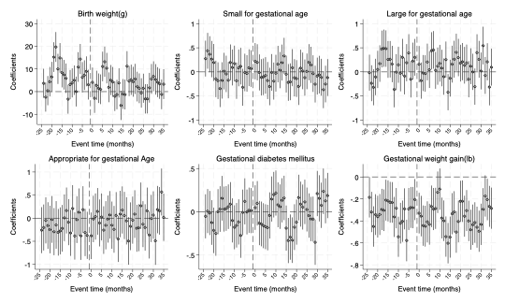

Abbreviations: SNAP: Supplemental Nutrition Assistance Program; TANF: Temporary Assistance for Needy Families; EITC: Earned Income Tax Credit
Note: Data were drawn from 2008-2012 US birth certificates (N = 11,855,417 women in 27 states). WIC eligibility was imputed using self-reported demographics. Coefficients for binary outcomes were multiplied by 100 and therefore represent a change in percentage points. Binary outcomes include small/large/appropriate for gestational age, and gestational diabetes. All models include individual characteristics (mother's age, race/ethnicity, nativity, education, marital status, and parity), state characteristics (birth rate, unemployment rate, % SNAP/capita, % TANF/capita, EITC rate, and Medicaid income eligibility threshold), and fixed effects for the month when a woman’s second trimester started and state. Robust standard errors were used to address possible heteroskedasticity. Dashed vertical lines represent the baseline event time, i.e., one month before the policy change.

Figure S3. Quantitative examination of the parallel trends assumption (event study analyses) for the standard DID design (with standard errors clustered by state)

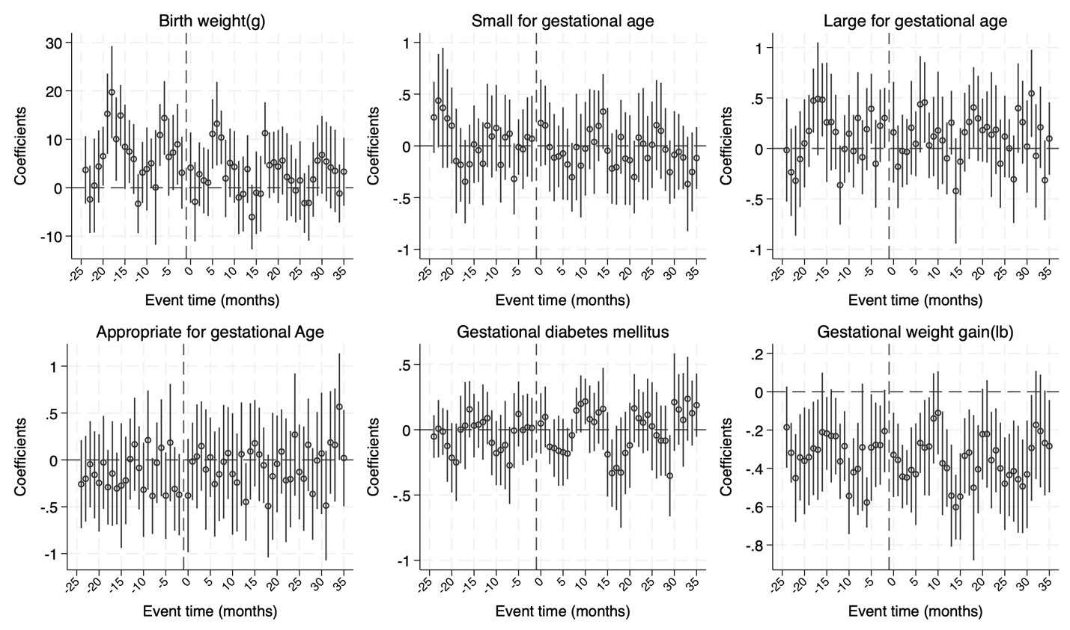

Abbreviations: SNAP: Supplemental Nutrition Assistance Program; TANF: Temporary Assistance for Needy Families; EITC: Earned Income Tax Credit
Note: Data were drawn from 2008-2012 US birth certificates (N = 11,855,417 women in 27 states). WIC eligibility was imputed using self-reported demographics. Coefficients for binary outcomes were multiplied by 100 and therefore represent a change in percentage points. Binary outcomes include small/large/appropriate for gestational age, and gestational diabetes. All models include individual characteristics (mother's age, race/ethnicity, nativity, education, marital status, and parity), state characteristics (birth rate, unemployment rate, % SNAP/capita, % TANF/capita, EITC rate, and Medicaid income eligibility threshold), and fixed effects for the month when a woman’s second trimester started and state. Dashed vertical lines represent the baseline event time, i.e., one month before the policy change.

Figure S4. Sensitivity Analysis for potential violations of the parallel trends assumption (“HonestDiD”)

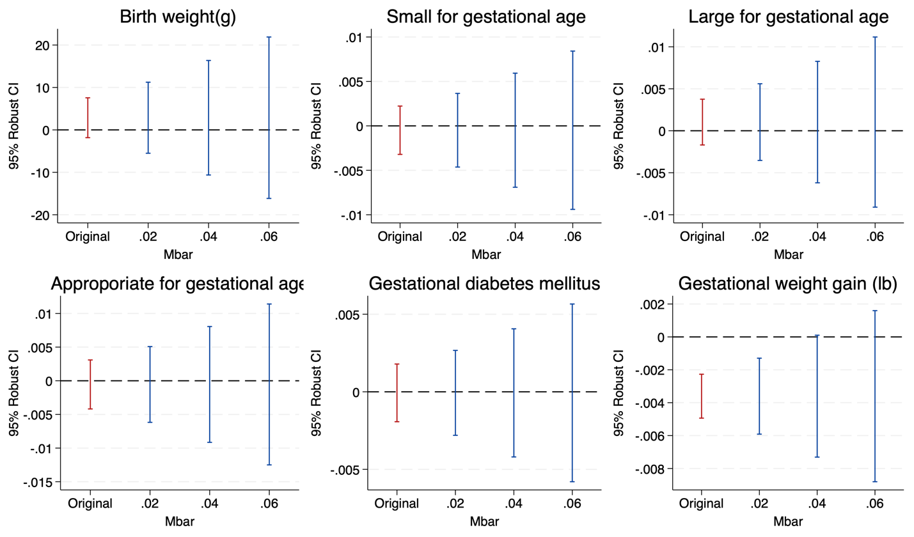

Abbreviations: SNAP: Supplemental Nutrition Assistance Program; TANF: Temporary Assistance for Needy Families; EITC: Earned Income Tax Credit
Note: Data were drawn from 2008-2012 US birth certificates (N = 11,855,417 women in 27 states). WIC eligibility was imputed using self-reported demographics. Coefficients for binary outcomes were multiplied by 100 and therefore represent a change in percentage points. Binary outcomes include small/large/appropriate for gestational age, and gestational diabetes. All models include individual characteristics (mother's age, race/ethnicity, nativity, education, marital status, and parity), state characteristics (birth rate, unemployment rate, % SNAP/capita, % TANF/capita, EITC rate, and Medicaid income eligibility threshold), and fixed effects for the month when a woman’s second trimester started and state. Robust standard errors were used to address possible heteroskedasticity. Dashed vertical lines represent the baseline event time, i.e., one month before the policy change.

Figure S5. Quantitative examination of the parallel trends assumption (event study analyses) for the staggered DID design

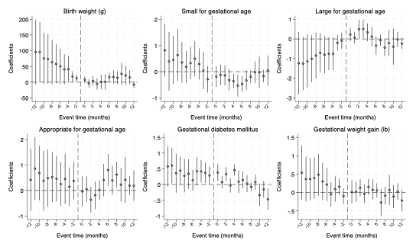

Abbreviations: SNAP: Supplemental Nutrition Assistance Program; TANF: Temporary Assistance for Needy Families; EITC: Earned Income Tax Credit
Note: Data were drawn from 2008-2012 US birth certificates (N = 11,855,417 women in 27 states). WIC eligibility was imputed using self-reported demographics. Sample was further limited to predicted WIC eligible women and a balanced panel for 12 months within the policy change. Coefficients for binary outcomes were multiplied by 100 and therefore represent a change in percentage points. Binary variables include small/large/appropriate for gestational age and gestational diabetes mellitus. All models include individual characteristics (mother's age, race/ethnicity, nativity, education, marital status, and parity), state characteristics (birth rate, unemployment rate, % SNAP/capita, % TANF/capita, EITC rate, and Medicaid income eligibility threshold), and fixed effects for the month when a woman’s second trimester started and state. Robust standard errors were used to address possible heteroskedasticity. Dashed vertical lines represent the baseline event time, i.e., one month before the policy change.

Table S1. States implementing the revised birth certificate, between 2003 and 2016
Year | States
2003 | PA, WA
2004 | FL, ID, KY, NH, NY, SC, TN
2005 | KS, NE, TX, UT, VT
2006 | CA, DE, OH, SD, WY
2007 | CO, GA, IN, IA, MI
2008 | NV, NM, MT, OR
2009 | DC, ND, OK, UT
2010 | IL, LA, MD, MO, NC
2011 | MA, MN, WI
2012 | VA
2013 | AK, ME, MS
2014 | AL, AZ, AR, HI, NJ, RI, WV
2015
2016 | CT
Note: Most states implemented the revised birth certificate as of January 1st of a given year. New York City implemented the revised birth certificate in 2008 separately from the rest of New York state.

Table S2. States implementing WIC revision in 2009
Month | States
January | NY, DE
February
March
April
May | KY, SC
June | CO
July | UT
August | IL, KS, MI, OK, OR, WT
September | MN, SD
October | All others
November
December | MT
Note: The above summary was obtained from Oh et al., (2016).

Table S3. Association of Revised WIC Food Package with Infant and Maternal Health (with standard errors clustered by state)
 | Birthweight (grams) | Small for gestational age | Large for gestational age | Appropriate for gestational age | Gestational diabetes mellitus | Gestational weight gain (pounds)
WIC-eligible*Post-2009 | -3.521*** | -0.081 | -0.004 | 0.085 | 0.032 | -0.053
WIC-eligible*Post-2009 | [-5.288,-1.754] | [-0.182,0.020] | [-0.088,0.081] | [-0.024,0.193] | [-0.083,0.147] | [-0.168,0.061]
N | 11,855,417 | 11,855,417 | 11,855,417 | 11,855,417 | 11,824,402 | 11,246,710
Baseline mean or % | 3,248 | 12.0 | 9.6 | 78.4 | 3.8 | 29.7
95% confidence intervals in brackets. * p < 0.05, ** p < 0.01, *** p < 0.001
Notes: Data were drawn from 2008-2012 US birth certificates (N = 11,855,417 women in 27 states). WIC eligibility was imputed using self-reported demographics. Coefficients for binary outcomes were multiplied by 100 and therefore represent a change in percentage points. All models include individual characteristics (mother's age, race/ethnicity, nativity, education, marital status, and parity), state characteristics (birth rate, unemployment rate, % SNAP/capita, % AFDC/capita, EITC rate, and Medicaid income eligibility threshold), and fixed effects for time (year-month) and state. Baseline mean or % represents mean or % of outcomes among WIC-eligible mothers before the 2009 WIC revision.

Table S4. Association of Revised WIC Food Package with Infant and Maternal Health, sensitivity test using alternative WIC eligibility threshold
 | Birth weight (1000 grams) | Small for gestational age | Large for gestational age | Appropriate for gestational age | Gestational diabetes mellitus | Gestational weight gain (pound)
WIC-eligible*Post-2009 | -3.017*** | -0.072 | -0.065 | 0.138** | 0.042 | 0.054**
WIC-eligible*Post-2009 | [-4.302,-1.733] | [-0.147,0.002] | [-0.140,0.009] | [0.038,0.237] | [-0.009,0.093] | [0.017,0.090]
N | 11,855,417 | 11,855,417 | 11,855,417 | 11,855,417 | 11,824,402 | 11,246,710
Baseline mean or % | 3,225 | 12.7 | 9.3 | 78.0 | 3.5 | 29.0
95% confidence intervals in brackets; * p < 0.05, ** p < 0.01, *** p < 0.001
Abbreviations: SNAP: Supplemental Nutrition Assistance Program; TANF: Temporary Assistance for Needy Families; EITC: Earned Income Tax Credit
Notes: Data were drawn from 2008-2012 US birth certificates (N = 11,855,417 women in 27 states). WIC eligibility was imputed using self-reported demographics. WIC-eligible was defined as having a predicted probability of being eligible greater than or equal to 0.8. Coefficients for binary outcomes were multiplied by 100 and therefore represent a change in percentage points. Binary variables include small/large/appropriate for gestational age and gestational diabetes mellitus. All models include individual characteristics (mother's age, race/ethnicity, nativity, education, marital status, and parity), state characteristics (birth rate, unemployment rate, % SNAP/capita, % TANF/capita, EITC rate, and Medicaid income eligibility threshold), and fixed effects for time (year-month) and state. Robust standard errors were used to address possible heteroskedasticity. Baseline mean or % represents mean or % of outcomes among WIC-eligible mothers before the 2009 WIC revision.

Table S5. Association of Revised WIC Food Package with Infant and Maternal Health, sensitivity test with post-period recoded to April 2009
 | Birth weight (1000 grams) | Small for gestational age | Large for gestational age | Appropriate for gestational age | Gestational diabetes mellitus | Gestational weight gain (pound)
WIC-eligible*Post-2009 | -2.425*** | -0.095* | 0.007 | 0.087 | 0.037 | -0.024
WIC-eligible*Post-2009 | [-3.748,-1.103] | [-0.171,-0.018] | [-0.070,0.084] | [-0.015,0.190] | [-0.015,0.090] | [-0.062,0.014]
N | 11,855,417 | 11,855,417 | 11,855,417 | 11,855,417 | 11,824,402 | 11,246,710
Baseline mean or % | 3,248 | 12.0 | 9.6 | 78.4 | 3.7 | 29.7
95% confidence intervals in brackets. * p < 0.05, ** p < 0.01, *** p < 0.001
Abbreviations: SNAP: Supplemental Nutrition Assistance Program; TANF: Temporary Assistance for Needy Families; EITC: Earned Income Tax Credit
Notes: Data were drawn from 2008-2012 US birth certificates (N = 11,855,417 women in 27 states). WIC eligibility was imputed using self-reported demographics. Coefficients for binary outcomes were multiplied by 100 and therefore represent a change in percentage points. Binary variables include small/large/appropriate for gestational age and gestational diabetes mellitus. All models include individual characteristics (mother's age, race/ethnicity, nativity, education, marital status, and parity), state characteristics (birth rate, unemployment rate, % SNAP/capita, % TANF/capita, EITC rate, and Medicaid income eligibility threshold), and fixed effects for time (year-month) and state. Robust standard errors were used to address possible heteroscedasticity. Baseline mean or % represents mean or % of outcomes among WIC-eligible mothers before the 2009 WIC revision.

Table S6. Association of Revised WIC Food Package with Infant and Maternal Health, sensitivity test using different lengths of pre-treatment periods
 |  | Birthweight  (1000 grams) |  | Small for gestational age | Large for gestational age | Appropriate for gestational age | Gestational diabetes mellitus | Gestational weight gain  (pounds)
Sample A
WIC-eligible*Post-2009 | -3.514*** |  | -0.074* |  | -0.005 | 0.08 | 0.029 | -0.061***
WIC-eligible*Post-2009 | [-4.766,-2.262] |  | [-0.147,-0.002] |  | [-0.078,0.067] | [-0.017,0.177] | [-0.021,0.078] | [-0.096,-0.025]
N | 11,329,056 |  | 11,329,056 |  | 11,329,056 | 11,329,056 | 11,298,207 | 10,745,245
Baseline mean | 3,247 |  | 12.0 |  | 9.6 | 78.4 | 3.8 | 29.7
Sample B
WIC-eligible*Post-2009 |  | -3.342*** |  | -0.100* | 0.022 | 0.078 | 0.078** | -0.055**
 |  | [-4.716,-1.968] |  | [-0.179,-0.021] | [-0.058,0.102] | [-0.028,0.184] | [0.024,0.133] | [-0.093,-0.016]
N |  | 9,418,976 |  | 9,418,976 | 9,418,976 | 9,418,976 | 9,404,136 | 8,964,003
Baseline mean |  | 3,252 |  | 11.8 | 9.7 | 78.5 | 3.8 | 29.7
95% confidence intervals in brackets. * p < 0.05, ** p < 0.01, *** p < 0.001
Abbreviations: SNAP: Supplemental Nutrition Assistance Program; TANF: Temporary Assistance for Needy Families; EITC: Earned Income Tax Credit
Notes: Data were drawn from 2008-2012 US birth certificates (N = 11,855,417 women in 27 states). WIC eligibility was imputed using self-reported demographics. Sample A includes mothers whose second trimester started between January 2007 and December 2012 in 23 states that implemented the new birth certificate in or before 2007. Sample B includes mothers whose second trimester started between January 2006 and December 2012 in 18 states that implemented the new birth certificate in or before 2006. Coefficients for binary outcomes were multiplied by 100 and therefore represent a change in percentage points. Binary variables include small/large/appropriate for gestational age and gestational diabetes mellitus. All models include individual characteristics (mother's age, race/ethnicity, nativity, education, marital status, and parity), state characteristics (birth rate, unemployment rate, % SNAP/capita, % TANF/capita, EITC rate, and Medicaid income eligibility threshold), and fixed effects for time (year-month) and state. Robust standard errors were used to address possible heteroskedasticity. Baseline mean or % represents mean or % of outcomes among WIC-eligible mothers before the 2009 WIC revision.

Table S7. Association of Revised WIC Food Package with WIC Participation Rate among Pregnant Women ("First-stage")
 | WIC participation rate
New package adoption (coefficient X 100) | -0.240
 | [-2.762, 2.282]
Mean of WIC participation rate (%) | 45.3
Mean of state's new package adoption status (%) | 59
Note: Data were kindly provided by the USDA Food and Nutrition Service. The key independent variable was the implementation of the new package in a given state, month, and year. The controls were state and time (month by year) fixed effects, as well as time-varying state covariates in the main analysis. Final analytic sample was restricted to the same states and years as in the main analysis (i.e., 27 states, September 2007 to August 2012 to match the second trimester timing in the main analysis; total observation = 1620). Regressions were weighted by the number of births and standard errors were clustered by state to allow for arbitrary correlations within state.

Table S8. Association of revised WIC food package with infant and maternal health among single first-time mothers
 | Birthweight (grams) | Small for gestational age | Large for gestational age | Appropriate for gestational age | Gestational diabetes mellitus | Gestational weight gain (pounds)
WIC-eligible*Post-2009 | -2.425 | -0.233 | 0.158 | 0.075 | -0.116 | -0.217*
WIC-eligible*Post-2009 | [-8.298, 3.449] | [-0.614, 0.147] | [-0.125, 0.442] | [-0.373, 0.523] | [-0.299, 0.068] | [-0.393, -0.042]
N | 2,331,816 | 2,331,816 | 2,331,816 | 2,331,816 | 2,324,699 | 2,212,130
Baseline mean or % | 3,201 | 14.7 | 7.4 | 77.9 | 2.5 | 33.2
95% confidence intervals in brackets. * p < 0.05, ** p < 0.01, *** p < 0.001
Notes: Data were drawn from 2008-2012 US birth certificates (N = 11,855,417 women in 27 states). WIC eligibility was imputed using self-reported demographics. Coefficients for binary outcomes were multiplied by 100 and therefore represent a change in percentage points. All models include individual characteristics (mother's age, race/ethnicity, nativity, education, marital status, and parity), state characteristics (birth rate, unemployment rate, % SNAP/capita, % AFDC/capita, EITC rate, and Medicaid income eligibility threshold), and fixed effects for time (year-month) and state. Robust standard errors were used to address possible heteroskedasticity. Baseline mean or % represents mean or % of outcomes among WIC-eligible mothers before the 2009 WIC revision.

Table S9. Association of Revised WIC Food Package with Infant and Maternal Health (full model)
 | Birthweight (grams) | Small for gestational age | Large for gestational age | Appropriate for gestational age | Gestational diabetes mellitus | Gestational weight gain (pounds)
WIC-eligible*Post-2009 | -3.521*** | -0.081* | -0.004 | 0.085 | 0.032 | -0.053**
WIC-eligible*Post-2009 | [-4.745,-2.297] | [-0.152,-0.010] | [-0.075,0.067] | [-0.010,0.179] | [-0.016,0.081] | [-0.088,-0.019]
WIC eligible | -0.153*** | 0.008*** | -0.009*** | 0.001 | -0.001*** | 0.001***
WIC eligible | [-0.167,-0.139] | [0.007,0.009] | [-0.010,-0.008] | [-0.000,0.002] | [-0.002,-0.001] | [0.001,0.001]
Race/ethnicity (ref=White)
Black | -1.935*** | 0.057*** | -0.036*** | -0.021*** | -0.002*** | -0.025***
Black | [-1.945,-1.926] | [0.056,0.057] | [-0.036,-0.035] | [-0.022,-0.020] | [-0.002,-0.002] | [-0.025,-0.024]
Hispanic | -0.427*** | 0.005*** | -0.010*** | 0.005*** | 0.004*** | -0.022***
Hispanic | [-0.436,-0.418] | [0.004,0.005] | [-0.011,-0.010] | [0.005,0.006] | [0.003,0.004] | [-0.022,-0.021]
Asian/NHOPI | -2.012*** | 0.068*** | -0.060*** | -0.008*** | 0.031*** | -0.015***
Asian/NHOPI | [-2.027,-1.998] | [0.067,0.069] | [-0.061,-0.059] | [-0.009,-0.007] | [0.031,0.032] | [-0.016,-0.015]
Other | 0.174*** | -0.007*** | 0.026*** | -0.019*** | 0.017*** | -0.019***
Other | [0.136,0.211] | [-0.009,-0.005] | [0.023,0.028] | [-0.022,-0.016] | [0.016,0.019] | [-0.020,-0.018]
Age 35+ | -0.233*** | 0.003*** | 0.017*** | -0.019*** | 0.040*** | -0.008***
Age 35+ | [-0.242,-0.224] | [0.002,0.003] | [0.016,0.017] | [-0.020,-0.019] | [0.039,0.040] | [-0.008,-0.007]
Education (ref=less HS)
High school | 0.281*** | -0.012*** | 0.003*** | 0.009*** | 0.002*** | 0.010***
High school | [0.272,0.290] | [-0.013,-0.012] | [0.002,0.003] | [0.009,0.010] | [0.001,0.002] | [0.009,0.010]
Some college | 0.607*** | -0.027*** | 0.009*** | 0.018*** | 0.005*** | 0.016***
Some college | [0.597,0.617] | [-0.028,-0.027] | [0.008,0.010] | [0.017,0.019] | [0.005,0.006] | [0.015,0.016]
College | 0.961*** | -0.039*** | 0.009*** | 0.029*** | -0.009*** | 0.021***
College | [0.949,0.974] | [-0.039,-0.038] | [0.008,0.010] | [0.028,0.030] | [-0.010,-0.009] | [0.021,0.022]
Married | 0.481*** | -0.015*** | 0.008*** | 0.008*** | 0.010*** | -0.009***
Married | [0.472,0.490] | [-0.016,-0.015] | [0.007,0.008] | [0.007,0.008] | [0.009,0.010] | [-0.009,-0.008]
Foreign born | 0.397*** | -0.013*** | 0.006*** | 0.007*** | 0.010*** | -0.016***
Foreign born | [0.388,0.406] | [-0.014,-0.013] | [0.005,0.006] | [0.007,0.008] | [0.009,0.010] | [-0.016,-0.016]
Parity (ref=first birth)
Second birth | 0.725*** | -0.037*** | 0.029*** | 0.008*** | 0.002*** | -0.032***
Second birth | [0.718,0.732] | [-0.037,-0.037] | [0.029,0.029] | [0.007,0.009] | [0.001,0.002] | [-0.033,-0.032]
Third or higher birth | 0.862*** | -0.043*** | 0.046*** | -0.003*** | 0.009*** | -0.042***
Third or higher birth | [0.854,0.870] | [-0.043,-0.042] | [0.045,0.046] | [-0.004,-0.003] | [0.008,0.009] | [-0.042,-0.042]
Birth rate(log) | -0.923*** | -0.001 | -0.015*** | 0.017*** | -0.038*** | -0.025***
Birth rate(log) | [-0.960,-0.885] | [-0.004,0.001] | [-0.018,-0.013] | [0.014,0.020] | [-0.040,-0.037] | [-0.026,-0.024]
Unemployment rate | -0.029*** | 0.001*** | -0.000*** | -0.001*** | -0.001*** | -0.001***
Unemployment rate | [-0.030,-0.027] | [0.001,0.001] | [-0.001,-0.000] | [-0.001,-0.001] | [-0.001,-0.001] | [-0.001,-0.001]
% SNAP/capita | 4.352*** | -0.104*** | 0.249*** | -0.144*** | 0.205*** | -0.080***
% SNAP/capita | [4.124,4.579] | [-0.118,-0.091] | [0.236,0.262] | [-0.162,-0.127] | [0.196,0.214] | [-0.086,-0.074]
% AFDC/capita | 79.200*** | -2.316*** | 1.797*** | 0.519*** | 0.115*** | 0.685***
% AFDC/capita | [78.131,80.269] | [-2.378,-2.254] | [1.735,1.859] | [0.436,0.602] | [0.073,0.158] | [0.655,0.715]
EITC rate | 1.138*** | -0.022*** | 0.028*** | -0.006*** | -0.008*** | -0.006***
EITC rate | [1.095,1.181] | [-0.025,-0.020] | [0.025,0.030] | [-0.009,-0.002] | [-0.010,-0.006] | [-0.008,-0.005]
Medicaid eligibility income cutoff | -0.381*** | 0.013*** | -0.014*** | 0.001* | 0 | -0.006***
Medicaid eligibility income cutoff | [-0.393,-0.368] | [0.012,0.014] | [-0.015,-0.013] | [0.000,0.002] | [-0.001,0.000] | [-0.006,-0.005]
Constant | 34.363*** | 0.150*** | 0.110*** | 0.740*** | 0.123*** | 0.411***
Constant | [34.257,34.470] | [0.144,0.156] | [0.104,0.116] | [0.732,0.749] | [0.119,0.128] | [0.408,0.414]
N | 11,855,417 | 11,855,417 | 11,855,417 | 11,855,417 | 11,824,402 | 11,246,710
Baseline mean | 3,248 | 12.0 | 9.6 | 78.4 | 3.8 | 29.7
95% confidence intervals in brackets. * p < 0.05, ** p < 0.01, *** p < 0.001
Notes: Data were drawn from 2008-2012 US birth certificates (N = 11,855,417 women in 27 states). WIC eligibility was imputed using self-reported demographics. Coefficients for binary outcomes were multiplied by 100 and therefore represent a change in percentage points. All models include individual characteristics (mother's age, race/ethnicity, nativity, education, marital status, and parity), state characteristics (birth rate, unemployment rate, % SNAP/capita, % AFDC/capita, EITC rate, and Medicaid income eligibility threshold), and fixed effects for time (year-month) and state. Robust standard errors were used to address possible heteroskedasticity. Baseline mean or % represents mean or % of outcomes among WIC-eligible mothers before the 2009 WIC revision.

Supplemental References

Bitler, M. P., & Seifoddini, A. (2019). Health impacts of food assistance: evidence from the United States. Annual Review of Resource Economics, 11, 261-287.
Callaway, B., & Sant’Anna, P. H. (2021). Difference-in-differences with multiple time periods. Journal of Econometrics, 225(2), 200-230.
Clarke, D., & Tapia-Schythe, K. (2021). Implementing the panel event study. The Stata Journal, 21(4), 853-884.
De Chaisemartin, C., & D’Haultfoeuille, X. (2020). Two-way fixed effects estimators with heterogeneous treatment effects. American Economic Review, 110(9), 2964-2996.
Miller, D. L. (2023). An Introductory Guide to Event Study Models. Journal of Economic Perspectives, 37(2), 203-230.
Rambachan, A., & Roth, J. (2023). A more credible approach to parallel trends. Review of Economic Studies, rdad018.
Sun, L., & Abraham, S. (2021). Estimating dynamic treatment effects in event studies with heterogeneous treatment effects. Journal of Econometrics, 225(2), 175-199.
United States Department of Agriculture. (04/04/2023). WIC Eligibility Requirements. Retrieved Oct 31 from https://www.fns.usda.gov/wic/wic-eligibility-requirements

