Online Supplemental for Manuscript Titled "Employer Compliance with OSHA Requirements for Immediate Reporting of Severe Injuries"
Detailed Data Linkage Methodology
To evaluate the completeness of direct reporting of severe injuries/illnesses by employers to OSHA in compliance with the reporting rule 1904.39, we linked the OSHA data file with hospital data records for emergent ED visits and admissions. The daily linkage frame is very small. There were an average of 2.5 reports made to OSHA per day and an average of 4.0 reportable cases treated in all Illinois hospitals per day. Because neither dataset has personal identifiers of the workers, we used a multi-stage data linkage procedure to link the data file provided by OSHA with the hospital datasets (Friedman, 2012; Kyeremateng-Amoah, 2020). The concept of using multiple passes is to allow for variations in the data by starting with the highest level of precision and then modifying the precision with each subsequent step, thereby, ensuring that higher probability matches are identified in the initial steps, and removed from the datasets prior to subsequent linkage steps, so that they do not match again to another case when the matching criteria is less rigorous. In the initial pass, cases match exactly on all linkage variables. In the subsequent passes, we use “fuzzy” matching criteria (+/- 1 day of incident/admission) or omit variables that have substantial missing data to account for data entry errors and omissions.
Standardization of variables
We standardized the format of all the linkage variables in the datasets, ensuring that the variable types, lengths, and codes were equivalent. Next, we used a combination of SQL and SAS code to link the two data files on the following variables: gender, age, date of admission/event date, vital status, nature of the injury/illness, body part affected, cause of injury, and hospital name. While completeness was 100% for the linkage variables in the hospital data, the completeness of the linkage variables in the OSHA data was as follows: gender, 66%; age, 38%; event date, 100%; vital status, 100%; nature of injury/illness, 90.9%; body part, 97%; cause of injury, 93.7%; treating hospital, 7.0%; incident location, 100%. Only 4.6% of OSHA reports were missing both body part and nature of injury or illness.
Treating hospital
Because 93% of reports were missing data on the treating hospital in the OSHA dataset, we used injury site address/geolocation (99.7% complete) to identify the nearest hospitals for the linkage process. Among the 449 OSHA reports that included data on treating hospital, the median distance traveled to the treating hospital was 5.9 miles (IQR: 1.6, 25.1), 16.0% of workers suffering traumatic injuries were treated in a trauma unit, and 6.2% were treated in out of state hospitals. In the OSHA file, we identified the nearest ten hospitals and the nearest five trauma units (if different from the nearest ten hospitals) by calculating the distance from the incident address to the hospital address. To validate this strategy, this approach resulted in a true match rate of 94.4% among the OSHA reports with the hospital name reported (excluding those treated out of state and multiple casualty events – incidents where two or more workers are reported injured on the same report). In the final linked dataset, the median distance traveled to a treating hospital was 20.3 miles (IQR: 5.6, 93.1) with 13.1% treated in a trauma unit.
Nature of Injury and Illness
We used hospital ICD-10 diagnostic coding to characterize nature of injury and illness, associated affected body part, and cause of injury/illness. However, the OSHA reports do not code this information. Instead the reports have 13 different text fields that potentially capture these data. Using an iterative text mining procedure, we analyzed the highly structured information in each report to extract information on nature of injury and illness, associated affected body part, and cause of injury/illness. First, we parsed each section of the reports and identified all relevant keywords and phrases (linguistic categories). Second we systematically extracted text and created categories using SAS (v.9.4; Cary, NC) code written by the researchers. After each text mining stage, coded cases were validated by reviewing the notes to identify and eliminate keywords that resulted in false positives, as well as to add new keywords missed in previous rounds of coding.
We created categories from the narrative text that was consistent with ICD-10 coding categories used in the hospital data. We used the Barrel Matrix to develop categories for major body parts and nature of injuries described in the narrative fields. We coded body parts into the following categories: head and neck, torso, spine and back, upper extremity, lower extremity, and systemic. We coded nature of injury into the following categories: fracture, amputations, crush injuries, open wounds, burns, traumatic brain injuries (inc. concussion), superficial injuries or contusions, internal organs, sprains and strains, dislocations, poisonings, lower back and vertebral injuries (musculoskeletal conditions), electrocutions, asphyxiation/drowning/suffocation, and enucleations of the eye.
For illnesses, there were specific acute medical emergencies reported by employers. Work-relatedness is defined differently by workers’ compensation and OSHA. For OSHA, all events that are caused by, contributed to, or significantly aggravated by work are determined to be reportable, including cases that are denied by workers’ compensation, with the exception of cases meeting exclusion criteria defined by OSHA rules (1904.5 and 1904.39). This includes cases requiring changes in medical treatment following a workplace event or exposure (e.g., emergency dialysis). In fact, the 1904.39 reporting rule differs from the recordkeeping rule in that there is no time to determine pre-existing conditions or contributing causes. If a work-related event results in a hospitalization, it should be reported (with the exception of cases meeting exclusion criteria defined by OSHA in rules 1904.5 and 1904.39). This includes conditions that occur within 24 hours of the hospitalization and subsequently results in a hospital admission.
The iterative text mining procedure described above was used to identify these reported conditions which included the following: COVID illness, acute myocardial infarction, heat related injury/illness (including syncope, exhaustion, heat stroke), cerebrovascular accidents (inc. “stroke”), seizures, cardiovascular emergencies (e.g. high blood pressure, coronary artery disease, angina), infections, pregnancy complications, respiratory conditions (inc. asthma, COPD, pneumoconiosis, pneumothorax), dehydration, diabetes related medical emergencies (e.g. low blood sugar), cancer, and allergic reactions.
For cause of injury, we coded the narrative text into the following categories which aligned with the schema used in the ICD-10-CM:
Cause of Injury Description | Related ICD-10-CM Codes
Falls - Slips, trips, at level, one level to another | W00, W01, W03, W04, W05, W06, W07, W08, W09, W10, W11, W12, W13, W14, W15, W16, W17, W18, W19, Y30
Struck by or against or Caught, crushed, jammed or pinched in or between objects | W20, W21, W22.0, W22.8, W23, W50, W51, W52, Y31
Machinery | W24, W28, W29, W30, W31
Motor vehicle collisions on public roadways that occurred on construction sites or work zones | Any V-Code not shown below relating to motor vehicle collision on a public roadway with a corresponding Y92.6 place of injury code noting industrial and construction area as the place of occurrence of the external cause. OSHA standard requires reporting of collisions occurring in a construction work zone.
Transportation incident - excluding motor vehicle collisions on public roadways and passengers on public transportation | V05, V06, V09 (exc. V09.3), V80, V83, V84, V85, V86, V87, V88, V89, V90, V91, V92, V93, V94, V98, V99
Cut or Piercing Instrument | W25, W26, W45, W46, Y28
Poisoning or Toxic Effects | T36, T37, T38, T39,T40, T41, T42, T43, T44, T45, T46, T47, T48, T49, T50, T51, T52, T53, T54, T55, T56, T57, T59,T60, T61, T62, T63, T64, T65, X40, X41, X42, X43, X44, X45, X46, X47, X48, X49, Y10, Y11, Y12, Y13, Y14, Y15, Y16, Y17, Y18, Y19, Y40, Y41, Y42, Y43, Y44, Y45, Y46, Y47, Y48, Y49, Y50, Y51, Y52, Y53, Y54, Y55, Y56, Y57, Y58, Y59
Heat Sources | X00, X01, X02, X03, X04, X05, X06, X07, X08, X09, X10, X11, X12, X13, X14, X15, X16, X17, X18, X19, X20, Y26, Y27
Animals - contact with or bitten | W53, W54, W55, W56, W57, W58, W59, W61, W62, W64, X20, X21, X22, X23, X24, X25, X26, X27, X28, X29
Assault or homicide (inc. firearms) | X85, X86, X87, X88, X89, X90, X91, X92, X93, X94, X95, X96, X97, X98, X99, Y00, Y01, Y02, Y03, Y04, Y07, Y08, Y09
Asphyxiation, Drowning, Suffocation | W65, W67, W69, W73, W74, W75, W76, W77, W78, W79,W80, W81, W82, W83, W84, Y21, T17, T58, T71, R09.0
Contact with non-powered hand tool | W27
Electric Current | W85, W86, T754
Ergonomic and motion related hazards | X50
Accidental explosion high pressure or explosive materials | W35, W36, W37, W38, W39, W40, Y25
Firearm - Accidental and undetermined intent | W32, W33, W34, Y22, Y23, Y24, Y35.0
Heat or Cold Related Injury (inc. hypothermia, heat stroke) | T33, T34, T67, T68, T69, W92, W93, X30, X31
Nature or Environment - Cataclysmic storms, tornadoes, earthquakes, volcano, avalanche, floods | X34, X35, X36, X37, X38, X39
Suicide | T360X2, T361X2, T362X2, T363X2, T364X2, T365X2, T366X2, T367X2, T368X2, T3692, T370X2, T371X2, T372X2, T373X2, T374X2, T375X2, T376X2, T377X2, T378X2, T3792, T380X2, T381X2, T382X2, T383X2, T384X2, T385X2, T386X2, T387X2, T38802, T38812, T38892, T38902, T38992, T39012, T39092, T391X2, T392X2, T39312, T39392,T394X2, T398X2, T3992, T400X2, T401X2, T402X2, T403X2, T404X2, T405X2, T40602, T40692, T407X2, T408X2, T40902, T40992, T410X2, T411X2, T41202, T41292, T413X2, T4142, T415X2, T420X2, T421X2, T422X2, T423X2, T424X2, T425X2, T426X2, T4272, T428X2, T43012, T43022, T431X2, T43202, 43212, T43222, T43292, T433X2, T434X2, T43512, T43592, T43602, T43612, T43622, T43632, T43692, T438X2, T4392, T440X2, T441X2, T442X2,T443X2, T444X2, T445X2, T446X2, T447X2, T448X2, T44902, T44992, T450X2, T451X2, T452X2, T453X2, T454X2,T45512, T45522, T45602, T45612, T45622, T45692, T457X2, T458X2, T4592, T460X2, T461X2, T462X2, T463X2,T464X2, T465X2, T466X2, T467X2, T468X2, T46902, T46992, T470X2, T471X2, T472X2, T473X2, T474X2, T475X2, T476X2, T477X2, T478X2, T4792, T480X2, T481X2, T48202, T48292, T483X2, T484X2, T485X2, T486X2, T48902, T48992, T490X2, T491X2, T492X2, T493X2, T494X2, T495X2, T496X2, T497X2, T498X2, T4992, T500X2, T501X2, T502X2, T503X2, T504X2, T505X2, T506X2, T507X2, T508X2, T50A12, T50A22, T50A92, T50B12, T50B22, T50B92, T50Z12, T50Z22, T50Z92,T50902, T50992, T510X2, T511X2, T512X2, T513X2, T518X2, T5192, T520X2, T521X2, T522X2, T523X2, T524X2, T528X2, T5292, T530X2, T531X2, T532X2, T533X2, T534X2, T535X2, T536X2, T5392, T540X2, T541X2, T542X2, T543X2, T5492,T550X2, T551X2, T560X2, T561X2, T562X2, T563X2, T564X2, T565X2, T566X2, T567X2, T56812, T56892, T5692, T570X2,T571X2, T572X2, T573X2, T578X2, T5792, T5802, T5812, T582X2, T588X2, T5892, T590X2, T591X2, T592X2, T593X2,T594X2, T595X2, T596X2, T597X2, T59812, T59892, T5992, T600X2, T601X2, T602X2, T603X2, T604X2, T608X2, T6092, T6102, T6112, T61772, T61782, T618X2, T6192, T620X2, T621X2, T622X2, T628X2, T6292, T63002, T63012, T63022,T63032, T63042, T63062, T63072, T63082, T63092, T63102, T63112, T63122, T63192, T632X2, T63302, T63312, T63322, T63332, T63392, T63412, T63422, T63432, T63442, T63452, T63462, T63482, T63512, T63592, T63612, T63622, T63632, T63692, T63712, T63792, T63812, T63822, T63832, T63892, T6392, T6402, T6482, T6492, T650X2, T651X2, T65212,T65222, T65292, T653X2, T654X2, T655X2, T656X2, T65812, T65822, T65832, T65892, T6592, T1491, T71112, T71122, T71132, T71152, T71162, T71192, T71222, T71232, X71, X72, X73, X74, X75, X76, X77, X78, X79, X80, X81, X82, X83

Linkage steps
In the first linkage steps, 4,057 OSHA reports matched to the hospital data file of reportable cases (Figure 1). However, past research demonstrates that employers frequently report cases that do not meet the reporting requirement (Friedman, 2019; Reilly, 2023). We created a second data file that included all emergent outpatient cases with a workers’ compensation payer, but excluded elective cases, amputations, enucleations and deaths. An additional 881 reports linked to these non-admitted ED visits despite not meeting the OSHA reporting requirement.
Finally, research also demonstrates that injured workers frequently use alternative insurance coverage instead of workers’ compensation (Rappin, 2016; Reilly, 2023). To account for this, we created a third data file that included all (1) hospital admissions and (2) amputations/enucleations treated in the ED that did not have a workers’ compensation payer, but we excluded all elective cases and patients under 16 or over 65 years old. In this final linkage set, 230 hospitalizations without a workers’ compensation payer matched to the remaining OSHA reports.
There were 1,221 reports that did not link to hospital records providing a crude linkage rate of 80.9%. However, many reports were expected to not link to hospital records for several recognized reasons that are independent of the inherent inaccuracy of data linkage including (some workers had more than one reason):
- Workers who were declared dead at the scene and were not transported to a hospital (N=809 unmatched reports).
- During the first wave, COVID cases were referred to OSHA even if they were not treated in a hospital or were reported to only involve quarantine (N=127 unmatched reports).
- The affected worker was treated in an out-of-state hospital. This is particularly common for traumatic injuries in 11 counties near St. Louis (Missouri), Iowa and Indiana (N=124 unmatched reports were injured in these counties).
- OSHA data relating to the multiple casualty events, involving 148 individuals, did not adequately differentiate between individual workers and were missing a lot of data. In addition, reports for multiple casualty events often included information on all persons injured including minor injuries that were likely not admitted (N=57 unmatched reports).
There were a total of 942 reports that did not link to the hospital records that involved fatalities, COVID infections/exposures, incidents along Illinois border regions and multiple casualty events. The final linkage rate based on the remaining unlinked cases (n=279 out of 6,389) was 95.6%. In addition, among the remaining 279 unlinked cases, none of these reports resulted in an OSHA inspection which contributed to missing data, and nearly all were missing data on gender, age, nature of injury/illness, body part affected and cause of injury/illness.

Online Supplemental Figure 1: Linkage of Reports to OSHA with Work-Related Cases Identified in Illinois Hospital Data, 2017-2023
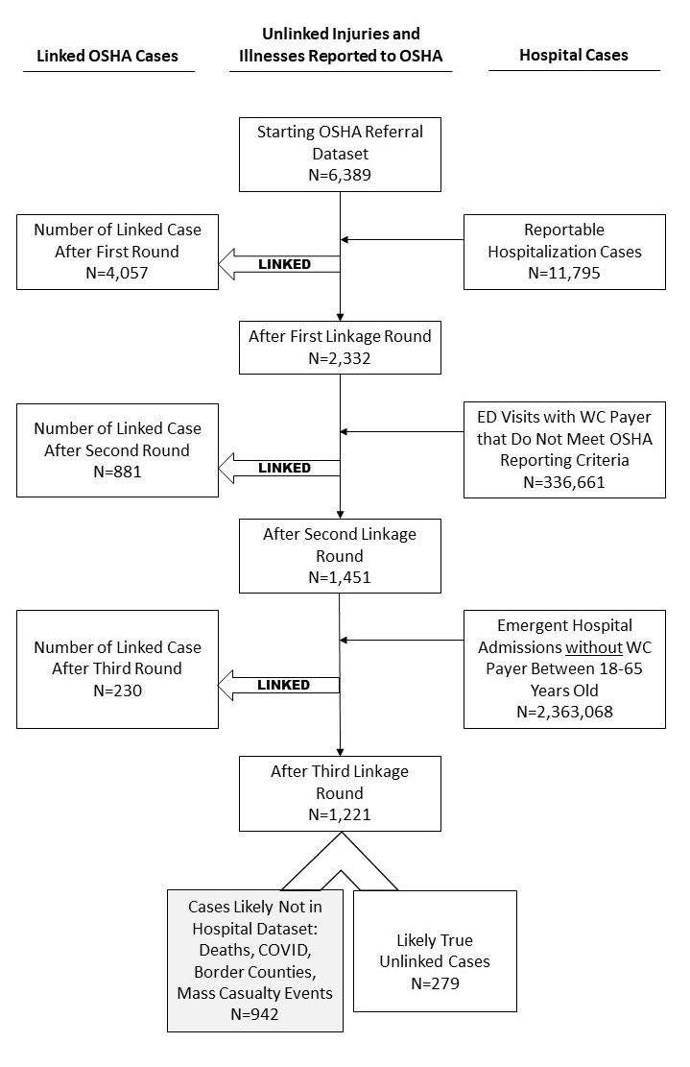

APPENDIX A: Matching Criteria and Number of Matched Cases for Each Linkage Step
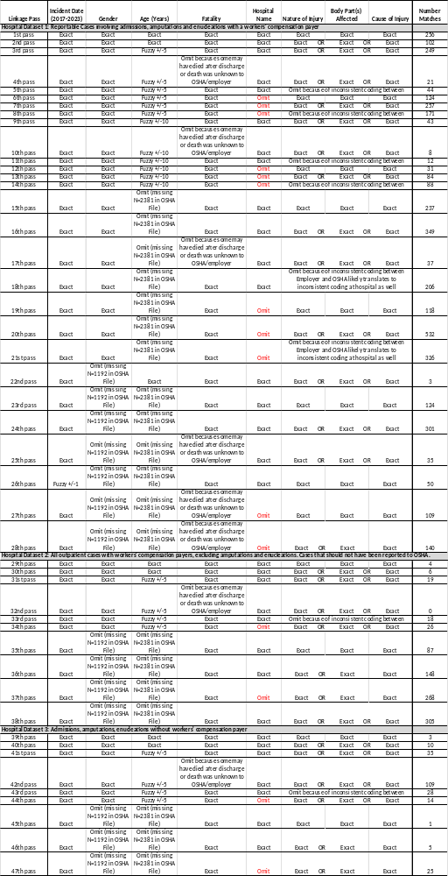
References
- Reilly MJ, Wang L, Rosenman KD. Evaluation of the characteristics of workers injured on the job requiring hospitalization, and employer compliance with OSHA's reporting requirement for these work related hospitalizations. Am J Ind Med. 2023;66:109‐121.
- Rappin CL, Wuellner SE, Bonauto DK. Employer reasons for failing to report eligible workers' compensation claims in the BLS survey of occupational injuries and illnesses. Am J Ind Med. 2016 May;59(5):343-56. doi: 10.1002/ajim.22582. Epub 2016 Mar 11. PMID: 26970051; PMCID: PMC5069593.
- Friedman LS, Ruestow P, and Forst L. Analysis of Ethnic Disparities in Workers’ Compensation Claims Using Data Linkage. J Occup Environ Med. 2012 Oct;54(10):1246-52.
- Kyeremateng-Amoah E, Friedman L, Wahl M, and Forst L. Public Health Surveillance for the Prevention of Pesticide-Related Illness in Illinois. J Occ Environ Med. 2020 May; 62(5):359-369.

