SUPPLEMENTARY FILES

Supplementary Table 1: Patterns of vaccine uptake and decision-making for adolescents aged 9-17 years (n=987), cross-sectional survey of caregivers from 13 southern US states, December 2019 – January 2020.
Covariate | Level | Residenceª |  | Parametric P-value^{b}
Covariate | Level | Rural  N=193 | Urban  N=794 | Parametric P-value^{b}
Have you ever talked with a health care provider about the HPV vaccine (Gardasil) for your adolescent? | Yes | 78 (40.5%) | 390 (49.2%) | 0.03
 | No | 115 (59.5%) | 403 (50.8%) | 0.03
Has a health care provider ever recommended that your adolescent receive the HPV vaccine? | Yes | 87 (44.9%) | 416 (52.4%) | 0.06
 | No/Don’t know | 106 (55.1%) | 378 (47.6%) | 0.06
Has a health care provider ever recommended AGAINST your adolescent receiving the HPV vaccine? | Yes | 7 (3.5%) | 17 (2.1%) | 0.28
 | No/ Don’t know | 187 (96.5%) | 777 (97.9%) | 0.28
How likely is it that your adolescent will receive an/another HPV vaccine dose in the next 12 months?^{c} | Not likely at all | 13 (8.1%) | 94 (16.5%) | 0.04
 | Not very likely | 22 (13.7%) | 84 (14.7%) | 0.04
 | Somewhat likely | 22 (13.8%) | 81 (14.2%) | 0.04
 | Very likely | 58 (36.9%) | 155 (27.3%) | 0.04
 | Not sure | 44 (27.5%) | 156 (27.4%) | 0.04
What are the reasons why your adolescent will not receive the HPV vaccine in the next 12 months?^{d} | Concern about the HPV vaccine | 51 (26.5%) | 104 (13.1%) | <0.0001
 | Personal beliefs | 15(7.5%) | 46 (5.8%) | 0.39
 | Adolescent does not need the vaccine (Age 9-10) | 10 (26.1%)^{e} | 56 (29.7%)^{e} | 0.65
 | Adolescent does not need the vaccine (Age 11 or older) | 31 (20.1%)^{f} | 84 (13.9%)^{f} | 0.06
 | Other reason | 23 (12.1%) | 64 (8.1%) | 0.08
 | Don’t know | 21 (11.0%) | 93 (11.8%) | 0.76
Abbreviations: HPV, human papillomavirus

Footnotes: Number of observations may not add up to 987 due to missing values on variable of interest. Percentages may not add up to 100 due to application of sample weights.

The 13 southern US states were in HHS regions 4 and 6 and included Alabama, Arkansas, Florida, Georgia, Kentucky, Louisiana, Mississippi, New Mexico, North Carolina, Oklahoma, South Carolina, Tennessee, and Texas.

ªUrban residence status was determined based on participants’ ZIP code of residence, using criteria defined by the US Census Bureau.³¹ For 66 records with zip codes in non-residential areas, rural-urban designation was based on participants’ county of residence using the USDA Federal Information Processing System (FIPS) Codes.³²

^{b}The parametric p-value is calculated by chi-square test. Bolded values indicate statistically significant values at p<0.05.

^{c}Question was only asked to those who responded “no” to “As far as you know, has your adolescent completed all recommended doses of the HPV vaccination?”

^{d}Question only asked to those who responded “not very likely”, “not likely”, or “not sure” to “How likely is it that your adolescent will receive an/another HPV vaccine dose in the next 12 months?” Ns and percentages are reported for each item as participants could select multiple response options. Some responses reported by very small numbers of caregivers were suppressed to protect participant confidentiality. Response options omitted due to data suppression include medical reasons (e.g., illness, allergy, or pregnancy), financial concerns, and barriers related to access to health care provider.

^{e}Denominator for calculation of percentages for this item was the number of caregivers (n=227) with an adolescent between the ages of 9-10 years.

^{f}Denominator for calculation of percentages for this item was the number of caregivers (n=756) with an adolescent aged 11 years or older.

Supplementary Table 2: HPV Knowledge Questionnaire (HPV-KQ) responses among rural and urban caregivers in the survey (n=987), cross-sectional survey of caregivers from 13 southern US states, December 2019 – January 2020.

HPV-KQ item | Urbanª caregivers with correct response  N (%) | Ruralª caregivers with correct response  N (%) | p-value
1. Only women can get infected with HPV* | 630 (79.4) | 159 (82.4) | 0.35
2. HPV can cause cervical cancer in women | 668 (84.2) | 156 (80.5) | 0.22
3. HPV can cause cancer in areas such as the head and neck | 194 (24.5) | 32 (16.6) | 0.02
4. HPV causes cancer in women only* | 507 (63.9) | 131 (67.9) | 0.30
5. HPV can cause genital warts | 390 (49.2) | 90 (46.7) | 0.54
6. A person could have HPV for many years without knowing it | 608 (76.6) | 150 (77.5) | 0.79
7. HPV is transmitted through sex | 519 (65.4) | 118 (61.3) | 0.29
8. Most people infected with HPV have visible signs or symptoms of the infection* | 441 (55.6) | 110 (56.9) | 0.74
9. A person’s chances of getting HPV increase with the number of sexual partners they have | 545 (68.7) | 130 (67.0) | 0.65
10. Nearly all sexually active people will contract HPV at some point | 186 (23.5) | 32 (16.7) | 0.04
11. The HPV vaccine is only recommended for girls* | 533 (67.1) | 131 (67.9) | 0.84
12. Full protection against HPV requires more than 1 dose of the vaccine | 439 (55.3) | 92 (47.8) | 0.06
13. The HPV vaccine is most effective if given to people who have not yet started having sex | 377 (47.5) | 87 (44.7) | 0.49
Total score (mean (SD)) | 7.6 (3.8) | 7.3 (3.5) | 0.34
Footnotes: Participants responded to HPV-KQ items by selecting “true”, “false”, or “I don’t know.” A total knowledge score (possible range=0–13) was created for each participant by summing their correct responses across the 13 items. Incorrect responses and responses of “I don’t know” were assigned a score of 0.

The parametric p-value is calculated by chi-square test. Bolded values indicate statistically significant values at p<0.05.

The 13 southern US states were in HHS regions 4 and 6 and included Alabama, Arkansas, Florida, Georgia, Kentucky, Louisiana, Mississippi, New Mexico, North Carolina, Oklahoma, South Carolina, Tennessee, and Texas.

ªUrban residence status was determined based on participants’ ZIP code of residence, using criteria defined by the US Census Bureau.³¹ For 66 records with zip codes in non-residential areas, rural-urban designation was based on participants’ county of residence using the USDA Federal Information Processing System (FIPS) Codes.³²

*Items were reverse scored.

Supplementary Figure 1: General adolescent vaccination attitudes (9 items, 0-strongly disagree to 10-strongly agree) among rural and urban caregivers in the survey (n=987), cross-sectional survey of caregivers from 13 southern US states, December 2019 – January 2020.

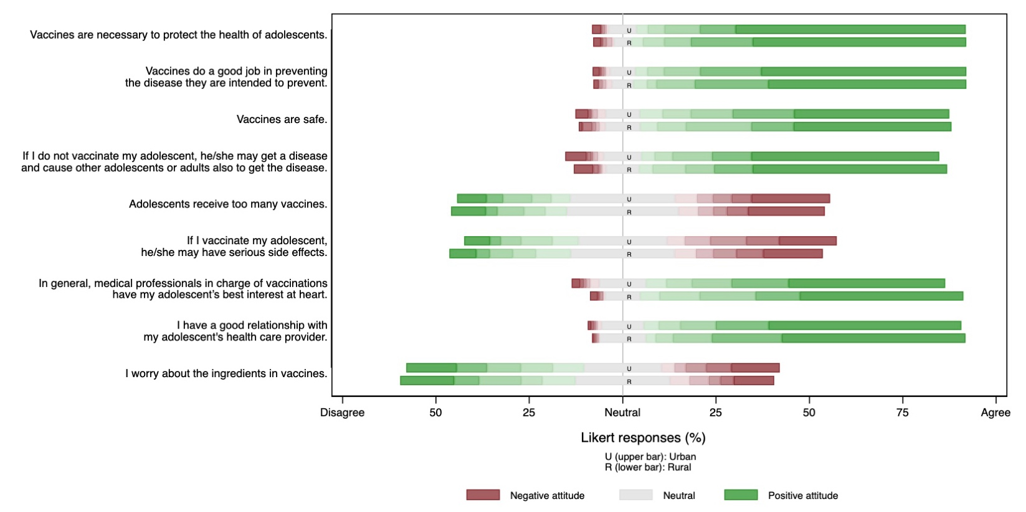
Footnotes:
The 13 southern US states were in HHS regions 4 and 6 and included Alabama, Arkansas, Florida, Georgia, Kentucky, Louisiana, Mississippi, New Mexico, North Carolina, Oklahoma, South Carolina, Tennessee, and Texas.

ªUrban residence status was determined based on participants’ ZIP code of residence, using criteria defined by the US Census Bureau.³¹ For 66 records with zip codes in non-residential areas, rural-urban designation was based on participants’ county of residence using the USDA Federal Information Processing System (FIPS) Codes.³²

