Supplement to “Impact of targeted testing and treatment of Mtb infection among Asian and Hispanic persons with diabetes in the United States”.

Contents
Supplemental Methods
- Survey methods
  - National Health and Nutrition Examination Survey
  - National Health Interview Survey
- Description of deterministic, transmission dynamic model (MITUS)
  - FIGURE S1: Structural schematic of the MITUS model, showing model compartments and transitions.
- Economic analysis methods
  - Health impacts
    - TABLE S1: Remaining life expectancy by age, for calculation of life-years and QALYs saved.
    - TABLE S2: Additional inputs for QALY calculation.
  - Health services costs
    - TABLE S3: Inputs for Mtb infection testing and treatment costs in USD 2022.
  - Productivity costs
    - TABLE S4: Inputs for productivity costs associated with Mtb infection treatment in USD 2022.
    - TABLE S5: Inputs for productivity costs associated with TB disease
- Sensitivity analyses
  - TABLE S6: Parameters varied in one-way sensitivity analysis

Supplemental Results
- Mtb infection and diabetes prevalence estimates
  - FIGURE S2: Estimated diagnosed diabetes prevalence among the Hispanic and non-Hispanic Asian population stratified by age group and origin of birth.
  - FIGURE S3: Age distribution of intervention populations with diagnosed diabetes stratified by race-ethnicity and origin of birth.
  - FIGURE S4: Estimated Mtb infection prevalence among the Hispanic and non-Hispanic Asian population stratified by age group, origin of birth, and diabetes status.
- Incremental costs from additional costing perspectives
  - TABLE S7: Incremental intervention associated health service, productivity, and societal costs per 100,000 persons tested for Mtb infection for each population (in millions, USD 2022).
  - FIGURE S5: Estimated incremental costs (in millions, 2022 USD) per 100,000 persons tested for Mtb infection as part of targeted testing and treatment interventions among non-Hispanic Asian and Hispanic persons with diagnosed diabetes as compared to no intervention baseline scenario, 2024–2100.
  - TABLE S8: Discounted incremental intervention associated costs per 100,000 persons tested for Mtb infection for each population (in millions, USD 2022).
- Cost-effectiveness
  - FIGURE S6: Incremental cost effectiveness ratios per QALY gained in targeted testing and treatment interventions for Mtb infection among non-Hispanic Asian and Hispanic persons with diagnosed diabetes as compared to no intervention baseline scenario, 2024–2100

Reporting Checklists
- TABLE S9: CHEERS reporting checklist

Supplemental methods

I. Survey methods

A. National Health and Nutrition Examination Survey
We defined IGRA positivity as those individuals with “1” values for the LBXTBIN variable in the National Health and Nutrition Examination Survey. We determined diabetes status using the LBXGLU, DIQ280, and DIQ010 variables. Persons with LBXGLU > 124 mg/dL, DIQ280 > 6.4, or DIQ010 value “1”, were considered to have diabetes.

B. National Health Interview Survey
To define diagnosed diabetes, we selected all individuals that had “YES” value for the DIABETICEV variable in the National Health Interview Survey, regardless of their value for the DIADIAGPREG variable. Individuals who had “YES” value for the DIADIAGPREG variable, but “NO” for DIABETICEV were not included in the analysis.

II. Description of deterministic, transmission dynamic model
Model structure
The MITUS model is a deterministic compartmental model of TB. Figure 1 presents the schematic of the MITUS model structure. The model subdivides the population into discrete strata describing important mechanisms of TB transmission, natural history, and treatment. The model is further stratified into additional dimensions describing (i) prior TB disease and mycobacterium tuberculosis (Mtb) infection treatment, (ii) heterogeneity in TB risks between US-born and non-US-born populations, (iii) age-based differences in disease mechanisms and risk factor prevalence, and (iv) disparity in TB risks among marginalized populations. This model was based on earlier TB models of TB ¹, with the addition of two generic risk strata to allow flexibility in simulating the impact of preventive treatment in different populations. The first of these strata is TB progression risk, representing the risk of developing TB disease after acquisition of Mtb infection. The second of these strata is all-cause mortality risk, which aims to capture the competing mortality risk due to the intervention population’s risk factor.

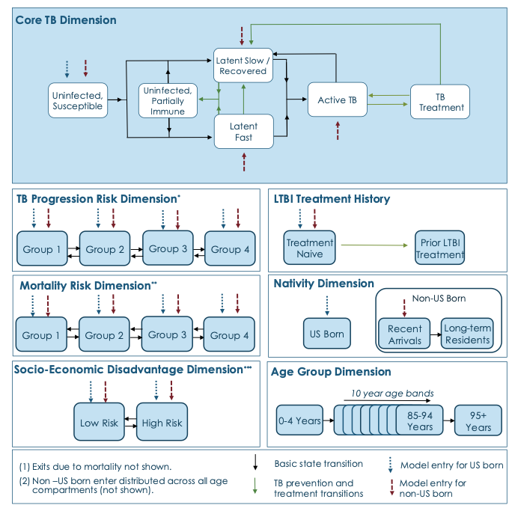
Figure 1: Structural schematic of the MITUS model, showing model compartments and transitions.
i) The TB progression risk dimension represents the differential risk of latent tuberculosis infection progressing to TB disease associated with differential immune activity.
ii) The mortality risk dimension represents the differential all-cause mortality risk associated with an individual’s immune activity.
iii) Socio-economic disadvantage dimension includes assortative mixing within the population, higher TB contact rates, an elevated mortality rate, higher LTBI screening rates, and higher active TB treatment default.
iv) Assortative mixing was included in both nativity and socioeconomic disadvantage dimensions. A fraction of contacts is withheld for “with-like” interactions; this value is calibrated and applied to future model runs. Each nativity and socio-economic disadvantage stratum has a unique contact rate and probability of transmission per effective contact.

Key MITUS model assumptions
A small fraction of individuals with Mtb infection are assumed to progress immediately to TB disease. All remaining infected individuals enter a pair of latent tuberculosis infection (LTBI) states and experience a declining reactivation risk over time ^{2,3}. Individuals with distant infection also have reduced LTBI test positivity. Mtb infection treatment is assumed to reduce but not eliminate TB progression risk ^{4,5}, and treated individuals could experience a future Mtb reinfection.
The MITUS model includes international immigration, emigration of non-US-born residents, and interstate net migration of both US-born and non-US-born residents. International migrants are assumed to have higher TB burden than current US residents, but domestic migrants are assumed to have the same TB burden, by age and other TB risk factors. Future international immigration volume is assumed to increase at an annual rate of 0.4% from 2019 levels, based on net immigration projections from the US Census Bureau ⁶. TB burden among persons entering the United States is assumed to decline at 1.5% per year. Future rates of interstate migration and international emigration are fixed at 2019 levels. TB transmission risks are calculated dynamically based on TB disease prevalence and population mixing patterns.
Model calibration
The MITUS model was originally developed to project future TB trends and outcomes in the United States ⁷. A Bayesian calibration approach ^{8,9} was used to combine data sources and calibrate the model to data on U.S. demography, reported TB epidemiological data, natural history evidence, and health services data spanning 1950–2019. Log-likelihood functions were used to compare model estimates to reported data for each of the calibration data targets. We used incremental mixture importance sampling to sample the posterior distribution for the step function parameters of each epidemiological mechanism. This procedure yielded 1,000 parameter sets consistent with the reported TB data while representing the joint uncertainty in the effects of the calibrated parameters. To incorporate the potential impact of COVID-19 on tuberculosis in the United States we performed a secondary calibration of the MITUS model. We mapped four mechanisms (changes in immigration, accurate diagnosis and treatment initiation rates, interpersonal contact rates, and mortality among persons with TB disease) to their corresponding parameter input the MITUS model and allowed these to vary over 2020-2023. We fit the model to reported data on annual TB outcomes: total TB cases, percentage of annual TB cases among non-US-born individuals, percentage of non-US-born cases among recent arrivals, and TB deaths.
III. Economic analysis methods
A. Health impacts
Life-years saved
We first calculated the total life-years lost from TB for each scenario. We did so by taking the cumulative number of TB deaths in each age group from the transmission model (between 2024 and 2100) and multiplying this value by a life expectancy estimate for that age group. We then summed these totals across all age groups. Life expectancy inputs for each age group are shown in Table S1. Estimates of life-years saved were calculated by subtracting the total life-years lost to TB in the intervention scenario from the total life-years lost to TB under the ‘no treatment’ scenario.
Age Group | Life expectancy ¹⁰
0–4 years | 78.7
5–14 years | 72.0
15–24 years | 62.2
25–34 years | 52.7
35–44 years | 43.4
45–54 years | 34.2
55–64 years | 25.7
65–74 years | 18.0
75–84 years | 11.3
85–94 years | 6.19
95 years+ | 3.18
TABLE S1: Remaining life expectancy for the general population by age group,* for calculation of life-years and QALYs saved.

*The age-weighted average of life expectancies by 5-year age groups in 2018 was calculated to produce the 10-year age bands presented above. In order to account for the reduced life expectancy associated with diabetes, we reduced life expectancy by 12% for those with diabetes ¹¹.

QALYs saved
We calculated the total QALYs lost to TB for each scenario. These were calculated as the sum of:
- QALYs lost due to TB death: these were considered equal to the total life-years lost from TB, as described above.
- QALYs lost during TB disease and TB treatment: these were calculated as the product of total life-years lived with TB disease, including time spent on TB treatment, and the disutility of TB disease.
- QALYs lost during Mtb infection treatment: these were calculated as the product of total individuals initiating Mtb infection treatment, the probability of hepatoxicity for this group, and the estimated QALYs lost per episode of hepatoxicity. Persons either initiated treatment with 3 months of weekly doses of 900 mg of isoniazid and 900 mg of rifapentine (3HP), 3 months of daily doses of 300 mg of isoniazid and 600 mg of rifampin (3HR), or 4 months of daily doses of 600 mg of rifampin (4R).
Values and sources for QALY inputs are shown in Table S2. Estimates of QALYs saved were calculated by subtracting the total QALYs lost to TB in the intervention scenario from the total QALYs lost to TB under the ‘no treatment’ scenario.
In order to account for the QALY reduction due to diabetes, the estimates of QALYs lost due to TB death among the diabetic populations were scaled proportional to the reduced utility rate in Table S2.

TABLE S2: Additional inputs for QALY calculation.
Input | Value | Source
Life expectancy at the time of TB death | See Table S1 | ¹⁰
Utility weights
Mtb infection treatment with no toxicity | 1 | Assumed
Mtb infection treatment with toxicity | 0.75 (0.56–0.94) | ¹²
TB disease pre-treatment,  TB treatment month 1 | 0.75 (0.64–0.83) | ^{12,13}
TB treatment month 2 through completion | 0.89 (0.79-0.98) | ¹³
Diabetes without complications | 0.79 (0.68–0.89) | ¹⁴
Other parameters
Duration of Mtb infection treatment toxicity | 14 (10.50–17.50) days | ¹⁵
Duration of TB disease prior to TB treatment | 3 (2.25–4.75) months | Assumed
Duration of TB treatment | 9 (6.75–11.25) months* | ¹⁶
Probability of toxicity during Mtb infection treatment | 0.003** | ¹⁷
Notes:
*We assumed that a 6-month TB treatment regimen takes, on average, 9 months to complete due to interruptions in care.
** We assumed a common cost of adverse effects for both isoniazid-containing regimens (3HP and 3HR). This cost is based on hepatoxicity due to the use of isoniazid as evidenced with consideration of 3HP in Sterling et al.¹⁷ Given a lack of differential toxicity between the regimens, we assumed common proportion of toxicity in 3HR and 3HP. We assumed no toxicity from the 4R regimen, as it does not use isoniazid.

B. Health services costs
For each scenario we estimated health services costs related to treatment of Mtb infection and TB disease. These were calculated from incremental differences in health service provision estimated by the MITUS transmission dynamic model cumulated over the study’s analytic horizon and unit costs estimated for each of these services, adjusted for future healthcare spending. Details on the calculation of each cost outcomes are shown below.
Health service costs of Mtb infection testing and treatment
Mtb infection testing and treatment costs were calculated as the sum of the costs associated with:
- Mtb infection testing: total individuals tested multiplied by a unit cost of testing. All Mtb infection testing was assumed to be performed with IGRA.
- Ruling out TB disease: total individuals testing positive for Mtb infection, multiplied by the costs of TB disease screening (estimated as the cost of two chest x-rays).
- Mtb infection treatment: total individuals initiating Mtb infection treatment multiplied by a unit cost of Mtb infection treatment. This unit cost was calculated as the average cost of 3HP, 4R, and 3HR regimens, weighted by the distribution of regimens used.
Values for these inputs are shown in Table S3. All health cost estimates taken from published sources were updated to 2022 US dollar values using Bureau of Economic Analysis Personal Consumption Expenditures (PCE) indices for outpatient healthcare services.

TABLE S3: Inputs for Mtb infection testing and treatment costs in USD 2022.
Input | Value | Comment/source
Cost of IGRA | $61.98 | ¹⁸  Current Procedural Terminology (CPT) 86480
Cost of ruling out TB disease before treatment initiation via chest x-ray (2 view) | $34.61 | ¹⁹  CPT 71046
Total cost of treatment with 3HP  by self-administered treatment (SAT) | $557.26
Medication costs | $278.57 | ²⁰  Isoniazid  NDC 00555-0071-02  Rifapentine  NDC 00088-2102-24
Cost of clinic visits | $230.00 | ¹⁵  See note below*, **
Adverse events of 3HP (medical) | $48.69 | ¹⁵  See note below***
Total cost of treatment with 3HR by SAT | $1054.27
Medication costs | $775.58 | ²⁰  Isoniazid  NDC 00555-0071-02  Rifampin  NDC 24658-0802-60
Cost of clinic visits | $230.00 | ¹⁵  See note below*, **
Adverse events of 3HR (medical) | $48.69 | ¹⁵  See note below***
Total cost of treatment with 4R by SAT*** | $1275.91
Medication costs | $1,010.88 | ²⁰  Rifampin  NDC 24658-0802-60
Cost of clinic visits | $265.03 | ¹⁵  See note below *, **
Distribution of treatment of Mtb infection regimens
Fraction treated receiving 3HP | 0.25 | ²¹
Fraction treated receiving 3HR | 0.07 | ²¹
Fraction treated receiving 4R | 0.68 | ²¹
* Values were converted from 2010 to 2022 dollars using the ratio of PCE separate indices for outpatient healthcare services for each of these years (1.44) ²².
** Cost of clinic visit is assumed to be inclusive of supplies for the associated visits.
*** We assumed a common cost of adverse effects for both isoniazid-containing regimens (3HP and 3HR). This cost was based on hepatoxicity due to the use of isoniazid as evidenced with consideration of 3HP in Sterling et al ¹⁷. Given a lack of differential toxicity between the regimens, we assumed a common proportion of patients experiencing toxicity with 3HR and 3HP. We assume no toxicity from the 4R regimen, as it does not use isoniazid.
Health service cost of TB disease treatment
TB treatment costs were calculated as the number of individuals receiving TB treatment multiplied by a fixed unit cost of $25,285 ²³. Of note, the transmission model does not stratify cases by drug resistance and therefore assumes a single unit cost for TB treatment. For this reason, the disease cost averted which is associated with TB cases averted by Mtb infection treatment may be overestimated by 10–15%. This is because the averted cases did not include Multidrug-resistant TB (MDR-TB), even though the unit cost is calculated as a weighted average that included MDR-TB. The average cost of TB treatment included the cost of diagnosing TB disease.
Non-TB future healthcare costs (included under health services and societal perspectives)
We calculated future healthcare costs for those persons surviving the TB episode. These persons incurred costs that they would not have if they had not survived the episode. These costs are calculated by multiplying the deaths averted under a scenario by an estimated lifetime annual healthcare spending. Annual healthcare spending varied by age group and range from $2,397–30,106 ($599–37,633) for the general population and $3,388–55,713 ($2,541–69,642) for the population with diabetes ²⁴. These costs were converted from 2019 USD to 2022 USD using the ratio of PCE separate indices for total healthcare services for each of these years (1.39) ²².

C. Productivity costs (included under societal perspective)
In addition to health services costs, we calculated the loss in economic productivity associated with morbidity and mortality related to the intervention and to TB disease. These are calculated from incremental differences in health outcomes and health services estimated by the transmission dynamic model, and age-stratified estimates of economic productivity loss. Details on the calculation of these outcomes are shown below.

Productivity costs of Mtb infection treatment
For each scenario, the productivity costs associated with treatment of Mtb infection are calculated from the cost inputs shown in Table S4. Adverse event costs associated with treatment of Mtb infection are estimated for isoniazid-containing regimens; the probability of toxicity was 0.003 ¹⁷.
TABLE S4: Inputs for productivity losses associated with Mtb infection treatment in USD 2022.
Input | Value (2022 USD) | Comment / Source
Initial clinic visit | $53.73 | ¹⁵ See note below*
Follow-up clinic visit | $31.50 | ¹⁵ See note below*
Adverse events of Mtb infection treatment with 3HP or 3HR | $6.48 | ¹⁵ See notes below*,**
Adverse events of Mtb infection treatment with 4R | $0 | See note below ***
* These values were converted from 2010 dollars to 2022 dollars using the ratio of Bureau of Labor Statistics Average Hourly Earnings of Production and Nonsupervisory Employees index for patient productivity (1.45) ²⁵.
** We assumed the patient productivity per day is $220 (2016 USD) and average hospitalization stay is 7 days. The average cost of adverse events with 3HP can be calculated as the product of these values and the probability of hospitalization with 3HP toxicity. This value was then converted to 2022 dollars using the ratio of Bureau of Labor Statistics Average Hourly Earnings of Production and Nonsupervisory Employees index for patient productivity for each of these years (1.203) ²⁵.
*** While we allowed for differential Mtb infection treatment regimens, which have different probabilities of adverse events, we assume a common cost of these adverse effects across 3HP and 3HR as they both include isoniazid, which has some risk of hepatotoxicity. We assumed no hepatotoxicity from the 4R regimen, thus included no adverse event costs. The costs of adverse events for 3HP and 3HR have been weighted by the probability of hepatotoxicity (Table S2), which was assumed equivalent for both 3HR and 3HP.

Productivity costs of TB disease
The productivity costs of TB disease are calculated as the sum of productivity losses from mortality and morbidity. Mortality costs for each scenario are calculated as loss of productivity given the age-specific life expectancy at TB death and the remaining age-specific annual productivity estimates. Morbidity costs are calculated as the average time loss due to outpatient TB services and the average hospitalization cost, derived as the product of the probability of hospitalization, average duration of hospitalization, and age-specific productivity estimate. The total productivity costs of TB disease are the sum of both of these values minus future non-healthcare expenditures as estimated by the U.S. Bureau of Labor Statistics ²⁶. Values used in these calculations are shown in Table S5.
TABLE S5: Inputs for productivity costs associated with TB disease (2022 USD)
Input | Value | Source
Probability of hospitalization with TB | 0.49 | ²⁷
Average duration of hospitalization with TB | 24 (18–30) days | ¹⁵
Time losses due to outpatient services | 6.8 (5.0–8.5) days | ¹⁵
Annual productivity by age |  | ²⁸
15–24 years old | $25,812
25–34 years old | $82,798
35–44 years old | $111,389
45–54 years old | $106,693
55–64 years old | $87,027
65–74 years old | $48,709
75-84 years old | $20,502
85–94 years old | $7,270
95+ years old | $2,380
Lifetime productivity by age |  | ²⁸
0–4 years old | $1,569,689
5–14 years old | $1,872,878
15–24 years old | $2,331,056
25–34 years old | $2,470,037
35–44 years old | $2,112,788
45–54 years old | $1,508,652
55–64 years old | $882,714
65–74 years old | $404,293
75–84 years old | $154,328
85–94 years old | $31,703
95+ years old | $6,602
Future non-healthcare spending |  | ²⁶
0–4 years old | $8,513
5–14 years old | $18,485
15–24 years old | $37,231
25–34 years old | $57,663
35–44 years old | $72,250
45–54 years old | $74,736
55–64 years old | $60,396
65–74 years old | $42,834
75–84 years old | $27,721
85–94 years old | $15,962
95+ years old | $9,342
Note: annual and lifetime labor productivity estimates for future years were adjusted for a projected real income growth of (0.5% annually). Annual and lifetime productivity estimates are converted from 2016 dollars to 2022 dollars using the ratio of Bureau of Labor Statistics Average Hourly Earnings of Production and Nonsupervisory Employees index for patient productivity for each of these years (1.28). ²⁵
- Sensitivity analyses
TABLE S6: Parameters varied in one-way sensitivity analysis
Input | Mean value | Evaluated range | Source
Mtb infection care cascade
IGRA test sensitivity
U.S. born individuals | 0.78 | 0.65–0.91 | ²⁹
Non–U.S.-born individuals | 0.79 | 0.70–0.90 | ²⁹
IGRA test specificity
U.S. born individuals | 0.98 | 0.96–0.99 | ²⁹
Non–U.S.-born individuals | 0.99 | 0.96–1.0 | ²⁹
Fraction accepting Mtb infection treatment | 0.77 | 0.70–0.85 | ³⁰
Fraction completing Mtb infection treatment | 0.76 | 0.57–0.95 | ²¹
Probability of cure with Mtb infection treatment completion | 0.93 | 0.90–0.96 | ³¹
Population risk of developing TB
Risk ratio of Mtb infection prevalence*
Non-U.S.–born Asian persons with diabetes | 2.25 | 0.15–5.03 | ³²
Non-U.S.–born Hispanic persons with diabetes | 1.90 | 1.05–2.84 | ³²
U.S.–born Asian persons with diabetes | 1.48 | 0–3.46 | ³²
U.S.–born Hispanic persons with diabetes | 1.47 | 0.76–2.32 | ³²
Mortality rate ratio (with diabetes) | 1.93 | 1.84–2.03 | ³³
TB progression rate ratio (with diabetes) | 1.60 | 1.47–1.73 | ³⁴
Unit costs
Total cost of Mtb infection testing | $96.59 | +/- 25%
Average cost of Mtb infection treatment | $945.53 | +/- 25%
Cost of TB treatment | $25,285 | +/- 25%
Utility weights
Mtb infection treatment with toxicity | 0.75 | +/- 25% | ¹²
TB disease pre-treatment and TB treatment month 1 | 0.75 | 0.64–0.83 | ¹³
TB treatment month 2 through completion | 0.89 | 0.79-0.98 | ¹³

* Population-specific Mtb infection prevalence in the transmission dynamic model is defined relative to the general population prevalence using risk ratios.
Supplemental results

- Mtb infection and diabetes prevalence estimates
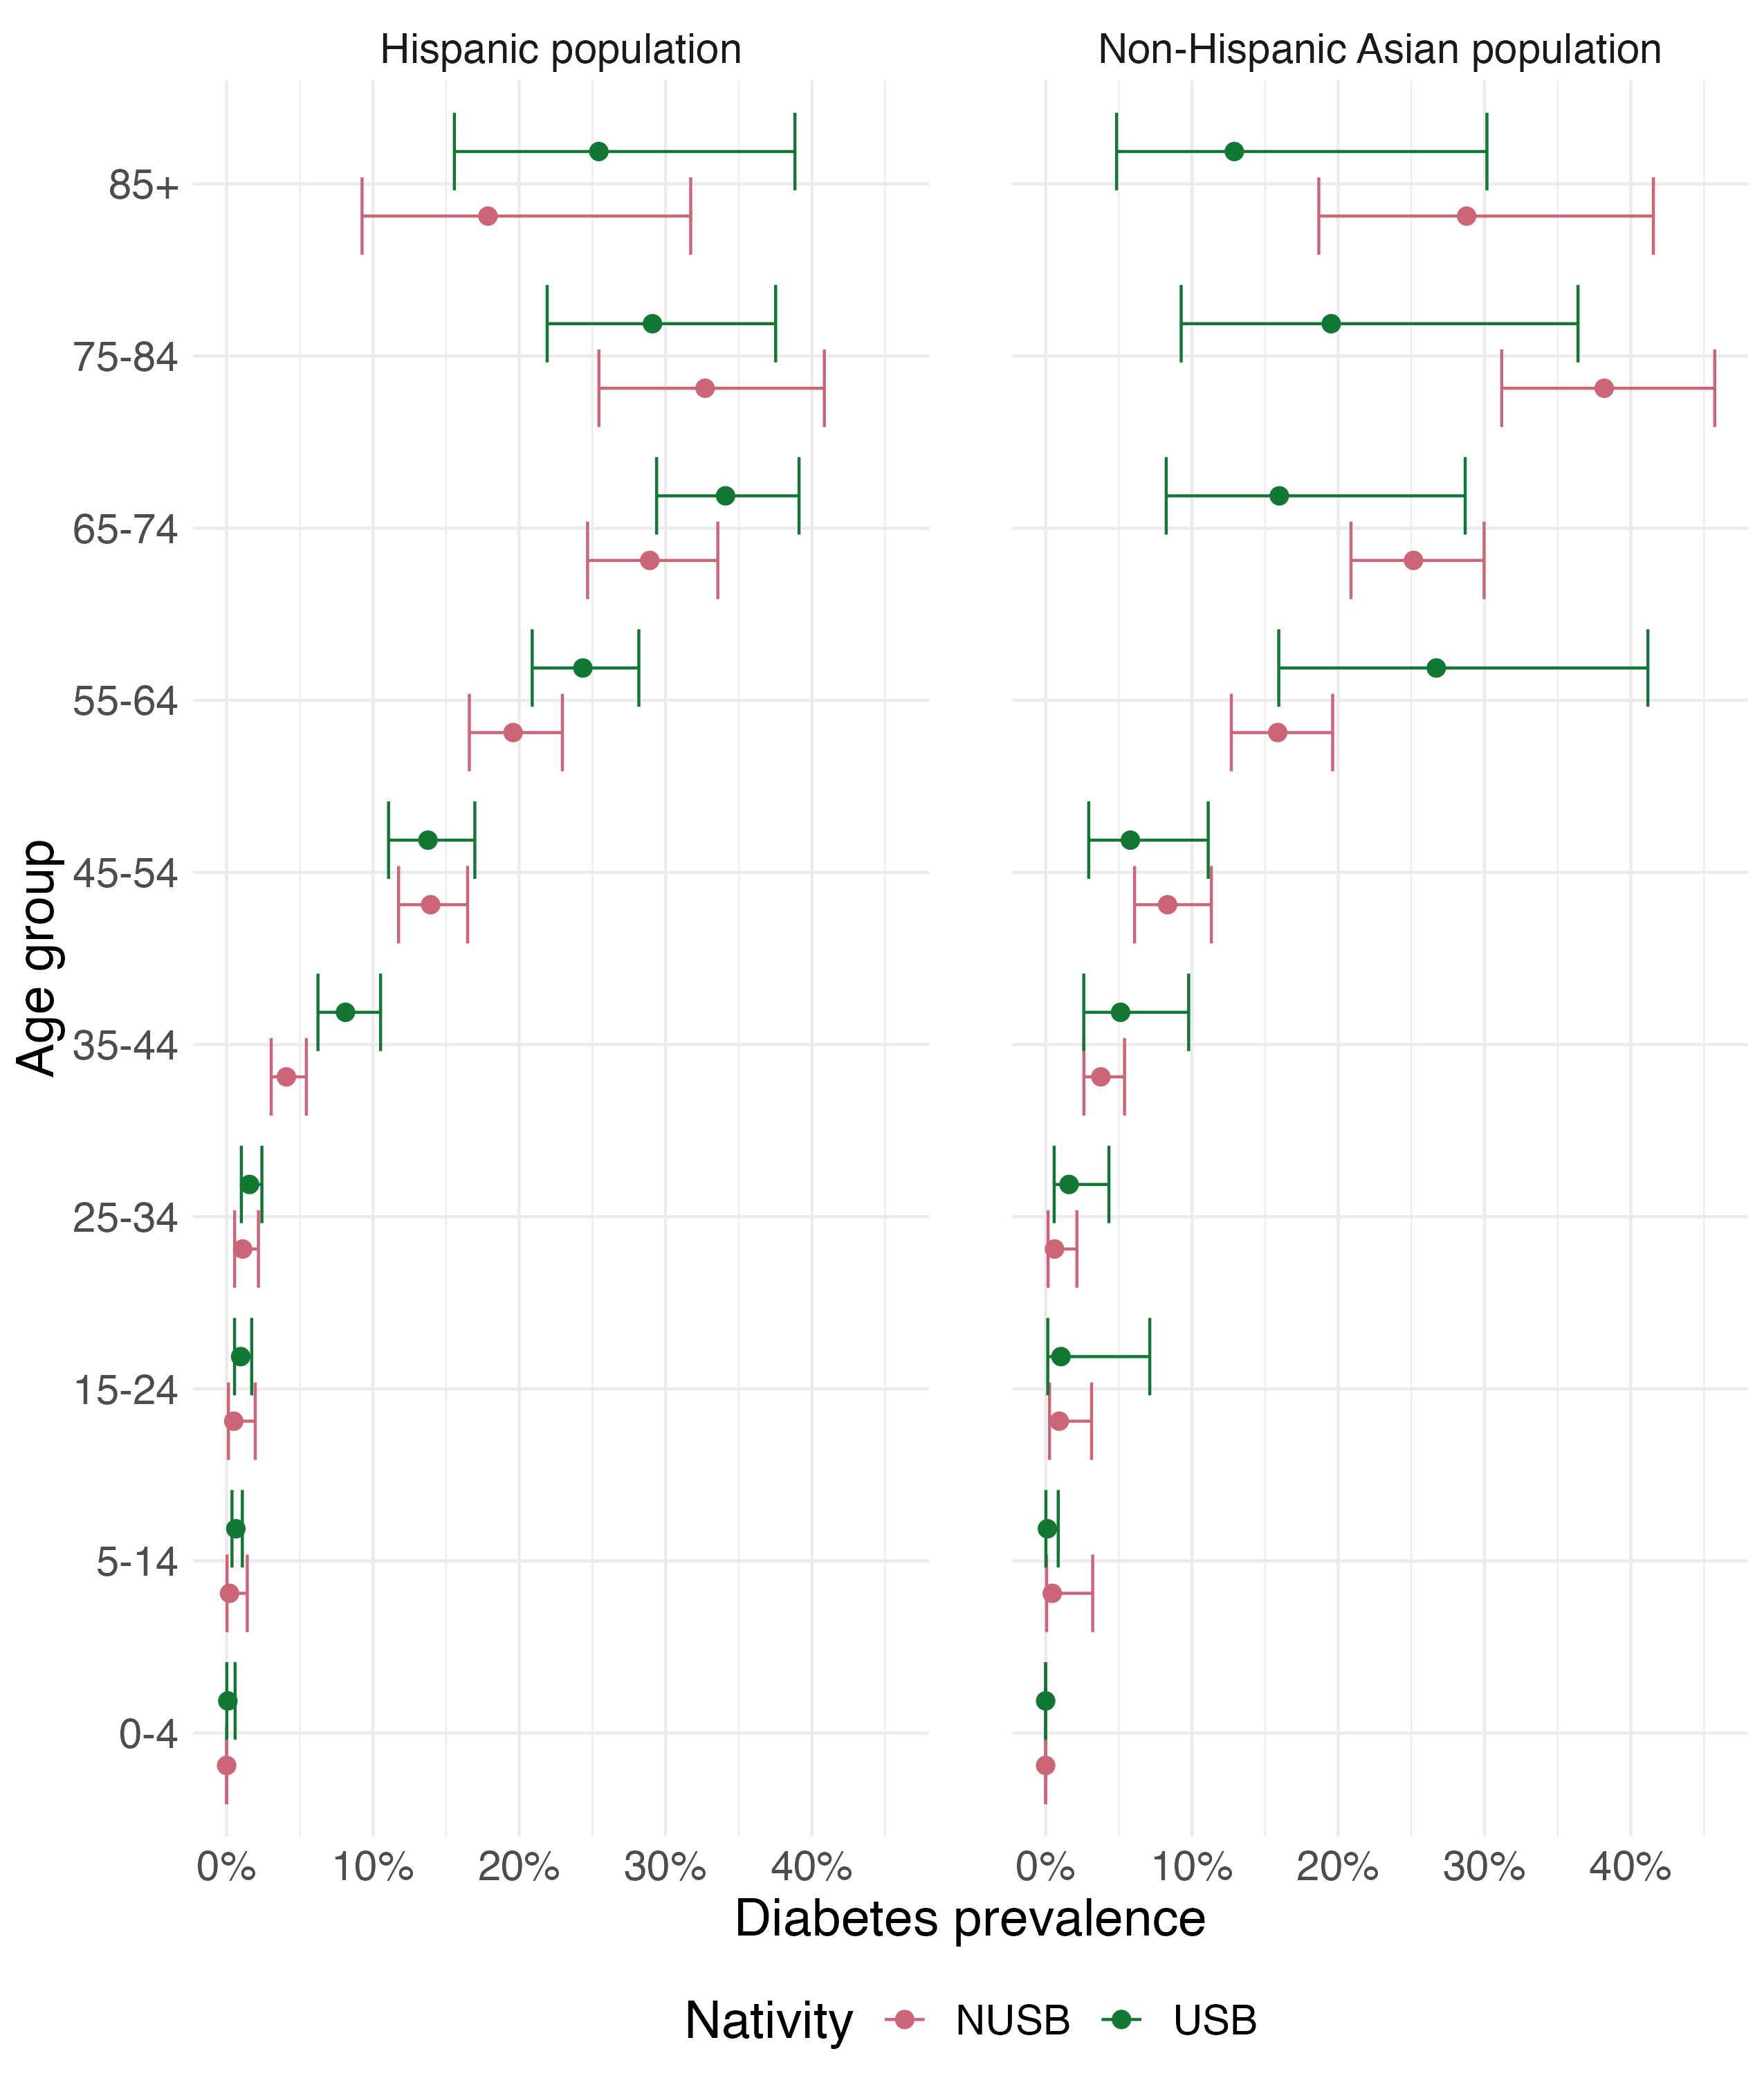
Figure S2: Estimated diagnosed diabetes prevalence among the Hispanic and non-Hispanic Asian population stratified by age group and origin of birth.
Self-reported diabetes prevalence was estimated using the National Health Interview Surveys for 2020–2022. Individuals were determined to have diabetes if they indicated they had been diagnosed with diabetes by a health professional, other than only during pregnancy.

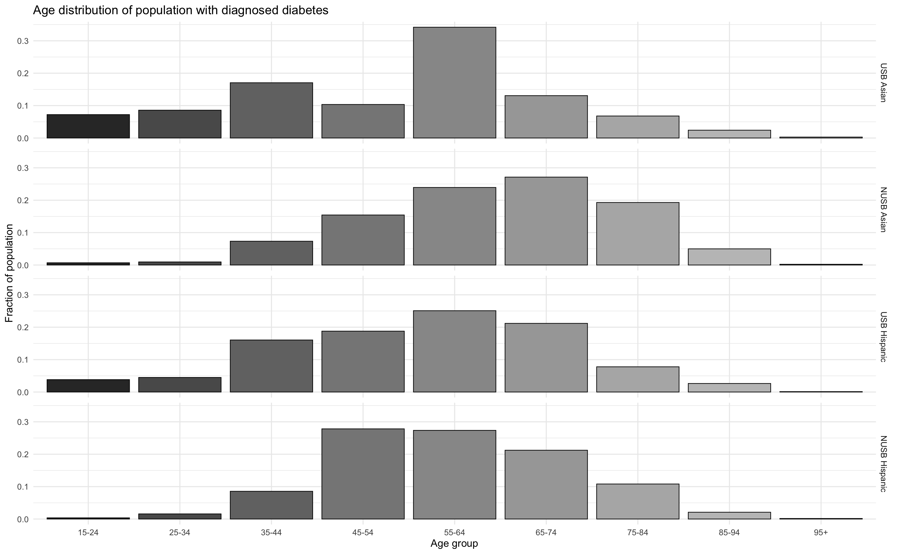
Figure S3: Age distribution of intervention populations with diagnosed diabetes stratified by race-ethnicity and origin of birth.
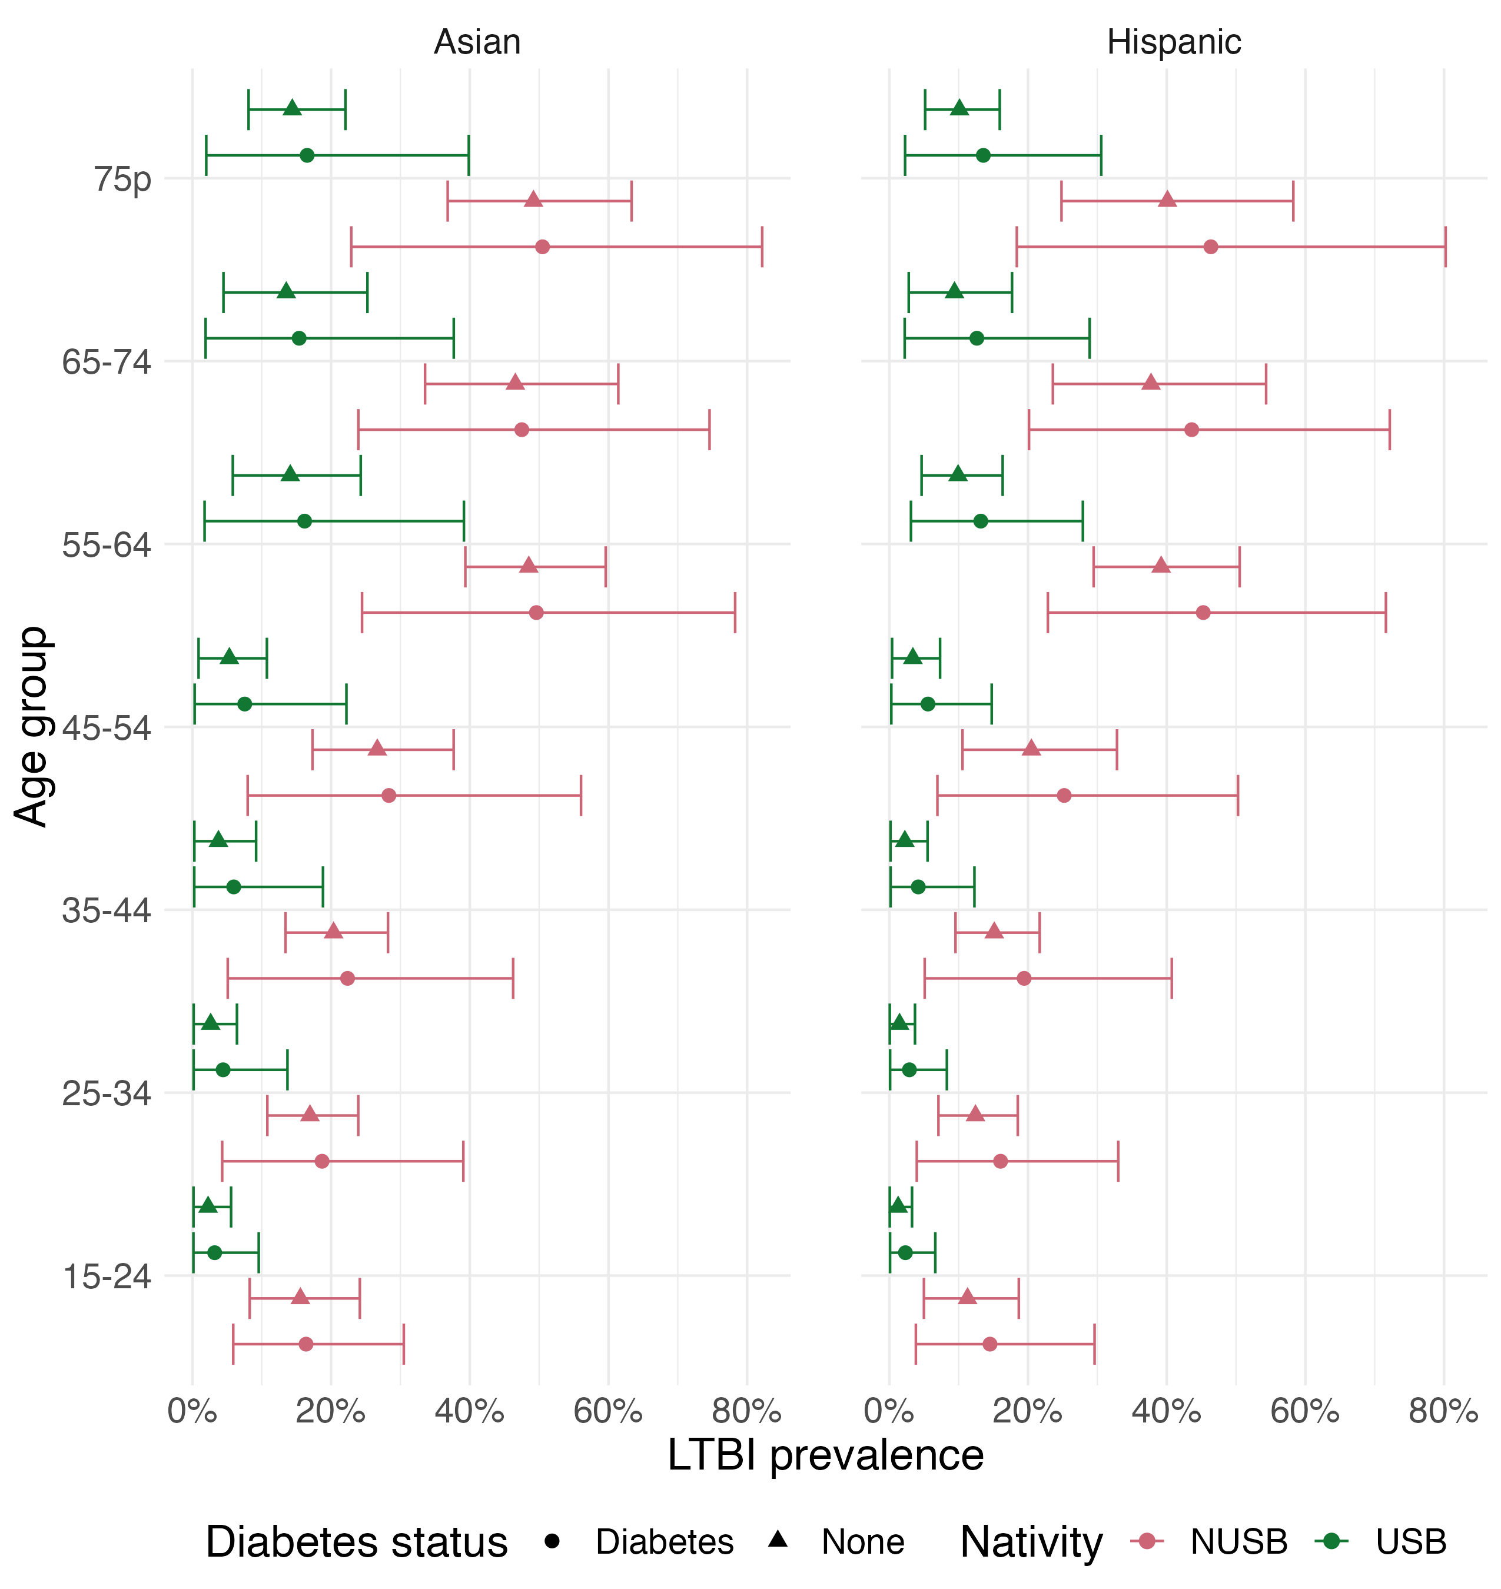
Figure S4: Estimated Mtb infection prevalence among the Hispanic and non-Hispanic Asian population stratified by age group, origin of birth, and diabetes status.
IGRA positive and diabetes positive proportions were calculated from the National Health and Nutrition Survey 2011-2012. Mtb infection prevalence was calculated by adjusting IGRA positive for test sensitivity and specificity. A person was considered to have diabetes if they either reported a previous diagnosis by a healthcare professional, had a HgA1C > 7%, or had fasting plasma glucose > 125 mg/dl and reported at least 8 hours of fasting. Gestational diabetes was removed.

- Incremental costs from additional costing perspectives

Intervention population | Incremental health services costs | Incremental productivity costs | Incremental societal costs | Discounted incremental societal costs*
Non-U.S.–born Asian persons with diabetes | 24.37  (15.22–33.57) | -2.36  (-4.88–  -0.06) | 22.01  (12.63–31.79) | 29.35  (20.14– 38.67)
Non-U.S.–born Hispanic persons with diabetes | 21.97  (13.88–30.27) | -3.87  (-6.89–  -1.08) | 18.11  (9.65–27.00) | 24.57  (16.22– 32.98)
U.S.–born Asian persons with diabetes | 11.31  (7.54 – 15.28) | -0.09  (-0.26–  0.07) | 11.22  (7.46– 15.17) | 11.54  (7.78–15.48)
U.S.–born Hispanic persons with diabetes | 11.26  (7.51–15.17) | -0.02  (-0.16–  0.10) | 11.23  (7.51–15.17) | 11.48  (7.73–15.38)

Table S7: Incremental intervention associated health service, productivity, and societal costs per 100,000 persons tested for Mtb infection for each population (in millions, USD 2022). Values in parentheses represent 95% uncertainty intervals.
The interventions presented above are non-competing interventions. *Results estimated from a societal perspective, with 3% discount rate applied to future costs and health outcomes. The intervention has large first year Mtb infection and treatment costs, followed by benefits of averted TB treatment costs in the future. Due to these future benefits being discounted, the discounted incremental TB health services cost (i.e., intervention costs minus the cost of TB cases prevented) is greater than the non-discounted incremental TB health services costs.
Intervention population | Discounted incremental  Mtb infection  testing  cost | Discounted incremental  Mtb infection treatment  cost | Discounted incremental  TB treatment cost | Discounted incremental health services costs | Discounted incremental productivity costs | Discounted incremental societal  costs
Non-U.S.–born Asian persons with diabetes | 9.61  (5.96–  13.3) | 19.74  (12.40–  27.85) | -4.60  (-6.95–  -2.41) | 30.25  (21.24–  39.45) | -0.89  (-2.69–  0.75) | 29.35  (20.14–  38.67)
Non-U.S.–born Hispanic persons with diabetes | 9.61  (5.96–  13.3) | 16.93  (10.63–  23.87) | -4.33  (-6.53–  -2.27) | 26.67  (18.67–  34.68) | -2.09  (-4.19–  -0.10) | 24.57  (16.22–  32.98)
U.S.–born Asian persons with diabetes | 9.55  (5.91–  13.25) | 1.97  (1.23–  2.75) | -0.20  (-0.30–  -0.10) | 11.50  (7.72–  15.44) | 0.05  (-0.06–  0.16) | 11.54  (7.78–  15.48)
U.S.–born Hispanic persons with diabetes | 9.55  (5.91–  13.25) | 1.86  (1.16–  23.87) | -0.15  (-0.22–  -0.08) | 11.40  (7.65–  15.32) | 0.08  (-0.02–  0.17) | 11.48  (7.73–  15.38)
Table S8: Discounted* incremental intervention associated costs per 100,000 persons tested for Mtb infection for each population (in millions, USD 2022). Values in parentheses represent 95% uncertainty intervals.
The interventions presented above are non-competing interventions. *3% discount rate applied to future costs. The intervention has large first year Mtb infection and treatment costs, followed by benefits of averted TB treatment costs in the future. Due to these future benefits being discounted, the discounted incremental TB health services cost (i.e., intervention costs minus the cost of TB cases prevented) is greater than the non-discounted incremental TB health services costs.
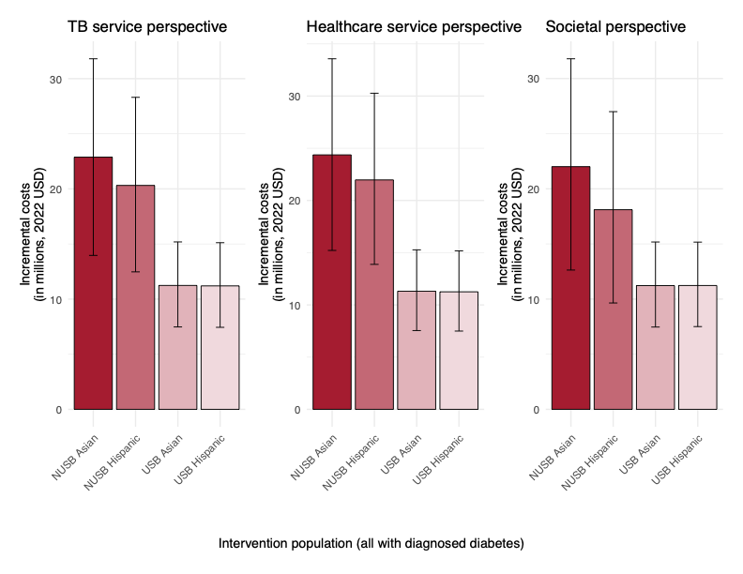
Figure S4: Estimated incremental costs (in millions, 2022 USD) per 100,000 persons tested for Mtb infection as part of targeted testing and treatment interventions among non-Hispanic Asian and Hispanic persons with diagnosed diabetes, as compared to the no intervention scenario, 2024–2100.

- Cost-effectiveness

Cost-effectiveness from the societal perspective

Figure S5 shows the incremental cost-effectiveness ratio (ICERs) for each intervention scenario as compared to the baseline scenario from the societal perspective. The ICERs among non-U.S.–born Asian population and Hispanic populations with diagnosed diabetes were $79,081 ($52,785–$107,852) and $76,035 ($49,265–$107,005), respectively. Interventions among U.S.-born Asian and Hispanic populations with diagnosed diabetes were substantially higher: $873,831 ($549,446–$1,255,418) and $1,102,605 ($695,169–$1,576,240), respectively.
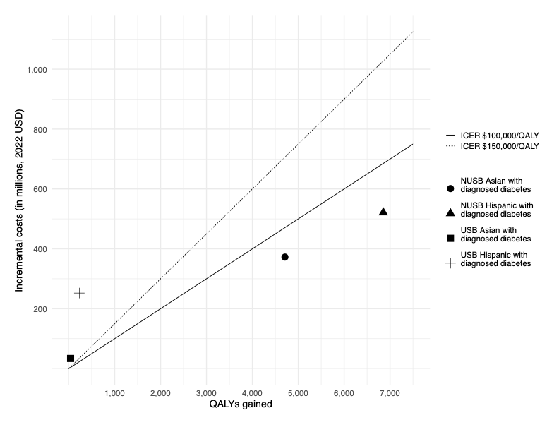

Figure S6: Incremental cost per quality-adjusted life year (QALY) gained from the societal perspective over 2024–2100 for one-time Mtb infection testing and treatment intervention among non-Hispanic Asian and Hispanic persons with diagnosed diabetes by U.S-born (USB) versus non-U.S. –born (NUSB) status, as compared to no intervention.
The interventions presented above are non-competing interventions. The results presented above reflect the mean total incremental costs and mean total QALYs gained for each intervention, which were used to calculate the incremental cost effectiveness ratios (ICERs). Results estimated from a TB health services perspective in 2022 dollars, with 3% discount rate applied to future costs and health outcomes

CHEERS 2022 Checklist
Topic | No. | Item | Location where item is reported
Title
Title | 1 | Identify the study as an economic evaluation and specify the interventions being compared. | Title, Page 1
Abstract
Abstract | 2 | Provide a structured summary that highlights context, key methods, results, and alternative analyses. | Abstract, Page 3
Introduction
Background and objectives | 3 | Give the context for the study, the study question, and its practical relevance for decision making in policy or practice. | Introduction, Paragraph 2
Methods
Health economic analysis plan | 4 | Indicate whether a health economic analysis plan was developed and where available. | Methods
Study population | 5 | Describe characteristics of the study population (such as age range, demographics, socioeconomic, or clinical characteristics). | Results, First paragraph; Supplement, Figures S1-S3
Setting and location | 6 | Provide relevant contextual information that may influence findings. | Methods, First Paragraph
Comparators | 7 | Describe the interventions or strategies being compared and why chosen. | Methods, Third Paragraph
Perspective | 8 | State the perspective(s) adopted by the study and why chosen. | Methods, Seventh Paragraph
Time horizon | 9 | State the time horizon for the study and why appropriate. | Methods, Sixth Paragraph
Discount rate | 10 | Report the discount rate(s) and reason chosen. | Methods, Ninth Paragraph
Selection of outcomes | 11 | Describe what outcomes were used as the measure(s) of benefit(s) and harm(s). | Methods, Sixth Paragraph
Measurement of outcomes | 12 | Describe how outcomes used to capture benefit(s) and harm(s) were measured. | Methods, Sixth Paragraph
Valuation of outcomes | 13 | Describe the population and methods used to measure and value outcomes. | Methods, Seventh Paragraph; Supplement, Economic analysis methods
Measurement and valuation of resources and costs | 14 | Describe how costs were valued. | Methods, Seventh Paragraph; Supplement, Economic analysis methods
Currency, price date, and conversion | 15 | Report the dates of the estimated resource quantities and unit costs, plus the currency and year of conversion. | Methods, Seventh Paragraph; Supplement, Economic analysis methods
Rationale and description of model | 16 | If modelling is used, describe in detail and why used. Report if the model is publicly available and where it can be accessed. | Methods, Fourth Paragraph
Analytics and assumptions | 17 | Describe any methods for analysing or statistically transforming data, any extrapolation methods, and approaches for validating any model used. | Methods , First paragraph and Appendix
Characterising heterogeneity | 18 | Describe any methods used for estimating how the results of the study vary for subgroups. | Methods , First paragraph, Table 1
Characterising distributional effects | 19 | Describe how impacts are distributed across different individuals or adjustments made to reflect priority populations. | Not applicable
Characterising uncertainty | 20 | Describe methods to characterise any sources of uncertainty in the analysis. | Methods, Paragraph 10; Supplement, Economic analysis methods
Approach to engagement with patients and others affected by the study | 21 | Describe any approaches to engage patients or service recipients, the general public, communities, or stakeholders (such as clinicians or payers) in the design of the study. | Funding statement
Results
Study parameters | 22 | Report all analytic inputs (such as values, ranges, references) including uncertainty or distributional assumptions. | Methods, Table 1; Supplement Tables S1-S7, Figures S1-S3
Summary of main results | 23 | Report the mean values for the main categories of costs and outcomes of interest and summarise them in the most appropriate overall measure. | Results, second paragraph
Effect of uncertainty | 24 | Describe how uncertainty about analytic judgments, inputs, or projections affect findings. Report the effect of choice of discount rate and time horizon, if applicable. | Results, third paragraph
Effect of engagement with patients and others affected by the study | 25 | Report on any difference patient/service recipient, general public, community, or stakeholder involvement made to the approach or findings of the study | Not reported
Discussion
Study findings, limitations, generalisability, and current knowledge | 26 | Report key findings, limitations, ethical or equity considerations not captured, and how these could affect patients, policy, or practice. | Discussion
Other relevant information
Source of funding | 27 | Describe how the study was funded and any role of the funder in the identification, design, conduct, and reporting of the analysis | Page 2
Conflicts of interest | 28 | Report authors conflicts of interest according to journal or International Committee of Medical Journal Editors requirements. | Page 2
TABLE S9: CHEERS reporting checklist
From: Husereau D, Drummond M, Augustovski F, et al. Consolidated Health Economic Evaluation Reporting Standards 2022 (CHEERS 2022) Explanation and Elaboration: A Report of the ISPOR CHEERS II Good Practices Task Force. Value Health 2022;25. doi:10.1016/j.jval.2021.10.008
References

1. Menzies NA, Cohen T, Hill AN, et al. Prospects for tuberculosis elimination in the United States: results of a transmission dynamic model. American journal of epidemiology. 2018;187(9):2011-2020.
2. Ferebee SH, Mount FW. Tuberculosis morbidity in a controlled trial of the prophylactic use of isoniazid among household contacts. American Review of Respiratory Disease. 1962;85(4):490-510.
3. Sutherland I. The ten-year incidence of clinical tuberculosis following “conversion” in 2550 individuals aged 14 to 19 years. TSRU Progress Report. 1968;13:1781-1783.
4. Prophylaxis IUATCo. Efficacy of various durations of isoniazid preventive therapy for tuberculosis: five years of follow-up in the IUAT trial. Bulletin of the World Health Organization. 1982;60(4):555.
5. Comstock G. How much isoniazid is needed for prevention of tuberculosis among immunocompetent adults?[Counterpoint]. The International Journal of Tuberculosis and Lung Disease. 1999;3(10):847-850.
6. U.S. Census Bureau. Data from: 2023 National Population Projections Tables: Main Series (NP2023-T13). 2023. Washington D.C. . Deposited 31 Oct 2023.
7. Swartwood NA, Testa C, Cohen T, et al. Tabby2: a user-friendly web tool for forecasting state-level TB outcomes in the United States. BMC medicine. 2023;21(1):331.
8. Menzies NA, Soeteman DI, Pandya A, Kim JJ. Bayesian methods for calibrating health policy models: a tutorial. Pharmacoeconomics. 2017;35(6):613-624.
9. Jackson CH, Jit M, Sharples LD, De Angelis D. Calibration of complex models through Bayesian evidence synthesis: a demonstration and tutorial. Medical decision making. 2015;35(2):148-161.
10. United States Mortality DataBase. usa.mortality.org
11. Tomic D, Morton JI, Chen L, et al. Lifetime risk, life expectancy, and years of life lost to type 2 diabetes in 23 high-income jurisdictions: a multinational, population-based study. The lancet Diabetes & endocrinology. 2022;10(11):795-803. doi:10.1016/S2213-8587(22)00252-2
12. Guo N, Marra CA, Marra F, Moadebi S, Elwood RK, FitzGerald JM. Health state utilities in latent and active tuberculosis. Value in health. 2008;11(7):1154-1161.
13. Bauer M, Ahmed S, Benedetti A, et al. The impact of tuberculosis on health utility: a longitudinal cohort study. Quality of Life Research. 2015;24:1337-1349.
14. Beaudet A, Clegg J, Thuresson P-O, Lloyd A, McEwan P. Review of Utility Values for Economic Modeling in Type 2 Diabetes. Value in Health. 2014/06/01/ 2014;17(4):462-470. doi:https://doi.org/10.1016/j.jval.2014.03.003
15. Shepardson D, Marks S, Chesson H, et al. Cost-effectiveness of a 12-dose regimen for treating latent tuberculous infection in the United States. The International journal of tuberculosis and lung disease. 2013;17(12):1531-1537.
16. Centers for Disease Control and Prevention. Reported TB in the US 2022. US Department of Health and Human Services. Accessed January 13, 2024. https://www.cdc.gov/tb/statistics/reports/2022/default.htm
17. Sterling TR, Villarino ME, Borisov AS, et al. Three months of rifapentine and isoniazid for latent tuberculosis infection. New England Journal of Medicine. 2011;365(23):2155-2166.
18. U.S. Centers for Medicare & Medicaid Services. Clinical laboratory fee schedule - 2022 Q4 Release. Accessed 1 June 2024, 2024. https://www.cms.gov/medicaremedicare-fee-service-paymentclinicallabfeeschedclinical-laboratory-fee-schedule-files/22clabq4
19. U.S. Centers for Medicare & Medicaid Services. Physicans fee schedule. Accessed 1 June 2024, 2024. https://www.cms.gov/medicare/physician-fee-schedule/search
20. U.S. Department of Veterans Affairs. National Acquisition Center. Accessed 30 January 2024, 2024. https://www.vendorportal.ecms.va.gov/nac/Pharma/List
21. Holzman SB, Perry A, Saleeb P, et al. Evaluation of the latent tuberculosis care cascade among public health clinics in the United States. Clinical Infectious Diseases. 2022;75(10):1792-1799.
22. U.S. Bureau of Economic Analysis. Data from: Table 2.4.5. Personal Consumption Expenditures by Type of Product.
23. Winston CA, Marks SM, Carr W. Estimated Costs of 4-Month Pulmonary Tuberculosis Treatment Regimen, United States. Emerging Infectious Diseases. 2023;29(10):2102-2104.
24. Jiao B, Basu A. U.S. Catalogue of Age- and Medical-Condition-Specific Healthcare Costs. Accessed 1 June 2024, 2024. https://uwchoice.shinyapps.io/futuremedicalcosts/
25. U.S. Bureau of Labor Statistics. Data from: Series CEU0500000008. Average hourly earnings of production and nonsupervisory employees, total private, not seasonally adjusted. .
26. U.S. Bureau of Labor Statistics. Table 1300. Age of reference person: Annual expenditure means, shares, standard errors, and coefficients of variation, Consumer Expenditure Surveys, 2022. Accessed 1 June 2024, 2024. https://www.bls.gov/cex/tables/calendar-year/mean-item-share-average-standard-error/reference-person-age-ranges-2022.pdf
27. Taylor Z, Marks S, Rios Burrows N, Weis S, Stricof R, Miller B. Causes and costs of hospitalization of tuberculosis patients in the United States. The International Journal of Tuberculosis and Lung Disease. 2000;4(10):931-939.
28. Grosse SD, Krueger KV, Pike J. Estimated annual and lifetime labor productivity in the United States, 2016: implications for economic evaluations. Journal of medical economics. 2019;22(6):501-508.
29. Stout JE, Wu Y, Ho CS, et al. Evaluating latent tuberculosis infection diagnostics using latent class analysis. Thorax. 2018;73(11):1062-1070.
30. Centers for Disease Control and Prevention. 2021 State and City TB Report. US Department of Health and Human Services. Accessed June 24, 2024. https://www.cdc.gov/tb/statistics/indicators/2021/StateCity-TBReport.htm
31. Thompson N. International Union Against Tuberculosis Committee on Prophylaxis. Efficacy of various durations of isoniazid preventive therapy for tuberculosis: five years of follow‐up in the IUAT trial. Bull World Health Organ. 1982;60(4):555-564.
32. Centers for Disease Control and Prevention (CDC), National Center for Health Statistics (NCHS). Data from: National Health and Nutrition Examination Survey Data. 2013;2011-2012. Hyattsville, MD.
33. Stokes A, Preston SH. Deaths attributable to diabetes in the United States: comparison of data sources and estimation approaches. PloS one. 2017;12(1):e0170219. doi:10.1371/journal.pone.0170219
34. Ekramnia M, Li Y, Haddad MB, et al. Latent TB reactivation rates for TB risk populations in the United States. Epidemiology. 2024;

