Appendix A Supplementary data

Mixture analysis of associations between environmental and workplace toxins and liver damage and telomere length, stratified by race/ethnicity

Ning Ma¹, Rowena Yip², Mark Woodward^{3,4}, Sara Lewis², Michael Crane⁵, Artit Jirapatnakul², Costica Aloman⁶, Meena B. Bansal¹, Douglas Dieterich¹, Louis Gros², Damaskini Valvi⁵, Elena Colicino⁵, David Yankelevitz², Claudia Henschke², Andrea D. Branch^{1,*}

- Division of Liver Diseases, Icahn School of Medicine Mount Sinai, New York, NY, 10029, USA
- Department of Diagnostic, Molecular and Interventional Radiology, Icahn School of Medicine at Mount Sinai, New York, NY, 10029, USA
- The George Institute for Global Health, School of Public Health, Imperial College London, London, W12 7RZ, UK
- The George Institute for Global Health, University of New South Wales, Sydney, 2000, Australia
- Department of Environmental Medicine and Public Health, Icahn School of Medicine at Mount Sinai, New York, NY, 10029, USA
- Department of Medicine, Division of Gastroenterology and Hepatobiliary Diseases,
Westchester Medical Center, Valhalla, 10595, USA

----------------------------------
* Corresponding author. E-mail: andrea.branch@mssm.edu (A. D. Branch).

Table of Contents

Fig. S1 Spearman correlation coefficient matrices of blood levels of lead, cadmium and mercury, stratified by race/ethnicity
Fig. S2 Spearman correlation coefficient matrix of blood levels of lead, cadmium, mercury and four PFAS
Fig. S3 Odds ratios of the indices and weights of the components in the WQS_{metal}, WQS_{PFAS}, and WQS_{metal-PFAS} indices in group 2 with the outcome of advanced liver fibrosis
Fig. S4 Odds ratios of the indices and weights of the components in the WQS_{metal}, WQS_{PFAS}, and WQS_{metal-PFAS} indices in group 2 with the outcome of ALT elevation
Fig. S5 Odds ratios of the indices and weights of the components in the WQS_{metal-PFAS} indices in group 2 with the outcome of ALT elevation, stratified by race/ethnicity
Fig. S6 Odds ratios of the indices and weights of the components in the WQS_{PFAS} indices in group 2 with the outcome of ALT elevation, stratified by race/ethnciity
Fig. S7 Spearman correlation coefficient matrix of blood and/or urine levels of eleven metals
Fig. S8 Odds ratios of the indices and weights of the components in the blood and urine metal indices in group 3 with the outcome of advanced liver fibrosis
Fig. S9 Odds ratios of the indices and weights of the components in the blood and urine metal indices in group 3 with outcome of ALT elevation
Fig. S10 Odds ratios of the indices and weights of the components in the urine metal indices in group 3 with outcome of ALT elevation, stratified by race/ethnicity group
Fig. S11 Odds ratios of the indices and weights of the components in the blood and/or urine metal indices in group 3 with outcome of ALT elevation, stratified by race/ethnicity group
Fig. S12 Spearman correlation coefficient matrix of blood levels of lead, cadmium and mercury, PCBs, and PCDD/Fs
Fig. S13 Odds ratios of telomere length quartiles with the outcome of ALT elevation
Table S1a. Characteristics of group 1, the participants with blood levels of three metals in NHANES 2003-2018 (weighted % (95% CI))
Table S1b. Characteristics of the group 2, participants with four per- and polyfluoroalkyl substances (PFAS) in NHANES 2003-2018 (weighted % (95% CI))
Table S1c. Characteristics of group 3, participants with eight urine metals and three blood metals in NHANES 2003-2018 (weighted mean, % (95% CI))
Table S1d. Characteristics of the group 4, participants with measurements of blood levels of three metals and PCBs and PCDD/Fs in NHANES 2003-2018 (weighted mean, % (95% CI))
Table S1e. Characteristics of group 5, participants with blood levels of two metals and telomere length in NHANES 1999-2002 (weighted % (95% CI))
Table S2. Odds ratios from multivariable logistic regression models with the outcome of advanced liver fibrosis with blood levels of two metals included as independent variables; the study group does not include participants with viral hepatitis
Table S3. Odds ratios from multivariable logistic regression models with the outcome of advanced liver fibrosis with blood levels of three metals included as continuous variables
Table S4. Odds ratios from multivariable logistic regression models with the outcome of ALT elevation with blood levels of three metals included in the analysis
Table S5. Odds ratios of the WQS mixture indices for blood levels of lead, cadmium and mercury with outcome of ALT elevation
Table S6. Odds ratios of log-transformed PCBs with outcome of ALT elevation in NHANES 2003-2004 (group 4) adjusted for age, sex, and race/ethnicity
Table S7. Toxins selected by lasso regression
Table S8. Logistic Regression Model Adjusted for Age, Sex, and Race/Ethnicity with Outcome of ALT Elevation - Continuous and Categorical TEQ Models for Specific Dioxin-like PCBs and PCDD/Fs
Table S9. Logistic Regression Model Adjusted for Age, Sex, and Race/Ethnicity with Outcome of ALT Elevation - Continuous and Categorical TEQ Models for All of Dioxin-like PCBs and PCDD/Fs

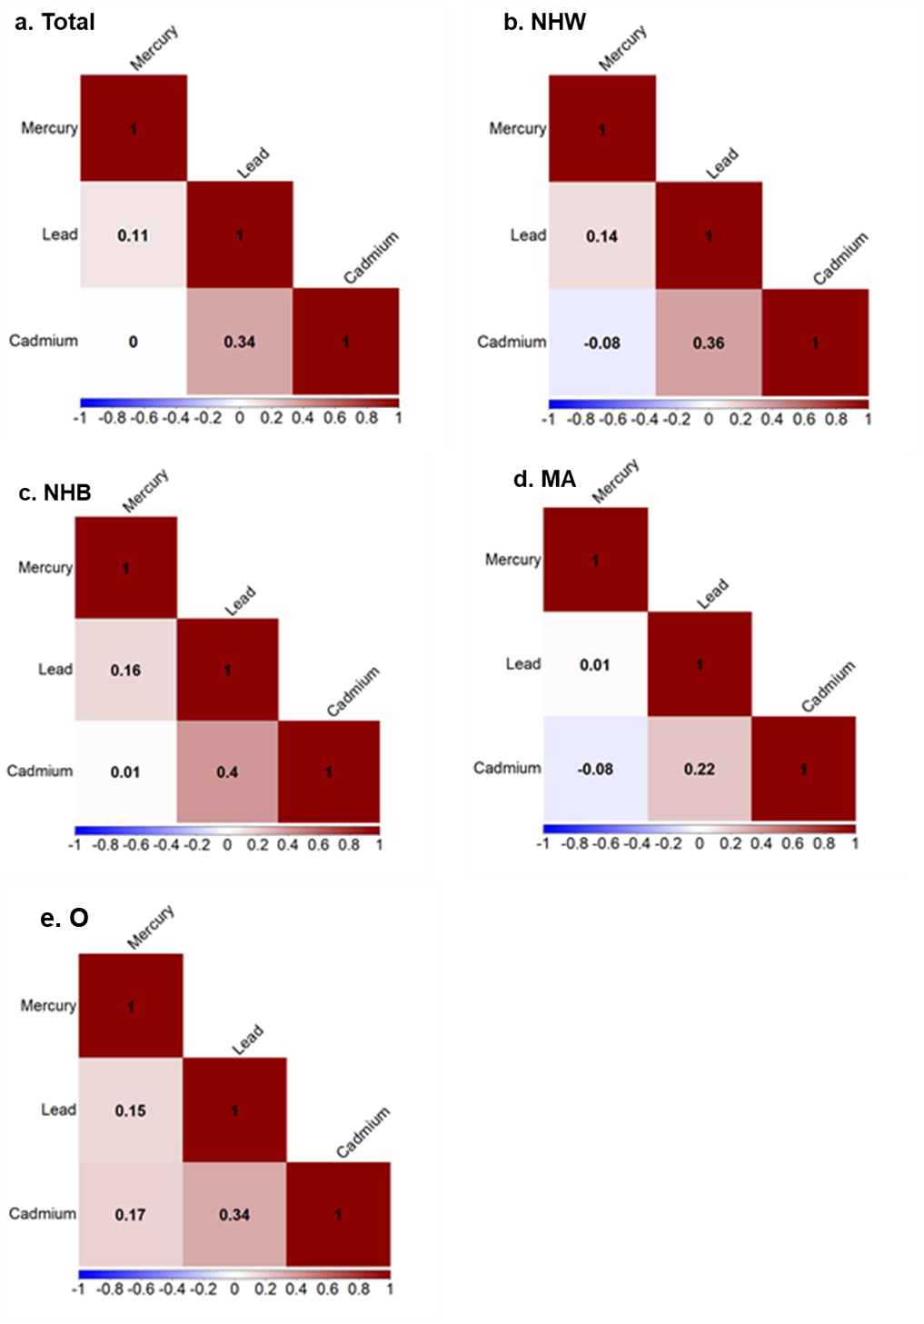
Fig. S1 Spearman correlation coefficient matrices of blood levels of lead, cadmium and mercury, stratified by race/ethnicity. Correlation matrix depicting the spearman correlation coefficients of blood levels of lead, cadmium, and mercury in (a) the total population; (b) Non-Hispanic White, NHW; (c) Non-Hispanic Black, NHB; (d) Mexican American, MA; (e) other race, O. The color and value in the cell represent the strength and direction of the correlation
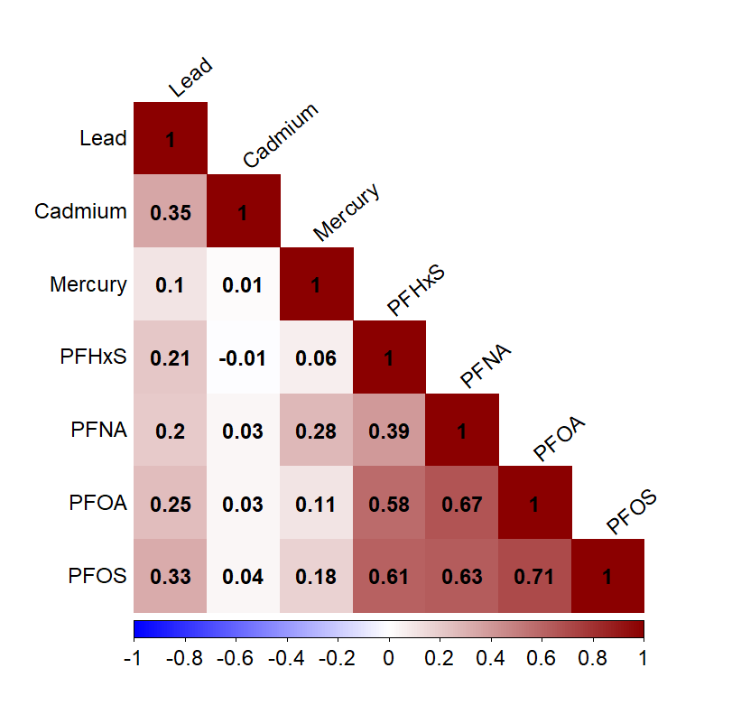
Fig. S2 Spearman correlation coefficient matrix of blood levels of lead, cadmium, mercury and four PFAS. The correlation matrix depicts the Spearman correlation coefficients of 4 per- and polyfluoroalkyl substances (PFAS) and blood levels of cadmium, lead and mercury. The color and values of the cells represent the strength and direction of the correlation. Abbreviations: PFAS: per- and polyfluoroalkyl substances; PFOS: Perfluorooctane sulfonic acid; PFOA: Perfluorooctanoic acid; PFHxS: Perfluorohexane sulfonic acid; PFNA: Perfluorononanoic acid.

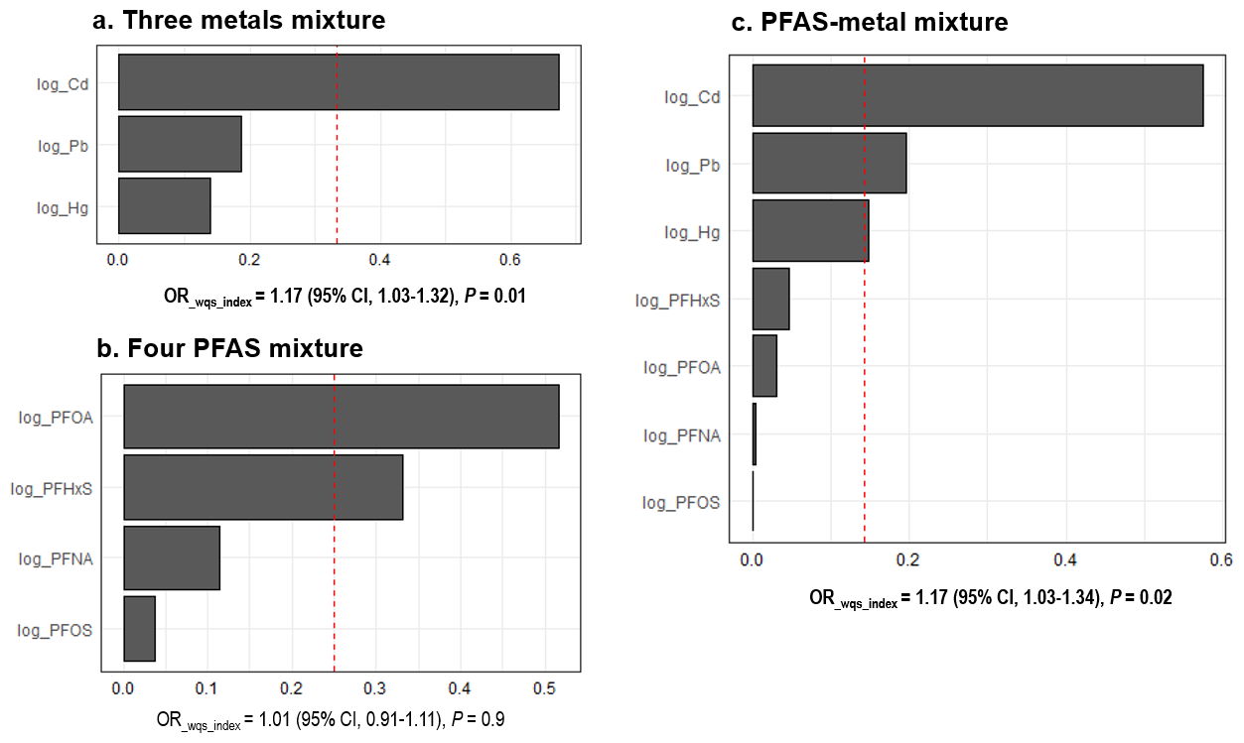Fig. S3 Odds ratios of the indices and weights of the components in the WQS_{metal}, WQS_{PFAS}, and WQS_{metal-PFAS} indices in group 2 with the outcome of advanced liver fibrosis. Blood levels of metals (lead, cadmium and mercury) and four per- and polyfluoroalkyl substances (PFAS) were analyzed in a weighted quantile sums (WQS) model, with adjustment for age, sex, smoking and alcohol use, poverty, and diabetes. (a) mixture of three blood metals; (b) mixture of four PFAS; (c) mixture of PFAS-metals. By default, a chemical was considered a significant contributor if its weight exceeded the inverse of the number of elements in the mixture, which is 1/3 = 0.33 in (a), 1/4 = 0.25 in (b), and 1/7 = 0.143 in (c), indicated by the red dashed line. Data of blood levels of cadmium, lead and mercury and PFAS were not normally distributed and were log-transformed. Abbreviations: CI: confidence interval; OR: odds ratio; PFAS: per- and polyfluoroalkyl substances; PFOS: Perfluorooctane sulfonic acid; PFOA: Perfluorooctanoic acid; PFHxS: Perfluorohexane sulfonic acid; PFNA: Perfluorononanoic acid.

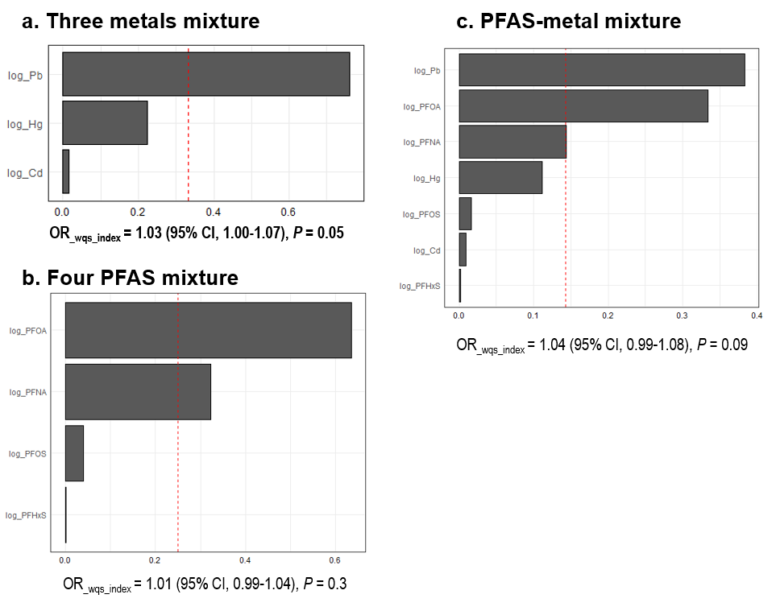
Fig. S4 Odds ratios of the indices and weights of the components in the WQS_{metal}, WQS_{PFAS}, and WQS_{metal-PFAS} indices in group 2 with the outcome of ALT elevation. Blood levels of metals (lead, cadmium and mercury) and four per- and polyfluoroalkyl substances (PFAS) were analyzed in a weighted quantile sums (WQS) model, with adjustment for age, sex, smoking and alcohol use, poverty, and diabetes. (a) mixture of three blood metals; (b) mixture of four PFAS; (c) mixture of PFAS-metals. By default, a chemical was considered a significant contributor if its weight exceeded the inverse of the number of elements in the mixture, which is 1/3 = 0.33 in (a), 1/4 = 0.25 in (b), and 1/7 = 0.143 in (c), indicated by the red dashed line. Data of blood levels of cadmium, lead and mercury and PFAS were not normally distributed and were log-transformed. Abbreviations: CI: confidence interval; OR: odds ratio; PFAS: per- and polyfluoroalkyl substances; PFOS: Perfluorooctane sulfonic acid; PFOA: Perfluorooctanoic acid; PFHxS: Perfluorohexane sulfonic acid; PFNA: Perfluorononanoic acid.

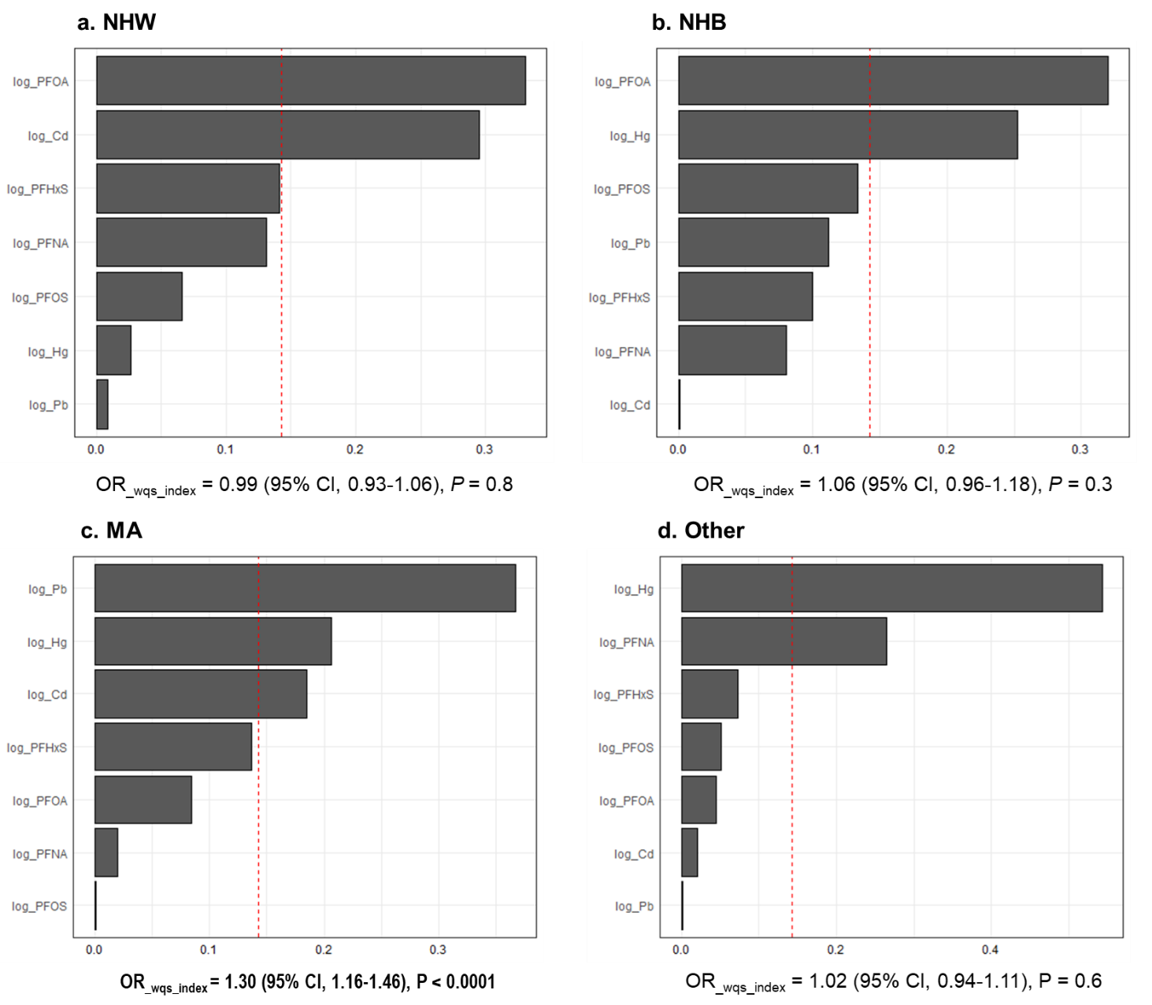

Fig. S5 Odds ratios of the indices and weights of the components in the WQS_{metal-PFAS} indices in group 2 with the outcome of ALT elevation, stratified by race/ethnicity. Blood levels of metals (lead, cadmium and mercury) and four per- and polyfluoroalkyl substances (PFAS) were analyzed in weighted quantile sums (WQS) models with the outcome of ALT-elevation with adjustment for age, sex, smoking and alcohol use status, poverty, and diabetes. By default, a chemical was considered a significant contributor if its weight exceeded the inverse of the number of elements in the mixture, which is 1/7 (0.143) for PFAS-metal mixture, indicated by the red dashed line. Data of blood levels of cadmium, lead and mercury and PFAS were not normally distributed and were log-transformed in the analysis. Abbreviations: CI: confidence interval; NHW: non-Hispanic White; NHB: non-Hispanic Black; MA: Mexican American; OR: odds ratio; PFAS: per- and polyfluoroalkyl substances; PFOS: Perfluorooctane sulfonic acid; PFOA: Perfluorooctanoic acid; PFHxS: Perfluorohexane sulfonic acid; PFNA: Perfluorononanoic acid.
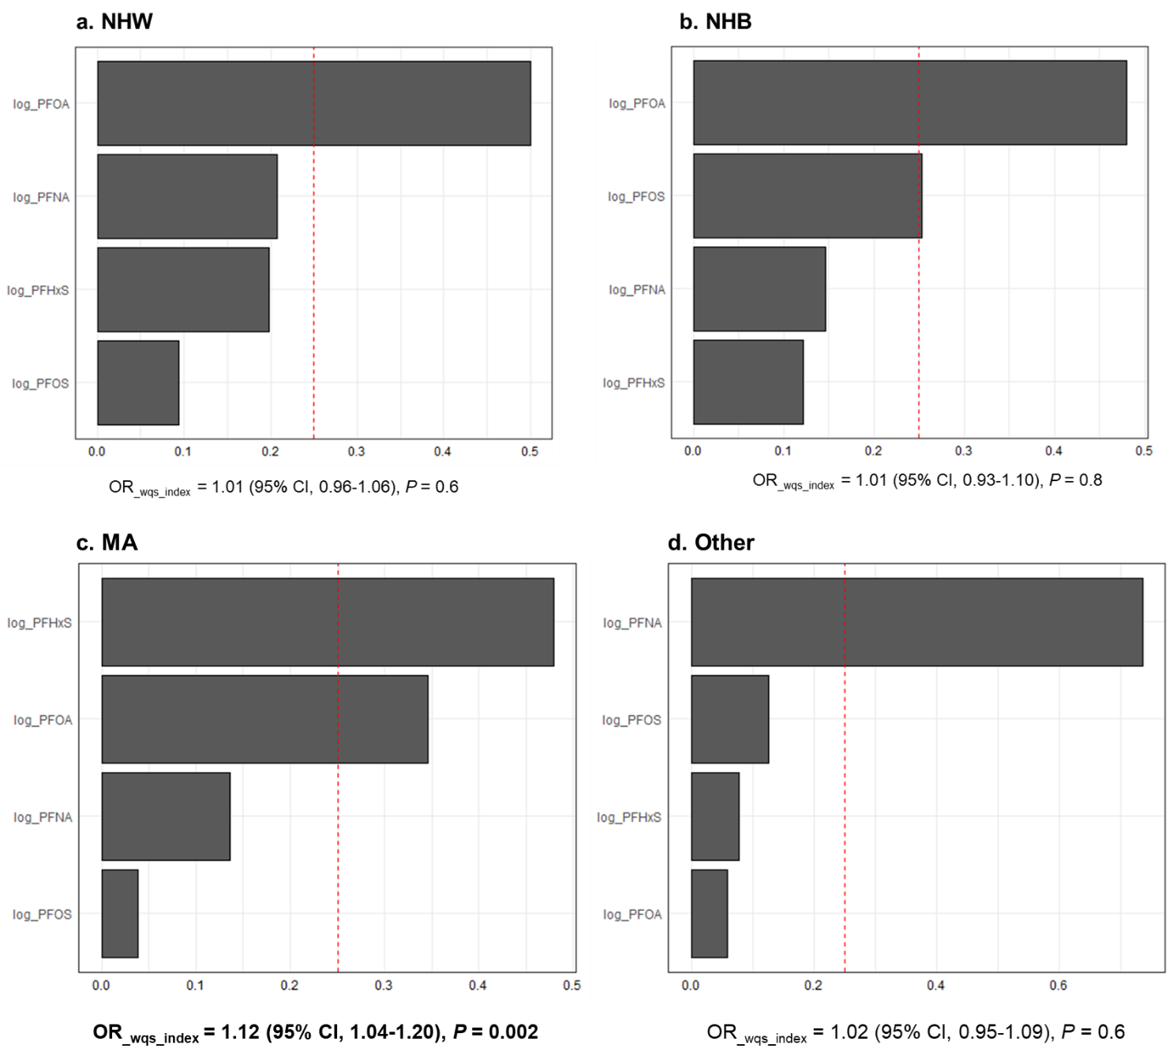
Fig. S6 Odds ratios of the indices and weights of the components in the WQS_{PFAS} indices in group 2 with the outcome of ALT elevation, stratified by race/ethnciity. Serum levels of four per- and polyfluoroalkyl substances (PFAS) were analyzed in weighted quartile sums (WQS) models with outcome of ALT- elevation with adjustment for age, sex, smoking and alcohol use, poverty, and diabetes. By default, a chemical in the mixture was considered a significant contributor if its weight exceeded the inverse of the number of elements in the mixture, which is 1/4 (0.25) for PFAS mixture, indicated by the red dashed line. Data of serum levels of PFAS were not normally distributed and were log-transformed in the analysis. Abbreviations: CI: confidence interval; NHW: non-Hispanic White; NHB: non-Hispanic Black; MA: Mexican American; OR: odds ratio; PFAS: per- and polyfluoroalkyl substances; PFOS: Perfluorooctane sulfonic acid; PFOA: Perfluorooctanoic acid; PFHxS: Perfluorohexane sulfonic acid; PFNA: Perfluorononanoic acid.

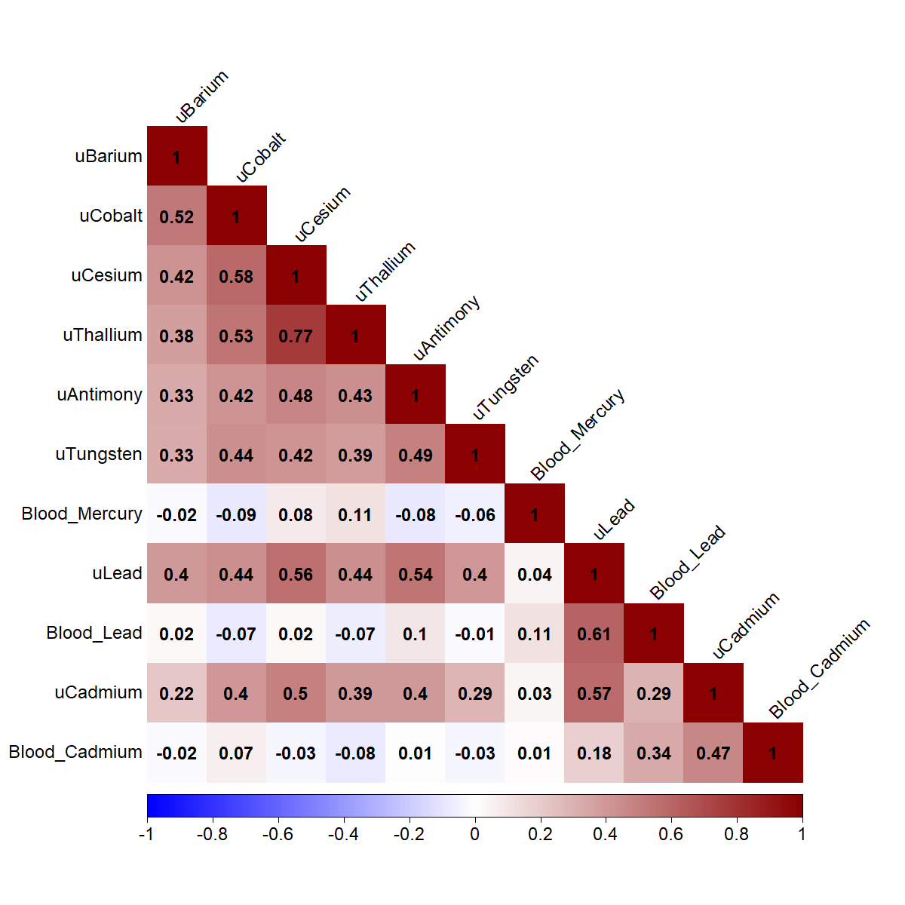
Fig. S7 Spearman correlation coefficient matrix of blood and/or urine levels of eleven metals. The plot shows the Spearman correlation coefficients of the blood levels of three metals (lead, cadmium and mercury) and urine levels of eight metals: cadmium, lead, cobalt, cesium, thallium, barium, antimony, and tungsten. All urine metals were labeled as “u + metal name”. The color and values in the cells represent the strength and direction of the correlation.

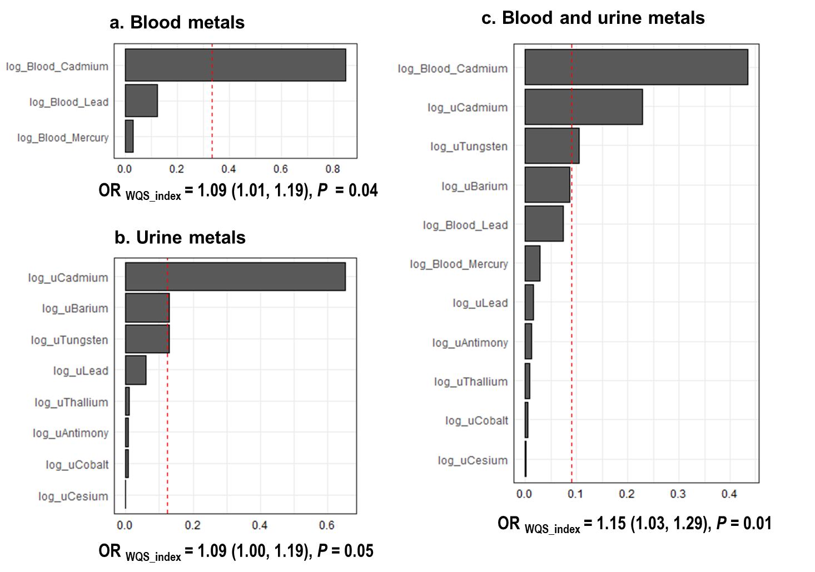
Fig. S8 Odds ratios of the indices and weights of the components in the blood and urine metal indices in group 3 with the outcome of advanced liver fibrosis. Weighted quantile sum (WQS) models were used to analyze blood levels of three metals and urine levels of eight metals with the outcome of advanced liver fibrosis, with adjustment for age, sex, smoking and alcohol use, poverty, and diabetes. In the WQS models, the weights and odds ratios of mixture indices were showed for mixtures of (a) Blood metals; (b) Urinary metals; and (c) Blood and urinary metals.By default, a chemical in the mixture was considered to be a significant contributor if its weight exceeded the inverse of the number of elements in the mixture, which are 1/3 = 0.33 in panel (a), 1/8 = 0.125 in panel (b), and 1/11= 0.09 in panel (c), indicated by the red dashed line. Data of blood and urine levels of metals were not normally distributed and were log-transformed in the analysis. Abbreviations: CI: confidence interval; OR: odds ratio.

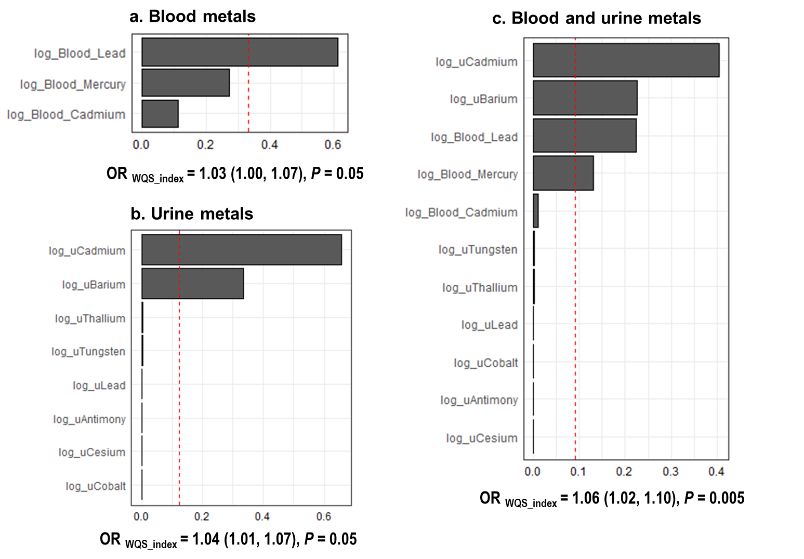
Fig. S9 Odds ratios of the indices and weights of the components in the blood and urine metal indices in group 3 with outcome of ALT elevation. Weighted quantile sum (WQS) models were used to analyze blood levels of three metals and urine levels of eight metals with the outcome of advanced liver fibrosis, with adjustment for age, sex, smoking and alcohol use, poverty, and diabetes. In the WQS models, the weights and odds ratios of mixture indices were showed for mixtures of (a) Blood metals; (b) Urinary metals; and (c) Blood and urinary metals.By default, a chemical in the mixture was considered to be a significant contributor if its weight exceeded the inverse of the number of elements in the mixture, which are 1/3=0.33 in panel (a), 1/8 = 0.125 in panel (b), and 1/11= 0.09 in panel (c), indicated by the red dashed line. Data of blood and urine levels of metals were not normally distributed and were log-transformed in the analysis. Abbreviations: CI: confidence interval; OR: odds ratio.

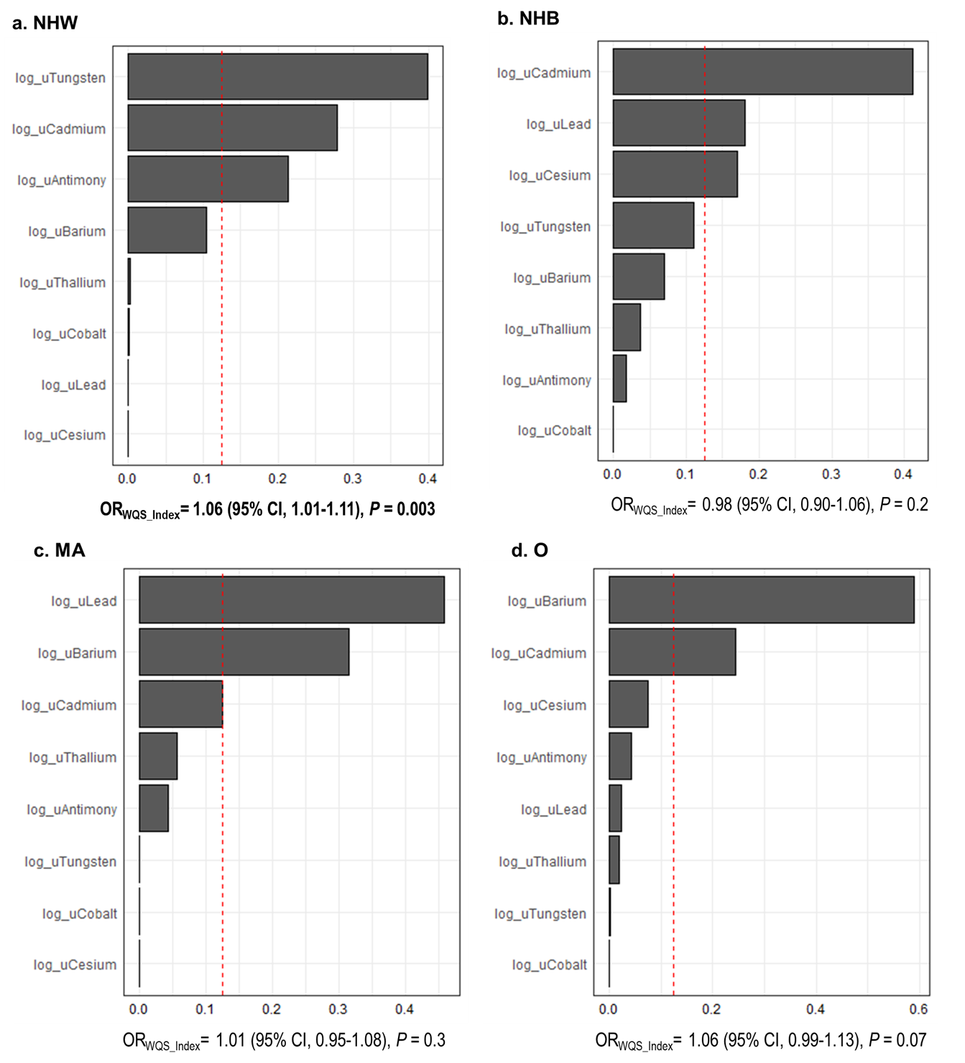
Fig. S10 Odds ratios of the indices and weights of the components in the urine metal indices in group 3 with outcome of ALT elevation, stratified by race/ethnicity group. Weighted quantile sum (WQS) models were used to analyze urine levels of eight metals with the outcome ALT elevation in (A) non-Hispanic White, NHW; (B) non-Hispanic Black, NHB; (C) Mexican American, MA; (D) Other racial group, with adjustment for age, sex, smoking and alcohol use, poverty, and diabetes. By default, a chemical in the mixture was considered to be a significant contributor if its weight exceeded the inverse of the number of elements in the mixture, which is 1/8 (0.125), indicated by the red dashed line. Data of urine levels of metals were not normally distributed and were log-transformed in the analysis. Abbreviations: CI: confidence interval; OR: odds ratio

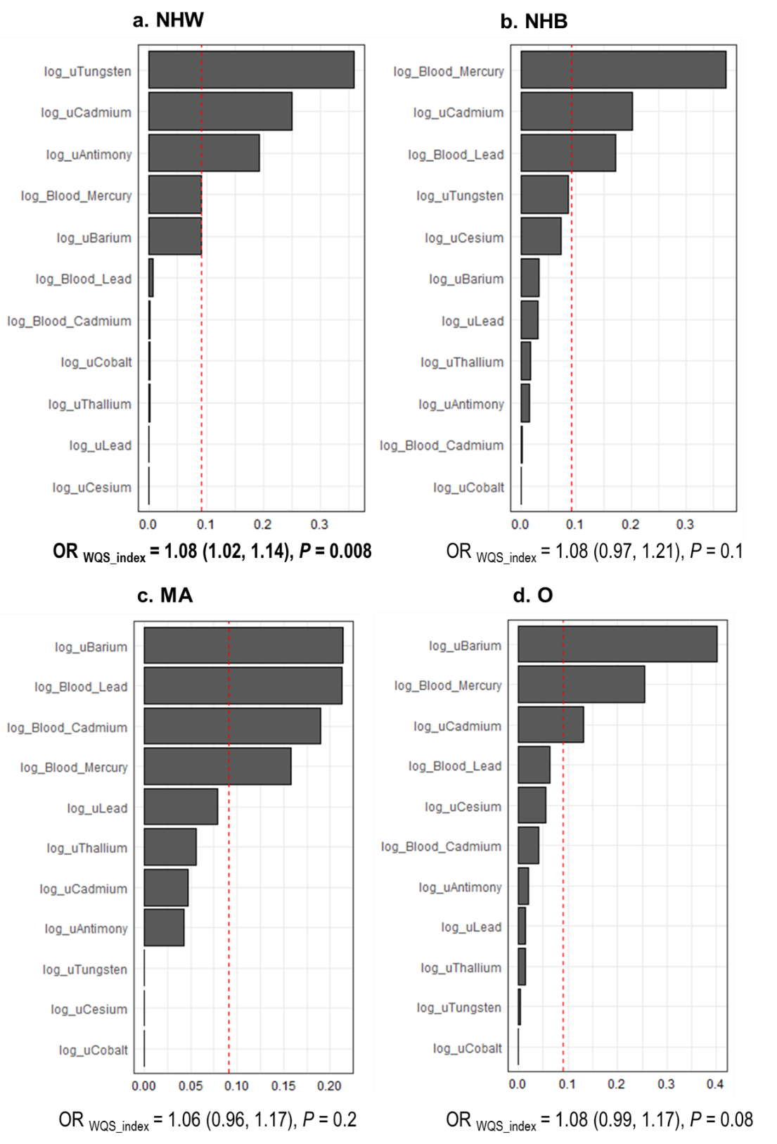
Fig. S11 Odds ratios of the indices and weights of the components in the blood and/or urine metal indices in group 3 with outcome of ALT elevation, stratified by race/ethnicity group. Weighted quantile sum (WQS) models were used to analyze blood levels of three metals and urine levels of eight metals with the outcome ALT elevation in (a) non-Hispanic White, NHW; (b) non-Hispanic Black, NHB; (c) Mexican American, MA; (d) Other racial group, with adjustment for age, sex, smoking and alcohol use, poverty, and diabetes. By default, a chemical in the mixture was considered to be a significant contributor if its weight exceeded the inverse of the number of elements in the mixture, which is 1/11 (0.09), indicated by the red dashed line. Data of urine levels of metals were not normally distributed and were log-transformed in the analysis. Abbreviations: CI: confidence interval; OR: odds ratio.
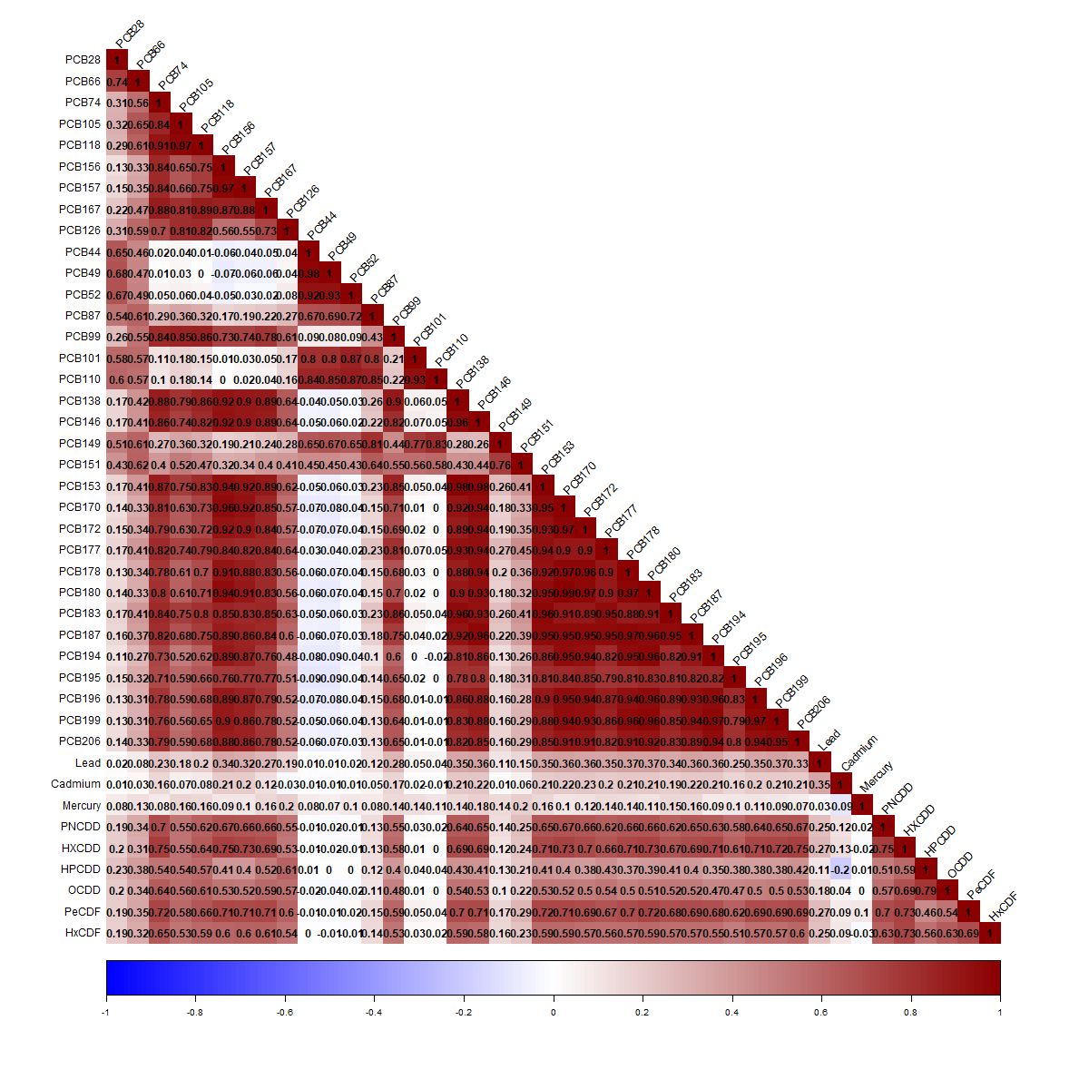
Fig. S12 Spearman correlation coefficient matrix of blood levels of lead, cadmium and mercury, PCBs, and PCDD/Fs. The correlation matrix depicts the Spearman correlation coefficients of 34 polychlorinated biphenyls (PCBs), six polychlorinated dibenzo-p-dioxins (PCDD) and dibenzofuranes (PCDF), and blood levels of cadmium, lead and mercury. The color and numbers in the cells represent the strength and direction of the correlation.
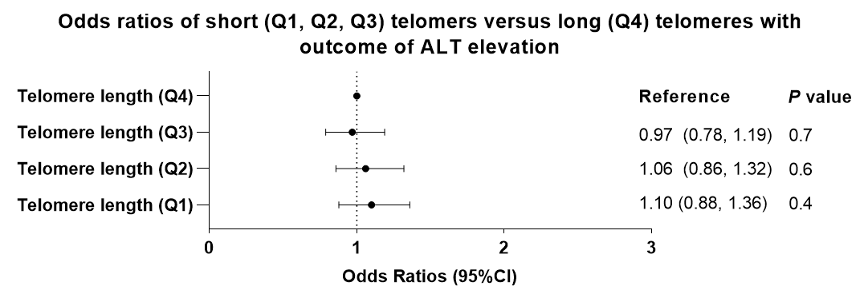
Fig. S13 Odds ratios of telomere length quartiles with the outcome of ALT elevation. Multivariable logistic regression models were constructed to determine the odds ratios of telomere length quartiles [reference level long (Q4) telomeres] with the outcome of ALT-elevation, adjusted for age, sex, diabetes, BMI, alcohol use, smoking status, and poverty. Abbreviations: ALT: alanine aminotransferase; BMI: body mass index; Q: quartile.

Table S1a Characteristics of group 1, the participants with blood levels of three metals in NHANES 2003-2018 (weighted % (95% CI))
Cohort (n) | Total (33,979) | NHW (15,091) | NHB (7046) | MA (5532) | O (6310)
Advanced fibrosis | 1.2 (1.1, 1.3) | 1.2 (1, 1.4) | 1.4 (1.1, 1.7) | 1.4 (1.1, 1.7) | 0.9 (0.6, 1.1)
ALT elevation | 14.2 (13.7, 14.8) | 13.4 (12.6, 14.1) | 10.0 (9.2, 10.9) | 22.4 (21, 23.8) | 17.2 (16.1, 18.4)
Ageª (years) | 47.5 (47.0, 47.9) | 49.4 (48.8, 49.9) | 44.9 (44.3, 45.5) | 40.7 (40.0, 41.4) | 43.9 (43.3, 44.6)
Male | 49.0 (48.4, 49.6) | 49.9 (48.2, 49.8) | 45.7 (44.6, 46.8) | 53.2 (51.8, 54.6) | 49.1 (47.6, 50.5)
Diabetes | 12.7 (12.1, 13.2) | 11.4 (10.7, 12.1) | 17.1 916.2, 18.1) | 14.6 (135, 15.7) | 14.3 (13.2, 15.5)
BMI
Normal | 30.1 (29.1, 31) | 31.0 (29.8, 32.2) | 23.7 (22.5, 24.8) | 20.8 (19, 22.5) | 36.6 (34.7, 38.5)
Overweight | 33.1 (32.3, 33.9) | 33.3 (32.3, 34.4) | 28.1 (26.9, 29.4) | 36.2 (34.7, 37.7) | 34.1 (32.5, 35.7)
Obese | 35.7 (34.7, 36.7) | 34.7 (33.4, 35.9) | 46.8 (45.3, 48.4) | 41.6 (39.9, 43.4) | 28.3 (26.3, 30.3)
Missing | 1.1 (0.9, 1.2) | 1.0 (0.8, 1.2) | 1.4 (1.0, 1.7) | 1.4 (1.0, 1.8) | 1.0 (0.7, 1.4)
Alcohol use
Lifetime abstainers | 9.7 (9.1, 10.3) | 7.9 (.07, 8.7) | 13.5 (12.2, 14.7) | 11.4 (10.3, 12.5) | 15.4 (14.1, 16.8)
Former drinkers | 15.1 (14.3, 16) | 15.3 (14.1, 16.5) | 16.2 (15, 17.3) | 14.1 (13, 15.3) | 13.8 (12.4, 15.3)
Non-excessive current drinkers | 37.6 (36.7, 38.5) | 39.1 (37.9, 40.4) | 38.2 (36.9, 39.6) | 29 (27.1, 30.9) | 34.1 (32.2, 36.1)
Excessive current drinkers | 30.1 (29.1, 31.1) | 31.6 (30.3, 32.9) | 22.2 (20.8, 23.6) | 36.4 (34.7, 38.1) | 24.6 (22.8, 26.4)
Missing | 7.5 (7.0, 8.0) | 6.1 (5.5, 6.7) | 9.9 (9.0, 11.0) | 9.1 (8.1, 10.1) | 12.0 (10.6, 13.4)
Smoking status
Never | 53.9 (52.9, 55) | 50.2 (49, 51.6) | 59.3 (57.5, 61.1) | 62.6 (60.7, 64.6) | 63.6 (61.7, 65.6)
Past/current | 46.0 (45.0, 47.1) | 49.7 (48.4, 51.0) | 40.6 (38.8, 42.4) | 37.3 (35.3, 39.2) | 36.3 (34.4, 38.2)
Missing | 0.01 (0, 0.04) | 0.01 (0, 0.02) | 0.1 (0, 0.2) | 0.1 (0, 0.2) | 0.02 (0, 0.1)
Poverty
No | 80.5 (79.5, 81.5) | 85.8 (84.7, 87) | 69.8 (67.7, 71.8) | 63.9 (60.9, 65) | 71.8 (70, 73.7)
Yes | 12.2 (11.4, 12.9) | 8.3 (7.5, 9.2) | 20.8 (18.9, 22.7) | 26 (23.6, 28.4) | 16.7 (15.1, 18.4)
Missing | 7.3 (6.8, 7.9) | 5.8 (5.2, 6.4) | 9.4 (8.3, 10.6) | 10.1 (9.7, 12.5) | 11.4 (10, 12.9)
Blood level of leadª (µg/dL) | 1.52 (1.48, 1.56) | 1.49 (1.44, 1.54) | 1.66 (1.59, 1.73) | 1.67 (1.55, 1.79) | 1.46 (1.40, 1.52)
Blood level of cadmiumª (µg/L) | 0.51 (0.49, 0.52) | 0.51 (0.50, 0.53) | 0.57 (0.55, 0.59) | 0.37 (0.35, 0.39) | 0.52 (0.49, 0.55)
Blood level of mercuryª (µg/L) | 1.57 (1.49, 1.65) | 1.49 (1.40, 1.58) | 1.52 (1.41, 1.62) | 1.04 (0.97, 1.11) | 2.41 (2.22, 2.59)
a Continuous variable summarized using weighted means (95% CI). Abbreviations: BMI: body mass index; CI: confidence interval; NHW: non-Hispanic White; NHB: non-Hispanic Black; MA: Mexican American; O: other racial/ethnic group.

Table S1b Characteristics of the group 2, participants with four per- and polyfluoroalkyl substances (PFAS) in NHANES 2003-2018 (weighted % (95% CI))
Cohort (n) | Total (10,257) | NHW (4629) | NHB (2135) | MA (1674) | O (1819)
Advanced fibrosis | 1.09  (0.85, 1.34) | 1.13  (0.78,1.47) | 1.10  (0.64, 1.56) | 1.24  (0.61, 1.86) | 0.80  (0.38, 1.22)
ALT elevation | 14.16  (13.25, 15.07) | 13.52  (12.31, 14.72) | 9.14  (7.64, 10.63) | 23.14  (20.62, 25.65) | 16.14  (13.72, 18.55)
Ageª (years) | 47.41  (46.87 47.94) | 49.18  (48.49, 49.88) | 44.72  (43.91, 45.53) | 40.62  (39.61, 41.64) | 44.19  (43.17, 45.2)
Male | 48.89  (47.53, 50.25) | 49.16  (47.34, 50.97) | 45.38  (43.39, 47.38) | 53.26  (50.64, 55.87) | 47.47  (44.66, 50.28)
Perfluorooctane sulfonic acid (PFOS)ª ng/mL | 14.71  (13.93, 15.48) | 15.29  (14.35, 16.24) | 17.2  (15.68, 18.72) | 10.16  (9.22, 11.1) | 12.28  (11.18, 13.38)
Perfluorooctanoic acid (PFOA)ª ng/mL | 3.64  (3.48, 3.81) | 3.9  (3.7, 4.1) | 3.37  (3.08, 3.66) | 2.71  (2.52, 2.91) | 3.06  (2.85, 3.28)
Perfluorohexane sulfonic acid (PFHxS )ª ng/mL | 2.32  (2.19, 2.45) | 2.49  (2.34 2.63) | 2.22  (1.98, 2.46) | 1.7  (1.57, 1.84) | 1.87  (1.61, 2.13)
Perfluorononanoic acid (PFNA)ª ng/mL | 1.22  (1.12, 1.31) | 1.21  (1.1, 1.32) | 1.39  (1.25, 1.54) | 0.94  (0.86, 1.01) | 1.26  (1.15, 1.37)
a Continuous variable summarized using weighted means (95% CI). Abbreviations: CI: confidence interval; NHW: non-Hispanic White; NHB: non-Hispanic Black; MA: Mexican American; O: other racial/ethnic group.

Table S1c Characteristics of group 3, participants with eight urine metals and three blood metals in NHANES 2003-2018 (weighted mean, % (95% CI))
Cohort (n) | Total (12,847) | NHW (5572) | NHB (2657) | MA (2097) | O (2521)
Advanced fibrosisª | 1.35 (1.09, 1.60) | 1.44 (1.09, 1.79) | 1.19 (0.75, 1.64) | 1.37 (0.8, 1.94) | 0.96 (0.6, 1.33)
ALT elevationª | 14.94  (14.09, 15.79) | 14.12  (12.97, 15.27) | 10.2  (8.71, 11.69) | 22.56  (20.13, 24.99) | 18.37  (16.11, 20.63)
Age (years) | 47.46  (46.91, 48.01) | 49.41  (48.71, 50.1) | 44.76  (43.92, 45.59) | 40.51  (39.55, 41.47) | 43.85  (43.02, 44.69)
Maleª | 49.15  (48.09, 50.21) | 49.27  (47.84, 50.7) | 45.81  (44.09, 47.52) | 53.09  (50.8, 55.38) | 48.69  (46.15, 51.22)
Barium, urine (ng/mL) | 2.07  (1.96, 2.19) | 2.21  (2.04, 2.37) | 1.70  (1.60, 1.81) | 1.70  (1.56, 1.85) | 1.93  (1.69, 2.16)
Cadmium, urine (ng/mL) | 0.34  (0.33, 0.35) | 0.32  (0.31, 0.34) | 0.45  (0.42, 0.47) | 0.29  (0.27, 0.3) | 0.35  (0.33, 0.38)
Cobalt, urine (ng/mL) | 0.53  (0.49, 0.57) | 0.54  (0.48, 0.59) | 0.57  (0.51, 0.63) | 0.53  (0.49, 0.58) | 0.49  (0.46, 0.52)
Cesium, urine (ng/mL) | 5.3  (5.18, 5.42) | 5.28  (5.11, 5.45) | 5.43  (5.15, 5.71) | 5.16  (4.96, 5.36) | 5.39  (5.18, 5.61)
Lead, urine (ng/mL) | 0.63  (0.61, 0.66) | 0.60  (0.58, 0.63) | 0.73  (0.67, 0.79) | 0.79  (0.71, 0.86) | 0.61  (0.49, 0.74)
Antimony, urine (ng/mL) | 0.08  (0.08, 0.09) | 0.08  (0.07, 0.08) | 0.12  (0.09, 0.14) | 0.09  (0.08, 0.11) | 0.07  (0.06, 0.08)
Thallium, urine (ng/mL) | 0.19  (0.18, 0.19) | 0.18  (0.17, 0.18) | 0.22  (0.21, 0.23) | 0.18  (0.18, 0.19) | 0.21  (0.2, 0.22)
Tungsten, urine (ng/mL) | 0.12  (0.11, 0.13) | 0.11  (0.1, 0.12) | 0.15  (0.13, 0.17) | 0.14  (0.13, 0.16) | 0.11  (0.1, 0.12)
a Binary variable summarized using weighted prevalence (95% CI). Abbreviations: CI: confidence interval; NHW: non-Hispanic White; NHB: non-Hispanic Black; MA: Mexican American; O: other racial/ethnic group.

Table S1d Characteristics of the group 4, participants with measurements of blood levels of three metals and PCBs and PCDD/Fs in NHANES 2003-2018 (weighted mean, % (95% CI))
Cohort (n) | n (1043)
Advanced fibrosisª | 1.35 (1.09, 1.60)
ALT elevationª | 14.94 (14.09, 15.79)
Age (years) | 47.46 (46.91, 48.01)
Maleª | 49.15 (48.09, 50.21)
PCB28 (ng/g) | 5.55 (5.28, 5.81)
PCB66 (ng/g) | 1.74 (1.65, 1.82)
PCB74 (ng/g) | 8.14 (7.52, 8.75)
PCB105 (ng/g) | 2.12 (1.86, 2.39)
PCB118 (ng/g) | 10.72 (9.51, 11.92)
PCB156 (ng/g) | 5.59 (5.18, 6)
PCB157 (ng/g) | 1.34 (1.24, 1.44)
PCB167 (ng/g) | 1.34 (1.22, 1.46)
PCB126 (pg/g) | 24.86 (21.95, 27.77)
PCB44 (ng/g) | 2.39 (2.25, 2.54)
PCB49 (ng/g) | 1.5 (1.41, 1.58)
PCB52 (ng/g) | 3.16 (2.87, 3.44)
PCB87 (ng/g) | 1.04 (0.96, 1.12)
PCB99 (ng/g) | 6.47 (5.74, 7.19)
PCB101 (ng/g) | 2.14 (1.97, 2.31)
PCB110 (ng/g) | 1.56 (1.44, 1.68)
PCB138 (ng/g) | 26.82 (24.53, 29.11)
PCB146 (ng/g) | 4.19 (3.75, 4.62)
PCB149 (ng/g) | 0.74 (0.68, 0.8)
PCB151 (ng/g) | 0.39 (0.34, 0.43)
PCB153 (ng/g) | 35.76 (32.95, 38.57)
PCB170 (ng/g) | 10.61 (10.1, 11.12)
PCB172 (ng/g) | 1.47 (1.36, 1.59)
PCB177 (ng/g) | 2.54 (2.27, 2.82)
PCB178 (ng/g) | 2.09 (1.95, 2.23)
PCB180 (ng/g) | 30.6 (29.04, 32.15)
PCB183 (ng/g) | 2.9 (2.7, 3.1)
PCB187 (ng/g) | 8.74 (7.91, 9.58)
PCB194 (ng/g) | 7.05 (6.6, 7.51)
PCB195 (ng/g) | 1.54 (1.39, 1.7)
PCB196 (ng/g) | 5.88 (5.47, 6.29)
PCB199 (ng/g) | 7.25 (6.54, 7.96)
PCB206 (ng/g) | 4.72 (4.13, 5.31)
PCB209 (ng/g) | 3.38 (2.82, 3.95)
1,2,3,7,8-Pentachlorodibenzo-p-dioxin (pncdd) (pg/g) | 4.53 (4.15, 4.9)
1,2,3,6,7,8-Hexachlorodibenzo-p-dioxin (hxcdd) (pg/g) | 28.12 (25.76, 30.49)
1,2,3,4,6,7,8-Heptachlorodibenzo-p-dioxin (hpcdd) (pg/g) | 36.69 (31.74, 41.63)
1,2,3,4,6,7,8,9-Octachlorodibenzo-p-dioxin (ocdd) (pg/g) | 295.28 (250.86, 339.7)
2,3,4,7,8-Pentachlorodibenzofuran (pg/g) | 5.48 (5.13, 5.83)
1,2,3,4,7,8-Hexachlorodibenzofuran (pg/g) | 4.36 (3.98, 4.73)
a The categorical variables summarized as weighted prevalence (95% CI). Abbreviations: CI: confidence interval; PCB: polychlorinated biphenyls; PCDD: polychlorinated dibenzo-p-dioxins; PCDF: polychlorinated dibenzofuranes.

Table S1e Characteristics of group 5, participants with blood levels of two metals and telomere length in NHANES 1999-2002 (weighted % (95% CI))
Cohort | n (7360)
Advanced fibrosis | 0.9 (0.6, 1.1)
ALT elevation | 13.5 (12.6, 14.5)
Ageª (years) | 46.5 (45.7, 47.2)
Male | 49.6 (48.7, 50.6)
Diabetes | 9.6 (8.7, 10.4)
BMI
Normal | 33.9 (32.0, 35.8)
Overweight | 34.2 (32.4, 36)
Obese | 29.5 (27.4, 31.5)
Missing | 2.5 (1.9, 3.0)
Alcohol use
Lifetime abstainers | 12.0 (8.7, 15.3)
Former drinkers | 16.2 (14.4, 18.0)
Non-excessive current drinkers | 38.0 (35.1, 40.9)
Excessive current drinkers | 28.9 (27.5, 30.4)
Missing | 4.8 (4.1, 5.6)
Smoking status
Never | 49.8 (47.2, 52.4)
Past/current | 50.0 (47.4, 52.7)
Missing | 0.2 (0, 0.3)
Poverty
No | 79.7 (77.9, 81.5)
Yes | 11.9 (10.1, 13.7)
Missing | 8.4 (6.8, 10.0)
Blood level of leadª (µg/dL) | 2.1 (2.1, 2.2)
Blood level of cadmiumª (µg/L) | 0.6 (0.5, 0.6)
Telomere lengthª (base pair) | 5820 (5746.4, 5893.7)
a Continuous variable summarized using weighted means (95% CI). The categorical variables summarized using weighted prevalence (95% CI). Abbreviations: BMI: body mass index; CI: confidence interval.

Table S2 Odds ratios from multivariable logistic regression models with the outcome of advanced liver fibrosis with blood levels of two metals included as independent variables; the study group does not include participants with viral hepatitis
Cohorts | OR (95% CI)
Sample size (n) | Total (31,007) | NHW (14,417) | NHB (5999) | MA (5310) | O (5281)
Advanced fibrosis (n) | 321 | 154 | 46 | 70 | 51
Age (unit 10 years) | 1.35  (1.23, 1.49) ‡ | 1.33  (1.15, 1.53) ‡ | 1.22  (1.03, 1.45) ‡ | 1.43  (1.18, 1.74) ‡ | 1.86  (1.54, 2.23) ‡
Diabetes
No | Reference
Yes | 2.92  (2.17, 3.92) ‡ | 3.29  (2.22, 4.88) ‡ | 0.61  (0.28, 1.34) | 2.26  (1.20, 4.26) * | 3.99  (1.97, 8.09) †
Smoking status
Never | Reference
Past/current | 1.46  (1.06, 2.02) * | 1.49  (0.96, 2.30) | 1.50  (0.64, 3.53) | 1.46  (0.75, 2.82) | 1.24  (0.60, 2.56)
Blood Lead (Pb)
Q1-3 | Reference
Q4 | 1.18  (0.85, 1.64) | 1.21  (0.81, 1.81) | 2.39  (1.18, 4.86) † | 0.57  (0.27, 1.22) | 1.14  (0.43, 3.01)
Blood Cadmium (Cd)
Q1-3 | Reference
Q4 | 1.55  (1.12, 2.16) ‡ | 1.60  (1.04, 2.44) * | 1.56  (0.74, 3.28) | 1.83  (0.92, 3.66) | 1.22  (0.59, 2.53)
Multiple imputation was performed in multivariate logistic regression models. *p < .05, † p < .001, ‡ p < .0001. Advanced fibrosis defined by APRI ≥ 1.5 and/or FIB-4 ≥ 2.67 and/or Forns ≥6.9. Abbreviations: APRI: Aspartate aminotransferase to platelet ratio index; FIB-4: Fibrosis-4 score; OR: odds ratio; CI: confidence interval; BMI: body mass index; NHW: Non-Hispanic White; NHB: Non-Hispanic Black; MA: Mexican American; O: other race; Q: quartile.

Table S3 Odds ratios from multivariable logistic regression models with the outcome of advanced liver fibrosis with blood levels of three metals included as continuous variables
Cohorts | OR (95% CI)
Sample size (n) | Total (33,979) | NHW (15,091) | NHB (7046) | MA (5532) | O (6310)
Advanced fibrosis (n) | 496 | 207 | 118 | 90 | 81
Survey Cycle | 1.10  (1.05, 1.16) † | 1.14  (1.07, 1.21) † | 1.03  (0.95, 1.13) | 1.05  (0.92, 1.19) | 1.03  (0.88, 1.20)
Age (unit 10 years) | 1.40  (1.29, 1.51) ‡ | 1.31  (1.18, 1.46) ‡ | 1.35  (1.16, 1.57) ‡ | 1.60  (1.33, 1.92) ‡ | 1.99  (1.69, 2.35) ‡
Gender
Female | Reference
Male | 1.71  (1.26, 2.34) † | 1.76  (1.15, 2.70) * | 1.5  (0.92, 2.45) | 2.07 (1.07, 4.01) * | 1.46  (0.78, 2.72)
Diabetes
No | Reference
Yes | 2.63  (2.03, 3.42) ‡ | 3.25  (2.28, 4.64) ‡ | 0.77  (0.48, 1.23) | 2.10  (1.17, 3.76) * | 2.87  (1.51, 5.48) *
BMI
Normal | Reference
Overweight | 0.97  (0.66, 1.44) | 0.9  (0.52, 1.56) | 1.24  (0.69, 2.23) | 1.17  (0.55, 2.47) | 0.87  (0.41, 1.88)
Obese | 1.05  (0.76, 1.46) | 0.93  (0.6, 1.45) | 1.05  (0.56, 1.95) | 1.16  (0.55, 2.48) | 1.59  (0.74, 3.43)
Alcohol use
Lifetime abstainers | Reference
Former drinkers | 0.99  (0.63, 1.57) | 0.75  (0.39, 1.45) | 2.73  (1.14, 6.56) * | 0.70  (0.25, 1.98) | 1.49  (0.65, 3.42)
Non-excessive current drinkers | 1.10  (0.71, 1.71) | 1.02  (0.54, 1.92) | 1.85 (0.71, 4.82) | 0.80  (0.25, 2.6) | 1.04  (0.42, 2.61)
Excessive current drinkers | 2.11  (1.31, 3.40) † | 1.79  (0.88, 3.66) | 2.93  (1.18, 7.26) * | 1.99  (0.63, 6.25) | 2.73  (1.00, 7.47) *
Smoking status
Never | Reference
Past/current | 1.13  (0.81, 1.58) | 1.21  (0.75, 1.94) | 0.80  (0.47, 1.36) | 1.25  (0.66, 2.39) | 1.03  (0.49, 2.17)
Poverty
No | Reference
Yes | 1.15  (0.86, 1.53) | 0.88  (0.54, 1.44) | 1.86  (1.40, 2.48) † | 1.02  (0.54, 1.93) | 0.96  (0.48, 1.93)
Log-transformed concentrations of lead | 1.16  (0.94, 1.43) | 1.21  (0.9, 1.63) | 1.07  (1.01, 1.12) * | 0.57  (0.35, 1.02) | 0.87  (0.53, 1.43)
Log-transformed concentrations of cadmium | 1.65  (1.42, 1.92) ‡ | 1.68  (1.36, 2.09) ‡ | 1.68  (1.20, 2.33) ‡ | 1.8  (1.27, 2.55) * | 1.46  (0.95, 2.23)
Log-transformed concentrations of mercury | 0.96  (0.84, 1.10) | 0.98  (0.80, 1.20) | 1.23  (0.98, 1.55) | 0.84  (0.68, 1.05) | 0.89  (0.68, 1.18)
Multiple imputation was performed in multivariate logistic regression models. *p < .05, † p < .001, ‡ p < .0001. Advanced fibrosis defined by APRI ≥ 1.5 and/or FIB-4 ≥ 2.67 and/or Forns ≥ 6.9. Abbreviations: APRI: Aspartate aminotransferase to platelet ratio index; FIB-4: Fibrosis-4 score; OR: odds ratio; CI: confidence interval; BMI: body mass index; NHW: Non-Hispanic White; NHB: Non-Hispanic Black; MA: Mexican American; O: other race; Q: quartile.

Table S4 Odds ratios from multivariable logistic regression models with the outcome of ALT elevation with blood levels of three metals included in the analysis
Cohorts | OR (95% CI)
Sample size (n) | Total (33,979) | NHW (15,091) | NHB (7046) | MA (5532) | O (6310)
ALT elevation (n) | 4960 | 1878 | 677 | 1113 | 1022
Survey Cycle | 0.99  (0.98, 1.01) | 0.99  (0.96, 1.02) | 0.99  (0.95, 1.04) | 0.96  (0.93, 0.99) * | 0.99  (0.95, 1.03)
Age (unit 10 years) | 0.85  (0.83, 0.87) ‡ | 0.84  (0.81, 0.87) ‡ | 0.93  (0.87, 0.99) * | 0.81  (0.76, 0.86) ‡ | 0.95  (0.89, 1.00) *
Gender
Female | Reference
Male | 1.34  (1.21, 1.47) ‡ | 1.21  (1.05, 1.38) * | 1.82  (1.51, 2.19) ‡ | 1.52  (1.26, 1.84) ‡ | 1.50  (1.25, 1.81) ‡
Diabetes
No | Reference
Yes | 1.42  (1.27, 1.59) ‡ | 1.41  (1.21, 1.65) ‡ | 1.12  (0.85, 1.46) | 1.75  (1.42, 2.15) ‡ | 1.30  (1.02, 1.66) *
BMI
Normal | Reference
Overweight | 1.88  (1.68, 2.10) ‡ | 1.82  (1.55, 2.13) ‡ | 1.51  (1.16, 1.95) * | 2.47  (1.86, 3.28) ‡ | 2.12  (1.65, 2.72) ‡
Obese | 3.18  (2.85, 3.54) ‡ | 3.27  (2.80, 3.83) ‡ | 2.13  (1.69, 2.69) ‡ | 4.49  (3.36, 6.02) ‡ | 3.71  (2.84, 4.85) ‡
Alcohol use
Lifetime abstainers | Reference
Former drinkers | 1.00  (0.84, 1.19) | 1.11  (0.84, 1.46) | 1.18  (0.85, 1.63) | 0.78  (0.54, 1.12) | 0.85  (0.63, 1.14)
Non-excessive current drinkers | 1.00  (0.86, 1.17) | 1.12  (0.88, 1.44) | 1.08  (0.79, 1.48) | 0.82  (0.58, 1.15) | 0.88  (0.69, 1.13)
Excessive current drinkers | 1.17  (0.98, 1.38) | 1.23  (0.94, 1.60) | 1.36  (1.00, 1.84) * | 1.14  (0.84, 1.54) | 0.93  (0.69, 1.26)
Smoking status
Never | Reference
Past/current | 1.04  (0.95, 1.14) | 1.08  (0.95, 1.22) | 1.00  (0.81, 1.23) | 1.00  (0.82, 1.21) | 0.88  (0.72, 1.07)
Poverty
No | Reference
Yes | 1.00  (0.90, 1.11) | 0.93  (0.78, 1.10) | 1.13  (0.93, 1.39) | 0.93  (0.78, 1.11) | 0.97  (0.76, 1.24)
Blood Lead (Pb)
Q1-3 |  |  | Reference
Q4 | 1.06  (0.95, 1.18) | 1.01  (0.86, 1.18) | 1.24  (1.01, 1.53) * | 1.13  (0.95, 1.34) | 1.02  (0.76, 1.36)
Blood Cadmium (Cd)
Q1-3 | Reference
Q4 | 0.95  (0.86, 1.06) | 0.95  (0.82, 1.11) | 1.25  (1.03, 1.55) * | 1.11  (0.86, 1.42) | 0.92  (0.72, 1.18)
Blood Mercury (Hg)
Q1-3 | Reference
Q4 | 1.15  (1.04, 1.27) * | 1.14  (0.99, 1.32) | 1.17  (0.94, 1.46) | 1.39  (1.13, 1.72) * | 1.1  (0.91, 1.34)
Multiple imputation was performed in multivariate logistic regression models. *p < .05, † p < .001, ‡ p < .0001. Abbreviations: APRI: Aspartate aminotransferase to platelet ratio index; FIB-4: Fibrosis-4 score; OR: odds ratio; CI: confidence interval; BMI: body mass index; NHW: Non-Hispanic White; NHB: Non-Hispanic Black; MA: Mexican American; O: other race; Q: quartile.

Table S5 Odds ratios of the WQS mixture indices for blood levels of lead, cadmium and mercury with outcome of ALT elevation
Outcomes | Race/ethnicity | ORª (95% CI) of WQS mixture index | P value | Significant mixture components | Weights^{b}
Outcomes | (Total/ cases)
ALT elevation | Total (33,979/ 4960) | 1.05 (1.03, 1.07) | <0.0001 | Mercury | 0.499
ALT elevation |  |  |  | Lead | 0.472
ALT elevation | NHW (15,091/ 1878) | 1.06 (1.02, 1.09) | 0.0008 | Mercury | 0.661
ALT elevation | NHB (7046/ 677) | 1.08 (1.02, 1.14) | 0.006 | Lead | 0.644
ALT elevation | MA (5532/ 1113) | 1.12 (1.07, 1.18) | <0.0001 | Lead | 0.462
ALT elevation | Other (6310/ 1022) | 1.01 (0.97, 1.05) | 0.7 | Mercury | 0.675
ªEstimated ORs were associated with a unit (per decile) increase in the WQS index. ^{b}Weights of significant influential blood metals in mixture index in the Weighted Quantile Sum binominal models were listed (by default the significant blood metals equal to the inverse of the number of elements in the mixture, which equals to 1/3 = 0.33). Multiple imputation was performed in multivariate WQS binomial models with outcomes. The models were adjusted for age, sex, race/ethnicity, smoking status, alcohol use, BMI, poverty, and diabetes. Data of blood levels of cadmium, lead and mercury were not normally distributed and were log-transformed in analysis. Abbreviations: NHW: non-Hispanic White; NHB: non-Hispanic Black; MA: Mexican American.

Table S6 Odds ratios of log-transformed PCBs with outcome of ALT elevation in NHANES 2003-2004 (group 4) adjusted for age, sex, and race/ethnicity
Variable (log transformed) | Outcome of ALT elevation (n = 1043 / n cases = 145)
Variable (log transformed) | OR (95% CI) | p value | q-value
PCB28 | 0.95 (0.64, 1.41) | 0.7882 | 0.9029
PCB66 | 1.16 (0.74, 1.8) | 0.5146 | 0.8471
PCB74 | 1.29 (0.89, 1.88) | 0.1783 | 0.5174
PCB105 | 1.57 (1.24, 1.99) | 0.0002 | 0.0042
PCB118 | 1.54 (1.19, 1.98) | 0.001 | 0.0140
PCB156 | 1.03 (0.77, 1.38) | 0.8423 | 0.9071
PCB157 | 0.96 (0.78, 1.18) | 0.7019 | 0.9029
PCB167 | 1.08 (0.89, 1.31) | 0.455 | 0.8471
PCB126 | 1.69 (1.3, 2.21) | 0.0001 | 0.0042
PCB44 | 0.92 (0.58, 1.46) | 0.7269 | 0.9029
PCB49 | 0.94 (0.59, 1.49) | 0.7892 | 0.9029
PCB52 | 1.02 (0.72, 1.46) | 0.9056 | 0.9277
PCB87 | 1.12 (0.87, 1.44) | 0.3743 | 0.7486
PCB99 | 1.28 (1.02, 1.6) | 0.0342 | 0.2052
PCB101 | 1.14 (0.79, 1.63) | 0.4861 | 0.8471
PCB110 | 1.10 (0.77, 1.58) | 0.6065 | 0.9029
PCB138 | 1.22 (0.93, 1.60) | 0.1444 | 0.5174
PCB146 | 1.35 (1.03, 1.76) | 0.0291 | 0.2037
PCB149 | 1.04 (0.70, 1.53) | 0.8641 | 0.9073
PCB151 | 1.21 (0.93, 1.58) | 0.1603 | 0.5174
PCB153 | 1.17 (0.88, 1.56) | 0.2884 | 0.6375
PCB170 | 1.14 (0.87, 1.50) | 0.3527 | 0.7407
PCB172 | 1.16 (0.92, 1.47) | 0.2059 | 0.5405
PCB177 | 1.19 (0.98, 1.46) | 0.0842 | 0.3536
PCB178 | 1.10 (0.84, 1.43) | 0.4892 | 0.8471
PCB180 | 1.04 (0.77, 1.40) | 0.7986 | 0.9029
PCB183 | 1.18 (0.93, 1.48) | 0.1688 | 0.5174
PCB187 | 1.22 (0.91, 1.63) | 0.1848 | 0.5174
PCB194 | 1.01 (0.82, 1.24) | 0.9314 | 0.9314
PCB195 | 0.96 (0.77, 1.21) | 0.7562 | 0.9029
PCB196 | 1.07 (0.84, 1.37) | 0.5842 | 0.9029
PCB199 | 1.03 (0.80, 1.33) | 0.8169 | 0.9029
PCB206 | 0.85 (0.65, 1.11) | 0.2334 | 0.5766
PCB 209ª | 0.71 (0.53, 0.97) | 0.0312 | NA
1,2,3,7,8-Pentachlorodibenzo-p-dioxin (pncdd) | 0.94 (0.71, 1.24) | 0.6662 | 0.9029
1,2,3,6,7,8-Hexachlorodibenzo-p-dioxin (hxcdd) | 0.83 (0.59, 1.17) | 0.2799 | 0.637516
1,2,3,4,6,7,8-Heptachlorodibenzo-p-dioxin (hpcdd) | 1.25 (1.01, 1.55) | 0.04 | 0.21
1,2,3,4,6,7,8,9-Octachlorodibenzo-p-dioxin (ocdd) | 1.40 (1.05, 1.87) | 0.0208 | 0.17472
2,3,4,7,8-Pentachlorodibenzofuran | 1.07 (0.70, 1.64) | 0.745 | 0.902889
1,2,3,4,7,8-Hexachlorodibenzofuran | 1.23 (0.65, 2.33) | 0.5244 | 0.847108
lead | 1.05 (0.81, 1.36) | 0.7239 | 0.902889
Cadmium | 1.2 (1.03, 1.39) | 0.02 | 0.1747
Mercury | 1.21 (0.98, 1.5) | 0.0781 | 0.3536
a PCB209 was removed from the mixture analysis because it had a significant negative association with ALT elevation. Note: PCBs and PCDD/Fs were not normally distributed and were log-transformed in analysis. Abbreviations: ALT: alanine aminotransferase; OR: odds ratio; FIB-4: fibrosis-4; PCB: polychlorinated biphenyls. q-value was from the false discovery rate adjustment.

Table S7 Toxins selected by lasso regression
Variables selected from lasso regression model adjusted with age, sex, and race/ethnicity | coefficients
PCB28 | -0.001
PCB66 | -0.0001
PCB105 | 0.019
PCB126 | 0.044
PCB44 | -0.003
PCB149 | -0.02
PCB151 | 0.005
PCB172 | 0.01
PCB195 | -0.01
PCB206 | -0.02
1,2,3,6,7,8-Hexachlorodibenzo-p-dioxin (hxcdd) | -0.02
1,2,3,4,6,7,8-Heptachlorodibenzo-p-dioxin (hpcdd) | 0.02
1,2,3,4,6,7,8,9-Octachlorodibenzo-p-dioxin (ocdd) | 0.01
Cadmium | 0.04
Mercury | 0.02

Table S8 Logistic Regression Model Adjusted for Age, Sex, and Race/Ethnicity with Outcome of ALT Elevation - Continuous and Categorical TEQ Models for Specific Dioxin-like PCBs and PCDD/Fs
Models | Predictor | OR | 95% CI |  | p value
Continuous  Model | Total TEQ (unit 10 pg/g) | 1.89 | 1.09 | 3.26 | 0.02
Categorical  model | Total TEQ Quartile 1 | Reference
Categorical  model | Total TEQ Quartile 2 | 1.031 | 0.582 | 1.825 | 0.9
Categorical  model | Total TEQ Quartile 3 | 3.43 | 1.80 | 6.56 | 0.0002
Categorical  model | Total TEQ Quartile 4 | 3.21 | 1.90 | 5.41 | <0.0001
Toxic Equivalent Quantity (TEQ) was based on PCB 105, 118, 126, 1,2,3,4,6,7,8-Heptachlorodibenzo-p-dioxin (HpCDD), 1,2,3,4,6,7,8,9-Octachlorodibenzo-p-dioxin (OCDD). Abbreviations: ALT: Alanine Aminotransferase; CI: confidence interval; OR: odds ratio; PCB: Polychlorinated Biphenyls; PCDD/Fs: Polychlorinated Dibenzo-p-dioxins and Dibenzofurans.

Table S9 Logistic Regression Model Adjusted for Age, Sex, and Race/Ethnicity with Outcome of ALT Elevation - Continuous and Categorical TEQ Models for All of Dioxin-like PCBs and PCDD/Fs
Models | Predictor | OR | 95% CI |  | p value
Continuous Model | Total TEQ (unit 10 pg/g) | 1.16 | 0.92 | 1.47 | 0.2
Categorical model | Total TEQ Quartile 1 | Reference
Categorical model | Total TEQ Quartile 2 | 1.107 | 0.605 | 2.027 | 0.7
Categorical model | Total TEQ Quartile 3 | 1.397 | 0.77 | 2.532 | 0.2
Categorical model | Total TEQ Quartile 4 | 1.242 | 0.495 | 3.117 | 0.8
Toxic Equivalent Quantity (TEQ) was based on PCB PCB 105, 118, 156, 157, 167, 126, 1,2,3,7,8-Pentachlorodibenzo-p-dioxin, 1,2,3,6,7,8-Hexachlorodibenzo-p-dioxin, 1,2,3,4,6,7,8-Heptachlorodibenzo-p-dioxin, 1,2,3,4,6,7,8,9-Octachlorodibenzo-p-dioxin, 2,3,4,7,8-Pentachlorodibenzofuran, and 1,2,3,4,7,8-Hexachlorodibenzofuran. Abbreviations: ALT: Alanine Aminotransferase; CI: confidence interval; OR: odds ratio; PCB: Polychlorinated Biphenyls; PCDD/Fs: Polychlorinated Dibenzo-p-dioxins and Dibenzofurans.

