Appendix A Supplementary data

Heavy metals are liver fibrosis risk factors in people without traditional liver disease etiologies

Ning Ma¹, Meena Bansal¹, Jaime Chu², Mark Woodward^{3,4}, Andrea D. Branch^{1,*}

1. Division of Liver Diseases, Department of Medicine, Icahn School of Medicine at Mount Sinai, New York, 10029, USA
2. Department of Pediatrics, Icahn School of Medicine at Mount Sinai, New York, 10029, USA
3. The George Institute for Global Health, School of Public Health, Imperial College London, London, W12 7RZ, UK
4. The George Institute for Global Health, University of New South Wales, Sydney, 2000, Australia

-----------------------------------------------
* Corresponding author. E-mail: andrea.branch@mssm.edu (A. D. Branch).

Table content

Fig. S1 Odds ratios from multivariable logistic regression models with the outcome of F1 fibrosis in the No-Traditional-Etiology (NTE) group in NHANES III dataset
Fig. S2 Odds ratios from multivariable logistic regression models with the outcome of significant fibrosis (≥ F2) in the No-Traditional-Etiology (NTE) group in NHANES III dataset
Fig. S3 Odds ratios from multivariable logistic regression models with the outcome of significant fibrosis in the MASLD group with steatosis defined by CAP ≥ 240 dB/m in NHANES 2017-March 2020
Fig. S4 Odds ratios from multivariable logistic regression models with the outcome of significant fibrosis in the MASLD group with steatosis defined by CAP ≥ 285 dB/m
Fig. S5 Estimated counts of SLD, MASLD, and NTE cases, counts of people who qualify for referral to hepatology, and counts of treatment candidates
Table S1 Comparison of the age-standardized weighted prevalence of CMRFs in participants with and without SLD in NHANES III and NHANES 2017-March 2020
Table S2 Age-standardized weighted prevalence of elevated adiposity in NHANES III and NHANES 2017-March 2020
Table S3 Odds ratios of factors associated with fibrosis (defined by age-specific FIB-4 scores) among adults with MASLD in univariable logistic regression models in the NHANES III dataset with steatosis defined by ultrasonography as mild/moderate/severe steatosis
Table S4 Odds ratios of factors associated with significant fibrosis (FIB-4 score ≥ 2.67) among adults with MASLD in univariable logistic regression models in the NHANES III dataset with steatosis defined by ultrasonography
Table S5 Odds ratios of factors associated with significant fibrosis (LS ≥ 8.6 kPa) among adults in the No-SLD (CAP < 240 dB/m) and No Traditional Etiology group in univariable logistic regression models
Table S6 Odds ratios of factors associated with significant fibrosis (LS ≥ 8.6 kPa) among adults in the No-SLD (CAP < 285 dB/m) No Traditional Etiology group in univariable logistic regression
Table S7 Odds ratios of factors associated with significant fibrosis (LS ≥ 8.6 kPa) among adults with MASLD with steatosis defined by CAP ≥ 240 dB/m in univariable logistic regression models in each racial/ethnic group
Table S8 Odds ratios of factors associated with significant fibrosis (LS ≥ 8.6 kPa) among adults with MASLD with steatosis defined by CAP ≥ 285 dB/m in univariable logistic regression models in each racial/ethnic group
Table S9 The blood levels of lead (Pb) in NHANES III and NHANES 2017-March 2020

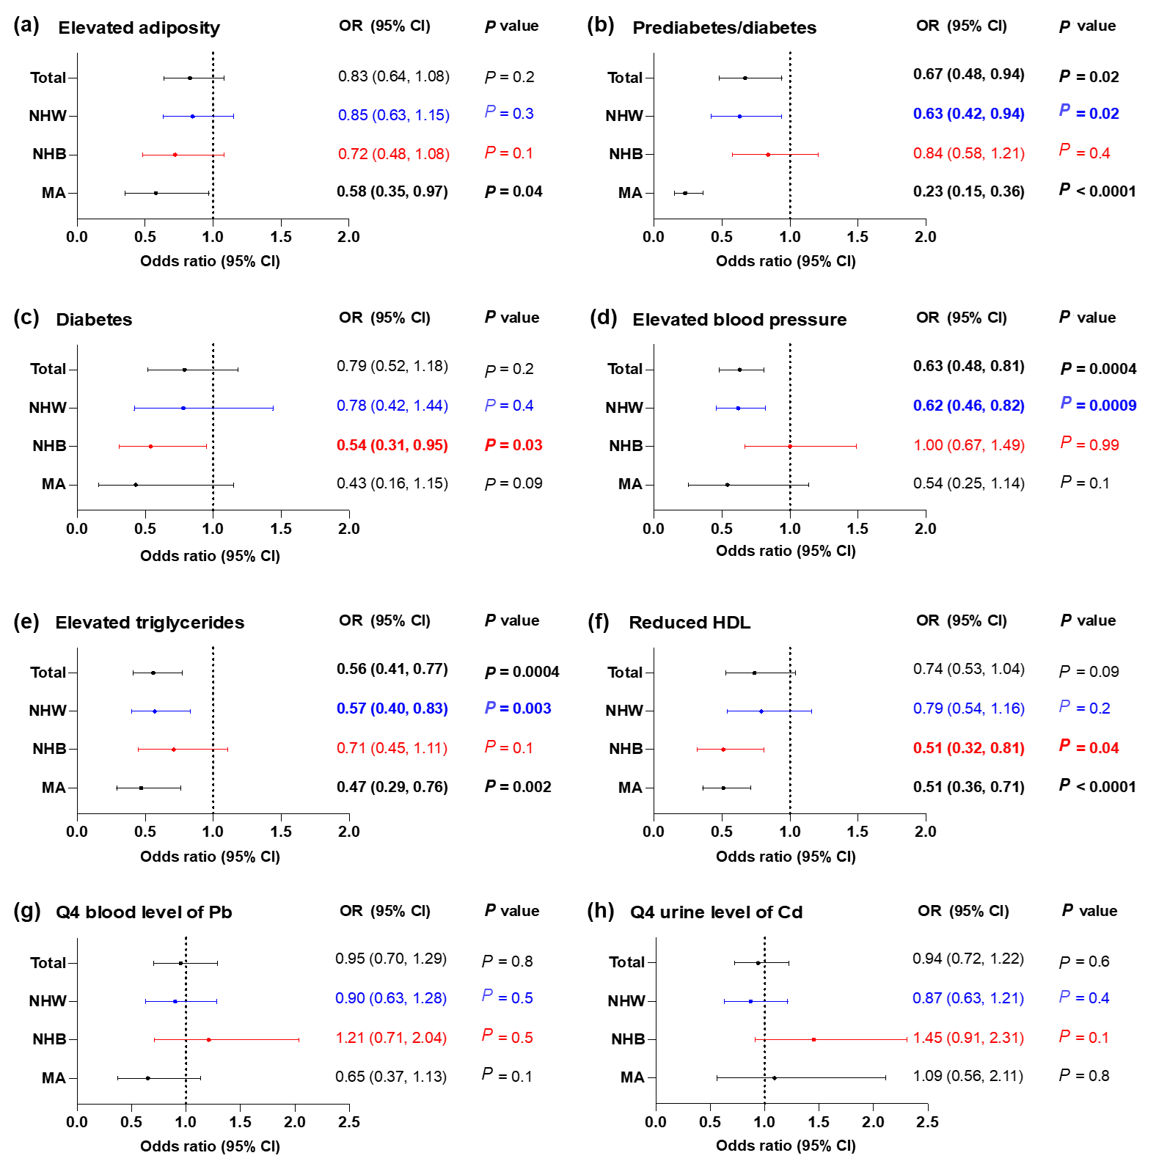
Fig. S1 Odds ratios from multivariable logistic regression models with the outcome of F1 fibrosis in the No-Traditional-Etiology (NTE) group in NHANES III dataset. F1 fibrosis was defined by age-specific FIB-4 scores (≥ F1). Multivariable logistic regression models adjusted for age, sex, smoking status, alcohol use and poverty. The odds ratios of the five cardiometabolic risk factors (CMRFs) and diabetes with outcome of fibrosis (≥ F1) are reported as following: (a) elevated adiposity, (b) prediabetes/diabetes, (c) diabetes, (d) elevated blood pressure, (e) elevated triglycerides, (f) reduced HDL, (g) quartile (Q) 4th blood levels of lead (Pb) and (h) Q4 urine level of cadmium (Cd) in the total NTE cohort and stratified by race/ethnicity including, non-Hispanic White (NHW, blue), non-Hispanic Black (NHB, red), Mexican American (MA) and other race. NHANES III dataset only measured urine levels of Cd. Bold p value indicated the corresponding odds ratio was statistically significant (p < 0.05). CAP: controlled attenuation parameter; CI: confidence interval; MASLD: Metabolic dysfunction-associated liver disease; NA: Not available; OR: odds ratio.
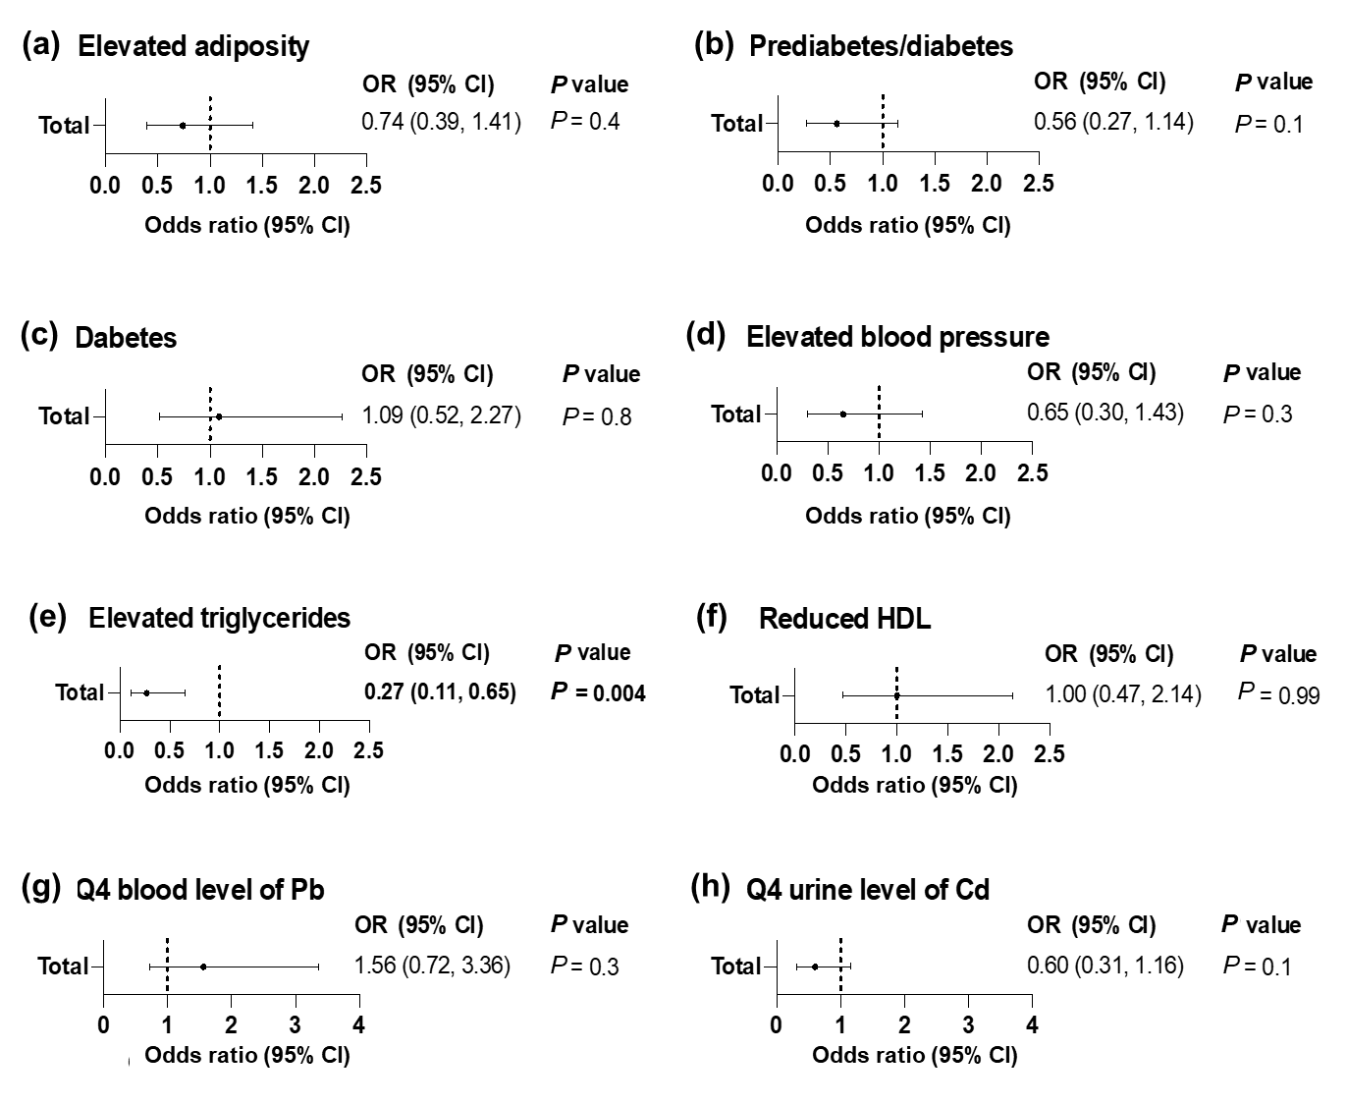
Fig. S2 Odds ratios from multivariable logistic regression models with the outcome of significant fibrosis (≥ F2) in the No-Traditional-Etiology (NTE) group in NHANES III dataset. Significant fibrosis (≥ F2) was defined by FIB-4 scores ≥2.67. Multivariable logistic regression models adjusted for age, sex, smoking status, alcohol use and poverty. The odds ratios of the five cardiometabolic risk factors (CMRFs) and diabetes with outcome of fibrosis (≥ F1) are reported as following: (a) elevated adiposity, (b) prediabetes/diabetes, (c) diabetes, (d) elevated blood pressure, (e) elevated triglycerides, (f) reduced HDL, (g) quartile (Q) 4th blood levels of lead (Pb) and (h) Q4 urine level of cadmium (Cd) in the total NTE cohort. Sample size limitations precluded an analysis of risk factors for ≥ F2 fibrosis stratified by race/ethnicity. NHANES III dataset only measured urine levels of Cd. Bold p value indicated the corresponding odds ratio was statistically significant (p < 0.05). CAP: Controlled attenuation parameter; CI: confidence interval; MASLD Metabolic dysfunction-associated liver disease; NA, Not available; odds ratio, OR.

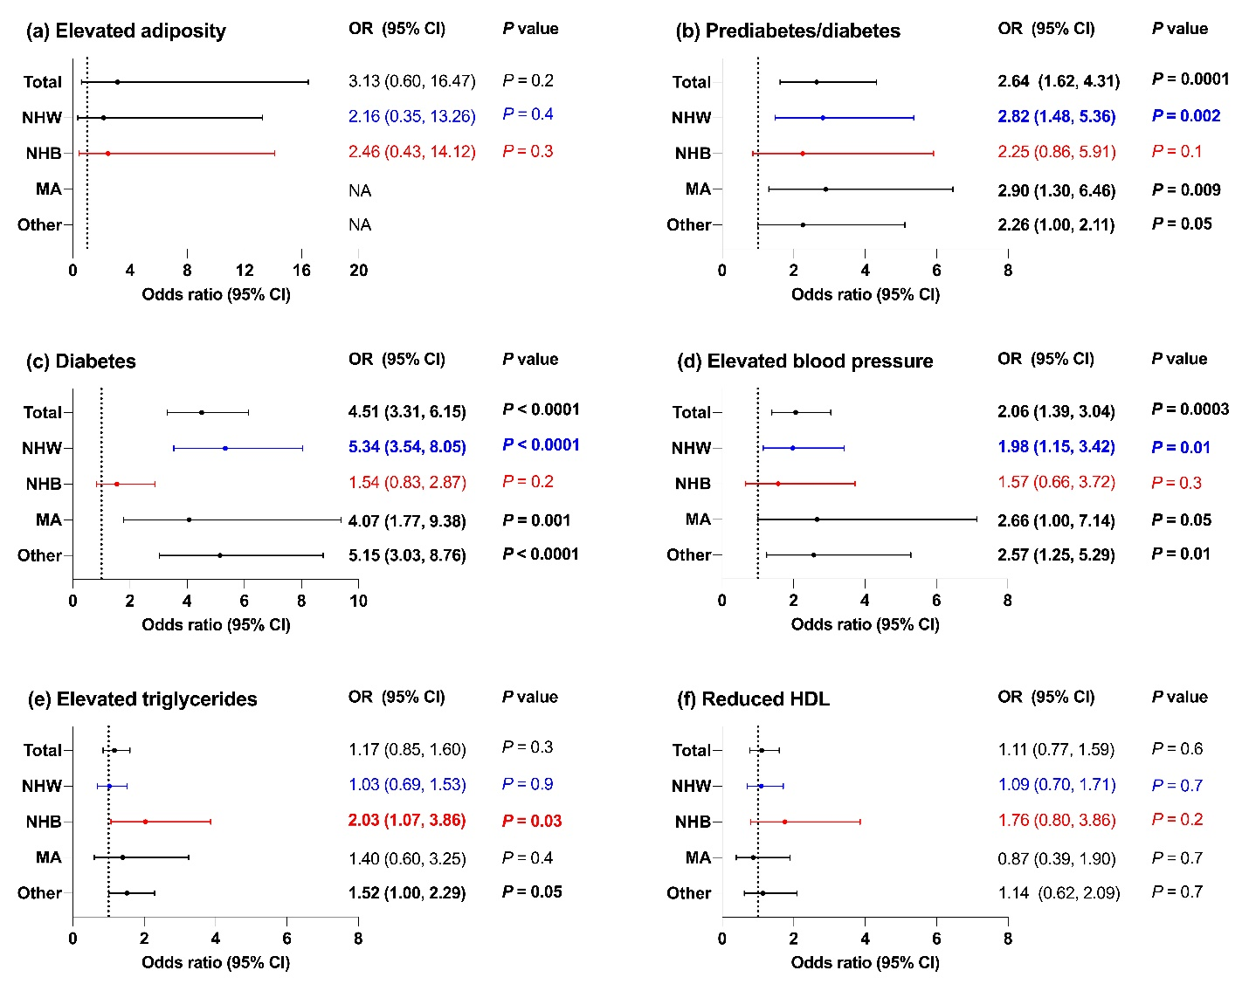
Fig. S3 Odds ratios from multivariable logistic regression models with the outcome of significant fibrosis in the MASLD group with steatosis defined by CAP ≥ 240 dB/m in NHANES 2017-March 2020. Significant fibrosis was defined by liver stiffness ≥8.6 kPa. Multivariable logistic regression models adjusted for age, sex, smoking status, alcohol use and poverty. The odds ratios of the five MASLD case-defining CMRFs and diabetes with outcome of MASLD-fibrosis are reported as following: (a) elevated adiposity, (b) diabetes, (c) prediabetes/diabetes, (d) elevated blood pressure, (e) elevated triglycerides, (f) reduced HDL, in the total population and stratified by race/ethnicity including, non-Hispanic White (NHW, blue), non-Hispanic Black (NHB, red), Mexican American (MA) and other race. Bold p value indicated the corresponding odds ratio was statistically significant (p < 0.05). CAP: controlled attenuation parameter; CI: confidence interval; MASLD: Metabolic dysfunction-associated liver disease; NA: Not available; OR: odds ratio.

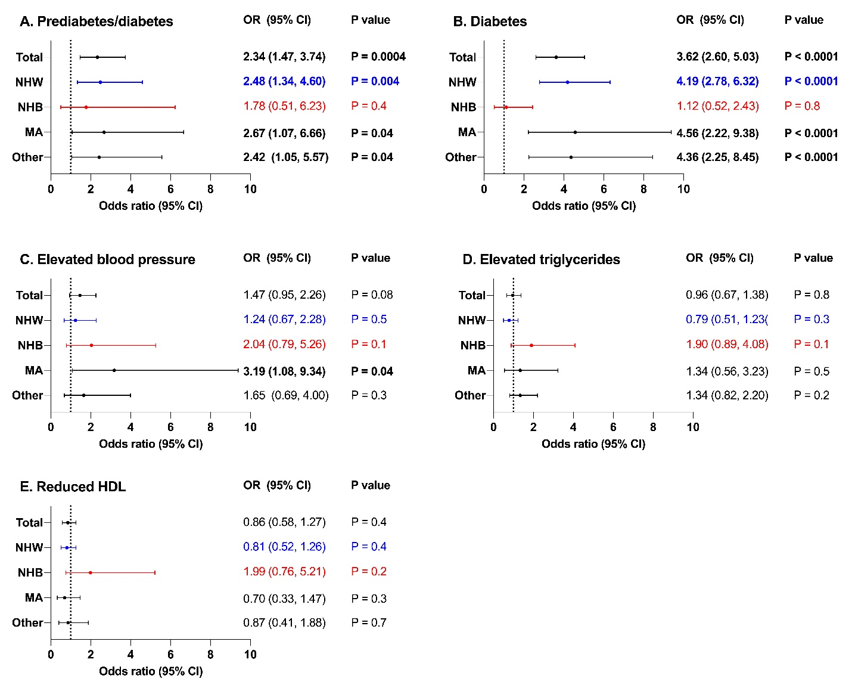Fig. S4 Odds ratios from multivariable logistic regression models with the outcome of significant fibrosis in the MASLD group with steatosis defined by CAP ≥ 285 dB/m in NHANES 2017-March 2020. Significant fibrosis was defined by liver stiffness ≥ 8.6 kPa. Multivariable logistic regression models adjusted for age, sex, smoking status, alcohol use and poverty. Odds ratios of CMRFs and diabetes with outcome of MASLD-fibrosis reported as following: (a) prediabetes/diabetes, (b) diabetes, (c) elevated blood pressure, (d) elevated triglycerides, (e) Reduced HDL, stratified by racial groups including total, non-Hispanic White (NHW, blue), non-Hispanic Black (NHB, red), Mexican American (MA) and other race. All significant fibrosis cases had elevated adiposity, so the logistic regression models cannot estimate if elevated adiposity is a risk factor. Bold p value indicated the corresponding odds ratio was statistically significant (p < 0.05). CAP: Controlled attenuation parameter; CI: confidence interval; MASLD: Metabolic dysfunction-associated liver disease; NA: Not available; OR: odds ratio; SLD: Steatotic liver disease; SLD.

Fig. S5 Estimated counts of SLD, MASLD, and NTE cases, counts of people who qualify for referral to hepatology, and counts of treatment candidates. The number of people with liver stiffness < 8.0 kPa (low concern for fibrosis), ≥ 8.0 kPa (qualify for referral), ≥ 8.6 kPa (significant, ≥ F2 fibrosis), and 8.6-20.0 kPa (treatment candidate) in (a) SLD and (b) MASLD categories at various CAP cut points (≥ 240 dB/m, black; ≥ 263 dB/m, yellow; ≥ 270 dB/m, orange; ≥ 285 dB/m, green; ≥ 300 dB/m, white). Parallel data for the (c) NTE category at various CAP cut points (< 240 dB/m, grey; < 263 dB/m, purple; < 270 dB/m, light blue; < 285 dB/m, brown; < 300 dB/m, patterned bars). CAP: controlled attenuation parameter; MASLD: Metabolic dysfunction-associated liver disease; NTE: no traditional etiology; SLD: Steatotic liver disease.
Table S1 Comparison of the age-standardized weighted prevalence of CMRFs in participants with and without SLD in NHANES III and NHANES 2017-March 2020
Cohorts | CMRF | Age-standardized weighted prevalence, % (95% CI) |  | Fold change* | P value**
Cohorts | CMRF | SLD | No-SLD | Fold change* | P value**
NHANES III (1988-1994) | At least one CMRF | 88.1 (86.4, 89.7) | 79.8 (77.5, 82.1) | 1.1 | <0.0001
NHANES III (1988-1994) | Elevated adiposity | 76.3 (73.9, 78.7) | 61.8 (60.1, 63.6) | 1.2 | <0.0001
NHANES III (1988-1994) | Prediabetes/diabetes | 42.2 (39.8, 44.5) | 27.8 (26.0, 29.6) | 1.5 | <0.0001
NHANES III (1988-1994) | Elevated blood pressure | 40.0 (37.2, 42.8) | 27.3 (25.8, 28.9) | 1.5 | <0.0001
NHANES III (1988-1994) | Elevated triglycerides | 44.0 (41.8, 46.3) | 23.7 (21.7, 25.8) | 1.9 | <0.0001
NHANES III (1988-1994) | Reduced HDL | 47.7 (45.1, 50.2) | 31.4 (28.9, 33.8) | 1.5 | <0.0001
NHANES 2017-March 2020 | At least one CMRF | 98.1 (97.1, 99.1) | 81.6 (78.3, 84.9) | 1.2 | <0.0001
NHANES 2017-March 2020 | Elevated adiposity | 94.4 (92.8, 96.0) | 64.7 (59.9, 69.5) | 1.5 | <0.0001
NHANES 2017-March 2020 | Prediabetes/diabetes | 59.6 (56.7, 62.6) | 35.7 (32.0, 39.3) | 1.7 | <0.0001
NHANES 2017-March 2020 | Elevated blood pressure | 45.3 (41.6, 49.1) | 30.7 (27.9, 33.5) | 1.5 | <0.0001
NHANES 2017-March 2020 | Elevated triglycerides | 38.5 (36.1, 41) | 20.1 (17.4, 22.7) | 1.9 | <0.0001
NHANES 2017-March 2020 | Reduced HDL | 53.9 (50.6, 57.1) | 31.6 (28.4, 34.8) | 1.7 | <0.0001
*Fold change was calculated by the prevalence in the group with SLD divided by the group without SLD. **The difference in the age-standardized weighted prevalence of CMRFs compared between participants with and without SLD by the univariate t statistic with significant level at P < 0.05. CMRF: cardiometabolic risk factor; HDL: high-density lipoprotein cholesterol; SLD: steatotic liver disease.

Table S2 Age-standardized weighted prevalence of elevated adiposity in NHANES III and NHANES 2017-March 2020
BMI/WC criteria | NHANES III  (1988-1994) | NHANES  2017-March 2020
BMI/WC criteria | Age-standardized weighted % (95%)
BMI ≥ 25 kg/m² | 56.0 (54.4, 57.7) | 74.1 (71.8, 76.3)
WC > 80 cm for women and 94 cm for men | 60.0 (58.6, 61.4) | 76.8 (73.8, 79.8)
BMI ≥ 25 kg/m² or WC > 80 cm for women and 94 cm for men | 67.0 (65.6, 68.4) | 82.3 (79.7, 85.0)
BMI: body mass index; WC: waist circumference; NHANES: National Health and Nutrition Evaluation Survey.

Table S3 Odds ratios of factors associated with fibrosis (defined by age-specific FIB-4 scores) among adults with MASLD in univariable logistic regression models in the NHANES III dataset with steatosis defined by ultrasonography as mild/moderate/severe steatosis
 | Total |  | NHW |  | NHB |  | MA
Sample size | 3365 |  | 1256 |  | 715 |  | 1279
Fibrosis defined by age-specific FIB-4 score* | 451 |  | 201 |  | 90 |  | 149
 | OR (95%CI) | P value | OR (95%CI) | P value | OR (95%CI) | P value | OR (95%CI) | P value
Age (unit 10 years) | 1.90 (1.68, 2.15) | <0.0001 | 1.85 (1.59, 2.16) | <0.0001 | 1.80 (1.48, 2.18) | <0.0001 | 2.18 (1.92, 2.47) | <0.0001
Gender
Female | Reference |  | Reference |  | Reference |  | Reference
Male | 1.41 (1.03, 1.92) | 0.03 | 1.24 (0.88, 1.75) | 0.2 | 2.17 (1.43, 3.30) | 0.0003 | 1.15 (0.63, 2.10) | 0.7
Elevated adiposity
No | Reference |  | Reference |  | Reference |  | Reference
Yes | 1.03 (0.55, 1.93) | 0.9 | 0.93 (0.44, 1.95) | 0.8 | 0.69 (0.34, 1.42) | 0.3 | 1.97 (0.82, 4.76) | 0.1
Prediabetes/diabetes
No | Reference |  | Reference |  | Reference |  | Reference
Yes | 1.18 (0.79, 1.75) | 0.4 | 1.14 (0.75, 1.73) | 0.5 | 1.27 (0.70, 2.29) | 0.4 | 2.72 (1.85, 3.99) | <0.0001
Diabetes
No
Yes | 1.84 (1.27, 2.66) | 0.001 | 2.07 (1.31, 3.28) | 0.002 | 0.92 (0.55, 1.54) | 0.7 | 2.33 (1.59, 3.41) | <0.0001
Elevated blood pressure
No | Reference |  | Reference |  | Reference |  | Reference
Yes | 2.37 (1.58, 3.54) | <0.0001 | 2.20 (1.39, 3.48) | 0.0008 | 1.91 (1.08, 3.38) | 0.03 | 4.03 (2.63, 6.19) | <0.0001
Raised triglycerides
No
Yes | 1.11 (0.81, 1.51) | 0.5 | 1.19 (0.81, 1.75) | 0.4 | 0.94 (0.60, 1.48) | 0.8 | 1.42 (0.84, 2.41) | 0.2
Reduced HDL
No
Yes | 1.23 (0.98, 1.53) | 0.07 | 1.24 (0.96, 1.61) | 0.1 | 0.71 (0.45, 1.12) | 0.1 | 1.10 (0.75, 1.60) | 0.6
Smoking status
Never | Reference |  | Reference |  | Reference |  | Reference
Past/current | 1.31 (0.91, 1.89) | 0.15 | 1.13 (0.74, 1.71) | 0.6 | 1.62 (0.98, 2.68) | 0.06 | 1.38 (0.82, 2.32) | 0.2
Alcohol use
Lifetime abstainers | Reference |  | Reference |  | Reference |  | Reference
Former drinkers | 1.10 (0.68, 1.79) | 0.7 | 0.85 (0.48, 1.52) | 0.6 | 1.62 (0.80, 3.29) | 0.2 | 1.82 (0.95, 3.49) | 0.07
Current drinkers | 1.10 (0.66, 1.84) | 0.7 | 0.88 (0.50, 1.56) | 0.7 | 1.39 (0.56, 3.43) | 0.5 | 1.20 (0.61, 2.37) | 0.6
Lead (blood)
Q1-3 | Reference |  | Reference |  | Reference |  | Reference
Q4 | 1.62 (1.10, 2.37) | 0.01 | 1.13 (0.74, 1.71) | 0.6 | 4.23 (2.69, 6.67) | <0.0001 | 1.31 (0.89, 1.93) | 0.2
Cadmium (urine)
Q1-3 | Reference |  | Reference |  | Reference |  | Reference
Q4 | 1.22 (0.84, 1.77) | 0.3 | 1.17 (0.76, 1.80) | 0.5 | 1.28 (0.79, 2.08) | 0.3 | 2.15 (1.35, 3.43) | 0.001
Poverty
No | Reference |  | Reference |  | Reference |  | Reference
Yes | 0.95 (0.65, 1.41) | 0.8 | 1.03 (0.58, 1.84) | 0.9 | 1.15 (0.70, 1.90) | 0.6 | 1.16 (0.72, 1.87) | 0.5
*Fibrosis was defined by age-specific thresholds: ≥ 1.05 for adults 20 ≤ to ≤ 35 yr, FIB-4 ≥ 1.3 for 35 < to < 65 yr, and FIB-4 ≥ 2.0 for ≥ 65 yr. Steatosis was defined by ultrasonography as mild/moderate/severe steatosis. Multiple imputation was performed in univariable logistic regression models. CI: confidence interval; HDL: high-density lipoprotein cholesterol; OR: odds ratio; MASLD: metabolic dysfunction-associated liver disease; NHANES: National Health and Nutrition Evaluation Survey.

Table S4 Odds ratios of factors associated with significant fibrosis (FIB-4 score ≥ 2.67) among adults with MASLD in univariable logistic regression models in the NHANES III dataset with steatosis defined by ultrasonography
Sample size | 3365
Significant fibrosis defined by FIB-4 ≥ 2.67 | 62
 | OR (95%CI) | P value
Age (unit 10 years) | 2.82 (1.93, 4.11) | <0.0001
Gender
Female | Reference
Male | 0.88 (0.40, 1.94) | 0.8
Elevated adiposity
No | Reference
Yes | 1.67 (0.70, 3.94) | 0.2
Prediabetes/diabetes
No | Reference
Yes | 2.20 (1.21, 3.99) | 0.01
Diabetes
No | Reference
Yes | 4.02 (1.78, 9.08) | 0.0008
Elevated blood pressure
No | Reference
Yes | 11.85 (4.69, 29.93) | <0.0001
Raised triglycerides
No | Reference
Yes | 0.87 (0.42, 1.8) | 0.7
Reduced HDL
No | Reference
Yes | 0.97 (0.44, 2.16) | 0.9
Smoking status
Never | Reference
Past/current | 1.19 (0.57, 2.49) | 0.6
Alcohol use
Lifetime abstainers | Reference
Former drinkers | 2.94 (0.85, 10.18) | 0.1
Current drinkers | 2.67 (0.77, 9.26) | 0.1
Lead (blood)
Q1-3 | Reference
Q4 | 2.02 (0.93, 4.38) | 0.07
Cadmium (urine)
Q1-3 | Reference
Q4 | 1.24 (0.65, 2.37) | 0.5
Poverty
No | Reference
Yes | 0.49 (0.18, 1.31) | 0.2
Multiple imputation was performed in univariable logistic regression models. CI: confidence interval; HDL: high-density lipoprotein cholesterol; OR: odds ratio; MASLD: metabolic dysfunction-associated liver disease; NHANES: National Health and Nutrition Evaluation Survey.

Table S5 Odds ratios of factors associated with significant fibrosis (LS ≥ 8.6 kPa) among adults in the No-SLD (CAP < 240 dB/m) and No Traditional Etiology group in univariable logistic regression models
 | No Traditional Etiology (NTE)
Sample size | 1646
Significant fibrosis | 40
 | OR (95%CI) | P value
Age (unit 10 years) | 1.17 (0.85, 1.62) | 0.3
Gender
Female | Reference
Male | 2.85 (1.61, 5.07) | 0.0004
Elevated adiposity
No | Reference
Yes | 1.21 (0.30, 4.84) | 0.8
Prediabetes/diabetes
No | Reference
Yes | 1.48 (0.54, 4.07) | 0.5
Diabetes
No | Reference
Yes | 1.32 (0.52, 3.32) | 0.6
Elevated blood pressure
No | Reference
Yes | 1.90 (1.10, 3.27) | 0.02
Raised triglycerides
No | Reference
Yes | 2.91 (1.75, 4.84) | <0.0001
Reduced HDL
No | Reference
Yes | 1.64 (0.97, 2.78) | 0.06
Smoking status
Never
Past/current | 1.82 (0.44, 7.44) | 0.4
Alcohol use*
Lifetime abstainers
Former drinkers | - | -
Current drinkers | - | -
Lead
Q1-3 | Reference
Q4 | 4.84 (2.48, 9.43) | <0.0001
Cadmium
Q1-3 | Reference
Q4 | 1.91 (1.10, 3.32) | 0.02
Poverty
No | Reference
Yes | 0.97 (0.19, 3.93) | 0.9
No-steatotic liver disease (SLD) defined by CAP < 240 dB/m. *Only one significant fibrosis case in the reference group of alcohol use, so the estimation was limited by significant fibrosis cases numbers. CAP: Controlled attenuation parameter; HDL: High-density lipoprotein cholesterol.

Table S6 Odds ratios of factors associated with significant fibrosis (LS ≥ 8.6 kPa) among adults in the No-SLD (CAP < 285 dB/m) No Traditional Etiology group in univariable logistic regression
 | No Traditional Etiology (NTE)
Sample size | 2880
Significant fibrosis | 85
 | OR (95%CI) | P value
Age (unit 10 years) | 1.26 (0.98, 1.62) | 0.07
Gender
Female | Reference
Male | 1.51 (0.82, 2.79) | 0.2
Elevated adiposity
No | Reference
Yes | 1.03 (0.34, 3.18) | 0.9
Prediabetes/diabetes
No | Reference
Yes | 1.84 (0.83, 4.07) | 0.1
Diabetes
No | Reference
Yes | 2.45 (1.38, 4.35) | 0.002
Elevated blood pressure
No | Reference
Yes | 2.56 (1.38, 4.75) | 0.003
Raised triglycerides
No | Reference
Yes | 2.12 (1.29, 3.51) | 0.003
Reduced HDL
No | Reference
Yes | 1.46 (0.97, 2.19) | 0.07
Smoking status
Never | Reference
Past/current | 1.38 (0.59, 3.22) | 0.5
Alcohol use
Lifetime abstainers | Reference
Former drinkers | 1.92 (0.32, 11.6) | 0.5
Current drinkers | 0.68 (0.10, 4.59) | 0.7
Lead
Q1-3 | Reference
Q4 | 2.16 (1.45, 3.20) | 0.0001
Cadmium
Q1-3 | Reference
Q4 | 1.93 (1.11, 3.36) | 0.02
Poverty
No | Reference
Yes | 1.10 (0.46, 2.67) | 0.8
No-steatotic liver disease (SLD) defined by CAP < 285 dB/m. Multiple imputation was performed in univariable logistic regression models. Variables with P value < 0.1 in the univariable analysis in the in total cohort were included in multivariable models. CAP: controlled attenuation parameter; CI: confidence interval; HDL: high-density lipoprotein cholesterol; OR: odds ratio.

Table S7 Odds ratios of factors associated with significant fibrosis (LS ≥ 8.6 kPa) among adults with MASLD with steatosis defined by CAP ≥ 240 dB/m in univariable logistic regression models in each racial/ethnic group
 | Total |  | NHW |  | NHB |  | MA |  | Other
Sample size | 3055 |  | 1180 |  | 674 |  | 428 |  | 773
Significant fibrosis | 331 |  | 138 |  | 73 |  | 49 |  | 71
 | OR (95%CI) | P value | OR (95%CI) | P value | OR (95%CI) | P value | OR (95%CI) | P value | OR (95%CI) | P value
Age (unit 10 years) | 1.08  (0.99, 1.19) | 0.08 | 1.00  (0.89, 1.13) | 0.99 | 1.33  (1.09, 1.61) | 0.005 | 1.48  (1.26, 1.74) | <0.0001 | 1.17  (1.00, 1.38) | 0.05
Gender
Female | Reference |  | Reference |  | Reference |  | Reference |  | Reference
Male | 1.43  (0.90, 2.28) | 0.13 | 1.45  (0.80, 2.65) | 0.2 | 0.92  (0.55, 1.55) | 0.8 | 0.98  (0.46, 2.08) | 0.9 | 2.20  (1.17, 4.15) | 0.01
Elevated adiposity
No | Reference |  | Reference |  | Reference |  | Reference |  | Reference
Yes | 2.55  (0.42, 15.42) | 0.3 | 1.73  (0.23, 13.19) | 0.6 | 2.15  (0.44, 10.57) | 0.3 | - | - | - | -
Prediabetes/diabetes
No | Reference |  | Reference |  | Reference |  | Reference |  | Reference
Yes | 2.81  (1.70, 4.63) | <0.0001 | 2.78  (1.43, 5.40) | 0.003 | 2.85  (1.18, 6.91) | 0.02 | 3.96  (1.69, 9.30) | 0.002 | 2.51  (1.17, 5.39) | 0.02
Diabetes
No | Reference |  | Reference |  | Reference |  | Reference |  | Reference
Yes | 4.31  (3.23, 5.74) | <0.0001 | 4.59  (3.19, 6.63) | <0.0001 | 1.98  (1.20, 3.27) | 0.008 | 5.22  (2.55,10.69) | <0.0001 | 4.80  (2.88, 7.99) | <0.0001
Elevated blood pressure
No | Reference |  | Reference |  | Reference |  | Reference |  | Reference
Yes | 2.06  (1.47, 2.91) | <0.0001 | 1.81  (1.12, 2.92) | 0.01 | 2.21  (0.94, 5.20) | 0.07 | 3.40  (1.49, 7.76) | 0.004 | 2.89  (1.41, 5.93) | 0.004
Elevated triglycerides
No | Reference |  | Reference |  | Reference |  | Reference |  | Reference
Yes | 1.27  (0.92, 1.76) | 0.15 | 1.01  (0.68, 1.49) | 0.97 | 2.57  (1.36, 4.86) | 0.004 | 2.02  (0.94, 4.32) | 0.07 | 1.91  (1.27, 2.89) | 0.002
Reduced HDL
No | Reference |  | Reference |  | Reference |  | Reference |  | Reference
Yes | 1.16  (0.80, 1.69) | 0.4 | 1.09  (0.69, 1.75) | 0.7 | 1.98  (0.93, 4.19) | 0.07 | 1.01  (0.48, 2.13) | 0.98 | 1.28  (0.71, 2.30) | 0.4
Smoking status
Never | Reference |  | Reference |  | Reference |  | Reference |  | Reference
Past/current | 1.06  (0.72, 1.56) | 0.8 | 0.90  (0.53, 1.51) | 0.7 | 1.34  (0.80, 2.23) | 0.3 | 2.39  (1.10, 5.24) | 0.03 | 1.20  (0.73, 1.96) | 0.5
Alcohol use
Lifetime abstainers | Reference |  | Reference |  | Reference |  | Reference |  | Reference
Former drinkers | 0.75  (0.40, 1.40) | 0.4 | 0.52  (0.22, 1.23) | 0.14 | 1.37  (0.40, 4.76) | 0.6 | 0.91  (0.34, 2.47) | 0.9 | 1.66  (0.58, 4.74) | 0.3
Current drinkers | 0.59  (0.38, 0.93) | 0.02 | 0.42  (0.23, 0.79) | 0.007 | 1.03  (0.33, 3.18) | 0.96 | 0.85  (0.32, 2.26) | 0.7 | 1.11  (0.51, 2.44) | 0.8
Lead
Q1-3 | Reference |  | Reference |  | Reference |  | Reference |  | Reference
Q4 | 0.57  (0.41, 0.79) | 0.0007 | 0.53  (0.35, 0.80) | 0.003 | 1.17  (0.62, 2.18) | 0.6 | 0.82  (0.39, 1.73) | 0.6 | 0.42  (0.20, 0.87) | 0.02
Lead (unit µg/dL) | 0.78  (0.63, 0.96) | 0.02 | 0.71  (0.53, 0.95) | 0.02 | 1.02  (0.79, 1.33) | 0.9 | 0.82  (0.62, 1.09) | 0.2 | 0.90  (0.69, 1.17) | 0.4
Cadmium
Q1-3 | Reference |  | Reference |  | Reference |  | Reference |  | Reference
Q4 | 0.61  (0.41, 0.92) | 0.02 | 0.62  (0.34, 1.15) | 0.13 | 0.55  (0.25, 1.18) | 0.12 | 0.93  (0.30, 2.94) | 0.9 | 0.57  (0.30, 1.08) | 0.08
Cadmium (unit µg/L) | 0.38  (0.23, 0.63) | 0.002 | 0.35  (0.17, 0.72) | 0.004 | 0.61  (0.29, 1.26) | 0.18 | 0.97  (0.60, 1.57) | 0.9 | 0.17  (0.04, 0.67) | 0.01
Poverty
No | Reference |  | Reference |  | Reference |  | Reference |  | Reference
Yes | 1.20  (0.83, 1.74) | 0.3 | 1.27  (0.70, 2.29) | 0.4 | 0.64  (0.34, 1.21) | 0.17 | 1.25  (0.50, 3.11) | 0.6 | 0.79  (0.39, 1.58) | 0.5
Multiple imputation was performed in univariable logistic regression models. Variables with P value < 0.1 in the univariable analysis in the in total cohort were included in multivariable models. CAP: controlled attenuation parameter; CI: confidence interval; HDL: high-density lipoprotein cholesterol; OR: odds ratio.

Table S8 Odds ratios of factors associated with significant fibrosis (LS ≥ 8.6 kPa) among adults with MASLD with steatosis defined by CAP ≥ 285 dB/m in univariable logistic regression models in each racial/ethnic group
 | Total |  | NHW |  | NHB |  | MA |  | Other
Sample size | 1853 |  | 729 |  | 373 |  | 304 |  | 447
Significant fibrosis | 286 |  | 122 |  | 59 |  | 42 |  | 63
 | OR (95%CI) | P value | OR (95%CI) | P value | OR (95%CI) | P value | OR (95%CI) | P value | OR (95%CI) | P value
Age (unit 10 years) | 1.06  (0.96, 1.16) | 0.3 | 0.96  (0.84, 1.10) | 0.6 | 1.21  (0.96, 1.54) | 0.1 | 1.44  (1.21, 1.71) | <0.0001 | 1.19  (1.00, 1.42) | 0.05
Gender
Female | Reference |  | Reference |  | Reference |  | Reference |  | Reference
Male | 1.40  (0.87, 2.28) | 0.2 | 1.46  (0.79, 2.69) | 0.2 | 0.73  (0.37, 1.44) | 0.4 | 1.08  (0.43, 2.66) | 0.9 | 1.98  (0.98, 3.98) | 0.06
Elevated adiposity ª
No
Yes | NA |  | NA |  | NA |  | NA |  | NA
Prediabetes/diabetes
No | Reference |  | Reference |  | Reference |  | Reference |  | Reference
Yes | 2.36  (1.47, 3.80) | 0.0004 | 2.25  (1.21, 4.19) | 0.01 | 1.94  (0.58, 6.49) | 0.3 | 3.75  (1.36, 10.31) | 0.01 | 2.74  (1.37, 5.47) | 0.004
Diabetes
No | Reference |  | Reference |  | Reference |  | Reference |  | Reference
Yes | 3.32  (2.32, 4.76) | <0.0001 | 3.43  (2.21, 5.33) | <0.0001 | 1.26  (0.65, 2.44) | 0.5 | 5.70  (2.75, 11.79) | <0.0001 | 3.75  (1.90, 7.42) | 0.0001
Elevated blood pressure
No | Reference |  | Reference |  | Reference |  | Reference |  | Reference
Yes | 1.52  (1.04, 2.23) | 0.03 | 1.19  (0.71, 1.99) | 0.5 | 2.33  (0.94, 5.74) | 0.07 | 3.74  (1.58, 8.87) | 0.003 | 2.15  (0.87, 5.27) | 0.1
Elevated triglycerides
No | Reference |  | Reference |  | Reference |  | Reference |  | Reference
Yes | 1.04  (0.70, 1.54) | 0.9 | 0.79  (0.50, 1.25) | 0.3 | 2.14  (1.02, 4.48) | 0.04 | 1.88  (0.81, 4.34) | 0.1 | 1.65  (0.97, 2.82) | 0.07
Reduced HDL
No | Reference |  | Reference |  | Reference |  | Reference |  | Reference
Yes | 0.89  (0.58, 1.37) | 0.6 | 0.80  (0.49, 1.31) | 0.4 | 2.20  (0.88, 5.52) | 0.09 | 0.82  (0.38, 1.77) | 0.6 | 0.94  (0.44, 2.01) | 0.9
Smoking status
Never | Reference |  | Reference |  | Reference |  | Reference |  | Reference
Past/current | 1.03  (0.70, 1.52) | 0.9 | 0.85  (0.50, 1.45) | 0.6 | 1.19  (0.72, 1.97) | 0.5 | 2.08  (0.86, 5.00) | 0.1 | 1.40  (0.79, 2.48) | 0.3
Alcohol use
Lifetime abstainers | Reference |  | Reference |  | Reference |  | Reference |  | Reference
Former drinkers | 0.98  (0.61, 1.58) | 0.9 | 0.86  (0.48, 1.54) | 0.6 | 1.02  (0.28, 3.66) | 0.9 | 0.87  (0.28, 2.74) | 0.8 | 1.44  (0.49, 4.24) | 0.5
Current drinkers | 0.73  (0.48, 1.13) | 0.2 | 0.65  (0.37, 1.13) | 0.1 | 0.86  (0.25, 2.95) | 0.8 | 0.72  (0.30, 1.73) | 0.5 | 0.97  (0.44, 2.14) | 0.9
Lead
Q1-3 | Reference |  | Reference |  | Reference |  | Reference |  | Reference
Q4 | 0.59  (0.42, 0.83) | 0.002 | 0.60  (0.40, 0.91) | 0.02 | 0.76  (0.32, 1.80) | 0.5 | 0.63  (0.26, 1.54) | 0.3 | 0.45  (0.20, 1.02) | 0.06
Lead (unit µg/dL) | 0.80  (0.63, 1.01) | 0.06 | 0.75  (0.56, 1.00) | 0.05 | 0.96  (0.66, 1.38) | 0.8 | 0.73  (0.50, 1.06) | 0.09 | 0.98  (0.83, 1.16) | 0.8
Cadmium
Q1-3 | Reference |  | Reference |  | Reference |  | Reference |  | Reference
Q4 | 0.53  (0.27, 1.05) | 0.07 | 0.50  (0.19, 1.33) | 0.2 | 0.44  (0.16, 1.19) | 0.1 | 0.76  (0.18, 3.20) | 0.7 | 0.66  (0.33, 1.33) | 0.2
Cadmium (unit µg/L) | 0.32  (0.15, 0.68) | 0.003 | 0.27  (0.09, 0.78) | 0.02 | 0.56  (0.27, 1.15) | 0.1 | 0.66  (0.10, 4.27) | 0.7 | 0.24  (0.06, 0.96) | 0.04
Poverty
No | Reference |  | Reference |  | Reference |  | Reference |  | Reference
Yes | 0.88  (0.62, 1.24) | 0.5 | 1.08  (0.61, 1.92) | 0.8 | 0.79  (0.40, 1.54) | 0.5 | 1.14  (0.42, 3.05) | 0.8 | 0.64  (0.31, 1.31) | 0.2
In this analysis, SLD is defined by CAP ≥ 285 dB/m. Multiple imputation was performed in univariable logistic regression models. a: All fibrosis cases had elevated adiposity, so the estimation was not available (NA). CAP: controlled attenuation parameter; CI: confidence interval; HDL: high-density lipoprotein cholesterol; OR: odds ratio.

Table S9 The blood levels of lead (Pb) in NHANES III and NHANES 2017-March 2020
Cohort | Quartiles (Unit μg/dL) | MASLD |  | No Traditional Etiology (NTE)
Cohort | Quartiles (Unit μg/dL) | NHANES III | NHANES 2017-March 2020 | NHANES III | NHANES 2017-March 2020
Total | Q1 | 1.7 | 0.6 | 1.7 | 0.5
Total | Median | 2.9 | 0.9 | 2.8 | 0.8
Total | Q3 | 4.6 | 1.3 | 4.6 | 1.4
NHW | Q1 | 1.7 | 0.6 | 1.6 | 0.5
NHW | Median | 2.8 | 0.9 | 2.6 | 0.9
NHW | Q3 | 4.3 | 1.4 | 4.2 | 1.4
NHB | Q1 | 1.7 | 0.6 | 1.8 | 0.5
NHB | Median | 3.0 | 0.9 | 2.9 | 0.8
NHB | Q3 | 4.9 | 1.2 | 5.0 | 1.5
MA | Q1 | 1.8 | 0.5 | 1.8 | 0.5
MA | Median | 3.0 | 0.9 | 3.0 | 0.7
MA | Q3 | 4.7 | 1.4 | 4.8 | 1.4
Other | Q2 | 1.9 | 0.6 | 1.7 | 0.6
Other | Median | 3.0 | 0.9 | 2.6 | 0.8
Other | Q4 | 4.8 | 1.3 | 4.3 | 1.4
MASLD: Metabolic dysfunction-associated liver disease; NHANES: National Health and Nutrition Evaluation Survey; NHW: Non-Hispanic White; NHB: Non-Hispanic Black; MA: Mexican American; Q: quartile.

