SUPPLEMENTARY MATERIALS

Model Specifications:
Our controlled interrupted time series (CITS) model for the analyses is as follows:

Prescribing rate = β0 + β1(time) + β2(SOPI) + β3(SOPIposttrend) + β4(STOPAct) + β5(STOPActposttrend) + β6(Group) + β7(Group-time) + β8(Group-SOPI)+ β9(Group-SOPIposttrend+ β10(Group-STOPAct)+ β11(Group-STOPActposttrend)+εt.
Here, time represents months since April 2014 as a continuous variable; SOPI and STOPAct represent time before and after each policy change as dichotomous variables; SOPIposttrend and STOPActposttrend are time variables with time 1 starting when the policies are enacted, and prior months set to zero. Group is a dichotomous variable differentiating opioid prescriptions (intervention series) from benzodiazepine prescriptions (control series). Group-SOPI, and Group-STOP Act represent interaction of the two dichotomous policy variables with the group variable, while Group-time, Group-SOPIposttrend, and Group-STOPActposttrend represent the interaction of the three time variables with the group variable.
Further, β₀ estimates the baseline rate in April 2014 for benzodiazepines; β₁ estimates the pre-SOPI trend of benzodiazepine prescriptions; β₂ and β₃ are the immediate and sustained change in benzodiazepine prescription rates after SOPI was implemented; and β₄ and β₅ are the immediate and sustained change in benzodiazepine prescription rates after STOP act was implemented;²⁹ β₆ estimates the difference between opioid and benzodiazepine prescribing rates at baseline in April 2014. β₇ estimates is the difference between pre-SOPI opioid and benzodiazepine prescribing rates; β₈ and β₉ are the immediate and sustained changes in opioid prescribing after SOPI, but relative to the respective changes observed in benzodiazepines (β₂ and β₃); β₁₀ and β₁₁ are the immediate and sustained changes in opioid prescribing after STOP act, but relative to the respective changes observed in benzodiazepines (β₄ and β₅).²⁹

Our single series model for these analyses is as follows:
MME/Days’ supply =β0+β1(time)+β2(SOPI)+β3(SOPIposttrend)+β4(STOPAct)+ β5(STOPActposttrend)+εt,
Here time, SOPI, STOP Act, SOPIposttrend and STOPActposttrend are the same as the first 5 variables in the controlled interrupted time series model as described above, except these are specified for opioid MMEs and Days’ supply rather than benzodiazepines as there is no control population for the single series ITS.

Supplementary Table 1: International Classification of Disease codes version 9 and 10 for acute injuries.
Diagnosis | ICD-9 codesª | ICD-10 codesª
Injury, Trauma, complications | 800- 909, 920-929, 940-959, 993, 995-998 | S00-S99, T07,T14, T20-T32, T70, T74, T76, T79, T80-T88
ª - all subcategories of the specified diagnosis codes were included.

Supplementary Table 2: Surgery procedure codes, CPT, ICD9, and ICD10
Please see attached csv file – also available here: https://github.com/ShabbarIR/OUD-algorithms-development-and-validation/blob/main/OUD%20Algorithm%20Definitions/Source%20Code/V4/cc_1171_surgery.csv

Supplementary Table 3. Prescription rates, Mean Days’ Supply and Mean Daily MME for surgery, injury, and benzodiazepine prescribed patients based on pre-SOPI time period (April 2014 to April 2016), Post-SOPI time and Pre-STOP period (May 2016 to December 2017) and the Post- STOP time period (January 2018 to December 2019) in North Carolina

 | Average measures (95% CI)
Categories | Pre-SOPI  (04/2014-04/2016) | Post-SOPI  (05/2016-12/2017) | Post-STOP  (01/2018-12/2019)
Surgery
% Patients receiving index opioid Rx | 62.06 (60.85, 63.27) | 69.25 (68.41, 70.08) | 66.05 (65.00, 67.14)
Index opioid Rx rate per 100 person-months | 91.49 (89.76, 93.23) | 100.36 (99.03, 101.68) | 92.39 (90.83, 93.94)
Subsequent opioid Rx rate per 100 person-months | 61.23 (59.01, 63.45) | 66.69 (65.49, 67.90) | 59.28 (58.26, 60.29)
Dispensed index opioid daily MME | 61.02 (56.70, 65.34) | 52.51 (49.07, 55.95) | 43.22 (42.16, 44.27)
Dispensed subsequent opioid daily MME | 66.53 (64.36, 68.69) | 57.91 (55.98, 59.83) | 50.52 (49.02, 52.03)
Dispensed index opioid days’ supply | 7.59 (7.45, 7.72) | 7.73 (7.59, 7.87) | 6.08 (5.90, 6.25)
Dispensed subsequent opioid days’ supply | 11.06 (10.83, 11.29) | 11.40 (11.26, 11.54) | 9.83 (9.68, 9.97)
Injury
% Patients receiving index opioid Rx | 14.15 (13.55, 14.75) | 12.32 (11.64, 12.99) | 8.38 (8.00, 8.76)
Index opioid Rx rate per 100 person-months | 18.25 (17.14, 19.36) | 14.87 (14.01, 15.73) | 10.00 (9.53, 10.47)
Subsequent opioid Rx rate per 100 person-months | 10.35 (10.01, 10.69) | 9.79 (9.48, 10.09) | 7.64 (7.32, 7.96)
Dispensed index opioid daily MME | 37.18 (34.93, 39.44) | 31.74 (30.91, 32.57) | 29.13 (28.66, 29.59)
Dispensed subsequent opioid daily MME | 58.71 (56.48, 60.94) | 55.38 (53.63, 57.13) | 52.88 (51.72, 54.05)
Dispensed index opioid days’ supply | 6.84 (6.64, 7.03) | 6.48 (6.37, 6.58) | 5.69 (5.58, 5.79)
Dispensed subsequent opioid days’ supply | 13.95 (13.37, 14.53) | 15.95 (15.63, 16.27) | 16.58 (16.40, 16.77)
Control
% Patients receiving Benzodiazepine Rx | 2.49 (2.44, 2.55) | 2.84 (2.79, 2.88) | 2.79 (2.75, 2.84)
Benzodiazepine Rx rate per 100 person-months | 14.01 (13.54, 14.47) | 13.07 (12.85, 13.29) | 12.24 (12.02, 12.46)
Abbreviations: Rx – prescription; SOPI=Safe Opioid Prescribing Initiative; STOP=Strengthen Opioid Misuse Prevention; CI=confidence interval; MME= Morphine Milligram Equivalents.

Supplementary Table 4. Single Series Results of Opioid Use for surgery and injury based on two policy implementations in North Carolina from April 2014 through December 2019
 | pre-SOPI  (04/2014-04/2016) | post-SOPI  (05/2016-12/2017) |  | post-STOP act  (01/2018-12/2019)
Opioid prescribing measures | Trend  (95% CI) | Immediate absolute change (95% CI) | Sustained trend change (95% CI) | Immediate absolute change (95% CI) | Sustained trend change (95% CI)
 | β1* | β2 | β3* | β4 | β5*
Surgery
% Patients receiving index opioid Rx | 3.45 (2.40, 4.51) | 3.29 (1.37, 5.20) | -2.81 (-4.62, -1.00) | 0.12 (-1.79, 2.03) | -4.33 (-6.18, -2.48)
Index opioid Rx rate per 100 person-months | 0.07 (-2.08, 2.21) | 9.92 (6.02, 13.82) | -2.05 (-5.73, 1.64) | -1.27 (-5.15, 2.61) | -2.95 (-6.71, 0.82)
Subsequent opioid Rx rate per 100 person-months | 9.89 (8.53, 11.25) | -0.53 (-3.00, 1.95) | -12.55 (-14.89, -10.21) | -1.94 (-4.40, 0.52) | -0.57 (-2.96, 1.82)
Dispensed index daily MME | -3.75 (-8.48, 0.98) | 2.89 (-5.71, 11.49) | -5.00 (-13.13, 3.12) | -1.24 (-9.80, 7.32) | 7.68 (-0.63, 15.98)
Dispensed subsequent daily MME | 0.21 (-2.27, 2.70) | -3.63 (-8.16, 0.89) | -6.16 (-10.43, -1.88) | 2.44 (-2.06, 6.94) | 1.03 (-3.34, 5.40)
Dispensed index days’ supply | 0.43 (0.31, 0.55) | 0.01 (-0.21, 0.23) | -0.77 (-0.98, -0.56) | -0.70 (-0.91, -0.48) | -0.32 (-0.53, -0.11)
Dispensed subsequent days’ supply | 0.83 (0.68, 0.98) | -0.24 (-0.50, 0.03) | -1.10 (-1.35, -0.85) | -0.80 (-1.06, -0.53) | -0.28 (-0.54, -0.02)
Injury
% Patients receiving index opioid Rx | -2.42 (-2.85, -1.99) | 2.15 (1.36, 2.94) | 0.23 (-0.51, 0.98) | -0.77 (-1.55, 0.01) | 0.81 (0.05, 1.57)
Index opioid Rx rate per 100 person-months | -4.97 (-5.60, -4.33) | 3.35 (2.19, 4.50) | 2.03 (0.94, 3.13) | -0.77 (-1.91, 0.38) | 1.23 (0.11, 2.34)
Subsequent opioid Rx rate per 100 person-months | 0.77 (0.30, 1.24) | -0.89 (-1.74, -0.03) | -1.01 (-1.74, -0.03) | -0.99 (-1.84, -0.14) | -0.69 (-1.51, 0.14)
Dispensed index daily MME | -2.72 (-4.95, -0.05) | -1.84 (-5.88, 2.20) | 1.72 (-2.10, 5.54) | -1.24 (-5.26, 2.79) | 0.45 (-3.45, 4.35)
Dispensed subsequent daily MME | 1.23 (-1.51, 3.96) | -3.21 (-8.18, 1.76) | -2.77 (-7.46, 1.93) | -0.23 (-5.18, 4.72) | 0.54 (-4.26, 5.34)
Dispensed index days’ supply | 0.46 (0.27, 0.66) | -0.70 (-1.05, 0.34) | -0.54 (-0.87, -0.21) | -0.71 (-1.06, -0.35) | 0.03 (-0.31, 0.37)
Dispensed subsequent days’ supply | 2.12 (1.63, 2.61) | -0.84 (-1.73, 0.04) | -1.21 (-2.04, -0.37) | 0.40 (-0.48, 1.28) | -1.38 (-2.24, -0.53)
* - annualized estimates, calculated by multiplying monthly trend change estimates to 12.

Supplementary Table 5. Prescription rates for surgery and injury prescribed patients based on pre-SOPI time period (April 2014 to April 2016), Post-SOPI time and Pre-STOP period (May 2016 to December 2017) and the Post- STOP time period (January 2018 to December 2019) in North Carolina by racial category
 | Average measures (95% CI)
Categories | Pre-SOPI  (04/2014-04/2016) | Post-SOPI  (05/2016-12/2017) | Post-STOP  (01/2018-12/2019)
Surgery: % Patients receiving index opioid Rx
American Native | 64.60 (59.46, 69.75) | 74.79 (69.87, 79.71) | 67.37 (64.04, 70.70)
Asian | 59.75 (57.79, 61.71) | 62.81 (60.92, 64.70) | 57.56 (55.34, 59.78)
Black | 67.27 (65.54, 68.99) | 76.27 (75.04, 77.49) | 71.69 (70.08, 73.30)
White | 59.99 (59.00, 60.97) | 66.69 (65.96, 67.42) | 64.06 (63.04, 65.09)
Surgery: Index opioid Rx rateª
American Native | 92.97 (85.03, 100.90) | 108.99 (101.52, 116.47) | 94.67 (88.73, 100.61)
Asian | 90.88 (87.37, 94.40) | 96.53 (93.13, 99.94) | 86.15 (82.67, 89.63)
Black | 97.80 (94.95, 100.65) | 111.37 (109.02, 113.72) | 99.91 (97.53, 102.28)
White | 90.08 (88.45, 91.71) | 96.44 (95.26, 97.62) | 89.55 (88.14, 90.97)
Surgery: Subsequent opioid Rx rateª
American Native | 76.23 (69.45, 83.02) | 89.38 (83.98, 94.78) | 71.38 (67.01, 75.76)
Asian | 45.97 (43.67, 48.26) | 44.81 (42.98, 46.64) | 37.22 (34.58, 39.86)
Black | 75.20 (71.62, 78.79) | 85.84 (83.73, 87.95) | 71.93 (69.88, 73.98)
White | 56.31 (53.77, 58.84) | 62.75 (61.71, 63.80) | 57.08 (56.23, 57.92)
Injury: % Patients receiving index opioid Rx
American Native | 10.38 (9.36, 11.40) | 8.97 (7.95, 9.99) | 6.26 (5.36, 7.17)
Asian | 8.70 (8.05, 9.36) | 6.61 (5.90, 7.33) | 4.34 (3.83, 4.85)
Black | 18.20 (17.10, 19.31) | 14.11 (13.28, 14.95) | 9.05 (8.63, 9.47)
White | 12.27 (11.66, 12.88) | 11.07 (10.44, 11.71) | 7.71 (7.36, 8.06)
Injury: Index opioid Rx rateª
American Native | 13.93 (12.20, 15.65) | 11.26 (9.71, 12.80) | 6.87 (5.45, 8.28)
Asian | 10.88 (9.98, 11.77) | 7.95 (7.08, 8.82) | 5.21 (4.54, 5.88)
Black | 25.06 (22.68, 27.43) | 17.30 (16.15, 18.45) | 10.88 (10.32, 11.44)
White | 15.69 (14.60, 16.79) | 13.27 (12.48, 14.06) | 9.16 (8.74, 9.59)
Injury: Subsequent opioid Rx rateª
American Native | 10.26 (9.03, 11.49) | 12.77 (11.57, 13.96) | 7.26 (6.26, 8.25)
Asian | 3.55 (3.09, 4.02) | 3.03 (2.75, 3.32) | 2.34 (2.02, 2.66)
Black | 11.66 (11.23, 12.10) | 9.44 (9.09, 9.79) | 6.60 (6.26, 6.93)
White | 9.43 (8.98, 9.89) | 9.94 (9.60, 10.28) | 8.09 (7.77, 8.41)
Abbreviations: Rx – prescription; SOPI=Safe Opioid Prescribing Initiative; STOP=Strengthen Opioid Misuse Prevention; CI=confidence interval; MME= Morphine Milligram Equivalents.

Supplementary Table 6: Proportion of opioid prescriptions by encounter type among racialized groups
Rx type | Encounter type where Rx received | Racialized groups
Rx type | Encounter type where Rx received | Black | White | American Native | Asian
First Injury Opioid Rx | Emergency visit % | 75.84 | 59.39 | 49.91 | 51.86
 | Inpatient visit % | 1.84 | 2.47 | 8.81 | 2.33
 | Outpatient visit % | 21.16 | 35.68 | 36.61 | 44.49
Subsequent Injury Opioid Rx | Emergency visit % | 51.68 | 36.45 | 31.83 | 38.14
 | Inpatient visit % | 5.64 | 6.48 | 15.22 | 8.41
 | Outpatient visit % | 39.08 | 48.60 | 46.37 | 45.35
First Surgery Opioid Rx | Emergency visit % | 20.07 | 12.13 | 12.55 | 12.12
 | Inpatient visit % | 25.96 | 26.80 | 31.53 | 31.15
 | Outpatient visit % | 52.79 | 59.76 | 53.52 | 55.77
Subsequent Surgery Opioid Rx | Emergency visit % | 26.34 | 17.90 | 15.30 | 16.34
 | Inpatient visit % | 29.32 | 33.92 | 36.59 | 41.40
 | Outpatient visit % | 43.24 | 46.93 | 46.71 | 41.47

Supplementary Table 7. Association of two policies on prescribing behaviors for prescription opioid patients for surgery by sex, age, and ethnicity in North Carolina from April 2014 through December 2019
 | pre-SOPI  (04/2014-04/2016) | post-SOPI  (05/2016-12/2017) |  | post-STOP act  (01/2018-12/2019)
Categories | Trend  (95% CI) | Absolute Immediate change (95% CI) | Sustained trend change (95% CI) | Absolute immediate change (95% CI) | Sustained trend change (95% CI)
 | β1* | β2 | β3* | β4 | β5*
Index Prescription Proportion
Overall | 3.45 (2.40, 4.51) | 3.29 (1.37, 5.20) | -2.81 (-4.62, -1.00) | 0.12 (-1.79, 2.03) | -4.33 (-6.18, -2.48)
Sex
Female | 3.26 (2.01, 4.52) | 3.82 (1.53, 6.10) | -2.38 (-4.54, -0.23) | 0.74 (-1.53, 3.02) | -4.97 (-7.18, -2.77)
Male | 2.95 (1.99, 3.91) | 2.83 (1.09, 4.56) | -2.61 (-4.26, -0.97) | -0.85 (-2.58, 0.88) | -3.26 (-4.94, -1.59)
Age (years)
<36 | 1.43 (0.08, 2.78) | 5.95 (3.49, 8.40) | 5.93 (3.61, 8.25) | -1.00 (-3.45, 1.44) | -4.96 (-7.33, -2.59)
36-65 | 4.61 (3.38, 5.83) | 5.24 (3.01, 7.47) | -3.14 (-5.25, -1.03) | 0.72 (-1.50, 2.95) | -2.69 (-4.85, 0.54)
> 65 | 1.99 (0.63, 3.36) | 1.26 (-1.22, 3.74) | -4.72 (-7.06, -2.38) | -0.27 (-2.74, 2.20) | -5.03 (-7.42, -2.63)
Ethnicity
Hispanic | -1.30 (-3.84, 1.24) | 6.31 (1.69, 10.92) | 1.52 (-2.85, 5.88) | -3.33 (-7.93, 1.27) | -1.76 (-6.22, 2.70)
Non-Hispanic | 3.31 (2.24, 4.39) | 3.38 (1.43, 5.33) | -2.61 (-4.46, -0.77) | -0.45 (-1.49, 2.39) | -4.45 (-6.33, -2.56)
Index Prescription Rateª
Overall | 0.07 (-2.08, 2.21) | 9.92 (6.02, 13.82) | -2.05 (-5.73, 1.64) | -1.27 (-5.15, 2.61) | -2.95 (-6.71, 0.82)
Sex
Female | -0.72 (-3.15, 1.71) | 10.93 (6.51, 15.35) | -0.80 (-4.98, 3.37) | -1.04 (-5.44, 3.36) | -3.85 (-8.12, 0.42)
Male | 0.00 (-2.03, 2.02) | 8.97 (5.28, 12.65) | -2.56 (-6.04, 0.92) | -1.78 (-5.45, 1.88) | -1.45 (-5.01, 2.10)
Age (years)
<36 | -1.18 (-3.29, 0.93) | 8.00 (4.16, 11.84) | 12.32 (8.69, 15.95) | -2.83 (-6.66, 0.99) | -7.91 (-11.61, -4.20)
36-65 | 1.46 (-0.89, 3.81) | 12.41 (8.13, 16.68) | -1.86 (-5.90, 2.18) | -0.76 (-5.02, 3.49) | -1.36 (-5.49, 2.77)
> 65 | -2.61 (-5.17, -0.04) | 8.31 (3.63, 12.98) | -5.96 (-10.38, -1.55) | -0.48 (-5.13, 4.17) | -1.94 (-6.45, 2.58)
Ethnicity
Hispanic | -1.60 (-5.98, 2.78) | 11.55 (3.58, 19.52) | 1.67 (-5.87, 9.20) | -7.64 (-15.58, 0.29) | -2.40 (-10.09, 5.30)
Non-Hispanic | -0.38 (-2.59, 1.84) | 10.40 (6.37, 14.43) | -1.73 (-5.54, 2.08) | -0.83 (-4.84, 3.18) | -2.88 (-6.77, 1.01)
Subsequent Prescription Rate
Overall | 9.89 (8.53, 11.25) | -0.53 (-3.00, 1.95) | -12.55 (-14.89, -10.21) | -1.94 (-4.40, 0.52) | -0.57 (-2.96, 1.82)
Sex
Female | 9.79 (8.21, 11.37) | -0.39 (-3.27, 2.48) | -12.01 (-14.73, -9.29) | -1.81 (-4.68, 1.05) | -1.58 (-4.36, 1.05)
Male | 9.30 (8.03, 10.57) | -0.50 (-2.81, 1.80) | -12.51 (-14.69, -10.33) | -2.20 (-4.50, 0.10) | 0.94 (-1.28, 3.17)
Age (years)
<36 | 3.06 (1.87, 4.26) | 1.34 (-0.84, 3.52) | -0.12 (-2.17, 1.94) | -1.69 (-3.86, 0.47) | -2.5 (-4.6, -0.40)
36-65 | 11.69 (10.17, 13.22) | 2.50 (-0.27, 5.28) | -14.32 (-16.94, -11.69) | -0.68 (-3.45, 2.08) | 0.45 (-2.23, 3.13)
> 65 | 9.33 (7.26, 11.40) | -3.15 (-6.91, 0.61) | -14.00 (-17.55, -10.45) | -3.04 (-6.78, 0.71) | -0.56 (-4.19, 3.07)
Ethnicity
Hispanic | 0.01 (-1.99, 2.01) | 4.38 (0.74, 8.02) | -2.9 (-6.34, 0.54) | -2.95 (-6.57, 0.68) | 0.06 (-3.46, 3.58)
Non-Hispanic | 10.06 (8.68, 11.44) | -0.65 (-3.16, 1.86) | -12.74 (-15.11, -10.37) | -1.89 (-4.39, 0.61) | -0.48 (-2.9, 1.95)
Note. SOPI=Safe Opioid Prescribing Initiative; STOP Act=Strengthen Opioid Misuse Prevention Act; CI=confidence interval. ªPrescribing rates per 100 insured person-months; trends calculated per 100 per year. *annualized estimates (multiplied by 12)

Supplementary Table 8. Association of two policies on prescribing behaviors for prescription opioid patients for injury by sex, age, and ethnicity in North Carolina from May 2015 through December 2019
 | pre-SOPI  (04/2014-04/2016) | post-SOPI  (05/2016-12/2017) |  | post-STOP act  (01/2018-12/2019)
Categories | Trend  (95% CI) | Absolute difference (95% CI) | Change in trend (95% CI) | Absolute difference  (95% CI) | Change in  Trend (95% CI)
 | β1* | β2 | β3* | β4 | β5*
Index Prescription Proportion
Overall | -2.42 (-2.85, -1.99) | 2.15 (1.36, 2.94) | 0.23 (-0.51, 0.98) | -0.77 (-1.55, 0.01) | 0.81 (0.05, 1.57)
Sex
Female | -2.86 (-3.34, -2.39) | 2.36 (1.50, 3.22) | 0.69 (-0.12, 1.51) | -0.89 (-1.75, -0.04) | 0.84 (0.01, 1.67)
Male | --2.89 (-3.35, -2.43) | 2.76 (1.92, 3.60) | 0.72 (-0.07, 1.51) | -0.55 (-1.39, 0.29) | 0.95 (0.14, 1.76)
Age (years)
<36 | -0.05 (-0.53, 0.43) | 2.78 (1.90, 3.66) | -1.27 (-2.10, -0.44) | -0.32 (-1.20, 0.55) | 0.40 (-0.45, 1.25)
36-65 | -3.84 (-4.36, -3.32) | 3.31 (2.37, 4.26) | 1.25 (0.36, 2.15) | -0.73 (-1.68, 0.21) | 1.06 (0.15, 1.98)
> 65 | -3.52 (-4.14, -2.89) | 2.20 (1.06, 3.34) | 1.40 (0.33, 2.48) | -1.05 (-2.18, 0.09) | 1.00 (-0.10, 2.10)
Ethnicity
Hispanic | -2.48 (-3.25, -1.71) | 2.36 (0.96, 3.76) | -0.35 (-1.67, 0.98) | -0.92 (-2.31, 0.47) | 1.65 (0.30, 3.00)
Non-Hispanic | -2.93 (-3.37, -2.49) | 2.59 (1.78, 3.39) | 0.76 (0.00, 1.52) | -0.75 (-1.55, 0.05) | 0.87 (0.10, 1.65)
Index Prescription Rateª
Overall | -4.97 (-5.60, -4.33) | 3.35 (2.19, 4.50) | 2.03 (0.94, 3.13) | -0.77 (-1.91, 0.38) | 1.23 (0.11, 2.34)
Sex
Female | -5.53 (-6.26, -4.81) | 3.66 (2.34, 4.98) | 2.58 (1.33, 3.83) | -0.94 (-2.26, 0.38) | 1.33 (0.05, 2.61)
Male | -5.55 (-6.24, -4.86) | 4.09 (2.83, 5.34) | 2.70 (1.52, 3.89) | -0.49 (-1.74, 0.76) | 1.30 (0.09, 2.52)
Age (years)
<36 | -0.34 (-0.93, 0.25) | 3.05 (1.98, 4.12) | -1.25 (-2.26, -0.24) | -0.39 (-1.45, 0.68) | 0.49 (-0.55, 1.52)
36-65 | -7.37 (-8.22, -6.52) | 5.20 (3.64, 6.75) | 3.80 (2.33, 5.27) | -0.65 (-2.19, 0.90) | 1.65 (0.15, 3.15)
> 65 | -5.78 (-6.69, -4.88) | 3.46 (1.81, 5.11) | 3.05 (1.49, 4.61) | -1.15 (-2.79, 0.50) | 1.39 (-0.20, 2.98)
Ethnicity
Hispanic | -4.77 (-5.84, -3.69) | 3.39 (1.43, 5.35) | 1.23 (-0.62, 3.09) | -1.15 (-3.11, 0.80) | 2.12 (0.22, 4.01)
Non-Hispanic | -5.69 (-6.39, -4.99) | 3.95 (2.68, 5.22) | 2.77 (1.57, 3.97) | -0.75 (-2.01, 0.52) | 1.31 (0.08, 2.54)
Subsequent Prescription Rate
Overall | 0.77 (0.30, 1.24) | -0.89 (-1.74, -0.03) | -1.01 (-1.74, -0.03) | -0.99 (-1.84, -0.14) | -0.69 (-1.51, 0.14)
Sex
Female | 0.62 (0.07, 1.18) | -0.55 (-1.56, 0.47) | -0.84 (-1.79, 0.12) | -1.16 (-2.17, -0.15) | -0.85 (-1.83, 0.12)
Male | 0.14 (-0.23, 0.51) | -0.49 (-1.16, 0.18) | -0.53 (-1.17, 0.10) | -0.73 (-1.40, -0.07) | -0.21 (-0.86, 0.43)
Age (years)
<36 | 0.12 (-0.02, 0.26) | 0.40, (0.15, 0.66) | -0.59 (-0.83, -0.34) | -0.28 (-0.54, -0.03) | 0.36 (0.11, 0.60)
36-65 | 0.43 (-0.13, 0.98) | -0.66, (-1.67, 0.36) | -0.75 (-1.71, 0.21) | -1.21 (-2.22, -0.21) | -0.56 (-1.54, 0.42)
> 65 | 0.905 (0.22, 1.58) | -0.92 (-2.16, 0.31) | -0.94 (-2.11, 0.23) | -1.63 (-2.86, -0.39) | -1.52 (-2.71, -0.32)
Ethnicity
Hispanic | -0.46 (-0.80, -0.13) | -0.23 (-0.84, 0.38) | -0.32 (-0.90, 0.26) | -0.26 (-0.87, 0.35) | 0.41 (-0.18, 1.00)
Non-Hispanic | 0.47 (-0.01, 0.94) | -0.60 (-1.47, 0.26) | -0.73 (-1.55, 0.09) | -1.01 (-1.87, -0.14) | -0.62 (-1.46, 0.21)
Note. SOPI=Safe Opioid Prescribing Initiative; STOP Act=Strengthen Opioid Misuse Prevention Act; CI=confidence interval. ªPrescribing rates per 100 insured person-months; trends calculated per 100 per year. *annualized estimates (multiplied by 12)

Supplementary Figure 3 (A-B). Association of SOPI and STOP Act with index opioid prescription proportion by racial group for (A) surgery and (B) injury in NC using single interrupted time series analyses: 2014‒2019. PM, Person-Months; NC, North Carolina; SOPI, Safe Opioid Prescribing Initiative; STOP Act, Strengthen Opioid Misuse Prevention Act.

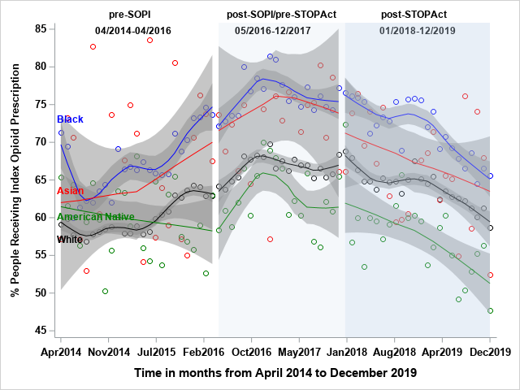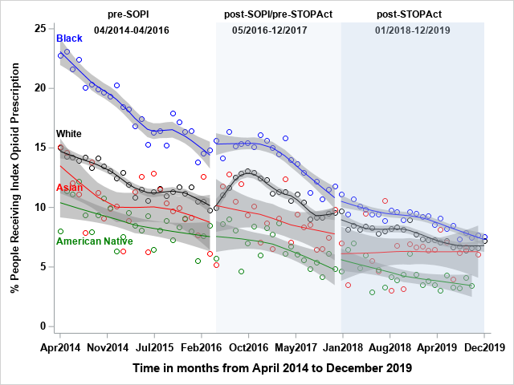
A
B

Supplementary Figure 4 (A-B). Association of SOPI and STOP Act with index opioid prescribing rate by racial group for (A) surgery and (B) injury in NC using single interrupted time series analyses: 2014‒2019. PM, Person-Months; NC, North Carolina; SOPI, Safe Opioid Prescribing Initiative; STOP Act, Strengthen Opioid Misuse Prevention Act.

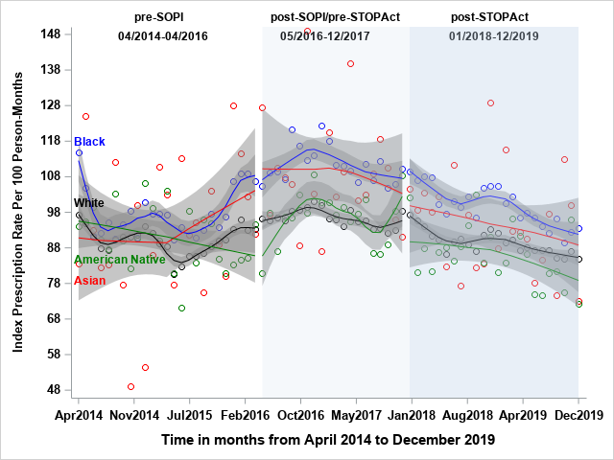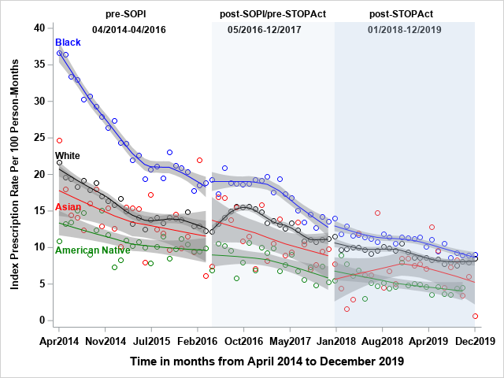
B
A

