Appendix C: Social Network Digraphs

Reminders by Type

Shade: Hydration OR rest knowledge score (black=highest)
Size: Intervention exposure score (largest=max)

Intervention: Hydration

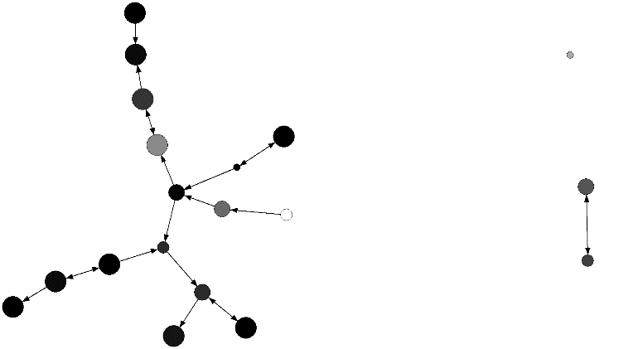

Comparison 1: Hydration

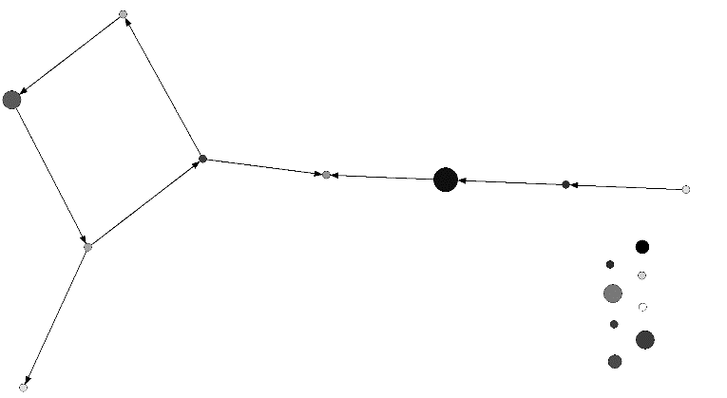

Comparison 2: Hydration

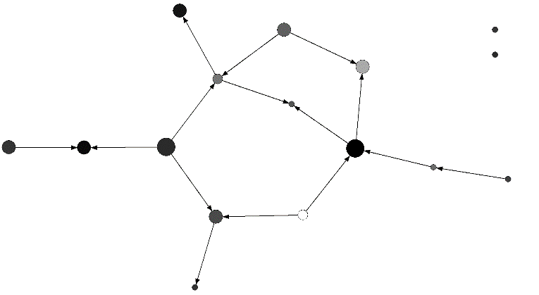
Intervention: Rest

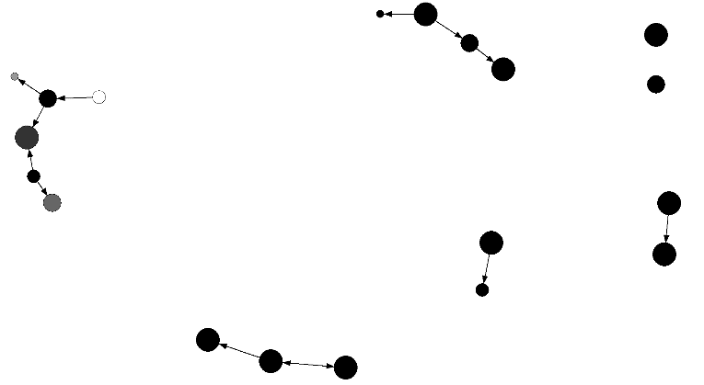

Comparison 1: Rest

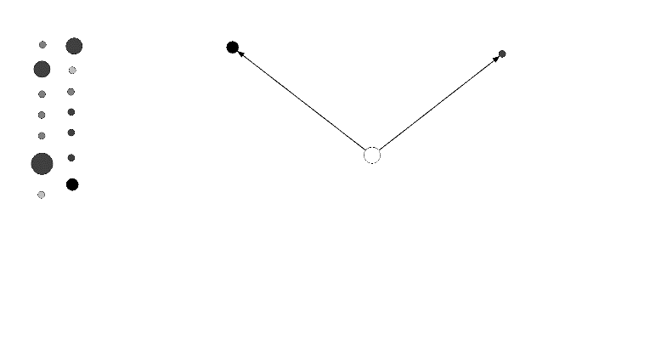

Comparison 2: Rest

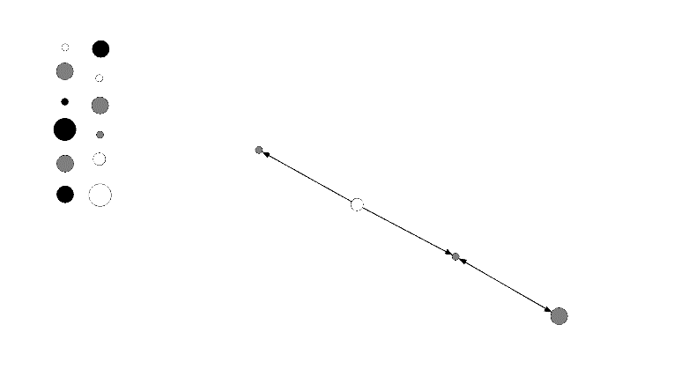

Reminders by Day

Shade: Wellness (darkest green=very well; yellow=neither well nor unwell; orange=unwell; gray=missing)
Size: Breaks per hour (larger=higher)
Border: Times stopped for a drink per hour (larger=higher)

Intervention: Day 1

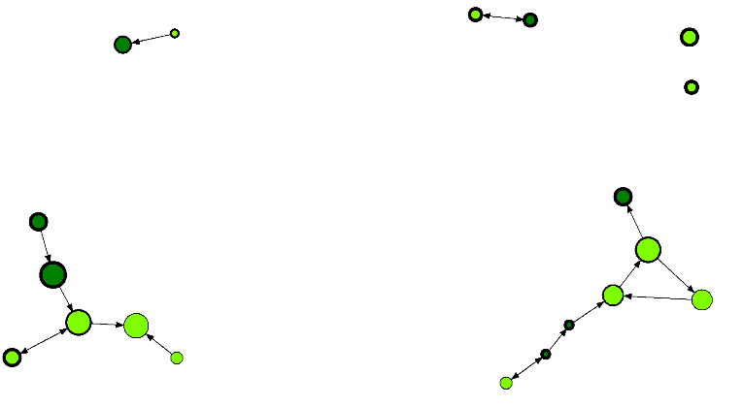

Comparison 1: Day 1

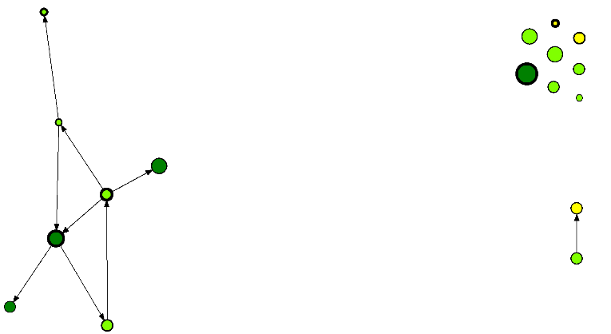

Comparison 2: Day 1

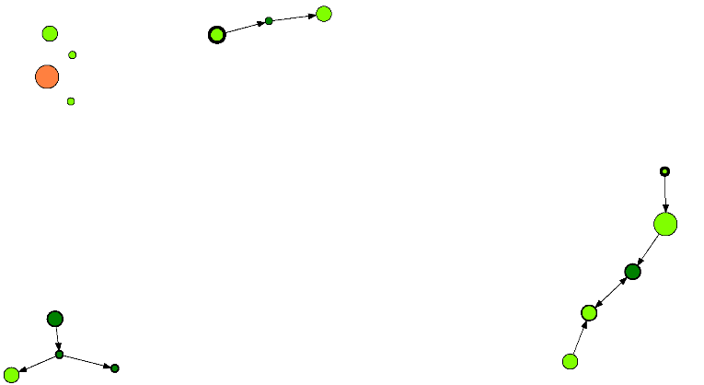
Intervention: Day 2

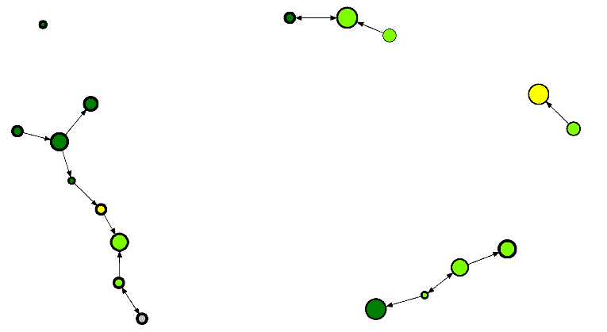

Comparison 1: Day 2

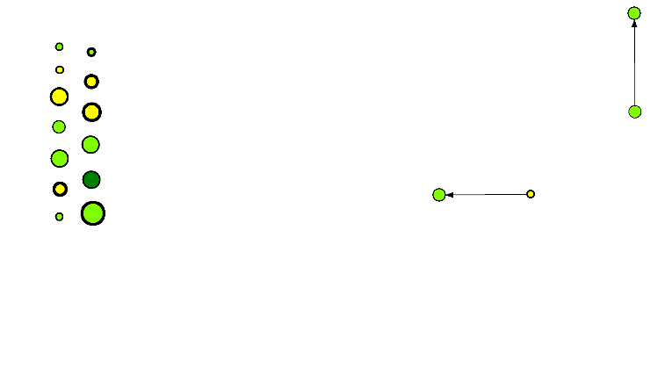

Comparison 2: Day 2

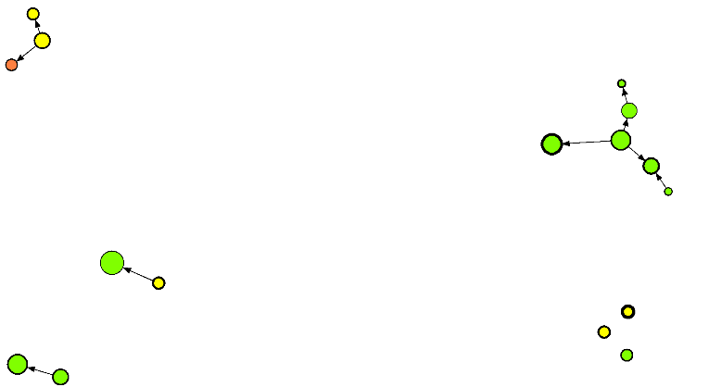

Promotors and Buddies

Green node=promotor
Blue oval=buddies*

*9 of the 11 initial pairs were still intact at the time of the data collection, given that one worker went home and another switched crews.

All Reminders
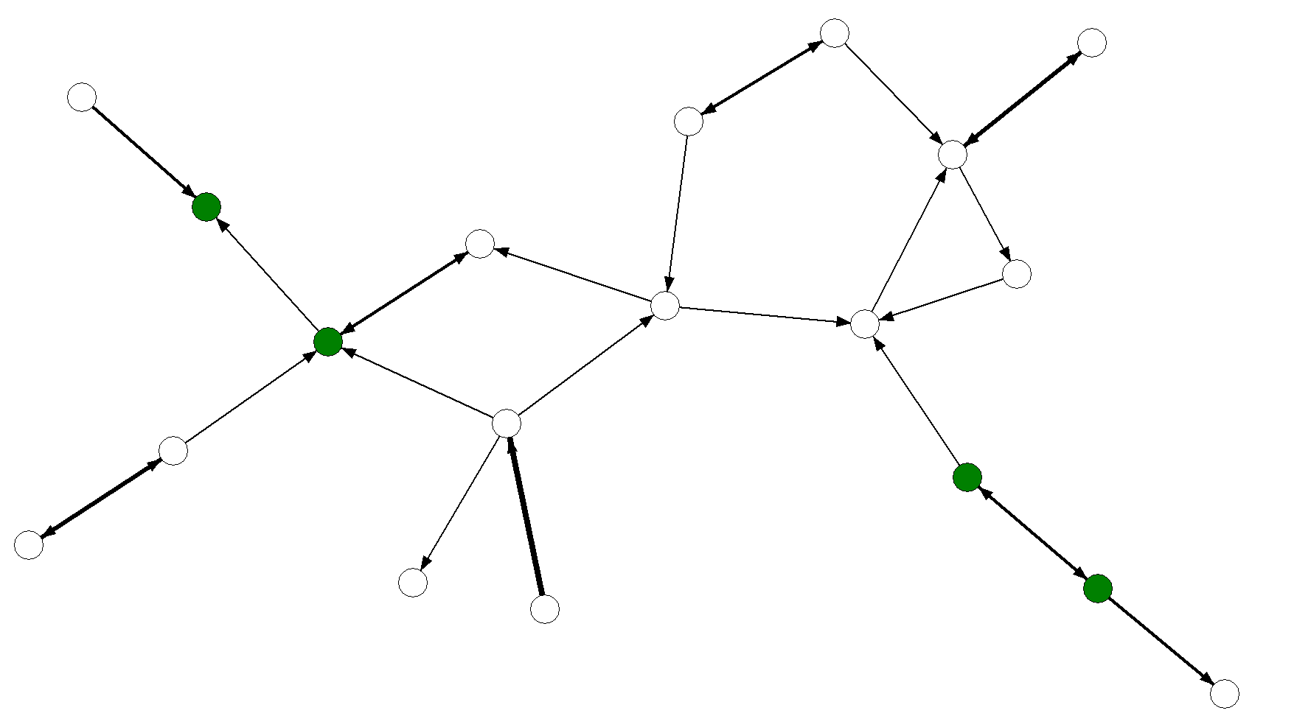

Hydration Reminders
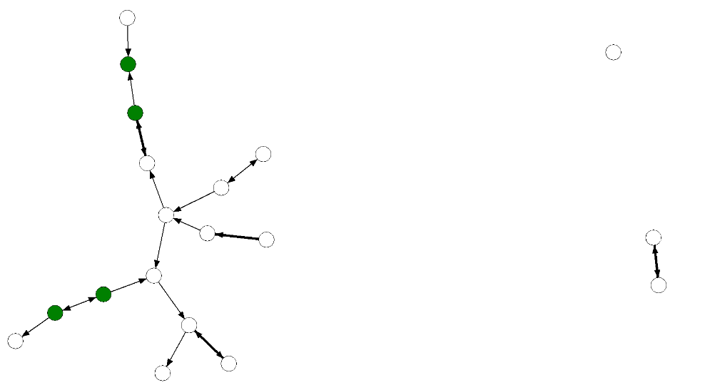

Rest Reminders
