Supplementary Materials
Evaluation of the current state of thyroid hormone testing in human serum—Results of the free thyroxine and thyroid stimulating hormone interlaboratory comparison study
Ashley Ribera, M.S., Otoe Sugahara, B.S., Tatiana Buchannan, B.S., Norma Vazquez, B.S., Alicia N. Lyle, PhD, Li Zhang, PhD, Uliana Danilenko, PhD*, Hubert W. Vesper PhD.
Disclaimer
The findings and conclusions in this report are those of the authors and do not necessarily represent the official position of Centers for Disease Control and Prevention. Use of trade names and commercial sources is for identification only and does not constitute endorsement by the Centers for Disease Control and Prevention or the U.S. Department of Health and Human Services.

Sample collection, shipment, storage, and analysis
Forty individual-donor (PS) and three pooled (Pool1–3) sera used in this study were procured from Solomon Park Research Laboratories and were prepared according to standard protocols. ¹ Four of the forty PS samples (PS 1, PS 27, PS 28, and PS39) were from donors taking levothyroxine. A sample from a pregnant woman (PN) in the third trimester procured from Covidien® was collected in a red top vacutainer-type blood collection tube with no additives (Covidien® #8881301512) and processed using standard specimen collection protocols.²
Samples shipped to CDC on dry ice underwent one freeze-thaw cycle before shipment to study participants. Materials were shipped on dry ice overnight to participants, including major immunoassay (IA) manufacturers with assays cleared in USA or/and internationally and large laboratories using FT4 lab-developed tests (LDTs) in patient care. Participants were asked to store samples at -70 °C until use and analyze them in a specified order (Table S1) in duplicate on two different days. While FT4 was measured by all participants, TSH was measured by participants with an available TSH assay at commencement of the study. Additional information concerning assay methodology, reportable measurement range, calibrators, and reagent lots were collected.
Sample preparation and ID-LC/MS/MS analysis procedures
Sera thawed at room temperature were adjusted to pH 7.4 ± 0.03 at 37 °C with 776 mmol/L 4-(2-Hydroxyethyl)piperazine-1-ethanesulfonic acid (HEPES). Equilibrium dialysis (ED) was conducted in the Micro-Equilibrium Dialyzer System from Harvard Apparatus (Holliston, MA), which consisted of two 1 mL PTFE dialysis half-cells forming compartments for serum and dialysis buffer when separated by a semipermeable membrane. An aliquot of 1 mL of serum and 1 mL of HEPES dialysis buffer in a dialyzer were separated by 5 kDa molecular weight cut-off (MWCO) regenerated cellulose membrane during ED at 37 °C for 4 hours. Sample dialysate collected after ED was diluted with sufficient internal standard (IS) solution for an IS concentration approximating the T4 concentration. The FT4 in the dialysate was quantified by liquid chromatography tandem mass spectrometry (LC-MS/MS) using a Shimadzu LC-30AD high-performance liquid chromatography module (Kyoto, Japan) coupled with an AB Sciex API 5500 Triple Quad Mass Spectrometer (Framingham, MA, USA).
Classification of serum samples
The percent of samples where measurement results for TSH and FT4 led to the same classification for hypo-, eu-, or hyperthyroid (classification agreement), was determined using the forty PS. Classification was performed by comparing the results reported on the forty PS with the respective reference interval (RI) provided by study participants (Figure 1). For simplicity, classification was based solely on either FT4 or TSH concentration to observe potential improvements to these analytes independently.
Estimating the impact of pregnancy, sample pooling, and T4 supplementation on measurement accuracy
The potential impact of pregnancy on FT4 measurement accuracy was estimated by comparing the measurement bias observed with the PN serum with the measurement bias observed among the PS. A measurement bias of this sample within the PS bias distribution would indicate that pregnancy in the third trimester may not impact the measurement accuracy of the FT4 test. The same comparison was conducted with Pool1-3 sera to assess whether pooling sera impacts the measurement accuracy for both FT4 and TSH assays. Two-sample t-tests were performed to evaluate potential differences in mean biases among PS samples from patients taking levothyroxine measured by IA and LDT assays.

Table S1. Recommended run order for participants measuring interlaboratory comparison samples
Participants were asked to analyze 40 single-donor patient samples (PS01-40) and 3 serum pool samples (Pool1-3) in duplicate on 2 separate days. The 2 replicate measurements per day are indicated as “_1” and “_2” in the sample code. Quality controls were analyzed at the beginning of the run, after every 50 samples, and at the end of the run. One sample from a pregnant woman in the third trimester (“PN”) was analyzed using FT4 assays only during Day 1.
Day 1
Run Order | Sample Code | Run Order | Sample Code | Run Order | Sample Code
1 | Mfr Control1_1 | 33 | PS29_1 | 65 | PS24_2
2 | Mfr Control2_1 | 34 | PS30_1 | 66 | PS23_2
3 | PS01_1 | 35 | PS31_1 | 67 | PS22_2
4 | PS02_1 | 36 | PS32_1 | 68 | PS21_2
5 | PS03_1 | 37 | PS33_1 | 69 | PS20_2
6 | PS04_1 | 38 | PS34_1 | 70 | PS19_2
7 | PS05_1 | 39 | PS35_1 | 71 | PS18_2
8 | PS06_1 | 40 | PS36_1 | 72 | PS17_2
9 | PS07_1 | 41 | PS37_1 | 73 | PS16_2
10 | PS08_1 | 42 | PS38_1 | 74 | PS15_2
11 | PS09_1 | 43 | PS39_1 | 75 | PS14_2
12 | PS10_1 | 44 | PS40_1 | 76 | Pool2_2
13 | PS11_1 | 45 | Pool3_1 | 77 | PS13_2
14 | PS12_1 | 46 | PS40_2 | 78 | PS12_2
15 | PS13_1 | 47 | PS39_2 | 79 | PS11_2
16 | Pool1_1 | 48 | PS38_2 | 80 | PS10_2
17 | PS14_1 | 49 | PS37_2 | 81 | PS09_2
18 | PS15_1 | 50 | PS36_2 | 82 | PS08_2
19 | PS16_1 | 51 | Mfr Control1_2 | 83 | PS07_2
20 | PS17_1 | 52 | Mfr Control2_2 | 84 | PS06_2
21 | PS18_1 | 53 | PS35_2 | 85 | PS05_2
22 | PS19_1 | 54 | PS34_2 | 86 | PS04_2
23 | PS20_1 | 55 | PS33_2 | 87 | PS03_2
24 | PS21_1 | 56 | PS32_2 | 88 | PS02_2
25 | PS22_1 | 57 | PS31_2 | 89 | PS01_2
26 | PS23_1 | 58 | PS30_2 | 90 | Pool1_2
27 | PS24_1 | 59 | PS29_2 | 91 | PN_1
28 | PS25_1 | 60 | PS28_2 | 92 | PN_2
29 | PS26_1 | 61 | Pool3_2 | 93 | Mfr Control1_3
30 | Pool2_1 | 62 | PS27_2 | 94 | Mfr Control2_3
31 | PS27_1 | 63 | PS26_2 | 95
32 | PS28_1 | 64 | PS25_2 | 96

Day 2
Run Order | Sample Code | Run Order | Sample Code | Run Order | Sample Code
1 | Mfr Control1_1 | 33 | PS29_1 | 65 | PS24_2
2 | Mfr Control2_1 | 34 | PS30_1 | 66 | PS23_2
3 | PS01_1 | 35 | PS31_1 | 67 | PS22_2
4 | PS02_1 | 36 | PS32_1 | 68 | PS21_2
5 | PS03_1 | 37 | PS33_1 | 69 | PS20_2
6 | PS04_1 | 38 | PS34_1 | 70 | PS19_2
7 | PS05_1 | 39 | PS35_1 | 71 | PS18_2
8 | PS06_1 | 40 | PS36_1 | 72 | PS17_2
9 | PS07_1 | 41 | PS37_1 | 73 | PS16_2
10 | PS08_1 | 42 | PS38_1 | 74 | PS15_2
11 | PS09_1 | 43 | PS39_1 | 75 | PS14_2
12 | PS10_1 | 44 | PS40_1 | 76 | Pool2_2
13 | PS11_1 | 45 | Pool3_1 | 77 | PS13_2
14 | PS12_1 | 46 | PS40_2 | 78 | PS12_2
15 | PS13_1 | 47 | PS39_2 | 79 | PS11_2
16 | Pool1_1 | 48 | PS38_2 | 80 | PS10_2
17 | PS14_1 | 49 | PS37_2 | 81 | PS09_2
18 | PS15_1 | 50 | PS36_2 | 82 | PS08_2
19 | PS16_1 | 51 | Mfr Control1_2 | 83 | PS07_2
20 | PS17_1 | 52 | Mfr Control2_2 | 84 | PS06_2
21 | PS18_1 | 53 | PS35_2 | 85 | PS05_2
22 | PS19_1 | 54 | PS34_2 | 86 | PS04_2
23 | PS20_1 | 55 | PS33_2 | 87 | PS03_2
24 | PS21_1 | 56 | PS32_2 | 88 | PS02_2
25 | PS22_1 | 57 | PS31_2 | 89 | PS01_2
26 | PS23_1 | 58 | PS30_2 | 90 | Pool1_2
27 | PS24_1 | 59 | PS29_2 | 91 | Mfr Control1_3
28 | PS25_1 | 60 | PS28_2 | 92 | Mfr Control2_3
29 | PS26_1 | 61 | Pool3_2 | 93
30 | Pool2_1 | 62 | PS27_2 | 94
31 | PS27_1 | 63 | PS26_2 | 95
32 | PS28_1 | 64 | PS25_2 | 96

Table S2. List of participants of the interlaboratory comparison study.
A total of twenty-two assays, 4 LDTs and 18 IAs, performed by fourteen independent entities (12 manufacturers and 2 clinical laboratories) were included in the interlaboratory comparison. Each assay was analyzed independently. Assay manufacturers that submitted data for more than one platform are indicated as multiple letters in the ID column. Twenty-one of the laboratories measured serum FT4 and seventeen measured serum TSH with commercially available IAs. Four of the laboratories performed serum FT4 measurements with LDTs based on ED LC-MS/MS methods.
ID | Participant Type | Platform/Method Principle | FT4 | TSH
A | Manufacturer | Immunoassay | x | x
B, V | Manufacturer | Immunoassay | X* | x
C, D | Manufacturer | Immunoassay | x | x
E, F | Manufacturer | Immunoassay | x | x
G | Clinical Laboratory | Immunoassay | x | x
H | Manufacturer | ED-based LC-MS/MS | x
I | Manufacturer | ED-based LC-MS/MS | x
J | Manufacturer | ED-based LC-MS/MS | x
K | Manufacturer | ED-based LC-MS/MS | x
L, M | Manufacturer | Immunoassay | x | x
N | Manufacturer | Immunoassay | x | x
O | Manufacturer | Immunoassay | x | x
P, Q, R, S, T | Manufacturer | Immunoassay | x | x
U | Clinical Laboratory | Immunoassay | x
* Assay manufacturer “V” did not submit FT4 data

Table S3. Median Biases of FT4 and TSH measurements by sample
Median percent bias (and range of the mean bias of replicate measurements in parentheses) to either the reference value (FT4) or the all-lab mean (TSH) among all participants, all LDTs, and all IAs are shown for each of the 40 PS, 3 pooled materials, and PN pre-recalibration (A) and post-recalibration (B). Samples from patients taking levothyroxine are indicated with an asterisk.
- Pre-recalibration median biases
Sample ID | FT4 Median Bias, All Assays | FT4 Median Bias, IAs Only | FT4 Median Bias, LDTs Only | TSH Median Bias, All Assays (IAs)
PS 1* | -11.3 (-36.3–8.2) | -19.9 (-36.3–8.2) | -2.5 (-16.5–0.2) | 1.9 (-15.5–11)
PS 2 | -9.0 (-30.6–8.8) | -12.1 (-30.6–8.2) | -4.1 (-9–8.8) | -1.0 (-10.7–17.3)
PS 3 | -17.2 (-34.0–-1.5) | -23.7 (-34.0–-3.1) | -6.7 (-9.2–-1.5) | -0.7 (-17–24.4)
PS 4 | -12.9 (-33.8–8.7) | -17.7 (-33.8–8.7) | -7.4 (-8.9–-6.7) | -2.2 (-10.5–22.7)
PS 5 | -13.4 (-30.7–9.1) | -19.1 (-30.7–9.1) | 0.1 (-1.1–1.0) | -1.1 (-26.0–21.3)
PS 6 | -11.5 (-29.1–5.5) | -14.7 (-29.1–1.7) | 1.0 (-2.7–5.5) | -1.1 (-13.2–17.7)
PS 7 | -8.5 (-27.2–5.2) | -11.2 (-27.2–5.2) | 1.4 (-5.1–3.3) | -0.7 (-14.2–18.0)
PS 8 | -12.4 (-30.6–3.2) | -15.4 (-30.6–3.2) | -1.7 (-10.4–-0.8) | -0.3 (-13.5–17.4)
PS 9 | -9.5 (-30.8–6.1) | -13.9 (-30.8–3.8) | -2.5 (-9.5–6.1) | -1.0 (-11.6–12.2)
PS 10 | -0.1 (-25.7–16.4) | -8.2 (-25.7–16.4) | 1.0 (-0.1–3.5) | -1.3 (-12.6–18.3)
PS 11 | -24.2 (-39.3–-0.2) | -27.4 (-39.3–-5.0) | -14.5 (-19.9–-0.2) | -1.4 (-13.5–22.0)
PS 12 | -16.4 (-33.0–-2.2) | -19.1 (-33.0–-2.2) | -8.6 (-16.4–-8.2) | -1.8 (-14.2–16.0)
PS 13 | -20.1 (-36.8–-1.2) | -23.3 (-36.8–-1.2) | -8.2 (-12.6–-2.7) | -1.1 (-14.1–16.3)
PS 14 | -14.6 (-33.5–0.6) | -16.4 (-33.5–-1.1) | -6.7 (-14.6–0.6) | -1.5 (-14.5–18.2)
PS 15 | -15.6 (-33.2–-4.2) | -17.3 (-33.2–-4.2) | -8.7 (-15.6–-4.2) | -1.8 (-16.3–16.4)
PS 16 | -4.9 (-31.2–5.4) | -11.6 (-31.2–3.7) | 0.7 (-4.8–5.4) | -0.5 (-16.4–16.8)
PS 17 | -16.0 (-35.5–2.8) | -19.3 (-35.5–1.2) | -6.6 (-11.9–2.8) | 1.4 (-20.4–34.2)
PS 18 | -10.4 (-33.4–5.2) | -17.8 (-33.4–2.0) | -4.4 (-15.6–5.2) | -0.2 (-10.8–18.6)
PS 19 | -19.3 (-35.4–-6.5) | -20.4 (-35.4–-8.1) | -9.6 (-16.8–-6.5) | 1.2 (-10.7–19.8)
PS 20 | -16.2 (-32.1–15.1) | -18.0 (-32.1–-3.1) | -1.5 (-16.2–15.1) | -2.6 (-10.0–20.3)
PS 21 | -17.5 (-35.4–1.9) | -20.1 (-35.4–-2.7) | -10.8 (-16.9–1.9) | -0.7 (-12.5–19.4)
PS 22 | -16.5 (-31.4–6.4) | -18.9 (-31.4–6.4) | 0.7 (-12.9–4.6) | -1.6 (-16.9–18.5)
PS 23 | -26.8 (-41.8–12.2) | -27.9 (-41.8–12.2) | -3.6 (-7.3–10.9) | -0.9 (-14.4–16.1)
PS 24 | -20.3 (-35.2–5.2) | -22.8 (-35.2–-2.1) | 0.0 (-11.3–5.2) | -0.4 (-12.1–21.0)
PS 25 | -21.6 (-36.2–-1.5) | -21.8 (-36.2–-2.5) | -6.4 (-10.9–-1.5) | 0.1 (-19.7–11.6)
PS 26 | -8.6 (-28.8–24.2) | -9.6 (-28.8–19.3) | 8.2 (0.4–24.2) | -0.5 (-8.5–11.1)
PS 27* | -24.9 (-39.5–0.7) | -29.0 (-39.5–-13.0) | -11.0 (-21.0–0.7) | -0.9 (-13.5–16.5)
PS 28* | -22.9 (-41.1–-4.5) | -26.4 (-41.1–-10.0) | -14.1 (-18.1–-4.5) | -3.5 (-23.5–18.9)
PS 29 | -23.6 (-38.1–5.2) | -24.4 (-38.1–-13.4) | -6.5 (-14.9–5.2) | -0.4 (-17.0–21.0)
PS 30 | -18.2 (-38.0–0.2) | -22.3 (-38.0–-6.4) | -9.4 (-16.8–0.2) | -4.0 (-13.2–26.5)
PS 31 | -14.8 (-31.2–1.1) | -17.2 (-31.2–-8.5) | -5.5 (-11.0–1.1) | -0.2 (-23.9–13.7)
PS 32 | -15.2 (-33.7–-2.0) | -16.3 (-33.7–-2.9) | -5.5 (-11.6–-2.0) | -1.5 (-12.7–17.2)
PS 33 | -19.9 (-34.7–-3.6) | -23.5 (-34.7–-11.7) | -4.7 (-8.8–-3.6) | -1.2 (-10.3–17.1)
PS 34 | -29.7 (-42.8–-4.6) | -31.5 (-42.8–-10.4) | -11.0 (-13.1–-4.6) | -2.0 (-10.8–23.1)
PS 35 | -23.8 (-37.1–4.1) | -26.8 (-37.1–-3.4) | -1.4 (-7.6–4.1) | -2.3 (-9.4–17.7)
PS 36 | -22.1 (-36.9–3.3) | -22.1 (-36.9–3.3) | -3.6 (-6.0–-2.4) | -1.9 (-16.6–21.6)
PS 37 | -23.7 (-39.9–-7.1) | -25.7 (-39.9–-7.1) | -12.8 (-16.1–-8.7) | -0.4 (-23.4–17.1)
PS 38 | -20.2 (-38.5–2.7) | -21.7 (-38.5–-9.1) | -6.5 (-12.6–2.7) | n/a
PS 39* | -23.1 (-38.2–4.1) | -24.1 (-38.2–-5.4) | 2.0 (0.9–4.1) | -0.5 (-35.4–26.3)
PS 40 | -28.9 (-45.6–4.8) | -31.4 (-45.6–-8.3) | -2.0 (-3.5–4.8) | -2.4 (-61.1–26.0)
Pool 1 | -23.3 (-43.6–21.9) | -26.1 (-43.6–-2.1) | 9.7 (4.3–21.9) | 0.5 (-12.7–16.5)
Pool 2 | -14.2 (-33.1–27.8) | -17.4 (-33.1–-2.2) | 2.5 (-1.8–27.8) | -2.1 (-9.5–13.6)
Pool 3 | -16.2 (-31.8–16.4) | -18.1 (-31.8–-3.8) | 0.6 (-2.7–16.4) | 0.6 (-9.2–12.9)
PN | -1.0 (-27.8–52.5) | -1.9 (-27.8–19.8) | 1.8 (-8.7–52.5) | n/a

- Post-recalibration Median Biases
Sample ID | FT4 Median Bias, All Assays | FT4 Median Bias, IAs Only | FT4 Median Bias, LDTs Only | TSH Median Bias, All Assays (IAs)
PS 1* | -3.1 (-43.7–8.3) | -5.9 (-43.7–8.3) | 1.2 (-4.8–4.2) | 0.2 (-1.7–0.8)
PS 2 | 1.4 (-21.2–32.5) | 1.1 (-21.2–32.5) | 1.9 (-2.9–13.5) | -0.6 (-8.1–10.1)
PS 3 | -8.0 (-16.2–3.6) | -9.1 (-16.2–-2.3) | -0.7 (-5.0–3.6) | -1.8 (-7.8–16.1)
PS 4 | -4.9 (-16.3–4.4) | -5.4 (-16.3–2.5) | -3.6 (-5.7–4.4) | -1.4 (-5.3–6.8)
PS 5 | -1.4 (-14.1–10.8) | -2.7 (-14.1–7.9) | 5.0 (1.8–10.8) | 0.8 (-20.2–12.9)
PS 6 | 1.7 (-14.7–16.5) | 0.6 (-14.7–5.5) | 4.6 (1.7–16.5) | 0.7 (-6.7–7.8)
PS 7 | 4.6 (-0.8–14.1) | 4.6 (-0.1–14.1) | 5.0 (-0.8–14) | 3.1 (-21.9–25)
PS 8 | 1.5 (-9.3–9.8) | 0.5 (-1.7–4.9) | 3.3 (-9.3–9.8) | 1.2 (-7.2–10.6)
PS 9 | 2.9 (-7.2–22.8) | 2.9 (-7.2–22.8) | 2.7 (-4.2–11.4) | 0.5 (-9.5–9.1)
PS 10 | 11.2 (4.9–39.8) | 12.4 (5.0–39.8) | 6.1 (4.9–11.2) | -0.8 (-8.0–12.6)
PS 11 | -11.9 (-31.8–1.1) | -13.3 (-31.8–-2.7) | -7.1 (-16.0–1.1) | 0.7 (-15.0–9.1)
PS 12 | -1.2 (-10.4–1.5) | 0.1 (-10.4–1.5) | -5.6 (-7.7–-2.9) | -1.2 (-7.1–9.3)
PS 13 | -5.0 (-11.6–3.4) | -6.3 (-11.6–3.4) | -4.2 (-5.0–1.0) | -1.0 (-9.6–13.1)
PS 14 | 2.6 (-6.8–12.7) | 2.7 (0.6–12.7) | -2.7 (-6.8–4.2) | -0.3 (-4.0–8.1)
PS 15 | 3.5 (-16.9–11.4) | 4.4 (-16.9–11.4) | -4.4 (-7.0–-2.5) | 0.6 (-8.4–8.7)
PS 16 | 9.4 (4.1–20.5) | 11.6 (4.1–20.5) | 5.6 (4.6–6.9) | 0.9 (-28.5–33.0)
PS 17 | -1.8 (-10.0–19.8) | -1.8 (-10.0–19.8) | -2.1 (-3.7–4.3) | 8.1 (-65.8–39.9)
PS 18 | 5.3 (-7.2–23.7) | 5.8 (-1.2–23.7) | 0.2 (-7.2–6.8) | 1.0 (-8.9–6.6)
PS 19 | -5.5 (-11.8–1.6) | -4.7 (-11.8–1.6) | -6.4 (-8.0–-2.9) | 1.4 (-14.9–12.9)
PS 20 | 1.5 (-7.6–18.6) | 1.5 (-6.9–11.5) | 2.1 (-7.6–18.6) | 0.1 (-14.2–7.5)
PS 21 | 1.1 (-17.3–13.6) | 3 (-17.3–13.6) | -3.8 (-13.5–3.4) | 0.4 (-6.9–9.0)
PS 22 | 3.2 (-13.0–30.7) | 3.2 (-13.0–30.7) | 4.2 (-4.3–8.7) | -0.4 (-20.0–11.3)
PS 23 | -8.1 (-24.6–19.9) | -12.5 (-24.6–19.9) | 1.9 (-2.6–14.3) | 1.1 (-9.9–6.8)
PS 24 | 0.3 (-7.2–12.5) | -0.8 (-7.2–12.5) | 3.7 (-3.1–8.5) | 0.5 (-6.7–8.0)
PS 25 | 0.0 (-19.2–4.2) | 1.3 (-19.2–4.2) | -1.8 (-3.5–0.0) | -0.9 (-9.0–12.6)
PS 26 | 17.2 (-8.5–32.3) | 18.2 (-8.5–32.3) | 12.3 (8.4–27.5) | 2.0 (-15.4–16.1)
PS 27* | -8.8 (-16.9–2.2) | -9.3 (-16.9–-4.0) | -6.7 (-13.3–2.2) | -0.8 (-4.4–6.6)
PS 28* | -6.5 (-11.2–-3.1) | -6.1 (-10.0–-3.9) | -9.7 (-11.2–-3.1) | -2.1 (-15.7–13.2)
PS 29 | -4.0 (-9.9–8.4) | -4.0 (-9.9–-1.3) | -3.1 (-7.0–8.4) | 1.0 (-9.4–8.7)
PS 30 | -4.5 (-16.0–20.6) | -4.5 (-16.0–20.6) | -3.8 (-12.5–2.7) | 0.6 (-17.8–12.9)
PS 31 | 4.7 (-7.0–13) | 5.5 (-7.0–13) | -1.0 (-3.0–2.6) | 1.5 (-12.9–6.0)
PS 32 | 6.2 (-6.3–16.1) | 7.1 (-3.0–16.1) | -2.8 (-6.3–5.0) | 0.5 (-8.0–8.5)
PS 33 | -0.2 (-11.3–12.5) | -0.2 (-11.3–12.5) | -0.6 (-5.9–3.3) | 2.0 (-18.0–7.0)
PS 34 | -9.3 (-15.8–1.2) | -9.8 (-15.8–-4.4) | -6.3 (-11.4–1.2) | 0.0 (-6.8–6.2)
PS 35 | -1.8 (-7.4–15.4) | -1.8 (-7.4–15.4) | 1.9 (-2.7–9.7) | 3.4 (-19.7–13.1)
PS 36 | 0.0 (-9.1–12.0) | 0.2 (-9.1–12.0) | -0.4 (-0.9–3.9) | 5.7 (-45.9–31.0)
PS 37 | -4.0 (-9.6–12.4) | -3.9 (-7.9–12.4) | -8.8 (-9.6–-7.3) | 0.4 (-15.1–9.2)
PS 38 | 1.9 (-9.9–31.3) | 7.9 (-9.9–31.3) | -4.5 (-7.2–9.5) | n/a
PS 39* | 5.8 (-1.4–12.0) | 4.1 (-1.4–12.0) | 6.6 (4.1–8.5) | 1.1 (-26.8–6.9)
PS 40 | -0.4 (-26.2–6.9) | -2.5 (-26.2–6.1) | 2.7 (0.4–6.9) | 2.6 (-46.9–21.3)
Pool 1 | -8.1 (-31.7–25.8) | -11.0 (-31.7–16) | 14.6 (12.3–25.8) | -1.4 (-8.8–15.3)
Pool 2 | 3.9 (-10.9–31.5) | 3.6 (-10.9–9.9) | 10.0 (-0.4–31.5) | -0.4 (-3.1–5.2)
Pool 3 | 2.6 (-7.8–19.9) | 2.4 (-7.8–7.5) | 7.5 (-0.2–19.9) | 2.2 (-7.9–8.7)
PN | 16.2 (-28.5–57.6) | 16.9 (-28.5–30.0) | 5.3 (3.1–57.6) | n/a

Figure S1. Comparing FT4 concentrations measured by each participant to the CDC FT4 RMP
Linear regression analysis was performed using only the 40 single nonpregnant donors (PS), and the 95% confidence and prediction intervals are shown as dashed and dotted lines, respectively. Mean FT4 concentrations (pmol/L) of 44 study samples reported by 19 IA and LDT manufacturers (A–F and H–T) and 2 IA end-users (G and U) were compared to the CDC RMP FT4 reference value. PS are shown as circles; samples from single pregnant donors (third trimester, triangles) and samples from pooled donors (X’s) are included in the graph for comparison only and were not part of linear regression analysis.
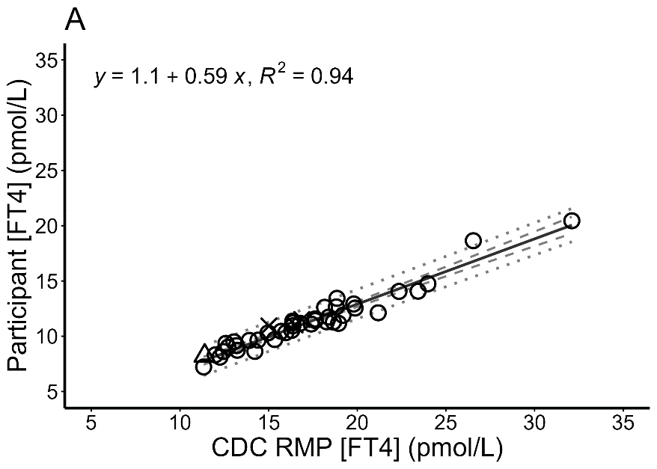
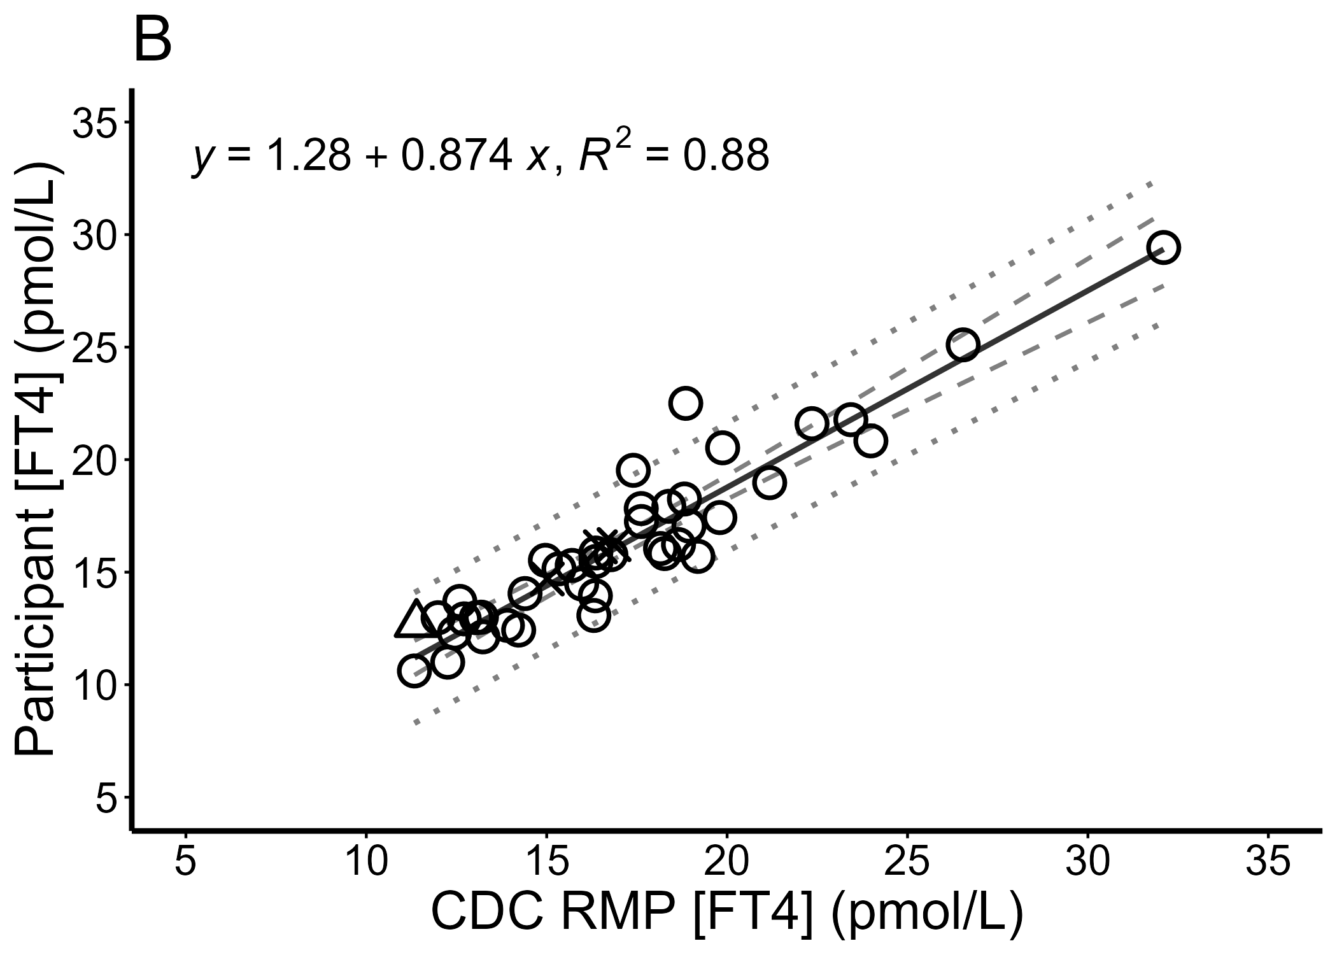
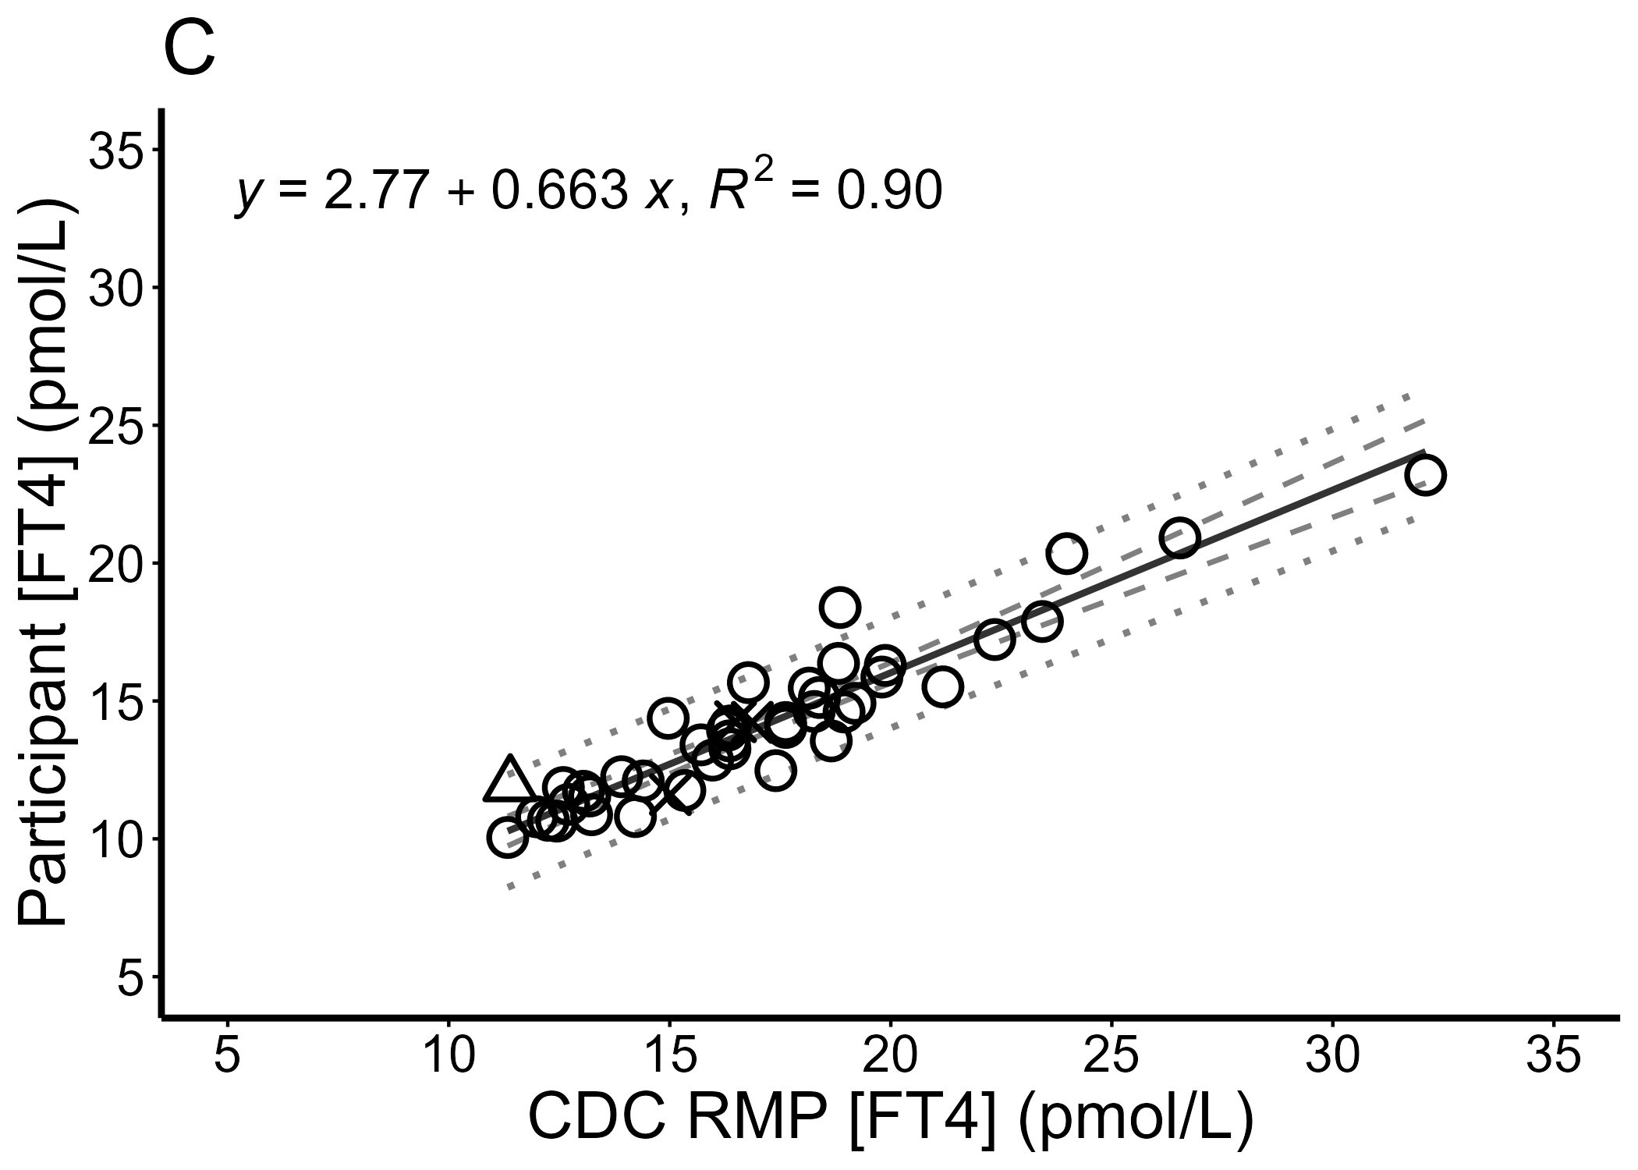
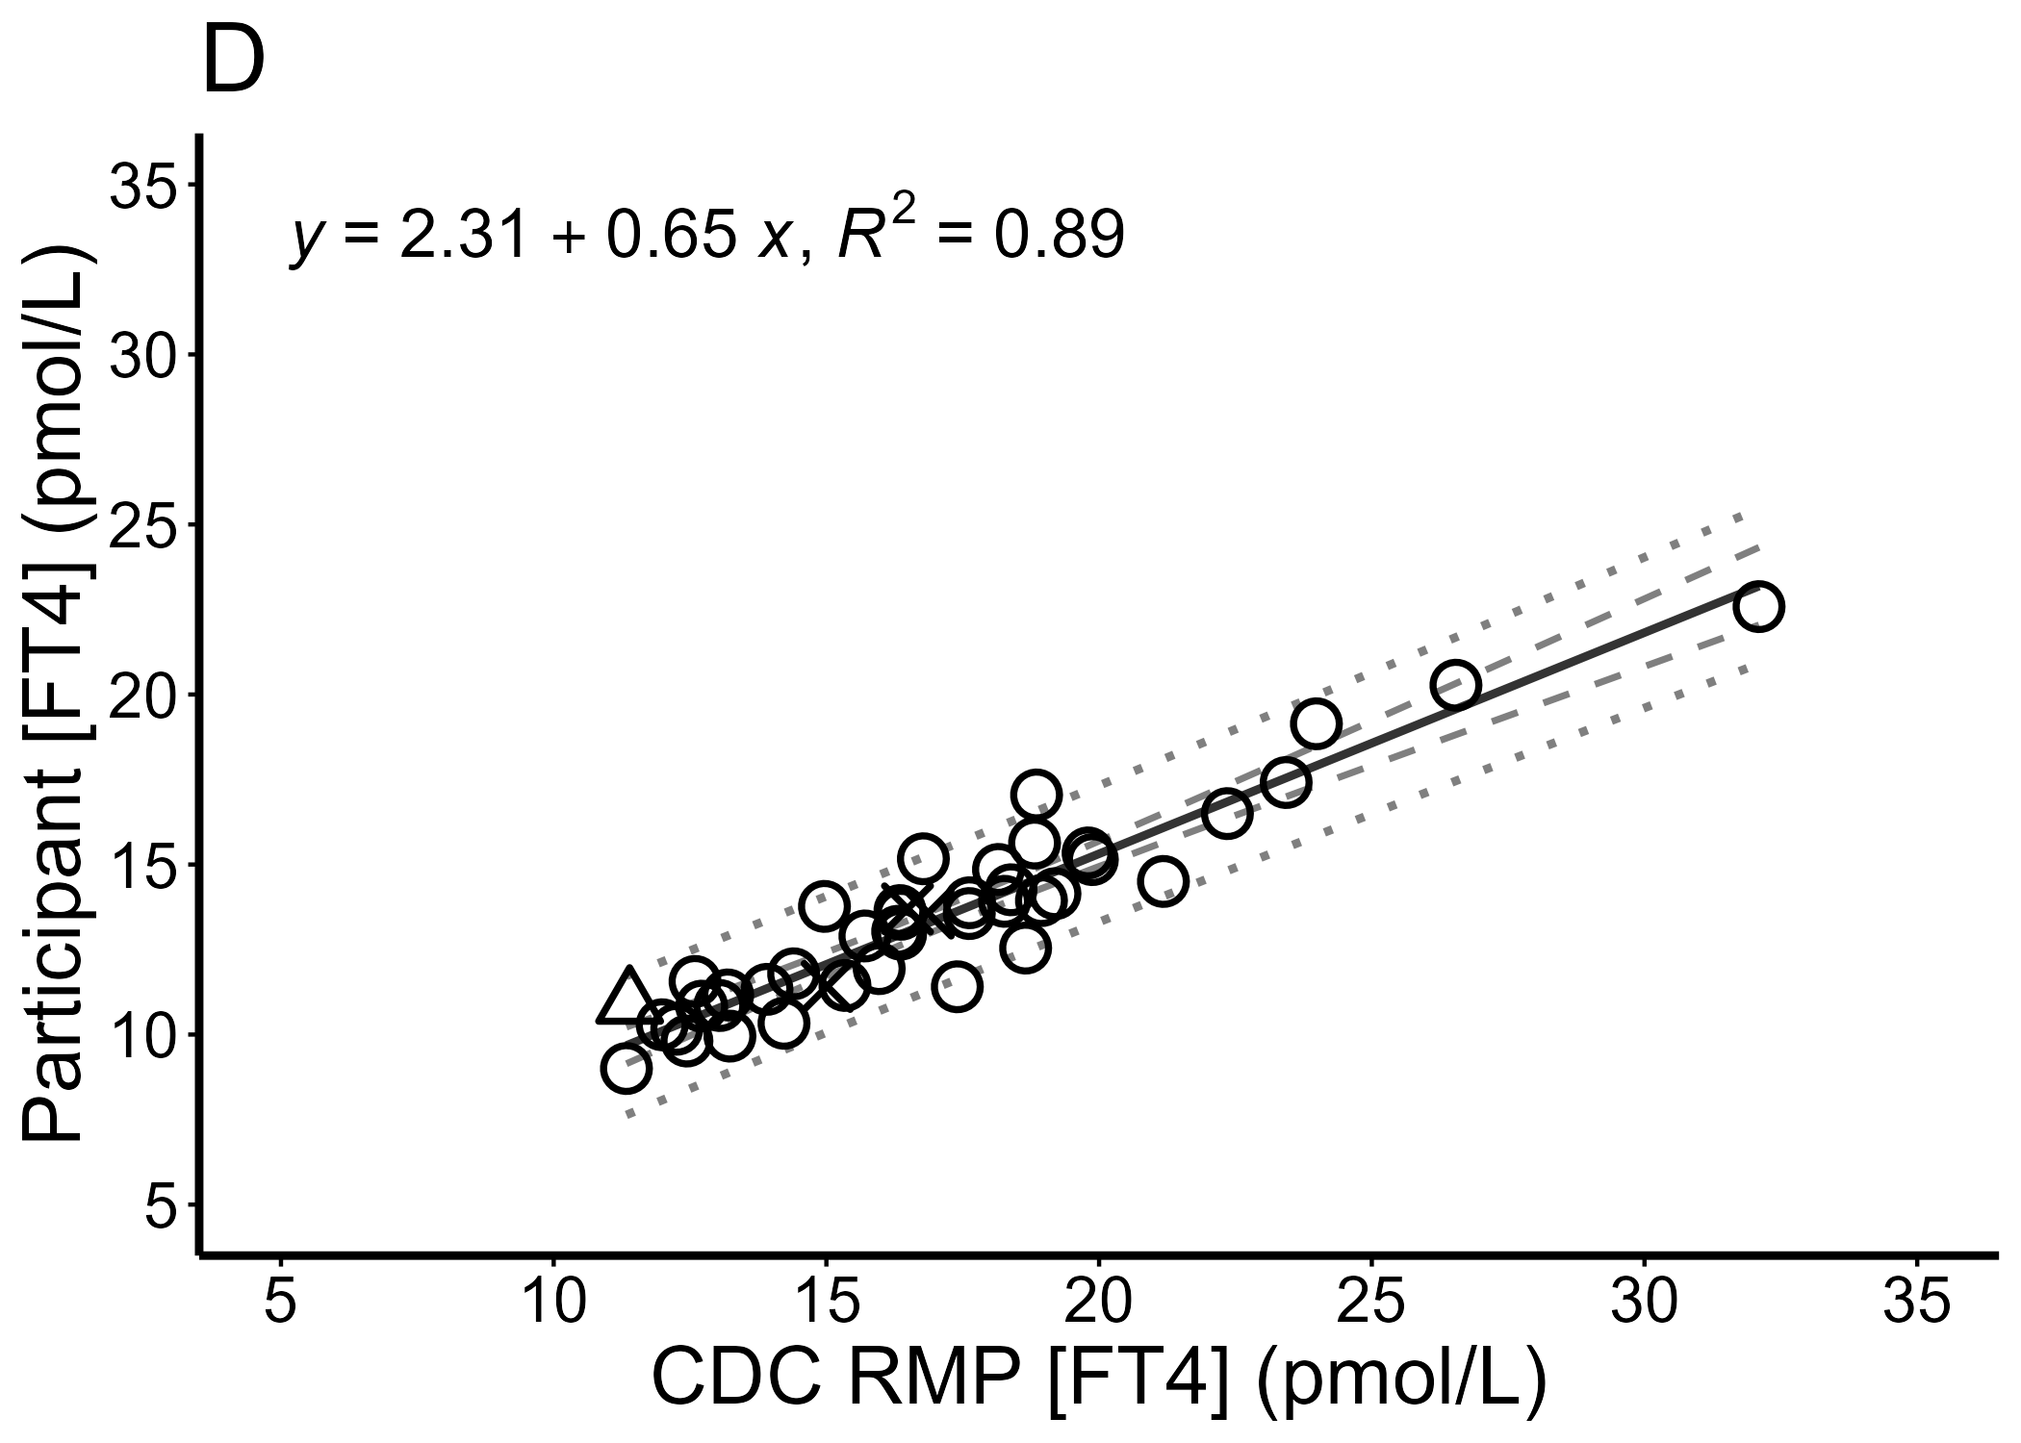

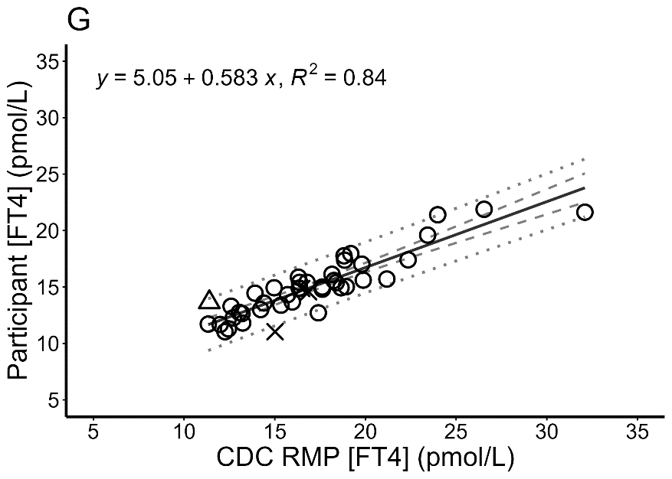
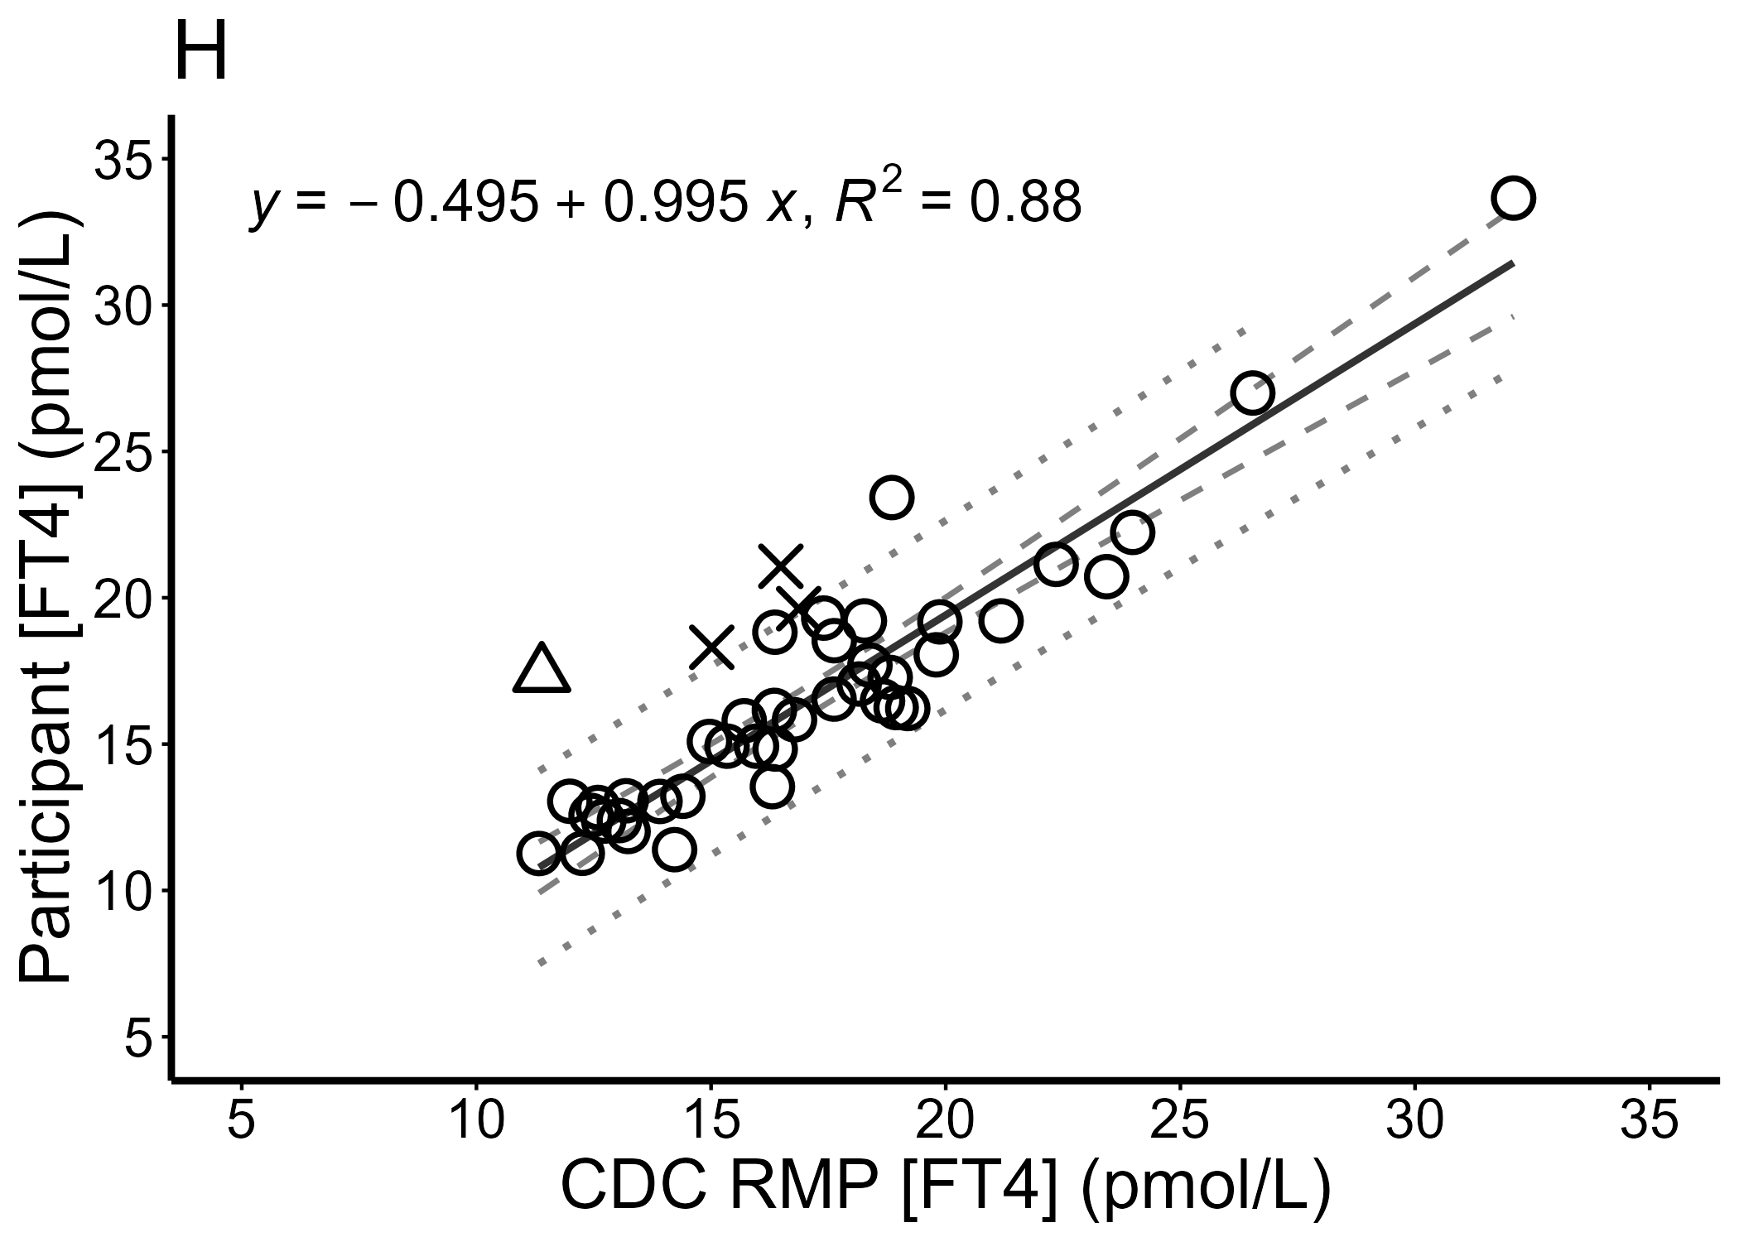
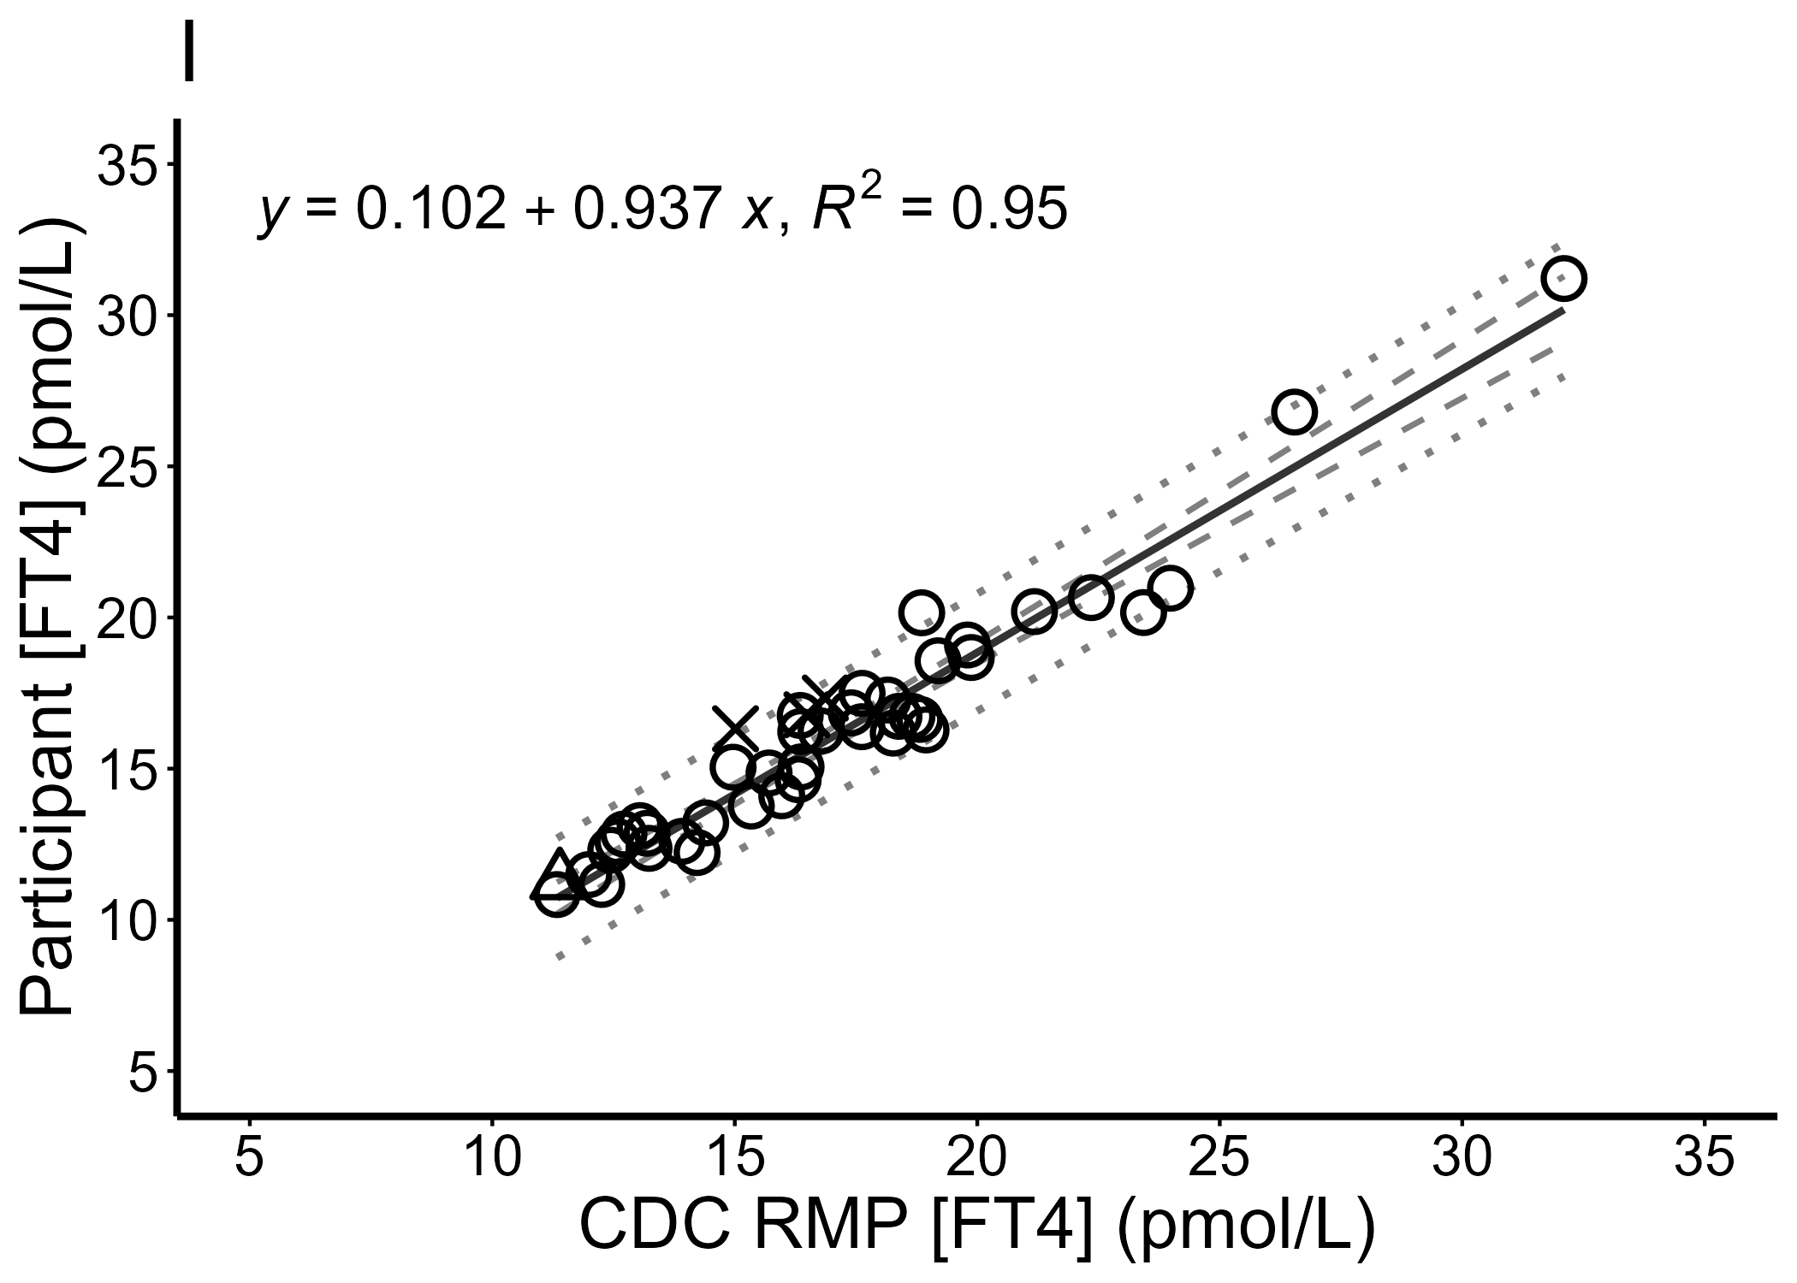
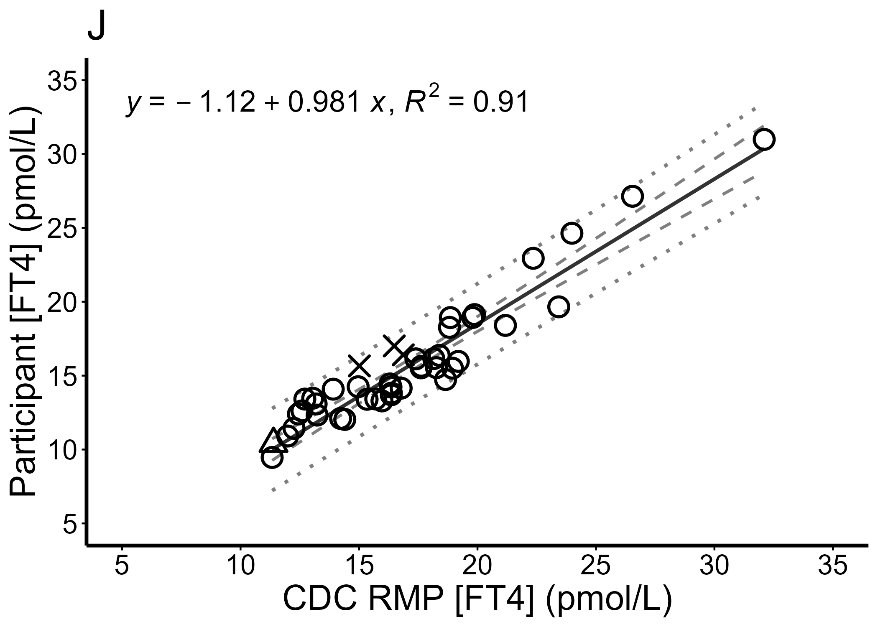
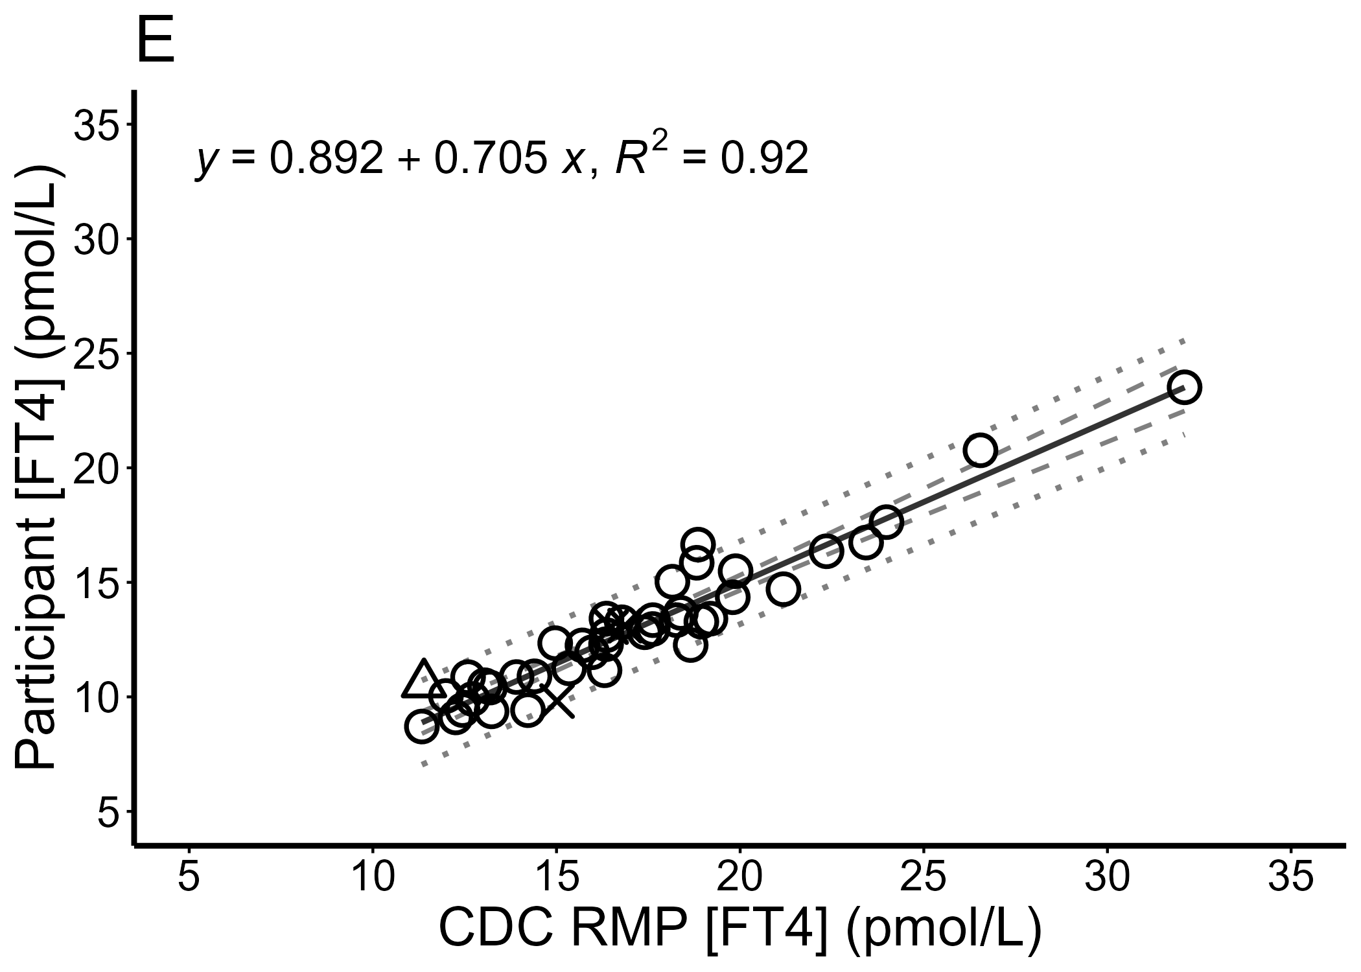
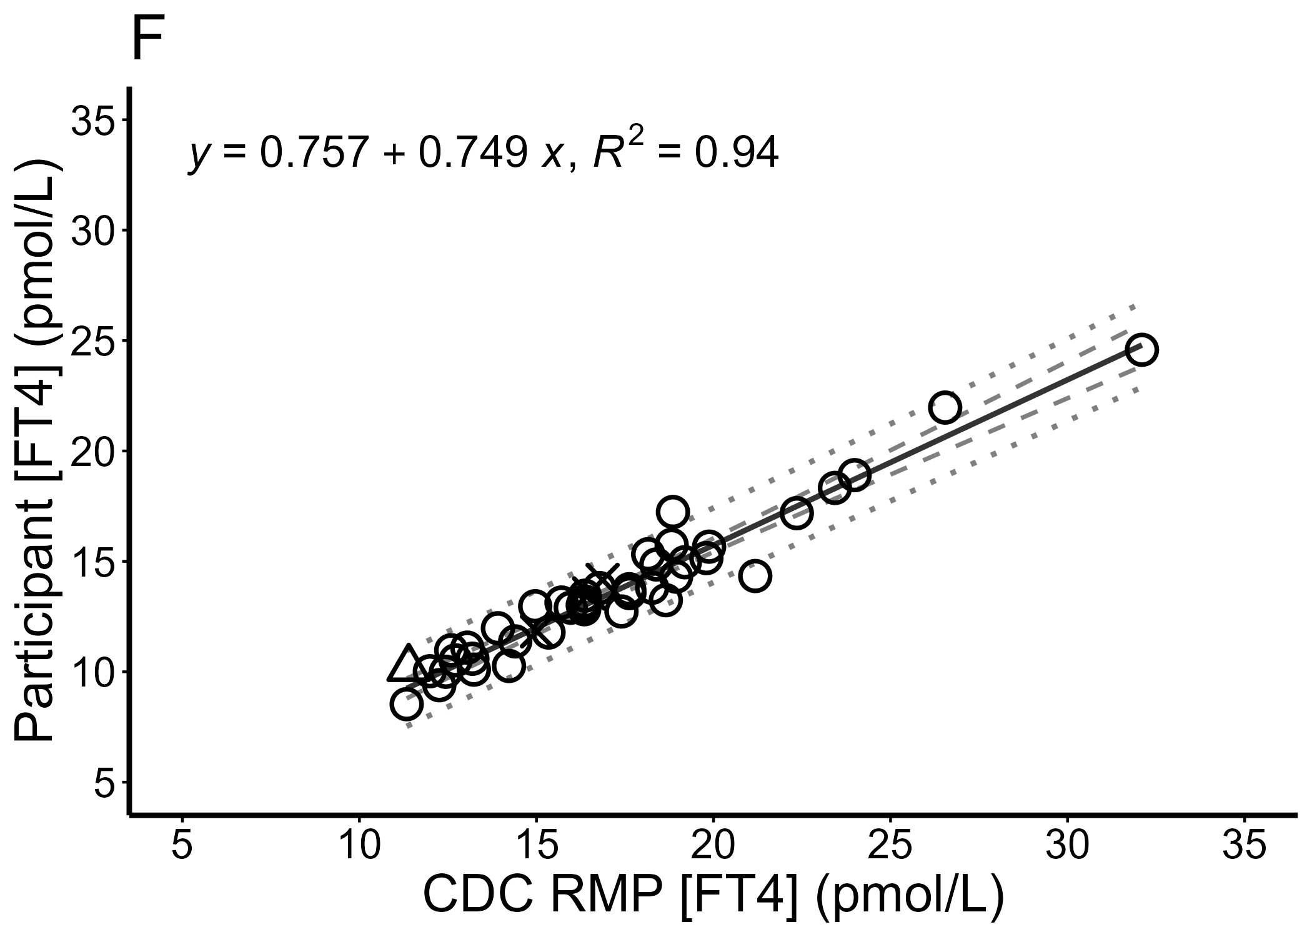

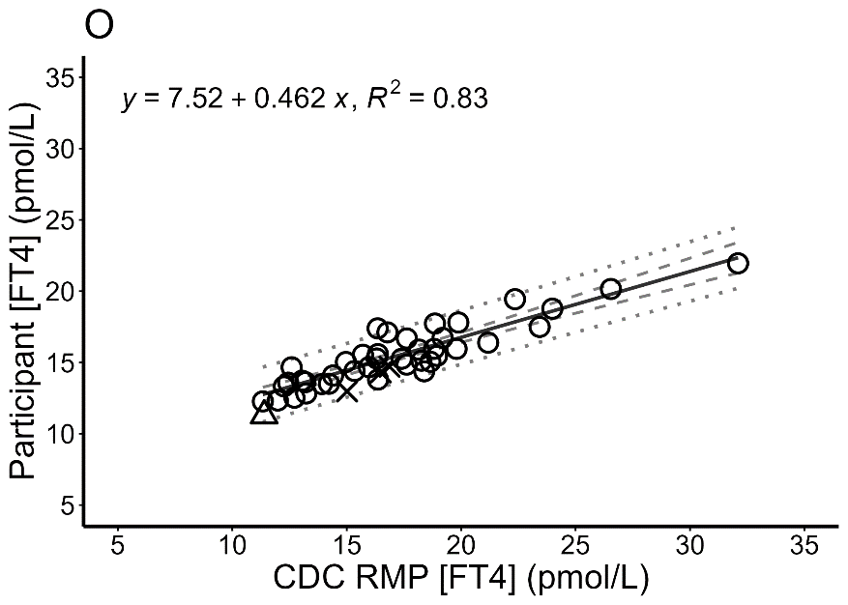
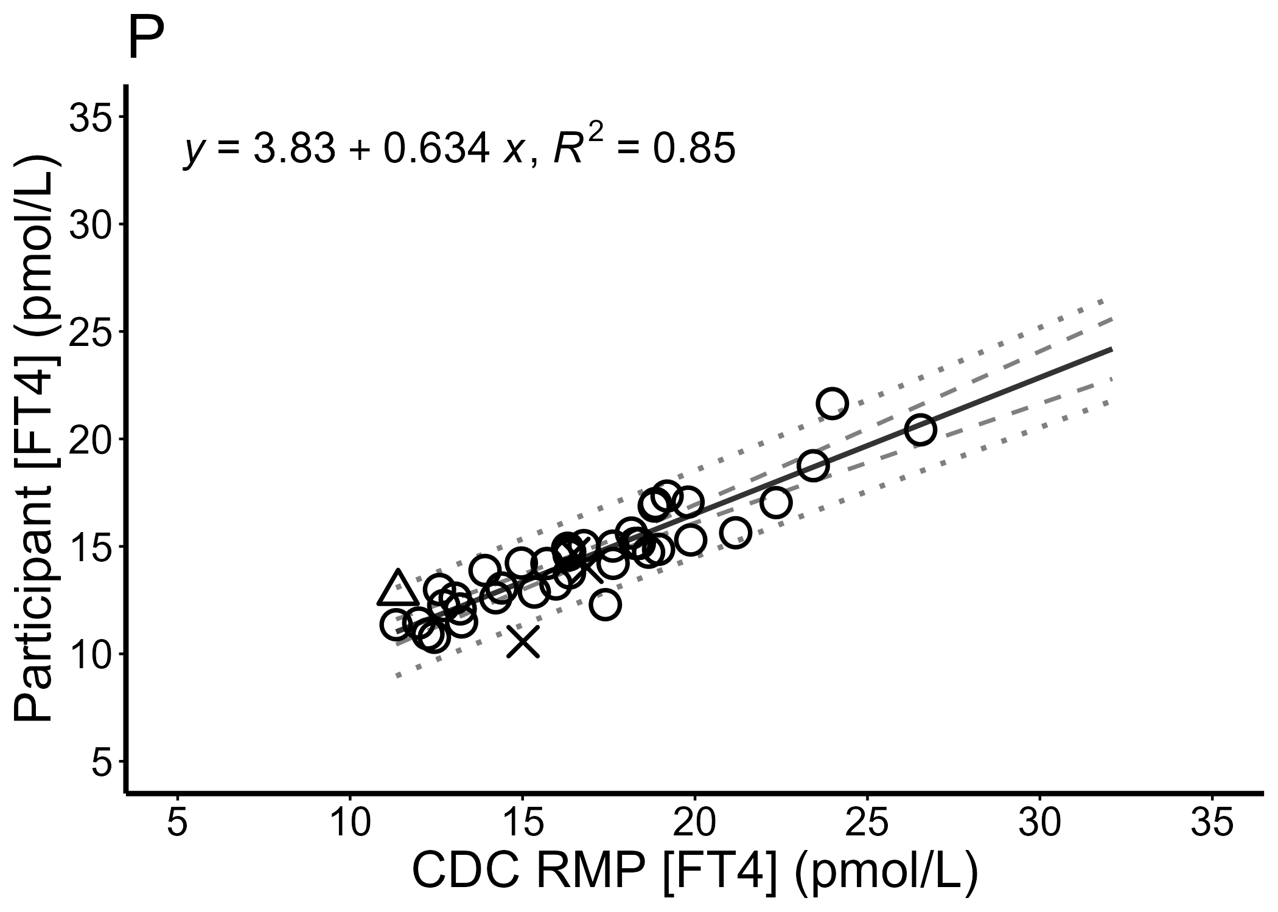
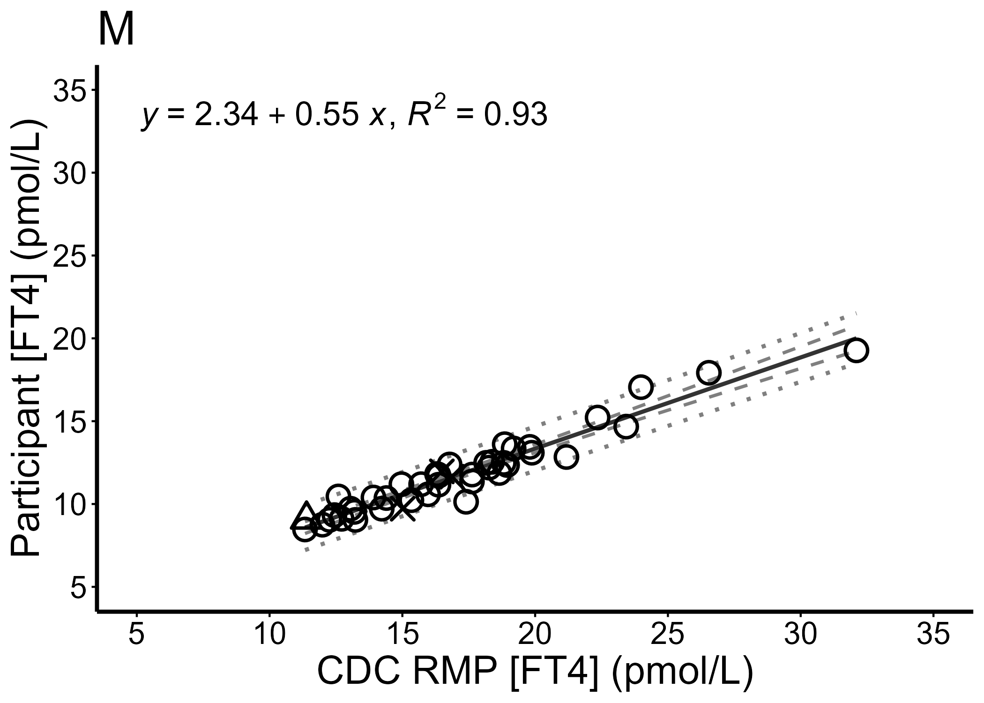
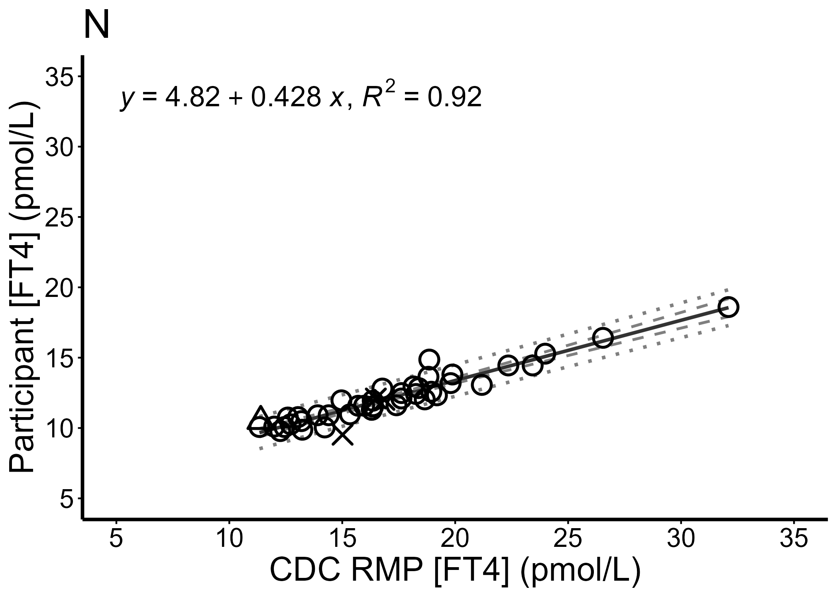
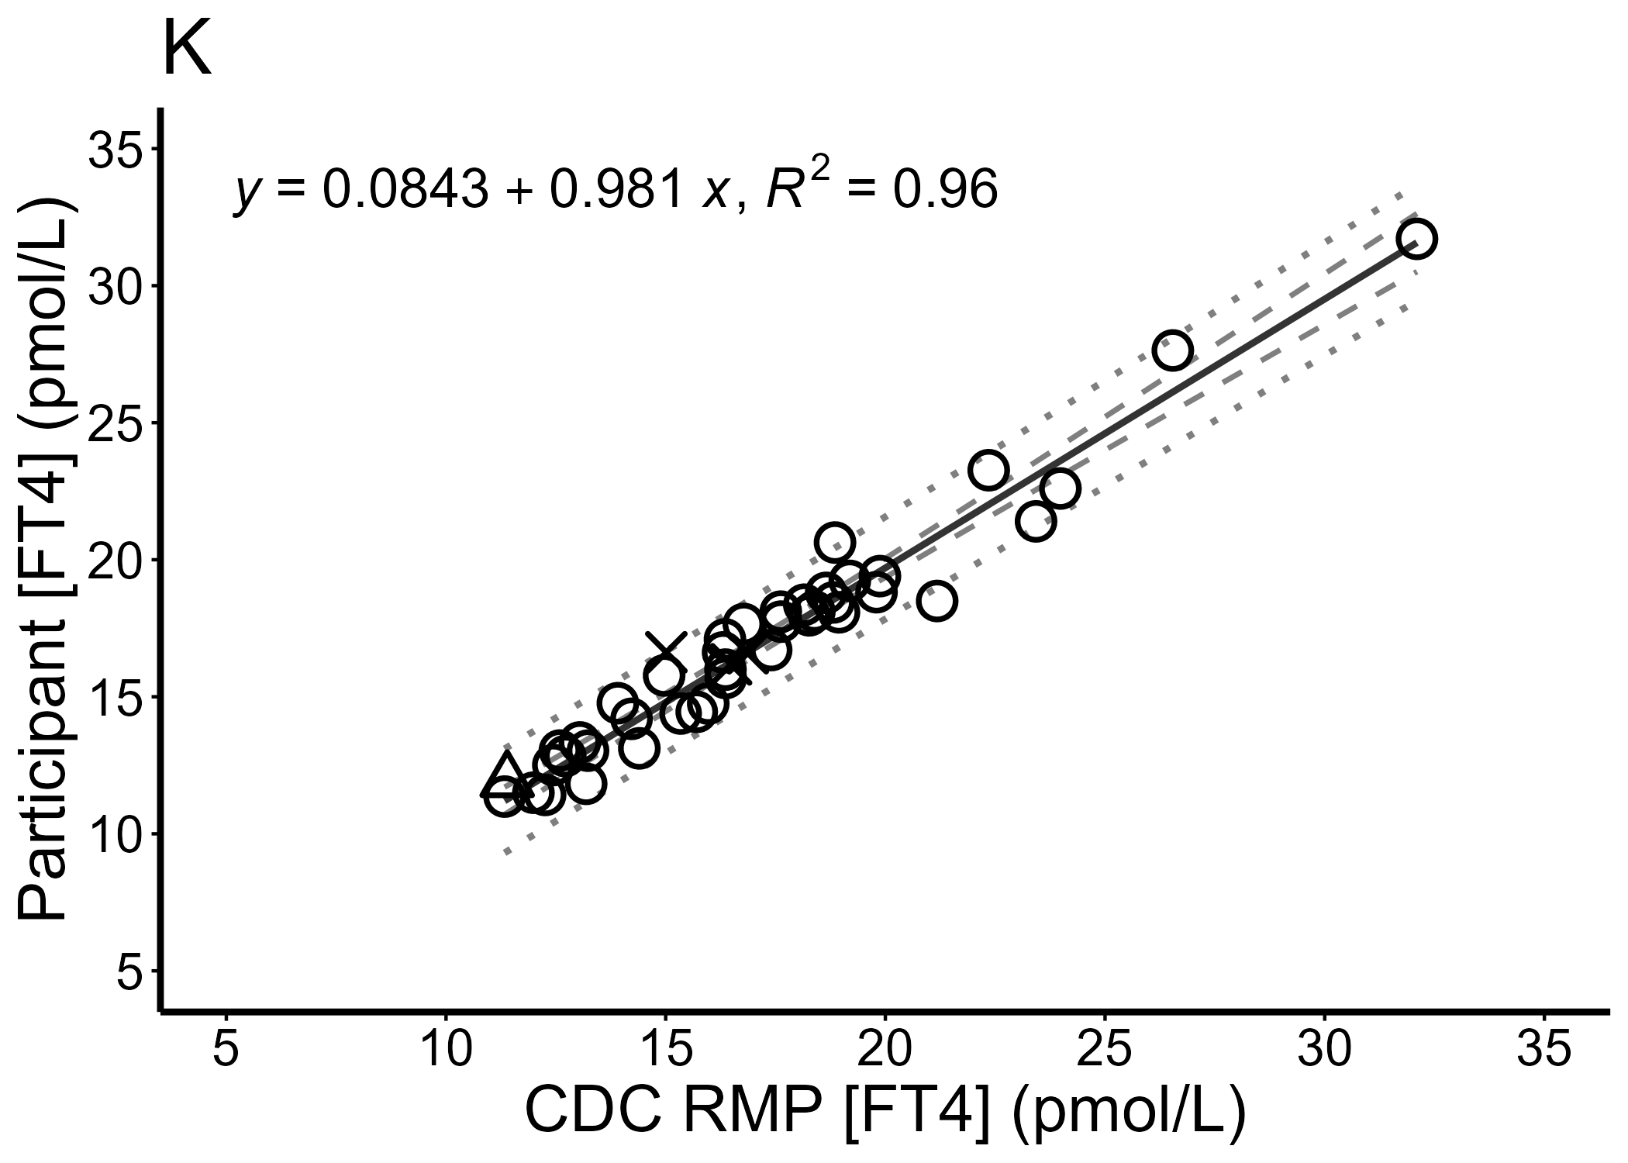
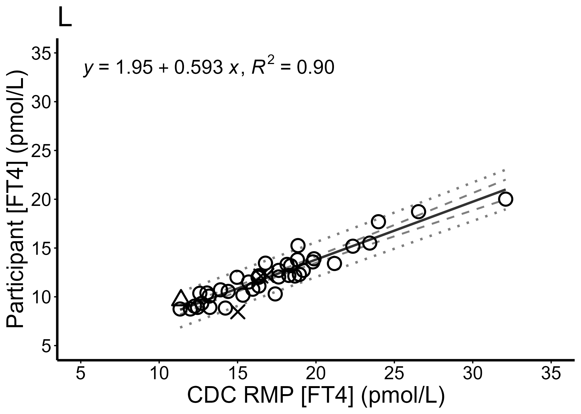

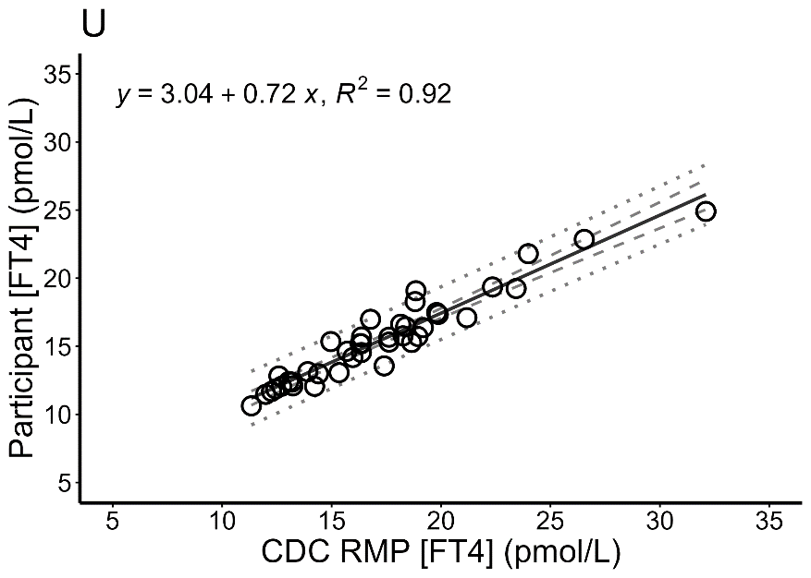
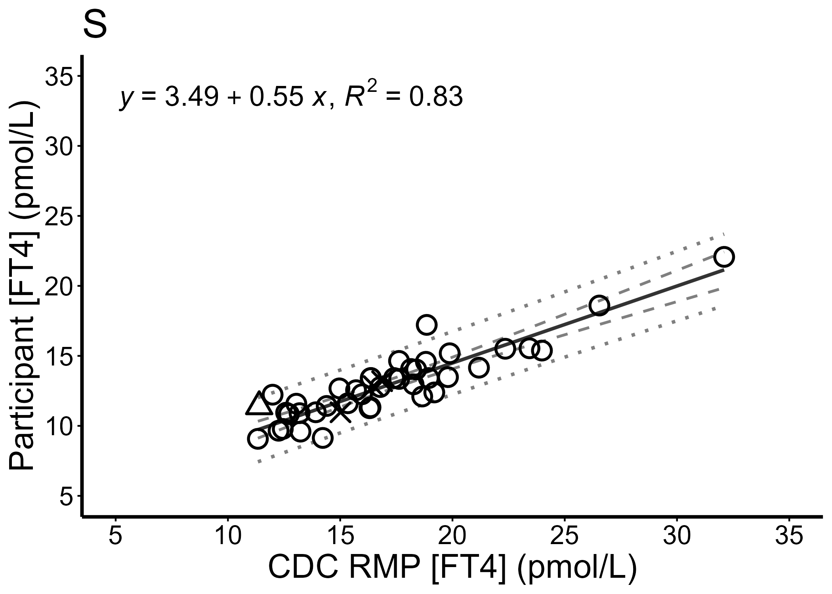
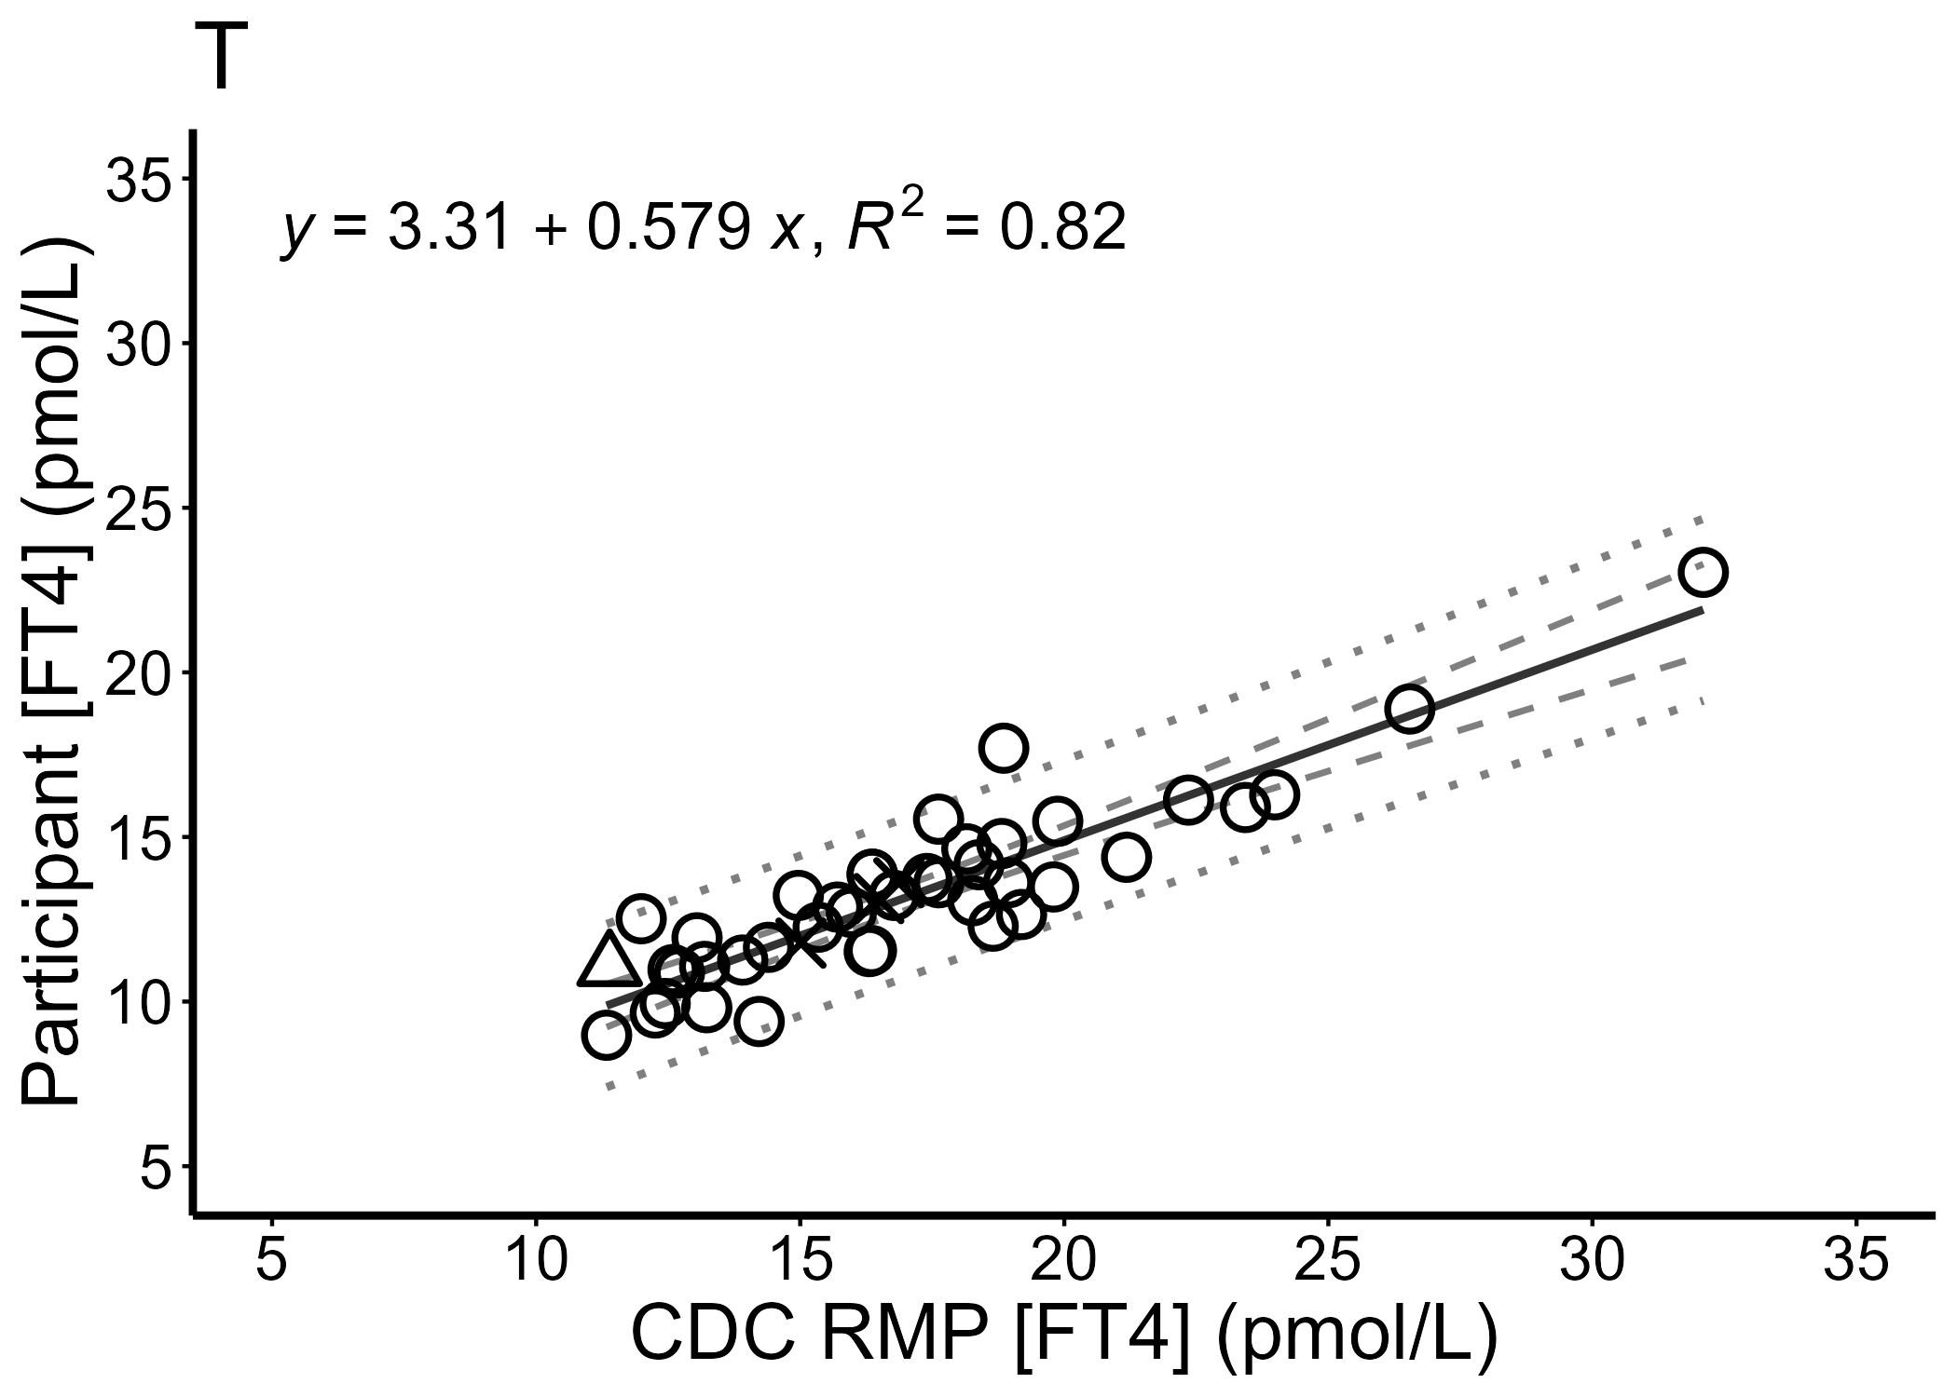
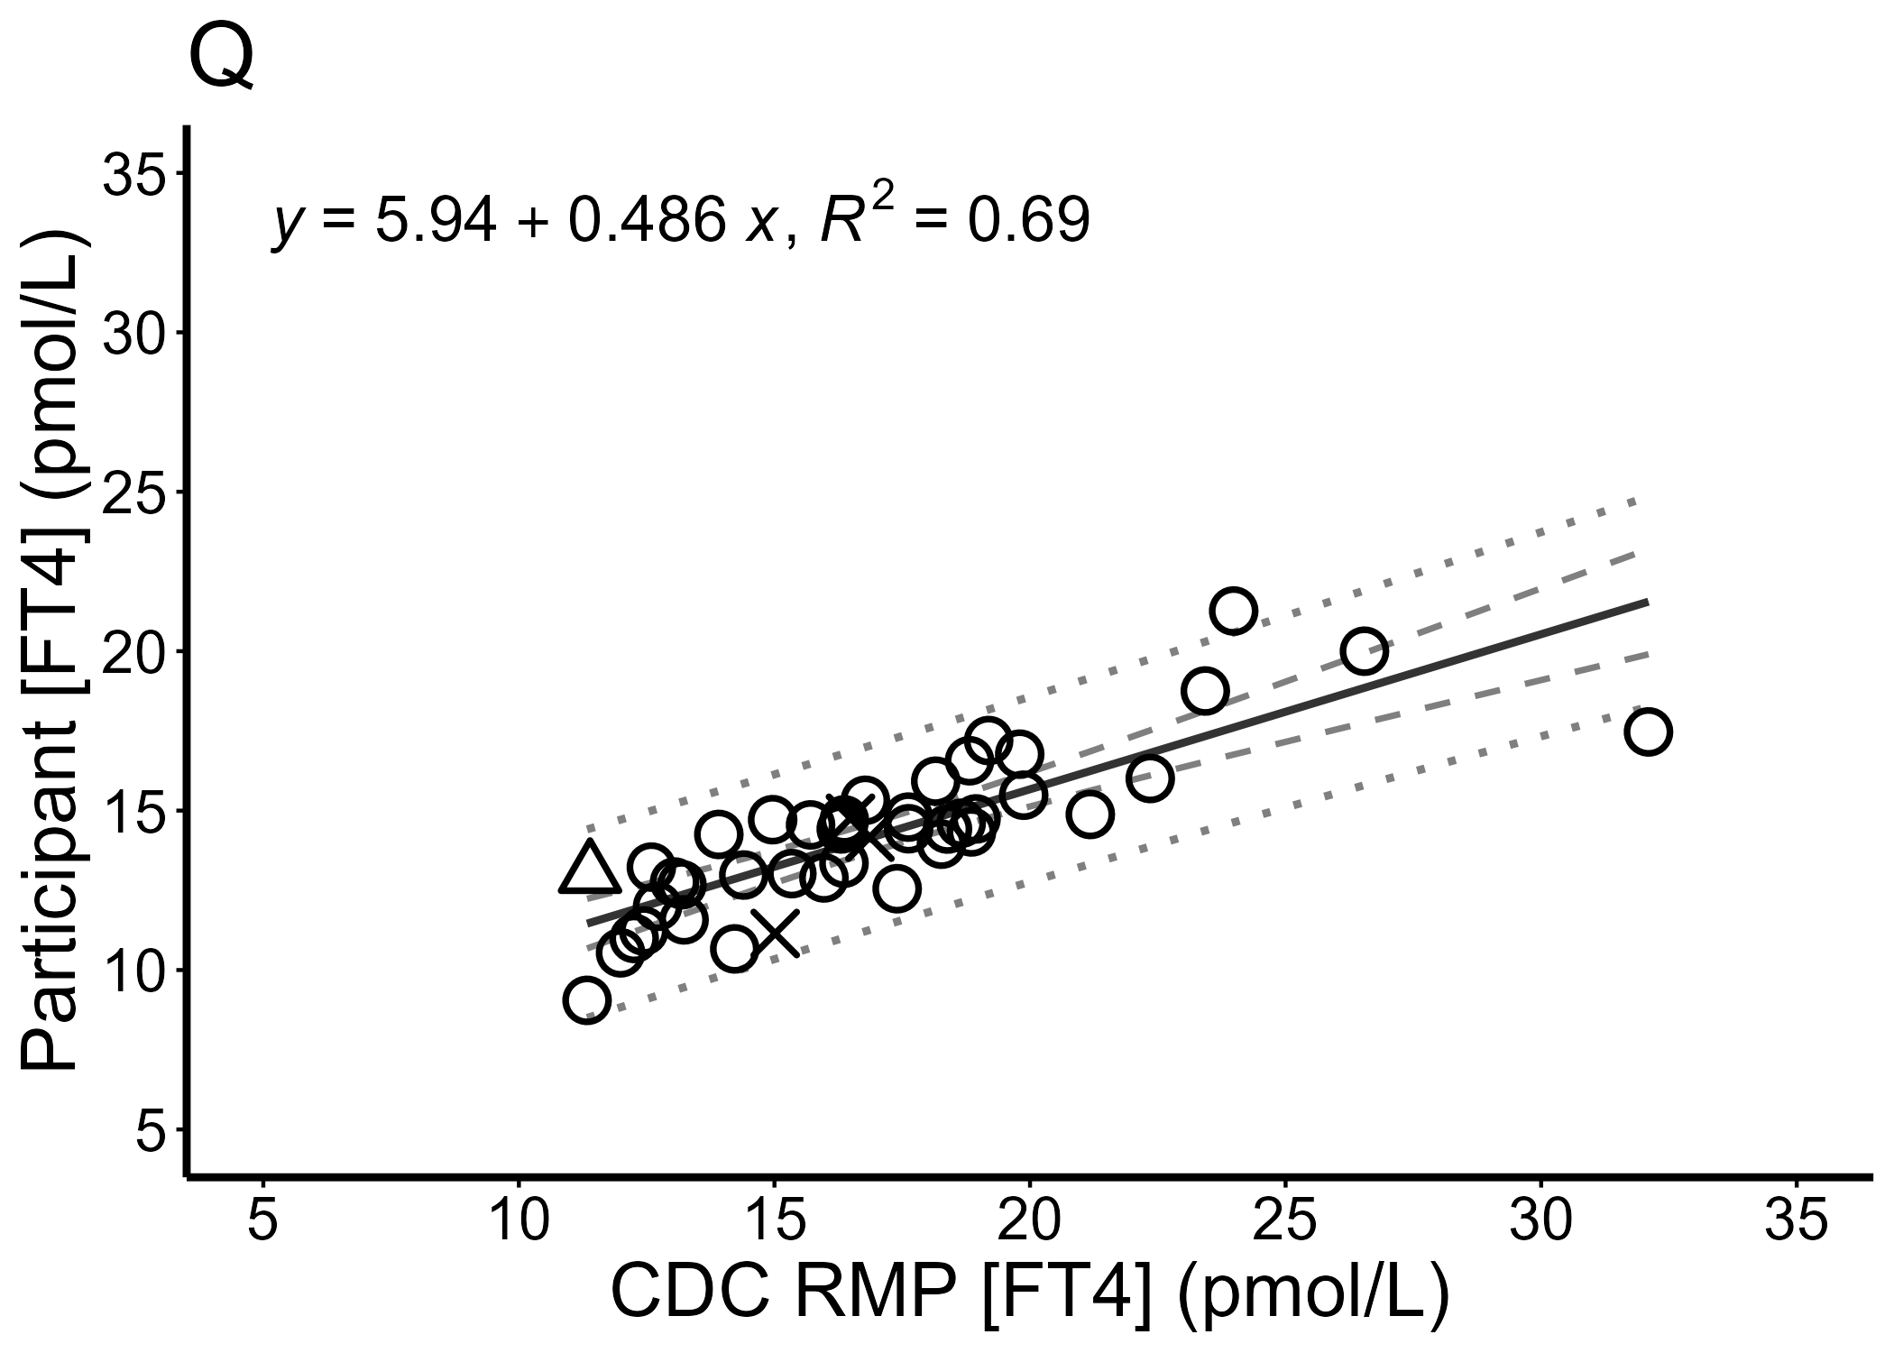
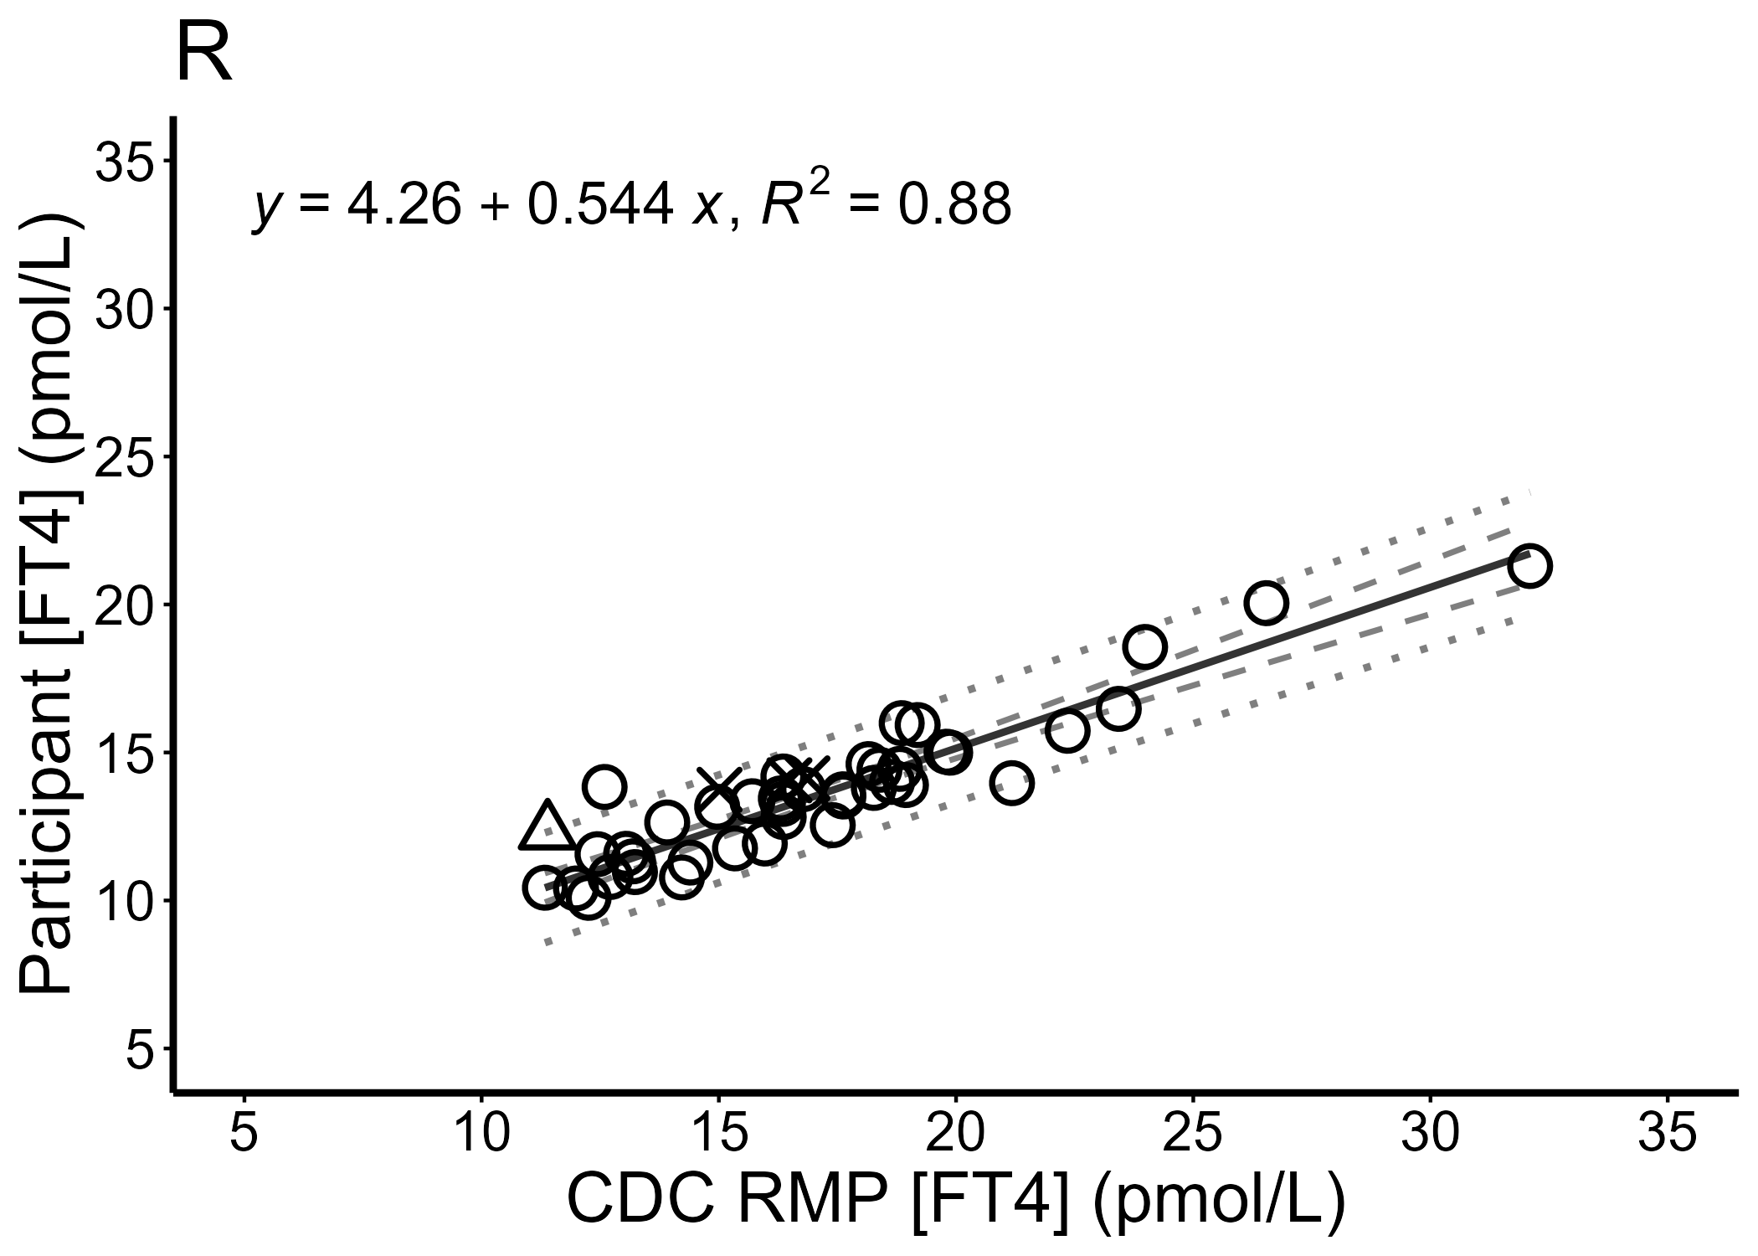

Figure S2. Comparing mean percent bias of the 44 FT4 study samples to the CDC FT4 RMP
Mean percent bias of all replicate measurements of the 44 study samples reported by 19 IA and LDT manufacturers (A–F and H–T) and 2 IA clinical labs (G and U) were plotted against the CDC RMP FT4 reference value. Samples (40) from nonpregnant single donors are shown as circles, samples (1) from pregnant single donors in the third trimester are shown as triangles, and samples from pooled nonpregnant donors are shown as X’s. Linear regression analysis was performed using only the 40 single nonpregnant donors, and the 95% confidence and prediction intervals are shown as dashed and dotted lines, respectively.
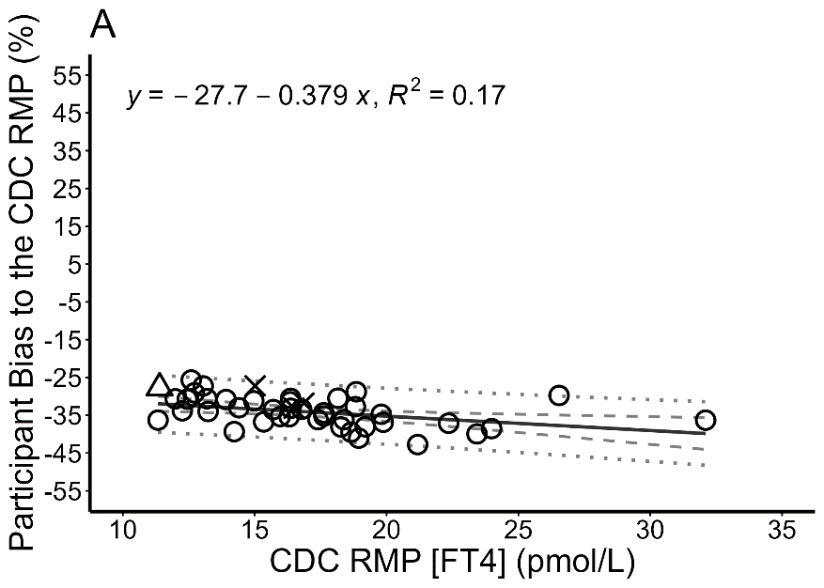
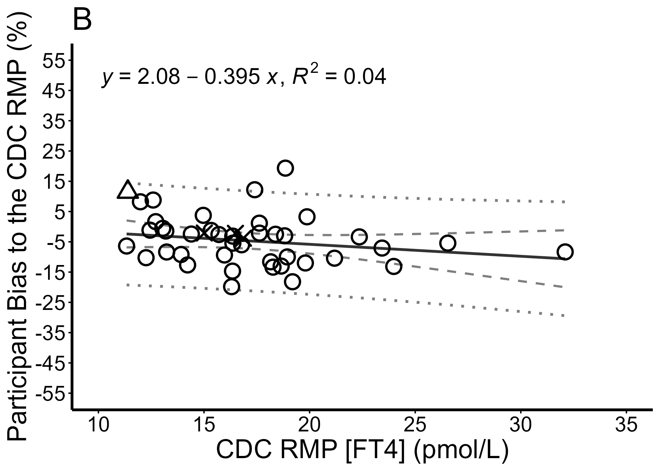
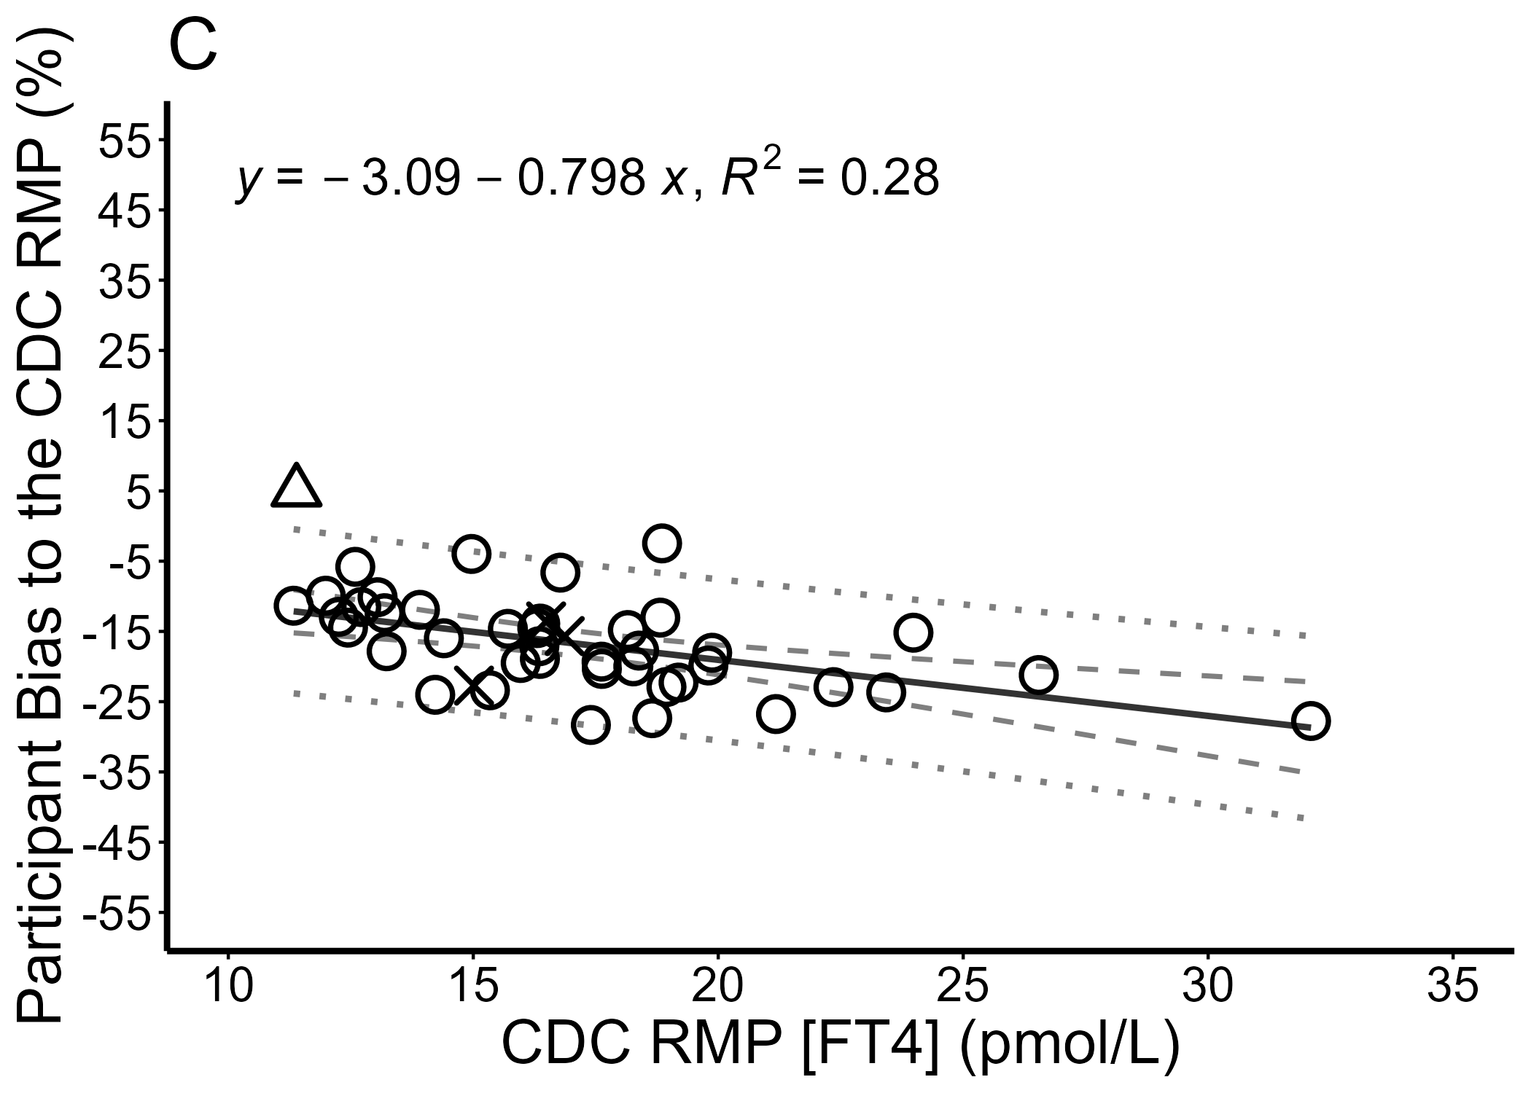
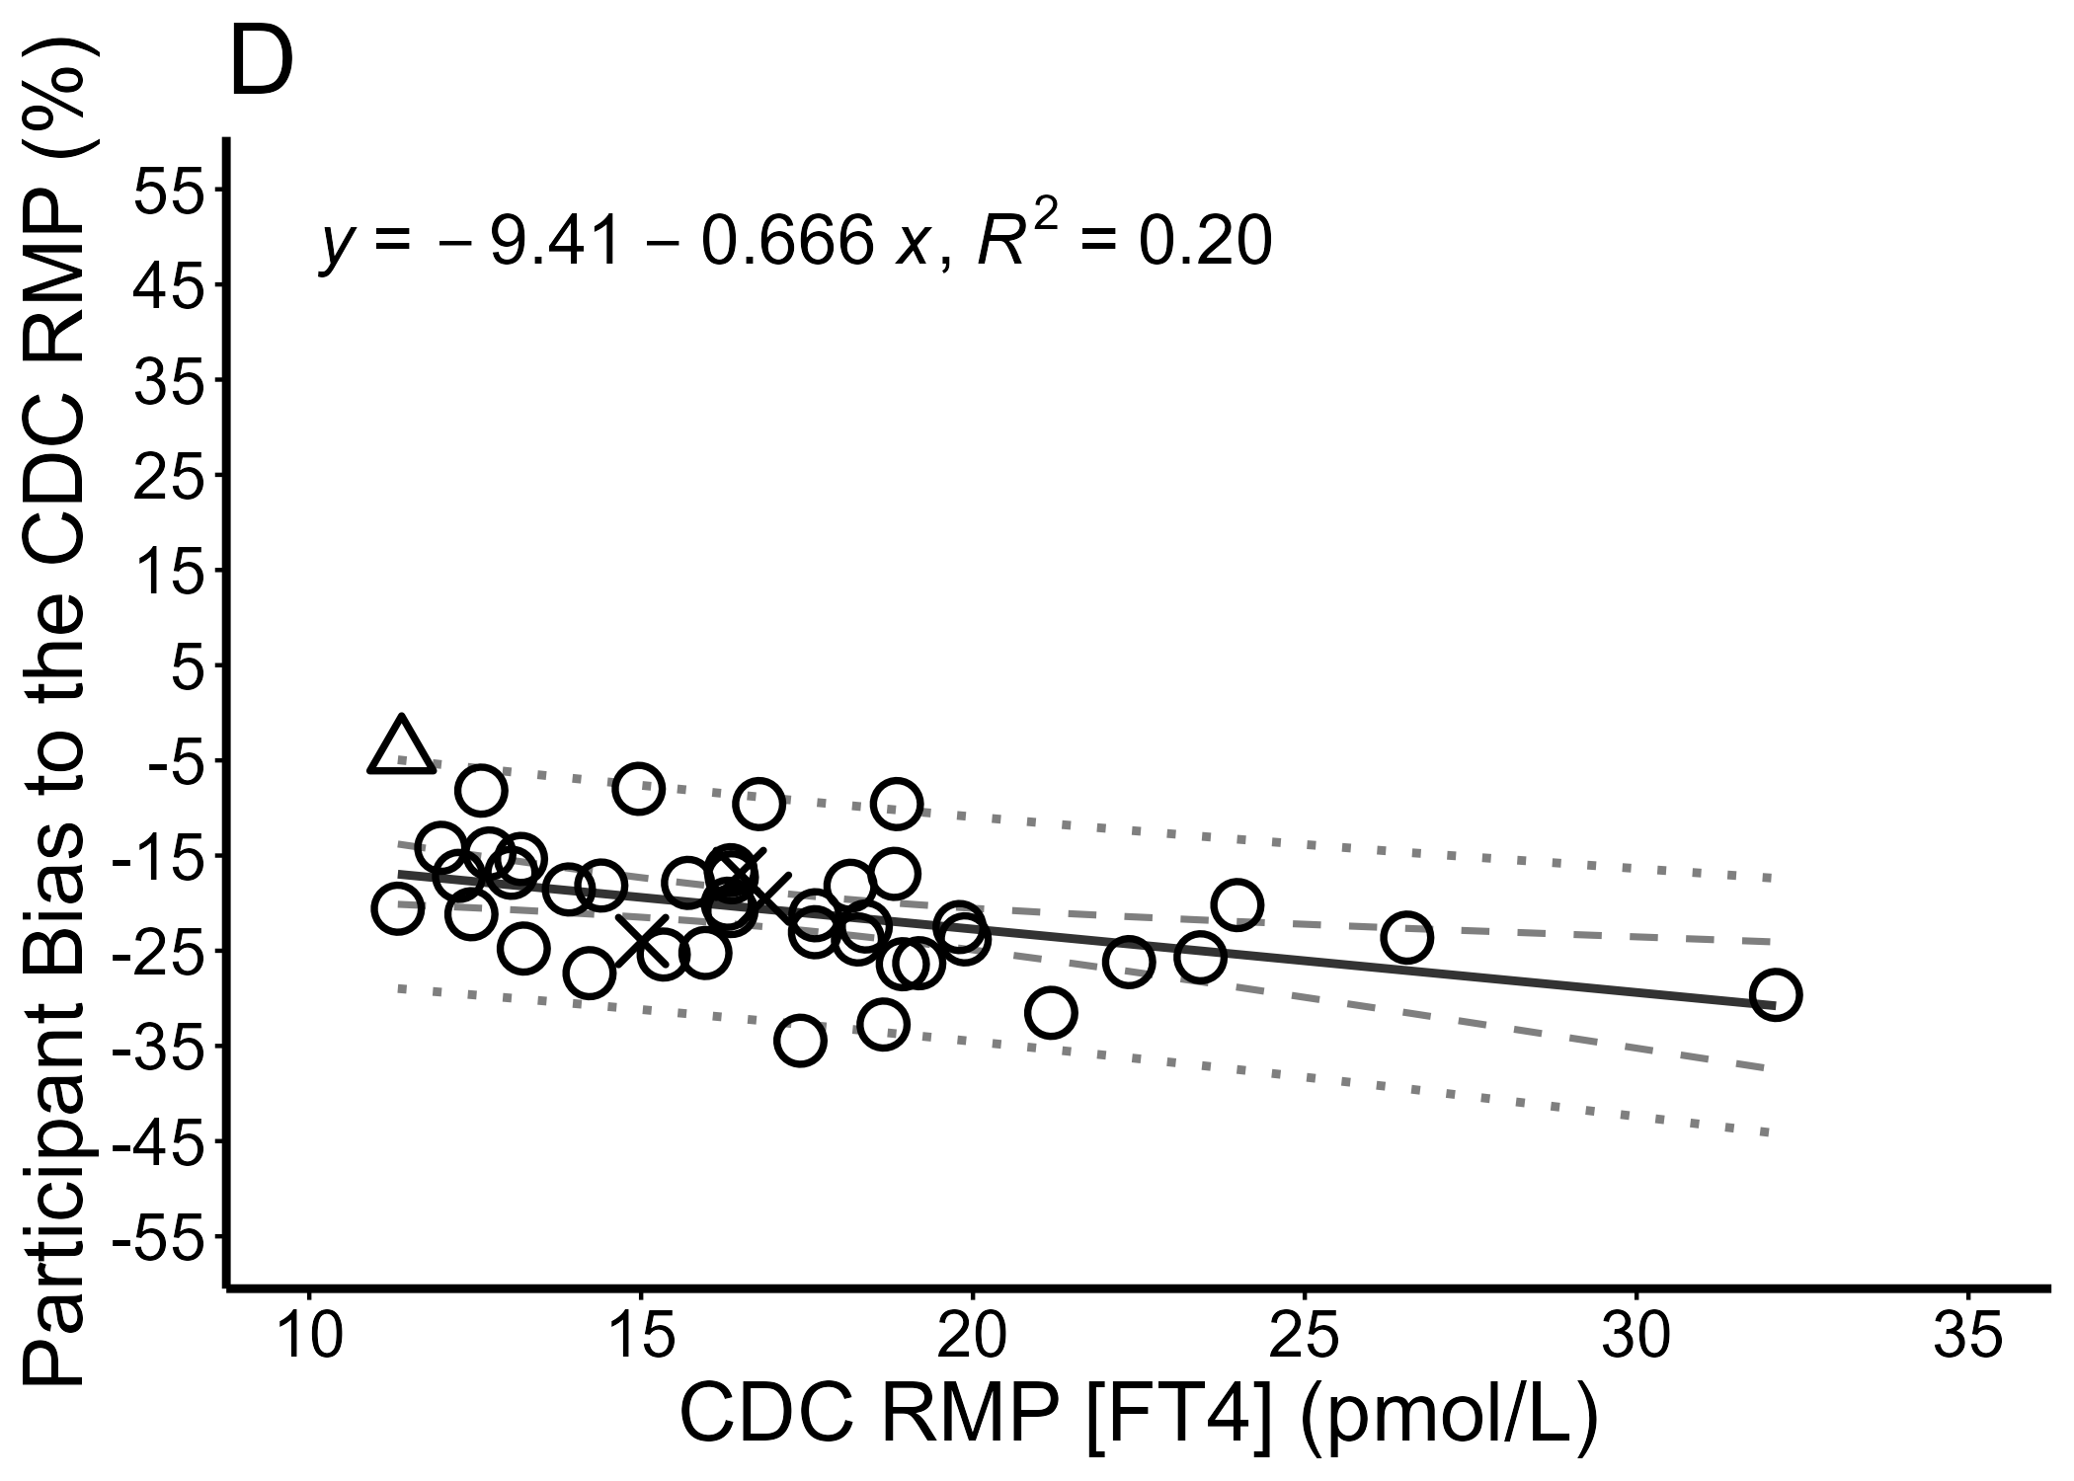

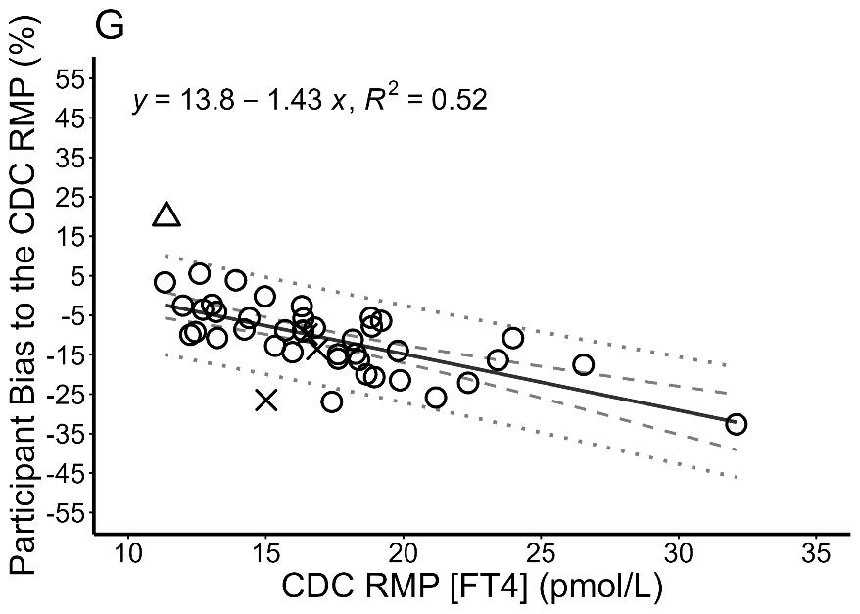
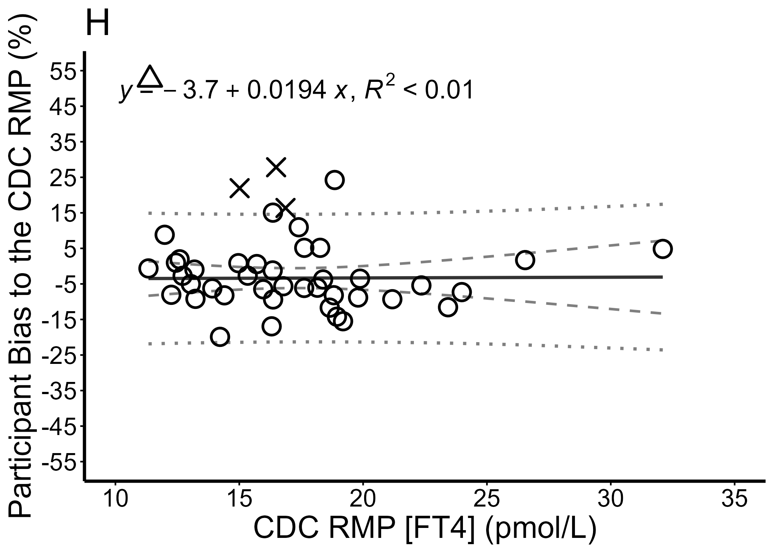
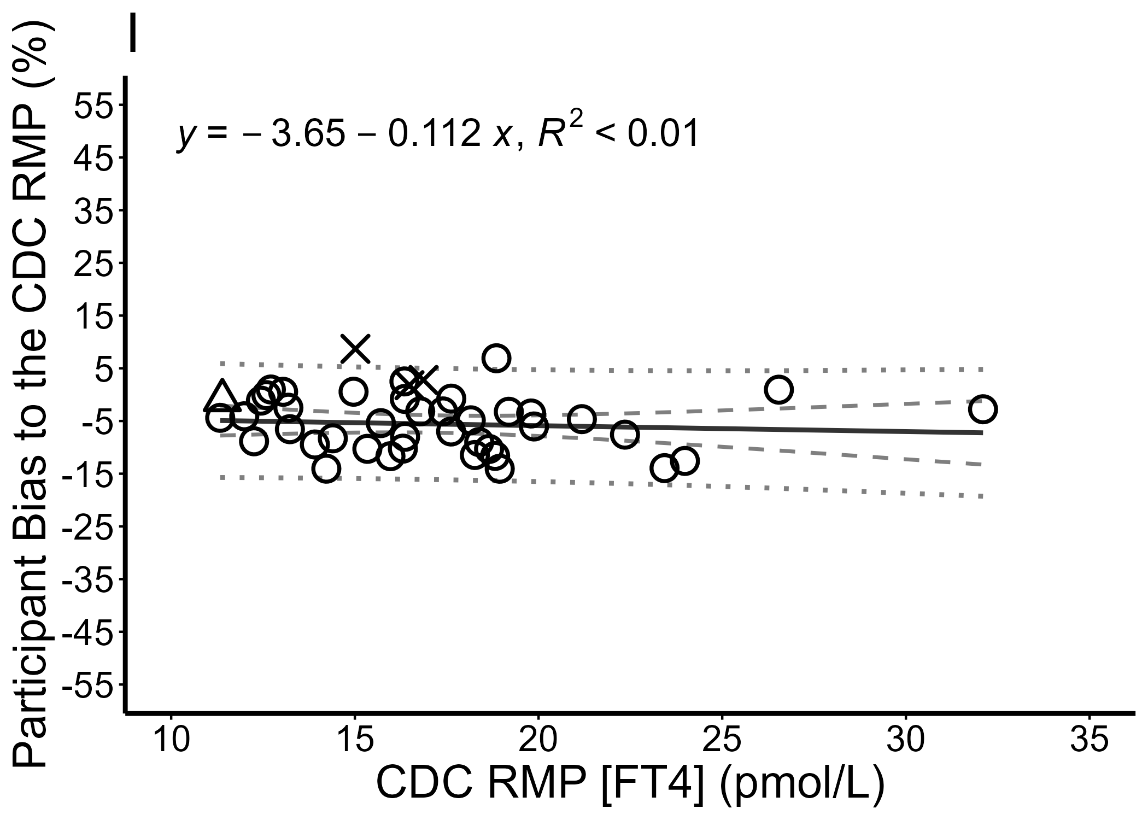
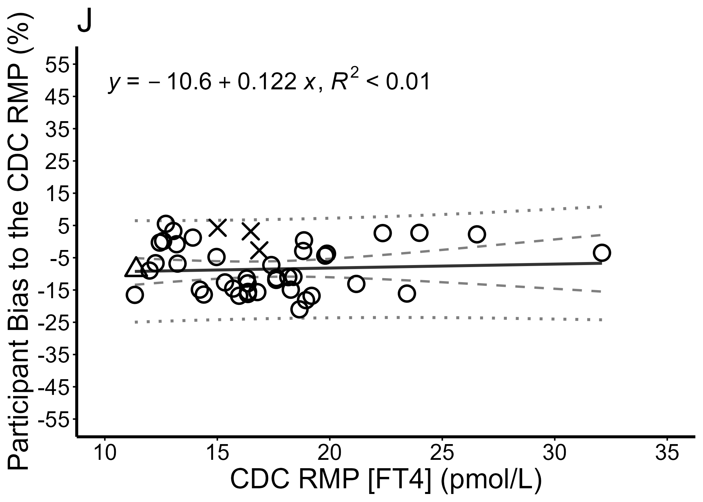
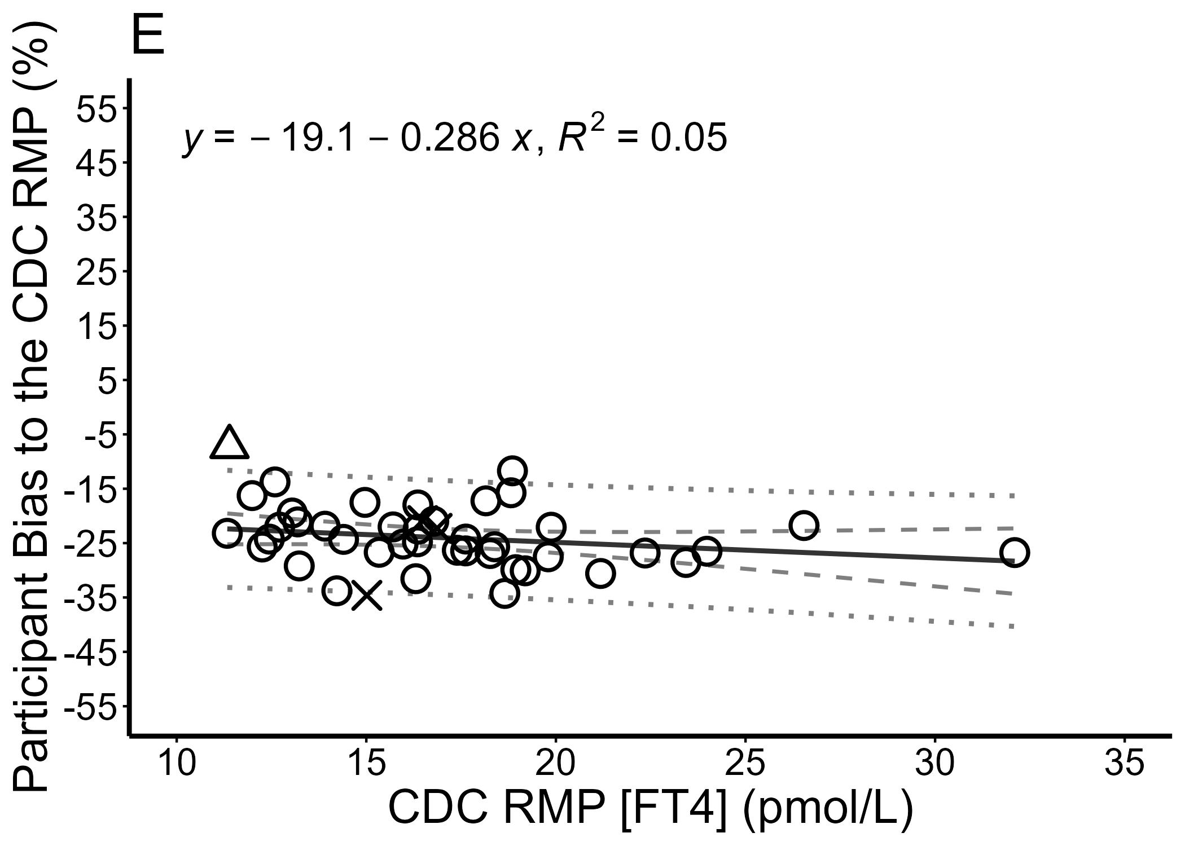
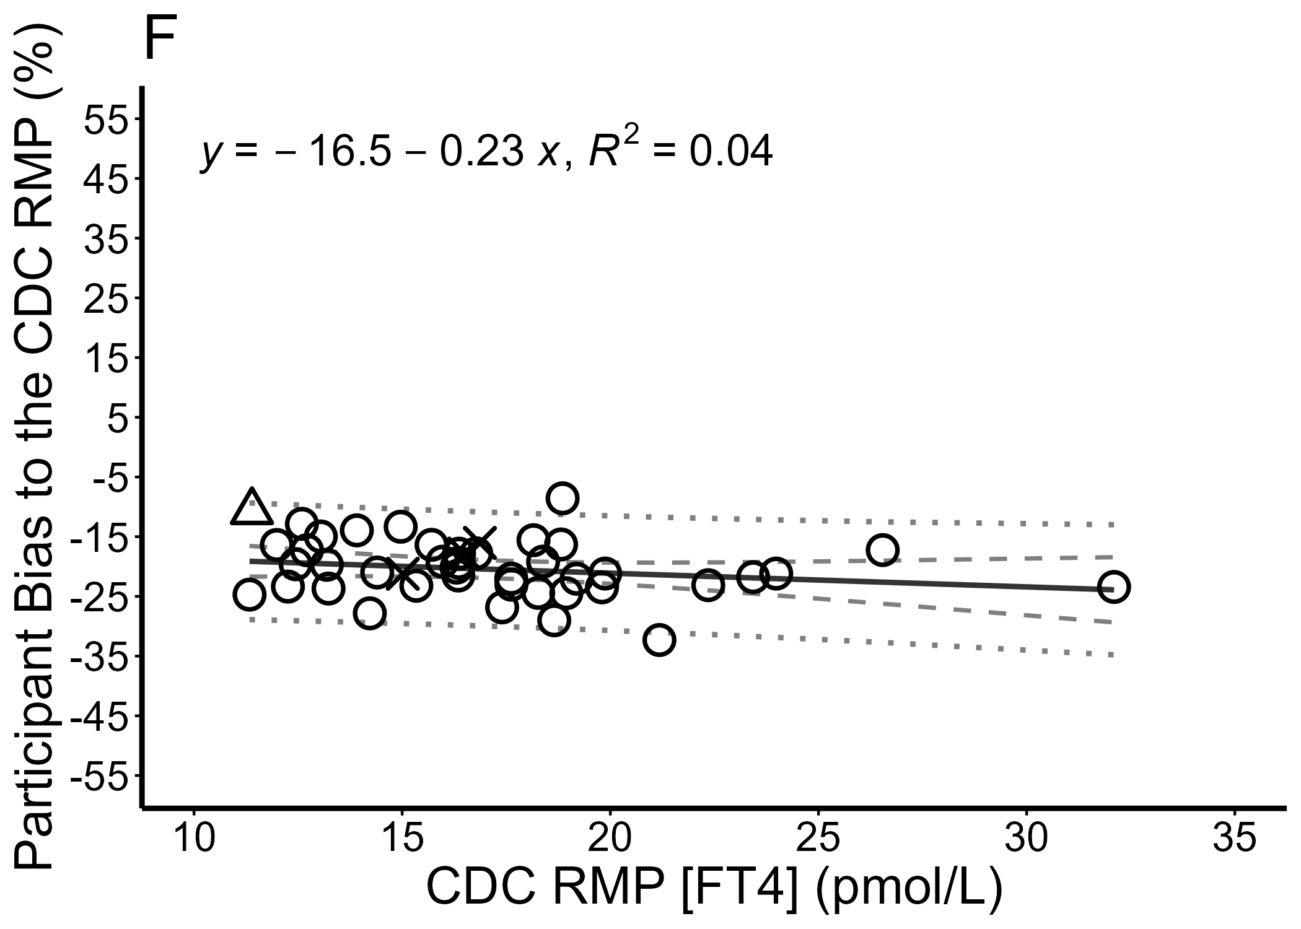

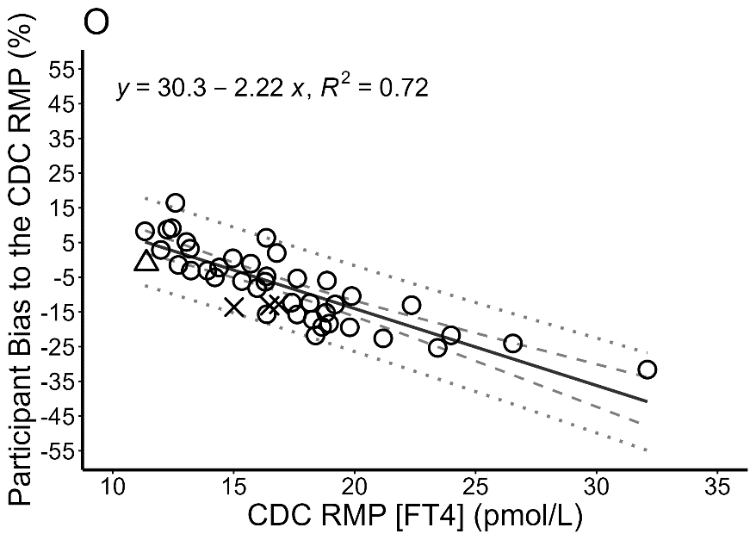
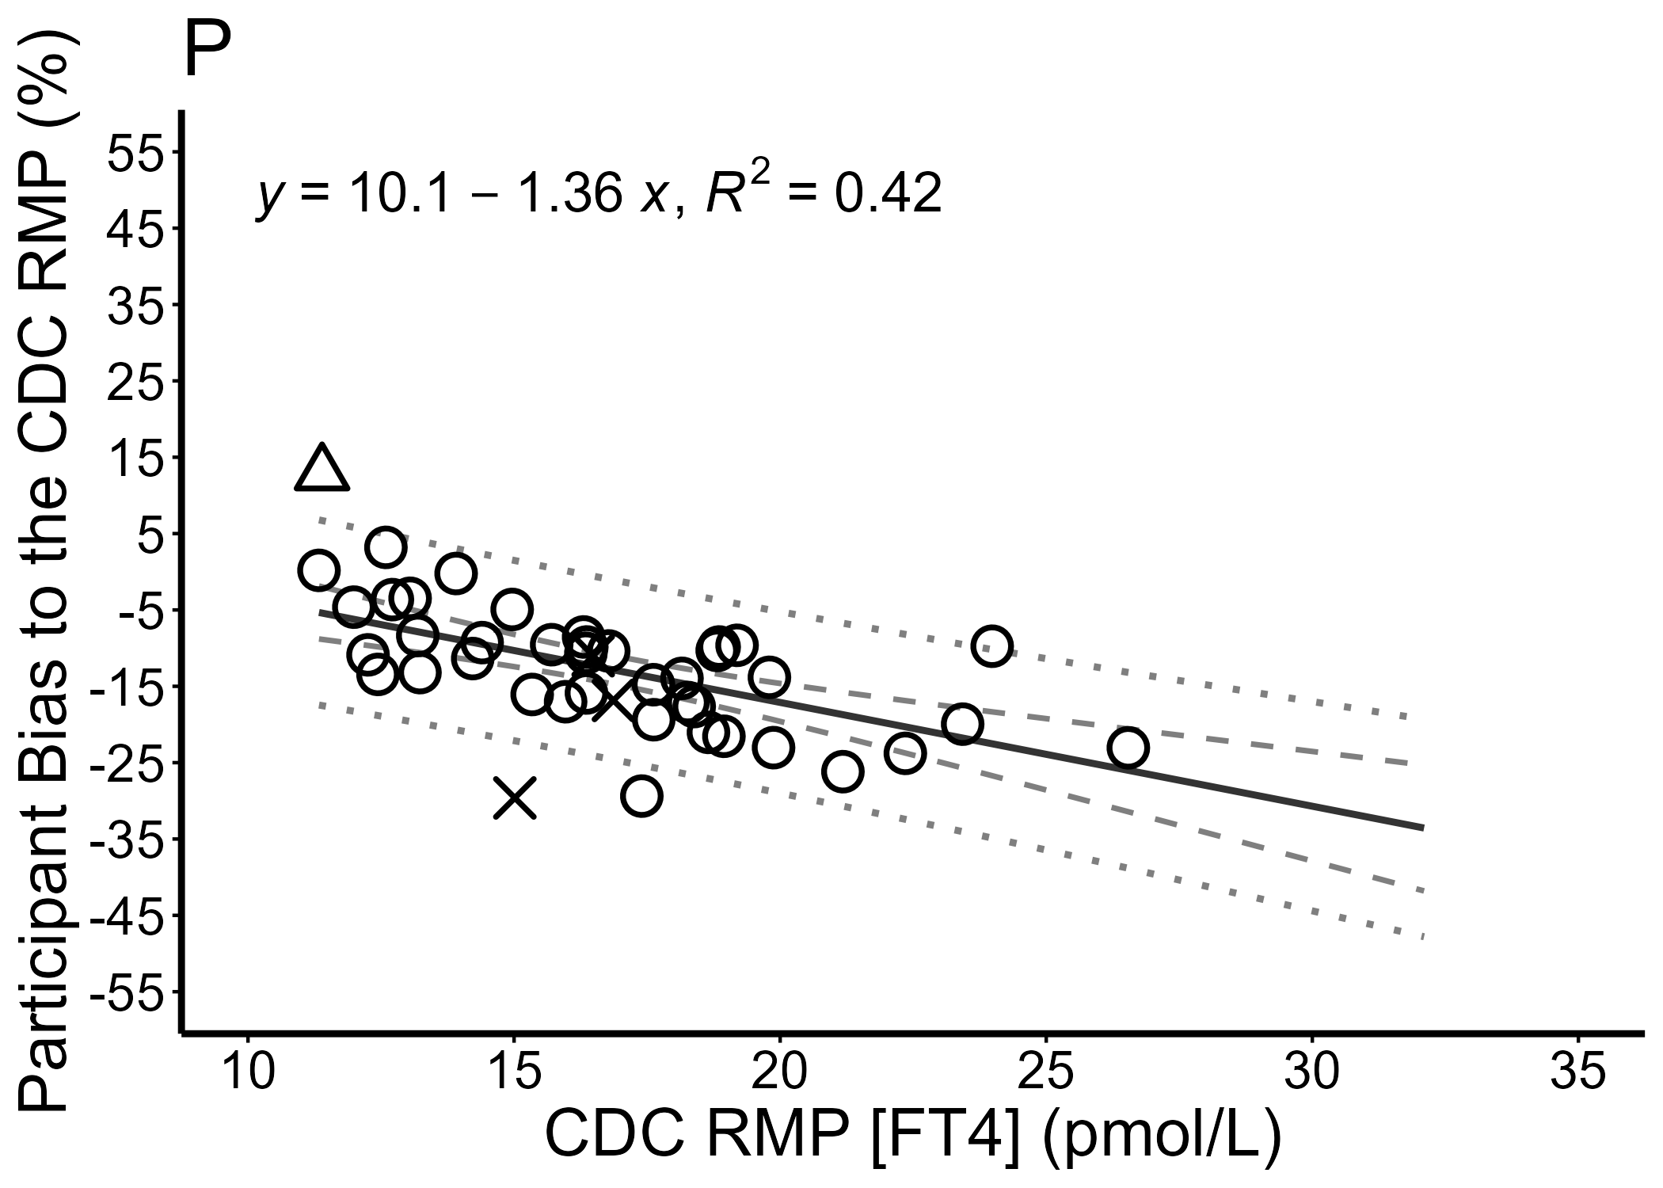
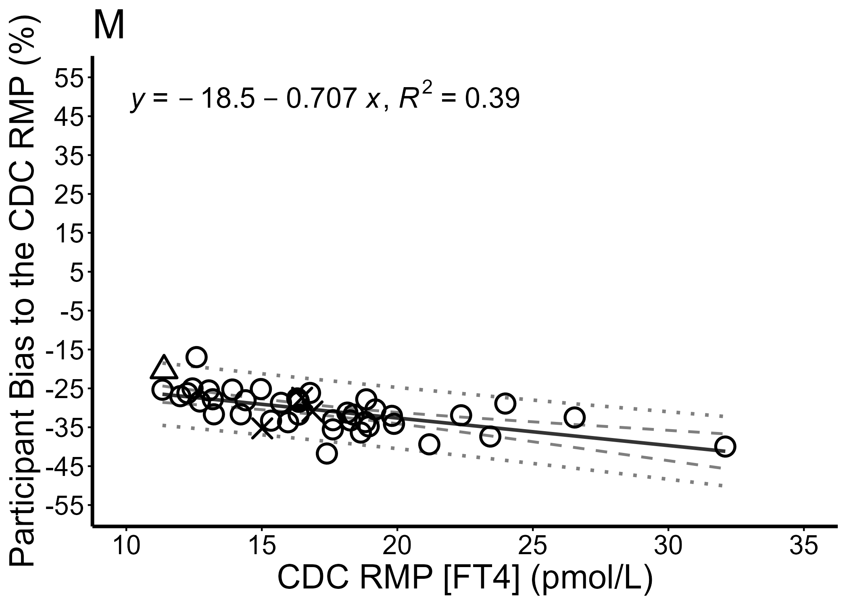
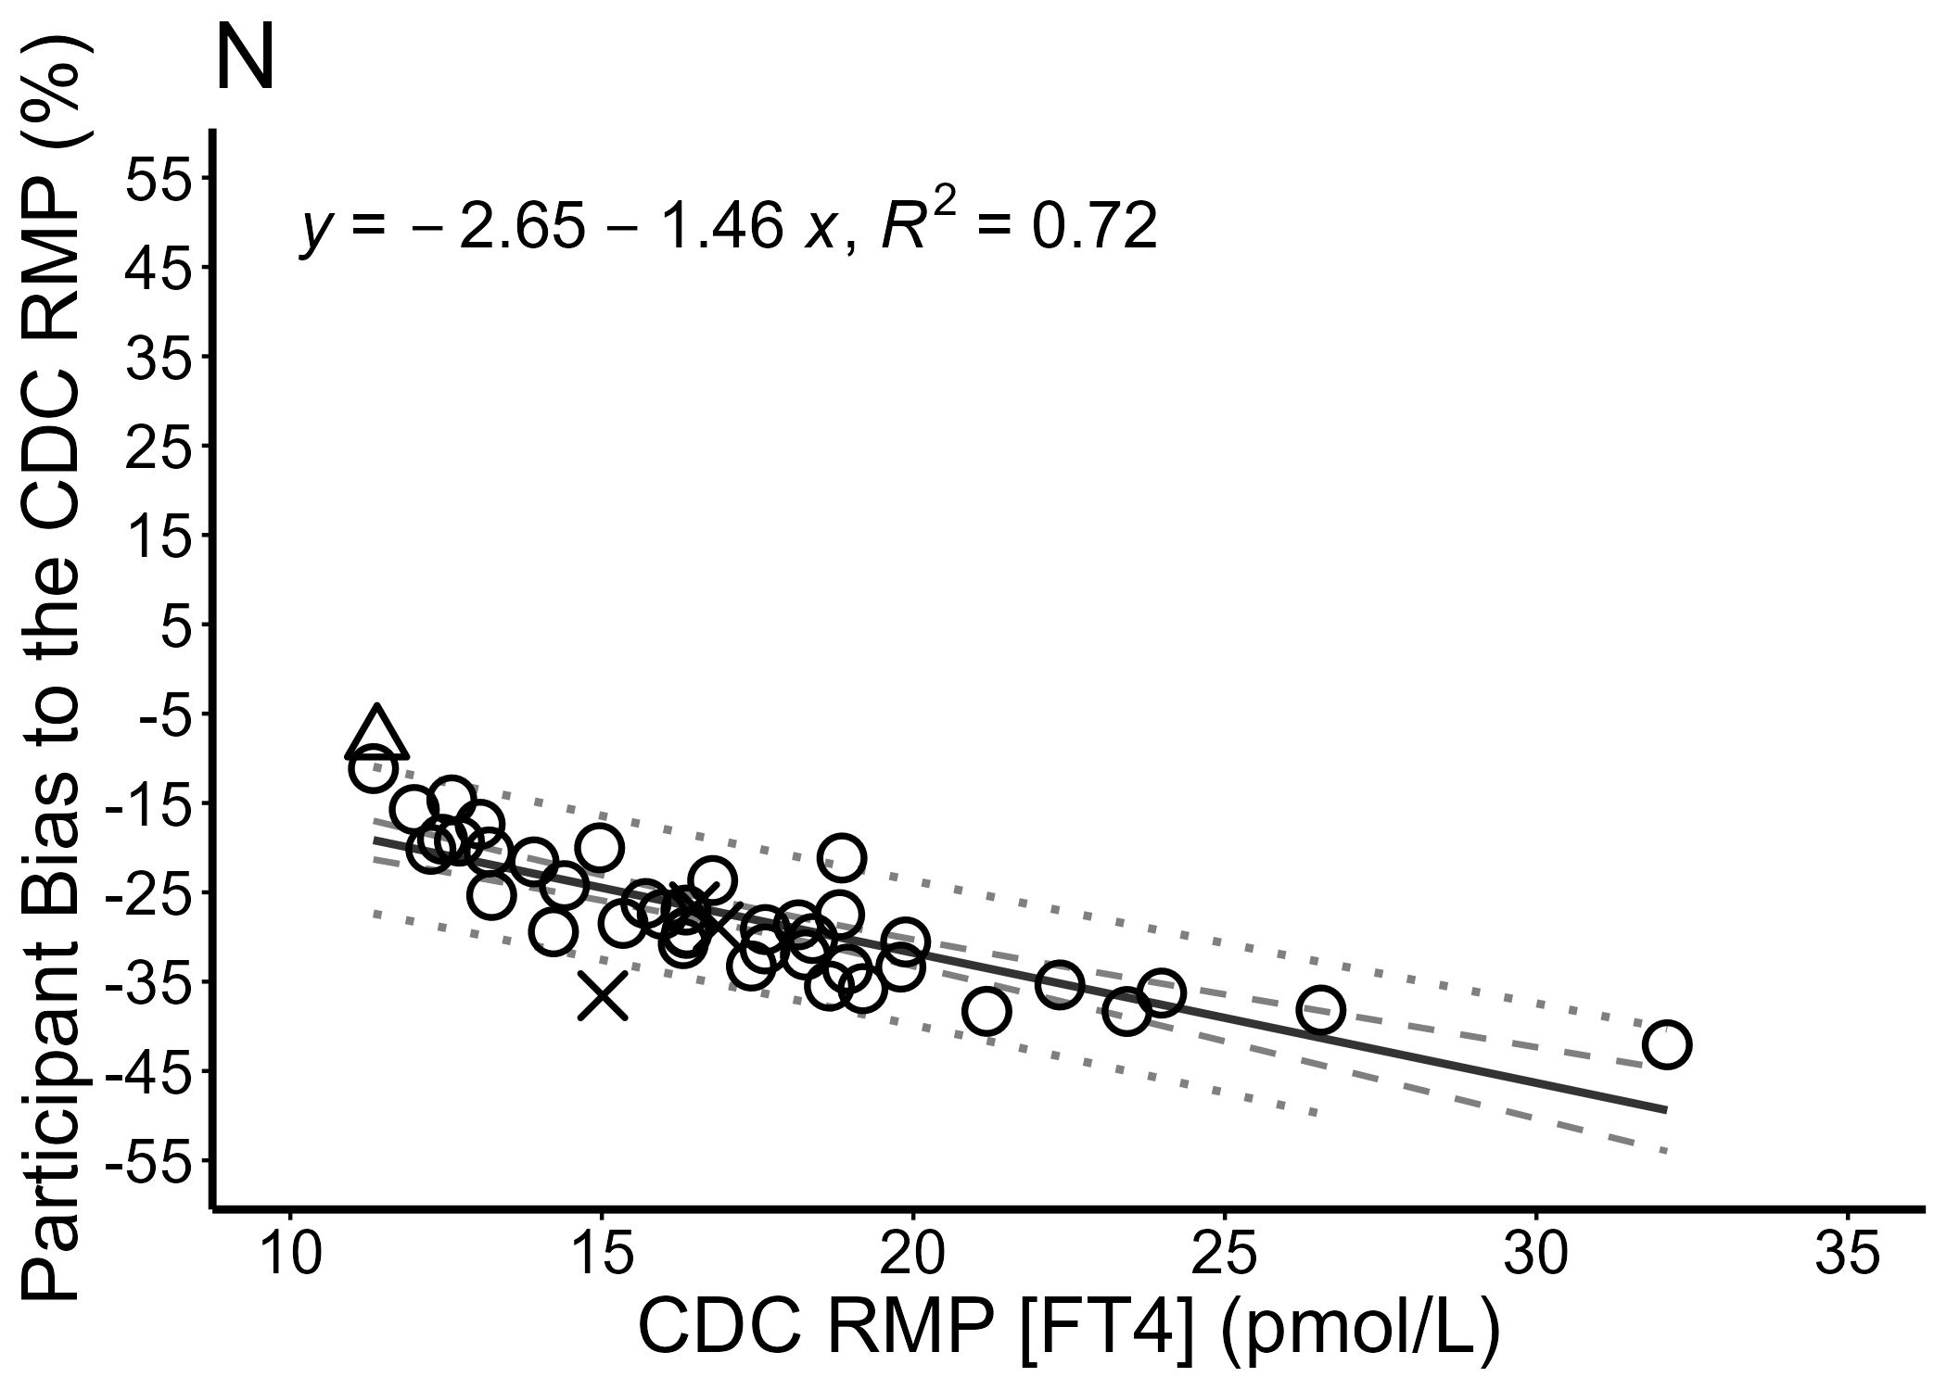
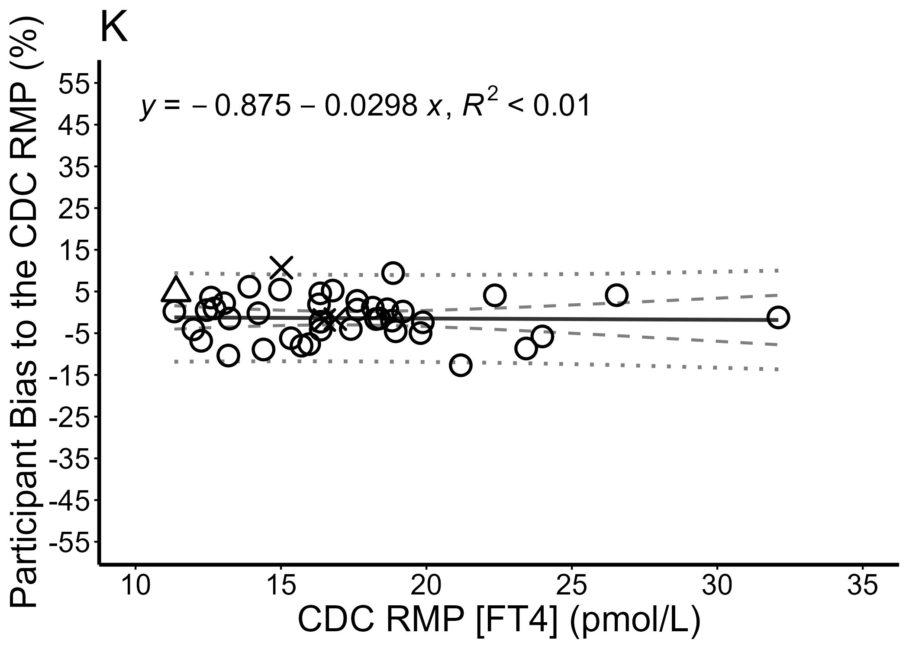
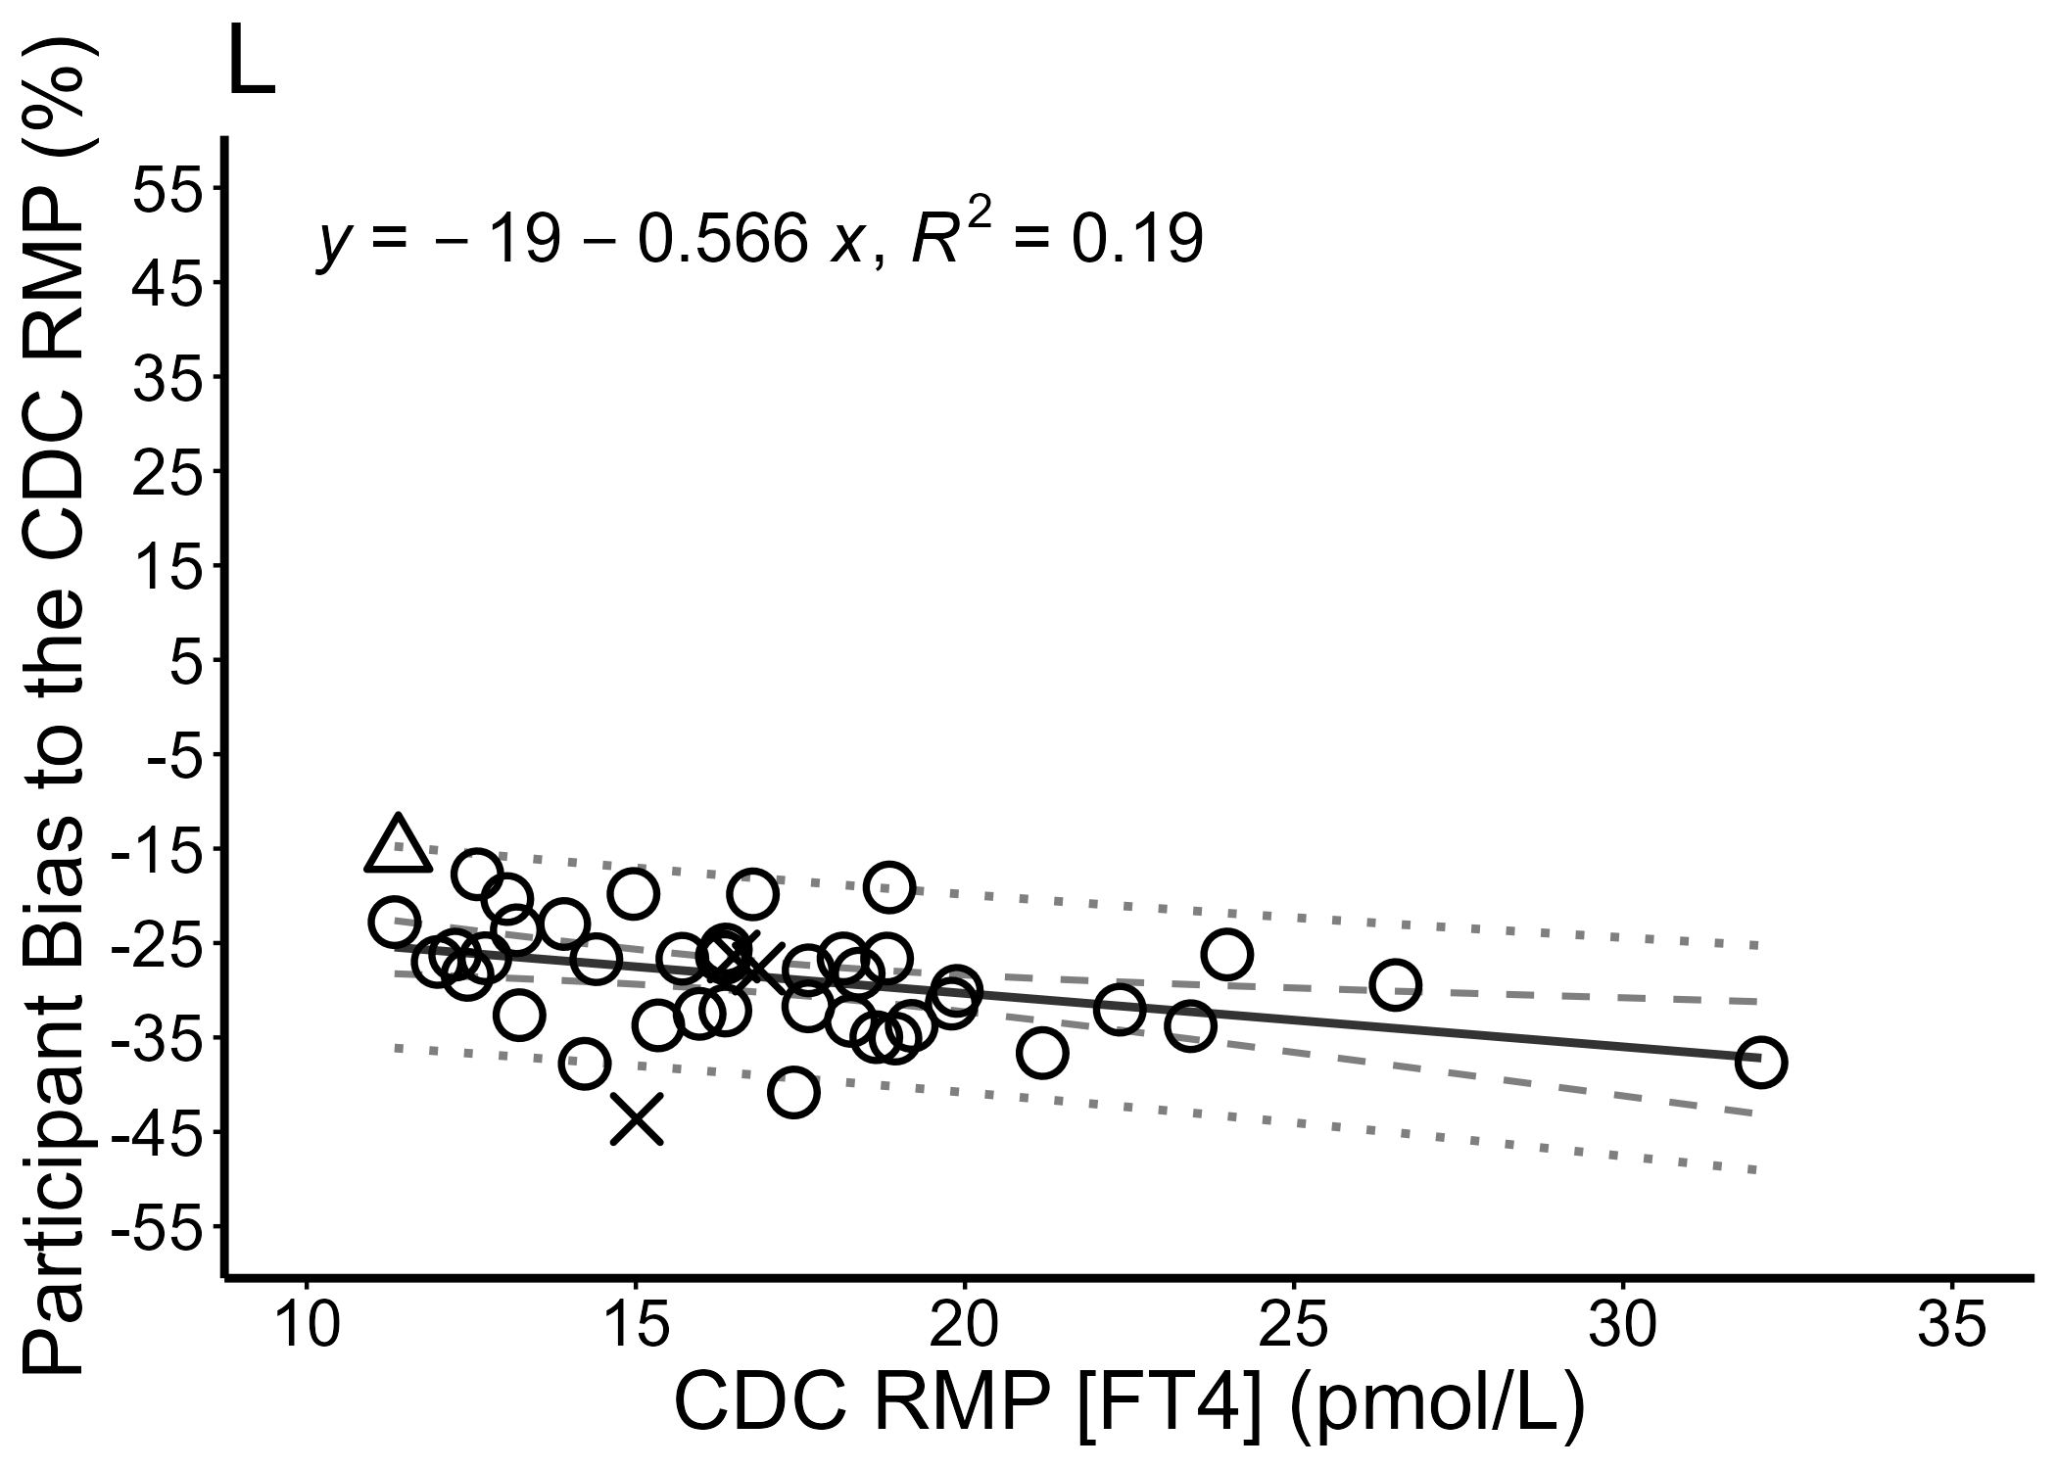

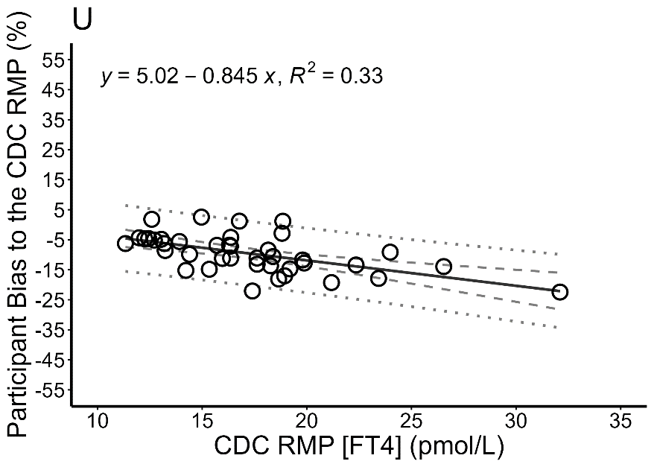
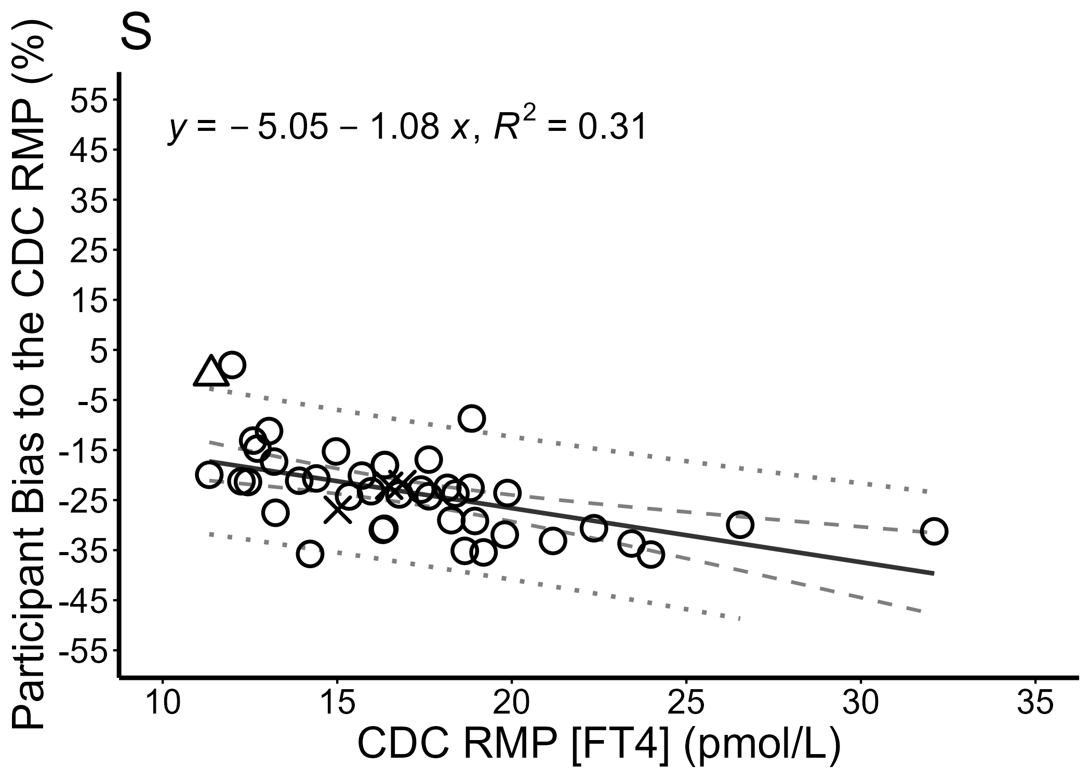
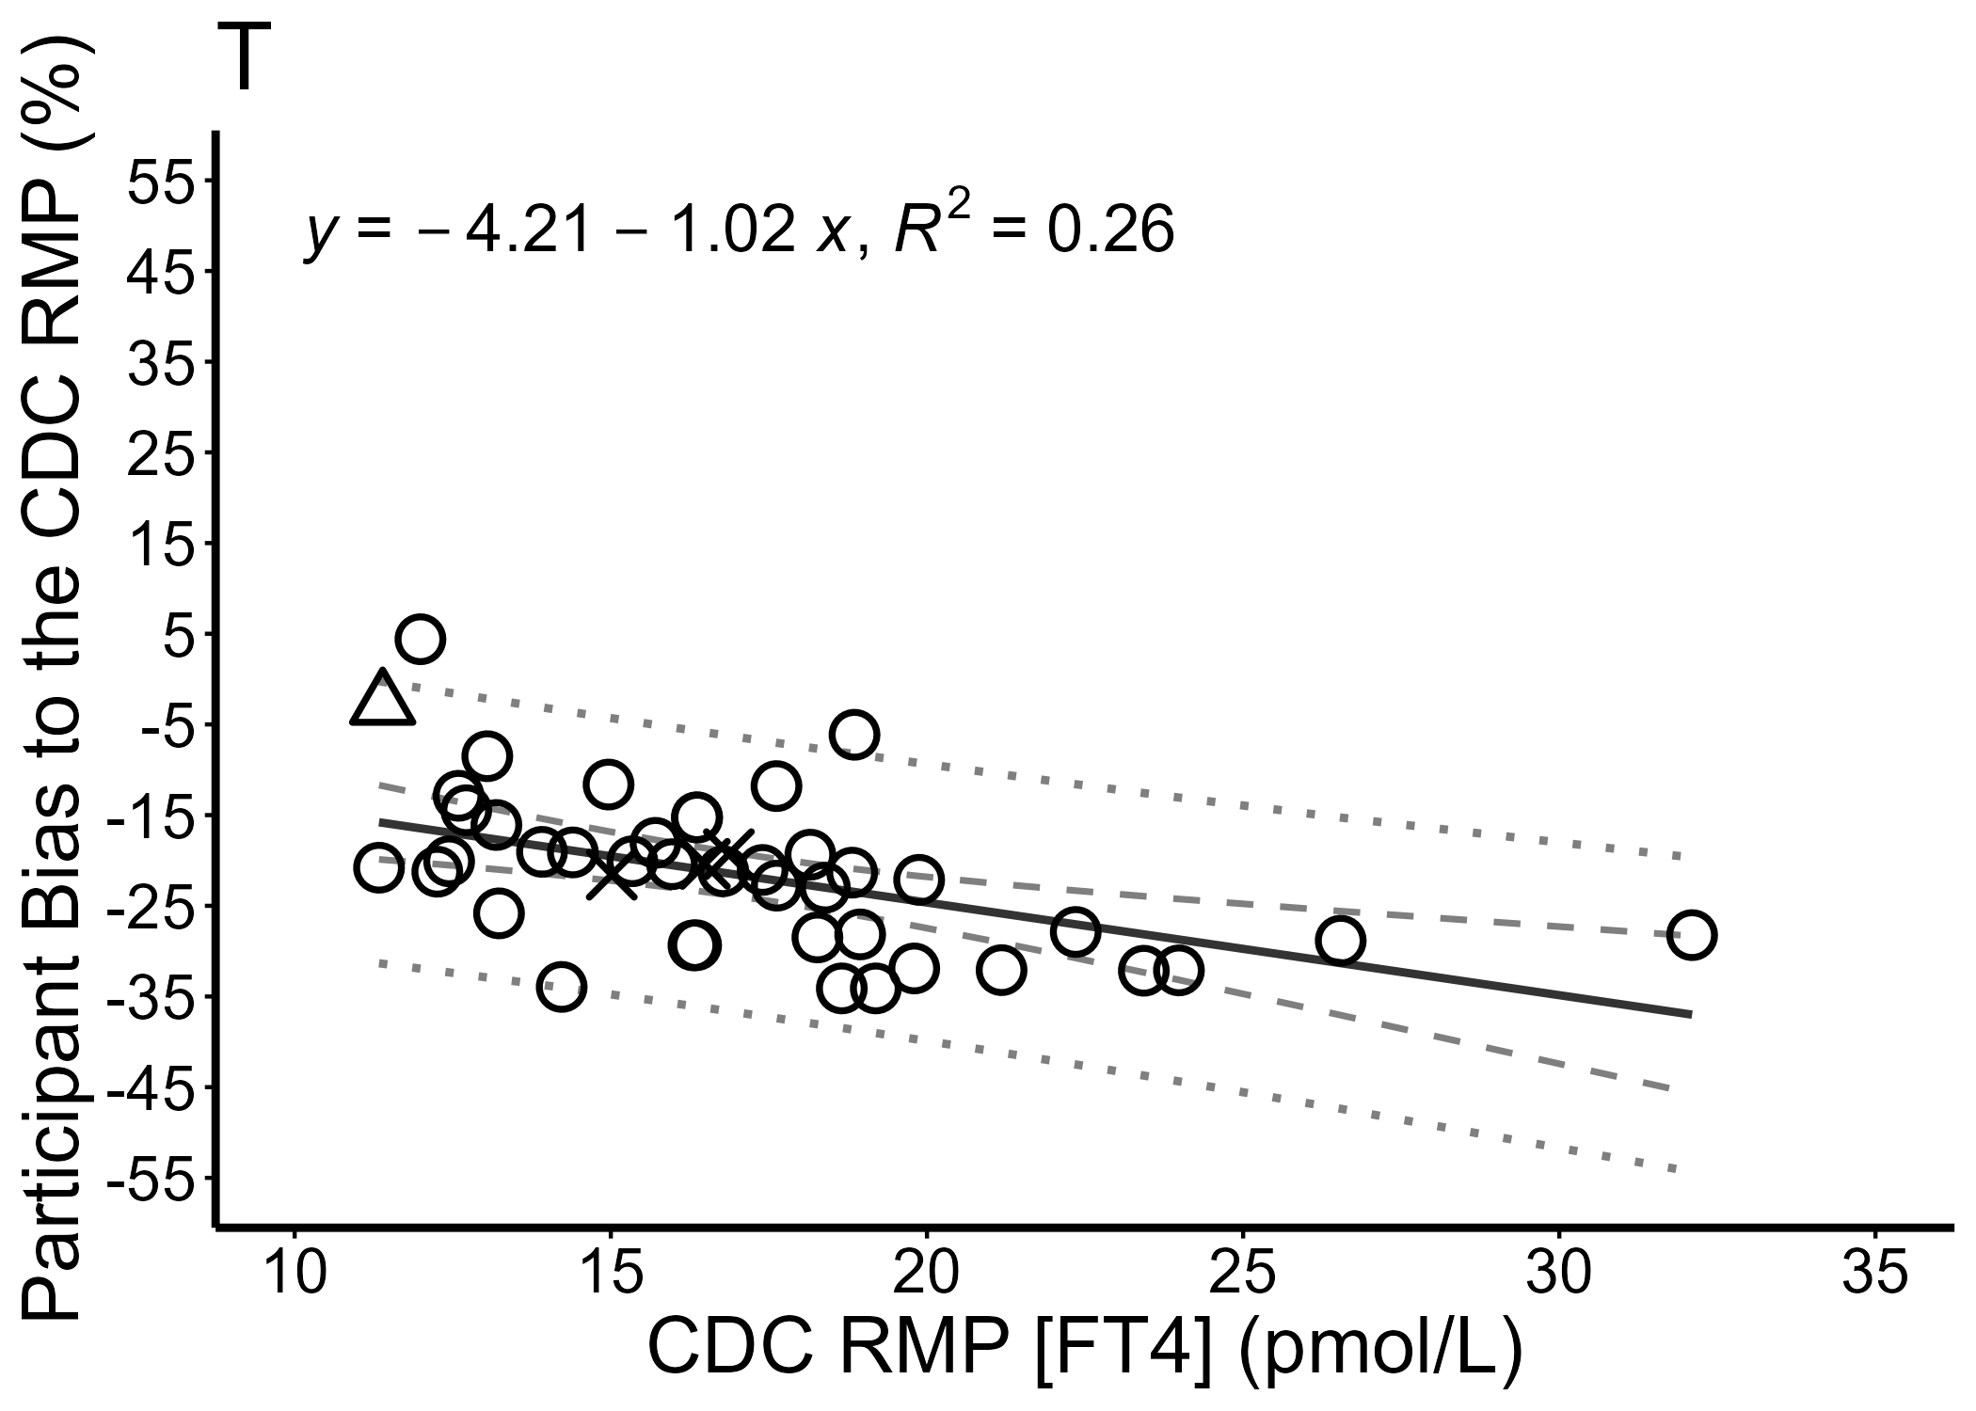
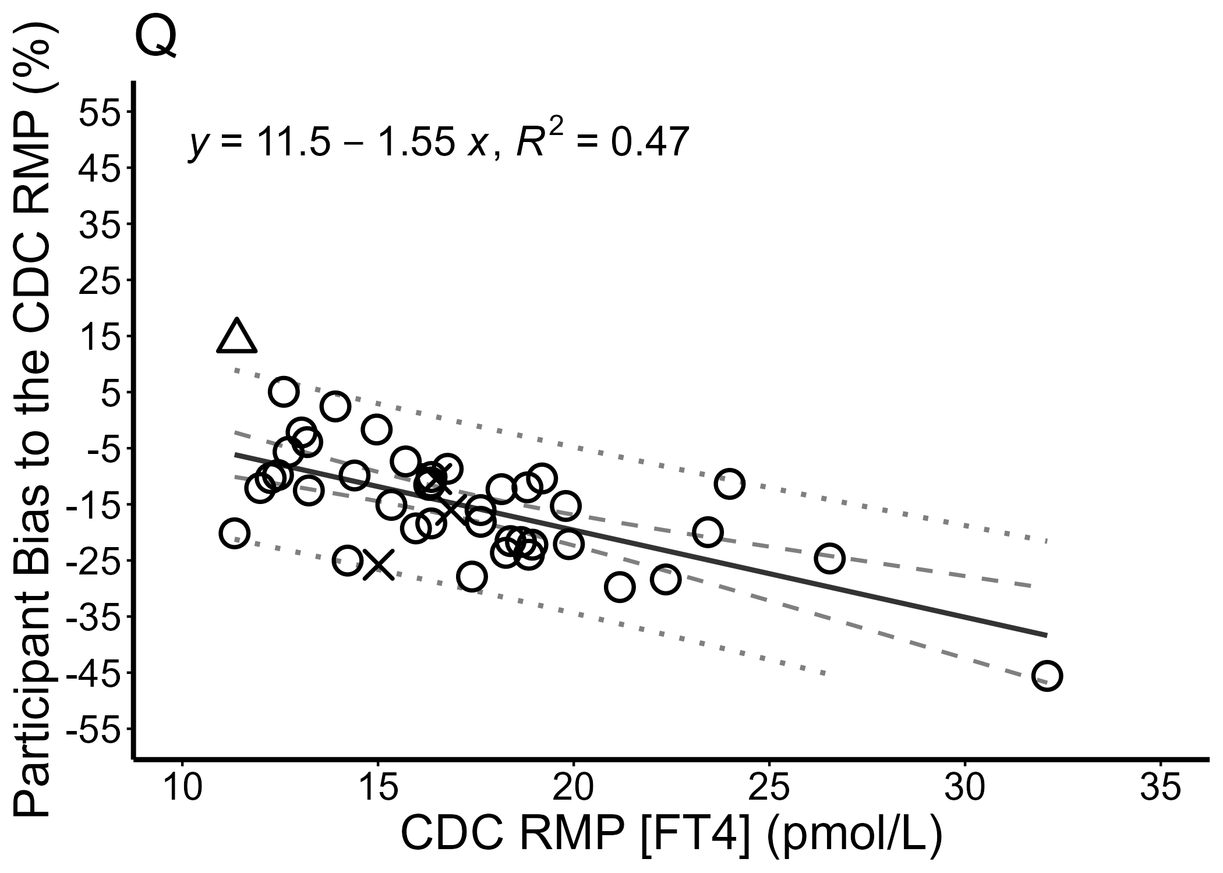
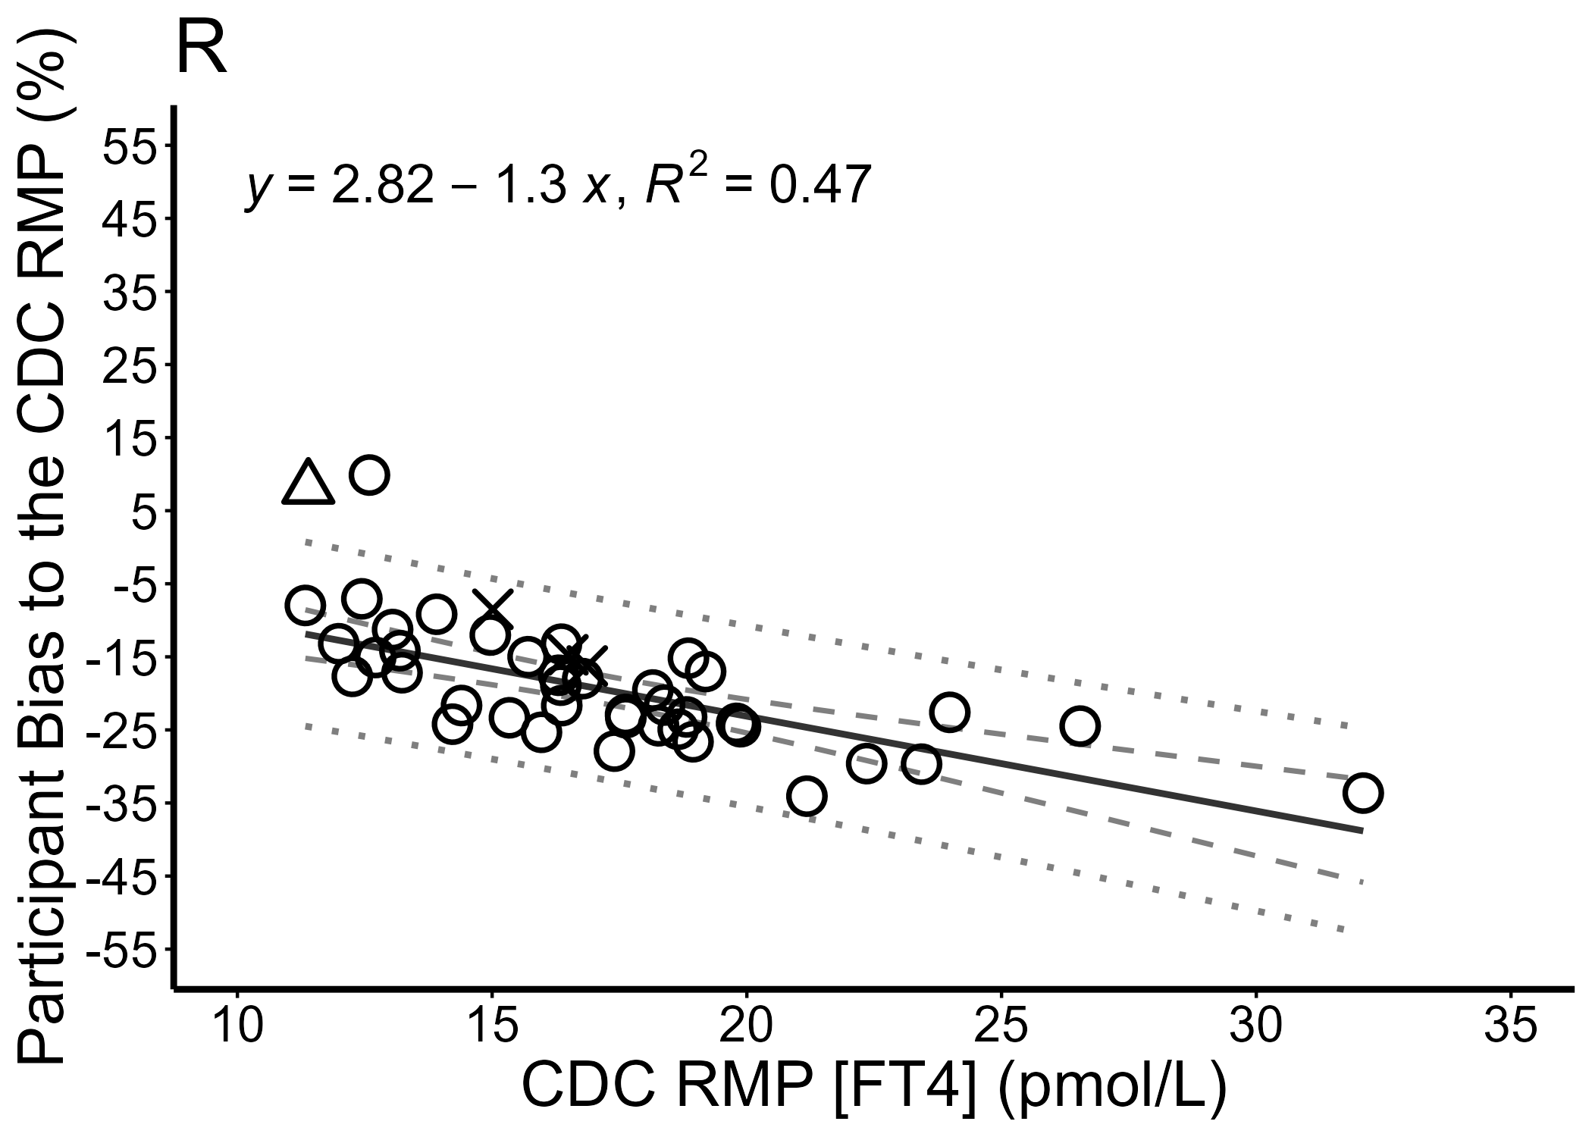

Figure S3. Passing-Bablok regression analysis of participating FT4 assays
Mean percent bias of all replicate measurements of the 40 single nonpregnant donor samples reported by 19 IA and LDT manufacturers (A–F and H–T) and 2 IA clinical labs (G and U) were compared to the CDC RMP by Passing-Bablok regression. The 95% confidence intervals are calculated with the bootstrap method and are shown as light grey bands. The regression line is shown as a solid grey line, and the y=x identity line is indicated by a dashed line.
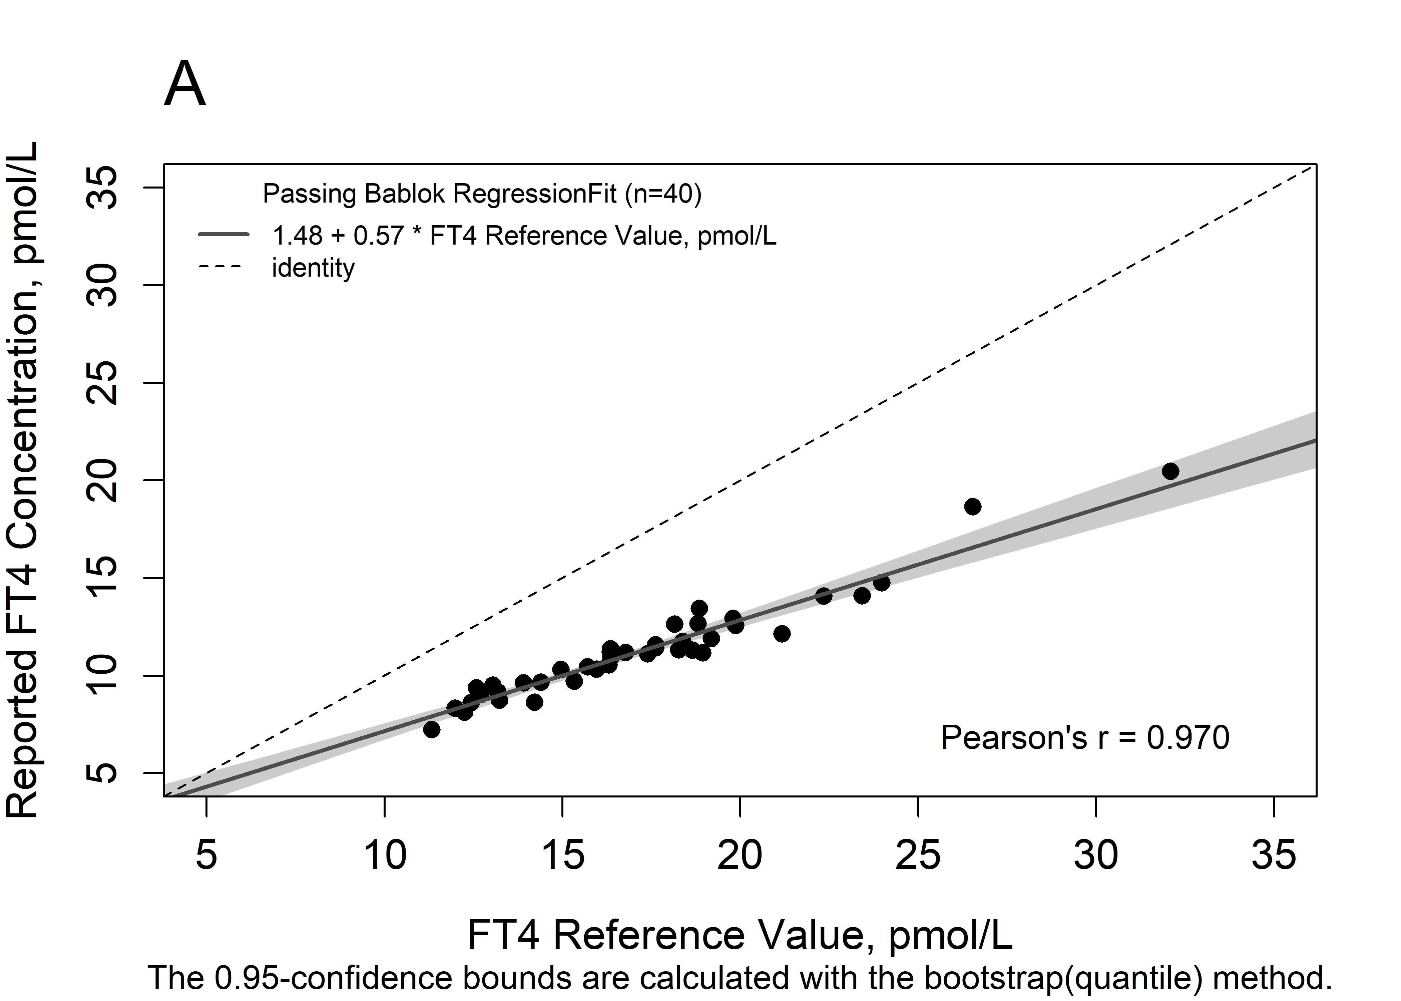
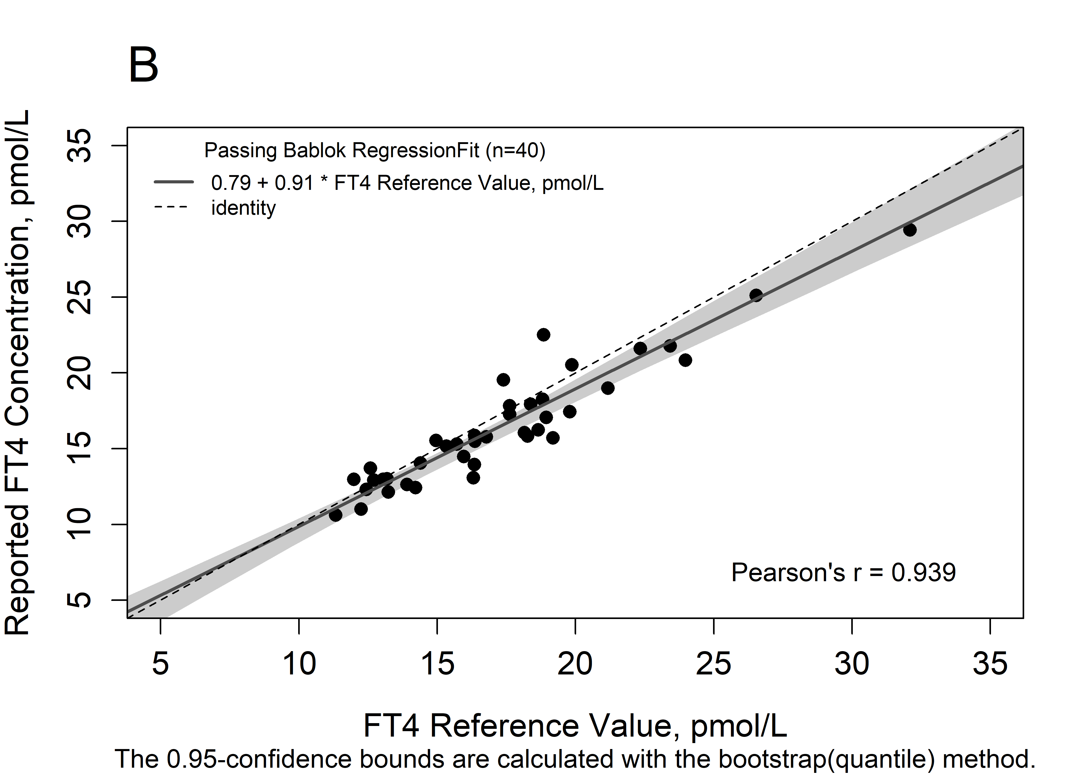

Figure S4. Comparing TSH concentrations measured by each participant to the all-lab mean
Linear regression analysis was performed using only the 40 single nonpregnant donors (PS), and the 95% CI and 95% PI are shown as dashed and dotted lines, respectively. TSH concentration for all samples reported by IA manufacturers (and clinical lab “G”) were compared to the all-lab mean. PS are shown as circles; samples from single pregnant donors (third trimester, triangles) and samples from pooled donors (Xs) are included in the graph for comparison only and were not part of linear regression analysis.
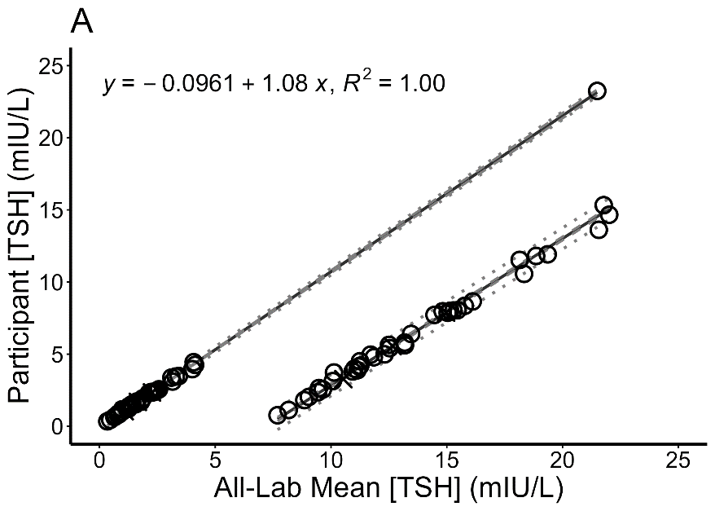
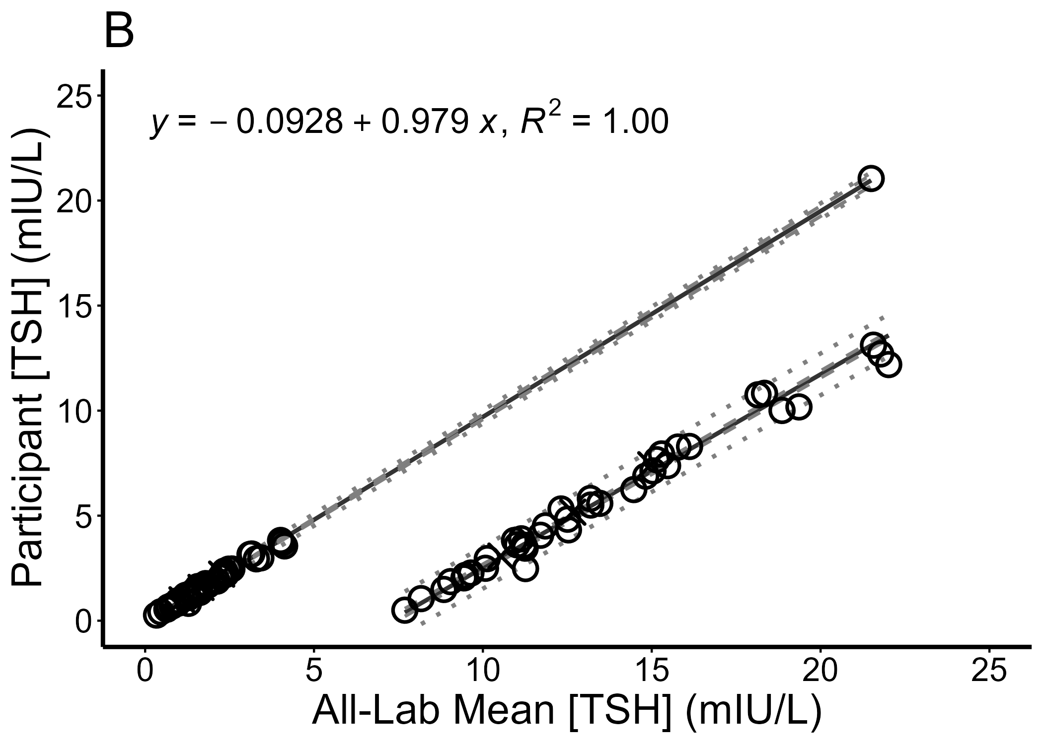
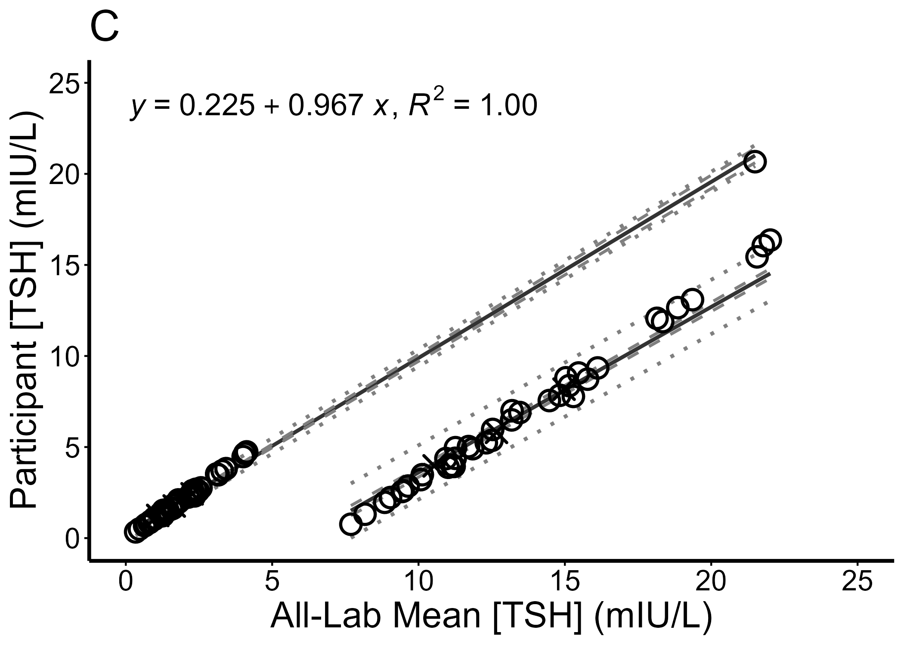

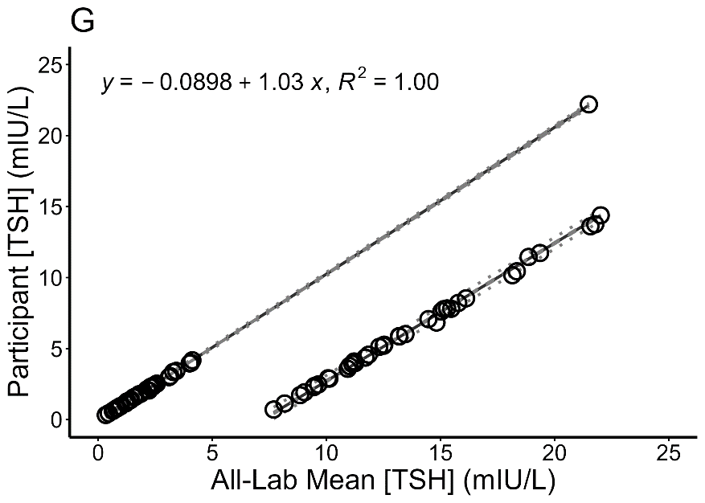

Figure S5. Comparing TSH mean percent bias of all samples to the all-lab mean
Linear regression was performed using only the 40 single nonpregnant donors, and the 95% CI and PI are shown as dashed and dotted lines, respectively. Mean percent bias of all replicate measurements reported by 15 IA manufacturers (and clinical lab “G”) were compared to the all-lab mean. Samples (40) from nonpregnant single donors are shown as circles, samples (1) from pregnant single donors in the third trimester are shown as triangles, and samples from pooled nonpregnant donors are shown as X’s.

Figure S6. Passing-Bablok regression analysis of participating TSH assays
Mean percent bias of all replicate measurements of 39 single nonpregnant donor samples with TSH concentrations of 0.337–4.13 mIU/L reported by 15 IA manufacturers and 1 IA clinical lab (“G”) were compared to the all-lab mean by Passing-Bablok regression. The 95% confidence intervals calculated with the bootstrap method are shown as light grey bands. The regression line is shown as a solid grey line, and the y=x identity line is indicated by a dashed line.

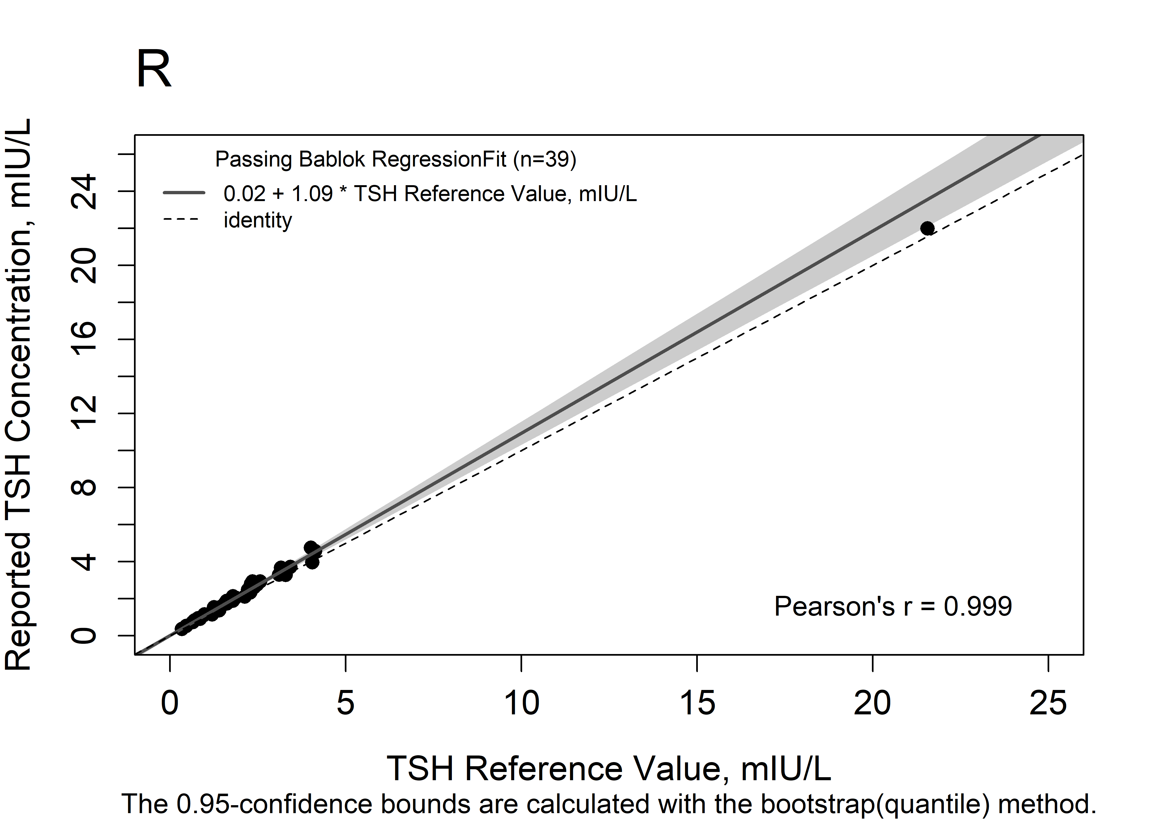
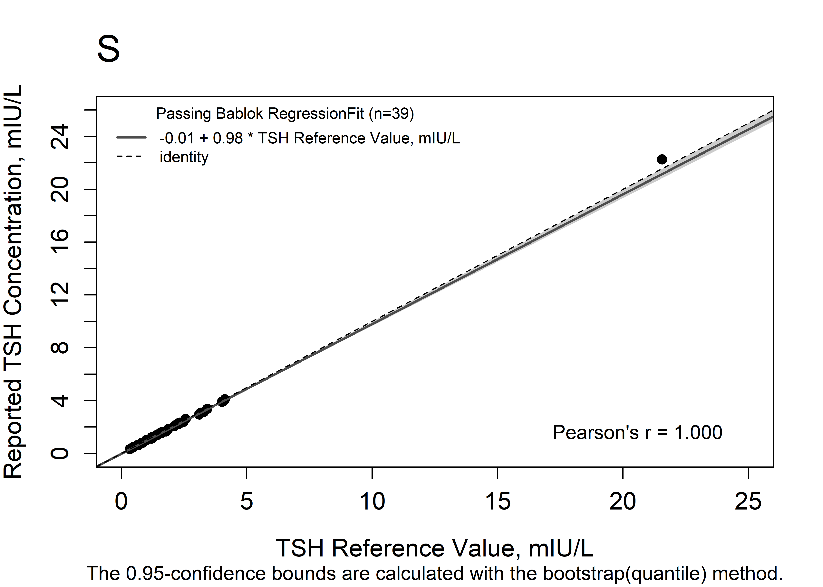
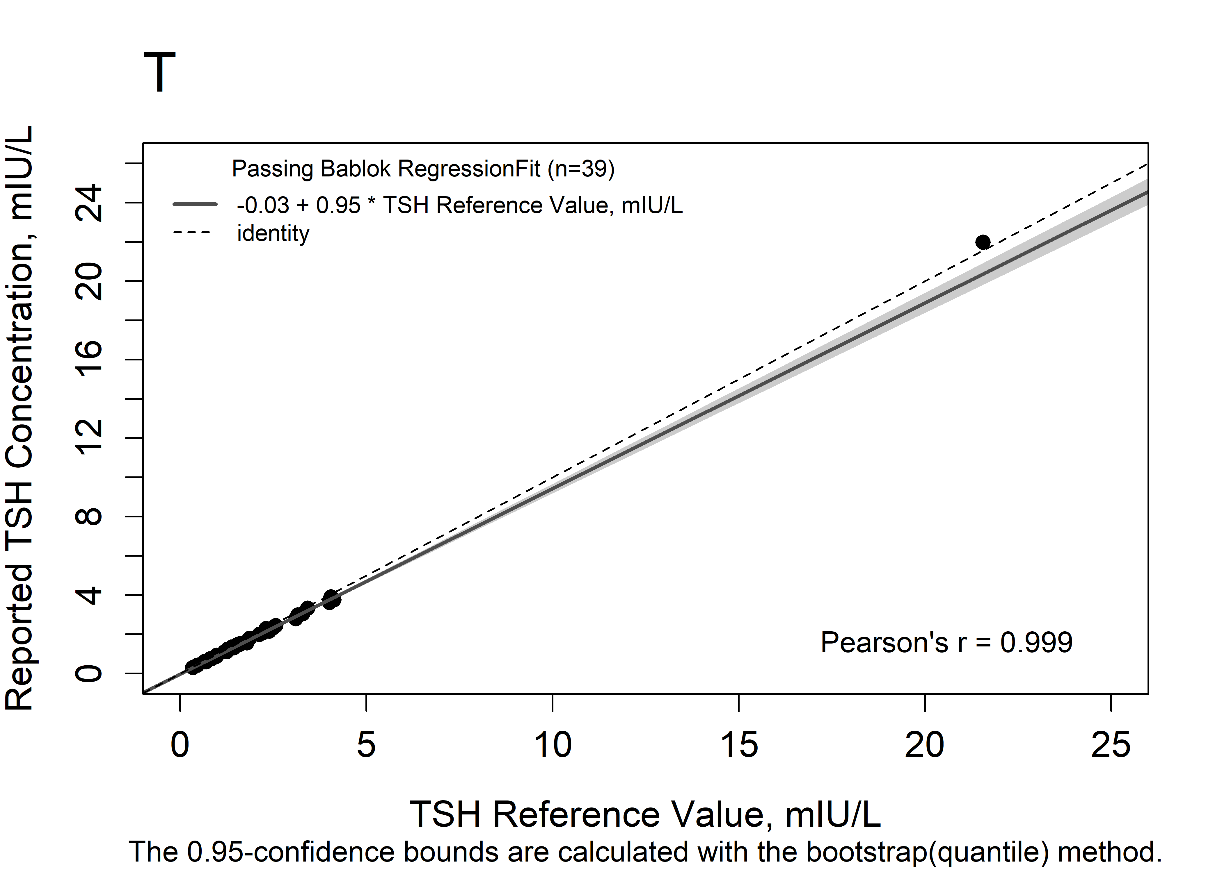
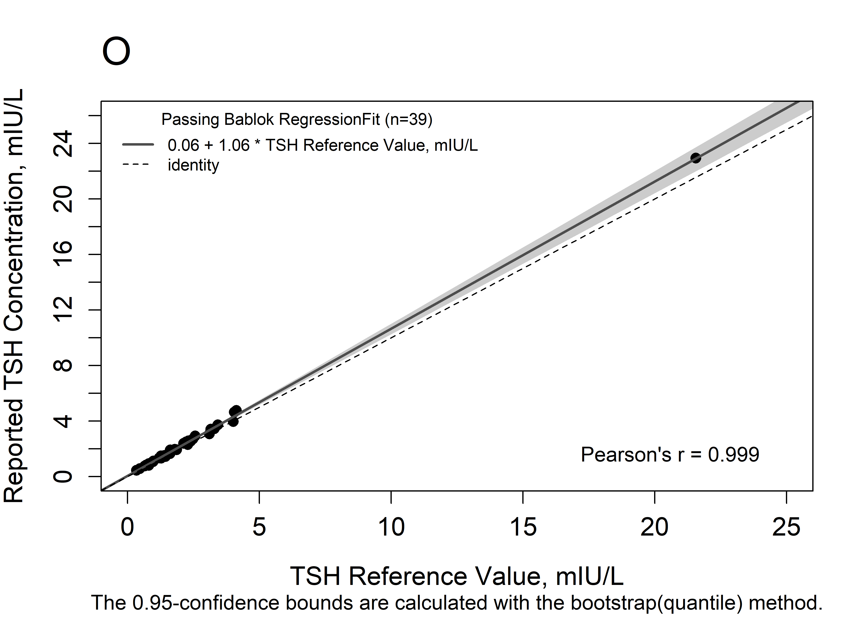
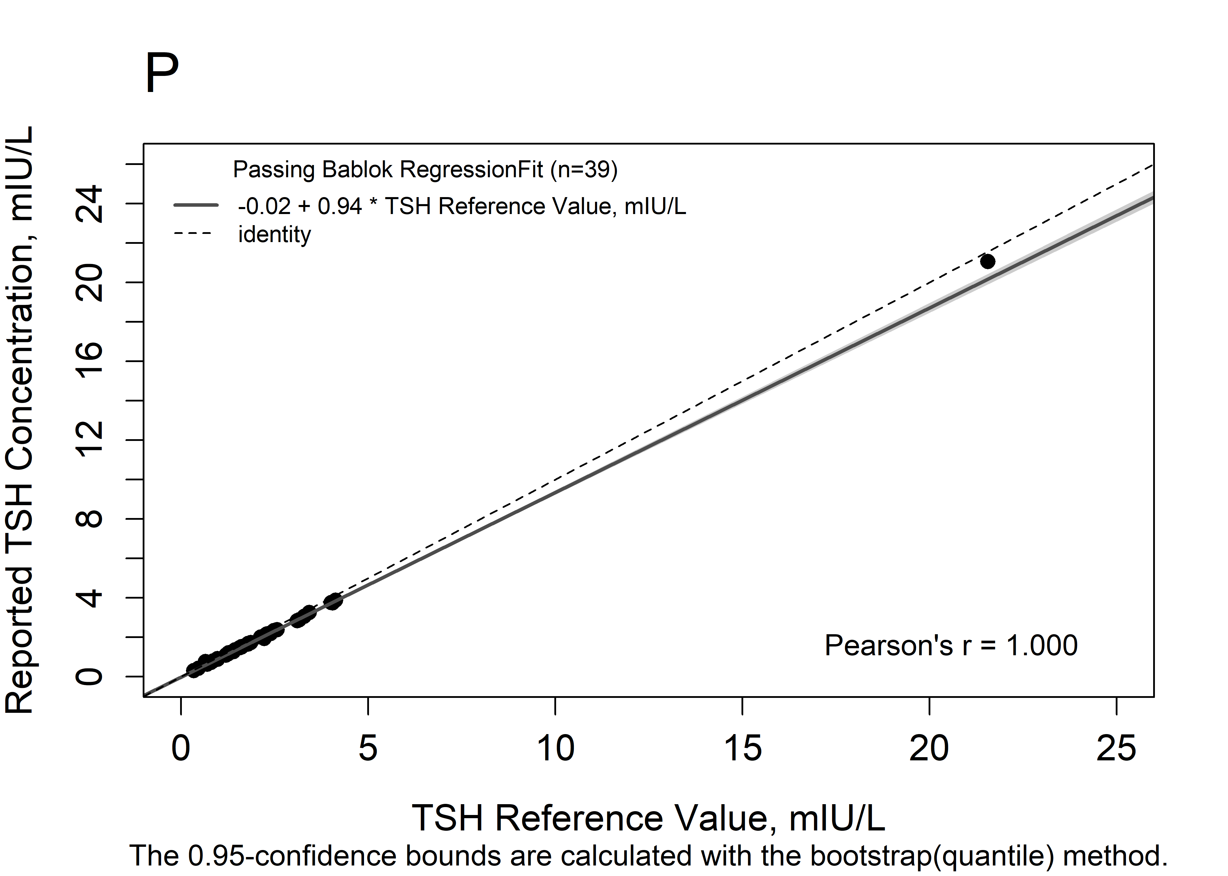

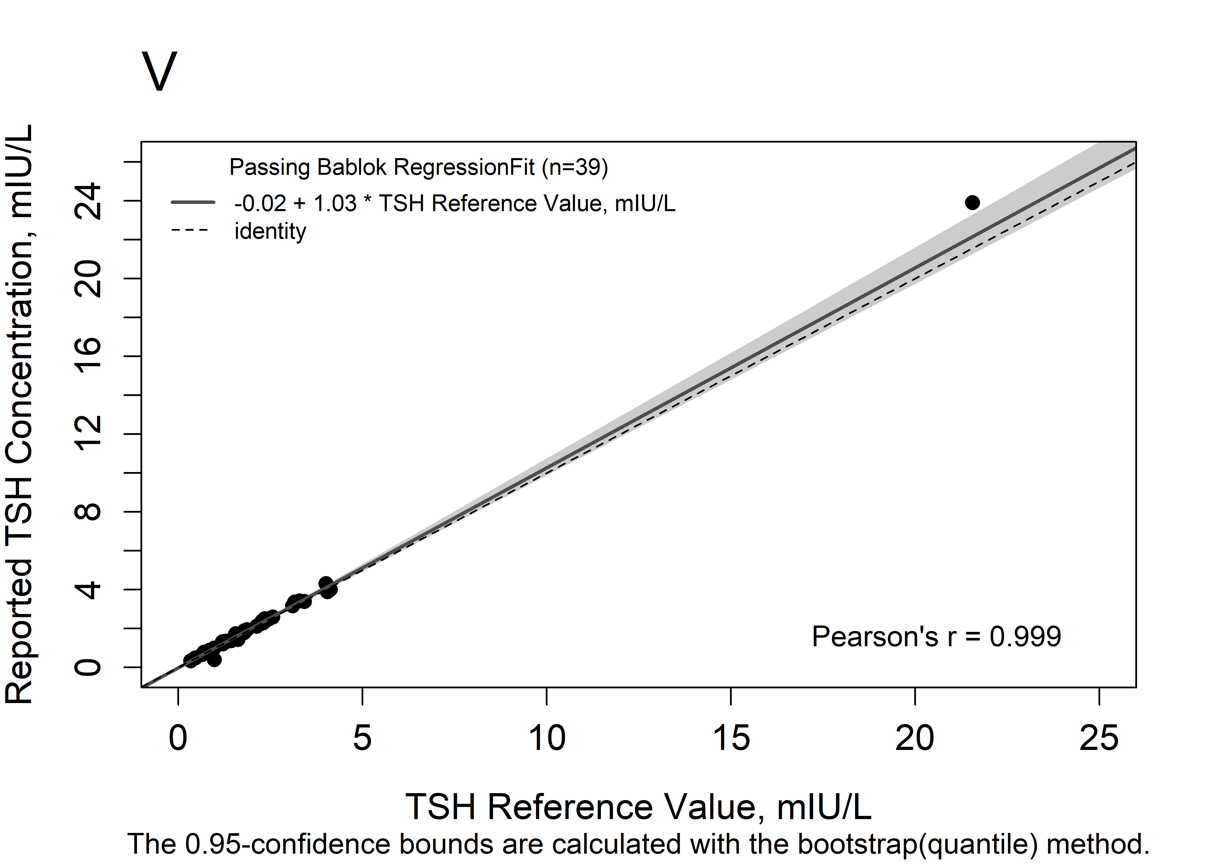
References.
1. Danilenko U, Vesper HW, Myers GL, et al. An updated protocol based on CLSI document C37 for preparation of off-the-clot serum from individual units for use alone or to prepare commutable pooled serum reference materials. Clin Chem Lab Med 2020;58(3):368-374, doi:10.1515/cclm-2019-0732
2. Ernst DJ, Martel AM, Arbique JC, et al. GP41. Collection of diagnostic venous blood specimens. 7th Edition. Clinical and Laboratory Standards Institute (CLSI) 2017;

