APPENDIX
Supplementary Materials
Poly(DL-lactic acid)-b-poly(acrylic acid) (PLA-PAA) was purchased from Sigma Aldrich (Milwaukee, Wi, USA) (PCode: 802190, Lot: MKBW2049V, PDI<1.7).

Supplementary Methods

Quantum Dot Nanoparticle synthesis: Before use, QDs were solvent switched into THF via rotary evaporation. Poly(D,L lactide) 10-18kDa, rubrene, and tetrahydrofuran were purchased from Sigma-Aldrich. Ultrapure deionized water was generating using Milli-Q Benchtop Purification System (Millipore-Sigma). NPs were synthesized as previously reported using a confined impinging jet mixer (CIJ). ^{1, 2} Briefly, organic streams were prepared containing PLA (13 mg/mL), PEG-PLA (5 mg/mL), QD (1mg/mL), and rubrene (1mg/mL) dissolved in THF. Organic streams were then rapidly mixed in the CIJ against equal volumes of MilliQ Ultrapure Water and collected in aqueous quench baths to dilute the organic stream by 10 times. NP were then dialyzed in regenerated cellulose membranes (SpectraPor, Spectrum Laboratories), pore size 12-14kDa, for 6 hours, with hourly changes, against MilliQ water at a 100:1 volume excess.
QD-NP formulations were purified using a serial fractionation via centrifugation. The original sample was centrifuged at low centrifugal force – 1000 g for 30 min, and the pellet and supernatant were separated. The resulting supernatant was then centrifuged at increasing centrifugal forces up to 25000g, and the process was repeated until the pellet was too small to discern. The resuspended pellets were then pooled together for use downstream.
NP size was determined using dynamic light scattering (DLS) using a Malvern ZetaSizer Nano ZS. Samples were diluted to approximately 0.05mg/mL concentration in MilliQ and measured using a detection angle of 173°. Size distribution plots are reported as intensity-weighted traces as presented by the Malvern deconvolution software general purpose mode, normalized to peak intensity. NP total solids concentration was determined using thermogravimetric analysis. (TGA), (Discovery 550 TGA, TA Instruments) as previously reported. ² Sample concentration was then determined as final weight divided by initial sample volume. Absorbance and emission spectra were generated using Duetta spectrophotometer-fluorimeter (Horiba). Emission intensity spectrums were normalized to total solids concentration. NP visualization was done using transmission electron microscopy (TEM) using 300 mesh Au lacey carbon grids (TedPella) with 2% phosphotungstic acid negative staining. Imaging was done using FEI Talos 120C at NYU Langone Microscopy Suite (RRID: SCR_017934).

Thermogravimetric analysis: Briefly, aqueous samples were heated under nitrogen from 25°C to 105°C at 10°C/min and then held at 105°C for 20 min.

Proton Nuclear Magnetic Resonance Spectrometry: PLA-PAA was dried for >48 hours under high vacuum to remove any residual solvent before the sample was prepared at 4.1 mg/mL in THF-d8. The sample was analyzed on a Bruker AVANCE NEO 500 MHz NMR. Sample acquisition was performed with 64 scans and a 10 second relaxation delay time.

Gel Permeation Chromatography (GPC): GPC analysis was performed in tetrahydrofuran on a Shimadzu UFLC instrument with a sample concentration of 2 mg/mL. The sample was prepared in HPLC grade solvent and subsequently filtered through .45 um PTFE filters and analyzed at a flow rate of 1 mL/min. The GPC was equipped with both a UV and RI detector (model RID-20A). Both the RI detector cell temperature and the column temperature were set to 40C. The GPC columns were composed of styrene divinylbenzene copolymer from Shodex (model KF-802.5 and KF-804) equipped with a guard column from Shodex (model KF-G 4A). The molecular weight of the polymer analyte was determined through calibration with poly(styrene) standards.

Hematoxylin and Eosin (H&E) staining: H&E staining was performed using a Leica ST5010 Autostainer XL by the Tumor Tissue and Pathology Shared Resource at Wake Forest Institute of Regenerative Medicine. The authors wish to acknowledge the support of the Wake Forest Baptist Tumor Tissue and Pathology Shared Resource, supported by the National Cancer Institute’s Cancer Center Support Grant award number P30CA012197. The content is solely the responsibility of the authors and does not necessarily represent the official views of the National Institutes of Health.

Staining with anti-bovine DNase 1 antibody: Tissue sections were fixed in 2% PFA/1X PBS for 15 minutes at 4°C, followed by washing with 1X PBS, and then permeabilization for 10 minutes with 0.1% Triton-X-100/1X PBS at room temperature. Tissue sections were either incubated in 1X PBS, or rabbit anti-bovine DNase 1 antibody (Rockland, catalog number: 200-4161, 5 µg/mL in IHC-Tek antibody diluent (IW-1000)) for 1.5 hours at room temperature in a humidified chamber. Tissue sections were then washed and then stained with donkey anti-rabbit IgG Alexa Fluor 555 (Invitrogen, A-31572, 4 µg/mL) for 1 hour at room temperature. Tissue sections were then washed (1X PBS) and stained with DAPI in 1X PBS (1 µM) for 10 minutes at room temperature. Finally, tissue sections were washed and mounted in Prolong GoldTM medium (Invitrogen, P36934), cover-slipped, and allowed to dry overnight.
Whole slide imaging: Slides stained with H&E were scanned using an Olympus VS200 Slide Scanner by the Virtual Microscopy Core Facility, Pathology Department at Wake Forest University School of Medicine. Images were processed with BioFormats Importer Plugin with FIJI.³ For fluorescence microscopy, whole slides were also scanned with a wide-field microscope, see “wide-field microscopy”. Slides were then analyzed with Fiji (Fiji Is Just ImageJ; NIH).³

Flow cytometry of human and mouse neutrophils: Flow Cytometry was performed on the BD LSR Fortessa X-20 analyzer instrument and data acquired and analyzed with FCS Express De Novo software. For staining of human neutrophils, we employed Anti-human CD15-APC (Invitrogen 17-0158-42, 1:200, final 0.125 µg/mL), Anti-Human CD66b (Thermo Fisher Scientific, 12-0666042, 1:400, 0.0625 µg/mL), and the Violet live dead stain (Thermo Fisher, L34963, 1:5000). Cells were gated in the order of cell granularity/size, singlet events, live cells, CD15⁺, qDOT⁺. For staining of mouse neutrophils, we employed Anti-mouse-Ly6G-PE (Invitrogen 12-5931-85, 1:1500, 0.13 µg/mL), Anti-mouse-CD45-Pe-Cy5 (Fisher Scientific, 15-0451-81, 1:3000, 0.067 µg/mL), and Anti-mouse CD11b-APC (Invitrogen 17-0112-82, 1:3000, 0.067 µg/mL). Cells were gated in the order of cell granularity/size, singlet events, live cells, Ly6G⁺, and Cd45⁺ when present or alternatively RbqDOT⁺. CD11b geometric mean was measured on all Ly6G⁺ events.

Nanoparticle internalization of Ru-QD-NPs or QD-NPs by Human & Mouse Neutrophils: This method was adapted from previous literature.⁴ Briefly, 96 well U-bottom microplates (08-772-54, Fisher scientific) were treated overnight with 1% BSA/1XPBS. On the day of the experiment, 100,000 human or mouse neutrophils in RPMI media (no serum) at 1x10⁶ cells/mL were added to the treated wells. 10μL of QD-Ru-NPs or QD-NPs (final concentration of 100-135 µg/mL by particle mass) were added to the neutrophils and incubated at 37°C with 5% CO2 and humidity for up to 1.5 hour. For Flow cytometry analysis neutrophils were pelleted (300 g, 5min), and washed with flow cytometry staining buffer (0.5% BSA in 1X PBS). Cells were pelleted and resuspended in 1X PBS and stained with the violet live/dead stain for 30 minutes, protected from light at room temperature. Human neutrophils were washed and then stained with CD15 antibody for 30 minutes at 4°C. Mouse neutrophils were washed and then stained with Ly6G/CD11b antibody staining cocktail (see “Flow cytometry of human and mouse neutrophils” for staining conditions). Cells were washed and then fixed with 1% PFA in 1X PBS for 15 minutes at 4°C. Cells were stored overnight in 1X PBS at 4°C and analyzed by flow cytometry within 48 hours. For Clot contraction assays please see “In vitro Clot formation with human blood”.

In vitro clot formation with human blood: Human venous blood was drawn from healthy volunteer into an EDTA tube. Blood was then recalcified (final concentration 30mM) and treated with tissue factor (TF; Innovin, diluted 1:9000, ~1 pM Tissue Factor) and clot formation proceeded in siliconized wells for 1 hr at 37ºC. Human blood neutrophils were labelled with 1µM Cell Tracker Deep Red (Thermo Fisher, Catalog #: C34565) or Green-CMFDA (Thermo Fisher, Catalog #: C7025) according to manufacturer’s instructions. Deep Red labelled neutrophils were then loaded with QD-NPs (100 ug/ml) for 1h at 37ºC, 5% CO2. Following incubation and washing, neutrophil count was standardized so that empty and DNP-loaded neutrophils were both at 10 million cells/mL. Subsequently both empty and DNP-loaded neutrophils were added to the same pre-formed clot at equal concentrations and allowed to associate with the clot overnight (18 h).
Histological sections: The clot was washed with 1X cold HBSS, and then fixed with 2%PFA/1X PBS for 1 h at 4ºC. The clot was then placed in 30% sucrose/1XPBS for 1-2 h at 4ºC, and then frozen in OCT freezing medium (Fisher Scientific, Catalog #: 23-730-625) over liquid N2. Sections were cut with a Leica CM3050S cryostat at -20°C at 10 µm thickness and placed on Superfrost Plus Slides (Fisher Scientific, catalog # 12-550-15). Tissue sections were washed with 1X PBS and stained with DAPI (300 nM) for 5 min, room temperature, and subsequently mounted in ProLong Gold AntiFade Mounting Medium (Thermo Fisher Scientific, Catalog #: P36930), with #1 thickness cover slips (VWR, Catalog #: 16004-098).

Confocal microscopy:
Two confocal microscopes were used over the course of the study.

(1) Fluorescence images were obtained by using an inverted laser scanning confocal microscope (Zeiss LSM 780; Zeiss, Oberkochen Germany) through a 63x oil immersion objective lens (numerical aperture 1.40, catalog# 420782–9900; Zeiss, Oberkochen, Germany) with a zoom of 2, pixel size: 0.0659×0.0659 μm². Nuclear DAPI was excited by a 405 nm laser diode and images obtained through a detection wavelength of 410–585 nm with a conventional PMT detector. Pinhole size for all channels was set to 1 airy unit. Scanning mode was set to frame. 3D stacks were obtained with dz=1.00 μm. Three-dimensional rendering and related surfaces were obtained with IMARIS software v9.7.2 (Bitplane AG, Zürich, Switzerland). Orthogonal views and representative image (slice, z6/13) images were obtained using Fiji (Fiji Is Just ImageJ; NIH).³

(2) Fluorescent confocal microscopy images were acquired on an inverted Leica Stellaris 5 Laser Scanning Confocal Microscope, which is configured on an automated Leica DMi8 CS inverted microscope platform with an XY automated stage (Catalog #: 158004141). Laser excitation is provided by a 405nm diode laser, a 448nm diode laser, and a pulsed supercontinuum white light laser that provides a tunable range of laser excitation from 488nm to 685nm. Images were acquired with the following objectives: (1) HC PL APO 20x/0.75 N.A. IMM CORR CS2, multi-immersion and (2) HC PL APO 63x/1.40 N.A. OIL CS2, both with immersion oil (Type F Immersion Liquid, ISO 8036, Leica microsystems, Cat#: 11513859). Multichannel fluorescence images of human clots with QDNP were acquired by sequential scanning in the order of DAPI (4% intensity), Alexa Fluor 488 (5% intensity), Alexa Fluo 647 (16% intensity) and qDOT 585 (6% intensity) channels. Pinhole diameter was set to 1 A.U. Acquisition settings were the same for all clots. Multichannel fluorescence images of murine clots stained with anti-bovine DNase 1 antibody were acquired by sequential scanning in the order of DAPI (3% intensity), Alexa Fluor 488 (5% intensity), Alexa Fluo 647 (2% intensity) and qDOT 585 (5% intensity) channels. Digital Gain was set to 2.5% for all channels. The scan frame was 1024 x 1024 pixels with a scan rate of 400. 3D stacks were obtained with dz=1.00 μm. Image acquisition was performed with Leica Las X Office (1.4.7 282921) and images were analyzed with Fiji (Fiji Is Just ImageJ; NIH).³

Wide-field microscopy: Fluorescent wide-field microscopy images were acquired on an inverted IX83 Evident microscope, which is configured on an automated Marzhauser motorized inverted microscope platform with an XY automated stage (Catalog #: 48-24-580-0000, scan IM 120-80). Laser excitation is provided by an X-Cite Xylis II. Whole tissue section images were acquired with an Olympus UPLXAPO 20X/0.80 NA, 0.6mm WD. Images were automatically tiled. To obtain higher magnification single snapshot images an Olympus UPLXAPO 40x/0.16 N.A, 13mm WD was employed. Multichannel fluorescence images were acquired by sequential scanning in the order of DAPI, GFP, Alexa Fluor 555, and Alexa Fluor 647. Acquisition settings were the same for all clots. Image acquisition was performed with cellSens software (version 4.3.1) and images were analyzed with Fiji (Fiji Is Just ImageJ; NIH).³

Confocal microscopy video: The video was created with syGlass (http://www.syglass.io/, RRID:SCR_01796).⁵

Statistical Analyses: Log transformed uptake data (Fig5A), neutrophil activation data (Fig 5B) and the cell-tracker clot-association data of Supplementary Figure 7 were analyzed with factorial ANOVA. The data for Supplementary Figure 7 meets the ANOVA assumptions as the values are far from the 0-100 boundary. In the NETs degradation assay, the area ratio of control is set to 1. Therefore, data were analyzed by a beta-distributed generalized linear model in SAS 9.4. See code below.
proc glimmix data=work.Area initglm plots=all PCONV=1E6;
class NP time;
model areaRatioCorrected=NP|time /dist=beta link=logit s cl ddfm=kenwardroger;
lsmeans NP*time / pdiff=all ilink adjdfe=row adjust=simulate cl alpha=0.05;
output out=beta_pred / allstats; nloptions tech=nrridg;
run;
Supplementary Discussion
Upon characterization of the PLA-PAA block copolymer, the material was determined to be 10% PLA and 90% PAA with a dispersity of 1.75 (Supplementary Table 1). Proton NMR was used to determine Mn through end group analysis of the terminal protons found in the RAFT chain transfer agent (CTA) at 1.31 ppm, shown in Supplementary Figure 2. By correcting the integration for the CTA, the 1:1 alpha proton ratio between PLA and PAA enabled determination of Mn for each block. Only the relative molecular weight information from GPC could be reported in poly(styrene) equivalents due to the lack of Mark Houwink-Sakurada parameters at the identical GPC acquisition conditions.
Supplementary Table 1. Molecular weight characterization results for Sigma Aldrich PLA-PAA
 | ¹H NMR |  | THF GPC
Compound | PLA M_{n} (Da), % | PAA M_{n} (Da), % | M_{n} (Da) | M_{w} (Da) | Đ
PLA-PAA | 1700, 10% | 15000, 90% | 7486 | 13088 | 1.75
ª percentage is representative of total chain composition
^{b}GPC number-average molecular weight (M_{n}) and weight-average molecular weight (M_{w}) are reported in styrene-equivalents
Supplementary Table 2. QD-NP Characterization Results
Name | Formulation | Size (nm) | PdI
QD-NP | PEG-PLA-OQD-5-75-Fr | 118 | 0.093
Ru-QD-NP | PEG-PLA-Ru-OQD-5-5-75 | 105 | 0.144

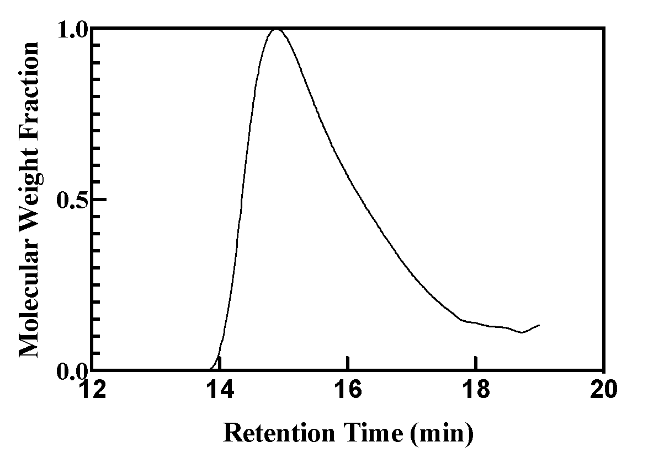
Supplementary Figure 1. THF GPC refractive index detector trace of Sigma Aldrich PLA-PAA

Supplementary Figure 2. Proton (¹H) NMR of Sigma Aldrich PLA-b-PAA block copolymer
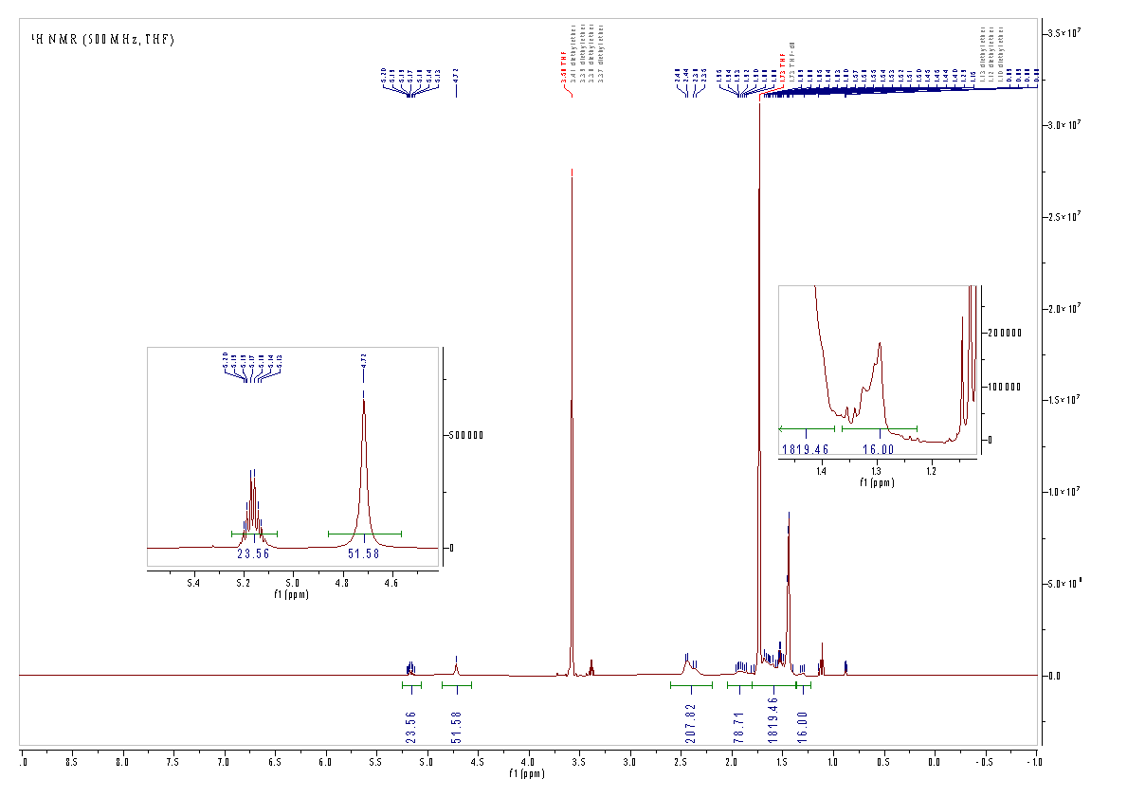
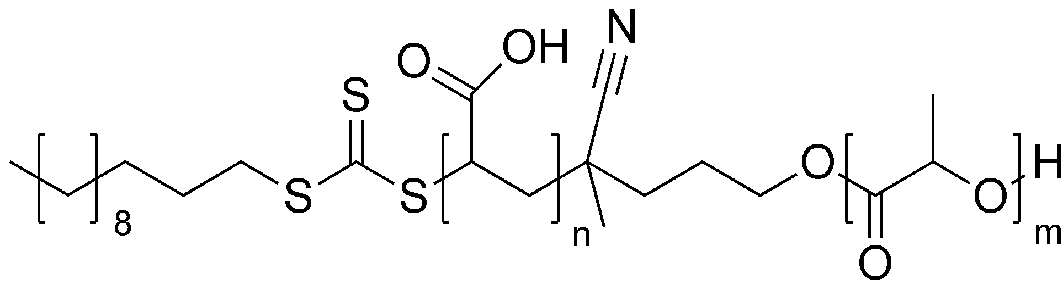
¹H NMR (500 MHz, THF) δ 5.17 (h, J = 7.1 Hz, 23H), 4.72 (s, 61H), 2.59 – 2.22 (m, 206H), 2.04 – 1.79 (m, 98H), 1.81 – 1.38 (m, 758H), 1.31 (t, J = 8.1 Hz, 16H).

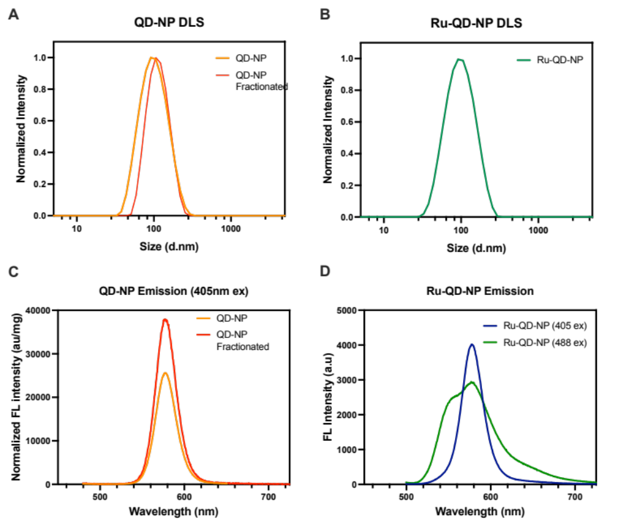
Supplementary Figure 3. QD-NP Size and Emission. Normalized, intensity-weighted size distribution of (A) QD-NP before and after centrifugal fractionation, and (B) Ru-QD-NP. Emission intensity of (C) QD-NP and (D) Ru-QD-NP.

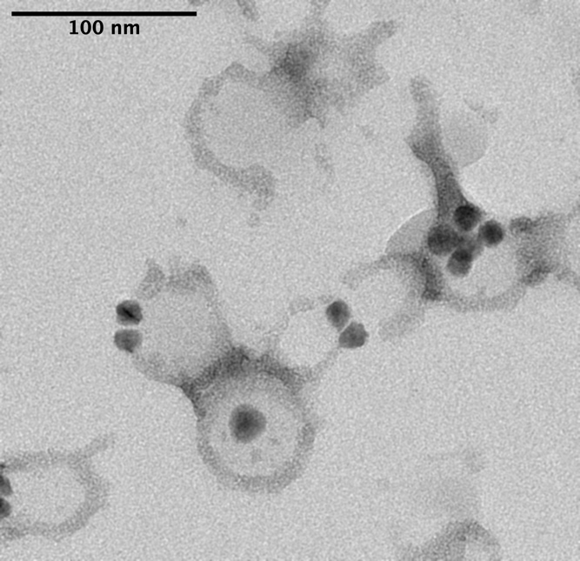
Supplementary Figure 4. Representative TEM image of QD-NP, negatively stained with 2% phosphotungstic acid.

Supplementary Figure 5. Representative images of positive and negative control in NET degradation assay (Scale bar = 200µm). Left panel: NETs were generated by stimulating murine bone marrow derived neutrophils with 100 nM PMA for 4 hours at 37°C with 5% CO₂ and humidity. NETs incubated with in the presence of free DNase 1 (1U/mL) for 10 minutes leading to almost completed NET digestion. Right Panel: Neutrophils were not simulated with PMA but incubated for 4 hours at 37°C with 5% CO₂ and humidity. This background fluorescence was used to threshold for positive SYTOX green staining.

Supplementary Figure 6. Characterization of isolated murine neutrophils. Murine neutrophils were isolated via magnetic cell separation from the bone marrow of C57Bl/6J mice. Here, neutrophils were stained with Ly6G-PE and CD45-Pe-Cy5. The gating strategy that was applied was as follows: SSC-FSC; SSCA-SSCH (singlets); Live/Dead; Ly6G/CD45. Double staining of cells with CD45 and Ly6G demonstrate a high purity of Ly6G/CD45 positive (lower right panel, upper right quadrant).
Supplementary Figure 7. Time course of CD11b expression following Ru-QD-NP internalization by murine neutrophils. (A) Representative gating strategy for murine neutrophils to determine % of Ly6G⁺/RuQDNP⁺ cells from total Ly6G⁺ cells. (B) Internalization of RuQD-NPs by murine Ly6G⁺ cells over 90 minutes at 37°C and 4°C. (C) Quantification of CD11b fluorescence by geometric mean in Ly6G⁺ cells. Neutrophils were incubated with RuQDNPs for up to 90 minutes at 37°C. Data represents 3 independent biological replicates. Data is represented as mean ± SEM. Shapiro-Wilk test confirmed data normality. Data was analyzed by a one-way ANOVA (F(4,10) = 3.814, P<0.05), followed by post-hoc Dunnet’s multiple comparisons (* = p<0.05).
Supplementary Figure 8. Internalization of RuQD-NP by human neutrophils. Human neutrophils were incubated for 1 hr at 37°C, 5% CO_{2,} with humidity, with Ru-QD-NPs (100 µg/mL). CD15 positive cells positive also for Ru-QD-NPs were detected with the gating strategy SSC/FSC; Live population; CD15⁺/RuQDNP⁺, where the gates were set with unstained and singly stained controls.

Supplementary Figure 9. Representative hematoxylin and eosin (H&E) stained tissue sections directly adjacent to the mouse thrombi shown in Figure 6C with no exogenous BMDNφs (left panel) or of a clot with exogenous empty and DNP-loaded BMDNφs (right panel). Images were captured at 20x (scale bar = 500 µm).

Supplementary Figure 10. In vitro thrombi were prepared for flow cytometry by first grinding the thrombus into 10 mL of cold HBSS, and subsequently incubating the cell dispersion with DNase 1 digest solution (60U/mL DNase 1, 1X PBS 3mM MgCl₂) for 30 min, 37ºC, 5% CO₂, to remove extracellular DNA. The digest of free extracellular DNA was halted by the addition of EDTA to a final concentration of 2 mM in PBS. Following pelleting and washing with flow cytometry staining buffer, the cells were then stained with Anti-ly6G PE (Thermo Fisher, Clone 1RB6-8C5, Cat#: 12-5931-85, 1:1500 dilution, 0.13µg/mL) for 30 min at 4ºC. Cells were then treated with RBC Lyse-&-Fix (Thermo Fisher, Catalog #: 00-5333-54). The single cell suspension was then stained with DAPI (300 nM) for 15 min, room temperature, to stain nucleated cells. The gating strategy that was applied to the single cell suspensions of in vitro-formed blood clots was as followed: 1) DAPI stained cells, 2) Ly6G positive staining, and then 3) gating for either Deep-Red or Green-CMFDA stained cells. (A) A representative in vitro thrombus where no exogenous neutrophils were added to the in vitro thrombus. (B) A representative in vitro thrombus where only Green-CMFDA stained exogenous neutrophils were added to the thrombus. (C) A representative in vitro thrombus where only Deep-Red stained exogenous neutrophils were added to the thrombus.

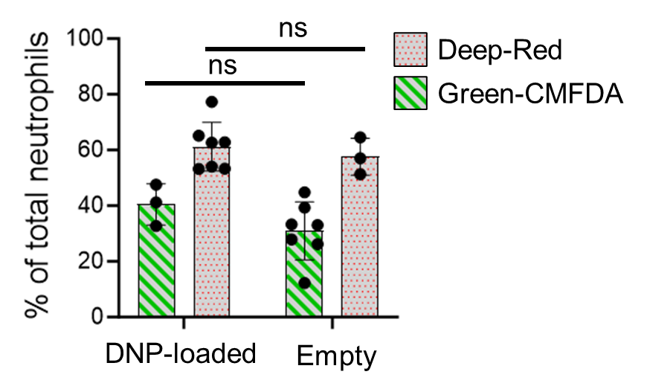
Supplementary Figure 11. Ly6G positive events in single cell suspensions of in vitro thrombi. Deep-Red labeled neutrophils whether they were DNP loaded or empty consistently indicated a higher % of Ly6G positive events. A 2-way factorial ANOVA to assess the effect of DNP-loading, and Deep-Red labeling/Green-CMFDA labeling was conducted, followed by a post-hoc Tukey Pairwise comparison. The 2-way ANOVA model was significant, and a simple main effects analysis revealed that DNP loading was not significant (F(1,16)=2.210, p=0.1566), however Deep-Red labeling vs Green-CMFDA labeling significantly affected the % of Ly6G positive events. (F(1,16)=28.84, P<0.0001, ω_{p}² =0.58). In the main text we have compared DNP-loaded neutrophils vs empty neutrophils regardless of whether they were labeled with Deep-Red or Green-CMFDA.

Supplementary Figure 12. (A) Representative 20x magnification fluorescent tissue sections of mouse thrombi stained with anti-bovine DNase 1 antibody and secondary antibody or secondary antibody alone. Scale bar = 50 µm. (B) Quantification of fluorescence from 20x magnification images as raw integrated density per cell area for cell-tracker Deep Red labelled DNP-loaded BMDNφs stained with both anti-bovine DNase 1 antibody and secondary antibody, compared to cell-tracker Deep Red labelled DNP-loaded BMDNφs stained only with secondary antibody. Whole tissue sections were imaged at 20x by widefield microscopy, and a circular region of interest (ROI) was drawn around cell-tracker Deep Red labelled cells. The raw integrated density for these ROI was measured and then normalized to cell area in µm².N = 100 cells, data is expressed as means ± SEM, and means were compared by a two-tailed students t-test (**** = p<0.0001). (C) Representative 63x maximum projection image of confocal z-stack. Scale bar = 20 µm.
Supplementary Figure 13. Characterization of isolated human neutrophils. Human neutrophils were isolated via magnetic cell separation from healthy volunteers. The gating strategy that was applied was as follows: SSC-FSC; SSCA-SSCH (singlets); Live/Dead; CD66b/CD15. Cells were stained with CD66b-PE and CD15-APC to determine the purity of the isolated cell population. Doubly stained cells were ~93% of the live sample (lower right panel, upper right quadrant).

Supplementary Figure 14. (A) Representative fluorescent tissue sections of either clot with no exogenous human Nφ (left panel) or of a clot with exogenous empty (Green CMFDA-labelled) and QD-NP-loaded human Nφ (Deep Red labelled, right panel). A 20x image is shown (scale bar = 1000 µm) with corresponding zoomed in inset (scale bar = 250µm). QD fluorescence is shown in yellow. (B) Representative H&E-stained tissue sections directly adjacent to the human thrombi shown in A with no exogenous Nφ (left panel) or of a clot with exogenous empty and QD-NP-loaded Nφ (right panel). Images were captured at 20x (scale bar = 500 µm).

Supplementary Movie 1. Internalization of rubrene-DNP by murine bone marrow derived neutrophils. Scale bar is 15 µm. Red or Grey channel: CD45 membrane staining. Green Channel: Rubrene-DNP. Blue channel: DAPI. Initially, the red channel denotes the CD45 membrane staining, which is then digitally rendered by Syglass to designate the membrane boundary of the cell in clear grey.

Supplementary References
(1) Markwalter, C. E.; Pagels, R. F.; Wilson, B. K.; Ristroph, K. D.; Prud'homme, R. K. Flash NanoPrecipitation for the Encapsulation of Hydrophobic and Hydrophilic Compounds in Polymeric Nanoparticles. J Vis Exp 2019, (143). DOI: 10.3791/58757 From NLM.
(2) Pinkerton, N. M.; Gindy, M. E.; Calero-DdelC, V. L.; Wolfson, T.; Pagels, R. F.; Adler, D.; Gao, D.; Li, S.; Wang, R.; Zevon, M.; et al. Single-Step Assembly of Multimodal Imaging Nanocarriers: MRI and Long-Wavelength Fluorescence Imaging. Advanced Healthcare Materials 2015, 4 (9), 1376-1385. DOI: https://doi.org/10.1002/adhm.201400766.
(3) Schindelin, J.; Arganda-Carreras, I.; Frise, E.; Kaynig, V.; Longair, M.; Pietzsch, T.; Preibisch, S.; Rueden, C.; Saalfeld, S.; Schmid, B.; et al. Fiji: an open-source platform for biological-image analysis. Nat Methods 2012, 9 (7), 676-682. DOI: 10.1038/nmeth.2019 From NLM.
(4) Bisso, P. W.; Gaglione, S.; Guimarães, P. P. G.; Mitchell, M. J.; Langer, R. Nanomaterial Interactions with Human Neutrophils. ACS Biomaterials Science and Engineering 2018, 4 (12), 4255-4265, Article. DOI: 10.1021/acsbiomaterials.8b01062 Scopus.
(5) Stanislav Pidhorskyi, M. M., Quinn Jones, George Spirou, Gianfranco Doretto. syGlass: Interactive Exploration of Multidimensional Images Using Virtual Reality Head-mounted Displays. Arxiv 2018. DOI: https://doi.org/10.48550/arXiv.1804.08197.

