Supplemental Table 1. American Community Survey variables included in analysis
 | Precinct 25  (East Harlem) | Precinct 34  (Washington Heights)
Median age | 40.19 | 38.51
Median household income in past 12 months | $16,390.03 | $41,952.86
% of residents who identify as White | 14.40% | 23.2%
% of residents who identify as Black | 47.60% | 16.20%
% of residents who identify as Hispanic/Latinx | 32.30% | 48.80%
% of residents who are female | 32.30% | 44.50%
% of residents who are male | 67.70% | 48.50%
% of residents with at least a high school degree/GED | 64.20% | 59.20%
% of residents with income below poverty line | 46.20% | 15.00%
% of households with public assistance income in past 12 months | 3.30% | 3.90%
% of residents who are unemployed | 23.50% | 5.60%

Supplemental Table 2. Model selection: Results from models with pre-OPC RMSPE less than 5.0
OnPoint - East Harlem
Spatial zone of impact | Temporal resolution | Mean post-OPC difference | Pre-RMSPE | Post-RMSPE | Post/pre-RMSPE ratio | Permutation ratio (permuted P)
Storefront SSPs | Daily arrests | 0.64 | 2.72 | 2.23 | 0.82 | 0.25
Storefront SSPs | 7-day rolling avg of daily arrests | 0.13 | 1.55 | 1.43 | 0.92 | 0.25
Storefront SSPs | 30-day rolling avg of daily arrests | -0.15 | 1.29 | 1.17 | 0.89 | 0.38
Mobile and storefront SSPs | Daily arrests | 0.63 | 2.73 | 2.20 | 0.81 | 0.19
Mobile and storefront SSPs | 7-day rolling avg of daily arrests | 0.11 | 1.56 | 1.43 | 0.91 | 0.15
Mobile and storefront SSPs | 30-day rolling avg of daily arrests | -0.29 | 1.30 | 1.22 | 0.94 | 0.26
Police precincts | Daily arrests | 0.95 | 4.18 | 2.93 | 0.70 | 0.19
Police precincts | 7-day rolling avg of daily arrests | 0.99 | 2.28 | 1.86 | 0.81 | 0.14
Police precincts | 30-day rolling avg of daily arrests | 0.86 | 1.43 | 1.54 | 1.08 | 0.11
OnPoint - Washington Heights
Spatial zone of impact | Temporal resolution | Mean post-OPC difference | Pre-RMSPE | Post-RMSPE | Post/pre-RMSPE ratio | Permutation ratio (permuted P)
Storefront SSPs | Daily arrests | 0.04 | 1.05 | 0.76 | 0.72 | 0.25
Storefront SSPs | 7-day rolling avg of daily arrests | 0.01 | 0.41 | 0.30 | 0.73 | 0.38
Storefront SSPs | 30-day rolling avg of daily arrests | 0.03 | 0.25 | 0.17 | 0.69 | 0.38
Mobile and storefront SSPs | Daily arrests | 0.14 | 1.05 | 0.74 | 0.71 | 0.22
Mobile and storefront SSPs | 7-day rolling avg of daily arrests | 0.16 | 0.40 | 0.33 | 0.81 | 0.19
Mobile and storefront SSPs | 30-day rolling avg of daily arrests | 0.15 | 0.23 | 0.18 | 0.80 | 0.30
Police precincts | Daily arrests | 0.10 | 1.56 | 1.07 | 0.69 | 0.26
Police precincts | 7-day rolling avg of daily arrests | 0.11 | 0.59 | 0.45 | 0.75 | 0.22
Police precincts | 30-day rolling avg of daily arrests | 0.10 | 0.35 | 0.33 | 0.93 | 0.15
Notes: Analyses presented for models from Table 3 with a pre-OPC RMSPE < 5, indicating satisfactory pre-intervention fit.
Abbreviations: OPC, overdose prevention center; RMSPE, root mean squared prediction error; SSP, syringe service program

Supplemental Table 3. Sensitivity analyses: Modeling comparison to Chalfin et al., 2023
OnPoint - East Harlem
Spatial zone of impact | Time period | Temporal resolution | Mean post-OPC difference | Pre-RMSPE | Post-RMSPE | Post/pre-RMSPE ratio | Permutation ratio (permuted P)
200m buffer around stationary SSPs | January 1, 2014-September 30, 2023 | Daily arrests | 0.80 | 1.75 | 1.82 | 1.04 | 0.38
200m buffer around mobile and stationary SSPs | January 1, 2014-September 30, 2023 | Daily arrests | 0.87 | 1.72 | 1.85 | 1.08 | 0.11
500m buffer around stationary SSPs | January 1, 2019-December 31, 2022 | Daily arrests | -0.31 | 2.81 | 1.35 | 0.48 | 0.88
500m buffer around mobile and stationary SSPs | January 1, 2019-December 31, 2022 | Daily arrests | -0.31 | 2.81 | 1.35 | 0.48 | 0.85
Police precincts | January 1, 2019-December 31, 2022 | Daily arrests | 0.05 | 3.47 | 2.02 | 0.58 | 0.96
OnPoint - Washington Heights
Spatial zone of impact | Time period | Temporal resolution | Mean post-OPC difference | Pre-RMSPE | Post-RMSPE | Post/pre-RMSPE ratio | Permutation ratio (permuted P)
200m buffer around stationary SSPs | January 1, 2014-September 30, 2023 | Daily arrests | 0.05 | 0.45 | 0.32 | 0.70 | 0.63
200m buffer around mobile and stationary SSPs | January 1, 2014-September 30, 2023 | Daily arrests | 0.02 | 0.45 | 0.31 | 0.70 | 0.37
500m buffer around stationary SSPs | January 1, 2019-December 31, 2022 | Daily arrests | 0.01 | 0.73 | 0.58 | 0.79 | 0.50
500m buffer around mobile and stationary SSPs | January 1, 2019-December 31, 2022 | Daily arrests | 0.04 | 0.72 | 0.56 | 0.78 | 0.41
Police precincts | January 1, 2019-December 31, 2022 | Daily arrests | 0.12 | 0.82 | 0.78 | 0.95 | 0.20
Abbreviations: OPC, overdose prevention center; RMSPE, root mean squared prediction error; SSP, syringe service program

Supplemental Figure. Sensitivity analysis: 200-meter buffer around OnPoint-East Harlem and OnPoint-Washington Heights
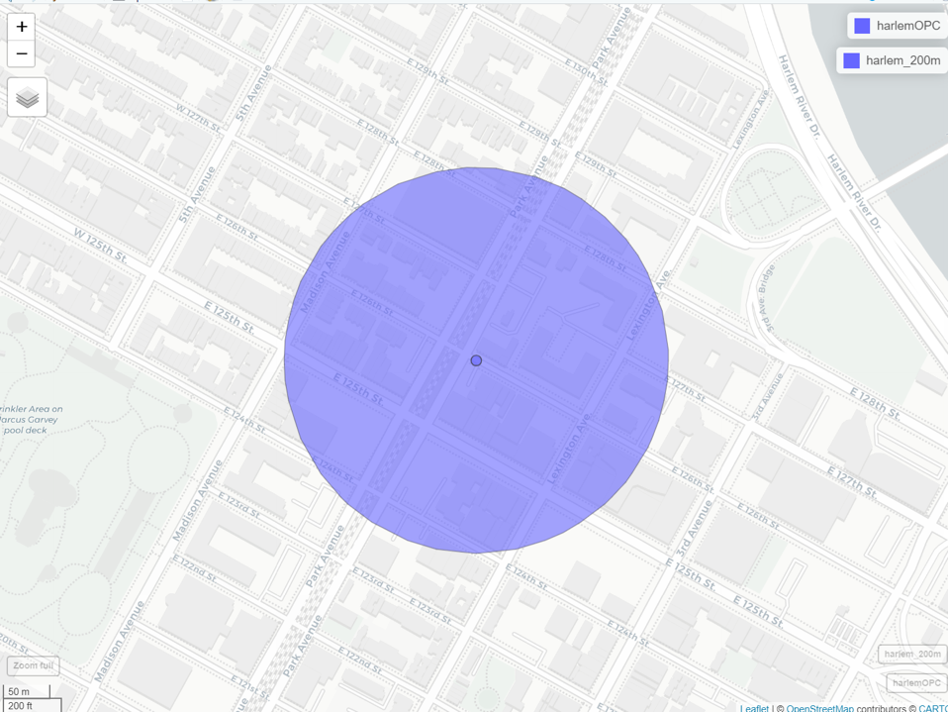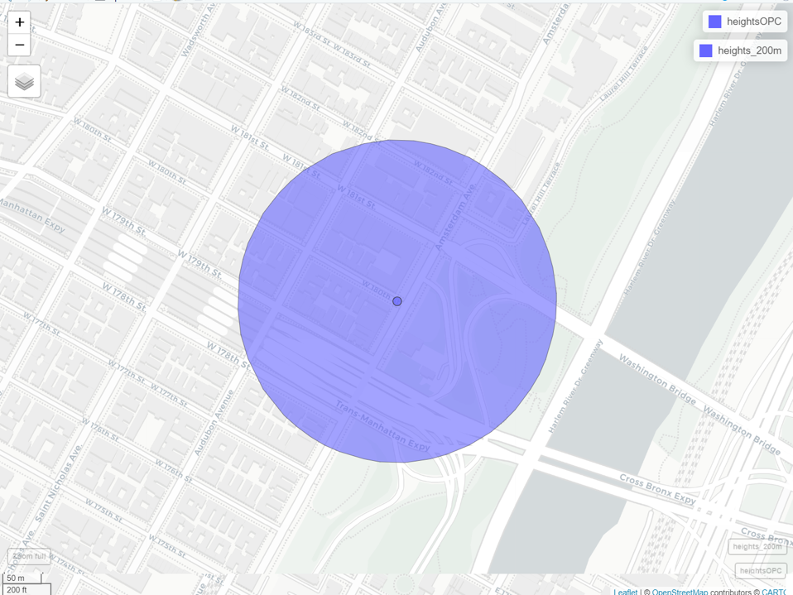
OnPoint-East Harlem OnPoint-Washington Heights

