Supplementary Data

Supplemental Table 1. CRISPR-Cas9 screens in Myc-MB.
Supplemental Table 2. Hi-C loops anchored at Myc promoter, primary data.
Supplemental Table 3. Hi-C loops anchored at Myc promoter, published data.
Supplemental Table 4. Myc CUT&RUN enrichment following zotiraciclib treatment.
Supplemental Table 5. TRRUST enrichment following zotiraciclib treatment.

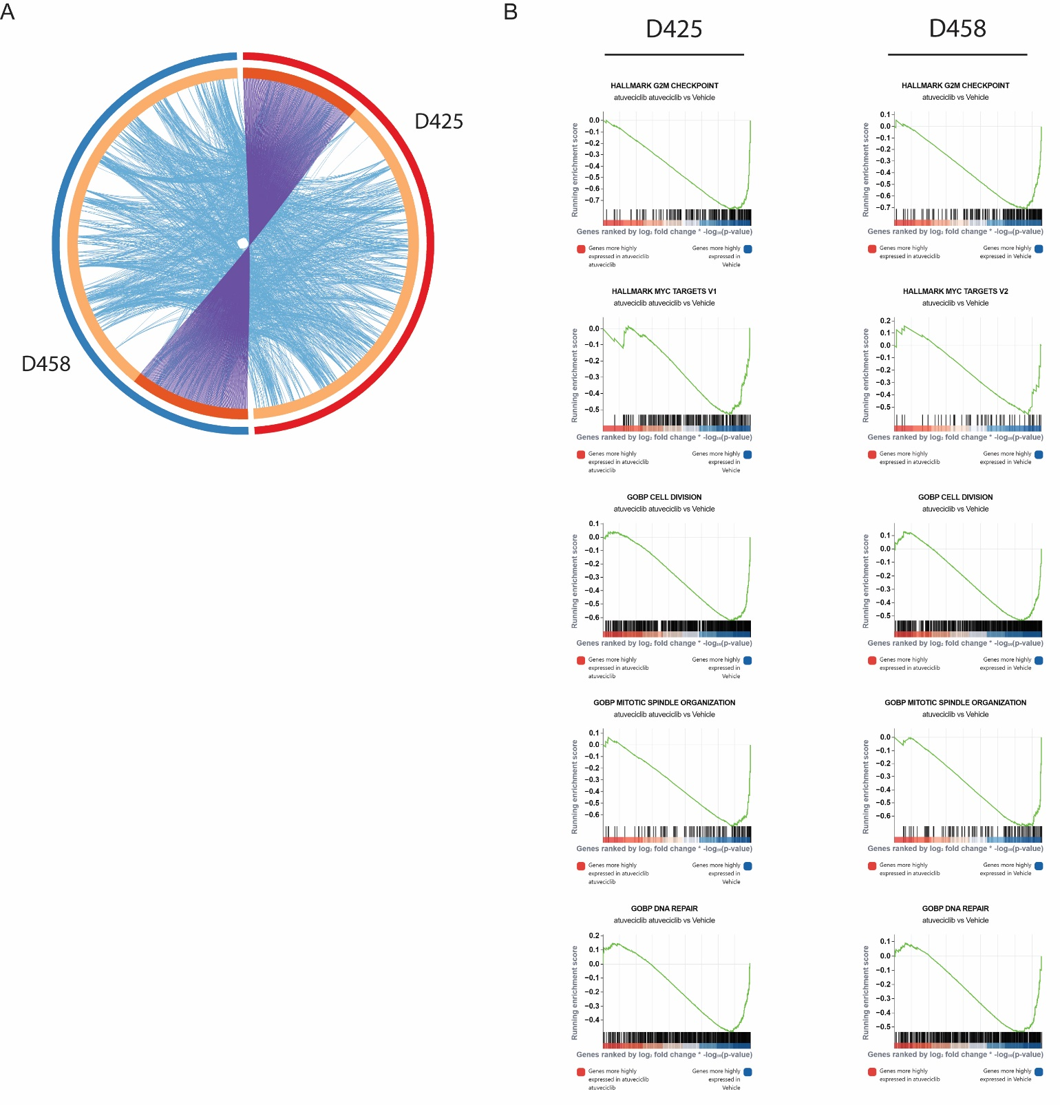

Supplemental Figure 1. Atuveciclib-induced transcriptional changes display strong overlap between models. A. Circlos plot of genes differentially upregulated (top 1000 genes, p adj <0.05) in D425 and D458 models. Purple connections indicate identical genes in both lists, while blue connections indicate common enriched GO terms. B. Representative common gene sets from RNA-seq in D425 (left) and D458 (right) models.

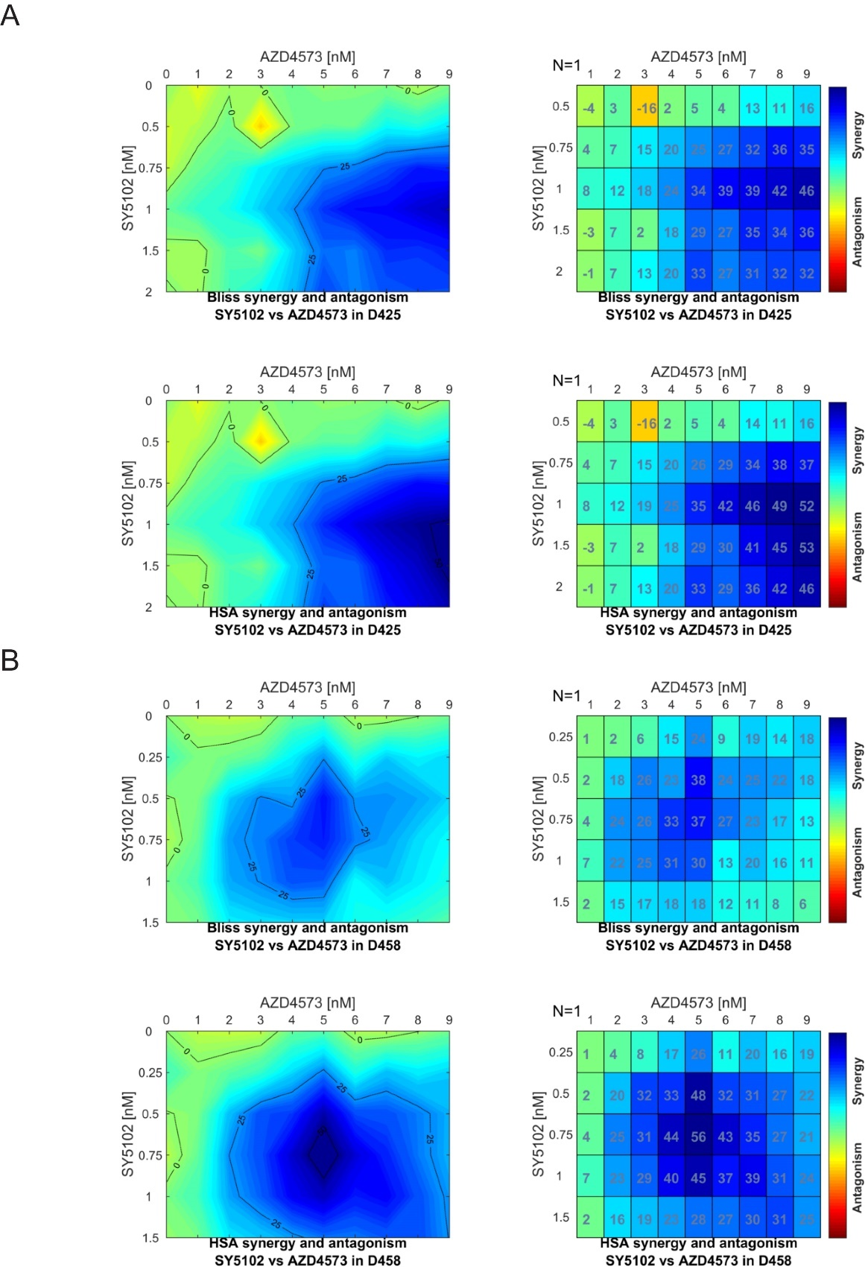

Supplemental Figure 2. Selective CDK9i and CDK7i are highly synergistic. A. Bliss model (top) and HSA model (bottom) of synergy scoring at increasing concentrations of AZD4573 and SY5102 in D425 cells. Scores ≥10 are considered synergistic, represented as cyan to blue. B. Bliss model (top) and HSA model (bottom) of synergy scoring at increasing concentrations of AZD4573 and SY5102 in D458 cells. Scores ≥10 are considered synergistic, represented as cyan to blue.

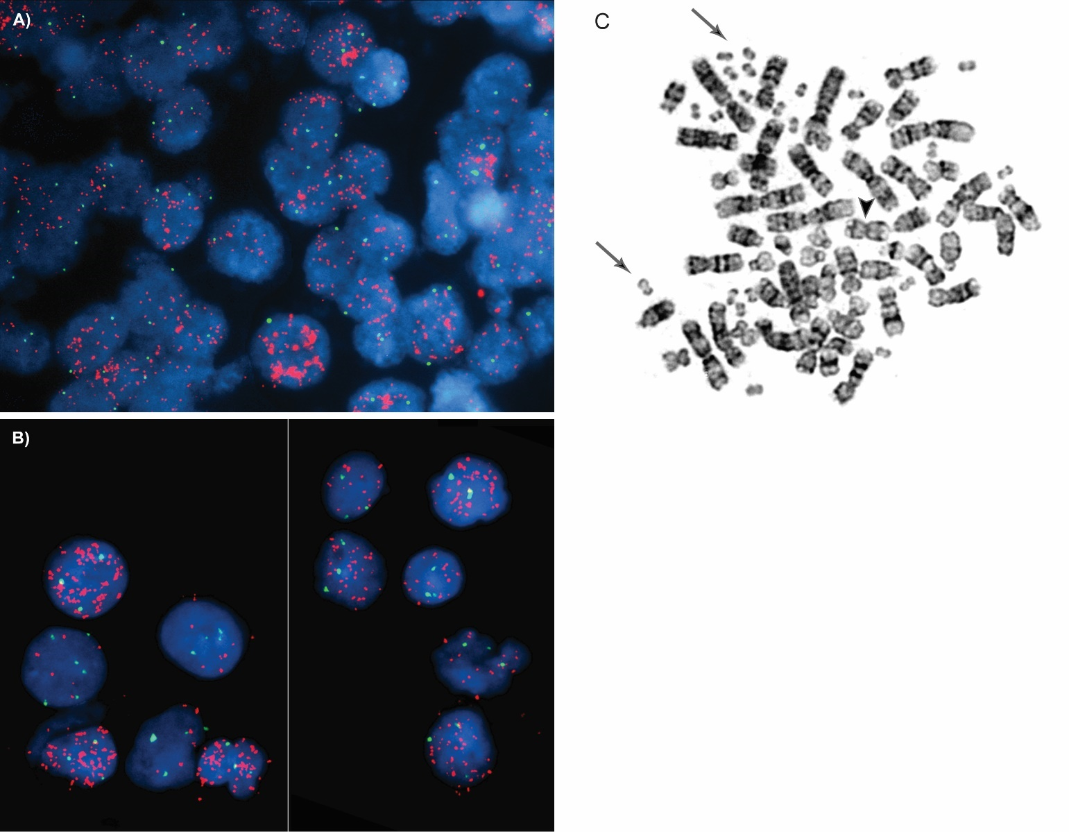

Supplemental Figure 3. Clinical annotation of Myc amplification in primary patient samples. A. and B. Interphase FISH analysis on brain tissue was performed using probes for chromosome 8 centromere (green signal) and MYC at locus 8q24 (red signal) (Vysis, Abbott Molecular). Top and bottom panels both display a high level MYC amplification in the majority of cells in a pattern consistent with double minutes. C. Metaphase of G-banded chromosomes from patient in (B) demonstrating multiple double minutes (arrows) and an isochromosome 17q (arrowhead).

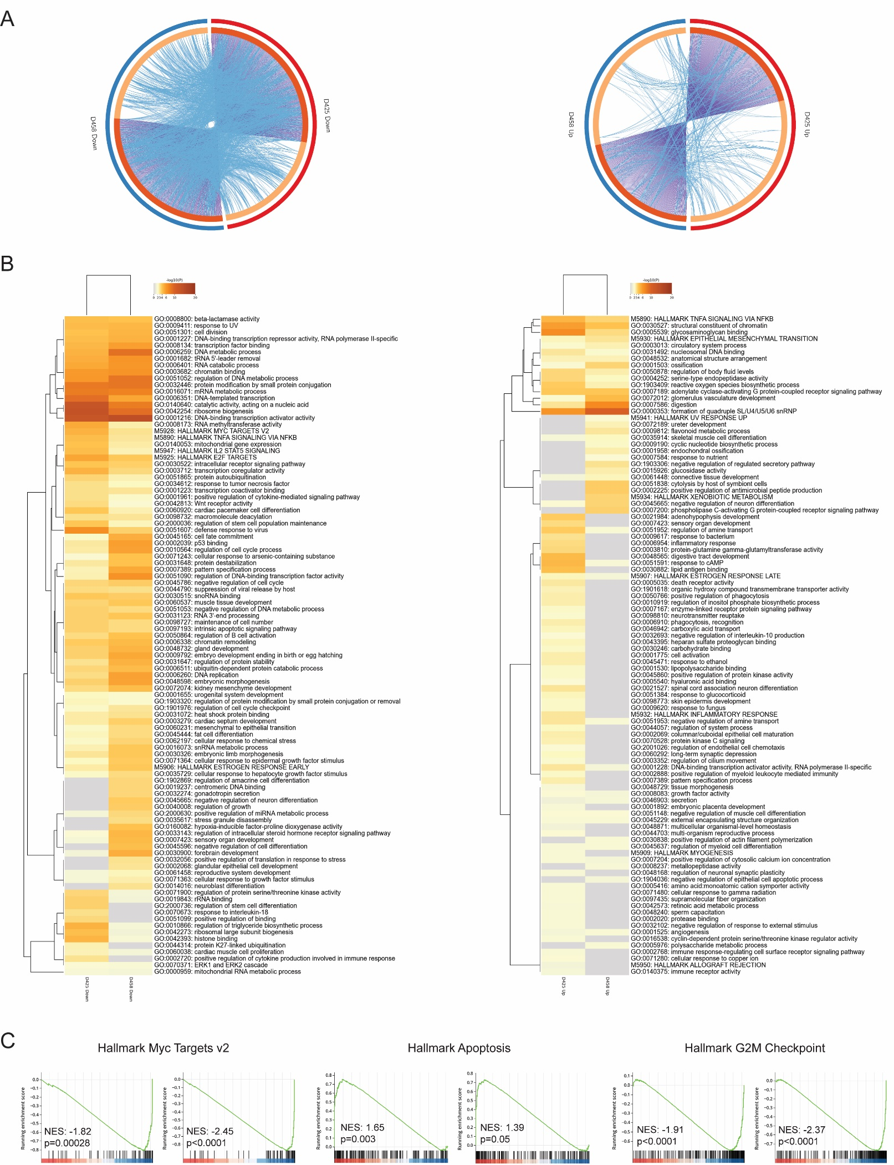
Supplemental Figure 4. Zotiraciclib-induced transcriptional changes display strong overlap between models. A. Circlos plot of differentially down- (left) or upregulated (right) genes (top 1000 genes, p adj <0.05) in D425 and D458 models. Purple connections indicate identical genes in both lists, while blue connections indicate common enriched GO terms. B. Clustered heatmap of GO terms enriched from (A). C. Representative common gene sets from RNA-seq in D425 (left) and D458 (right) models.

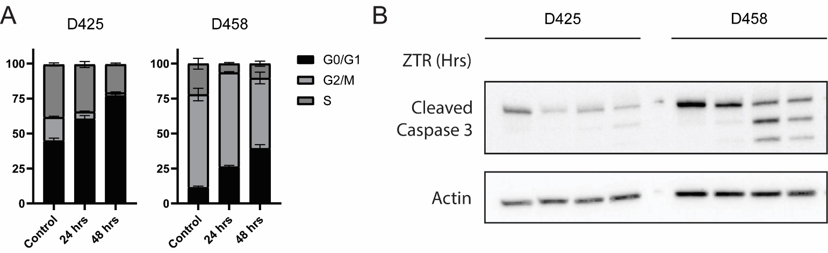
Supplemental Figure 5. Validation of cell cycle and apoptosis. A. Cell cycle analysis of D425 and D458 cells over time in the presence of zotiraciclib. B. Immunoblot for cleaved caspase 3 at indicated timepoints following zotiraciclib treatment.
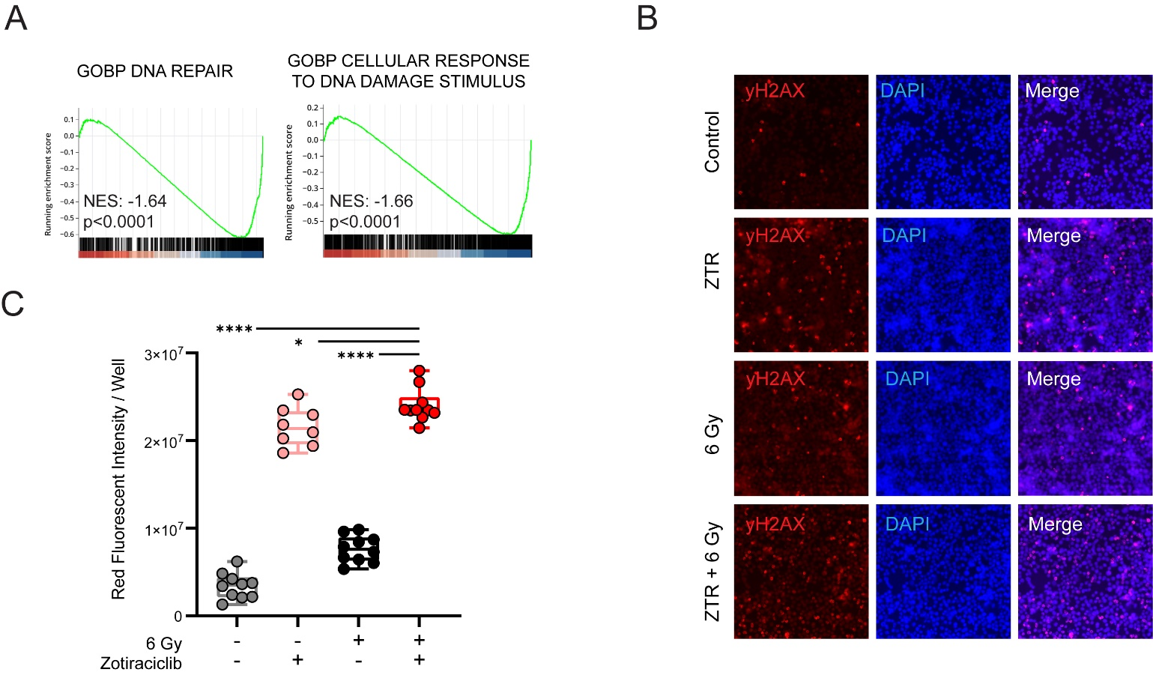

Supplemental Figure 6. Zotiraciclib treatment impairs DNA damage response programs. A. Gene sets related to DNA repair following zotiraciclib treatment. B. Immunofluorescent staining for yH2AX in D458 cells following zotiraciclib treatment, 6 Gy radiation, or combination. C. Quantification from imaging in (B).

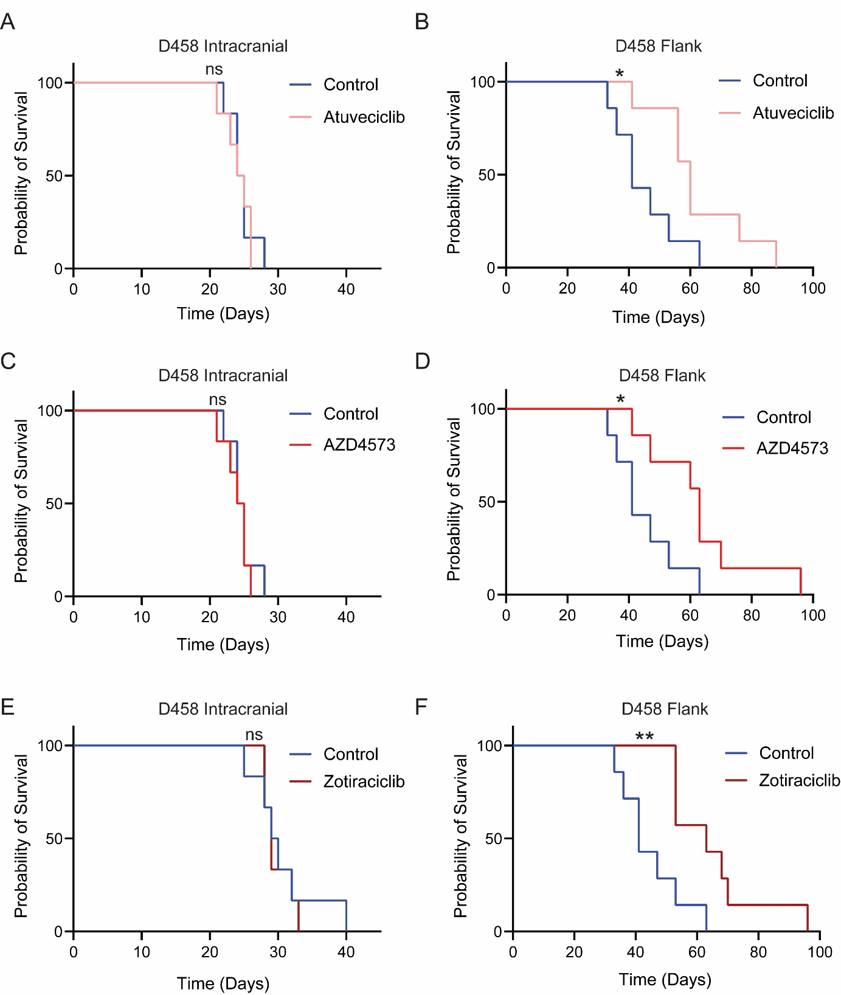
Supplemental Figure 7. CDK9i improves survival in flank but not intracranial xenograft models of Myc-MB. Individual Kaplan-Meier survival analysis of intracranial (A, C, E) or flank (B, D, F) xenografts treated with atuveciclib (A, B), AZD4573 (C, D), or zotiraciclib (E, F) (* p=<0.05, ** p=<0.01). A and C reflect single experiment with same control cohort. B, D, F reflect single experiment with same control cohort.

