Supplemental Model Documentation

This documentation is for the simulation model described in the paper, “Estimating the Long-Term Health Impact and Program Cost-Effectiveness of Providing Direct Screening Services to Low-Income, Medically Underserved Patients through the Colorectal Cancer Control Program (CRCCP).”

We previously shared details about this model in technical reports published in the following references, and have summarized them below.

- Koutouan P. The Effect of Screening Behavior Assumptions and Heterogeneity on Preventive Health Intervention Evaluation using Simulation Modeling. PhD dissertation. North Carolina State University. October 19, 2023. Available at: https://repository.lib.ncsu.edu/items/ef2c1618-825c-490c-8a93-f8f61e0d69ca

- Koutouan P, Mayorga ME, O’Leary MC, Hassmiller Lich K. "Creating simulated equivalents to project long-term population health outcomes of underserved patients: an application to colorectal cancer screening”. Proceedings of the 2021 Winter Simulation Conference. S. Kim, B. Feng, K. Smith, S. Masoud, Z. Zheng, C. Szabo and M. Loper, eds.

Model Overview

The simulation model is comprised of three components: 1) lesion incidence and development, 2) the person’s health states (i.e. disease states), and 3) screening and surveillance. The three components communicate with each other as the model runs. The model simulates individuals from birth until death, and shows the incidence and progression of lesions in these individuals as they move from non-cancerous states to cancerous states. The model allows for interruption in the natural cycle of the lesions through interventions (e.g., colonoscopies, etc.) where the lesions can be removed, thus changing the individual’s potential outcomes. In the model, all simulated individuals will eventually die either from CRC or from non-CRC causes (i.e., all other causes of death). The model has been built in AnyLogic simulation software using the personal learning edition version 8.4.0 and updated in the university edition of Anylogic version 8.5.2. It can simulate up to tens of thousands of individuals per replication.

Lesion incidence and development
Lesion occurrence and development are modeled in AnyLogic through a statechart that includes different transitions within and between preclinical and clinical states. Figure 1 displays the lesion development statechart.

As shown in Figure 1, once a person develops a lesion, the lesion starts in the polyp state at size small. The lesion is then allowed to grow to size medium, after which the lesion can either grow to size large while still not being cancerous, or the lesion can become cancerous from size medium and move to the preclinical cancer state. This preclinical cancer state represents the scenario where cancer is present in a person, but it is not yet detected either through symptoms or screening.

In the preclinical cancer state, the cancerous lesion can again grow from stage 1 to stage 4. Once the cancer is detected, the lesion transitions from the preclinical cancer state to the clinical cancer state. This transition from preclinical to clinical can happen during any cancer stage and reflects the communication between model components. That is, if a CRC screening test, such as colonoscopy, is simulated for the individual within the screening and surveillance statechart and cancer is found, a message is sent to the lesion and disease statecharts indicating that the lesion has been detected. The model allows for a person to have more than one lesion at a time. The assumption concerning detection is that once a lesion is detected, a message is sent for all of the other lesions to also be detected so they can also transition to the clinical state.

Once a cancerous lesion transitions from the preclinical state to the clinical state, the remaining lifetime of the person is computed. When that time expires, the lesion transitions to the death state and a message is sent to the disease state for the person to be classified as deceased from CRC.

Figure 1: Lesion development statechart
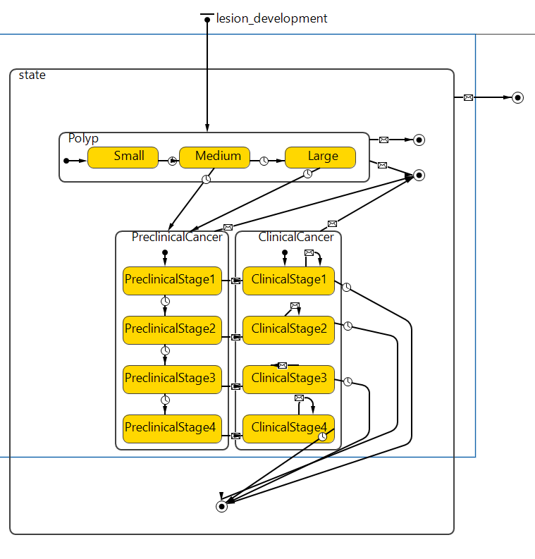

Disease states
In this component of the model, the changes in each individual’s health state (i.e., disease state) as polyps develop and progress are also characterized in a statechart. Figure 2 shows the different disease states accounted for in the model. All individuals in the model start in the healthy (or cancer free) state. Transition from the healthy state to the polyp state only occurs if the individual develops a polyp. If a polyp develops, a message is sent from the lesion development statechart to the disease statechart and the person transitions from the healthy state to the small polyp state. Those two statecharts work hand in hand. As the polyps keep progressing, different messages are sent, and the person’s health worsens. Transitions from the preclinical cancer state to the clinical cancer state depend on the results of any CRC screening test given to the individual. If the test is positive for cancer, a message is sent to the disease statechart from the screening statechart and the transition is made. Alternatively, the model allows for the individual to return to the healthy state if a CRC screening test is given and any polyps found are removed. This only happens if the person does not have cancer.

Death is also represented in this statechart. As previously stated, the person is considered to have died due to CRC if the individual’s remaining lifetime expires. All other individuals’ deaths are due to testing or natural causes which are all classified as death
from other causes.

Figure 2: Disease state progression

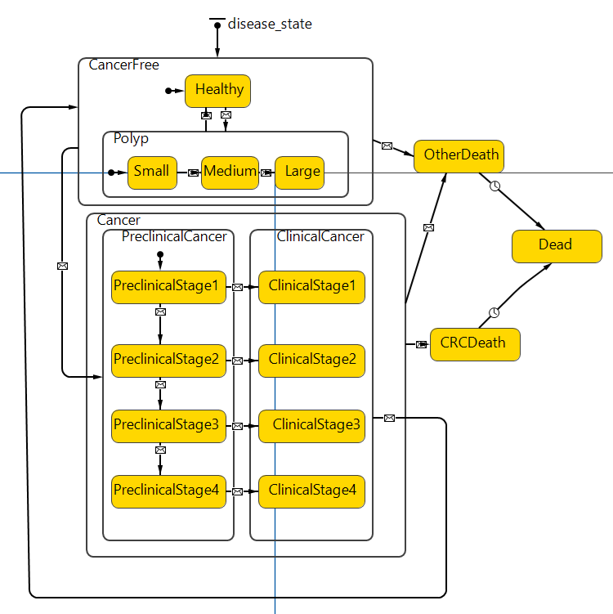

Screening and surveillance
The screening and surveillance component of the model includes all testing for CRC. Figure 3 shows the different states and actions considered. This component allows for CRC testing to be performed in order to change the trajectory of the natural history of CRC and analyzed in terms of its impact on individuals’ health outcomes.

At the start of the model, all individuals are in the routine state shown in Figure 3. They can transition from the routine state to the diagnostic state if they either have symptoms or if they are due for an intervention CRC screening test like colonoscopy. They can also transition to the Fobt_screen state if they are due for an intervention CRC screening test like FOBT or FIT. From the Fobt_screen state, they can transition to the diagnostic state if the test is positive. Once in the diagnostic state, a colonoscopy test is given and, depending on the results, an individual will typically transition to either the low risk state or surveillance state. The transition to the low risk state happens if the test is negative. The transition to the surveillance state happens if the test is positive for one or more polyps. In the case that cancer is found, the individual transitions instead to the treatment state and the lesion development statechart is notified that the cancerous polyp has been detected, thus classifying the disease state as clinical cancer.

Figure 3: Screening and surveillance statechart

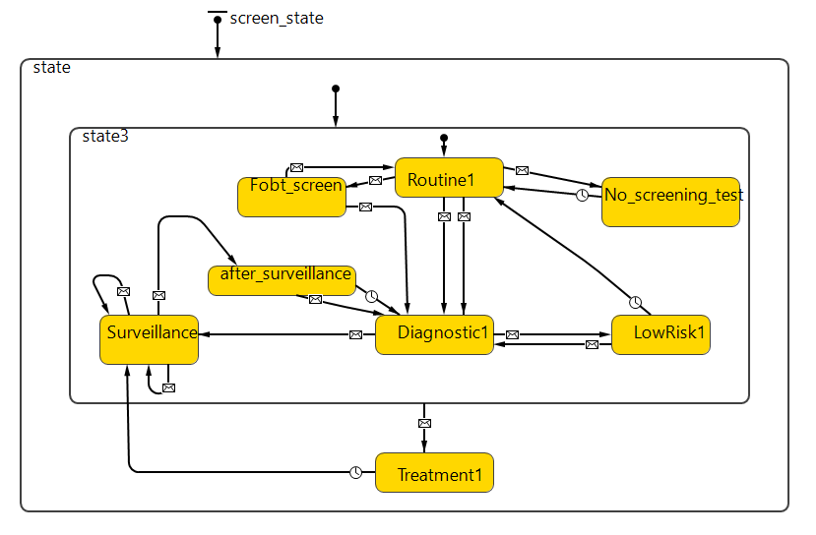

Once in the low risk state, the person either returns to the routine state after 5 years or to the diagnostic state if the person becomes symptomatic. The 5 years of wait time are assumed to avoid the risk of the model attributing a CRC test to an individual earlier than would occur in practice.

In this model, CRC testing (routine, diagnostic or surveillance) is only available for individuals who are still alive and are not classified as having clinical cancer. Individuals who have clinical cancer are assumed to receive treatment as described below in the Treatment section.

As previously mentioned, the model can be modified to accommodate different sets of assumptions pertaining to how the intervention is implemented or to surveillance.

Treatment
In the model, it is assumed that any person who has cancer receives treatment. Once individuals develop clinical cancer, we estimate their life expectancy. For individuals with cancer, their survival time depends on their cancer stage, race and sex. Their remaining life expectancy is recalculated using colon and rectum cancer survival rates by time since diagnosis from the Surveillance, Epidemiology, and End Results Program (SEER). More details on this process are given in the parameterization section.

Parameterization

Multiple parameter values are required as model inputs in order to run this CRC cancer natural history model. These parameters pertain to the population, lesion incidence and development, screening and surveillance, and mortality, as described in the subsequent sections. The values of these parameters can be derived from prior studies already published, specific datasets (e.g., our use of data from the CRCCP), or a combination of the two.

Population
For the model to run, characteristics of the population of interest including sex (male or female), race (White, Black, other), ethnicity (Hispanic, non-Hispanic), year of birth, and year of intervention must be provided in a coded population file.

Screening and surveillance

The model allows for the introduction of testing using colonoscopy or FIT/FOBT though other modalities could be included. These screening tests can reveal the presence of polyps and lead to their removal. Completion of a colonoscopy can detect polyps and lead to removal. Completion of FIT/FOBT can give signal of possible polyps’ presence and if followed by diagnostic testing, confirmation can be obtained, and polyps removed. In both cases, the individual will be sent to surveillance following removal of polyps where a colonoscopy will be administered after 5 years to determine if there are any existing polyps. If the surveillance test is negative, the individual can now receive a routine screening test after 10 years. This 10-year standby period is the recommended time before being due for screening after a colonoscopy. In the case where the lesion found during non-surveillance testing is cancerous, the model will classify the individual as being diagnosed with clinical cancer and recalculate their remaining lifetime.

The model currently supports receipt of CRC testing through colonoscopy or FIT/FOBT. CRC testing can be initiated due to an intervention, symptoms or surveillance. Testing due to an intervention or symptoms are both classified as diagnostic testing and are distinguished from surveillance testing as shown in Figure 3 above. The model assigns sensitivity and specificity values to the CRC screening tests as reported in the Appendix. Each individual is checked for polyps and each polyp found is checked to see if the test detects it. The probability of detection is controlled by the test’s sensitivity parameters. The parameter value for each lesion is determine based on the state (i.e. size) of the lesion.

If polyps are detected, they are removed via a polypectomy. The model also integrates probabilities of the following complications occurring during colonoscopy: bleeding, perforation of the colon, and immediate death. The probabilities of these complications are included in the Appendix.

Death from cancer or other causes
In the model, death from other causes happens either due to colonoscopy testing where there is a small probability of death due to complications assigned or if the individual reaches his or her assigned lifespan. This lifespan is attributed to each individual at the start of the model based on calculations using the death rate tables from the CDC (Arias 2004). Given survival to an age between 0 and max_age -1, the death rate parameters specify the probability of dying between that age and the age in the following year. Given survival to the max_age, the parameters specify the probability of dying at any age beyond max_age; this probability is 1, by definition. The Appendix presents the values for these parameters.

Concerning death from cancer, the model assumes that death due to cancer cannot happen until the cancerous polyps have been clinically detected, which happens when cancer is detected through testing or due to symptoms. When cancer is detected, the model recalculates the remaining lifetime of the individual based on the SEER survival rates by time since diagnosis. These survival rates are classified based on stage of cancer, race, sex and whether the age of the individual is less than 65 or greater than 65.

Model Calibration
Note: This section is cited from Koutouan P, Mayorga ME, O’Leary MC, Hassmiller Lich K. "Creating simulated equivalents to project long-term population health outcomes of underserved patients: an application to colorectal cancer screening”. Proceedings of the 2021 Winter Simulation Conference. S. Kim, B. Feng, K. Smith, S. Masoud, Z. Zheng, C. Szabo and M. Loper, eds.
“To start the calibration process using our CRC simulation model, we first assessed how accurately our model was able to predict polyp detection and CRC incidence for our cohort of CRCCP colonoscopy screeners. Although individuals in both cohorts included in this analysis may have their natural history changed by undergoing a colonoscopy, we calibrated our model using only the screening colonoscopy cohort for two reasons. First, our diagnostic colonoscopy cohort is relatively small in size compared to the screening colonoscopy cohort (2,802 vs. 22,605 individuals, respectively). Second, there is a potential for bias in the data when a colonoscopy is triggered due to a positive FIT/FOBT test. For example, an abnormal FIT/FOBT may result in increased likelihood that polyps are detected during a diagnostic colonoscopy, as compared to a screening colonoscopy, due to providers’ awareness of the stool test result (Ebner and Kisiel 2020; Kligman et al. 2018). Thus, we calibrated our model to the colonoscopy results of the screening cohort in which providers have no prior knowledge of the potential presence of polyps or cancer.
For the screening colonoscopy cohort, our previous model (which adjusts for age, sex and race) well underestimated the actual proportion of polyps and cancers based on their CRCCP results. Specifically, the proportion of polyps and cancers among these CRCCP patients was about 0.4184 and 0.0050, respectively; however, our simulated results showed proportions of 0.1051 and 0.00329, respectively. Our model likely underestimated the colonoscopy outcomes in this cohort because it was previously calibrated to cancer incidence in the full state population of North Carolina using the North Carolina Central Cancer Registry (Hassmiller Lich et al. 2019). In contrast, the CRCCP patient population is a U.S.-wide low-income and underserved population with low CRC screening rates.
Due to the large differences between the actual and simulated results, our first step was to calibrate the model to the colonoscopy findings for our CRCCP screening colonoscopy cohort. We aimed to identify the best combination of multipliers to match the actual CRCCP data for three parameters - 1) individual risk factor, 2) incidence rate, and 3) transition rate from polyp to cancer. One multiplier is associated with each of these three parameters. We focused on these three specific parameters as they drive incidence and polyp progression toward cancer in the model. The risk factor is associated with how susceptible a person is to ever developing polyps. The incidence rate is associated with the likelihood of developing a polyp based on a person’s age. Finally, the third parameter affects the rate at which non-cancerous polyps become cancerous. We focused on finding multipliers for the original parameters as extensive time-based clinical data about CRC incidence and progression is not available for this population, and this allowed us to maintain interactions between sex, age, and race that had been calibrated in the population-level model.
We used Latin hypercube sampling (LHS) to achieve our calibration objective. LHS is a sampling method (Mckay et al. 1979; Helton and Davis 2003) in which a grid of all possible ​​variables is created and samples are selected from non-overlapping intervals across each dimension. In 2-dimensions, for example, this results in one sample in each row and column. This method allows for coverage of the entire parameter space with a smaller number of samples. We chose LHS as the simulation model runs are computationally expensive. The main objective was to reduce the initial sample space after obtaining a batch of samples at each step by identifying the concentration of points giving us the lowest Sum of Squared Errors (SSE). The SSE was calculated as the sum of squared errors between the average proportion of polyp and cancer rates of the simulated versus true data. Our stopping criterion was to find a combination of multipliers that gave predicted proportions of polyps and cancers within +/- 1% of the actual values. To account for randomness in the simulation model, each LHS sample was run 30 times and average values were obtained. We selected a total of 30 replications due to computationally expensive runs and to also ensure a halfwidth of less than 0.005 and 0.0005 around the mean of the estimated proportions of polyps and cancers in the simulated population, respectively.
After calibration, our model successfully matched the CRCCP data for the screening colonoscopy cohort based on our criteria; simulated results now showed proportions of about 0.4171 and 0.0050 for both polyps and cancers, respectively. This is less than a one percent difference in both the simulated proportion of detected polyps and the simulated proportion of detected cancers compared to the actual results. Computationally, based on the point combination, 30 replications took between 1 and 10 minutes to run.”
Simulated Equivalents and Matching Strategy
Note: This section is cited from Koutouan P, Mayorga ME, O’Leary MC, Hassmiller Lich K. "Creating simulated equivalents to project long-term population health outcomes of underserved patients: an application to colorectal cancer screening”. Proceedings of the 2021 Winter Simulation Conference. S. Kim, B. Feng, K. Smith, S. Masoud, Z. Zheng, C. Szabo and M. Loper, eds.
“To assess the long-term impact of the first-time CRC testing intervention provided through the CRCCP in our two CRCCP cohorts and stay true to the individuals’ clinical results, we created simulated equivalents for each individual in the CRCCP cohort. The process of creating simulated equivalents is fully described here using the CRCCP screening colonoscopy cohort. However, we used the same process to create simulated equivalents for the diagnostic colonoscopy after positive FIT/FOBT cohort since we directly simulated the diagnostic colonoscopy, but not the stool test itself since stool tests do not alter natural history.
Our initial step in constructing simulated equivalents was to identify unique combinations of demographic characteristics for each cohort. We focused specifically on the race, [sex], and age of the individuals at the time of receipt of their baseline CRCCP testing. Using these three demographic factors for our screening colonoscopy cohort of 22,605 individuals, there were a total of T=183 combinations of individuals with unique demographic characteristics (e.g., white male screened at age 50) to simulate. Identifying these combinations allowed us to reduce both the number of individuals we needed to track and the number of simulations that we needed to run because we were able to pool simulated individuals to sample from who shared the same characteristics.
After creating the reduced cohort of T combinations of individuals (i.e., individual types) sharing the same demographic information as our CRCCP screening colonoscopy cohort, we simulated their lifetimes with and without receipt of the CRCCP screening colonoscopy numerous times. We created up to R = 1 million replications of each individual type in the set T. Replications that did not reflect reality were discarded. For example, we removed replications where simulated individuals died before their age when they received the CRCCP intervention, or where they were diagnosed with cancer prior to receipt of the intervention. Then, we chose simulated equivalents – that is, simulated individuals who in addition to matching demographically shared the correct colonoscopy result as their real counterpart’s CRCCP colonoscopy result. We grouped the colonoscopy results into the following categories: normal with no polyps detected, polyps detected but not cancerous, and diagnosed cancer. We ran up to one million replications for each individual type in set T to ensure that we had enough to sample the desired number of simulated equivalents for each person in the original cohort.
To estimate this cohort’s long-term outcomes, we matched individuals in the CRCCP screening colonoscopy cohort to their simulated equivalents with the correct colonoscopy result and then sampled the required number of replications. The number of replications for the CRCCP screening colonoscopy cohort (n = 450 simulated equivalents per cohort individual) was established to produce results that were within 1% of the total number of cancers in the population. To estimate the impact of the CRCCP screening colonoscopy intervention compared to no intervention, we identified the corresponding simulated equivalents with the same replication number in the set of no CRCCP intervention replications.”
Estimates of Background Screening in the CRCCP Cohort
Note: This section is heavily based on information originally reported in Koutouan P. The Effect of Screening Behavior Assumptions and Heterogeneity on Preventive Health Intervention Evaluation using Simulation Modeling. PhD dissertation. North Carolina State University. October 19, 2023. Available at: https://repository.lib.ncsu.edu/items/ef2c1618-825c-490c-8a93-f8f61e0d69ca. The table is cited directly from this reference.
We used a careful, multi-step process to derive our estimates of the likelihood of completing routine screening by FIT/FOBT or by colonoscopy, building on self-reported screening data from the Behavioral Risk Factor Surveillance System (BRFF). We obtained the following BRFSS screening data by modality for the years 2014, 2016, and 2018 for individuals without health insurance and for insured individuals. We used the following items:
- Do you have any kind of health care coverage, including health insurance, prepaid plans such as HMOs, or government plans such as Medicare, or Indian Health Service?
- Respondents aged 50-75 who have had a blood stool test within the past year
- Respondents aged 50-75 who have had a colonoscopy within the past year
We selected these years because questions about CRC screening completion are not required as part of the core questions every year; instead, they are required every other year. Data were only available through 2018 at the time of our analysis, and we started with 2014 due to health policy change at that time with the Affordable Care Act. We calculated a three-year average across the available years for insured individuals and uninsured individuals. For routine colonoscopy, we determined their 5-year probability of screening by colonoscopy (as individuals in our model were offered the chance to complete a colonoscopy every five years).
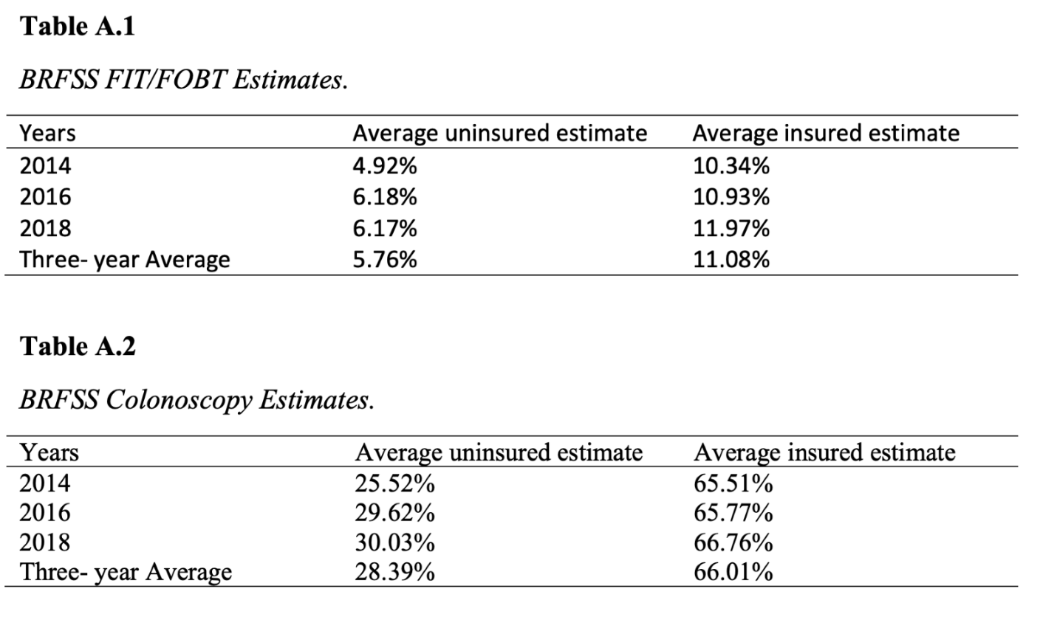
To estimate the lower background screening scenario, we first assumed that individuals in our cohort would be uninsured and screen like the uninsured individuals in the BRFSS dataset, except for those age-eligible for Medicare, who would screen like the insured individuals from BRFSS. We then took a weighted average knowing the proportion of individuals at least 65 years of age. The proportions of individuals 65+ in the screening colonoscopy cohort and the FIT/FOBT cohort were 2.9% and 5.2%, respectively. These estimates informed the “Low background screening” scenario.
We then assumed that all individuals screen like individuals who have health insurance. We calculated the three-year average for the FIT/FOBT and the colonoscopy cohorts, respectively. These estimates informed the “Higher background screening” scenario.
Recognizing that BRFSS estimates are self-reported data, we also looked to recent literature on screening data in lower-income, medically underserved populations to support our estimates.

Parameter Values

Parameter | Description | Value | Sources/Parameters informed by…
Lesion incidence and risk data
lesion_incidence_black_female_ages | Defines the probability of a black female developing each lesion type at age i, for i=0..max_age. The ages and rates parameters should parallel each other; that is, for each age there should be a corresponding rate. The rate corresponding to a given age is the probability of developing a lesion at that age. If an age does not appear, then the rate used is the one corresponding to the largest age less than that age that does appear. Ages 0 and max_age must appear. Separate ages or rates by commas. | 0,30,40,45,50,55,60,65,70,75,85,100 | Lansdorp-Vogelaar et al., 2009
lesion_incidence_black_female_rates |  | 0,0.002,0.006,0.012,0.015,0.023,0.024,0.025,0.025,0.01,0.005,0 | Lansdorp-Vogelaar et al., 2009
lesion_incidence_black_male_ages | Defines the probability of a black male developing each lesion type at age i, for i=0..max_age. See the description of lesion_incidence_black_female for details. | 0,30,40,45,50,55,60,65,70,75,85,100 | Lansdorp-Vogelaar et al., 2009
lesion_incidence_black_male_rates |  | 0,0.002,0.01,0.013,0.02,0.03,0.033,0.037,  0.043,0.013,0.011,0 | Lansdorp-Vogelaar et al., 2009
lesion_incidence_white_female_ages | Defines the probability of a white female developing each lesion type at age i, for i=0..max_age. See the description of lesion_incidence_black_female for details. | 0,30,40,45,50,55,60,65,70,75,85,100 | Lansdorp-Vogelaar et al., 2009
lesion_incidence_white_female_rates |  | 0,0.001,0.004,0.006,0.01,0.018,0.022,0.022,0.023,0.012,0.011,0 | Lansdorp-Vogelaar et al., 2009
lesion_incidence_white_male_ages | Defines the probability of a white male developing each lesion type at age i, for i=0..max_age. See the description of lesion_incidence_black_female for details. | 0,30,40,45,50,55,60,65,70,75,85,100 | Lansdorp-Vogelaar et al., 2009
lesion_incidence_white_male_rates |  | 0,0.002,0.004,0.009,0.016,0.029,0.032, 0.032,0.032,0.018,0.014,0 | Lansdorp-Vogelaar et al., 2009
lesion_risk_alpha | Parameters of the gamma distribution from which each person's risk index for developing each lesion type is selected. | 0.5 | Lansdorp-Vogelaar et al., 2009
lesion_risk_beta |  | 2
Lesion state duration
mean_duration_polyp1_polyp2 | Mean number of years that a lesion remains in the small polyp state before moving to the medium polyp state. | 15 | Calibrated to North Carolina cancer incidence data from the North Carolina Central Cancer Registry
mean_duration_polyp2_polyp3 | Mean number of years that a lesion remains in the medium polyp state before moving to the large polyp state. | 5 | Calibrated to North Carolina cancer incidence data from the North Carolina Central Cancer Registry
mean_duration_polyp1_pre | Mean number of years that a lesion remains in the small polyp state before moving to the preclinical cancer state. [NOTE: This transition is currently disabled in the model, so this parameter has no effect.] | 200 | Calibrated to North Carolina cancer incidence data from the North Carolina Central Cancer Registry
mean_duration_polyp2_pre | Mean number of years that a lesion remains in the medium polyp state before moving to the preclinical cancer state. | 41 | Calibrated to North Carolina cancer incidence data from the North Carolina Central Cancer Registry
mean_duration_polyp3_pre | Mean number of years that a lesion remains in the large polyp state before moving to the preclinical cancer state. | 41 | Calibrated to North Carolina cancer incidence data from the North Carolina Central Cancer Registry
mean_duration_pre1_pre2 | Mean number of years that a lesion remains in preclinical stage 1 before moving to preclinical stage 2. | 1.39534883721 | Calibrated to North Carolina cancer incidence data from the North Carolina Central Cancer Registry
mean_duration_pre2_pre3 | Mean number of years that a lesion remains in preclinical stage 2 before moving to preclinical stage 3. | 1.49038461169 | Calibrated to North Carolina cancer incidence data from the North Carolina Central Cancer Registry
mean_duration_pre3_pre4 | Mean number of years that a lesion remains in preclinical stage 3 before moving to preclinical stage 4. | 3.3 | Calibrated to North Carolina cancer incidence data from the North Carolina Central Cancer Registry
mean_duration_pre1_clin1 | Mean number of years that a lesion remains in preclinical stage 1 before it is diagnosed based on symptoms (i.e., not due to a screening test). | 12 | Calibrated to North Carolina cancer incidence data from the North Carolina Central Cancer Registry
mean_duration_pre2_clin2 | Mean number of years that a lesion remains in preclinical stage 2 before it is diagnosed based on symptoms (i.e., not due to a screening test). | 7.75 | Calibrated to North Carolina cancer incidence data from the North Carolina Central Cancer Registry
mean_duration_pre3_clin3 | Mean number of years that a lesion remains in preclinical stage 3 before it is diagnosed based on symptoms (i.e., not due to a screening test). | 2.75 | Calibrated to North Carolina cancer incidence data from the North Carolina Central Cancer Registry
mean_duration_pre4_clin4 | Mean number of years that a lesion remains in preclinical stage 4 before it is diagnosed based on symptoms (i.e., not due to a screening test). | 1.5 | Calibrated to North Carolina cancer incidence data from the North Carolina Central Cancer Registry
Specificity data
specificity_f | Test specificity of fecal test (FIT/FOBT) | 0.94 | Lin 2016
Col_specificity | Test specificity of colonoscopy | 0.95 | Lin 2016
Sensitivity data for colonoscopy
test_sensitivity_polyp1 | Sensitivity of colonoscopy for detecting small polyps (<6 mm). | 0.75 | Lin 2016; Van Rijn 2006
test_sensitivity_polyp2 | Sensitivity of colonoscopy for detecting medium polyps (6-9 mm). | 0.9 | Lin 2016; Van Rijn 2006
test_sensitivity_polyp3 | Sensitivity of colonoscopy for detecting large polyps (≥10 mm). | 0.94 | Lin 2016; Van Rijn 2006
test_sensitivity_cancer | Sensitivity of colonoscopy for detecting cancer. | 0.95 | Lin 2016; Rex 1997
Sensitivity data for FIT/FOBT
test_sensitivity_polyp1 | Sensitivity of fecal test for detecting small polyps (<6 mm). | 0.05 | Lin 2016; Zauber 2007
test_sensitivity_polyp2 | Sensitivity of fecal test for detecting medium polyps (6-9 mm). | 0.10 | Lin 2016; Zauber 2007
test_sensitivity_polyp3 | Sensitivity of fecal test for detecting large polyps (≥10 mm). | 0.34 | Lin 2016; Smith 2006; Allison 2007
test_sensitivity_cancer | Sensitivity of fecal test for detecting cancer. | 0.87 | Lin 2016; Smith 2006; Allison 2007
Colonoscopy complications
test_proportion_lethal | Proportion of colonoscopies where immediate death occurs. | 0.0001
test_proportion_perforation | Proportion of colonoscopies where perforation of the colon occurs. | 0.01 | Levin 2016
test_proportion_bleeding | Proportion of colonoscopies where bleeding occurs. | 0.032 | Levin 2016

Death Rates (Arias 2004)

Age | Death Rate
Age | Black Females | Black Males | White Females | White Males
0 | 0.013220 | 0.015395 | 0.005124 | 0.006417
1 | 0.000613 | 0.000815 | 0.000384 | 0.000467
2 | 0.000408 | 0.000540 | 0.000258 | 0.000328
3 | 0.000272 | 0.000427 | 0.000184 | 0.000249
4 | 0.000270 | 0.000373 | 0.000146 | 0.000209
5 | 0.000209 | 0.000263 | 0.000153 | 0.000173
6 | 0.000185 | 0.000200 | 0.000117 | 0.000155
7 | 0.000177 | 0.000186 | 0.000113 | 0.000153
8 | 0.000167 | 0.000270 | 0.000128 | 0.000150
9 | 0.000186 | 0.000279 | 0.000120 | 0.000138
10 | 0.000200 | 0.000252 | 0.000113 | 0.000161
11 | 0.000189 | 0.000268 | 0.000116 | 0.000158
12 | 0.000219 | 0.000354 | 0.000128 | 0.000202
13 | 0.000207 | 0.000352 | 0.000182 | 0.000244
14 | 0.000254 | 0.000455 | 0.000204 | 0.000296
15 | 0.000284 | 0.000518 | 0.000248 | 0.000426
16 | 0.000328 | 0.000906 | 0.000405 | 0.000734
17 | 0.000419 | 0.001132 | 0.000448 | 0.000885
18 | 0.000512 | 0.001649 | 0.000464 | 0.001151
19 | 0.000513 | 0.001912 | 0.000457 | 0.001325
20 | 0.000604 | 0.002060 | 0.000435 | 0.001294
21 | 0.000664 | 0.002258 | 0.000487 | 0.001338
22 | 0.000714 | 0.002306 | 0.000424 | 0.001253
23 | 0.000723 | 0.002336 | 0.000415 | 0.001300
24 | 0.000698 | 0.002438 | 0.000457 | 0.001257
25 | 0.000808 | 0.002484 | 0.000458 | 0.001202
26 | 0.000891 | 0.002584 | 0.000459 | 0.001233
27 | 0.000927 | 0.002593 | 0.000441 | 0.001145
28 | 0.000925 | 0.002439 | 0.000530 | 0.001173
29 | 0.001229 | 0.002670 | 0.000515 | 0.001230
30 | 0.001153 | 0.002561 | 0.000560 | 0.001290
31 | 0.001205 | 0.002724 | 0.000594 | 0.001316
32 | 0.001367 | 0.002547 | 0.000629 | 0.001252
33 | 0.001487 | 0.002695 | 0.000697 | 0.001465
34 | 0.001581 | 0.003123 | 0.000758 | 0.001482
35 | 0.001746 | 0.003457 | 0.000855 | 0.001578
36 | 0.001850 | 0.003521 | 0.000929 | 0.001683
37 | 0.001989 | 0.003356 | 0.001003 | 0.001866
38 | 0.002280 | 0.003931 | 0.001081 | 0.002025
39 | 0.002617 | 0.002226 | 0.001292 | 0.002226
40 | 0.002615 | 0.004250 | 0.001360 | 0.002507
41 | 0.003126 | 0.004682 | 0.001468 | 0.002649
42 | 0.003114 | 0.004920 | 0.001572 | 0.002772
43 | 0.003816 | 0.005410 | 0.001771 | 0.003072
44 | 0.004026 | 0.005867 | 0.001853 | 0.003350
45 | 0.004249 | 0.006645 | 0.002069 | 0.003558
46 | 0.004405 | 0.007212 | 0.002134 | 0.003962
47 | 0.004783 | 0.007738 | 0.002305 | 0.004138
48 | 0.005422 | 0.009069 | 0.002545 | 0.004527
49 | 0.005692 | 0.009607 | 0.002725 | 0.004870
50 | 0.006189 | 0.010434 | 0.002844 | 0.005229
51 | 0.006628 | 0.011466 | 0.003180 | 0.005661
52 | 0.006589 | 0.011736 | 0.003290 | 0.005912
53 | 0.007141 | 0.012882 | 0.003827 | 0.006474
54 | 0.007910 | 0.013817 | 0.004081 | 0.006755
55 | 0.009022 | 0.015549 | 0.004737 | 0.007871
56 | 0.008613 | 0.015056 | 0.004646 | 0.007766
57 | 0.009679 | 0.016680 | 0.005541 | 0.008873
58 | 0.010768 | 0.018483 | 0.006041 | 0.009717
59 | 0.011831 | 0.020253 | 0.006858 | 0.011121
60 | 0.011824 | 0.021157 | 0.007219 | 0.011375
61 | 0.013521 | 0.022425 | 0.008015 | 0.012838
62 | 0.014018 | 0.024843 | 0.008790 | 0.014135
63 | 0.015432 | 0.026032 | 0.009672 | 0.015409
64 | 0.016374 | 0.028167 | 0.010707 | 0.016620
65 | 0.017783 | 0.029344 | 0.011652 | 0.018184
66 | 0.019446 | 0.030784 | 0.012542 | 0.019668
67 | 0.020548 | 0.032442 | 0.014109 | 0.021785
68 | 0.021847 | 0.035282 | 0.015102 | 0.023639
69 | 0.024438 | 0.038245 | 0.016851 | 0.026049
70 | 0.025775 | 0.040816 | 0.018562 | 0.028633
71 | 0.028768 | 0.045549 | 0.019881 | 0.031275
72 | 0.030438 | 0.048428 | 0.022023 | 0.033339
73 | 0.032519 | 0.052073 | 0.024158 | 0.037412
74 | 0.035398 | 0.055073 | 0.026635 | 0.040664
75 | 0.039437 | 0.059165 | 0.029541 | 0.044647
76 | 0.042360 | 0.064715 | 0.032085 | 0.048946
77 | 0.046255 | 0.067787 | 0.035606 | 0.053039
78 | 0.047926 | 0.072996 | 0.039183 | 0.058065
79 | 0.053997 | 0.081816 | 0.043811 | 0.064456
80 | 0.056930 | 0.087335 | 0.049136 | 0.069812
81 | 0.060278 | 0.088502 | 0.053288 | 0.076341
82 | 0.071023 | 0.099494 | 0.062062 | 0.086981
83 | 0.071252 | 0.094660 | 0.064527 | 0.088920
84 | 0.080358 | 0.112654 | 0.075300 | 0.102473
85 | 0.087277 | 0.120346 | 0.083577 | 0.112276
86 | 0.094648 | 0.128359 | 0.092538 | 0.122723
87 | 0.102486 | 0.136687 | 0.102211 | 0.133822
88 | 0.110807 | 0.145325 | 0.112621 | 0.145577
89 | 0.119622 | 0.154263 | 0.123790 | 0.157985
90 | 0.128944 | 0.163491 | 0.135737 | 0.171043
91 | 0.138782 | 0.172995 | 0.148475 | 0.184737
92 | 0.149146 | 0.182761 | 0.162015 | 0.199051
93 | 0.160042 | 0.192772 | 0.176360 | 0.213963
94 | 0.171474 | 0.203008 | 0.191509 | 0.229442
95 | 0.183446 | 0.213448 | 0.207455 | 0.245455
96 | 0.195958 | 0.224068 | 0.224184 | 0.261957
97 | 0.209007 | 0.234843 | 0.241673 | 0.278902
98 | 0.222589 | 0.245745 | 0.259895 | 0.296235
99 | 0.236696 | 0.256744 | 0.278812 | 0.313893
100 | 1.000000 | 1.000000 | 1.000000 | 1.000000

