Table S1. Baseline Characteristics and Covariate Balance for Pre-ZDC Users (N = 3,945)
 | Non-Weighted Group Monthly Average |  |  | Weighted Group Mean Monthly Average
Variables | Control  (N = 2,199) | Treatment  (N = 1,746) | SMD | Control  (N = 1,744) | Treatment  (N = 1,746) | SMD
Age | 51.44  (12.05) | 47.51  (12.95) | -0.31 | 47.5  (12.89) | 47.51  (12.95) | 0.00
Age (≤45) | 632  (28.74%) | 723  (41.41%) | 0.27 | 727  (41.7%) | 723  (41.41) | -0.01
Age (46 - 64) | 1372  (62.39%) | 924  (52.92%) | -0.19 | 921  (52.79%) | 924  (52.92) | 0.00
Age (≥65) | 195  (8.87%) | 99  (5.67%) | -0.12 | 96  (5.5%) | 99  (5.67) | 0.01
Sex (Women) | 1349  (61.35%) | 1158  (66.32%) | 0.10 | 1139  (65.29%) | 1158  (66.32) | 0.02
Covid | 30  (1.36%) | 28  (1.6%) | 0.02 | 26  (1.51%) | 28  (1.6) | 0.01
Anxiety | 485  (22.06%) | 381  (21.82%) | -0.01 | 376  (21.58%) | 381  (21.82) | 0.01
Cancer | 273  (12.41%) | 160  (9.16%) | -0.10 | 155  (8.91%) | 160  (9.16) | 0.01
CHF | 58  (2.64%) | 14  (0.8%) | -0.14 | 14  (0.78%) | 14  (0.8) | 0.00
CAD | 198  (9%) | 90  (5.15%) | -0.15 | 92  (5.26%) | 90  (5.15) | 0.00
CKD | 80  (3.64%) | 43  (2.46%) | -0.07 | 45  (2.58%) | 43  (2.46) | -0.01
COPD | 62  (2.82%) | 23  (1.32%) | -0.11 | 25  (1.43%) | 23  (1.32) | -0.01
ESRD | 5  (0.23%) | 4  (0.23%) | 0.00 | 5  (0.28%) | 4  (0.23) | -0.01
Hypertension | 1468  (66.76%) | 747  (42.78%) | -0.50 | 752  (43.11%) | 747  (42.78) | -0.01
Osteoarthritis | 350  (15.92%) | 204  (11.68%) | -0.12 | 206  (11.82%) | 204  (11.68) | 0.00
SAD | 82  (3.73%) | 55  (3.15%) | -0.03 | 55  (3.18%) | 55  (3.15) | 0.00
Urban | 1800  (81.86%) | 1331  (76.23%) | -0.14 | 1325  (75.97%) | 1331  (76.23) | 0.01
IA | 13  (0.58%) | 8  (0.43%) | -0.07 | 7  (0.43%) | 8  (0.43) | 0.00
OP Surgery | 94  (4.28%) | 65  (3.7%) | -0.05 | 63  (3.59%) | 65  (3.7) | 0.01
PCP Visit | 442  (20.09%) | 306  (17.53%) | -0.14 | 307  (17.58%) | 306  (17.53) | 0.00
SO Visit | 1172  (53.28%) | 906  (51.88%) | -0.02 | 895  (51.32%) | 906  (51.88) | 0.01
Office Visit | 1613  (73.37%) | 1212  (69.41%) | -0.05 | 1202  (68.91%) | 1212  (69.41) | 0.01
UC Visit | 88  (4%) | 59  (3.37%) | -0.09 | 58  (3.3%) | 59  (3.37) | 0.01
ER Visit | 48  (2.17%) | 27  (1.55%) | -0.13 | 26  (1.52%) | 27  (1.55) | 0.01
Drug Counts | 0.74  (0.44) | 0.62  (0.44) | -0.27 | 0.63  (0.42) | 0.62  (0.44) | -0.02
DCSI | 1.17  (2.13) | 0.77  (1.79) | -0.21 | 0.77  (1.78) | 0.77  (1.79) | 0.00
Monthly PDC | 0.58  (0.34) | 0.49  (0.35) | -0.25 | 0.5  (0.34) | 0.49  (0.35) | -0.02
Monthly Total Health Care Spending | 713.56  (1242.51) | 648.93  (1258.6) | -0.05 | 581.64  (1052.2) | 648.93  (1258.6) | 0.06
Monthly Drug Spending | 183.59  (584.96) | 224.12  (752.88) | 0.06 | 158.03  (570.19) | 224.12  (752.88) | 0.099
Monthly Medical Spending | 529.97  (1009.53) | 424.81  (947.34) | -0.11 | 423.61  (813.11) | 424.81  (947.34) | 0.00
Abbreviations: Congestive Heart Failure (CHF), Coronary Artery Disease (CAD), Chronic Kidney Disease (CKD), Chronic Obstructive Pulmonary Disease (COPD), End-stage Renal Disease (ESRD), Substance Abuse Disorder (SAD), Allowed Amount (AA), Inpatient Admission (IA), Outpatient Surgery (OP), Primary Care Physician (PCP), Specialty Office (SO), Urgent Care (UC), Emergency Room (ER), Diabetes Complication Severity Index (DCSI), Standardized Mean Difference (SMD), Proportion of Days Covered (PDC)
Notes: Table displays counts and percentages for categorical variables and means and standard deviations for continuous variables. Monthly expenditures were not included in the probit regression that predicted treatment status, it is displayed to assessment balance across treatment and control groups.

Table S2. Baseline Characteristics and Covariate Balance for Pre-ZDC Non-Users (N = 1,290)
 | Non-Weighted Group Monthly Average |  |  | Weighted Group Mean Monthly Average
Variables | Control  (N = 711) | Treatment  (N = 579) | SMD | Control  (N = 577) | Treatment  (N = 579) | SMD
Age | 52.09  (11.84) | 47.64  (12.66) | -0.36 | 47.64  (13.02) | 47.64  (12.66) | 0.00
Age (≤45) | 177  (24.89%) | 225  (38.86%) | 0.30 | 225  (38.92%) | 225  (38.86) | 0.00
Age (46 - 64) | 456  (64.14%) | 323  (55.79%) | -0.17 | 321  (55.6%) | 323  (55.79) | 0.00
Age (≥65) | 78  (10.97%) | 31  (5.35%) | -0.21 | 32  (5.48%) | 31  (5.35) | -0.01
Sex (Women) | 391  (54.99%) | 263  (45.42%) | -0.19 | 268  (46.42%) | 263  (45.42) | -0.02
Covid | 14  (1.97%) | 14  (2.42%) | 0.03 | 16  (2.72%) | 14  (2.42) | -0.02
Anxiety | 139  (19.55%) | 77  (13.3%) | -0.17 | 81  (13.98%) | 77  (13.3) | -0.02
Cancer | 62  (8.72%) | 43  (7.43%) | -0.05 | 46  (7.99%) | 43  (7.43) | -0.02
CHF | 34  (4.78%) | 15  (2.59%) | -0.12 | 20  (3.51%) | 15  (2.59) | -0.05
CAD | 95  (13.36%) | 41  (7.08%) | -0.21 | 41  (7.17%) | 41  (7.08) | 0.00
CKD | 67  (9.42%) | 32  (5.53%) | -0.15 | 32  (5.47%) | 32  (5.53) | 0.00
COPD | 27  (3.8%) | 14  (2.42%) | -0.08 | 16  (2.72%) | 14  (2.42) | -0.02
ESRD | 18  (2.53%) | 4  (0.69%) | -0.15 | 5  (0.93%) | 4  (0.69) | -0.03
Hypertension | 531  (74.68%) | 276  (47.67%) | -0.58 | 278  (48.2%) | 276  (47.67) | -0.01
Osteoarthritis | 136  (19.13%) | 59  (10.19%) | -0.25 | 60  (10.44%) | 59  (10.19) | -0.01
SAD | 33  (4.64%) | 23  (3.97%) | -0.03 | 22  (3.75%) | 23  (3.97) | 0.01
Urban | 590  (82.98%) | 460  (79.45%) | -0.09 | 463  (80.21%) | 460  (79.45) | -0.02
IA | 8  (1.08%) | 3  (0.51%) | -0.19 | 3  (0.55%) | 3  (0.51) | -0.02
OP Surgery | 44  (6.15%) | 24  (4.12%) | -0.18 | 24  (4.14%) | 24  (4.12) | 0.00
PCP Visit | 167  (23.48%) | 104  (17.96%) | -0.29 | 104  (18.01%) | 104  (17.96) | 0.00
SO Visit | 437  (61.41%) | 321  (55.41%) | -0.08 | 332  (57.6%) | 321  (55.41) | -0.03
Office Visit | 604  (84.89%) | 425  (73.37%) | -0.14 | 436  (75.61%) | 425  (73.37) | -0.03
UC Visit | 29  (4.02%) | 17  (2.99%) | -0.14 | 18  (3.13%) | 17  (2.99) | -0.02
ER Visit | 21  (2.93%) | 12  (2%) | -0.16 | 11  (1.94%) | 12  (2) | 0.01
Drug Counts | 1.26  (0.74) | 1.1  (0.72) | -0.22 | 1.09  (0.66) | 1.1  (0.72) | 0.02
DCSI | 2.82  (3) | 1.87  (2.66) | -0.34 | 1.88  (2.67) | 1.87  (2.66) | -0.01
Monthly PDC | 0.72  (0.3) | 0.65  (0.32) | -0.22 | 0.67  (0.31) | 0.65  (0.32) | -0.04
Monthly Total Health Care Spending | 1821.3  (1910.81) | 1289.27  (1320.37) | -0.32 | 1435.75  (1516.54) | 1289.27  (1320.37) | -0.10
Monthly Drug Spending | 1007.58  (1143.06) | 774.14  (893.44) | -0.23 | 858.04  (1069.78) | 774.14  (893.44) | -0.09
Monthly Medical Spending | 813.71  (1396.82) | 515.13  (829.01) | -0.26 | 577.72  (942.42) | 515.13  (829.01) | -0.07
Abbreviations: Congestive Heart Failure (CHF), Coronary Artery Disease (CAD), Chronic Kidney Disease (CKD), Chronic Obstructive Pulmonary Disease (COPD), End-stage Renal Disease (ESRD), Substance Abuse Disorder (SAD), Allowed Amount (AA), Inpatient Admission (IA), Outpatient Surgery (OP), Primary Care Physician (PCP), Specialty Office (SO), Urgent Care (UC), Emergency Room (ER), Diabetes Complication Severity Index (DCSI), Standardized Mean Difference (SMD), Proportion of Days Covered (PDC).
Notes: Table displays counts and percentages for categorical variables and means and standard deviations for continuous variables. Monthly expenditures were not included in the probit regression that predicted treatment status, it is displayed to assessment balance across treatment and control groups.

Table S3. Baseline Characteristics and Covariate Balance for Complex Users (N = 2,330)
 | Non-Weighted Group Monthly Average |  |  | Weighted Group Mean Monthly Average
Variables | Control  (N = 1,620) | Treatment  (N = 710) | SMD | Control  (N = 708) | Treatment  (N = 710) | SMD
Age | 55.23  (9.38) | 52.72  (9.92) | -0.26 | 52.62  (10.14) | 52.72  (9.92) | 0.01
Age (≤45) | 233  (14.38%) | 154  (21.69%) | 0.19 | 156  (21.99%) | 154  (21.69) | -0.01
Age (46 - 64) | 1188  (73.33%) | 497  (70%) | -0.07 | 493  (69.6%) | 497  (70) | 0.01
Age (≥65) | 199  (12.28%) | 59  (8.31%) | -0.13 | 60  (8.4%) | 59  (8.31) | 0.00
Sex (Women) | 779  (48.09%) | 322  (45.35%) | -0.05 | 325  (45.9%) | 322  (45.35) | -0.01
Covid | 13  (0.8%) | 12  (1.69%) | 0.08 | 9  (1.32%) | 12  (1.69) | 0.03
Anxiety | 299  (18.46%) | 114  (16.06%) | -0.06 | 120  (16.96%) | 114  (16.06) | -0.02
Cancer | 172  (10.62%) | 75  (10.56%) | 0.00 | 74  (10.52%) | 75  (10.56) | 0.00
CHF | 77  (4.75%) | 26  (3.66%) | -0.05 | 27  (3.76%) | 26  (3.66) | -0.01
CAD | 224  (13.83%) | 68  (9.58%) | -0.13 | 68  (9.62%) | 68  (9.58) | 0.00
CKD | 144  (8.89%) | 46  (6.48%) | -0.09 | 45  (6.31%) | 46  (6.48) | 0.01
COPD | 60  (3.7%) | 19  (2.68%) | -0.06 | 18  (2.6%) | 19  (2.68) | 0.00
ESRD | 15  (0.93%) | 4  (0.56%) | -0.04 | 4  (0.57%) | 4  (0.56) | 0.00
Hypertension | 1347  (83.15%) | 534  (75.21%) | -0.20 | 534  (75.49%) | 534  (75.21) | -0.01
Osteoarthritis | 270  (16.67%) | 116  (16.34%) | -0.01 | 113  (16.01%) | 116  (16.34) | 0.01
SAD | 65  (4.01%) | 42  (5.92%) | 0.09 | 39  (5.51%) | 42  (5.92) | 0.02
Urban | 1273  (78.58%) | 548  (77.18%) | -0.03 | 547  (77.27%) | 548  (77.18) | 0.00
IA | 10  (0.64%) | 7  (0.98%) | 0.11 | 7  (0.96%) | 7  (0.98) | 0.01
OP Surgery | 95  (5.88%) | 40  (5.66%) | -0.02 | 40  (5.68%) | 40  (5.66) | 0.00
PCP Visit | 404  (24.92%) | 150  (21.06%) | -0.18 | 149  (21.1%) | 150  (21.06) | 0.00
SO Visit | 1019  (62.89%) | 373  (52.47%) | -0.13 | 370  (52.29%) | 373  (52.47) | 0.00
Office Visit | 1423  (87.81%) | 522  (73.53%) | -0.17 | 520  (73.39%) | 522  (73.53) | 0.00
UC Visit | 52  (3.21%) | 18  (2.53%) | -0.11 | 18  (2.48%) | 18  (2.53) | 0.01
ER Visit | 43  (2.65%) | 17  (2.37%) | -0.05 | 17  (2.41%) | 17  (2.37) | -0.01
Drug Counts | 1.88  (1.1) | 1.5  (1.16) | -0.33 | 1.53  (1.06) | 1.5  (1.16) | -0.02
DCSI | 3.19  (2.91) | 2.61  (2.84) | -0.20 | 2.61  (2.83) | 2.61  (2.84) | 0.00
Monthly PDC | 0.77  (0.32) | 0.64  (0.4) | -0.35 | 0.67  (0.37) | 0.64  (0.4) | -0.08
Monthly Total Health Care Spending | 1452.61  (1514.66) | 1387.16  (1853.88) | -0.04 | 1292.09  (1461.09) | 1387.16  (1853.88) | 0.06
Monthly Drug Spending | 777.65  (812.4) | 644.2  (837.27) | -0.16 | 614.41  (705.42) | 644.2  (837.27) | 0.04
Monthly Medical Spending | 674.97  (1242.5) | 742.97  (1610.11) | 0.05 | 677.68  (1240.55) | 742.97  (1610.11) | 0.05
Abbreviations: Congestive Heart Failure (CHF), Coronary Artery Disease (CAD), Chronic Kidney Disease (CKD), Chronic Obstructive Pulmonary Disease (COPD), End-stage Renal Disease (ESRD), Substance Abuse Disorder (SAD), Allowed Amount (AA), Inpatient Admission (IA), Outpatient Surgery (OP), Primary Care Physician (PCP), Specialty Office (SO), Urgent Care (UC), Emergency Room (ER), Diabetes Complication Severity Index (DCSI), Standardized Mean Difference (SMD), Proportion of Days Covered (PDC).
Notes: Table displays counts and percentages for categorical variables and means and standard deviations for continuous variables. Monthly expenditures were not included in the probit regression that predicted treatment status, it is displayed to assessment balance across treatment and control groups.
Event studies for Pre-ZDC Users
Figure S1. Event study of Impact of ZDC Program on Total Healthcare Spending, Pre-ZDC Users
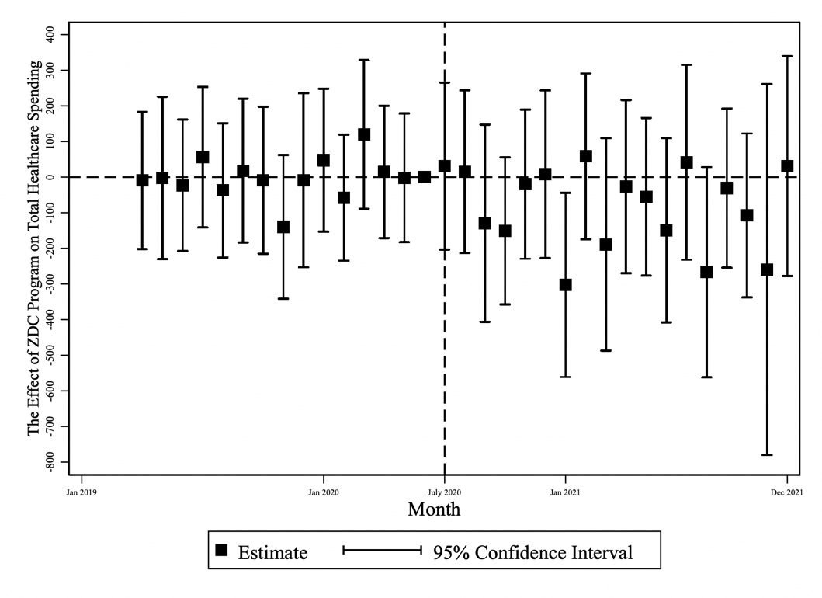
Note: Figure Displays leads and lags coefficients of ZDC program impact from difference-in-difference.
Figure S2. Event study of Impact of ZDC Program on Medical Spending, Pre-ZDC Users
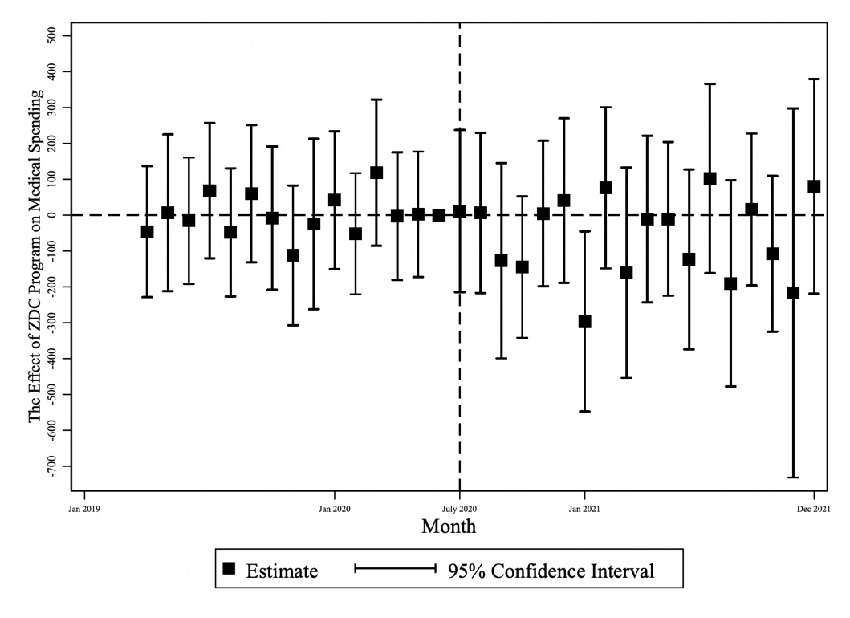
Note: Figure Displays leads and lags coefficients of ZDC program impact from difference-in-difference.

Figure S3. Event study of Impact of ZDC Program on Pharmacy Spending, Pre-ZDC Users
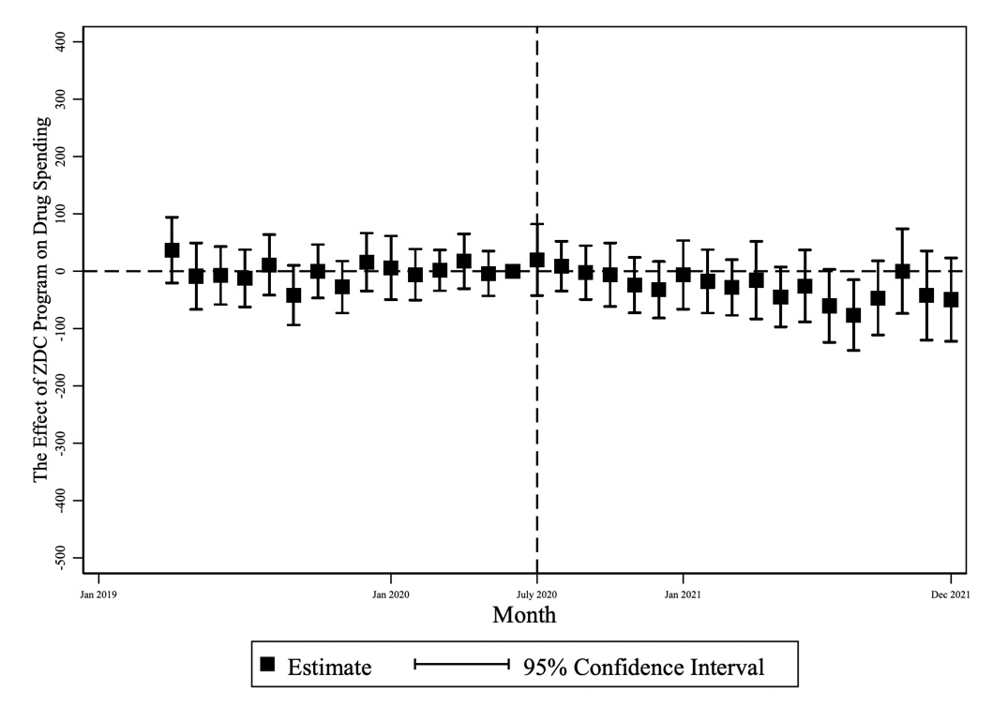
Note: Figure Displays leads and lags coefficients of ZDC program impact from difference-in-difference.

Event Studies for Pre-ZDC Non-Users
Figure S4. Event study of Impact of ZDC Program on Total Healthcare Spending, Pre-ZDC Non-Users
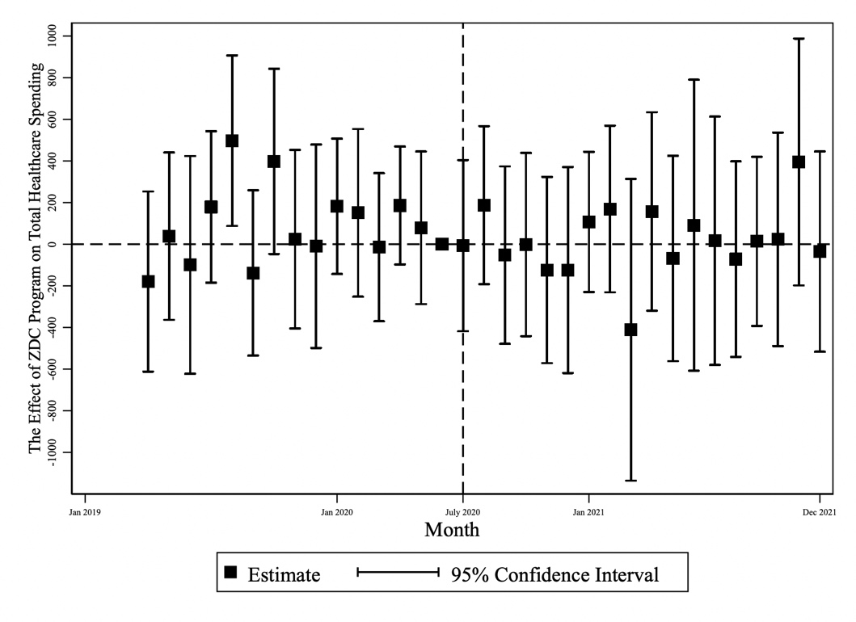
Note: Figure Displays leads and lags coefficients of ZDC program impact from difference-in-difference.

Figure S5. Event study Of Impact of ZDC Program on Medical Spending, Pre-ZDC Non-Users
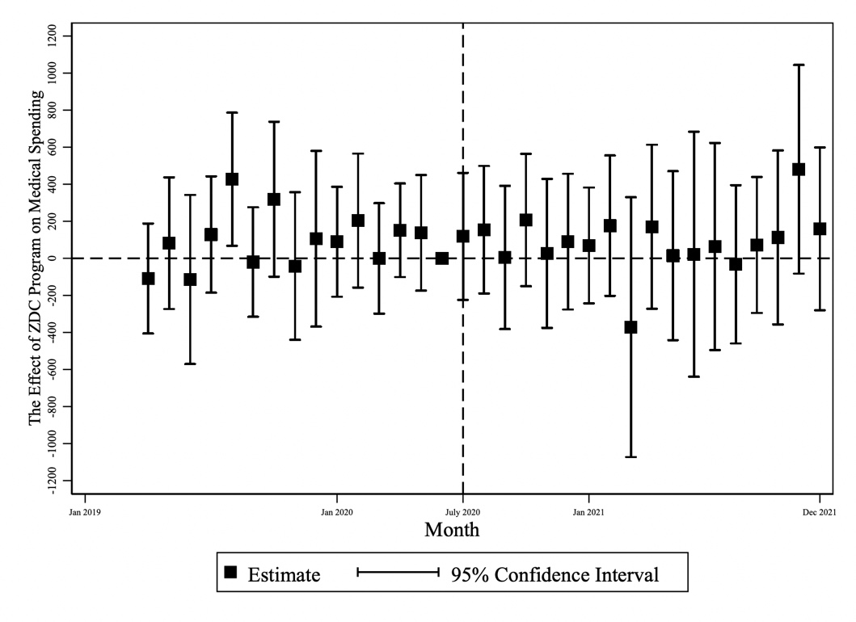
Note: Figure Displays leads and lags coefficients of ZDC program impact from difference-in-difference.
Figure S6. Event study Of Impact of ZDC Program on Pharmacy Spending, Pre-ZDC Non-Users
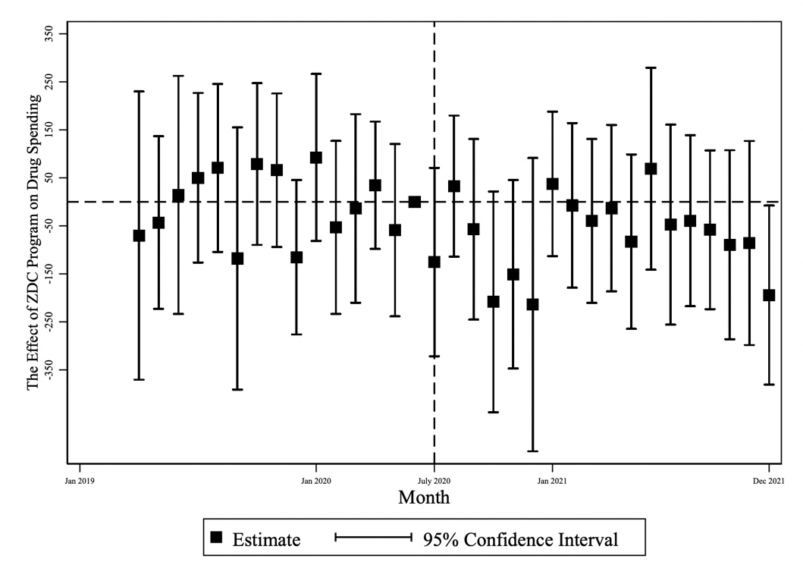
Note: Figure Displays leads and lags coefficients of ZDC program impact from difference-in-difference.

Event Studies for Complex Users
Figure S7. Event study of Impact of ZDC Program on Total Healthcare Spending, Complex Users
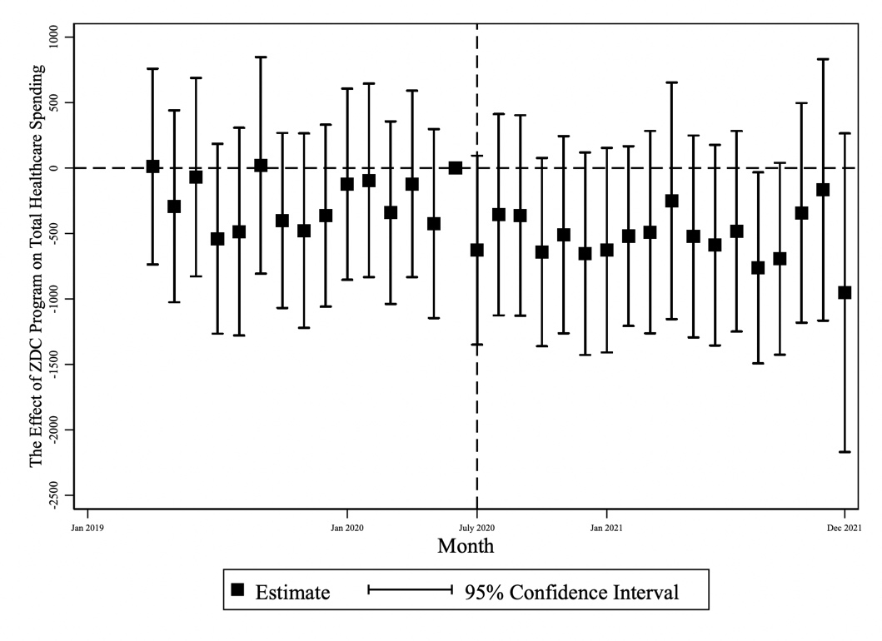
Note: Figure Displays leads and lags coefficients of ZDC program impact from difference-in-difference.
Figure S8. Event study of Impact of ZDC Program on Medical Spending, Complex Users
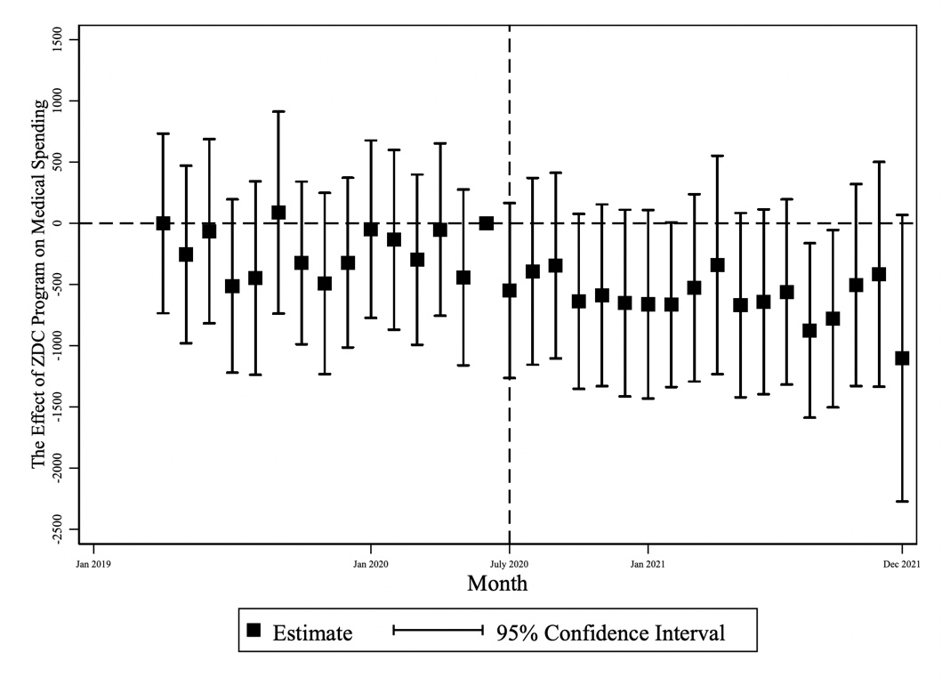
Note: Figure Displays leads and lags coefficients of ZDC program impact from difference-in-difference.

Figure S9. Event study Of Impact of ZDC Program on Pharmacy Spending, Complex Users
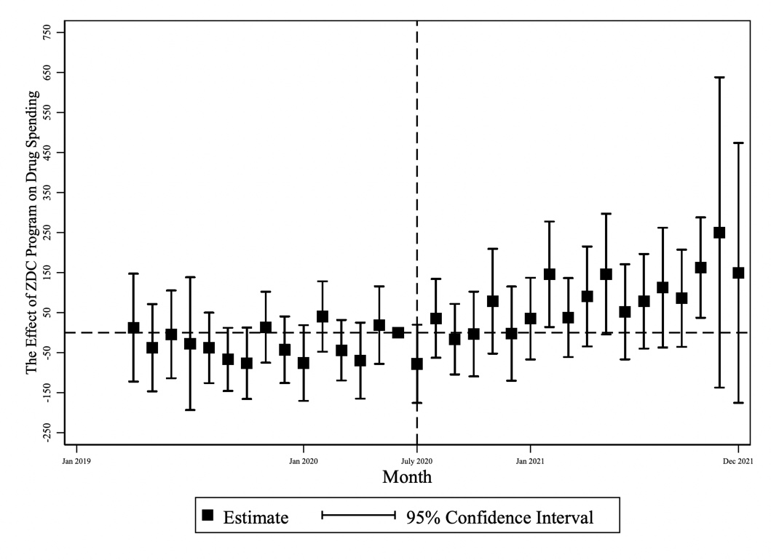
Note: Figure Displays leads and lags coefficients of ZDC program impact from difference-in-difference.

Data Illustration Supporting the Exclusion of the First Three Months in Outcome Analysis
Figure S10. Data Visualization of the Monthly PDC Over Time
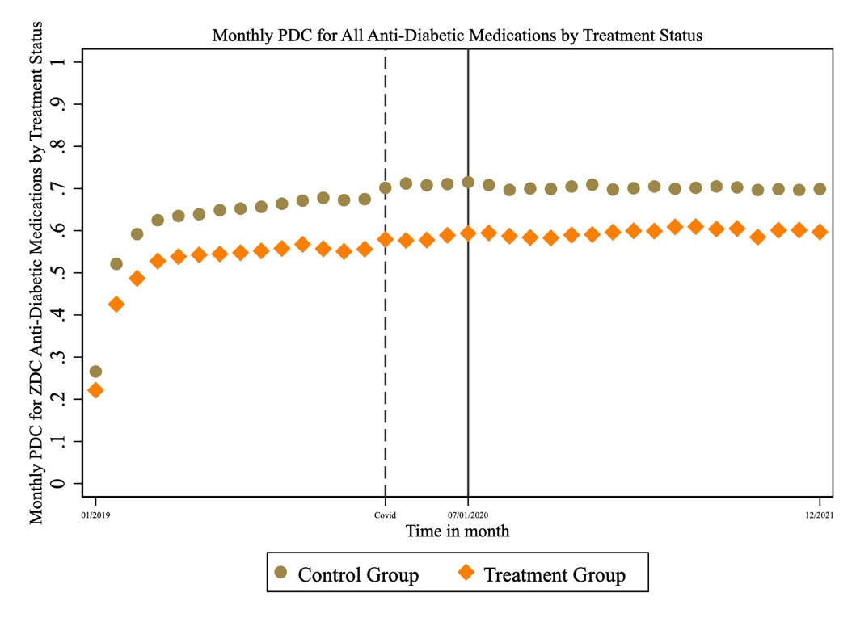
Figure S11.Data Visualization of the Monthly Drug Counts Over Time
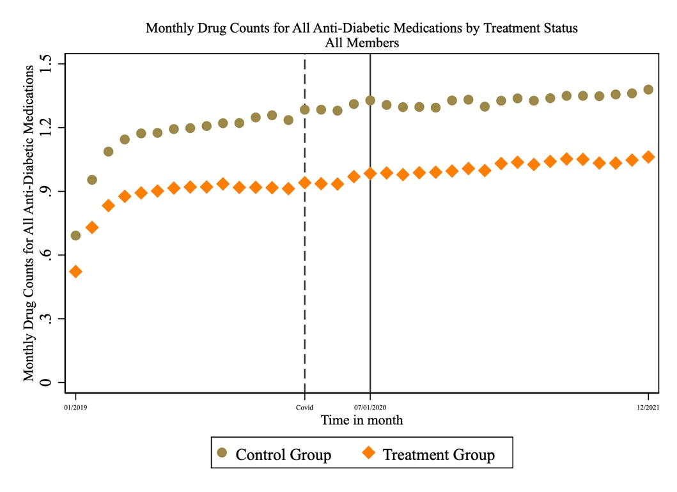
Because our dataset begins on January 1, 2019, we were unable to capture prescription refill dates and days’ supply information for the latter part of 2018. As a result, the PDC/drug count values for the first three months are clearly riddled with data artifacts and, as such, do not represent valid measures. Since monthly monthly drug count were included in our outcome analysis, we removed the data of the first months for analysis consistency.

