Supplemental material
Appendix 1. Decision trees developed to study the cost-effectiveness of the reverse sequence syphilis screening algorithm (panel A) compared to the traditional algorithm (panel B) among pregnant women in prenatal care (PNC).
(A) Traditional algorithm
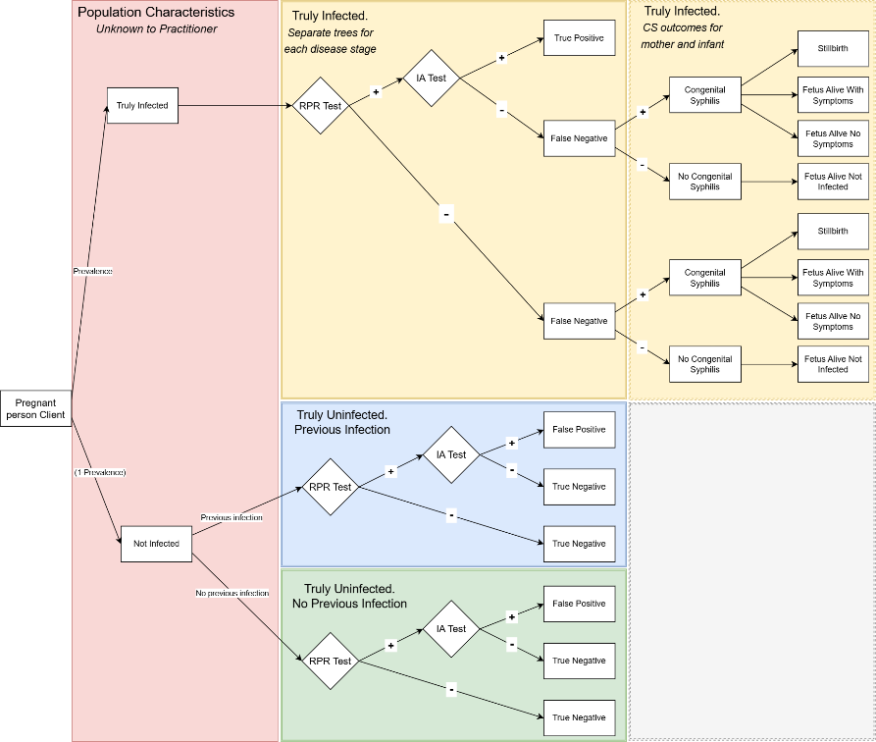
(B) Reverse sequence algorithm
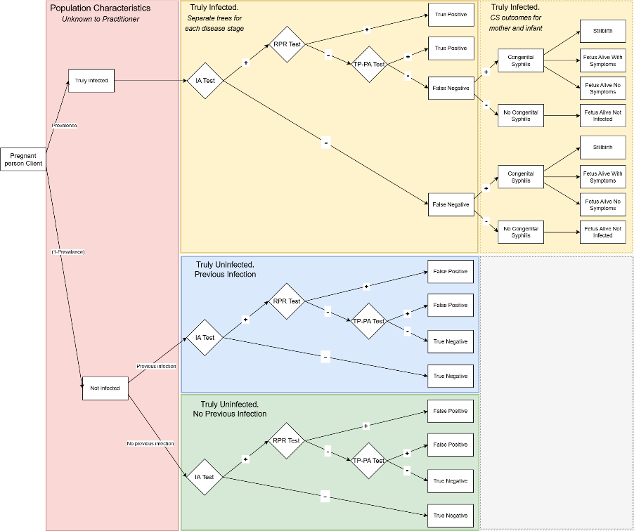

Appendix 2. Estimation of treatment costs per person by syphilis stage and diagnosis.
We extracted the cost (mean and confidence intervals) for all relevant syphilis treatment and associated sequelae from Chesson and Peterman, 2021²⁹ and updated them from 2019 U.S. Dollars (USD) to 2024 USD using the Personal Consumption Expenditures price index for Health Care.¹² We also updated the costs per dose of benzathine penicillin G 2.4 million units, based on the Federal Supply Schedule to $568.2 per shot.³⁰ Since some of the treatment costs will occur in the future, particularly those associated with sequelae due to lack of detection and treatment, we discounted the costs to bring to present value at a 3% annual rate. We followed Chesson and Peterman assumption and did not discount treatment for primary, secondary, or early syphilis (assuming these occur within one year); further, we discounted treatment for unknown duration and late syphilis as well as early neurosyphilis and ocular syphilis for one year, and all long-term sequelae costs for 30 years.²⁹ Table A shows the updated costs per outcome.
Table A. Costs of syphilis treatment per outcome.
Outcome | Base value ($) | Lower bound ($) | Upper bound ($)
Primary and secondary syphilis or early non-primary non-secondary syphilis | 986 | 599 | 1,497
Unknown duration or late syphilis | 2,503 | 1,766 | 3,915
Early neurosyphilis and ocular syphilis | 8,717 | 2,428 | 23,173
Late benign syphilis | 1,405 | 843 | 2,154
Cardiovascular syphilis | 16,436 | 2,950 | 51,226
Tabes dorsalis | 19,058 | 5,525 | 45,514
Meningovascular syphilis | 36,711 | 7,960 | 186,925
General paresis | 61,575 | 15,452 | 135,839
Source: Updated to 2024 U.S. Dollars from Chesson and Peterman 2021.²⁹
Among those diagnosed with a syphilis infection, 3.2% (95%CI 0.4, 7.8%)²⁹ will develop early neurosyphilis or ocular syphilis. We used this probability in combination with the costs estimates from Table A to estimate the base value and confidence interval of the treatment of Primary and Secondary syphilis or early non-Primary nor Secondary syphilis in $986 (95%CI 599, 1,497) and of Unknown duration or late syphilis in $2,503 (95%CI 1,766, 3,915).
For the estimation of the sequelae costs of those who remain untreated, and following the lifetime perspective described by Chesson and Peterman, 2021,²⁹ we need to account for the probability of all possible outcomes, including getting treated for syphilis but not reported as such, being treated inadvertently (at no additional costs related to the syphilitic infection), and remaining untreated and alive for 30 years which leads to several possible sequelae. Among those treated for syphilis but not reported, we assumed that 63% would be Primary and Secondary infections. Table B shows the probabilities per outcome and the associated costs.

Table B. Probabilities and costs per outcome among people with syphilis but not detected during screening.
Outcome | Probability | Adjusted* probability | Mean cost ($) | Lower bound ($) | Upper bound ($) | Contribution – Mean ($) | Contribution – Lower ($) | Contribution – Upper ($)
Treated for syphilis but not reported as a case | 0.725 | 72.5% | 1,826 | 1,040 | 4,199 | 1,324 | 754 | 3,044
Treated inadvertently, or unrelated death within 30 years, or both | 0.242 | 24.2% | 0 | 0 | 0 | 0 | 0 | 0
Alive and still infected after 30+ years: Latent syphilis, no adverse outcomes, no costs incurred | 0.68 | 2.2% | 0 | 0 | 0 | 0 | 0 | 0
Alive and still infected after 30+ years: Treated for late benign syphilis | 0.16 | 0.5% | 1,405 | 843 | 2,154 | 7 | 4 | 11
Alive and still infected after 30+ years: Treated for cardiovascular syphilis | 0.09 | 0.3% | 16,436 | 2,950 | 51,226 | 49 | 9 | 152
Alive and still infected after 30+ years: Treated for tabes dorsalis | 0.02 | 0.1% | 19,058 | 5,525 | 45,514 | 13 | 4 | 30
Alive and still infected after 30+ years: Treated for meningovascular syphilis | 0.03 | 0.1% | 36,711 | 7,960 | 186,925 | 36 | 8 | 185
Alive and still infected after 30+ years: Treated for general paresis | 0.02 | 0.1% | 61,575 | 15,452 | 135,839 | 41 | 10 | 90
Total |  | 100.0% |  |  |  | 1,470 | 789 | 3,513
Source: Based on Chesson and Peterman 2021.²⁹Treatment costs Treatment costs updated to 2024 U.S. Dolars and costs per dose of benzathine penicillin G 2.4 million units to updated to $568.^{12,30}
*Adjusted by the probability of being alive and infected after 30+ years of initial infection, 3.3%.
Mean costs, Lower bound, and upper bound, correspond to the costs updated to 2024 U.S. Dollars and discounted (Table A).
We estimated the costs of untreated in $1,470 (95%CI 789, 3,513) per infection.

Appendix 3. Economic burden of performing contact tracing on all identified syphilis cases, by population.
Using the baseline results we calculated the monetary resources required for contact tracing of all identified positive cases, which is a key activity performed by disease intervention specialists (DIS) in public health departments.³¹ For this analysis we made certain assumptions: 95% of pregnant women will be willing to be interviewed,³² each case provided an average of 1.1 named contacts,³³ and the average time spent with each interviewee is 1.5 hours.³⁴ From these assumptions we calculated the average time a DIS would spend conducting contact tracing per case and converted into monetary values using the national average annual DIS salary and monetary benefits (e.g., tips and cash bonus), $51,188.³⁵ Thus, we determined the resources needed for each algorithm and population group, categorizing them into true positive and false positive cases.
We found that following up cases identified by the reverse sequence algorithm would cost twice as much compared to the traditional algorithm, $47,094 vs. $26,247 (Figure A). However, when considering contact tracing of true positive cases only, there were minimal differences across algorithms. The significant disparity lies in resources allocated for follow-up with false positive cases, where there was a two-fold difference. Therefore, implementing the reverse sequence algorithm led to a much less efficient use of DIS resources.
Figure A. Resources needed for disease intervention specialists (DIS) to conduct contact-tracing activities based on the number of positive cases identified by each of the syphilis screening algorithms.
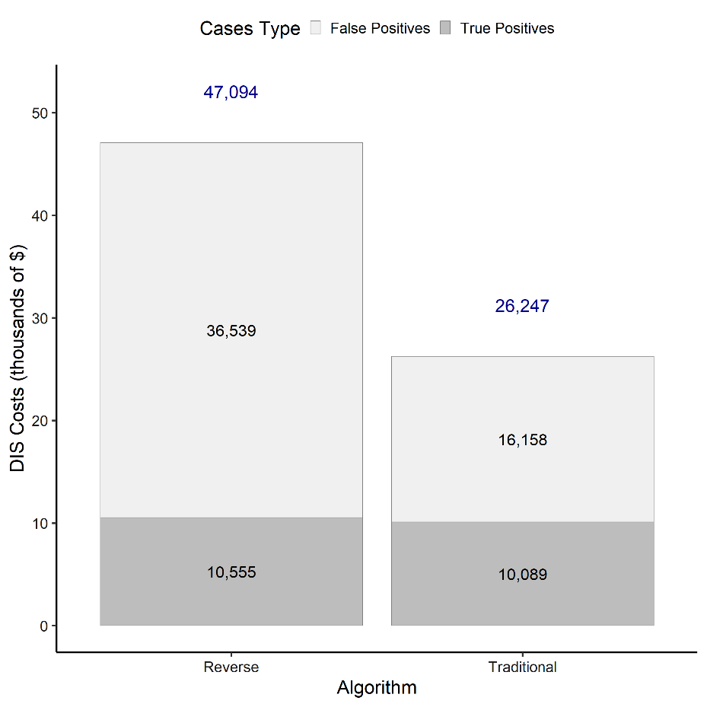
Costs are expressed in 2024 U.S. Dollars. Values are rounded to the nearest integer.
Appendix 4. Threshold analysis on the RPR test costs to further investigate the potential of the reverse sequence algorithm to be cost-effective.

We performed a threshold analysis to determine the minimum rapid plasma regain (RPR) test cost required for the reverse sequence algorithm to be considered cost-effective. This analysis helps identify the level at which the reverse sequence algorithm becomes favorable compared to the traditional algorithm.
We found that a cost of $60 per test would generate the necessary conditions for the reverse sequence algorithm to be cost-effective compared to the traditional algorithm. This cost is many times higher than the base cost of $6 per RPR test (Table 1).

Appendix 5. Results of the probabilistic sensitivity analysis (PSA) comparing the Reverse sequence and Traditional algorithms for syphilis screening and congenital syphilis prevention among pregnant women receiving prenatal care (PNC). The figure displays 1,000 simulations of the incremental differences in quality-adjusted life years (QALYs) (x-axis) and costs (y-axis).
All points fall in the northeast (first) quadrant, indicating that the Reverse sequence algorithm is both more costly and more effective than the Traditional algorithm. The red line denotes a $50,000 per QALY gained cost-effectiveness threshold, used in this study for illustrative purposes. In 979 of 1,000 simulations (98%), the Reverse sequence yielded an incremental cost-effectiveness ratio (ICER) exceeding this threshold (i.e., plotted above the red line), suggesting it would not be considered cost-effective under this benchmark in most scenarios.
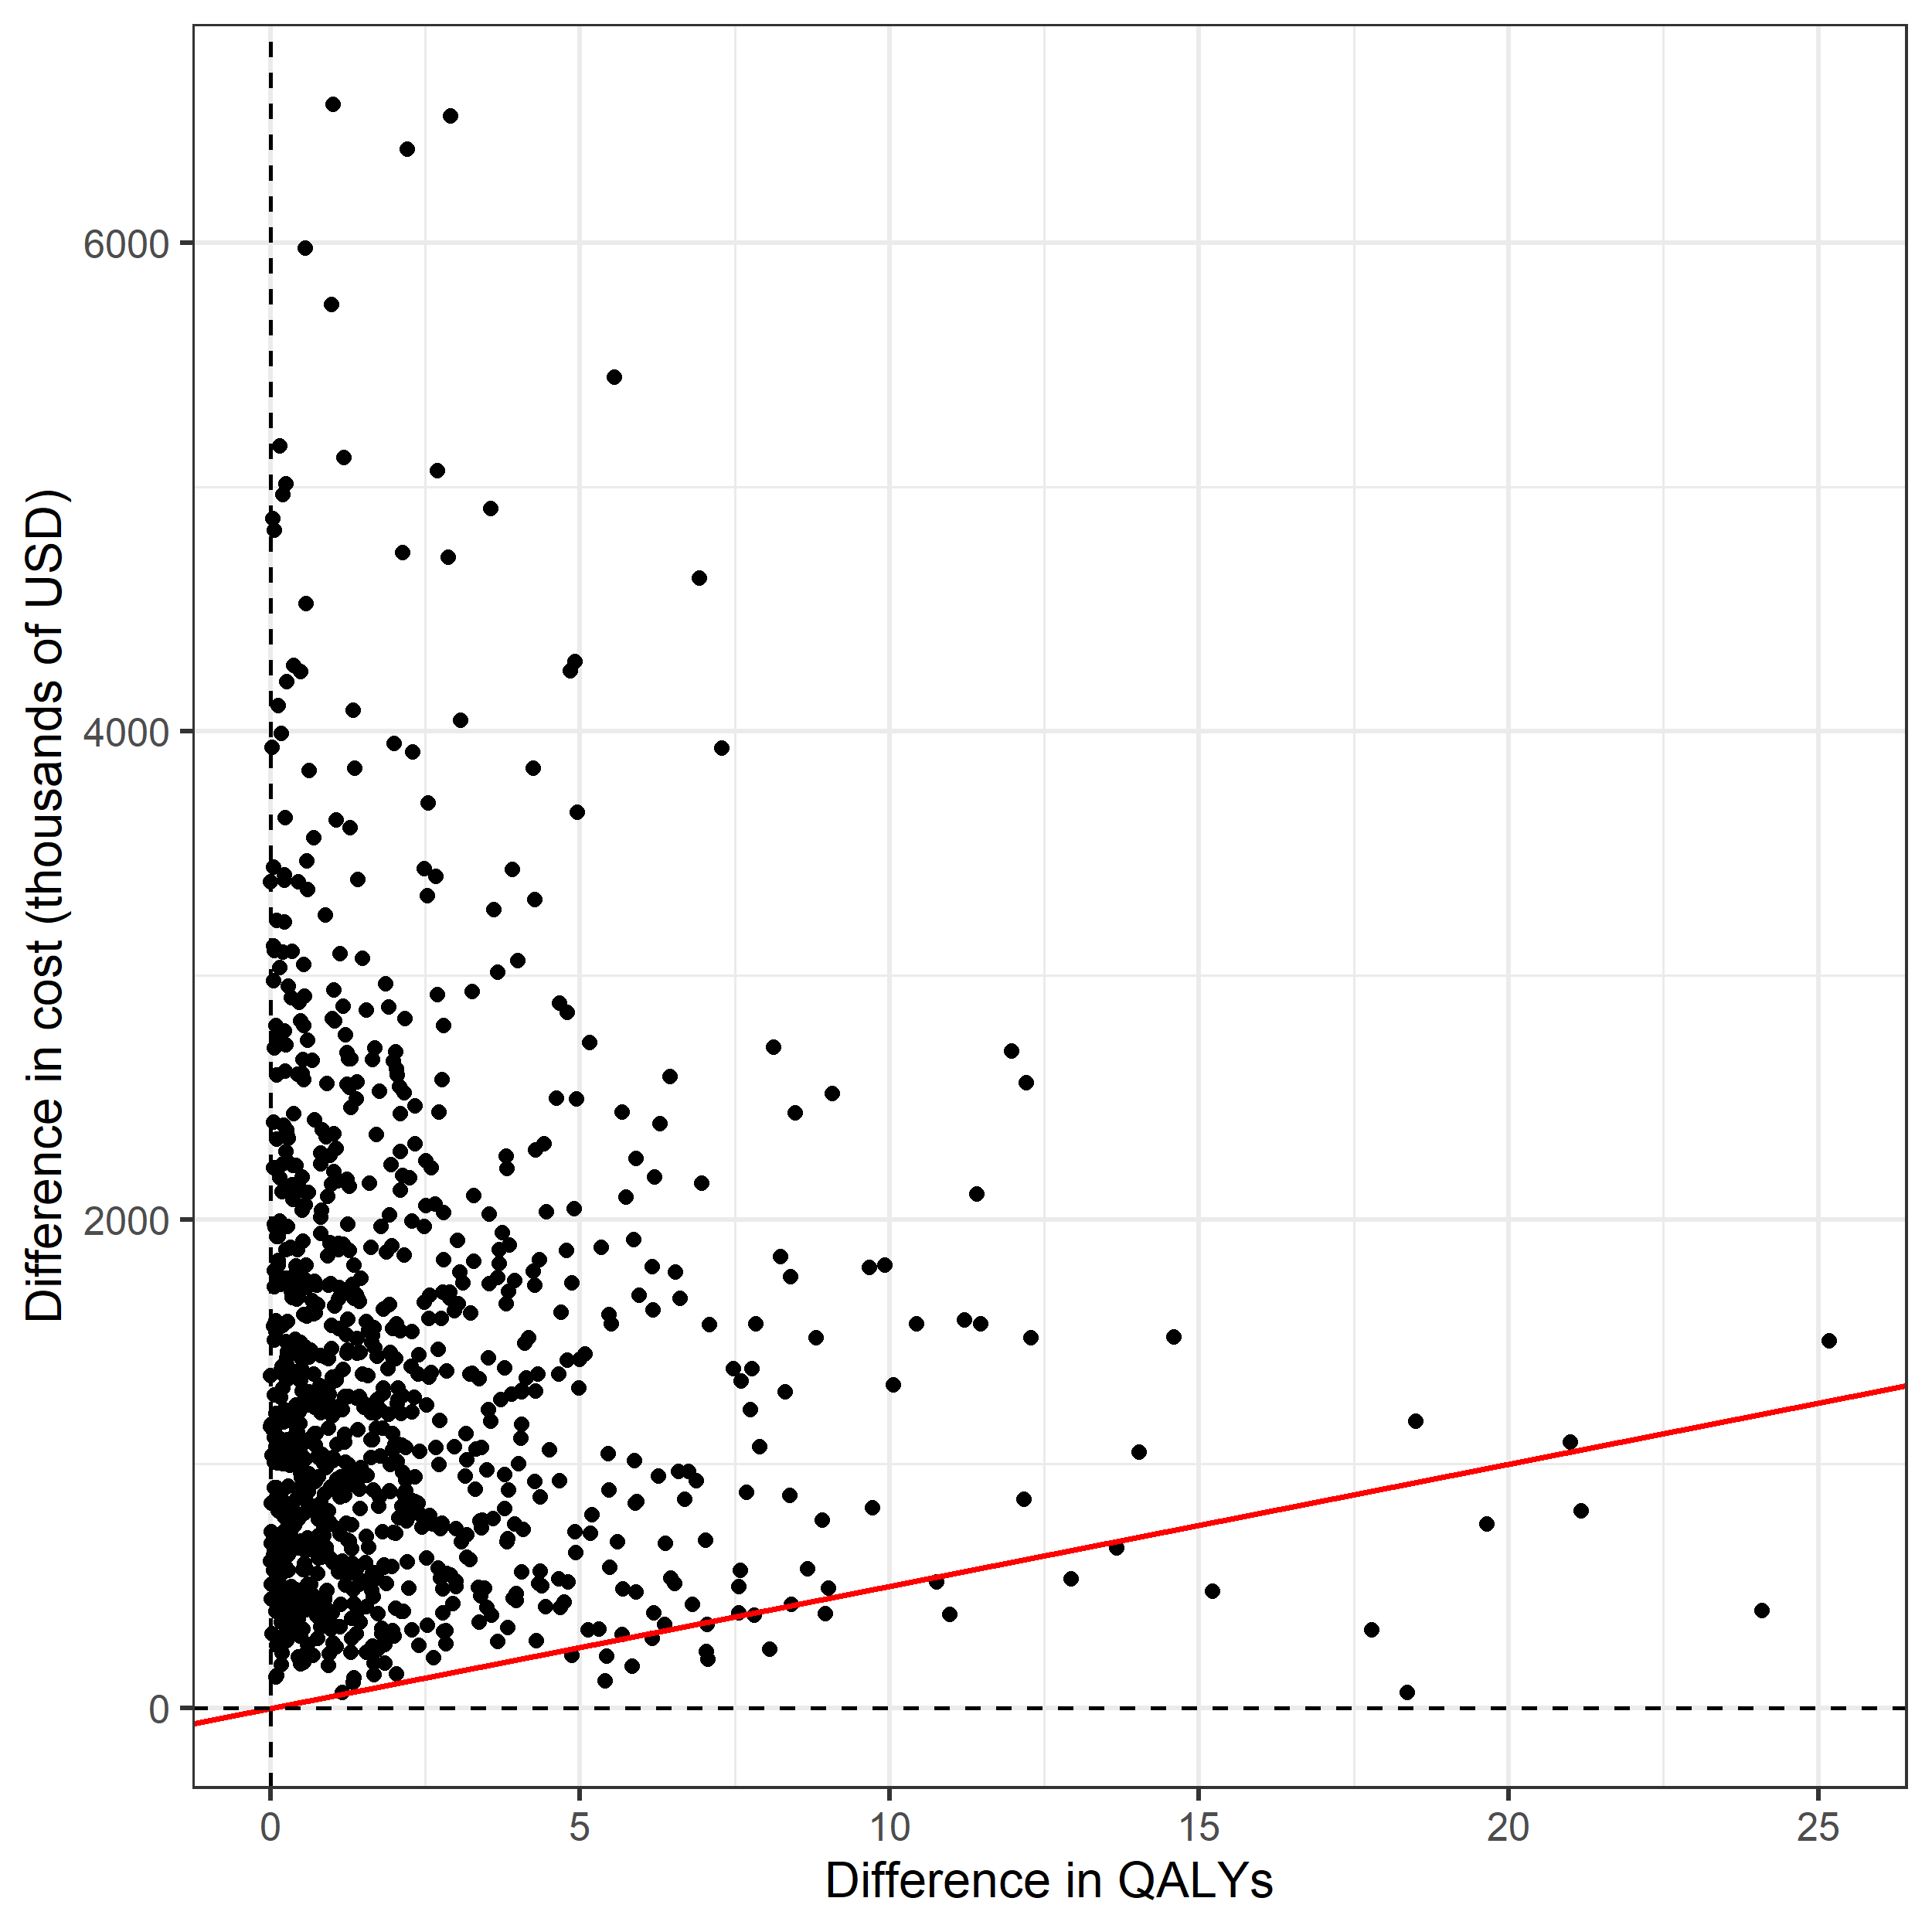
Appendix 6. Treatment costs accrued by the reverse sequence and traditional algorithms for syphilis screening, broken down into stages of infection and false positive cases, among pregnant women in prenatal care (PNC).
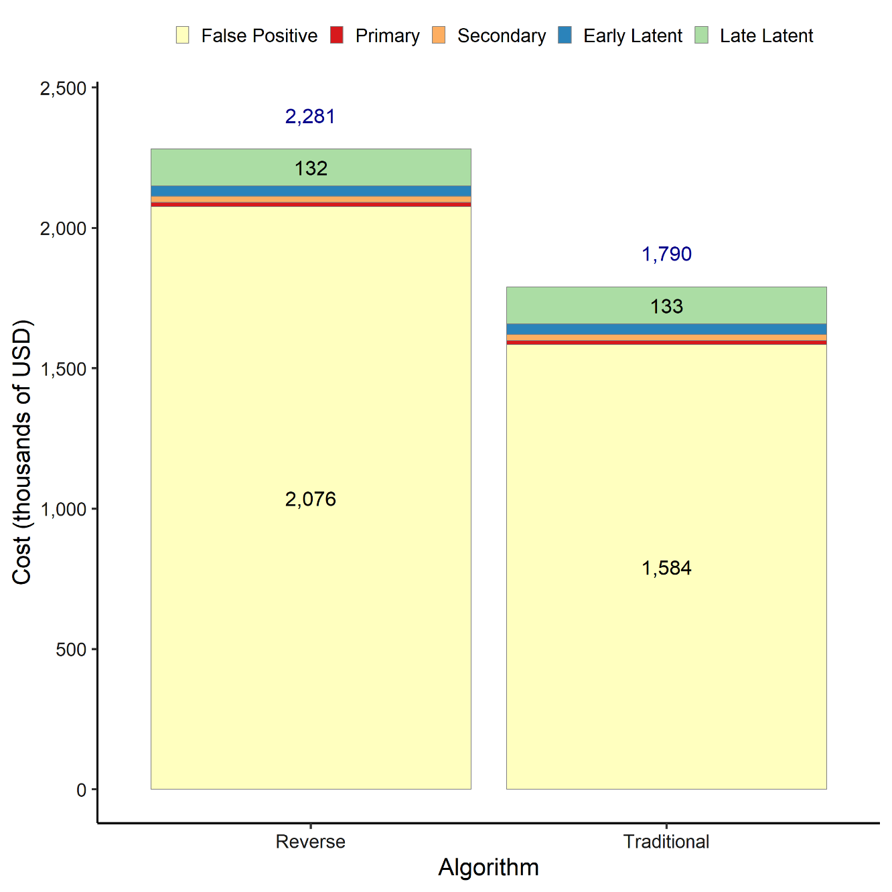
Labels shown for the two main categories in each bar, treatment costs for false positive and late latent cases.
Costs are expressed in 2024 U.S. Dollars.
Appendix 7. Univariate sensitivity analysis for the extended range of the prevalence of syphilis (from 0% to 100%) for the cost-effectiveness of the reverse sequence algorithm for syphilis screening compared to the traditional algorithm among pregnant women undergoing prenatal care (PNC).
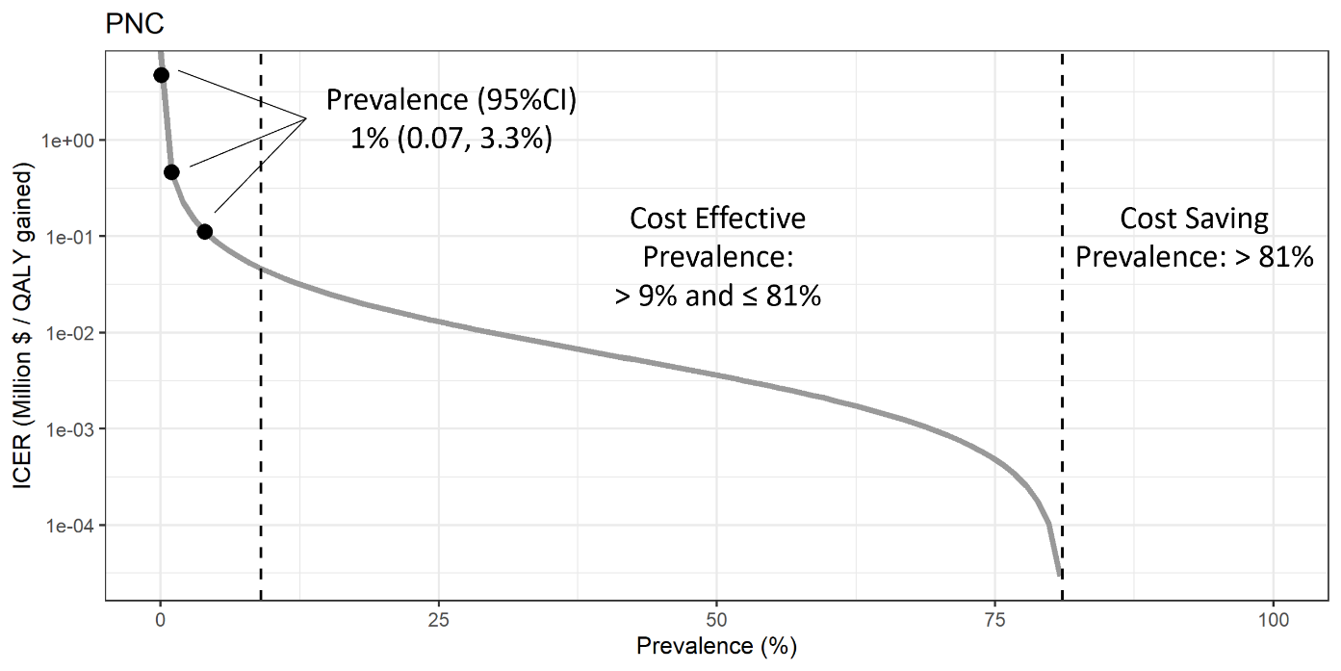
The dots represent the base values (mean and 95% confidence intervals), and the side dots represent the feasible uncertainty range for the Prevalence parameter among pregnant women in prenatal care (PNC).
We found that a prevalence of syphilis of 9% or higher among pregnant women would make the reverse sequence cost-effective compared to the traditional algorithm. In addition, at a prevalence of 81% or higher, the reverse sequence is cheaper and more effective, i.e., cost-saving, than the traditional algorithm.
Appendix 8. Classification trees to identify under which parameters’ values the reverse sequence algorithm for syphilis screening is cost-effective compared to the traditional algorithm among pregnant women undergoing prenatal care (PNC). Parameters included in the analysis were selected for having important variation across settings and being highly influential over the incremental cost-effectiveness ratio. The parameters were varied beyond the feasible uncertainty bounds to study a broader parameters space.
