Table S1: Additional characteristics of Vibrio vulnificus cases reported to COVIS between 2000-2022 by transmission route (defined as confirmed or probable foodborne transmission, confirmed or probable non-foodborne transmission, or unknown).
 | All cases (%)  N=2,989 | Foodborne (%)  n=656 (21.9%) | Non-foodborne (%)  n=1,619 (54.2%) | Unknown (%)  n=714 (23.9%)
Travel outside home state
Yes | 421 (14.1%) | 112 (17.1%) | 208 (12.9%) | 101 (14.1%)
No | 2,073 (69.3%) | 480 (73.2%) | 1,169 (72.2%) | 424 (59.4%)
Unknown | 495 (16.6%) | 64 (9.8%) | 242 (14.9%) | 189 (26.5%)
Specimen source
Blood* | 1,943 (65.0%) | 486 (74.1%) | 796 (49.2%) | 661 (92.6%)
Skin or soft tissue | 793 (26.5%) | 33 (5.0%) | 760 (46.9%) | 0 (0.0%)
Gastrointestinal | 119 (4.0%) | 113 (17.2%) | 6 (0.4%) | 0 (0.0%)
Other non-sterile | 24 (0.8%) | 3 (0.5%) | 5 (0.3%) | 16 (2.2%)
Multiple (non-blood) | 4 (0.1%) | 0 (0.0%) | 1 (0.1%) | 3 (0.4%)
Unknown | 106 (3.6%) | 21 (3.2%) | 51 (3.2%) | 34 (4.8%)
Vomiting
Yes | 712 (23.8%) | 256 (39.0%) | 266 (16.4%) | 190 (26.6%)
No | 1,465 (49.0%) | 274 (41.8%) | 900 (55.6%) | 291 (40.8%)
Unknown | 812 (27.2%) | 126 (19.2%) | 453 (28.0%) | 233 (32.6%)
Diarrhea
Yes | 644 (21.6%) | 315 (48.0%) | 169 (10.4%) | 160 (22.4%)
No | 1,483 (49.6%) | 210 (32.0%) | 965 (59.6%) | 308 (43.1%)
Unknown | 862 (28.8%) | 131 (20.0%) | 485 (30.0%) | 246 (34.5%)
Visible blood in stools
Yes | 89 (3.0%) | 47 (7.1%) | 17 (1.0%) | 25 (3.5%)
No | 1,774 (59.3%) | 377 (57.5%) | 1,029 (63.6%) | 368 (51.5%)
Unknown | 1,126 (7.7%) | 232 (35.4%) | 573 (35.4%) | 321 (45.0%)
Abdominal cramps
Yes | 504 (16.9%) | 255 (38.9%) | 105 (6.5%) | 114 (20.2%)
No | 1,476 (49.4%) | 219 (33.4%) | 961 (59.4%) | 296 (41.4%)
Unknown | 1,009 (33.7%) | 182 (27.7%) | 55 (34.1%) | 274 (8.4%)
Fever (>100.4F or 38C)
Yes | 1,551 (51.8%) | 379 (57.8%) | 812 (50.2%) | 360 (50.4%)
No | 719 (24.1%) | 157 (23.9%) | 421 (26.0%) | 141 (19.8%)
Unknown | 719 (24.1%) | 120 (18.3%) | 386 (23.8%) | 213 (29.8%)
Muscle Pain
Yes | 858 (28.7%) | 208 (31.7%) | 440 (27.2%) | 210 (29.4%)
No | 1,061 (35.5%) | 240 (36.6%) | 615 (38.0%) | 206 (28.9%)
Unknown | 1,070 (35.8%) | 208 (31.7%) | 564 (34.8%) | 298 (41.7%)
Septic shock
Yes | 813 (27.2%) | 218 (33.2%) | 361 (22.3%) | 234 (32.8%)
No | 1,218 (40.8%) | 249 (38.0%) | 744 (46.0%) | 225 (31.5%)
Unknown | 958 (32.0%) | 189 (28.8%) | 514 (31.7%) | 255 (35.7%)
Cellulitis
Yes | 1,795 (60.0%) | 214 (32.6%) | 1,212 (74.9%) | 369 (51.7%)
No | 594 (19.9%) | 256 (39.0%) | 193 (11.9%) | 145 (20.3%)
Unknown | 600 (20.1%) | 186 (28.4%) | 214 (13.2%) | 200 (28.0%)
Bullae
Yes | 774 (25.9%) | 142 (21.7%) | 474 (29.3%) | 158 (22.1%)
No | 1,117 (37.4%) | 290 (44.2%) | 588 (36.3%) | 239 (33.5%)
Unknown | 1,098 (36.7%) | 224 (34.1%) | 557 (34.4%) | 317 (44.4%)
*Includes cases with multiple sources if any of them included blood as a source

Table S2: Summary of case latitude statistics among non-foodborne Vibrio vulnificus cases reported from or linked to travel to the East Coast between 1988-2022. Reported statistics for each five-year time block include number of cases reported within this category, maximum latitude for all included cases, 99th percentile of case latitudes (excluding the top 1% of latitude values), 95th percentile of case latitudes (excluding the top 5% of latitude values), mean case latitude, and median case latitude.

 | n | Maximum case latitude | p99* | p95** | Mean case latitude | Median case latitude
1988-1992 | 56 | 30.85 | 30.85 | 30.79 | 29.42 | 29.86
1993-1997 | 88 | 35.02 | 35.02 | 30.79 | 29.34 | 29.79
1998-2002 | 123 | 38.11 | 37.11 | 35.78 | 30.22 | 30.07
2003-2007 | 231 | 41.46 | 39.88 | 39.01 | 31.32 | 30.07
2008-2012 | 238 | 43.85 | 41.83 | 40.87 | 32.44 | 30.58
2013-2017 | 390 | 43.85 | 41.81 | 39.89 | 32.62 | 30.51
2018-2022 | 430 | 42.67 | 42.16 | 40.44 | 32.12 | 30.42
*99th percentile of case latitudes; **95th percentile of case latitudes

Table S3: Summary of transmission route-related exposures among Vibrio vulnificus cases reported to COVIS between 2000-2022, overall and by reported mortality status.^ Associations with mortality status are calculated using bivariate chi-square tests.
Foodborne transmission** | All cases (%)  N=656* | Patient died (%) n=260* | Patient not die (%) n=350* | P
Any seafood consumption | 623 (98.3%) | 257 (100.0%) | 332 (97.1%) | 0.006
Shrimp | 174 (38.2%) | 62 (38.5%) | 99 (36.0%) | 0.6
Fish | 129 (30.1%) | 49 (31.6%) | 72 (28.4%) | 0.5
Lobster | 26 (6.1%) | 12 (7.9%) | 14 (5.5%) | 0.3
Crawfish | 18 (4.3%) | 6 (4.1%) | 11 (4.4%) | 0.9
Bivalve consumption
Any bivalve | 532 (86.6%) | 231 (93.5%) | 274 (82.5%) | <0.001
Oysters | 501 (83.9%) | 220 (90.5%) | 259 (79.9%) | 0.001
Clams | 64 (14.8%) | 25 (16.2%) | 33 (12.8%) | 0.3
Mussels | 32 (7.6%) | 16 (10.4%) | 15 (6.0%) | 0.1
Scallops | 1 (0.9%) | 0 (0.0%) | 1 (1.3%) | 0.6
Raw seafood consumption
Any raw seafood | 469 (81.0%) | 205 (86.9%) | 241 (77.5%) | 0.005
Raw shrimp | 11 (2.6%) | 5 (3.4%) | 6 (2.3%) | 0.5
Raw fish | 26 (6.5%) | 7 (4.9%) | 16 (6.7%) | 0.5
Raw lobster | 1 (0.2%) | 0 (0.0%) | 1 (0.4%) | 0.4
Raw crawfish | - | - | - | -
Raw bivalve consumption
Any raw bivalve | 451 (78.9%) | 200 (88.1%) | 230 (73.7%) | <0.001
Raw oysters | 435 (78.1%) | 192 (86.1%) | 224 (73.4%) | <0.001
Raw clams | 27 (6.4%) | 14 (9.3%) | 10 (4.0%) | 0.03
Raw mussels | 7 (1.7%) | 4 (2.7%) | 3 (1.2%) | 0.3
Raw scallops | - | - | - | -
Non-foodborne transmission | All cases (%)  N=1,619* | Patient died (%) n=200* | Patient not die (%) n=1,268* | P
Any water/marine exposure | 1,509 (98.2%) | 174 (96.7%) | 1,210 (98.4%) | 0.1
Exposure to any body of water | 1,417 (94.0%) | 154 (88.5%) | 1,145 (94.6%) | 0.002
Salt | 741 (54.9%) | 81 (55.9%) | 604 (54.9%) | 0.8
Brackish | 434 (32.1%) | 31 (21.4%) | 367 (33.4%) | 0.004
Fresh | 43 (3.2%) | 5 (3.4%) | 35 (3.2%) | 0.8
Other | 42 (3.1%) | 8 (5.5%) | 28 (2.5%) | 0.05
Exposure to drippings from live seafood | 588 (50.1%) | 48 (56.5%) | 494 (49.5%) | 0.2
Exposure to any marine life | 385 (36.6%) | 32 (42.7%) | 324 (36.2%) | 0.3
Had an exposed wound | 1,230 (86.4%) | 120 (81.1%) | 1,015 (87.4%) | 0.03
Sustained a wound | 755 (54.2%) | 56 (37.8%) | 640 (56.5%) | <0.001
Had a pre-existing wound | 346 (24.8%) | 45 (30.4%) | 273 (24.1%) | 0.1
Uncertain | 100 (7.2%) | 19 (12.8%) | 73 (6.5%) | 0.005
^Cases with unknown mortality analysis were excluded; *Analytic denominator varies by variable due to missingness and non-response; **Whether patient consumed item in 7 days prior to illness; respondents can have answered yes to multiple items

Table S4: Factors associated with mortality among Vibrio vulnificus cases reported to COVIS between 2000-2022 using bivariate chi-square tests.^
 | All cases  N=2,989* |  | Foodborne Transmission  n=656* |  | Non-foodborne Transmission  n=1,619*
 | OR (95% CI) | P | OR (95% CI) | P | OR (95% CI) | P
Demographic Characteristics
Age group (years)
<30 | Ref |  | Ref**** |  | Ref****
30-44 | 8.1 (3.6, 18.0) | <0.001 | Ref**** |  | Ref****
45-59 | 12.4 (5.7,26.9) | <0.001 | 1.4 (0.81, 2.3) | 0.3 | 4.2 (2.4, 7.4) | <0.001
60-74 | 5.3 (2.4, 11.5) | <0.001 | 0.78 (0.45, 1.3) | 0.4 | 1.7 (0.96, 3.0) | 0.07
75+ | 5.2 (2.4.11.4) | <0.001 | 0.81 (0.45, 1.5) | 0.5 | 2.0 (1.1, 3.7) | 0.007
Sex
Female | Ref |  | Ref |  | Ref
Male | 0.95 (0.75, 1.2) | 0.7 | 1.4 (0.92, 2.1) | 0.1 | 1.1 (0.72, 1.7) | 0.6
Race/Ethnicity
White | Ref |  | Ref |  | Ref
Hispanic/Latino | 2.1 (1.5, 2.8) | <0.001 | 1.4 (0.82, 2.3) | 0.2 | 1.4 (0.72, 2.6) | 0.3
Black/African American | 2.4 (1.7, 3.3) | <0.001 | 1.1 (0.63, 2.1) | 0.6 | 1.6 (0.80, 3.1) | 0.2
Asian | 2.3 (1.5, 3.5) | <0.001 | 1.7 (0.8, 3.5) | 0.1 | 1.4 (0.53, 3.7) | 0.7
Other** | 0.68 (0.30, 1.5) | 0.4 | 0.43 (0.09, 2.1) | 0.3 | 1.0 (0.30, 3.4) | 0.9
Geographic region of residence
Atlantic | Ref |  | Ref |  | Ref
Gulf Coast | 1.5 (1.2, 1.8) | <0.001 | 1.0 (0.69, 1.5) | 0.9 | 1.8 (1.2, 2.6) | 0.002
Noncoastal | 2.4 (1.7, 3.3) | <0.001 | 1.2 (0.69, 1.9) | 0.5 | 2.5 (1.2, 5.2) | 0.02
Pacific | 1.9 (1.3, 2.9) | 0.001 | 1.4 (0.70, 2.6) | 0.4 | 1.6 (0.75, 3.3) | 0.2
Transmission characteristics
Foodborne transmission route*** | 4.7 (3.8, 5.9) | <0.001 | - |  | -
Travel outside home state | 1.0 (0.80, 1.3) | 0.8 | 1.1 (0.73, 1.7) | 0.6 | 1.2 (0.73, 1.9) | 0.5
Clinical characteristics
Taken antibiotics | 0.24 (0.16, 0.36) | <0.001 | 0.80 (0.43, 1.5) | 0.5 | 0.13 (0.06, 0.27) | <0.001
Pre-existing conditions
Liver disease | 7.9 (6.4, 9.8) | <0.001 | 2.9 (2.0, 4.3) | <0.001 | 10.8 (7.5, 15.8) | <0.001
Alcoholism | 6.2 (5.0, 7.7) | <0.001 | 3.1 (2.1, 4.5) | <0.001 | 6.4 (4.4, 9.2) | <0.001
Kidney disease | 2.2 (1.7, 2.8) | <0.001 | 1.2 (0.78, 1.9) | 0.4 | 2.6 (1.7, 4.1) | <0.001
Heart disease | 1.3 (1.0, 1.6) | 0.02 | 1.3 (0.85, 1.9) | 0.3 | 1.7 (1.2, 2.4) | 0.003
Diabetes | 1.2 (1.0, 1.5) | 0.05 | 0.72 (0.49, 1.1 | 0.1 | 1.4 (0.95, 2.0) | 0.09
Hematologic disease | 2.1 (1.5, 3.0) | <0.001 | 1.3 (0.77, 2.2) | 0.3 | 2.8 (1.6, 5.0) | 0.001
Cancer | 1.4 (1.1, 1.9) | 0.009 | 1.2 (0.76, 2.0) | 0.4 | 2.0 (1.3, 3.1) | 0.003
Gastric surgery | 1.9 (1.3, 2.7) | <0.001 | 0.81 (0.47, 1.4) | 0.5 | 2.6 (1.3, 5.5) | 0.01
Ulcer | 2.5 (1.7, 3.9) | <0.001 | 2.0 (1.0, 3.8) | 0.04 | 2.3 (1.0, 5.5) | 0.05
Took antacid/ulcer medication | 1.1 (0.74, 1.8) | 0.5 | 0.99 (0.47, 2.1) | 0.9 | 1.1 (0.49, 2.5) | 0.8
Immunosuppressive condition | 1.6 (1.1, 2.2) | 0.007 | 0.92 (0.53, 1.6) | 0.8 | 1.8 (0.96, 3.4) | 0.07
Immunosuppressive therapy | 1.6 (1.0, 2.4) | 0.05 | 1.5 (0.63, 3.3) | 0.4 | 2.1 (1.0, 4.3) | 0.04
^Separate bivariate comparisons were run for all cases, cases with confirmed or probable foodborne transmission, and cases with confirmed or probable non-foodborne transmission. Comparisons were not run separately for cases with unknown transmission type
*Analytic denominator varies by variable due to missingness and non-response; **Includes native Hawaiian/pacific islander, American Indian/Alaska Native, and all who selected Other; ***Reference group is non-foodborne or unknown transmission route; ****Reference group is age <45 due to small sample size of <30 age group
Table S5: Factors associated with mortality among Vibrio vulnificus cases reported to COVIS between 2000-2022 using multivariate logistic regression models, stratified by transmission route (defined as confirmed or probable foodborne transmission, confirmed or probable non-foodborne transmission, or unknown).

Participant Characteristic | Foodborne N=375 |  |  | Non-Foodborne N=988
 | OR | 95% CI | P value | PRR | 95% CI | P value
History of liver disease or alcoholism | 2.6 | 1.6, 4.6 | <0.001 | 7.1 | 4.3, 11.8 | <0.001
History of diabetes | 1.1 | 0.52, 2.5 | 0.7
Interaction of liver/alcoholism x diabetes | 0.35 | 0.13, 0.98 | 0.05
History of ulcer | 2.7 | 1.2, 6.1 | 0.01
History of kidney disease |  |  |  | 3.0 | 1.7, 5.5 | <0.001
Taken antibiotics |  |  |  | 0.11 | 0.04, 0.33 | <0.001
Age <45* |  |  |  | Ref
Age 45-59 |  |  |  | 2.3 | 1.0, 5.3 | 0.05
Age 60-75 |  |  |  | 1.6 | 0.68, 3.6 | 0.3
Age 75+ |  |  |  | 2.6 | 1.1, 6.1 | 0.03
Residence in Gulf Coast region |  |  |  | 1.7 | 1.0, 3.0 | 0.05
Eaten raw bivalves in past 7 days | 3.4 | 1.8, 6.5 | <0.001
Exposure to any body of water |  |  |  | 0.37 | 0.18, 0.73 | 0.004
Sustained a wound during exposure |  |  |  | 0.45 | 0.27, 0.73 | 0.001
* Reference group is age <45 due to small sample size of <30 age group in stratified analyses

Table S6: Combined parameter estimates across 10 imputed data sets for multivariate logistic regression of factors associated with mortality among Vibrio vulnificus cases reported to COVIS between 2000-2022. (Total N=29,290 across all imputed data sets, each model n=2,989)
Participant Characteristic | OR | 95% CI | P
History of liver disease | 4.4 | 3.1, 6.2 | <0.001
History of diabetes | 1.1 | 0.75, 1.6 | 0.6
Interaction: (liver disease) x diabetes | 0.5 | 0.33, 0.87 | 0.01
History of alcoholism | 2.2 | 1.6, 3.0 | <0.001
History of heart disease | 1.4 | 1.1, 1.8 | 0.005
History of cancer | 1.4 | 1, 1.9 | 0.04
Taken antibiotics | 0.25 | 0.15, 0.41 | 0.003
Foodborne transmission route | 1.9 | 1.5, 2.5 | <0.001
Age <30
Age 30-44 | 3.4 | 1.5, 7.7 | 0.003
Age 45-59 | 3.8 | 1.8, 8.3 | <0.001
Age 60-74 | 2.9 | 1.3, 6.5 | 0.008
Age 75+ | 3.7 | 1.6, 8.5 | 0.002
Residence in Atlantic region
Gulf Coast region | 1.5 | 1.1, 1.8 | 0.002
Noncoastal region | 1.7 | 1.1, 2.5 | 0.009
Pacific region | 1.5 | 0.92, 2.4 | 0.1
White/Caucasian
Black/African American | 2.1 | 1.4, 3.1 | <0.001
Hispanic/Latino | 1.3 | 0.89, 1.9 | 0.2
Asian | 2.1 | 1.2, 3.6 | 0.009
Other race/ethnicity | 1.1 | 0.49, 2.4 | 0.8

Table S7: Combined parameter estimates across 10 imputed data sets for multivariate logistic regression of factors associated with mortality among Vibrio vulnificus cases reported to COVIS between 2000-2022, stratified by transmission type (defined as confirmed or probable foodborne transmission, confirmed or probable non-foodborne transmission, or unknown transmission type). (Total N=29,290 across all imputed data sets, each model n=2,989).
Participant Characteristic | Foodborne |  |  |  | Non-Foodborne
 | OR | 95% CI |  | P value | OR | 95% CI |  | P value
History of liver disease | 2.6 | 1.6 | 4.3 | 0.003 | 4.1 | 2.6 | 6.5 | <0.001
History of diabetes | 1.0 | 0.49 | 2.1 | 0.9
Interaction of liver disease x diabetes | 0.58 | 0.26 | 1.3 | 0.2
History of alcoholism | 2.1 | 1.4 | 3.1 | <0.001 | 2.4 | 1.5 | 3.9 | 0.001
History of kidney disease |  |  |  |  | 1.6 | 1.0 | 2.4 | 0.04
Taken antibiotics | 0.36 | 0.19 | 0.69 | 0.003 | 0.12 | 0.06 | 0.27 | <0.001
Age <30 | Ref |  |  |  | Ref
Age 30-44 | 5.0 | 1.1 | 22.4 | 0.04 | 2.4 | 0.86 | 6.7 | 0.09
Age 45-59 | 4.7 | 1.1 | 20.8 | 0.04 | 3.4 | 1.28 | 9.1 | 0.01
Age 60-74 | 3.8 | 0.85 | 17.1 | 0.08 | 3.0 | 1.2 | 7.9 | 0.02
Age 75+ | 5.5 | 1.2 | 25.0 | 0.03 | 3.7 | 1.33 | 10.2 | 0.01
Residence in Atlantic region |  |  |  |  | Ref
Gulf Coast region |  |  |  |  | 1.6 | 1.2 | 2.3 | 0.006
Noncoastal region |  |  |  |  | 1.9 | 0.95 | 3.6 | 0.07
Pacific region |  |  |  |  | 1.3 | 0.6 | 3.0 | 0.5
White/Caucasian | Ref |  |  |  | Ref
Black/African American | 2.0 | 1.2 | 3.5 | 0.01 | 1.9 | 1.0 | 3.6 | 0.04
Hispanic/Latino | 1.2 | 0.69 | 2.0 | 0.6 | 1.3 | 0.73 | 2.3 | 0.4
Asian | 2.6 | 1.3 | 5.1 | 0.007 | 1.4 | 0.51 | 4.0 | 0.5
Other race/ethnicity | 0.88 | 0.33 | 2.3 | 0.8 | 1.3 | 0.54 | 3.3 | 0.5
Eaten bivalves in past 7 days | 2.2 | 1.3 | 3.7 | <0.001
Exposure to any body of water |  |  |  |  | 0.53 | 0.29 | 0.97 | 0.04
Sustained a wound during exposure |  |  |  |  | 0.5 | 0.35 | 0.72 | <0.001

Figure S1: The 95th and 99th percentile of case latitudes among non-foodborne Vibrio vulnificus cases reported from or linked to travel to the East Coast between 1988-2022 plotted against three-dimensional county-level US population density per square kilometer, depicted on a logarithmic scale.
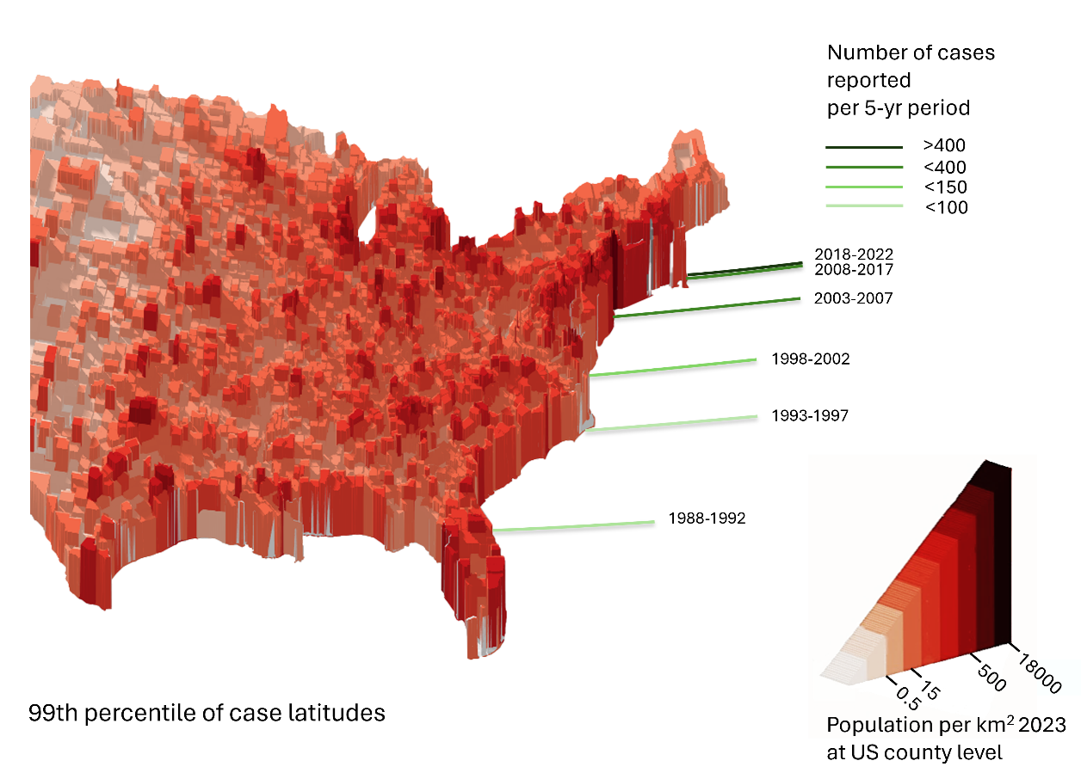
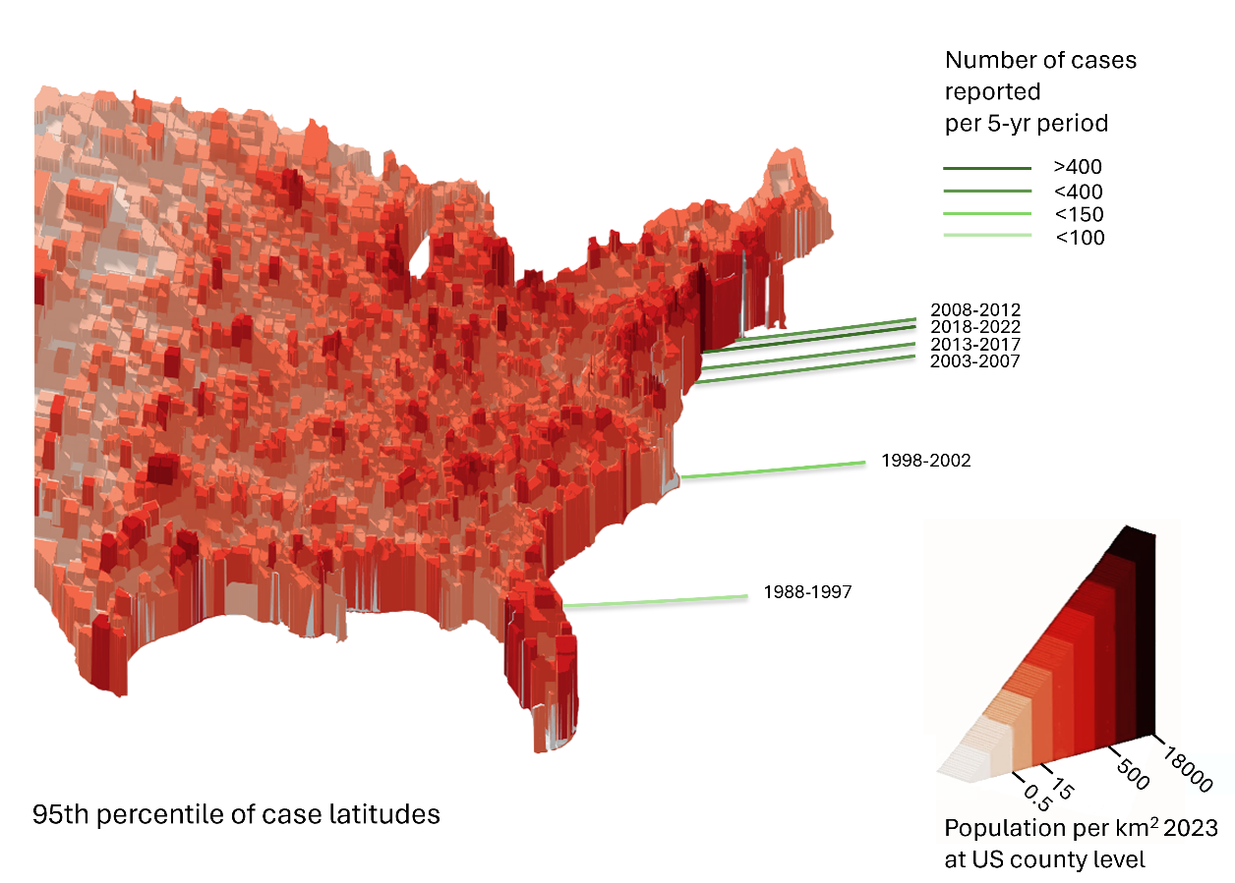

Figure S2: Patterns of missingness for key variables in Vibrio vulnificus cases reported to COVIS from 2000-2022. To see patterns over time, observations 1-487 are from the period from 2000-2004, lines 488-1009 are from 2005-2009, lines 1010-1643 are from 2010-2014, lines 1644-2493 are from 2015-2019, and lines 2494-2989 are from 2020-2022.
