Table S1. Thermal gradient analysis of InfC real-time RT-PCR assay
Annealing Tm (°C) | Ct values of InfC rRT-PCR (Mean±SD)
50.0 | 28.45±0.05
51.0 | 28.25±0.04
53.0 | 28.57±0.14
55.9 | 28.32±0.10
59.5 | 28.24±0.10
62.5 | 28.12±0.08
64.1 | 28.12±0.02
65.0 | 28.21±0.02
Thermal gradient analysis was performed using Invitrogen reagent with viral RNAs from C/Yamagata/11/1981(Taylor47 lineage) on a Bio-Rad CFX96™ Real-Time PCR Detection System.

Table S2. Analytical sensitivity evaluation with historical and recent influenza C viruses (test in triplicate)

Table S3. Analytical specificity (exclusivity) with common respiratory viruses
Strain | Respiratory Virus | Titer | Result of InfC rRT-PCR
Echo 6 | Enterovirus | 10^{6.9a} | -
Ad. 71 | Human Adenovirus, type 1 | 10^{9.2a} | -
S-1058 | Human Adenovirus, type 7a | 10^{7.1a} | -
OC43 | Human Coronavirus | 50.4^{b} | -
229E | Human Coronavirus | 31.6^{b} | -
1A | Human Rhinovirus A | 10^{5.8a} | -
 | Human Parainfluenza 1 virus | 3.0^{b} | -
Greer | Human Parainfluenza 2 virus | 10^{3.1a} | -
C-243 | Human Parainfluenza 3 virus | 10^{7.9a} | -
CH93-18b | Respiratory Syncytial Virus (RSV) | 10^{6.8a} | -
KOS | Herpes Simplex Virus | 10^{8.4a} | -
AV92-3 | Varicella-zoster Virus | 10^{4.4a} | -
B95-8 | Epstein Barr Virus | 1.7^{b} | -
Edmonston | Measles Virus | 10^{5.2a} | -
AD-169 | Cytomegalovirus | 10^{6.9a} | -
ªTCID50/mL ; ^{b}ng/mL •IFU/mL

Figure S1. Amplification chart of thermal gradient analysis of InfC real-time RT-PCR assay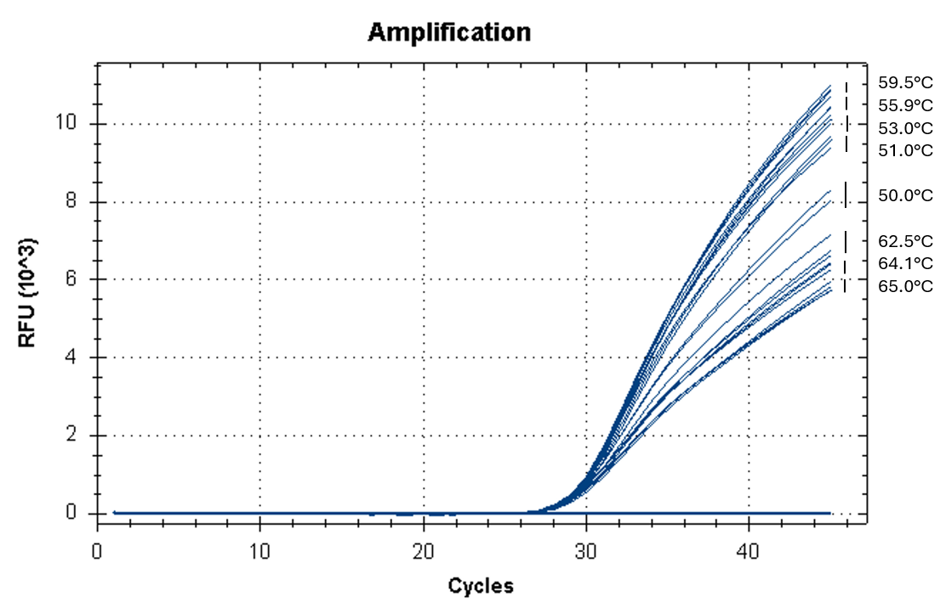Thermal gradient analysis was performed using viral RNA of C/Yamagata/11/1981 (Taylor47 lineage) with annealing temperatures ranging from 50.0-65.0°C.

