An HIV-1 risk assessment tool for men aged 15-59 in 13 African countries:
A pooled analysis of nationally representative surveys

Supplementary material

Nora E. Rosenberg, Amber M. Young, Yating Zou, Jessica Justman, Manhattan E. Charurat, Sizulu Moyo,
Khangelani Zuma, Linda-Gail Bekker, Lynda Stranix-Chibanda, Sam J. Phiri, Nadia A. Sam-Agudu, Marcel Yotebieng, Michael G. Hudgens, Benjamin H. Chi, Bonnie E. Shook-Sa

Table of Contents
Supplement 1. Specification of key variables…………...……………………………..………………………………..2
Supplement 2. Detailed methodology …………………..……………………………………………………………….3
Supplement 3. Location of men prioritized for PrEP in 15 countries at four sensitivity levels…….…..……………8
Supplement 4. Variables retained in backward logistic regression model.……………………………………………9
Supplement 5. Variable importance in random forest model…………….…………………………………………..10

Supplement 1. Specification of key variables
Variable | Description
Number and type of subnational areas in each country | The 13 and 15 countries were divided into 208 and 231 subnational areas, respectively, described here:  Southern Africa  Eswatini: 4 regions  Lesotho: 10 districts  Malawi: 5 health zones + 2 cities (Lilongwe and Blantyre)  Namibia: 14 regions  South Africa: 9 provinces  Zambia: 10 provinces  Zimbabwe: 10 provinces  Eastern Africa  Ethiopia Urban: 11 regions [Excluded from 13-country model]  Kenya: 47 counties  Rwanda: 5 provinces  Tanzania: 31 regions  Uganda: 10 regions defined by PHIA based on the 2011 AIDS Indicator Survey  Western/Central Africa  Cameroon: 10 regions + 2 cities (Yaounde and Douala) [Excluded from 13-country model]  Cote d’Ivoire: 14 districts  Nigeria: 36 states + Federal Capital Territory
Epidemiologic characteristics:  HIV-1 prevalence  Adult living with HIV (ALHIV) HIV-1 viremia  Population HIV-1 viremia | These variables were calculated from all men and women aged 15-59 in the 208 or 231 subnational areas described above. Variables are defined as follows:  The proportion of all adults with a positive HIV test result.  The proportion of ALHIV with HIV RNA >1000 copies/mL in their blood.  The proportion of all adults with HIV RNA >1000.
Reports at least one partner who is a male | No: Survey respondent reports no lifetime sexual partners; no sexual partners in the last year; or all sexual partners in the last year (up to 3) were female.  Yes: Survey respondent reports that at least one partner from the last year was male.

Table Legend: This table describes how key variables in the model were defined.
Supplement 2. Detailed Methodology
Supplement 2 includes additional methodological details for the analyses presented in the main text, including analytic dataset construction, incidence rate calculations, multiple imputation, bivariate analyses, Lasso regression model fitting (primary analysis), backwards regression model fitting (sensitivity analysis), and external validation. These analyses were conducted in R version 4.2.0 (Vienna, Austria) and SAS version 9.4. The statistical methods conducted and described in this document closely follow those applied in Rosenberg et al.¹, which developed a similar risk assessment tool for women based on PHIA data.

Analytic dataset construction
Prior to analyses, two analytic datasets were derived by pooling individual-level data: (1) from 13 African countries (Côte d’Ivoire, Eswatini, Kenya, Lesotho, Malawi, Namibia, Nigeria, Rwanda, South Africa, Tanzania, Uganda, Zambia, and Zimbabwe) and (2) from 15 African countries (those in the 13-country dataset plus Cameroon and Ethiopia – urban areas). As noted in the manuscript, Cameroon and Ethiopia were excluded from primary analyses because their surveys did not ask male participants if they had male sexual partners.

For each of the 15 counties, sampling weights were derived that account for the probability of selection for each individual across all stages of sampling. These weights were then adjusted for non-participation in household, individual, and biomarker data collection. Final analysis weights were benchmarked to the national population (in 14 countries) or urban population (in Ethiopia). After benchmarking, analysis weights summed to population-level totals by country, sex, and age group. The sampling and weighting process within each country is outlined in more detail in the PHIA Sampling and Weighting Technical Report. These reports are published for each country and made available on icap at the University of Columbia’s PHIA website (https://phia.icap.columbia.edu/).

Final sampling weights, stratification variable identifiers, and primary sampling units (PSUs) were accounted for in each stage of analysis to allow inference to the target population. Details about how the sample design features were incorporated in each stage of analysis are described below. All men aged 15-59 (regardless of HIV-1 test status) were included when estimating incidence rates, as the estimation approach accounted for men with non-recent HIV-1 infection. For the remaining analyses (i.e., bivariate analyses, Lasso and backwards regression modeling), the sample was restricted to the 167,121 men (13-country analyses) and 185,358 men (15-country analyses) with HIV-negative or recent HIV-1 test results.

Estimation of incidence rates
The inctools package in R was used to estimate the instantaneous HIV-1 incidence rates presented in the “Study sample” section of the results. This package implements methods developed by Kassanjee et al.² and incorporates the number of recent HIV-1 infections in the sample based on the LAg/VL/ARV algorithm, the number of susceptible individuals (i.e., individuals without HIV), the mean duration of recent infection (MDRI), the cutoff time for the assay, and the proportion of false positive recent cases (FRR). Specifically, the inctools package estimates incidence rates using the following formula:
$$I_{r}=\frac{R-εQ}{\left(1-\frac{εT}{ω}\right)\left(\frac{ω}{T}\right)N^{ }}$$
where $R$ represents the number of recent HIV-1 infections, $ε$ represents the proportion of false positives, $Q$ represents the number of individuals testing positive for HIV, $ω$ represents the MDRI, $T$ represents the cutoff time for the assay, and $N^{ }$represents the number of individuals who tested negative for HIV. For consistency with PHIA published reports, $ε$ was assumed to equal zero, and a cutoff time of $T$ = 365 days was assumed. Also based on estimates from PHIA reports, the MDRI $ω$ was assumed to be 130 days (95% CI 118-142 days). The proportion of men aged 15-59 who tested positive for HIV-1 and the proportion testing positive for recent HIV-1 infection were estimated in order to estimate HIV-1 incidence rates using the inctools R package. These proportions were estimated along with corresponding relative standard errors using the surveymeans procedure in SAS. This procedure incorporates analytic weights, and variances were estimated using the Taylor Series Linearization method to appropriately account for the complex sample design features (sampling weights, strata, and PSUs).

Multiple imputation
The 28 predictor variables (see Figure 1 of the main text) were available in the 13 countries in the primary analysis, and they were harmonized for analysis. For the analysis including Cameroon and Ethiopia, 27 of these variables were included, with the male partner variable excluded. Predictors included epidemiologic, individual, household, and community-level variables. The epidemiologic variables were estimated based on persons aged 15-59 for the 231 subnational areas in the pooled, weighted data.

While predictor-level missingness was sparse (0-5.2% missing for each variable), 17.8% of observations in the 13-country dataset and 17.3% of observations in the 15-country dataset had one or more missing values. To account for missing data prior to conducting bivariate analyses and model fitting, multiple imputation by chained equations^{3,4} was implemented using the mice package in R. Imputation models included the outcome variable (recent HIV-1 infection), predictor variables, and sample design features (the sampling weights and country)^{5,6}. Only five multiply imputed datasets were generated from the imputation model due to the computational complexity of subsequent models fit based on imputed data (see below for details). Note that separate multiple imputation models were run for the 13-country and 15-country analyses due to inclusion of different numbers of observations and different predictor variables.

Bivariate analyses (13-countries)
The association between recent HIV-1 infection and each of the 28 predictor variables was estimated (see Figure 1a-d). Within each of the five multiply imputed datasets, the proportion of men with recent HIV-1 infection in each level of each predictor was estimated using the svymean function in R. This analysis accounted for sampling weights, strata, and PSUs using the svydesign function. Estimated proportions of men with recent HIV-1 infection were combined across the five multiply imputed datasets, and corresponding 95% confidence intervals were constructed using Rubin’s rules and R function MIcombine. The svyglm function in R was used to fit logistic regression models for each multiply imputed dataset, where recent HIV-1 infection was regressed separately on each predictor. From the fitted models, odds ratios, corresponding confidence intervals, and p-values were computed and were combined using Rubin’s rules. Because recent HIV-infection is rare, odds ratios approximate incidence rate ratios. Wald tests were performed based on the combined model.

Lasso model building and internal validation (13-countries)
Least absolute shrinkage and selection operator (Lasso) models were used to develop a risk assessment tool to identify men at highest risk of HIV-1 acquisition. The goal was to predict recent HIV-1 infection from a parsimonious model representative of the estimated 122 million HIV-1 negative and newly infected men aged 15-59 in the target population of the 13 countries. Predictive performance was gauged by the (1) weighted area under the receiver-operating-characteristic (ROC) curve (AUC) for the full model and (2) cross-validated weighted AUC. The latter was the primary measure of predictive performance.

The risk assessment tool was developed using a survey weighted logistic Lasso regression model. Lasso regression is a penalized regression approach that aims to determine the best set of predictors of recent HIV-1 infection while maintaining model parsimony. Specifically, the Lasso model coefficients ${\hat{β}}_{λ}$ minimized the following quantity⁷
$$-pl\left(β\right)+λ\sum_{j=1}^{v}{\left|β_{j}\right|}$$

where $pl\left(β\right)=\sum_{i=1}^{n}{w_{i}\left[y_{i}ln\left\{p(x_{i})\right\}+\left(1-y_{i}\right)ln\left\{1-p(x_{i})\right\}\right]}$and $logit\left\{p(x_{i})\right\}=β_{0}+\sum_{j=1}^{v}{β_{j}x_{ij}}$. Here, $w_{i}$, $x_{i}$,
and $y_{i}$represent the sampling weight, $v$-dimensional vector of predictor variables, and outcome for participant $i$, respectively, $n$ is the number of participants, $p\left(x_{i}\right)$ is the predicted probability of recent infection for a participant with predictors $x_{i}$, $β_{j}$ are the regression parameters for the $v$ predictors in the Lasso model, $λ$ represents the tuning parameter, and $ln$ and $logit$ are the natural log and logit functions, respectively. The parameter $λ$ shrinks some regression coefficients to zero and thus determines variable selection.

To fit the Lasso model, first the five multiply imputed datasets were stacked, and sampling weights were adjusted by dividing them by the number of imputed datasets. Predictor variables were standardized to have a mean of zero and a standard deviation of one. Then, the logistic Lasso model described above was fit to the stacked data⁸ using the caret package in R. Five-fold cross validation⁹ was applied to find the tuning parameter $λ$ that maximized weighted AUC within a 1% tolerance. Cross-validation folds were formed by stratifying the dataset by sampling strata and randomly allocating entire PSUs to cross-folds within each stratum. This was done to appropriately account for the complex sample design and potential correlation of participants within clusters (PSUs). Based on this final model, predicted probabilities of recent infection were computed for all participants and were used to estimate the full model AUC.

The final model was also used to derive additional measures of model performance. Risk thresholds corresponding to 10, 30, 70, and 90% sensitivity levels were considered. For each of threshold, the number of men identified by the Lasso model as being at increased risk of HIV-1 acquisition (and thus recommended for PrEP) was estimated by the weighted count of participants with predicted risk exceeding the threshold. The number of annual infections averted for each threshold was estimated by the weighted sum of men with recent HIV-1 whose predicted risk of HIV-1 acquisition exceeded the threshold, scaled up to account for the MDRI of the recency assays. For men in Uganda, the MDRI was assumed to be 153 days, due to a higher prevalence of HIV-1 subtype D, which has a higher MDRI value. MDRI was assumed to be 130 days in all other countries, as was assumed for estimation of incidence rates. Incidence rates for men above each risk threshold were calculated based on $I_{r}$ above, with $ϵ=0$, using the svyratio function in R to incorporate sampling weights . Variances of estimated incidence rates were estimated using Taylor Series Linearization. The number needed to treat (NNT) was estimated by the ratio of the number of men recommended for PrEP to the number of infections averted.

Internal validation of model performance was conducted using an additional five-fold cross validation. We chose five folds to balance the need for a large enough sample to appropriately train the model while ensuring enough men with recent HIV-1 in each test dataset to evaluate model performance. Within each fold of the data, (1) the methods described in the “Multiple Imputation” section were used to impute missing data separately for the training and testing datasets⁴, (2) the logistic Lasso regression model was fit to the stacked training data, and (3) the resulting model was applied to the stacked testing data to estimate the AUC for that fold. The final cross-validated AUC for the model was estimated by the average of the testing AUCs across the five folds.

For each model performance metric (AUC, sensitivity, specificity) and downstream metrics (number on PrEP, infections averted, and NNT), a corresponding 95% confidence interval was constructed based on the Rao-Wu rescaling bootstrap^{10,11} with 500 resamples. Due to the computational complexity of the model, the number of bootstrap resamples was limited. For each bootstrap replication, simple random samples of PSUs were selected with replacement within each sampling stratum, with the number of resamples equal to the original number of PSUs selected in the stratum minus one. Sampling weights were rescaled to account for resampling. For each of the 500 bootstrap samples, the entire Lasso analysis was repeated, i.e., 500 estimates of each performance metric and downstream metric were derived. Wald-type confidence intervals were constructed from the bootstrap standard error for measures of AUC, and percentile-based confidence intervals were constructed from the bootstrap estimates for additional performance metrics (sensitivity, specificity, number on PrEP, infections averted, and NNT).

Lasso model and internal validation (15-countries)
The analysis described in “Lasso Model and Internal validation (13-countries)” was repeated with data from 185,358 men from the 15 countries, representing 134 million HIV-1 negative and newly infected men aged 15-59 in the target population of the 15 countries. There were a total of 27 potential predictor variables (those in Figure 1 except for the male partner variable). The remaining methods were consistent with those applied to the 13-country dataset.

Backwards regression model-building and internal validation (13 countries)
Backwards weighted logistic regression was applied in place of the Lasso as a sensitivity analysis. Predictors from the bivariate analysis (Figure 1) with Wald-test p-values < 0.05 were included in the initial backwards regression model. Predictors were then removed one at a time based on the Wald p-values for the test of significance for each predictor, conditional on inclusion of the other model predictors. For each step of backwards regression, the predictor with the largest p-value was removed from the model. This process stopped when all remaining predictors had p-values below 0.05. As with the Lasso method, both full-model and cross-validated AUCs were estimated.

Random forest model-building and internal validation (13 countries)
As a second sensitivity analysis, a random forest model was fit to the data. All 28 variables were included as candidate predictors. Survey weights were applied as case weights for selection of participants into bootstrap samples used to fit trees¹². Hellinger distance was used for the splitting rule, as it was found to improve performance with imbalanced datasets¹³. Hyperparameters, including the number of variables to sample as split candidates and the maximum depth, were selected via a grid search as the pair maximizing out of bag (OOB) five-fold cross-validated (CV) weighted AUC. The tuned model was then applied to the test data and the weighted AUC was calculated. This procedure was repeated in each of the five folds and on the full dataset, using 500 trees and 8 maximum depths. The optimal model, which maximized cross-validated weighted AUC, uses a maximum depth of 2, a minimum node size of 1, and 6 variables sampled for each split. Variable importance was calculated as the average reduction of Gini impurity over the trees. The variable importance plot (Supplement 5) includes the top 10 predictors from the random forest model. As with the Lasso and backwards elimination methods, full-model and cross-validated AUCs were estimated.
References for Supplement 2

1. Rosenberg NE, Shook-Sa BE, Young AM, et al. An HIV-1 risk assessment tool for women aged 15-49 in African countries: A pooled analysis across 15 nationally representative surveys. Clinical Infectious Diseases 2024: ciae211.
2. Kassanjee R, McWalter TA, Barnighausen T, Welte A. A new general biomarker-based incidence estimator. Epidemiology 2012; 23(5): 721-8.
3. White IR, Royston P, Wood AM. Multiple imputation using chained equations: issues and guidance for practice. Statistics in medicine 2011; 30(4): 377-99.
4. Wahl S, Boulesteix A-L, Zierer A, Thorand B, van de Wiel MA. Assessment of predictive performance in incomplete data by combining internal validation and multiple imputation. BMC Medical Research Methodology 2016; 16(1): 144.
5. Rubin DB. Multiple imputation after 18+ years. Journal of the American statistical Association 1996; 91(434): 473-89.
6. Berglund P, Heeringa SG. Multiple imputation of missing data using SAS: SAS Institute; 2014.
7. Iparragirre A, Lumley T, Barrio I, Arostegui I. Variable selection with LASSO regression for complex survey data. Stat 2023; 12(1): e578.
8. Du J, Boss J, Han P, et al. Variable selection with multiply-imputed datasets: choosing between stacked and grouped methods. Journal of Computational and Graphical Statistics 2022; 31(4): 1063-75.
9. Wieczorek J, Guerin C, McMahon T. K-fold cross validation for complex sample surveys. Statistics 2022: e454.
10. Rao JN, Wu C. Resampling inference with complex survey data. Journal of the american statistical association 1988; 83(401): 231-41.
11. Rao J, Wu C, Yue K. Some recent work on resampling methods for complex surveys. Survey methodology 1992; 18(2): 209-17.
12. Wright MN, Ziegler A. ranger: A Fast Implementation of Random Forests for High Dimensional Data in C++ and R. Journal of Statistical Software 2017; 77(1): 1 - 17.
13. Su C, Ju S, Liu Y, Yu Z. Improving random forest and rotation forest for highly imbalanced datasets. Intelligent Data Analysis 2015; 19(6): 1409-32.

Supplement 3. Location of men prioritized for PrEP in 15 countries at four sensitivity levels
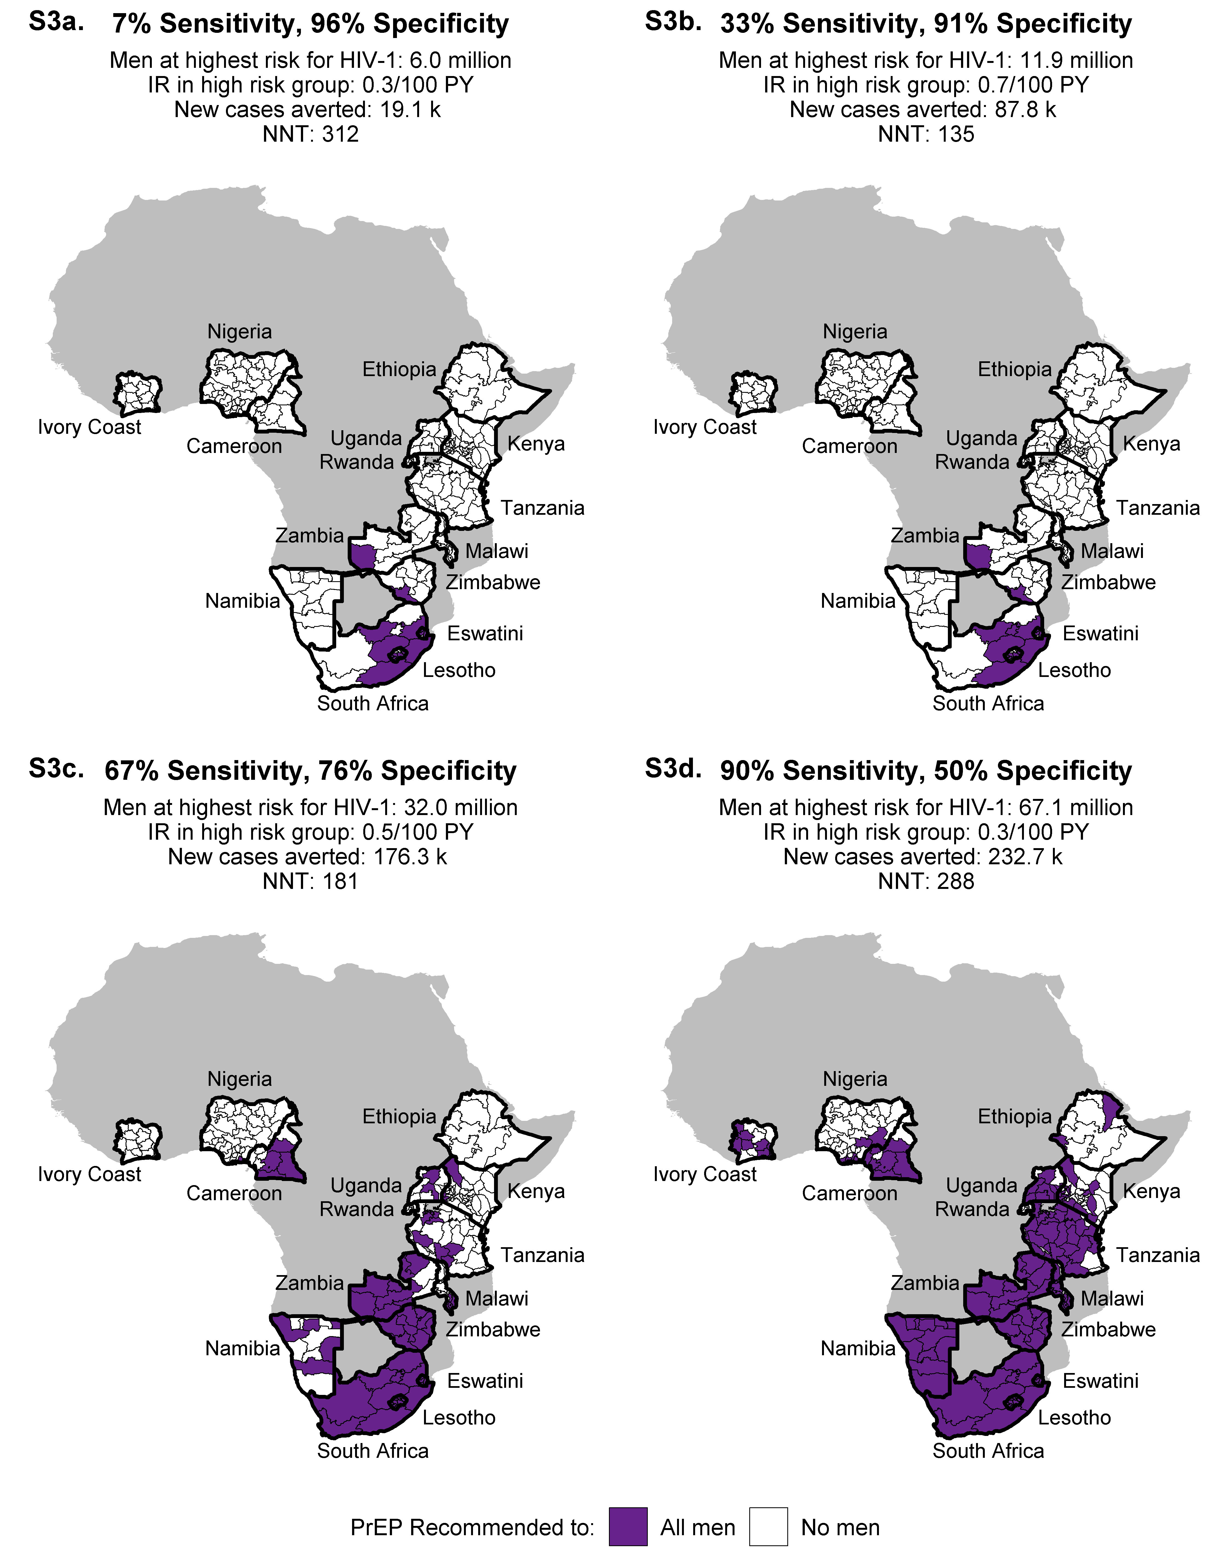
Figure Legend: Supplement 3 displays the subnational areas in the 15-country analysis that have men with elevated HIV-1 acquisition risk at four sensitivity thresholds: 7%, 33%, 67%, 90%. These thresholds are similar to the sensitivity thresholds in the main paper (10%, 30%, 70%, 90%), but not identical due to the discrete nature of the ROC curve. At each sensitivity threshold, five additional values are provided: specificity, number of men with predicted HIV-1 acquisition risk above the threshold (i.e. to prioritize for PrEP), the HIV-1 incidence rate among men above the threshold, number of cases averted if men above the threshold adhered to PrEP, and the number of men needed to treat to avert one new case of HIV-1.
Supplement 4. Variables retained in backward logistic regression model
 |  | OR (95% CI)
Subnational epidemiologic characteristics
HIV prevalence |  | 1.08 (1.05, 1.12)
Individual characteristics
Previously tested for HIV
 | No | 1
 | Yes | 2.68 (1.38, 5.23)
Partner characteristics
Number of sexual partners
 | 0 | 1
 | 1 | 2.54 (1.21, 5.33)
 | >2 | 3.86 (1.84, 8.08)
Has at least one male partner
 | No | 1
 | Yes | 14.36 (4.46, 46.27)
Household characteristics
Exterior wall material
 | Natural walls | 1
 | Rudimentary walls | 0.06 (0.01, 0.44)
 | Finished walls | 0.99 (0.53, 1.86)
 | Other | 1.86 (0.54, 6.39)
Owns car, motorcycle, or scooter
 | No | 1
 | Yes | 0.38 (0.17, 0.86)
Overall AUC |  | 0.83
Cross-validated AUC |  | 0.74

Table legend: This table presents the results of the backward elimination model. The starting model contained all variables with a p-value <0.05 in bivariate regression (Figure 1a-d). Variables were dropped one at a time until all remaining ones were significant at an alpha-level of 0.05. Overall and cross-validated AUC values are presented.

Supplement 5. Variable importance in random forest model
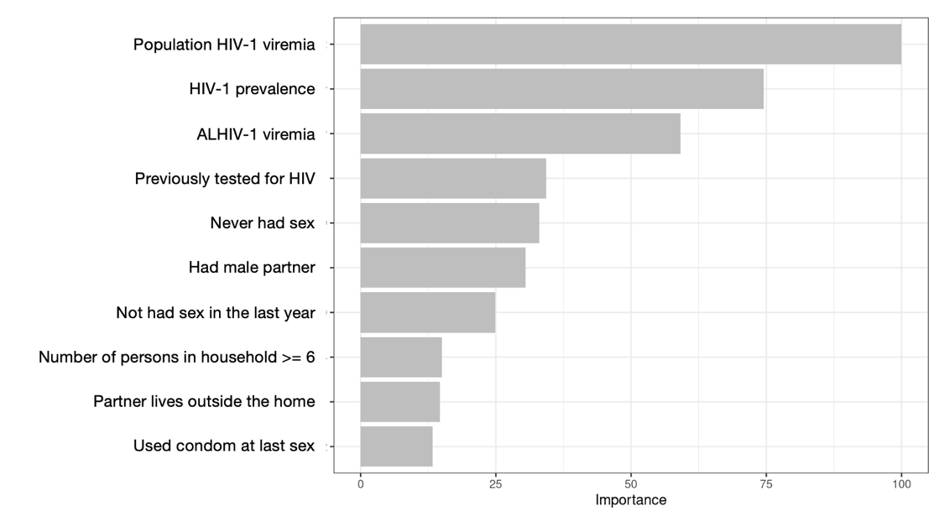
Figure Legend: Supplement 5 displays the 10 variables from the random forest with the highest variable importance.

