Supplementary Tables and Figures
Article: Attfield et al. Flame retardant biomarker changes with furniture replacement after flammability standard update. Environmental Pollution. 2025

Supplementary Table 1. Summary statistics for polybrominated diphenyl ethers (PBDEs) (ng/g lipid) and organophosphate flame retardants (OPFRs) metabolites (µg/L) (measured from 2015 to 2017 at two sampling timepoints per person for both furniture/foam replacement group and comparison group
Polybrominated Diphenyl Ethers (PBDEs)
Analyte | N  Subjects | N  Serum samples | LOD | DF  Baseline (%) |  | DF  12 month (%) | DF  Overall (%) | Range Baseline | Range  12 month
BDE-17 | 53 | 105 | 0.63-1.93 |  | 0.00 | 0.00 | 0 | 0 | 0
BDE-28 | 53 | 105 | 0.63-1.93 |  | 30.19 | 5.66 | 18 | 1.34-9.3 | <LOD - 9.3
BDE-47 | 53 | 106 | 2.73-7.64 |  | 90.57 | 81.13 | 86 | 3.44-224.2 | <LOD - 224.2
BDE-66 | 53 | 106 | 0.63-1.93 |  | 0.00 | 0.00 | 0 | 0 | 0
BDE-85 | 53 | 106 | 0.63-1.93 |  | 7.55 | 1.89 | 5 | 1.11-4.08 | <LOD - 4.08
BDE-99 | 53 | 106 | 1.49-4.18 |  | 75.47 | 43.40 | 59 | 1.37-44.75 | <LOD - 44.75
BDE-100 | 53 | 106 | 0.63-1.93 |  | 79.25 | 60.38 | 70 | 0.76-38.02 | <LOD - 8.02
BDE-153 | 53 | 106 | 1.25-3.85 |  | 79.25 | 71.70 | 75 | 2.31-64.1 | <LOD - 64.1
BDE-154 | 53 | 106 | 1.25-3.85 |  | 1.89 | 0.00 | 1 | 4 | <LOD - 4
BDE-183 | 53 | 106 | 1.25-3.85 |  | 1.89 | 0.00 | 1 | 3 | <LOD - 3
BDE-196 | 53 | 106 | 1.25-3.85 |  | 0.00 | 0.00 | 0 | 0 | 0
BDE-197 | 53 | 106 | 1.25-3.85 |  | 1.89 | 0.00 | 1 | 9 | <LOD - 9
BDE-201 | 53 | 106 | 1.25-3.85 |  | 0.00 | 0.00 | 0 | 0 | 0
BDE-202 | 53 | 106 | 1.25-3.85 |  | 0.00 | 0.00 | 0 | 0 | 0
BDE-203 | 53 | 106 | 1.25-3.85 |  | 0.00 | 0.00 | 0 | 0 | 0
BDE-206 | 53 | 105 | 1.57-4.82 |  | 0.00 | 1.89 | 1 | 4 | <LOD - 4
BDE-207 | 53 | 105 | 1.57-4.82 |  | 0.00 | 0.00 | 0 | 0 | 0
BDE-208 | 53 | 105 | 1.57-4.82 |  | 0.00 | 0.00 | 0 | 0 | 0
BDE-209 | 53 | 102 | 11.7-36.1 |  | 1.89 | 0.00 | 1 | 29 | <LOD - 29
Organophosphate flame retardant metabolites

Analyte | N  Subjects | N  Urine samples | LOD * |  | DF  Baseline (%) | DF  12 month (%) | DF  Overall (%) | Range baseline | Range  12 month
BCEP | 51 | 102 | 0.11-1.79 |  | 96.08 | 100 | 98 | 0.26-13.77 | <LOD - 13.77
BDCIPP | 52 | 104 | 0.02-0.36 |  | 100 | 100 | 100 | 0.22-6.5 | 0.22-6.5
DPhP | 52 | 104 | 0.11-1.79 |  | 98.08 | 94.23 | 96 | 0.33-20.2 | <LOD - 20.2

* Values have been adjusted by specific gravity using the reference value of 1.017.

Supplementary Table 2. Tests of demographic and behavioral factors that may have impacted foam/furniture replacement group concentrations and change in concentrations of PBDEs (ng/g lipid) and OPFR metabolites (µg/L)

 | Meat eating |  |  |  |  |  |  | Slept on a foam mattress |  |  |  |  |  |  |  |  | Sex
 | N |  | Baseline GM |  | T-test p-value for initial conc. | Wilcoxon p-value for change over time |  | N |  | Baseline GM |  | T-test p-value for initial conc. | Wilcoxon p-value for change over time |  |  |  | N |  | Baseline GM |  | T-test p-value for initial conc. | Wilcoxon p-value for change over time
 | Yes | No | Yes | No | T-test p-value for initial conc. | Wilcoxon p-value for change over time |  | Yes | No | Yes | No | T-test p-value for initial conc. |  |  |  | Male |  | Female | Male | Female | T-test p-value for initial conc.
BDE-47 | 4 | 24 | 26.15 | 20.18 | 0.49 | 0.86 |  | 17 | 8 | 44.35 | 18.72 | 0.05 | 0.92 |  |  | 8 |  | 17 | 38.25 | 20.57 | 0.43 | 0.71
BDE- 99 | 4 | 24 | 7.40 | 6.12 | 0.64 | 0.45 |  | 17 | 8 | 10.50 | 5.75 | 0.11 | 0.51 |  |  |  |  | 17 | 9.95 | 6.16 | 0.41 | 0.84
BDE- 100 | 4 | 24 | 4.78 | 3.22 | 0.33 | 0.64 |  | 17 | 8 | 8.10 | 3.34 | 0.05 | 0.92 |  |  |  |  | 17 | 6.52 | 3.76 | 0.55 | 0.75
BDE- 153 | 4 | 24 | 10.57 | 6.99 | 0.20 | 0.69 |  | 17 | 8 | 17.77 | 7.89 | 0.14 | 0.87 |  |  |  |  | 17 | 15.51 | 8.00 | 0.20 | 0.34
BCEP | 4 | 24 | 1.94 | 2.32 | 0.33 | 0.39 |  | 17 | 8 | 1.63 | 2.18 | 0.40 | 0.53 |  |  |  |  | 17 | 1.84 | 2.09 | 0.22 | 0.83
BDCIPP | 4 | 24 | 1.93 | 2.04 | 0.79 | 0.75 |  | 17 | 8 | 1.89 | 2.02 | 0.82 | 0.55 |  |  |  |  | 17 | 2.30 | 1.80 | 0.68 | 0.09
DPhP | 4 | 24 | 2.40 | 2.69 | 0.68 | 0.54 |  | 17 | 8 | 2.02 | 2.62 | 0.40 | 0.83 |  |  |  |  | 17 | 2.00 | 2.69 | 0.10 | 0.55
 | Hand washing (times/day) |  |  |  |  |  |  | Computer hours for work (hours/week) |  |  |  |  |  |  |  |  | Age (years)
 |  |  | Initial concentration |  | Change over time* |  |  |  |  | Initial concentration |  | Change over time* |  |  |  |  |  |  | Initial concentration |  | Change over time*
 | Mean | Median | Spearman correlation | p-value | Spearman correlation | p-value |  | Mean | Median | Spearman correlation | p-value | Spearman correlation | p-value |  |  | Mean |  | Median | Spearman correlation | p-value | Spearman correlation | p-value
BDE-47 | 9.64 | 8.00 | -0.004 | 0.99 | -0.01 | 0.95 |  | 28.84 | 30.00 | -0.04 | 0.84 | -0.31 | 0.14 |  |  | 46.68 |  | 45.00 | 0.15 | 0.47 | 0.14 | 0.50
BDE-99 | 9.64 | 8.00 | 0.07 | 0.74 | -0.10 | 0.62 |  | 28.84 | 30.00 | 0.02 | 0.93 | -0.23 | 0.27 |  |  |  |  | 45.00 | 0.06 | 0.76 | 0.19 | 0.36
BDE-100 | 9.64 | 8.00 | -0.12 | 0.57 | -0.09 | 0.68 |  | 28.84 | 30.00 | -0.14 | 0.50 | -0.29 | 0.16 |  |  |  |  | 45.00 | 0.31 | 0.13 | 0.21 | 0.32
BDE-153 | 9.64 | 8.00 | -0.12 | 0.57 | 0.26 | 0.22 |  | 28.84 | 30.00 | 0.20 | 0.33 | -0.15 | 0.48 |  |  |  |  | 45.00 | 0.03 | 0.88 | -0.19 | 0.36
BCEP | 9.64 | 8.00 | -0.12 | 0.57 | 0.44 | 0.03 |  | 28.84 | 30.00 | -0.002 | 0.99 | -0.04 | 0.85 |  |  |  |  | 45.00 | 0.18 | 0.41 | 0.30 | 0.16
BDCIPP | 9.64 | 8.00 | 0.13 | 0.54 | -0.12 | 0.56 |  | 28.84 | 30.00 | 0.15 | 0.47 | -0.10 | 0.63 |  |  |  |  | 45.00 | -0.36 | 0.08 | 0.08 | 0.71
DPhP | 9.64 | 8.00 | 0.17 | 0.41 | 0.18 | 0.38 |  | 28.84 | 30.00 | 0.29 | 0.15 | -0.17 | 0.42 |  |  |  |  | 45.00 | -0.14 | 0.51 | -0.04 | 0.85
*Similar to Table 4, for PBDEs, change over time calculated as the difference in natural logged biomarker concentrations from baseline to 12 months divided by time. For OPFRs, change over time is calculated as an absolute difference.
GM = geometric mean

Supplemental Table 3. Magnitudes of change over time depicted as log change over time and half-times for PBDEs and absolute change in concentrations for OPFRs between baseline and 12 months for comparison group participants (N=28) and furniture/foam replacement group participants (N=25) excluding replacement group extreme values (N=3)

 | Log change in concentrations over time (yr⁻¹) |  |  |  |  |  |  | Median half-times (years)
 | Comparison group |  |  | Furniture/foam replacement group |  |  | Wilcoxon p-value | Comparison group | Furniture/foam replacement group
 | 25th pctl | Median | 75th pctl | 25th pctl | Median | 75th pctl | Wilcoxon p-value | Median | Median
BDE-47 | -0.42 | -0.26 | -0.06 | -0.87 | -0.51 | -0.33 | <0.01 | 2.7 | 1.4
BDE-99 | -0.50 | -0.26 | 0.04 | -0.81 | -0.48 | -0.16 | 0.04 | 2.6 | 1.4
BDE- 100 | -0.29 | -0.13 | 0.04 | -0.68 | -0.54 | -0.23 | <0.01 | 5.2 | 1.3
BDE- 153 | -0.36 | -0.08 | 0.04 | -0.24 | -0.15 | -0.09 | 0.42 | 9.1 | 4.6
 | Change in concentrations (µg/L)
 | Comparison group |  |  | Furniture/foam replacement group |  |  | Wilcoxon p-value
 | 25th pctl | Median | 75th pctl | 25th pctl | Median | 75th pctl | Wilcoxon p-value
BCEP | -0.14 | 0.96 | 1.93 | -1.61 | -0.02 | 0.84 | 0.04
BDCIPP | -1.34 | -0.43 | 0.61 | -1.82 | -1.02 | -0.12 | 0.17
DPhP | -0.76 | -0.26 | 0.17 | -1.53 | -0.04 | 1.04 | 0.58

Supplementary Table 4. Wilcoxon p-values with clustering by household among furniture/foam replacement group participants (N=25)
 | Change over time, Wilcoxon p-value*
BDE-47 | 0.01
BDE-99 | 0.20
BDE-100 | 0.03
BDE-153 | 0.70
BCEP | 0.11
BDCIPP | 0.67
DPhP | 0.84

*Similar to Table 4, for PBDEs, change over time calculated as the difference in natural logged biomarker concentrations from baseline to 12 months divided by time. For OPFRs, change over time is calculated as an absolute difference.

Supplemental Table 5. Correlation coefficients and p-values for individual PBDEs and for individual OPFRs
 | BDE-47 | BDE-99 | BDE-100 | BDE-153 |  |  | BCEP | BDCPP | DPP
BDE-47 | 1 |  |  |  |  | BCEP | 1
BDE-99 | 0.84 | 1 |  |  |  | BDCPP | 0.18 | 1
BDE-99 | <.0001 |  |  |  |  | BDCPP | 0.20
BDE-100 | 0.96 | 0.76 | 1 |  |  | DPP | 0.11 | 0.30 | 1
BDE-100 | <.0001 | <.0001 |  |  |  | DPP | 0.44 | 0.03
BDE-153 | 0.63 | 0.42 | 0.63 | 1
BDE-153 | <.0001 | 0.002 | <.0001

Supplementary Figures

Supplementary Figure 1. Individual values of BDE-99 (ng/g lipids) over study period by group. Median change indicated with bolded black line.
- Furniture/foam replacement group
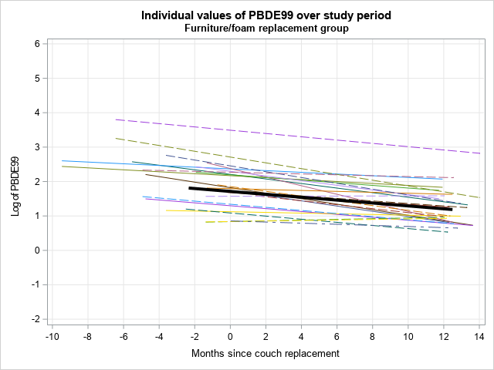

- Comparison group
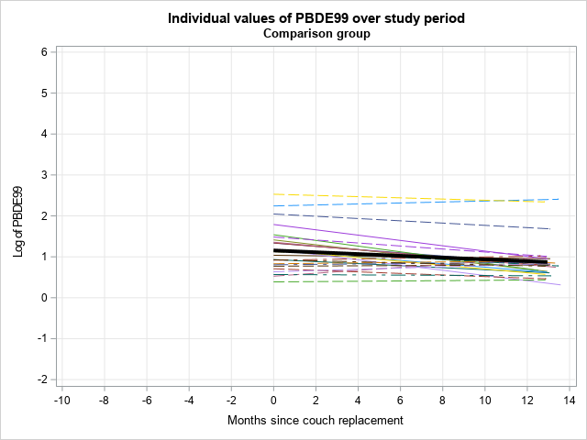

Supplementary Figure 2. Individual values of BDE-100 (ng/g lipids) over study period by group. Median change indicated with bolded black line.
- Furniture/foam replacement group
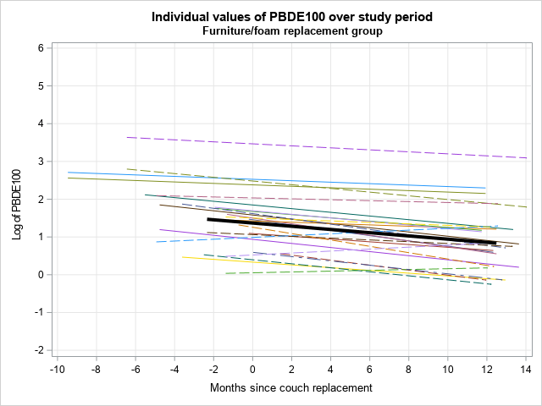

- Comparison group
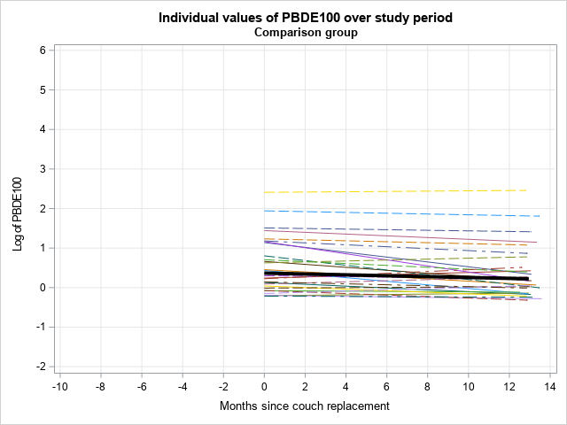

Supplementary Figure 3. Individual values of BDE-153 (ng/g lipids) over study period by group. Median change indicated with bolded black line.
- Furniture/foam replacement group
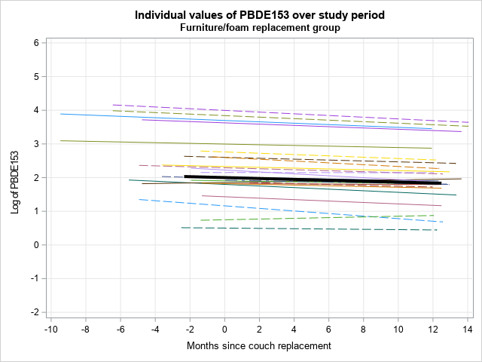

- Comparison group
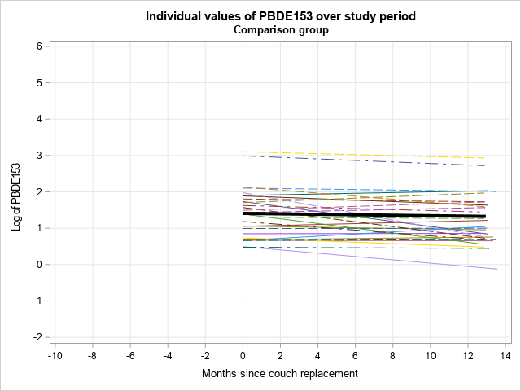

Supplementary Figure 4. Individual values of BCEP (µg/L) over study period by group. Median change indicated with bolded black line.
- Furniture/foam replacement group
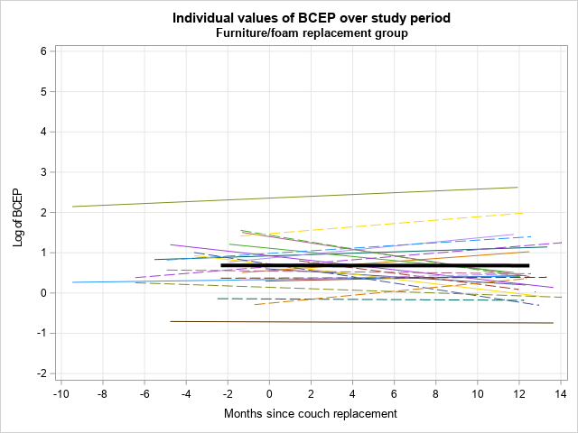

- Comparison group
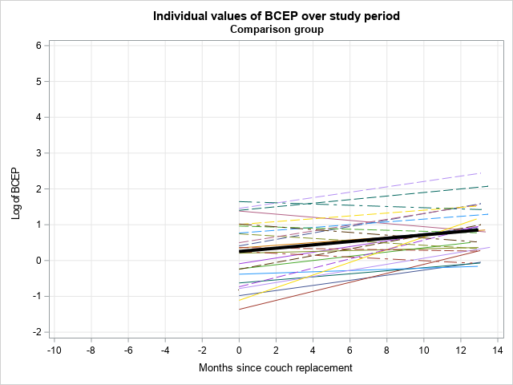

Supplementary Figure 5. Individual values of BDCIPP (µg/L) over study period by group. Median change indicated with bolded black line.
- Furniture/foam replacement group

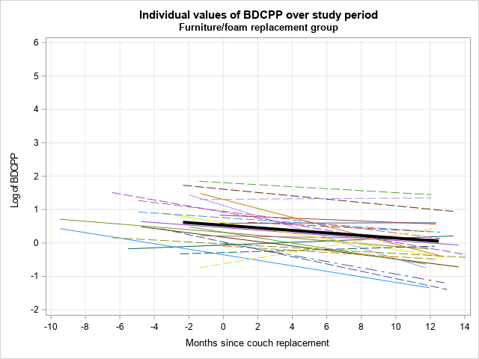

- Comparison group

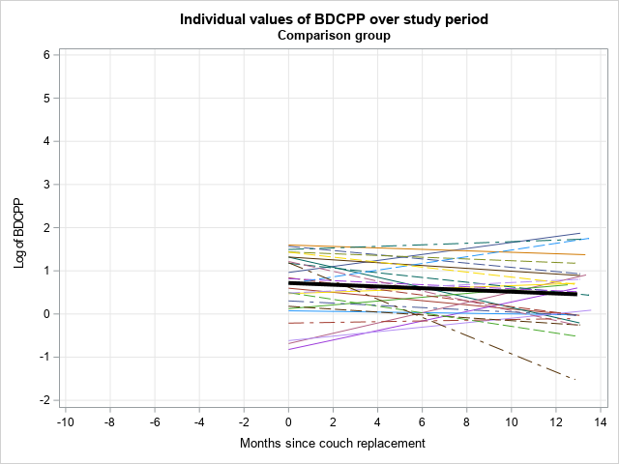

Supplementary Figure 6. Individual values of DPP (µg/L) over study period by group. Median change indicated with bolded black line.
- Furniture/foam replacement group

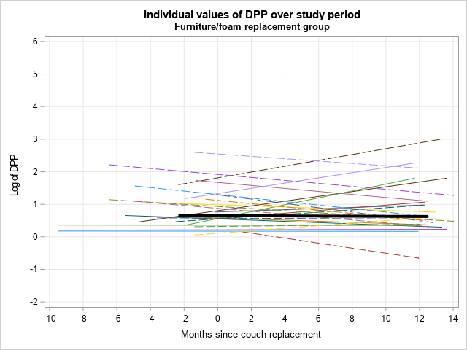

- Comparison group

