SUPPLEMENTARY TABLE. A global map showing departure country of flights on which individuals flew who developed measles after exposure to infectious travelers reported to CDC from January 2018 to December 2019 (n=7)
Country | # primary cases | Citizenship
Philippines | 1 | US
Ukraine**** | 1 | US
Taiwan* | 1 | unknown
Germany*** | 1 | US
Samoa** | 3 | US
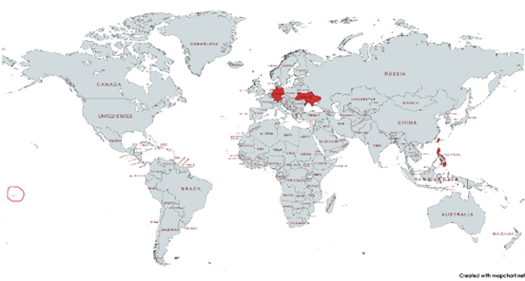
*Case returned to US from Taiwan 13-14 days prior to rash onset
**Family members traveling together
***Case traveled in Germany and Vietnam during the 14 days prior to rash onset, but port of exit was Germany. Exposure may have occurred in either country.
****Case’s younger brother’s rash onset 7 days before flight, tested positive after flight

