Supplemental Table 1
Prevalence of diabetes and prediabetes by characteristics of non-pregnant women of reproductive Age, 12–49:
National Health and Nutrition Examination Survey 2011–March 2020

Characteristics and risk factors | Overall  (n = 3731) |  | Diabetes¹  (n = 229) |  | Prediabetes¹  (n = 1210) |  | No Diabetes¹  (n = 2292)
 | n | Weighted % (95% CI)² | n | Weighted % (95% CI)² | n | Weighted % (95% CI)² | n | Weighted % (95% CI)²
Age (years)
<35 | 2365 | 60.8 (58.8-62.7) | 51 | 22.2 (15.8-30.2)³ | 657 | 51.2 (47.5-54.9) | 1657 | 69.1 (66.9-71.2)
≥35 | 1366 | 39.2 (37.3-41.2) | 178 | 77.8 (69.8-84.2) | 553 | 48.8 (45.1-52.5) | 635 | 30.9 (28.8-33.1)
Age (years)
<25 | 1504 | 34.6 (32.3-37.0) | 16 | 5.4 (3.1-9.1)⁴ | 373 | 25.8 (22.8-29.0) | 1115 | 41.6 (38.7-44.6)
25-29 | 415 | 13.0 (11.4-14.7) | 12 | 6.1 (3.0-12.0)⁴ | 123 | 11.2 (8.9-14.0) | 280 | 14.5 (12.5-16.7)
30-34 | 446 | 13.3 (11.8-14.9) | 23 | 10.7 (6.4-17.4)⁴ | 161 | 14.2 (11.5-17.5) | 262 | 13.0 (11.4-14.8)
≥35 | 1366 | 39.2 (37.3-41.2) | 178 | 77.8 (69.8-84.2) | 553 | 48.8 (45.1-52.5) | 635 | 30.9 (28.8-33.1)
Race/Ethnicity | 3731 |  | 229 |  | 1210 |  | 2292
NH White | 1157 | 55.7 (51.6-59.7) | 54 | 42.2 (32.9-52.1)³ | 341 | 51.8 (46.4-57.0) | 762 | 58.9 (54.8-62.8)
NH Black | 875 | 13.6 (11.4-16.2) | 69 | 18.1 (13.2-24.4) | 300 | 14.7 (11.8-18.1) | 506 | 12.7 (10.5-15.3)
NH Asian | 506 | 6.3 (5.2-7.6) | 20 | 5.0 (2.9-8.3)⁴ | 165 | 6.4 (5.0-8.2) | 321 | 6.4 (5.2-7.9)
All Hispanic⁵ | 1013 | 20.1 (17.2-23.3) | 76 | 30.1 (23.3-37.9) | 347 | 22.0 (18.3-26.3) | 590 | 18.2 (15.5-21.3)
NH Other⁵ | 180 | 4.3 (3.4-5.3) | 10 | 4.6 (2.3-9.0)^{4, 6} | 57 | 5.1 (3.5-7.5) | 113 | 3.8 (3.0-4.9)
Family-income-poverty ratio | 3425 |  | 210 |  | 1093 |  | 2122
<1.0 | 1011 | 21.4 (19.3-23.7) | 76 | 28.7 (21.5-37.1) | 346 | 23.0 (20.0-26.2) | 589 | 20.0 (17.8-22.5)
1-1.9 | 860 | 21.8 (19.7-24.0) | 55 | 22.5 (15.9-30.9)³ | 276 | 21.6 (18.3-25.3) | 529 | 21.9 (19.4-24.5)
2-3.9 | 859 | 28.1 (25.4-30.9) | 48 | 29.4 (21.3-39.0)³ | 286 | 31.1 (26.7-35.8) | 525 | 26.5 (23.7-29.4)
≥4.0 | 695 | 28.7 (25.7-31.9) | 31 | 19.4 (13.1-27.9)³ | 185 | 24.3 (20.5-28.7) | 479 | 31.7 (28.1-35.4)
Smoking exposure⁷ | 3690 |  | 225 |  | 1196 |  | 2269
Non-smoker | 2866 | 76.9 (74.6-79.0) | 169 | 73.0 (64.0-80.5) | 910 | 73.4 (69.2-77.2) | 1787 | 79.0 (76.3-81.5)
Smoker | 824 | 23.1 (21.0-25.4) | 56 | 27.0 (19.5-36.0) | 286 | 26.6 (22.8-30.8) | 482 | 21.0 (18.5-23.7)
BMI⁸ (kg/m²) | 3678 |  | 221 |  | 1203 |  | 2254
Under/Normal weight | 1465 | 40.6 (38.4-42.9) | 12 | 5.2 (2.5-10.4)⁴ | 308 | 25.6 (22.8-28.7) | 1145 | 51.4 (48.5-54.2)
Overweight | 873 | 23.5 (21.8-25.3) | 41 | 17.2 (12.0-24.1)³ | 293 | 24.9 (22.1-27.9) | 539 | 23.3 (21.1-25.6)
Obesity | 1340 | 35.9 (33.9-37.8) | 168 | 77.6 (70.0-83.7) | 602 | 49.4 (46.0-52.9) | 570 | 25.3 (23.0-27.9)
Optimal RBC folate (nmol/L) | 3731 |  | 229 |  | 1210 |  | 2292
≥748 | 2965 | 82.4 (80.4-84.2) | 194 | 88.7 (83.4-92.5) | 968 | 81.5 (78.3-84.2) | 1803 | 82.3 (79.7-84.6)
<748 | 766 | 17.6 (15.8-19.6) | 35 | 11.3 (7.5-16.6)³ | 242 | 18.5 (15.8-21.7) | 489 | 17.7 (15.4-20.3)
RBC folate (nmol/L) | 3731 |  | 229 |  | 1210 |  | 2292
>90th percentile: >1700 | 290 | 10.3 (8.8-12.1) | 45 | 28.9 (21.2-38.0)³ | 100 | 11.3 (8.7-14.6) | 145 | 8.3 (6.5-10.5)
≤90th percentile | 3441 | 89.7 (87.9-91.2) | 184 | 71.1 (62.0-78.8) | 1110 | 88.7 (85.4-91.3) | 2147 | 91.7 (89.5-93.5)
RBC folate (nmol/L) | 3731 |  | 229 |  | 1210 |  | 2292
>95th percentile: >1965 | 142 | 5.1 (4.1-6.2) | 25 | 17.3 (11.1-26.0)⁴ | 52 | 5.7 (4.2-7.7) | 65 | 3.7 (2.6-5.3)
≤95th percentile | 3589 | 94.9 (93.8-95.9) | 204 | 82.7 (74.0-88.9) | 1158 | 94.3 (92.3-95.8) | 2227 | 96.3 (94.7-97.4)
Serum MeFox (nmol/L) | 3677 |  | 226 |  | 1193 |  | 2258
>90th percentile: >2.2 | 325 | 10.0 (8.5-11.7) | 44 | 24.0 (17.4-32.3)³ | 117 | 10.9 (8.9-13.2) | 164 | 8.3 (6.5-10.5)
≤90th percentile | 3352 | 90.0 (88.3-91.5) | 182 | 76.0 (67.7-82.6) | 1076 | 89.1 (86.8-91.1) | 2094 | 91.7 (89.5-93.5)
Serum MeFox (nmol/L) | 3677 |  | 226 |  | 1193 |  | 2258
>95th percentile: >2.9 | 156 | 5.0 (4.0-6.3) | 20 | 11.7 (6.6-19.8)⁴ | 56 | 5.6 (4.0-7.8) | 80 | 4.2 (3.0-5.6)
≤95th percentile | 3521 | 95.0 (93.7-96.0) | 206 | 88.3 (80.2-93.4) | 1137 | 94.4 (92.2-96.0) | 2178 | 95.8 (94.4-97.0)
Serum B₁₂⁹ (nmol/L) | 1218 |  | 82 |  | 402 |  | 734
Deficiency (<148) | 21 | 2.1 (1.1-3.8) | 2 | 4.7 (0.9-22.0)^{4, 6} | 6 | 2.0 (0.8-5.3)^{4, 6} | 13 | 1.9 (1.0-3.6)⁴
Marginal/Insufficiency (148-258) | 218 | 19.5 (16.5-22.8) | 13 | 15.5 (7.2-30.2)⁴ | 79 | 22.3 (17.4-28.0) | 126 | 18.4 (14.7-22.8)
Sufficient (>258) | 979 | 78.5 (75.0-81.6) | 67 | 79.8 (70.3-86.9) | 317 | 75.7 (69.7-80.8) | 595 | 79.7 (75.3-83.5)
Serum MMA⁹ (nmol/L) | 1218 |  | 82 |  | 402 |  | 734
Elevated MMA (>210) | 89 | 7.5 (5.5-10.2) | 11 | 12.9 (5.9-26.0)⁴ | 27 | 6.9 (3.7-12.4)⁴ | 51 | 7.4 (5.3-10.3)
Non-elevated MMA (≤210) | 1129 | 92.5 (89.8-94.5) | 71 | 87.1 (74.0-94.1) | 375 | 93.1 (87.6-96.3) | 683 | 92.6 (89.7-94.7)
eGFR¹⁰ (mL/min/1.73 m2) | 3669 |  | 224 |  | 1193 |  | 2252
Normal (90 or higher) | 3336 | 88.7 (87.0-90.2) | 186 | 84.9 (77.5-90.2) | 1083 | 87.4 (84.3-90.1) | 2067 | 89.7 (87.4-91.6)
Mild loss (60-89) | 313 | 10.9 (9.4-12.6) | 32 | 13.3 (8.6-20.1)^{3, 6} | 105 | 12.2 (9.6-15.4) | 176 | 10.0 (8.1-12.2)
Moderate loss-Kidney failure (15-59) | 20 | 0.4 (0.3-0.7) | 6 | 1.8 (0.7-4.7)^{4, 6} | 5 | 0.3 (0.1-0.9)^{4, 6} | 9 | 0.4 (0.2-0.7)^{4, 6}
Albumin-creatinine ratio¹¹ (mg/g) | 3696 |  | 226 |  | 1196 |  | 2274
<30 | 3300 | 90.8 (89.6-91.9) | 170 | 77.3 (68.4-84.3) | 1079 | 92.4 (90.5-93.9) | 2051 | 91.2 (89.7-92.4)
30-300 | 350 | 8.3 (7.3-9.4) | 43 | 18.0 (12.1-26.0) | 105 | 6.9 (5.5-8.7) | 202 | 8.2 (7.0-9.7)
>300 | 46 | 0.9 (0.6-1.2) | 13 | 4.7 (2.4-8.7)^{4, 6} | 12 | 0.7 (0.4-1.2)⁴ | 21 | 0.6 (0.4-1.0)⁴
Supplement use | 3731 |  | 229 |  | 1210 |  | 2292
Yes | 914 | 27.9 (25.8-30.1) | 60 | 29.1 (22.9-36.2) | 268 | 24.6 (20.8-28.9) | 586 | 29.5 (26.9-32.2)
No | 2817 | 72.1 (69.9-74.2) | 169 | 70.9 (63.8-77.1) | 942 | 75.4 (71.1-79.2) | 1706 | 70.5 (67.8-73.1)
Supplement use (μg/day) | 3731 |  | 229 |  | 1210 |  | 2292
≥400 | 400 | 12.3 (10.8-14.1) | 36 | 19.0 (13.0-27.0)³ | 128 | 11.7 (9.7-14.1) | 236 | 12.1 (10.2-14.3)
<400 | 3331 | 87.7 (85.9-89.2) | 193 | 81.0 (73.0-87.0) | 1082 | 88.3 (85.9-90.3) | 2056 | 87.9 (85.7-89.8)
Supplement use (μg/day) | 3731 |  | 229 |  | 1210 |  | 2292
<400 | 514 | 15.5 (13.9-17.4) | 24 | 10.1 (6.2-16.0)⁴ | 140 | 12.9 (10.0-16.5) | 350 | 17.4 (15.3-19.6)
≥400 | 400 | 12.3 (10.8-14.1) | 36 | 19.0 (13.0-27.0)³ | 128 | 11.7 (9.7-14.1) | 236 | 12.1 (10.2-14.3)
Non-user | 2817 | 72.1 (69.9-74.2) | 169 | 70.9 (63.8-77.1) | 942 | 75.4 (71.1-79.2) | 1706 | 70.5 (67.8-73.1)
Folic acid consumption group¹² | 3473 |  | 213 |  | 1120 |  | 2140
ECGP/CMF | 1914 | 53.5 (51.5-55.6) | 127 | 58.4 (50.7-65.7) | 658 | 58.3 (53.8-62.6) | 1129 | 50.7 (48.1-53.2)
ECGP/CMF+RTE | 710 | 18.5 (16.8-20.3) | 30 | 12.8 (8.8-18.2)³ | 219 | 17.2 (14.6-20.2) | 461 | 19.6 (17.4-22.1)
ECGP/CMF+Sup | 650 | 21.0 (19.2-22.9) | 44 | 21.5 (15.5-29.0)³ | 187 | 19.0 (15.6-22.9) | 419 | 22.0 (19.7-24.5)
ECGP/CMF+RTE+Sup | 199 | 6.9 (5.9-8.2) | 12 | 7.3 (3.7-14.0)^{4, 6} | 56 | 5.5 (3.9-7.7)³ | 131 | 7.7 (6.3-9.3)
RBC folate-folate intake | 3731 |  | 229 |  | 1210 |  | 2292
>90th centile and ≥400 μg | 114 | 3.9 (3.0-5.0) | 16 | 10.9 (5.9-19.1)⁴ | 36 | 3.4 (2.2-5.3)³ | 62 | 3.5 (2.4-5.0)
>90th centile and <400 μg | 176 | 6.5 (5.2-8.0) | 29 | 18.0 (11.6-26.8)⁴ | 64 | 7.9 (5.8-10.5) | 83 | 4.8 (3.5-6.4)
≤90th centile and ≥400 μg | 286 | 8.5 (7.3-9.8) | 20 | 8.1 (4.9-13.3)^{4, 6} | 92 | 8.3 (6.7-10.1) | 174 | 8.6 (7.2-10.3)
≤90th centile and <400 μg | 3155 | 81.2 (78.9-83.3) | 164 | 63.0 (55.1-70.3) | 1018 | 80.4 (77.2-83.3) | 1973 | 83.1 (80.2-85.7)
¹Categorized using Diabetes NHANES questionnaire- fasting blood sugar and glycohemoglobin level (HbA1c); includes self-reported (n= 151) and undiagnosed (n = 78)
² Unadjusted percentages and geometric means are weighted, and CIs accounting for complex sampling design.
³ Degree of freedom <8
⁴ Degree of freedom <8 and Sample size <30
⁵ “Hispanic” include respondents self-identified as “Mexican American” and self-identified “Hispanic” ethnicity. non-Hispanic (NH) participants were then categorized based on their self-reported races; “NH Other” (including multiple races).
⁶ Does not meet the criteria for prevalence estimate reliability
⁷ Smoking exposure: Biomonitoring Summary | CDC, Cotinine levels- (non-smoker = <10ng/ml) and smoker = >10ng/ml)
⁸ BMI categories for non-Hispanic Asian participants was based the WHO expert consultation: Appropriate body-mass index for Asian populations and its implications for policy and intervention strategies - PubMed (nih.gov)
⁹ NHANES dataset available for 2011–2012
¹⁰ eGFR based on the National Kidney Foundation- CKD-EPI Creatinine Equation (2021)
¹¹ ACR based on the National Kidney Foundation- https://www.kidney.org/kidneydisease/siemens_hcp_acr
¹² ECGP/CMF only, consumed enriched cereal-grain products/corn masa flour only, excluding ready-to-eat cereals and supplements containing folic acid; ECGP/CMF+RTE, consumed enriched cereal-grain products/corn masa flour plus ready-to-eat cereals; ECGP/CMF+SUP, consumed enriched cereal-grain products/corn masa flour (excluding ready-to-eat cereals) plus supplements containing folic acid; ECGP/CMF+RTE+SUP, consumed enriched cereal-grain products/corn masa flour, ready-to-eat cereals, and supplements containing folic acid.
Abbreviations: Body mass index (BMI), Estimated glomerular filtration rate (eGFR), Methylmalonic acid (MMA), Pyrazino-s-triazine derivative of 4-alpha-hydroxy-5-methyltetrahydrofolate (MeFox), Red blood cell (RBC), Unmetabolized folic acid (UMFA)

Supplemental Table 2
Adjusted Median Usual intake Among Non-pregnant Women of Reproductive Age, 12–49 Years: National Health and Nutrition Examination Survey 2011–March 2020

 | n | Median estimate (IQR)¹
 | n | Total food folate² (DFE/day) | Total folic acid³  (μg/day) | Total folate⁴  (μg/day) | Total folate⁵  (DFE/day)
Overall⁶ | 3473 | 173 (126-223) | 196 (92-343) | 390 (233-570) | 533 (300-814)
Age⁷ (years)
<35 years | 2238 | 168 (124-216) | 195 (97-329) | 381 (237-546) | 523 (309-779)
≥ 35 years | 1235 | 180 (132-231) | 198 (83-364) | 404 (231-604) | 548 (290-863)
Race/Ethnicity⁸
NH White | 1106 | 174 (128-225) | 211 (100-370) | 406 (245-599) | 559 (318-861)
NH Black | 822 | 152 (112-193) | 174 (83-295) | 340 (206-489) | 465 (266-697)
NH Asian | 433 | 192 (148-236) | 193 (88-329) | 406 (255-570) | 546 (321-802)
All Hispanic | 937 | 183 (129-239) | 178 (84-301) | 382 (234-539) | 512 (296-752)
NH Other | 175 | 153 (120-187) | 197 (93-345) | 370 (226-540) | 511 (293-785)
Folic acid consumption group⁹ | 3473
ECGP/CMF | 1914 | 162 (119-207) | 110 (79-144) | 275 (215-336) | 355 (278-432)
ECGP/CMF+RTE | 710 | 161 (112-214) | 249 (235-261) | 412 (348-474) | 594 (543-639)
ECGP/CMF+Sup | 650 | 196 (154-240) | 416 (242-629) | 631 (429-855) | 925 (599-1297)
ECGP/CMF+RTE+Sup | 199 | 202 (149-271) | 615 (438-822) | 839 (628-1079) | 1271 (940-1649)
BMI¹⁰ (kg/m²) | 3432
Under/Normal weight | 1366 | 180 (130-236) | 215 (105-369) | 418 (255-607) | 575 (332-867)
Overweight | 807 | 178 (134-225) | 188 (91-323) | 385 (242-550) | 522 (309-779)
Obesity | 1259 | 162 (120-206) | 186 (87-330) | 367 (218-543) | 502 (281-779)
Diabetes status¹¹
Diabetes | 213 | 171 (126-220) | 197 (78-384) | 391 (212-616) | 536 (268-891)
Pre-diabetes | 1120 | 167 (124-211) | 179 (86-304) | 362 (227-512) | 490 (288-725)
No diabetes | 2140 | 175 (127-228) | 205 (96-359) | 402 (240-593) | 553 (312-847)
¹ Median intake and IQR accounting for the complex sampling design, adjustment for variations in day 1, day 2 measurements and by the day of the week; statistical analyses performed using Monte Carlo simulated pseudo-persons (each participant generated 100 pseudo-persons of the participant)
²Total food folate (DFE): Total natural folate from foods
³ Total folic acid (μg): Total folic acid from fortified foods and supplements (30d)
⁴ Total folate (μg): Total folate from foods (folic acid and natural food folate) and folic acid from supplements (30d)
⁵ Total folate (DFE): Total folate in DFEs from foods (folic acid and natural food folate) and folic acid from supplements (30d)
μg DFE = μg naturally occurring folate + (1.7 × μg folic acid from foods and supplements)
⁶Adjusted for adjusted for age, race, FIPR and BMI
⁷Adjusted for race, FIPR, BMI
⁸ Adjusted for age, FIPR and BMI; “Hispanic” include respondents self-identified as “Mexican American” and self-identified “Hispanic” ethnicity. non-Hispanic (NH) participants were then categorized based on their self-reported races; “NH Other” (including multiple races).
⁹ Adjusted for age, race, FIPR and BMI; ECGP/CMF only, consumed enriched cereal-grain products/corn masa flour only, excluding ready-to-eat cereals and supplements containing folic acid; ECGP/CMF+RTE, consumed enriched cereal-grain products/corn masa flour plus ready-to-eat cereals; ECGP/CMF+SUP, consumed enriched cereal-grain products/corn masa flour (excluding ready-to-eat cereals) plus supplements containing folic acid; ECGP/CMF+RTE+SUP, consumed enriched cereal-grain products/corn masa flour, ready-to-eat cereals, and supplements containing folic acid.
¹⁰Adjusted for age, race and FIPR
¹¹ Categorized using Diabetes NHANES questionnaire, fasting blood sugar and glycohemoglobin level (HBA1c); adjusted for age, race, FIPR and BMI
Abbreviations: Body mass index (BMI), Family-income-poverty ratio (FIPR), Interquartile range (IQR)
Supplemental Table 3A
Adjusted odds ratios for serum MeFox >90th vs. ≤90th percentile, non-pregnant women of reproductive age, 12–49 years: National Health and Nutrition Examination Survey 2011–March 2020

 | aOR (95% CI) | P value
Glycohemoglobin (%) | 1.30 (1.16-1.46) | <0.0001
Race/Ethnicity
Non-Hispanic Black | 0.40 (0.28-0.58) | <0.0001
Non-Hispanic Asian | 0.62 (0.38-1.01) | 0.0529
Hispanic¹ | 0.37 (0.26-0.54) | <0.0001
Non-Hispanic White | Reference | --
Age² | 1.01 (1.00-1.03) | 0.1112
Body mass index (kg/m²) | 1.05 (1.03-1.06) | <0.0001
Folic acid (μg/day)
≥400 | 1.40 (0.94-2.07) | 0.0942
< 400 | Reference
¹ “Hispanic” include respondents self-identified as “Mexican American” and self-identified “Hispanic” ethnicity. non-Hispanic (NH) participants were categorized based on their self-reported races.
² Age in years
Sample size, n = 3626
Abbreviation: Pyrazino-s-triazine derivative of 4-alpha-hydroxy-5-methyltetrahydrofolate (MeFox)

Supplemental Table 3B
Adjusted odds ratios for serum MeFox >90th vs. ≤90th percentile, non-pregnant women of reproductive age, 12–49 years: National Health and Nutrition Examination Survey 2011–March 2020

 | aOR (95% CI) | P value
Diabetes status
Diabetes | 2.16 (1.34-3.46) | 0.0018
Prediabetes | 1.06 (0.78-1.44) | 0.7040
No diabetes | Reference | --
Race/Ethnicity
Non-Hispanic Black | 0.44 (0.31-0.62) | <0.0001
Non-Hispanic Asian | 0.64 (0.40-1.03) | 0.0665
Hispanic¹ | 0.38 (0.26-0.55) | <0.0001
Non-Hispanic White | Reference | --
Age² | 1.01 (1.00-1.03) | 0.1162
Body mass index (kg/m²) | 1.05 (1.03-1.06) | <0.0001
Folic acid (μg/day)
≥400 | 1.35 (0.92-1.98) | 0.1207
< 400 | Reference
¹ “Hispanic” include respondents self-identified as “Mexican American” and self-identified “Hispanic” ethnicity. non-Hispanic (NH) participants were categorized based on their self-reported races.
² Age in years
Sample size, n = 3626
Abbreviation: Pyrazino-s-triazine derivative of 4-alpha-hydroxy-5-methyltetrahydrofolate (MeFox)

Supplemental Table 3C
Adjusted odds ratios for serum MeFox >90th vs. ≤90th percentile, non-pregnant women of reproductive age, 12–49 years: National Health and Nutrition Examination Survey 2011–March 2020

 | aOR (95% CI) | P value
Diabetes status
Diabetes-Controlled¹ | 0.82 (0.18-3.65) | 0.7902
Diabetes-Uncontrolled¹ | 2.36 (1.44-3.87) | 0.0009
Prediabetes | 1.06 (0.78-1.44) | 0.7019
No diabetes | Reference | --
Race/Ethnicity
Non-Hispanic Black | 0.44 (0.31-0.62) | <0.0001
Non-Hispanic Asian | 0.64 (0.40-1.03) | 0.0654
Hispanic² | 0.38 (0.26-0.55) | <0.0001
Non-Hispanic White | Reference | --
Age³ | 1.01 (1.00-1.03) | 0.1183
Body mass index (kg/m²) | 1.05 (1.03-1.06) | <0.0001
Folic acid (μg/day)
≥400 | 1.37 (0.94-2.00) | 0.1026
< 400 | Reference
¹ Diabetes: Controlled (HbA1c <5.7), Uncontrolled (HbA1c ≥5.7)
² “Hispanic” include respondents self-identified as “Mexican American” and self-identified “Hispanic” ethnicity. non-Hispanic (NH) participants were categorized based on their self-reported races.
³ Age in years
Sample size, n = 3626
Abbreviation: Pyrazino-s-triazine derivative of 4-alpha-hydroxy-5-methyltetrahydrofolate (MeFox)

Supplemental Table 4
Association of glycohemoglobin concentrations on folate status among non-pregnant women of reproductive age, 12–49 years: National Health and Nutrition Examination Survey 2011–March 2020

 | RBC folate (nmol/L) |  |  |  | Serum MeFox (nmol/L)
 | N | Mean¹ (95% CI) | aOR² (95% CI) | P value | N | Mean¹ (95% CI) | aOR² (95% CI) | P value
HbA1c ≥5.7 vs. <5.7
Among only those with self-reported diabetes | 151 |  |  |  | 150
≥5.7 | 132 | 1391 (1230-1574) | 7.66 (1.19-49.17) | 0.0324 | 131 | 1.59 (1.27-1.98) | 2.49 (1.20-5.18) | 0.0155
<5.7 | 19 | 956 (689-1326) | Reference | -- | 19 | 1.16 (0.92-1.47) | Reference | --
Among only those with diabetes (self-reported and undiagnosed) | 229 |  |  |  | 226
≥5.7 | 201 | 1337 (1216-1469) | 8.28 (2.29-29.94) | 0.0016 | 198 | 1.51 (1.28-1.78) | 2.61 (1.28-5.31) | 0.0089
<5.7 | 28 | 942 (776-1144) | Reference | -- | 28 | 1.07 (0.89-1.30) | Reference | --
Self-reported diabetes (HbA1c ≥5.7) vs. All WRA³ (HbA1c <5.7) | 2443 |  |  |  | 2408
≥5.7 | 132 | 1327 (1157-1523) | 3.96 (1.86-8.42) | 0.0005 | 131 | 1.44 (1.15-1.81) | 2.30 (1.59-3.31) | <0.0001
<5.7 | 2311 | 1034 (1010-1059) | Reference | -- | 2277 | 0.99 (0.96-1.03) | Reference | --
All those with diabetes (HbA1c ≥5.7) vs. All WRA³ (HbA1c <5.7) | 2521 |  |  |  | 2484
≥5.7 | 201 | 1279 (1154-1417) | 3.85 (1.98-7.48) | 0.0001 | 198 | 1.36 (1.16-1.60) | 2.24 (1.57-3.20) | <0.0001
<5.7 | 2320 | 1035 (1011-1059) | Reference | -- | 2286 | 1.00 (0.96-1.04) | Reference | --
All WRA, (HbA1c ≥5.7 vs. <5.7) | 3731 |  |  |  | 3677
≥5.7 | 678 | 1115 (1066-1166) | 1.52 (1.08-2.12) | 0.0166 | 667 | 1.19 (1.09-1.30) | 1.63 (1.29-2.06) | 0.0001
<5.7 | 3053 | 1035 (1013-1058) | Reference | -- | 3010 | 1.00 (0.97-1.04) | Reference | --
HbA1c ≥5.7 to <6.5 to <5.7
Among only those with self-reported diabetes | 56 |  |  |  | 56
≥5.7 to <6.5 | 37 | 1385 (1165-1646) | 6.15 (0.93-40.65) | 0.059 | 37 | 1.49 (1.21-1.82) | 2.76 (0.69-11.04) | 0.1482
<5.7 | 19 | 1061 (765-1471) | Reference | -- | 19 | 1.23 (1.05-1.45) | Reference | --
Among only those with diabetes (self-reported and undiagnosed) | 82 |  |  |  | 81
≥5.7 to <6.5 | 54 | 1422 (1235-1637) | 12.92 (2.40-69.67) | 0.0034 | 53 | 1.55 (1.26-1.90) | 3.54 (1.09-11.49) | 0.0357
<5.7 | 28 | 968 (777-1207) | Reference | -- | 28 | 1.11 (0.98-1.26) | Reference | --
Self-reported diabetes (HbA1c ≥5.7 to <6.5) vs.  All WRA³ (HbA1c <5.7) | 2348 |  |  |  | 2314
≥5.7 to <6.5 | 37 | 1319 (1052-1654) | 4.07 (1.06-15.64) | 0.0414 | 37 | 1.32 (1.01-1.72) | 2.46 (1.13-5.34) | 0.0236
<5.7 | 2311 | 1033 (1009-1058) | Reference | -- | 2277 | 0.99 (0.96-1.03) | Reference | --
All those with diabetes (HbA1c ≥5.7 to <6.5) vs.  All WRA³ (HbA1c <5.7) | 2374 |  |  |  | 2339
≥5.7 to <6.5 | 54 | 1314 (1113-1552) | 5.22 (1.65-16.47) | 0.0054 | 53 | 1.35 (1.07-1.70) | 2.67 (1.35-5.26) | 0.0052
<5.7 | 2320 | 1034 (1010-1058) | Reference | -- | 2286 | 0.99 (0.96-1.03) | Reference | --
All WRA, (HbA1c ≥5.7 to <6.5 vs. <5.7) | 3584 |  |  |  | 3532
≥5.7 to <6.5 | 531 | 1082 (1030-1138) | 1.28 (0.88-1.87) | 0.1876 | 522 | 1.14 (1.05-1.24) | 1.53 (1.18-1.98) | 0.0018
<5.7 | 3053 | 1034 (1012-1057) | Reference | -- | 3010 | 1.00 (0.97-1.04) | Reference | --
HbA1c ≥6.5 vs. <5.7
Among only those with self-reported diabetes | 114 |  |  |  | 113
≥6.5 | 95 | 1374 (1171-1612) | 7.63 (1.37-42.43) | 0.0209 | 94 | 1.64 (1.21-2.23) | 2.37 (1.08-5.18) | 0.0317
<5.7 | 19 | 910 (662-1250) | Reference | -- | 19 | 1.14 (0.87-1.49) | Reference | --
Among only those with diabetes (self-reported and undiagnosed) | 175 |  |  |  | 173
≥6.5 | 147 | 1300 (1151-1467) | 6.94 (2.06-23.39) | 0.0022 | 145 | 1.51 (1.21-1.88) | 2.41 (1.13-5.16) | 0.0236
<5.7 | 28 | 921 (767-1104) | Reference | -- | 28 | 1.07 (0.88-1.29) | Reference | --
Self-reported diabetes (HbA1c ≥6.5) vs. All WRA³ (HbA1c <5.7) | 2406 |  |  |  | 2371
≥6.5 | 95 | 1330 (1116-1585) | 4.24 (1.73-10.38) | 0.002 | 94 | 1.51 (1.09-2.10) | 2.29 (1.56-3.37) | 0.0001
<5.7 | 2311 | 1033 (1008-1057) | Reference | -- | 2277 | 0.99 (0.96-1.03) | Reference | --
All those with diabetes (HbA1c ≥6.5) vs. All WRA³ (HbA1c <5.7) | 2467 |  |  |  | 2431
≥6.5 | 147 | 1257 (1107-1428) | 3.47 (1.63-7.39) | 0.0015 | 145 | 1.36 (1.09-1.69) | 2.11 (1.50-2.96) | <0.0001
<5.7 | 2320 | 1033 (1009-1058) | Reference | -- | 2286 | 1.00 (0.96-1.03) | Reference | --
All WRA, (HbA1c ≥6.5 vs. <5.7) | 3200 |  |  |  | 3155
≥6.5 | 147 | 1279 (1126-1452) | 3.74 (1.79-7.78) | 0.0006 | 145 | 1.40 (1.12-1.76) | 2.21 (1.58-3.10) | <0.0001
<5.7 | 3053 | 1036 (1014-1059) | Reference | -- | 3010 | 1.00 (0.97-1.04) | Reference | --
HbA1c ≥7 vs. <5.7
Among only those with self-reported diabetes | 95 |  |  |  | 94
≥7 | 76 | 1281 (1144-1434) | 8.13 (1.14-58.07) | 0.0371 | 75 | 1.36 (1.17-1.58) | 2.00 (0.86-4.62) | 0.1044
<5.7 | 19 | 909 (690-1198) | Reference | -- | 19 | 1.07 (0.86-1.32) | Reference | --
Among only those with diabetes (self-reported and undiagnosed) | 131 |  |  |  | 129
≥7 | 103 | 1244 (1120-1382) | 7.65 (1.87-31.35) | 0.0053 | 101 | 1.32 (1.15-1.52) | 2.51 (1.07-5.90) | 0.0352
<5.7 | 28 | 929 (786-1098) | Reference | -- | 28 | 1.04 (0.91-1.19) | Reference | --
Self-reported diabetes (HbA1c ≥7) vs. All WRA³ (HbA1c <5.7) | 2387 |  |  |  | 2352
≥7 | 76 | 1239 (1060-1448) | 3.28 (1.16-9.27) | 0.0255 | 75 | 1.24 (1.06-1.46) | 1.83 (1.14-2.94) | 0.0136
<5.7 | 2311 | 1032 (1008-1057) | Reference | -- | 2277 | 0.99 (0.96-1.03) | Reference | --
All those with diabetes (HbA1c ≥7) vs. All WRA³ (HbA1c <5.7) | 2423 |  |  |  | 2387
≥7 | 103 | 1206 (1064-1366) | 3.11 (1.27-7.64) | 0.0141 | 101 | 1.19 (1.03-1.38) | 1.80 (1.15-2.82) | 0.0107
<5.7 | 2320 | 1032 (1008-1057) | Reference | -- | 2286 | 0.99 (0.96-1.03) | Reference | --
All WRA, (HbA1c ≥7 vs. <5.7) | 3156 |  |  |  | 3111
≥7 | 103 | 1224 (1085-1381) | 3.21 (1.36-7.55) | 0.0084 | 101 | 1.23 (1.06-1.44) | 1.85 (1.19-2.89) | 0.0074
<5.7 | 3053 | 1036 (1014-1059) | Reference | -- | 3010 | 1.00 (0.96-1.04) | Reference | --
¹ Adjusted for age, race, body mass index, family-income-poverty ratio, smoking status, eGFR and supplement use
² Adjusted for age, race, body mass index, eGFR and supplement use
³ Those with controlled diabetes and those without diabetes (excludes participants with prediabetes)
Abbreviations: Estimated glomerular filtration rate (eGFR), Pyrazino-s-triazine derivative of 4-alpha-hydroxy-5-methyltetrahydrofolate (MeFox), Red blood cell (RBC), Women of reproductive age (WRA)
Supplemental Table 5
Adjusted RBC folate concentrations and medication use among non-pregnant women of reproductive age 12–49 years with diabetes: National Health and Nutrition Examination Survey 2011–March 2020

 | RBC folate (nmol/L)
Medication use | Overall¹  (n = 229) |  | Diagnosed²  (n = 151) |  | Diagnosed (HbA1c <6.5)³  (n = 56) |  | Undiagnosed¹  (n = 78)
 | n | Mean⁴ (95% CI) | n | Mean⁴ (95% CI) | n | Mean⁴ (95% CI) | n | Mean⁴ (95% CI)
Type of diabetic medication
No metformin or insulin | 128 | 1112 (1020-1212) | 55 | 1049 (900-1222) | 31 | 1096 (997-1270) | 73 | 1157 (900-12223)
Metformin only | 60 | 1638 (1375-1952) | 55 | 1632 (1338-1990) | 21 | 1518 (1230-1873) | 5 | 1727 (1226-2432)
Metformin and insulin | 19 | 1420 (962-2096) | 19 | 1420 (962-2096) | 2 | -- | 0 | --
Insulin only | 22 | 1436 (1127-1830) | 22 | 1436 (1127-1830) | 2 | -- | 0 | --
Number of prescriptions
<5 | 171 | 1193 (1074-1325) | 100 | 1474 (1117-1945) | 63 | 1103 (962-1265) | 71 | 1158 (1026-1306)
≥5 | 58 | 1602 (1390-1846) | 51 | 1620 (1400-1945) | 19 | 1815 (1498-2199) | 7 | 1474 (1117-1945)
¹ Overall (n = 229): categorized using Diabetes NHANES questionnaire, fasting blood sugar and glycohemoglobin level (HbA1c); includes self-reported (n = 151) and undiagnosed (n = 78)
² Diagnosed (n = 151): includes only those who self-reported to having diabetes
³ Diagnosed (HbA1c), (n = 56, [41.8%, 95% CI: 32.1–52.2] ): includes only those who self-reported to having diabetes with HbA1c <6.5
⁴ Geometric Mean: Adjusted for age, race, body mass index, estimated glomerular filtration rate, family-income-poverty ratio, smoking exposure and supplement use
Abbreviation: Red blood cell (RBC)

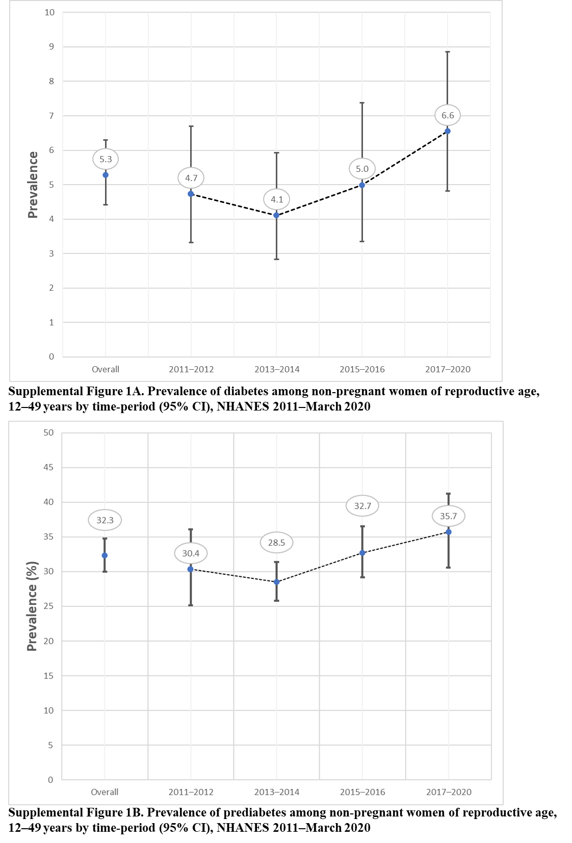 Supplemental Figures 1 (A-B)

Supplemental Figure 1A. Prevalence of diabetes among non-pregnant women of reproductive age, 12–49 years by time-period (95% CI): NHANES 2011–March 2020. Overall weighted percent of diabetes by NHANES cycles (2011–2012, 2013–2014, 2015–2016 and 2017–2020). Two-sided Wald 2011–2012 vs. 2017–2020 p = 0.16, p = 0.12 trend 2011–2020.
Supplemental Figure 1B. Prevalence of prediabetes among non-pregnant women of reproductive age, 12–49 years by time-period (95% CI): NHANES 2011–March 2020. Overall weighted percent of prediabetes by NHANES cycles (2011–2012, 2013–2014, 2015–2016 and 2017–2020). Two-sided Wald 2011–2012 vs. 2017–2020 p = 0.16, p = 0.08 trend 2011–2020.

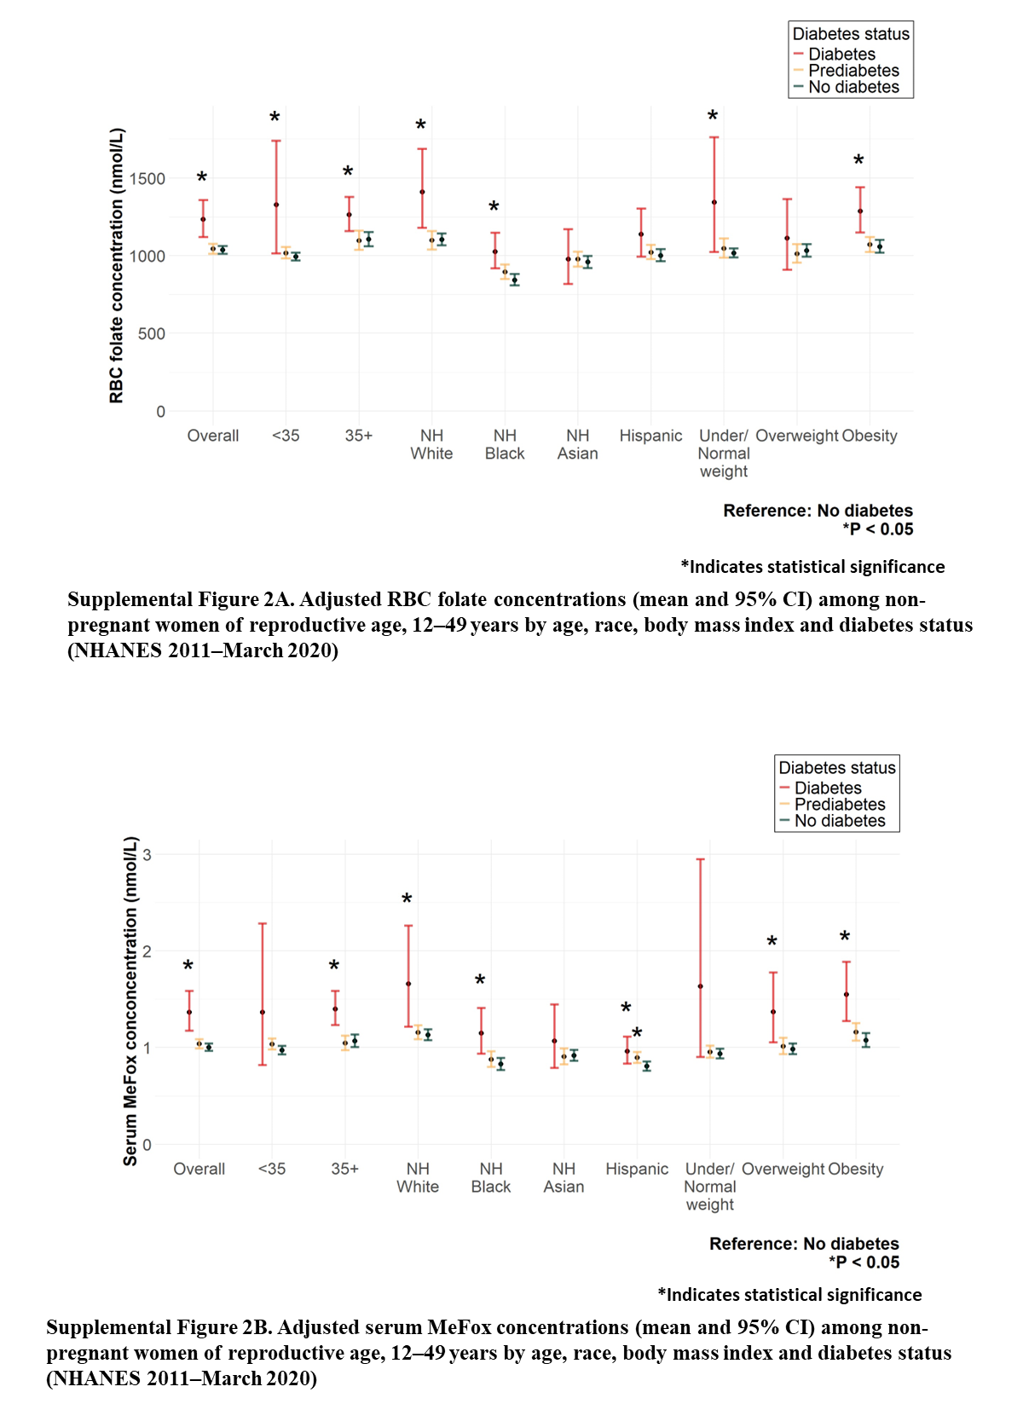

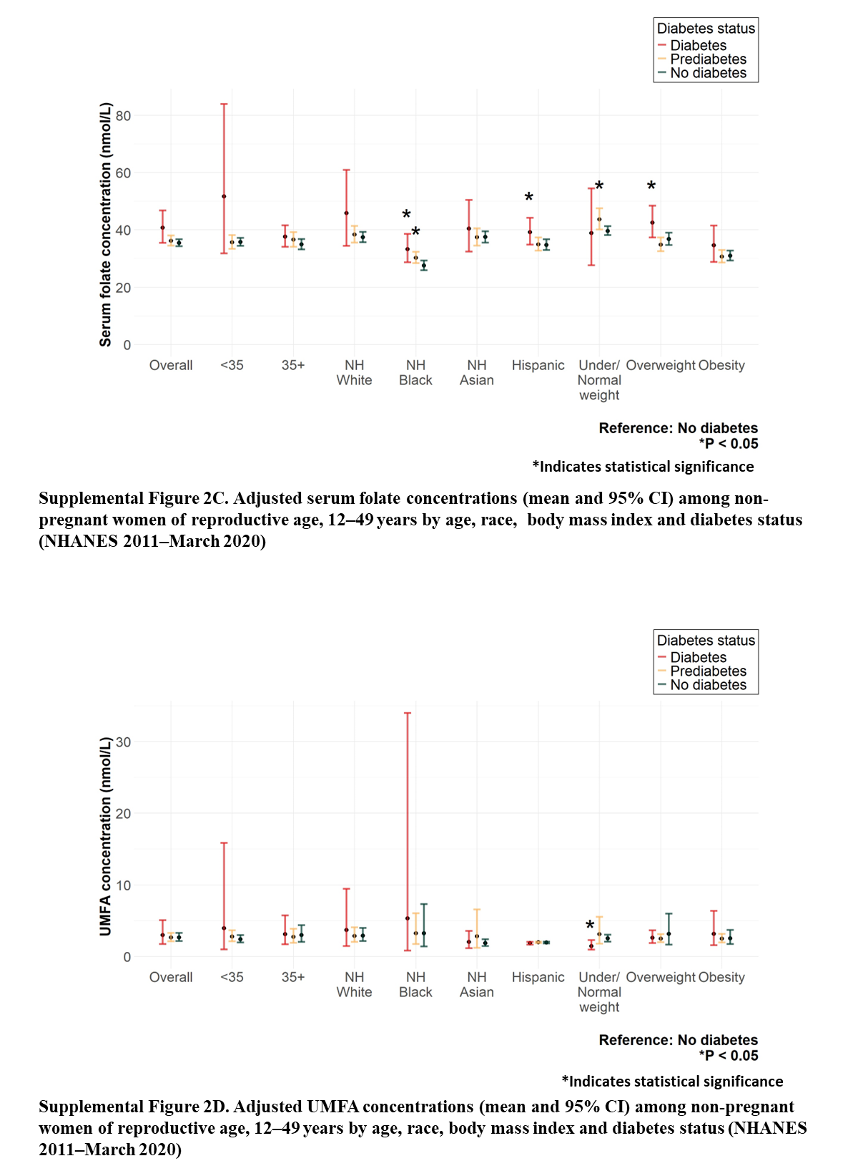

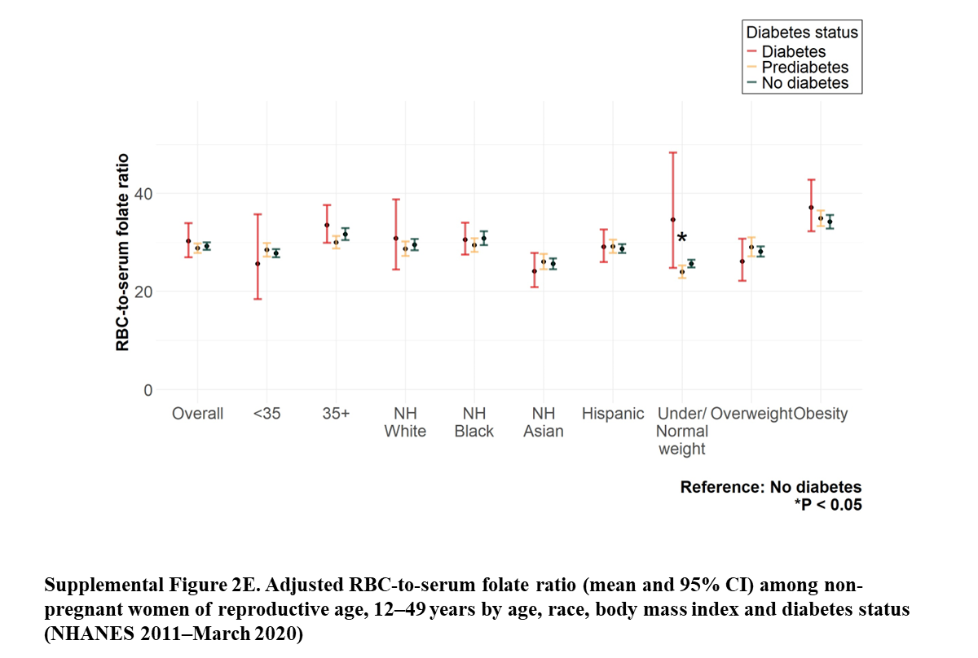

Figure 2A. Adjusted RBC folate concentrations (mean and 95% CI) among non-pregnant women of reproductive age, 12–49 years by age, race, body mass index and diabetes status: NHANES 2011–March 2020. RBC folate concentrations were higher among participants with diabetes compared to those without diabetes. Differences in RBC folate concentrations between participants with diabetes to those without diabetes were significant overall¹, and for the following subgroups: ≥35y², non-Hispanic White³, non-Hispanic Black⁴ , under/normal weight⁴ and obesity⁴ .
Supplemental Figure 2B. Adjusted serum MeFox concentrations (mean and 95% CI) among non-pregnant women of reproductive age, 12–49 years by age, race, body mass index and diabetes status: NHANES 2011–March 2020. Serum MeFox concentrations were higher among participants with diabetes compared to those without diabetes. Serum MeFox concentrations for overall¹, ≥35y², non-Hispanic White³, non-Hispanic Black³, Hispanic³, overweight⁴ and obesity⁴ were statistically significant comparing participants with diabetes to those without diabetes.
¹ Adjusted for age, race, body mass index, estimated glomerular filtration rate, family-income-poverty ratio income ratio, smoking exposure, supplement use
² Adjusted for race, body mass index, estimated glomerular filtration rate, family-income-poverty ratio income ratio, smoking exposure, supplement use
³ Adjusted for age, body mass index, estimated glomerular filtration rate, family-income-poverty ratio income ratio, smoking exposure, supplement use
⁴ Adjusted for age, race, estimated glomerular filtration rate, family-income-poverty ratio income ratio, smoking exposure, supplement use
Abbreviations: non-Hispanic (NH), pyrazino-s-triazine derivative of 4-α-hydroxy-5-methyltetrahydrofolate (MeFox), Red blood cell (RBC)
Supplemental Figure 2C. Adjusted serum concentrations (mean and 95% CI) among non-pregnant women of reproductive age, 12–49 years by age, race, body mass index and diabetes status: NHANES 2011–March 2020. Except for underweight, serum folate concentration was higher among participants with diabetes compared to those without diabetes. Serum folate concentrations for non-Hispanic Black¹, Hispanic¹ and overweight² were statistically significant comparing participants with diabetes to those without diabetes. Supplemental Figure 2D. Adjusted UMFA concentrations (mean and 95% CI) among non-pregnant women of reproductive age, 12–49 years by age, race, body mass index and diabetes status: NHANES 2011–March 2020. For underweight, UMFA concentration was lower and statistically significant comparing participants with diabetes to those without diabetes. UMFA concentrations for overall³, <35y⁴, ≥35y⁴, non-Hispanic White¹, non-Hispanic Black¹ , non-Hispanic Asian¹, Hispanic¹, overweight² and obesity² were not statistically significant. Supplemental Figure 2E. Adjusted RBC-to-serum ratio (mean and 95% CI) among non-pregnant women of reproductive age, 12–49 years by age, race, body mass index and diabetes status: NHANES 2011–March 2020. RBC-to-serum ratio for overall³, <35y⁴, ≥35y⁴, non-Hispanic White¹, non-Hispanic Black¹ , non-Hispanic Asian¹, Hispanic¹, under/normal weight², overweight² and obesity² were not statistically significant comparing participants with diabetes to those without diabetes.
¹ Adjusted for age, body mass index, estimated glomerular filtration rate, family-income-poverty ratio, smoking exposure, supplement use
² Adjusted for age, race, estimated glomerular filtration rate, family-income-poverty ratio, smoking exposure, supplement use
³ Adjusted for age, race, body mass index, estimated glomerular filtration rate, family-income-poverty ratio, smoking exposure, supplement use
⁴ Adjusted for race, body mass index, estimated glomerular filtration rate, family-income-poverty ratio, smoking exposure, supplement use
Abbreviations: non-Hispanic (NH), Red blood cell (RBC), Unmetabolized folic acid (UMFA)

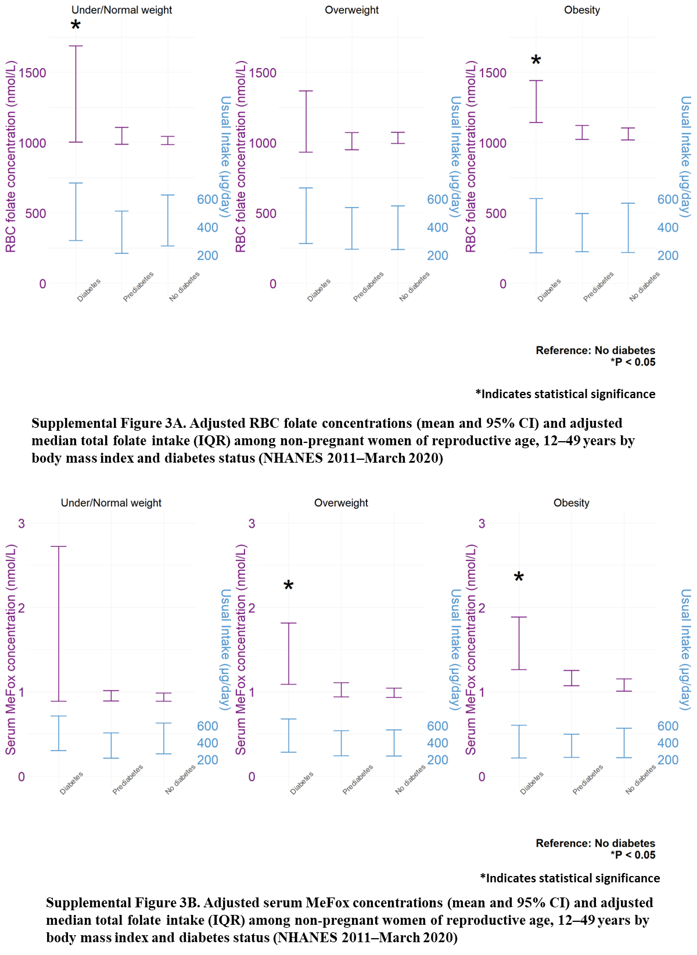

Supplemental Figure 3A. Adjusted RBC folate concentrations (mean and 95% CI) and median total folate intake (IQR) among non-pregnant women of reproductive age, 12–49 years by diabetes status and body mass index: NHANES 2011–March 2020. RBC folate concentration¹ among under/normal weight participants and those with obesity were higher and statistically significant comparing those with diabetes to those without diabetes, with no difference in median folic acid intake^{2, 3} (μg/day).
Supplemental Figure 3B. Adjusted serum MeFox concentrations (mean and 95% CI) and median total folate intake (IQR) among non-pregnant women of reproductive age, 12–49 years by diabetes status and body mass index: NHANES 2011–March 2020. Serum MeFox concentrations¹ among overweight participants and those with obesity was higher and statistically significantly comparing those with diabetes to those without diabetes, with no difference in median folic acid intake^{2, 3} (μg/day).
¹ Adjusted for age, race, body mass index, estimated glomerular filtration rate, family-income-poverty ratio, smoking exposure, supplement use
² Median intake and IQR accounting for the complex sampling design, adjustment for variations in day 1, day 2 measurements and by the day of the week; statistical analyses performed using Monte Carlo simulated pseudo-persons (each participant generated 100 pseudo-persons of the participant)
³ Adjusted for adjusted for age, race, family-income-poverty ratio and body mass index
Abbreviations: Interquartile range (IQR), Pyrazino-s-triazine derivative of 4-α-hydroxy-5-methyltetrahydrofolate (MeFox), Red blood cell (RBC)
Pink line: RBC folate and serum MeFox concentrations (nmol/L); Blue line: usual intake (μg/day)

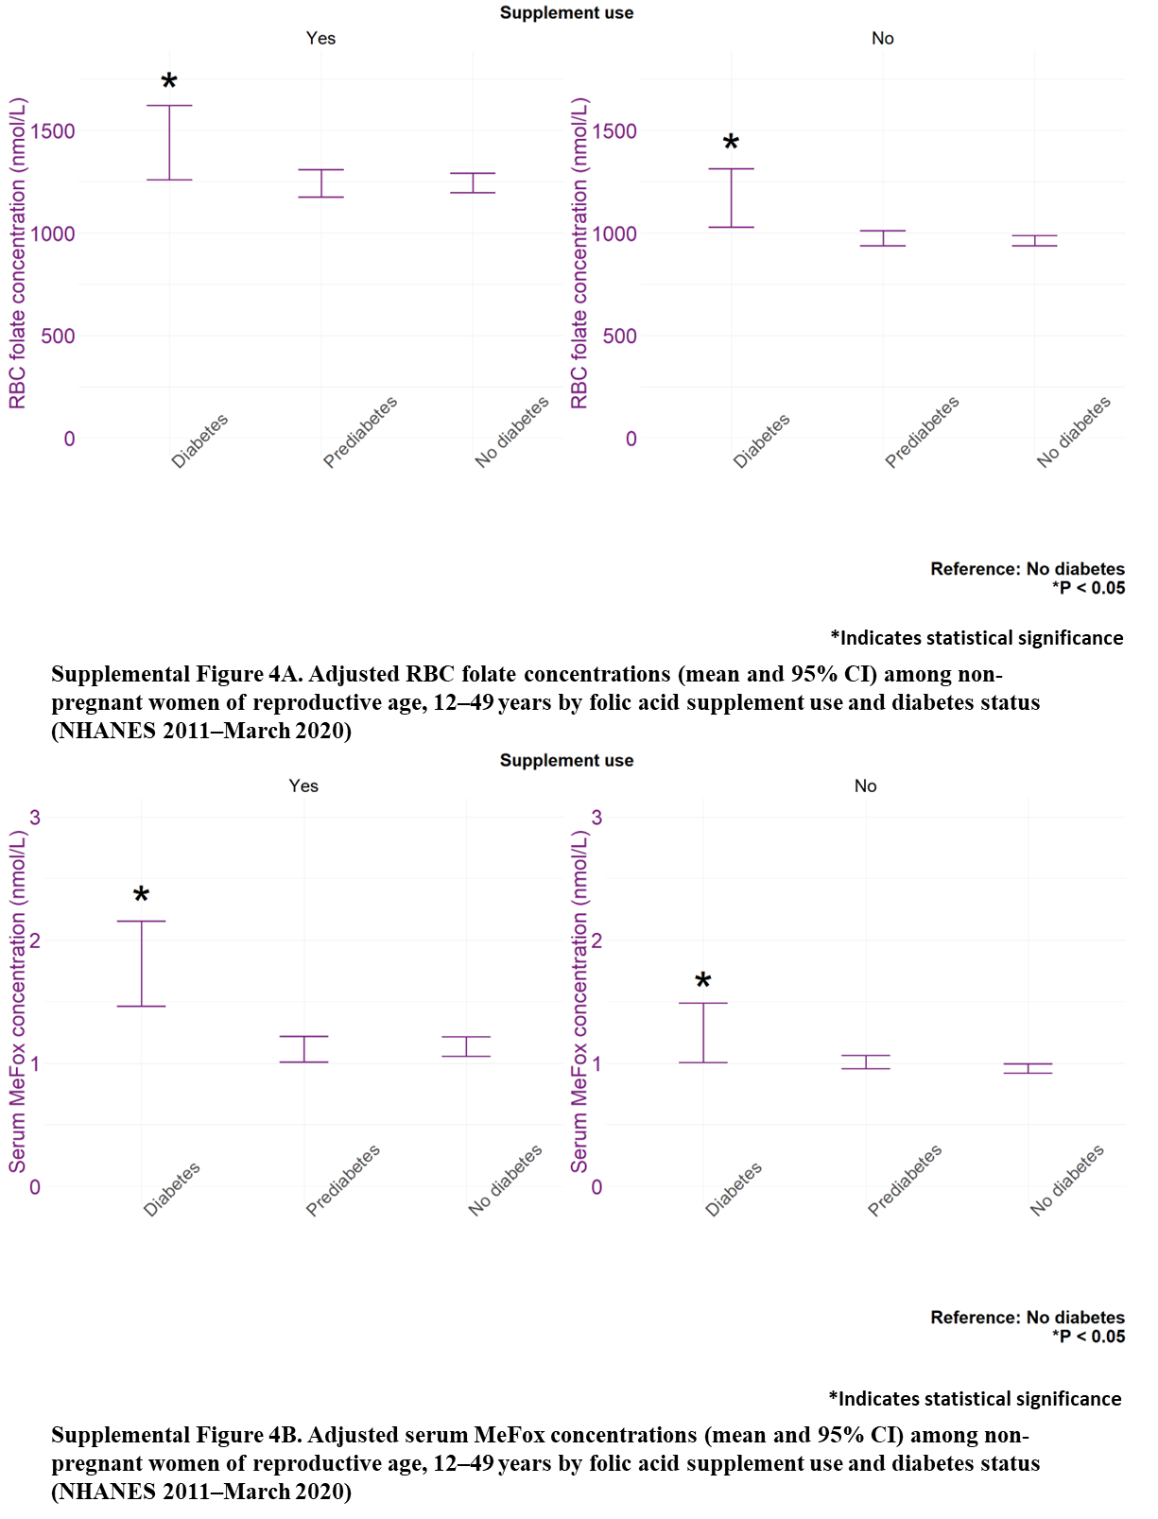
Supplemental Figure 4A. Adjusted RBC folate concentrations (mean and 95% CI) among non-pregnant women of reproductive age, 12–49 years by folic acid supplement use and diabetes status: NHANES 2011–March 2020. RBC folate concentration¹ was higher and statistically significant among participants with diabetes compared to those without diabetes, regardless of folic acid supplementation status.
Figure Supplemental 4B. Adjusted serum MeFox concentrations (mean and 95% CI) among non-pregnant women of reproductive age, 12–49 years by folic acid supplement use and diabetes status: NHANES 2011–March 2020. Serum MeFox concentration¹ was higher and statistically significant among participants with diabetes compared to those without diabetes, regardless of folic acid supplementation status.
¹ Adjusted for age, race, body mass index, estimated glomerular filtration rate, family-income-poverty ratio and smoking exposure

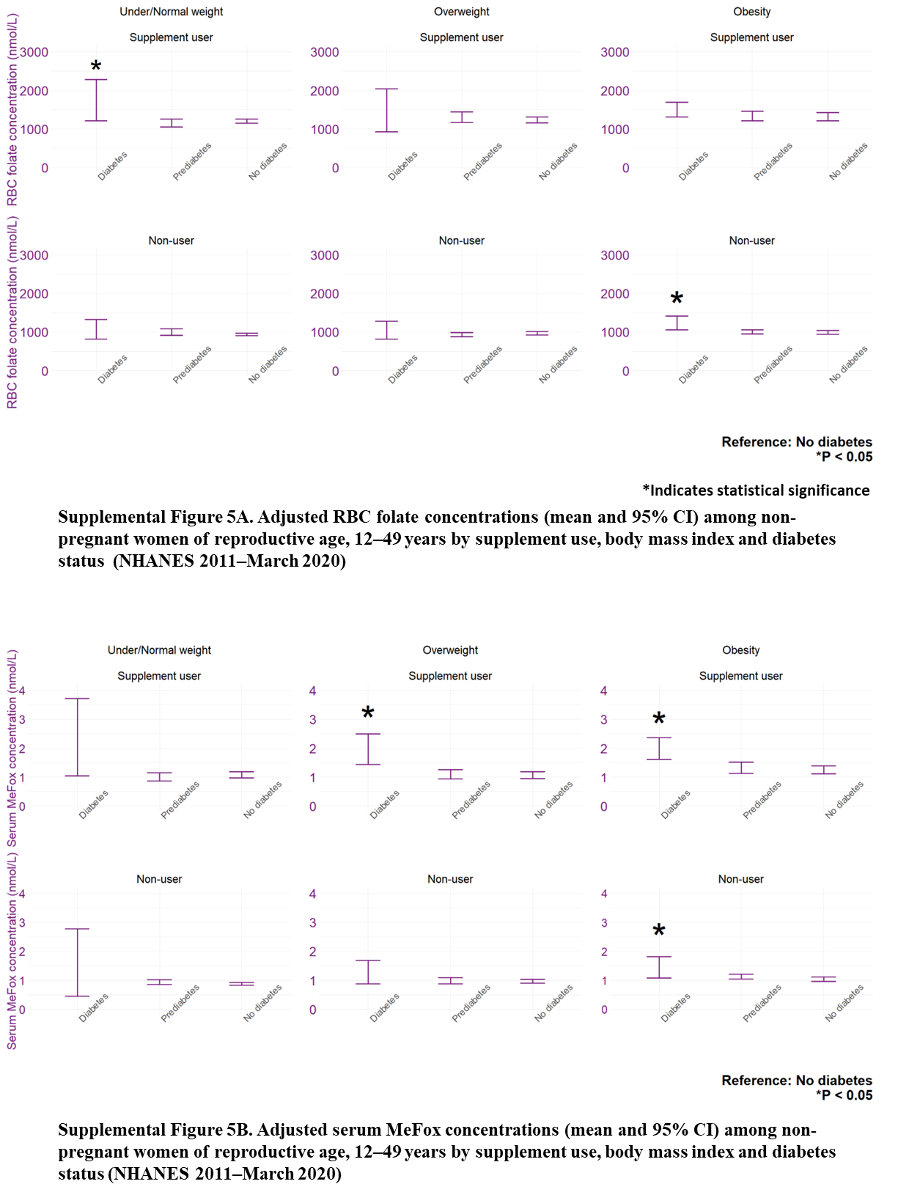
Supplemental Figures 5 (A-B)
Supplemental Figure 5A. Adjusted RBC folate concentrations (mean and 95% CI) among non-pregnant women of reproductive age, 12–49 years by supplement use, body mass index and diabetes status: NHANES 2011–March 2020. For under/normal weight participants taking folic acid supplements and those with obesity not taking folic acid supplementation, RBC folate concentration¹ were higher and statistically significant comparing those with diabetes to those without diabetes.
Supplemental Figure 5B. Adjusted serum MeFox concentrations (mean and 95% CI) among non-pregnant women of reproductive age, 12–49 years by folic acid supplement use, body mass index and diabetes status: NHANES 2011–March 2020. For participants with obesity, serum MeFox concentration¹ was higher and statistically significant comparing those with diabetes to those without diabetes, regardless of folic acid supplementation status.
¹ Adjusted for age, race, estimated glomerular filtration rate, family-income-poverty ratio and smoking exposure
Abbreviations: Pyrazino-s-triazine derivative of 4-α-hydroxy-5-methyltetrahydrofolate (MeFox), Red blood cell (RBC)

