Supplementary Data
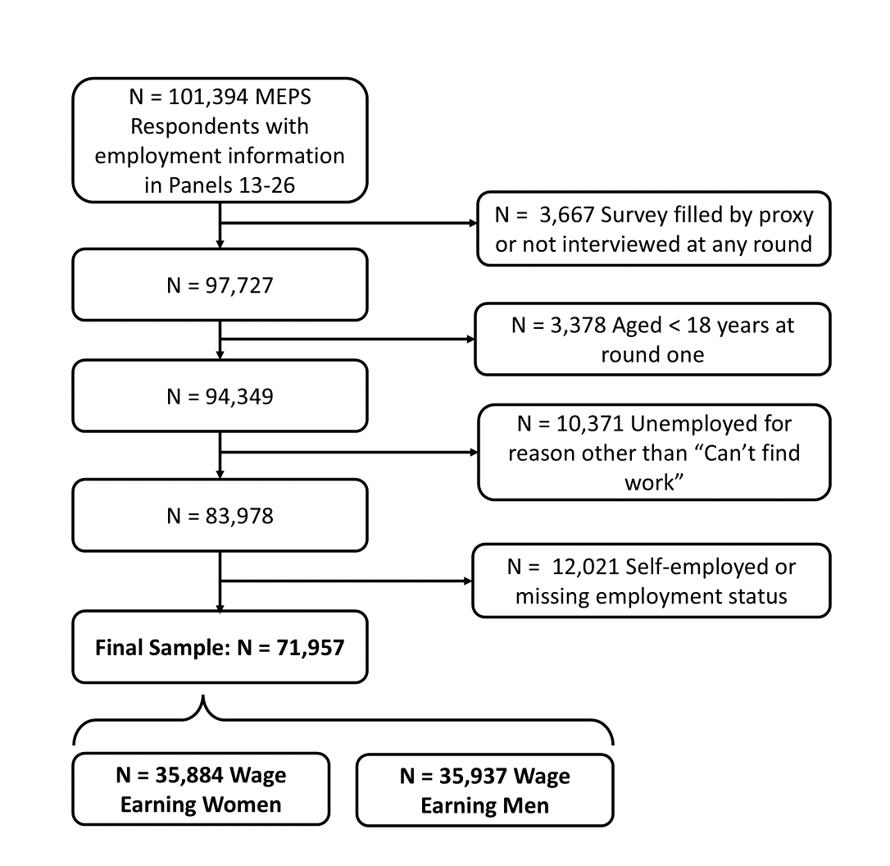
Supplementary Figure 1. Construction of the analytic sample used in this study of US Medical Panel Expenditure Panel Survey (MEPS) data from 2008-2022; all values unweighted.

Supplementary Table 1. Conditional probability output from latent transition analysis (LTA) models used to create employment quality (EQ) types in a sample of men and women from the US Medical Expenditure Panel Survey, 2008-2022.
Employment Quality Indicator | Overall | Men |  |  |  |  | Women
Employment Quality Indicator | Overall | Salaried-Intensive | SER-like | SEV | Precarious | Unemployed | SER-like, Union | SER-like, Non-Union | Precarious | Unemployed
Sample Proportion | 1.000 | 0.058 | 0.392 | 0.234 | 0.253 | 0.063 | 0.096 | 0.462 | 0.374 | 0.069
Job is Temporary
No | 0.880 | 0.987 | 0.982 | 0.966 | 0.834 | 0.000 | 0.984 | 0.982 | 0.891 | 0.000
Yes | 0.054 | 0.013 | 0.019 | 0.034 | 0.166 | 0.000 | 0.016 | 0.018 | 0.109 | 0.000
Unemployed | 0.066 | 0.000 | 0.000 | 0.000 | 0.000 | 1.000 | 0.000 | 0.000 | 0.000 | 1.000
Job is Seasonal
No | 0.891 | 0.988 | 0.988 | 0.978 | 0.871 | 0.000 | 0.937 | 0.983 | 0.922 | 0.000
Yes | 0.043 | 0.012 | 0.012 | 0.022 | 0.129 | 0.000 | 0.063 | 0.018 | 0.078 | 0.000
Unemployed | 0.066 | 0.000 | 0.000 | 0.000 | 0.000 | 1.000 | 0.000 | 0.000 | 0.000 | 1.000
Length of Time in Current Job
> 1 Year | 0.699 | 0.874 | 0.875 | 0.732 | 0.534 | 0.000 | 0.929 | 0.848 | 0.579 | 0.000
<= 1 Year | 0.236 | 0.126 | 0.125 | 0.268 | 0.466 | 0.000 | 0.071 | 0.152 | 0.421 | 0.000
Unemployed | 0.066 | 0.000 | 0.000 | 0.000 | 0.000 | 1.000 | 0.000 | 0.000 | 0.000 | 1.000
Hours Worked per Week
Unemployed | 0.066 | 0.000 | 0.000 | 0.000 | 0.000 | 1.000 | 0.000 | 0.000 | 0.000 | 1.000
< 35 | 0.187 | 0.001 | 0.021 | 0.105 | 0.376 | 0.000 | 0.133 | 0.063 | 0.546 | 0.000
35-48 | 0.620 | 0.005 | 0.836 | 0.758 | 0.527 | 0.000 | 0.734 | 0.808 | 0.421 | 0.000
> 48 | 0.127 | 0.994 | 0.143 | 0.137 | 0.098 | 0.000 | 0.132 | 0.129 | 0.033 | 0.000
Hourly Wage
Unemployed | 0.066 | 0.000 | 0.000 | 0.000 | 0.000 | 1.000 | 0.000 | 0.000 | 0.000 | 1.000
Q1 | 0.234 | 0.013 | 0.009 | 0.277 | 0.490 | 0.000 | 0.065 | 0.077 | 0.620 | 0.000
Q2/Q3 | 0.467 | 0.001 | 0.567 | 0.609 | 0.431 | 0.000 | 0.544 | 0.615 | 0.332 | 0.000
Q4 | 0.234 | 0.987 | 0.425 | 0.114 | 0.080 | 0.000 | 0.391 | 0.308 | 0.047 | 0.000
Pay Structure
Salary | 0.303 | 0.991 | 0.453 | 0.237 | 0.102 | 0.000 | 0.464 | 0.472 | 0.072 | 0.000
Non-Salary | 0.632 | 0.009 | 0.547 | 0.763 | 0.899 | 0.000 | 0.536 | 0.528 | 0.928 | 0.000
Unemployed | 0.066 | 0.000 | 0.000 | 0.000 | 0.000 | 1.000 | 0.000 | 0.000 | 0.000 | 1.000
Employer Offers Paid Sick Leave or Vacation
Yes | 0.676 | 0.985 | 0.966 | 0.990 | 0.042 | 0.000 | 0.983 | 0.990 | 0.326 | 0.000
No | 0.259 | 0.015 | 0.034 | 0.010 | 0.958 | 0.000 | 0.017 | 0.010 | 0.674 | 0.000
Unemployed | 0.066 | 0.000 | 0.000 | 0.000 | 0.000 | 1.000 | 0.000 | 0.000 | 0.000 | 1.000
Employer Offers Insurance
Yes | 0.650 | 0.971 | 0.979 | 0.720 | 0.211 | 0.000 | 0.960 | 0.946 | 0.292 | 0.000
No | 0.284 | 0.029 | 0.021 | 0.280 | 0.789 | 0.000 | 0.040 | 0.054 | 0.708 | 0.000
Unemployed | 0.066 | 0.000 | 0.000 | 0.000 | 0.000 | 1.000 | 0.000 | 0.000 | 0.000 | 1.000
Pension/Retirement Plan through Employer
Yes | 0.491 | 0.897 | 0.995 | 0.193 | 0.046 | 0.000 | 0.865 | 0.807 | 0.073 | 0.000
No | 0.444 | 0.103 | 0.005 | 0.807 | 0.954 | 0.000 | 0.135 | 0.193 | 0.927 | 0.000
Unemployed | 0.066 | 0.000 | 0.000 | 0.000 | 0.000 | 1.000 | 0.000 | 0.000 | 0.000 | 1.000
Union Member
Yes | 0.11 | 0.075 | 0.214 | 0.075 | 0.032 | 0.000 | 0.998 | 0.000 | 0.030 | 0.000
No | 0.82 | 0.925 | 0.785 | 0.925 | 0.968 | 0.000 | 0.000 | 0.996 | 0.969 | 0.000
Unemployed | 0.07 | 0.000 | 0.000 | 0.000 | 0.000 | 1.000 | 0.000 | 0.000 | 0.000 | 1.000

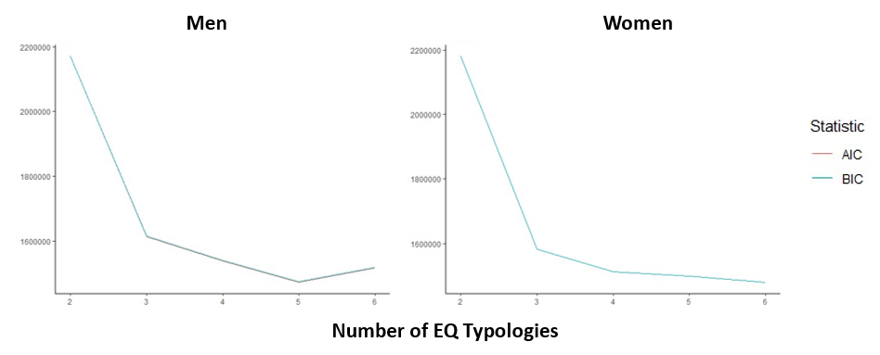 Supplementary Figure 2. Akaike Information Criteria (AIC) and Bayesian Information Criteria (BIC) for latent transition analysis (LTA) models in a sample of men and women from the US Medical Expenditure Panel Survey, 2008-2022.

Supplementary Table 2. Transition probabilities between current and previous employment quality (EQ) types and related probabilities of reporting poor/fair self-rated health (SRH) and self-rated mental health (SRMH).
Current EQ Type | Previous EQ Type | Transition Probabilityª | Probability of Reporting
Current EQ Type | Previous EQ Type | Transition Probabilityª | Poor/Fair SRH | Poor/Fair SRMH
Men
Salaried-Intensive | Salaried-Intensive | 0.978 | 0.045 | 0.026
Salaried-Intensive | SER-like | 0.001 | 0.106 | 0.043
Salaried-Intensive | SEV | 0.001 | 0.127 | 0.092
Salaried-Intensive | Precarious | 0.001 | 0.025 | 0.007
Salaried-Intensive | Unemployed | 0.007 | 0.074 | 0.052
SER-like | Salaried-Intensive | 0.008 | 0.003 | 0.008
SER-like | SER-like | 0.977 | 0.055 | 0.031
SER-like | SEV | 0.006 | 0.049 | 0.012
SER-like | Precarious | 0.009 | 0.039 | 0.044
SER-like | Unemployed | 0.050 | 0.062 | 0.044
SEV | Salaried-Intensive | 0.003 | 0.364 | 0.161
SEV | SER-like | 0.003 | 0.046 | 0.032
SEV | SEV | 0.942 | 0.081 | 0.042
SEV | Precarious | 0.022 | 0.055 | 0.045
SEV | Unemployed | 0.116 | 0.067 | 0.040
Precarious | Salaried-Intensive | 0.001 | 0.020 | 0.020
Precarious | SER-like | 0.006 | 0.051 | 0.040
Precarious | SEV | 0.021 | 0.096 | 0.048
Precarious | Precarious | 0.899 | 0.081 | 0.050
Precarious | Unemployed | 0.385 | 0.082 | 0.063
Unemployed | Salaried-Intensive | 0.010 | 0.091 | 0.050
Unemployed | SER-like | 0.014 | 0.081 | 0.067
Unemployed | SEV | 0.031 | 0.114 | 0.072
Unemployed | Precarious | 0.069 | 0.119 | 0.078
Unemployed | Unemployed | 0.444 | 0.090 | 0.091
Women
SER-like, Union | SER-like, Union | 0.978 | 0.071 | 0.049
SER-like, Union | SER-like, Non-Union | 0.001 | 0.034 | 0.087
SER-like, Union | Precarious | 0.002 | 0.082 | 0.077
SER-like, Union | Unemployed | 0.012 | 0.086 | 0.026
SER-like, Non-Union | SER-like, Union | 0.006 | 0.049 | 0.107
SER-like, Non-Union | SER-like, Non-Union | 0.974 | 0.062 | 0.042
SER-like, Non-Union | Precarious | 0.014 | 0.098 | 0.060
SER-like, Non-Union | Unemployed | 0.076 | 0.075 | 0.052
Precarious | SER-like, Union | 0.005 | 0.043 | 0.034
Precarious | SER-like, Non-Union | 0.007 | 0.095 | 0.103
Precarious | Precarious | 0.921 | 0.095 | 0.065
Precarious | Unemployed | 0.476 | 0.113 | 0.085
Unemployed | SER-like, Union | 0.011 | 0.097 | 0.051
Unemployed | SER-like, Non-Union | 0.018 | 0.089 | 0.093
Unemployed | Precarious | 0.063 | 0.125 | 0.109
Unemployed | Unemployed | 0.437 | 0.110 | 0.098
ª Transition probabilities determined via latent transition analysis.

