Symptomatic and asymptomatic norovirus infections in early life; The PREVAIL Cohort, 2017-2020

Julia M. Baker, Jennifer L. Cannon, Claire P. Mattison, Hannah Browne, Kenny Nguyen, Rachel M. Burke, Eddie Bartlett, Shannon C. Conrey, Allison R. Burrell, Mary Allen Staat, Ardythe L. Morrow, Umesh D. Parashar, Jan Vinjé, Sara A. Mirza, Daniel C. Payne

SUPPLEMENTAL MATERIAL
Pathogen detection

Viral nucleic acids extracted from stools were tested by RT-PCR (realtime and/or conventional) for the presence of norovirus GI, norovirus GII, sapovirus, astrovirus, and rotavirus [1–3]. Stools collected during the first year of life were additionally tested using the Luminex xTAG GPP for the presence of norovirus GI and GII, rotavirus, and adenovirus 40/41 [4]. A bead manipulation method for mechanical release of non-viral pathogen DNA was performed to extract total nucleic acids on a subset of stools (n = 611) associated with 491 AGE episodes that occurred during the first two years of life. This was then tested using the Luminex xTAG GPP for the presence of nine bacteria, and three protozoa [4]. Additional details and a testing flow chart are available in Cannon et al [5]. A positive test for norovirus by any method prompted testing by conventional RT-PCR, Sangar sequencing [5] and genotyping [6] using the most recent classification for noroviruses [7]. Reference sequences for new GII.4 variants were included in the classification method and only GII.4 Sydney was found.

Other enteropathogen infections and co-infection definition

Other enteropathogen infections were defined using the same approach as that for norovirus. The initial positive sample was considered the start of an infection. Subsequent detections of the same genotype were included as part of the same infection if the subsequent detection occurred ≤30 days of the prior detection. Any detection of a new genotype or detection that occurred >30 from the prior detection was considered a new infection [5].

A norovirus infection was considered a co-infection if the initial positive sample for norovirus occurred on the same day as the initial positive sample for another viral enteropathogen. A norovirus infection was also considered a co-infection if the initial positive sample for a non-viral enteropathogen occurred during the symptomatic period of the norovirus infection.

Symptom status assigned based on the timing of norovirus detection relative to the timing of AGE symptom start, as described in the main text. Symptom status was unknown if data were not available for the weeks leading up to or following the start of the infection or if symptoms that occurred within the 14-day window were attributed to another pathogen.

Infections with norovirus alone (n=219) and norovirus co-infections (n=18) had similar rates of symptomatic illness (34.7% for norovirus alone versus 47.1% for co-infections, p=0.446). Among symptomatic infections, infections with norovirus alone were more likely to include both vomiting and diarrhea (61.8% vs 25.0% among co-infections) or vomiting only (22.4% vs. 0% among co-infections) and less likely to present with diarrhea only (15.8% vs. 75.0% among co-infections) (p<0.001).

Modified Vesikari Score

The original Vesikari score [8] for evaluating the severity of an AGE episode was modified to account for behavioral signs and symptoms and allows for evaluation of severity of illness without follow-up through the entire duration of the illness. The modified scoring system has been validated for use among US children [9] and is detailed below. Episodes were classified as mild (scores ≤8), moderate (scores 9-10) or severe (scores ≥11).

Component | 1 Point | 2 Points | 3 Points
Duration of diarrhea (days) | 1-4 | 5 | ≥6
Maximum episodes of diarrhea in 24 hours | 1-3 | 4-5 | ≥6
Duration of vomiting (days) | 1 | 2 | ≥3
Maximum episodes of vomiting in 24 hours | 1 | 2-4 | ≥5
Fever (°F) | 98.7-101.1 | 101.2-102 | ≥102.1
Behavioral signs | Less playful/irritable | Lethargic/listless | Seizure
Treatment | Oral or IV rehydration, no hospitalization | Hospitalization | N/A

FUT2 genotype (secretor status)

Maternal saliva samples were collected at enrollment and child samples were collected at 6 weeks or 12 months of age. DNA was extracted from saliva samples and tested via PCR to detect the presence of a 428 G > A point mutation. Individuals with the point mutation in both FUT2 alleles (AA) were classified as non-secretors. Individuals with GG or GA genotypes were classified as secretors [10]. Prior literature suggests that viral binding to target cells may be reduced among non-secretors, impacting susceptibility to infection and disease [11].

Model predictors

Model predictors were selected a priori and included health insurance type, childcare at the time of infection, whether the child was breastfed at the time of infection, mother and child secretor status, norovirus genogroup/genotype, whether the child had a previous norovirus infection, child’s age, and minimum Ct value detected among stool samples collected during the infection. Health insurance status was defined as the mother’s reported insurance source, either private or public. A survey on childcare (location, number of days per week, and number of other children in the childcare setting) was administered to mothers when the child was 6 weeks, 4 months, 6 months, 12 months, 18 months and 24 months of age. Childcare at the time of infection was identified from the most proximal childcare survey completed either prior to or after the time of infection. Childcare was considered at home if the child was in their own home or another’s home with no other children. Small childcare centers are those with ≤5 other children while large childcare centers are those with >5 other children. Whether the child was breastfed at the time of infection was based on dates of breastfeeding initiation and completion. Mother and child secretor status are defined as stated above. Ct value was the minimum Ct value detected among stool samples collected during the infection.
Figure S1. Distribution of GI (A) and GII (B) genotypes¹ detected in norovirus infections among all children and adherent children in the PREVAIL cohort.
A
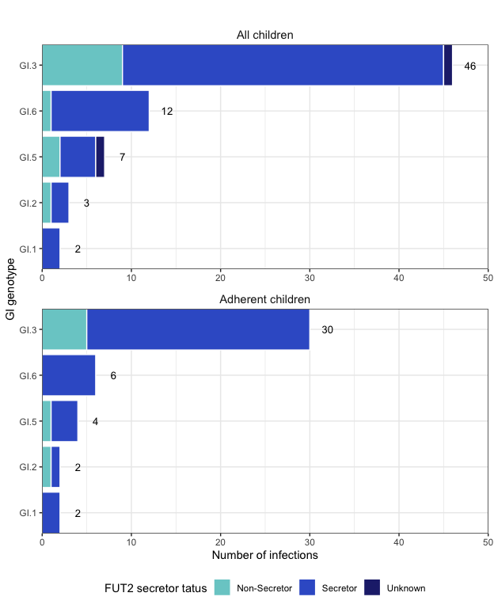

B
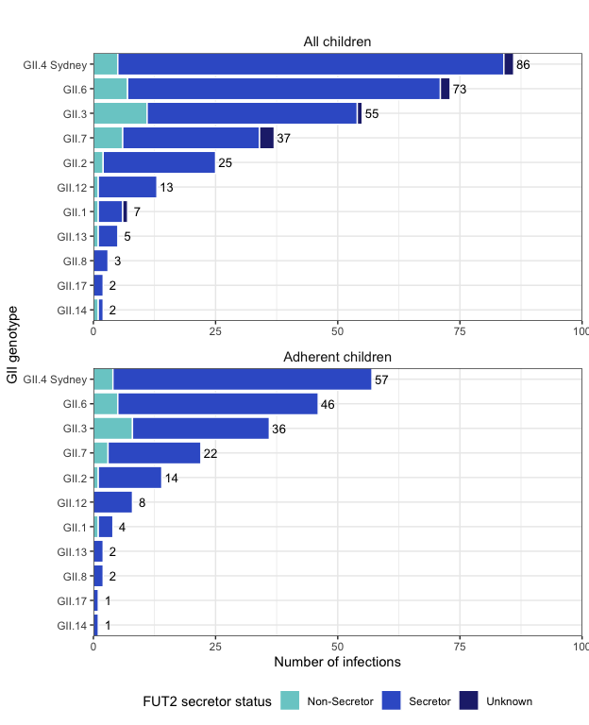
¹Counts exclude infections where the genotype could not be determined (All children: n=2 for GI, n=22 for GII; Adherent children: n=1 for GI, n=15 for GII)). Genotypes are collapsed by capsid and polymerase. Full list of GI genotypes: GI.1[P1], GI.2[P2], GI.3[P13], GI.3[P3], GI.5[P4], GI.5[P5], GI.6[P11], GI.6[P6], GI.unknown. Full list of GII genotypes: GII.1[P16], GII.1[P33], GII.12[P unknown], GII.12[P untypeable], GII.12[P16], GII.13[P16], GII.14[P7], GII.17[P3], GII.2[P16], GII.2[P2], GII.3[P12], GII.3[P21], GII.3[P30], GII.4 Sydney[P16], GII.4 Sydney[P31], GII.4 Sydney[P4], GII.6[P7], GII.7, GII.7[P7], GII.8[P8], GII.unknown, GII.unknown[P7].

Table S1. Individual symptoms and norovirus infection¹ characteristics among adherent children in the PREVAIL cohort stratified by child year of life.
Characteristic | 1st year of life  N=26 | 2nd year of life  N=50 | p-value²
Symptom duration (days, median [IQR]) | 3.0 [2.0-4.8] | 3.0 [2.0-5.0] | 0.516
Symptom type
Diarrhea | 22 (84.6%) | 37 (74.0%) | 0.445
Vomiting | 24 (92.3%) | 40 (80%) | 0.287
Fever | 7 (29.2%) | 16 (32.7%) | 0.974
Diarrhea
Maximum episodes in 24  hours (median [IQR]) | 4.0 [2.5-5.0] | 4.0 [3.0-6.0] | 0.627
Duration (days, median [IQR]) | 3.0 [2.0-4.5] | 3.0 [2.0-4.0] | 0.708
Vomiting
Maximum episodes in 24  hours (median [IQR]) | 3.0 [2.0-4.0] | 3.0 [2.0-5.5] | 0.447
Duration (days, median [IQR]) | 2.0 [1.0-3.0] | 1.0 [1.0-2.0] | 0.095
Illness severity (MVS)³
Mild (score 0-8) | 22 (84.6%) | 45 (90.0%) | 0.751
Moderate (score 9-10) | 2 (7.7%) | 3 (6.0%)
Severe (score ≥11) | 2 (7.7%) | 2 (4.0%)
Care seeking
Home care | 16 (61.5%) | 35 (70.0%) | 0.506
Outpatient | 6 (23.1%) | 9 (18.0%)
ED/Hospital | 4 (15.4%) | 6 (12.0%)
Abbreviations: IQR, interquartile range; ED, emergency department; MVS, modified Vesikari score
¹ Among symptomatic infections only and excluding co-infections (n=18).
² Comparing distributions across years of life
³ Calculated using a modified Vesikari score incorporating diarrhea duration and number of episodes, vomiting duration and number of episodes, fever, behavioral signs, and treatment.
Table S2. Unadjusted and adjusted generalized estimating equation model results describing predictors of norovirus symptomatic status among adherent children in the PREVAIL cohort, stratified by year of life or limited to first infection.
Category | Unadjusted  OR (95% CI)  (all infections)  N=219 | Adjusted  OR (95% CI)  1st year of life¹  N=88 | Adjusted  OR (95% CI)  2nd year of life  N=126 | Adjusted  OR (95% CI)  1st infection¹  N=73
Mother’s insurance
Private | 1.00 (ref) | 1.00 (ref) | 1.00 (ref) | 1.00 (ref)
Public | 1.01 (0.48-2.09) | 1.19 (0.25-5.77) | 0.92 (0.45-1.90) | 2.94 (0.65-15.09)
Childcare setting at time of infection²
At home/other’s home | 1.00 (ref) | 1.00 (ref) | 1.00 (ref) | 1.00 (ref)
Small | 0.87 (0.36-2.09) | 4.96 (0.95-25.96) | 0.25 (0.07-0.87) | 1.36 (0.16-9.82)
Large | 1.09 (0.57-2.08) | 4.97 (1.42-17.40) | 0.31 (0.14-0.73) | 2.31 (0.62-9.42)
Breastfed at time of infection³
No | 1.00 (ref) | 1.00 (ref) | 1.00 (ref) | 1.00 (ref)
Yes | 0.82 (0.45-1.51) | 0.75 (0.25-2.26) | 5.92 (1.64-21.33) | 0.57 (0.13-2.44)
Mother’s secretory status⁴
Non-secretor | 1.00 (ref) | -- | 1.00 (ref) | 1.00 (ref)
Secretor | 1.23 (0.55-2.79) | -- | 0.40 (0.12-1.31) | 1.10 (0.12-10.72)
Child’s secretor status⁴
Non-secretor | 1.00 (ref) | -- | 1.00 (ref) | 1.00 (ref)
Secretor | 2.43 (0.84-7.04) | -- | 4.59 (0.91-23.10) | 4.58 (0.54-75.58)
Genogroup/genotype
GI | 1.00 (ref) | -- | 1.00 (ref) | 1.00 (ref)
GII.4 | 2.95 (1.11-7.82) | -- | 1.84 (0.47-7.28) | 0.88 (0.08-10.07)
Other GII (not GII.4) | 2.43 (1.00-5.88) | -- | 1.58 (0.49-5.07) | 1.48 (0.16-14.84)
Previous noro infection
No | 1.00 (ref) | 1.00 (ref) | 1.00 (ref) | --
Yes | 1.06 (0.60-1.88) | 0.81 (0.28-2.38) | 0.70 (0.19-2.54) | --
Age at infection (months) | 1.06 (1.01-1.12) | 1.17 (0.93-1.47) | 1.13 (0.99-1.30) | 1.11 (0.96-1.29)
Ct value (continuous) | 0.88 (0.83-0.94) | 0.95 (0.85-1.05) | 0.85 (0.77-0.95) | 0.87 (0.74-0.99)
Abbreviations: OR, odds ratio; CI, confidence interval; ref, reference group; Ct, cycle-threshold.
¹ Predictors without odds ratios were unable to be included in the model. Inclusion of these predictors prevented model convergence.
² Childcare was considered at home if the child was in their own home or another’s home with no other children; small childcare centers are those with 5 or fewer other children; large childcare centers are those with more than 5 other children.
³ Describes whether the child was breastfed at all (any amount or frequency) at the time of infection.
⁴ Refers to FUT2 status of the mother/child. FUT2 genotype was categorized based on detection of a 428 G > A point mutation. Individuals with the point mutation in both FUT2 alleles (AA) were classified as non-secretors. Individuals with GG or GA genotypes were classified as secretors.

Supplemental material references

1. Diez-Valcarce M, Cannon JL, Browne H, et al. Prevalence and Genetic Diversity of Adenovirus 40/41, Astrovirus, and Sapovirus in Children with Acute Gastroenteritis in Kansas City 2011-2016. J Infect Dis 2024; :jiae251.
2. Cannon JL, Barclay L, Collins NR, et al. Genetic and Epidemiologic Trends of Norovirus Outbreaks in the United States from 2013 to 2016 Demonstrated Emergence of Novel GII.4 Recombinant Viruses. J Clin Microbiol 2017; 55:2208–2221.
3. Burke RM, Payne DC, McNeal M, et al. Correlates of Rotavirus Vaccine Shedding and Seroconversion in a U.S. Cohort of Healthy Infants. The Journal of Infectious Diseases 2024; :jiae055.
4. Navidad JF, Griswold DJ, Gradus MS, Bhattacharyya S. Evaluation of Luminex xTAG gastrointestinal pathogen analyte-specific reagents for high-throughput, simultaneous detection of bacteria, viruses, and parasites of clinical and public health importance. J Clin Microbiol 2013; 51:3018–3024.
5. Cannon JL, Baker JM, Mattison CP, et al. Enteric viral pathogens in infants in the United States: 2017-2020. Pediatrics. In press
6. Chhabra P, Browne H, Huynh T, et al. Single-step RT-PCR assay for dual genotyping of GI and GII norovirus strains. Journal of Clinical Virology 2021; 134:104689.
7. Chhabra P, de Graaf M, Parra GI, et al. Updated classification of norovirus genogroups and genotypes. J Gen Virol 2019; 100:1393–1406.
8. Ruuska T, Vesikari T. Rotavirus Disease in Finnish Children: Use of Numerical Scores for Clinical Severity of Diarrhoeal Episodes. Scandinavian Journal of Infectious Diseases 1990; 22:259–267.
9. Wikswo ME, Weinberg GA, Szilagyi PG, et al. Evaluation of a Modified Vesikari Severity Score as a Research Tool for Assessing Pediatric Acute Gastroenteritis. Journal of the Pediatric Infectious Diseases Society 2024; 13:547–550.
10. Thorman AW, Adkins G, Conrey SC, et al. Gut Microbiome Composition and Metabolic Capacity Differ by FUT2 Secretor Status in Exclusively Breastfed Infants. Nutrients 2023; 15:471.
11. Kambhampati A, Payne DC, Costantini V, Lopman BA. Host Genetic Susceptibility to Enteric Viruses: A Systematic Review and Metaanalysis. Clinical Infectious Diseases 2016; 62:11–18.

