Supplementary Figure. Images used for survey about ringworm in children

- Hives
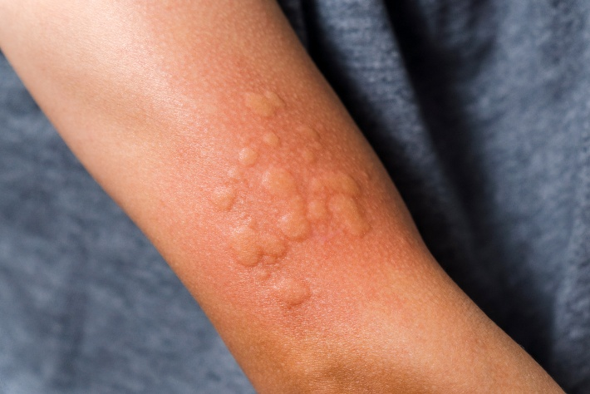

- Ringworm
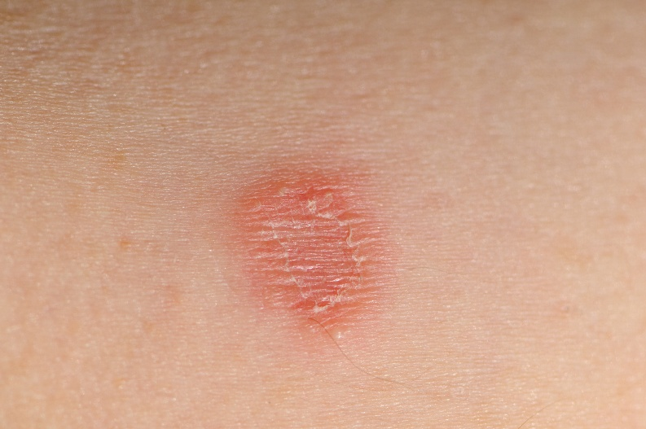

- Eczema or psoriasis
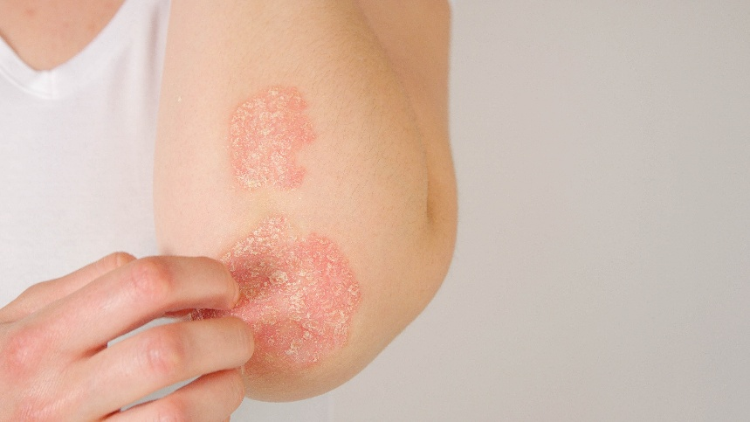

- Erythema migrans
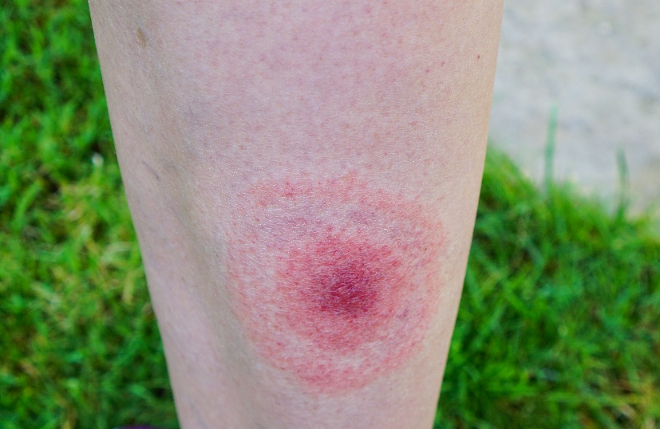

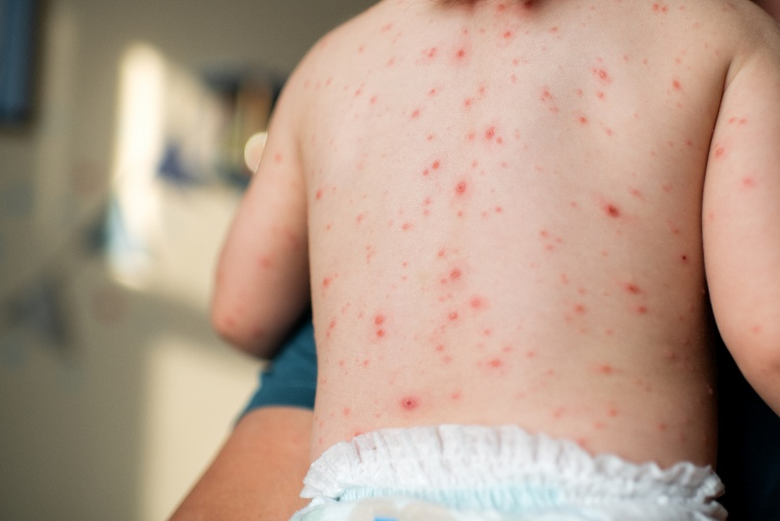
- Chicken pox

Credit: Getty Images

Supplemental Table. Characteristics of participants reporting they would vs. would not treat ringworm with an over-the-counter (OTC) corticosteroid cream
Characteristic | Treat with OTC steroid cream |  | Not treat with OTC steroid cream
Characteristic | n=51 | col % | n=255 | col % | p-value
Age group, years |  |  |  |  | 0.104
18 to 29 | 16 | 31% | 46 | 18%
30 to 39 | 17 | 33% | 80 | 31%
30 to 49 | 14 | 27% | 91 | 36%
50+ | 4 | 8% | 38 | 15%
Region |  |  |  |  | 0.605
Northeast | 7 | 14% | 42 | 16%
Midwest | 10 | 20% | 54 | 21%
South | 23 | 45% | 90 | 35%
West | 11 | 22% | 69 | 27%
Marital status |  |  |  |  | 0.381
Married or living with partner | 32 | 63% | 176 | 69%
Single, separated, divorced, widowed | 19 | 37% | 79 | 31%
Own or rent dwelling |  |  |  |  | 0.278
Own | 24 | 47% | 143 | 56%
Rent | 26 | 51% | 101 | 40%
Live with others at no cost | 1 | 2% | 11 | 4%
Highest level of formal education completed |  |  |  |  | 0.032
High school or less | 23 | 45% | 70 | 27%
Some college | 16 | 31% | 89 | 35%
Bachelor's degree or higher | 12 | 24% | 96 | 38%
Employment status |  |  |  |  | 0.288
Working full or part time or student | 39 | 76% | 176 | 69%
Not working | 12 | 24% | 79 | 31%
Total household income before taxes |  |  |  |  | 0.166
Less than $75,000 | 32 | 63% | 133 | 52%
$75,000 or more | 19 | 37% | 122 | 48%
Race/ethnicity |  |  |  |  | 0.009
African/African American/Black, non-Hispanic | 15 | 29% | 29 | 11%
Asian, non-Hispanic | 0 | 0% | 7 | 3%
Hispanic/Latinx | 5 | 10% | 21 | 8%
Multiple race, non-Hispanic | 8 | 16% | 27 | 11%
Other race/ethnicity, non-Hispanic | 1 | 2% | 6 | 2%
White, non-Hispanic | 22 | 43% | 165 | 65%
Community type |  |  |  |  | 0.084
Urban | 18 | 35% | 58 | 23%
Suburban | 26 | 51% | 134 | 53%
Rural | 7 | 14% | 63 | 25%
Political affiliation |  |  |  |  | 0.666
Republican | 14 | 27% | 68 | 27%
Democrat | 19 | 37% | 69 | 27%
Independent | 13 | 25% | 74 | 29%
Something else | 1 | 2% | 8 | 3%
Not sure | 3 | 6% | 26 | 10%
Decline to answer | 1 | 2% | 10 | 4%
Childrens' ages
Infant 1-3 weeks | 1 | 2% | 3 | 1% | 0.520
Infant 4-7 weeks | 1 | 2% | 6 | 2% | 0.864
Infant 2 months to toddler (2 months-2 years) | 14 | 27% | 60 | 24% | 0.551
Preschool-aged (3-5 years) | 17 | 33% | 75 | 29% | 0.577
Elementary school-aged (6-10 years) | 27 | 53% | 109 | 43% | 0.181
Middle school-aged (11-13 years) | 10 | 20% | 91 | 36% | 0.026
High school-aged (14-17 years) | 20 | 39% | 94 | 37% | 0.751
Total children in household |  |  |  |  | 0.763
1 | 17 | 33% | 97 | 38%
2 | 16 | 31% | 86 | 34%
3 | 9 | 18% | 39 | 15%
4 or more | 9 | 18% | 33 | 13%

