Supplementary Materials

Supplementary Methods
Variant epidemic curves
We used data from CDC’s national genomic surveillance program, which aggregates biweekly SARS-CoV-2 sequence data from CDC-funded programs and public data repositories [1], to estimate COVID-19 cases attributable to variants circulating from July 2021 to September 2024. Using previously defined SARS-CoV-2 lineage groups [2,3], we included the following variants that attained 5% prevalence or greater anytime from July 20, 2021, to September 14, 2024: B.1.617.2, B.1.1.529, BA.1.1, BA.2, BA.2.12.1, BA.4, BA.5, BA.4.6, BF.7, BQ.1, BQ.1.1, XBB.1.5-like, XBB.1.16-like, EG.5-like, XBB, XBB.2.3, FL.1.5.1-like, HV.1, HK.3-like, JD.1.1, JN.1-like, KQ.1-like, KP.2-like, JN.1.16-like, KP.3, LB.1-like, and KP.3.1.1-like lineages. XBB and JN.1 lineages with identical spike residue 31 and receptor binding domain substitutions (residues 332–527) were grouped and denoted as “representative lineage-like.” We estimated biweekly numbers of COVID-19 infections attributable to these variants by multiplying counts of positive SARS-CoV-2 positive test results from the National Respiratory and Enteric Virus Surveillance System (NREVSS) with biweekly variant proportions from genomic surveillance [4]. For each included variant, we restricted to biweeks in which it circulated at 0.1% share or greater, and normalized to the maximum cases per variant. No additional adjustments were made for overall decreasing detection of COVID-19 cases over time due to reductions in testing availability.
Biweekly estimates of normalized variant-attributable COVID-19 cases generally appeared to be symmetrically distributed over time (Supplementary Figure 1). Periods of sequential variant takeover and predominance, such as during early Omicron evolution from B.1.1.529/BA.1 to BA.2 to BA.4/5 in 2022, appeared to have staggered variant epidemic curves (Supplementary Figure 1A). Periods of more prolonged co-circulation, such as during the latter half of 2023 when multiple XBB descendants circulated, showed greater overlap in variant epidemic curves (Supplementary Figure 1B). The peak number of attributed cases per variant occurred a median of 12 weeks after the variant first reached 0.1% prevalence. Across the variants included, the median epidemic curve standard deviation was 6.0 weeks. Assuming normally distributed time series, this indicated that approximately 95% of cases for a given variant occurred within a 24-week (5.5 month) period.

Variant co-circulation model
Based on our empiric assessments of variant circulation, we used a simple deterministic model to represent dynamics of two SARS-CoV-2 lineages, adapted from Bond et al.’s approach of defining symmetric epidemic curves using the binomial distribution for influenza transmission [5]. This approach allows full parametric determination of the shape and height of an epidemic curve but does not assume a mechanistic model underlying transmission.
Formally, epidemic dynamics for variants 1 and 2 are assumed to each follow a normally distributed time series $P_{i}$, with $T_{1}$ and $T_{2}$ representing the weeks in which variants 1 and 2 peak, respectively. Variant 1 is assumed to peak at 15 weeks, and variant 2 is assumed to peak 2 to 30 weeks after variant 1 (Figure 1); this degree of right-shift is the main variable that is adjusted to generate different variant circulation patterns. The standard deviation $σ$ from the peak of the epidemic time series is assumed to be 6 weeks for both variants, corresponding to 95% of cases for a given variant occurring within a 24-week period.
$$P_{1}\sim N\left(T_{1},σ^{2}\right) P_{2} \sim N\left(T_{2},σ^{2}\right)$$
We define U(t) and V(t) as the number of unvaccinated and vaccinated individuals, respectively, at time t. The total population size [N = U(t) + V(t)] is fixed with the assumption of no births, deaths, or migration in or out of the population. We assume the total population size (e.g., VE study recruitment catchment area) is 1 million individuals with no age or other demographic strata modeled. The number of vaccinated individuals is represented by a piecewise linear function that increases until a pre-determined threshold $V_{max}$ at time $T_{v}$. We set $V_{max}$ to be 20% of the total population and $T_{v}$ to be 10 weeks, as updated 2023–2024 COVID-19 vaccination uptake in the US appeared to plateau at approximately 20% of the eligible adult population several months after updated doses were available [6].
$$V\left(t\right)=V_{max}, t≥T_{v}$$
$$V\left(t\right)=\frac{V_{max}}{T_{v}}t, t<T_{v}$$
The numbers of unvaccinated and vaccinated individuals hospitalized following infection from variant 1 and recruited into the study are given by U₁(t) and V₁(t), respectively:
$$U_{1}\left(t\right)=U\left(t\right) ϕ_{1} P_{1}\left(t\right)$$
$$V_{1}\left(t\right)=V\left(t\right) ϕ_{1} P_{1}\left(t\right) (1-VE_{1})$$
where $ϕ_{1}$is a parameter that scales the height of the epidemic curve (representing multiple factors not individually modeled here, including infectiousness and severity of variant 1) and VE₁ represents time-invariant VE specific to variant 1. We assume time-invariant VE against variants 1 and 2 (VE₁ = 50% and VE₂ = 20%, respectively), representing approximate levels of recent VE against hospitalization observed empirically against strain-matched and divergent variants, respectively [7–10]. Letting $ϕ_{1}= ϕ_{2}$, the dynamics of variant 2 are similar:
$$U_{2}\left(t\right)=U\left(t\right) ϕ_{2} P_{2}\left(t\right)$$
$$V_{2}\left(t\right)=V\left(t\right) ϕ_{2} P_{2}\left(t\right) (1-VE_{2})$$
In a sensitivity analysis, we extend this model by allowing VE to change by time since vaccination $τ$. Similar to the approach used by Lin et al. [11], we define piecewise functions such that VE increases from 0% at $τ=0$ to a peak at $τ=4$ weeks, representing the mounting of the immune response following vaccination; VE then subsequently wanes, representing natural waning of immunologic protection over time due to antibody decay or other immunological mechanisms. Denoting $VE_{k}\left(τ\right)$ as the time-varying VE function specific to variant k:
$$VE_{k}\left(τ\right)=\left\{\begin{aligned}1- exp⁡(γ_{k1}τ), 0≤τ<4 \\ 1-\exp\left(γ_{k1}τ+ γ_{k2}(τ-4)\right), τ>4\end{aligned}\right.$$
Where $γ_{i}$ are parameters for adjusting the rates of increase and waning and time-varying VE functions are constrained to be greater or equal to 0. We selected $γ_{i}$ such that $VE_{1}\left(τ\right)$ peaks at 50% and $VE_{2}\left(τ\right)$ peaks at 20% (identical to VE under the time-invariant setting), $VE_{2}\left(τ\right)$ wanes to ~0% by 35 weeks, and $VE_{1}\left(τ\right)$ has a similar rate of waning (Supplementary Figure 3). These parameters represent illustrative scenarios and are not meant to be best estimates of current rates of waning of COVID-19 VE.
Under time-varying VE, the numbers of vaccinated individuals hospitalized following infection from variant k and recruited into the study is given by V_{k}(t), which combines the number of newly vaccinated individuals $ΔV$ and the time-varying VE function for each week through a convolution:
$$ΔV\left(t\right)=V\left(t\right)-V\left(t-1\right)$$
$$V_{k}\left(t\right)=ϕ_{k}P_{k}\left(t\right)\sum_{τ=0}^{t}{ΔV\left(t-τ\right)\left(1-VE_{k}\left(τ\right)\right)}$$
Test-negative controls can present with infection from multiple acute respiratory illness-causing pathogens and are used to estimate vaccine uptake. Numbers of enrolled test-negative control-patients are assumed to accrue at a constant rate over time. Example time series are shown in Figure 1 for counts of patients with variant 1, variant 2, and test-negative controls stratified by vaccination status.

Estimating vaccine effectiveness
We simulate this model for 52 weeks, which produces a time series of vaccinated and unvaccinated cases for each SARS-CoV-2 lineage that is then used as input in a logistic regression model for estimating VE. The log odds of case versus control status was modeled as a linear function of vaccination status and categorical calendar week. In simulations where VE was assumed to be time-variant, VE was calculated as 1 minus the odds ratio and compared to the defined VE value. In the setting of time-varying VE, an empirical reference VE was estimated from the full time series data, representing a weighted average of VE over the observed time since vaccination distribution. For period-based analyses with a specified threshold α, the predominance period for variant 1 was defined from the start of COVID-19 circulation (1 or more cases detected) to the last week in which variant 1’s prevalence was above α. The predominance period for variant 2 spanned from the first week in which variant 2’s prevalence was above α to the end of COVID-19 circulation. For sequence-based analyses, correct lineage determination was assumed to occur in 60% of patients, reflecting possible sample reduction from specimens with low viral load [8]. Our simplified model does not incorporate differences among patients with and without successful sequencing results.

Predominance periods
We reviewed empirical COVID-19 TND VE studies to see which predominance thresholds have been commonly used. A 50% threshold was common [12–17], but higher thresholds such as 60% [9,18–20], 70% [21], 75% [22], 80% [10,23–25], and 90% [26] have also been used. We selected 50%, 70% and 90% as representative predominance threshold values spanning the range of empirical thresholds to use in our simulation.
Supplementary Figure 1. Normalized estimated biweekly variant-attributed COVID-19 cases among A) early Omicron variants, B) XBB and descendants, and C) JN.1. and descendants

(Next page)

Data from CDC’s national genomic surveillance program [1] were used to estimate COVID-19 cases attributable to variants circulating from July 2021 to September 2024 among previously defined SARS-CoV-2 lineage groups [2,4]. We estimated biweekly numbers of COVID-19 infections attributable to these variants by multiplying counts of positive SARS-CoV-2 positive test results from the National Respiratory and Enteric Virus Surveillance System (NREVSS) with biweekly variant proportions from genomic surveillance [4]. For each variant, we restricted to biweeks in which it circulated at 0.1% share or greater and normalized to the maximum cases per variant.

Supplementary Figure 2. Counts of simulated cases and controls by variant and vaccination status (top) and proportions of variants (bottom) over time for a range of standard deviations for the variant 2 epidemic curve.

Variant co-circulation was modeled using symmetric normally-distributed epidemic curves, with the standard deviation of the variant 2 epidemic curve ranging from 2 to 14 weeks. Time-invariant VE was assumed to be 50% against variant 1 and 20% against variant 2, representing approximate differences in VE observed empirically against recent strain-matched and divergent variants, respectively. Vaccine coverage was assumed to increase linearly from the start of the season before plateauing at 20%, derived from empirical trends in vaccination coverage 2023–24 and 2024–25 in the US.
Supplementary Figure 3. Time-varying vaccine effectiveness by number of weeks since vaccination for variant 1 and 2.
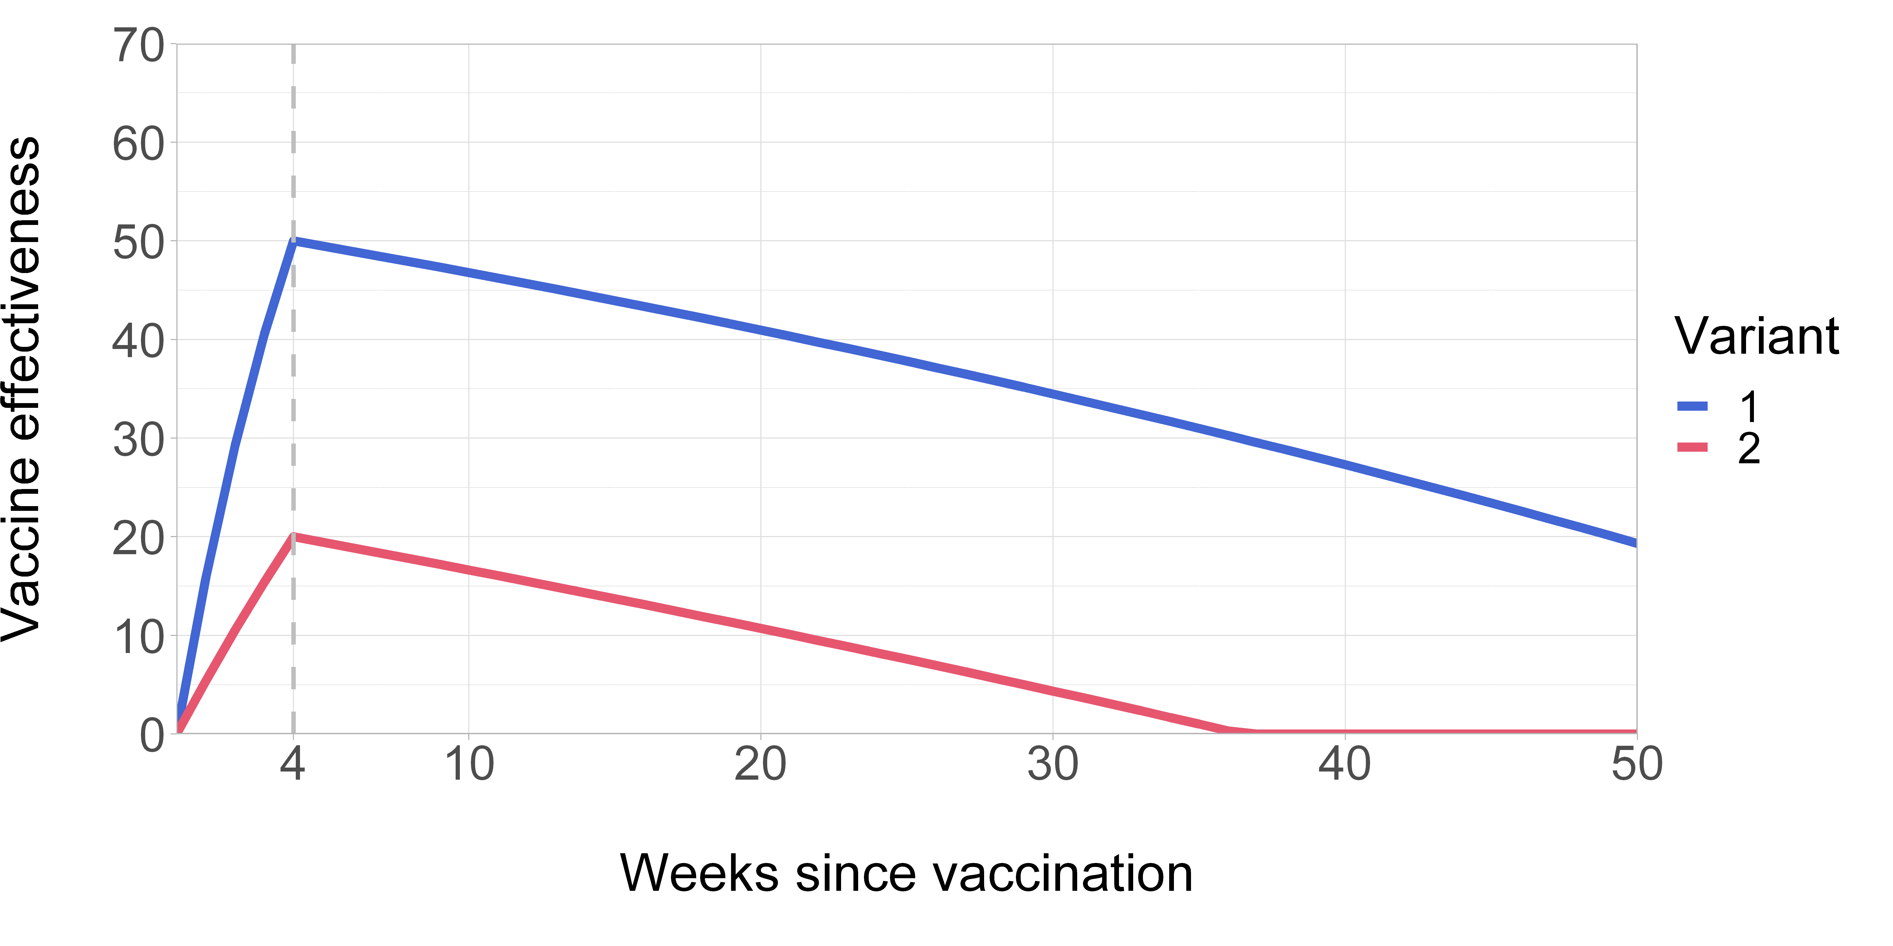
Time-varying vaccine effectiveness was defined using the piecewise function approach of Lin et al. [11]. In this model, VE increases from $τ=0$ to a peak at $τ=4$ weeks of 50% against variant 1 and 20% against variant 2, representing the mounting of the immune response following vaccination; VE then subsequently wanes to 0%, representing natural waning of immunologic protection over time. The rate of waning was defined to be similar for both variants.
Supplementary Figure 4. Delay between peak of variant 1 and 2 versus duration of co-circulation in simulated epidemic curves. 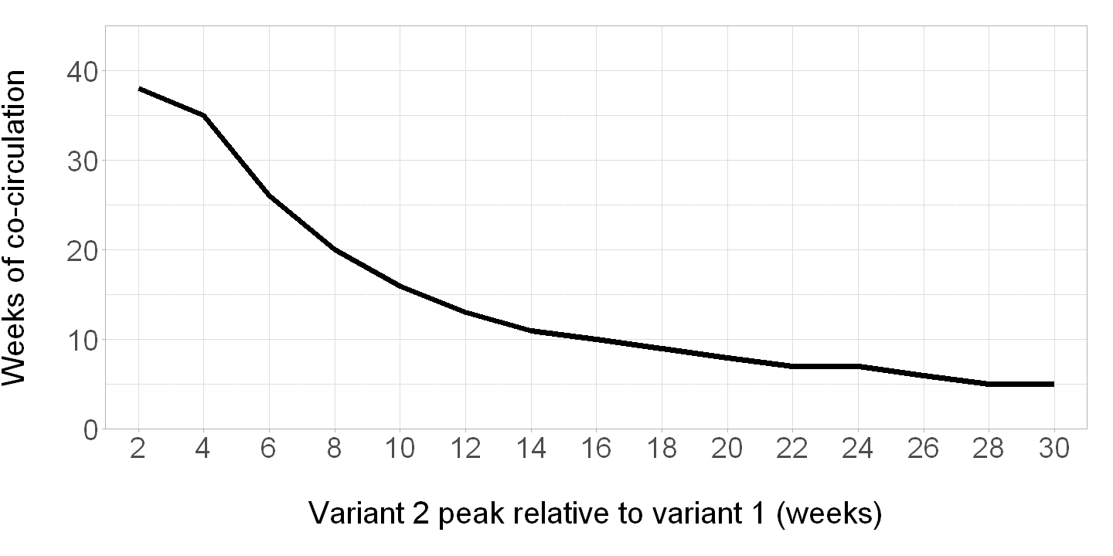
Co-circulation was defined as weeks in which both variants had a prevalence of 10% or greater. Variant co-circulation was modeled using symmetric normally-distributed epidemic curves, with the peak of variant 2 circulation occurring a range of 2 to 30 weeks after variant 1.

Supplementary Figure 5. Point estimates and 95% confidence intervals for period-based vaccine effectiveness estimates across different variant co-circulation scenarios and predominance thresholds with higher variant 2 vaccine effectiveness.
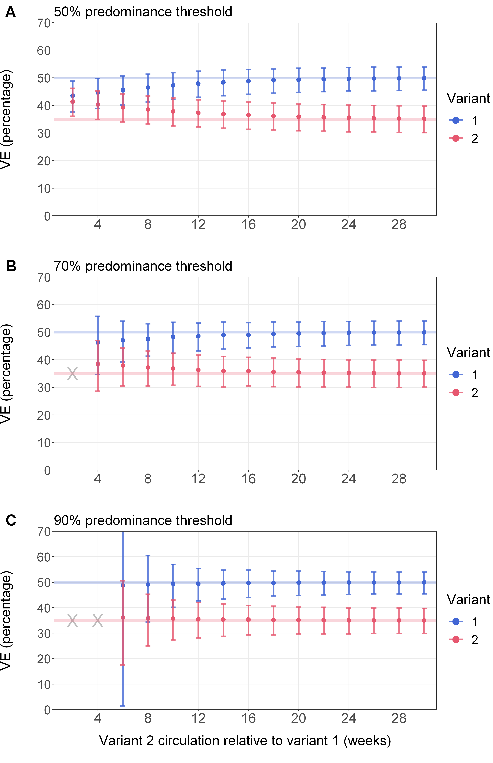
X = scenarios during which a predominance threshold was not met or the number of COVID-19 cases was <100 for either variant and VE could not be estimated.
Variant co-circulation was modeled using symmetric normally-distributed epidemic curves, with the peak of variant 2 circulation occurring a range of 2 to 30 weeks after variant 1. In this sensitivity analysis, time-invariant VE was assumed to be 50% against variant 1 and 35% against variant 2. Vaccine coverage was assumed to increase linearly from the start of the season before plateauing at 20%, derived from empirical trends in vaccination coverage 2023–24 and 2024–25 in the US. Using a TND framework, we estimated lineage-specific VE using logistic regression adjusting for calendar time, and we estimated lineage-specific VE using a period-based analysis with different predominance thresholds.

Supplementary Figure 6. Point estimates and 95% confidence intervals for period-based vaccine effectiveness estimates across different variant co-circulation scenarios and predominance thresholds assuming higher population-wide vaccination coverage.
X = scenarios during which a predominance threshold was not met or the number of COVID-19 cases was <100 for either variant and VE could not be estimated.
Variant co-circulation was modeled using symmetric normally-distributed epidemic curves, with the peak of variant 2 circulation occurring a range of 2 to 30 weeks after variant 1. Time-invariant VE was assumed to be 50% against variant 1 and 20% against variant 2, representing approximate differences in VE observed empirically against recent strain-matched and divergent variants, respectively. In this sensitivity analysis, vaccine coverage was assumed to increase linearly from the start of the season before plateauing at 40%, potentially representing higher coverage among a subpopulation with risk factors such as older age. Using a TND framework, we estimated lineage-specific VE using logistic regression adjusting for calendar time, and we estimated lineage-specific VE using a period-based analysis with different predominance thresholds.

Supplementary Figure 7. Point estimates and 95% confidence intervals for (A) sequence-based and (B-D) period-based vaccine effectiveness estimates across different predominance thresholds by week after variant 2 reaches 50% prevalence allowing for time-varying vaccine effectiveness.
X = scenarios during which a predominance threshold was not met or the number of COVID-19 cases <100 for either variant and VE could not be estimated.
Variant co-circulation was modeled using symmetric normally-distributed epidemic curves, with the peak of variant 2 circulation occurring a range of 2 to 30 weeks after variant 1. Time-varying vaccine effectiveness was defined using the piecewise function approach of Lin et al. [11]. In this model, VE increases from $τ=0$ to a peak at $τ=4$ weeks of 50% against variant 1 and 20% against variant 2, representing the mounting of the immune response following vaccination; VE then subsequently wanes to 0%, representing natural waning of immunologic protection over time (Supplementary Figure 3). Vaccine coverage was assumed to increase linearly from the start of the season before plateauing at 20%, derived from empirical trends in vaccination coverage 2023–24 and 2024–25 in the US. Using a TND framework, we estimated lineage-specific VE using logistic regression adjusting for calendar time, and we estimated lineage-specific VE using a period-based analysis with different predominance thresholds.
Supplementary Tables
Supplementary Table 1. Simulation results underlying Figure 2 (Point estimates and 95% confidence intervals for period-based weekly vaccine effectiveness estimates across different variant co-circulation scenarios and predominance thresholds).
Supplementary Table 2. Simulation results underlying Figure 3 (Point estimates and 95% confidence intervals for sequence-based and period-based weekly vaccine effectiveness estimates across different predominance thresholds by week after variant 2 reaches 50% prevalence).

Supplementary References
1. CDC. COVID Data Tracker Variant Proportions. [cited 16 May 2024]. Available: https://covid.cdc.gov/covid-data-tracker/#variant-proportions
2. Ma KC, Shirk P, Lambrou AS, Hassell N, Zheng X-Y, Payne AB, et al. Genomic Surveillance for SARS-CoV-2 Variants: Circulation of Omicron Lineages - United States, January 2022-May 2023. MMWR Morb Mortal Wkly Rep. 2023;72: 651–656.
3. Ma KC, Castro J, Lambrou AS, Rose EB, Cook PW, Batra D, et al. Genomic surveillance for SARS-CoV-2 variants: Circulation of Omicron XBB and JN.1 lineages — United States, May 2023–September 2024. Morbidity and Mortality Weekly Report. 2024;73: 938–945.
4. Ma KC. Genomic surveillance for SARS-CoV-2 variants: Circulation of Omicron XBB and JN.1 lineages — United States, May 2023–September 2024. MMWR Morb Mortal Wkly Rep. 2024;73. doi:10.15585/mmwr.mm7342a1
5. Bond HS, Sullivan SG, Cowling BJ. Regression approaches in the test-negative study design for assessment of influenza vaccine effectiveness. Epidemiol Infect. 2016;144: 1601–1611.
6. COVID-19 Vaccination Coverage and Vaccine Confidence Among Adults. 23 Jan 2024 [cited 25 July 2024]. Available: https://www.cdc.gov/vaccines/imz-managers/coverage/covidvaxview/interactive/adults.html
7. Kirsebom FCM, Stowe J, Lopez Bernal J, Allen A, Andrews N. Effectiveness of autumn 2023 COVID-19 vaccination and residual protection of prior doses against hospitalisation in England, estimated using a test-negative case-control study. J Infect. 2024;89: 106177.
8. Ma KC, Surie D, Lauring AS, Martin ET, Leis AM, Papalambros L, et al. Effectiveness of updated 2023-2024 (Monovalent XBB.1.5) COVID-19 vaccination against SARS-CoV-2 omicron XBB and BA.2.86/JN.1 lineage hospitalization and a comparison of clinical severity-IVY network, 26 hospitals, October 18, 2023-March 9, 2024. Clin Infect Dis. 2024; ciae405.
9. Carazo S, Skowronski DM, Brousseau NM, Guay C-A, Sauvageau C, Racine É, et al. Monovalent mRNA XBB.1.5 vaccine effectiveness against COVID-19 hospitalization in Quebec, Canada: impact of variant replacement and waning protection during 10-month follow-up. medRxiv; 2024. Available: https://www.medrxiv.org/content/10.1101/2024.11.13.24317190v1.full.pdf
10. Caffrey AR, Appaneal HJ, Lopes VV, Puzniak L, Zasowski EJ, Jodar L, et al. Effectiveness of BNT162b2 XBB vaccine in the US Veterans Affairs Healthcare System. medRxiv. 2024. p. 2024.04.05.24305063. doi:10.1101/2024.04.05.24305063
11. Lin D-Y, Du Y, Xu Y, Paritala S, Donahue M, Maloney P. Durability of XBB.1.5 vaccines against omicron subvariants. N Engl J Med. 2024;390: 2124–2127.
12. Britton A, Embi PJ, Levy ME, Gaglani M, DeSilva MB, Dixon BE, et al. Effectiveness of COVID-19 mRNA vaccines against COVID-19-associated hospitalizations among immunocompromised adults during SARS-CoV-2 Omicron predominance - VISION Network, 10 states, December 2021-August 2022. MMWR Morb Mortal Wkly Rep. 2022;71: 1335–1342.
13. Link-Gelles R, Levy ME, Natarajan K, Reese SE, Naleway AL, Grannis SJ, et al. Estimation of COVID-19 mRNA Vaccine Effectiveness and COVID-19 Illness and Severity by Vaccination Status During Omicron BA.4 and BA.5 Sublineage Periods. JAMA Netw Open. 2023;6: e232598.
14. Adams K, Rhoads JP, Surie D, Gaglani M, Ginde AA, McNeal T, et al. Vaccine effectiveness of primary series and booster doses against covid-19 associated hospital admissions in the United States: living test negative design study. BMJ. 2022;379: e072065.
15. Plumb ID, Feldstein LR, Barkley E, Posner AB, Bregman HS, Hagen MB, et al. Effectiveness of COVID-19 mRNA Vaccination in Preventing COVID-19-Associated Hospitalization Among Adults with Previous SARS-CoV-2 Infection - United States, June 2021-February 2022. MMWR Morb Mortal Wkly Rep. 2022;71: 549–555.
16. Lind ML, Copin R, McCarthy S, Coppi A, Warner F, Ferguson D, et al. Use of whole-genome sequencing to estimate the contribution of immune evasion and waning immunity on decreasing COVID-19 vaccine effectiveness. J Infect Dis. 2023;227: 663–674.
17. Schrag SJ, Verani JR, Dixon BE, Page JM, Butterfield KA, Gaglani M, et al. Estimation of COVID-19 mRNA vaccine effectiveness against medically attended COVID-19 in pregnancy during periods of Delta and Omicron variant predominance in the United States. JAMA Netw Open. 2022;5: e2233273.
18. Merdrignac L, Lanièce Delaunay C, Verdasca N, Vega-Pirisc L, O’Donnell J, Sève N, et al. Effectiveness of XBB.1.5 Vaccines against Symptomatic SARS-CoV-2 Infection in Older Adults during the JN.1 Lineage-Predominant Period, European VEBIS Primary Care Multicentre Study, 20 November 2023–1 March 2024. 2024. doi:10.2139/ssrn.4883286
19. Laniece Delaunay C, Mazagatos C, Martínez-Baz I, Túri G, Goerlitz L, Domegan L, et al. COVID-19 Vaccine Effectiveness in autumn and winter 2022 to 2023 among older Europeans. JAMA Netw Open. 2024;7: e2419258.
20. Antunes L, Rojas-Castro M, Lozano M, Martínez-Baz I, Leroux-Roels I, Borg M-L, et al. Effectiveness of the XBB.1.5 COVID-19 vaccines against SARS-CoV-2 hospitalisation among adults aged ≥ 65 years during the BA.2.86/JN.1 predominant period, VEBIS hospital study, Europe, November 2023 to May 2024. Influenza Other Respi Viruses. 2025;19: e70081.
21. Nguyen JL, Mitratza M, Volkman HR, de Munter L, Tran TMP, Marques C, et al. Effectiveness of the BNT162b2 XBB.1.5-adapted vaccine against COVID-19 hospitalization related to the JN.1 variant in Europe: a test-negative case-control study using the id.DRIVE platform. EClinicalMedicine. 2025;79: 102995.
22. Oliveira EA, Oliveira MCL, Colosimo EA, Simões E Silva AC, Mak RH, Vasconcelos MA, et al. Vaccine effectiveness against SARS-CoV-2 variants in adolescents from 15 to 90 days after second dose: A population-based test-negative case-control study. J Pediatr. 2023;253: 189-196.e2.
23. Tartof SY, Slezak JM, Puzniak L, Frankland TB, Ackerson BK, Jodar L, et al. Effectiveness of BNT162b2 XBB Vaccine against XBB and JN.1 Sub-lineages. medRxiv. 2024. p. 2024.05.04.24306875. doi:10.1101/2024.05.04.24306875
24. Rose AM, Nicolay N, Sandonis Martín V, Mazagatos C, Petrović G, Niessen FA, et al. Vaccine effectiveness against COVID-19 hospitalisation in adults (≥ 20 years) during Alpha- and Delta-dominant circulation: I-MOVE-COVID-19 and VEBIS SARI VE networks, Europe, 2021. Euro Surveill. 2023;28. doi:10.2807/1560-7917.ES.2023.28.47.2300186
25. Rose AM, Nicolay N, Sandonis Martín V, Mazagatos C, Petrović G, Baruch J, et al. Vaccine effectiveness against COVID-19 hospitalisation in adults (≥ 20 years) during Omicron-dominant circulation: I-MOVE-COVID-19 and VEBIS SARI VE networks, Europe, 2021 to 2022. Euro Surveill. 2023;28: 2300187.
26. Britton A, Fleming-Dutra KE, Shang N, Smith ZR, Dorji T, Derado G, et al. Association of COVID-19 vaccination with symptomatic SARS-CoV-2 infection by time since vaccination and Delta variant predominance. JAMA. 2022;327: 1032–1041.

