Trends in a Persistent Strain of Multidrug-Resistant Salmonella Infantis (REPJFX01) in humans and chickens — United States, 2010–2023
Appendix B: Sensitivity analyses
Excluding international travel-associated isolates
We examined trends excluding international travel-associated REPJFX01 illnesses because sources for illness acquired domestically and internationally may differ. Unfortunately, international travel history data were not available for most human illnesses in this study. For illnesses during 2012–2015, we used available travel history from Brown et al (2018) to exclude travel-associated isolates. For illnesses during 2016–2023, we assumed that 7% of isolates were travel-associated based on analysis of data from the Foodborne Diseases Active Surveillance Network (FoodNet) during 2018–2022 (CDC, 2024). The number of illnesses we assumed were domestically acquired and US population offset numbers (U.S. Census Bureau, 2024) are shown in Table B.1.
Table B.1: Number of domestically acquired REPJFX01 illnesses and US population numbers from the Census Bureau, by year, 2010–2023
Year | Domestically acquired REPJFX01 illnesses | US population
2010 | 0 | 309,327,143
2011 | 0 | 311,583,481
2012 | 1 | 313,877,662
2013 | 4 | 316,059,947
2014 | 7 | 318,386,329
2015 | 8 | 320,738,994
2016 | 30 | 323,071,755
2017 | 169 | 325,122,128
2018 | 422 | 326,838,199
2019 | 580 | 328,329,953
2020 | 424 | 331,526,933
2021 | 448 | 332,048,977
2022 | 462 | 333,271,411
2023 | 510 | 334,914,895

Excluding presumed travel-associated isolates, we implemented a Poisson regression with cubic penalized B-spline regression. Similar to when travel-associated cases were included, the model demonstrated a significant annual increasing trend, with the increase in incidence beginning in 2016 (Figure B.1). We confirmed that the default unconstrained basis dimension (k=10) was sufficient.
Excluding presumed travel-associated isolates, the rank-order cross-correlation showed that the increase in REPJFX01 incidence in humans and prevalence in chicken carcasses began in the same year, with an estimated cross-correlation value of 0.88 for a 0-year lag, identical to the model including travel-associated isolates.

Figure B.1: Penalized B-spline regression of annual reported PulseNet incidence per 100,000 population of REPJFX01 infections excluding international-travel associated isolates, 2010–2023. Black dots = observed data, black line = mean curve, gray lines = upper and lower 95% confidence band.
Chicken products
We chose to use REPJFX01 isolates from whole chicken carcasses for the main analysis of this study because sampling methods were more consistent over the study period. However, other chicken products including chicken parts and comminuted chicken are consumed more frequently in the United States than whole chickens (National Chicken Council, 2024), and there are more REPJFX01 isolates from these chicken products. Chicken product data include Pathogen Reduction; Hazard Analysis and Critical Control Point (PR/HACCP) chicken parts and comminuted chicken samples collected at federally inspected slaughter establishment under the United States Department of Agriculture’s Food Safety and Inspection Service jurisdiction and were only available from 2013–2023 (Table B.2).
Using chicken product data, we performed a separate generalized logistic regression and negative binomial regression to assess change in chicken product REPJFX01 prevalence over time. The generalized logistic regression model had a lower Akaike information criterion (AIC) and the results from that model are presented here.
Table B.2: Number of REPJFX01 isolates from non-whole carcass chicken products and number of chicken product samples, 2013–2023
Year | REPJFX01 isolates | Number of samples
2013 | 0 | 572
2014 | 7 | 3,092
2015 | 7 | 10,636
2016 | 57 | 17,128
2017 | 308 | 19,994
2018 | 589 | 24,187
2019 | 690 | 26,480
2020 | 659 | 27,850
2021 | 758 | 27,450
2022 | 781 | 27,723
2023 | 852 | 28,218

Similar to when using chicken carcass data, the model demonstrated a significant annual trend, with the increase in incidence beginning in 2016 (Figure B.2). We confirmed that the default unconstrained basis dimension (k=10) was sufficient.
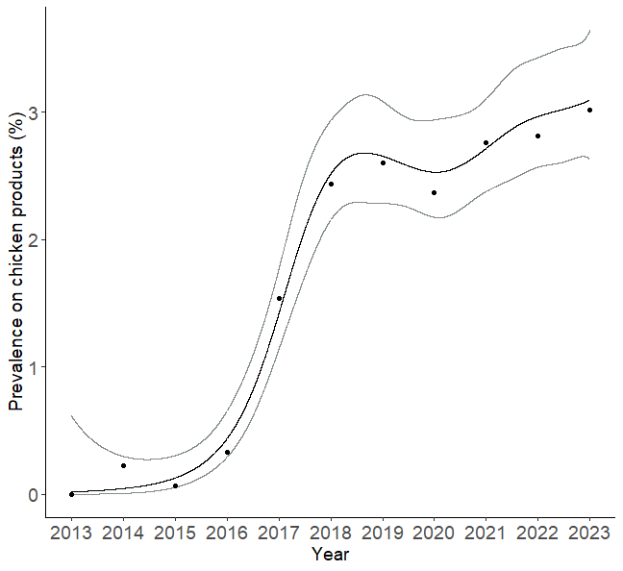
Figure B.2: Penalized B-spline regression of annual reported prevalence of REPJFX01 isolates on chicken products, 2013–2023. Black dots = observed data, black line = mean curve, gray lines = upper and lower 95% confidence band.
The rank-order cross-correlation showed that the increase in REPJFX01 incidence in humans and prevalence in chicken products began in the same year, with an estimated cross-correlation value of 0.88 for a 0-year lag.

References
Brown, A. C., Chen, J. C., Watkins, L. K. F., Campbell, D., Folster, J. P., Tate, H., Wasilenko, J., Van Tubbergen, C., and Friedman, C. R. (2018). Ctx-M-65 extended-xpectrum Β-lactamase-producing Salmonella enterica serotype Infantis, United States. Emerging Infectious Diseases, 24, 2284–2291. https://doi.org/10.3201/eid2412.180500.
CDC (Centers for Disease Control and Prevention). (2024). Data Summary: Persistent Strain of Salmonella Infantis (REPJFX01). Retrieved from: https://www.cdc.gov/salmonella/php/data-research/repjfx01.html. Accessed Nov 8, 2024.
National Chicken Council. How Broilers Are Marketed. Retrieved from: https://www.nationalchickencouncil.org/statistic/how-broilers-are-marketed/. Accessed Dec 11, 2024.
U.S. Census Bureau. (2024), Population and Housing Unit Estimates. Retrieved from: https://www.census.gov/programs-surveys/popest.html. Accessed Oct 25, 2024.

