SUPPLEMENTAL APPENDIX
Comparison of the Continuous Glucose Monitoring Profiles of Four Glucose-Lowering Medications in the GRADE Randomized Trial
Richard M. Bergenstal; Jill P. Crandall, Samuel P. Rosin, Nicole M. Butera, Anne Bantle, Cyrus Desouza, Elizabeth Duran-Valdez, Stephanie Hall, William Herman, Mary L. Johnson, Violet Lagari, Mary E. Larkin, Lawrence S. Phillips, Holly J. Willis, and Heidi Krause-Steinrauf, for the GRADE Research Group
Table of Contents
Item S1: GRADE Research Group (April 30, 2021) 2
Supplemental Table 1. Core CGM metrics by randomized treatment group, separately for nighttime only (12:00 AM – 5:59 AM) and daytime only (6:00 AM – 11:59 PM), among the on-treatment cohort. 6
Supplemental Table 2. Episodes of CGM-derived hypoglycemia (>15 minutes with glucose < 54 mg/dL), CGM-derived prolonged hypoglycemia (>120 minutes with glucose < 54 mg/dL), and self-reported hypoglycemia per participant during the 14-day CGM period, among the on-treatment cohort. 8
Supplemental Table 3. HbA1c and CGM metrics for each treatment group by HbA1c strata in the on-treatment cohort. 10
Supplemental Table 4. Proportion of participants reaching each ADA consensus* CGM management goal (1) by treatment group, among the on-treatment cohort. 11
Supplemental Table 5. Descriptive characteristics at time of CGM among the intention-to-treat cohort by randomized treatment group. 13
Supplemental Table 6. HbA1c and core CGM metrics by randomized treatment group in the intention-to-treat cohort; values reported as sample means (standard deviation) 14
Supplemental Table 7. Episodes of CGM-derived hypoglycemia (> 15 minutes with glucose < 54 mg/dL), CGM-derived prolonged hypoglycemia (> 120 minutes with glucose < 54 mg/dL), and self-reported hypoglycemia per participant during the 14-day CGM period, among the intention-to-treat cohort. 15
Supplemental Table 8. Proportion of participants reaching each ADA consensus* CGM management goal (1) by treatment group, among the intention-to-treat cohort. 16
Supplemental Figure 1. CONSORT diagram. 18
Supplemental Figure 2. Boxplots of the distribution of core CGM metrics by treatment group among the on-treatment cohort.. 19
Supplemental Figure 3. The percent time spent in defined CGM ranges by randomized treatment group, among the on-treatment cohort. Suggested targets for metrics are provided on the right side of the figure. 20
Supplemental Figure 4. Boxplots of distribution of core CGM metrics by treatment group, among the intention-to-treat cohort. 21
Supplemental Figure 5. Ambulatory glucose profiles (AGP) in the intent-to-treat cohort. 22
Supplemental Figure 6. Bar plots of the proportion reaching the ADA consensus CGM management goals by treatment group, among the intention-to-treat cohort. 23
References 24

Item S1: GRADE Research Group (April 30, 2021)

Designations: Principal Investigator (PI); Co-Principal Investigator (Co-PI); Co-Investigator (Co-I); Study Coordinator (SC); Recruitment/Retention Coordinator (RC); Research Staff (RS)

Current Clinical Centers
Albert Einstein College of Medicine: Crandall, JP (PI); McKee, MD (Co-PI, past); Behringer-Massera , S (Co-I, past); Brown-Friday, J (SC); Xhori, E (RC, past); Ballentine-Cargill, K (RS); Duran, S (RS); Estrella, H (RS); Gonzalez de la torre, S (RS, past); Lukin, J (RS, past)
Atlanta VA Medical Center: Phillips, LS (PI); Burgess, E (Co-I); Olson, D (Co-I); Rhee, M (Co-I); Wilson, P (Co-I); Raines, TS (SC); Boers, J (SC); Costello, J (SC); Maher-Albertelli, M (SC); Mungara, R (SC); Savoye, L (SC, past); White, CA (SC); Gullett, C (SC; past); Holloway, L (SC, past); Morehead, F (SC, past); Person, S (SC, past); Sibymon, M (SC, past); Tanukonda, S (SC, past); Adams, C (RC, past); Ross, A (RC, past)
Baylor College of Medicine: Balasubramanyam, A (PI); Gaba, R (Co-I); Gonzalez Hattery, E (SC); Ideozu, A (SC); Jimenez, J (SC); Montes, G (RC); Wright, C (RS, past)
Baylor Scott & White Research Institute (Baylor Research Institute): Hollander, P (PI); Roe, E (Co-I, past); Jackson, A (SC); Smiley, A (SC); Burt, P (SC, past); Estrada, L (RS); Chionh, K (RS, past)
Case Western Reserve University/Cleveland VA/MetroHealth Medical Center: Ismail-Beigi, F (PI); Falck-Ytter, C (Co-PI); Sayyed Kassem, L (Co-PI); Sood, A (Co-PI, past); Tiktin, M (Co-I, SC); Kulow, T (SC); Newman, C (SC); Stancil, KA (SC); Cramer, B (SC, past); Iacoboni, J (SC, past); Kononets, MV (SC, past); Sanders, C (SC, past); Tucker, L (SC, past); Werner, A (SC, past); Maxwell, A (RS); McPhee, G (RS); Patel, C (RS); Colosimo, L (RS, past); Krol, A (RS, past)
Columbia University Medical Center: Goland, R (PI); Pring, J (SC); Alfano, L (SC); Kringas, P (SC, past); Hausheer, C (RC, past); Tejada, J (RC, past); Gumpel, K (RS, past); Kirpitch, A (RS, past); Schneier, H (RS, past)
Duke University Medical Center: Green, JB (PI); AbouAssi, H (Co-I); Chatterjee, R (Co-I); Feinglos, MN (Co-I, past); English Jones, J (SC, RC); Khan, SA (SC, RC); Kimpel, JB (SC, past); Zimmer, RP (SC, past); Furst, M (RC, past); Satterwhite, BM (RS); Thacker, CR (RS); Evans Kreider, K (RS, past)
Indiana University: Mariash, CN (PI); Mather, KJ (PI, past); Ismail, HM (Co-I); Lteif, A (Co-I, past); Mullen, M (SC); Hamilton, T (SC, past); Patel, N (SC, past); Riera, G (RC); Jackson, M (RC, past); Pirics, V (RC, past); Aguillar, D (RS, past); Howard, D (RS, past); Hurt, S (RS, past)
International Diabetes Center: Bergenstal, R (PI); Carlson, A (Co-I); Martens, T (Co-I); Johnson, M (SC); Hill, R (SC); Hyatt, J (SC); Jensen, C (SC); Madden, M (SC); Martin, D (SC); Willis, H (SC); Konerza, W (RS); Yang, S (RS); Kleeberger, K (RS, past); Passi, R (RS, past)
Kaiser Permanente Northwest: Fortmann, S (PI); Herson, M (Co-I); Mularski, K (Co-I); Glauber, H (Co-I, past); Prihoda, J (Co-I, past); Ash, B (SC); Carlson, C (SC); Ramey, PA (SC); Schield, E (SC); Torgrimson-Ojerio, B (SC); Arnold, K (SC, past); Kauffman, B (SC, past); Panos, E (SC, past); Sahnow, S (RC); Bays, K (RS); Berame, K (RS); Cook, J (RS); Ghioni, D (RS); Gluth, J (RS); Schell, K (RS); Criscola, J (RS, past); Friason, C (RS, past); Jones, S (RS, past); Nazarov, S (RS, past)
Kaiser Permanente of Georgia: Barzilay, J (PI); Rassouli, N (Co-PI); Puttnam, R (Co-I); Ojoawo, B (SC); Nelson, R (RC); Curtis, M (SC, past); Hollis, B (SC, past); Sanders-Jones, C (SC, past); Stokes, K (SC, past); El-Haqq, Z (RS, past); Kolli, A (RS, past); Tran, T (RS, past)
Massachusetts General Hospital: Wexler, D (PI); Larkin, ME (Co-I, SC); Meigs, J (Co-I); Chambers, B (SC, past); Dushkin, A (SC, past); Rocchio, G (SC, past); Yepes, M (SC, past); Steiner, B (RC); Dulin, H (RC, past); Cayford, M (RS); Chu, K (RS); DeManbey, A (RS); Hillard, M (RS); Martin, K (RS); Thangthaeng, N (RS); Gurry, L (RS, past); Kochis, R (RS, past); Raymond, E (RS, past); Ripley, V (RS, past); Stevens, C (RS, past)
MedStar Health Research Institute/ MedStar Baltimore: Park, J (PI); Aroda, V (PI, past); Ghazi, A (Co-PI); Magee, M (Co-I); Ressing, Ann (Co-I); Loveland, A (SC); Hamm, M (SC); Hurtado, M (SC); Kuhn, A (SC); Leger, J (SC); Manandhar, L (SC); Mwicigi, F (SC); Sanchez, O (SC); Young, T (SC)
Miami VA Healthcare System/University of Miami: Garg, R (PI), Lagari-Libhaber, V (PI); Florez, HJ (PI, past); Valencia, WM (PI, past); Marks, J (Co-PI, past); Casula, S (Co-I); Oropesa-Gonzalez, L (SC); Hue, L (SC, past); Cuadot, A (SC, past); Nieto-Martinez, R (SC, past); Riccio Veliz, AK (SC, past); Gutt, M (RC, past); Kendal, YJ (RS, past); Veciana, B. (RS, past)
Oregon Health & Science University: Ahmann, A (PI); Aby-Daniel, D (Co-I); Joarder, F (Co-I); Morimoto, V (Co-I); Sprague, C (Co-I); Yamashita, D (Co-I); Cady, N (SC); Rivera-Eschright, N (SC); Kirchhoff, P (SC, past); Morales Gomez, B (RC); Adducci, J (RC, past); Goncharova, A (RC, past)
Pacific Health Research and Education Institute/VA Pacific Islands: Hox, SH (PI); Petrovitch, H (Co-PI); Matwichyna, M (SC); Jenkins, V (SC, past); Broadwater, L (RS); Ishii, RR (RS); Bermudez, NO (RS; past)
Pennington Biomedical Research Center: Hsia, DS (PI); Cefalu, WT (PI, past); Greenway, FL (Co-I); Waguespack, C (Co-I); King, E (SC); Fry, G (SC); Dragg, A (SC); Gildersleeve, B (SC); Arceneaux, J (SC); Haynes, N (SC, past); Thomassie, A (SC, past); Pavlionis, M (SC, past); Bourgeois, B (RC, past); Hazlett, C (RS)
San Diego VA Medical Center: Mudaliar, S (PI); Henry, R (PI, past); Boeder, S (Co-I, past); Pettus, J (Co-I, past); Diaz, E (SC); Garcia-Acosta, D (SC); Maggs, S (SC); DeLue, C (SC, past); Stallings, A (SC, past); Castro, E (RC, past); Hernandez, S (RC, past)
Southwestern American Indian Center: Krakoff, J (PI); Curtis, JM (Co-I); Killean, T (SC); Khalid, M (SC); Joshevama, E (RC, past); Diaz, E (RS); Martin, D (RS); Tsingine, K (RS); Karshner, T (RS, past)
St. Luke's‐Roosevelt Hospital: Albu, J (Co-PI); Pi-Sunyer, FX (Co-PI, past); Frances, S (Co-I); Maggio, C (SC, past); Ellis, E (RC); Bastawrose, J (RC, past); Gong, X (RS)
SUNY Downstate Medical Center/New York Hospital‐Queens: Banerji, MA (PI); August, P (Co-I); Lee, M (Co-I); Lorber, D (Co-I); Brown, NM (SC, RC); Josephson, DH (SC); Thomas, LL (SC, RC); Tsovian, M (SC, RC); Cherian, A (SC, RC, past); Jacobson, MH (RS); Mishko, MM (RS)
The University of North Carolina Diabetes Care Center: Kirkman, MS (PI); Buse, JB (Co-I); Diner, J (Co-I); Dostou, J (Co-I); Machineni, S (Co-I); Young, L (Co-I); Bergamo, K (Co-I, past); Goley, A (Co-I, past); Kerr, J (Co-I, past); Largay, JF (Co-I, past); Guarda, S (SC); Cuffee, J (SC, past); Culmer, D (SC, past); Fraser, R (RC); Almeida, H (RC, past); Coffer, S (RC, past); Debnam, E (RC, past); Kiker, L (RC, past); Morton, S (RC, past); Josey, K (RS); Fuller, G (RS, past)
University of Alabama Birmingham: Garvey, WT (PI); Cherrington, AL (Co-PI); Dyer, D (SC); Lawson, MCR (SC); Griffith, O (SC, past); Agne, A (RC); McCullars, S (RC)
University of Cincinnati/Cincinnati VA Medical Center: Cohen, RM (PI); Craig, J (SC); Rogge, MC (SC; past); Burton, K (SC, past); Kersey, K (SC, RC, past); Wilson, C (SC, past); Lipp, S (RC, past); Vonder Meulen, MB (RC, past); Adkins, C (RS); Onadeko, T (RS)
University of Colorado‐Denver/VA: Rasouli, N (PI); Baker, C (Co-I); Schroeder, E (Co-I, past); Razzaghi, M (Co-I); Lyon, C (Co-I, past); Penaloza, R (Co-I, past); Underkofler, C (SC); Lorch, R (SC); Douglass, S (SC, past); Steiner, S (SC, past)
University of Iowa: Sivitz, WI (PI); Cline, E (SC); Knosp, LK (SC); McConnell, J (SC, past); Lowe, T (RC)
University of Michigan: Herman, WH (PI); Pop-Busui, R (Co-PI); Tan, MH (Co-I); Martin, C (SC); Waltje, A (SC, RC); Katona, A (SC); Goodhall, L (SC, past); Eggleston, R (RC, past); Kuo, S (RS); Bojescu, S (RS, past); Bule, S (RS, past); Kessler, N (RS, past); LaSalle, E (RS, past); Whitley, K (RS, past)
University of Minnesota: Seaquist, ER (PI); Bantle, A (Co-I); Harindhanavudhi, T (Co-I); Kumar, A (Co-I); Redmon, B (Co-I); Bantle, J (Co-I, past); Coe, M (SC); Mech, M (SC); Taddese, A (RC); Lysne, L (RS); Smith, S (RS)
University of Nebraska Medical Center/Omaha VA: Desouza, C (PI); Kuechenmeister, L (Co-I); Shivaswamy, V (Co-I); Burbach, S (SC); Rodriguez, MG (SC); Seipel, K (SC); Alfred, A (SC, past); Morales, AL (SC; past); Eggert, J (RS); Lord, G (RS); Taylor, W (RS, past); Tillson, R (RS, past)
University of New Mexico: Schade, DS (PI); Adolphe, A (Co-PI); Burge, M (Co-PI, past); Duran-Valdez, E (SC); Martinez, J (RC, past); Bancroft, A (RS); Kunkel, S (RS); Ali Jamaleddin Ahmad, F (RS, past); Hernandez McGinnis, D (RS, past); Pucchetti, B (RS, past); Scripsick, E (RS, past); Zamorano, A (RS, past)
UT Health San Antonio: DeFronzo, RA (PI); Cersosimo, E (Co-PI); Abdul-Ghani, M (Co-I); Triplitt, C (Co-I); Juarez, D (SC); Mullen, M (SC); Garza, RI (SC, past); Verastiqui, H (SC, past); Wright, K (RC, past); Puckett, C (RS)
University of Texas‐Southwestern Medical Center: Raskin, P (PI); Rhee, C (Co-I, past); Abraham, S (SC); Jordan, LF (SC); Sao, S (SC); Morton, L (SC, past); Smith, O (SC, past); Osornio Walker, L (RC, past); Schnurr-Breen, L (RC, past); Ayala, R (RS); Kreymer, RB (RS); Sturgess, D (RS, past)
VA Puget Sound Health Care System/University of Washington: Utzschneider, KM (PI); Kahn, SE (Co-I); Alarcon-Casas Wright, L (Co-I); Boyko, EJ (Co-I); Tsai, EC (Co-I); Trence, DL (Co-I, past); Trikudanathan, S (Co-I, past); Fattaleh, BN (SC); Montgomery, BK (SC, past); Atkinson, KM (RS); Kozedub, A (RS); Concepcion, T (RS, past); Moak, C (RS, past); Prikhodko, N (RS, past); Rhothisen, S (RS, past)
Vanderbilt University: Elasy, TA (PI); Martin, S (SC); Shackelford, L (RC, RS, past); Goidel, R (RS); Hinkle, N (RS); Lovell, C (RS); Myers, J (RS); Lipps Hogan, J (RS, past)
Washington University: McGill, JB (PI); Salam, M (Co-I); Schweiger, T (SC, RC); Kissel, S (SC, RC, past); Recklein, C (SC, past); Clifton, MJ (RS)
Yale University/Fair Haven Community Health Center/West Haven VA Medical Center: Tamborlane, W (PI); Camp, A (Co-I); Gulanski, B (Co-I); Inzucchi, SE (Co-I); Pham, K (Co-I); Alguard, M (SC, RC); Gatcomb, P (SC); Lessard, K (SC); Perez, M (SC); Iannone, L (RC); Magenheimer, E (RC); Montosa, A (RC)

Study Units
NIH/NIDDK (Sponsor): Cefalu, WT (Director, Division of Diabetes, Endocrinology and Metabolic Diseases); Fradkin, J (Director, Division of Diabetes, Endocrinology and Metabolic Diseases, past); Burch, HB (Project Scientist); Bremer, AA (Project Scientist, past)

Chairman’s Office, Massachusetts General Hospital, Harvard Medical School: Nathan, DM (Study Chair, Study Co-PI)

Executive Committee: Nathan, DM (Study Chair, Study Co-PI); Lachin, JM (U01 Contact PI, Study Co-PI); Buse, JB (Co-I); Kahn, SE (Co-I); Krause-Steinrauf, H (Co-I, Project Director); Larkin, ME (Co-I, SC); Tiktin, M (Co-I, SC); Wexler, D (PI); Burch, HB (Program Scientist); Bremer, AA (Project Scientist, past)

Coordinating Center, The George Washington University Biostatistics Center: Lachin, JM (U01 Contact PI, Study Co-PI); Krause-Steinrauf, H (Co-I, Project Director); Younes, N (Co-I); Bebu, I (RS); Butera, N (RS); Buys, CJ (RS); Fagan, A (RS); Gao, Y (RS); Ghosh, A (RS); Gramzinski, MR (RS); Hall, SD (RS); Kazemi, E (RS); Legowski, E (RS); Liu, H (RS); Suratt, C (RS); Tripputi, M (RS); Arey, A (RS, past); Backman, M (RS, past); Bethepu, J (RS, past); Lund, C (RS, past); Mangat Dhaliwal, P (RS, past); McGee, P (RS, past); Mesimer, E (RS, past); Ngo, L (RS, past)

Central Biochemical Laboratory, University of Minnesota Advanced Research and Diagnostic Laboratory: Steffes, M (PI); Seegmiller, J (Co-I); Saenger, A (Co-I, past); Arends, V (SC); Gabrielson, D (SC, past)

Drug Distribution Center, VA Cooperative Studies Program Clinical Research Pharmacy Coordinating Center: Conner, T (PI); Warren, S (PI, past); Day, J (RS); Huminik, J (RS); Scrymgeour, A (RS)

ECG Reading Center, EPICARE, Wake Forest University: Soliman, EZ (PI); Pokharel, Y (PI, past), Zhang, ZM (Co-I, past); Campbell, C (SC); Hu, J (SC); Keasler, L (SC); Hensley, S (SC, past); Li, Y (RS)

Economic Evaluation and Assessment Center:
University of Michigan: Herman, WH (PI); Kuo, S (RS); Martin, C (SC); Waltje, A (SC, RC); Mihalcea, R (RS); Min, DJ (RS); Perez-Rosas, V (RS); Prosser, L (RS); Resnicow, K (RS); Ye, W (RS)
Centers for Disease Control and Prevention: Shao, H (RS); Zhang, P (RS)

Neurocognitive Coordinating Center, Columbia University Medical Center: Luchsinger, J (PI); Sanchez, D (SC); Assuras, S (RS)

QWB Reading Center, University of California San Diego Health Services Research Center: Groessl, E (PI); Sakha, F (SC); Chong, H (SC, past); Hillery, N (RS)

Collaborators

Cardiovascular Adjudication Advisor: Everett, BM (Brigham and Women’s Hospital)

Collaborating Investigators (Recruitment Sites): Abdouch, I (University of Nebraska Medical Center/Omaha VA); Bahtiyar, G (SUNY Downstate Medical Center); Brantley, P (Pennington Biomedical Research Center (LSU)); Broyles, FE (Swedish Medical Center); Canaris, G (University of Nebraska Medical Center/Omaha VA); Copeland, P (Massachusetts General Hospital); Craine, JJ (UW Valley Medical Center); Fein, WL (Swedish Medical Center); Gliwa, A (SUNY Downstate Medical Center); Hope, L (SUNY Downstate Medical Center); Lee, MS (SUNY Downstate Medical Center); Meiners, R (Pennington Biomedical Research Center (LSU)); Meiners, V (Pennington Biomedical Research Center (LSU)); O’Neal, H (Pennington Biomedical Research Center (LSU)); Park, JE (UW Valley Medical Center); Sacerdote, A (SUNY Downstate Medical Center; Sledge, Jr., E (Pennington Biomedical Research Center (LSU)); Soni, L (SUNY Downstate Medical Center); Steppel-Reznik, J (Massachusetts General Hospital); Turchin, A (Massachusetts General Hospital)

Beta Cell Ancillary Study: Brooks-Worrell, B (University of Washington); Hampe, CS (University of Washington); Palmer, JP (University of Washington); Shojaie, A (University of Washington)

Continuous Glucose Monitoring Sub-study: Higgins, J (Massachusetts General Hospital; Harvard Medical School)

Emotional Distress Sub-study: Golden, S (Johns Hopkins University); Gonzalez, J (Yeshiva University; Albert Einstein College of Medicine); Naik, A (Baylor College of Medicine); Walker, E (Albert Einstein College of Medicine)

National Diabetes Education Program (NDEP) Sub-study: Doner Lotenberg, L (Hager Sharp); Gallivan, JM (National Institutes of Health); Lim, J (Hager Sharp); Tuncer, DM (National Institutes of Health)

Recruitment Ancillary Study: Behringer-Massera, S (The Mount Sinai Hospital, Beth Israel Medical Center)

Supplemental Table 1. Core CGM metrics by randomized treatment group, separately for nighttime only (12:00 AM – 5:59 AM) and daytime only (6:00 AM – 11:59 PM), among the on-treatment cohort.
Metric | Glargine | Glimepiride | Liraglutide | Sitagliptin | p-value¹
AG (mg/dL)
Night | 115.0 (36.3) | 115.9 (35.8) | 115.4 (39.4) | 118.4 (31.7) | 0.057
Day | 134.6 (36.3) | 133.9 (35.2) | 129.7 (39.2) | 132.9 (32.7) | 0.026
%CV
Night | 24.8 (7.2) | 25.7 (8.0) | 20.6 (5.9) | 20.5 (5.6) | <0.001
Day | 28.3 (5.2) | 30.2 (5.8) | 25.3 (4.5) | 24.7 (4.5) | <0.001
TAR (%)
Night | 8.3 (17.9) | 9.4 (17.9) | 8.0 (19.6) | 7.3 (14.9) | <0.001
Day | 16.3 (20.0) | 17.0 (19.3) | 12.9 (20.0) | 13.9 (18.6) | <0.001
TAR-H (%)
Night | 6.3 (11.4) | 7.6 (12.8) | 5.9 (13.3) | 6.0 (10.9) | 0.008
Day | 12.6 (12.0) | 13.5 (12.4) | 9.8 (12.3) | 11.3 (12.7) | <0.001
TAR-VH (%)
Night | 2.0 (9.1) | 1.8 (7.5) | 2.1 (9.7) | 1.3 (7.0) | 0.005
Day | 3.7 (11.5) | 3.5 (9.9) | 3.1 (10.5) | 2.5 (8.1) | <0.001
TBR (%)
Night | 9.4 (14.7) | 12.6 (17.5) | 7.5 (15.5) | 5.6 (12.2) | <0.001
Day | 4.4 (7.9) | 7.3 (9.9) | 4.0 (8.5) | 2.9 (6.2) | <0.001
TBR-L (%)
Night | 7.3 (10.1) | 8.8 (11.4) | 6.1 (11.9) | 4.5 (9.8) | <0.001
Day | 3.6 (5.4) | 5.4 (6.7) | 3.5 (7.0) | 2.6 (5.4) | <0.001
TBR-VL (%)
Night | 2.2 (6.7) | 3.8 (8.1) | 1.3 (5.1) | 1.0 (3.2) | <0.001
Day | 0.8 (3.2) | 1.9 (3.8) | 0.5 (1.9) | 0.3 (1.0) | <0.001
TIR (%)
Night | 82.3 (20.1) | 78.1 (20.8) | 84.5 (22.6) | 87.1 (17.2) | <0.001
Day | 79.4 (19.2) | 75.7 (17.7) | 83.1 (19.5) | 83.2 (17.8) | <0.001
TITR (%)
Night | 70.0 (23.2) | 63.6 (24.0) | 73.2 (26.6) | 72.1 (24.6) | 0.752
Day | 59.2 (21.3) | 54.9 (20.3) | 64.9 (23.6) | 61.9 (23.8) | <0.001
Abbreviations: AG, average glucose; %CV, coefficient of variation (standard deviation of glucose divided by average glucose); TAR, time above range (% time > 180 mg/dL); TAR-H, time above range high (% time 181-250 mg/dL); TAR-VH, time above range very high (% time >250 mg/dL); TBR, time below range (% time < 70 mg/dL); TBR-L, time below range low (% time 54-69 mg/dL); TBR-VL (% time < 54 mg/dL); TIR, time in range (% time 70-180 mg/dL); TITR, time in tight range (% time 70-140 mg/dL).
¹ P-value is from an overall test of treatment differences (i.e., test that at least one pair of treatment groups differ), based on an omnibus Kruskal-Wallis test. Separately for the sets of daytime and nighttime analyses, adjustment for false discovery rate was made across all omnibus tests.

Supplemental Table 2. Episodes of CGM-derived hypoglycemia (>15 minutes with glucose < 54 mg/dL), CGM-derived prolonged hypoglycemia (>120 minutes with glucose < 54 mg/dL), and self-reported hypoglycemia per participant during the 14-day CGM period, among the on-treatment cohort.
CGM Metric | Glargine | Glimepiride | Liraglutide | Sitagliptin | p-value¹
CGM-derived hypoglycemia episodes (>15 min.)
Mean (95% CI)² | 2.1 (1.7, 2.7) | 4.6 (3.6, 5.9) | 1.7 (1.4, 2.2) | 1.3 (1.0, 1.7) | <0.001
Pairwise comparisons p-values³
Glargine | -- | <0.001 | 0.298 | 0.035
Glimepiride | -- | -- | <0.001 | <0.001
Liraglutide | -- | -- | -- | 0.294
CGM-derived prolonged hypoglycemia episodes (>120 min.)
Mean (95% CI)² | 0.5 (0.3, 0.7) | 1.0 (0.7, 1.5) | 0.2 (0.2, 0.4) | 0.2 (0.1, 0.3) | <0.001
Pairwise comparisons p-values³
Glargine | -- | 0.013 | 0.058 | 0.004
Glimepiride | -- | -- | <0.001 | <0.001
Liraglutide | -- | -- | -- | 0.220
Self-reported hypoglycemia episodes⁴
Mean (95% CI)² | 0.4 (0.3, 0.6) | 0.4 (0.3, 0.7) | 0.1 (0.1, 0.2) | 0.2 (0.1, 0.3) | 0.001
Pairwise comparisons p-values³
Glargine | -- | 0.733 | 0.008 | 0.174
Glimepiride | -- | -- | 0.003 | 0.100
Liraglutide | -- | -- | -- | 0.412
¹ P-value from a Wald test of the overall treatment effect.
² For CGM-derived hypoglycemia episodes and prolonged hypoglycemia episodes, model-estimated mean counts of the number of episodes in a 14-day CGM period by treatment group are presented based on the negative binomial regression model with an offset term for duration of CGM.
³ For the pairwise comparison p-values reported, the treatment group name in the row label and in the column label correspond to the two comparison groups for the pairwise comparison. For example, the p-value in the row labeled “Glargine” and the column labeled “Glimepiride” corresponds to the glargine-glimepiride comparison, the cell in the row labeled “Glargine” and the column labeled “Glargine” is blank since there is no comparison of the glargine group with itself, and the cell in the row labeled “Glimepiride” and the column labeled “Glargine” is blank since the p-value for the glargine-glimepiride comparison was already presented in the cell for the “Glargine” row and the “Glimepiride” column. P-values are presented from Wald tests of pairwise comparisons between treatment groups, adjusted for multiple testing using the Holm method.
⁴ The analysis of self-reported hypoglycemia episodes was restricted to the 985 participants who reported that they recorded their low blood sugar symptoms (if any) in the diary 100% of the time.

Supplemental Table 3. HbA1c and CGM metrics for each treatment group by HbA1c strata in the on-treatment cohort.

Glycemic Metric | <6.5% (n=358) |  |  |  | 6.5% to <7% (n=341) |  |  |  | 7% to <7.5% (n=223) |  |  |  | ≥7.5% (n=156)
 | Gla | Gli | Lira | Sita | Gla | Gli | Lira | Sita | Gla | Gli | Lira | Sita | Gla | Gli | Lira | Sita
HbA1c (range) | 5.6-6.4 | 5.1- 6.4 | 5.0-6.4 | 5.3-6.4 | 6.5-6.9 | 6.5-6.9 | 6.5-6.9 | 6.5-6.9 | 7.0- 7.4 | 7.0- 7.4 | 7.0- 7.4 | 7.0- 7.4 | 7.5-15.8 | 7.5-11.3 | 7.5-12.9 | 7.5-10.4
HbA1c (mean) | 6.1 | 6.1 | 6.0 | 6.0 | 6.7 | 6.7 | 6.7 | 6.7 | 7.1 | 7.2 | 7.2 | 7.2 | 8.7 | 8.3 | 8.4 | 8.1
AG_{CGM} | 108 | 108 | 105 | 106 | 120 | 121 | 122 | 124 | 136 | 136 | 138 | 143 | 183 | 175 | 192 | 171
%CV | 28 | 31 | 24 | 24 | 30 | 31 | 27 | 25 | 30 | 31 | 26 | 25 | 29 | 28 | 25 | 25
TIR₇₀₋₁₈₀ | 87 | 82 | 89 | 90 | 87 | 80 | 88 | 90 | 79 | 78 | 85 | 81 | 54 | 57 | 52 | 63
TAR_{>180} | 4.1 | 4.8 | 2.8 | 2.3 | 7.7 | 10.3 | 7.8 | 7.7 | 17 | 17 | 14 | 18 | 44 | 41 | 48 | 36
TBR_{<70} | 9.2 | 13.3 | 8.5 | 7.7 | 5.6 | 9.8 | 3.9 | 2.7 | 4.0 | 5.6 | 0.7 | 1.3 | 1.4 | 2.1 | 0.1 | 0.5

Treatment group effects were tested separately within each A1c stratum, and strata for which there was a nominally significant overall treatment group effect are bolded.

Supplemental Table 4. Proportion of participants reaching each ADA consensus CGM management goal (1) by treatment group, among the on-treatment cohort.
ADA Glycemic Management Goal | Glargine  (I) | Glimepiride (G) | Liraglutide (L) | Sitagliptin (S) | p-value¹ | Pairwise Comparisons²
TIR >70% | 82.4% | 77.9% | 84.7% | 85.6% | 0.085 | N/A³
TITR >50%* | 78.5% | 71.5% | 81.3% | 76.4% | 0.054 | N/A³
TBR <4% | 61.3% | 46.8% | 70.1% | 76.4% | <0.001 | 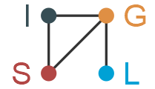
TBR-VL <1% | 74.2% | 59.9% | 88.1% | 88.6% | <0.001 | 
TIR >70% and TBR <4% | 49.2% | 32.6% | 59.2% | 64.3% | <0.001
TIR >70% and TBR-VL <1% | 61.3% | 44.6% | 77.2% | 76.4% | <0.001
TITR > 50% and TBR <4%* | 43.8% | 23.6% | 52.7% | 53.2% | <0.001 | 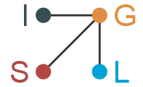
TITR > 50% and TBR-VL <1%* | 55.9% | 36.0% | 70.7% | 65.4% | <0.001 | 
Abbreviations: TBR, time below range (% time < 70 mg/dL); TBR-VL (% time < 54 mg/dL); TIR, time in range (% time 70-180 mg/dL).
* There is no established ADA consensus goal for time in tight range (TITR), but a goal of >50% TITR has been proposed.
1 P-value is from an overall test of treatment differences (i.e., test that at least one pair of treatment groups differ), based on an omnibus Kruskal-Wallis test, with adjustment for false discovery rate made across all omnibus tests.
2 P-values for pairwise comparisons between treatment groups were adjusted for multiple comparisons using the Holm procedure (6 pairwise comparisons per metric). Boxes in this column graphically display the results of testing pairwise treatment effects. Each corner of the box represents one of the four treatments (I=Insulin glargine, G = Glimepiride, L = Liraglutide, S = Sitagliptin), and solid lines connect the treatments that differ significantly (p ≤0.05). Absence of a line between letters indicates no statistically significant difference.
3 Since the overall tests of treatment differences were not statistically significant (i.e., no treatment group differences), pairwise comparisons between treatment groups were not conducted.

Supplemental Table 5. Descriptive characteristics at time of CGM among the intention-to-treat cohort by randomized treatment group.
Characteristic | Overall (n=1453) | Glargine (n=319) | Glimepiride (n=351) | Liraglutide (n=398) | Sitagliptin (n=385) | p-value¹
Age (years) | 58.9 ± 9.7 | 58.7 ± 9.5 | 58.8 ± 10.1 | 59.1 ± 9.7 | 59.0 ± 9.5 | 0.949
Female (%) | 585 (40.3%) | 111 (34.8%) | 150 (42.7%) | 156 (39.2%) | 168 (43.6%) | 0.076
Race/ethnicity |  |  |  |  |  | 0.370
Black non-Hispanic | 389 (26.8%) | 97 (30.4%) | 98 (27.9%) | 103 (25.9%) | 91 (23.6%)
White Hispanic | 326 (22.4%) | 57 (17.9%) | 82 (23.4%) | 89 (22.4%) | 98 (25.5%)
White non-Hispanic | 534 (36.8%) | 121 (37.9%) | 118 (33.6%) | 153 (38.4%) | 142 (36.9%)
Other | 204 (14.0%) | 44 (13.8%) | 53 (15.1%) | 53 (13.3%) | 54 (14.0%)
Diabetes duration (years), median [IQR]² | 6.4 [4.2, 9.1] | 6.1 [4.4, 9.1] | 6.2 [4.2, 9.1] | 6.8 [4.2, 9.3] | 6.7 [4.3, 9.0] | 0.689
Metformin dose (mg/d)³ |  |  |  |  |  | <0.001
≤1000 | 165 (11.4%) | 44 (13.8%) | 28 (8.0%) | 65 (16.3%) | 28 (7.3%)
1500 | 82 (5.6%) | 19 (6.0%) | 16 (4.6%) | 20 (5.0%) | 27 (7.0%)
2000 | 1,206 (83.0%) | 256 (80.3%) | 307 (87.5%) | 313 (78.6%) | 330 (85.7%)
Randomized treatment dose⁴, median [IQR] | N/A | 0.3 [0.2, 0.5] | 2.0 [1.0, 6.0] | 1.8 [1.2, 1.8] | 100.0 [100.0, 100.0] | N/A
Taking statins | 967 (66.6%) | 215 (67.4%) | 242 (68.9%) | 254 (63.8%) | 256 (66.5%) | 0.504
Taking blood pressure medications | 1,120 (77.1%) | 247 (77.4%) | 268 (76.4%) | 310 (77.9%) | 295 (76.6%) | 0.956
Body mass index (kg/m²) | 33.4 ± 6.5 | 34.1 ± 6.7 | 34.1 ± 6.7 | 32.5 ± 6.5 | 33.1 ± 6.2 | 0.002
eGFR (mL/min/1.73 m²) | 92.3 ± 18.6 | 92.2 ± 18.7 | 92.6 ± 18.3 | 91.4 ± 19.4 | 93.0 ± 18.1 | 0.671
UACR (mg/g), median [IQR]² | 6.8 [3.3, 19.6] | 8.8 [3.7, 20.2] | 6.5 [3.2, 19.1] | 6.2 [3.1, 21.2] | 6.8 [3.2, 17.8] | 0.090
HbA1c (%), median [IQR]² | 6.8 [6.4, 7.3] | 6.9 [6.4, 7.4] | 6.9 [6.4, 7.4] | 6.7 [6.2, 7.3] | 6.9 [6.4, 7.4] | 0.004
Fasting glucose (mg/dL) | 130.5 ± 34.1 | 128.4 ± 37.7 | 129.0 ± 33.3 | 128.2 ± 33.5 | 135.9 ± 31.8 | 0.004
Study visit of CGM |  |  |  |  |  | 0.834
12 – 24 months | 589 (40.5%) | 131 (41.1%) | 144 (41.0%) | 155 (38.9%) | 159 (41.3%)
36 – 39 months | 574 (39.5%) | 129 (40.4%) | 129 (36.8%) | 165 (41.5%) | 151 (39.2%)
60 months | 290 (20.0%) | 59 (18.5%) | 78 (22.2%) | 78 (19.6%) | 75 (19.5%)
Taking protocol driven rescue insulin | 259 (17.8%) | 39 (12.2%) | 59 (16.8%) | 63 (15.8%) | 98 (25.5%) | <0.001
Taking non-study diabetes medications | 75 (5.2%) | 15 (4.7%) | 21 (6.0%) | 17 (4.3%) | 22 (5.7%) | 0.681
Discontinued randomized study medication | 131 (9.0%) | 22 (6.9%) | 32 (9.1%) | 51 (12.8%) | 26 (6.8%) | 0.011
Abbreviations: IQR, interquartile range.
Note: All continuous variables are summarized as mean (standard deviation), and all categorical variables are summarized as counts (percent), unless otherwise noted.
¹ Nominal (unadjusted) p-value is from an overall test of treatment differences (i.e., test that at least one pair of treatment groups differ), based on an ANOVA (continuous variables) or chi-squared test (categorical variables), unless otherwise noted.
² P-value is based on a Kruskal-Wallis test (due to nonnormally distributed variables).
³ There was a total of 40 (2.8%) participants with metformin dose <1000 mg/d.
⁴ Dose for glargine was in units/kg/d. Dose for glimepiride, liraglutide, and sitagliptin were in mg/d.

Supplemental Table 6. HbA1c and core CGM metrics by randomized treatment group in the intention-to-treat cohort; values reported as sample means (standard deviation)
Glycemic Metric | Glargine  (I)  (n=319) | Glimepiride (G)  (n=351) | Liraglutide (L)  (n=398) | Sitagliptin (S)  (n=385) | p-value¹ | Pairwise Comparisons²
HbA1c (%) | 7.1 (1.2) | 7.0 (1.0) | 6.9 (1.0) | 7.0 (1.0) | 0.004 | 
AG_{CGM} (mg/dL) | 137.2 (43.0) | 133.0 (37.6) | 131.7 (44.2) | 135.4 (40.1) | 0.037 | 
%CV | 29.4 (6.0) | 31.2 (6.9) | 26.2 (5.1) | 26.3 (5.5) | <0.001
TIR₇₀₋₁₈₀ (%) | 76.0 (21.9) | 74.6 (18.9) | 80.3 (21.5) | 79.9 (20.6) | <0.001
TITR₇₀₋₁₄₀ (%) | 57.5 (23.1) | 55.4 (20.7) | 62.9 (24.9) | 59.8 (24.5) | 0.003
TAR-VH_{>250} (%) | 5.5 (14.4) | 4.1 (11.1) | 4.3 (13.2) | 4.2 (12.4) | <0.001 | 
TAR_{>180} (%) | 18.7 (23.3) | 17.2 (20.3) | 14.8 (22.1) | 16.0 (21.5) | <0.001
TBR_{<70} (%) | 5.3 (8.5) | 8.2 (10.8) | 4.9 (9.8) | 4.1 (8.0) | <0.001
TBR-VL_{<54} (%) | 1.1 (3.5) | 2.3 (4.4) | 0.7 (2.4) | 0.8 (2.7) | <0.001
TAR-H₁₈₁₋₂₅₀ (%) | 13.2 (12.5) | 13.1 (12.2) | 10.5 (12.8) | 11.8 (12.5) | <0.001
TBR-L₅₄₋₆₉ (%) | 4.3 (5.9) | 5.9 (7.0) | 4.2 (8.0) | 3.3 (6.1) | <0.001
Abbreviations: AG, average glucose; %CV, coefficient of variation (standard deviation of glucose divided by average glucose); TAR, time above range (% time > 180 mg/dL); TAR-H, time above range high (% time 181-250 mg/dL); TAR-VH, time above range very high (% time >250 mg/dL); TBR, time below range (% time < 70 mg/dL); TBR-L, time below range low (% time 54-69 mg/dL); TBR-VL (% time < 54 mg/dL); TIR, time in range (% time 70-180 mg/dL); TITR, time in tight range (% time 70-140 mg/dL).
¹ P-value is from an overall test of treatment differences (i.e., test that at least one pair of treatment groups differ), based on an omnibus Kruskal-Wallis test, with adjustment for false discovery rate made across all omnibus tests.
² P-values for pairwise comparisons between treatment groups were adjusted for multiple comparisons using the Holm procedure (6 pairwise comparisons per metric). Boxes in this column graphically display the results of testing pairwise treatment effects. Each corner of the box represents one of the four treatments (I=Insulin glargine, G = Glimepiride, L = Liraglutide, S = Sitagliptin), and solid lines connect the treatments that differ significantly (p ≤0.05). Absence of a line between letters indicates no statistically significant difference.

Supplemental Table 7. Episodes of CGM-derived hypoglycemia (> 15 minutes with glucose < 54 mg/dL), CGM-derived prolonged hypoglycemia (> 120 minutes with glucose < 54 mg/dL), and self-reported hypoglycemia per participant during the 14-day CGM period, among the intention-to-treat cohort.
CGM Metric | Glargine | Glimepiride | Liraglutide | Sitagliptin | p-value¹
Hypoglycemic episodes (>15 min.)
Mean (95% CI)² | 2.1 (1.7, 2.6) | 4.5 (3.6, 5.5) | 1.7 (1.4, 2.1) | 1.7 (1.4, 2.1) | <0.001
Pairwise comparisons p-values³
Glargine | -- | <0.001 | 0.426 | 0.426
Glimepiride | -- | -- | <0.001 | <0.001
Liraglutide | -- | -- | -- | 0.946
Prolonged hypoglycemic episodes (>120 min.)
Mean (95% CI)² | 0.4 (0.3, 0.6) | 1.0 (0.7, 1.4) | 0.3 (0.2, 0.4) | 0.3 (0.2, 0.4) | <0.001
Pairwise comparisons p-values³
Glargine | -- | 0.003 | 0.086 | 0.191
Glimepiride | -- | -- | <0.001 | <0.001
Liraglutide | -- | -- | -- | 0.592
Self-reported hypoglycemia episodes⁴
Mean (95% CI)² | 0.4 (0.3, 0.6) | 0.5 (0.3, 0.6) | 0.2 (0.1, 0.3) | 0.3 (0.2, 0.4) | 0.007
Pairwise comparisons p-values³
Glargine | -- | 0.583 | 0.052 | 0.583
Glimepiride | -- | -- | 0.005 | 0.299
Liraglutide | -- | -- | -- | 0.344
¹ P-value reported from a Wald test of the overall treatment effect.
² For CGM-derived hypoglycemia episodes and prolonged hypoglycemia episodes, model-estimated mean counts of the number of episodes in a 14-day CGM period by treatment group are presented based on the negative binomial regression model with an offset term for length of time of CGM.
³ For the pairwise comparison p-values, the treatment group name in the row label and in the column label correspond to the two comparison groups for the pairwise comparison. For example, the p-value in the row labeled “Glargine” and the column labeled “Glimepiride” corresponds to the glargine-glimepiride comparison, the cell in the row labeled “Glargine” and the column labeled “Glargine” is blank since there is no comparison of the glargine group with itself, and the cell in the row labeled “Glimepiride” and the column labeled “Glargine” is blank since the p-value for the glargine-glimepiride comparison was already presented in the cell for the “Glargine” row and the “Glimepiride” column. P-values are reported from Wald tests of pairwise comparisons between treatment groups, adjusted for multiple testing using the Holm method.
⁴ The analysis of self-reported hypoglycemia episodes was restricted to the 1282 participants who reported that they recorded their blood sugar symptoms (if any) in the diary 100% of the time.

Supplemental Table 8. Proportion of participants reaching each ADA consensus CGM management goal (1) by treatment group, among the intention-to-treat cohort.
ADA Glycemic Management Goal | Glargine  (I) | Glimepiride (G) | Liraglutide (L) | Sitagliptin (S) | p-value¹ | Pairwise Comparisons²
TIR >70% | 74.9% | 72.1% | 79.4% | 78.7% | 0.077 | N/A³
TITR >50%* | 70.2% | 67.5% | 75.1% | 69.9% | 0.131 | N/A³
TBR <4% | 63.0% | 48.1% | 69.6% | 73.2% | <0.001
TBR-VL <1% | 74.6% | 60.1% | 86.2% | 85.5% | <0.001
TIR >70% and TBR <4% | 44.8% | 32.2% | 54.0% | 55.8% | <0.001
TIR >70% and TBR-VL <1% | 55.8% | 43.0% | 70.9% | 67.5% | <0.001
TITR >50% and TBR <4%* | 38.2% | 24.2% | 47.0% | 45.7% | <0.001 | 
TITR >50% and TBR-VL <1%* | 49.2% | 35.3% | 63.8% | 57.4% | <0.001 | 
Abbreviations: TBR, time below range (% time < 70 mg/dL); TBR-VL (% time < 54 mg/dL); TIR, time in range (% time 70-180 mg/dL).
* There is no established ADA consensus goal for time in tight range (TITR), but a goal of >50% TITR has been proposed.
¹ P-value is from an overall test of treatment differences (i.e., test that at least one pair of treatment groups differ), based on an omnibus Kruskal-Wallis test, with adjustment for false discovery rate made across all omnibus tests.
² P-values for pairwise comparisons between treatment groups were adjusted for multiple comparisons using the Holm procedure (6 pairwise comparisons per metric). Boxes in this column graphically display the results of testing pairwise treatment effects. Each corner of the box represents one of the four treatments (I=Insulin glargine, G = Glimepiride, L = Liraglutide, S = Sitagliptin), and solid lines connect the treatments that differ significantly (p ≤0.05). Absence of a line between letters indicates no statistically significant difference.
³ Since the overall tests of treatment differences were not statistically significant (i.e., no treatment group differences), pairwise comparisons between treatment groups were not conducted.

Supplemental Figure 1. CONSORT diagram.
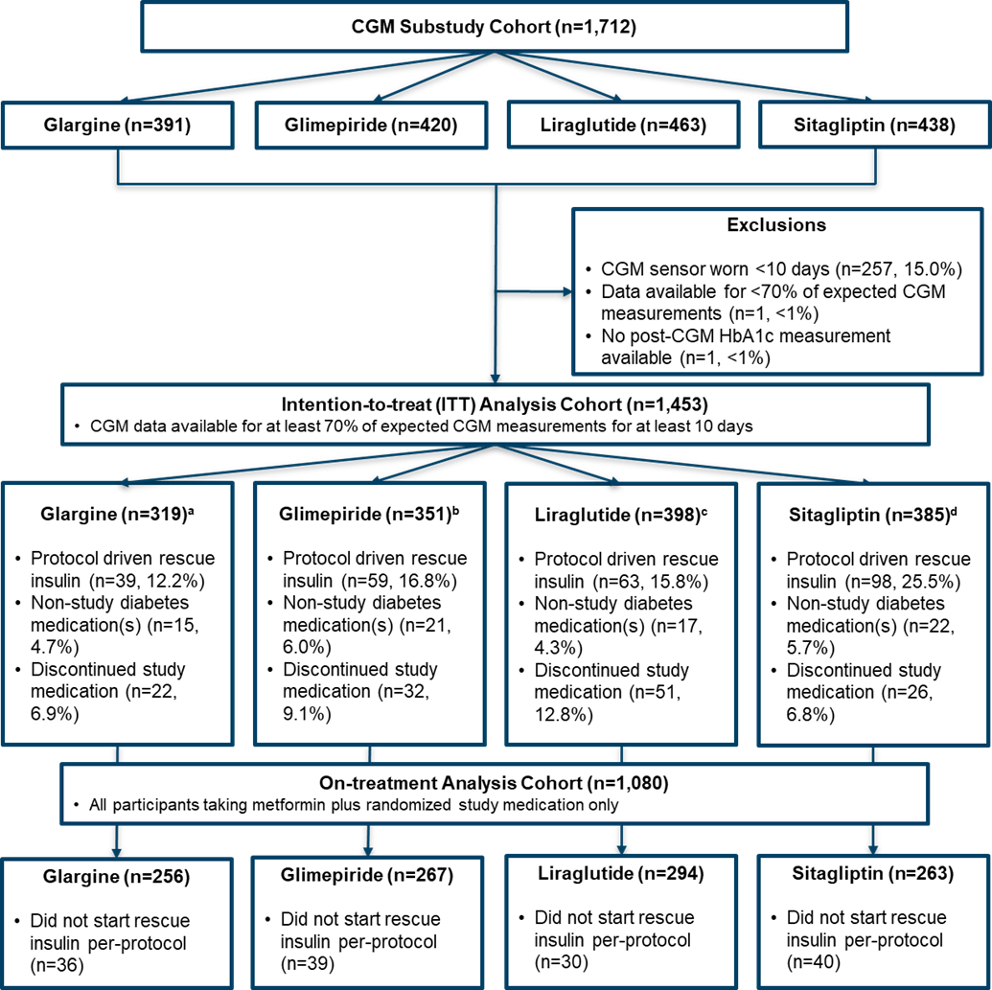
ª Of the 87 who met secondary outcome, 48 (55.2%) refused per-protocol rescue insulin
^{b} Of the 103 who met secondary outcome, 46 (44.7%) refused per-protocol rescue insulin
^{c} Of the 103 who met secondary outcome, 40 (38.8%) refused per-protocol rescue insulin
^{d} Of the 146 who met secondary outcome, 49 (33.6%) refused per-protocol rescue insulin

Supplemental Figure 2. Boxplots of the distribution of core CGM metrics by treatment group among the on-treatment cohort..
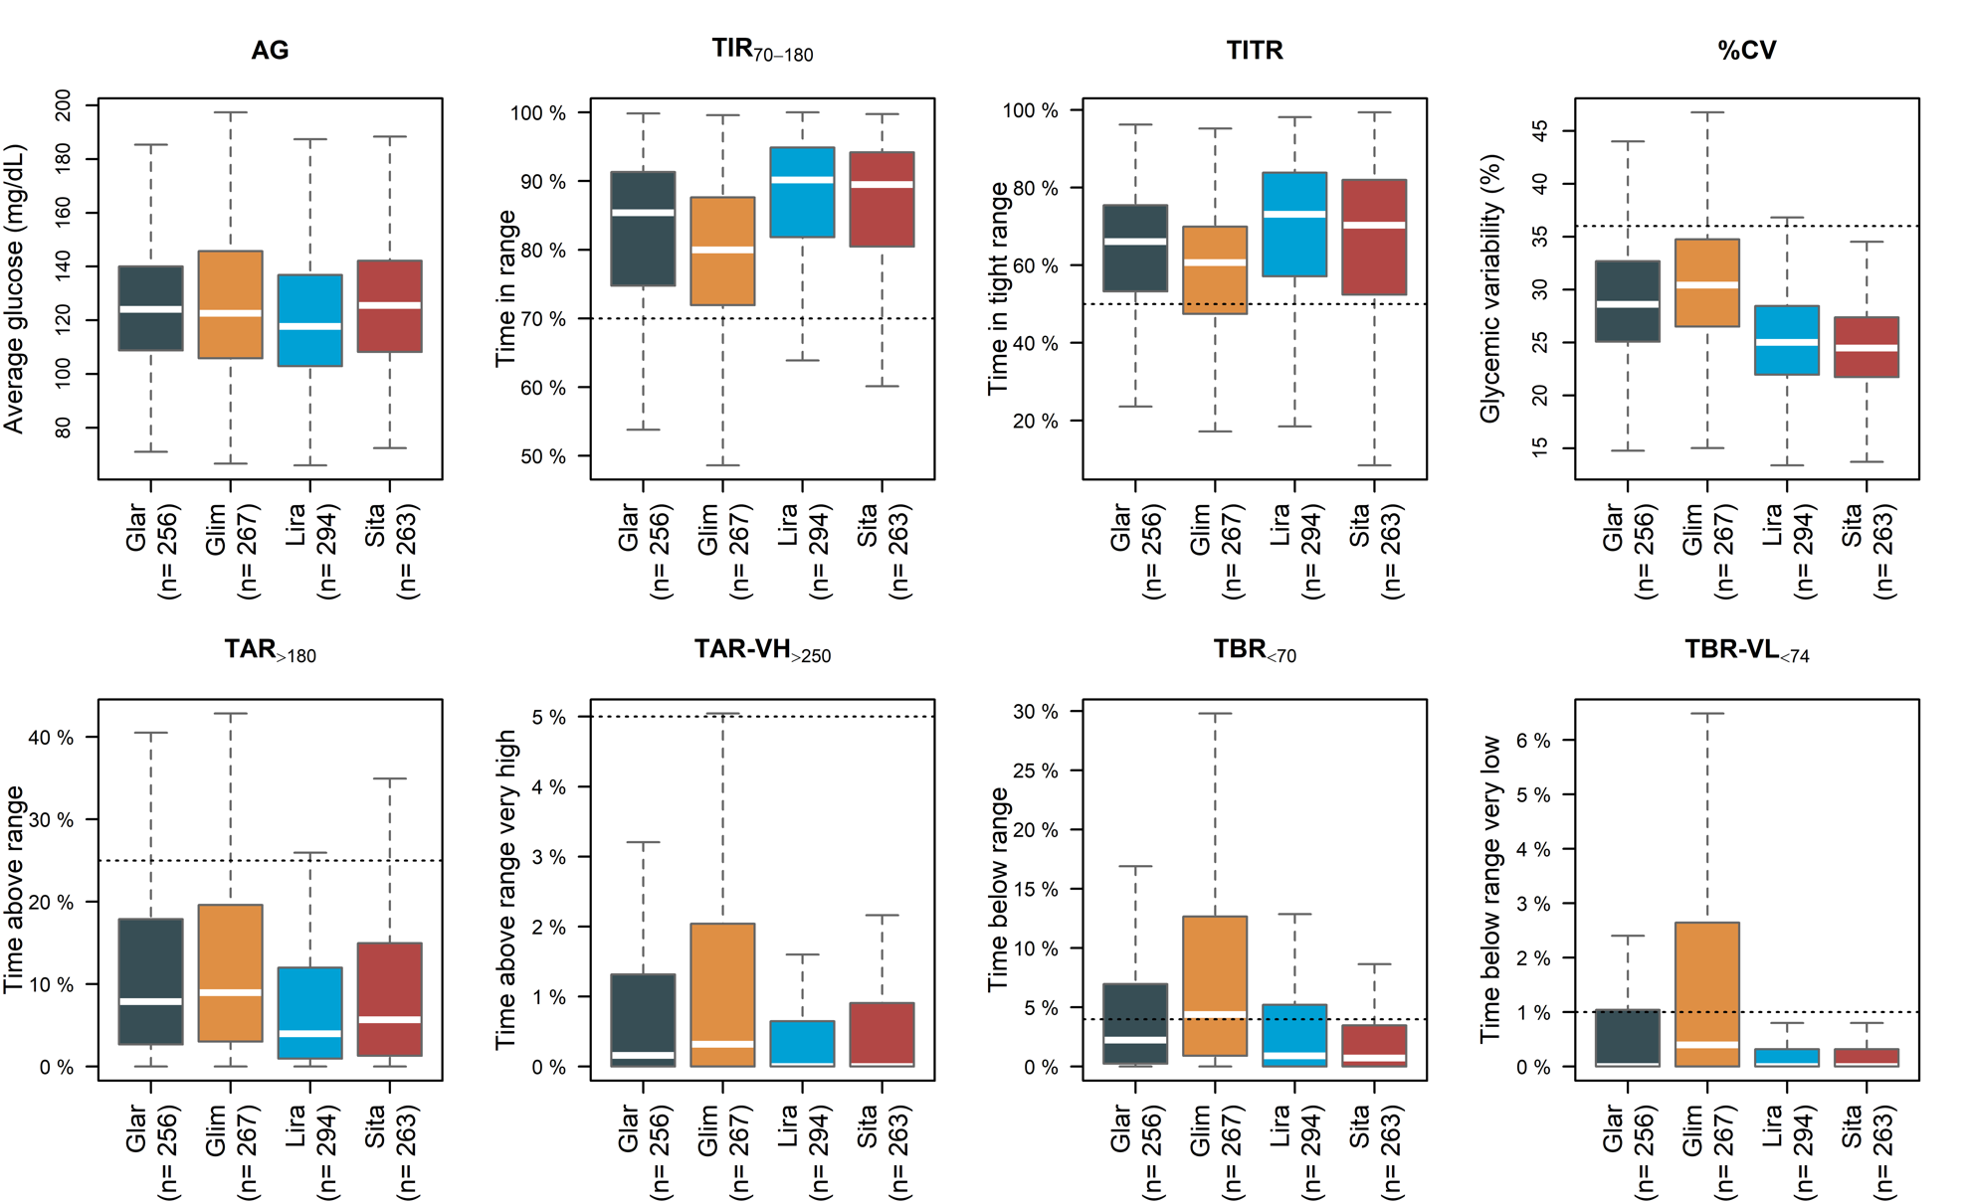
Note: The box indicates the interquartile range, outliers are not displayed on the boxplot, and whiskers extend to 1.5 times the interquartile range. Abbreviations: AG, average glucose; %CV, coefficient of variation (standard deviation of glucose divided by average glucose); TAR, time above range (% time > 180 mg/dL); TAR-H, time above range high (% time 181-250 mg/dL); TAR-VH, time above range very high (% time >250 mg/dL); TBR, time below range (% time < 70 mg/dL); TBR-L, time below range low (% time 54-69 mg/dL); TBR-VL (% time < 54 mg/dL); TIR, time in range (% time 70-180 mg/dL); TITR, time in tight range (% time 70-140 mg/dL).

Supplemental Figure 3. The percent time spent in defined CGM ranges by randomized treatment group, among the on-treatment cohort. Suggested targets for metrics are provided on the right side of the figure.
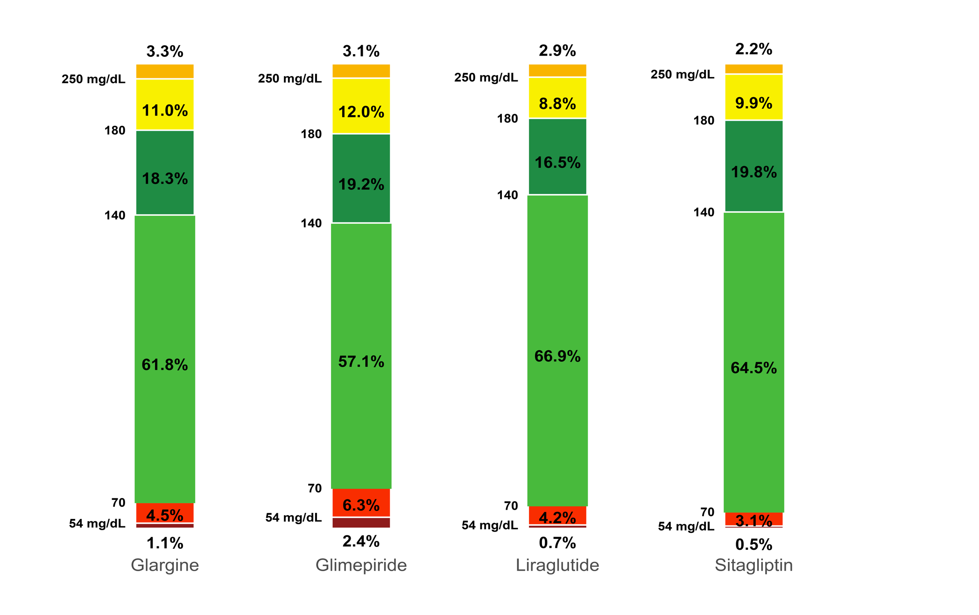
Time in Range 70-180 mg/dL
Time in Tight Range 70-140
Goal: >70%
Time Above Range >180 mg/dL
Goal: <25%
Time Below Range <70
Goal: >50%
Goal: <4%

Supplemental Figure 4. Boxplots of distribution of core CGM metrics by treatment group, among the intention-to-treat cohort.
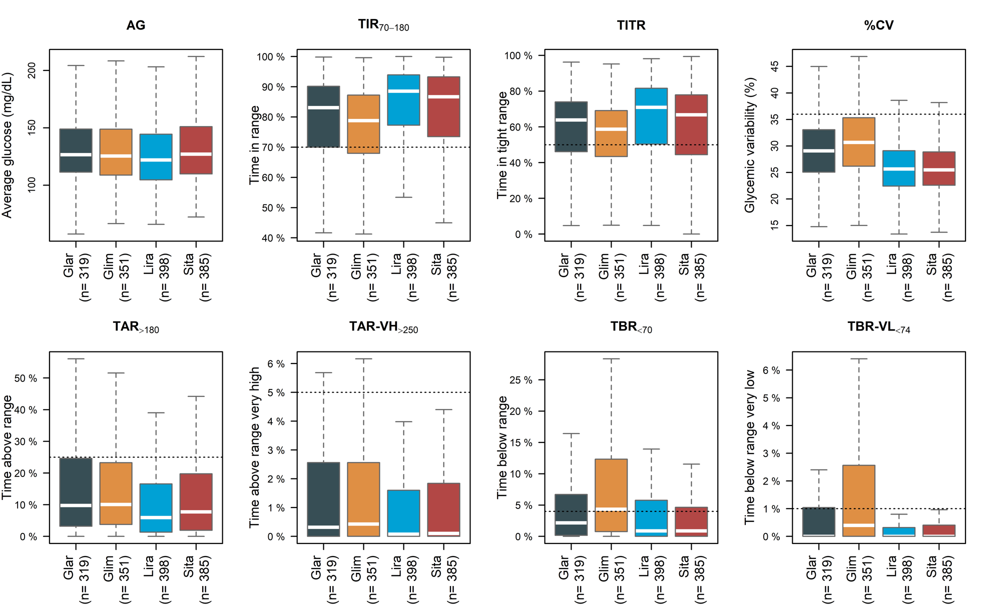
Note: The box indicates the interquartile range, outliers are not displayed on the boxplot, and whiskers extend to 1.5 times the interquartile range. Abbreviations: AG, average glucose; %CV, coefficient of variation (standard deviation of glucose divided by average glucose); TAR, time above range (% time > 180 mg/dL); TAR-H, time above range high (% time 181-250 mg/dL); TAR-VH, time above range very high (% time >250 mg/dL); TBR, time below range (% time < 70 mg/dL); TBR-L, time below range low (% time 54-69 mg/dL); TBR-VL, time below range very low (% time < 54 mg/dL); TIR, time in range (% time 70-180 mg/dL); TITR, time in tight range (% time 70-140 mg/dL).

Supplemental Figure 5. Ambulatory glucose profiles (AGP) in the intent-to-treat cohort.
The target range is between 70 and 180 mg/dL. Panel a: Median 24-hour ambulatory glucose profiles (AGP) of the randomized treatment groups. Panel b: AGPs separately by treatment group, with 5th, 25th, 50th, 75th, and 95th percentiles, and with target ranges.
A.
B.

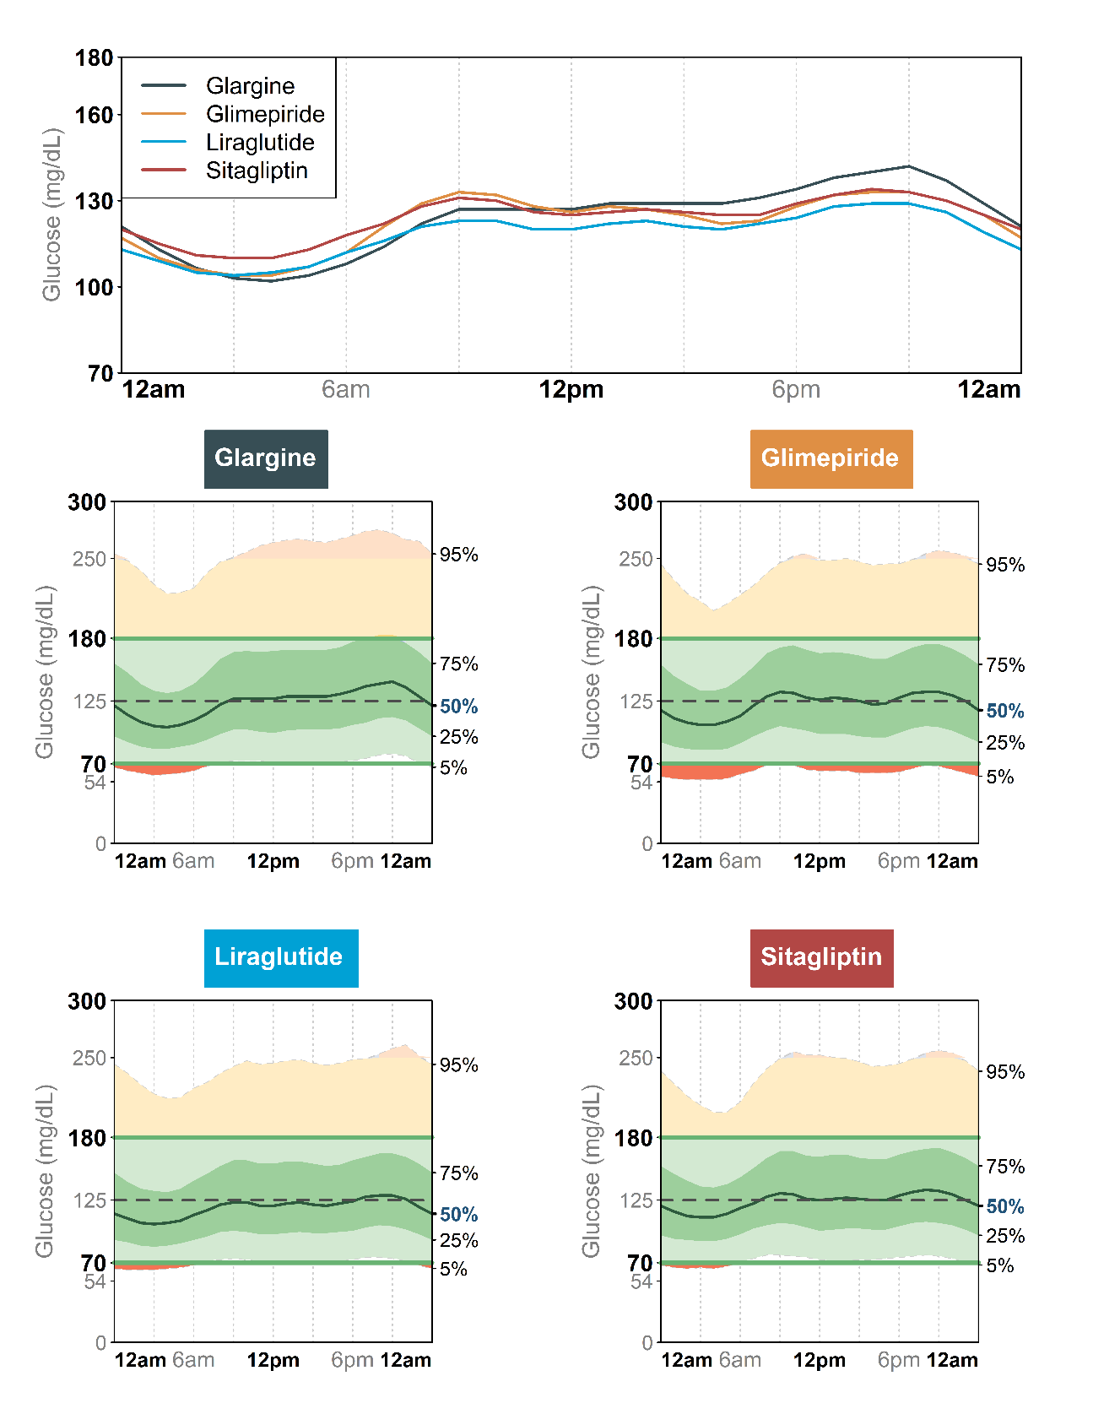

Supplemental Figure 6. Bar plots of the proportion reaching the ADA consensus CGM management goals by treatment group, among the intention-to-treat cohort.
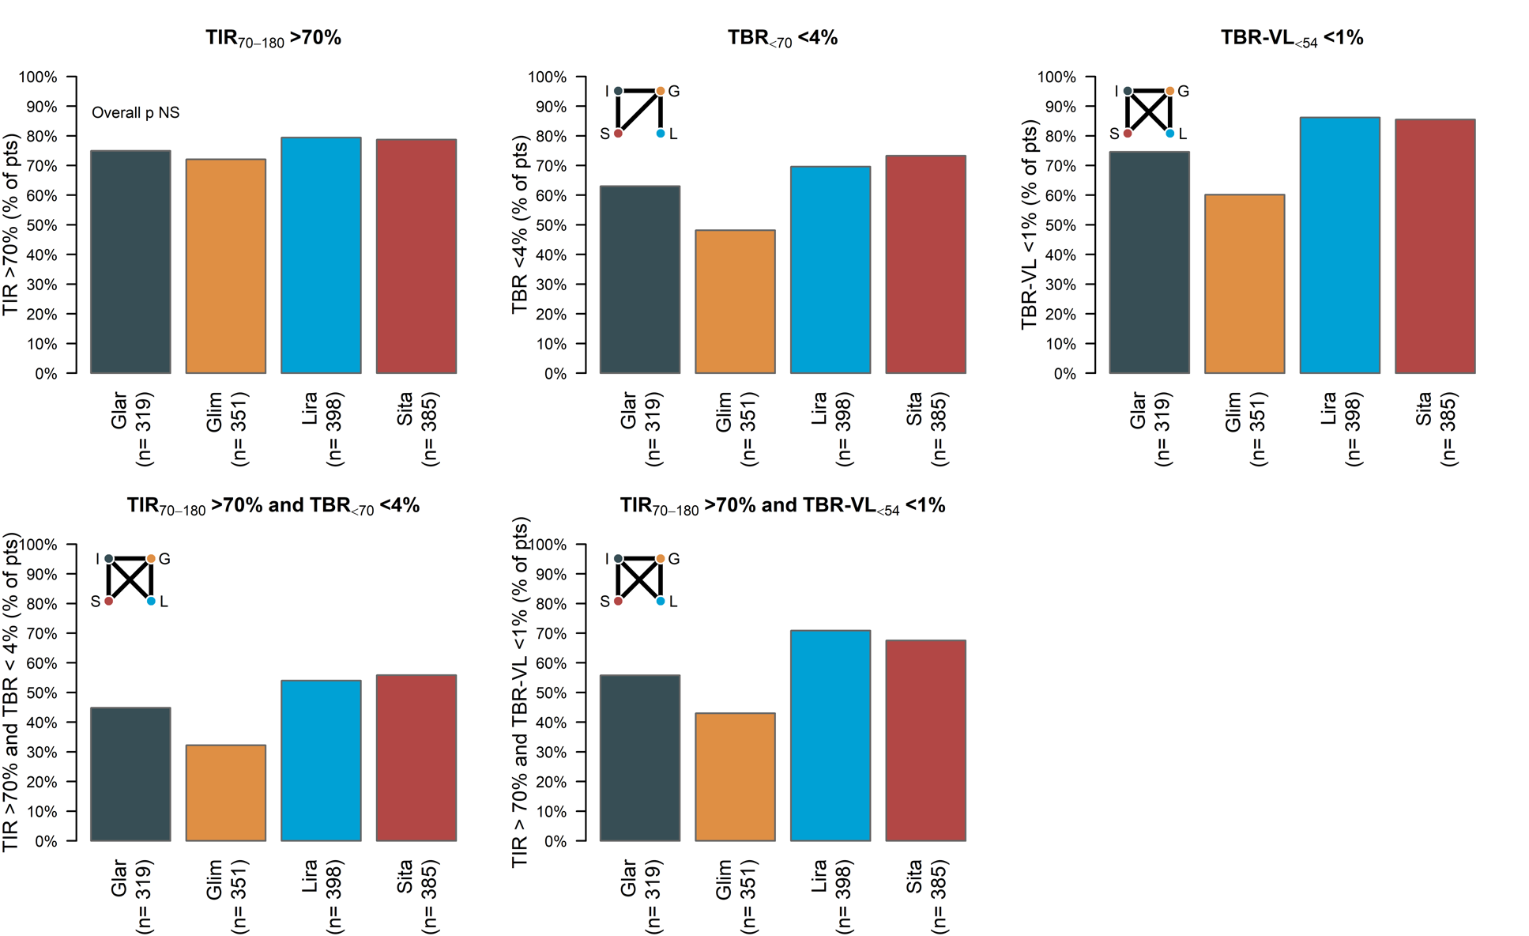
Abbreviations: TBR, time below range (% time < 70 mg/dL); TBR-VL (% time < 54 mg/dL); TIR, time in range (% time 70-180 mg/dL). For CGM management goals with a statistically significant overall test of treatment differences (overall p ≤0.05), boxes graphically display the results of testing pairwise treatment effects. Each corner of the box represents one of the four treatments (I=Insulin glargine, G = Glimepiride, L = Liraglutide, S = Sitagliptin), and solid lines connect the treatments that differ significantly (p ≤0.05). Absence of a line between letters indicates no statistically significant difference. For CGM management goals without a statistically significant overall test of treatment differences (overall p >0.05), “Overall p NS” is stated on the bar plot.

References

1. American Diabetes Association Professional Practice Committee. 6. Glycemic Goals and Hypoglycemia: Standards of Care in Diabetes-2025. Diabetes Care 2025;48:S128-S145

